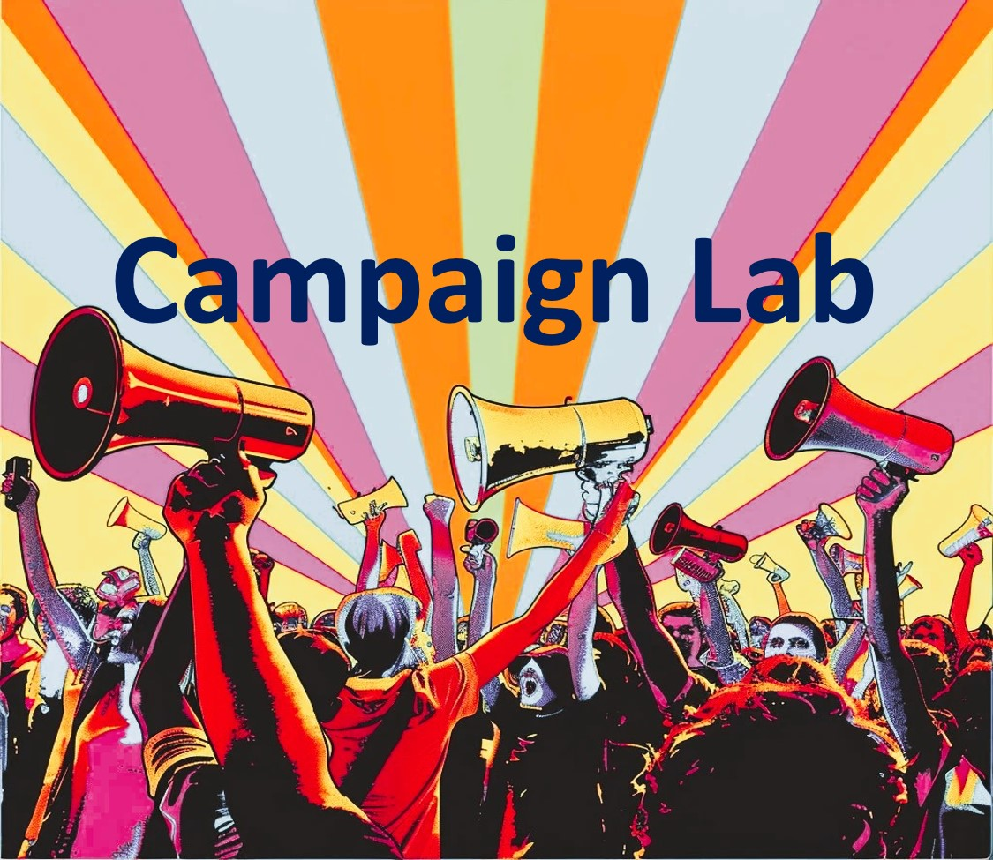
  Campaign Planning | Overview  Centering Equity  Team  Problem and Issue  Power Analysis  Strategy

Campaign Plan Overview

Centering Equity (process to ensure this throughout your campaign?
Problem (big issue, no clear
solution)

Issue (personal, manageable, specific to the problem needing to be solved with a tangible solution)
Demand (what do we want in order to solve the issue)

Target (has the decision making or resources to solve your
problem)
Allies (supporters on this issue)

Opposition (do not support you on this issue)

Metrics (inform is you are winning along the way)
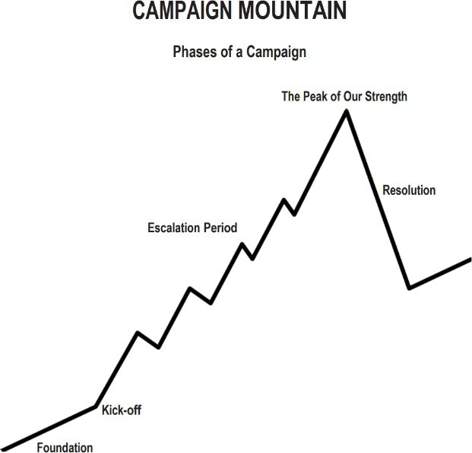

Timeline
Tactics (in order) of escalation Benchmarks for each tactic

Data (what will you collect and how) Campaign Team and Roles (consider distributing responsibilities) Res

CENTERING EQUITY (Iterative Analysis)
What does it mean to center equity in your campaign?
Race, class, and gender dynamics, disparities, and divisions permeate our society, communities, schools, and classrooms. Systemic oppression is so deeply rooted in our history, culture, and institutions that there is no escaping it. Visible or not, the impacts are ever-present. Race, class, and gender justice is the systematic fair treatment of all people resulting in equitable opportunities and outcomes for all. Justice, or equity goes beyond being against the systematic use of oppressions like misogyny, racism, and classism. It is not just the absence of discrimination and inequities, but also the presence of deliberate systems and supports to achieve and sustain equity through proactive and preventative measures.

To engage in a systems analysis of a racial issue and develop solutions or to test if the campaign demands center race, class, and gender justice, good discussion questions to have with partners and union members include:
Problems: What inequities are you noticing or experiencing? What are the impacts on different groups? Who benefits most and who is hurt most?
Causes: What institutions, policies, or practices are causing or contributing to the inequities? What social norms, popular myths, or cultural biases
may be contributing?
History: How did things get this way and are things worsening or improving?
Solutions: What solutions could address the root causes and eliminate the inequities? How would
different racial groups be impacted by the proposed solutions?
Strategies: What strategies and actions could be used to advance the solutions?
Leadership: Who are the stakeholders most affected by the inequities? Are they involved in naming the issues and solutions? What kinds of
active leadership roles could they take to advance the proposed solution?
Additional Equity Tool Questions:
Who is most directly impacted?
Who has been left out?
How can they be directly engaged?
How do our demands center race, class, and gender justice?
Leadership Team
Who are the key people that will lead the actions and shape the plan? What is their shared purpose? What are the community agreements that they are committed to?

Shared Purpose Process
- In the first part, as individuals, you will take 5 minutes to clarify your own thinking about what the purpose of your team could be as you work on a campaign together.
- In the second part, as a team, you will take 10 minutes to share your ideas, look for the common focus, and discern a purpose you can all support.
- You then have 5 more minutes to write a new sentence that you think captures the sense of your team.
- And finally, as a team, you will have 5 minutes to consider the second round of sentences and decide on one that best articulates your team’s perspective.

Step 1: Individual Work (5 min.)
- In the first column, based on the work you did on common interests and values in the relationship session, write down the unique purpose or purposes of your team.
- In the second column, write down whom your team serves: What are the people like and what are their interests?
- In the third column, write down the kinds of activities that your team could engage in to fulfill its purpose by serving this community? What is the unique work that your team could do?

Chart your Individual Responses
WHAT? | WHO? | HOW?
Our team’s shared purpose is to…  (briefly describe your team’s unique reason for coming together) | The constituency we organize is…  (briefly describe your constituency’s characteristics) | We will achieve our shared purpose by…  (list the specific activities that your team would undertake)

After brainstorming answers to all three questions, take a few moments to write a sentence that you think best describes your team’s purpose, its constituency, and its activities. Draw on all three columns above.

Examples of a shared purpose sentence:
We share the purpose of educational justice by organizing high school students in Milwaukee to develop their capacity for collective action through providing them with coaching, training, and mentoring.

We share the purpose of gaining water access for organic farming by organizing farmers and community activists through holding 1:1 meetings, community meetings, proposing and passing legislation.

Step 2: Team Work (7 minutes)
As each person reads their sentence, the facilitator notes the key words on the wall poster under purpose, constituency, or work. Note specific words to which you respond, that spark your curiosity, or that give you energy. When you are done, your facilitator circles the words that seem to resonate most strongly with your team.
Our team’s shared purpose is to:
Step 3: Individual Work (3 minutes)
In light of what you learned from the last session, write a new sentence that you think can articulate a shared purpose, using some of the key words and themes.
YOUR draft Our team’s shared purpose is to:
Step 4: Team Work (5 minutes)
We will read our sentences again and choose—or combine—one that can best articulate the shared sense of your team.
Final Team draft Our team’s shared purpose is to:

Team Community Agreements
Process for Developing Community Agreements:
Review the sample community agreements below. Add, subtract or modify to create norms for your team. Be sure to include group agreements on each theme below and how you will self-correct if one is broken. (If you don’t self-correct, the new agreement will be breaking the agreements.)

Sample Agreements

Decision-making: What is the process by which we will make decisions?
- Majority rules: Whatever gets the most votes wins.
- Consensus: Everyone must agree.
- Delegation: Nominate one or two people on your team to be the ultimate decision-makers.
  - Coin flip: Leave the decision to fate!
  - Other:
Discussion and Decision-making: How we will discuss options and reach decisions as a team to ensure vigorous input and debate?
Always Do  Engage in open, honest debate  Ask open-ended questions  Balance advocacy with inquiry | Never Do  Engage in personal attacks  Fail to listen to what others say  Jump to conclusions
Meeting Management: How will we manage meetings to respect each other’s time?
Always Do  Start on time; stay on time  Be fully present throughout the meeting | Never Do  Come to meetings unprepared  Answer cell phones or do email
Accountability: How we will delegate responsibilities for actions and activities? How will we follow through on commitments?
Always Do  Clarify understanding  Provide follow-up on action items  Ask for/offer support when there is a need  Weekly check-in | Never Do  Assume you have agreement  Assume tasks are getting done  Commit to a task that you know you  won’t do
How will you "self-correct" if norms are not followed?
We will have to sing a song from childhood for 30 seconds
Teams work best when you have a regular, reliable time to coordinate together. What will your team’s regular meeting time and place be?
We are going to meet at the Chanin Auditorium side room A, 5:00 PM every other Friday.

Team Workspace for Community Agreements
Decision-making: What is the process by which we will make decisions?
Discussion and Decision-making: How we will discuss options and reach decisions as a team to ensure vigorous input and debate?
Always Do | Never Do
Meeting Management: How will we manage meetings to respect each other’s time?
Always Do | Never Do
Accountability: How we will delegate responsibilities for actions and activities? How will we follow through on commitments?
Always Do | Never Do
How will you "self-correct" if norms are not followed?

Teams work best when you have a regular, reliable time to coordinate together. What will your team’s regular meeting time and place be?

Team Roles
Process for developing team roles:
Review the Team Coordinator role below as an example of what roles might look like in your individual campaigns. Thinking about how you should organize the next event/meeting, discuss how your roles would fit together to create an interdependent leadership team that supports one another in your individual projects. What would each role have to be good at?
Based on the discussion about the roles, and ask each person to tell others:
- What experience and talents they have that might contribute to the leadership team
- What specifically they want to learn in more detail
How might these talents match up to particular roles? Are there any clear “fits?” Note: These team roles should not be seen as permanent. For the team to be strong, all leaders should have to earn leadership by carrying out responsibilities relevant to the role they seek.
ROLE | RESPONSIBILITIES | YOU WOULD BE GOOD FOR THIS ROLE IF YOU… | INTERESTED TEAM MEMBERS & RELATED SKILLS/TALENTS
Ex. Team Lead | Coordinate the work of the leadership team. Prepare for meetings; give support and coaching to the team. | Organized, experienced, good people skills, can make good snacks | Jesse, Queenie, Vera
Ex. Communications | Coordinates the messages sent out to other people in the campaign. | Access to technology, good design skills, attention to detail | Jorge, Mia, Jack

Team Role Workspace
ROLE | RESPONSIBILITIES | YOU WOULD BE GOOD FOR THIS ROLE IF YOU… | INTERESTED TEAM MEMBERS & RELATED SKILLS/TALENTS
Team Name & Chant (5 min.)
Team Roster:
NAME | PHONE | EMAIL ADDRESS

PROBLEM AND ISSUE
What is the problem(s) we are trying to address?

What is a concrete solution(s) to one part of this problem? This is where we find our issue.

Is the issue.. (See Issue Analysis Tools)
- Widely felt and/or deeply felt?
- Winnable?
- Aligned with our values?
Does the issue..
- Build the union and builds leaders?
DEMAND
What is the demand to the target(s)? The demand should name a clear target, call on the target to take a specific action, and demonstrate the harm or impact. There may be a primary target and a secondary target.

ORGANIZATIONAL ASSESSMENT - RESOURCES
Examine what resources we have to build and use power. Power is organized people and organized money (and resources).
People
Who are our organized people?
- How many current leaders and active members do we have?
- Who are potential new leaders and active members, and how can we recruit them?
- Who are our allies? How many leaders and active members do they have? What relationship do they have with the target(s)?

Expertise
Key, specialized knowledge that is used to support the change you want to see. Where is it, how do you get it, how do you communicate it, how do you use it?

Durable Resources
Does not go away (meeting space, research)

Exhaustible Resources
One time use, need to be replenished, need a sustainability plan (money, time)

PRIMARY POWER ANALYSIS OF THE ISSUE

Issue Background
What is the history and current status of the issue?

What are the competing agendas or positions on the issue?

What are the narratives surrounding the issue?

Who are allies on the issue? Who are opponents on the issue?

System Landscape
What are the decision making processes on this issue?
Who is involved in each step of the decision making process?

TARGET(S)
Primary Target Name:

- Based on the Primary Power Analysis who is the primary target? Who can give us what we want?
- Be specific. A target has a name, a face and an address.

Primary Target Power Analysis

Position  - What is the target’s position on the issue?  - Why is the target taking this position?  - What is the target’s history on the issue? | Self-Interest  - What does the target care about?  - What motivates the target to act?  - What are the target’s goals?
Relationships  - What relationship do we have with the target?  - Who influences the target? Do we (or our allies) have a relationship with any of them?  - Who are the target’s allies and opponents?  - To whom is the target accountable? Is the target elected or appointed?  - Who are the target’s base of support? | Power  - What power does the target have and where does their power derive from?  - How do they organize people?  - How do they organize money and resources?

Secondary Target Name (if there is one) :

- Be specific. A target has a name and a face. A secondary target can MOVE the primary target.

Secondary Target Power Analysis (if applicable)

Position  - What is the target’s position on the issue?  - Why is the target taking this position?  - What is the target’s history on the issue? | Self-Interest  - What does the target care about?  - What motivates the target to act?  - What are the target’s goals?
Relationships  - What relationship do we have with the target?  - Who influences the target? Do we (or our allies) have a relationship with any of them?  - Who are the target’s allies and opponents?  - To whom is the target accountable? Is the target elected or appointed?  - Who are the target’s base of support? | Power  - What power does the target have and where does their power derive from?  - How do they organize people?  - How do they organize money and resources?
SPECTRUM OF ALLIES POWER ANALYSIS (WHO CAN WE MOVE?)

Active Allies: Your Constituency
You believe you can already count on them to help you.
If your target falls in this area of the spectrum – you tactics will need to find ways to engage your allies even more actively in working with you toward your goal.

Passive Allies: Support
You think they have the same interest, investment or need to solve the problem as you do, and may be close to agreeing with you about your vision, but perhaps may not be able or willing to actively or overtly support you.
If your target falls in this area of the spectrum - your tactics will need to help move them to the “active ally” position; increasing their interest and willingness to be active.

Neutral: Not Yet – With you or Against you
These are people, organizations, institutions that may not know about the problem; may not know about you and your work; have no particular investment in the problem.
If your target falls in this area of the spectrum – your tactics will need to find ways to inform or educate them about the problem and your position in order to move them to a “passive ally” position. Examine your tactics to be sure you will not move them toward your opponent’s position.

Passive Opponents:
These are people, organizations, institutions that you think have some interests that would be opposed to your vision; they may have relationships with people who are actively opposed to you.
If your target falls in this area of the spectrum – your tactics will need to create doubt about their position, raise fears that their position may be “costly” to them in some way. You want your tactics to move them to a “neutral” position and NOT to an active opponent position.

Active Opponents:
These are people, organizations, institutions that have a big investment in opposing your position (related to power, position, finances, relationships, etc.).
If your target is located in this area of the spectrum – your tactic goal would need to put them into a great dilemma, that any action they would take against you would be very “costly” to them. Your tactic goal would be to move them into a “passive opponent” position.


New Tactics in Human Rights is a program of The Center for Victims of Torture
www.newtactics.org ● www.cvt.org
Creative Commons: Attribution-Noncommercial 4.0 International License ● http://creativecommons.org/licenses/by-nc/4.0/

Problem Statement:
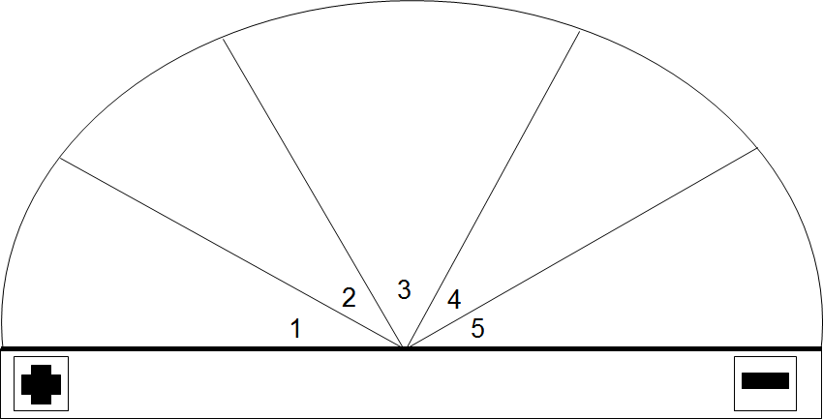

Source: Original Source – Training for Change (www.trainingforchange.org) and adapted into five segments by New Tactics in Human Rights.

New Tactics in Human Rights is a program of The Center for Victims of Torture
www.newtactics.org ● www.cvt.org
Creative Commons: Attribution-Noncommercial 4.0 International License ● http://creativecommons.org/licenses/by-nc/4.0/

PEOPLE COMMUNICATION PLAN – Based on the spectrum of allies analysis, how do you strategically communicate with the people in each of these groups?

Constituency- Your people who care about this issue and may take action to work towards the win
What is your plan for being in contact with as many of these folks as often as possible? How will you know they care about this issue?
Support- Individuals and organizations who support the win but may not be a part of the actions | Neutral - Individuals and organizations who are not yet working towards similar wins or against you. | Passive Opposition and Opposition - Individuals and organizations who are against the win you are seeking to achieve
What is your plan for being in contact with these folks? How will you know they support this issue? | What is your plan for being in contact with these folks? How will you know if and when they move towards you or away from you? | What is your plan for being in contact with these folks? How will you know that they oppose this issue?
Individuals and Organizations you identified that you may not know yet if they support, oppose, or compete with you.
What is your plan for being in contact with these folks?

MESSAGING
Focusing only on the opposition leads to becoming disheartened or cynical, which means you ignore potential allies and support. Focusing only on how to convince the important power-holder who is against you leads to ignoring all of the potential support you could build that could overpower her opposition.

Focusing only on active allies leads to being an isolated interest-group, which also means you ignore potential allies and support Always doing events with the same group of individuals or organizations isolates you from creative, powerful community-building that can arise from new alliances and partnerships

Generalizing about whole groups of people risks misunderstanding the nuances of communities If you think about "students" as an entire group, you ignore the huge number of different groups & organizations (potential allies!) that exist in a student community

DO focus on passive allies. These are folks who know or care
about what you’re up to, but aren’t doing anything about it! Give them a chance to participate and build power with you. Good news, In most social change campaigns, it is not necessary to win the opponent to your point of view, even if the powerholders are the opponent. It is only necessary to move some or all of the pie wedges one step in your direction. If we shift each wedge one step, we are likely to win, even if the hardliners on the opponent’s side don’t budge.
Who is the audience for the campaign messaging? What kind of message will reach them? What are their values? Think about 5 sectors you communicate with – Allies, Passive Allies, Neutral, Passive Opponents, Opponents.
Allies
Passive Allies
Neutral
Passive Opponents
Opponents

STRATEGY AND TACTICS
Brainstorm tactics that will put pressure on the target(s).
Name how each tactic would disrupt the target(s)’s self-interest, relationships, or power.

List the tactics above which meet the criteria below:
- Put pressure on the target (push them out of their comfort zone)
- Build our power (develop our leaders and bring more people into the campaign)
- Are strategic (make good use of our resources to put pressure on target)

Number the tactics above in order of escalation:
Think about how much participation, resources, and risk each tactic requires, as well as how much pressure it will put on the target(s).

Keep reviewing this list throughout the campaign. Remember that each implemented tactic gives us more information about the readiness of our members for the next step and how much pressure the target(s) can sustain. Use this information to inform the next tactic.

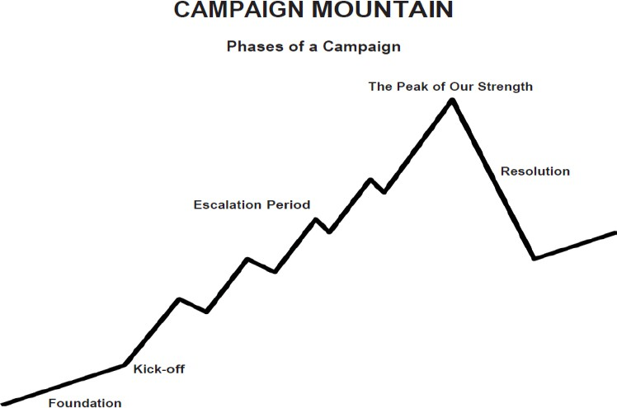

COMPRESSION POINTS
What are the key dates to plan the campaign around?
This can be either externally set dates (board meetings, breaks, etc) or internally set dates (deadlines we give to the target).
BUILDING POWER & DEVELOPING LEADERS
In what ways will we activate more members and build power throughout this campaign?

In what ways will we develop leaders throughout this campaign?

BUILDING POWER & DEVELOPING LEADERS – Do the Math

What is your goal? How many people on what date will it take to win that?

Example:
Goal is 5000 paper petitions signed 4 months from now.
Universe of Potential Actors: 60 Worksites each with 100 Workers

Team Planning: 10 Campaign Team Lead Members create plan (30 Days) (10 People)

Foundation: Each Campaign Team Lead Works with 5 Sites to recruit and train a Campaign Action Lead. (1 Team Lead to 5 Worksite Leads - 50 People)

Structure Building: Those 50 Campaign Action Leads recruit 5 People and train them. (50 Worksite Leads to 5 Building Team Members - 250 People)

Second Peak: Expansion Communication and Kick-off (30 Days)
Each Building team holds one10 Minute Meeting recruiting 25 people in attendance. (each Campaign Action Team Member is responsible for recruiting 5 people to the meeting) (250 Building Team Members to 5 Supporters -1250 People)

Third Peak: Resolution - Asking for Signatures (30 Days)
Each of the 25 who attended each of the 50 building meetings are responsible for collecting at least 5 petition signatures. (1250 Supporters to 5 Supporters - 6250 Signatures and People)

What is your math?

OUTLINE OF STRATEGIC PLAN
- What foundation do you need to build before implementing your campaign (leadership team, initial planning, recruit leaders, gather resources, etc.)? How many people? Date?
- What will you do to kick-off your campaign and gear up for the first tactic? How many people? Date?
- What tactics will you take to reach the win? How many people? Date?
- Are there any natural compression points (dates, events, deadlines) that tactics should align with?
Foundation
Kick-off
Tactic 1
Tactic 2
Tactic 3
Tactic 4
Tactic 5
Win/Demand

Kick-Off
Kick-Off Goal
# Leaders
# Participants
Date(s)
Location(s)
Recruitment and Communication Plan
Resources and Supplies
Measurable Data (Qualitative and Quantitative)

Debrief (Complete after action, Plus, Delta, Key Learning)

Tactic 1 (Complete for each tactic)
Tactical Goal
#Leaders
#Participants
Date(s)
Location(s)
Recruitment and Communication Plan
Resources and Supplies
Measurable Data (Qualitative and Quantitative)

Debrief (Complete after action, Plus, Delta, Key Learning for Next Action)

