Advancing LGBTQ+ Justice Agenda: Day # 1
General Materials Needed: |  |  |  | Room Set-up:
1 Set of Handouts per Person  Name Tents with the Norms  Room signs,  One ream of white photocopy paper  Chart Paper (4 to 5 full w Sticky Strip) |  | Materials Box for each table with:  Markers (Mr. Sketch variety)  Post its – 3x3” and 4X5” sizes  Index Cards  Highlighters – 4 colors  Pens and Pencils Participant “toys” |  | Long Rectangle table at back for facilitators  Round Tables for participants  Projector, Screen, mics, and Speakers  Carousel stations and reporting stations  No podium, table with projector big enough for laptop
Key Outcomes for the Day:

Understanding of identity and how it informs a person’s relationship to privilege and power
Explore unconscious biases around LGBTQ+ and how these can change
Explore the history of the construction of oppression for LGBTQ+ community and times justice has prevailed
Understand aspects of gender as a continuum
Develop a foundational understanding of key terminology

Overview of Content, Time, and Facilitator Assignment
8:30-9:15 Entry and Welcome  9:15-9:30 Ice Breaker  9:30-9:45 Core Values  9:45-10:10 Shared Identity  10:10-10:25 Break  10:25-10:55 I AM Poem  10:55-11:25 First Impressions  11:25-12:00 Oppression Over Time  Lunch – 12:00 -1:00 | Ellen  Grat  Bekah  Ben  Michelle  Barb  Natasha |  | 1:00 -1:30 Shoe switch and Timeline Debrief  1:30- 1:50 Terminology  1:50 – 2:05 BREAK  2:05-2:25 Intro of Transgender Umbrella  2:25-2:45 Gender Unicorn  2:45-3:00 Pronoun Practice  3:00-3:50 Contract Language Activity  3:50-4:30 Closing Discussion and Wrap Up  4:30 -5:00 Adult Choice Networking  5:00 Adjourn |  | Bekah  Grat/Michelle  Jeny/Barb  Jeny/Barb  Ben  Ellen

Time Slides Facilitator | Resources | Instructions, Activity and Debrief (Facilitators) | Essential Questions and Outcomes
Name of facilitator, the slides to be used, the clock time to accomplish the learning section | Charts, handouts, articles, materials, slide | What are you saying, what are they doing, what questions will you use to guide learning and make clear the important points  Include an estimate for how long each section of the learning will take | What question(s) will this learning answer? What will participants know or be able to do?
ENTRY ACTIVITY:
Upon entering the room participants go to the front of the room and indicate what state they are from, and the facilitator drags the dot to the state.
If the laminated map arrives at the training site transfer information from the slide to the room map and keep the map up throughout all three days of the training.
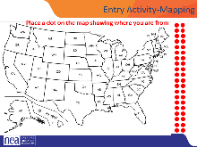
8:30-9:15 Ellen |  | 30 Minutes Getting Started
s  Anthony  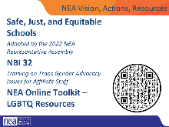   | Chart of “Lingering Questions/Continuing Conversations” that stays up that participants can write stuff on | 15 Minutes minutes  General Welcome  Land Acknowledgment - We begin by acknowledging that we meet on the traditional lands served by the XXXXXXX () people. We honor America’s First People and all elders, past, present and emerging and we are called on to learn and share what we learn about the tribal history, culture, and contributions that have been suppressed in telling the story of what we now call the United States America. We invite you to think about the spaces you are inhabiting and the Indigenous people who came before them and were stewards of the land.  Overview of Agenda – 3 Day view and Today View  Logistics  Intro of Facilitators  15 Minutes Community Agreement Review  Group Review  Begin with a proposed list of community agreements, each table needs to describe what they think each agreement means and propose any additional norms not covered by the proposed agreements:  - Using Self-Awareness and Self-Knowledge  - Listening for Understanding  - Being Gracious  - Staying Engaged  - Being Open and Suspend Judgment  - Saying “I”- tell your truth  - Seeking Discomfort  - Reaching Empathy  - Expecting Non-Resolution and Non-Closure  Refer them to the Community Agreements in their handouts and that they received as part of their Pre Attendance documents  - Prompt table groups to review the agreements  - They will have 10 minutes to scan the agreements looking for items that they don’t understand.  - They should also be tracking what they think is missing.  Debrief  - Share what you mean by the agreements  - Check to see if tables were on track or need clarity for EACH of the Agreements. Before moving to the next one- ask the group to show thumbs  - Thumbs up is I totally agree  - Thumbs sideways is I can live with it and I am fine to move on  - Thumbs down – I simply cannot move on AND I have questions or something different to propose.  - A thumbs down comes with the responsibility of working until your thumb can at least be sideways. (what follows are facilitator notes to help you debrief the ways of thinking that shaped each of the proposed agreements 1-4)  Quick Intro – 15 Seconds Each  Name, Pronouns, Title (we are not all called UniServ Directors)  15 Minutes Why We are Here  Why are we here – the system of oppression’s outcomes on the LGBTQ+ community are something that justice seeking people can not tolerate.  In the words of our members – show slide  NEA Mission, Actions and Resources Slides  TIK TOK VIDEO SLIDE | How will this program be structured?  Participants will understand how the entire program flows. They will review the day 1 agenda. They will create a core values chart.
9:15-9:30 |  | 15 Minutes -ICE BREAKER –
Grat  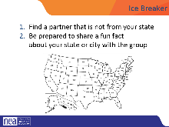 |  | Group introductions  Using the Map, people will introduce their partner with name, their state, and something interesting about their state. Example: state bird! | Who is here?  Participants will begin to develop a learning community.
9:30—9:45 |  | 15 Minutes – Core Values Introduction- Pg 11
Bekah  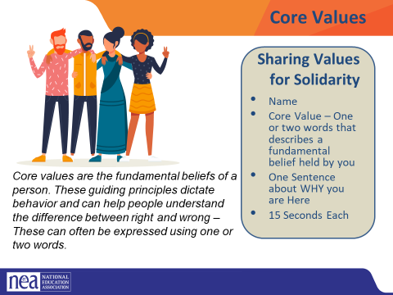 | CORE VALUES CHART  Core Values Handout pg 13  Charting Folks - | Core Value Quick whip intro  Review what a core value is (Core values are the fundamental beliefs of a person. These guiding principles dictate behavior and can help people understand the difference between right and wrong – one or two words) These can often be expressed as one or two words, WE are taking a moment to consider our core values because they can provide a basis for solidarity in the midst of struggles.  Have participants go to the handout, and take five minutes to list a number of their core values in the one or two word format.  Next ask participants to introduce themselves:  - By saying their name and a core value –  - One word or two that describes a fundamental belief held by you – start the chart with yours (ex. Solidarity) - you and your partners will chart the core values only as they are shared – Use two charts and two recorders so that it can move quickly. (15 seconds per person INCLUDE THE PRESENTERS)  A copy of this can be found on your handouts.  Key Ideas for Debrief  Shared Core Values are critical for building solidarity in our work.  IDEALLY -Unions advance the welfare of all workers. They are based on the idea of justice, progress, and betterment of self and of society. They embody the universal ideal of human rights and the need to aspire to become more complete human beings. By becoming an active participant in the labor movement, members become part of something larger than themselves. | Why do I do this work?  Participants will reflect on their own core values and how those are related to union and justice seeking values that build solidarity.
9:45 -10:10 |  | 20 Minutes - Shared Identity Activity
Ben  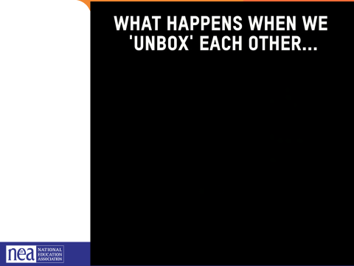  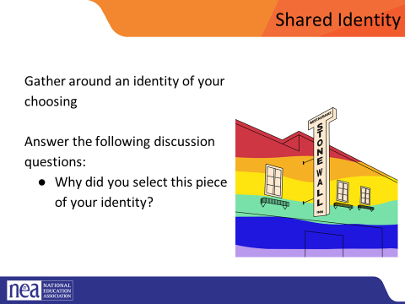  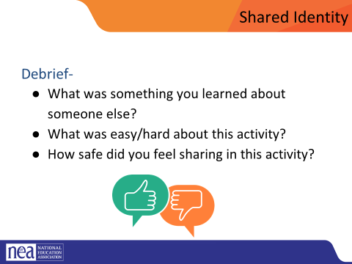  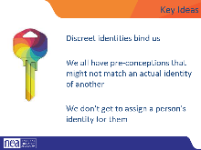 | Unboxing video  Signs that we need  Low Risk Labels  musician, traveler, foodie, planner, nature lover, indoor person pet owner/Animal Lover | Post the following identities around the room: (we are only using day one labels today)  - Low risk (day 1) - musician, traveler, foodie, planner, nature lover, indoor person pet owner/Animal Lover  - Medium risk (day 2) – parent, only child, has siblings, struggles with technology, tech is easy, life-long learner  - High risk (day 3) – religious, spiritual, agnostic, immigrant, LGBTQ+, in recovery/survivor, nontraditional family  We are going to explore our identities. Identities are personal and only we know what they are. Let's watch this video that shows what happens when we unbox each other.  Show the video what happens when we unbox each other video as an introduction to what we are going to do  Participants will get up and gather around an identity of their choosing. Everyone needs to make a choice that makes sense for them (2 min instructions), then they will answer the following discussion questions (8 min):  - Why did you select this piece of your identity?  - What are some challenges you face with this identity?  Share out/debrief (5 min)  - What was something you learned about someone else  - What was easy/hard about this activity?  - Which of these identities are internal vs external?  If additional time, consider having folks go to another poster, share if there were multiple possibilities, why they chose that one, or the one most unlike you and discuss.  Possible Key Ideas for these on each day  - Identity is a socially and historically constructed concept. We learn about our own identity and the identity of others through interactions with family, peers, organizations, institutions, media and other connections we make in our everyday life.  - Key facets of identity—like gender, social class, age, sexual orientation, race and ethnicity, religion, age and disability—play significant roles in determining how we understand and experience the world, as well as shaping the types of opportunities and challenges we face.  - Social and cultural identity is inextricably linked to issues of power, value systems, and ideology.  - Discrete identities bind us | How do I think about my identity?  Participants will deepen their understanding of identity and how this informs their relationship with privileges and oppression.
10:10 - 10:25 BREAK
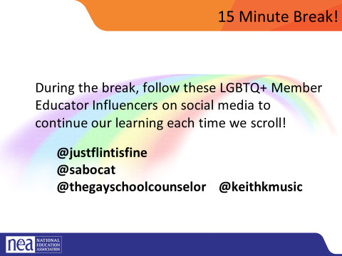
10:25 -10:55 |  | “I am” Identity poem (30 minutes)
Michelle  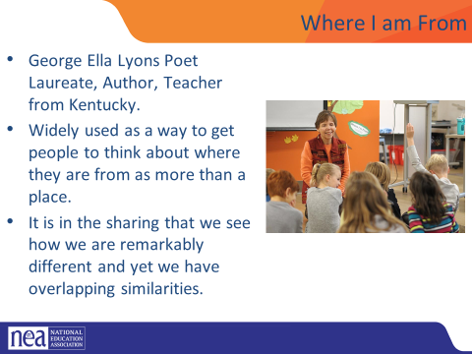    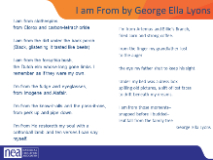  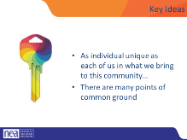 | “I Am” Identity Poem Handout  I am poem video  Pg. 14 | We are going to be writing a poem that has been widely used to help people understand the differences and similarities that exist within a group.  George Ella Lyons Poet Laureate, Author, Teacher from Kentucky.  Widely used as a way to get people to think about where they are from as more than a place.  It is in the sharing that we see how we are remarkably different and yet we have overlapping similarities. We need TWO voices to read this.  Show Video of Kenneth  Share reading of I Am From (George Ella Lyon)  I am from clothespins,  from Clorox and carbon-tetrachloride  I am from the dirt under the back porch  (Black, glistening  it tasted like beets)  I am from the forsythia bush,  the Dutch elm  whose long gone limbs I remember  as if they were my own.  I’m from the fudge and eyeglasses,  from Imogene and Alafair.  I’m from the know-it-alls  and the pass-it-ons,  from perk up and pipe down.  I’m from He restoreth my soul  with a cottonball lamb  and ten verses I can say myself.  I’m from Artemus and Billie’s Branch,  fried corn and strong coffee.  from the finger my grandfather lost  to the auger  the eye my father shut to keep his sight.  Under my bed was a dress box  spilling old pictures,  a sift of lost faces  to drift beneath my dreams.  I am from those moments–  snapped before I budded–  leaf-fall from the family tree  Directions  Participant will have 15 minutes to work on their poems individually, 10 minutes to share in small groups and then 3 will volunteer or be selected to share with the whole group.  Key Ideas  - We are all individuals with unique sets of experiences and yet...  - There are many points of common ground | What do I share about who I am?  Participants will develop a sense of community, shared experiences, in preparation for more difficult content.
10:55-11:25 |  | First Impressions of LGBTQ+ from Safe zone (30 minutes)
Barb  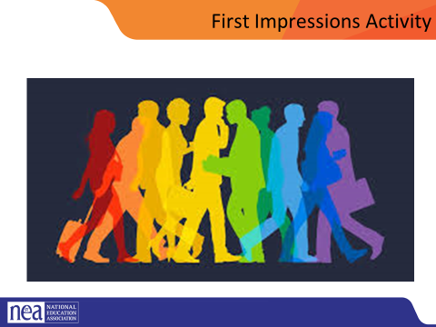  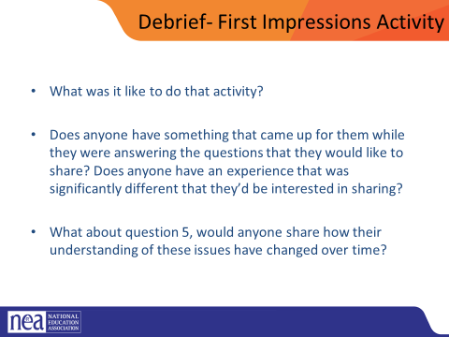  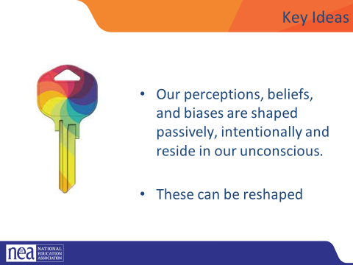 | First impressions handout  www.TheSafeZoneProject.com  Pg 17  p.15 | Provide directions for the activity and assure participants that this activity is primarily reflective and they won’t be asked to share anything they don’t want to. For example, “We are going to start with a reflective activity called First Impressions. We’re going to give you a few minutes to think about and write some answers to the list of questions on this sheet. These questions are for your reflection, we aren’t going to collect your sheets or require you to share anything with the group that you don’t want to. If there is any question you’re struggling with skip it and come back at the end of the activity. We’ll give you a few minutes here to answer the questions and then bring it back to the big group.”  HANDOUT QUESTIONS: (10-15 minutes)  Answer the following questions to the best of your ability:  1. When’s the first time you can remember learning that some people are lesbian, gay, bisexual, or queer?  2. Where did most of the influence of your initial impressions/understanding of lesbian, gay, bisexual, and queer people come from? (e.g., family, friends, television, books, news, church)  3. When’s the first time you can remember learning that some people are transgender?  4. Where did most of the influence of your initial impressions/understanding of transgender people come from? (e.g., family, friends, television, books, news, church)  5. How have your impressions/understanding of LGBTQ (lesbian, gay, bisexual, transgender, and queer/questioning) people changed or evolved throughout your life?  Debrief (10- 15 minutes)  What was it like to do that activity?  Does anyone have something that came up for them while they were answering the questions that they would like to share?  Does anyone have an experience that was significantly different that they’d be interested in sharing?  What about question 5, would anyone share how their understanding of these issues have changed over time?  Key Ideas  - Our perceptions, beliefs, and biases are shaped passively, intentionally and reside in our unconscious.  - These can be reshaped | What are my perceptions of others? Have they changed over time?  Participants will reflect upon their first impressions with LGBTQ people and identity.  Participants will reflect on how their understanding of LGBTQ people and identity has changed  over their lifetime.  Participants will have an opportunity to hear how diverse the group’s experience with LGBTQ  people and identity are.
11:25-12:00 |  | The Arc of LGBTQ+ Oppression and Justice in Time (30 mins)
Natasha  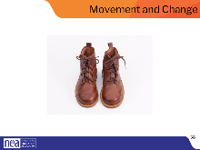  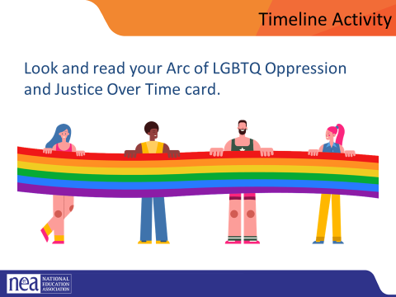  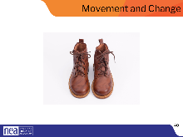 | LGBTQ-History-Cards.pdf (glsen.org)  LGBTQ-History-Timeline-References.pdf (glsen.org)  LGBTQ-History-Timeline-Lesson.pdf (glsen.org)  Resources for history and timelines: LGBTQ Rights Timeline in American History » Teaching LGBTQ History | 5 minutes - Opening Activity- Switch shoes!  Ask each participant to switch their left and right shoes (left shoe on the right foot, right shoe on the left foot). Say it’s part of the training, and then move on. DO NOT mention their shoes further. (The objective is that participants will experience a familiar but uncomfortable sensation that their shoes are on the opposite foot. This will help them experience, in a non-threatening way, the uncomfortable, awkward feelings or fear that transgender or gender non-conforming people may experience while they are in public.)  10 minutes of prep and participant movement - You are going to build a timeline circle. The earliest date and latest date will be standing side by side – and the rest of you will be place yourself in chronological order around the circle. (Facilitator note – it would be easiest for the facilitator to have the 1620 card and use that to model how to present, it also gives a point for participants to join the circle. On your tables you will find a some random cards. Select one and work to get in chronological order on the circle. Once we do that I will give you a new direction.  (15 minutes) of report out. Each person is going to share the event on their card along with their name and the state that they are from.  We are going to have a good discussion of this following lunch – and while you go to lunch be thinking about the following:  Why are we incorporating history into this training?  Why do you think we asked you to switch shoes?  You can switch back your shoes! | What is the history of LGBTQ?  What do I need to know about the history?  Participants will understand the systemic development of oppressions against the LGBTQ+ community and the points where those oppressions are challenged or dismantled.
12:00 to 1:00 LUNCH

1:00-1:30 |  | 30 Minutes - Timeline and Shoe Switch Debrief
Bekah  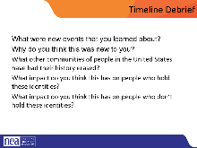  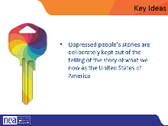  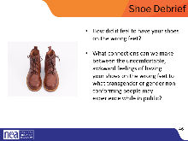  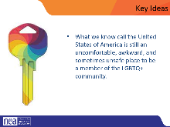 |  | Timeline Debrief: What were new events that you learned about? Why do you think this was new to you? What other communities of people in the United States have had their history erased? What impact do you think this has on people who hold these identities? What impact do you think this has on people who don’t hold these identities?  What did it feel like to switch your shoes? What was your experience with switching them? Why do you think we asked you to do this activity? (The objective is that participants will experience a familiar but uncomfortable sensation that their shoes are on the opposite foot. This will help them experience, in a non-threatening way, the uncomfortable, awkward feelings or fear that transgender or gender non-conforming people may experience while they are in public.)  KEY IDEAS:  Oppressed people’s stories are deliberately kept out of the telling of the story of what we now as the United States of America.  Shoe debrief (15 minutes)  Ask participants to focus on their feet. How has it felt to have their shoes on the wrong feet during today’s session? What connections can they make between the uncomfortable, awkward feelings of having their shoes on the wrong feet to what transgender or gender non-conforming people may experience while in public?  it’s important to note that trans visibility does not equal the advancement of transgender rights, or progress for transgender people. The goal is liberation. Our hope is that with what we’ve learned today, that you too will be an advocate for trans educators across all our schools and districts.  Key Ideas  What we know call the United States of America is still an uncomfortable, awkward, and sometimes unsafe place to be a member of the LGBTQIA community. | What understanding do I need to know from learning history?  Participants will explore what it feels like to be awkward, uncomfortable and unsafe.
1:30-2:05 |  | Terminology Activity (35 minutes)
Grat and Michelle  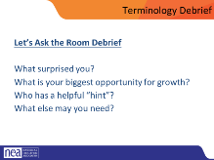  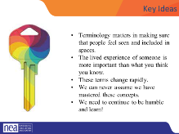 | Terminology Handout | Terminology Activity (20 minutes)  5 minutes—turn and talk:  Before you arrived, we asked you to review the terminology handout and mark down which terms you know well, which terms you ahve questions about, and which you don’t know at all. Using the collective knowledge at your table, become more comfortable with the terms you have questions about. You will have five minutes to have this conversation.  15 minutes—Large Group:  Which words do you still have questions about? Facilitators will help to large group answer questions. Remember: when there is dissent about the terminology—fall back on the idea that these are vetted NEA/HRC definitions that are meant to work professionally and may not reflect the personal life or experiences of unique individuals.  Language in the LGBTQ+ communities changes very quickly. Language in ethnic communities' changes about every ten years while language in the LGBTQ+ communities changes about every two years.  What makes a word a slur? (10 minutes)  Individuals get to ID what makes it a slur  If privileged folks use it to injure others. Targeted group gets to identify slurs not privileged folks (generally). Make sure to bring up “queer” specifically.  Tonight/tomorrow--on Gayborhood tour: there may be folks who use terminology that makes you feel some type of way. We will offer the grace that people are using terminology that empowers them and they are not trying to bring you down or make you uncomfortable.  Don’t get FQD up—these three words are being reclaimed. Let’s respect that if we hear it.  LGBTQ+ Terminology Debrief (5 minutes)  - Which of these surprised you?  Which of these terms do you find difficult or confusing to use correctly/implement? Where do you have the most opportunity for growth? What else do you need? (Do others share this same struggle? What hints/tricks do we have for working through that?)  For Example: GLSEN gay straight alliance is now gender sexuality alliances  Key Ideas:  Terminology matters in making sure that people feel seen and included in spaces. The lived experience of someone is more important than what you think you know. These terms change rapidly. We can never assume we have mastered these concepts. We need to continue to be humble and learn! ￼ | What vocabulary do I need to know? How does language change over time? How does this affect me and my work?  Participants will explore through a variety of small and large group experiences the foundational vocabulary to understand the LGBTQ community.
2:05-2:20 BREAK
2:20-2:40 |  | Introduction of Transgender Umbrella (20 minutes)
Jeny  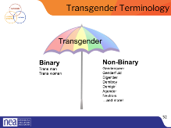  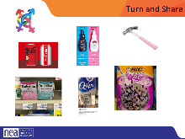  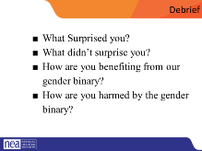  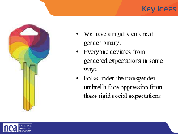 |  | Trans men and trans women are men or women- don’t need the trans as a choice!- or reason to be asking for it- as if tracking it for demographic purposes  Transgender/Trans: This is an umbrella term for people whose gender identity and/or expression is different from cultural expectations based on the sex they were assigned at birth. Being transgender does not imply any specific sexual orientation. Both binary and non-binary genders and gender expressions fall under the umbrella.  Often, we hear transphobic comments when the appearance of Black and Brown bodies are compared to white/Eurocentric views of femininity. For example, internet conspiracy theories have long criticized the natural muscular frame of tennis superstar Serena Williams, and even former First Lady Michelle Obama. Obviously, these comparisons are harmful, and are just one example of how hate, prejudice and fear show up.  Activity: Move into new groups Turn and share gendered items (drinks, clothing, appearance) How embedded is binary in society?- ideas: Magazine, advertising, stores  Debrief  What Surprised you? What didn’t surprise you? How are you benefiting from our gender binary? How are you harmed by the gender binary?  Key takeaway- We have a rigidly enforced gender binary. Everyone deviates from gendered expectations in some ways. Folks under the transgender umbrella face oppression from these rigid social expectations  Facilitator note: link between what is said about good/bad and help recognize that the binary actually serves no one  Key points:  We have a rigidly enforced gender binary. Everyone deviates from gendered expectations in some ways. Folks under the transgender umbrella face oppression from these rigid social expectations  Return to original seats | What does it mean to be transgender?  Participants will explore and be able to recognize how the binary presentation of gender is prevalent and normalized.
2:40-3:00 |  | Gender Unicorn Activity (20 minutes) pages 22-23
Jeny & Barb  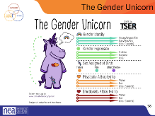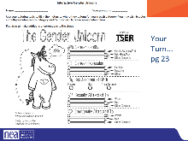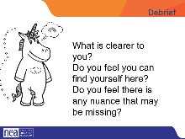  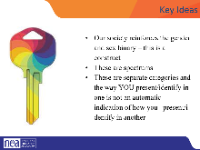 | Gender Unicorn Handout  Gender Unicorn - (transstudent.org)  Pg. 25  Pg. 26 | The Gender Unicorn is a popular way to help explain gender that was developed by Trans Student Educational Resources. You may be familiar with the “Genderbread Person,” but we choose not to use it. The Gender Unicorn was created by a Black trans woman, but the person who promoted the Genderbread Person popularized it, and continues to get credit, pay and notoriety for it.  As you see, the Gender Unicorn highlights gender identity, expression, sex assigned at birth, and physical and emotional attraction.  Children most often learn that there are two groups—boys and girls—and that they fit into one or the other based on how their bodies are made. They are then socialized to accept specific gender norms and stereotypes, which are ways of behaving, based on this gender assigned at birth. (May want to offer examples from previous exercises to make connection as “behavior.”)  There’s increasing understanding that gender is more than a binary division. The spectrum of gender identity is becoming more widely accepted and gender expression is more expansive. (Note that in each category — other than “assigned at birth,” the category imposed by someone other than the self—the gender unicorn has a “ball” that can slide like a sliding scale.)  However, there are challenges to looking at gender beyond male and female and not just the challenges we all personally face as we grow in our understanding of ourselves and others. Across states, many laws and policies are being passed that affirm or harm individuals outside of the gender binary.  Gender Unicorn Activity- Go through the colorless unicorn and describe how to color it in  Participants fill out their Unicorn then ask the following questions-  1. Share your takeaways about gender identity, gender expression, and physical and emotional attraction.  What is clearer to you?  Do you feel you can find yourself here?  Do you feel there is any nuance that may be missing? | What does gender actually mean?  Participants will engage with five aspects of gender – assignment at birth, identity, expression, physical attraction, and emotional attraction.
3:00-3:15 |  | Pronoun Practice Exercise (15 minutes)
Ben | Pg 4-5  NEA handouts  GLSEN Handout on Pronouns as an overview resource – not as an activity | Everyone thinks of a story about your best friend. Something silly, funny, endearing. Find a partner. Tell the story of your friend. USE They/them pronouns. The listener’s job is to correct any time a binary pronoun is used.  Key Ideas:  - Using someone’s correct pronouns is an important way to show respect.  - It is on us to get good at this.  - Using someone’s name or neutral pronouns is the most respectful approach if you don’t know. | What is the right way to use pronouns?  Participants will practice the use of gender neutral pronouns.
3:15-3:50 |  | Contract Activity (35 Mins)
 | Contract and Policy Language Activity | Count off by FIVE (can be more if the group is large—then double up some of the larger examples).  Number of group corresponds with exercise. People take 15 minutes to look at the language in front of them and work to identify the problem with it and figure out how to revise it to be more inclusive. They should also think about what barriers may exist to making the changes.  Pick a person to do a three minute share out of work done.  Key Points:  Using language that is inclusive in our contracts and policies is one small way of moving towards LGBTQ+ equity.  When we know better we need to do better.  Barriers may include our members—we need to be willing to introduce the conversation.
3:50- 4:30 |  | Closing/Wrap up
Ellen |  | How does YOUR learning from today inform your work with members? How might we inadvertently cause well-intentioned harm?  How can we prevent that?  Open Questions  Added Information  Evening Email  Feedback Forms  Any Logistics for Next Day  Vouchers and Travel | What do I think about today?  What am I doing tomorrow?  Participants will engage in some reflection and closing activities.
4:30 – 5:00 |  | Choice Networking Time
5:00 ADJOURN

