Advancing LGBTQ+ Justice Agenda: Day # 1
General Materials Needed: |  |  |  |  |  | Room Set-up:
1 Set of Handouts per Person  Chart Markers – non-permanent |  |  | Chart Paper  Post its |  |  | Round Tables  Projector, Screen and Speakers  Carousel stations and reporting stations around the perimeter  50 people

Key Outcomes for the Day
  - Starting the conversation outside the umbrella
  - Issues
  - Framework for Determining Actions
  - A Little Law Talk
  - Lessons Learned and Actions to Apply
Time |  | Essential Questions |  | Resources | Instructions, Activity and Debrief (Facilitators) |  | Outcomes
90- Minutes Total | What question(s) should this learning section answer? |  |  | Charts, handouts, articles, materials, slide | What are you saying, what are they doing, what questions will you use to guide learning and make clear the important points  Include an estimate for how long each section of the learning will take |  | As a result of this section of learning, what will participants know or be able to do?
15 Minutes Facilitator  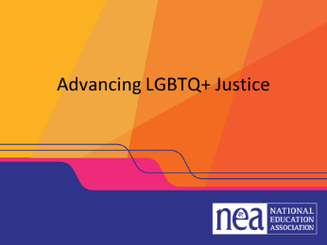  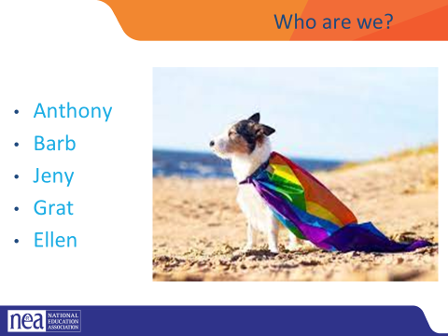  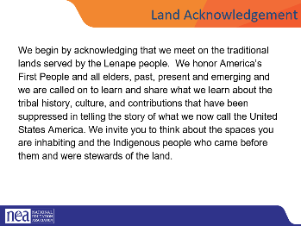  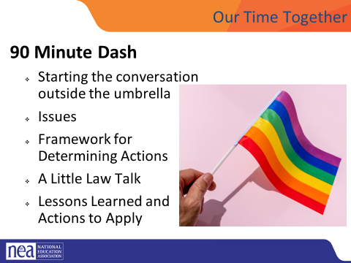  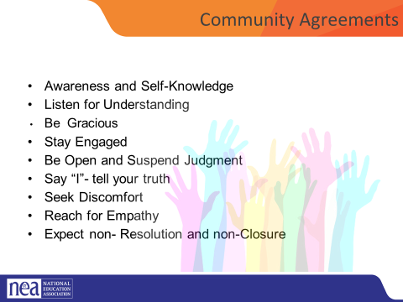  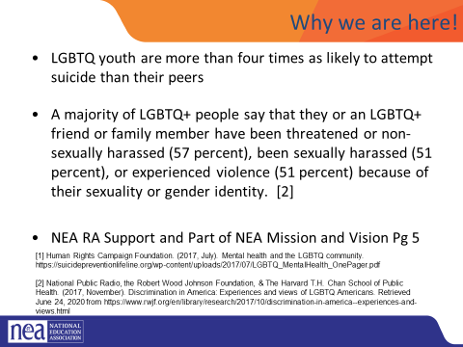  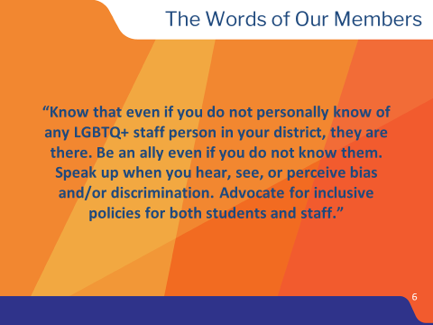  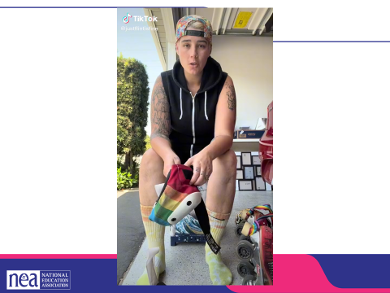  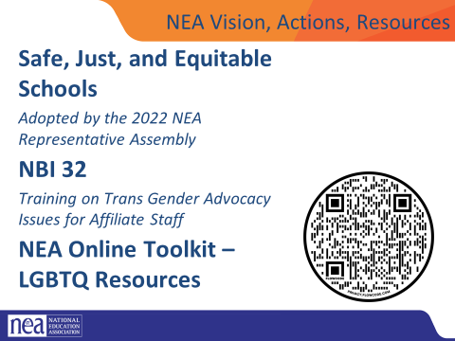 | Who am I? Who are we together? |  |  | Community Agreements | 15 Minutes Getting Started  General Welcome  Intro of Facilitators  Quick Intro – 15 Seconds Each  Name, Pronouns, Title  Land Acknowledgment - We begin by acknowledging that we meet on the traditional lands served by the XXXXXXX people. We honor these People, all elders, past, present and emerging and we are called on to learn and share what we learn about the tribal history, culture, and contributions that have been suppressed in telling the story of what we now call the United States America. We invite you to think about the spaces you are inhabiting and the Indigenous people who came before them and were stewards of the land.  Overview of Agenda – 90 Minute Dash  - Starting the conversation outside the umbrella  - Issues  - Framework for Determining Actions  - A Little Law Talk  - Lessons Learned and Actions to Apply  Community Agreement Review  - Using Self-Awareness and Self-Knowledge  - Listening for Understanding  - Being Gracious  - Staying Engaged  - Being Open and Suspend Judgment  - Saying “I”- tell your truth  - Seeking Discomfort  - Reaching Empathy  - Expecting Non-Resolution and Non-Closure  Why We are Here  Why are we here – the system of oppression’s outcomes on the the LGBTQ+ community are something that justice seeking people can not tolerate.  In the words of our members – show slide  TIK TOK VIDEO SLIDE  NEA Vision, Actions, Resources |  | Participants will understand how the entire program flows.
15 Minutes Facilitator  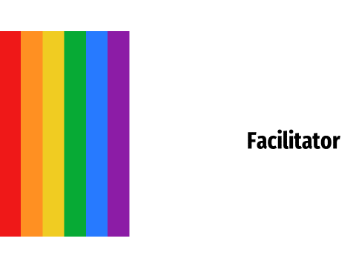  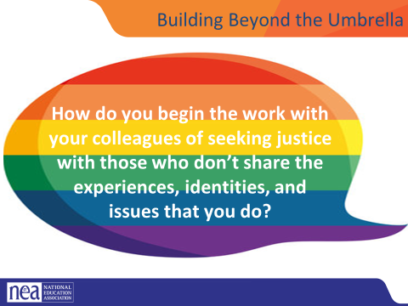  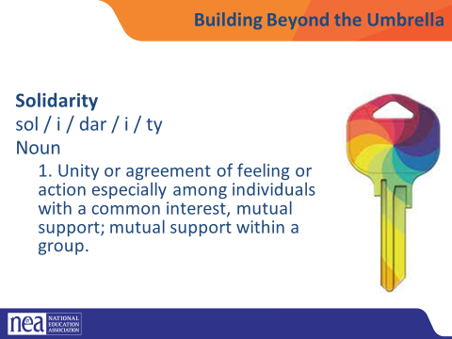  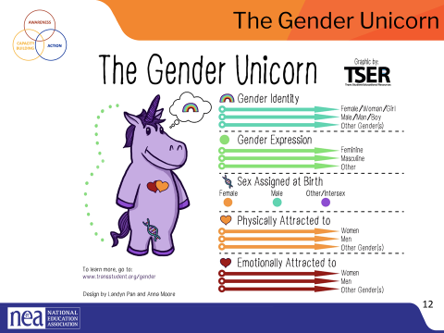  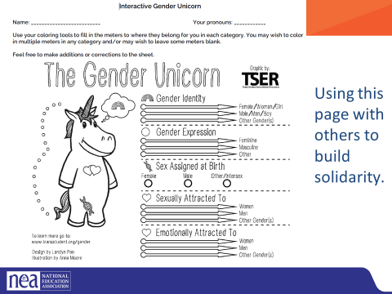  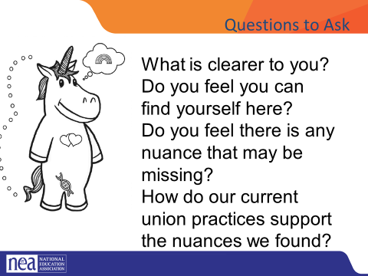  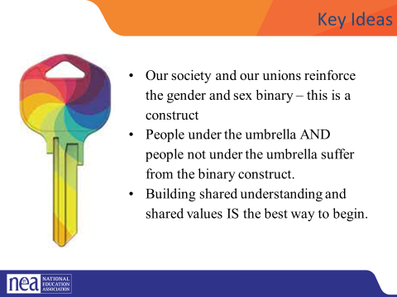 | How do I start organizing for change with someone that is not yet a supporter of my issues? |  |  | Gender Unicorn Handouts | 15 Minutes Building Beyond the Umbrella  Show this question :  How do you How do you begin the work with your colleagues of seeking justice with those who don’t share the experiences, identities, and issues that you do?  Union members, leaders, and staff know the word solidarity – but let’s review what it means  Unity or agreement of feeling or action especially among individuals with a common interest, mutual support; mutual support within a group.  If we are going to achieve justice for all the various constituencies within our unions, schools, and communities we have to build across these – looking for ways to empathize and understand the experiences and issues of others. Intentionally looking for issues that we have common interests in. That often begins by reaching out to those not under the LGBTQ umbrella and cultivating their support and allyship.  A tool that I have used in this way is the Gender Unicorn. The Gender Unicorn is a popular way to help explain gender that was developed by Trans Student Educational Resources. You may be familiar with the “Genderbread Person,” but we choose not to use it. It was created by a Black trans woman, but someone else popularized it, and continues to get credit, pay and notoriety for it.  As you see, the Gender Unicorn highlights gender identity, expression, sex assigned at birth, and physical and emotional attraction.  Children most often learn that there are two groups—boys and girls—and that they fit into one or the other based on how their bodies are made. They are then socialized to accept specific gender norms and stereotypes, which are ways of behaving, based on this gender assigned at birth. (May want to offer examples from previous exercises to make connection as “behavior.”)  There’s increasing understanding that gender is more than a binary division. The spectrum of gender identity is becoming more widely accepted and gender expression is more expansive. (Note that in each category — other than “assigned at birth,” the category imposed by someone other than the self—the gender unicorn has a “ball” that can slide like a sliding scale.)  However, there are challenges to looking at gender beyond male and female and not just the challenges we all personally face as we grow in our understanding of ourselves and others. Across states, many laws and policies are being passed that affirm or harm individuals outside of the gender binary.  Gender Unicorn Activity- Go through the colorless unicorn and describe how to color it in  Participants fill out their Unicorn then ask the following questions-  1. Share your takeaways about gender identity, gender expression, and physical and emotional attraction.  What is clearer to you?  Do you feel you can find yourself here?  Do you feel there is any nuance that may be missing?  How do our current union practices support the nuances we found?  Link to the Gender Unicorn document: https://transstudent.org/gender/  Key Ideas  - Our society and our unions reinforce the gender and sex binary – this is a construct  - People under the umbrella AND people not under the umbrella suffer from the binary construct.  - Building shared understanding and shared values IS the best way to begin. |  | Participants will familiarize how to use a tool designed to open up conversations and develop understanding of intersections.
30 Minutes Facilitator  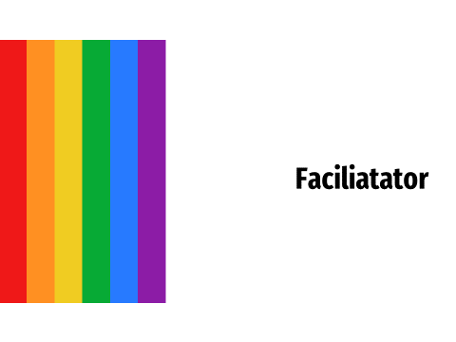  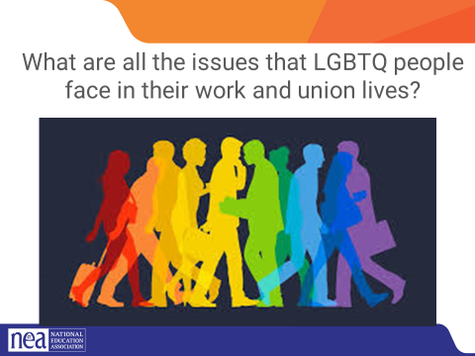  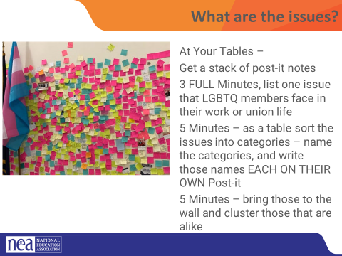  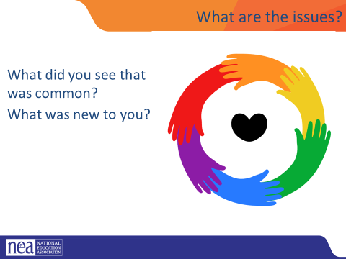  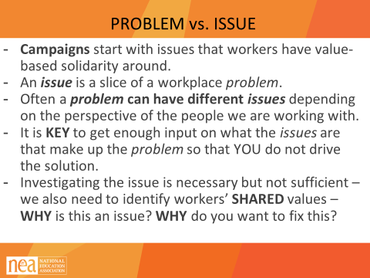  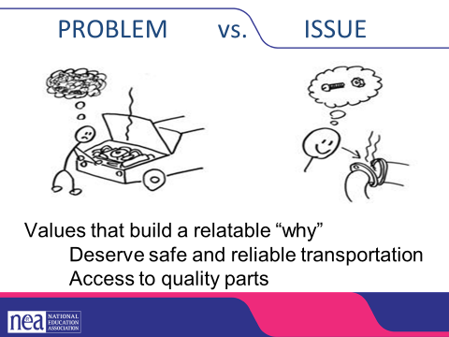  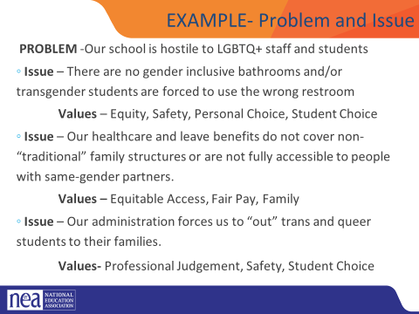  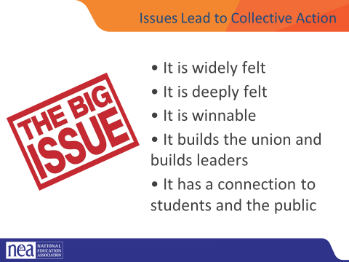  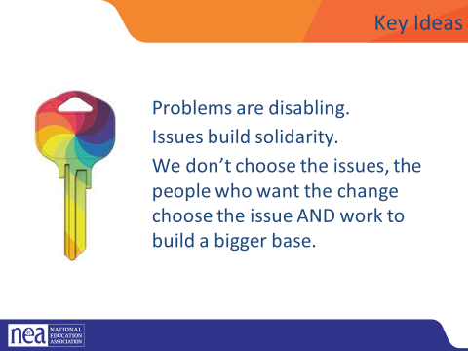 | How do we begin to build a campaign to make the kind of changes that matter in the lives of LGBTQ workers? |  |  | Post It Notes | 30 Minutes What are the Issues?  What are all the issues that LGBTQ people face in their work and union lives?  At Your Tables –  Get a stack of post-it notes  3 FULL Minutes, list one issue that LGBTQ members face in their work or union life  5 Minutes – as a table sort the issues into categories – name the categories, and write those names EACH ON THEIR OWN Post-it  5 Minutes – bring those to the wall and cluster those that are alike  What did you see that was common?  What was new to you?  PROBLEM vs. ISSUE  - Campaigns start with issues members care about.  - An issue is a slice of a workplace problem.  - Often, a problem can have different issues depending on the perspective of the people we are working with.  - It is key to get enough input on what the issues are that make up the problem so that YOU don’t drive the solution.  - A staff-driven solution may not meet the needs and commitment of the people you are working with.  Problems are debilitating and overwhelming, issues build solidarity through shared values.  Examples  How to select an issue  Since there may be many issues confronting workers on the job, we have to also think about what makes a good issue to organize around.  CRITERIA:  - It is widely felt.  - It is deeply felt.  - It is winnable.  - It builds the union and builds leaders.  - It has a connection to students and the public  NOTE HERE: Often, issues of equity are deeply felt by a marginalized few, and NOT by the privileged majority. If an issue is very deeply felt, it does not have to be widely felt.  Key Points  Problems are disabling.  Issues build solidarity.  We don’t choose the issues, the people who want the change choose the issue AND work to build a bigger base. |  | Participants will understand the difference between problem identification and issue statements.
30 Minutes Facilitator  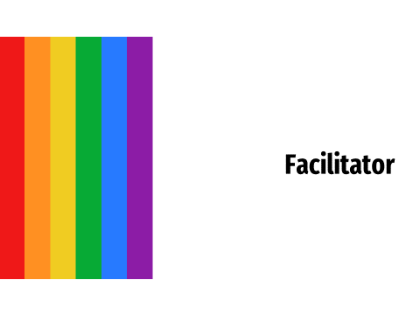  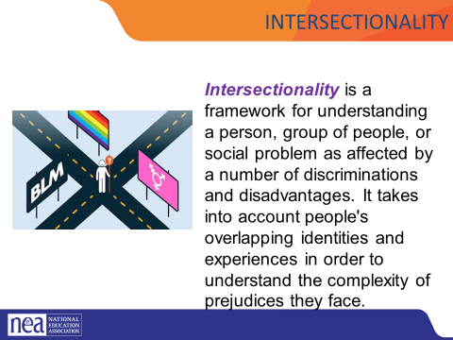  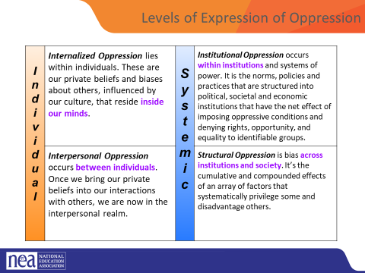  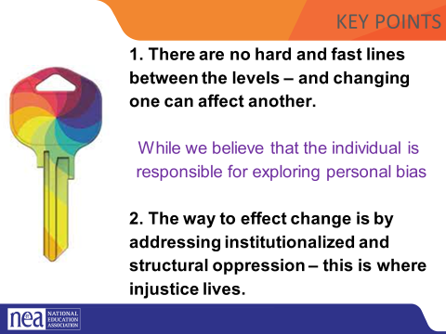  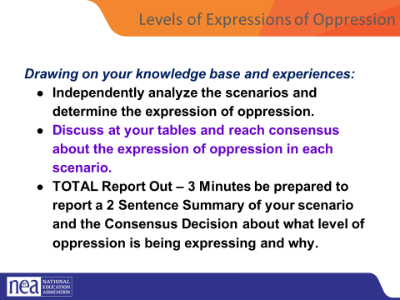  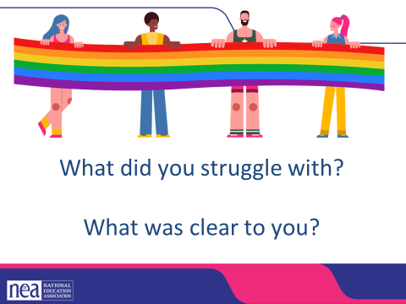  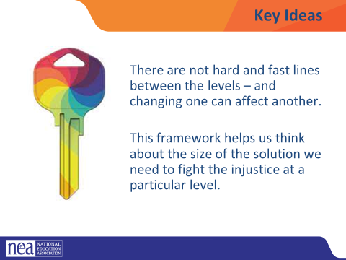 | What are the right size solutions for the level of oppression? |  |  | Levels of Expression Of Oppression Handout | 4 expressions of Oppression and Intersectionality – (45 minutes)  To review Intersectionality is a framework for understanding a person, group of people, or social problem as affected by a number of discriminations and disadvantages. It takes into account people's overlapping identities and experiences in order to understand the complexity of prejudices they face. This is important to keep in mind as we approach our work in supporting individuals experiencing oppression.  Now, let’s define The Levels of Expressions of Oppression. We use this framework because it allows us to think about the scope of the solution to a particular problem.  Internalized oppression lies within individuals. These are our private beliefs and biases about others, influenced by our culture.  Interpersonal Oppression occurs between individuals. Once we bring our private beliefs about differences into our interactions with others, we are now in the interpersonal realm.  Institutional Oppression occurs within institutions and systems of power. It is the norms, policies and practices that are structured into political, societal and economic institutions that have the net effect of imposing oppressive conditions and denying rights, opportunity, and equality to identifiable groups based upon differences.  Structural Racism is bias across institutions and society. It’s the cumulative and compounded effects of an array of factors that systematically privilege white people and disadvantage people of color.  Key point – there are not hard and fast lines between the levels – and changing one can affect another. While we believe that the individual is responsible for exploring personal bias – the way to effect change is by addressing institutionalized and structural racism – this is where injustice lives.  Defining Expressions of Racism Activity - PAGE 28 Use the Handout Levels of Oppression Scenarios had to shorted to 15 minutes  3 minutes form 8 groups. Each group is given a scenario to look at. They are to determine which level of oppression this scenario is about  5 minutes for teams to review scenarios and come up with what level of oppression their scenario is and why. Prepare a summary of your scenario to share with the whole group. Each group will have a total of 3 minutes to share a short summary, provide which level of oppression the scenario exemplifies, and tell why.  20 Mins: Debrief – GIVE a summary of your scenario to share with the whole group. Each group will have a total of 3 minutes to share a short summary, provide which level of oppression the scenario exemplifies, and tell why. what level did your group determine your scenario was at and why?  Overall debrief questions if there is time:  - What did you struggle with? What was Clear to You?  Let’s revisit our key point - there are not hard and fast lines between the levels – and changing one can affect another. While we believe that the individual is responsible for exploring personal bias – the way to effect change is by addressing institutionalized and structural racism – this is where injustice lives.  Also, let’s revisit how using an intersectional lens alongside the understanding of levels of oppression can really help us decide the scope of the solution we need and the power it will take to implement that solution. |  | Participants will learn about a framework of understanding oppression so that they can better identify actions to take in seeking justice.
10 Minutes Facilitator  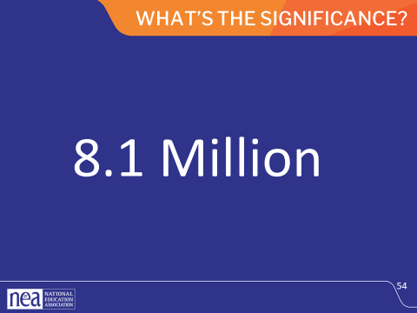  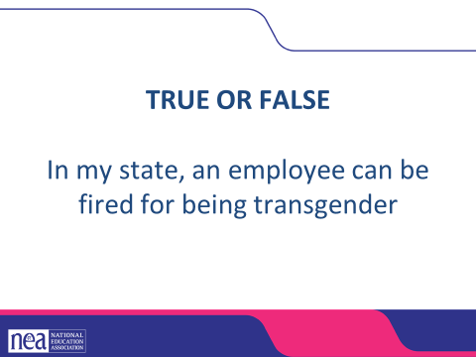  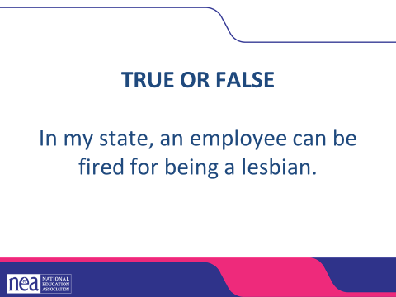  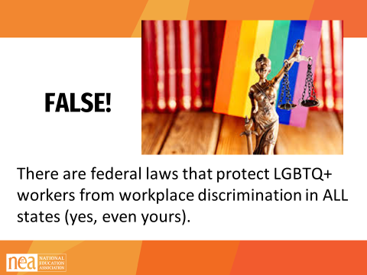  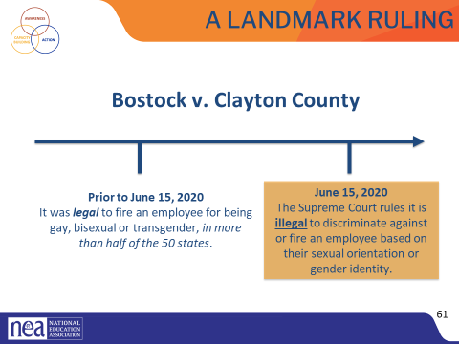  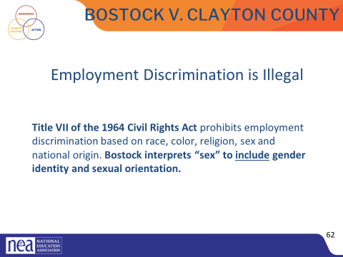  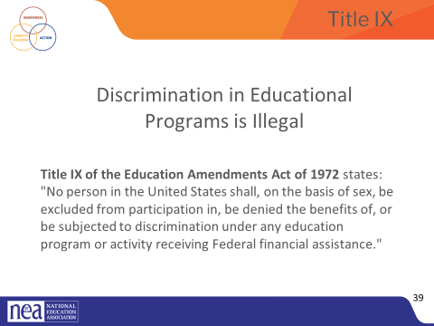  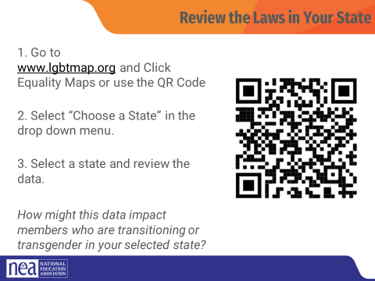  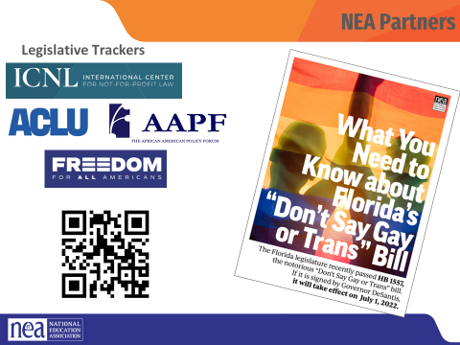  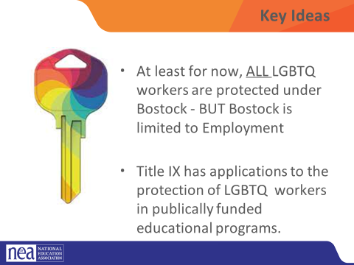 | What are the protections for LGBTQ people? |  |  | Bostock 1 pager  Title IX 1 Pager | Little Legal Overview  In 2019, there were 157 million employees in the US. What do you think this number represents?  According to Catalyst.org, there are an estimated 8.1 million LGBTQ+ employees in the United States who are age 16 or older. 50% of these employees are not out at work because of fears of discrimination or ostracization. And 1 in 5 LGBTQ+ employees have experienced discrimination.  Reference: https://www.catalyst.org/research/lesbian-gay-bisexual-and-transgender-workplace-issu  The Civil Rights Act of 1964 prohibits discrimination based on race, color, religion, sex, or national origin. The courts and the federal government have long refused to recognize LGBTQ+ discrimination as a form of sex discrimination. Over the past 20 years, however, federal courts and the government have at times recognized LGBTQ+ discrimination as sex discrimination.  It was not until June 15, 2020 that the Supreme Court finally recognized that LGBTQ+ employment discrimination is prohibited sex discrimination under Title VII of the Civil Rights Act of 1964.  This ruling recognized that it is illegal to discriminate against or fire an employee based on their sexual orientation or gender identity. Now lower federal courts and the Biden Administration are applying that ruling to education, health care, housing, credit discrimination, and more.  The Bostock ruling specifically states that employment discrimination on the basis of gender identity and sexual orientation is illegal.  Title VII of the Civil Rights Act covers the full spectrum of employment decisions, including recruitment, selections, terminations, and other actions concerning terms and conditions of employment. This is significant for the LGBTQ+ community because, as we saw, in many states it was legal to be denied an interview or a promotion, and even to be fired because of one’s gender identity or sexual orientation.  On March 26, 2021, the Department of Justice concluded that, as a result of the Bostock ruling, Title IX of the Education Amendments Act of 1972 also prohibits sexual-orientation and gender-identity discrimination in educational institutions that receive federal funding. This means all public schools. This means that students cannot be discriminated against in schools based on their LGBTQ+ identity.  There have been some significant wins recently for LGBTQ+ rights in the US But while progress is being made, attacks on LGBTQ+ rights in certain states have accelerated.  Reference: Department of Justice, “Application of Bostock v. Clayton County to Title IX of the Education Amendments of 1972,” March 26, 2021, https://www.justice.gov/crt/page/file/1383026/download  While some schools and districts are implementing gender-affirming policies and practices, like recognizing proper names and pronouns for children, in the background, states are trying to license LGBTQ+ discrimination under the guise of religious freedom. The proposed legislation in these areas, if passed, would serve to limit, further marginalize, and in some cases criminalize efforts to support LGBTQ+ youth and adults.  These attacks on LGBTQ+ people, especially young people, are being challenged in court and should be struck down under the reasoning of Bostock. But those lawsuits are just getting started.  Key Notes  Bostock only applies to employers with more than 15 employees. Employers with fewer than 15 total employees are not covered by Title VII.  Bostock applies nationwide and protects employees from sexual orientation or gender identity discrimination regardless of state or local laws.  An employer covered by Title VII is not allowed to fire, refuse to hire, or take assignments away from someone (or discriminate in any other way) because customers or clients would prefer to work with people who have a different sexual orientation or gender identity. (For example, keeping LGBTQ+ employees out of public-facing positions.)  Although accidental misuse of a transgender employee’s preferred name and pronouns does not violate Title VII, intentionally and repeatedly using the wrong name and pronouns to refer to a transgender employee could contribute to an unlawful hostile work environment.  Look at Your State’s Equality Profile.  How might this impact members who are transitioning or transgender?  Instructions:  Go to www.lgbtqmap.org  Click Equality Maps  Select “Choose a State” in the drop down menu.  Select a state and review the data. How might this data impact members who are transitioning or transgender in your selected state?  The NEA has several resources and recommendations for legislative trackers. (See handout for full list and website links.)  https://www.icnl.org/usprotestlawtracker/  https://www.aclu.org/legislation-affecting-lgbtq-rights-across-country  Key Ideas  - At least for now, ALL LGBTQ workers are protected under Bostock - BUT Bostock is limited to Employment  - Title IX has applications to the protection of LGBTQ workers in publically funded educational programs. |  | Participants will gain an understanding of the legal landscape.
Facilitator 15 Minutes  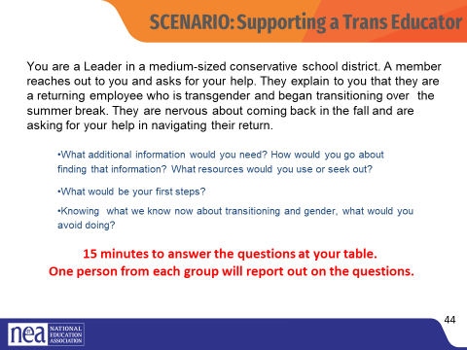  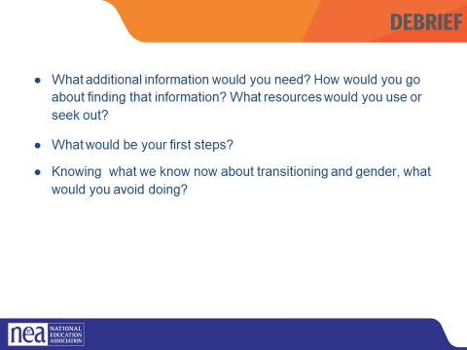  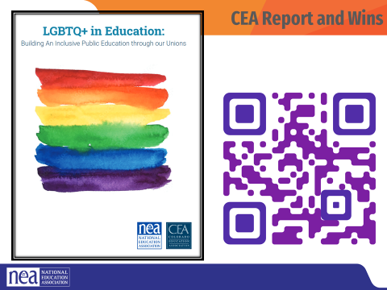 | What can we do when we get back home? |  |  | PG 37 of Handouts  Colorado Policy Guide | What can we do when we go home?  We are now going to apply the information we have learned over the last day and a half to a scenario about supporting a transitioning educator in our roles as leaders. You will discuss the scenario with the people at your table and answer the questions.  Transition in different ways in different places.  A reminder- EVERY EDUCATOR HAS THE LEGAL RIGHT TO TRANSITION AT WORK UNDER BOSTOCK. Your job is to make a plan to help this educator exercise their legal right!  Debrief- page 37- some questions you could use.  - Have each group report on the three questions.  - Things to push back on  - Incorrect or inappropriate language  - Inappropriate lines of questions to the member  - Any suggestion that the UD would challenge or discourage the member from transitioning  The Colorado Education Association intentionally worked on the inclusion of LGBTQ people in leadership roles, in policies, and in practices of their union. This brief highlights both the findings and the recommendations. Any number of these are replicable and applicable in your union work. |  | Participants will explore the suggestions provided in the Colorado Brief.  Participants will do a quick reflect on what they are likely to do as a result of this session.
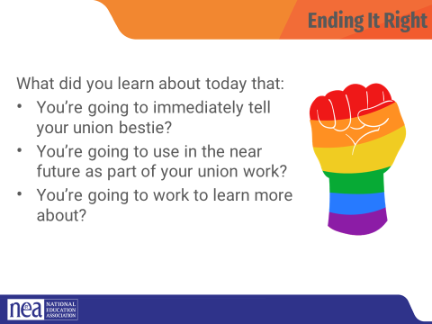  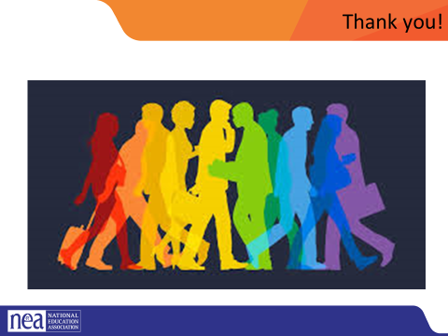 |  |  |  |  | Ending Right  What did you learn about today that:  - You’re going to immediately tell your union bestie?  - You’re going to use in the near future as part of your union work?  - You’re going to work to learn more about?
ADJOURN

