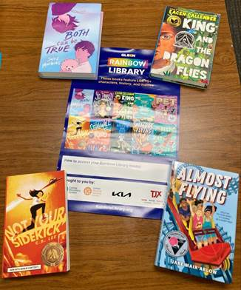
Rainbow Library

UniServ Director
Specific Link:

Request a FREE set of LGBTQ+ affirming K-12 books!

GLSEN is sending LGBTQ+ affirming text sets to over 2,300 schools in 31 states in the 2023-2024 school year. NEA UniServ Directors are also eligible to request Rainbow Library sets! There are four grade-range options: K-2, 3-5, 6-8, or 9-12.

LGBTQ+ students at schools with an LGBTQ+ inclusive curriculum, which includes LGBTQ+ affirming books, have higher GPAs, are less likely to hear anti-LGBTQ remarks at school, and are less likely to report missing school due to feeling unsafe. Students also have a constitutional right to read these books. Founded in 2019, GLSEN’s Rainbow Library Program has been featured in School Library Journal, District Administration Magazine, and has won a commendation award from the American Association of School Librarians. Over 5,800 elementary, middle, and high schools have already received Rainbow Library sets. Rainbow Library books are selected by a committee of experienced educators, librarians, and students. These texts are award-winning, grade-aligned, and all received positive reviews from major literary journals. Resources are limited and will be prioritized in part on a first come, first served basis. Learn more at rainbowlibrary.org.

Note: UniServ Directors should submit their requests through the UniServ-specific link, not the request form on the Rainbow Library website.
UniServ Director Specific Link: Request a FREE set of LGBTQ+ affirming K-12 books!

Michael Rady, Ed.M
michael.rady@glsen.org
Pronouns: he/him/his
Senior Education Programs Manager
GLSEN

Farris Steele
farris.steele@glsen.org
Pronouns: All
Education Associate
GLSEN

