Problems vs. Issues:
Problems are statements of the world as it is. “Our school isn’t a safe space for members of the LGBTQ+ community.”
Issues are a diagnosis of the problem that almost indicates what the solution is. “Our curriculum does not include LGBTQ+ histories or heroes.”

Take some time to first brainstorm the pain and/or problems our people are feeling. Then work to identify the issues within that problem that are causing the pain. Asking, “why do you think this is the way it is?” can move you into an analysis of issues that make up the problem.
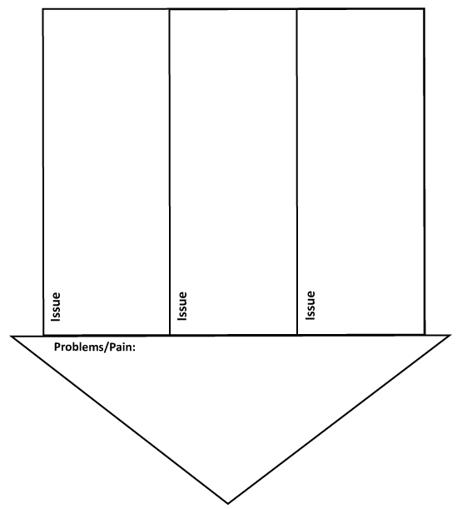
Problem/Pain
Issue Criteria Check List:

Score each Issue from 1 to 3 (1 = No, 2 = Unsure, 3 = Yes) on the specific criteria then total your scores and compare with your team.

Will the Issue… | Issue #1 | Issue #2 | Issue #3
1. Result in a real improvement in people’s lives?
2. Give people a sense of their own power?
3. Alter the relations of power?
4. Be worthwhile?
5. Be winnable?
6. Be widely felt?
7. Be deeply felt?
8. Be easy to understand?
9. Have a clear target?
10. Have a clear timeframe that works for you?
11. Be non-divisive?
12. Build leadership?
13. Set your organization up for the next campaign?
14. Increase membership?
15. Be consistent with your values and vision?
16.
TOTALS

