Speak Up / Speak Out Pre-Conference Facilitator Agenda
General Materials Needed: |  |  |  | Room Set-up:
1 Set of Handouts per Person  Name Tents with the Norms  Room signs,  One ream of white photocopy paper  Chart Paper (4 to 5 full w Sticky Strip) |  | Materials Box for each table with:  Markers (Mr. Sketch variety)  Post its – 3x3” and 4X5” sizes  Index Cards  Highlighters – 4 colors  Pens and Pencils  Participant “toys” |  | Long Rectangle table at back for facilitators  Round Tables for participants  Projector, Screen, mics, and Speakers  Carousel stations and reporting stations  No podium, table with projector big enough for laptop  50 people max
Key Outcomes for the Event:
Participants will be able to develop a long-term campaign
Participants can apply methods of issue identification, tactic design, and strategically escalate to win a demand
Participants will be able to apply a race, class, and gender lens

Overview of Content, Time, and Facilitator Assignment (Total 290 Mins)
9:00 – 9:30 Core Values (30 mins)  9:30 – 9:45 Highest Hopes (15 mins)  9:45 – 10:30 Three Theories and Leaders (45 mins)  10:30 – 10:45 Break (15 mins)  10:45-10:55: NEA Zoom  10:55 - 11:30: Organizing, Power, Campaigns (35 mins)  11:30 – 11:45 Building a Campaign (15 mins)  11:45 – 12:00 Problem, Issues, Values Pt 1. (15 mins)  12:00 – 1:00 Lunch (60 mins) | Linda/Albert  Matt  Linda  Matt  Albert  Linda |  | 1:00 – 1:15 Problem, Issues, Values Pt 1. (15 mins)  1:15-1:30 – Targets and Demands (15 Mins)  1:30-1:50 - Spectrum of Allies (20 mins)  1:50-2:05 – Strategy and Tactics (15 mins)  2:05-2:20 – Compression and Escalation (15 mins)  2:20 – 2:30 – Group Work Explanation  2:30 – 2:45 – Break  2:45 – 3:15 – Campaign Planning  3:15-3:25 – Presentation  3:25 –3:30 - Closing |  | Albert  Matt  Albert  Linda  Albert/Matt  Albert/Matt  Linda/Matt/Albert  Linda/Matt/Albert  Linda/Matt/Albert
Handouts Needed
Pre Attendance Handouts– Community Agreements - Core Values – What is a campaign
Participant Handouts – Community Agreements, Core Values, Three theories of Change, Campaign Plan Packet, Race Class and Gender Tool, Spectrum of Allies Tool Add Power Analysis Questions to Campaign Planning

Time Slides Facilitator | Resources | Instructions, Activity and Debrief (Facilitators) | Essential Questions and Outcomes
 | Charts, handouts, articles, materials, slide | What are you saying, what are they doing, what questions will you use to guide learning and make clear the important points  Include an estimate for how long each section of the learning will take | What question(s) will this learning answer? What will participants know or be able to do?
9:00 – 9:30 Linda/Albert |  | 30 Minutes TOTAL Getting Started and Community Agreements
Linda  5 minutes in this section  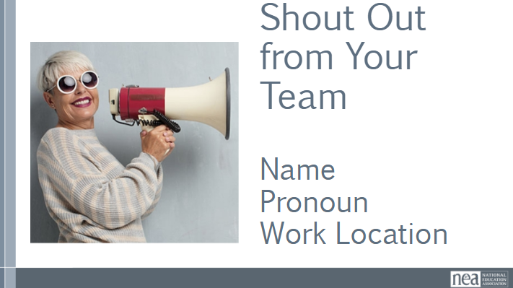  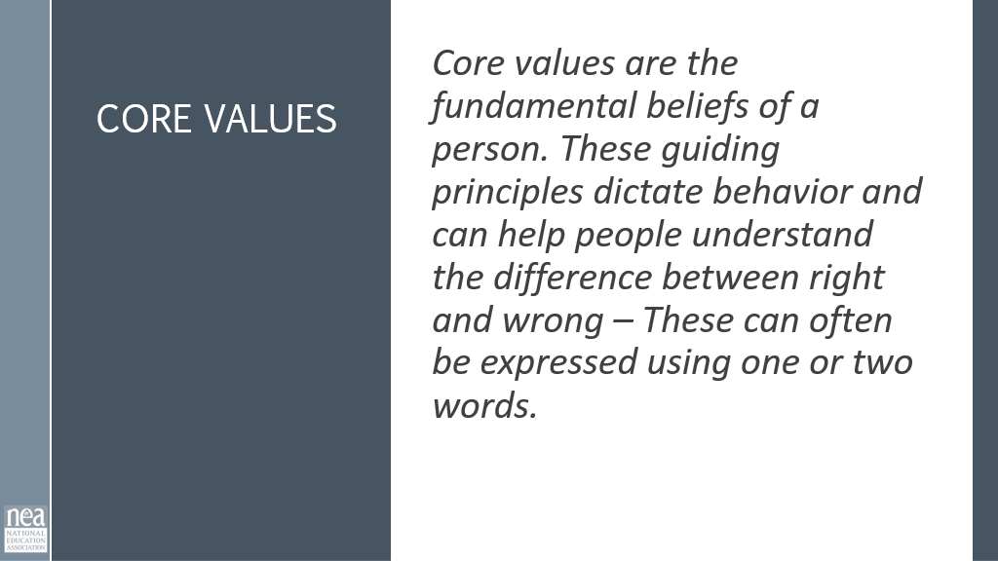  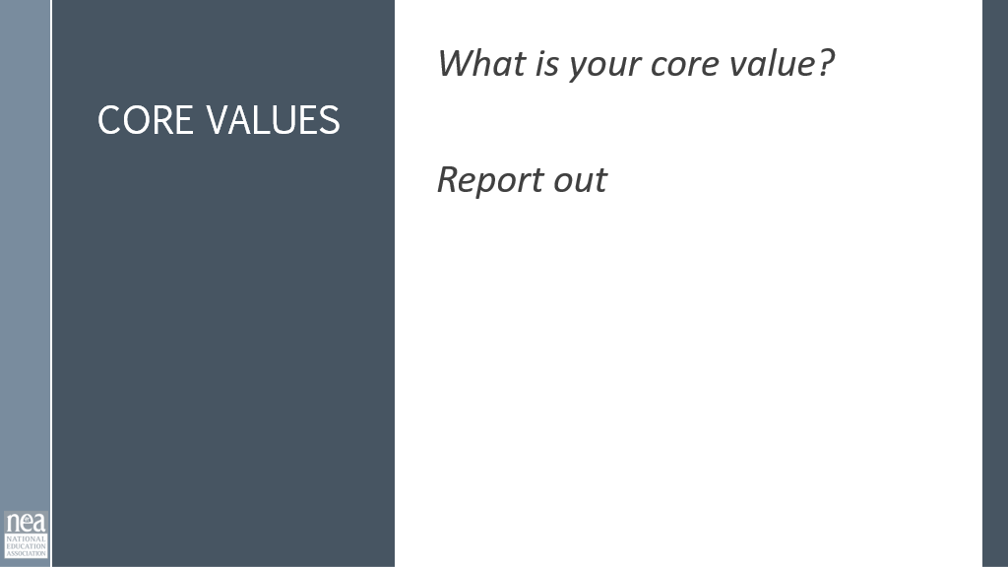  Albert  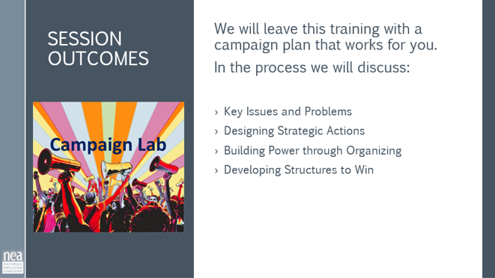  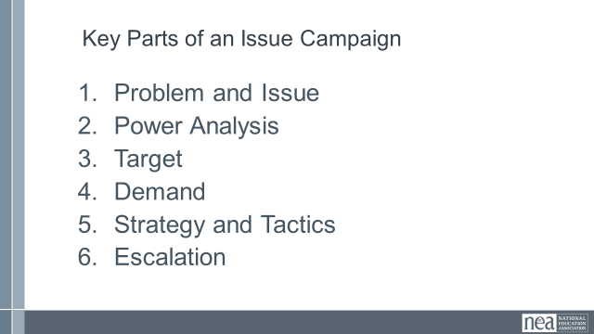  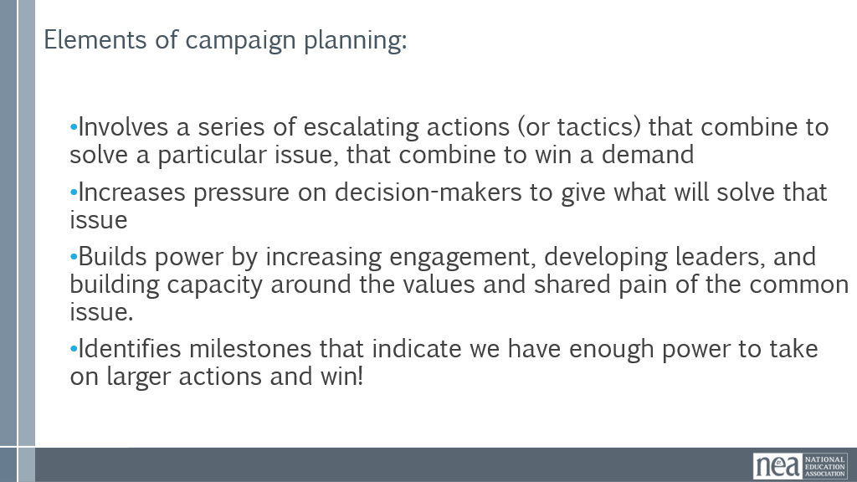  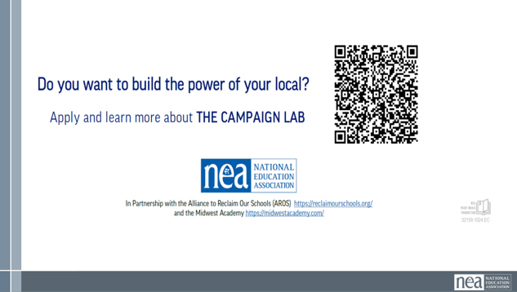 |  | Linda  5 Minutes  Welcome  Introduce yourself and your core value. Give participants 5 mins to think about what their core values are.  Have participants report out Name/State/Role/Pronouns/Core Value. Chart core value as they go.  Albert  We are going to do a quick little overview of the parts of a well-designed campaign. This will set us up for the following sessions with you.  Campaign plans, at their core, are simple. They should all have:  - Involves a series of escalating actions (or tactics) that combine to solve a particular issue, that combine to win a demand  - Increases pressure on decision-makers to give what will solve that issue  - Builds power by increasing engagement, developing leaders, and building capacity around the values and shared pain of the common issue.  - Identifies milestones that indicate we have enough power to take on larger actions and win!  Remind folks: part of our work as staff is to check in, look back and reflect. Benchmarks are a way to do that. Did we hit our benchmark? Is our strategy working? Are the current tactics we are using getting us to where we want to be? Are they building power? Are they moving the target? Do we need to pivot? Are we increasing our base?  Building a culture into our work and our plans of debrief/reflection and being nimble to adjust as needed helps keep us honest. Remember, the numbers tell us a story and checking them is important.  There are six main parts to building a campaign. We are going to go through each-  - Problem and Issue - The problem and issue is the spark! Why we are coming together, why we want a contract etc.  - Power Analysis – What power do the decision makers have? Who has power over them? What power do we have?  - Target- Who has the power to make a change? Who is the PERSON who can make the change.  - Demand - What needs to be changed? By when? By who?  - Strategy and Tactics -How will we get our demands met? Who needs to be in the fight?  - Escalation-Always plan to escalate. What happens when the target says no? Or doesn’t respond?  Remind them about the Campaign Lab | Participants will know how we are going to work, the basic schedule, and the logistics relevant to the training.
9:30 – 9:45 Matt |  | 15 Minutes Highest Hopes
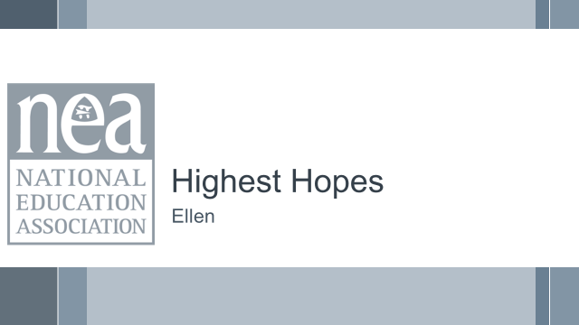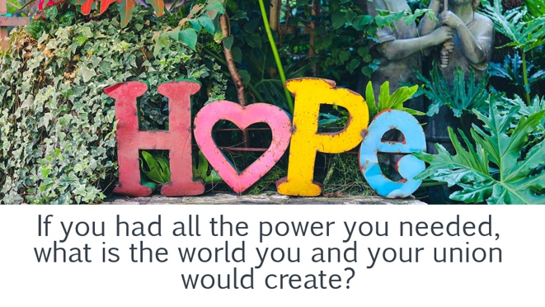 | Chart Paper | 15 Minutes Total  If we get stuck in the what we can’t do and what is being taken away – we are already defeated. Powerful organizers know that they have to be aware of the “World as it is” AND the have to be able to dream about the “World as it should be”  In your groups and using the chart paper you can use pictures, words dance, or whatever to identify the biggest dreams you have for the organizing work you and your team are going to take on.  - If you had all the power you needed, what is the world you and your union would create? | Participants will create a list of the BIG goals they have for organizing and building power
9:45 – 10:30 Linda |  | 45 Minutes Three Theories of Change for Organizing
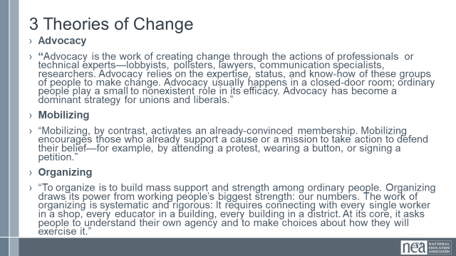  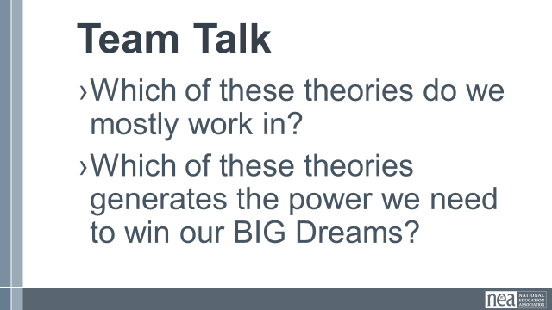  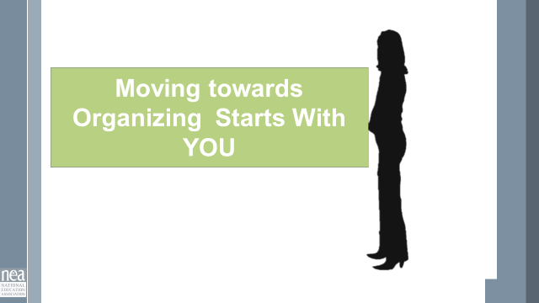  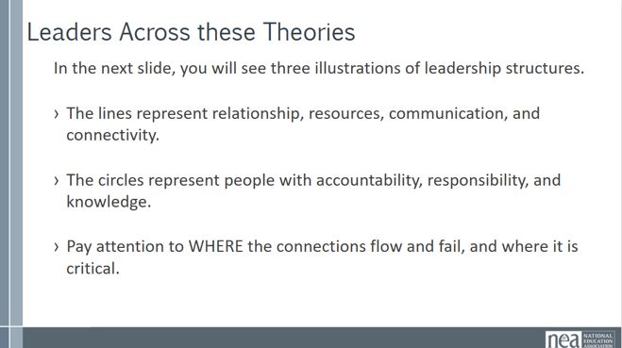  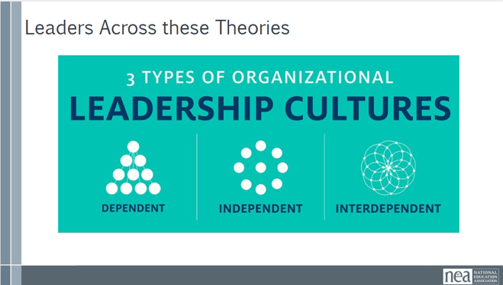  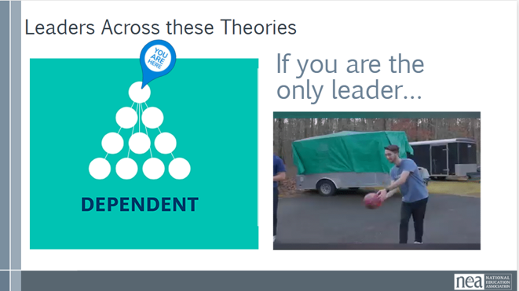  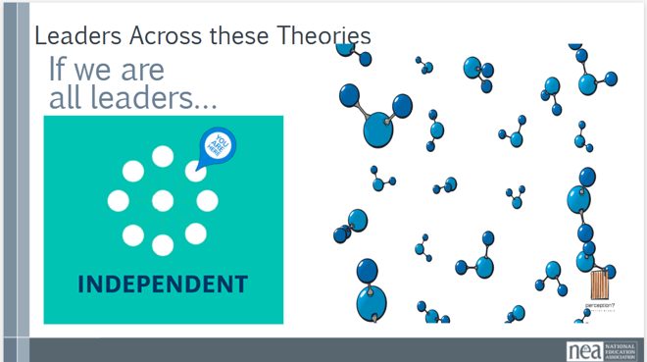  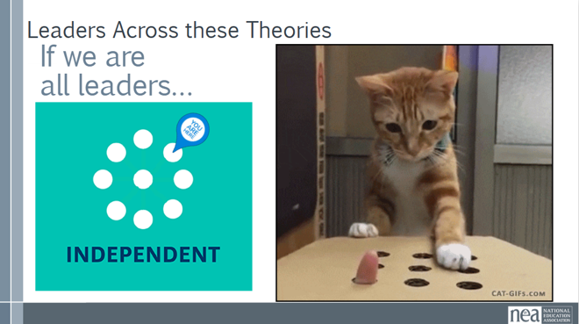  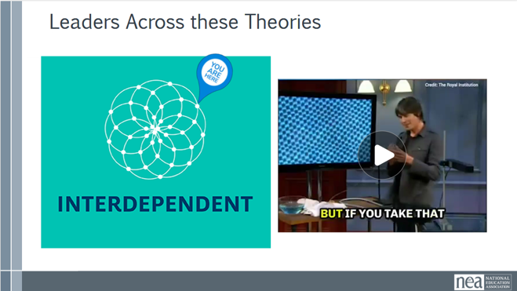  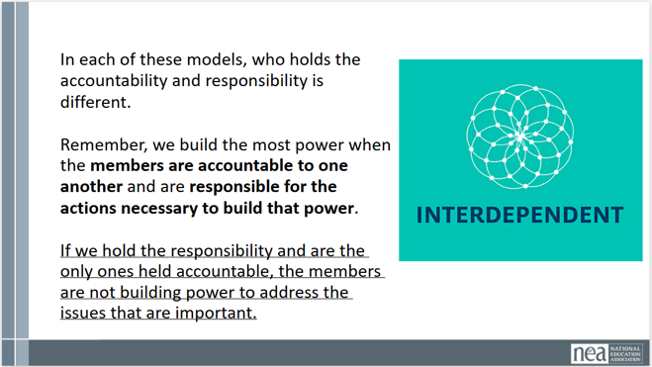  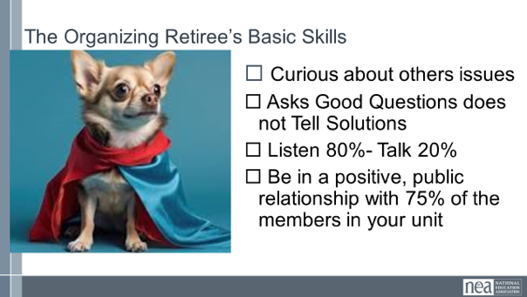  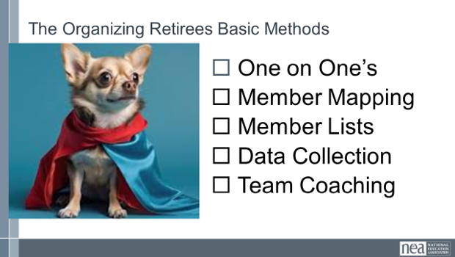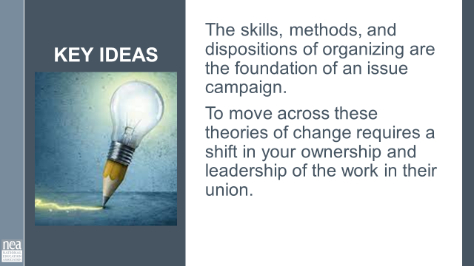 |  | 5 Minutes Introduce Three Theories of change - These theories out lined in that are - Advocacy Mobilizing Organizing. Give participants time to Write down words/ideas that stand out in each Ad/Mob/Org - as a table team.  Which of these theories are going to build the power we need to achieve the BIG dreams we have?  5 Minutes Discuss at your tables  - Which of these theories is most prevalent in your affiliate?  - Which of these theories will build the power you need to achieve the BIG dreams you have for your affiliate?  5 Minutes Discuss as a Whole Room  - How you approach the work will shape the culture, impact, and effectiveness of your affiliate.  - How do you move your affiliate from one theory of change to another?  15 Minutes Leadership  So, if we remember the first part of our Organizing definition: Organizers identify, recruit and develop leadership – I want to give you three structures to consider. As we move through these structures, keep track of where the power is and what your job would look like in each of these structures.  In the next slide, you will see three illustrations of leadership structures.  The lines represent relationship, resources, communication, and connectivity. The circles represent people with accountability, responsibility, and knowledge. Pay attention to WHERE the connections flow and fail, and where it is critical.  Let’s take a look at the first model – the “I am the leader” or the Dependent model.  In this slide- There are sixty pins in this structure. If there is one leader, one kingpin, where is the weight? Where is the power? Is this a powerful or sustainable model? Who benefits from the resources? What happens if the kingpin is knocked out?  Let’s take a look at another model – this is the “we are all leaders” or independent model.  In this model – where is the weight? Where is the power? Is this a powerful or sustainable model – Who benefits from the resources? Sometimes this also looks like the Whack a mole model (second slide)  Let’s take a look at our last model – this is the “Interdependent Leadership” model.  In this model – where is the weight? Where is the power? Is this a powerful or sustainable model – Who benefits from the resources?  Let’s look at a short video to help you remember this model – What do you notice about the bonds? How are they different from the dependent model? What are the qualities of a diamond that we get from this structure?  -One of the strongest known materials  -Cuts through almost anything  Leaders who try to do everything for everyone set themselves up to be THE single point of power and when they leave the structure falls apart. Leaders who ONLY work with “the already willing” only continue the status quo – to grow you have to continually reach out and include others – invite them to do something not simply come to something you have developed- Leaders who are organizing are constantly making room for new people and allowing them to lead – taking in new ideas and building new work together.  In each of these models, who holds the accountability and responsibility is different.  Remember, we build the most power when the members are accountable to one another and are responsible for the actions necessary to build that power.  If we hold the responsibility and are the only ones held accountable, the members are not building power to address the issues that are important.  There some basic ideas, skills, and methods you need for this move  Basic Skills -- You need to know how to be  - Curious about others issues  - Asks Good Questions does not Tell Solutions  - Listen 80%- Talk 20%  - Be in a positive, public relationship with 75% of the members in your unit  Basic Methods to Learn to Use Consistently  - One on One’s  - Worksite Mapping  - Member Lists  - Data Collection  - Team Coaching  2 Minutes Key Ideas  Organizing is how we create the future we want to see. (Achieving our greatest hopes)  Creating lasting change requires more than good ideas or quick actions. It requires changing how we approach the work.  Real power comes from strong relationships. When members are connected to one another and working together across the affiliate, they build the collective power needed to win meaningful change and create a better future. | What Theory of Change and Organizing framework are we using in our work?  Participants will learn a framework for Theory of Change and assess what approach they are currently taking  Participants will be introduced to the skills and methods required for leading campaigns
10:30-10:45 Break |  | 15 Minutes
10:45 – 10:55 |  | 10 minutes - NEA Secretary-Treasurer Zoom
10:55 – 11:30 Matt |  | 35 Mins TOTAL - Organizing, Power and Campaigns
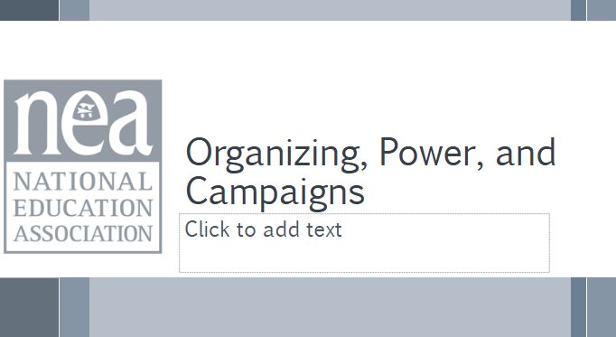  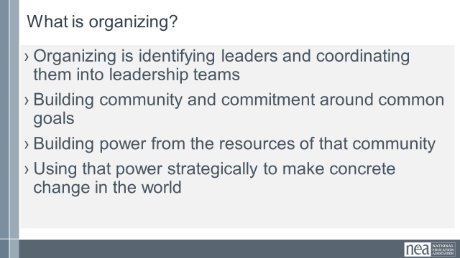  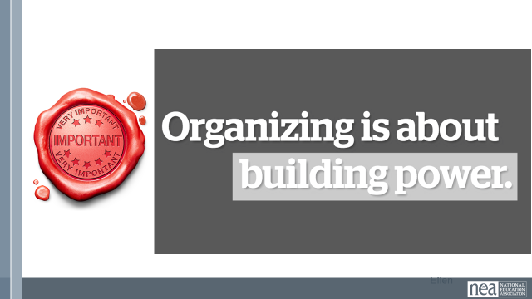 |  | 5 Minutes – Reminder of Organizing Framework  While organizing can be defined a number of ways, for today this is the one we are going to use.  Organizing is identifying leaders and coordinating them into leadership teams; Building community and commitment around common goals; Building power from the resources of that community; Using that power strategically to make concrete change in the world.  KEY POINT - these are the methods we use to BUILD POWER organizing is about building and using power | Participants will develop a common definition of organizing and power.
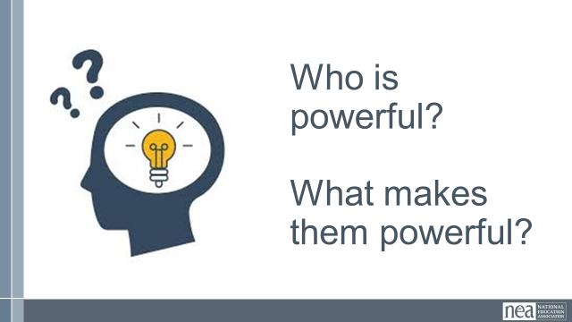  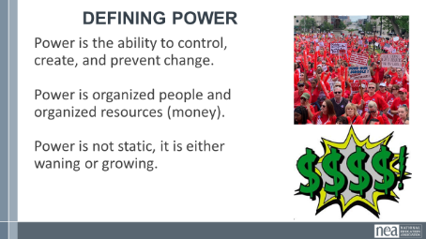  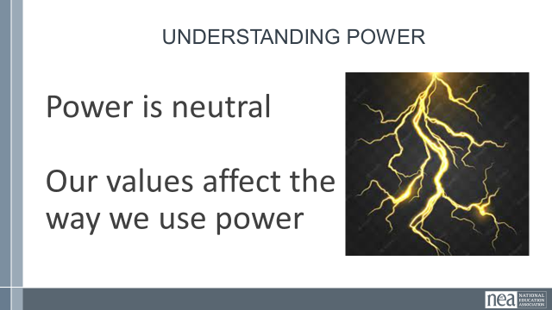  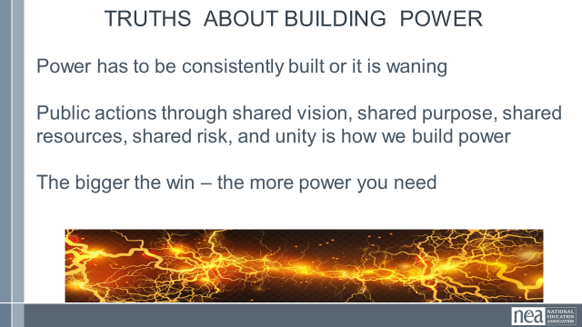  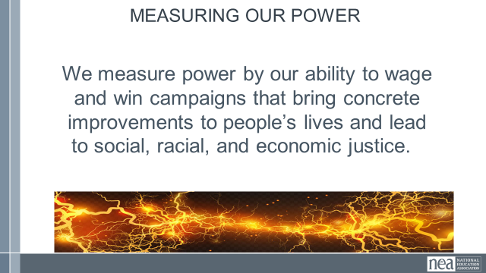  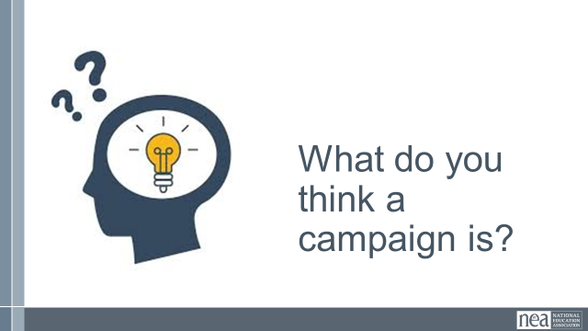  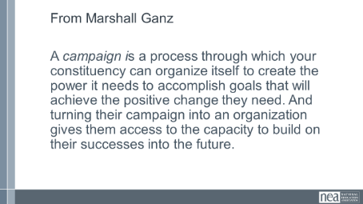  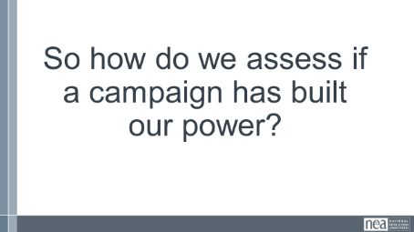  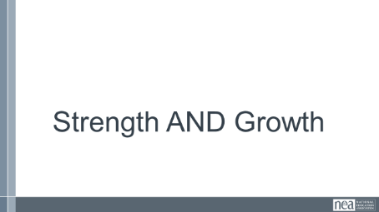  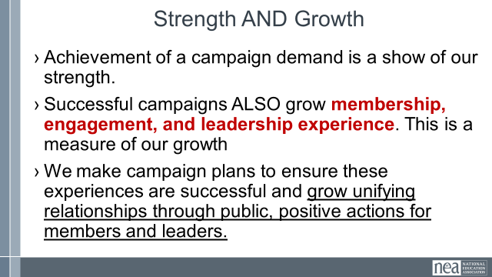  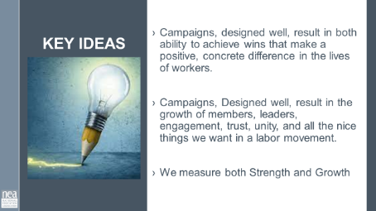 |  | 15 Minutes – DEFINING POWER (lecture)  10 minutes – Take 4 minutes at your table to write down WHO is powerful – use full names not institutions. At the end of the four minutes facilitator asks tables to report out and a large group poster is made. Ask the room what do you think these people have in common? Facilitator note - Take all ideas – affirm and lift up any ideas about getting others to act, having control of money, can enact decisions, etc. Then move to defining power and make connections from the content to the people on the list as appropriate. (ex. President Trump might relate to the content about values affecting the way power is used)  Definition of power  - Power is the ability to create, control, and prevent change.  - Power is made up of organized people and organized resources  - Power is not static, it is either growing or waning.  Understanding Power  Power is neutral. Power is simply the ability to make change. Society has biased our beliefs and feelings about who should have and how they should use power – but ultimately power is neutral – we bring all our feels and biases to that.  Our values affect the way we use power. If we are in relationship with people with a certain set of values we would find it easier to risk our resources and personal agency to advance an agenda based on our shared values. Power of the people is always grounded in our values and relationships.  Truths About Building Power  - Power has to be consistently built or it is waning  - Not everyone wants us to have power and will actively work to take our power away  - Public actions through shared vision, shared purpose, shared resources, shared risk, and unity is how we build power  - The bigger the win – the more power you need  - Building power requires leadership  We measure power by our ability to wage and win campaigns that bring concrete improvements to people’s lives and lead to social, racial, and economic justice.  9 Minutes – Defining Campaigns (Turn and Talk and Lecture)  Turn and talk to the person next to and say the first thing you think of when asked – What do think a campaign is?  Campaigns are defined as the following (From Marshall Ganz) A campaign is a process through which your constituency can organize itself to create the power it needs to accomplish goals that will achieve the change they need. And turning their campaign into an organization gives them access to the capacity to build on their successes into the future.  *Collective action.  How do know if a campaign has built power?  We measure campaign success by two metrics - Strength and growth.  This is how we define strength and growth.  - Achievement of a campaign demand is a show of our strength.  - Successful campaigns ALSO grow membership, engagement, and leadership experience. This is a measure of our growth  - We make campaign plans to ensure these experiences are successful and grow unifying relationships through public, positive actions for members and leaders.  1 Minute Key Points  - Issue Campaigns, when they are designed well, result in the ability to achieve wins that make a positive, concrete difference in the lives of workers.  - Issue Campaigns also develop good and effective leaders, positive engagement, trust, unity that we want and need in our movement.  We measure both Strength and Growth | What is the importance of campaigns  Participants will understand the purpose of using campaigns and to build both union strength and growth.
11:30 – 11:45 Albert |  | 15 Minutes - Building a Campaign – Scenario Work
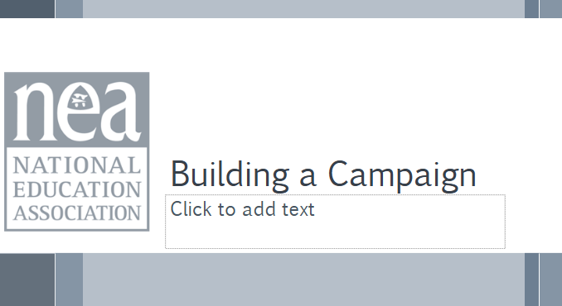 | Campaign plan outline | We are going to do a quick little overview of the parts of a well-designed campaign. This will set us up for the following sessions with you.  There are six main parts to building a campaign. We are going to go through each-  - Problem and Issue - The problem and issue is the spark! Why we are coming together, why we want a contract etc.  - Power Analysis – What power do the decision makers have? Who has power over them? What power do we have?  - Target- Who has the power to make a change? Who is the PERSON who can make the change.  - Demand - What needs to be changed? By when? By who?  - Strategy and Tactics -How will we get our demands met? Who needs to be in the fight?  - Escalation-Always plan to escalate. What happens when the target says no? Or doesn’t respond?  Campaign plans, at their core, are simple. They should all have:  - An action plan with a beginning, middle, and end, working towards a specific demand  - Involves a series of escalating actions (or tactics) that combine to solve a particular issue  - Increases pressure on decision-makers to give what will solve that issue  - Builds power by increasing engagement, developing leaders, and building capacity around the values and shared pain of the common issue.  - Throughout the campaign we identify milestones that indicate we have enough power to try something more and something bigger and win!  5 minutes - Read the two scenarios  5 Minutes - Choose your issue  In the room, we have two issues:  1. Student's use of pride flags lead to teacher discipline  2. Community members push school board for book bans  Choose the issue you would like to work on for the next  couple of hours and head to that location. Once there, find  a team of no more than 5 folks to work with. | How do you build a campaign?  Participants will understand the critical pieces of a campaign plan structure.
3:20 – 4:10 Linda |  | 50 Minutes TOTAL – Problem, Issue, and Values
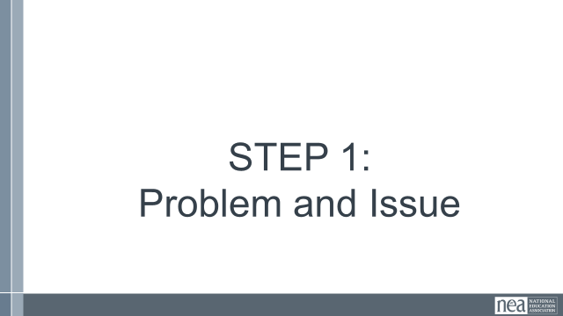  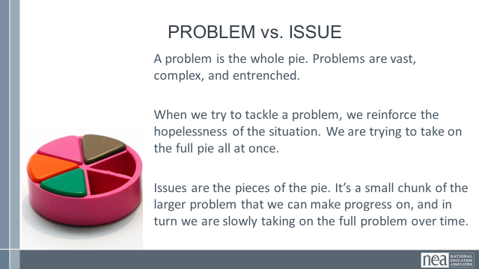  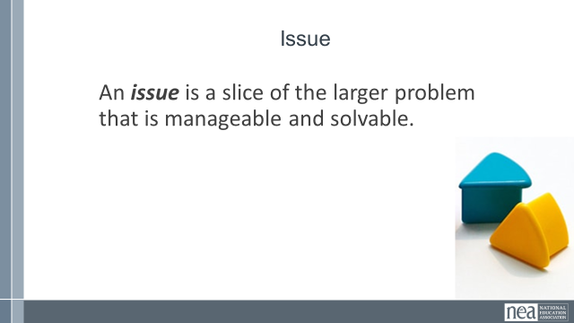  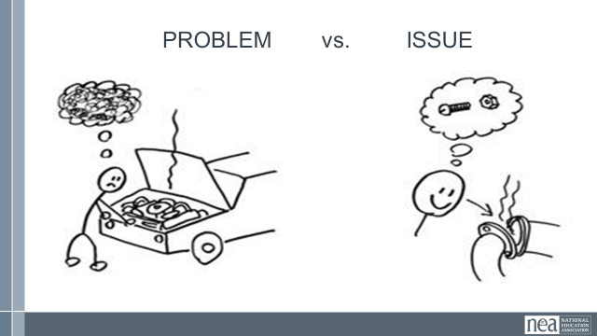  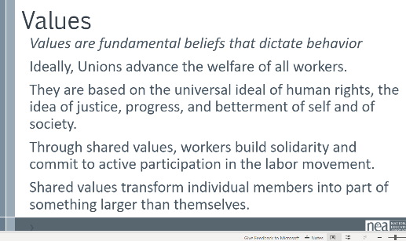  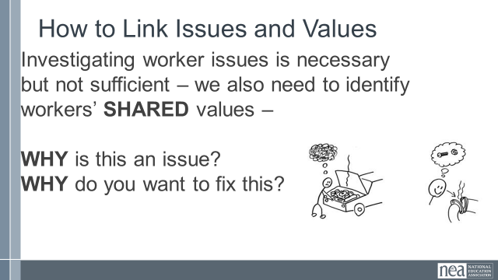  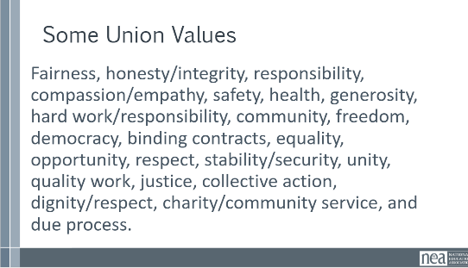  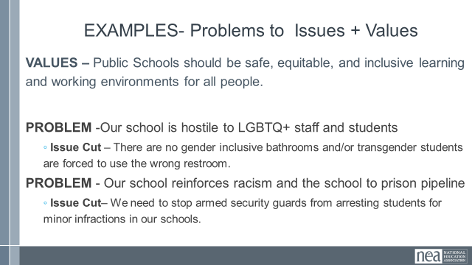  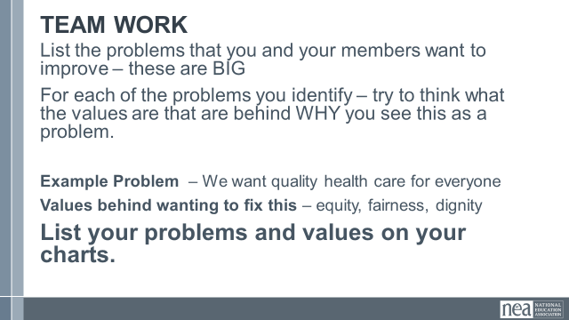  STOP for Lunch (12-1)  Albert  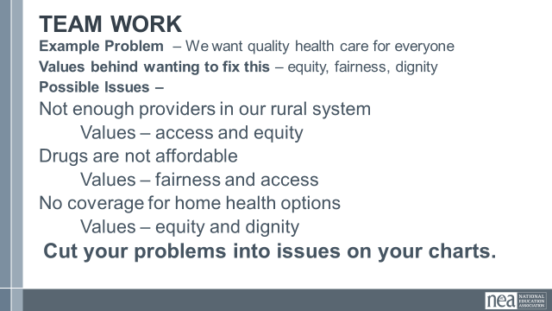  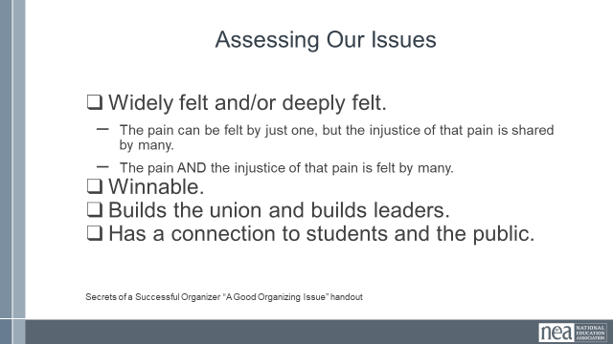 |  | 10 Minutes PROBLEM , ISSUES and Values  - Campaigns start with issues that people have value-based solidarity around.  - An issue is a slice of a workplace problem.  - Often a problem can have different issues depending on the perspective of the people we are working with.  - It is KEY to get enough input on what the issues are that make up the problem so that YOU do not drive the solution.  - Investigating the issue is necessary but not sufficient – we also need to identify workers’ SHARED values – WHY is this an issue? WHY do you want to fix this?  For example, A problem My Car is a piece of JUNK --- Issues – broken radiator hose, bad brakes, smelly interior, hole in the muffler.  We Begin to Get to Values when we ask WHY?  VALUES are  - Values are deeply-held beliefs that shape who you are.  - Ideally, Unions advance the welfare of all workers.  - They are based on the universal ideal of human rights, the idea of justice, progress, and betterment of self and of society.  - Through shared values, workers build solidarity and commit to active participation in the labor movement.  - Shared values transform individual members into part of something larger than themselves.  How to Link Issues and Values – The Organizing Conversation Magic  You might ask, Do you want to fix this problem? Which of these do you think you can fix? Which one matters the most to you? Why does it Matter?  The radiator hose is something that my friend and I can fix and it matters to me because I can afford to fix it.  The radiator hose will be fixed by putting a new fitting on it. Is an issue that allows me to see the solution.  We can get to values by asking how do you feel about your car being a piece of junk? Do you think others feel the same way about cars that are pieces of junk? Why do you want to fix this problem?  We deserve safe and reliable transportation  We deserve access to affordable and quality car parts  Some union values we might recognize: Fairness, honesty/integrity, responsibility, compassion/empathy, safety, health, generosity, hard work/responsibility, community, freedom, democracy, binding contracts, equality, opportunity, respect, stability/security, unity, quality work, justice, collective action, dignity/respect, charity/community service, and due process.  Share slide of examples of Problems, the Values, and the issue Cut  Connect the Problems to the values  Team Work - List of Problems and the values that might be linked to those  You and your team are going to make a list of problems that you and your members want to improve – these are big  For each of the problems you identify – try to think what the values are that are behind WHY you see this as a problem.  STOP for Lunch (12-1)  Albert  15 Minutes - Cutting our Problems into Issues and Assessing  Using the charts you made as we started pick one of your big problems and think about the issues that might be built into that.  Example Problem – We want quality health care for everyone  Values behind wanting to fix this – equity, fairness, dignity  Possible Issues –  Not enough providers in our rural system  Retiree benefits don’t cover specialists  Drugs are not sourced in ways that make them affordable  No coverage for home health options  Cut your problems into issues on your charts.  Assessing Our Issues  So how can we determine – assess what issues make the best organizing issues. We can work them through a couple of processes. Using these processes with them keeps us from taking over and allows for leadership development opportunities. They build their confidence and trust and solidarity through a shared process.  At the very least a good issue  - It is widely felt and/or deeply felt.  - The pain can be felt by just one, but the injustice of that pain is shared by many.  - The pain AND the injustice of that pain is felt by many.  - It is winnable.  - It builds their union and builds leaders.  - It has a values-based connection to our workers, students, and the public.  Using the issues you charted at the beginning of this section about issues – Spend just a few minutes using the simplified screener from Labor Notes on p. 13 of the PG– and see how it would allow you to screen out issues that might not be good for Organizing.  Report out - what did you find? (if it doesn’t come out, reemphasize the earlier Key Point – Not every issue is an organizing issue) | Why are problem and issue something we need to know? 4  Participants will differentiate between problems and issues, and evaluate issues as being well connected to values and the community, deeply and widely felt, and winnable.
1:15-1:30 Matt |  | 15 Mins – Target and Demands
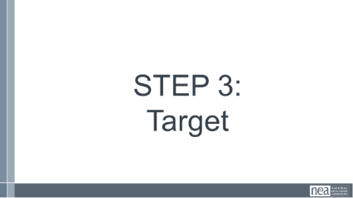  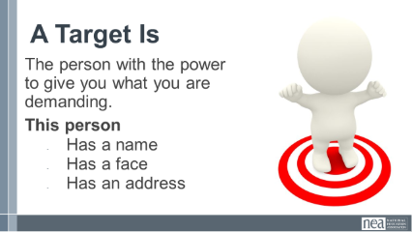  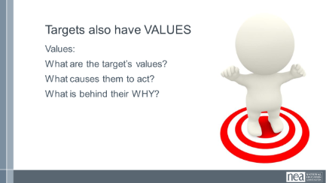  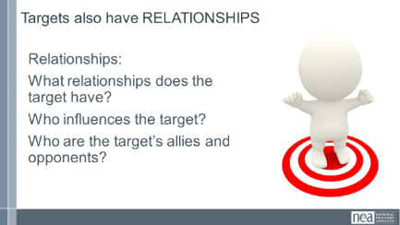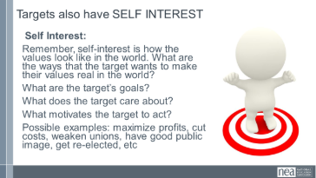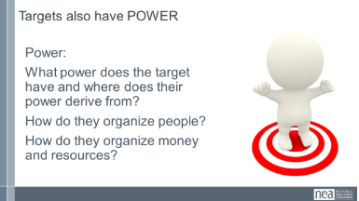  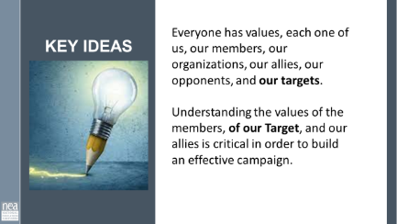  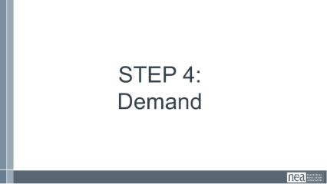  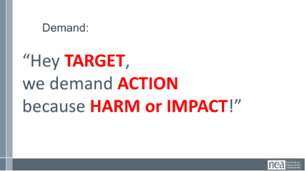  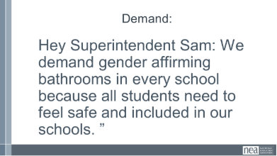  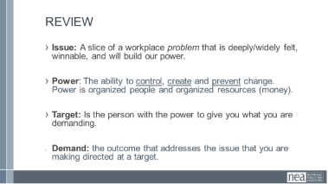  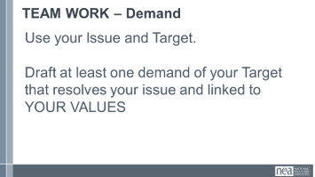  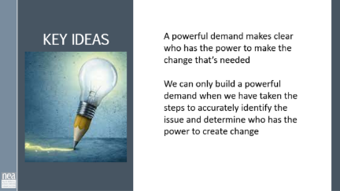 | Participant handouts:  Target Analysis in the Campaign Planning Guide | Now we’ll move into Targets and Demands.  Definition of Target  Ask group: Who has an idea of what we mean by a target in the context of a campaign?  - A target is the person who can make the decision to give you what you want. The target is the person who can meet your demands. We need to be very specific in identifying the target. A target is not an organization or a committee. A target is a person with a face, name, and an address.  WHO HAS THE POWER TO BRING A VOTE TO THE BOARD OF ED  WHO IS THE SWING VOTE –WHO IS THE KEY PERSON  Understanding OUR values that are connected to our issues can help us to analyze the target. We’ll walk through an example together.  Identification and Power Analysis of Your Target  It is key to remember that just as you and your members have values and relationships that cause you to act – Targets do to and you have to understand these. Let’s look at an analysis that is helpful in designing campaigns.  Relationships:  - What relationships does the target have?  - Who influences the target?  - Who are the target’s allies and opponents?  - To whom is the target accountable? (Is the target elected or appointed?)  - Who’s the target’s base of support?  Values:  - What are the target’s values?  Self Interest:  - Remember, self-interest is how the values look like in the world. What are the ways that the target wants to make their values real in the world?  - What are the target’s goals?  - What does the target care about?  - What motivates the target to act?  - Possible examples: maximize profits, cut costs, weaken unions, have good public image, get re-elected, etc  Power:  - What power does the target have and where does their power derive from?  - How do they organize people?  - How do they organize money and resources?  Points (1 min)  - Everyone has a values that drive our decisions, each one of us, our members, our organizations, our allies, our opponents, and our targets.  - Understanding how values influence the use of power is critical in order to build an effective campaign.  A demand is the outcome that addresses the issue that you are making of a target.  The demand should have the 3 components: the target, the action, and the harm or impact.  “Hey Superintendent Sam: We demand gender affirming bathrooms in every school because all students need to feel safe and included in our schools. ”  This example clearly articulates the Target (Superintendent Sam), the action that we want the target to take (implement gender affirming bathrooms in every school), and the harm or impact (that this will allow students to feel safe and included).  The demand is usually the first thing that your supporters or potential supporters will hear about the campaign. This is why it is important to include the harm or impact, because it creates a moral crisis in the listener and move them to act in support of the campaign.  - Measurable  - Achievable  The demand should be measurable in that we can clearly know whether the target takes the action in the demand or not  Review of steps 1-4  Team work – 10 Minutes  Return to your charts and draft a demand of your Target that resolves your issue and linked to YOUR VALUES  1 minute - Key Ideas  - A powerful demand makes clear who has the power to make the change that’s needed  - We can only build a powerful demand when we have taken the steps to accurately identify the issue and determine who has the power to create change | How do you identify and analyze a target?  Participants will understand that a target is a specific person with decision making power over the demand they seek.  Participants will learn how to identify and analyze a target.  How do you determine the demand?  Participants will understand how to determine a measurable and winnable demand.
1:30-1:50 Albert |  | 20 Minutes TOTAL – Spectrum of Allies
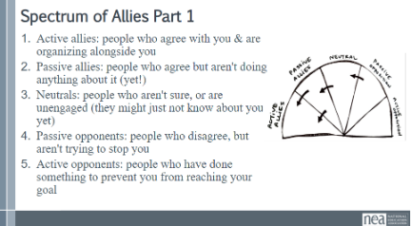  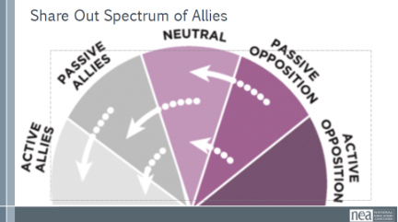  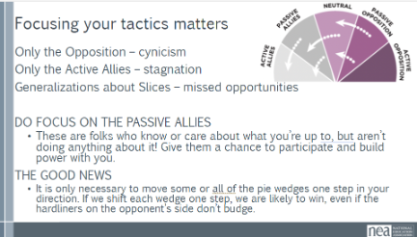  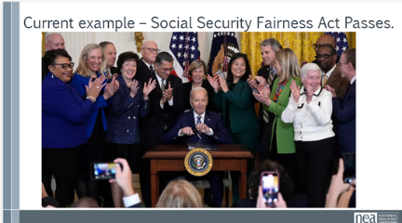  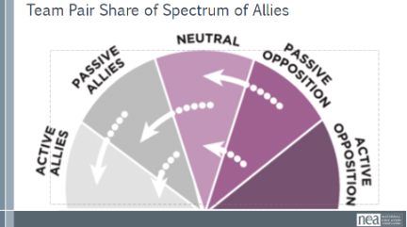  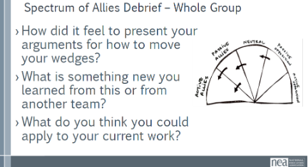  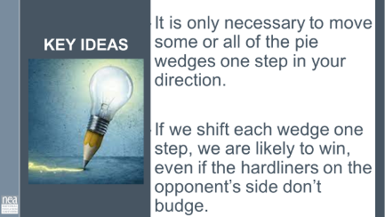 | Chart Paper Teams work to make their own spectrum of allies  SPECTRUM OF ALLIES TO HANODUTS | We are going to begin by learning a method Called Spectrum of Allies. All of our campaigns CAN include a wide range of groups, but particularly in the campaigns we are thinking about that you will be part of, you MUST include others outside of your constituency.  These include a wide range of groups that can be put on a kind of spectrum, from those closest to the point of view of the advocates to those who actively oppose change. Draw a horizontal line to represent that. Those who advocate change are represented by a point at one end of the line (say, on the left), and the opponents by a point at the other end.  Draw a semicircle with wedges. The wedges closest to either end are the active allies and opponents, next in are passive allies. The group in the middle are neutral.  Use the issue that your group identified.  Begin by asking, who might be inclined to be most supportive, least supportive, or neutral. Some examples of groups: ‘unions?’, ‘poor people’s groups?’, ‘business community?’. In your teams, identify these (AND WHY) and put them on your spectrum on the spectrum, and write them into the ‘pie’. Be as specific as possible – names, make them up to match the vignettes you are working with. Identify why people are placed where you placed them.  Whole Group Share – Do a little share out – as the facilitator, focus on the sharing of why the teams placed certain people in certain places.  Content – Where do you focus your tactics?  Focusing only on the opposition leads to becoming disheartened or cynical, which means you ignore potential allies and support. Focusing only on how to convince the important power-holder who is against you leads to ignoring all of the potential support you could build that could overpower her opposition  Focusing only on active allies leads to being an isolated interest-group, which also means you ignore potential allies and support Always doing events with the same group of individuals or organizations isolates you from creative, powerful community-building that can  arise from new alliances and partnerships  Generalizing about whole groups of people risks misunderstanding the nuances of communities If you think about "students" as an entire group, you ignore the huge number of different groups & organizations (potential allies!) that exist in a student community  DO focus on passive allies. These are folks who know or care  about what you’re up to, but aren’t doing anything about it! Give them a chance to participate and build power with you.  Good news, in most social change campaigns, it is not necessary to win the opponent to your point of view, even if the powerholders are the opponent. It is only necessary to move some or all of the pie wedges one step in your direction. If we shift each wedge one step, we are likely to win, even if the hardliners on the opponent’s side don’t budge.  An Current example -  The Passage of the Social Security Fairness act finally passed this year and ended over 40 years of inequity.  For years, members have been fighting to repeal these decades old Social Security laws that unfairly penalized any public service employee retiree by severely reducing their earned Social Security Benefits for recipients and surviving spouses despite meeting the requirements for Social Security benefits and paying their fair share into the program. Allies in this were the AFFECTED WORKERS AND Families from postal workers to other federal workers, from firefighters to teachers in 26 states. Without the engagement of Passive Allies from the other states not affected, this would have never passed.  Group Work  Have them come up with their own for the scenario  Whole Group Discussion  How does categorizing potential allies help focus your  campaign possibilities?  Which group would you focus on moving first and why?  1 Minutes – Key Points  - It is only necessary to move some or all of the pie wedges one step in your direction.  - If we shift each wedge one step, we are likely to win, even if the hardliners on the opponent’s side don’t budge. | Participants will apply the Spectrum of Allies method to map focused tactics, narratives, and asks designed to move people toward their overall goal of the campaign.
1:50 – 2:05 Linda |  | 15 Minutes - Strategy, Tactics, and Escalation
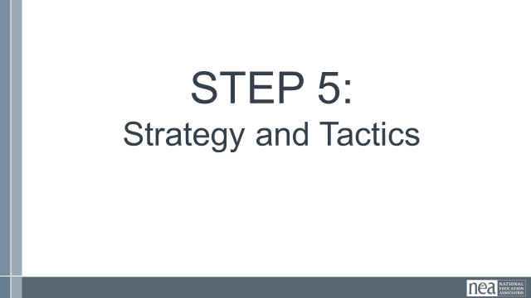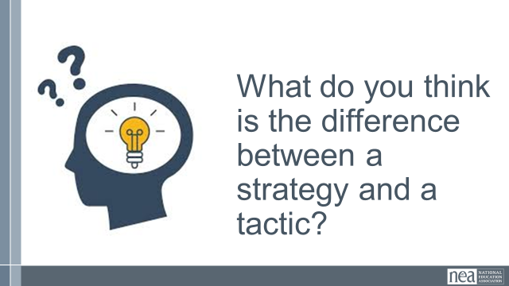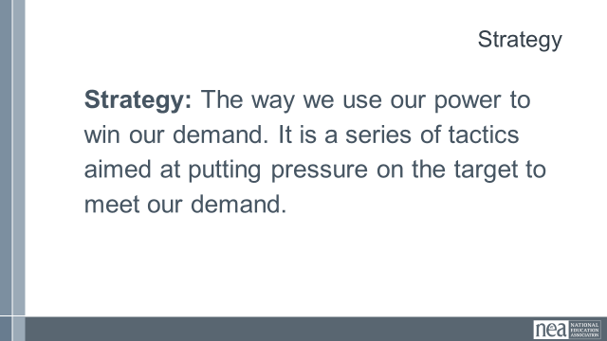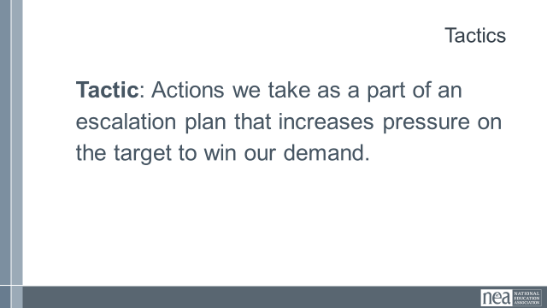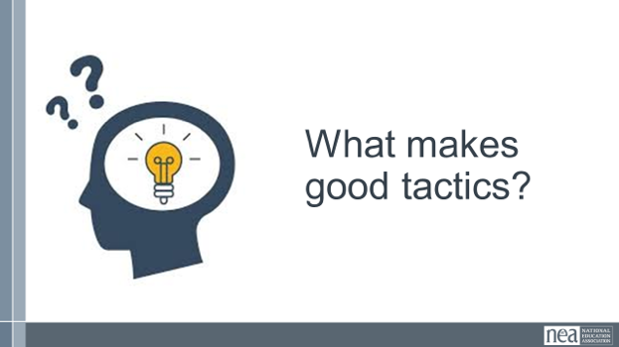  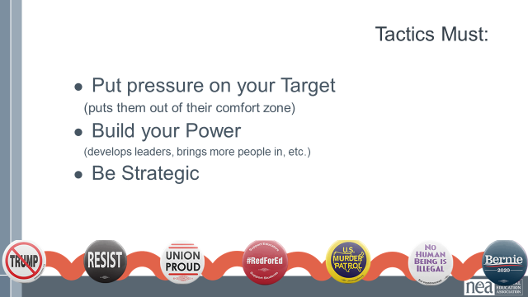  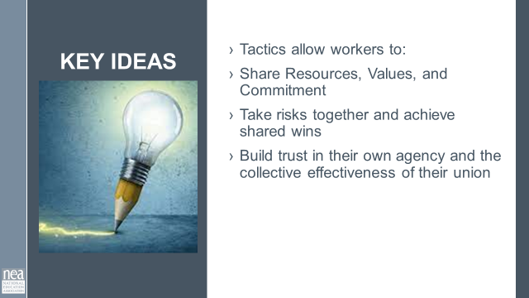  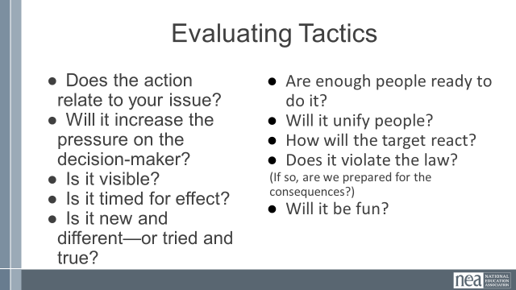 |  | Whole Group (5 mins)  Once we know where we are going, we have to plan how to get there.  Strategy vs Tactics  Ask group: What do you think is the difference between a strategy and a tactic?  A strategy is the way we use our power to win our demand. It is a series of tactics aimed at putting pressure on the target to meet our demand. We need a strategy because we cannot just implement tactics in a random way, we need to plan and order our tactics strategically according to an escalation plan.  Tactics are actions we take as part of an escalation plan that increases pressure on the target to win our demand. We design tactics based on our power analysis on the target. Each tactic should put pressure on the target’s self-interest, relationships, or power that we identified in the power analysis.  What makes good Tactics?  Let’s hear from a few people. Who wants to share about their favorite tactic and what made it a good tactic?  Tactics must:  - Put pressure on your Target. Tactics must put pressure on the Target’s Self-Interests, Relationships, or Power. Tactics should put the Target out of their comfort zone - we don’t want to use tactics that the Target is expecting or is used to seeing already, because that won’t put pressure on them.  - Build your Power. We should always be thinking about how each tactic can help us develop our leaders and brings more people into the campaign.  - Be Strategic. We don’t do tactics just for the sake of doing them. We need to make sure that our tactics make good use of our resources in order to put the most amount of pressure on the Target and as part of an escalation plan.  Key points – Tactics allow workers to:  - Share Resources, Values, and Commitment  - Take risks together and achieve shared wins  - Build trust in their own agency and the collective effectiveness of their union  Campaigns often focus on the visible moments, rallies, petitions, meetings with decision makers, or public actions. Those are campaign tactics. They're important because they move decision makers and demonstrate power.  But campaign tactics are only as strong as the relationships behind them.  Relational tactics are the conversations, one on ones, leadership development, team building, and shared experiences that build trust and commitment. They answer the question: Why are people willing to show up?  Think about it this way: campaign tactics mobilize people. Relational tactics organize people.  If we only rely on campaign tactics, we may get participation for a moment. If we invest in relational tactics, we develop leaders who continue organizing long after one campaign ends.  We don't choose between relationships and action. We use relationships to generate collective action, and we use collective action to deepen relationships and develop more leaders. That cycle is how we build lasting power.  Tactics must:  - Put pressure on your Target. Tactics must put pressure on the Target’s Self-Interests, Relationships, or Power. Tactics should put the Target out of their comfort zone - we don’t want to use tactics that the Target is expecting or is used to seeing already, because that won’t put pressure on them.  - Build your Power. We should always be thinking about how each tactic can help us develop our leaders and brings more people into the campaign.  - Be Strategic. We don’t do tactics just for the sake of doing them. We need to make sure that our tactics make good use of our resources in order to put the most amount of pressure on the Target and as part of an escalation plan. WE WILL DO THIS IN OUR NEXT SECTION  Evaluate your tactics using this list (OPTIONAL:  - Does the action relate to your issue?  - Does it align with your values?  - Will it increase the pressure on the decision-maker?  - Is it visible?  - Is it timed for effect?  - Is it new and different—or tried and true?  - Are enough people ready to do it?  - Will it unify people?  - How will management react?  - Does it violate the law? (If so, are we prepared for the consequences?)  - Will it be fun?  Debrief (5 mins)  - Let’s hear from a few groups. How do each of your tactics put pressure on the Target’s Self-Interest, Relationships, or Power? | What are strategy and tactics?  What makes effective tactics?  Participants will understand the difference between strategy and tactics and the criteria for effective tactics.
2:05 – 2:20 Albert and Matt |  | 15 Minutes Compression Points and Escalation of Tactics
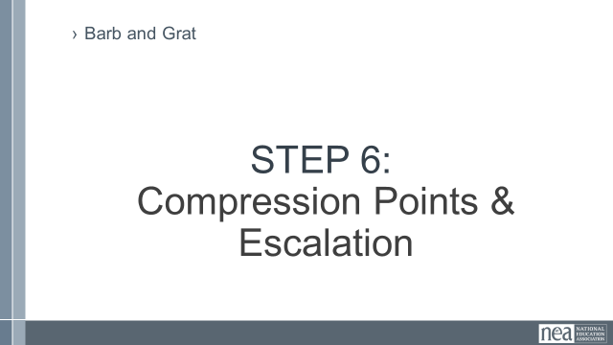  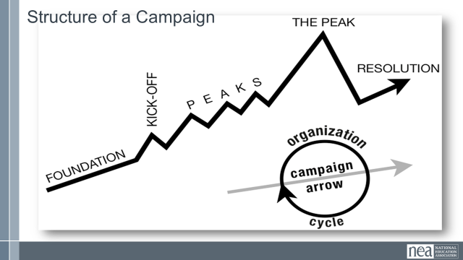  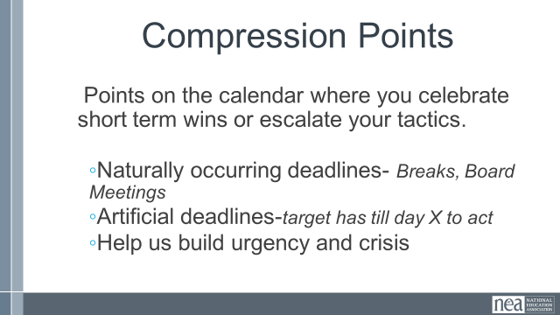  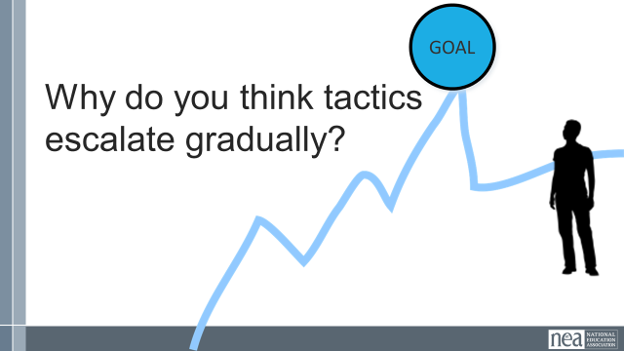  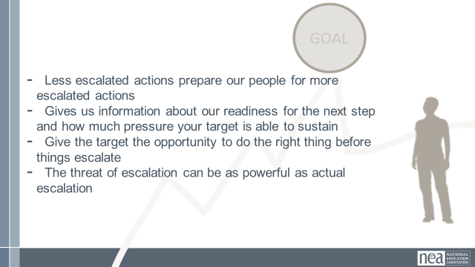  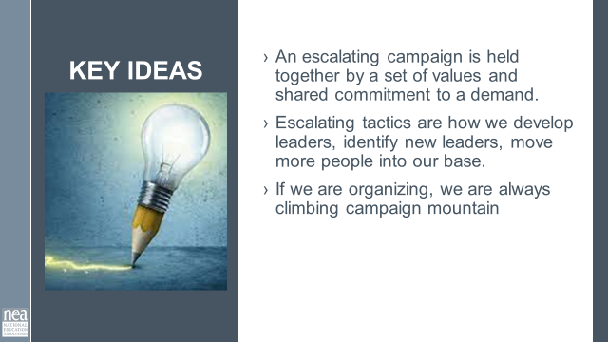 |  | STEP 6: Escalation Content 10 Minutes  Tactics are structure tests, and should come with a demand. We can’t just walk off the job, but not communicate why or what is needed to bring people back to work  In the last section, we wanted to show that escalations can be fun, and creative. In this section we will be talking about more of the nitty gritty of escalations. Has anyone in their home campaigns helped a workplace action, and realized there were no clear next steps? Or the action halted the momentum of the campaign? (that is a question for participants)  Campaign Mountain  - Foundation  - Kick-Off  - Peaks  - The Peak  - Resolution  Timeline  - How long can you wait for the demand to be met?  - Are you creating a deadline?  - Is there and event creating the deadline?  - How long will it take to identify the problem, identify the issues, build a leadership team, build a presence, etc. etc. etc.  - When do you make the starting point?  Compression Points  - How long can you wait for the demand to be met?  - Are you creating a deadline?  - Is there and event creating the deadline?  - How long will it take to identify the problem, identify the issues, build a leadership team, build a presence, etc. etc. etc.  - When do you make the starting point?  Why do you think tactics escalate gradually?  - Less escalated actions prepare our people for more escalated actions  - Give the target a point to do the right thing before things escalate to the next tactic  - Use the threat of escalation  - Allows more people to join our base  3 Minutes Key Points – An escalating campaign is held together by a set of values and shared commitment to a demand.  Escalating tactics are how we develop leaders, identify new leaders, move more people into our base.  If we are organizing, we are always climbing campaign mountain | What is escalation and why it is important?  Participants will understand the importance of escalation and how to plan out tactics.
2:20-2:30 Albert/Matt |  | 10 min – Group Work Explanation
Now that we’ve covered the core components of campaign mountain, you are now going to return to your scenario.

Build a campaign mountain based on the issue, the target, and the demand you identified.

You may need to be creative about some of your compression points... (creating an artificial calendar date as an example)
2:30 – 2:45 Break |  | 15 minutes – Break
2:45-3:15 – Linda/Matt/Albert |  | 30 minutes – Campaign Planning
 |  | Work time
3:15-3:25 Linda/Matt/Albert |  | 15 minutes - Presentation
 |  | Present Campaigns
3:25-3:30 Linda/Matt/Albert |  | 5 min - CLOSING
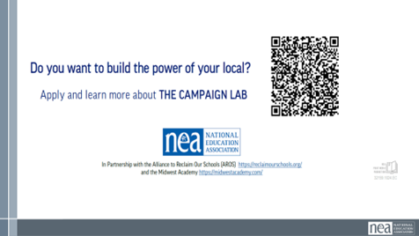   |  | What will you take with you into your future work?  Plug Campaign Lab  What we need you to do

