Centering Race

30 Minutes |  |  | Questions and Learning Goals
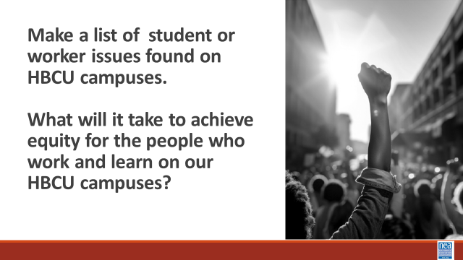  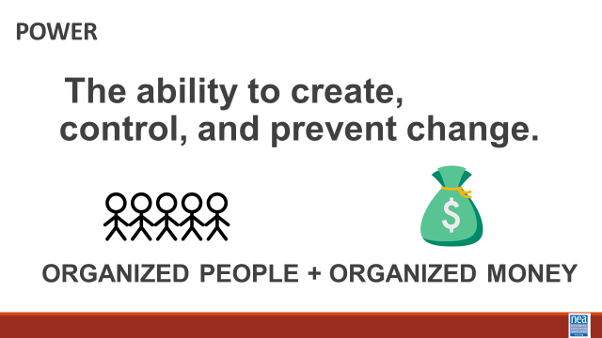  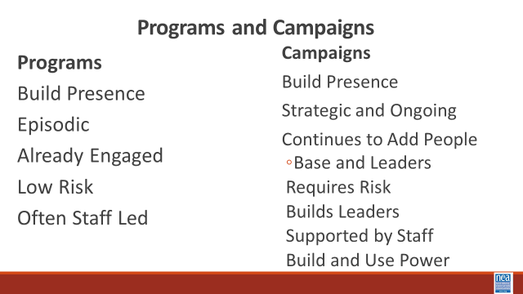  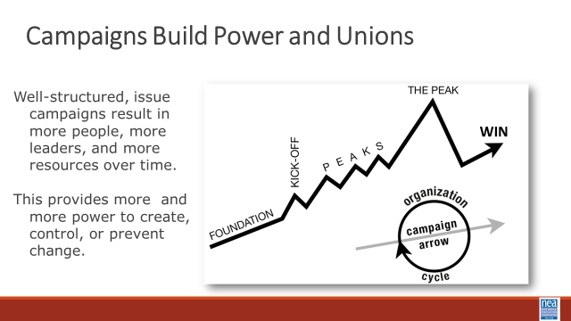  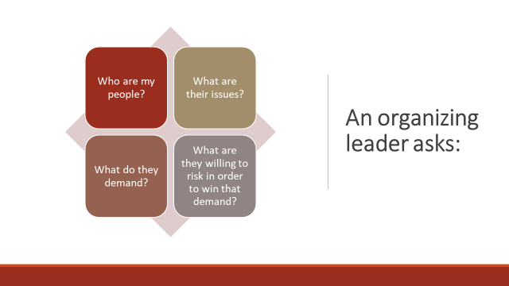  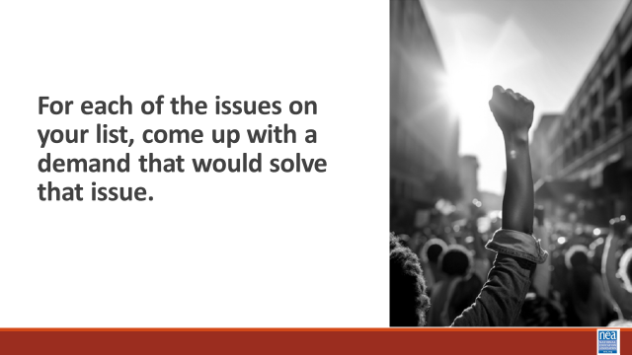  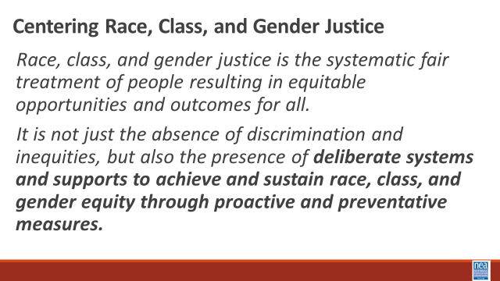  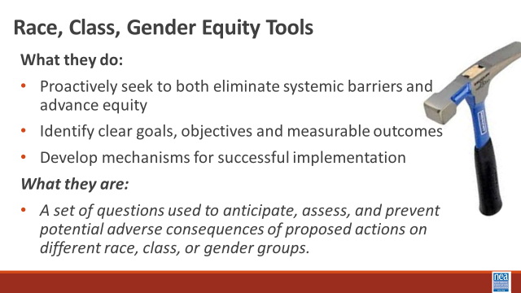  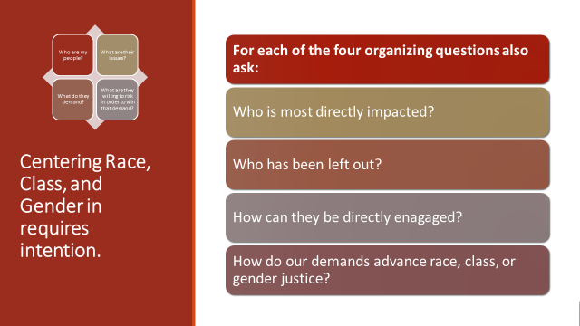  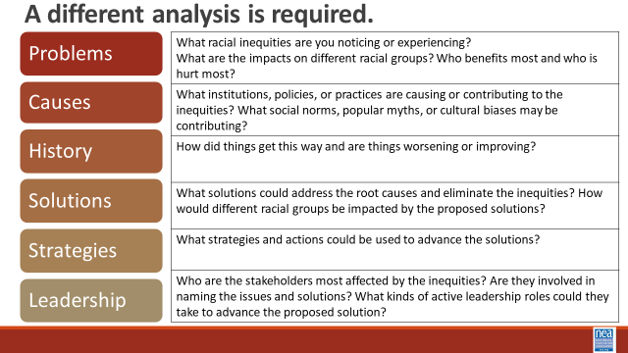  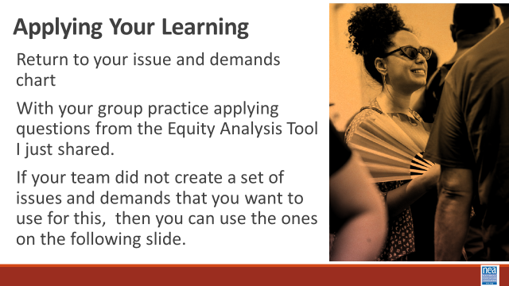  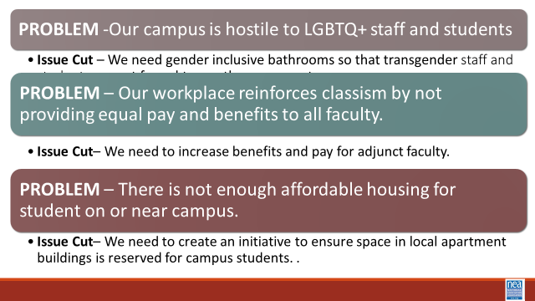  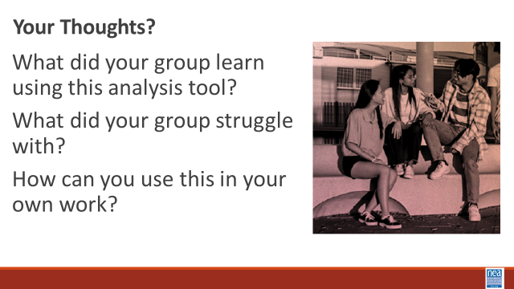  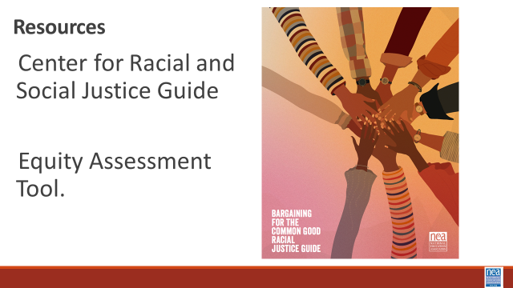  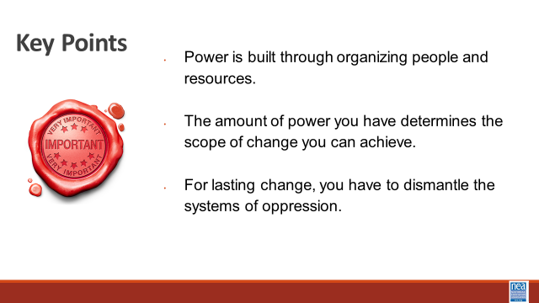 | Charts  Equity Analysis  Equity Assessment  CRSJ BCG Centering Race Guide | Intro – 10 Minutes Total  5 Minutes – Quick Brainstorm –Make a list of student and worker issues found on HBCU campuses. (At the end of 5 minutes take 2 minutes and popcorn out some issues)  2 Minutes Turn and talk - Consider the following question – what will it take to achieve equity for the people who work and learn on our HBCU Campuses?  ! Minute – Report out - Take about three ideas from the room.  5 minutes – Union Work that Builds Power  For all of those things, to make meaningful lasting STRUCTURAL change we need power. Power is defined as that ability to create, control, and prevent change. That typically means organized people and organized money or resources – your work is a resource.  What type of union builds power? Programs, such as professional learning, staff led advocacy, social focused events, even policy advocacy do little to build power. Why is that? Well all of these programs are self-selected with little risk to join or leave them. I want to improve my classroom management, so I come to the Union led training on that. I might even lead one – but I have done little to build power with others. Also in a program, I am choosing to solve a “me” Problem and it does not require any other collective commitment.  Campaigns put people at the center of solving the problems they are experiencing. They name the issue, they decide the solution, they decide who they follow, and they determine what the are willing to risk. When we center people in a campaign – staff move to a coaching role. When people are at the center they use their agency and decide how to act, who they will act with, and what they are willing to risk to win. This is when members and leaders feel powerful in their union.  To begin a campaign you have to ask what the people want to solve, ask what they are willing to risk to solve that, and form demands that they think will provided the solution to their problem.  6 Minutes – Make Demands – return to your issue list – for as many as you can, make demands that would solve the issue.  Example – Issue, there is not enough on campus parking for faculty.  Demand – Turn ¼ of first year student parking into faculty parking.  1 Minutes – Popcorn some demands.  5 mins - What about Race Class and Gender Justice  A lot of us indicated core values that are about seeking justice and a lot of us in this room have said that an important part of your work is ensuring equity. Then we need to be applying a race, class, and gender justice lens to our work work  What does it mean to center racial, class and gender justice?  Race, class and gender dynamics, disparities, and divisions permeate our society, communities, schools, and classrooms. Systemic oppression is so deeply rooted in our history, culture, and institutions that there is no escaping it. Visible or not, the impacts are ever-present. Race, class, and gender justice is the systematic fair treatment of people of all races, resulting in equitable opportunities and outcomes for all. It is not just the absence of discrimination and inequities, but also the presence of deliberate systems and supports to achieve and sustain race, class, and gender equity through proactive and preventative measures.  To continually and systematically keep equity in your work you have to use a Race, Class, and Gender Equity too, or lens. This is a person and institutional commitment to  - Proactively seek to both eliminate systemic barriers and advance equity  - Identify clear goals, objectives and measurable equity outcomes  - Develop mechanisms for successful implementation of equity focused programs  - A set of questions used to anticipate, assess, and prevent potential adverse consequences of proposed actions on different race, class, or gender groups.  Think about how the answers to each of the Organizer Questions shift when you also apply a Race, Class, and Gender Equity tool?  10 Mnutes – Group Practice – Applying a race, class, and gender lens to your Demands  2 minutes intro  To engage in a systems analysis of a race class and gender issues and develop solutions or to test if the campaign demands center racial justice, good discussion questions to have with partners and union members include:  • Problems: What racial inequities are you noticing or experiencing? What are the impacts on different racial groups? Who benefits most  and who is hurt most?  • Causes: What institutions, policies, or practices are causing or contributing to the inequities? What social norms, popular myths, or cultural biases may be contributing?  • History: How did things get this way and are things worsening or improving?  • Solutions: What solutions could address the root causes and eliminate the inequities? How would different racial groups be impacted by the  proposed solutions?  • Strategies: What strategies and actions could be used to advance the solutions?  • Leadership: Who are the stakeholders most affected by the inequities? Are they involved in naming the issues and solutions? What kinds of active leadership roles could they take to advance the proposed solution?  Group Work – Applying Your Learning – (8 Minutes)  - Return to your issue and demands chart  - With your group practice applying questions from the Equity Analysis Tool I just shared.  If your team did not create a set of issues and demands that you want to use for this, then you can use the ones on the following slide  Without intentionality – we might continue to build power – but it won’t be the type of power we need to demand solutions to the structural inequalities found on our HBCU campuses.  10 Minutes – Debrief Resources and Key Points  What did you learn about using this analysis tool?  What did your group stuggle with?  How do you think you could use this in your own work?  Share the additional resources  Key Points-  - Intentional campaigns, not programs build power.  - Centering race, class, and gender justice in our campaigns increases the people engaged, the number of leaders involved, and the amount of resources we have to win the change we want.  - Power is only built through people with a shared vision, making public commitments to act, to risk their collective resources, for the meaningful change they want. | Participants will understand how intentionally asking race and equity questions at every point of a campaign helps to center race, class, and gender in campaigns.

