Subject: Final Feedback and Invitations to Join Us!
Thank you for a great 3 Days. We are proud of the work you have done and the plans you have made while with us. We look forward to continuing to support you as you head back to your campuses to win the changes you are dreaming of.
Please make sure you give us five minutes to complete the FINAL Feedback Link Final Feedback for Organizing on HBCU campuses – Fill out form
Two Invitations to Keep Your Power Building Going!
Invitation 1: Please consider taking 10 minutes to apply for the Campaign Lab. Find a team of friends, colleagues, and co-conspirators and get connected to a campaign and organizing coach who can help you design and implement your campaign. What to win justice around equity in after school programs? Want to win working conditions for Faculty and Staff? Want to win the right to for students to access fully funded HBCU and MSI experiences? Have bigger dreams you want to achieve? Join the Campaign Lab!
Info and Application here https://www.nea.org/resource-library/campaign-lab
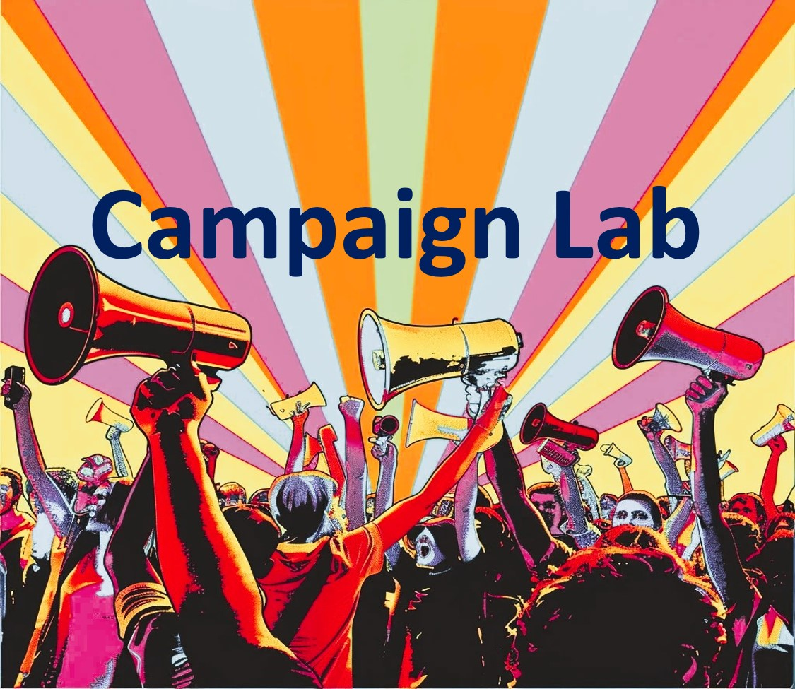
Invitation 2: Need support to achieve the win you want? Looking to connect with other unionists across the country to learn how to build people powered campaigns on HBCU and MSI Campuses? Join this online series that is just for you!
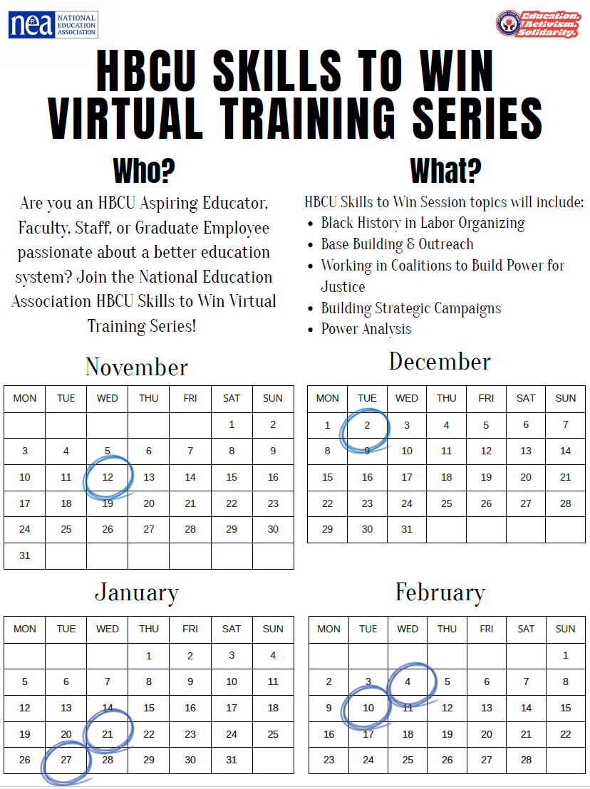
Let's Get Started!
To receive Zoom links for each of the sessions in this 6 part series, you have to be registered. Registration for this series requires the completion of 3 steps.
Step 1 : You must pre-register with NEA’s Staff Learning Portal known as PEPS at the following link: https://neapartnera.learnupon.com/users/sign_in
Step 2: Once you have accomplished Step 1, select the Unique Course link for this session named "HBCU and MSI Skills to Win," at the following link:https://neapartnera.learnupon.com/content-details/4748404/0,
Step 3: Select the button on the left of the screen that says. “Enroll.”
By completing steps 1-3, you can now access the materials & Zoom links for each of the sessions. It is recommended that you save or bookmark the NEA LearnUpon site to access materials & Zoom links.
Modules:
- Once you enroll, the course will open to a detailed description. You will also see a listing of the modules on the left-hand navigation window.
- Review “Community Agreements for Our Time” before the first session
- The modules, Participant Resources, Centering Equity in Your Campaign, HBCU and MSI Campaign Cycle Planning, Additional Resources, and Session PPTs each have descriptions for how they are to be used and will be updated throughout our time together.

Zoom links:
You will find the specific Zoom links for each of the sessions in the module titled, “HBCU and MSI Skills to Win”.
Trouble Shooting
If you experience issues, do not email Ellen until you have completed ALL the troubleshooting steps below. Then, if you need additional help after completing the troubleshooting below, Email both neahqhelp@nea.org and eholmes@nea.org with a description and screenshots of the error you are receiving. It is nearly impossible to help you without those.

Registration for PEPs Troubleshooting:
If you receive an invalid email or email in use message, that means that you are registered in another portal on our system. For example, Minnesota has a portal as part of our system and if you are a MN staff person, you might be registered in the MN portal with that email. About 21 States have a portal such as this. The solution is to register as a new user in this new portal with the same email and password you use in the original portal. Then, since both portals use the same credentials, you can log into one and have access to the other via a handy little toggle in the upper right corner of the screen called “the portal switcher”. It looks like a little 3-legged spider.
Do one of the following:
• If you can’t recall your password in the original portal, you can go to that portal and request a password reset. Once you’ve created a new password for the original portal, go to the new portal and register as a user with that same email and that same password.
• If you know your password for the original portal, you can use that same email and that same password to register as a user in the new portal. Then you’ll have a single log-in and have access to both.

If you receive a “resource not available” message when you select the course link, that means that you do not have the appropriate permissions to access the course and your account needs to be adjusted. Email BOTH neahqhelp@nea.org and Ellen Holmes eholmes@nea.org to get help.

Subject: Evaluation for Day 2 and Prepping for Day 3
Hello -
Everyone who is staying for the HBCU Summit must go to the front desk before breakfast and get your room rekeyed. IF you are leaving tomorrow, please check out before breakfast and bring your luggage to the office that is located near our training room. Reminder, the HBCU T-Shirts you received at the start of this pre-conference are to be worn on Saturday.
Thank you for you patience and grace as we transitioned rooms and adjusted curriculum real time based your needs. We were impressed with the evidence of your good thinking and the learning products you created. Please take time to complete our Day 2 Feedback Link Organizing on HBCU Campuses Day 2 – Fill out form.
Please remember that we begin at 8:30 in the morning. There is no prep tonight!!! So you COULD get caught up — LOL
Please sit in the same table teams in the morning.

Subject: Evaluation for Day 1 and Prepping for Day 2
Importance: High

Hello all
What a great day!!!

We use your feedback to make changes to our agenda and practices. We consider it essential to our work.

Please take five minutes at this link or QR Code and tell us how we are doing. Organizing on HBCU Campuses Day 1 – Fill out form

The energy for learning and the willingness to engage with us has been exciting. Please continue to work with the course materials. I believe that everyone is now “in” and able to navigate. Before tomorrow morning, please go to the vignette that has been assigned to you below. You will find your assigned vignette in the Participant Handouts Book you have been working in all day at the page number listed below.

First | Last | Vignettes
Adrianna | Hannon | pg 202
Armaan | Whitney | pg 202
Christina | Gordon | pg 202
Hannah | St. Clair | pg 202
KaLyn | Fagan | pg 202
Kiesha | Williams | pg 202
MaryRita | Watson | pg 202
Rachel | Grabowski | pg 202
Skylar | Nunley | pg 202
Tara | Richardson | pg 202
Albert | Jones | pg 203
Barbera | Whitman | pg 203
Danielle | Williams | pg 203
Ilissa | Morrow | pg 203
Karla | Medina | pg 203
LaQuita | Maxey | pg 203
Mia | Oliver Williams | pg 203
Rakia | Hardaway | pg 203
Syreese | Bailey | pg 203
Torina | Lewis | pg 203
Albert | Pearsall III | pg 204
Catherine | Wilson | pg 204
Elizabeth | Mathelier | pg 204
Jarmar | Muhammad | pg 204
Kayla | Mathis | pg 204
Lashay | Buckner | pg 204
Michelle | Couture | pg 204
Rita | Taylor | pg 204
Takisha | Durm | pg 204
Zenai | Randle | pg 204
ANGELA | THORNTON | pg 205
Cayla | Howard | pg 205
Ellen | Holmes | pg 205
Jasmine | Kinard | pg 205
Kennedy | Roberts | pg 205
Latrice | Patton | pg 205
Michiko | McClary | pg 205
Shanae | Bond | pg 205
Tammye | Walker | pg 205
Anthony | Swinton | pg 206
Chante | Palmer | pg 206
Vivian | Zimmerman | pg 206
Joshua | Frazier | pg 206
Keyerra | Chandler | pg 206
Lisa | Wilson | pg 206
Nandi | Riley | pg 206
Siala | Ene | pg 206
Taniya | Bannister | pg 206

Let's Get Started!
To receive Zoom links for each of the sessions in this 6 part series, you have to be registered. Registration for this series requires the completion of 3 steps.
Step 1 : You must pre-register with NEA’s Staff Learning Portal known as PEPS at the following link: https://neapartnera.learnupon.com/users/sign_in
Step 2: Once you have accomplished Step 1, select the Unique Course link for this session named "HBCU and MSI Skills to Win," at the following link:https://neapartnera.learnupon.com/content-details/4748404/0,
Step 3: Select the button on the left of the screen that says. “Enroll.”
By completing steps 1-3, you can now access the materials & Zoom links for each of the sessions. It is recommended that you save or bookmark the NEA LearnUpon site to access materials & Zoom links.

Modules:
- Once you enroll, the course will open to a detailed description. You will also see a listing of the modules on the left-hand navigation window.
- Review “Community Agreements for Our Time” before the first session
- The modules, Participant Resources, Centering Equity in Your Campaign, HBCU and MSI Campaign Cycle Planning, Additional Resources, and Session PPTs each have descriptions for how they are to be used and will be updated throughout our time together.

Zoom links:
You will find the specific Zoom links for each of the sessions in the module titled, “HBCU and MSI Skills to Win”.

Trouble Shooting
If you experience issues, do not email Ellen until you have completed ALL the troubleshooting steps below. Then, if you need additional help after completing the troubleshooting below, Email both neahqhelp@nea.org and eholmes@nea.org with a description and screenshots of the error you are receiving. It is nearly impossible to help you without those.

Registration for PEPs Troubleshooting:
If you receive an invalid email or email in use message, that means that you are registered in another portal on our system. For example, Minnesota has a portal as part of our system and if you are a MN staff person, you might be registered in the MN portal with that email. About 21 States have a portal such as this. The solution is to register as a new user in this new portal with the same email and password you use in the original portal. Then, since both portals use the same credentials, you can log into one and have access to the other via a handy little toggle in the upper right corner of the screen called “the portal switcher”. It looks like a little 3-legged spider.
Do one of the following:
• If you can’t recall your password in the original portal, you can go to that portal and request a password reset. Once you’ve created a new password for the original portal, go to the new portal and register as a user with that same email and that same password.
• If you know your password for the original portal, you can use that same email and that same password to register as a user in the new portal. Then you’ll have a single log-in and have access to both.

If you receive a “resource not available” message when you select the course link, that means that you do not have the appropriate permissions to access the course and your account needs to be adjusted. Email BOTH neahqhelp@nea.org and Ellen Holmes eholmes@nea.org to get help.

PREVIOUS EMAILS
Subject: Welcome and Prepping for Tomorrow – See you at 8:30 AM
Importance: High

Hello everyone,
The facilitator team looks forward to seeing you in the morning, all set up with your technology on and your documents all downloaded to your devices. We are in Rooms L504 and L505 on the lower level, where you checked in. Breakfast is provided beginning at 7:30 outside the training room. Lunch is at 12:00, and we adjourn by 5:00. There are water stations all day. There is no food or beverage served at break times; there will be a 15-minute morning and afternoon break. It is highly suggested that you make use of your travel mugs and fill them up at breakfast and lunch. Please remember that no fresh fruit may be consumed or opened in the training room or the area outside the training room. The meeting rooms are chilly; bring a couple of layers. I have included all other emails that were previously sent in case you missed one. PPTs that we are using will be uploaded to the Course in the same module where you find the Participant Handouts.

Reminder: On Thursday, ONLY FOR THOSE WHO ARE STAYING FOR THE HBCU SUMMIT - you will need to go to the front desk and get a new key. You will not be changing rooms, but you need to get a new key for your room.

Please make sure that you are able to access the online course following these 2 steps:
Step 1 : You must pre-register with NEA’s Staff Learning Portal, known as PEPS at the following link: https://neapartnera.learnupon.com/users/sign_in
Step 2: Once you have accomplished Step 1, select the Unique Course link for this session named "Organizing on HBCU Campuses, November 5-7, In Person" at the following link: https://neapartnera.learnupon.com/content-details/4713723/0
REMINDER - if you have issues of any kind with the Online course you must email neahqhelp@nea.org, put Issue with PEP course in the subject line, and in the body of the email describe your issue including a screen shot if necessary. You can CC eholmes@nea.org - but only emailing Ellen, just elongates the response time for help.

5 TASKS TO BE PREPARED FOR TOMORROW-

- Community Agreements- We begin our morning with a welcome and a review of the community agreements, please ensure you have completed that module and have your responses you wrote on Pg 3 available.
- Core Value Share Out - Core values are the fundamental beliefs of a person or an organization. These guiding principles dictate behavior and can help people understand the difference between right and wrong. These can often be expressed in one or two words. We are taking a moment to consider our core values because they can provide a basis for solidarity in the midst of struggles. Be ready to share your primary core value that directs your work decisions and be ready to share it in or two words (ex. Honesty, or Accountable Love) This will be an activity we do before 10:00 AM.
- Systems of Oppression – Review ONLY – Page 100, levels of Expressions of Oppression, and find the letter for your state from those in pages 101-148. You only need to be able to find it, and review. This will be later in the morning.

- Three Theories of Change – Review ONLY – Page 169 the table of descriptors for Advocacy, Organizing, and Mobilizing. There will be some time tomorrow for reflection on this table, but you need to be familiar with it. This will be later in the morning.
5. Poster Session Jig Saw - You have been assigned to a team below and each team has been assigned a section from the Participant Handout Document to be familiar with. All pages refer to the Participant Handout Document located in the Participant Handout Module in your online course. In the morning of Day 1 each team will create a Poster and 2 Minute presentation about the content they have been assigned. YOU will have work time in the room, but this will NOT include the time to read the assigned content.

Lashay | Buckner | 1: Tribal Colleges and Universities (TCUs) p. 17-28
Jasmine | Kinard | 1: Tribal Colleges and Universities (TCUs) p. 17-28
Kennedy | Roberts | 1: Tribal Colleges and Universities (TCUs) p. 17-28
Takisha | Durm | 1: Tribal Colleges and Universities (TCUs) p. 17-28
Torina | Lewis | 1: Tribal Colleges and Universities (TCUs) p. 17-28
Mia | Oliver Williams | 1: Tribal Colleges and Universities (TCUs) p. 17-28
Rita | Taylor | 1: Tribal Colleges and Universities (TCUs) p. 17-28
Lisa | Wilson | 1: Tribal Colleges and Universities (TCUs) p. 17-28
Elizabeth | Mathelier | 1: Tribal Colleges and Universities (TCUs) p. 17-28
Vivian | Zimmerman | 1: Tribal Colleges and Universities (TCUs) p. 17-28
Siala | Ene | 2: Hispanic Serving Institutions (HSIs)p. 29-39
Michiko | McClary | 2: Hispanic Serving Institutions (HSIs)p. 29-39
Hannah | St. Clair | 2: Hispanic Serving Institutions (HSIs)p. 29-39
Christina | Gordon | 2: Hispanic Serving Institutions (HSIs)p. 29-39
Kayla | Mathis | 2: Hispanic Serving Institutions (HSIs)p. 29-39
Albert | Pearsall III | 2: Hispanic Serving Institutions (HSIs)p. 29-39
ANGELA | THORNTON | 2: Hispanic Serving Institutions (HSIs)p. 29-39
Syreese | Bailey | 2: Hispanic Serving Institutions (HSIs)p. 29-39
Chante | Palmer | 2: Hispanic Serving Institutions (HSIs)p. 29-39
KaLyn | Fagan | 3: Historically Black Colleges and Universities (HBCUs) p. 40-69
Latrice | Patton | 3: Historically Black Colleges and Universities (HBCUs) p. 40-69
MaryRita | Watson | 3: Historically Black Colleges and Universities (HBCUs) p. 40-69
Rachel | Grabowski | 3: Historically Black Colleges and Universities (HBCUs) p. 40-69
Jarmar | Muhammad | 3: Historically Black Colleges and Universities (HBCUs) p. 40-69
Tara | Richardson | 3: Historically Black Colleges and Universities (HBCUs) p. 40-69
Tammye | Walker | 3: Historically Black Colleges and Universities (HBCUs) p. 40-69
Taniya | Bannister | 3: Historically Black Colleges and Universities (HBCUs) p. 40-69
Anthony | Swinton | 3: Historically Black Colleges and Universities (HBCUs) p. 40-69
Keyerra | Chandler | 3: Historically Black Colleges and Universities (HBCUs) p. 40-69
Cayla | Howard | 4: Asian American and Native American Pacific Islander-Serving Institutions (AANAPISI) p. 70-95
Zenai | Randle | 4: Asian American and Native American Pacific Islander-Serving Institutions (AANAPISI) p. 70-95
Catherine | Wilson | 4: Asian American and Native American Pacific Islander-Serving Institutions (AANAPISI) p. 70-95
Adrianna | Hannon | 4: Asian American and Native American Pacific Islander-Serving Institutions (AANAPISI) p. 70-95
Skylar | Nunley | 4: Asian American and Native American Pacific Islander-Serving Institutions (AANAPISI) p. 70-95
Nandi | Riley | 4: Asian American and Native American Pacific Islander-Serving Institutions (AANAPISI) p. 70-95
Danielle | Williams | 4: Asian American and Native American Pacific Islander-Serving Institutions (AANAPISI) p. 70-95
Shanae | Bond | 4: Asian American and Native American Pacific Islander-Serving Institutions (AANAPISI) p. 70-95
Armaan | Whitney | 4: Asian American and Native American Pacific Islander-Serving Institutions (AANAPISI) p. 70-95
- Case Studies for Intentional Power Building -You have been assigned a case and are responsible for reviewing it before 1:00 PM tomorrow. In the afternoon of day 1 the groups below will use their assigned case and analysis sheet found on Pages 172-191 (cases) and p. 192 (analysis sheet) in your participant handouts to do an analysis of intentional power building. YOU will have work time in the room as a team, but this will NOT include the time to read the assigned content.
First | Last | Cases
Lashay | Buckner | 1
Jasmine | Kinard | 1
Kennedy | Roberts | 1
Takisha | Durm | 1
Torina | Lewis | 1
Mia | Oliver Williams | 1
Rita | Taylor | 1
Lisa | Wilson | 1
Elizabeth | Mathelier | 1
Vivian | Zimmerman | 1
Keyerra | Chandler | 1
Siala | Ene | 2
Michiko | McClary | 2
Hannah | St. Clair | 2
Christina | Gordon | 2
Kayla | Mathis | 2
Albert | Pearsall III | 2
ANGELA | THORNTON | 2
Syreese | Bailey | 2
Chante | Palmer | 2
KaLyn | Fagan | 3
Latrice | Patton | 3
MaryRita | Watson | 3
Rachel | Grabowski | 3
Jarmar | Muhammad | 3
Tara | Richardson | 3
Tammye | Walker | 3
Taniya | Bannister | 3
Anthony | Swinton | 3
Cayla | Howard | 4
Zenai | Randle | 4
Catherine | Wilson | 4
Adrianna | Hannon | 4
Skylar | Nunley | 4
Nandi | Riley | 4
Danielle | Williams | 4
Shanae | Bond | 4
Armaan | Whitney | 4

10/27 Reminders and Updates and Previous Emails
Hello all – A critical reminder and an update about enrichment options. This emails contains all other emails that you have received from me.
REMINDER:
It is critical that you log in and complete the Online Course associated with this in-person event. You have to complete two steps, outlined below, to register for this.
Sent on October 10, 20205 –
Pre-Event Assignments and Participant Handouts - Ensure Access BEFORE October 27th.
Materials and Pre- Attendance Tasks
Our events are paperless unless you print the materials and bring them with you. All reading, all worksheets, and all PPTs used for your learning are within a course found on the NEA Learning Management System. Please make sure you can log in before October 27th since there's no onsite IT support. I've shared the detailed directions for access and troubleshooting below. Once logged in and registered, you will find a pre-attendance package chock-full of goodies for your busy brain to work on. Also, you will be able to download the Participant Handouts Package and access the PPTs for the meeting on your own device. Please ensure that your device of choice is large enough for you to easily work on and see. If you would like these items to be printed, please do so before attending, as we will not be providing any printed copies on-site. If not, simply make sure they are downloaded to your devices before attending. There are a number of required pre-academy activities for you to complete before arriving that will take an estimated time of 3 hours to complete.

To access your required pre-academy assignments and participant handouts you must complete the following:
Step 1 : You must pre-register with NEA’s Staff Learning Portal known as PEPS at the following link: https://neapartnera.learnupon.com/users/sign_in
Once you do this, you will be set for all future UniServ, Organizer, and Campaign Lab Events – Online or In-Person.

Step 2: Once you have accomplished Step 1, select the Unique Course link for this session named "Organizing on HBCU Campuses, November 5-7, In Person" at the following link: https://neapartnera.learnupon.com/content-details/4713723/0, then select the button on the left of the screen that says. “Enroll.” The course will open to a detailed description of what you will need to do to be ready for our time with you. Scroll through all the details. You will also see a listing of the modules on the left-hand navigation window. The modules contain fillable PDFs and other resources you will need to DOWNLOAD TO YOUR DEVICE before you arrive. This allows you to enter your work directly into the document. If you prefer a paper-based packet, please print and bring it with you. The modules, Daily PPTs, and Additional Resources will be updated throughout our time together with PPTs and other resources you might need.

Trouble Shooting
If you experience issues, do not email Ellen until you have completed ALL the troubleshooting steps below. Then, if you need additional help after completing the troubleshooting below, Email both neahqhelp@nea.org and eholmes@nea.org with a description and screenshots of the error you are receiving. It is nearly impossible to help you without those.

Registration for PEPs Troubleshooting:
If you receive an invalid email or email in use message, that means that you are registered in another portal on our system. For example, Minnesota has a portal as part of our system and if you are a MN staff person, you might be registered in the MN portal with that email. About 21 States have a portal such as this. The solution is to register as a new user in this new portal with the same email and password you use in the original portal. Then, since both portals use the same credentials, you can log into one and have access to the other via a handy little toggle in the upper right corner of the screen called “the portal switcher”. It looks like a little 3-legged spider.
Do one of the following:
• If you can’t recall your password in the original portal, you can go to that portal and request a password reset. Once you’ve created a new password for the original portal, go to the new portal and register as a user with that same email and that same password.
• If you know your password for the original portal, you can use that same email and that same password to register as a user in the new portal. Then you’ll have a single log-in and have access to both.

If you receive a “resource not available” message when you select the course link, that means that you do not have the appropriate permissions to access the course and your account needs to be adjusted. Email BOTH neahqhelp@nea.org and Ellen Holmes eholmes@nea.org to get help.

UPDATE: Optional Enrichment Visit: The Martin Luther King Jr. Center for Nonviolent Social Change https://thekingcenter.org/
We encourage you to find some time outside of our training agenda to visit the Martin Luther King J. Center. All the information you need is listed below.
Visits to the Center are self-guided and there is no admission fee. Ample free parking for personal vehicles and tour buses is available. The parking lot address is: 423 John Wesley Dobbs Ave., NE; ATL GA 30312. The Center’s hours are:
· Monday thru Saturday – 10:00AM – 5:00PM
· Sunday – 11:00AM – 5:00PM
The Center’s campus comprises three areas:
· Freedom Hall – Dr. & Mrs. King and Mahatma Gandhi exhibits are housed here.
· The Reflecting Pool – Crypt where Dr. & Mrs. King are entombed.
· The Coretta Scott King Peace and Meditation Garden - located across from the Crypt.
It is suggested that you start your visit at The Visitor Center/Museum [450 Auburn Ave. NE; ATL GA 30312 [ph.: 404-331-5190 follow the prompts for recorded information]. This building is across the street from the King Center's grounds and is clearly marked. You can view it on the website. There is also a brick sign drivers can use as a marker for drop-off. Currently, in the Visitor Center, there are some exhibits as well as an information film that plays every hour on the hour starting at 10:00AM. Last viewing of the referenced film is at 4:00PM each day. Although the Birth Home is closed for tours until November 2025, a National Park Service Ranger is available to share a presentation about the Home, if you sign up at the Visitors’ Center.
Currently - - the Birth Home Program is done at 10:00AM; 11AM; 2PM; 3PM; 4PM
The National Park Service website, Martin Luther King, Jr. National Historical Park (U.S. National Park Service; www.nps.gov/malu) should have the most up-to-date information re: the Visitor Center/Museum and the birth home presentation. PLS. NOTE: The Martin Luther King, Jr. National Historical Park is a unit of the National Park Service and is a separate entity from The King Center.
Additional FYI about a King Center visit - - - In addition to the exhibits, the National Park Service (“NPS”) conducts “Church Talks” in the sanctuary of Historic Ebenezer Church.
CURRENT “Church Talks” PRESENTATION TIMES:
Monday through Saturday - - 11AM, 2PM & 3PM
Sundays - - Noon; 2PM and 3PM.
Plan to arrive 5 – 10 minutes before the scheduled talk you want to join.
A National Park Service ranger will announce the next available time if a slot is full.
All of these mentioned sites are within walking distance of each other.
It will also be beneficial to review https://thekingcenter.org/what-we-do/ . There, you can learn more about the Center’s mission and vision and how Dr. King’s principles of nonviolence can be learned, adopted, and shared in your personal and professional life.

PREVIOUS EMAILS FROM ELLEN AND KARLA
Hello all!
Welcome to the Organizing on HBCU and MSI Campuses Winning Campaigns Academy Track. This is a VERY long email with a lot of details you will need. There is an action item that must be completed by October 27th described below. Please read this email carefully and save it for your reference. You should have already received an email from Karla Medina and/or Jasmine Eatmon regarding your registration and information for securing flights. I have included that at the end of this communication for easy reference. You may have begun receiving confirmation emails about your room from the hotel. A final rooming list will be sent by Karla Medina and /or Jamine Eatmon in the coming days.
Dates: Wednesday, November 5 - Friday, November 7, 2025
Location: Atlanta Marriott Marquis in Atlanta, Georgia (265 Peachtree Center Ave NE, Atlanta, GA, 30303, US)
Basic Agenda
Our meeting will convene at 8:30 am on the 5th and conclude at 2 pm on the 7th. Breakfast will be served from 7:30 to 8:30 am . Lunch is served from noon to 1:00 pm Monday through Wednesday and Friday is on your own. Monday through Wednesday, our classroom time ends at 5:00. On Friday, we will adjourn by 2:00 and lunch is on your own. You are expected to attend all portions of this event.
Communications
You should expect an evening email on Sunday before the start of our session. This email will have additional information about the meeting room location, any new directions, and locations for breakfast and lunch. You will receive an evening email each night with a feedback form and will reference any files you will need to access from our Online Learning Portal. Any questions you have about the content should be sent to eholmes@nea.org and any questions about the hotel, flights, food, and expense process should be sent to kmedina@nea.org.
What to Pack
Please dress comfortably, and feel free to wear your audacious HBCU, Soro, and Union solidarity swag. PROFESSIONAL BUSINESS ATTIRE IS NOT REQUIRED. Conference rooms are notorious for being too hot or too cold, so please bring layers so that you can adjust to your own comfort needs.
Expectations
You are expected to attend all portions of this event. Should your absence result in attrition costs, your affiliate may be charged for those. You will be required to use a laptop or other device capable of accessing the internet and your materials for this meeting. We will have electricity at each table to support this. Please work with your IT department to make sure that these can connect to public Wi-Fi such as you find in a school or a conference meeting room.
Pre-Event Assignments and Participant Handouts - Ensure Access BEFORE October 27th.
Materials and Pre- Attendance Tasks
Our events are paperless unless you print the materials and bring them with you. All reading, all worksheets, and all PPTs used for your learning are within a course found on the NEA Learning Management System. Please make sure you can log in before October 27th since there's no onsite IT support. I've shared the detailed directions for access and troubleshooting below. Once logged in and registered, you will find a pre-attendance package chock-full of goodies for your busy brain to work on. Also, you will be able to download the Participant Handouts Package and access the PPTs for the meeting on your own device. Please ensure that your device of choice is large enough for you to easily work on and see. If you would like these items to be printed, please do so before attending, as we will not be providing any printed copies on-site. If not, simply make sure they are downloaded to your devices before attending. There are a number of required pre-academy activities for you to complete before arriving that will take an estimated time of 3 hours to complete.

To access your required pre-academy assignments and participant handouts you must complete the following:
Step 1 : You must pre-register with NEA’s Staff Learning Portal known as PEPS at the following link:
https://neapartnera.learnupon.com/users/sign_in
Once you do this, you will be set for all future UniServ, Organizer, and Campaign Lab Events – Online or In-Person.

Step 2: Once you have accomplished Step 1, select the Unique Course link for this session named "Organizing on HBCU Campuses, November 5-7, In Person" at the following link: https://neapartnera.learnupon.com/content-details/4713723/0, then select the button on the left of the screen that says. “Enroll.” The course will open to a detailed description of what you will need to do to be ready for our time with you. Scroll through all the details. You will also see a listing of the modules on the left-hand navigation window. The modules contain fillable PDFs and other resources you will need to DOWNLOAD TO YOUR DEVICE before you arrive. This allows you to enter your work directly into the document. If you prefer a paper-based packet, please print and bring it with you. The modules, Daily PPTs, and Additional Resources will be updated throughout our time together with PPTs and other resources you might need.

Trouble Shooting
If you experience issues, do not email Ellen until you have completed ALL the troubleshooting steps below. Then, if you need additional help after completing the troubleshooting below, Email both neahqhelp@nea.org and eholmes@nea.org with a description and screenshots of the error you are receiving. It is nearly impossible to help you without those.

Registration for PEPs Troubleshooting:
If you receive an invalid email or email in use message, that means that you are registered in another portal on our system. For example, Minnesota has a portal as part of our system and if you are a MN staff person, you might be registered in the MN portal with that email. About 21 States have a portal such as this. The solution is to register as a new user in this new portal with the same email and password you use in the original portal. Then, since both portals use the same credentials, you can log into one and have access to the other via a handy little toggle in the upper right corner of the screen called “the portal switcher”. It looks like a little 3-legged spider.
Do one of the following:
• If you can’t recall your password in the original portal, you can go to that portal and request a password reset. Once you’ve created a new password for the original portal, go to the new portal and register as a user with that same email and that same password.
• If you know your password for the original portal, you can use that same email and that same password to register as a user in the new portal. Then you’ll have a single log-in and have access to both.

If you receive a “resource not available” message when you select the course link, that means that you do not have the appropriate permissions to access the course and your account needs to be adjusted. Email BOTH neahqhelp@nea.org and Ellen Holmes eholmes@nea.org to get help.

PREVIOUSLY SENT FROM Jasmine Eatmon
From: Eatmon, Jasmine [NEA] <JEatmon@nea.org> On Behalf Of Israel, Tom [NEA]
Sent: Tuesday, September 16, 2025 1:47 PM
Subject: SHARE: Invitation to NEA HBCU Summit

TO: NEA State Presidents and State Executive Directors in States with HBCU’s

FROM: Tom Israel, Senior Director, Center for Organizing & Affiliate Support
Marcy Kamienecki, Field Manager, Center for Organizing & Affiliate Support
Date: September 16, 2025

Invitation to Join us for 2025 National Education Association (NEA) HBCU Summit, November 7-9, 2025, at the Atlanta Marriott Marquis in Atlanta, Georgia.

This year’s conference theme is Still We Rise – The HBCU Blueprint for building power.
NEA is proud to sponsor an HBCU Summit focusing on members from HBCU’s. The 2025 NEA HBCU Summit is more than a conference it is a call to action. Faculty, staff, graduate assistants and Aspiring Educators from HBCU’s will come together to build relationships, learn together and strengthen our organizing power. Together, we will confront the challenges facing our campuses, celebrate the vital role of HBCU’s in shaping excellence and develop organizing strategies that ensure our unions grow stronger and our voices carry further. This is our space to dream, to plan and to act united for justice, equity and a brighter future for our communities. This summit offers space to connect, learn from peers and develop action plans that address the unique challenges and opportunities within HBCU’s today.

Target Audience: NEA Members at HBCU’s - Aspiring Educators, Members from Faculty, Staff, Graduate Assistants and State Affiliate Staff who work with HBCU’s.

NEA HBCU Summit Team Configuration – We strongly encourage HBCUs to register and attend as teams including faculty, graduate assistants, aspiring educators, state affiliate staff to maximize collaboration and impact. If you need any additional information or help with recruiting members to attend, please reach out for assistance. Each of the state affiliate teams should be comprised of the following:

Team Make-Up
State Affiliate Staff* that work with HBCUs
At least 1 HBCU Aspiring Educator program advisor*
At least 1-4 HBCU Aspiring Educator members* from each HBCU in your state (1-4)
At least 1-3 Faculty or Staff member* from each HBCU (1-3)
Early Career Educator alumni from an HBCU**
*Required team members
**Recommended

Costs/Funding
NEA Members Registration Fee $50.00
NEA Aspiring Educators Registration Fee $25.00. A limited number of scholarships are available for Aspiring Educators.
NEA will cover the costs for hotel accommodation and air travel to Atlanta GA. We will also cover the conference meals during the HBCU summit.

Register HERE By October 24, 2025

We look forward to your participation in NEA HBCU Summit. If you have any questions, please email or call one of the following: LaQuita Maxey, Lmaxey@nea.org 202-322-7805 for any program questions or Karla Medina, Kmedina@nea.org 202 822-7923 for any logistical questions.

