Facilitator Agenda – Day 1 November, 5 2025
General Materials Needed: |  |  |  | Room Set-up:
1 Set of Handouts per Person  Name Tents with the Norms  Room signs,  One ream of white photocopy paper  Chart Paper (4 to 5 full w Sticky Strip) |  | Materials Box for each table with:  Markers (Mr. Sketch variety)  Post its – 3x3” and 4X5” sizes  Index Cards  Highlighters – 4 colors  Pens and Pencils  Participant “toys |  | Long Rectangle table at back for facilitators  Round Tables for participants  Projector, Screen, mics, and Speakers  Carousel stations and reporting stations  No podium, table with projector big enough for laptop  50 people max
Key Outcomes for the Event:
Participants will understand the role staff play in building locals while maintaining a member-driven program on HBCU campuses
Participants will explore best practices from a number of member engagement case studies
Participants will explore successful affiliates that have focused on HBCU Programs and Campaigns
Participants will develop skills around strategic planning, leadership tests, data collection, and narrative development

Overview of Content, Time, and Facilitator Assignment
8:30-9:00 Getting Started  9:00-9:20 HBCU’s and MSI’s - A Difference that Matters  9:20- 10:20 Socialization and Bias/ Anti-Racism  10:20-10:35 Break  10:35-12:00 Systemic Underfunding: Impacts on Workers and Resources  12:00 -1:00 Lunch | Ellen  LaQuita and Michelle  Ilissa and Barb  Albert and Kiesha  Michelle and Rakia |  | 1-2pm Lived Values of Unionism and Anti-Racism  2-2:45pm What is your Role? (AE, Faculty Staff, Grad Assistants, State Affiliate Staff)  Break  3-3:30 Organizing Differently  3:30-4:15 Organizing in Unfamiliar Spaces – How our locals organizing or services models. How do we shift the model.  4:15-4:30 Ending it Right |  | Josh and Ilissa  Barb and Kiesha  Albert and Ilissa  Michelle and Josh  Ellen

Time Slides Facilitator | Resources | Instructions, Activity and Debrief (Facilitators) | Essential Questions and Outcomes
 | Charts, handouts, articles, materials, slide | What are you saying, what are they doing, what questions will you use to guide learning and make clear the important points  Include an estimate for how long each section of the learning will take | What question(s) will this learning answer? What will participants know or be able to do?
7:00 -8:30 – Team prep, practice, room set up, sound check, etc.
Entry Activity
Each person gets an HBCU card, and they learn about a HBCU or Minority Serving Institution person, site, event, historical event. This will be used for a HBCU or BIPOC institution Merry Mixer later.
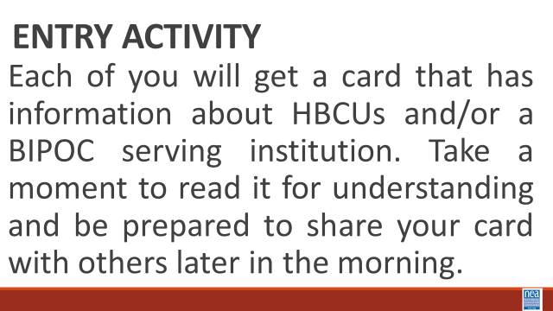
8:30 -9:00 Ellen |  | 30 Mins TOTAL Getting Started
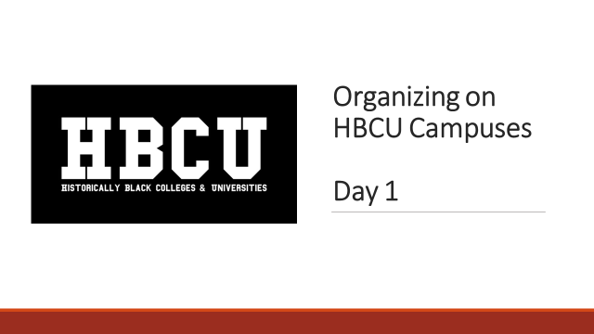  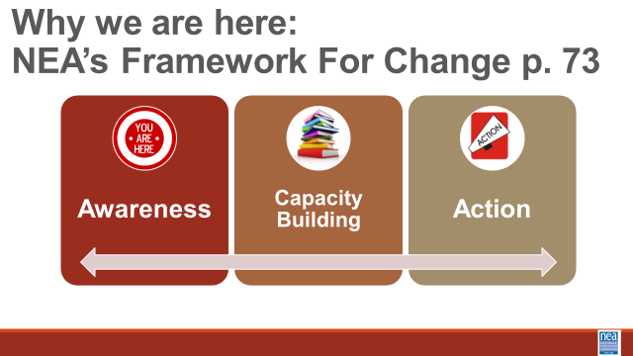  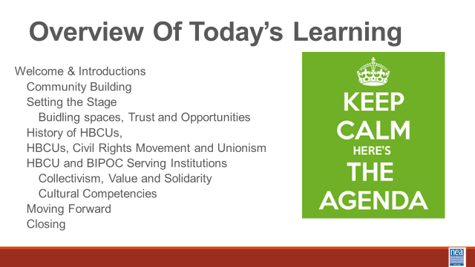  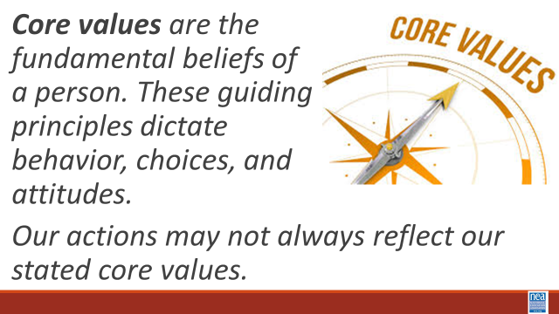  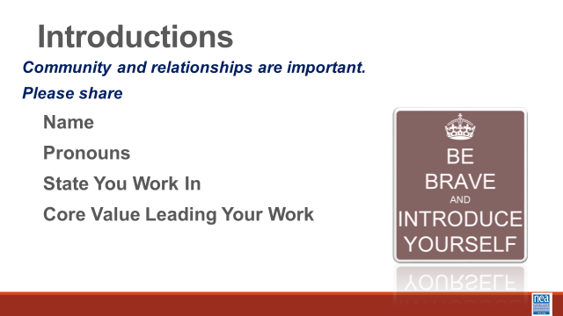  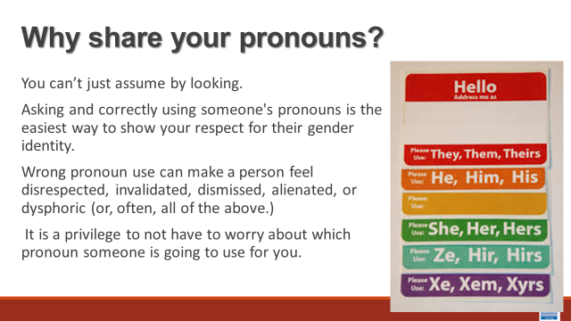  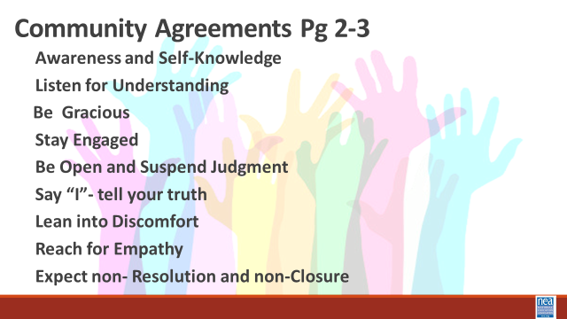  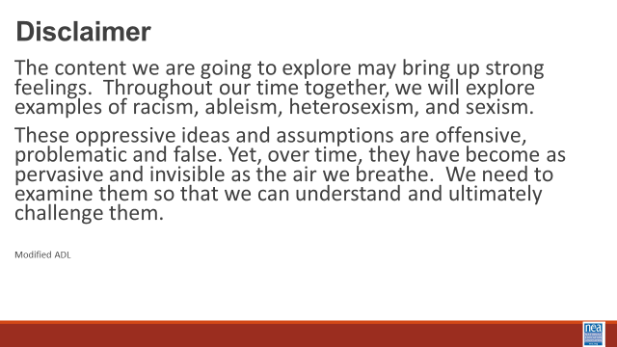 | Norms in Handouts  Agenda on Slides  Parking Lot Chart  Name Tents  Handout Package | 15 Mins – Welcome, honor the space, overview of learning goals, overview of days agenda and logistics –  Honoring this Space  We acknowledge the long history of systemic racism, oppression, and genocide that has shaped the land on which we stand today. This land was once home to Indigenous peoples who lived in harmony with their environment for millennia. Their sacred sites, cultural practices, cultural practices, and deep connections to the land were violently disrupted by colonial policies that sought to erase their existence. The forced removal, displacement, and dispossession of Indigenous communities from their ancestral lands continue to have lasting impacts on their social, cultural, and economic well-being.  We also acknowledge the trauma inflicted upon those who were trafficked, forced into servitude, or made undocumented through colonial and federal practices. This includes Indigenous peoples, enslaved Africans, and other marginalized groups who were brought to this land against their will, enduring systemic violence and exploitation.  We recognize that the United States was built on the backs of enslaved Black people, whose labor and sacrifices were exploited to build the foundations of this nation. The contributions of enslaved Black people, along with the struggles and perseverance of other immigrant communities throughout history, have been essential to the development of this country. Yet, their labor and humanity were often dehumanized, and their rights stripped away, perpetuating cycles of inequality and injustice that persist today.  We stand in solidarity with the ongoing efforts of Indigenous peoples, Black communities, and all marginalized groups fighting for justice, reparations, and the healing of the wounds inflicted by these histories of colonization, enslavement, and systemic oppression. We are committed to learning, unlearning, and working towards a more just, equitable, and inclusive future.  Why are we here - Framework for Change  We move through stages of awareness, capacity building into action. In this training we are helping you become aware of where you are in regards to racial justice, we will be increasing our capacity by building our skills and understanding, and we will begin to make plans for actions we can take.  Participants will learn how to build strong programs that elevate leaders, mobilizers, and activists in this important higher education setting. UniServ Directors and Organizers will:  - Understand role staff play in building locals while maintaining a member-driven program  - Explore best practices from a number of member engagement case studies  - Explore a number of successful affiliates that have focused on HBCU Programs and Campaigns  - Develop skills around strategic planning, leadership tests, data collection, and narrative development.  - Organizing new locals/chapters  Family Meeting- Extra for member/staff teams: Different space that what we are used to. Folks are members. Folks are staff. Maybe a new type of nervousness that we can’t predict? Try to solve problems in room, not by going to management at get.  8 minutes – Why is this our work?  Historical legacy of exclusion and struggle  Intersection of Race, class and labor  Building Collective Power  Creating sustainable change  Empowerment through education  Building Solidarity  BE SURE TO inoculate participants about who is in the room – all constituencies – ESP, Faculty, and AEs  In our time together over the next couple of days, we will take a more in depth look at Organizing at HBCU and BIPOC institutes. We will discuss these institutes' history and their connection to unionism. Understanding the culture and the staff role in this work and how we can work together to move this work.  These institutions of higher education provide their graduates with much higher rates of upward economic mobility than graduates of predominantly white institutions (PWIs). Despite this, systems of power and inequality still plague the workers and students on these campuses. UniServ and Organizers in these settings have to be highly skilled in leading, coaching and organizing across racial differences and especially in dealing with systems of economic and racial oppressions.  Racial justice is the systematic fair treatment of people of all races, resulting in equitable opportunities and outcomes for all. In order to have this discussion, we need to do an explicit, though not exclusive, examination of race and all aspects of our identity and look at how it compounds and intersects with other societal issues.  Please keep this Our essential question throughout this examination is this: As affiliate staff what does this mean in your work?  10 Mins -Introductions around the room – Share Name, work location and pronouns  Pronoun explanation is dropped in by the facilitator just in case it is needed BEFORE THE facilitators model-We cannot assume how someone identifies, we must allow them to tell us their preference and honor that. We need to be inclusive of all genders and non-genders.  Show the Pronoun slide and say:  You can't always know what someone’s Gender Pronoun is by looking at them. · Asking and correctly using someone's preferred pronoun is one of the most basic ways to show your respect for their gender identity. · When someone is referred to with the wrong pronoun, it can make them feel disrespected, invalidated, dismissed, alienated, or dysphoric (or, often, all of the above.) · It is a privilege to not have to worry about which pronoun someone is going to use for you based on how they perceive your gender. If you have this privilege, yet fail to respect someone else's gender identity, it is not only disrespectful and hurtful, but also oppressive.  Trainers will begin by modeling what is expected - briefly introduce themselves, their preferred pronoun, and the state they are from. These guiding principles dictate behavior and can help people understand the difference between right and wrong – one or two words) as a way of modeling for participants – less than 20 seconds per person.  20 Mins - Community Agreements for Our Time – Give this about 5 to 10 minutes -Ask participants to review the community agreements sent in advance and to review the three questions that they were asked to think about. Have a small table conversation in preparation for a whole group commitment.  Awareness and Self-Knowledge  Listening for Understanding  Being Gracious  Stay Engaged  Be Open and Suspend Judgment  Say “I”- tell your truth  Lean into Discomfort  Reaching Empathy  Resolution and Closure  Allow about 5 to 10 Mins – Participants will share their responses, suggestions, changes, etc. Then facilitator will call for a visual community commitment. This is a shift from colonizer norms that aim to preserve the order of the conversation and maintain the focus of the power. These are commitments that we have each reviewed and will change as needed. By consensus we will agree to work with these until we need to make a change. Consensus means we all agree that these are good enough to get us moving. Show your thumbs and hold them up and keep them up until I have had a chance to view the whole room. Up thumb means – love it, nothing needs to change for me. Sideways thumb means – I can live with it for now. Down thumb means I cannot move forward until we discuss and come to a decision about…- and the down thumb leads the discussion on that UNTIL it can at least become a sideways thumb.  Disclaimer- Warning -Before we dive into what this means to you, we begin with a disclaimer. If we do this right, you are going to be uncomfortable. The content we are going to explore may bring up strong feelings. Throughout our time together, we will explore examples of racism, ableism, heterosexism, and sexism. These oppressive ideas and assumptions are offensive, problematic and false. Yet, over time, they have become as pervasive and invisible as the air we breathe. We need to examine them so that we can understand and ultimately challenge them. | Participants will know how we are going to work, the basic schedule, and the logistics relevant to the training.
9:00-9:20 – LaQuita and Michelle | 20 Mins TOTAL The Federal Administration Discussion --
 | This will be of a whole room discussion and a lot of mic movement.  (Kiesha Timer) | 1 Minutes – Intro -- Facilitators – Keep this focused – the intent is for them to process how they are feeling.  Facilitator Note – take just 2 minutes with your elbow neighbor to discuss the following question to get ready for a whole room conversation. Which of your Core Values were highlighted, challenged, or affirmed by the current attacks on education?  How are you managing any anxieties or stress related to the current federal administration?  10 Minutes of content about the current changes to HBCU and MSI presented by LaQuita  Then allow for 8 minutes f What is your top line take away – and do not repeat. - there is no time for this- emphasis on why they are here- and share this instead:  End with Hope- since federal stuff is heavy  Quote by Maya Angelou-  Hope and fear cannot occupy the same space. Invite one to stay. | Participants will understand that each person has a valid and different experience with the election and that will affect how they engage in this space. We all react to current times based on our lived experiences.
9:20- 10:15 - Ilissa and Barb |  | 55 Mins TOTAL – HBCUs and MSI – A Difference that Matters
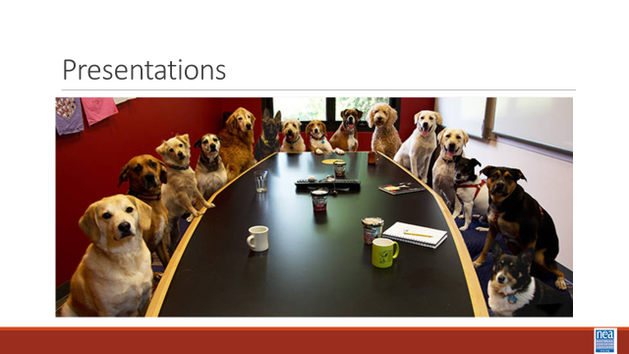 | Day 1 Merry Mixer Card File | 20 minutes – Merry Mixer  3 Minutes – Set up activity (You also did a pre academy module on this topic and the file for these cards are in that module)  - Each participant will receive an HBCU History Card. Take 3 minutes to read your HBCU/MSI card.  - Pair & Share: When prompted, you will find a partner. You will have 90 seconds each to share two takeaways of your HBCU/MSI history card.  - When signaled, you will find a different partner and repeat. There will be three (3) rounds in this activity.  9 minutes – Three 3-minute rotations  5 minutes – Debrief – Using the questions below  - What surprised you?  - What is the historical significance?  - What is something that you learned that is still relevant today?  - What aspects of this history/information align with “union values”?  SECOND SECTION BEGINS HERE WITH 35 Minutes  Ilissa picks up  5 minutes – Poster Session Activity Set Up  On the evening email pre-assign folks to the reading below and ask them to review it.  PG. Numbers-  TCU p. 14-28  HSI p. 29-39  HBCUs p 40-68  AANAPISA p 69-95  - Get into your assigned group --  - 1: Tribal Colleges and Universities (TCUs) p. 14-28  - 2: Hispanic Serving Institutions (HSIs)p. 29-39  - 3: Historically Black Colleges and Universities (HBCUs) p. 40-68  - 4: Asian American and Native American Pacific Islander-Serving Institutions (AANAPISI) p. 69-95  - Form groups based on the number assigned when counting. (If a group is too large, split them up into smaller groups.)  - Each group is assigned an institution (see above). In their groups they will review the resources provided and create a Poster on chart paper that they will then present to their colleagues. Its a Poster Session!  - Make sure they are clear of what page(s) in the participant handout they are responsible for reviewing and working from.  - In groups, ensure they select one or two speakers to present your chart to the group. They will have 2 minutes to present their chart to the group.  - Questions to consider when reviewing resources and creating their posters to present:  - What information should others see/know that clearly communicates what this institution(s) is/are?  - What celebration, joy, and/or significance is found within these institution(s)?  - What challenges do these institution(s) face?  - Why are these types of institutions great places to organize students, faculty, and staff?  - Is there anything that the room should hear/see?  15 minutes – Group Work Time  True 15 minutes needed to read and complete charts  15 minutes – Presentations  - Each group has 2 minutes to present their chart  2 minutes - Key Points  - HBCUs and MSIs have a rich legacy and culture that is centered in shared equity and advancement.  - These institutions have been centers of innovation and progress for marginalized people and their communities despite being systemically underfunded.  - Collectivism over individualism. | Participants will create information charts to share the foundational understandings with each other of HBCUs and MSIs.  This is a historical perspective and at a higher level, into the current day.
10:20-10:35 |  | BREAK
10:35-11:00 - Albert and Kiesha |  | 25 Mins Total – Socialization and Bias
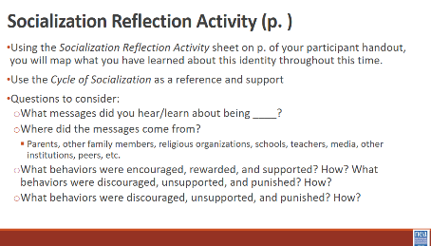  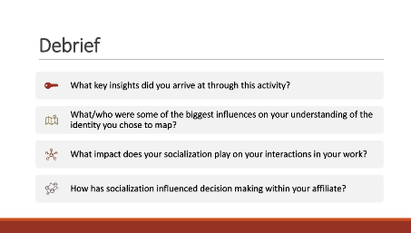  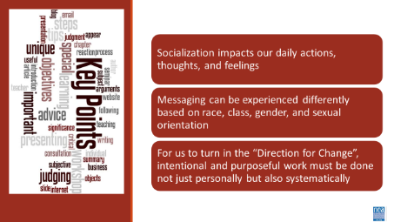 | Handout: Cycles of Socialization  Pg. 96  2nd File  Handout: Socialization Reflection Activity\  Pg. 97 and 2nd file in the participant handout module  Sticky Notes  Handout: Cycles of Liberation | 5 minutes – Review Cycle of Socialization  Kiesha starts  Ask the question: When you want to learn something new, what do you do? (Quick mic passes) This is the impact of socialization. (slide 36)  Define Socialization and Bias  - Socialization: (n) the process beginning during childhood by which individuals acquire the values, habits, and attitudes of a society (Merriam-Webster)  - Bias: (n) a tendency to believe that some people, ideas, etc., are better than others that usually results in treating some people unfairly (Britannica)  We consider this framework when thinking about how we develop our understanding of various identities.  Show Cycles of Socialization graphic (p.96 of participant handout and 2nd file in Participants Handout Module – it is a fillable form)  There are a variety of factors that impact how we acquire perspectives of individuals. Individuals, institutions, organizations, and media all impact how we shape our biases and thoughts around individuals from a variety of identities.  10 minutes - Socialization Reflection Activity (this part is done as a personal reflection activity, and folks WILL NOT have to share anything about this )  - Choose one social identity from the list below that you would like to reflect on and examine.  - Race: A social construct that artificially divides people into distinct groups based on certain characteristics such as physical appearance (particularly skin color) ancestral heritage, cultural affiliation, cultural history, ethnic classification  - Gender Identity: An internal, deeply felt sense of being female, male, a blend of both or neither. Refers to how individuals perceive themselves and what they call themselves. Can be the same as or different from their sex assigned at birth  - Sexual Orientation: An inherent or immutable enduring emotional, romantic, or sexual attraction to other people  - Class: Relative social rank in terms of income, wealth, education, status and/or power  - We are operating under the above common definitions for race, gender identity, sexual orientation, and class.  - Using the Socialization Reflection Activity sheet on p.97-98 in the participant handout and the 3rd file in your handout, you will map what you have learned about this identity throughout this time  - Use the Cycle of Socialization as a reference and support  - Questions to consider:  - What messages did you hear/learn about being ____?  - Where did the messages come from?  - Parents, other family members, religious organizations, schools, teachers, media, other institutions, peers, etc.  - What behaviors were encouraged, rewarded, and supported? How?  - What behaviors were discouraged, unsupported, and punished? How?  Albert picks up  12 minutes – Debrief  Facilitated Debrief (below are questions that can help frame the discussion – remind them that this is about the reflection process not their actual answers on the specific individual reflections)  - What key insights did you arrive at through this activity?  - What/who were some of the biggest influences on your understanding of the identity you chose to map?  - What impact does your socialization play on your interactions in your work?  - How has socialization influenced decision making within your affiliate?  1 minute – Touch on Cycle of Liberation Pg. 99 in the Handouts  - With the intentional socialization we’ve discussed, consider the cycle of liberation as a framework to progress.  - Find this on p 99. of your participant handout  - Moving from Bobbie Harro's Cycle of Socialization to the Cycle of Liberation involves shifting from learned roles and biases to actively challenging oppressive systems.  - This transition requires self-awareness and a commitment to unlearning harmful narratives, creating a foundation for being an accomplice and solidarity.  - It empowers individuals and communities to engage in collaborative action, aiming to dismantle systemic inequities and achieve collective freedom.  - This connects directly to the levels of oppression (intrapersonal, interpersonal, systemic) in the next section AND to the initial discussion of core values (center of the cycles of liberation; also discussing core values in unionism later today) in the beginning of the day  3 minutes – Key Points  - Socialization impacts our daily actions, thoughts, and feelings  - Messaging can be experienced differently based on race, class, gender, and sexual orientation  - For us to turn in the “Direction for Change”, intentional and purposeful work must be done not just personally but also systematically
11:00–12:00 (Michelle and Rakia) |  | 60 Minutes Total Systemic Underfunding: Impacts on Workers and Resources
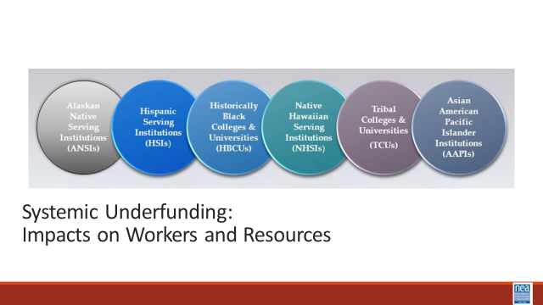  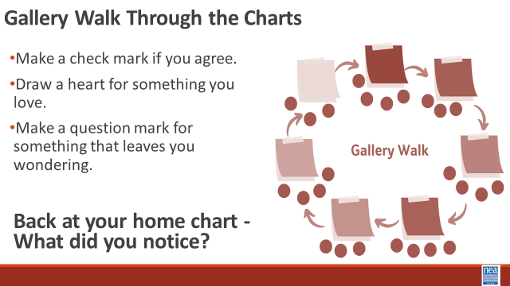  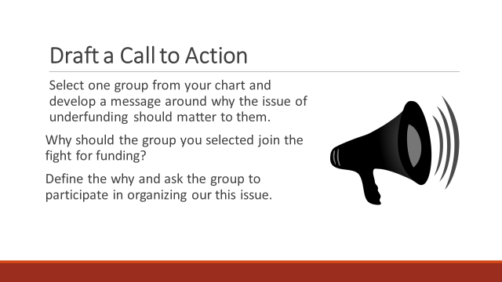  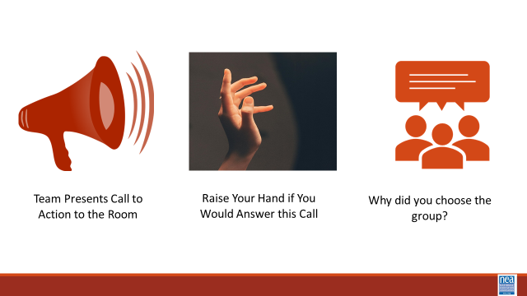  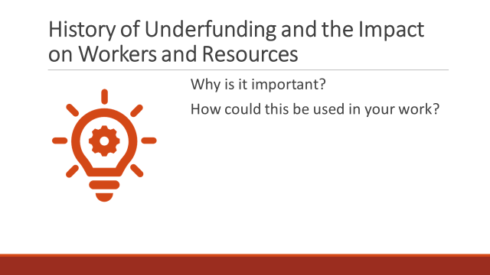 | Levels of Expression of Oppression Handout Pg. 100  A Looming Crisis for HBCU's Analysis of Funding Sources for Land Grant Universities  Sept 2023 Letter to governors regarding money owed to HBCUs. history of underfunding  Underfunding HBCUs leads to an underrepresentation of Black faculty (brookings.edu)  FACT SHEET: State-by-State Analysis of Record $2.7 Billion American Rescue Plan Investment in Historically Black Colleges and Universities | The White House  Opinion | Black colleges do more with less funding. Give them more. - The Washington Post | (HBCU’s versus PWI public universities in the same state)  3 Minutes- Introduction - The cycle of socialization feeds into how oppressions are realized. A useful framework for looking at this are the four levels of expressions of oppression. Find this document on p. 100 of your participant handout. This framework can be used to help us assess how much resource we must make change and then apply that strategic use of resource at the level we have the best chance to win. For example, let’s say you want to achieve an anti-racist society – but you only have the resources to hold series of trainings for staff about unconscious bias – you will have to monitor and adjust your outcomes – or amass a whole lot more resource. The key point to remember when you use this framework is that there are not hard and fast lines between the levels and that making a change at any one level can catapult a change at another level – but it requires intention and escalation of actions, efforts, and resources.  We are going to look at how an expression of oppression plays out in the funding of non PWI colleges and universities. There is a history of underfunding that has existed and an already won legal fight to name the amount of reparations that need to be paid to each non PWI. The question I want you to consider as we do this activity – can the fight for equal funding be won by using only a legal approach? Does the use of a legal approach transform the power dynamics that allow for the expression of oppression?  WE need a people power approach if we are going to get the funds to the HBCUs  20 Minutes – Make A Freyer Chart  Use pages 101- 148 – you were asked last night to find the letter specific to your state. Go ahead and pull that up. Participants will have 18 minutes to read and create a Freyer Chart to identify the organizing issues related to the underfunding of HBCUs for faculty, students, campus workers and community members. Participants will be in groups of 3 to 4. Each group will read one of the letters to the governors from the Secretary of Education from their state. They will organize their responses to the following questions in a Freyer Chart format using chart paper and markers.  Center square - what is the organizing issue in this letter?  Quadrant 1 – how do we make this a faculty issue?  Quadrant 2 – how can we make this campus worker issue?  Quadrant 3- How can we make this a student issue?  Quadrant 4 -Who would be the community allies in an issue campaign?  20 Minutes Share – Gallery Walk  Directions: You will move as a team. Each team will need a scribe. Each team needs a marker, post-it notes and a pen. When I say go, Put your chart on the wall and stand next to it as a team. Stand quietly for the next set of directions.  We will move clockwise in two minute intervals. As a team you will do the following:  15 minutes of gallery walking  - Make a check mark if you agree.  - Draw a heart for something you love.  - Make a question mark for something that leaves you wondering. -THIS IS ON THE POST-IT NOTE  Groups rotate through each poster until they come back to their own.  5 minutes to ask them when they get back to their home chart - What did you notice?  10 Minutes- Create a Call to Action  8 Minutes or less to create a call to action -Groups will go back and create invitation to join them in correcting the issue they analyzed in their freyer chart and they will choose one of the quadrants. – messaging, narrative, -- for building the urgency – why do we need to act now??  2 Minutes to share - Ask for two or three Teams to share their call to action with the whole room and tell the audience which quadrant as – ex. Faculty or student or community member. As a team shares, the facilitator asks people listening to raise their hand if they would join if they were a part of that group– then asks for two or three report outs – Facilitator will listen for ways that the call-to-action highlights worker and student values and highlight those.  5 Minutes Debrief –  Why is this important  How could this be used in your work?  (OTHER OPTIONS for Debrief)  Why don’t your members join in on campaigns that are about winning a legal issue? -- and sometimes not on a legislative issue?  How does creating a worksite, school site issue that results from the higher-level injustice of underfunding bring more urgency to the need to act?  What happens when the call to action includes values?  2 Minutes -KEY POINTS  - Legal wins don’t result in system level power changes  - For legal wins to be actualized people need to act. | History of underfunding  How does money affect the HBCUs?  Participants will make the connection between underfunding and worker needs.  Participants from states with an HBCU will be able to develop a a plan to Advocate for lost funding in their specific state.  Participants will learn how to frame organizing issues.  What are possible strategies  Who is the best target  How is this a people issue and not a policy issue
12:00 - 1:00 LUNCH
1:00 – 2:00 pm Josh and Ilissa |  | Lived Values of Unionism and Anti-Racism
 | Article  Unions Must Reckon Anti-Blackness  Organizing Must Change  Handout  Core Union Values | 15 Minutes Introduction and Core value Brainstorm for Unionism -  Introduction – 4 Minutes We are going to begin thinking about how values shape our unions. Let’s look at how the values held by black workers shaped the history of unionism.  Show Video (2 Minutes)  We like to think that Unions have always been about equity and fairness. Truth is, Women, formerly enslaved black people and their descendants, as well as immigrants were excluded from unions. Black teachers founded Colored Teachers Associations CTAs to enhance educational opportunities for Black children, to develop themselves as professionals, political actors, and intellectuals, as well as to organize around broader socio-political concerns in the Black Freedom Movement. Today – it is more important than ever for our work in our unions to be rooted in anti-racism. Unionism is a collection of core values. Core values are the fundamental beliefs of a person or an organization. These guiding principles dictate behavior and can help people understand the difference between right and wrong. These can often be expressed in one or two words. We are taking a moment to consider our core values because they can provide a basis for solidarity in the midst of struggles. | Participants will use the core values of unionism and the exemplified core values from the HBCU encounter to reflect on the level of intentional anti-racist values found in their own affiliates.
 | Thoughts – IF possible are there tweaks to this that would illuminate other aspects of inclusivity and our behaviors | At your tables, brainstorm what you think are CORE union values (turn and talk at your table and list those – be ready to report out). Use p. 165 in your participant handout to record them.  Report out by asking each table to report their list – record those (chart them) – as you go to each table ask them to only add not repeat. Some examples you would expect to see – keep them to one or two words.  Fairness, honesty/integrity, responsibility, compassion/empathy, safety, health, generosity, hard work/responsibility, community, freedom, democracy, binding contracts, equality, opportunity, respect, stability/security, unity, quality work, justice, collective action, dignity/respect, charity/community service, and due process.  5 Minutes -Whole room discussion – How did you see these values exemplified in your time with our HBCU/MSI?  Key idea for this introduction and brainstorm activity (2 Minutes)  (don’t read this out loud- ask them to read it for themselves) Ideally - Unions advance the welfare of all workers. They are based on the idea of justice, progress, and betterment of self and of society. They embody the universal ideal of human rights and the need to aspire to become more complete human beings. By becoming an active participant in the labor movement, members become part of something larger than themselves. We experienced some of these same values exemplified in the interactions we have had with the HBCU here. However, without INTENTIONAL APPLICATION of our stated values to dismantling systems of oppression we make no forward movement.  40 Minutes TOTAL- Union Values Walk the Line Activity  (Set Up) Take into consideration that this activity will require standing for an extended period, moving in a small space and some reading. Mark a line on the floor of the room with string or tape. Note that this line needs to be long enough for all of the participants to have space on it. On one side of the line, post a sign that reads “Strongly Agree,” and on the other, post a sign that reads “Strongly Disagree.”  Directions to Give- 2 Minutes  This activity gives us a chance to check and see how our Core Union Values we just discussed, and the Core Values we saw exemplified in our time with the HBCU relates to the values of unionism where we work, in our affiliate. When we intentionally add values that center anti-oppression in our work – Race Class and Gender are systemic forms of oppression that we are socialized to normalize in our work. I am going to read some common Union value statements out loud with a short description. After the description, I will read a simple statement. Once I read the statement, please move and stand on the spectrum of agree/disagree based on your opinion and what you have seen your affiliate do. Keep in mind, this is a reflection activity. People may feel very differently about the values and how they see our work. The variety of perspectives is important.  For each round, (there are 6) Read the description of a value and the statement that follows it. Repeat the statement twice. Then ask people to move. Intentionally call on people, just two or three for each statement, to share why they choose to stand where they did.  Walk the Line Activity 20 Minutes (About 3 minutes per round)  Round 1  Calling People In Not Out  Calling people in means trying to create a culture and community that people actually want to be a part of. Calling people in means we don’t shame or blame. It requires direct, specific and compassionate communication with one another. We all have space to grow, and calling people in is how we support one another through growth.  STATEMENT: Our affiliate calls one another in when we need to communicate within our affiliate and with other white people.  Round 2  Accountability through Collective Action  Collective actions means that we look to build a movement of millions of people. Individual transformation is not enough. This is done through building accountability relationships with people of color who are doing racial justice work in the movement and who are accountable to a group of people. We don’t wait to be asked to take action to organize white people.  STATEMENT: Our affiliate is taking accountable collective action on a regular basis.  Round 3  Taking risks, making mistakes, learn, and keep going. Making mistakes is part of life, and we know we have to be outside of our comfort zones in order to make change. Even when we take on real risk, we know that the risk is always greater for people of color. When we make mistakes, we want to reflect and stay in motion. We cannot let making mistakes prevent us from continuing our work. When others make mistakes, we do not shame, blame or exile.  STATEMENT: Our affiliate stays in the process of taking action, receiving feedback and staying in motion. We support one another through our mistakes.  Round 4  Mutual Interest  Racial justice isn’t something we help people of color with. The system of white supremacy harms all of us—including white people, though in very different ways than people of color. We need to get clear with ourselves about what we have to gain through this fight.  STATEMENT: Our affiliate and members are clear on our mutual interest. We’ve spent time getting clear on what’s at stake for us as individuals and as a group.  Round 5  Enough for All  There are enough resources in the world for everyone's basic needs to be met— for folks to have decent housing, enough food, safety, etc. The problem isn’t that we don’t have enough stuff—it’s that it’s distributed unfairly. White supremacy tells us we need to compete with everyone, even other people doing this work.  STATEMENT: We organize from a place of abundance and cooperation.  Round 6  Growing is good  We need millions of white people to join the movement for racial justice, and in order for this to happen our groups need to keep growing. We need to constantly bring in new voices and leaders. This means more than inviting people to come to meetings. It means finding new and exciting ways to bring people into the work based on their skills.  STATEMENT: Our group is open to growth. We bring in new members and engage with them as leaders.  Debrief Questions - 15 Minutes  • What are you taking away from that activity that relates to our time here learning about HBCU organizing?  • Is there anything that surprised you?  • Where are we doing really well?  • Where do we need to grow?  2 Minutes Key Ideas  Like HBCUs and other non- PWIs our unions CAN be critical in the dismantling of systems of oppression – BUT  Organizations that adopt racial justice principles must ensure that they also invest in sustained forms of leadership, staff, and member development to create a shared understanding of race and racism (and gender or class for that matter).
2-2:45 pm (Barb and Kiesha) |  | 45 Mins TOTAL – What is your Role
 | Three Charts – Advocacy, Mobilizing, Organizing  Handout- Day 2 Advocacy, Mobilizing, Organizing  Possible addition – black faces in high places will not change the system (Albert?) | 45 Minutes – How do members view me?  5 Minutes Introduction and Content - We are going to be using the handout called Advocacy, Mobilizing, Organizing on p. 166-169. These are three very different theories of change at use in our affiliates. Each have a very different way that staff roles and expectations are actualized. At times, members may have different expectations for us than our managers, than do our elected leaders. Just as there are different expectations for staff – there are different ways that we intentionally engage members. While you could view each of these as unchangeable, we DO HAVE a great deal of autonomy in how we do our work. Simple but significant shifts in how we show up can shift the expectations and actions of others.  Let’s define Advocacy, Mobilizing and Organizing –  - Advocacy  - “Advocacy is the work of creating change through the actions of professionals or technical experts—lobbyists, pollsters, lawyers, communication specialists, researchers. Advocacy relies on the expertise, status, and know-how of these groups of people to make change. Advocacy usually happens in a closed-door room; ordinary people play a small to nonexistent role in its efficacy. Advocacy has become a dominant strategy for unions and liberals. ” Power is limited to those with the specific expertise and role.  - Mobilizing  - “Mobilizing, by contrast, activates an already-convinced membership. Mobilizing encourages those who already support a cause or a mission to take action to defend their belief—for example, by attending a protest, wearing a button, or signing a petition.” Power is static and is dependent on a predictable core of folks.  - Organizing  - “To organize is to build mass support and strength among ordinary people. Organizing draws its power from working people’s biggest strength: our numbers... The work of organizing is systematic and rigorous: It requires connecting with every single worker in a shop, every educator in a building, every building in a district. At its core, it asks people to understand their own agency and to make choices about how they will exercise it.” Power is distributed and growing as more and more people join the base and more and more leaders evolve through actions.  5 Minutes at your tables – How many actions at an HBCU campus can you list that are examples of each of these theories?  10 Minutes Share and Report out  Report out one or two for each of the next three slides that already have examples. The key points to remember are that STAFF LED is typically advocacy and no transformation of the power relationship for the member typically happens. PROGRAM driven is typically mobilizing as it is the same, already committed, little risk to engage member groups – if there is a transformation in the power dynamic it keeps the presence of the union visible – but does not grow beyond the already committed. ORGANIZING adds leaders and committed people, involves risk, and escalated over time. Staff may lead in the beginning but move to coach and support roles – not the drivers. The relationship of the member transforms from individual participation to use of power with others to achieve meaningful changes.  Remember Advocacy and Mobilizing are opportunities to organize.  20 Minutes Move and Discuss - NOW that we have defined these theories as a group, we are going to use the table in the Advocacy, Mobilizing, Organizing handout that outlines these concepts even more. Your task as an individual is to take two minutes and scan the table of the Three Theories and make a decision about your expected role MOST OF THE TIME are you supporting the Advocacy Theory, the Mobilizing Theory, or the Organizing Theory? Give the room two to three minutes to review. This is quiet time.  Now look around the room and you will see three areas – you are going to move to the area (Advocacy, Mobilizing, Organizing) based on the question that I ask. You will be given the opportunity to move three times – but at each move you will answer the same two questions – WHY is this your expectation AND if this is the theory you are supporting who has the power?  First Move- Which Theory do your Members expect your role to support? Why? Where is the power if this is your role?  Do a little discussion between each move about WHY  - Second Move - Which Theory does your Manager, Faculty Advisor, and/or State Organizer expect your role  - to support? Why? Where is the power if this is your role?  - Third Move - Which Theory do your Elected Leaders expect your role to support? Why? Where is the power if this is your role?  Do a little discussion between each move about WHY  - (Let them go to their seats before debrief)  4 Minutes to Debrief -  What is some new thinking that evolved for you as a result of this activity?  What could you do differently to build power than what you are currently doing?  Why is this important to think about especially in the HBCU context?  1 Minute Key Points  We may see our roles differently than our managers, our members, and our elected leaders.  Our primary role is to build power, we only build power when we organize. | What are the ways members think about my role?  Participants will Understand that there are other areas for New Organizing – Faculty Staff chapters, ESP Chapters, Graduate Student Chapters, Aspiring Educators Chapters  Participants will understand that there is a continuum from advocacy, mobilizing, and organizing that builds member engagement.
2:45pm – 3pm |  | BREAK
3-3:30pm (Albert and Ilissa) |  | 30 Minutes Organizing Differently
 | Video 3 minutes  https://www.youtube.com/watch?v=McneFCdHUn0  Ella Baker on Leadership handout | Albert start  5 Minutes Introduction and Video, and Quick Debrief – Remember that you were asked to watch the video called “Fundi” prior to attendance. the We are going to watch a 3 Minute video and do a little group work to learn a little bit about leadership from Ella Baker.  1 Minute – take just a couple of answers to “What stands out to you about Ella’s ideas about leadership?  MAKE SURE YOU INCLUDE ALL CONSTITUENCY CATEGORIES There is not a hierarchy of constituencies.  15 Minutes Group Work - Using the article “Ella Baker on Leadership” - your team is going to identify the following: Pg. 170-171  - What did Ella believe was important about leadership?  - How did this shape her approach to organizing and building power?  - Why might this approach be especially helpful on an HBCU or MSI campus?  5 Minutes Whole Group Discussion (Ilissa Morrow)  (POSSIBLE ADDITION OF A STATEMENT ABOUT HBCUs have community within and outside – example alumni).  Key Points:  •Leaders influence others  •Leaders are accountable  •Leaders are not singular  •Leaders are everyday people  •Leaders have emotional presence  •Leaders listen to others | Participants will reflect on the leadership beliefs and organizing practices that Ella Baker used and discuss why they would be effective in an HBCU setting.
3:30- 4:15pm (Michelle and Josh) |  | 45 Minutes Total - Building Power in an HBCU Context
 | Intentional Building Power Cases  And  Intentional Power Building Analysis sheet.  Look for other examples for cases that will be beyond HBCUs | Intentional Power Building  Intro – 1 Minute– We are going to be taking a look at how power can be intentionally built by looking at some cases from Higher Ed. Some of the concepts will not be new, but the context in which this is applied may require different thinking.  5 Minutes – Turn and Talk – What does the following definition of power  make you think about when organizing in an HBCU setting?  POWER: THE ABILITY TO CREATE, CONTROL, AND PREVENT CHANGE. ORGANIZED PEOPLE + ORGANIZED MONEY  5 Minutes – Making Connections with Ella and Lessons Learned  What does the following definition about power make you think about when organizing in an HBCU/ campus?  There is the danger in our culture that because a person is called upon to give public statements and is acclaimed by the establishment, such a person gets to the point of believing that he is the movement. The real power is with the people.  -Ella Baker  3 Minutes – Popcorn out thoughts about the two previous slides. then  2 Minute Review of the Basics to hit home the purpose of WHAT we are doing – organizing to build power  EXPLAIN A CAMPAIGN IN GENERAL TERMS What type of union builds power? Programs, such as professional learning, staff led advocacy, social focused events, even policy advocacy do little to build power. Why is that? Well all of these programs are self-selected with little risk to join or leave them. I want to improve my classroom management, so I come to the Union led training on that. I might even lead one – but I have done little to build power with others. Also in a program, I am choosing to solve a “me” Problem and it does not require any other collective commitment.  Campaigns put people at the center of solving the problems they are experiencing. They name the issue, they decide the solution, they decide who they follow, and they determine what the are willing to risk. When we center people in a campaign – staff move to a coaching role. When people are at the center they use their agency and decide how to act, who they will act with, and what they are willing to risk to win. This is when members and leaders feel powerful in their union.  To begin a campaign you have to ask what the people want to solve, ask what they are willing to risk to solve that, and form demands that they think will provided the solution to their problem.  DO WE NEED SPECIFIC EXAMPLES FOR HIGHER ED?  For all successful, worker led, power building campaigns these are some of the most critical lessons we have learned and can all likely agree  - The workers, their energy, and their leadership must be at the front of the campaign  - Official union leadership and staff must be willing to work with rank-and-file members AND allow them to have meaningful roles in campaigns  - Must make space for rank and file to develop as leaders (training, chance to take risks, space to prove)  - Community-centric approach  - Democratic organizing (Marshall Ganz and Ella Barker)  - Gradual escalation of tactics  - Workers do have power  Tactical Guide to Power and Power Analysis Intro (5 Minutes)  NEED TO UPDATE EXAMPLES OF TACTICS FOR YOUNGER FOLKS  Ideas: canceling Disney subscriptions over Kimmel’s cancelation  Portland frog and inflatable costumes for peaceful protests over ICE/National Guard  No King Rallies  BACKGROUND ON CAMPAIGN NEEDED- WHAT IS A TARGET:  The four strategic power lines that we can build campaigns around include Political. We build PAC drives, staff with GR, and have legislative committees. There is consumer power, we boycott a good or a service to apply pressure. There is legal or regulatory power – we win in court or win some labor board decisions. Strikes and disruptive power – visible, escalating, targets a particular person who has power to solve a particular issue.  To intentionally think about power, we need to win the demand we want, we need to create a power analysis. In basic language- what do we want-what is the solution to our issue.  We ask four questions:  - Who has the power to give or prevent the change we want? (this is a target. Targets have a name, a face, and an address.)  - What actions influence this target? Actions are tactics that apply pressure in a public escalation until you get the change you want.  - Who influences your target?  - Who do you want to support your change?  19 Minutes – Group Work – Each Group is assigned a case. Pages 172-191 (cases) and p. 192 (analysis sheet) in your participant handout. Complete the four quadrants of the power analysis AND the 5th question – what is the role in all of this?  Switch slide order-superwoman picture after power analysis cases  10 Report Out and Discuss Key Points  What was a key learning you took from this activity?  What shifts in your work, expectations, or team practices could help you and your leader, manager, and/or state organizer make space for the lessons and perspectives shared in these cases?  What are the specific types of work people are engaged in that support  and cultivate these types of cases?  What shifts in your work, expectations, or team practices could help you and your leader, manager, and/or state organizer make space for the lessons and perspectives shared in these cases?  Key Points  - Power is always either growing or waning.  - Power must be intentionally built.  - If our work is focused primarily on advocacy, we are not building power | Participants will use cases of organizing work to support the analysis of the power dynamics.  Participants will understand the four main power strategies our affiliates employ.  Participants will reflect on the type of working conditions THEY need in order to intentionally build power.
4:15-4:30 Ellen |  | 15 Minutes - Ending it Right
1:30- 2:15 (August and Michelle) |  | 45 Mins Total – For Organizers in Unfamiliar Spaces
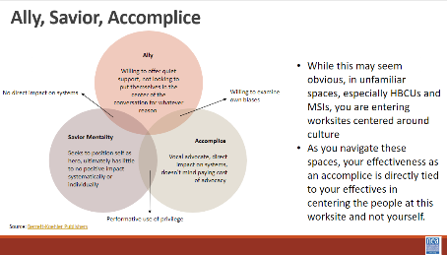  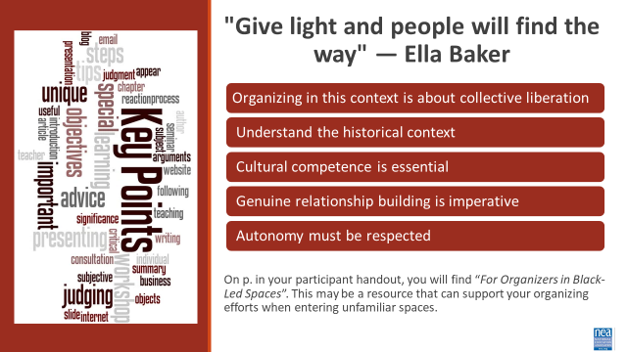 | Chart Paper for each group  Markers  Handout:  For Organizers in Black-Led Spaces | 10 minutes – Set Up (5 minutes) and Videos (5 minutes)  As discussed previously, socialization impacts our perspectives and interactions with the people around you. When entering HBCU and MSI spaces where you are culturally unfamiliar (even when there may be intersection with other identities you share), it is essential to be aware and honor that you are a guest in a significant cultural space. These spaces may be one of the few areas where folx of the global majority feel seen, heard, and valued.  Organizing is only as successful as your intentional listening. Labor Notes’ Secrets of a Successful Organizer by Alexandra Bradbury, Mark Brenner, and Jane Slaughter discusses employing an 80/20 rule during organizing conversations. Where you are actively listening for about 80 percent of the time and speaking roughly 20% of the time.  In spaces you are culturally unfamiliar, especially HBCUs and MSIs, this rule may need to be modified to 90/10.  A portion of your pre-attendance work was viewing a video that depicted the experience of a white student attending a HBCU. We are going to watch 2 clips from this video. These clips and the activity to follow directly discuss race. As a reminder to us all, this creates an opportunity to Lean into Discomfort, our community agreement.  Watch White Student at HBCU video (2 minutes)  Watch Push Back on White Student at HBCU video (3 minutes)  15 minutes – Affinity Grouping for Small group - Facilitators will ask groups to form into Faculty, ESP, Students, Affiliate Staff, and Governance -- (these groups can be fluid but should be an affinity within the group) discussion with chart paper  You may decide to keep them in table groups, or this may be an opportunity to count off by number break up in groups. (potential opportunity to split up staff in one group and members in the other)  Question: As participants, what challenges may exist in organizing at a predominately white college/university versus a HBCU or MSI?  - Think about not just about members and potential members (faculty, staff, and students) but also socialization (refer to Cycle of Socialization document in participant handout as needed).  - For each challenge, include potential solutions.  When there are 5 minutes left,- show debrief questions and intentionally bring attention to them. This will allow them to frame their thoughts during the debrief.  10 minutes – Report Out/Debrief  Facilitated Discussion Centering on the Following Questions: Time saving option: Each group does not have to answer all questions. You can present the questions before the report out/debrief and have them decide on which question(s) they will answer.  - Were there any challenges that were unique to HBCUs and/or MSIs?  - How do you address specific organizing challenges such as: governance requests of staff, different needs between units, and new chapter/local organizing on HBCU and MSI campuses?  - Is there any foundational work or pre-work that must happen within your affiliate prior to engaging the worksite? If so, what?  - How does our socialization influence our effectiveness in organizing at these institutions?  10 minutes – Saviorism and Key Points – Pg 150 “ Do This, Don’t do That”  Show Venn Diagram - Allies, Accomplices, and Saviors: Knowing the Difference to Maximize Impact  While this may seem obvious, in unfamiliar spaces, especially HBCUs and MSIs, you are entering worksites centered around culture. As you navigate these spaces, your effectiveness as an accomplice is directly tied to your effectiveness in centering the people at this worksite and not yourself.  Key Points  “Give light and people will find the way.” - Ella Baker  - Organizing in this context is about collective liberation  - Understand the historical context  - Cultural competence is essential  - Genuine relationship building is imperative  - Autonomy must be respected  On p.150 you will find “For Organizers in Black-Led Spaces”. This may be a resource that can support your organizing efforts when entering unfamiliar spaces. | How do affiliate staff show up in spaces and communities they have limited experience with?  Participants will identify potential challenges when organizing in unfamiliar spaces.  Participants will collaboratively find potential solutions to overcome challenges faced with organizing in unfamiliar spaces.
2:15 -2:30 BREAK
2:30-3:30 (LaQuita and Eric) |  | 60 Minutes – 1:1 Conversations
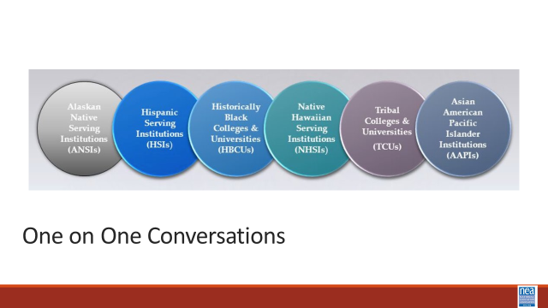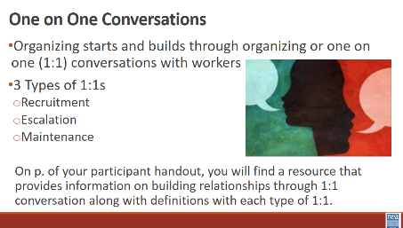  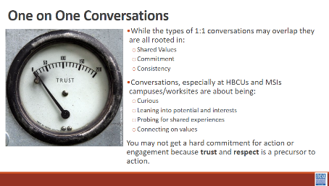  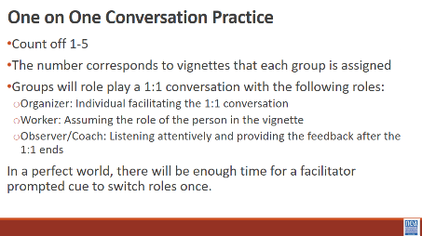  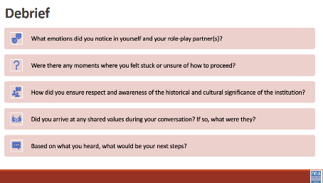 | Handout: Building Relationships  Handout: Vignettes | 5 minutes – Review Types of 1:1s – Page 152 Resource on Building Relationships  The beginning of any organizing starts and builds through organizing or 1:1 conversations with workers. On p 152. of your participant handout, you will find a resource that provides information on building relationships through 1:1 conversation along with definitions with each type of 1:1.  The 3 types of 1:1s we will frame our thinking around are:  - Recruitment  - Escalation  - Maintenance  These 1:1s sometimes overlap but the root of this is a relationship with shared values, commitment, and consistency. Take recruitment 1:1s for instance...when we think of this type of 1:1 you may think of recruiting individuals to join their union or commit to some task, activity, or role.  While this should be our focus widely, it is especially important to HBCUs and MSIs that you frame a recruitment 1:1 on being curious and leaning into potential and interests, probing for a shared experience (in a respectful way, not an interrogation), and connecting on values. You may not get a hard commitment for action or engagement because trust and respect are a precursor to action.  10 minutes – Activity Set Up  The Facilitator pair plus one other facilitator will do an example of what each role is in the triad. Two rounds with one better than the other.  Vignettes are found on pages 158-162  You will count off participants 1-5 (may be modified based on the number of individuals who are present). The number corresponds to vignettes that each group will be assigned. Individuals with the same number will be split into smaller groups of 3 or 4. Groups will role play a 1:1 conversation with the following roles:  - Organizer: Individual facilitating the 1:1 conversation  - Worker: Assuming the role of the person in the vignette  - Observer/Coach: Listening attentively and providing the feedback after the 1:1 ends  Perfect scenario:  15 minutes – Round 1 of 1:1 conversation  2 minutes – Mini-Debrief/Coaching  15 minutes – Round 2 of 1:1 conversation  2 minutes – Mini-Debrief/Coaching  35 minutes – 1:1 Practice  8 minutes – Debrief  Structured debrief using the following questions as a guide:  - What emotions did you notice in yourself and your role-play partner(s)?  - Were there any moments where you felt stuck or unsure of how to proceed?  - Did you ensure respect and awareness of the historical and cultural significance of the institution?  - Did you arrive at any shared values during your conversation? If so, what were they?  - Based on what you heard, what would be your next steps?  2 minutes – Key Points  - Recruitment, Escalation, and Maintenance 1:1s are essential for fostering strong, value-based relationships with workers, which are foundational to any organizing effort.  - When organizing at HBCUs and MSIs, emphasize curiosity, shared experiences, and values over immediate commitment, as trust and respect precede action. | Participants will practice the methods and skills of asking curious questions in 1:1s and apply those in identifying shared interests and values.
3:30- 4:00 (Ilissa and August) |  | 45 Minutes Total – Looking for Leaders – The Tour
 | (POSSIBLE ADDITION OF A STATEMENT ABOUT HBCUs have community within and outside – example alumni) | 5 Minutes Introduction: We are going to use an activity called social barometer. Imagine a line. On this end of the line is “we don’t need this in our organizing work” and that end of the line is “We can’t do our organizing work without this”  As I read the following 6 quotes about leadership – you will take a stand on the line based on what you think.  15 Minutes Activity – Give people a chance to move as you read each one, then once they have moved pick one or two people in different parts of the line to explain why they are standing where they are.  - "Just don't give up trying to do what you really want to do. Where there is love and inspiration, I don’t think you can go wrong." – Ella Fitzgerald  - "Leadership and learning are indispensable to each other." – John F. Kennedy  - "I’ve learned that people will forget what you said, people will forget what you did, but people will never forget how you made them feel." – Maya Angelou  - "When we speak we are afraid our words will not be heard or welcomed. But when we are silent we are still afraid. So it is better to speak." – Audre Lorde  - "We are not alone in our pain, and we are not alone in transforming our pain into power. We are all doing it, and we support each other in doing it." – Kerry Washington  - A leader is one who accepts responsibility for enabling others to achieve a common purpose in the face of uncertainty.” - Marshall Ganz  - – Jane Mcalevey.  ^{Key Points -}  ^{Leaders have followers.}  What that looks like is completely informed by our socialization.  We may need different lenses to “see” the leadership on this campus  25 Minutes – Setting the stage for the visit (August will likely be presenting on logistics and what to look for while at the HBCU - here are some suggestions for that)  What will leadership look like?  What are the aspects of the culture that would lend to a strong organizing plan?  What are challenges that would hamper organizing? | Participants will understand how leaders are identified and apply a social barometer to quotes about leadership.  Take what we have explored today from socialization, liberation inequities, building relationships and an organizing model, leadership. When exploring the power dynamics as it relates to we need this, we don't need this at an HBCU  Social Barometer:  Some groups choose to remain neutral, unknown, or undecided on the issue of tuition at Cooper out of fear of retaliation from the administration, because they feel there is not enough information, or that it’s not their job to make decisions about the way the institution is run. However, conflict occurs within a larger social context from which aspects of identity and oppression cannot be separated. Neutrality privileges those who are less impacted by experiences of systemic violence and lack of access to power or decision-making. It’s our collective responsibility to challenge each other to acknowledge that perceived neutrality reinforces an existing balance of power.
4:15-4:30 |  | 15 Minutes - Ending it Right
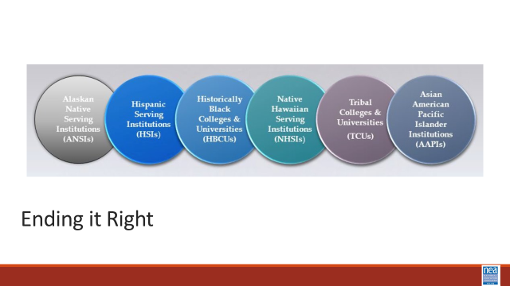 |  | Leave at 3:30 PM (3:45 PM at the latest) on bus to Tuskegee University  Back by 7:30 PM  Questions, Connections, Reflections  Housekeeping announcements  Plus/Delta at the Door  FOR TOMORROW – | Participants will be able to bring a little closure to their learning and provide feedback on the day.
4:30 – 5:00 |  | 30 Minutes - Choice Networking Activities – HBCU tour
 |  | This is a time for participants to meet and discuss any issues they are thinking about with other members of the group. This is not led by facilitators and highly encourage to occur in any other space besides the conference room. | Participants will make useful connections with staff from other affiliates.
5:00 ADJOURN

