Facilitator Agenda – Day 3 November 7, 2025
General Materials Needed: |  |  |  | Room Set-up:
1 Set of Handouts per Person  Name Tents with the Norms  Room signs,  One ream of white photocopy paper  Chart Paper (4 to 5 full w Sticky Strip) |  | Materials Box for each table with:  Markers (Mr. Sketch variety)  Post its – 3x3” and 4X5” sizes  Index Cards  Highlighters – 4 colors  Pens and Pencils  Participant “toys” |  | Long Rectangle table at back for facilitators  Round Tables for participants  Projector, Screen, mics, and Speakers  Carousel stations and reporting stations  No podium, table with projector big enough for laptop  50 people max
Key Outcomes for the Event:
Participants will understand the role staff play in building locals while maintaining a member-driven program on HBCU campuses
Participants will explore best practices from a number of member engagement case studies
Participants will explore successful affiliates that have focused on HBCU Programs and Campaigns
Participants will develop skills around strategic planning, leadership tests, data collection, and narrative development

Overview of Content, Time, and Facilitator Assignment
8:30-9:00 Entry and Welcome - Getting Started  9:30-10:15 Demand, Target, Tactics, and Escalation  10:15-11:45 Team Campaign Design  Self Break Directed break | Ellen  Ilissa and Michelle  Josh (and all hands-on deck) |  | 11:45-12:30 Team Presentations of Campaign, March, and Chant  12:30-1:00 Ending  1:00-2:00 LUNCH and Adult Choice Networking  2:00 Adjourn |  | Rakia and Albert  Ellen
Time Slides Facilitator | Resources | Instructions, Activity and Debrief (Facilitators) | Essential Questions and Outcomes
 | Charts, handouts, articles, materials, slide | What are you saying, what are they doing, what questions will you use to guide learning and make clear the important points  Include an estimate for how long each section of the learning will take | What question(s) will this learning answer? What will participants know or be able to do?
7:00 -8:30 – Team prep, practice, room set up, sound check, etc.
Entry Activity

8:30-9:00 |  | 30 Minutes – Getting Started
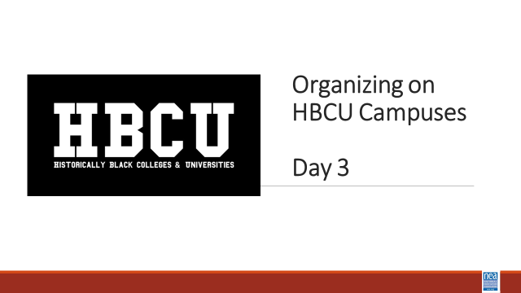  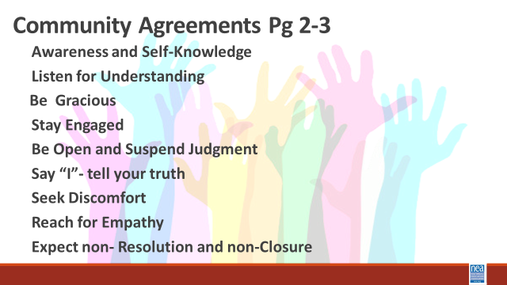  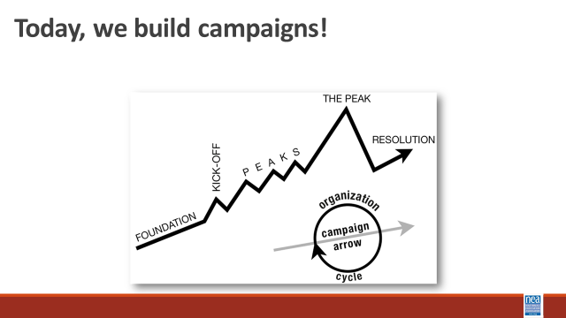 | 7th Issues and Opportunities | 5 Mins Feedback on Feedback, Agenda Review, Norms Review  INTRODUCE Campaign Mountain  - Foundation – gather info, id issues, id leadership team  - Kick-off –public event that indicates what the issue, demand, and targets are  - Escalating peaks of activity that should escalate in  - Risk  - Capacity (people, resources, engagement)  - Increase leadership and ownership  - Campaign Compression Points  - THE PEAK – The most public, risky, momentum, engagement, and resources  - The Win- We achieve our demand  - Debrief, regroup, and continue to climb  FOR THIS DAY – They work in teams that may have formed yesterday around particular issues. OR they can select a vignette to work from. | Participants will understand how they will spend their time together.
9:00-9:30 Ellen and Albert |  | 30 Minutes Campaign Lab
 |  | ELLEN  5 Minutes - What does a loving school community look like?  15 Minutes – Overview of the urgency to organize  What do we focus on?  In a number of states, it can seem like you are always in “recruitment” mode – new member organizers, new hire orientations, etc. And this base building is important. Nationally, we have to recruit 250,000 new members each year just to maintain our status quo. It is a necessary part of the work.  BUT – Maintenance does not build. AND only doing transactional recruitment does not build members to activists, activists to mobilizers, and mobilizers to leaders. It also does little to move our locals into organizations that can USE power.  .  Base building matters in every state and it is THE important work of our union. It is only through super majority locals that we will be able to win.  Base building only matters if we are also willing to act IN CERTAIN WAYS  Which theory builds the power we need with the super majority density that is required?  Advocacy “ ...is the work of creating change through the actions of professionals or technical experts—lobbyists, pollsters, lawyers, communication specialists, researchers. Advocacy relies on the expertise, status, and know-how of these groups of people to make change. Advocacy usually happens in a closed-door room; ordinary people play a small to nonexistent role in its efficacy. Advocacy has become a dominant strategy for unions and liberals.”  Mobilizing “..., by contrast, activates an already-convinced membership. Mobilizing encourages those who already support a cause or a mission to take action to defend their belief—for example, by attending a protest, wearing a button, or signing a petition.”  Organizing “... is to build mass support and strength among ordinary people. Organizing draws its power from working people’s biggest strength: our numbers. The work of organizing is systematic and rigorous: It requires connecting with every single worker in a shop, every educator in a building, every building in a district. At its core, it asks people to understand their own agency and to make choices about how they will exercise it.”  Advocacy is about – using expertise.  Mobilizing is about – engaging the already committed.  These are necessary, but not sufficient to build the power we need.  Organizing is about building power.  The best base building strategies in all our states are visible, member led, networked, issue campaigns. These are the ways that our strongest, most successful states build both membership and power.  NEA has two primary campaign strategies that are focused on building power. The Campaiang to Promote, Protect, and Strengthen Public education includes target tactics and partnerships that include fighting against budget cuts and attacks on federal funding, organizing "walk-ins" and "Days of Action," supporting pro-public education candidates in local elections, and opposing book bans and other threats to academic freedom and equity. The campaign also works to address systemic inequities and injustices within schools and advocates for policies that ensure students have access to necessary resources and support.  The second key strategy is the Campaign Lab that  ALBERT  That is what the Campaign Lab is about - This is an intentionally created and networked leadership structure focused on building and using power within and across issue campaigns  Which builds strong unions faster?  Focusing on Member recruitment  Focusing on People Powered Campaigns  It is only with high member density that we can claim the power to force the big wins – and keep them – that transforms the working conditions for our people into the future. But simply focusing on asking people to join does not build high member density. Organizing People Powered campaigns, like we have been learning about builds the skilled people, the trusted people, and the visibility to draw in more people to achieve the big dreams you want.  This is what organizing does and that is why we focus on these skills and methods in this academy.  To achieve the big dreams that you have discussed, we know that we need structures that allow us to develop leadership without reinforcing hierarchy or burnout. We need to keep those structures continuously connected and networked and that is what is different about the campaign lab. These structures rely on 4 four core roles. And we want to make sure we are very clear about those roles. Role clarity is not bureaucracy; it’s liberation in action.  All four roles are interdependent. The Campaign Lab is designed like a network, no one role is more important than the others. They all enable shared leadership and campaign effectiveness.  - Mentor Coaches help build coaches’ capacity. Think of them like scaffolding. They are mostly staff and experienced organizers, not the boss, not evaluators, but strategic thought partners  - Campaign Coaches are the frontline support for local organizing teams. They do a lot, but they’re not alone. They’re part of a larger structure that includes Mentor Coaches and other peer supports. They are our primary sensor – and researcher about the labs  - Team Leads anchor the day-to-day work of the team. They aren’t doing all the work; they’re ensuring others can. They model distributed leadership and build team cohesion.  - Team Members Implement the Plan and Primary contact with Rank and File. Assists in developing added structures  Attends regular meetings, Critical in building the base, increasing engagement, and gathering information  Key Points  - Intentional campaigns, not programs, build power.  - The power to win is only built through people with a shared vision, making public commitments to act, to risk their collective resources, for the big meaningful changes they want.  - This type of action ALSO build membership and density – the kind of super majority we need to win  The kind of power we needs depends a distributed and interdependent leadership structure. | Participants will understand
9:30-10:15 (Ilissa and Michelle) |  | 45 Minutes Demand, Target, Tactics, and Escalation
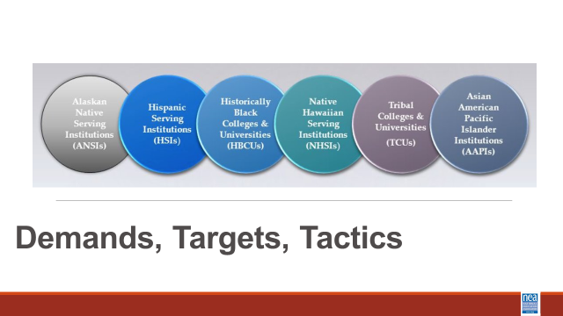  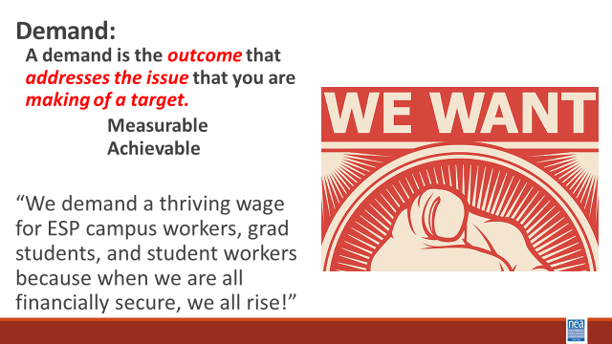  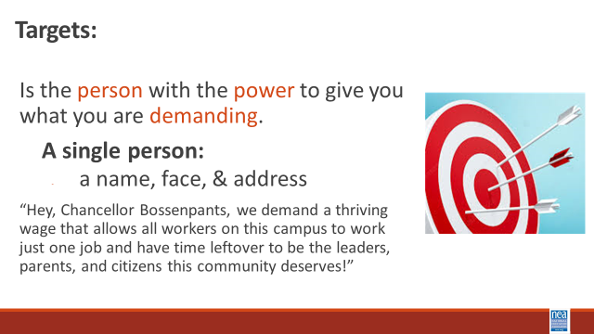  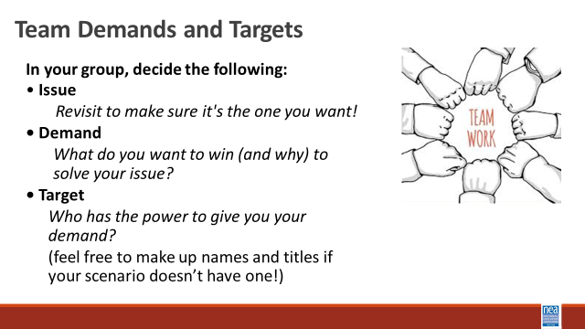  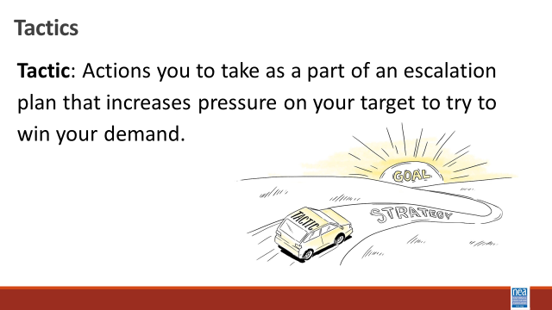  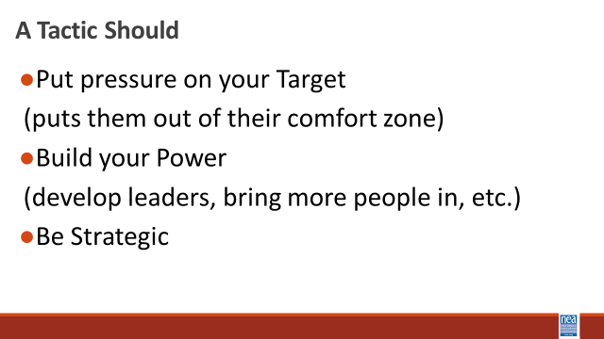  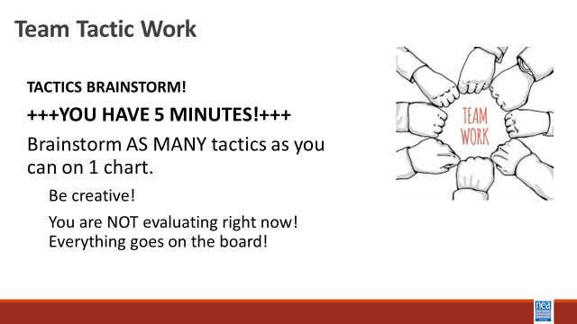  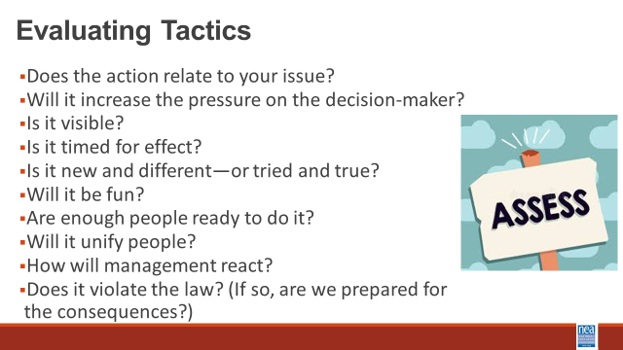  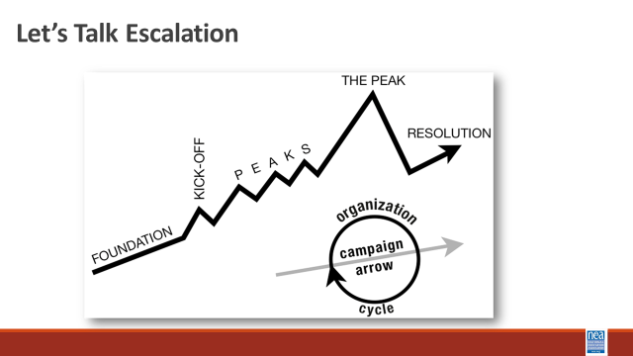  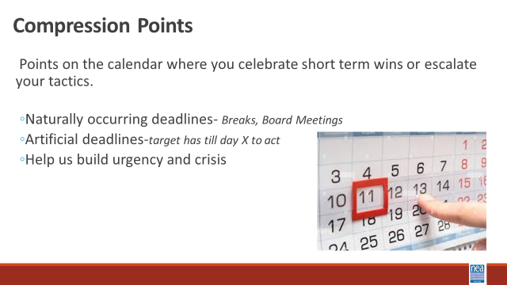  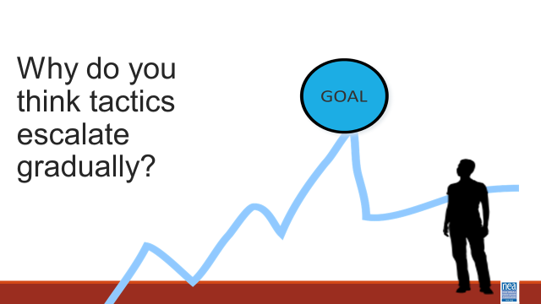  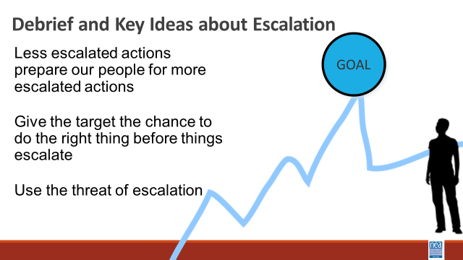  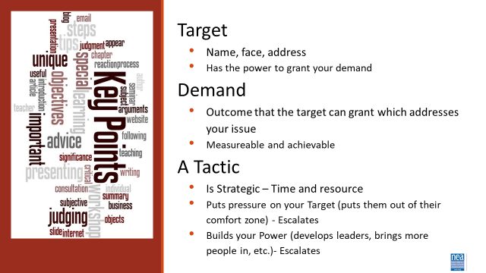 |  | Michelle Starts  Intro 5 Minutes - Intro of Content  DEMAND  - A demand is what the group wants– the win –  - A demand is the outcome that addresses the issue you are making of the target  - If the issue is what is wrong, the target is who will fix the issue.  Value ends up being the messaging  TARGET  - The last idea that we want to cover is Targets.  - TARGET: A target is a single person with a name and an address. The target is the person with the power to give the workers the change they are asking for. A target has a name, a face and an address. Takes 5 minutes to introduce  10 Mins – GROUP WORK  In your groups, return to your scenario and decide the:  Issue- Finalize the issue!  Demand What do you want to win to solve your issue?  Target Who has the power to give you your demand?  1 mins- INTRODUCE Tactics  Next we are going to talk about Tactics.  Tactic are Actions you to take as a part of an escalation plan that increases pressure on your target to try to win your demand.  A tactic should  - Put pressure on your Target  (puts them out of their comfort zone)  - Build your Power  (develop leaders, bring more people in, etc.)  - Be Strategic  We are going to model a tactics brainstorm that you can use when working with members.  5 Minutes Scenario Work  Brainstorm AS MANY tactics as you can on 1 chart.  - Be creative!  - You are NOT evaluating right now! Everything goes on the board!  We are going to have 5 minutes to list as many tactics as you can. Extra points for super creative ideas. WE ARE NOT. NOT. NOT. Evaluating tactic at this time. If someone says something (example- We are going to wear the same clothes without washing them until we get what we want) you right it down and move on. All ideas get on the board. Again, this is a brainstorm. NO EVALUATING.  YOU HAVE EXACTLY 5 MINUTES. After 5 minutes put your pens down.  Open your phone and actively start a timer. “ON YOUR MARKS. GET SET. GO”  Excellent! We now have a whole list of tactics. Next. We are going to assess our tactics. For this, I encourage you to use a list of questions like this-  3 minutes- How to evaluate a tactic  - Does the action relate to your issue?  - Will it increase the pressure on the decision-maker?  NOTE! This means that we have to engage in actions that make our target uncomfortable. SOOOOO the same old tactics WON’T WORK! They are used to them!  - ^{Is it visible?}  - ^{Is it timed for effect?}  - Is it new and different—or tried and true?  Note! SEE above. If a tactic is the same as always, your target has likely become comfortable with it AND it won’t develop new skills in your members and therefore build your power.  - Are enough people ready to do it?  - ^{Will it unify people?}  - ^{How will management react?}  - Does it violate the law? (If so, are we prepared for the consequences?)  NOTE! This doesn’t mean that it is off limits. Historically, breaking laws has been a big part of social justice movements. ESPECIALLY THE LABOR MOVEMENT! However, we have to consider if an unlawful tactic is the right tactic and whether you have the power to mitigate/absorb the consequences.  - ^{Will it be fun?}  Folks want to engage in things that fill them up! Who had a tactic that they would be excited to participate in?  Ilissa starts  10 minutes- Evaluating your tactics  You have 10 minutes. Look at your list of tactics.  - Circle the ones that you think are strategic, when looking at these questions.  - Cross out the ones that are NOT strategic.  5 Minutes - Escalation  – Compression Point Definition  - Points on the calendar where you celebrate short term wins or escalate your tactics based on how you have assessed your readiness to escalate.  - Naturally occurring deadlines  - Artificial deadlines  - Help us build urgency and crisis  2 Minutes – Turn and Talk  We keep saying that tactics should escalate gradually why do you think that is?  2 Minutes – Debrief  Each escalation is more public, more visible, and has more risk. WE transform members to activists, activists to leaders by asking them to take bigger risks  Some points to make if they are not said by the group  - Less escalated actions prepare our people for more escalated actions  - Give the target to do the right thing before things escalate the threat of escalation  2 Minutes Key Points  Target  - Name, face, address  - Has the power to grant your demand  Demand  - Outcome that the target can grant which addresses your issue  - Measurable and achievable  A Tactic  - Is Strategic – Time and resource  - Puts pressure on your Target (puts them out of their comfort zone) - Escalates  - Builds your Power (develops leaders, brings more people in, etc.)- Escalates | Participants will practice naming specific demands and targets.  Participants will brainstorm creative tactics and then work to put them in an escalation.
10:15-11:30 (true finish time is 11:45 with a self break) (Josh) ALL Facilitators work with teams as they plan and need support. |  | 60 Mins TOTAL – Team Campaign Design
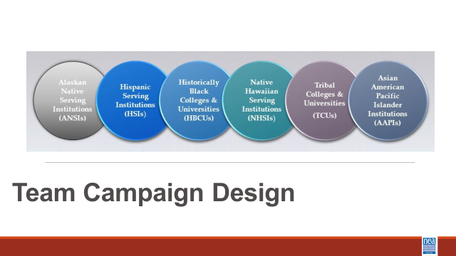  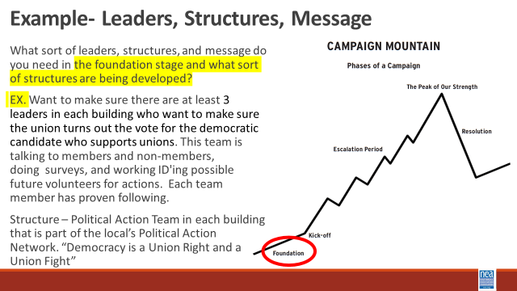  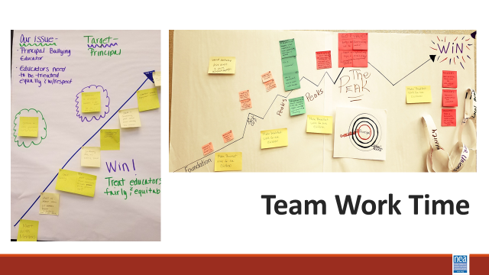 | Teams are creating Campaign Mountain, a Team Name, and Team Chant – extra points for a dance.  Day 2 Vignettes | 5 mins – Introduction  Focus on Leaders – they have followers and can achieve results  Focus on Structure - a group of people united by a common purpose.  Focus on Narrative Thread and Changes  All campaigns have a target, a win, and an issue to be solved by the win  All campaigns have tactics that escalate, they escalate to build new leaders, build the base of support, and build the public use of power to apply pressure to the target.  Campaigns are held together by the story of what you are working to achieve and the why it is important NOW.  You will be mapping it all out. (Campaign Mountain)  If you list a tactic, then you will explain which leaders involved, the structure created, and the narrative at that point.  Consider how you are moving your spectrum of allies and how the community around the scenario is a part of the campaign  How you applied a Race Equity Tool analysis to each part of the campaign  Your team will also create team name and a team chant. Extra Points for a Dance.  (each presenter will adopt a team(s) to mentor) | Participants will apply what they have learned about campaign design that is effective at HBCUs and present their products to other teams for coaching.
11:45-12:30 Rakia and Albert |  | 45 Mins Team Presentations
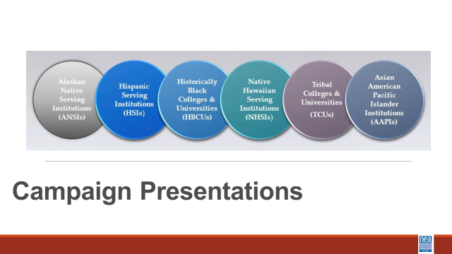 |  | Team Presentations of Campaign, March, and Chant  All will watch the team presentation of their name, chant, and dance – then depending on number of teams – we will make team huddles for presentation of campaign. | Participants will present, reflect, and discuss their plans with other teams.
12:30 – 1:00 (Ellen) |  | 30 Mins TOTAL– Ending | .
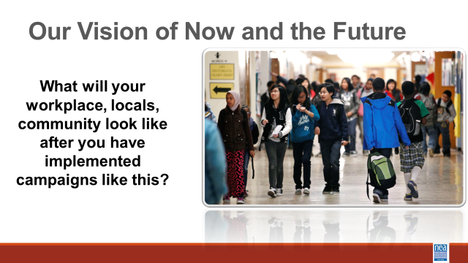  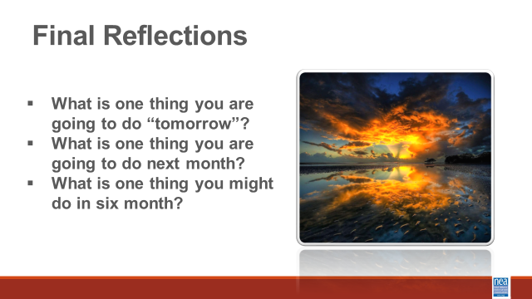  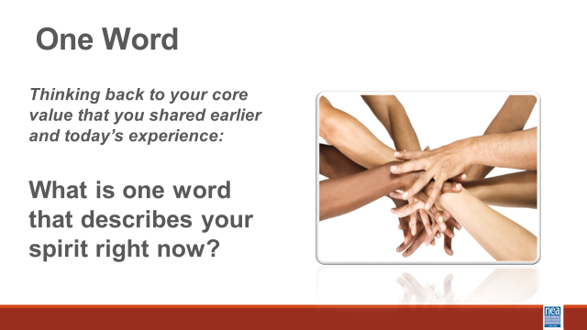  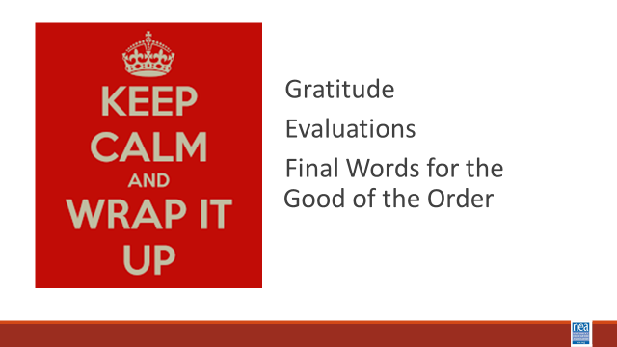 |  | Ella Baker’s assignment to each of us  ***The n-word is used in this video  Video from Ella Baker addressing a 1974 Puerto Rico solidarity rally  Solidarity Circle –  End training with solidarity circle where participants share their key takeaways and commitments to support organizing on HBCU/MSI’s.  Final Closing  Questions, Connections, Reflections  Housekeeping announcements | Participants will participate in a closing circle discussion to reinforce the collective nature of labor organizing and leave with a sense of purpose and solidarity.
1:00-2:00 |  | 60 Minutes - LUNCH AND Adult Choice Networking Activities –
 |  | This is a time for participants to meet and discuss any issues they are thinking about with other members of the group. This is not led by facilitators and highly encourage to occur in any other space besides the conference room. | Participants will make useful connections with staff from other affiliates.
2:00 Adjourn

Piloting HBCU Organizing Debriefing Notes _{01.30.2025}

- HBCU visit is a keep, this allows context from a cultural standpoint which helps to provide validity to organizing on unfamiliar sites.
- Modification to HBCU School visit add more time, suggesting a start time of 12 pm to allow time to for participants to become fully immersed.
- Utilizing AE Chapters to gain access to campuses for worksite visits.
- What do we want the participants to learn, and what do we want the participants to experience.
- Reorder content
- Centering Race, Class, and Gender
  - Extend the time
  - Remove Power
- Problems and Issues
- Spectrum of Allies
  - Power needs to be moved here
- Demands
- Focus for site visit to provide a frame of reference and for the debrief.
- How to reach out to targeted audiences about this training
- HBCU, AEs, and NSAII staff along with members participating
- Transfer of people working on content and presenting the content

