Facilitator Agenda – Day 1 January 28, 2025
General Materials Needed: |  |  |  | Room Set-up:
1 Set of Handouts per Person  Name Tents with the Norms  Room signs,  One ream of white photocopy paper  Chart Paper (4 to 5 full w Sticky Strip) |  | Materials Box for each table with:  Markers (Mr. Sketch variety)  Post its – 3x3” and 4X5” sizes  Index Cards  Highlighters – 4 colors  Pens and Pencils  Participant “toys” |  | Long Rectangle table at back for facilitators  Round Tables for participants  Projector, Screen, mics, and Speakers  Carousel stations and reporting stations  No podium, table with projector big enough for laptop  50 people max
Key Outcomes for the Event:
Participants will understand the role staff play in building locals while maintaining a member-driven program on HBCU campuses
Participants will explore best practices from a number of member engagement case studies
Participants will explore successful affiliates that have focused on HBCU Programs and Campaigns
Participants will develop skills around strategic planning, leadership tests, data collection, and narrative development

Overview of Content, Time, and Facilitator Assignment
8:30-9:00 Getting Started  9:15-10:15 HBCUs and MSI – A Difference that Matters  10:15-10:30 Break  10:30-11:00 Socialization and Bias  11:00-12:00 Systemic Underfunding: Impacts on Workers and Resources  12:00 -1:00 Lunch | Ellen  Barb and Eric  Illissa and Albert  Kiesha and Ellen |  | 1:00-1:30 Organizing Differently  1:30-2:15 For Organizers in Unfamiliar Spaces  2:15-2:30 Break  2:30-3:30 1:1 Conversations  3:30-4:15 Looking for Leaders – The Tour  4:15-4:30 Ending it Right  4:30 -5:00 Adult Choice Networking  5:00 Adjourn |  | Eric and Melissa  August and Michelle  LaQuita and Eric  August and Illissa  Ellen

Time Slides Facilitator | Resources | Instructions, Activity and Debrief (Facilitators) | Essential Questions and Outcomes
 | Charts, handouts, articles, materials, slide | What are you saying, what are they doing, what questions will you use to guide learning and make clear the important points  Include an estimate for how long each section of the learning will take | What question(s) will this learning answer? What will participants know or be able to do?
7:00 -8:30 – Team prep, practice, room set up, sound check, etc.
Entry Activity
Each person gets an HBCU card, and they learn about a HBCU or Minority Serving Institution person, site, event, historical event. This will be used for a HBCU or BIPOC institution Merry Mixer later.
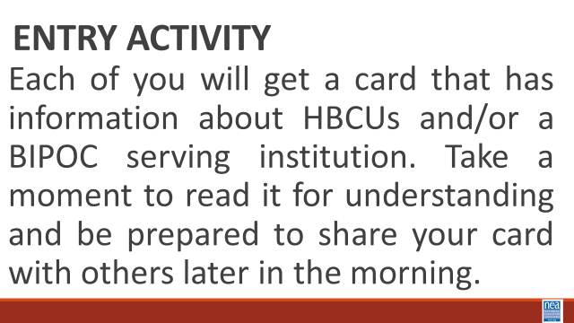
8:30 -9:15 Ellen |  | 45 Mins TOTAL Getting Started
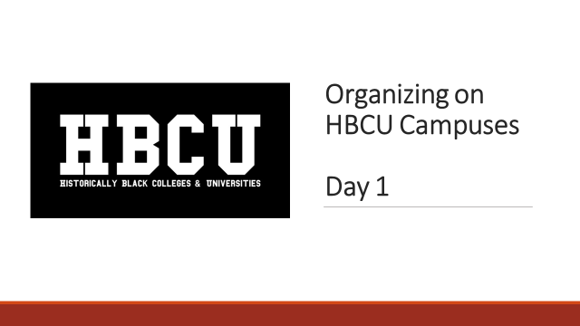  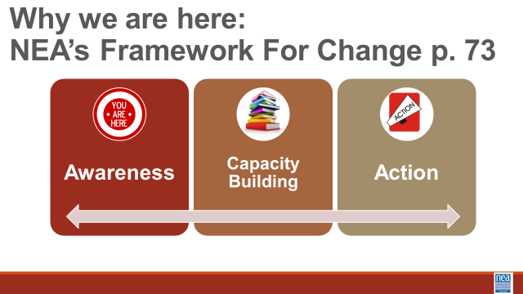  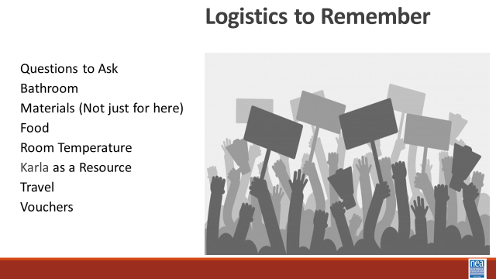  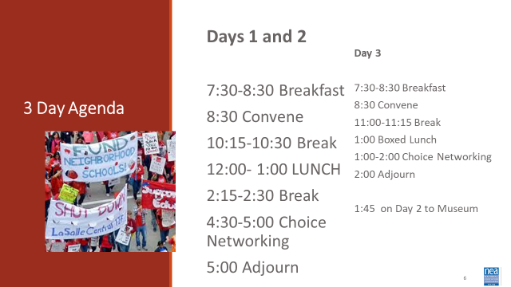  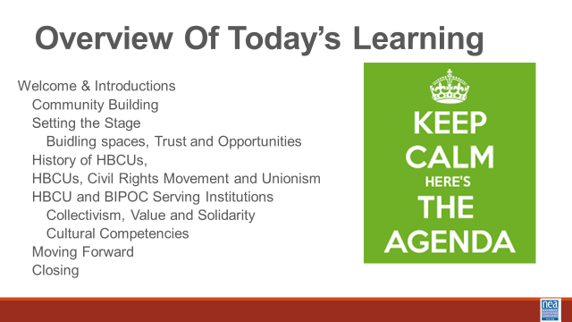  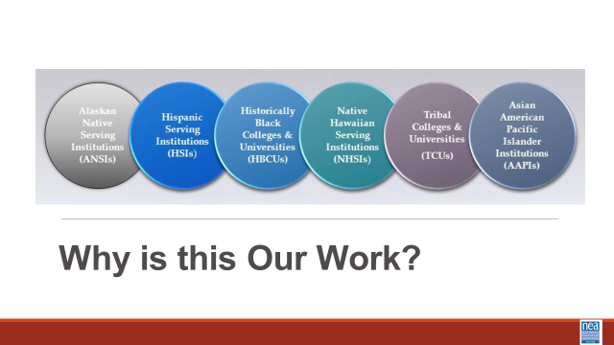  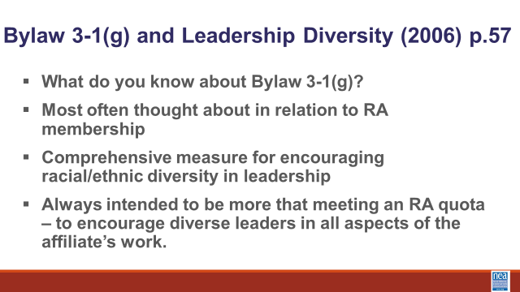  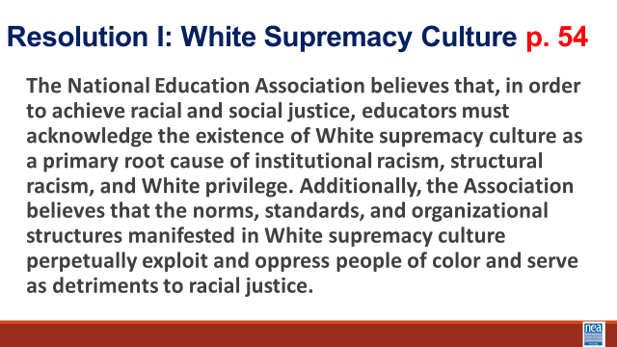  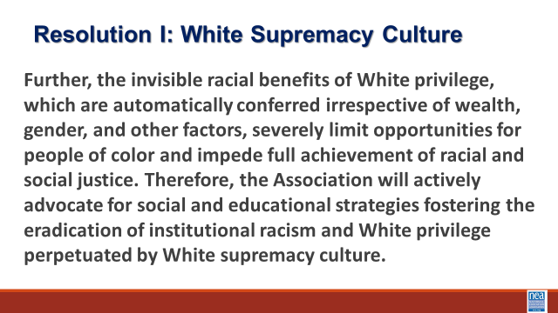  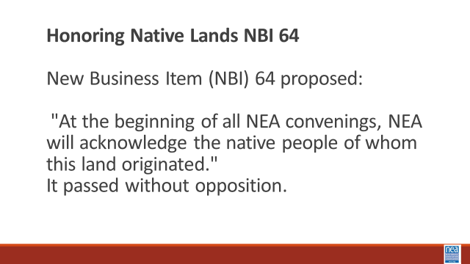  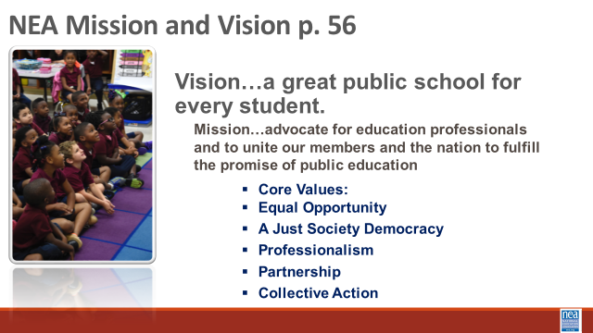  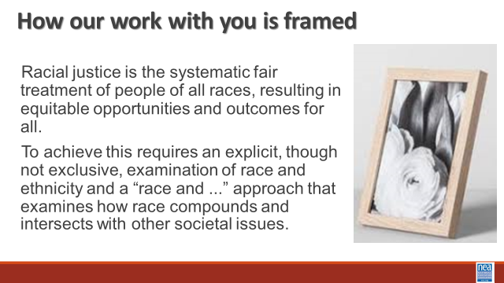  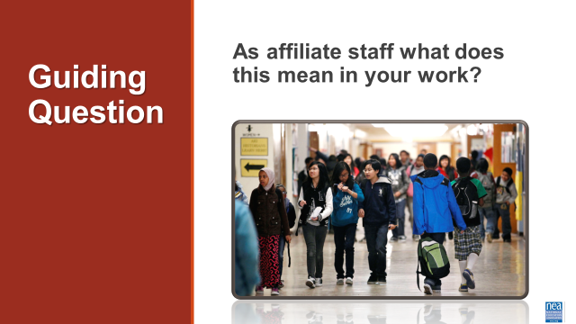  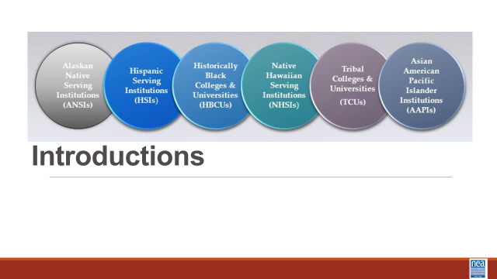  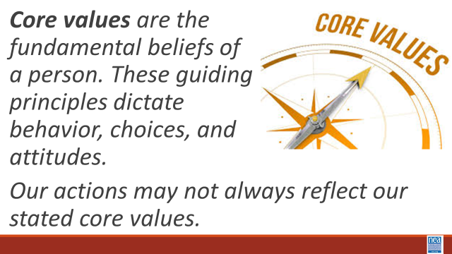  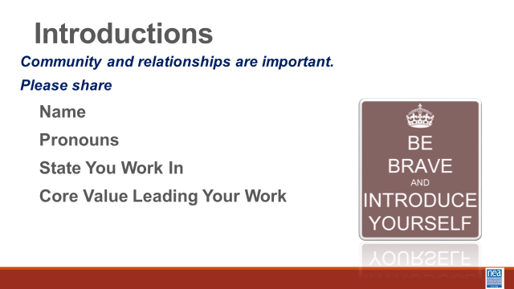  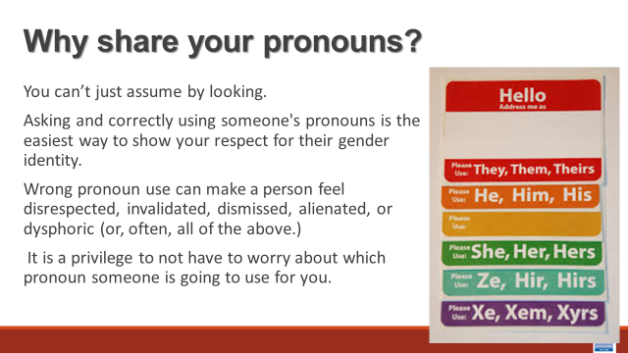  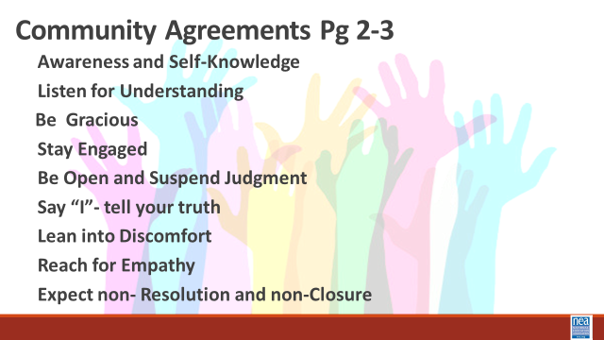  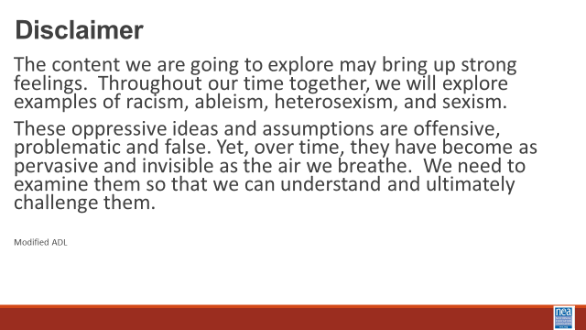 | Norms in Handouts  Agenda on Slides  Parking Lot Chart  Name Tents  Handout Package | 15 Mins – Welcome, honor the space, overview of learning goals, overview of days agenda and logistics –  Why are we here - Framework for Change  We move through stages of awareness, capacity building into action. In this training we are helping you become aware of where you are in regards to racial justice, we will be increasing our capacity by building our skills and understanding, and we will begin to make plans for actions we can take.  Participants will learn how to build strong programs that elevate leaders, mobilizers, and activists in this important higher education setting. UniServ Directors and Organizers will:  - Understand role staff play in building locals while maintaining a member-driven program  - Explore best practices from a number of member engagement case studies  - Explore a number of successful affiliates that have focused on HBCU Programs and Campaigns  - Develop skills around strategic planning, leadership tests, data collection, and narrative development.  - Organizing new locals/chapters  Family Meeting- Extra for member/staff teams: Different space that what we are used to. Folks are members. Folks are staff. Maybe a new type of nervousness that we can’t predict? Try to solve problems in room, not by going to management at get.  8 minutes – Why is this our work?  Historical legacy of exclusion and struggle  Intersection of Race, class and labor  Building Collective Power  Creating sustainable change  Empowerment through education  Building Solidarity  2 minutes each on Resolution I – Overview of NEA 3.1 G, NBI B 2015, Build the understanding that NEA views racial justice as a priority. Provide a brief each overview of each: Resolution 1 - 3.1 G, NBI B 2015.  Safe, Just and Equitable Schools – Adopted in 2022  In our time together over the next couple of days, we will take a more in depth look at Organizing at HBCU and BIPOC institutes. We will discuss these institutes' history and their connection to unionism. Understanding the culture and the staff role in this work and how we can work together to move this work.  These institutions of higher education provide their graduates with much higher rates of upward economic mobility than graduates of predominantly white institutions (PWIs). Despite this, systems of power and inequality still plague the workers and students on these campuses. UniServ and Organizers in these settings have to be highly skilled in leading, coaching and organizing across racial differences and especially in dealing with systems of economic and racial oppressions.  Racial justice is the systematic fair treatment of people of all races, resulting in equitable opportunities and outcomes for all. In order to have this discussion, we need to do an explicit, though not exclusive, examination of race and all aspects of our identity and look at how it compounds and intersects with other societal issues.  Our essential question throughout this examination is this: As affiliate staff what does this mean in your work?  10 Mins -Introductions around the room – Share Name, work location and pronouns  Pronoun explanation is dropped in by the facilitator just in case it is needed BEFORE THE facilitators model-We cannot assume how someone identifies, we must allow them to tell us their preference and honor that. We need to be inclusive of all genders and non-genders.  Show the Pronoun slide and say:  You can't always know what someone’s Gender Pronoun is by looking at them. · Asking and correctly using someone's preferred pronoun is one of the most basic ways to show your respect for their gender identity. · When someone is referred to with the wrong pronoun, it can make them feel disrespected, invalidated, dismissed, alienated, or dysphoric (or, often, all of the above.) · It is a privilege to not have to worry about which pronoun someone is going to use for you based on how they perceive your gender. If you have this privilege, yet fail to respect someone else's gender identity, it is not only disrespectful and hurtful, but also oppressive.  Trainers will begin by modeling what is expected - briefly introduce themselves, their preferred pronoun, and the state they are from. These guiding principles dictate behavior and can help people understand the difference between right and wrong – one or two words) as a way of modeling for participants – less than 20 seconds per person.  20 Mins - Community Agreements for Our Time – Give this about 5 to 10 minutes -Ask participants to review the community agreements sent in advance and to review the three questions that they were asked to think about. Have a small table conversation in preparation for a whole group commitment.  Awareness and Self-Knowledge  Listening for Understanding  Being Gracious  Stay Engaged  Be Open and Suspend Judgment  Say “I”- tell your truth  Lean into Discomfort  Reaching Empathy  Resolution and Closure  Allow about 5 to 10 Mins – Participants will share their responses, suggestions, changes, etc. Then facilitator will call for a visual community commitment. This is a shift from colonizer norms that aim to preserve the order of the conversation and maintain the focus of the power. These are commitments that we have each reviewed and will change as needed. By consensus we will agree to work with these until we need to make a change. Consensus means we all agree that these are good enough to get us moving. Show your thumbs and hold them up and keep them up until I have had a chance to view the whole room. Up thumb means – love it, nothing needs to change for me. Sideways thumb means – I can live with it for now. Down thumb means I cannot move forward until we discuss and come to a decision about…- and the down thumb leads the discussion on that UNTIL it can at least become a sideways thumb.  Disclaimer- Warning -Before we dive into what this means to you, we begin with a disclaimer. If we do this right, you are going to be uncomfortable. The content we are going to explore may bring up strong feelings. Throughout our time together, we will explore examples of racism, ableism, heterosexism, and sexism. These oppressive ideas and assumptions are offensive, problematic and false. Yet, over time, they have become as pervasive and invisible as the air we breathe. We need to examine them so that we can understand and ultimately challenge them. | Participants will know how we are going to work, the basic schedule, and the logistics relevant to the training.
 | 30 Minutes The Federal Administration Discussion --
 |  | Which of your Core Values were highlighted, challenged, or affirmed by the election outcome?  How are you managing any anxieties or stress related to the current federal administration?  They will have just completed the core values activity – so we will have a table talk around these questions  Give a full 10 minutes at the tables – You don’t have unlimited time to speak on this – it is complicated – and we want to use some of our time to discuss this.  Then allow for 20 minutes to report out – What is your top line take away – and do not repeat. | Participants will understand that each person has a valid and different experience with the election and that will affect how they engage in this space. We all react to current times based on our lived experiences.
9:15- 10:15 (Eric and Barb) |  | 60 Mins TOTAL –HBCUs and MSI – A Difference that Matters
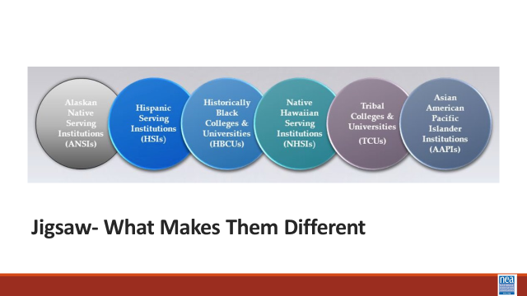  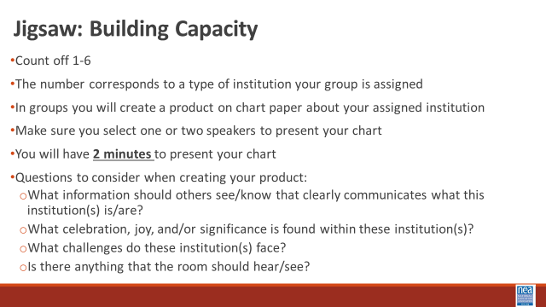  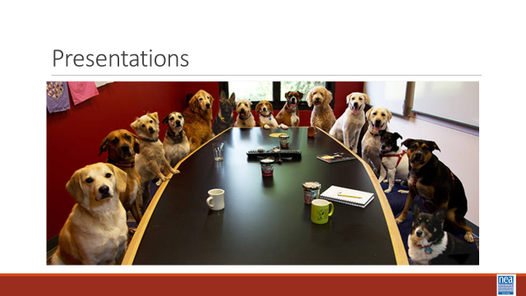 | Day 1 Merry Mixer Card File | 20 minutes – Merry Mixer  3 Minutes – Set up activity  - Each participant will receive an HBCU History Card. Take 3 minutes to read your HBCU/MSI card.  - Pair & Share: When prompted, you will find a partner. You will have 90 seconds each to share the content of your HBCU/MSI history card.  - When signaled, you will find a different partner and repeat. There will be three (3) rounds in this activity.  9 minutes – Three 3-minute rotations  5 minutes – Debrief – Using the questions below  - What surprised you?  - What is the historical significance?  - What is something that you learned that is still relevant today?  - What aspects of this history/information align with “union values”?  5 minutes – Jigsaw Activity Set Up  - Count from 1-4  - 1: Tribal Colleges and Universities (TCUs)  - 2: Hispanic Serving Institutions (HSIs)  - 3: Historically Black Colleges and Universities (HBCUs)  - 4: Asian American and Native American Pacific Islander-Serving Institutions (AANAPISI)  - Form groups based on the number assigned when counting. (If a group is too large, split them up into smaller groups.)  - Each group is assigned an institution (see above). In their groups they will review the resources provided and create a product on chart paper that they will then present to their colleagues.  - Make sure they are clear of what page(s) in the participant handout they are responsible for reviewing and working from.  - In groups, ensure they select one or two speakers to present your chart to the group. They will have 2 minutes to present their chart to the group.  - Questions to consider when reviewing resources and creating their product on chart paper:  - What information should others see/know that clearly communicates what this institution(s) is/are?  - What celebration, joy, and/or significance is found within these institution(s)?  - What challenges do these institution(s) face?  - Why are these types of institutions great places to organize students, faculty, and staff?  - Is there anything that the room should hear/see?  20 minutes – Group Work Time  True 20 minutes needed to read and complete charts  15 minutes – Presentations  - Each group has 2 minutes to present their chart  2 minutes - Key Points  - HBCUs and MSIs have a rich legacy and culture that is centered in shared equity and advancement.  - These institutions have been centers of innovation and progress for marginalized people and their communities despite being systemically underfunded.  - Collectivism over individualism. | Participants will create information charts to share the foundational understandings with each other of HBCUs and MSIs.  This is a historical perspective and at a higher level, into the current day.
10:15-10:30 |  | BREAK
10:30-11:00 (Albert and Ilissa) |  | 30 Mins Total – Socialization and Bias
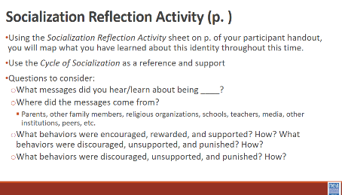  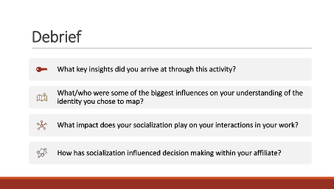  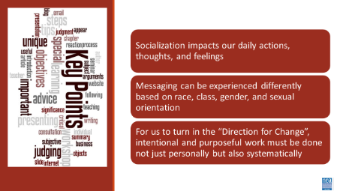 | Handout: Cycles of Socialization  Handout: Socialization Reflection Activity  Sticky Notes  Handout: Cycles of Liberation | 5 minutes – Review Cycle of Socialization  Define Socialization and Bias  - Socialization: (n) the process beginning during childhood by which individuals acquire the values, habits, and attitudes of a society (Merriam-Webster)  - Bias: (n) a tendency to believe that some people, ideas, etc., are better than others that usually results in treating some people unfairly (Britannica)  We consider this framework when thinking about how we develop our understanding of various identities.  Show Cycles of Socialization graphic (p. of participant handout)  There are a variety of factors that impact how we acquire perspectives of individuals. Individuals, institutions, organizations, and media all impact how we shape our biases and thoughts around individuals from a variety of identities.  10 minutes - Socialization Reflection Activity  - Choose one social identity from the list below that you would like to reflect on and examine.  - Race: A social construct that artificially divides people into distinct groups based on certain characteristics such as physical appearance (particularly skin color) ancestral heritage, cultural affiliation, cultural history, ethnic classification  - Gender Identity: An internal, deeply felt sense of being female, male, a blend of both or neither. Refers to how individuals perceive themselves and what they call themselves. Can be the same as or different from their sex assigned at birth  - Sexual Orientation: An inherent or immutable enduring emotional, romantic, or sexual attraction to other people  - Class: Relative social rank in terms of income, wealth, education, status and/or power  - We are operating under the above common definitions for race, gender identity, sexual orientation, and class.  - Using the Socialization Reflection Activity sheet on p. of your handout, you will map what you have learned about this identity throughout this time  - Use the Cycle of Socialization as a reference and support  - Questions to consider:  - What messages did you hear/learn about being ____?  - Where did the messages come from?  - Parents, other family members, religious organizations, schools, teachers, media, other institutions, peers, etc.  - What behaviors were encouraged, rewarded, and supported? How?  - What behaviors were discouraged, unsupported, and punished? How?  12 minutes – Debrief  Facilitated Debrief (below are questions that can help frame the discussion)  - What key insights did you arrive at through this activity?  - What/who were some of the biggest influences on your understanding of the identity you chose to map?  - What impact does your socialization play on your interactions in your work?  - How has socialization influenced decision making within your affiliate?  - How will insights gleaned from this activity influence how you understand the identity you chose to map?  - When were you first aware of yourself as a member of_____ group?  - When were you first aware of people from other groups in this category?  - When did you first experience being treated differently because of your membership in this group?  - When did you first witness someone being treated differently because of membership in another group?  1 minute – Touch on Cycle of Liberation  - With the intentional socialization we’ve discussed, consider the cycle of liberation as a framework to progress.  - Find this on p. of your participant handout  - Moving from Bobbie Harro's Cycle of Socialization to the Cycle of Liberation involves shifting from learned roles and biases to actively challenging oppressive systems.  - This transition requires self-awareness and a commitment to unlearning harmful narratives, creating a foundation for being an accomplice and solidarity.  - It empowers individuals and communities to engage in collaborative action, aiming to dismantle systemic inequities and achieve collective freedom.  3 minutes – Key Points  - Socialization impacts our daily actions, thoughts, and feelings  - Messaging can be experienced differently based on race, class, gender, and sexual orientation  - For us to turn in the “Direction for Change”, intentional and purposeful work must be done not just personally but also systematically | How does socialization impact how you show up in this work?  Participants will name how socialization impacts them personally and work they do within affiliates.
11:00–12:00 (Melissa and Kiesha) |  | 60 Minutes Total Systemic Underfunding: Impacts on Workers and Resources
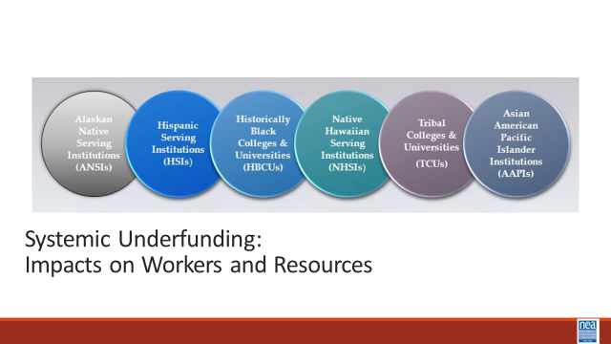  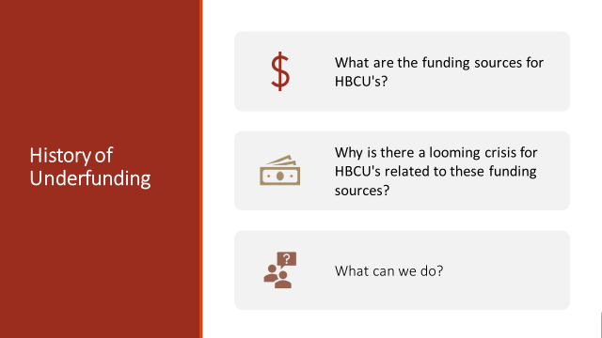  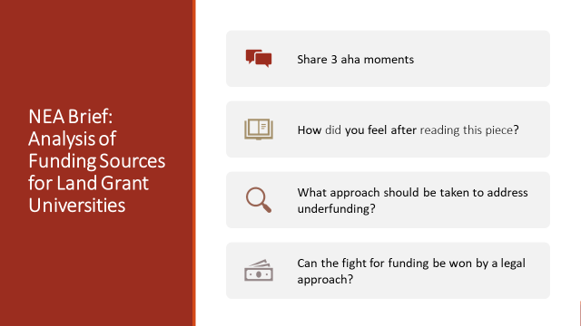  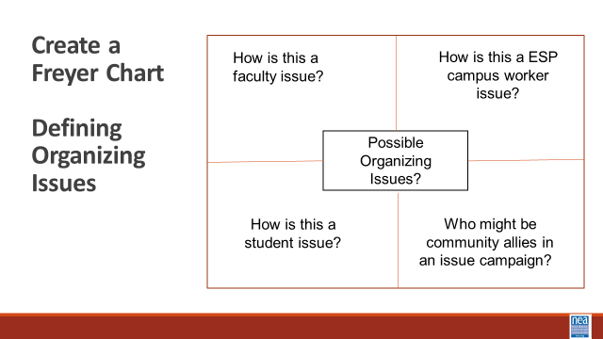  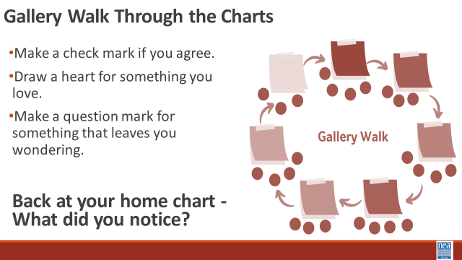  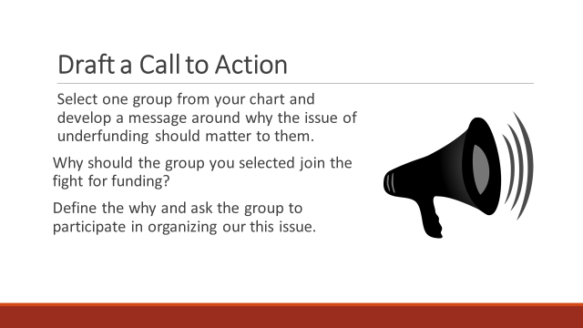  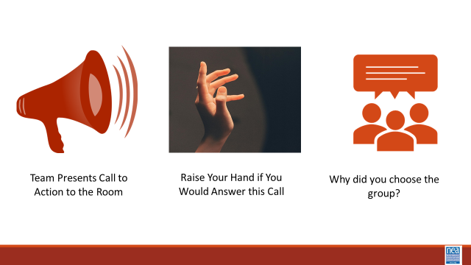  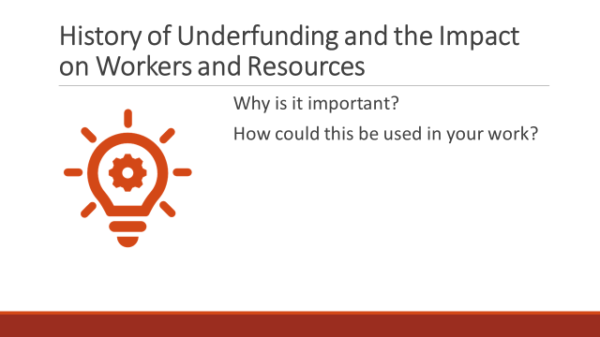 | Levels of Expression of Oppression Handout  A Looming Crisis for HBCU's Analysis of Funding Sources for Land Grant Universities  Sept 2023 Letter to governors regarding money owed to HBCUs. history of underfunding  Underfunding HBCUs leads to an underrepresentation of Black faculty (brookings.edu)  FACT SHEET: State-by-State Analysis of Record $2.7 Billion American Rescue Plan Investment in Historically Black Colleges and Universities | The White House  Opinion | Black colleges do more with less funding. Give them more. - The Washington Post | (HBCU’s versus PWI public universities in the same state)  3 Minutes- Introduction - The cycle of socialization feeds into how oppressions are realized. A useful framework for looking at this are the four levels of expressions of oppression. Find this document on p.99 of your participant handout. This framework can be used to help us assess how much resource we must make change and then apply that strategic use of resource at the level we have the best chance to win. For example, let’s say you want to achieve an anti-racist society – but you only have the resources to hold series of trainings for staff about unconscious bias – you will have to monitor and adjust your outcomes – or amass a whole lot more resource. The key point to remember when you use this framework is that there are not hard and fast lines between the levels and that making a change at any one level can catapult a change at another level – but it requires intention and escalation of actions, efforts, and resources.  We are going to look at how an expression of oppression plays out in the funding of non PWI colleges and universities. There is a history of underfunding that has existed and an already won legal fight to name the amount of reparations that need to be paid to each non PWI. The question I want you to consider as we do this activity – can the fight for equal funding be won by using only a legal approach? Does the use of a legal approach transform the power dynamics that allow for the expression of oppression?  WE need a people power approach if we are going to get the funds to the HBCUs  20 Minutes – Participants will have 20 minutes to read and create a Freyer Chart to identify the organizing issues related to the underfunding of HBCUs for faculty, students, ESP campus workers and community members. Participants will be in groups of 3 to 4. Each group will read one of the letters to the governors from the Secretary of Education from their state. They will organize their responses to the following questions in a Freyer Chart format using chart paper and markers.  Center square - what is the organizing issue in this letter?  Quadrant 1 – how do we make this a faculty issue?  Quadrant 2 – how can we make this ESP campus worker issue?  Quadrant 3- How can we make this a student issue?  Quadrant 4 -Who would be the community allies in an issue campaign?  20 Minutes Share – Report –and/or Gallery Walk  - Make a check mark if you agree.  - Draw a heart for something you love.  - Make a question mark for something that leaves you wondering.  Groups rotate through each poster until they come back to their own.  What did you notice?  20 Minutes- Groups will go back and create invitation to the campaign – messaging, narrative, -- for building the urgency – why do we need to act now??  Teams will share their call to action. As a team shares, the facilitator asks people listening to raise their hand if they would join – then asks for two or three report outs – Facilitator will listen for ways that the call-to-action highlights worker and student values and highlight those.  10 Minutes Debrief –  Why don’t your members join in on campaigns that are about winning a legal issue? -- and sometimes not on a legislative issue?  How does creating a worksite, school site issue that results from the higher-level injustice of underfunding bring more urgency to the need to act?  What happens when the call to action includes values?  2 Minutes -KEY POINTS  - Legal wins don’t result in system level power changes  - Even legal wins need compelling people led urgency and action to transform the power dynamics | History of underfunding  How does money affect the HBCUs?  Participants will make the connection between underfunding and worker needs.  Participants from states with an HBCU will be able to develop a a plan to Advocate for lost funding in their specific state.  Participants will learn how to frame organizing issues.  What are possible strategies  Who is the best target  How is this a people issue and not a policy issue
12:00 - 1:00 LUNCH
1:00 – 1:30 Eric and Melissa |  | 30 Minutes Organizing Differently
 | Video 3 minutes  https://www.youtube.com/watch?v=McneFCdHUn0  Ella Baker on Leadership handout | 5 Minutes Introduction and Video, and Quick Debrief – We are going to watch a 3 Minutes video and do a little group work to learn a little bit about leadership from Ella Baker.  1 Minute – take just a couple of answers to “What stands out to you about Ella’s ideas about leadership?  15 Minutes Group Work - Using the article “Ella Baker on Leadership” - your team is going to identify the following:  - What did Ella believe was important about leadership?  - How did this shape her approach to organizing and building power?  - Why might this approach be especially helpful on an HBCU or MSI campus?  5 Minutes Whole Group Discussion  (POSSIBLE ADDITION OF A STATEMENT ABOUT HBCUs have community within and outside – example alumni) .  Key Points:  •Leaders influence others  •Leaders are accountable  •Leaders are not singular  •Leaders are everyday people  •Leaders have emotional presence  •Leaders listen to others | Participants will reflect on the leadership beliefs and organizing practices that Ella Baker used and discuss why they would be effective in an HBCU setting.
1:30- 2:15 (August and Michelle) |  | 45 Mins Total – For Organizers in Unfamiliar Spaces
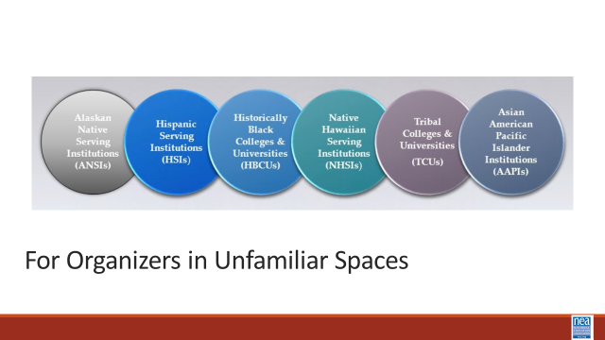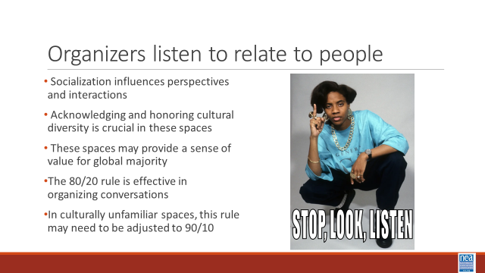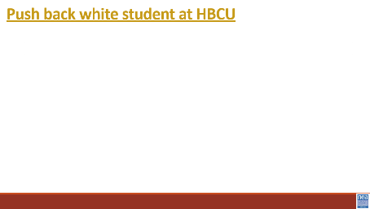  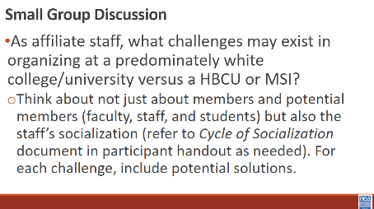  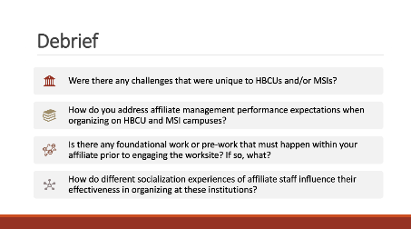  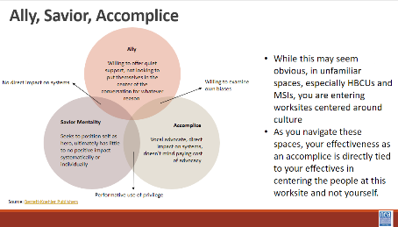  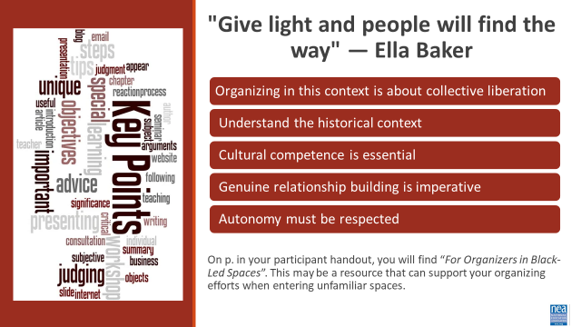 | Chart Paper for each group  Markers  Handout:  For Organizers in Black-Led Spaces | 10 minutes – Set Up (5 minutes) and Videos (5 minutes)  As discussed previously, socialization impacts our perspectives and interactions with the people around you. When entering HBCU and MSI spaces where you are culturally unfamiliar (even when there may be intersection with other identities you share), it is essential to be aware and honor that you are a guest in a significant cultural space. These spaces may be one of the few areas where folx of the global majority feel seen, heard, and valued.  Organizing is only as successful as your intentional listening. Labor Notes’ Secrets of a Successful Organizer by Alexandra Bradbury, Mark Brenner, and Jane Slaughter discusses employing an 80/20 rule during organizing conversations. Where you are actively listening for about 80 percent of the time and speaking roughly 20% of the time.  In spaces you are culturally unfamiliar, especially HBCUs and MSIs, this rule may need to be modified to 90/10.  A portion of your pre-attendance work was viewing a video that depicted the experience of a white student attending a HBCU. We are going to watch 2 clips from this video. These clips and the activity to follow directly discuss race. As a reminder to us all, this creates an opportunity to Lean into Discomfort, our community agreement.  Watch White Student at HBCU video (2 minutes)  Watch Push Back on White Student at HBCU video (3 minutes)  15 minutes - Small group discussion with chart paper  You may decide to keep them in table groups, or this may be an opportunity to count off by number break up in groups. (potential opportunity to split up staff in one group and members in the other)  Question: As affiliate staff, what challenges may exist in organizing at a predominately white college/university versus a HBCU or MSI?  - Think about not just about members and potential members (faculty, staff, and students) but also the staff’s socialization (refer to Cycle of Socialization document in participant handout as needed). For each challenge, include potential solutions.  When there are 5 minutes left, show debrief questions and intentionally bring attention to them. This will allow them to frame their thoughts during the debrief.  10 minutes – Report Out/Debrief  Facilitated Discussion Centering on the Following Questions: Time saving option: Each group does not have to answer all questions. You can present the questions before the report out/debrief and have them decide on which question(s) they will answer.  - Were there any challenges that were unique to HBCUs and/or MSIs?  - How do you address affiliate management performance expectations when organizing on HBCU and MSI campuses?  - Is there any foundational work or pre-work that must happen within your affiliate prior to engaging the worksite? If so, what?  - How do different socialization experiences of affiliate staff influence their effectiveness in organizing at these institutions?  10 minutes – Saviorism and Key Points  Show Venn Diagram - Allies, Accomplices, and Saviors: Knowing the Difference to Maximize Impact  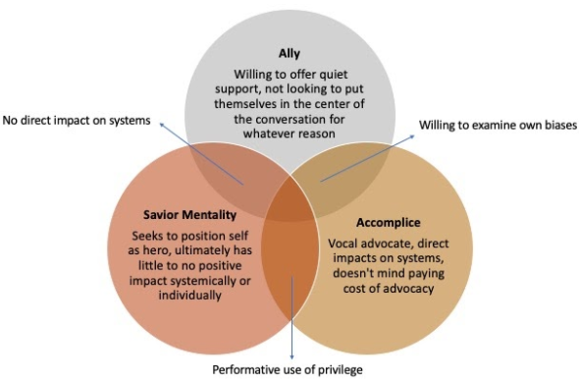  While this may seem obvious, in unfamiliar spaces, especially HBCUs and MSIs, you are entering worksites centered around culture. As you navigate these spaces, your effectiveness as an accomplice is directly tied to your effectiveness in centering the people at this worksite and not yourself.  Key Points  “Give light and people will find the way.” - Ella Baker  - Organizing in this context is about collective liberation  - Understand the historical context  - Cultural competence is essential  - Genuine relationship building is imperative  - Autonomy must be respected  On p. you will find “For Organizers in Black-Led Spaces”. This may be a resource that can support your organizing efforts when entering unfamiliar spaces. | How do affiliate staff show up in spaces and communities they have limited experience with?  Participants will identify potential challenges when organizing in unfamiliar spaces.  Participants will collaboratively find potential solutions to overcome challenges faced with organizing in unfamiliar spaces.
2:15 -2:30 BREAK
2:30-3:30 (LaQuita and Eric) |  | 60 Minutes – 1:1 Conversations
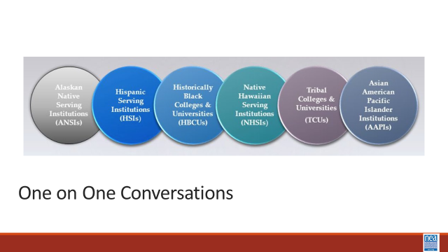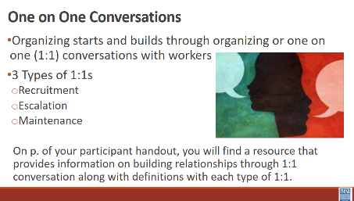  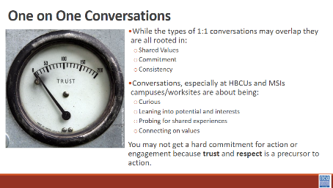  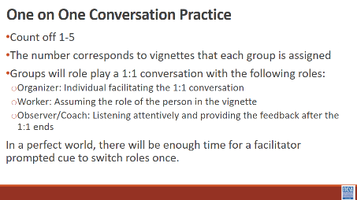  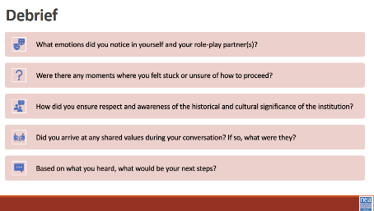 | Handout: Building Relationships  Handout: Vignettes | 10 minutes – Review Types of 1:1s  The beginning of any organizing starts and builds through organizing or 1:1 conversations with workers. On p. of your participant handout, you will find a resource that provides information on building relationships through 1:1 conversation along with definitions with each type of 1:1.  The 3 types of 1:1s we will frame our thinking around are:  - Recruitment  - Escalation  - Maintenance  These 1:1s sometimes overlap but the root of this is a relationship with shared values, commitment, and consistency. Take recruitment 1:1s for instance...when we think of this type of 1:1 you may think of recruiting individuals to join their union or commit to some task, activity, or role.  While this should be our focus widely, it is especially important to HBCUs and MSIs that you frame a recruitment 1:1 on being curious and leaning into potential and interests, probing for a shared experience (in a respectful way, not an interrogation), and connecting on values. You may not get a hard commitment for action or engagement because trust and respect are a precursor to action.  5 minutes – Activity Set Up  You will count off participants 1-5 (may be modified based on the number of individuals who are present). The number corresponds to vignettes that each group will be assigned. Individuals with the same number will be split into smaller groups of 3 or 4. Groups will role play a 1:1 conversation with the following roles:  - Organizer: Individual facilitating the 1:1 conversation  - Worker: Assuming the role of the person in the vignette  - Observer/Coach: Listening attentively and providing the feedback after the 1:1 ends  Perfect scenario:  15 minutes – Round 1 of 1:1 conversation  2 minutes – Mini-Debrief/Coaching  15 minutes – Round 2 of 1:1 conversation  2 minutes – Mini-Debrief/Coaching  35 minutes – 1:1 Practice  8 minutes – Debrief  Structured debrief using the following questions as a guide:  - What emotions did you notice in yourself and your role-play partner(s)?  - Were there any moments where you felt stuck or unsure of how to proceed?  - How did you ensure respect and awareness of the historical and cultural significance of the institution?  - Did you arrive at any shared values during your conversation? If so, what were they?  - Based on what you heard, what would be your next steps?  2 minutes – Key Points  - Recruitment, Escalation, and Maintenance 1:1s are essential for fostering strong, value-based relationships with workers, which are foundational to any organizing effort.  - When organizing at HBCUs and MSIs, emphasize curiosity, shared experiences, and values over immediate commitment, as trust and respect precede action.  ****Version that includes individuals from HBCUs and MSIs  Pair staff in small groups based on the number of individuals present. Have an organizing conversation with those individuals looking for potential shared values, interests, and challenges. Same debrief questions should apply. | Participants will practice the methods and skills of asking curious questions in 1:1s and apply those in identifying shared interests and values.
3:30- 4:15 (Ilissa and August) |  | 45 Minutes Total – Looking for Leaders – The Tour
 | Possible Tour of Tuskegee  (POSSIBLE ADDITION OF A STATEMENT ABOUT HBCUs have community within and outside – example alumni) | 5 Minutes Introduction: We are going to use an activity called social barometer. Imagine a line. On this end of the line is “we don’t need this in our organizing work” and that end of the line is “We can’t do our organizing work without this”  As I read the following 6 quotes about leadership – you will take a stand on the line based on what you think.  15 Minutes Activity – Give people a chance to move as you read each one, then once they have moved pick one or two people in different parts of the line to explain why they are standing where they are.  - "Just don't give up trying to do what you really want to do. Where there is love and inspiration, I don’t think you can go wrong." – Ella Fitzgerald  - "Leadership and learning are indispensable to each other." – John F. Kennedy  - "I’ve learned that people will forget what you said, people will forget what you did, but people will never forget how you made them feel." – Maya Angelou  - "When we speak we are afraid our words will not be heard or welcomed. But when we are silent we are still afraid. So it is better to speak." – Audre Lorde  - "We are not alone in our pain, and we are not alone in transforming our pain into power. We are all doing it, and we support each other in doing it." – Kerry Washington  - A leader is one who accepts responsibility for enabling others to achieve a common purpose in the face of uncertainty.” - Marshall Ganz  - – Jane Mcalevey.  ^{Key Points -}  ^{Leaders have followers.}  What that looks like is completely informed by our socialization.  We may need different lenses to “see” the leadership on this campus  25 Minutes – Setting the stage for the visit (August will likely be presenting on logistics and what to look for while at the HBCU - here are some suggestions for that)  What will leadership look like?  What are the aspects of the culture that would lend to a strong organizing plan?  What are challenges that would hamper organizing? | Participants will understand how leaders are identified and apply a social barometer to quotes about leadership.  Social Barometer:  Some groups choose to remain neutral, unknown, or undecided on the issue of tuition at Cooper out of fear of retaliation from the administration, because they feel there is not enough information, or that it’s not their job to make decisions about the way the institution is run. However, conflict occurs within a larger social context from which aspects of identity and oppression cannot be separated. Neutrality privileges those who are less impacted by experiences of systemic violence and lack of access to power or decision-making. It’s our collective responsibility to challenge each other to acknowledge that perceived neutrality reinforces an existing balance of power.
4:15-4:30 |  | 15 Minutes - Ending it Right
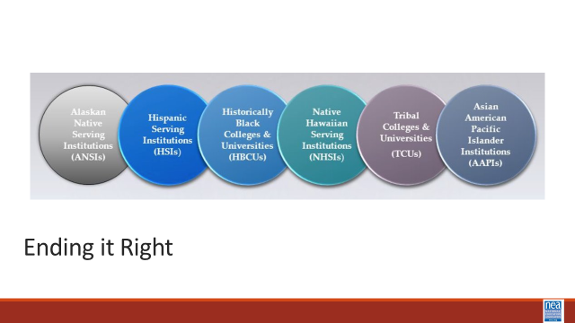 |  | Leave at 3:30 PM (3:45 PM at the latest) on bus to Tuskegee University  Back by 7:30 PM  Questions, Connections, Reflections  Housekeeping announcements  Plus/Delta at the Door  FOR TOMORROW – | Participants will be able to bring a little closure to their learning and provide feedback on the day.
4:30 – 5:00 |  | 30 Minutes - Choice Networking Activities – HBCU tour
 |  | This is a time for participants to meet and discuss any issues they are thinking about with other members of the group. This is not led by facilitators and highly encourage to occur in any other space besides the conference room. | Participants will make useful connections with staff from other affiliates.
5:00 ADJOURN

