Facilitator Agenda – Day 2 January 29, 2025
General Materials Needed: |  |  |  | Room Set-up:
1 Set of Handouts per Person  Name Tents with the Norms  Room signs,  One ream of white photocopy paper  Chart Paper (4 to 5 full w Sticky Strip) |  | Materials Box for each table with:  Markers (Mr. Sketch variety)  Post its – 3x3” and 4X5” sizes  Index Cards  Highlighters – 4 colors  Pens and Pencils  Participant “toys” |  | Long Rectangle table at back for facilitators  Round Tables for participants  Projector, Screen, mics, and Speakers  Carousel stations and reporting stations  No podium, table with projector big enough for laptop  50 people max
Key Outcomes for the Event:
Participants will understand the role staff play in building locals while maintaining a member-driven program on HBCU campuses
Participants will explore best practices from a number of member engagement case studies
Participants will explore successful affiliates that have focused on HBCU Programs and Campaigns
Participants will develop skills around strategic planning, leadership tests, data collection, and narrative development

Overview of Content, Time, and Facilitator Assignment
8:30-9:00 Entry and Welcome – Getting Started  9:00-9:15 Community Builder  9:15-10:15 Lived Values of Unionism and Anti-Racism  10:15-10:30 Break  10:30-11:15 What is Your Role  11:15-12:00 Intentional Power Building  12:00 -1:00 Lunch | Ellen  August and Illissa  LaQuita and Michelle  Eric and Barb  Albert and Kiesha |  | 1:00 -1:45 Partnerships and Coalitions  1:45-2:15 Problems to Issues Part 1  2:25-2:30 Break  2:30-2:50 Problems to Issues Part 2  2:50-3:20 Centering Race in Your Campaign  3:20-4:20 Spectrum of Allies  4:20-4:30 Ending it Right  4:30 -5:00 Adult Choice Networking - 5:00 Adjourn |  | Melissa and LaQuita  Illissa and Melissa  Melissa and Ilissa  Ellen and August  Kiesha and Eric  Ellen

Time Slides Facilitator | Resources | Instructions, Activity and Debrief (Facilitators) | Essential Questions and Outcomes
 | Charts, handouts, articles, materials, slide | What are you saying, what are they doing, what questions will you use to guide learning and make clear the important points  Include an estimate for how long each section of the learning will take | What question(s) will this learning answer? What will participants know or be able to do?
7:00 -8:30 – Team prep, practice, room set up, sound check, etc.
Entry Activity

8:30 -9:00 Ellen |  | 30 Mins TOTAL Getting Started
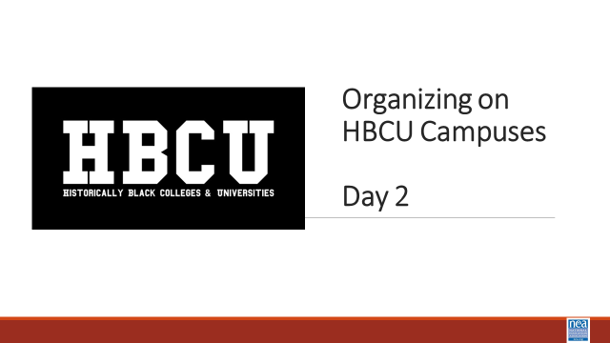  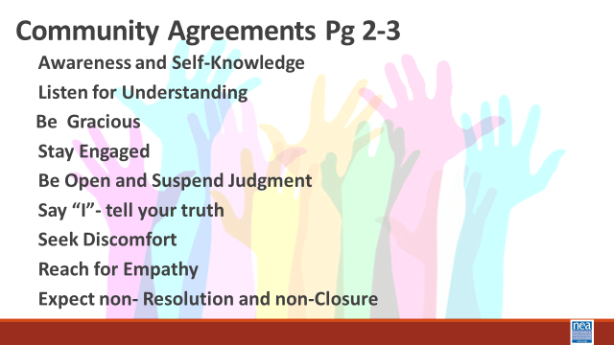   | Norms in Handouts  Agenda on Slides  Parking Lot Chart  Name Tents  Handout Package | 5 Minutes – Welcome back and any connections, reminders, or other needed info to start the day  5 Minutes – Review the Community Agreements – participants CAN highlight anything that we are doing well as a learning community or anything we need to improve on – Facilitators can as well.  15 Minutes – Feedback on Feedback – Present an overview of the previous day’s feedback, share the common points, any outliers, and adjustments to the agenda that were made. A good place to ask the room for any additional thoughts, solutions to identified issues, etc.  5 Minutes – Agenda overview and any other reminders. | Participants will know how we are going to work, the basic schedule, and the logistics relevant to the training.
9:00 -9:15 (August and Ilissa) |  | Community Builder
 | If this is focused on the HBCU folks or the visit – it will lead well into the rest of the day. | Reflective activity as a result worksite visit  Ideas we have had –  Timelines  Triad “Quaker Share” - Until yesterday I thought -------, now I think --------, I am still wondering ----------.  Define Power and Share Out Your Definitions  Possible picture activity -  Line Dancing, Singing, - Have the participants learn a call and response, have participants develop a line dance to show us.
9:15-10:15 (LaQuita and Michelle) |  | 60 Minutes – Lived Values of Unionism and Anti-Racism
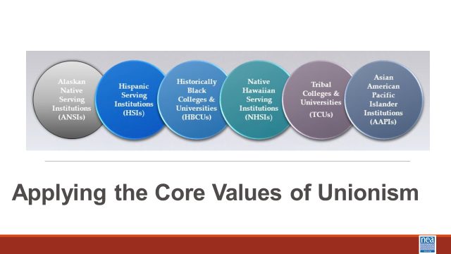  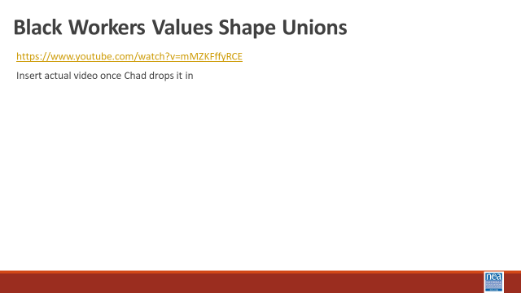  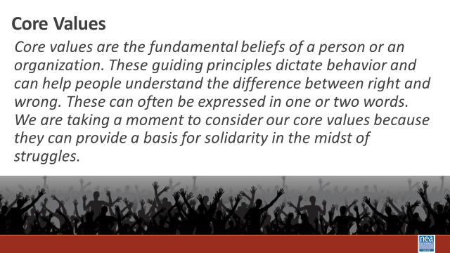  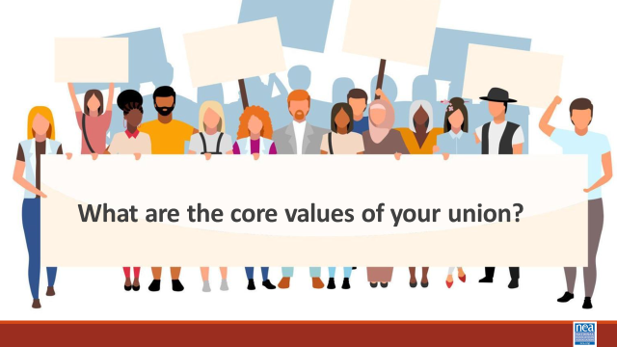  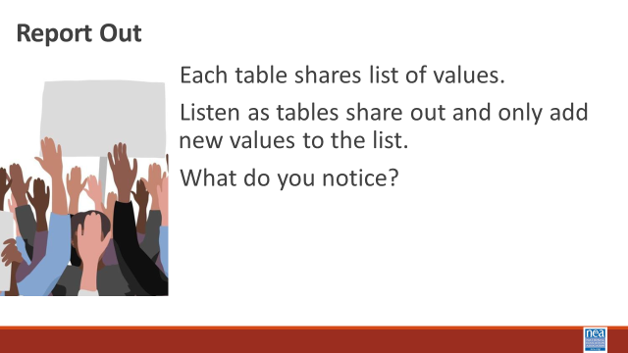  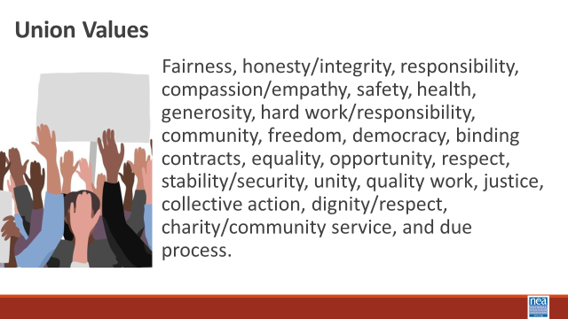  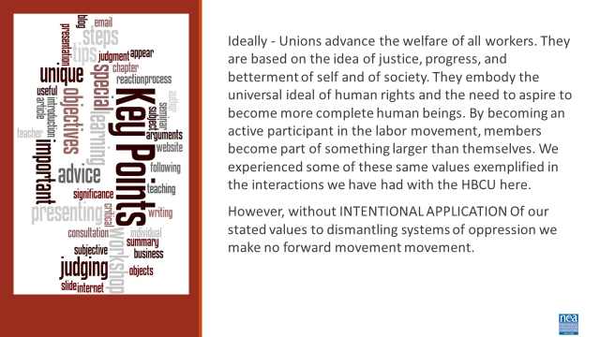  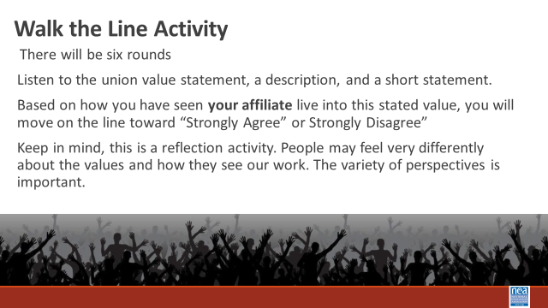  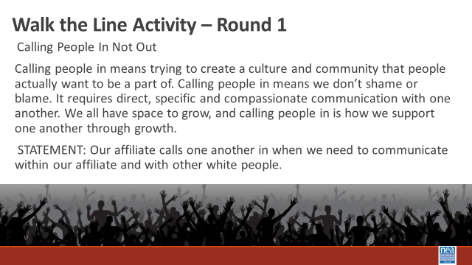  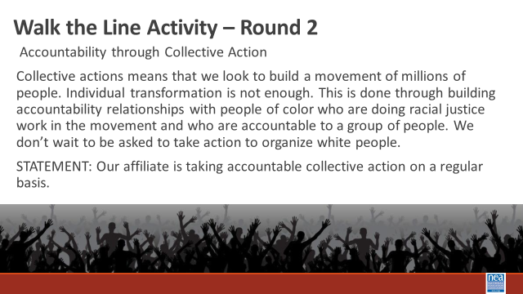  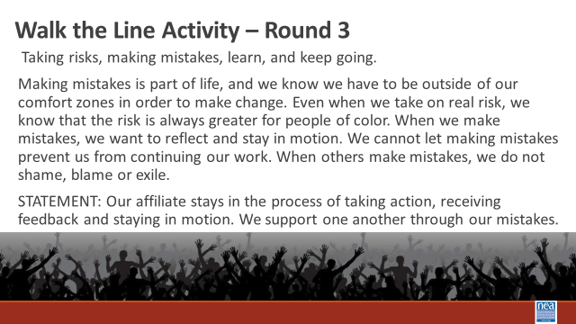  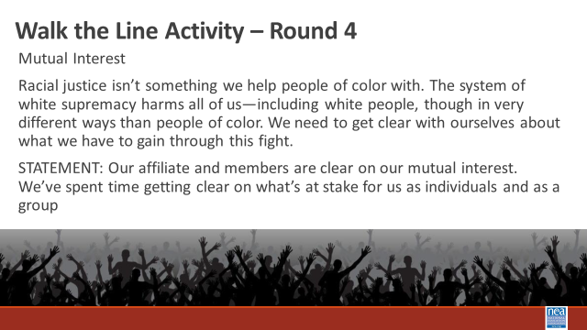  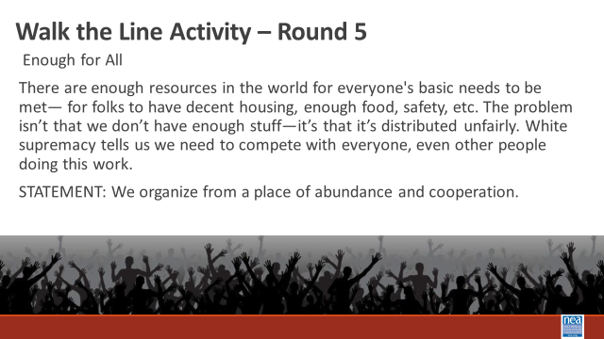  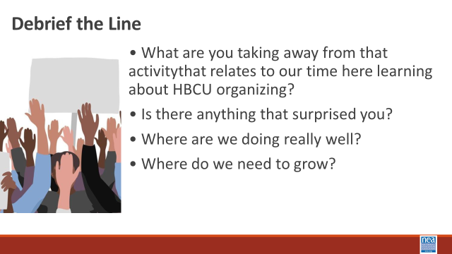  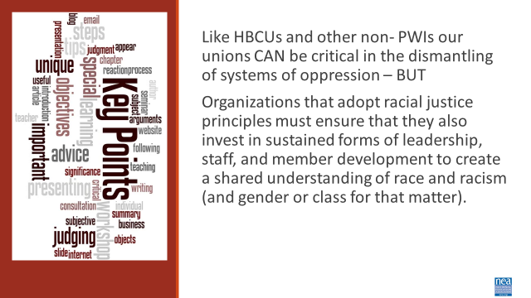 | Article  Unions Must Reckon Anti-Blackness  Organizing Must Change  Handout  Core Union Values | 15 Minutes Introduction and Core value Brainstorm for Unionism -  Introduction – 4 Minutes We are going to begin thinking about how values shape our unions. Let’s look at how the values held by black workers shaped the history of unionism.  Show Video (2 Minutes)  We like to think that Unions have always been about equity and fairness. Truth is, Women and formerly enslaved black people were excluded from unions. Black teachers founded Colored Teachers Associations CTAs to enhance educational opportunities for Black children, to develop themselves as professionals, political actors, and intellectuals, as well as to organize around broader socio-political concerns in the Black Freedom Movement. Today – it is more important than ever for our work in our unions to be rooted in anti-racism. Unionism is a collection of core values. Core values are the fundamental beliefs of a person or an organization. These guiding principles dictate behavior and can help people understand the difference between right and wrong. These can often be expressed in one or two words. We are taking a moment to consider our core values because they can provide a basis for solidarity in the midst of struggles.  At your tables, brainstorm what you think are CORE union values (turn and talk at your table and list those – be ready to report out). Use p. in your participant handout to record them.  Report out by asking each table to report their list – record those (chart them) – as you go to each table ask them to only add not repeat. Some examples you would expect to see – keep them to one or two words.  Fairness, honesty/integrity, responsibility, compassion/empathy, safety, health, generosity, hard work/responsibility, community, freedom, democracy, binding contracts, equality, opportunity, respect, stability/security, unity, quality work, justice, collective action, dignity/respect, charity/community service, and due process.  5 Minutes -Whole room discussion – How did you see these values exemplified in your time with our HBCU?  Key idea for this introduction and brainstorm activity (2 Minutes)  (don’t read this out loud- ask them to read it for themselves) Ideally - Unions advance the welfare of all workers. They are based on the idea of justice, progress, and betterment of self and of society. They embody the universal ideal of human rights and the need to aspire to become more complete human beings. By becoming an active participant in the labor movement, members become part of something larger than themselves. We experienced some of these same values exemplified in the interactions we have had with the HBCU here. However, without INTENTIONAL APPLICATION of our stated values to dismantling systems of oppression we make no forward movement.  40 Minutes TOTAL- Union Values Walk the Line Activity  (Set Up) Take into consideration that this activity will require standing for an extended period, moving in a small space and some reading. Mark a line on the floor of the room with string or tape. Note that this line needs to be long enough for all of the participants to have space on it. On one side of the line, post a sign that reads “Strongly Agree,” and on the other, post a sign that reads “Strongly Disagree.”  Directions to Give- 2 Minutes  This activity gives us a chance to check and see how our Core Union Values we just discussed, and the Core Values we saw exemplified in our time with the HBCU relates to the values of unionism where we work, in our affiliate. When we intentionally add values that center anti-oppression in our work – Race Class and Gender are systemic forms of oppression that we are socialized to normalize in our work. I am going to read some common Union value statements out loud with a short description. After the description, I will read a simple statement. Once I read the statement, please move and stand on the spectrum of agree/disagree based on your opinion and what you have seen your affiliate do. Keep in mind, this is a reflection activity. People may feel very differently about the values and how they see our work. The variety of perspectives is important.  For each round, (there are 6) Read the description of a value and the statement that follows it. Repeat the statement twice. Then ask people to move. Intentionally call on people, just two or three for each statement, to share why they choose to stand where they did.  Walk the Line Activity 20 Minutes (About 3 minutes per round)  Round 1  Calling People In Not Out  Calling people in means trying to create a culture and community that people actually want to be a part of. Calling people in means we don’t shame or blame. It requires direct, specific and compassionate communication with one another. We all have space to grow, and calling people in is how we support one another through growth.  STATEMENT: Our affiliate calls one another in when we need to communicate within our affiliate and with other white people.  Round 2  Accountability through Collective Action  Collective actions means that we look to build a movement of millions of people. Individual transformation is not enough. This is done through building accountability relationships with people of color who are doing racial justice work in the movement and who are accountable to a group of people. We don’t wait to be asked to take action to organize white people.  STATEMENT: Our affiliate is taking accountable collective action on a regular basis.  Round 3  Taking risks, making mistakes, learn, and keep going.  Making mistakes is part of life, and we know we have to be outside of our comfort zones in order to make change. Even when we take on real risk, we know that the risk is always greater for people of color. When we make mistakes, we want to reflect and stay in motion. We cannot let making mistakes prevent us from continuing our work. When others make mistakes, we do not shame, blame or exile.  STATEMENT: Our affiliate stays in the process of taking action, receiving feedback and staying in motion. We support one another through our mistakes.  Round 4  Mutual Interest  Racial justice isn’t something we help people of color with. The system of white supremacy harms all of us—including white people, though in very different ways than people of color. We need to get clear with ourselves about what we have to gain through this fight.  STATEMENT: Our affiliate and members are clear on our mutual interest. We’ve spent time getting clear on what’s at stake for us as individuals and as a group.  Round 5  Enough for All  There are enough resources in the world for everyone's basic needs to be met— for folks to have decent housing, enough food, safety, etc. The problem isn’t that we don’t have enough stuff—it’s that it’s distributed unfairly. White supremacy tells us we need to compete with everyone, even other people doing this work.  STATEMENT: We organize from a place of abundance and cooperation.  Round 6  Growing is good  We need millions of white people to join the movement for racial justice, and in order for this to happen our groups need to keep growing. We need to constantly bring in new voices and leaders. This means more than inviting people to come to meetings. It means finding new and exciting ways to bring people into the work based on their skills.  STATEMENT: Our group is open to growth. We bring in new members and engage with them as leaders.  Debrief Questions - 15 Minutes  • What are you taking away from that activity that relates to our time here learning about HBCU organizing?  • Is there anything that surprised you?  • Where are we doing really well?  • Where do we need to grow?  2 Minutes Key Ideas  Like HBCUs and other non- PWIs our unions CAN be critical in the dismantling of systems of oppression – BUT  Organizations that adopt racial justice principles must ensure that they also invest in sustained forms of leadership, staff, and member development to create a shared understanding of race and racism (and gender or class for that matter). | Participants will use the core values of unionism and the exemplified core values from the HBCU encounter to reflect on the level of intentional anti-racist values found in their own affiliates.
10:15- 10:30 BREAK
10:30 – 11:15 (Eric and Barb) |  | 45 Mins TOTAL– What is Your Role
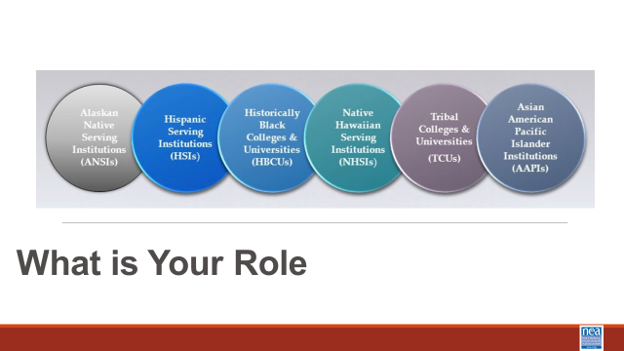  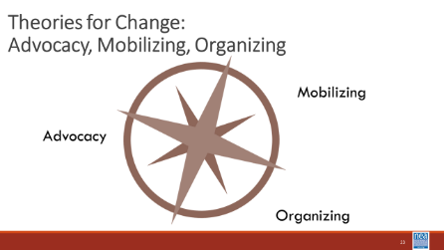  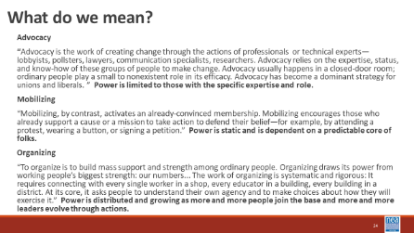  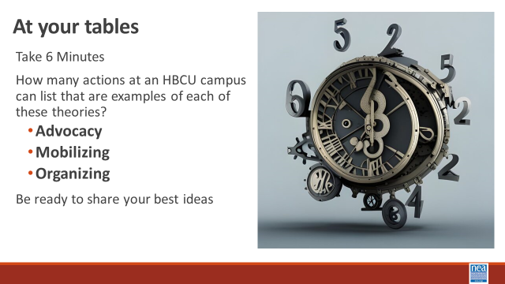  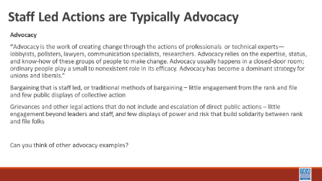  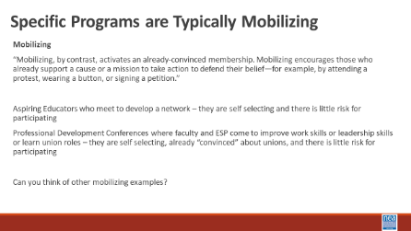  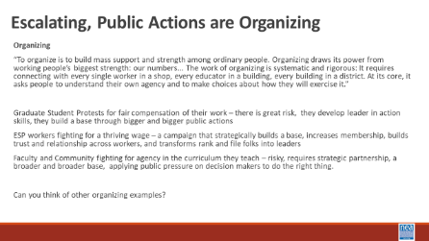  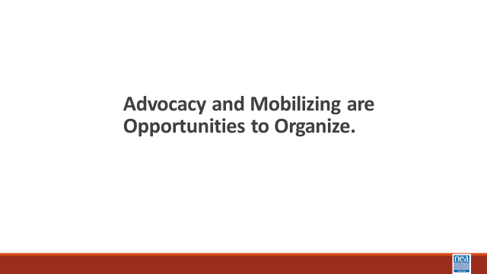  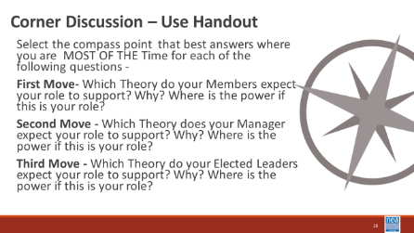  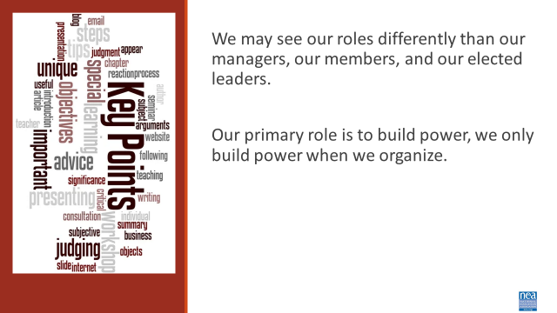 | Three Charts – Advocacy, Mobilizing, Organizing  Handout- Day 2 Advocacy, Mobilizing, Organizing  Possible addition – black faces in high places will not change the system (Albert?) | 45 Minutes – How do members view me?  Introduction and Content 10 Minutes - We are going to be using the handout called Advocacy, Mobilizing, Organizing on p. . These are three very different theories of change at use in our affiliates. Each have a very different way that staff roles and expectations are actualized. At times, members may have different expectations for us than our managers, than do our elected leaders. Just as there are different expectations for staff – there are different ways that we intentionally engage members. While you could view each of these as unchangeable, we DO HAVE a great deal of autonomy in how we do our work. Simple but significant shifts in how we show up can shift the expectations and actions of others.  Let’s define Advocacy, Mobilizing and Organizing –  - Advocacy  - “Advocacy is the work of creating change through the actions of professionals or technical experts—lobbyists, pollsters, lawyers, communication specialists, researchers. Advocacy relies on the expertise, status, and know-how of these groups of people to make change. Advocacy usually happens in a closed-door room; ordinary people play a small to nonexistent role in its efficacy. Advocacy has become a dominant strategy for unions and liberals. ” Power is limited to those with the specific expertise and role.  - Mobilizing  - “Mobilizing, by contrast, activates an already-convinced membership. Mobilizing encourages those who already support a cause or a mission to take action to defend their belief—for example, by attending a protest, wearing a button, or signing a petition.” Power is static and is dependent on a predictable core of folks.  - Organizing  - “To organize is to build mass support and strength among ordinary people. Organizing draws its power from working people’s biggest strength: our numbers... The work of organizing is systematic and rigorous: It requires connecting with every single worker in a shop, every educator in a building, every building in a district. At its core, it asks people to understand their own agency and to make choices about how they will exercise it.” Power is distributed and growing as more and more people join the base and more and more leaders evolve through actions.  15 Minutes at your tables and then Share – Can you list an action at an HBCU campus that staff would be part of supporting that exemplifies each of these?  Report out one or two for each of the next three slides that already have examples. The key points to remember are that STAFF LED is typically advocacy and no transformation of the power relationship for the member typically happens. PROGRAM driven is typically mobilizing as it is the same, already committed, little risk to engage member groups – if there is a transformation in the power dynamic it keeps the presence of the union visible – but does not grow beyond the already committed. ORGANIZING adds leaders and committed people, involves risk, and escalated over time. Staff may lead in the beginning but move to coach and support roles – not the drivers. The relationship of the member transforms from individual participation to use of power with others to achieve meaningful changes.  Remember Advocacy and Mobilizing are opportunities to organize  25 Minutes Move and Discuss - NOW that we have defined these theories as a group, we are going to use the table in the Advocacy, Mobilizing, Organizing handout that outlines these concepts even more. Your task as an individual is to take two minutes and scan the table of the Three Theories and make a decision about your expected role MOST OF THE TIME are you supporting the Advocacy Theory, the Mobilizing Theory, or the Organizing Theory? Give the room two to three minutes to review. This is quiet time.  Now look around the room and you will see three areas – you are going to move to the area (Advocacy, Mobilizing, Organizing) based on the question that I ask. You will be given the opportunity to move three times – but at each move you will answer the same two questions – WHY is this your expectation AND if this is the theory you are supporting who has the power?  First Move- Which Theory do your Members expect your role to support? Why? Where is the power if this is your role?  Do a little discussion between each move about WHY  - Second Move - Which Theory does your Manager expect your role to support? Why? Where is the power if this is your role?  Do a little discussion between each move about WHY  - Third Move - Which Theory do your Elected Leaders expect your role to support? Why? Where is the power if this is your role?  Do a little discussion between each move about WHY  - (Let them go to their seats before debrief)  5 Minutes to Debrief -  What is some new thinking that evolved for you as a result of this activity?  What could you do differently to build power than what you are currently doing?  Why is this important to think about especially in the HBCU context?  1 Minute Key Points  We may see our roles differently than our managers, our members, and our elected leaders.  Our primary role is to build power, we only build power when we organize. | What are the ways members think about my role?  Participants will Understand that there are other areas for New Organizing – Faculty Staff chapters, ESP Chapters, Graduate Student Chapters, Aspiring Educators Chapters  Participants will understand that there is a continuum from advocacy, mobilizing, and organizing that builds member engagement.
11:15-12:00 (Albert and Kiesha) |  | 45 Minutes Total – Building Power in an HBCU Context
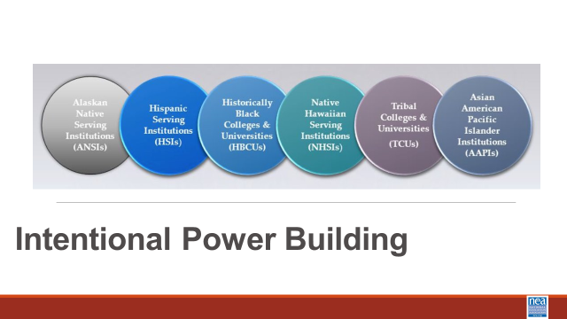  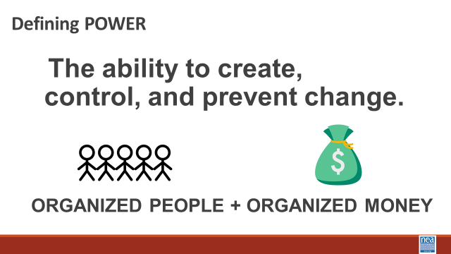  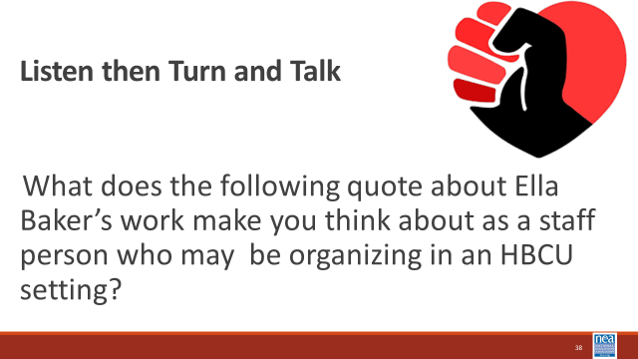  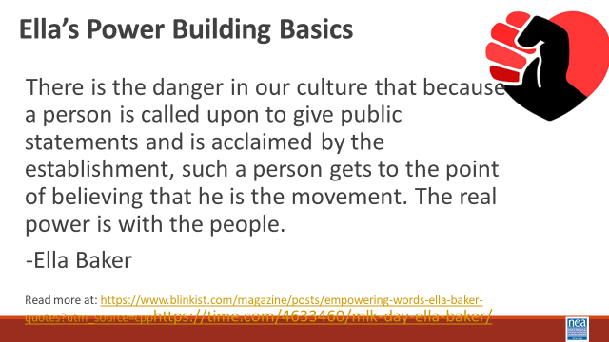  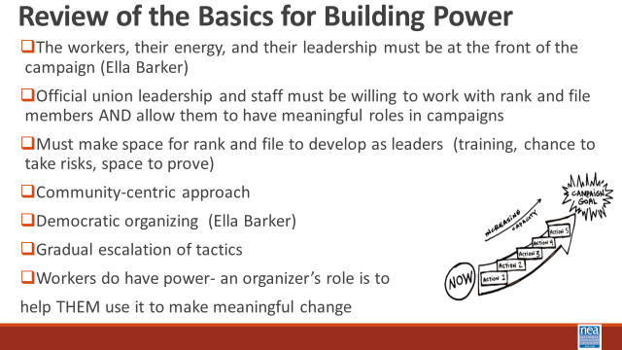  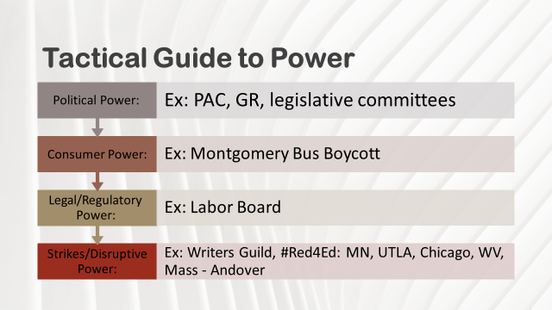  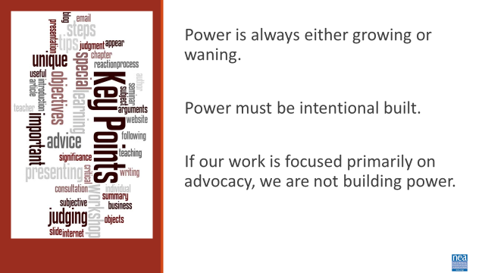 | Intentional Building Power Cases  And  Intentional Power Building Analysis sheet. | Intentional Power Building  Intro – 1 Minute– We are going to be taking a look at how power can be intentionally built by looking at some cases from Higher Ed. Some of the concepts will not be new, but the context in which this is applied may require different thinking.  5 Minutes – Turn and Talk – When you see the definition of power as a staff person who may be organizing in an HBCU setting, what does this make you think about?  5 Minutes – Making Connections with Ella and Lessons Learned  What does the following quote about Ella Baker’s work make you think about as a staff person who may be organizing in an HBCU setting?  There is the danger in our culture that because a person is called upon to give public statements and is acclaimed by the establishment, such a person gets to the point of believing that he is the movement. The real power is with the people.  -Ella Baker  Review of the Basics (5 Minutes)  For all successful, worker led, power building campaigns these are some of the most critical lessons we have learned and can all likely agree  - The workers, their energy, and their leadership must be at the front of the campaign  - Official union leadership and staff must be willing to work with rank-and-file members AND allow them to have meaningful roles in campaigns  - Must make space for rank and file to develop as leaders (training, chance to take risks, space to prove)  - Community-centric approach  - Democratic organizing (Marshall Ganz and Ella Barker)  - Gradual escalation of tactics  - Workers do have power  Tactical Guide to Power and Power Analysis Intro (5 Minutes)  The four strategic power lines that we can build campaigns around include Political. We build PAC drives, staff with GR, and have legislative committees. There is consumer power, we boycott a good or a service to apply pressure. There is legal or regulatory power – we win in court or win some labor board decisions. Strikes and disruptive power – visible, escalating, targets a particular person who has power to solve a particular issue.  To intentionally think about power, we need to win the demand we want, we need to create a power analysis. We ask four questions:  - Who has the power to give or prevent the change we want? (this is a target. Targets have a name, a face, and an address.)  - What actions influence this target? Actions are tactics that apply pressure in a public escalation until you get the change you want.  - Who influences your target?  - Who do you want to support your change?  15 Minutes – Group Work – Each Group is assigned a case. Pages in your participant handout. Complete the four quadrants of the power analysis AND the 5th question – what is the role of staff in all of this?  10 Report Out and Discuss Key Points  What was a key learning you took from this activity?  What changes in your work would you and your manager need to make room for in order to cultivate power building as presented in these cases?  Key Points  - Power is always either growing or waning.  - Power must be intentionally built.  - If our work is focused primarily on advocacy, we are not building power | Participants will use cases of organizing work to support the analysis of the power dynamics.  Participants will understand the four main power strategies our affiliates employ.  Participants will reflect on the type of working conditions THEY need in order to intentionally build power.
12:00-1:00 - 12:00-12:30 |  | LUNCH | Will need to trim 45 minutes of content this day
1:00-1:45 (Melissa and LaQuita) 12:30-1:15 |  | 45 Minutes Total – Partnerships and Coalitions | Needed more time, added 10 minutes for the group activity.
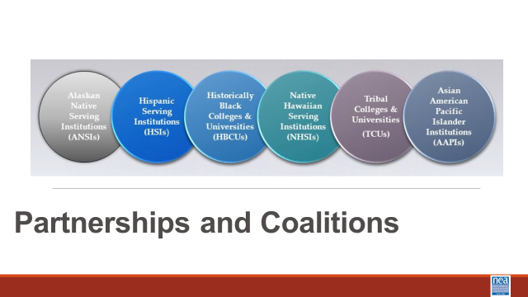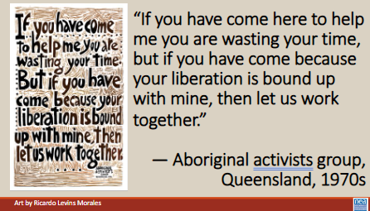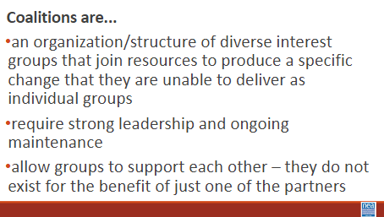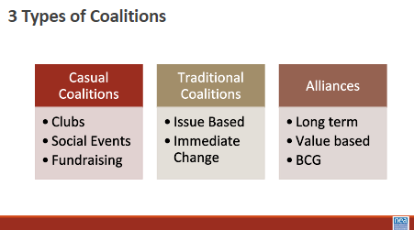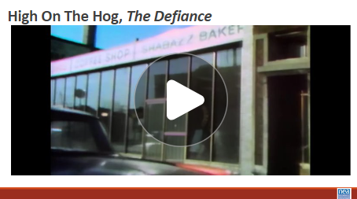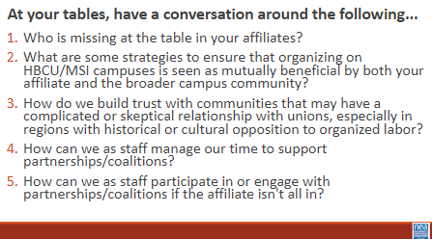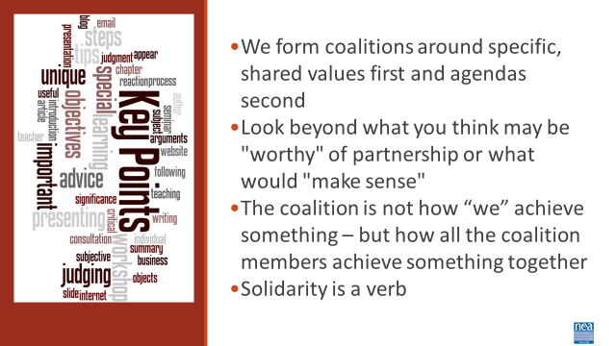 | PartnershipsCoalitions_HOTHClip.mp4  https://ctb.ku.edu/en/table-of-contents/assessment/promotion-strategies/maintain-a-coalition/tools | 10 Minutes – Partnership and Coalition Lecture  (POSSIBLE ADDITION OF A STATEMENT ABOUT HBCUs have community within and outside – example alumni)  - “If you have come here to help me you are wasting your time, but if you have come because your liberation is bound up with mine, then let us work together.” ― Aboriginal activists group, Queensland, 1970s  - This quote is credited to Lilla Watson, an Indigenous Australian woman who is an activist, artist, and academic. However, Watson says that because her words arose from a collective process, she wants them to be credited as “Aboriginal activists group, Queensland, 1970s."⁣  - Coalitions are...  - an organization/structure of diverse interest groups that join resources to produce a specific change that they are unable to deliver as individual groups  - require strong leadership and ongoing maintenance  - allow groups to support each other – they do not exist for the benefit of just one of the partners  - 3 Types of Coalitions  - Casual Coalitions  - Clubs  - Social Events  - Fundraising  - Traditional Coalitions  - Issue Based  - Immediate Change  - Alliances  - Long term  - Value based  - BCG  6 minutes – Watch Video  - High On The Hog, The Defiance Video  - High On The Hog is a Netflix series that depicts how they African Americans and their food influenced what is considered American culture  - You are about to watch a segment from the episode “The Defiance” from their second season. This episode captures events from the Civil Rights Movement including students who attended HBCUs at the time and were organizing for their liberation  - Initially, you may not see an obvious partnership or coalition. As you watch, adjust your lens to noticing the ecosystem and interdependence that takes place in this video  15 minutes – Small Group Discussion (needed more time, added 10 minutes to group work.)  - At your tables, have a conversation around the following...  - 1. Who is missing at the table in your affiliates?  - 2. What are some strategies to ensure that organizing on HBCU/MSI campuses is seen as mutually beneficial by both your affiliate and the broader campus community?  - 3. How do we build trust with communities that may have a complicated or skeptical relationship with unions, especially in regions with historical or cultural opposition to organized labor?  - 4. How can we as staff manage our time to support partnerships/coalitions?  - 5. How can we as staff participate in or engage with partnerships/coalitions if the affiliate isn't all in?  - You don’t have to answer every question. Have a free flowing, but on topic, conversation thinking around the video you just watched that documents coalition and partnership work and your affiliate.  10 minutes – Debrief/Share Out  - To avoid a rogue conversation, have individuals specifically reference what question number they are speaking to in a whole group discussion  4 minutes – Key Points  - We form coalitions around specific, shared values first and agendas second  - Look beyond what you think may be "worthy" of partnership or what would "make sense"  - The coalition is not how “we” achieve something – but how all the coalition members achieve something together  - Solidarity is a verb | Participants will build awareness and understanding around partnership and coalition building that reframes the focus solely on self-interest.  Participants will understand what it takes to develop a coalition, set norms, and decide how long it needs to last.  Participants will assess staff role in participating and engaging with coalitions and partnerships
1:45-2:15 (Melissa and Ilissa) 1:15-1:45 |  | 50 Minutes Problems to Issues (30 Before Break and 20 After)
 | Day 2 vignettes  Are the case Study for this. ELLEN REVIEW AND ADD IF NEEDED | 5 Minutes Intro to PROBLEM vs. ISSUE  - People have problems, our job is to ask how they think they could solve the problem.  - Solutions to problems indicate different issues depending on the perspective of the people we are working with.  - Campaigns start with issues members care about.  - An issue is a slice of a workplace problem.  - It is KEY to get enough input on what the issues are that make up the problem so that YOU do not drive the solution.  - It is key to get enough input on what the issues are that make up the problem so that YOU don’t drive the solution.  - A staff-driven solution may not meet the needs and commitment of the people you are working with.  Let’s consider the example of a car that is a piece of junk  - My car is a piece of junk.  - Why is that a problem?  - It is not safe to drive to work.  - What do you want to do about that?  - It is too much, I will need new tires, the brakes are weak, the exhaust is leaking.  - Is any of this a problem for anyone else?  - Yes, my kids are sick from the exhaust.  - What do you want to do about that?  - The first thing I can do is fix the exhaust.  Let’s Look at a campus example  PROBLEM – Workers on this campus don’t make enough money to thrive  “How would you solve that problem? – Raise wages.”  ◦ Issue – ESP workers are often seen as role models here and could be great mentors to some students, but because they have to rush out to work second jobs, they cannot focus on strong relationships with students.  ◦ Issue – Student workers are often already first generation students with limited financial support, when they work at low wage jobs on campus, that is one more stress that prevents them from being a leader on campus or focusing on the full opportunity of their schooling.  ◦ Issue – Faculty are the lifeblood of this institution and paid below other institutions levels. Designing and implementing high value curriculum and providing important coaching and mentoring for students. They are financially stressed by low pay and can not commit to their students in the way they could if they felt values and financially secure.  Issues can have different constituencies – and it is the work of the organizer to help the different constituencies see how their issues are connected – this builds the amount of people pulling together for change.  15 Minutes – Intro and GROUP WORK  In your groups, you are going to work with a scenario and decide the:  The potential issues in your scenario – this will be a brainstorm  BRAINSTORM- ON CHART PAPER- ANYTHING GOES- ALL IDEAS ON CHART PAPER  15 Minutes – Constituency Identification  Remember, different people will care about different issues – now identify who the constituency for each issue is – be as narrow or as broad as your team wants – but also try to be specific.  10 Minutes – Intro and Group work Assessing an issue  Since there may be many issues confronting workers on the job, we have to also think about what makes a good issue to organize around.  - CRITERIA:  - It is widely felt.  - It is deeply felt.  - It is winnable.  - It builds the union and builds leaders.  - It has a connection to students and the public.  2 Minutes Key points  - Problems are overwhelming and don’t focus people on the power they have to make change.  - Issues indicate what is possible  - Often, issues of equity are deeply felt by a marginalized few, and NOT by the privileged majority. If an issue is very deeply felt, it may not be widely felt, BUT does connect with shared values. | Participants will review problem and issue and will apply their understanding to both brainstorming issues and evaluating them.
2:15-2:30 BREAK
2:30-2:50 1:45-2:10 |  | Continuation of Activity Above
2:50-3:20 (Ellen and August) 2:10-2:40 |  | 30 Mins – Centering Race in Your Campaign
ELLEN  Working Notes  - Will apply a RET to demands and tactics - use the materials  - developed by The YRO ESP Team (Katie Bishop is lead) | Need a Handout  Use the Forge Article  Use the BGC Materials | Ideally – once they understand the content – in this section they will apply a race and equity lens to the issues and constituencies they identified above.  Get the Content from the team developing this for the ESP YRO Presentation (Katie Bishop is lead- using the FORGE Article)  What does it mean to center racial justice demands?  Racial dynamics, disparities, and divisions permeate our society, communities, schools, and classrooms. Systemic racism is so deeply rooted in our history, culture, and institutions that there is no escaping it.  Visible or not, the impacts are ever-present. Racial justice is the systematic fair treatment of people of all races, resulting in equitable opportunities and outcomes for all. Racial justice (or racial equity) goes beyond “anti-racism.” It is not just the absence of discrimination and inequities, but also the presence of deliberate systems and supports to achieve and sustain racial equity through proactive and preventative measures.  To engage in a systems analysis of a racial issue and develop solutions or to test if the campaign demands center racial justice, good discussion questions to have with partners and union members include:  • Problems: What racial inequities are you noticing or experiencing? What are the impacts on different racial groups? Who benefits most and who is hurt most?  • Causes: What institutions, policies, or practices are causing or contributing to the inequities? What social norms, popular myths, or cultural biases may be contributing?  • History: How did things get this way and are things worsening or improving?  • Solutions: What solutions could address the root causes and eliminate the inequities? How would different racial groups be impacted by the  proposed solutions?  • Strategies: What strategies and actions could be used to advance the solutions?  • Leadership: Who are the stakeholders most affected by the inequities? Are they involved in naming the issues and solutions? What kinds of  active leadership roles could they take to advance the proposed solution? | Participants will practice using a version of a race and equity tool to ensure that race, gender, and class are at the center of their campaign work.
HOW THIS WAS DONE IN ARJ |  | 15 Minutes Total Tools to Support Processes for Becoming Anti-racist
 | Racial Equity Impact Assessment | 15 mins Intro of Tools - (Facilitator note – this section is simply a walkthrough of some frameworks and tools that can support intentional work with groups that are working to become anti-racist)  We have focused to this point in this training on foundational concepts and dispositions you will need to do this work when you return. We are going to turn our attention now to tools and process for applying your learning.  30 Minutes – Group Work with Continuum for Becoming an Anti-Racist Organization – Take 2 minutes to introduce this tool – it is a way to BEGIN a conversation in an organization. This exact tool has been used in a number of places – a group of non-profits including the area NEA affiliates used this at one time to develop a stakeholder-wide approach to becoming anti-racist. You are going to take 10 minutes on your own first to look at each column and circle the indicators of where YOUR employer currently is. Then, take the next 15 minutes to talk as a group about what this means – note: the column in which you circle the greatest number of indicators is the column that YOU think the organization is currently operating – others might have a different perspective. Share your findings with your group and be ready for a short share out.  2 Minutes – Key Points  Racial Equity is something that has to be intentionally and explicitly planned for, implemented and monitored within an organization.  You cannot move forward as an organization without honestly and openly assessing where you are.  Change happens, intentional change happens with a plan. | Participants will learn about several tools that can support organizational planning for becoming anti-racist.  How do we plan for this work?
3:20- 4:20 (Kiesha and Eric) |  | 60 Minutes – Spectrum of Allies
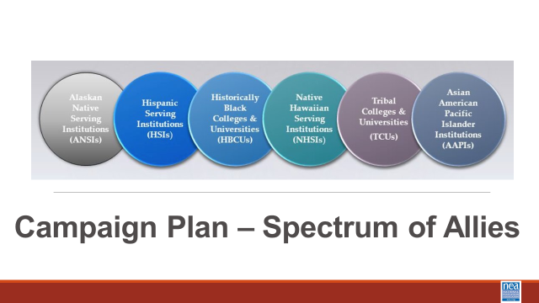  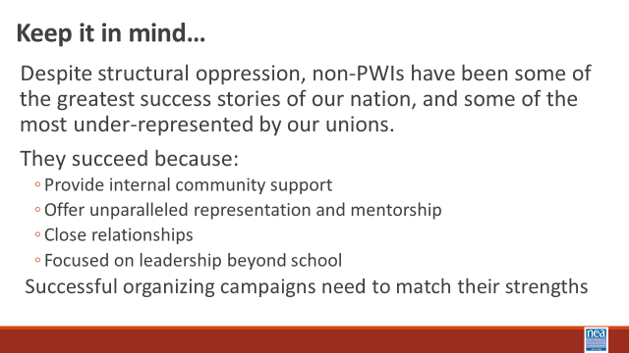  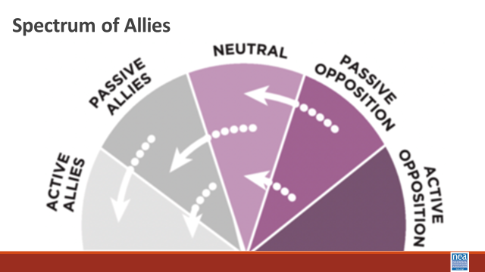  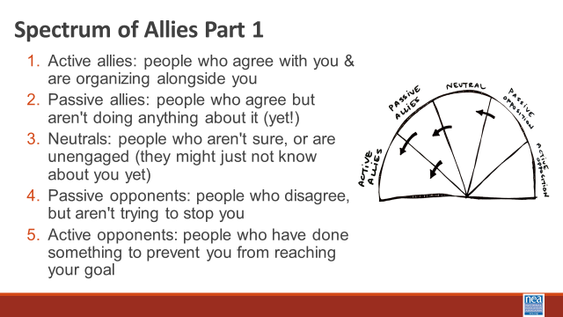  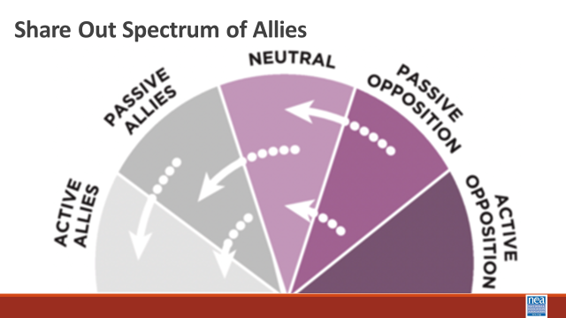  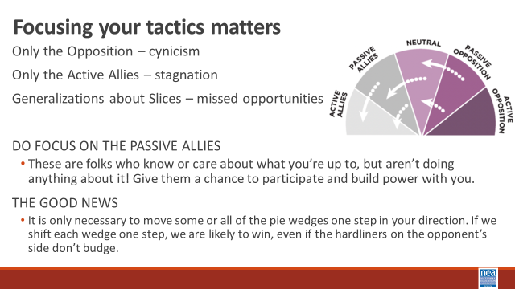  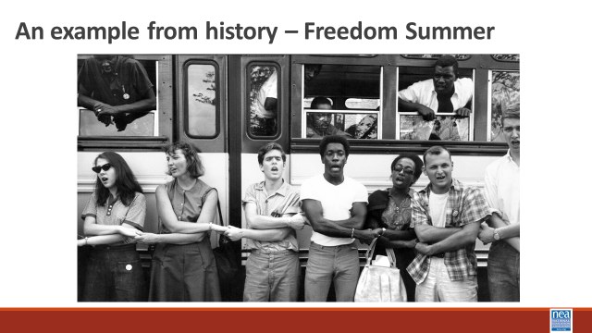  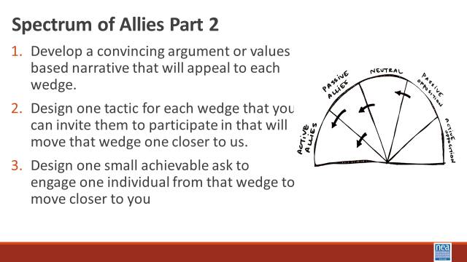  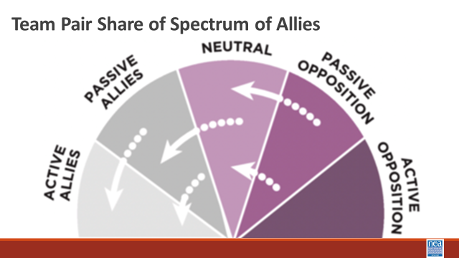  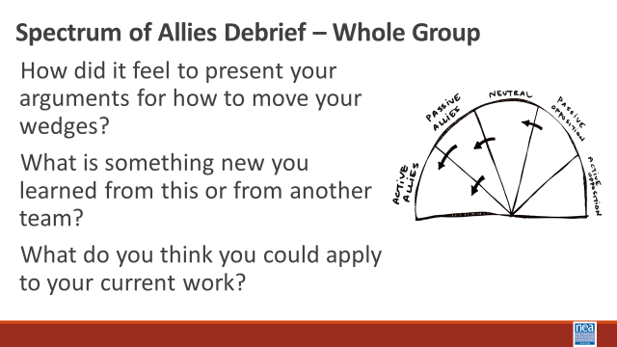  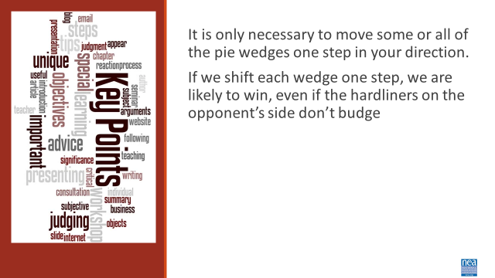 | CHOOSE ONE OF THE SPECTRUM OF ALLIES WORKSHEETS ELLEN | 5 Minutes Introduction- Your team just identified an Issue, a win, and a target based on our Vignettes. We are going to look at building a campaign plan. The methods and skills we are going to continue to apply here are linked to why we believe HBCUs and other non PWIs are successful – they are strong because of all the ways they are connected to various communities. So, as we build this plan, at each step of the escalation of a campaign from foundation, kick-off- through tactics to the BIG Win, we want you to intentionally think about the following:  - Your urgent message  - Your structure (leaders and teams)  - Your linked communities (not just YOUR people, but who they are connected with through shared values and commitments)  Our theory is that organizing on campuses like the one we visited have to include enough power to challenge and dismantle the expressions of oppression that exist.  15 Minutes of work time For Step 1 Activity - We are going to begin by learning a method Called Spectrum of Allies. All of our campaigns CAN include a wide range of groups, but particularly in the campaigns we are thinking about they must include that. These include a wide range of groups that can be put on a kind of spectrum, from those closest to the point of view of the advocates to those who actively oppose change. Draw a horizontal line to represent that. Those who advocate change are represented by a point at one end of the line (say, on the left), and the opponents by a point at the other end.  Draw a semicircle with wedges. The wedges closest to either end are the active allies and opponents, next in are passive allies. The group in the middle are neutral.  Use the issue that your group identified and the demand you came up with. Begin by asking, who might be inclined to be most supportive, least supportive, or neutral. Some examples of groups: ‘unions?’, ‘poor  people’s groups?’, ‘business community?’. In your teams, identify these (AND WHY) and put them on your spectrum on the spectrum, and write them into the ‘pie’. Be as specific as possible – names, make them up to match the vignettes you are working with. Identify why people are placed where you placed them.  5 Minutes Whole Group Share – Do a little share out – as the facilitator, focus on the sharing of why the teams placed certain people in certain places.  5 Minutes of Content – Where do you focus your tactics?  Focusing only on the opposition leads to becoming disheartened or cynical, which means you ignore potential allies and support. Focusing only on how to convince the important power-holder who is against you leads to ignoring all of the potential support you could build that could overpower her opposition  Focusing only on active allies leads to being an isolated interest-group, which also means you ignore potential allies and support Always doing events with the same group of individuals or organizations isolates you from creative, powerful community-building that can  arise from new alliances and partnerships  Generalizing about whole groups of people risks misunderstanding the nuances of communities If you think about "students" as an entire group, you ignore the huge number of different groups & organizations (potential allies!) that exist in a student community  DO focus on passive allies. These are folks who know or care  about what you’re up to, but aren’t doing anything about it! Give them a chance to participate and build power with you.  Good news, In most social change campaigns, it is not necessary to win the opponent to your point of view, even if the powerholders are the opponent. It is only necessary to move some or all of the pie wedges one step in your direction. If we shift each wedge one step, we are likely to win, even if the hardliners on the opponent’s side don’t budge.  An example from history -  In 1964, the Student Nonviolent Coordinating Committee (SNCC), a major  driver of the civil rights movement in the U.S. South, conducted a spectrum of-allies"-style analysis. They had a lot of passive student allies in the North: they were sympathetic, but had no entry point into the movement. They didn’t need to be “educated” or convinced, they needed an invitation to enter. SNCC sent buses north to bring folks down to “Freedom Summer.” Students became active allies -- they came in droves, and many were deeply radicalized in the process, witnessing lynching & violent police simply because black folks were trying to vote.  Many wrote letters home to their parents, who suddenly had a personal  connection to the struggle. This triggered another shift: their families became passive allies as they learned about the struggle from those letters. The students went back to school in the fall and proceeded to organize their campuses. More shifts. The result: a profound transformation of the political landscape of the U.S., resulting from a deliberate movement strategy.  15 Minutes of worktime for Step 2 Activity -  For each of the wedges, your team is going to :  - Develop a convincing argument or values based narrative that will appeal to each wedge.  - Design one tactic for each wedge that you can invite them to participate in that will move that wedge one closer to us.  - Design one small achievable ask to engage one individual from that wedge to move closer to you  9 Minutes – Pair Share  Two teams will come together to share their work with each other  5 Minutes Whole Group Discussion  How did it feel to present your arguments for how to move your wedges?  What is something new you learned from this or from another team?  What do you think you could apply to your current work?  1 Minutes – Key Points  - It is only necessary to move some or all of the pie wedges one step in your direction.  - If we shift each wedge one step, we are likely to win, even if the hardliners on the opponent’s side don’t budge. | Participants will apply the Spectrum of Allies method to map focused tactics, narratives, and asks designed to move people toward their overall goal of the campaign.
4:20-4:30 (Ellen) |  | 10 Minutes - Ending it Right
 |  | Questions, Connections, Reflections  Housekeeping announcements  Plus/Delta at the Door  FOR TOMORROW – | Participants will be able to bring a little closure to their learning and provide feedback on the day.
4:30 – 5:00 |  | 30 Minutes - Choice Networking Activities –
 |  | This is a time for participants to meet and discuss any issues they are thinking about with other members of the group. This is not led by facilitators and highly encourage to occur in any other space besides the conference room. | Participants will make useful connections with staff from other affiliates.
5:00 ADJOURN

