Facilitator Agenda – Day 3 January 30, 2025
General Materials Needed: |  |  |  | Room Set-up:
1 Set of Handouts per Person  Name Tents with the Norms  Room signs,  One ream of white photocopy paper  Chart Paper (4 to 5 full w Sticky Strip) |  | Materials Box for each table with:  Markers (Mr. Sketch variety)  Post its – 3x3” and 4X5” sizes  Index Cards  Highlighters – 4 colors  Pens and Pencils  Participant “toys” |  | Long Rectangle table at back for facilitators  Round Tables for participants  Projector, Screen, mics, and Speakers  Carousel stations and reporting stations  No podium, table with projector big enough for laptop  50 people max
Key Outcomes for the Event:
Participants will understand the role staff play in building locals while maintaining a member-driven program on HBCU campuses
Participants will explore best practices from a number of member engagement case studies
Participants will explore successful affiliates that have focused on HBCU Programs and Campaigns
Participants will develop skills around strategic planning, leadership tests, data collection, and narrative development

Overview of Content, Time, and Facilitator Assignment
1:00 -1:45 Partnerships and Coalitions  1:45-2:15 Problems to Issues Part 1  2:25-2:30 Break  2:30-2:50 Problems to Issues Part 2  2:50-3:20 Centering Race in Your Campaign  3:20-4:20 Spectrum of Allies  4:20-4:30 Ending it Right  4:30 -5:00 Adult Choice Networking - 5:00 Adjourn | Ellen  Albert and Melissa  Ilissa and LaQuita  Melissa and Michelle (and all hands-on deck) |  | 11:45-12:30 Team Presentations of Campaign, March, and Chant  12:30-1:00 Ending  1:00-2:00 LUNCH and Adult Choice Networking  2:00 Adjourn |  | August Eric and Barb  Ellen
Time Slides Facilitator | Resources | Instructions, Activity and Debrief (Facilitators) | Essential Questions and Outcomes
 | Charts, handouts, articles, materials, slide | What are you saying, what are they doing, what questions will you use to guide learning and make clear the important points  Include an estimate for how long each section of the learning will take | What question(s) will this learning answer? What will participants know or be able to do?
7:00 -8:30 – Team prep, practice, room set up, sound check, etc.
Entry Activity

8:30-9:00 |  | 30 Minutes – Getting Started
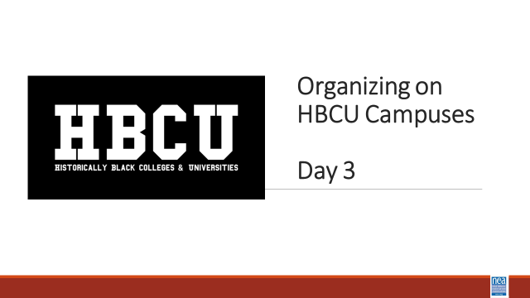  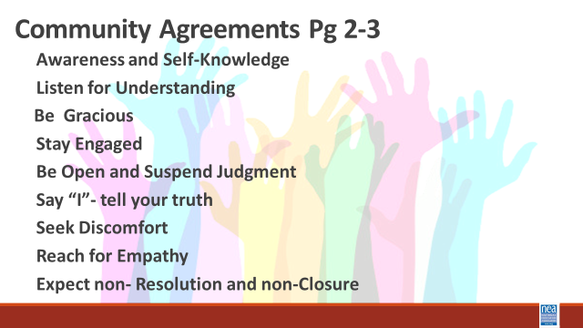  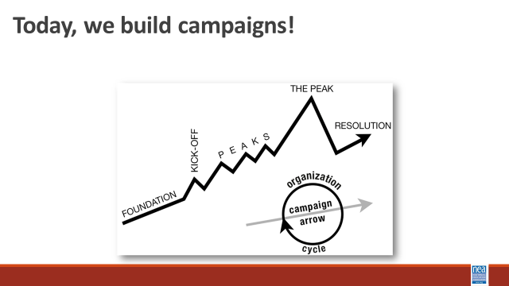 | Norms in Handouts  Agenda on Slides  Parking Lot Chart  Name Tents  Handout Package | 5 Mins Feedback on Feedback, Agenda Review, Norms Review  15 Mins Community building exercise – Getting Graphic  - Each table has only one sheet of chart paper  - Only pictures - no words, letters or numbers  - They will use the pictures to tell the story of what they have learned so far.  - Must be a joint effort, all table members should contribute  10 Mins – Share out  1 Minute – IN  INTRODUCE Campaign Mountain  - Foundation – gather info, id issues, id leadership team  - Kick-off –public event that indicates what the issue, demand, and targets are  - Escalating peaks of activity that should escalate in  - Risk  - Capacity (people, resources, engagement)  - Increase leadership and ownership  - Campaign Compression Points  - THE PEAK – The most public, risky, momentum, engagement, and resources  - The Win- We achieve our demand  - Debrief, regroup, and continue to climb  FOR THIS DAY – They work in teams that may have formed yesterday around particular issues. | Participants will understand how they will spend their time together.
9:00-9:30 (Albert and Melissa) |  | 30 Minutes Getting Graphic Reflection Activity
 |  | 2 Minutes Intro- Each table has a sheet of chart paper. Using only pictures, no words, letters, or numbers, highlight key learnings from your time with us so far. Everyone must participate in the drawing.  10 Minutes Activity -  15 Minutes Report Out - | Participants will complete a collaborative reflection on their key learnings.
9:30-10:15 (Ilissa and LaQuita) |  | 45 Minutes Demand, Target, Tactics, and Escalation
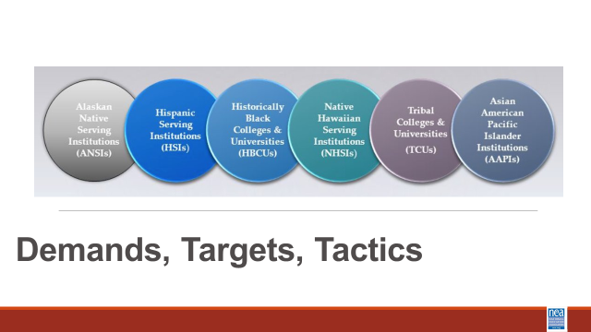  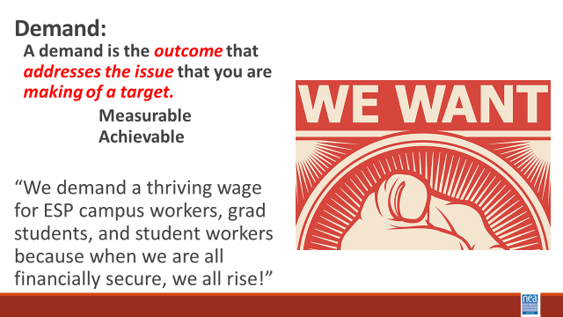  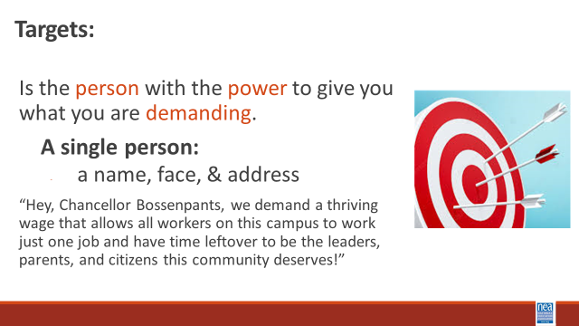  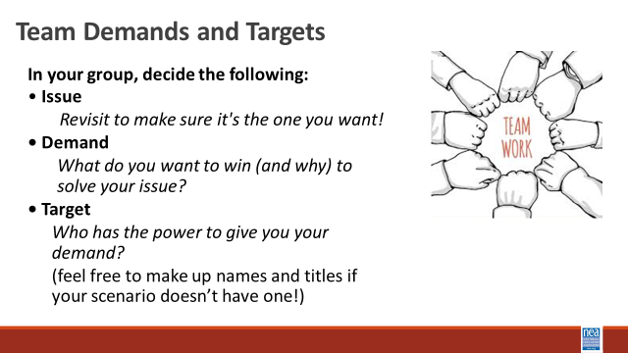  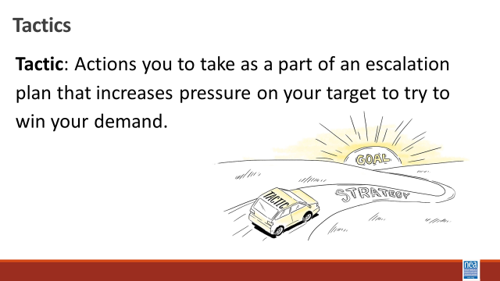  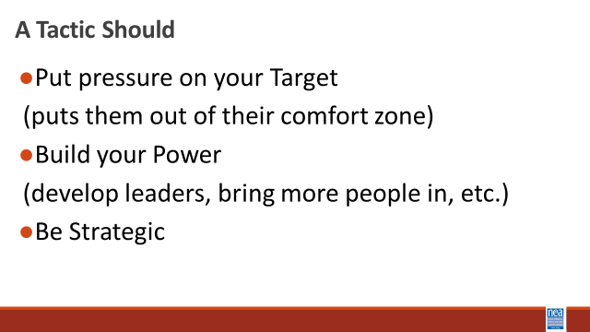  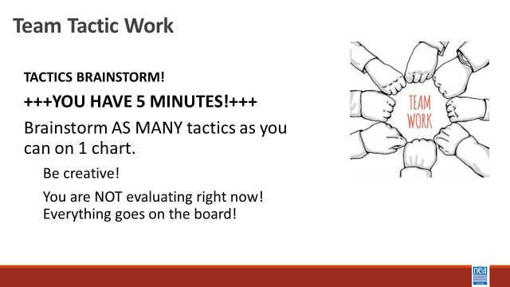  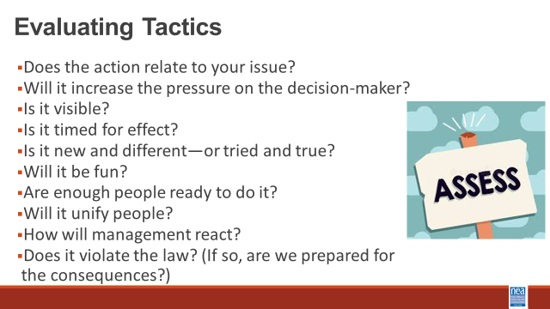  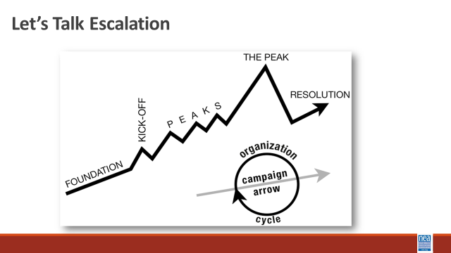  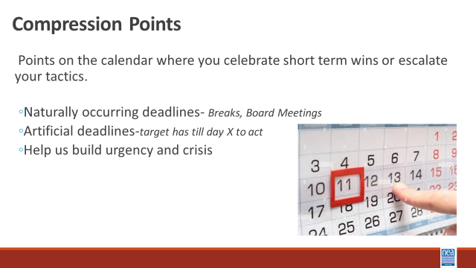  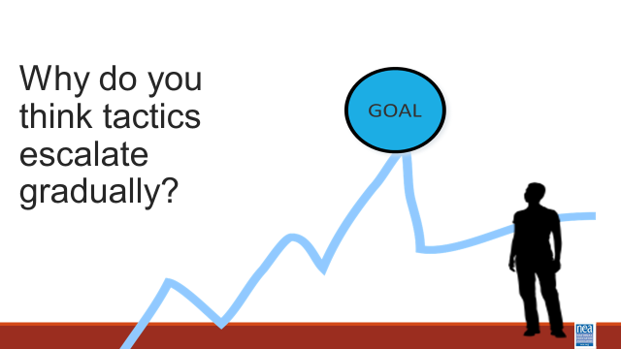  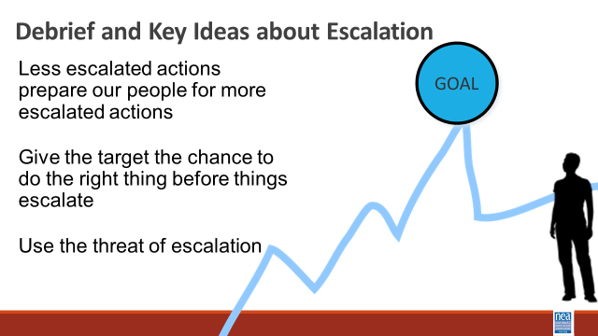  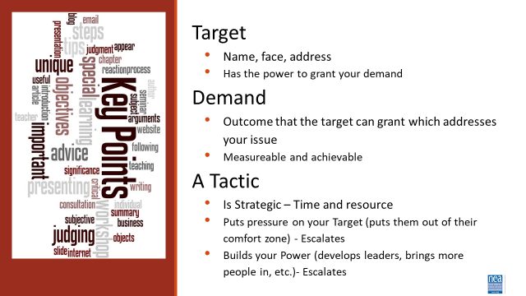 |  | Intro 5 Minutes Intro of Content  DEMAND  - A demand is what the group wants– the win –  - A demand is the outcome that addresses the issue you are making of the target  - If the issue is what is wrong, the target is what we want that will fix the issue.  Value ends up being the messaging  TARGET  - The last idea that we want to cover is Targets.  - TARGET: A target is a single person with a name and an address. The target is the person with the power to give the workers the change they are asking for. A target has a name, a face and an address. Takes 5 minutes to introduce  10 Mins – GROUP WORK  In your groups, return to your scenario and decide the:  Issue- Finalize the issue!  Demand What do you want to win to solve your issue?  Target Who has the power to give you your demand?  1 mins- INTRODUCE Tactics  Next we are going to talk about Tactics.  Tactic are Actions you to take as a part of an escalation plan that increases pressure on your target to try to win your demand.  A tactic should  - Put pressure on your Target  (puts them out of their comfort zone)  - Build your Power  (develop leaders, bring more people in, etc.)  - Be Strategic  We are going to model a tactics brainstorm that you can use when working with members.  5 Minutes Scenario Work  Brainstorm AS MANY tactics as you can on 1 chart.  - Be creative!  - You are NOT evaluating right now! Everything goes on the board!  We are going to have 5 minutes to list as many tactics as you can. Extra points for super creative ideas. WE ARE NOT. NOT. NOT. Evaluating tactic at this time. If someone says something (example- We are going to wear the same clothes without washing them until we get what we want) you right it down and move on. All ideas get on the board. Again, this is a brainstorm. NO EVALUATING.  YOU HAVE EXACTLY 5 MINUTES. After 5 minutes put your pens down.  Open your phone and actively start a timer. “ON YOUR MARKS. GET SET. GO”  Excellent! We now have a whole list of tactics. Next. We are going to assess our tactics. For this, I encourage you to use a list of questions like this-  3 minutes- How to evaluate a tactic  - Does the action relate to your issue?  - Will it increase the pressure on the decision-maker?  NOTE! This means that we have to engage in actions that make our target uncomfortable. SOOOOO the same old tactics WON’T WORK! They are used to them!  - ^{Is it visible?}  - ^{Is it timed for effect?}  - Is it new and different—or tried and true?  Note! SEE above. If a tactic is the same as always, your target has likely become comfortable with it AND it won’t develop new skills in your members and therefore build your power.  - Are enough people ready to do it?  - ^{Will it unify people?}  - ^{How will management react?}  - Does it violate the law? (If so, are we prepared for the consequences?)  NOTE! This doesn’t mean that it is off limits. Historically, breaking laws has been a big part of social justice movements. ESPECIALLY THE LABOR MOVEMENT! However, we have to consider if an unlawful tactic is the right tactic and whether you have the power to mitigate/absorb the consequences.  - ^{Will it be fun?}  Folks want to engage in things that fill them up! Who had a tactic that they would be excited to participate in?  10 minutes- Evaluating your tactics  You have 10 minutes. Look at your list of tactics.  - Circle the ones that you think are strategic, when looking at these questions.  - Cross out the ones that are NOT strategic.  5 Minutes - Escalation  – Compression Point Definition  - Points on the calendar where you celebrate short term wins or escalate your tactics based on how you have assessed your readiness to escalate.  - Naturally occurring deadlines  - Artificial deadlines  - Help us build urgency and crisis  2 Minutes – Turn and Talk  We keep saying that tactics should escalate gradually why do you think that is?  2 Minutes – Debrief  Each escalation is more public, more visible, and has more risk. WE transform members to activists, activists to leaders by asking them to take bigger risks  Some points to make if they are not said by the group  - Less escalated actions prepare our people for more escalated actions  - Give the target to do the right thing before things escalate the threat of escalation  2 Minutes Key Points  Target  - Name, face, address  - Has the power to grant your demand  Demand  - Outcome that the target can grant which addresses your issue  - Measurable and achievable  A Tactic  - Is Strategic – Time and resource  - Puts pressure on your Target (puts them out of their comfort zone) - Escalates  - Builds your Power (develops leaders, brings more people in, etc.)- Escalates | Participants will practice naming specific demands and targets.  Participants will brainstorm creative tactics and then work to put them in an escalation.
10:15-11:30 (Melissa and Michelle) |  | 60 Mins TOTAL – Team Campaign Design
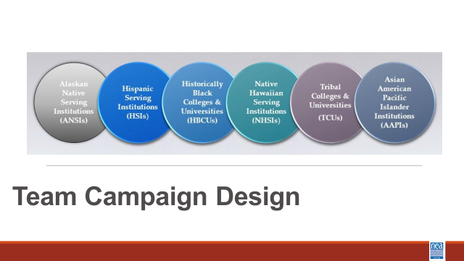  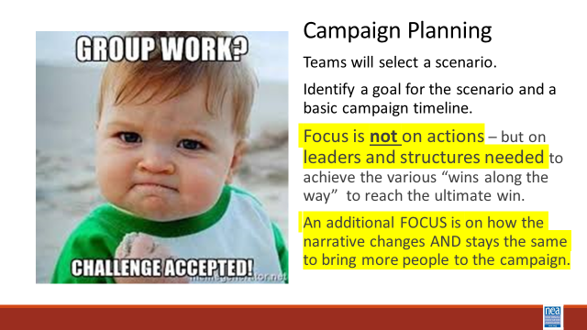  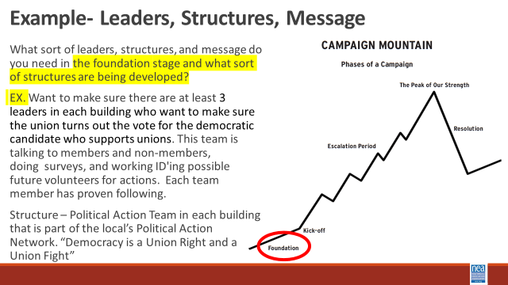  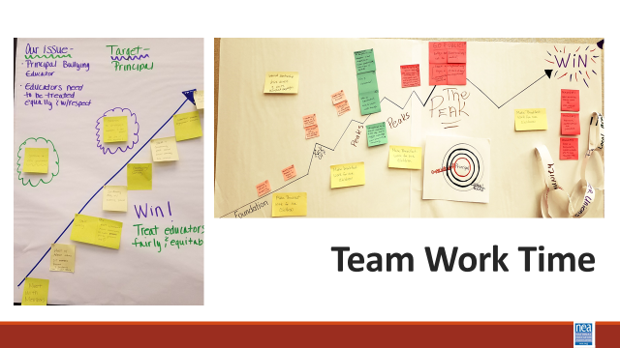 | Teams are creating Campaign Mountain, a Team Name, and Team Chant – extra points for a dance.  Day 2 Vignettes | 5 mins – Introduction  Focus on Leaders – they have followers and can achieve results  Focus on Structure - a group of people united by a common purpose.  Focus on Narrative Thread and Changes  All campaigns have a target, a win, and an issue to be solved by the win  All campaigns have tactics that escalate, they escalate to build new leaders, build the base of support, and build the public use of power to apply pressure to the target.  Campaigns are held together by the story of what you are working to achieve and the why it is important NOW.  You will be mapping it all out. (Campaign Mountain)  If you list a tactic, then you will explain which leaders involved, the structure created, and the narrative at that point.  Consider how you are moving your spectrum of allies and how the community around the scenario is a part of the campaign  Dunbar’s Number  How you applied a RET analysis to each part of the campaign  Your team will also create team name and a team chant. Extra Points for a Dance.  (each presenter will adopt a team(s) to mentor) | Participants will apply what they have learned about campaign design that is effective at HBCUs and present their products to other teams for coaching.
11:30-11:45 |  | BREAK
11:45-12:30 (August/ Eric/ Barb) |  | 45 Mins Team Presentations
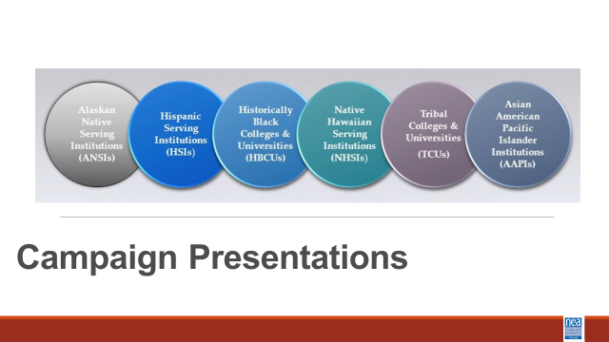 |  | Team Presentations of Campaign, March, and Chant  All will watch the team presentation of their name, chant, and dance – then depending on number of teams – we will make team huddles for presentation of campaign. | Participants will present, reflect, and discuss their plans with other teams.
12:30 – 1:00 (Ellen) |  | 30 Mins TOTAL– Ending | .
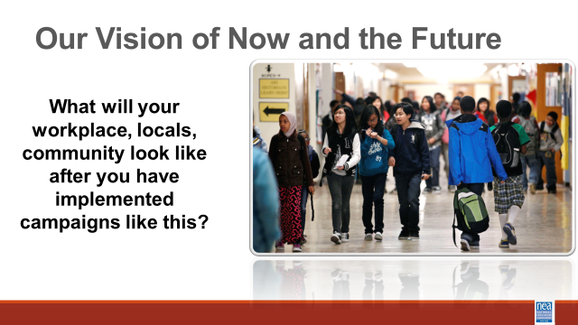  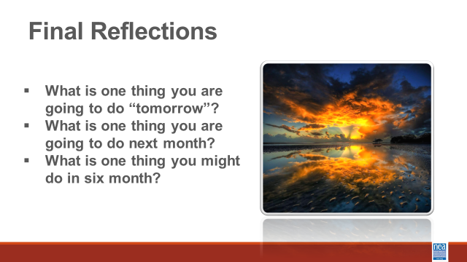  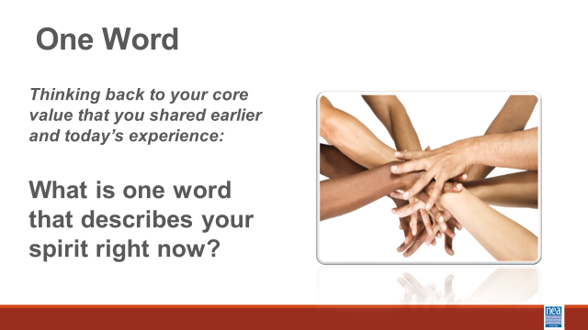  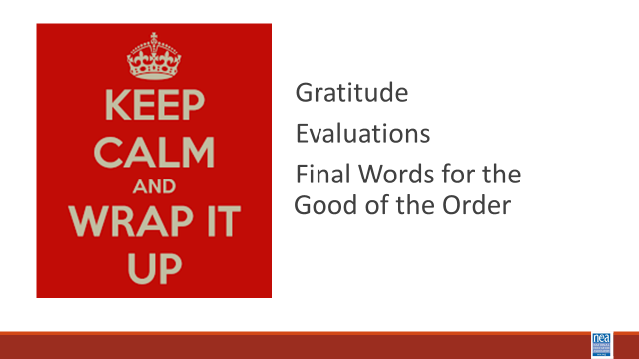 |  | Ella Baker’s assignment to each of us  ***The n-word is used in this video  Video from Ella Baker addressing a 1974 Puerto Rico solidarity rally  Solidarity Circle –  End training with solidarity circle where participants share their key takeaways and commitments to support organizing on HBCU/MSI’s.  Final Closing  Questions, Connections, Reflections  Housekeeping announcements | Participants will participate in a closing circle discussion to reinforce the collective nature of labor organizing and leave with a sense of purpose and solidarity.
1:00-2:00 |  | 60 Minutes - LUNCH AND Adult Choice Networking Activities –
 |  | This is a time for participants to meet and discuss any issues they are thinking about with other members of the group. This is not led by facilitators and highly encourage to occur in any other space besides the conference room. | Participants will make useful connections with staff from other affiliates.
2:00 Adjourn

