Hispanic Serving Institutions (HSIs)
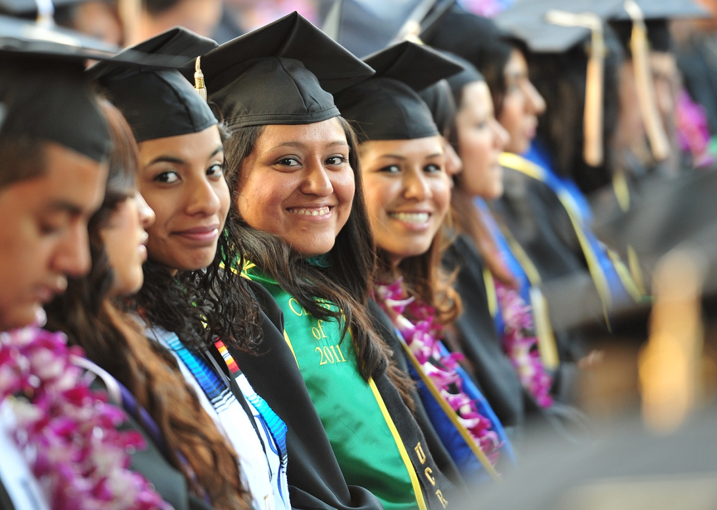
- Defined by the Higher Education Act of 1992 as degree-granting institutions with at least 25% Hispanic Full-Time Equivalent undergraduate enrollment.
- HSIs enroll 31.7% of all undergraduates in nonprofit postsecondary education.
- In 2022-23, there were 600 HSIs, up from 572 in 2021-22.
- HSIs serve 5.2 million students, including two-thirds of all Hispanic undergraduates.
- 9 out of the top 10 institutions on the 2022 Social Mobility Index (SMI) were HSIs.
- 82% of HSIs are in seven states and Puerto Rico: CA, TX, NY, IL, FL, NJ, NM, and PR.
- California and Texas account for 47% of all HSIs

Historically Black Colleges and Universities (HBCUs)
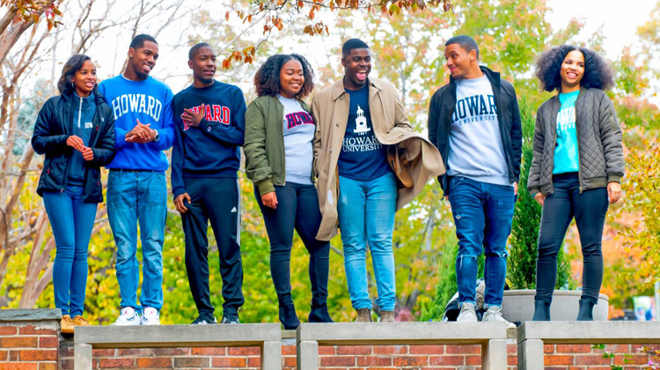
- HBCUs were established before 1964 with the mission of educating Black Americans when predominantly white institutions (PWIs) excluded them.
- Many began as colleges of education to train teachers for Black communities.
- Founded during segregation, HBCUs provided critical access to higher education, significantly contributing to Black Americans' progress.
- As of 2024, there are 101 HBCUs in the U.S.
- Though originally founded for Black students, 24% of HBCU enrollees in 2022 were non-Black.
- HBCUs have 1/8th the average endowment size compared to historically white institutions.
- HBCUs have educated the majority of America’s Black teachers, doctors, judges, engineers, and STEM professionals.
- Black students report higher satisfaction rates at HBCUs than at non-HBCUs, reflecting the positive experiences and pride they foster.

Tribal Colleges and Universities (TCUs)
- TCUs, also known as tribally controlled colleges, are governed by Native American tribes, promoting Native culture, language, and traditions.

- They emerged from the self-determination movement in the 1960s, starting with Dine College, founded by the Navajo Nation in 1968.
- As of 2022, 35 accredited TCUs operate over 90 campuses across 15 states, serving students from over 250 federally recognized tribes.
- State governments provide no financial support, and local property taxes are not collected due to their location on reservations with high poverty rates.
- TCUs partner with organizations like the U.S. Department of the Interior, NASA, and others to support research and education on topics such as climate change, agriculture, and diabetes prevention.
- TCUs offer support services like counseling, mentoring, tutoring, wellness programs, child care, and assistance with laptops, transportation, and housing.
- TCUs serve 100,000 community members through academic and community-based programs while preserving Native languages and promoting tribal sovereignty.
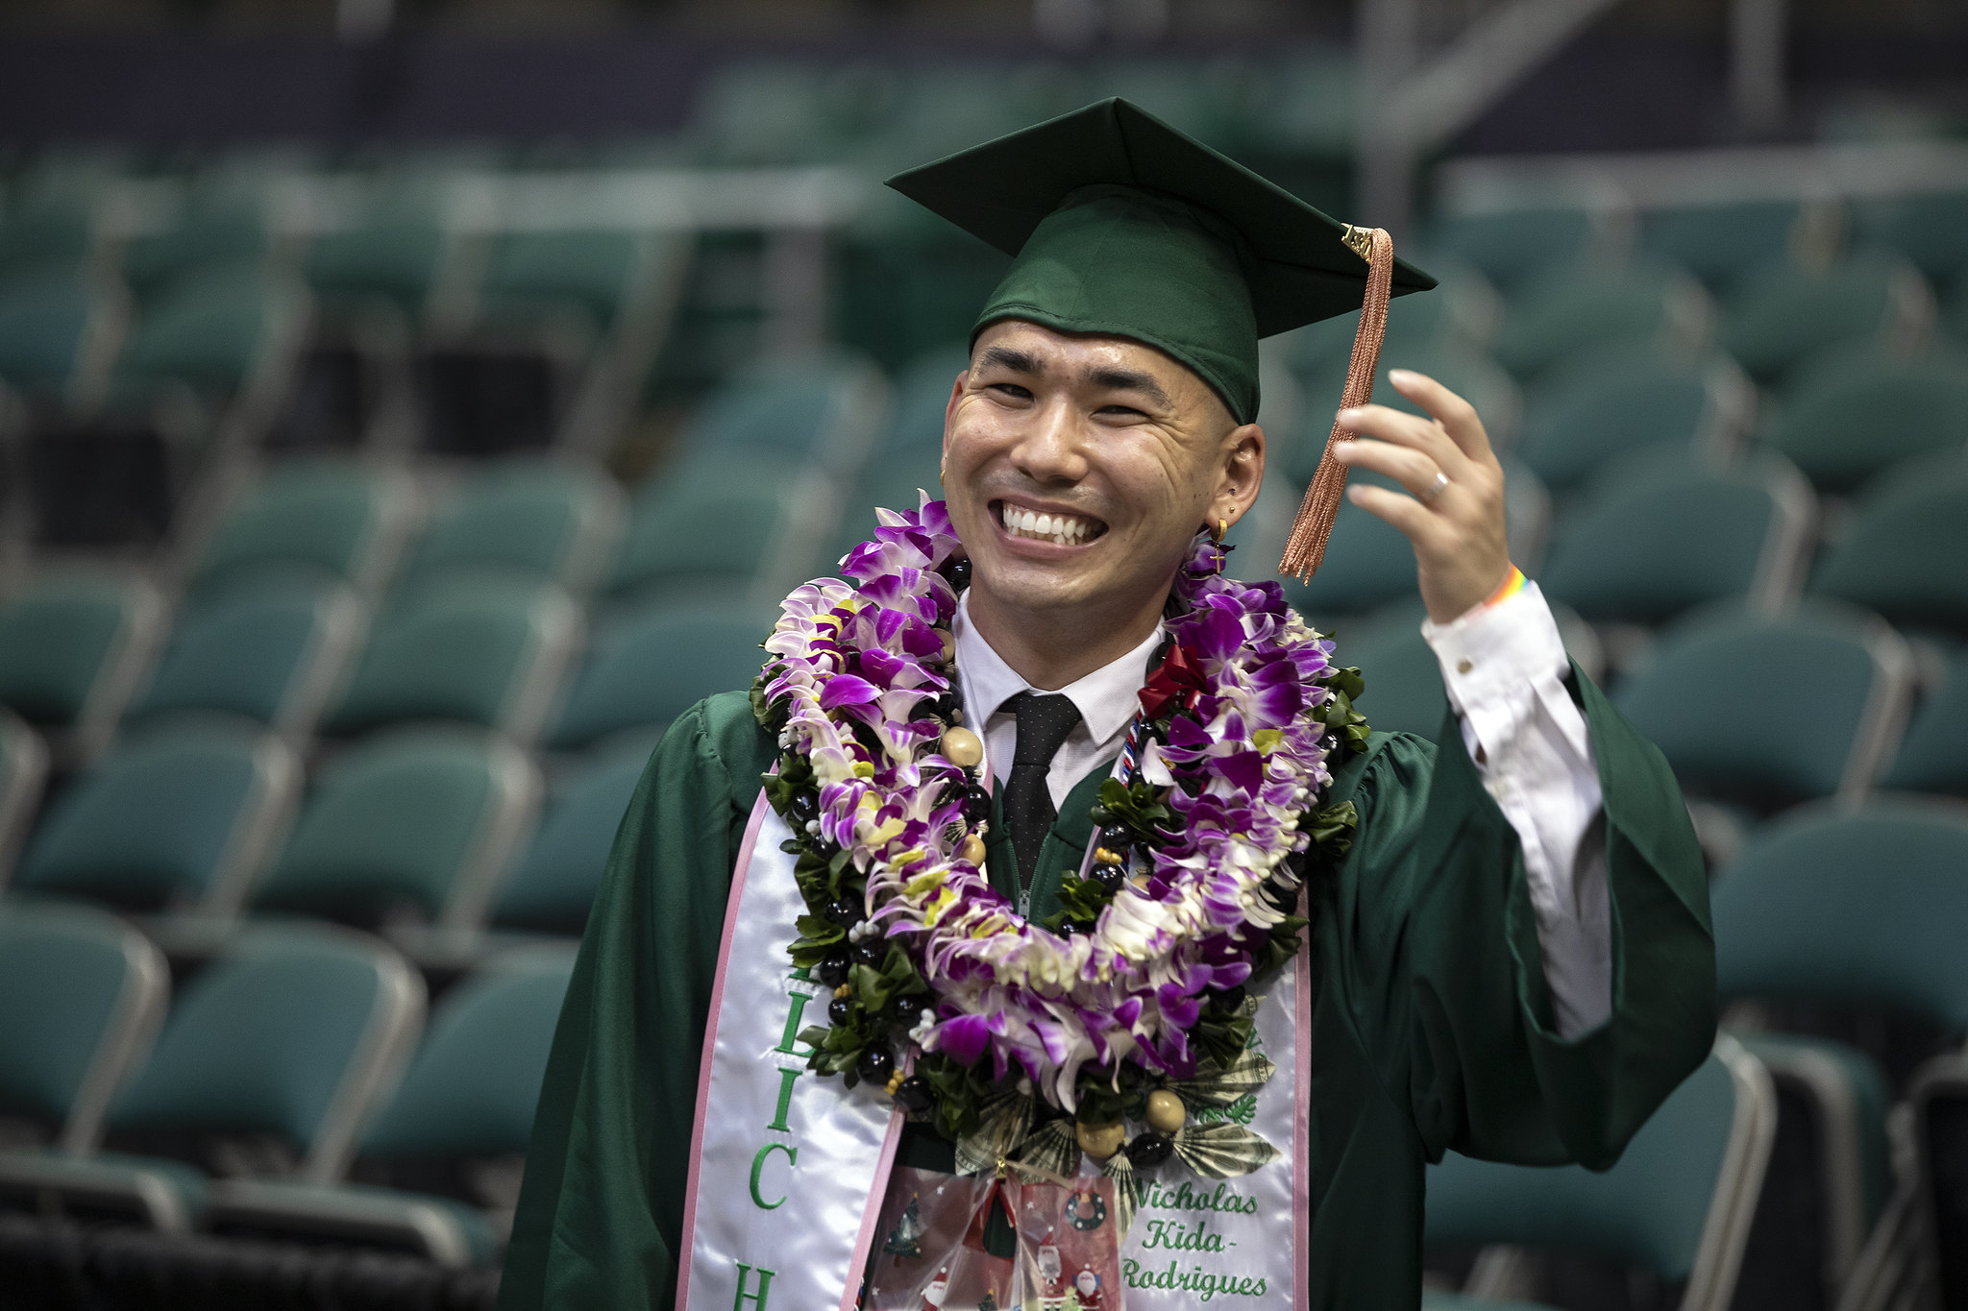
Asian American and Native American Pacific Islander-Serving Institutions (AANAPISIs)
- AANAPISIs are institutions with at least 10% of undergraduate enrollment consisting of Asian American or Native American Pacific Islander students
- Created to combat harmful stereotypes and allocate resources to support low-income AAPI students, recognizing their need for higher education support.
- Recognized with federal funding in 2007-2008, AANAPISIs serve students historically marginalized in U.S. higher education.
- The AANAPISI community's diversity is often overlooked, leading to a lack of resources for AAPI students.
- In the fall of 2020, AANAPISIs educated 33% of all AAPI students, primarily at public two- and four-year institutions.
- AANAPISIs are located in 27 states and territories, mainly on the West Coast, in Hawaii, Pacific territories, and New York.

