9:15- 10:15 Naomi |  | 60 Mins TOTAL – Building Knowledge of HBCUs and MSI
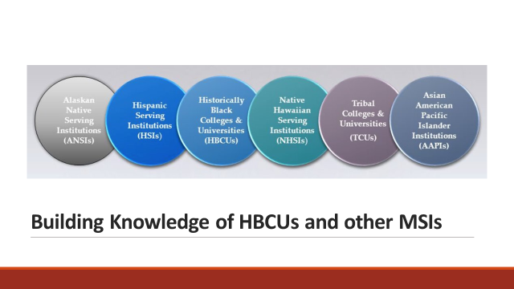      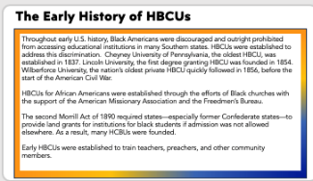  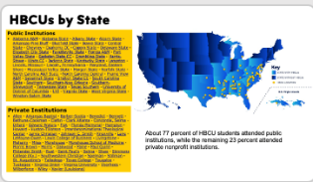  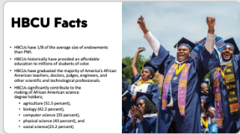  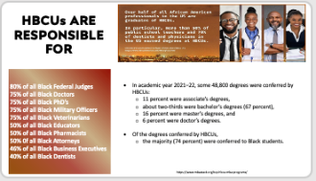  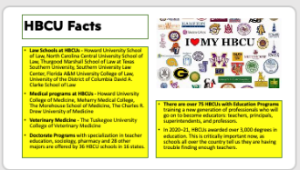  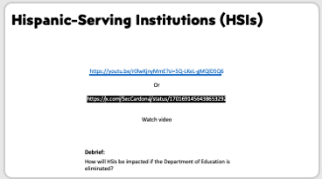  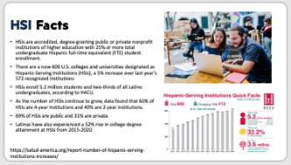  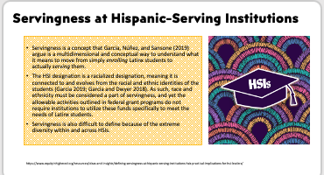      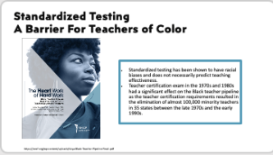  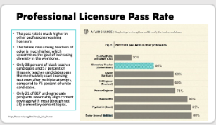  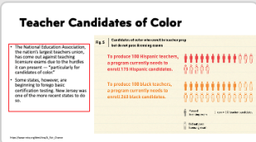  ==  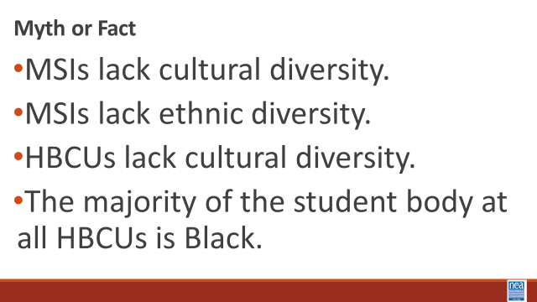   |  | HBCU and BIPOC serving institutions Merry Mixer – 20 Minutes  10- Minutes – THE NEED FOR HBCUs  WATCH VIDEO - How HBCUs: Making Black America | PBS (6:19 minutes) (Ask CHAD to download this for us or Albert)  https://whyy.pbslearningmedia.org/resource/historically-black-colleges-and-universities-video/making-black-america-through-the-grapevine/  Debrief: At their inception, how did HBCUs emerge and why were they an important step forward for African Americans?  Lecturette - Data Facts (15 Minutes) Facilitator will choose a good selection of the highpoints from the info below -- the slides support the content  - The first colleges for African Americans were established largely through the efforts of Black churches with the support of the American Missionary Association and the Freedmen’s Bureau. The second Morrill Act of 1890 required states—especially former Confederate states—to provide land grants for institutions for black students if admission was not allowed elsewhere. As a result, many HCBUs were founded.  - Early HBCUs were established to train teachers, preachers, and other community members.  - Today there are more than 100 HBCUs.  - One notable statistic from the Department of Education, is that 75% of all Black doctors, 75% of Black military officers, and 80% of Black federal judges today (2021) received their undergraduate degrees from a HBCU.  • Law Schools at HBCUs - Howard University School of Law, North Carolina Central University School of Law, Thurgood Marshall School of Law at Texas Southern University, Southern University Law Center, Florida A&M University College of Law, University of the District of Columbia David A. Clarke School of Law  - Medical programs at HBCUs - Howard University College of Medicine, Meharry Medical College, The Morehouse School of Medicine, The Charles R. Drew University of Medicine  • Veterinary Medicine - The Tuskegee University College of Veterinary Medicine  Hispanic Serving Institutions  - Watch HSI video (3 minutes)  - Question: How would HSIs be impacted if the Department of Education is eliminated?  Education programs HBCUs – https://hbcu-colleges.com/education  • (Source National Center for Educational Statistics  https://nces.ed.gov/whatsnew/commissioner/remarks2023/9_05_2023.asp  HBCUs not only provide an education — they also train new generations of professionals who will go on to become educators: teachers, principals, superintendents, and professors. In 2020–21, HBCUs awarded over 3,000 degrees in education. This is critically important now, as schools all over the country tell us they are having trouble finding enough teachers.  • https://uncf.org/news/uncf-issues-revealing-report-on-black-teacher-pipeline-best-practices-at-hbcu-teacher-education-programs  There is a national teacher shortage, however the shortage for teachers of color - African American, Latino, Native, etc. - is particularly severe. Despite a slight increase in teachers of color from 12% to 18% since 2006, there remains a significant gap as the student population of color has grown to over 50%.  Student demographics, Educator demographics  • 2020-2021 Educator -Student demographics from the USDOE National Center for Education Statistics  Barriers That Exist For Teachers of Color - (Praxis- rates of success)  • Standardized testing has been shown to have racial biases and does not necessarily predict teaching effectiveness.  • Teacher certification exam in the 1970s and 1980s had a significant effect on the Black teacher pipeline as the teacher certification requirements resulted in the elimination of almost 100,000 minority teachers in 35 states between the late 1970s and the early 1990s. (Source: UNCF’s -The Heart Work of Hard Work  Black Teacher Pipeline Best Practices at HBCU Teacher Education Programs)  • A high number of elementary teacher candidates fail their professional licensing tests each year. Fifty-four percent of new teachers fail their licensing exam on their first try. The pass rate is much higher in other professions requiring licensure  - The failure rate among teachers of color is much higher, which undermines the goal of increasing diversity in the workforce. Only 38 percent of black teacher candidates and 57 percent of Hispanic teacher candidates pass the most widely used licensing test even after multiple attempts, compared to 75 percent of white candidates. (Source: Why do so many new teachers stumble on licensing exams? By Maureen Downey 4-16-19)  - Teacher certification processes for ESL and bilingual education certifications  Tribal Colleges and Universities – data and other overview information  TCU Exploration Guide by American Indian college fund.pdf  TCUs.pdf (rutgers.edu)  TCU Exploration Guide by American Indian college fund.pdf  HSI  ED627317.pdf  HBCU Degree Data  (Source National Center for Educational Statistics https://nces.ed.gov/programs/digest/d23/tables/dt23_313.30.asp)  - In academic year 2021–22, some 48,800 degrees were conferred by HBCUs:  - 11 percent were associate’s degrees,  - about two-thirds were bachelor’s degrees (67 percent),  - 16 percent were master’s degrees, and  - 6 percent were doctor’s degrees.  - Of the degrees conferred by HBCUs,  - the majority (74 percent) were conferred to Black students. Black students earned  - 44 percent of the 5,300 associate’s degrees,  - 81 percent of the 32,800 bachelor’s degrees,  - 70 percent of the 7,600 master’s degrees, and  - 61 percent of the 3,000 doctor’s degrees conferred by HBCUs in 2021–22.  - Of all degrees conferred by HBCUs to Black students, more than two-thirds were conferred to female students (69 percent)  Closing Activity – Myth or Fact (10 Minutes)  NEED KEY Points  ELLEN MOVED ALL THE LINKS FOR RESOURCES TO THIS DOCUMENT  Resource and Research Page Day 1.docx | Participants will build a foundational understanding of HBCUs and MSIs.  This is a historical perspective and at a higher level, into the current day.

