LETS MAKE THIS A POPS ACtivity (online) |  | 60 Mins TOTAL – Unionism
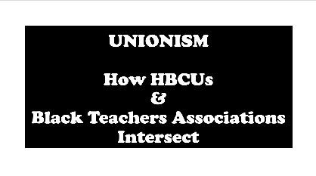  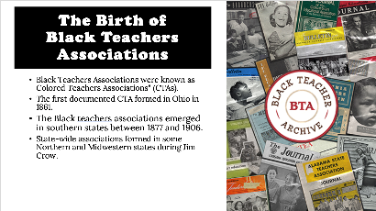  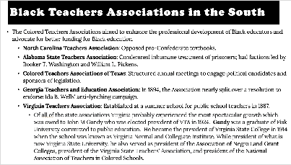  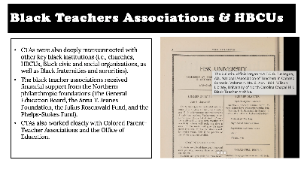  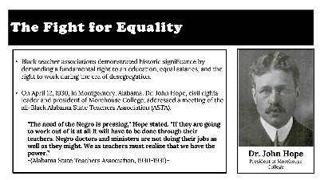  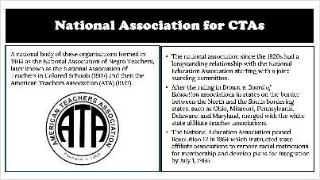  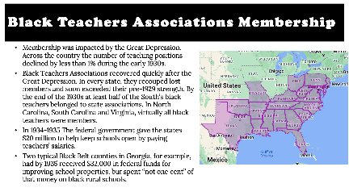  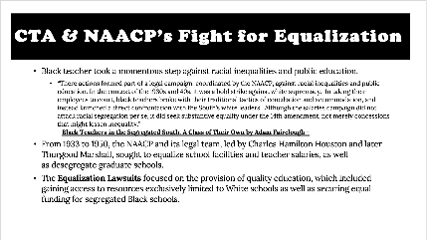    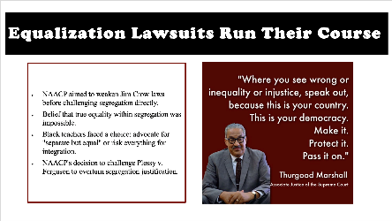    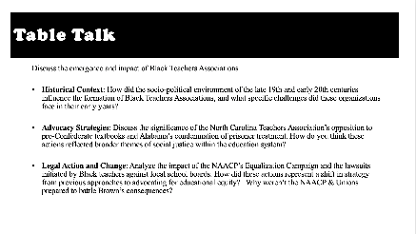  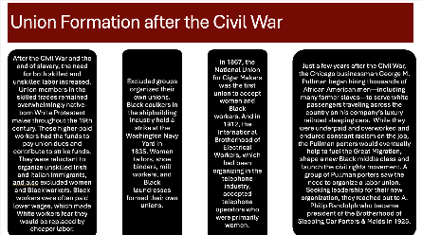  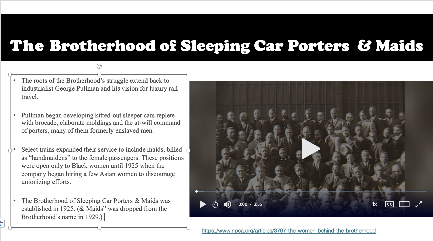  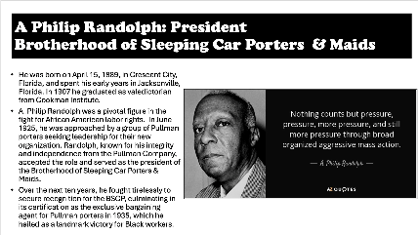  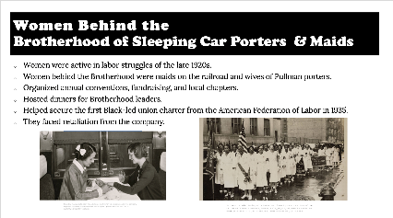  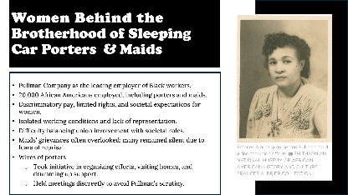  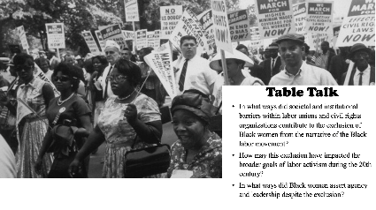  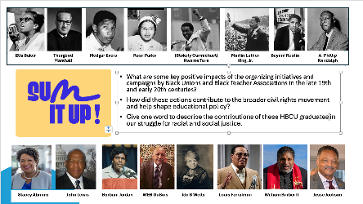 | Some Resources  https://www.archives.gov/publications/prologue/1997/summer/american-labor-movement.html  https://racial-justice.aflcio.org/blog/est-aliquid-se-ipsum-flagitiosum-etiamsi-nulla  https://curiosity.lib.harvard.edu/black-teacher-archive/feature/about-colored-teachers-associations  https://www.investopedia.com/financial-edge/0113/the-history-of-unions-in-the-united-states.aspx#toc-the-rise-of-labor-unions-in-the-us  https://www.history.com/topics/black-history/pullman-porters  Article  https://www.npca.org/articles/3707-the-women-behind-the-brotherhood | Idea for Chad and August to add to this section -- see the end of this section (30 Minutes of Unionism and Affiliate engagement and 30 minutes of Synthesis for participants to bring in what the experienced from tour and one on ones)  Method is illicitive questions – questions may already exist – based on experience with the people or the campus tour  Unionism (why is it important) how do we take our union work and move it into our everyday community and work.  This article speaks powerfully about this - https://prismreports.org/2022/11/30/unions-must-reckon-anti-blackness/  --------------------------------------------------------------------------  Unionism - Why and how did black teachers move their everyday existence into union work?  Women and formerly enslaved black people were excluded from  unions. Black teachers founded Colored Teachers Associations CTAs to enhance educational opportunities for Black children, to develop themselves as professionals, political actors, and intellectuals, as well as to organize around broader socio-political concerns in the Black Freedom Movement.  History of unions and black institutions (sit and get)  How did HBCUs & Black Teachers Associations Intersect  15 Minute Sit and Get - (Is this setting up the historical context for watching the videos – and is the outcome something about unionism – what would be the question for them to be trying to answer as they listen to this content? Could have a few posters with quotes on organizing and unionism from leaders of these and as an intro ask people to go to the quote that pulls them – “Magnetic Quote” and discuss why this pulled them to it)  Birth of Black Teachers Associations  - Black Teachers Associations were known as Colored Teachers Associations" (CTAs).  - The first documented CTA formed in Ohio in 1861.  - The Black teachers associations emerged in southern states between 1877 and 1906.  - State-wide associations formed in some Northern and Midwestern states during Jim Crow.  Black Teachers Associations in the South  - North Carolina Teachers Association: Opposed pro-Confederate textbooks.  - Alabama State Teachers Association: Condemned inhumane treatment of prisoners; had factions led by Booker T. Washington and William L. Pickens.  - Colored Teachers Associations of Texas: Structured annual meetings to engage political candidates and sponsors of legislation.  - Georgia Teachers and Education Association: In 1894, the Association nearly split over a resolution to endorse Ida B. Wells' anti-lynching campaign.  - Virginia Teachers Association: Established at a summer school for public school teachers in 1887.  Black Teachers Associations & HBCUs  - CTAs were also deeply interconnected with other key black institutions (i.e., churches, HBCUs, Black civic and social organizations, and Black fraternities and sororities). University presidents were often leaders in the CTAs.  - The black teacher associations received financial support from the Northern philanthropic foundations (The General Education Board, the Anna T. Jeanes Foundation, the Julius Rosenwald Fund, and the Phelps-Stokes Fund).  - CTAs also worked closely with Colored Parent-Teacher Associations and the Office of Education.  The Fight for Equality  - Black teacher associations demonstrated historic significance by demanding a fundamental right to an education, equal salaries, and the right to work during the era of desegregation.  - On April 12, 1930, in Montgomery, Alabama, Dr. John Hope, civil rights leader and president of Morehouse College, addressed a meeting of the all-Black Alabama State Teachers Association (ASTA).  National Association for the Black Teachers Associations  - A national body of these organizations formed in 1904 as the National Association of Negro Teachers, later known as the National Association of Teachers in Colored Schools (1907) and then the American Teachers Association (ATA) (1937).  Black Teachers Associations Membership  - Membership was impacted by the Great Depression. Across the country the number of teaching positions declined by less than 1% during the early 1930s.  - Black Teachers Associations recovered quickly after the Great Depression. In every state, they recouped lost members and soon exceeded their pre-1929 strength. By the end of the 1930s at least half of the South’s black teachers belonged to state associations. In North Carolina, South Carolina and Virginia, virtually all black teachers were members.  CTAs & NAACPs Fight for Equalization  - The Equalization Lawsuits focused on the provision of quality education, which included gaining access to resources exclusively limited to White schools as well as securing equal funding for segregated Black schools.  Video: https://whyy.pbslearningmedia.org/resource/bf09.socst.us.prosp.houston/charles-hamilton-houston-laying-the-groundwork-for-integration/  Equalization Lawsuits  - Charles Hamilton Houston led the NAACP in this strategy before Thurgood Marshall.  - Significant risks faced by teachers pursuing equalization suits.  Equalization Lawsuits Run Their Course  - NAACP aimed to weaken Jim Crow laws before challenging segregation directly.  - Belief that true equality within segregation was impossible.  - Black teachers faced a choice: advocate for "separate but equal" or risk everything for integration.  - NAACP's decision to challenge Plessy v. Ferguson to overturn segregation justification. -  - Brown v Board of Education  7 Minutes – Unintended Consequences of Brown vs, the Board of Education (Video and Group Work) (How we link this linked to unionism and the content above)  10 Minutes Intro – we are going to watch the 7 minute video as you watch think about the following:  1. How does historical context (the ending of the Equalization Campaign) drive the specific strategies and actions you see in the video?  2. How do the specific actions reflect what is going on in the schools at that time?  3. What were the unintended consequences of adopting a different strategy?  10 Minute Table Talk ( Use Guiding Questions) – split participants into equal sized small groups. Assign each group one of the following to be listening for during the video and to be prepared to provide the 3 Big Ideas for following a group discussion.  - Historical Context: How did the socio-political environment of the late 19th and early 20th centuries influence the formation of Black Teachers Associations, and what specific challenges did these organizations face in their early years?  - Advocacy Strategies: Discuss the significance of the North Carolina Teachers Association’s opposition to pro-Confederate textbooks and Alabama’s condemnation of prisoner treatment. How do you think these actions reflected broader themes of social justice within the education system?  - Legal Action and Change: Analyze the impact of the NAACP’s Equalization Campaign and the lawsuits initiated by Black teachers against local school boards. How did these actions represent a shift in strategy from previous approaches to advocating for educational equity? Why weren’t the NAACP & Unions prepared to battle Brown’s consequences?  5 Minutes – Each Group Shares their three most important ideas from their discussion.  Who was excluded from Unions?  After the Civil War and the end of slavery, the need for both skilled and unskilled labor increased. Union members in the skilled trades remained overwhelmingly native-born White Protestant males throughout the 19th century. These higher-paid workers had the funds to pay union dues and contribute to strike funds. They were reluctant to organize unskilled Irish and Italian immigrants, and also excluded women and Black workers. Black workers were often paid lower wages, which made White workers fear they would be replaced by cheaper labor.  Excluded groups organized their own unions. Black caulkers in the shipbuilding industry held a strike at the Washington Navy Yard in 1835. Women tailors, shoe binders, mill workers, and Black laundresses formed their own unions.  In 1867, the National Union for Cigar Makers was the first union to accept women and Black workers. And in 1912, the International Brotherhood of Electrical Workers, which had been organizing in the telephone industry, accepted telephone operators who were primarily women.  A few years after the Civil War, the Chicago businessman George M. Pullman began hiring thousands of African American men—including many former slaves—to serve white passengers traveling across the country on his company’s luxury railroad sleeping cars. While they were underpaid and overworked and endured constant racism on the job, the Pullman porters would eventually help to fuel the Great Migration, shape a new Black middle class and launch the civil rights movement. A group of Pullman porters saw the need to organize a labor union. Seeking leadership for their new organization, they reached out to A. Philip Randolph who became president of the Brotherhood of Sleeping Car Porters & Maids in 1925.  15 minutes total: The Brotherhood of Sleeping Car Porters & Maids  Watch the 3 minute video  https://www.pbs.org/video/look-back-at-pullman-porters-fight-for-labor-rights-iq7hq1/  A Philip Randolph  - A. Philip Randolph was a pivotal figure in the fight for African American labor rights. In June 1925, he was approached by a group of Pullman porters seeking leadership for their new organization. Randolph, known for his integrity and independence from the Pullman Company, accepted the role and served as the president of the Brotherhood of Sleeping Car Porters & Maids.  Women Behind the Brotherhood of Sleeping Car Porters & Maids  Brotherhood of Sleeping Car Porters & Maids - In which ways did sexism show up in the Porters union? How does it relate to unionism today?  Table Talk – Use guiding questions  - In what ways did societal and institutional barriers within labor unions and civil rights organizations contribute to the exclusion of Black women from the narrative of the Black labor movement?  - How may this exclusion have impacted the broader goals of labor activism during the 20th century?  - In what ways did Black women assert agency and leadership despite these exclusions?  5 Minute Closing - Whole Group Discussion:  What are some key positive impacts of the organizing initiatives and campaigns by Black Unions and Black Teacher Associations in the late 19th and early 20th centuries?  How did these actions contribute to the broader civil rights movement and help shape educational policy?  Give one word to describe the contributions of these HBCU graduates in our struggle for racial and social justice.  Might do a True or False Activity around how unions have or have not turned the dial  Pre ATA and NEA merger -- (maybe a video for the pre attendance)  https://www.nea.org/nea-today/all-news-articles/two-become-one-name-education  Two Videos that describe the merger one short and one more in depth  https://www.youtube.com/watch?v=lEJNBl8i9CI  https://www.youtube.com/watch?v=AZS7FNSK-UE  Maybe this is how we turn to a strategy to build up the pipeline of leaders in our union – dismantling white supremacy culture in our own workspaces – the theory is that if we want systematic change in our union we have to intentionally go to where the density of non white students and faculty are.  Importance of intentionality – highlight NJEA and ISTA work with k-12 organizing. How do we do this in the Higher Ed and AE constituencies  A structure for this section could be a so now what – we have this history – so what do you do as staff with your members and leaders to move into being an ally and accomplice  Adjust section to  30 –minutes based on their experiences at the worksite visit  30 - minutes based on Unionism and affiliate engagement with HBCUs/MSIs | What is the outcome and essential question for this section?  How did the establishment and evolution of Black Teachers Associations impact the struggle for educational equality and integration, particularly in their interactions with HBCUs and the broader civil rights movement?  How did Black Teachers Unions and Historically Black Colleges and Universities (HBCUs) intersect and collaborate to advance educational equity and support for Black educators and students?

