2024 AE Pre-Conference Session

Topic: Student Teaching Experience as it relates to cost
The world as it is | The world as it should be

What is our issue?
Our issue is…

What is a win?
Our win is…

Who are people? What are they willing to do?
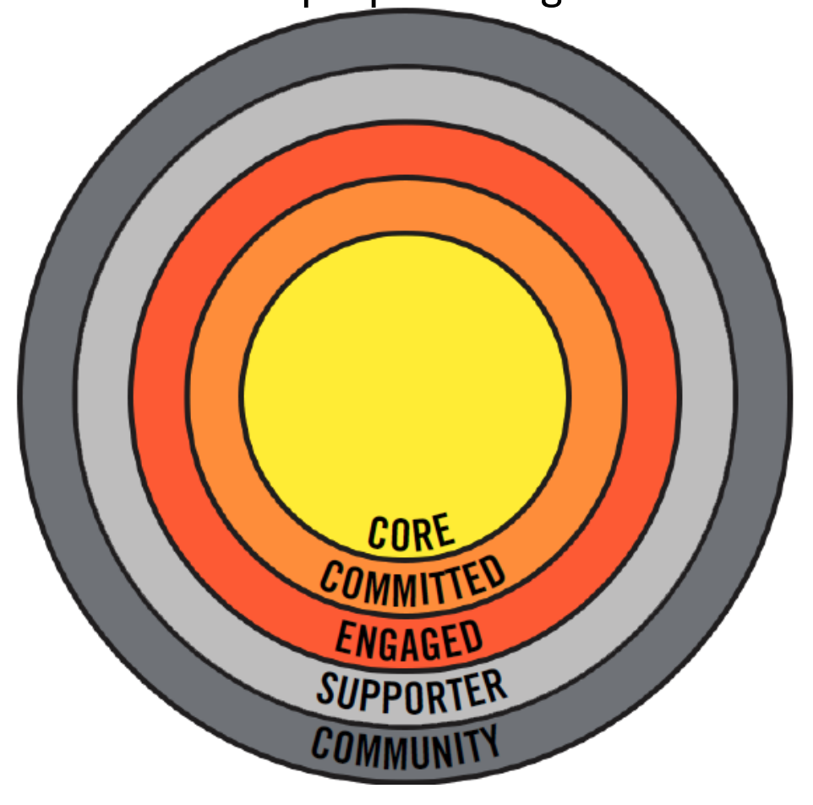

COMMUNITY: People that do not have any direct involvement with AEs
SUPPORTER: People that have taken some form of action with AEs e.g. signed an online action, liked our Facebook page or added themselves to our mailing list.
ENGAGED: People who are involved as activists in a supportive capacity. They support leaders & organizers by volunteering to help with public activities and/or behind the scenes.
COMMITTED: People that provide regular high level support or coordinate activities themselves. They have usually been in the movement for a while and have some form of ongoing responsibility.
CORE: People that lead the movement and do a wide range of high level activities. These include developing plans & strategies. They also coordinate, mentor, and develop other activists.
Community
Supporter
Engaged
Committed
Core

Digital Copy


bit.ly/aecpre24

