Facilitator Agenda
Time Slides Facilitator | Resources | Instructions, Activity and Debrief (Facilitators) | Essential Questions and Outcomes
 | Charts, handouts, articles, materials, slide | What are you saying, what are they doing, what questions will you use to guide learning and make clear the important points  Include an estimate for how long each section of the learning will take | What question(s) will this learning answer? What will participants know or be able to do?
 |  | 60 Minutes – Spectrum of Allies
Albert Slides 1-4  Rachel Slides 6-11  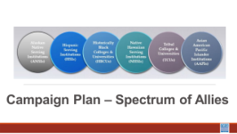  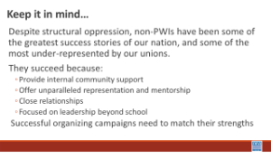  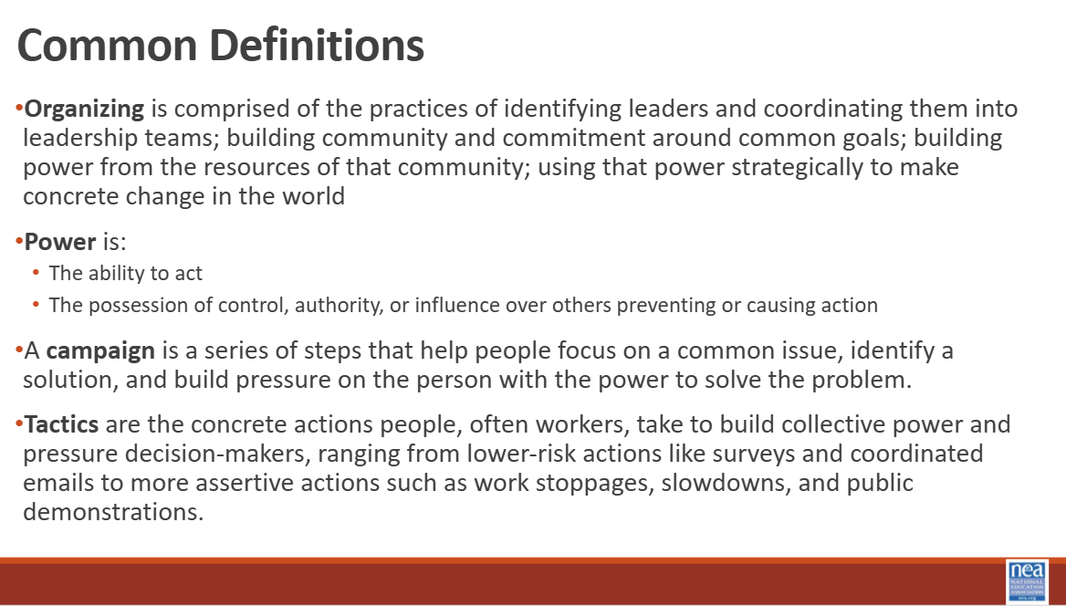  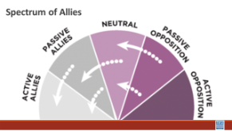  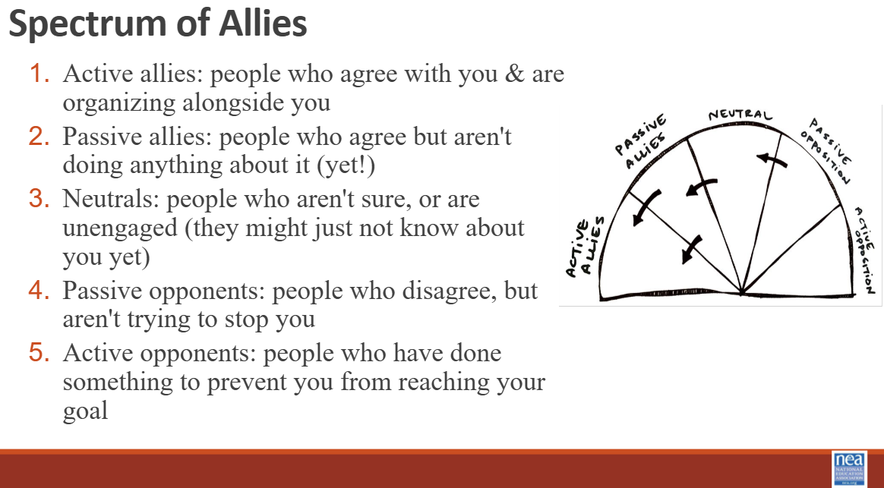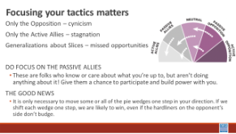  Taraja Slides 12-16  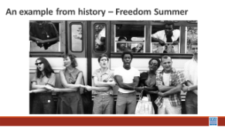  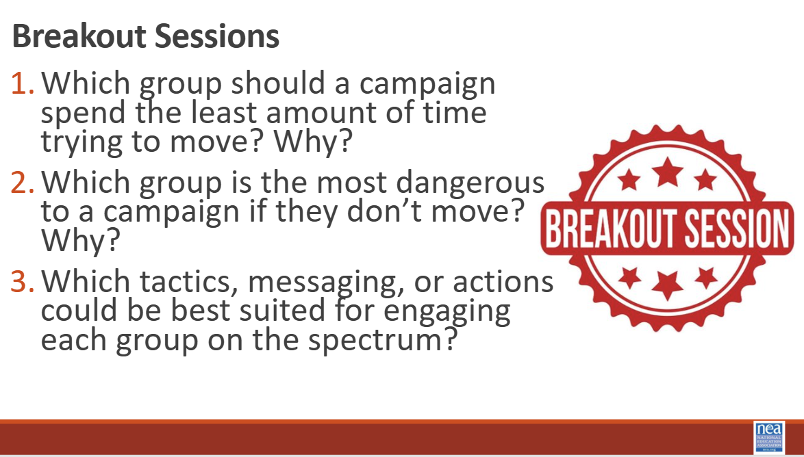  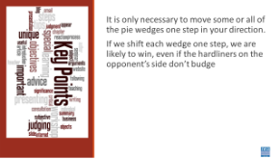 | 2.0050 Spectrum-of-Allies2FTarget-Audience-Development-.pdf  Feedback  Feedback  Organizing to Win on HBCU Campuses Session 3 – Fill out form | 5 Minutes Introduction- Disclaimer, Land Acknowledgement, & Community Agreements  We are going to look at building a portion of a campaign plan. The methods and skills we are going to continue to apply here are linked to why we believe HBCUs and other non PWIs are successful – they are strong because of all the ways they are connected to various communities. So, as we build this plan, at each step of the escalation of a campaign from foundation, kick-off- through tactics to the BIG Win, we want you to intentionally think about the following:  - Your urgent message  - Your structure (leaders and teams)  - Your linked communities (not just YOUR people, but who they are connected with through shared values and commitments)  Our theory is that organizing on HBCU and MSI campuses is to include enough power to challenge and dismantle the expressions of oppression that exist.  10 Minutes – Common Definitions  We want to make sure we have the same language, so we will briefly review some terms to make sure we have some common definitions:  - Organizing is comprised of the practices of identifying leaders and coordinating them into leadership teams; building community and commitment around common goals; building power from the resources of that community; using that power strategically to make concrete change in the world  - Power is:  - The ability to act  - The possession of control, authority, or influence over others preventing or causing action  - A campaign is a series of steps that help people focus on a common issue, identify a solution, and build pressure on the person with the power to solve the problem.  - Tactics are the concrete actions people, often workers, take to build collective power and pressure decision-makers, ranging from lower-risk actions like surveys and coordinated emails to more assertive actions such as work stoppages, slowdowns, and public demonstrations.  15 Minutes - Lecturette on Spectrum of Allies  We are going to begin by learning a method Called Spectrum of Allies. All of our campaigns CAN include a wide range of groups, but particularly in the campaigns we are thinking about they must include that. These include a wide range of groups that can be put on a kind of spectrum, from those closest to the point of view of the advocates to those who actively oppose change. That is what the horizontal line represents. Those who advocate for change are represented by a point at one end of the line (say, on the left), and the opponents by a point at the other end. The wedges in the semicircle closest to either end are the active allies and opponents, next in are passive allies. The group in the middle are neutral.  Where do you focus your tactics?  Focusing only on the opposition leads to becoming disheartened or cynical, which means you ignore potential allies and support. Focusing only on how to convince the important power-holder who is against you leads to ignoring all of the potential support you could build that could overpower her opposition  Focusing only on active allies leads to being an isolated interest-group, which also means you ignore potential allies and support Always doing events with the same group of individuals or organizations isolates you from creative, powerful community-building that can  arise from new alliances and partnerships  Generalizing about whole groups of people risks misunderstanding the nuances of communities If you think about "students" as an entire group, you ignore the huge number of different groups & organizations (potential allies!) that exist in a student community  DO focus on passive allies. These are folks who know or care  about what you’re up to, but aren’t doing anything about it! Give them a chance to participate and build power with you.  Good news, In most social change campaigns, it is not necessary to win the opponent to your point of view, even if the powerholders are the opponent. It is only necessary to move some or all of the pie wedges one step in your direction. If we shift each wedge one step, we are likely to win, even if the hardliners on the opponent’s side don’t budge.  An example from history -  In 1964, the Student Nonviolent Coordinating Committee (SNCC), a major driver of the civil rights movement in the U.S. South, conducted a “spectrum of allies"-style analysis. They had a lot of passive student allies in the North: they were sympathetic, but had no entry point into the movement. They didn’t need to be “educated” or convinced, they needed an invitation to enter. SNCC sent buses north to bring folks down to “Freedom Summer.” Students became active allies -- they came in droves, and many were deeply radicalized in the process, witnessing lynching & violent police simply because black folks were trying to vote.  Many wrote letters home to their parents, who suddenly had a personal connection to the struggle. This triggered another shift: their families became passive allies as they learned about the struggle from those letters. The students went back to school in the fall and proceeded to organize their campuses. More shifts. The result: a profound transformation of the political landscape of the U.S., resulting from a deliberate movement strategy.  15 Minutes – Breakout Sessions  Now that we’ve built some capacity around these concepts, let's spend time unpacking this in smaller groups. Here are some questions we want you to explore in your breakout rooms.  - Which group should a campaign spend the least amount of time trying to move? Why?  - Which group is the most dangerous to a campaign if they don’t move? Why?  - Which tactics, messaging, or actions could be best suited for engaging each group on the spectrum?  10 Minutes – Debrief  Decide how you want to hear their thinking from breakout session groups  One thought from each breakout group  or  3 things we feel the room needs to hear  5 Minutes – Key Points  - It is only necessary to move some or all of the pie wedges one step in your direction.  - If we shift each wedge one step, we are likely to win, even if the hardliners on the opponent’s side don’t budge.  Feedback: https://forms.office.com/pages/responsepage.aspx?id=AErz7XYRsEOoDpVi_-dqNpGE941tYUFGoT4Xa7J6G39UN0RRUThKVFZDT1lQTk5DRjBBMzFHRkY0QSQlQCNjPTEu&route=shorturl  See you next time  Before Session 4, January 27, you will need to access and download the file found in this Module called " Theory of Change Worksheet." It has several pages that you will use during this live session. There are also two more detailed resources about Theory of Change, Strategic Planning, and Tactics. These are in the Participant Resources Module and their titles are "Creating Shared Strategy" and "Strategy Charts and Power Maps."  **Assignments for Sessions 5 and 6 will be updated at a later time.  ^{Zoom Links for All Sessions}  - Strategy and Tactics January 27 https://nea-org.zoom.us/meeting/register/k9uzm9VDSnyZdi54C6nruw  - People Power February 4 https://nea-org.zoom.us/meeting/register/nu8k9ubjSFWVmAQAudjdjA  - Plans into Actions February 10https://nea-org.zoom.us/meeting/register/CjeJZ1ktSlO55v8XkVO1Mg | Participants will apply the Spectrum of Allies method to map focused tactics, narratives, and asks designed to move people toward their overall goal of the campaign.

