Facilitator Agenda: Day # 2 Organizing ESP
General Materials Needed: |  |  |  |  |  |  | Room Set-up:
1 Set of Handouts per Person  Name Tags or Name Tents  Room signs, sign-in signs  Painters Tape |  |  | Chart Paper  Post its  Chart Markers – Mr. Sketch  Pens and Pencils |  |  |  | Round Tables  Projector, Screen and Speakers  Carousel stations and reporting stations around the perimeter  20 people  Email links for living wage calculator and budget calculator in advance  Charts needed for today:  1 per table for Living Wage
Key Outcomes for the Day
Building conversation skills
Understanding financialization’s role in ESP wages
Living wage basics
What is a demand and target
What are tactics and escalation
Proposed New Schedule:  8:30-9:00 Welcome Back  9:00-9:30 Issue Identification and AAR  9:30 – 10:30 –One Ones  10:30 – 10:45 BREAK  10:45 – 12:00 – Living wage Campaigns  12:00 –1:00 - LUNCH |  |  |  |  | Ellen  Beth & Vanessa  Dawn  Jeny & Michael  Jeny & Michael
Time, Slides, Facilitator |  | Resources |  | Instructions, Activity and Debrief (Facilitators) |  |  |  | Outcomes and Essential Questions
 |  | Charts, handouts, articles, materials, slide |  | What are you saying, what are they doing, what questions will you use to guide learning and make clear the important points  Include an estimate for how long each section of the learning will take |  |  |  | As a result of this section, what will participants know or be able to do? What questions will this answer?
8:30 - 9:00 Ellen |  |  |  | Welcome Back (30 Min)
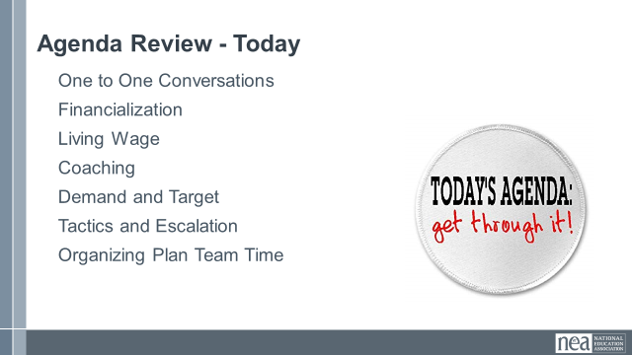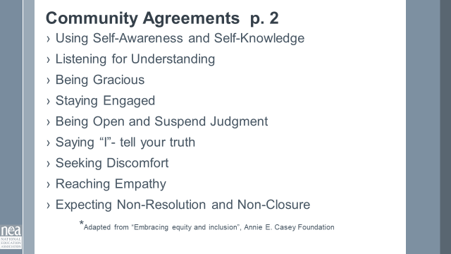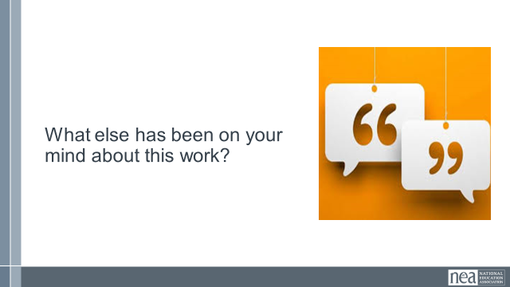 |  |  |  | 15 Min - Welcome  Reentry  Feedback on Feedback  Agenda Review  Norm Review  15 Min - Revisiting Classism discussion - if needed  After stepping away and reflecting, let's expand more on these two questions. What was your reaction to #1? Great info but not going to happen, don’t know how to do it, putting a plan together right now...  - How will you fold this learning into your work with ESPs?  - What are the consequences for not discussing and understanding classism?  Spend most of time on #2 getting to: If our members don’t name this, plan on how to address this and work to erase this within their own worksites and locals they will always be limiting their own power. How would someone who feels put down, degraded, othered and worse feel empowered. Without addressing this first, changing the narrative, collaboration, respect and understanding internally it will always be extremely difficult to move to change any external narrative. |  |  |  | Participants will re-enter the learning environment.  What have you been thinking about so far?
9:00 – 10:00 Beth & Vanessa |  |  |  | Organizing Conversations (15 minutes) & AAR (45 Min)
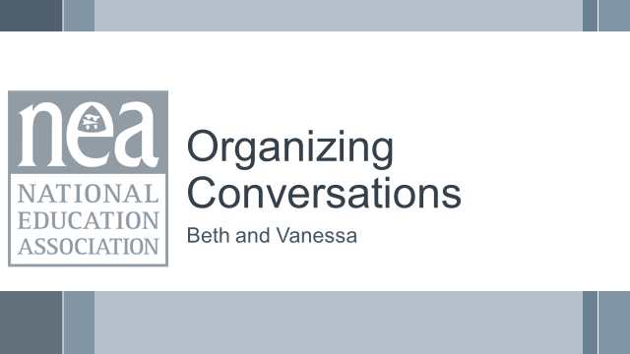  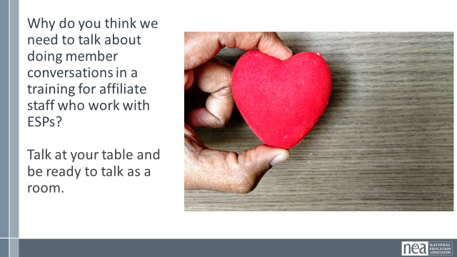  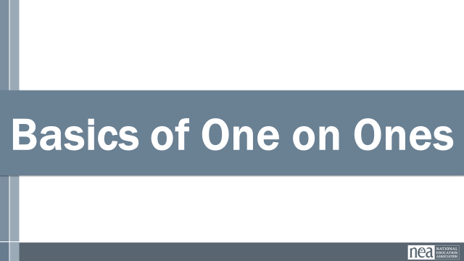  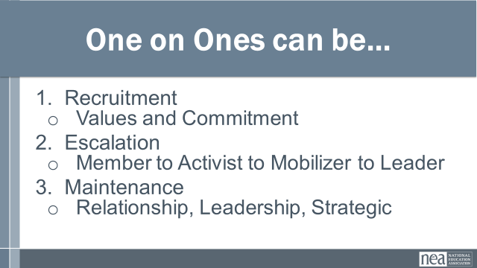  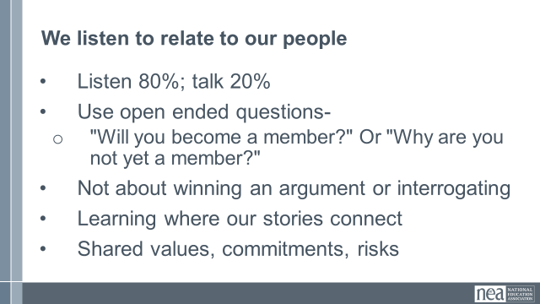  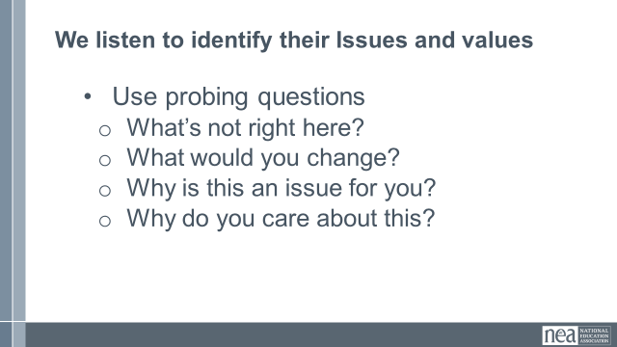  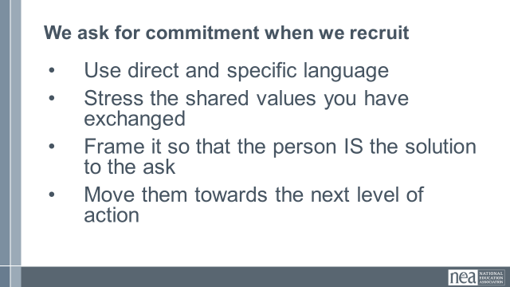  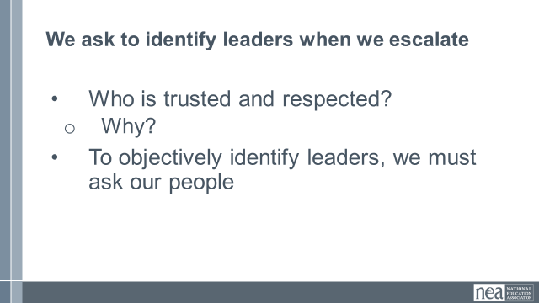  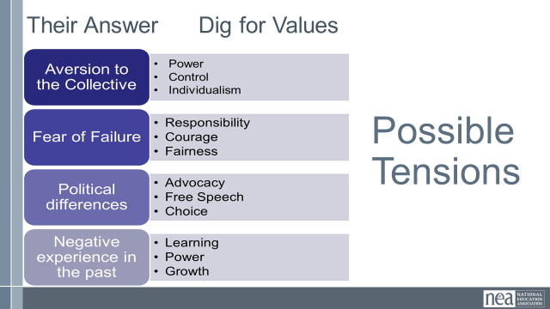  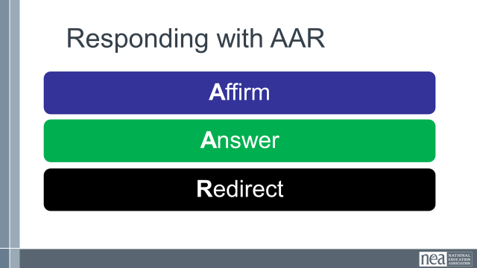  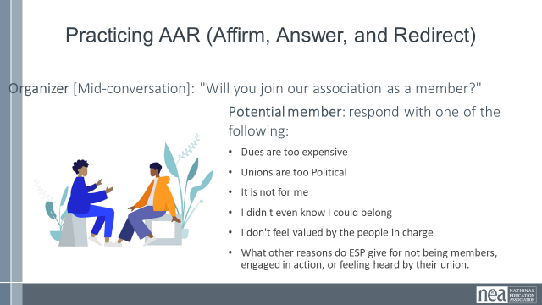   |  | Resources:  NEA ESP Messaging Framework  Narrative Training Guide |  | 15 Min - How do we identify member’s issues and build relationships?  Why do you think we need to talk about doing member conversations in a training for affiliate staff who work with workers?  Take some time – about 5 mins – and be ready to talk as a room  What did you come up with?  When one person talks to another person  And its primarily to get to know each other, but can be used for  Recruitment, Escalation, Maintenance  - Recruitment  - Values and Commitment  - Escalation  - Member to Activist to Mobilizer to Leader  - Maintenance  - Relationship, Leadership, Strategic  We listen to relate to our people  - Listen 80%; talk 20%  - Use open ended questions  - Not about winning an argument or interrogating  - Learning where our stories connect  As Organizers we are listening to identify their issues and values, not TELL them what the issues are  We use probing questions such as:  •Use probing questions  What’s not right here?  What would you change?  Why is this an issue for you?  Why do you care about this?  •Use direct and specific language – Are you ready to sign this pledge cards, will you bring 5 people with you  •Stress the shared values you have exchanged - Like you, I have been low paid person that has felt disrespected by my managers  •Frame it so that the person IS the solution to the ask – We cant win this if you do not show up, You are critical to the success of this action  •Move them towards the next level of action – You joined us last month at Happy Hour, can you bring 5 people  We do not organize worksites, worksites are already organized by natural leaders  We have to ask who is trusted and respected  Even if they are not a member, we need to be in contact  We cannot identify leaders based on our own observations and bias' -  They wear the swag, they have been here 20 years but no one talks to them  We have to ask our people who they trust.  Ex: The attendance at the most recent ESP Conference  5 Min - Affirm/Answer/Redirect: Intro - Vanessa  You will often experience conversations where concerns, incorrect information, tensions and disagreements come up. One strategy we are going to explore involves suspending assumptions; instead of immediately disagreeing or responding, what are some more probing questions we could ask to get at the CORE VALUES of their objections? In the slide, we see some broad categories of barriers, such as political differences and an aversion to collective action. But, if we try to dig deeper, maybe we will find that their aversion to the collective is really about their valuing of individualism or that they prefer control. If we can identify those values, we will be better positioned to respond in a productive and engaging way.  Another strategy to answer challenging questions and statements is to use the framework of Affirm, Answer and Redirect; this approach can be very helpful.  AFFIRM: Let them know you’re listening, you understand, and their feelings are valid. Don’t get mad at them—validate and educate them.  ANSWER: Give a truthful, concise answer to the question. If you don’t know the answer, don’t guess. Tell them you’ll find out and get back to them.  REDIRECT: Once you’ve answered the question, bring the conversation back to ask them to join your membership.  Example:  Statement: Unions are too aggressive.  Response:  AFFIRM: I was nervous too. I’m also an educator so my first instinct is to work together and help students—not agitate.  ANSWER: I have actually found our union to be very collaborative and supportive. We are working together with administrators and lawmakers from both major political parties to find a shared path forward, and I know we can be even more successful with a voice like yours at the table.  REDIRECT: Together, our voice can be even stronger to improve our daily lives and give students our best. Will you join ____________________ as a member?  20 Min - Practice  [Facilitator should have created two circles of chairs in the room- one chair facing another. Count off the participants by 2; direct the 1s to go to the chairs in the outer circle and the 2s to go to the inner circle. The outer circle will act as the organizer for 2 rounds of conversation; then, the inner circle will act as the organizer for the next 2 rounds of conversation. Allow 5 minutes for each round of conversation. Have the outer circle rotate counter-clockwise after each conversation.]  - Imagine you are in the middle of a 1:1 conversation with a worker; the organizer asks “Can you share why you haven’t yet joined our union as a member?”  - The worker will reply with one of these:  - I’d like to join but the fees are too high.  - I just have a hard time believing that joining a union will make a real difference in my life.  - Unions are too political  - Unions don’t focus on issues that matter to custodians like me  - Organizer uses AAR to continue conversation and return to an ask  10 Min – Debrief & Key Points  - How did that go? What was challenging?  - Key points: organizers prepare for difficult conversations and work to understand what values may be underlying a person’s concern or hesitation or disagreement.  - Transition to worksite conversation RAP |  |  |  | Participants identify the types of one-to-one organizing conversations  How can we find out our people’s issues?  How do we have effective organizing conversations to identify member’s issues?
10:00 – 10:15 BREAK

 |  | Finnicization - content moved to Day one
Participants will engage in an activity that highlights the history of the evolution of capitalism and public schools.

Who benefits from the privatization of public schools?

How has COVID affected the financialization of public schools?

Participants will engage in an activity that highlights wealth distribution.

11:15–12:00 Michael & Jeny |  | Living Wage Campaigns (45 Min Before Lunch & 30 Min After)
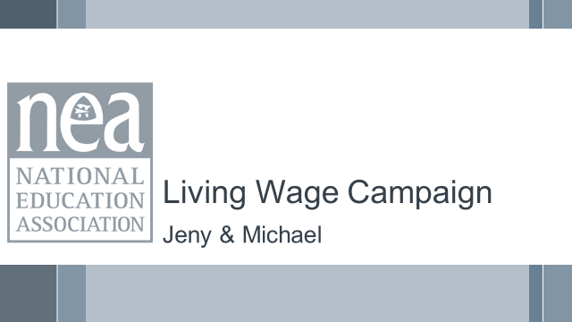  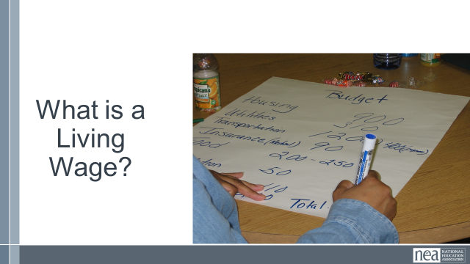  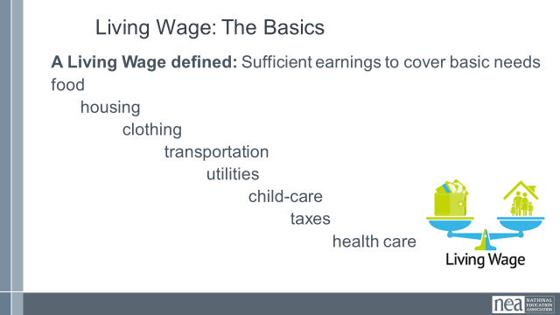  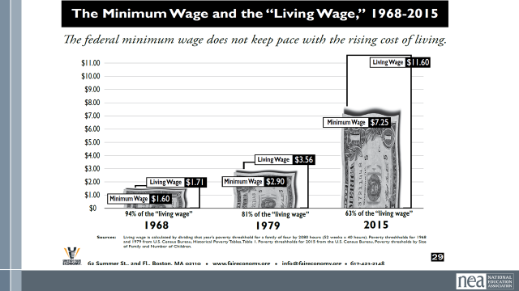  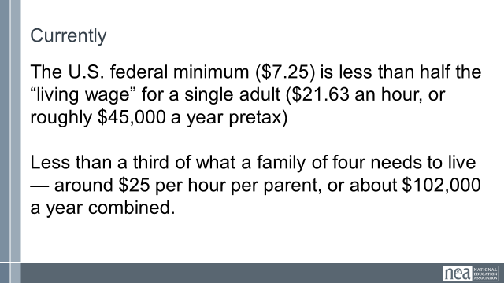  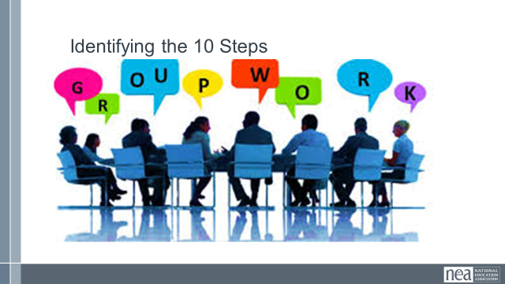    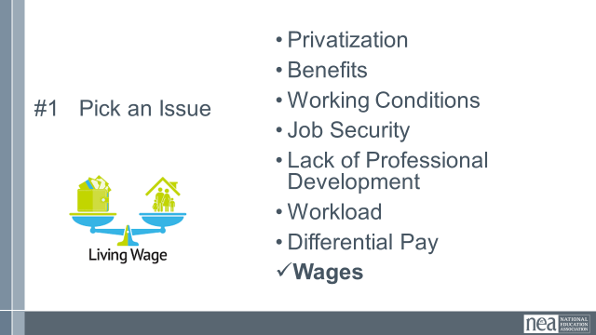  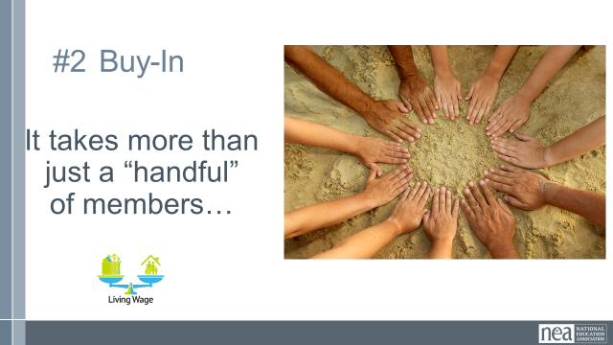  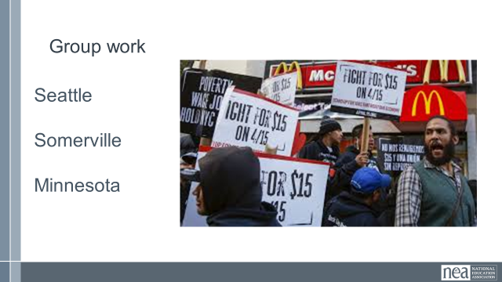  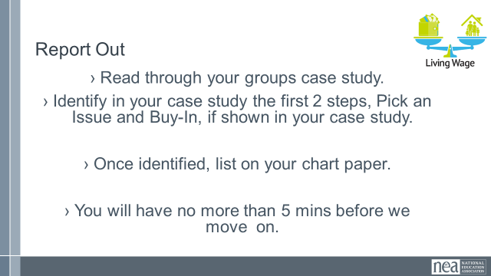  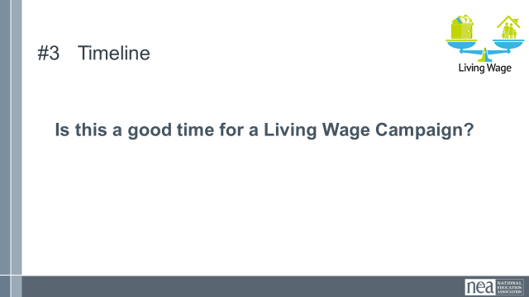  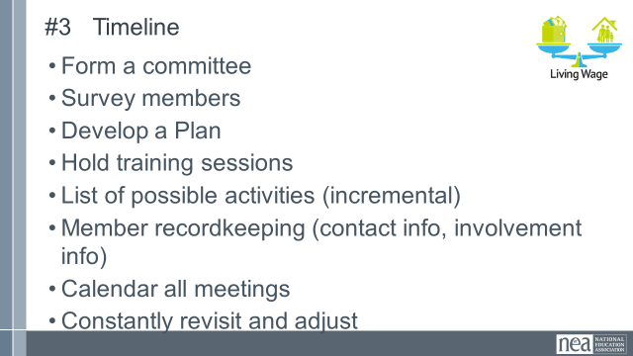  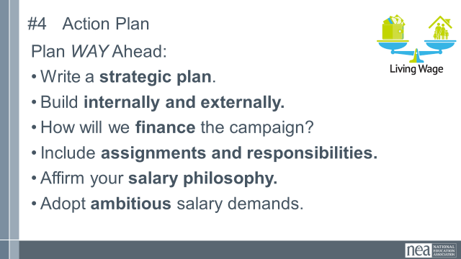  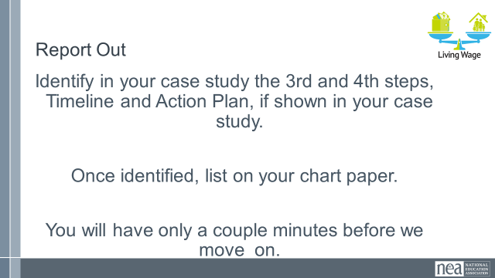  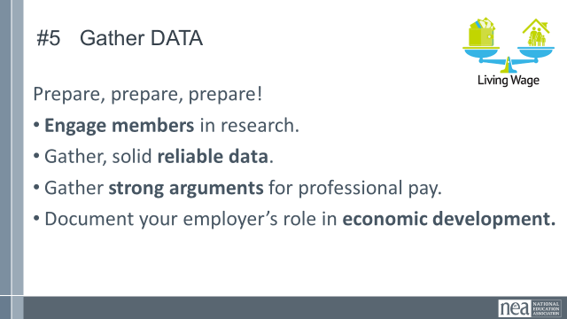  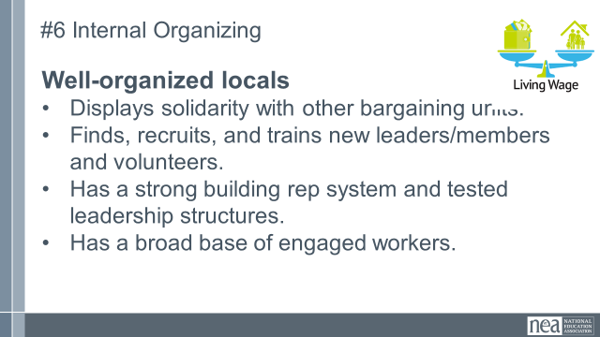  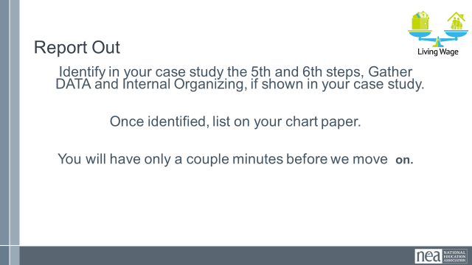  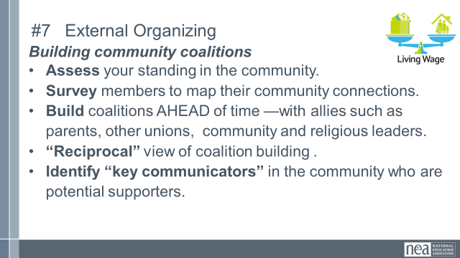  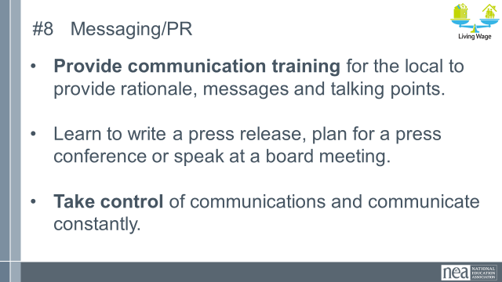  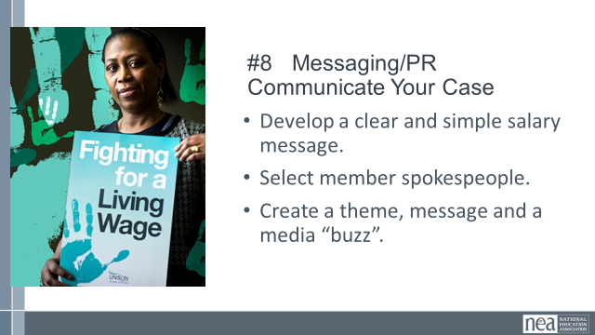  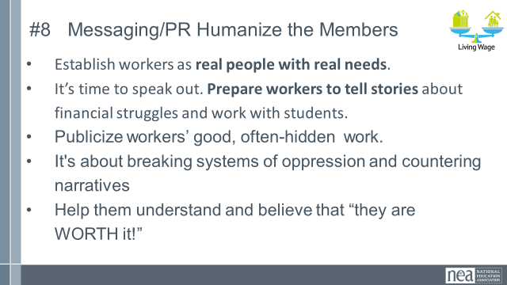  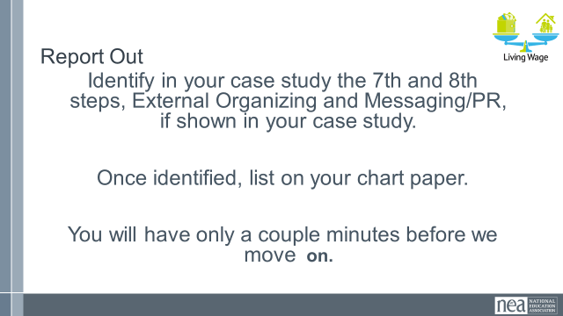 |  | Research a Living Wage  ESP and Living Wage Video o  Checklist for Living Wage Campaign  Living Wage Communication Tips |  | 5 Min – Living Wage, what’s included?  What do you think are all the items that would be covered in a household by a living wage? Work as a table to make a list  5 Min –minimum wage vs living wage  Slide 49  - Note: A Living Wage is still not at a level where someone is accumulating wealth. Think of the list we discussed earlier and what wasn’t on the list. (Take a few answers from the room) “Thriving” is a term to reflect people starting to generate wealth.  Slide 50  - In 1938 the minimum wage was set with the purpose of supporting laborers so they can have a wage to live on.  - The ability to live off of the set minimum wage has only deteriorated since.  - The current amount is no longer related at all to the ability to live off of the wage and people have very diverging beliefs on the current purpose of it.  - $7.25 current minimum wage (Federal set in 7/2009); living wage currently would be $21.63 (EPI site)  5 Min - Explain activity  Using either the Seattle, Somerville or Minnesota case studies, your groups will learn and identify the 10 steps of a living wage campaign – you may not find them all in your cases – and some may be implied and not explicitly stated.  Assign groups to Seattle, Somerville or Minnesota cases. Have each group get a piece of chart paper to track the 10 steps. Have them write their case study town on the top of the chart paper.  30 Min - Living wage campaigns  Introduction  We are going to take a look at the steps NEA has identified are core elements of a Living Wage Campaign.  10 Steps  It is all about organizing - -If a local leader doesn’t get this... They’re not ready for a campaign. A LW campaign can be done in a non-bargaining state as well as a bargaining state. Whether you are bargaining or advocating and lobbying – the campaign strategies are the same.  Salary campaign strategy always involves unity, consensus, strategic planning, solid research and arguments, member organizing and engagement, coalition work, constant communications, and the sense that “We’re worth it.”  What is It REALLY About?  - Working only one job and having time for your family, friends, and yourself.  - Social Justice, Worker’s rights, Human rights, Women’s rights,  - Self-worth, respect, and dignity on the job.  - These are settled out in the community, not at the bargaining table.  10 steps slides:  Step 1 – Pick an issue – how many of the issues identified on our wall can be directly, or indirectly related to the issues of not receiving a living wage?  Step 2 – Buy in This is a campaign for all of the members... Not just the local leaders and the Uniserv!  Everyone should have a chance to contribute and feel ownership. In actuality, a salary campaign builds better, stronger, more knowledgeable and independent locals and in the long run makes for a lighter workload for the UniServ.  Group Work- Read through your groups case study.  Identify in your case study the first 2 steps, Pick an Issue and Buy-In, if shown in your case study. Once identified, list it on your chart paper.  You will have no more than 5 mins before we move on.  Step 3 - YES!!! There is never a better time than now! The lowest paid ESPs are struggling to survive in this economy  Don’t Wait - It takes a good year – 18 months to prepare for a well thought out LW campaign – whether it’s bargaining or lobbying your legislators. When the economy does start to get better, you’re just that much further ahead, prepared to start your campaign, not starting from square one!  Step 4 Action Plan - Salary campaign model: internal organizing, external organizing, use of media, civil rights style tactics, social justice issue, bold salary goals, salary data /cost of living locally  Write a strategic plan: with clear goals, priorities, timelines, assignments and milestones to celebrate. “When we fail to plan we plan to fail.”  Group Work- Identify in your case study the 3rd and 4th steps, Timeline and Action Plan, if shown in your case study. Once identified, list on your chart paper.  You will have only a couple minutes before we move on.  Step 5 gather data - don’t let comparable pay be the district’s argument – poverty pay is poverty pay –even if it is what the surrounding districts get paid – it’s just not right!  Economic Development- includes faculty and ESP local spending power, institutional purchasing power and direct ties between quality local education, housing values, corporate site selection decisions, creation of rural entrepreneurs  Research – help verify current payroll data but don’t let comparable pay be the districts argument- “The district always says that we make what surrounding districts make.”  Document regional living costs –it’s the district’s problem to find the money  Look at management spending priorities, waste…  Quality… highest salaries attract highest quality applicants  Economic Development- includes ESP local spending power, institutional purchasing power and direct ties between quality local education, housing values, corporate site selection decisions, creation of rural entrepreneurs  Step 6 Internal organizing – leaders, structures, narratives  Group Work- Identify in your case study the 5th and 6th steps, Gather DATA and Internal Organizing, if shown in your case study. Once identified, list on your chart paper.  You will have only a couple minutes before we move on.  Step 7 – External organizing  Step 8 – Communicate -- Communication NO MORE SECRETS!! Do not hide the districts dirty little secrets (poverty wages) anymore- and the other secret that the community doesn’t know – TAXES should not now, not ever create or perpetuate poverty!  “Humanize” your members, tell their stories. It’s not their shame it’s the district shame for not paying a living wage.  ESPs are way too modest about the work they do.  We MUST start speaking out! Nobody knows how much they make!  Taxes should not create or perpetuate poverty!  Video tape them!  People are the issue. Put your members in front of the community.  Help them believe they are worth it BUT if they don’t speak out about it nothing will change  BRANDING - Develop a clear and simple salary message. NEA salary Campaign Create a theme, message and a media “buzz”. Visuals- promotional items, bumper stickers, t-shirts  Group Work- Identify in your case study the 7th and 8th steps, External Organizing and Messaging/PR, if shown in your case study. Once identified, list on your chart paper.  You will have only a couple minutes before we move on. |  |  |  | Participants will be introduced to a minimum wage- and living wage calculator that they will apply to their own locals.  Participants will review the 10 steps of a living wage campaign and identify those in case studies.  Participants will develop communications that humanize the issues of workers to build support.  Participants will review the 10 steps of a living wage campaign and identify those in case studies.  Participants will develop communications that humanize the issues of workers to build support.
 12:00 to 1:00 LUNCH
1:00 - 1:30 Michael & Jeny |  | Living Wage Campaign Cont. (30 Min)
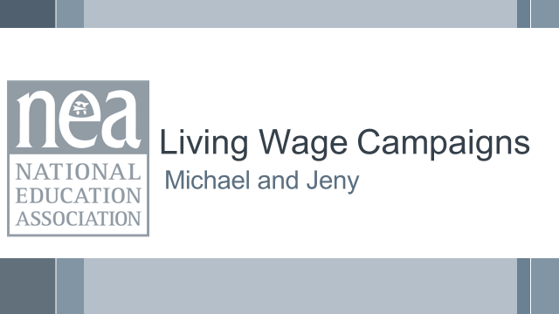  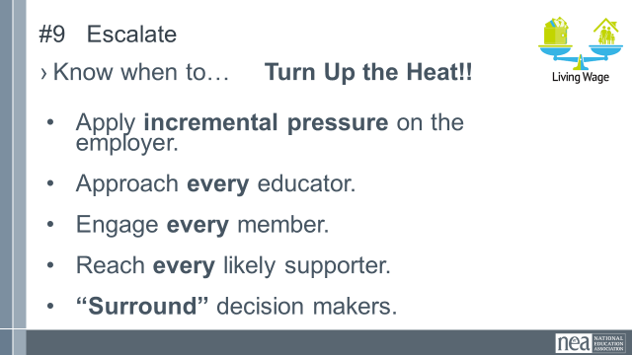  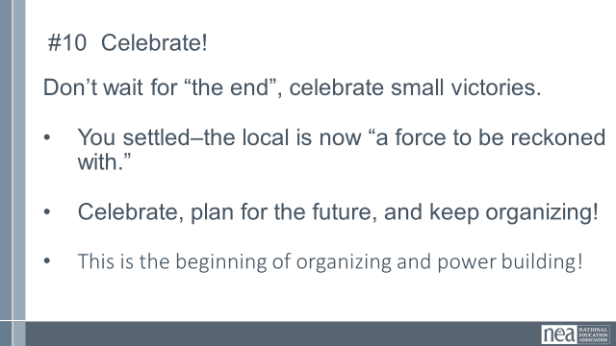  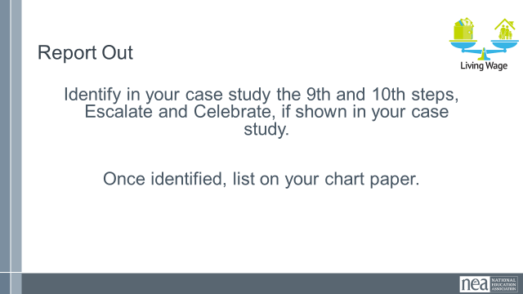  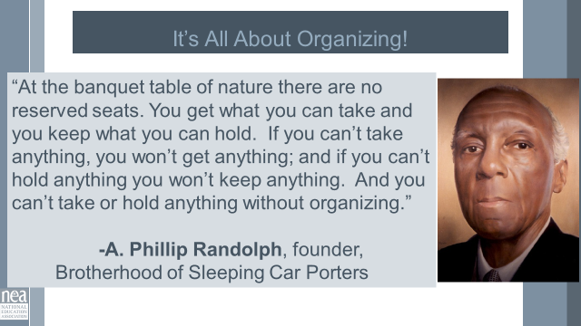  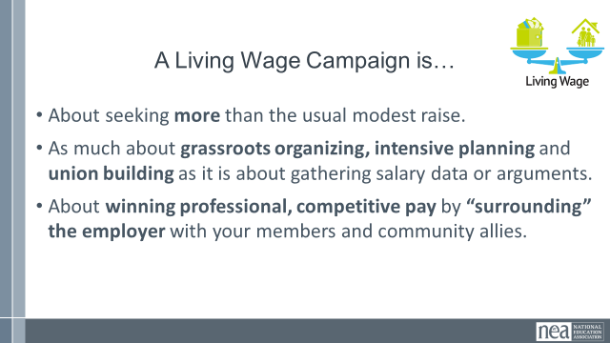  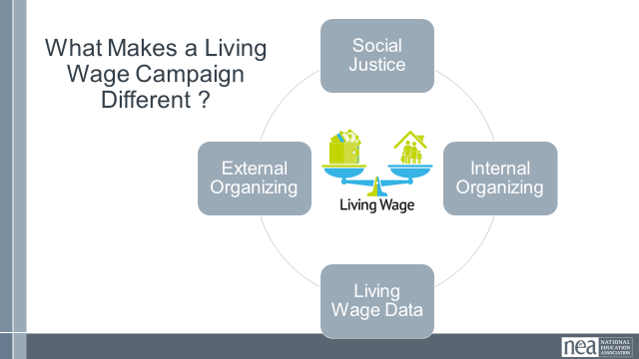  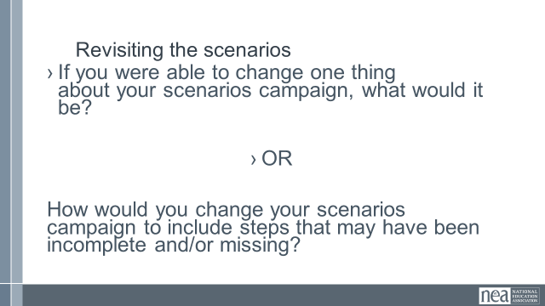  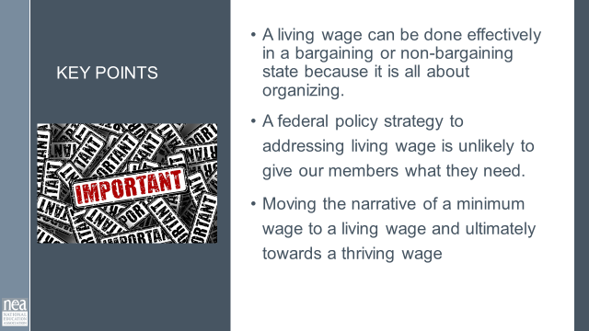 |  | Ithica Living Wage Case Study  Somerville Paras Case Study |  | This actually took an additional 20 minutes. So, extend time as appropriate, or consider doing the share out as a gallery walk rather than a report out.  5-7 Min - Living wage campaigns cont.  Remember where we were before lunch. Take a couple mins to review your chart so far  Step 9 – Escalate: Approach every educator –  1:1 conversations  - Engage every member- a job for everyone, spread the work out-prevent burnout  - Supporters- community allies-parents, students, other union, religious leaders, college faculty, community organizations  - Incremental Pressure – candlelight vigils to full blown rallies, protests  - Surround- pressure on the decision-makers  For bargaining states and non-bargaining states. Decision–maker; Supt., Board of Ed. Members, Legislators, Public  It’s all about your community connections (coalitions) putting pressure on the decision makers (whomever that may be)  Step 10 – Celebrate  Keep improving salary schedules, keep organizing, plan for the next.  “A force to be reckoned with…” - you may not be the districts favorite local president or union but they know you are a force to be reckoned with, you have the community's support...you’re now a player, where before you weren’t even in the game.  Group Work- Identify in your case study the 9th and 10th steps, Escalate and Celebrate, if shown in your case study. Once identified, list on your chart paper.  10 Min Share out-  Pair Groups with different case studies to share out what they found for each step.  Move everyone back to their groups as you pick a couple to share out reflections.  13 Min – Living wage wrap up  Bring group together. Why living wage campaigns are important.  - It’s all about organizing.  - About seeking more than the usual modest raise.  - As much about grassroots organizing, intensive planning and union building as it is about gathering salary data or arguments.  - About winning professional, competitive pay by “surrounding” the employer with your members and community allies.  What makes a living wage campaign different from other campaigns?  Social Justice- ESP as a group tend to be groups of people that historically have been left out by decision makers (minorities, woman, non-traditional families). When we fight for a living wage, we are also fighting for social justice for these groups.  Group Discussion- “If you were able to change one thing about your scenarios campaign, what would it be?” OR “how would you change your scenarios campaign to include steps that may have been incomplete and/or missing? “  Key Points  -A living wage can be made effectively in a bargaining or non-bargaining state because it is all about organizing.  -A federal policy strategy addressing living wage is unlikely to give our members what they need.  -Moving the narrative of a minimum wage to a living wage and ultimately towards a thriving wage  Might consider adding some of this A thriving wage goes beyond simply covering basic needs, aiming to provide enough income for individuals and families to not only survive but also to thrive by allowing for discretionary spending, savings, and participation in community life.  Here's a more detailed breakdown: Beyond Basic Needs: While a living wage focuses on covering essential expenses like food, housing, and healthcare, a thriving wage encompasses the ability to afford more than just the bare minimum.  Discretionary Income: A thriving wage allows for some disposable income, enabling individuals to pursue hobbies, invest in personal development, and participate in leisure activities.  Financial Security:It also provides a buffer for unexpected expenses and allows for savings and planning for the future, including retirement and children's education.  Community Participation:A thriving wage enables individuals to contribute to their communities and participate fully in society, rather than being solely focused on survival. |  |  |  | Participants will be able to identify the components of a living wage campaign.  What does a winning campaign look like?
1:30-2:00 Hedy |  | Coaching of Your Issue from Home (30 Min)
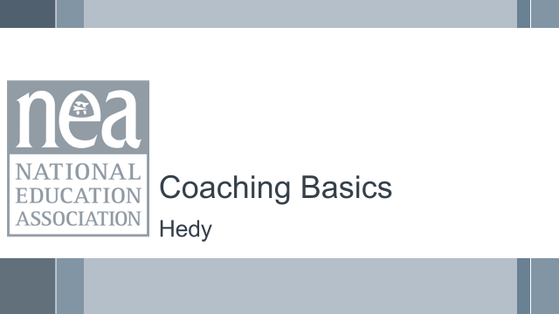  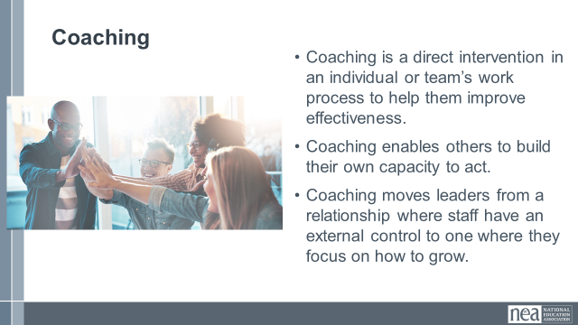  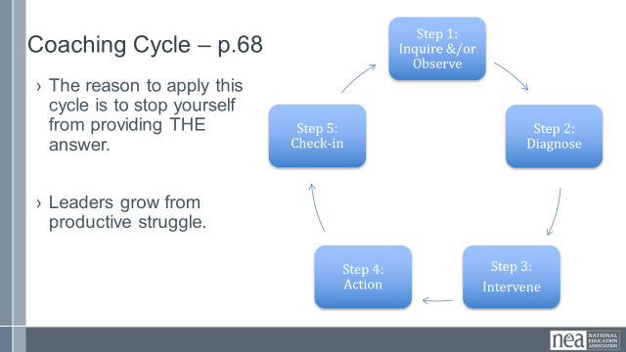  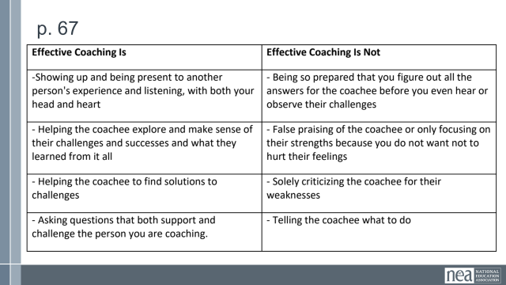  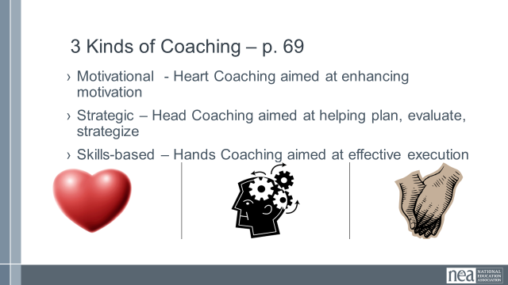  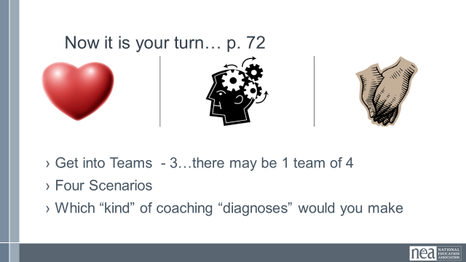  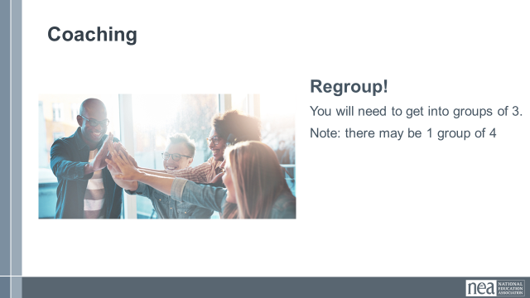  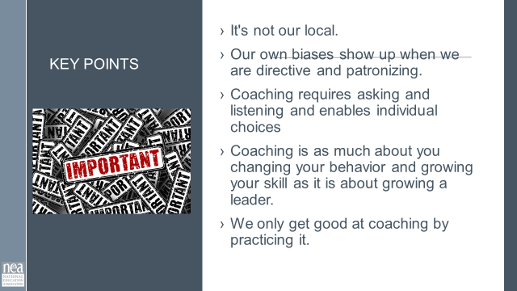 |  | Coaching Content Handouts including Consultancy Protocol  Coaching Scenario  Coaching Content Handouts including Consultancy Protocol  h |  | 10 Min - What is coaching section p. 68  Coaching is when we release our external control of leaders and enable them to grow. It is a direct intervention designed to help them figure out how to be more effective. Coaching moves individuals and teams away from staff led to self-direction of actions.  There are five steps to observe in a coaching cycle – we observe these to stop our own INCLINATION to move into consultant role and give the answer or the plan.  Effective coaching should result in a transformation of dependence on staff to that of independence. We do that by showing up, being present and listening. We ask good questions that help the team or individual explore what is going on and reflect on what they are learning. We help them identify choices and solutions by asking them what they think they should do and are willing to do. We are almost always in inquiry mode – not directive mode – asking not telling.  There are three kinds of coaching – motivational is when you  diagnose after listening that there is a problem of the heart and will. Strategic coaching is when you diagnose, after listening that help is needed in identifying a plan and sticking to it. Skills based is used when you diagnose, after listening that a strengthening of skills are needed.  Coaching is always asking questions, not directing.  Motivational: Why do you think it’s taking you so long to get started.  Strategic: So tell me more about the difference between  Skills-Based: Why do you think the spreadsheet is sideways  Don’t take away their opportunity to grow  15 Min - 3 Kinds of Coaching activity p.124  Now you and your tables are going to look at 4 scenarios. (stand up and move) In the next 10 minutes, determine which of the three kinds of coaching is best for each scenario. Be ready to shout out answers at the end of 10 minutes.  Take 5 minutes to hear answers.  5 Min - Key Point  - It's not our local  - Our own biases show up when we are directive and patronizing  - Coaching requires asking and listening and enables individual choices  - Coaching is as much about you changing your behavior and growing your skill as it is about growing a leader.  - WE only get good at coaching by practicing it. |  |  |  | How does coaching grow and develop leaders?  How do fighting unions make a material difference in the lives of their members?
2:00 – 2:15 BREAK
2:15-2:45 Jeny
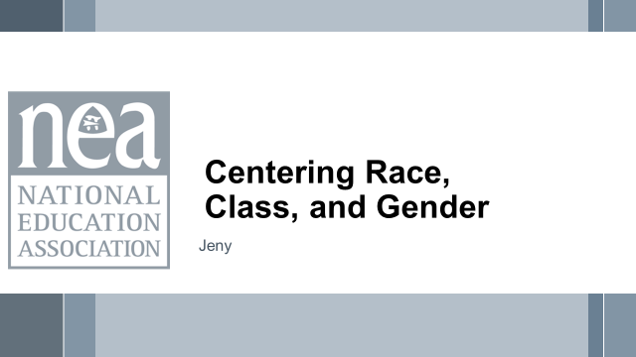  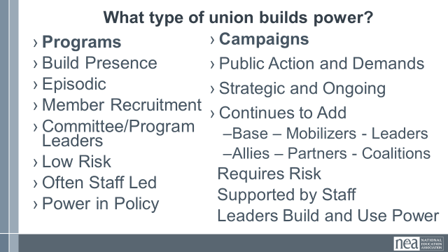  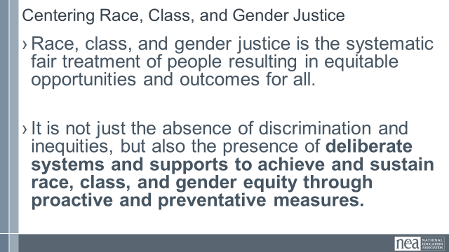  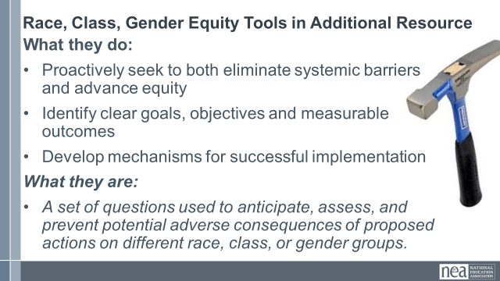  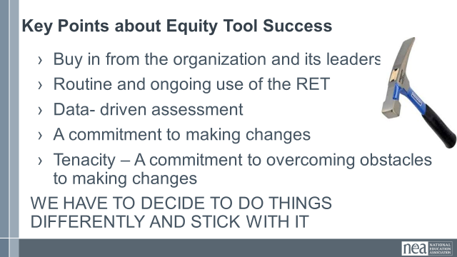  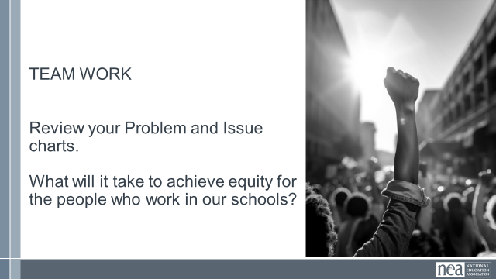  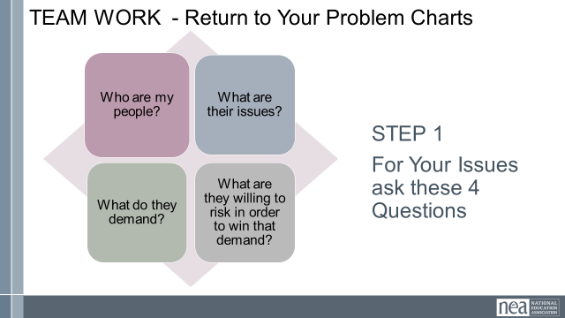  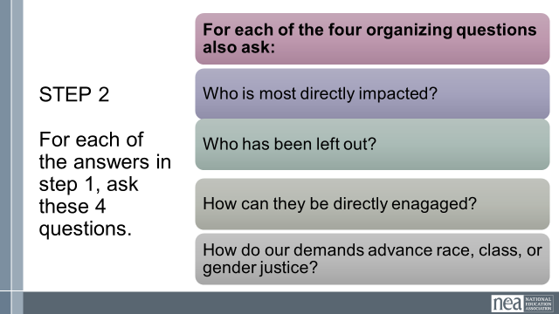  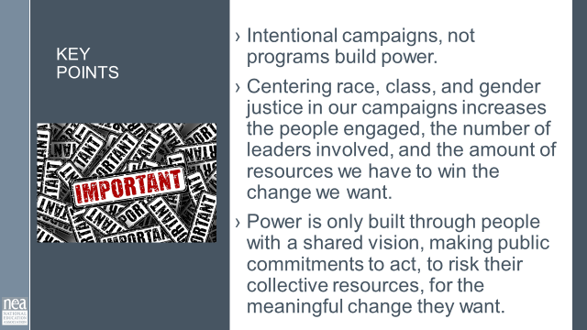 |  | Charts for problems  Equity Analysis  Equity Assessment  CRSJ BCG Centering Race Guide |  | 2 minutes – Union Work that Builds Power  For all of those things, to make meaningful lasting STRUCTURAL change we need power. Power is defined as that ability to create, control, and prevent change. That typically means organized people and organized money or resources – your work is a resource.  What type of union builds power? Programs, such as professional learning, staff led advocacy, social focused events, even policy advocacy do little to build power. Why is that? Well all of these programs are self-selected with little risk to join or leave them. I want to improve my classroom management, so I come to the Union led training on that. I might even lead one – but I have done little to build power with others. Also in a program, I am choosing to solve a “me” Problem and it does not require any other collective commitment.  Campaigns put people at the center of solving the problems they are experiencing. They name the issue, they decide the solution, they decide who they follow, and they determine what the are willing to risk. When we center people in a campaign – staff move to a coaching role. When people are at the center they use their agency and decide how to act, who they will act with, and what they are willing to risk to win. This is when members and leaders feel powerful in their union.  To begin a campaign you have to ask what the people want to solve, ask what they are willing to risk to solve that, and form demands that they think will provided the solution to their problem.  2 mins - What does it mean to center racial, class and gender justice?  Race, class and gender dynamics, disparities, and divisions permeate our society, communities, schools, and classrooms. Systemic oppression is so deeply rooted in our history, culture, and institutions that there is no escaping it. Visible or not, the impacts are ever-present. Race, class, and gender justice is the systematic fair treatment of people of all races, resulting in equitable opportunities and outcomes for all. It is not just the absence of discrimination and inequities, but also the presence of deliberate systems and supports to achieve and sustain race, class, and gender equity through proactive and preventative measures.  KEEP THIS AND CONSIDR WHEN IDING PROBLEM AND ISSUES  To continually and systematically keep equity in your work you have to use a Race, Class, and Gender Equity too, or lens. This is a person and institutional commitment to  Proactively seek to both eliminate systemic barriers and advance equity  Identify clear goals, objectives and measurable equity outcomes  Develop mechanisms for successful implementation of equity focused programs  A set of questions used to anticipate, assess, and prevent potential adverse consequences of proposed actions on different race, class, or gender groups.  10 Minutes – TEAM WORK – Return to Problem and Issue Charts  Step 1  Looking at your PROBLEM CHARTS – consider the c4 Organizing Questions for at least one of your problems - Who are my people? What are their issues?What do they Demand? What are they willing to risk to achieve that demand? WE HAVENT DISCUSSED THESE TERMS YET- SO HOW DO WE ADDRESS THIS?  Step 2- Apply the following Equity Tool:  Who is most directly impacted?  Who has been left out?  How can they be directly engaged?  Hows this demand advance race, class, or gender justice?  2 Minutes Key Points-  Intentional campaigns, not programs build power.  Centering race, class, and gender justice in our campaigns increases the people engaged, the number of leaders involved, and the amount of resources we have to win the change we want.  Power is only built through people with a shared vision, making public commitments to act, to risk their collective resources, for the meaningful change they want. |  |  |  | Participants will understand how intentionally asking race and equity questions at every point of a campaign helps to center race, class, and gender in campaigns.
2:45-3:10 Beth |  | Demands and Targets (25 Min)
  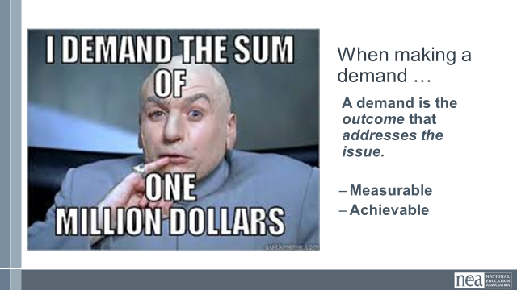  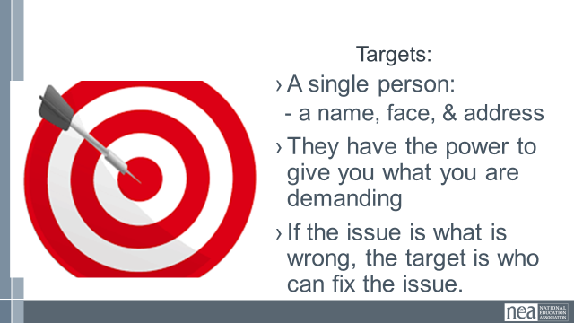  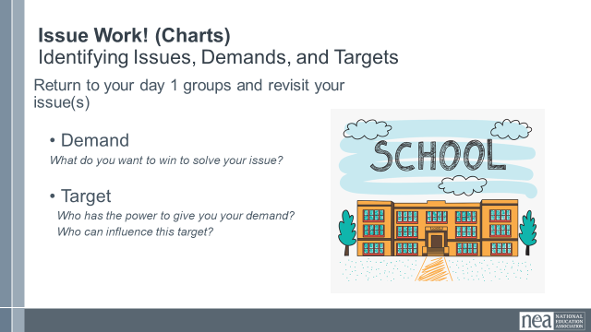  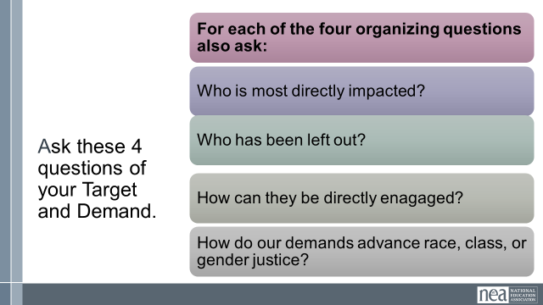  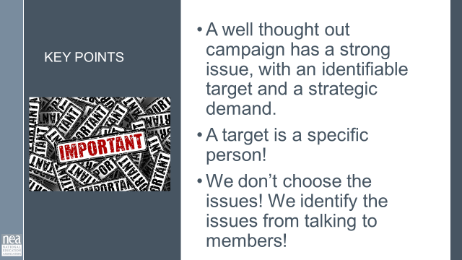 |  |  |  | 3 Min – Introduce Demand and Set Up  - A demand is what the group wants– the win –  - A demand is the outcome that addresses the issue you are making of the target  - If the issue is what is wrong, the target is who we want that will fix the issue.  3 Min - INTRODUCE TARGET  - The last idea that we want to cover is Targets.  - TARGET: A target is a single person with a name and an address. The target is the person with the power to give the workers the change they are asking for. A target has a name, a face and an address.  17 Min – GROUP WORK  In your groups, return to your issue from Day 1 and decide the:  - Issue - Keep in mind what makes a good issue!  - Demand - What do you want to win to solve your issue?  - Target - Who has the power to give you your demand?  - Who can influence this target?  Apply The Race and Equity Questions  2 Min - WRAP UP/KEY POINTS  - A well thought out campaign has a strong issue, with an identifiable target and a strategic demand.  - A target is a specific person!  - We don’t choose the issues! We identify the issues from talking to members! |  |  |  | Participants will create a demand and a target using the specified criteria.  What is a demand?  How do we identify a target?
3:10-3:45 Michael |  | Tactics and Escalation (35 Min)
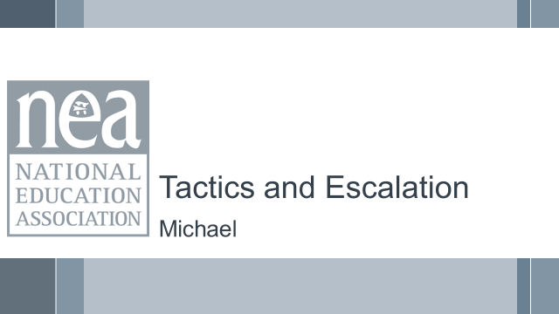  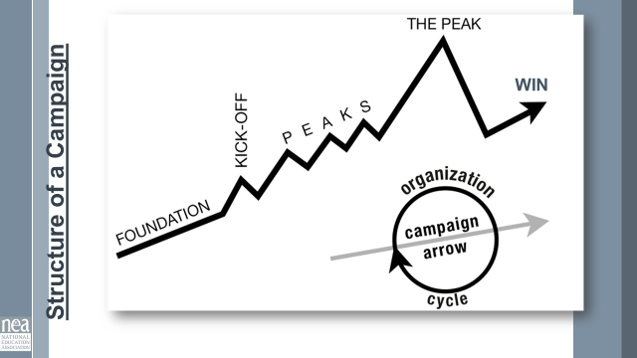  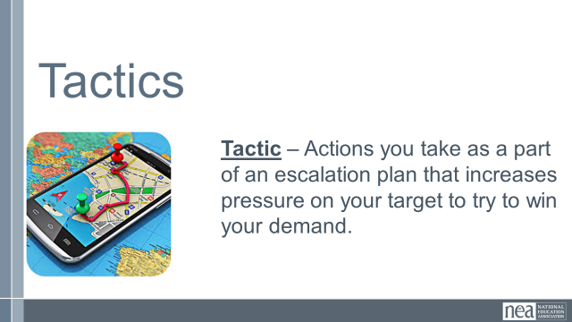  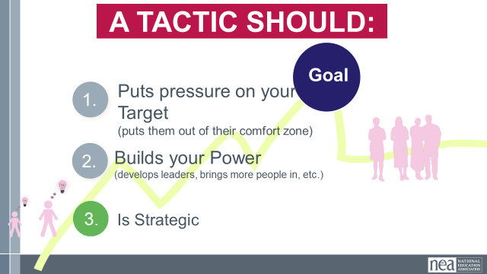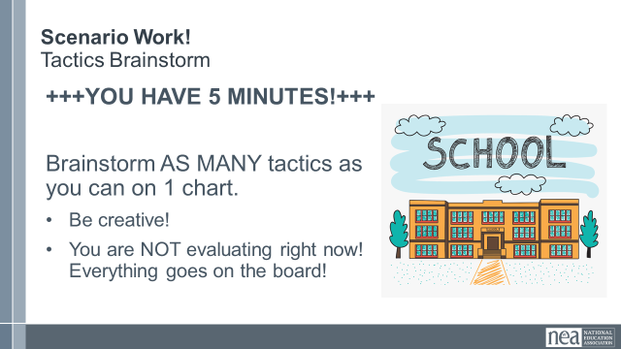  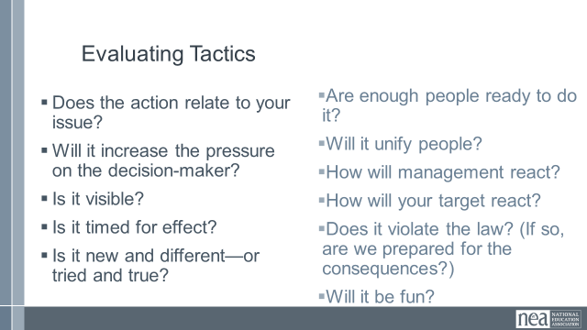  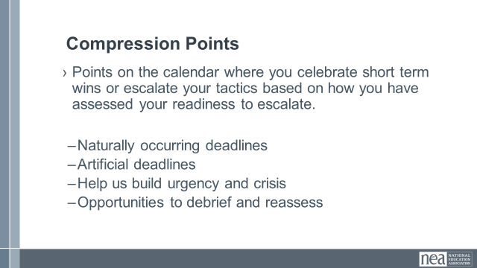  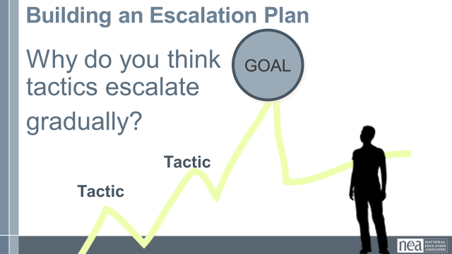  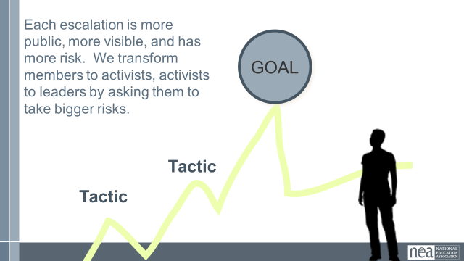  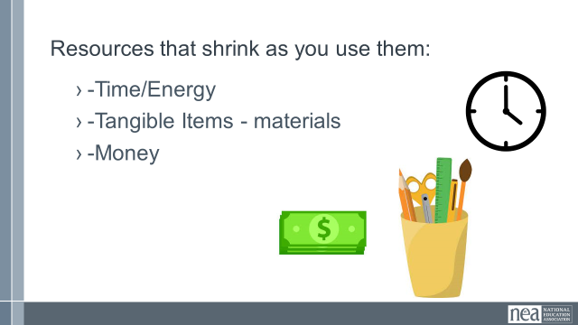  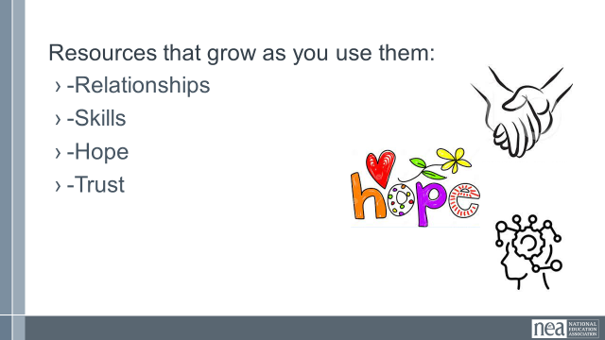  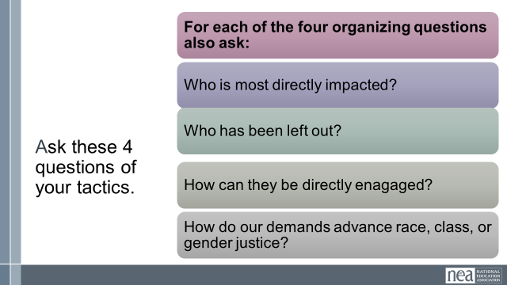  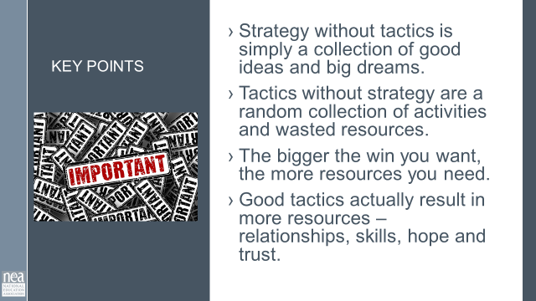 |  | Campaign Plan |  | 4 Min - INTRODUCE Campaign Mountain  - Foundation – gather info, id issues, id leadership team  - Kick-off – public event that indicates what the issue, demand, and targets are  - Escalating peaks of activity that should escalate in  - Risk  - Capacity (people, resources, engagement and Power)  - Increase leadership and ownership  - THE PEAK – The most public, risky, momentum, engagement, and resources  - The Win – We achieve our demand  - Debrief, regroup, and continue to climb  3 Min - INTRODUCE Tactics  Next, we are going to talk about Tactics.  Tactics are Actions you to take as a part of an escalation plan that increases pressure on your target to try to win your demand.  What are some examples of tactics? (Have a few people share out some tactics)  We are going to model a tactics brainstorm that you can use when working with members.  5 Min - Scenario Work  Brainstorm AS MANY tactics as you can on 1 chart.  - Be creative!  - You are NOT evaluating right now! Everything goes on the board!  We are going to have 5 minutes to list as many tactics as you can. Extra points for super creative ideas. WE ARE NOT evaluating tactics at this time. If someone says something (example- We are going to wear the same clothes without washing them until we get what we want) you write it down and move on. All ideas get on the board. Again, this is a brainstorm. NO EVALUATING.  YOU HAVE EXACTLY 5 MINUTES. After 5 minutes put your pens down.  Open your phone and actively start a timer. “ON YOUR MARKS. GET SET. GO”  Excellent! We now have a whole list of tactics. Next. We are going to assess our tactics. For this, I encourage you to use a list of questions like this-  3 Min - How to evaluate a tactic  - Does the action relate to your issue?  - Will it increase the pressure on the decision-maker?  NOTE! This means that we have to engage in actions that make our target uncomfortable. SOOOOO the same old tactics WON’T WORK! They are used to them!  - Is it visible?  - Is it timed for effect?  - Is it new and different—or tried and true?  Note! SEE above. If a tactic is the same as always, your target has likely become comfortable with it AND it won’t develop new skills in your members and therefore build your power.  - Are enough people ready to do it?  - Will it unify people?  - How will management react?  - How will your target react?  - Does it violate the law? (If so, are we prepared for the consequences?)  NOTE! This doesn’t mean that it is off limits. Historically, breaking laws has been a big part of social justice movements. ESPECIALLY THE LABOR MOVEMENT! However, we have to consider if an unlawful tactic is the right tactic and whether you have the power to mitigate/absorb the consequences.  - Will it be fun?  Folks want to engage in things that fill them up! Many of the same old  10 Min- Evaluating your tactics  Look at your list of tactics.  - Circle the ones that you think are strategic, when looking at these questions.  - Cross out the ones that are NOT strategic.  - You have 10 minutes.  2 Min – Compression Point Definition  Points on the calendar where you celebrate short term wins or escalate your tactics based on how you have assessed your readiness to escalate.  - Naturally occurring deadlines  - Artificial deadlines  - Help us build urgency and crisis  - Opportunities to debrief and reassess  2 Min – Turn and Talk  We keep saying that tactics should escalate gradually. Why do you think that is?  2 Min – Debrief  Each escalation is more public, more visible, and has more risk. WE transform members to activists, activists to leaders by asking them to take bigger risks  2 Min – Just a word about resources  RESOURCES: Resources are what are available to the people who are part of the campaign to use to achieve their demand.  Resources that shrink as you use them  - Time/Energy  - Tangible Items – materials  - Money  Resources that Grow as you use them  - Relationships  - Skills  - Hope  - Trust  Apply the Race and Equity Tool Process  2 Min - Key Points  - Strategy without tactics is simply a collection of good ideas and big dreams.  - Tactics without strategy are a random collection of activities and wasted resources.  - The bigger the win you want, the more resources you need.  - Good tactics actually result in more resources – relationships, skills, hope, and trust.  Handout: pg 71 in “organizing for action” (NEA strike manual), pg 96 in pre attendance handout |  |  |  | Participants will develop an organizing plan with teams that can be shared with Participants will develop an organizing plan with teams that can be shared with the whole group.  the whole group.  What are the strategic actions and use of resources we will use to achieve our demand?  How can we apply what we have learned?
3:45-4:15 Hedy |  | Organizing Plan Team Time (30 Min)
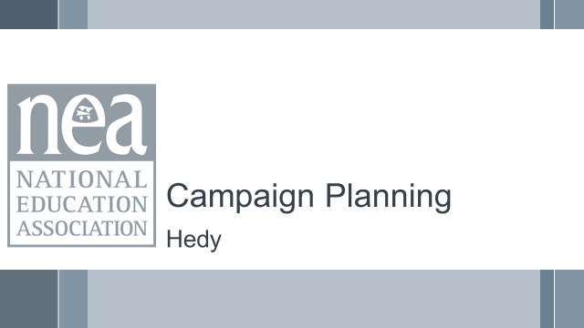  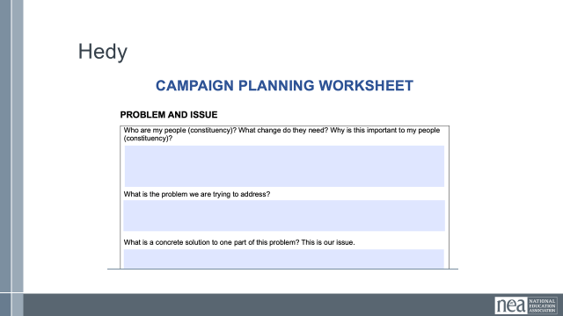  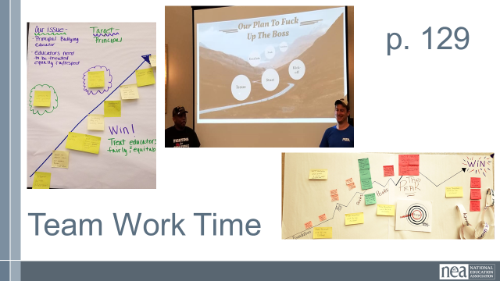 |  | Organizing Plan Template |  | Review what teamwork is in process/been completed and next steps  - In Process - Checklist for Deciding on an issue Doc  - In Process - Plan for Organizing Doc  - Next step – Strategic Planning Template Doc  - Preview – end result is a presentation on day three w/use of visuals  The idea for the work time of this section is that we go back and forth between using the template and then sharing out what they have done  They should be thinking about an 18 Month Timeline  They should keep in mind the 10 steps  They should incorporate the “test/task” design into their tactics  - Must be motivated  - Must be some risk (also more and more…)  - Must have accountability  CAMPAGIN PLANNING DOCUMENT NEEDS TO BE REFORMATTED |  |  |  | Participants will build a campaign using the template and content points provided.  How can we apply what we have learned
4:15-4:30 Ellen |  | Ending it Right (15 Min)
  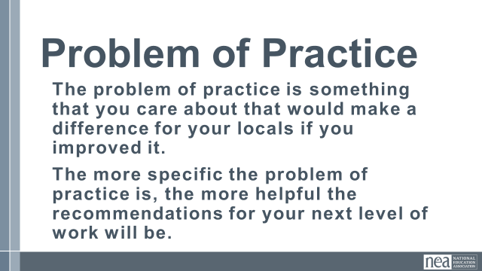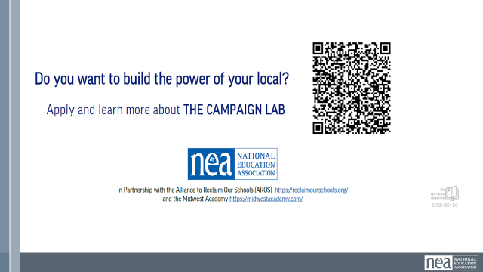  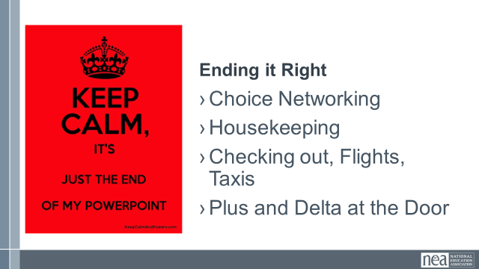 |  |  |  | Questions, Connections, Reflections  Housekeeping announcements  Plus/Delta at the Door  FOR TOMORROW – WHAT IS A PROBLEM THAT YOU ARE EXPERIENCING AROUND DEVELOPING ESP ORGANIZING? |  |  |  | Participants will be able to bring a little closure to their learning and provide feedback on the day.  How are we doing so far?
4:30 – 5:00 Ellen |  | Choice Networking Activities and Adjourn
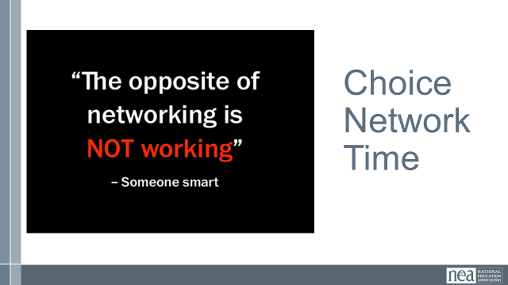 |  |  |  | Participants will make useful connections with staff from other affiliates. |  |  |  | Participants will make useful connections with staff from other affiliates.

