Facilitator Agenda: Day # 3 Organizing ESP
General Materials Needed: |  |  |  |  |  |  | Room Set-up:
1 Set of Handouts per Person  Name Tags or Name Tents  Room signs, sign-in signs  Painters Tape |  |  | Chart Paper  Post its  Chart Markers – Mr. Sketch  Pens and Pencils |  |  |  | Round Tables  Projector, Screen and Speakers  Carousel stations and reporting stations around the perimeter  50 people  Prep for the day:  Cut apart strips for Engagement activity - the leadership Tasks are the same – they redesign a task to make it go from low leadership and ownership to high ownership and leadership  Charts?
Key Outcomes for the Day
Participants will apply structure tasks and asks that move ESP members to leaders
Participants will be able to apply a consultancy protocol to identify solutions to real workplace problems of practice
Participants will complete a campaign design plan
8:30-8:45 Welcome Back  8:45-9:40 Consultancy Protocol  9:40-10:25 Leaders, from Clubs to Unions  10:25-10:40 Break |  |  |  |  | Ellen  Hedy & Vanessa  Dawn | 10:40-11:10 Building Engaged Leaders  11:10-12:00 Group Work Time  12:00-12:45 Team Presentations  12:45-1:00 Ending Right |  |  | Michael  Jeny  Dawn & Hedy  Ellen
Time, Slide, Facilitator |  | Resources |  | Instructions, Activity and Debrief (Facilitators) |  |  |  | Outcomes and Essential Questions
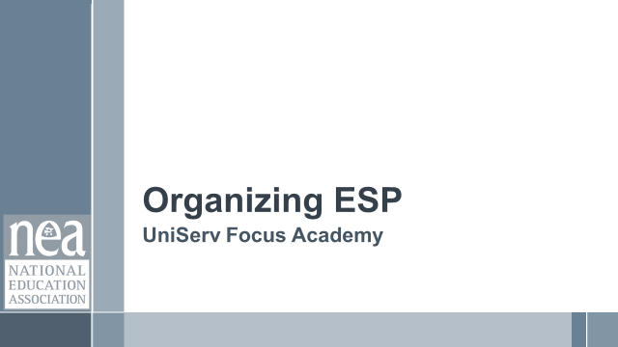 |  | Charts, handouts, articles, materials, slides, sticky notes |  | What are you saying, what are they doing, what questions will you use to guide learning and make clear the important points  Include an estimate for how long each section of the learning will take |  |  |  | As a result of this section of learning, what will participants know or be able to do? What questions will they be able to answer?
8:30 – 8:45 Ellen |  | Welcome Back (15 Min)
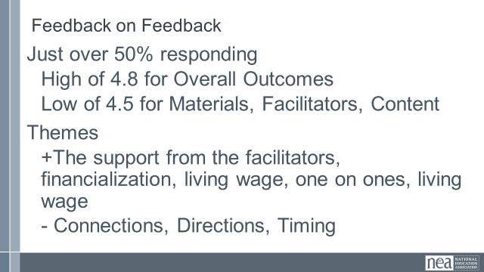  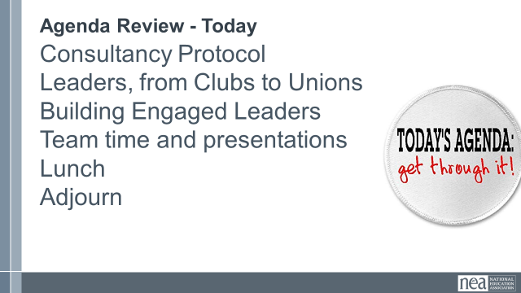  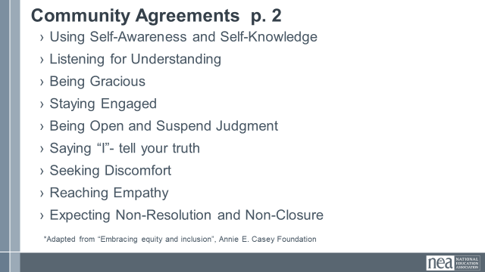 |  |  |  | Norm Review  Reentry  Feedback on Feedback  Problem of Practice  Today, we are going to turn again to looking at leaders and structures but with more of an eye towards coaching and testing – here is what we mean by testing – if you agreed you would do it, did you? Why or why not?  Showcase the examples of centering, race, class and gender. |  |  |  | Participants will re-enter the learning environment.  What have you been thinking about so far?
8:45 – 9:40 Hedy/Vanessa |  | Consultancy Protocol (55 Min)
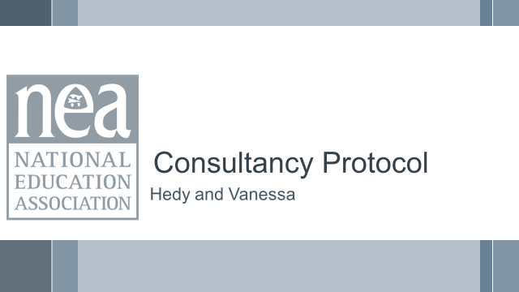  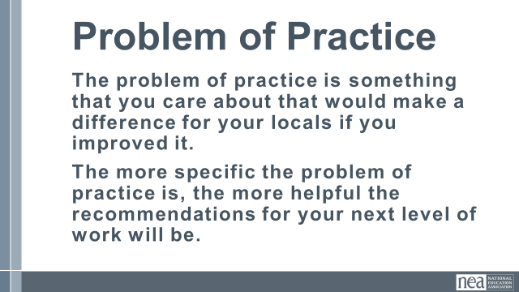  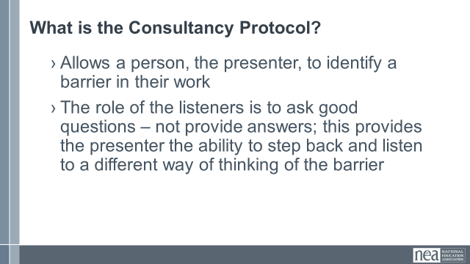  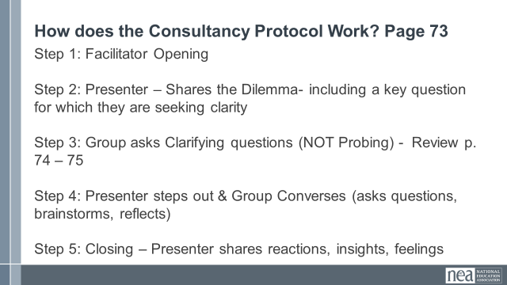  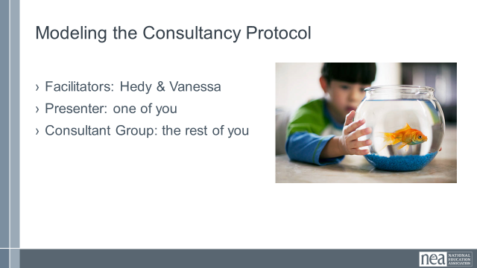  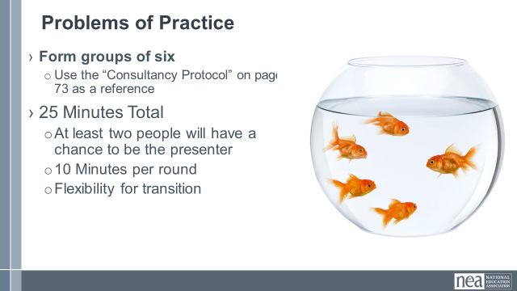  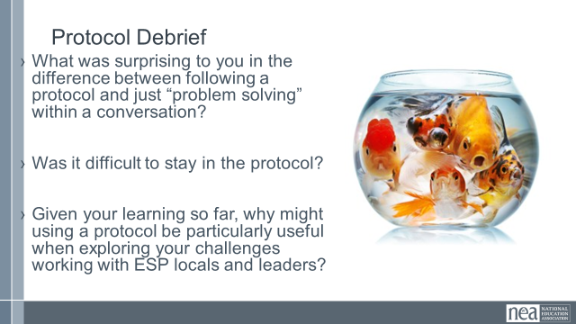  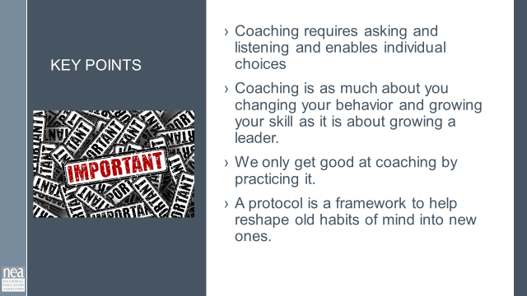 |  | Coaching Content Handouts including Consultancy Protocol |  | 13 Min - Consultancy protocol Intro  Now we are going to look at a different type of coaching protocol. Just like the discussions we had yesterday, this process is focused on the person identifying the solutions and the listeners acting as coaches – AND provides a way to give some consultation without becoming the person who provides all of the answers.  This protocol begins with a problem of practice. The problem of practice is something that you care about that would make a difference for your locals if you improved it. It allows a person, the presenter, to identify a barrier in their work; the role of the listeners is to ask good questions – not provide answers; this provides the presenter the ability to step back and listen to a different way of thinking of the barrier.  First, let’s find the consultancy protocol in our handouts (p.73). Each of the 5 steps are outlined; let’s look at them together. Now, we are going to practice as a large group.  Two Facilitators model the process with a participant  Form groups of six  - Use the “Consultancy Protocol” on page 73 as a reference  25 Minutes Total  - At least two people will have a chance to be the presenter  - 10 Minutes per round  - Flexibility for transition  10 Min - Debrief  - What was surprising to you in the difference in following a protocol and just “problem solving” within a conversation?  - Was it difficult to stay in the protocol?  - Given your learning so far, why might using a protocol be particularly useful when exploring your challenges working with ESP locals and leaders?  2 Min - Key Point  - Coaching requires asking and listening and enables individual choices  - Coaching is as much about you changing your behavior and growing your skill as it is about growing a leader.  - We only get good at coaching by practicing it.  - A protocol is a framework to help reshape old habits of mind into new ones. |  |  |  | Participants will work on a problem of practice that they are experiencing using a consultancy protocol.  How do I break the habit of just jumping in to give advice?  What can coaching look like in action?  Purpose is to de-center yourself -
9:40 – 10:25 Dawn (Vanessa Slide Clicker) |  | Leadership, From Clubs to Unions (45 Min)
  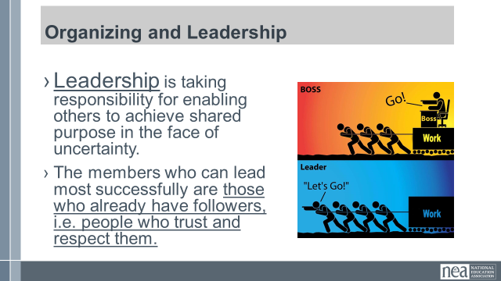  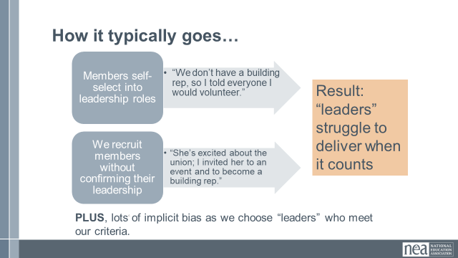  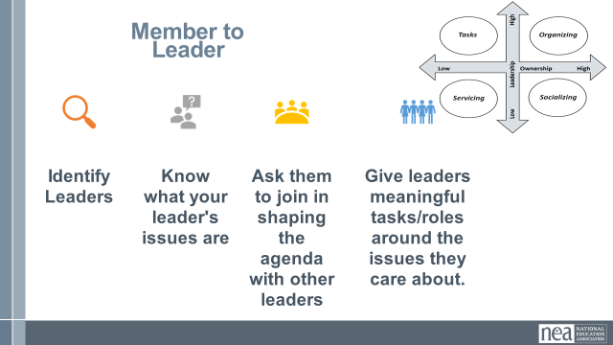  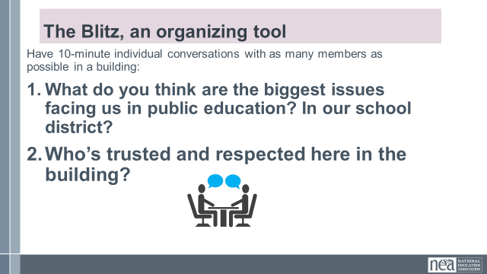  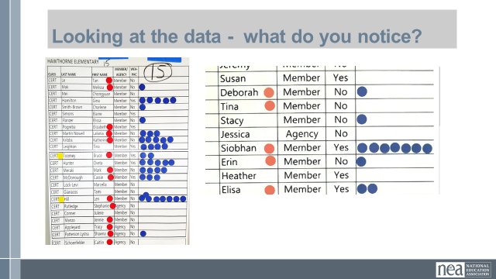  Slide 22:  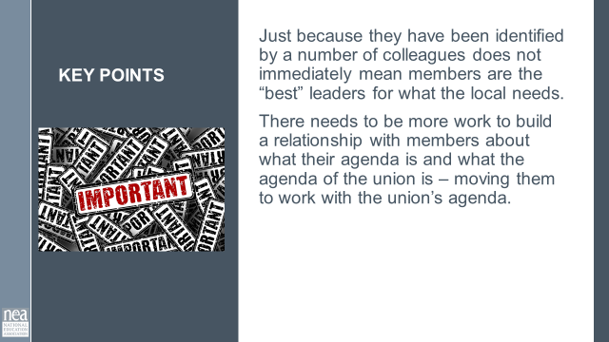    Slide 24  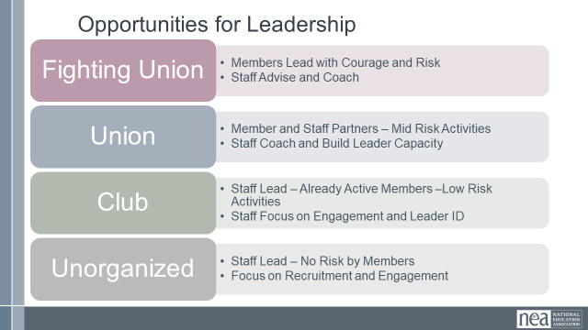  Slide 25  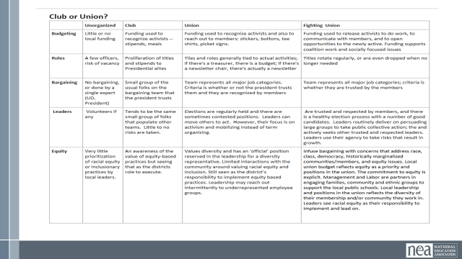  Slide 26  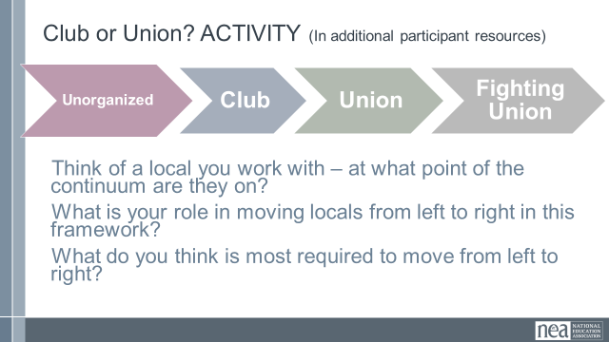  Slide 27:  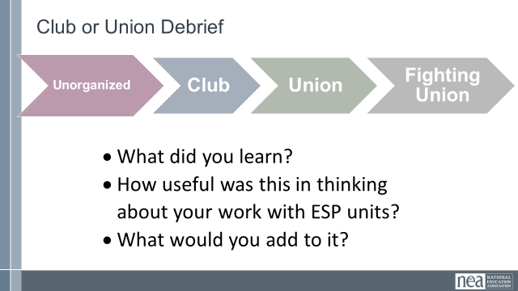  Slide 28:  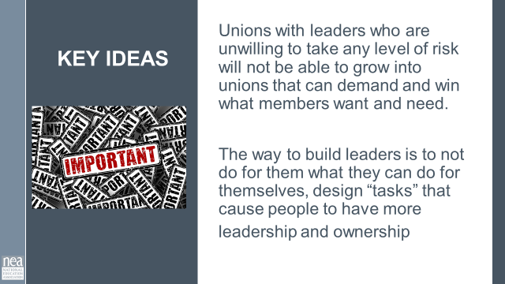 |  | Club to Fighting Union Continuum worksheet |  | 5 Min - Intro to section  Who are the kind of leaders ESP units will need to achieve the kind of wins their members want?  Let’s look at the definition used across our programs.  Take a minute and read it to yourselves.  There are three intentional and important points in the definition. Leaders take responsibility – they don’t wait for someone to do it for them, and they own the risk of whether or not the action will be successful. Leaders enable others – not empower – they remove the barriers that allow individuals to use their own agency to take action towards a shared purpose. Finally, leaders do both of these in the face of uncertainty. They don’t only choose to do the things that ensure they will be liked, will look successful, will ensure they stay employed. They take risks. Leaders are working towards an organizing stance always.  SLIDE 17:  10 Min - How do we identify leaders, and why it matters?  Leaders, ultimately have followers. We do not make leaders –they already exist in their worksites and our roles are to find them. How do we typically identify leaders when we or our members are working on recruitment?  Either members self-select into a leadership role (it’s my turn, there was no one else, I have always done it) or we recruit members without confirming their leadership with their co-workers (they were really excited about the union, they contact me a lot for information and seem to be in the know, they really remind me of other union folks I like)  What happens when we do this is that leaders struggle to deliver, take risks, and engage others in the union when it counts. They remain reliant on staff for success.  SLIDE 18:  The method that is now widely accepted as best practice is called “Natural Leader ID.” This method is the intentional identification of leaders. You can go high tech or low tech, but the process is the same. You and your organizers go to your people, ask, “Who here is trusted and respected?” Everyone records who they say. The more a person is named as a trusted and respected leader, the more relationship resources they have that could be used for union work. (p.62 article Seatle)  SLIDE 19:  How many of you have done a blitz? Purpose is to have as many conversations with members as possible. Data collection key. It won’t necessarily build relationships, but to gather information in a quick 10 minute conversation. But, if you end with who here is trusted and respected, you are building a data set.  As you look at the data, you are also working to identify who already has relationships with the union, and who does not. If they are an identified leader that is not in relationship with the union – your work is to get to know them and bring them into a relationship. For all who are identified your work is to build relationships with leaders and help them realize how the union can help them achieve their agenda. (red=member, but not actively connected; blue=trusted and respected (Trusted and Respected); yellow=BIPOC)  In a perfect world – identified leaders are doing the “listening tour” or “blitz” part of this work and staff are connecting with leaders who are identified in this process....If you are in a unit with very little leadership or ownership – there will be more staff work on the front end.  SLIDE 22:  Key Points – just because they have been identified by a number of colleagues does not immediately mean they are the “best” leaders for what the local needs – the needs to be more work to build a relationship with them about what their agenda is and what the agenda of the union is – moving them to work with the union’s agenda.  Slide 24:  Where are you on the Club to Fighting Union Continuum?  5 Min - Introduction to section  Clubs are groups of people who follow, rely, and build programs. Programs have a prescribed way of working with a pretty predictable set of outcomes. They are not bad, and we need to understand how they operate.  Fighting Unions are groups of people with multiple “natural leaders” engaged through structures, moving people to risk use their resources to achieve the change they want. Outcomes are unpredictable.  Slide 25:  15 Min - Activity Directions  Everyone – close your eyes and think about one ESP unit you work with – got it in your minds? Great.  You are going to work with your tablemates using a chart that found in the Additional Participant Resources that outlines the conditions we might find along the continuum of Unorganized to Fighting Union.  You will see elements listed in the left-hand column, with descriptors of what each element might look like as it moves across the continuum towards fighting union.  Use this grid to assess where the units you are each thinking about lie, and how you would move them forward. You can also add to this grid by suggesting other elements besides the ones listed in the left-hand column.  Slide 27:  10 Min - Debrief  - What did you learn?  - How useful was this in thinking about your work with ESP units?  - What would you add to it?  Slide 28:  Key Points  - Unions with leaders who are unwilling to take any level of risk will not be able to grow into unions that can demand and win what members want and need.  - The way to build leaders is to not do for them what they can do for themselves, design “tasks” that cause people to have more leadership and ownership  - p.86-89 Jane’s article |  |  |  | Participants will use a number of examples to understand how to design tasks (tests) that develop leaders towards more ownership and leadership in their work.  How will we bring more leadership to the campaign?  `
 10:25-10:40 BREAK

10:40 – 11:10 Michael |  | Building Engaged Leaders (30 Min)
  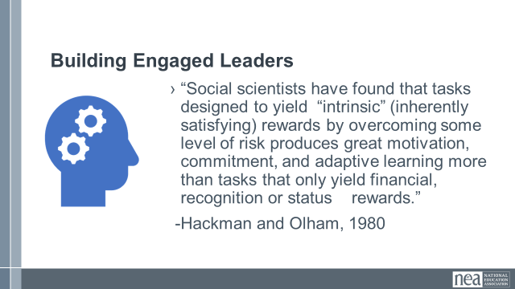  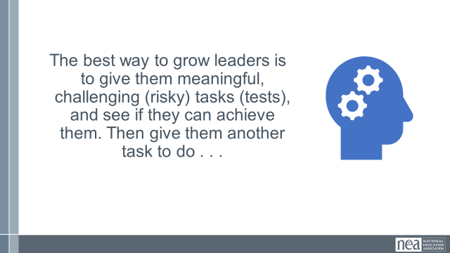  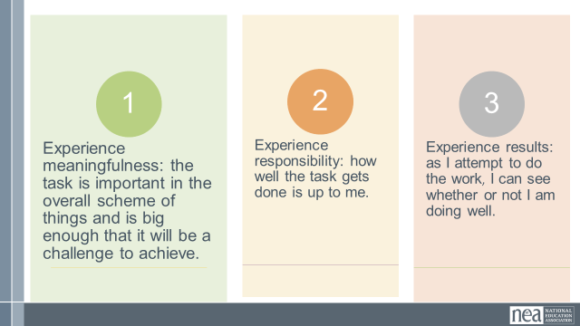  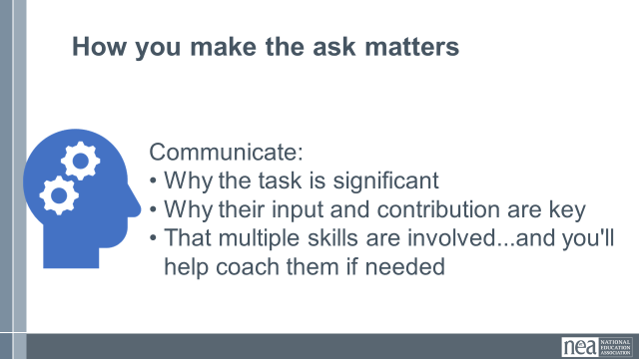  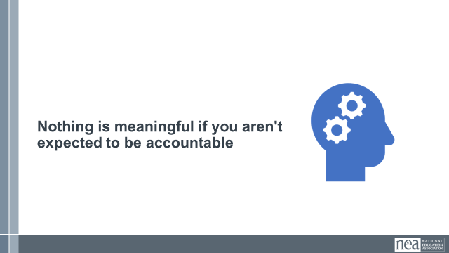  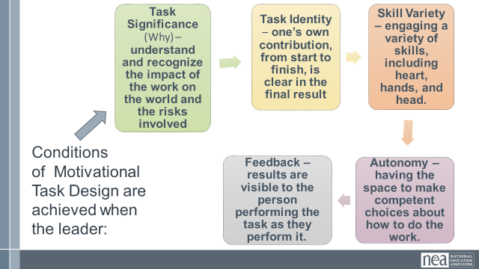  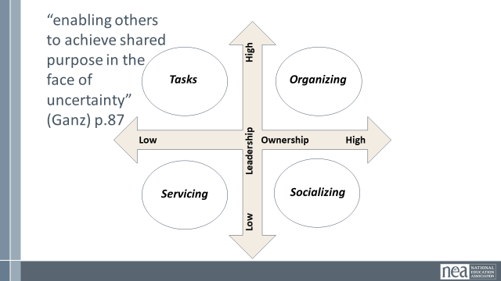  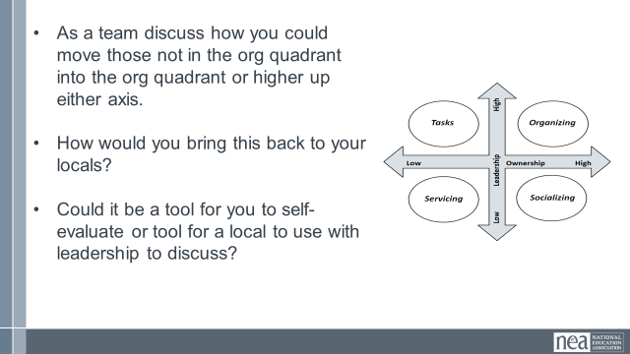  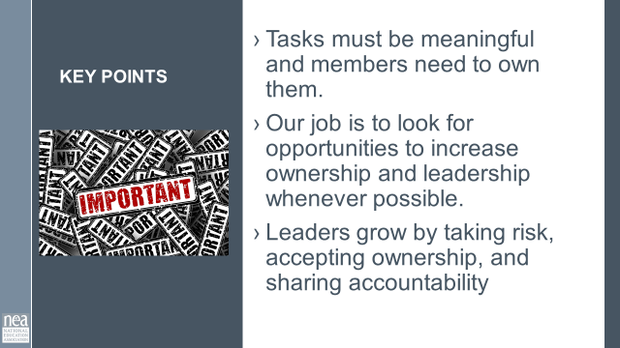 |  | Leadership Development Tasks – Tests  Structures – Jane McAlevey |  | 5 Min - Content Intro p.  more often than not when we are working with ESP units (workers) we are relucent to ask them to take on meaningful, challenging (risky) tasks (tests) and see if they can achieve them. Don’t build in the NO for them. Stop doing everything for them. If we don't stop that behavior, they won't do anything for themselves.  Social scientists have found that tasks designed to yield “intrinsic” (inherently satisfying) rewards by overcoming some level of risk produces great motivation, commitment, and adaptive learning more than tasks that only yield financial, recognition or status rewards.” -Hackman and Olham, 1980  The best way to grow leaders is to give them a task to do. If we are nervous and not willing to hear “no” when we ask leaders to do challenging risky things – we never move them along in their development and the affiliate does not move along from a club to fighting union.  When you ask a leader to commit to something. There are 3 conditions that grow leaders. The three conditions to keep in mind when you are developing “tasks” that test and build a leader are Meaningfulness, Responsibility, and Results.  The person’s perspective about the task is what is most important here – EX. Some will find meaning in asking their colleagues to participate in a bargaining survey while others will find meaning and challenge in learning how to conduct and track member recruitment conversations.  How you make the ask or invitation into the task for the leader matters too – you really need to be able to communicate WHY the task is significant, that their input and contribution will be key to the ask or task accomplishment, that a number of skills may be required, and the leader will be able to apply judgement to accomplish the task.  After we give them one task, we give them another and another and we let them grow and coach along the way. They will also grow when they know you will be meeting to discuss the outcomes and figure out next steps.  Nothing is meaningful if you aren’t expected to be accountable.  Conditions of Motivational Task Design  Walk through the 5 key points  - Task Significance  - Task Identity  - Skill Variety  - Autonomy  - Feedback  Engagement Grid Activity  5 Min - Introduction of the grid  Recall that an important part of our leadership definition is “enabling others to achieve purpose in the face of uncertainty” then how we design our tasks and tests for leaders matters. [Model this with chart paper in front of everyone while talking through]  We are going to be using an engagement grid that has two axis – the vertical one is the leadership, and the horizontal one is the ownership.  If you engage a leader in a task in which you have taken all the ownership and risk for the task, and all the leadership – then it is servicing – for example A completely staff led new employee recruitment table.  As the leader takes on ownership, then it moves to socializing – think new employee meet and greet with local leaders.  As the activity/event grows in leadership it becomes a “task” – think of an annual new member meeting that you direct the local to do – but they take on all the roles of implementing it.  As the task moves towards high leadership and high ownership – it moves into organizing. Example leaders determine why they are engaging with new employees, how they will do it, and what the outcomes will be. You are consulted and might be asked for resources or coaching.  15 Min - Work time  As the facilitator determine if it is time to regroup the participants – if so – do a count off into groups that result in working teams not larger than 4 to 5 – Make sure each group has a set of activity cards and knows where to find the sorting grid. For a paperless activity have participants refer to online module.  Directions - Turn to the page with the Engagement Grid on page _____  - Ask each person to select 2-3 activities from the ones listed on the strips of paper in the envelope. (these are found on the last page of the packet –or as a team – you can cut then into strips and put them in envelopes during team planning)  - For a paperless activity, have the participants pick 2-3 and write them down on a sticky note to be placed on chart paper where they would be. This allows them to move them in step 3.  - Work as a team and place them into the most appropriate quadrants. Come to some level of agreement as a team about WHY you are placing these where you are.  - Now, as a team discuss how you could move those not in the org quadrant into the org quadrant or higher up either axis. Some may not be worth moving – task – it is what it is.  - Lastly share/discuss how you would bring it back to your locals. Could it be a tool for you to self-evaluate or tool for a local to use with leadership to discuss.  5 Min - Debrief  - Why were activities placed where they were?  - Were there any of the engagement activities that your table struggled with placement?  - How could you use this activity?  2 Mins - Key Points  - Tasks must be meaningful, and members need to own them.  - Our job is to look for opportunities to increase ownership and leadership whenever possible.  - Leaders grow by taking risk, accepting ownership, and sharing accountability |  |  |  | Participants will learn about the best practices for recruiting members
11:10-12:00 Jeny |  | GROUP WORK TIME (60 Min)
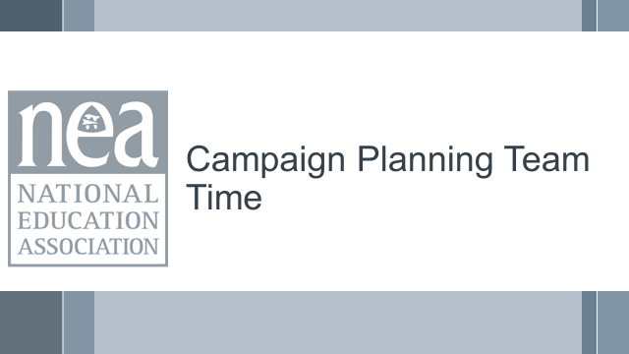  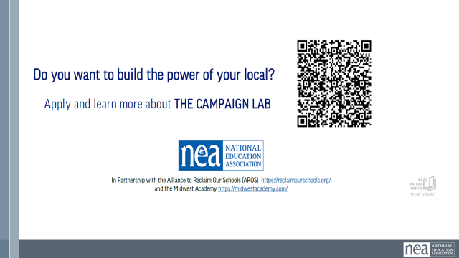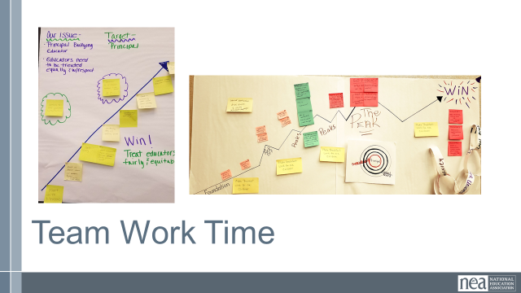 |  | Chart paper, markers |  | 5 Min – Directions  Now you are going to use the learnings from demand targets tactics and escalation to add into your campaign plan you have been working on for the past 2 days.  The end product of this work time is to present your issue and campaign plan to the group. It would be helpful to have a chart paper represent the background information for your campaign as there may be time for groups to provide feedback and ask questions about your plan.  You may not have a fully flushed out plan, but the idea is to have something to be able to share with others that incorporates the learning and insights from this training.  55 Min – Work Time |  |  |  | How can we apply what we have learned?  Participants will develop an organizing plan with teams that can be shared with the whole group.
12:00 -12:45 Dawn & Hedy |  | Team Presentations (45 Min)
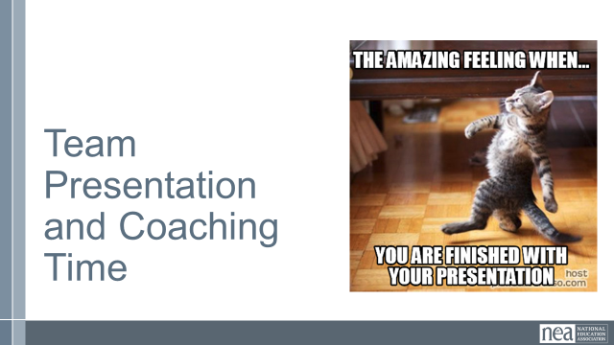 |  | Campaign plans, sticky notes, writing utensil |  | 5 Min – Directions-  Now we will review the plans everyone put together for their ESP campaign. We are going to break you into two groups.  30 min-Presentation  Group One will be presenting first. You will stand next to the campaign you drafted and answer any questions that people have about your campaign. You can provide any context about the situation or run through your plan with anyone who comes to you.  Group Two will need sticky notes and will visit each of the campaigns in Group One. You may ask clarifying or contextual questions about the campaign plan. Your job is to provide feedback, encouragement, or questions that help the presenter with their plan.  You will have 12 minutes to visit each of the campaign plans during this round. When the 12 minutes are over, the groups will switch roles.  Sample Feedback prompts  - How did the plan address finding and developing leaders to help implement the plan?  - Are the tactics directly related to representing the issue and goal of the campaign?  - In what ways does the plan use opportunities to build structure and power?  10-minute Debrief –  Sample Group Debrief Questions:  - Are there specific tactics or ideas that you are going to take back to your locals and share with leaders? What about with co-workers? Why did that stand out for you?  - What are the skills from today you are hoping to train your leaders/members/activists on in the next 6 months?  - What is something you learned from a colleague in the last three days that changed the way you thought about your work? |  |  |  | Participants will develop an organizing plan with teams that can be shared with the whole group.  How can we apply what we have learned?
12:45- 1:00 Ellen |  | Ending Right (15 Min)
 |  |  |  | Farewell
1:00 | Boxed Lunches ADJOURN

