Facilitator Agenda: Day # 1 Organizing ESP
General Materials Needed: |  |  |  |  |  | Room Set-up:
1 Set of Handouts per Person  Name Tags or Name Tents  Room signs, sign-in signs  Painters Tape |  |  |  | Chart Paper  Post its  Chart Markers – Mr. Sketch  Pens and Pencils |  | Round Tables - Projector, Screen and Speakers  Carousel stations and reporting stations around the perimeter  Easel with Chart paper
Key Outcomes for the Day:
- Who are ESP?
- What are their issues?
- What is our work like with them?
- What are some institutional challenges we have?
- What are ways that locals have succeeded?
Overview of Content and Facilitator
New Schedule:  8:30-9:00 Getting Started  9:00-9:45 What issues do ESP face?  9:45-10:30 What are your experiences leading ESP units?  10:30-10:45 BREAK  10:45-11:30 Language Matters (research)  11:30- 12:00- Financialization (this was added to day 1 at the Facilitator Planning meeting)  12:00 – 1:00 - Lunch |  |  |  |  | Ellen |  | 1:00-1:30 Financialization cont.  1:30 – 2:15 – An Institutional Problem  2:15 – 2:30 BREAK  2:30-3:35 Defining Class, Questioning Systems, Reflections on Practices  3:35 – 4:10 Spectrum of Allies/Narrative Shift  4:10 – 4:30 Ending it Right  4:30 – 5:00 – Choice Networking |  | Ellen
Time, Slides, Facilitator |  |  | Resources |  | Instructions, Activity and Debrief (Facilitators) |  |  | Outcomes and Essential Questions
 |  | Charts, handouts, articles, materials, slide |  |  | What are you saying, what are they doing, what questions will you use to guide learning and make clear the important points  Include an estimate for how long each section of the learning will take |  |  | As a result of this section, what will participants know or be able to do? What questions will they be able to answer?
Entry activity  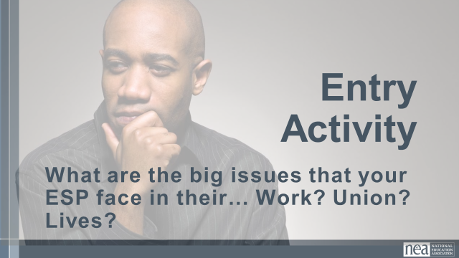 |  |  |  |  | Make a list – you will use this later
8:30 -9:00 Ellen |  | Getting Started (30 Min)
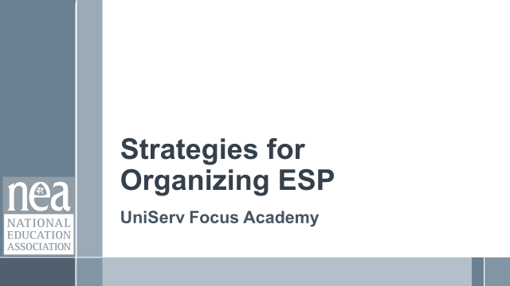  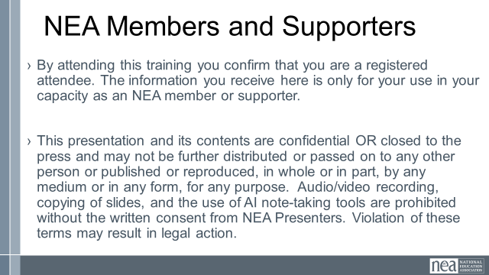  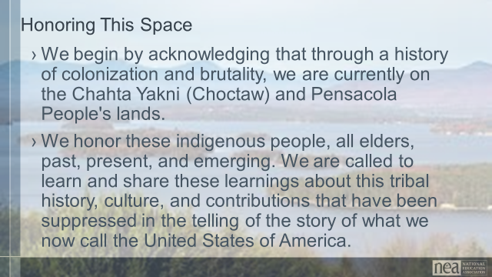    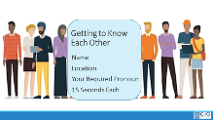  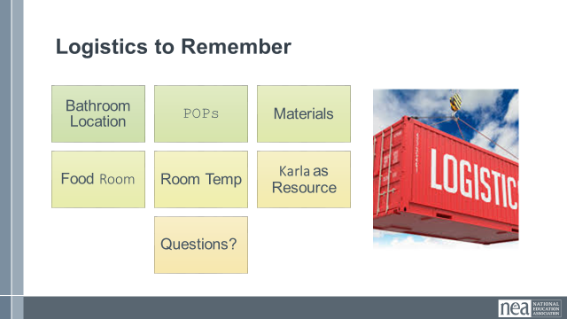  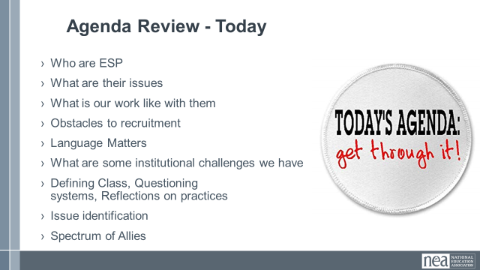  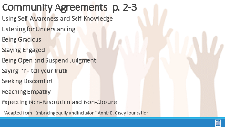  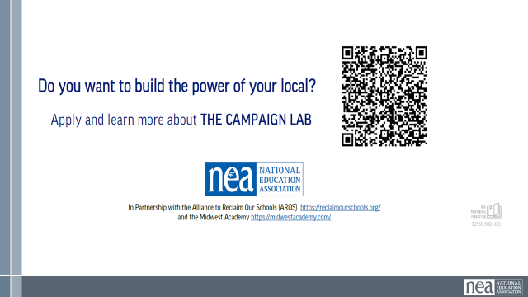 |  | Make the Following Charts  Community Agreements  Parking Lot  Agenda  Put out  Name Tents  Handout Package  (Re-visit History of ESP Doc) - Katrina |  |  | 4 Min - NEA Welcome  Native Land Recognition  The National Education Association is committed to honoring the spaces that we occupy to advance the work.  - We begin by acknowledging that through a history of colonization and brutality, we currently reside on and are connecting from the traditional lands stewarded by generations of indigenous people.  - We honor these indigenous people, all elders, past, present, and emerging. We are called to learn and share these learnings about this tribal history, culture, and contributions that have been suppressed in the telling of the story of what we now call the United States of America.  Why are we here?  - We are here to build stronger ESP leaders.  - NEA is committed to building effective sites where members can lead and growth their associations.  5 Min - Facilitator Introductions  - Team intros include Name, Work Location, years in the work, and your required pronoun  5 Min - Group Introduction Whip  - Have a quick model from one of the trainers.  Three Day Agenda Review  - See charts on walls for review.  - Note the two breaks, lunch, and adult network 4:30-5pm each day and then 1pm on Thursday.  3 Min - Group Logistics  5 Min – Group Agreements Pg. 2-3  3 Min - Revisit Pre-work Reading |  |  | Participants will know how we are going to work, the basic schedule, and the logistics relevant to the training.  How will we work together to support learning?
9:00 – 9:45 Beth & Michael |  | What Issues do ESP Face (45 Min)
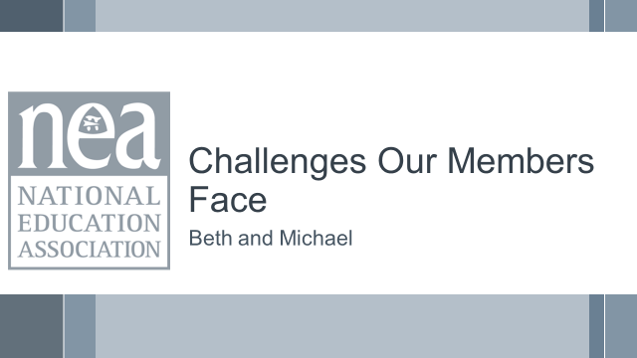  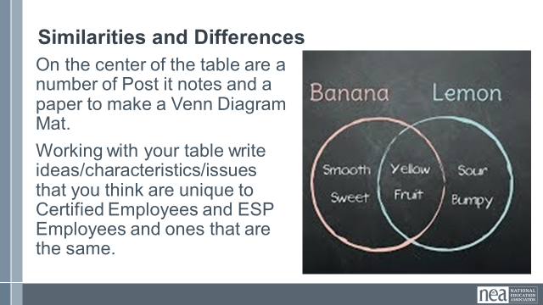  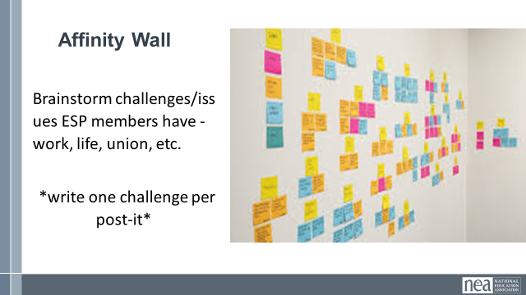  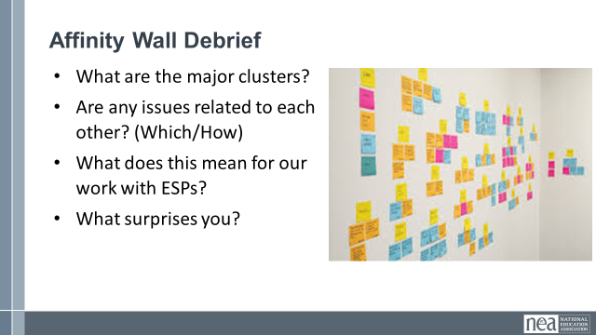  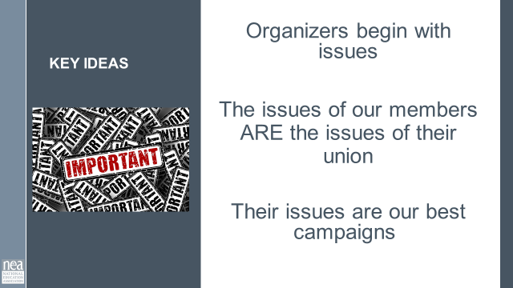 |  | Chart paper for Venn diagram  Lots of Post it Notes and a large wall  A few Larger sized post-it notes |  |  | 10 Min – Venn Diagram  On the center of the table are a number of Post it notes and a Venn Diagram Mat.  Working with your table, write ideas/characteristics/issues that you think are unique to Certified Employees and ESP Employees and ones that are the same. Have them refer to the list they made during the entry activity  25 Min - Understanding Challenges of our Members  This is an activity that you might find useful to do with members who are getting ready to identify priorities for bargaining or a campaign  Affinity wall activity – each participant is going to brainstorm as many challenges/issues as possible that their ESP members have -- work, life, union, etc. – in the true sense of brainstorming, anything that you are aware of is a challenge. Put one challenge per post-it. (this is about a 10-minute activity)  Step 2 – this part is a little bit like engineered chaos – now the group will apply these post-it's to a wall. They put them up – and as they are now on the wall, begin to move them into clusters that are similar – as the clusters begin to form, a few people will begin to NAME the clusters – ex. “Fair Pair” (this can take up to 10 minutes – encourage people at the front to move back and those at the back to move up – keep churning and engaging.  10-minute Debrief  - Do you notice any themes or clusters? Is there one that occurs more than others?  - Are any issues related to each other? (Which/How)  - How do these issues impact our work with ESP members?  - Is there anything that stood out to you as surprising?  Key Ideas -- these members have issues, and it is through our relationship with these members that we build member-led campaigns to address these issues. |  |  | Participants will have identified and described issues that ESP members face.  What are the challenges that ESP face in our affiliate system? Their work? Their lives?
9:45 – 10:30 Dawn |  |  |  |  | What are your experiences in supporting ESP units? (45 Min)
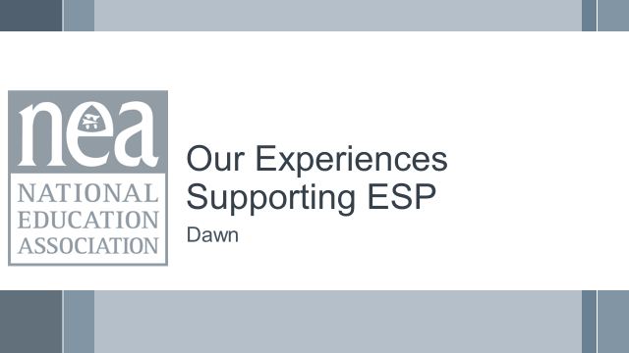    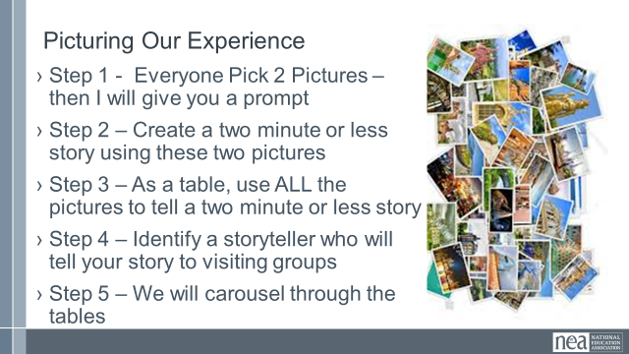  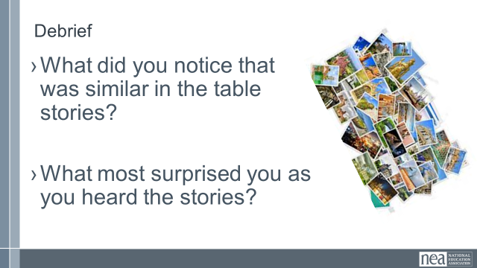 |  | Picture cards |  |  | 6 Min - Beginning activity  Step 1 - At tables, give each group a random selection of picture cards (face down). Each person picks two (without looking)- Don’t tell them why they are picking. Go around and scoop up the extra before you do the next step.  Once they have picked their two cards, tell them to use these to describe (in under 2 minutes) what their personal experiences are like in working with ESP Units.  [stay on title slide]  10 Min - Table Share  Each person shares their story around the table.  Once these 10 minutes are up, tell them that as a team, they are to use ALL their cards to create one unified story that can be shared. Get ONE team member prepped to tell that story.  10 Min - Whole Table Story  Using all the cards, the table comes up with a story about what their collective experiences are like working with ESPs. (the total story must be less than 2 minutes, and ONE person needs to know it very well)  At the end of this 10 minutes, tell them that all but the one team member who knows the story well are going to visit each of the other tables – leave the docent behind at the signal and move to the next table.  14 Min - Visiting the Others Step 3  Leave one person from each table behind as the storyteller who will share the table’s story. Each group rotates through each table. Facilitator signals every 3 minutes getting the group to move in a way that is as easy and effective as possible  5 Min - Quick Debrief  What did you notice that was similar around the room?  What surprised you most as you went around the room?  Why do you think these conditions exist?  REMIND Participants that the BREAK is a great time to review the Pre-Attendance Material, especially the ANAYLYZING EVERYDAY OPPERESSIONS IN UNION WORK in P 4-5 in Participants Handout (p 7 in Pre-Attendance materials POPs)—Be ready when you come back! |  |  | Participants build community and build a common understanding of experiences.  What are your experiences in supporting ESP units?
10:30 -10:45 BREAK
10:45–11:15 Vanessa |  | Research: Language Matters (30 Min)
  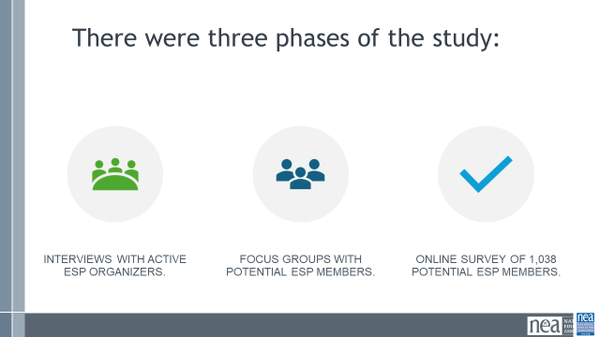  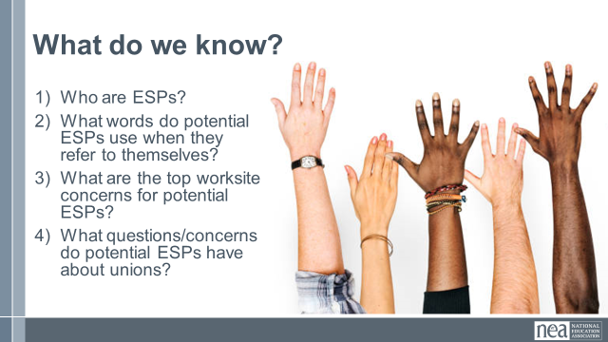  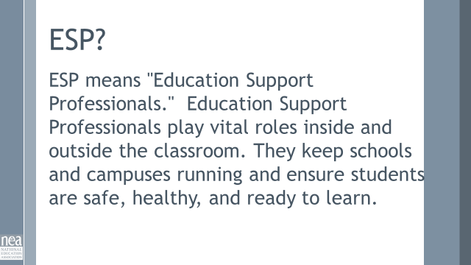  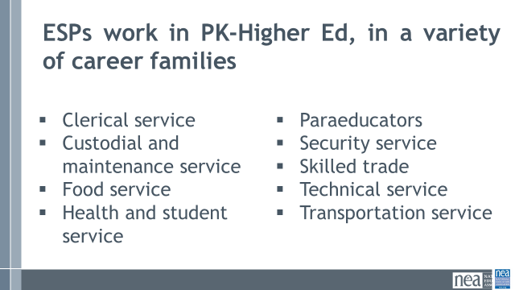  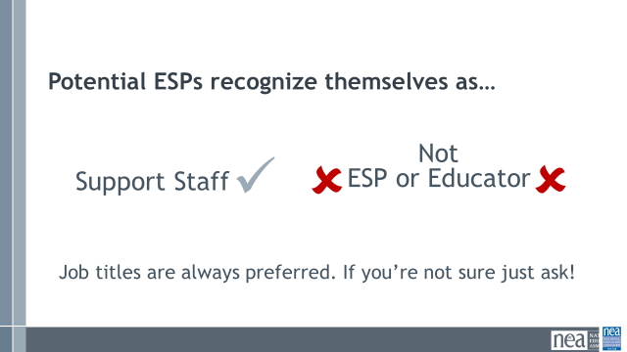  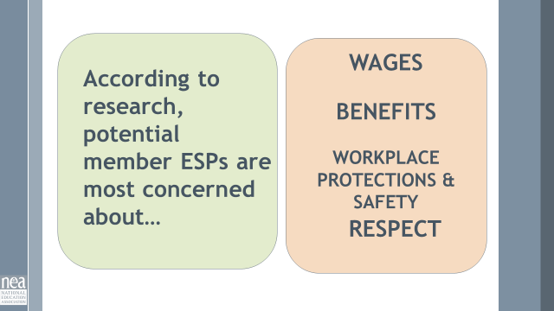  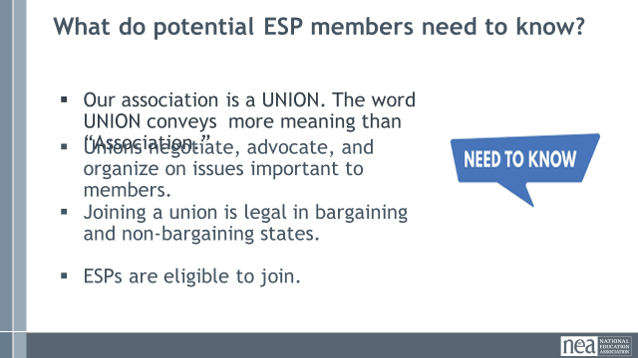  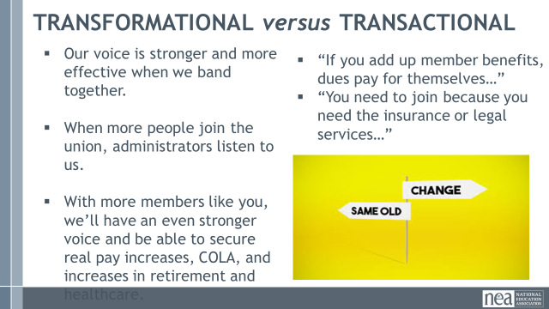  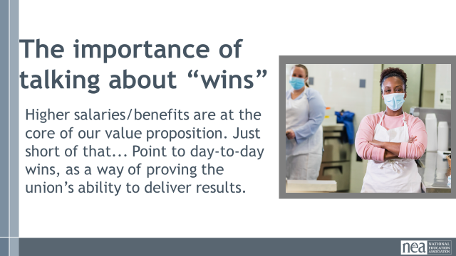  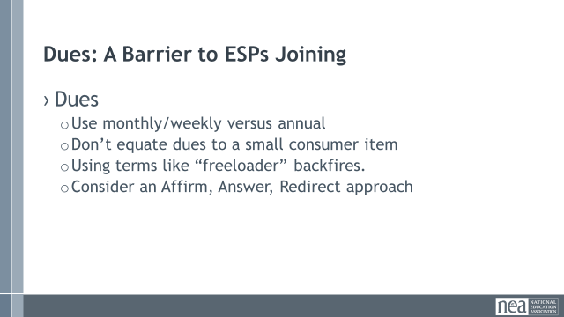  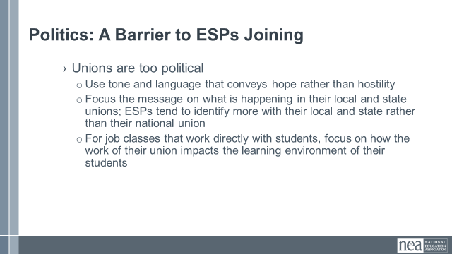  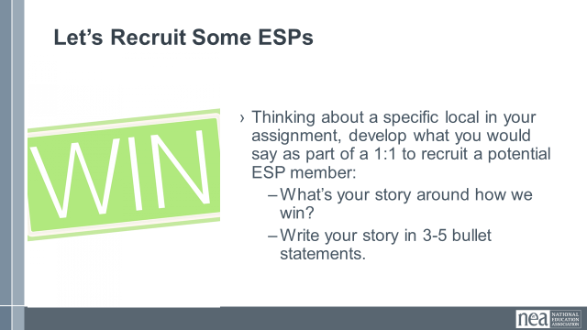  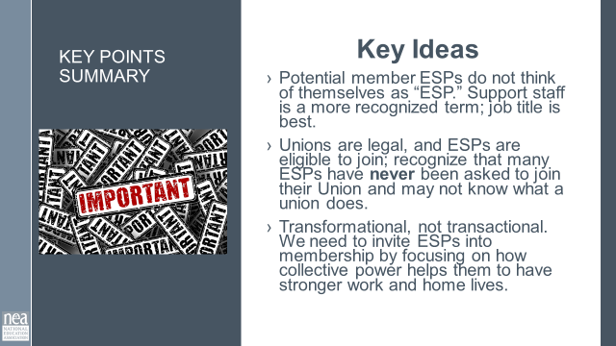 |  | GSG Findings and Recommendation Study Pg. 18 |  |  | ^{Who are ESPs?}  What do potential members who are ESPs like to be called?  (Higher Ed, PreK-12) Both groups see themselves very differently  What are the top worksite concerns for ESPs – both members and potential members?  What questions/concerns do potential ESP members have about unions?  What are the two biggest barriers to joining the Union for potential ESP members?  How important is it to show "wins" to potential members?  How do ESPs – potential members – view their state? How do they view NEA?  What does an effective recruitment effort for ESPs look like?  Consider using a few more of the slides from the ESP Research Slides file in the Old Archived Folder in the F2F Organizing ESP  Also, attempt to incorporate some data/examples around race, class, gender here to preview a deeper dive later.  ESPs are an untapped resource for NEA, and membership has always lagged. To learn more about what approaches and messages are most helpful in recruiting ESPs into the union, NEA spoke to the following people.  1.They started by conducting interviews with active ESP organizers across the country and with a range of positions within NEA’s state and local affiliates. Each interviewee was selected because they had been identified as particularly experienced in recruiting ESPs. The purpose of the interviews was 1) to determine what’s working and not working for organizers; 2) to understand what obstacles needed to be addressed; and 3) to gather ideas for future testing.  2.Phase two was extensive focus groups among potential member ESPs. This included six 90-minute online focus groups, which were segmented by career families, the collective bargaining status of the respondents’ home state, and race.  3.Conducted an online survey of 1,038 potential member ESPs from across the country to verify and hone the findings and attitudes that emerged in the qualitative research, understand attitudinal differences across job classifications and other demographic groups, and test updated messaging and positioning, including how and whether to address the cost of membership and the “freeloader” argument.  We are going to share the major findings of this research with you. But first, we want to know what you know about ESPs.  Some of this research is going to challenge your assumptions. Maybe for you or your colleagues back home. It did for us. We want to know what you know about ESPs.  Locate some paper and something to write with. (Give them a minute to locate, then call back together.) Working with your tablemates, you will answer the questions that are on the next slide. You will have five minutes to do this. Are there any questions?  (Change slide and set timer; this is an exercise in pre-thinking, not sharing out.)  Now we’re going to share what we found through the research. We want to see if there is anything that challenges your thinking.  Taken from NEA’s website, Education Support Professionals play vital roles inside and outside the classroom. They keep schools and campuses running and ensure students are safe, healthy, and ready to learn.  You may have a basic understanding of what an ESP is and the service they provide to our school communities, but we need to be more specific to support our active and potential ESP members when we advocate and organize for their needs. Referring to an individual’s specific job title honors their work in the school community, and builds a sense of belonging to a school community and by extension a Union. It confirms that they are part of something bigger than just their job, and brings those who are further from a school building into connection with the Union.  While we use the term “educators” to be more inclusive, it has actually had the opposite effect for potential ESP members. While current members may use and identify with the term “ESP,” Support Staff is the most unifying term for potential ESP members. Education Support Professionals (or ESPs) is an important term of respect for current members, but it's virtually unheard of among potentials. Potential members who are ESPs don’t tend to identify as educators, but over time, as they join the union and participate, they often begin to see themselves as educators and embrace the term. The use and belief in the term educator can also be dependent upon the job family/duties/title of the ESP. e.g. A groundskeeper may not view themselves as an educator, therefore they can struggle to see how they fit into a union of educators.  Out of four potential identifiers, support staff rose to the top across job classifications. “Educator” was the least likely to be identified as best descriptor, with ESP second from the bottom (and “Classified Workers” in second).  ESPs want their union to work towards higher salaries, better benefits, and workplace protection. The most important accomplishments a union could win across job categories included winning higher salaries, providing a safe workplace and protecting ESPs from additional duties outside their core responsibilities, and ensuring that the benefits that drew many ESPs to their job in the first place remain strong. The focus on wages is of particular importance to ESPs, more so than with certified educators. ESPs are joining the Union for these things.  Professional Development may be a retention strategy, particularly if by participating it assists with increased pay or the potential for promotion. That said, typically, ESPs do not join for PD. If PD is an important part of your recruitment strategy, take into consideration it’s helpful if it’s free and offered during paid time, and if it leads directly to pay increases.  Finally, respect is a topic that came up in our research in a lot of different ways. ESPs often feel like they are treated as second class citizens in the educational environment; we need to interrupt that narrative within our union.  Awareness of a) the union’s existence and b) the potential benefits for member ESPs are both low.  We must do more to educate potential members that NEA and its affiliates are unions. Additionally, the pitch to education support professionals does require another educational step. We must also be clear that NEA is a union for them, as well as certified members. Many potential member ESPs are aware of the collective power of teachers’ unions but are uncertain of their eligibility for membership or may not feel welcome as full and equal members of NEA.  Basic education about the union has tremendous value with ESPs, especially in non-collective bargaining states. As we saw in the research, a significant minority of ESPs are unaware that there is a local union that they are legally able to join. There are plenty of ESPs out there that would sign up right now if they knew that the union was an option. Moreover, we reach our apex of interest after a simple pitch that clarifies that unions are allowed (and have a legally protected right to bargain in CB states) and that the state affiliate is a union that advocates for higher wages, benefits, and changes that improve workers’ daily lives.  We must show that members can increase their collective power through advocacy, organizing, and/or bargaining. Potential members are generally familiar with the concept of unions, but there is little depth to that knowledge. They generally assume unions exist to solve problems (i.e., provide protection), and many in non-collective bargaining states incorrectly believe unions are illegal, underscoring how much education is necessary. Finally, potential and current members are often concerned that the Union is “too political” and partisan.  It is important to understand the difference between a TRANFORMATIONAL and TRANSACTIONAL approach  A transformational approach asks the potential member to become part of something bigger than them as an individual; it asks them to be a part of the solution.  A transactional approach is a “give to get” that you often see when we’re hawking liability insurance; this conveys that a third party- “the union”- will fix everything for them.  The problem with a transactional approach is that if we’re just selling a consumer product (insurance) and treating members as consumers, they will seek the lowest possible price for that product, and it might not be us!  Wins:  •Sharing "wins" builds credibility and overcomes skepticism; localizing those wins as much as possible helps members see how their union can impact their immediate circumstances  • Higher salaries should always be at the core of our value proposition, but use more tangible day-to-day wins to build credibility on that point. Higher wages are far and away the highest priority and most compelling issue for potential members. But in conversations with potential members, some were still skeptical that is possible for unions to win better salaries. Regardless, including day-to-day workload issues as part of our focus strengthens messaging by touching on something ESPs value highly while helping to build credibility with those who are more skeptical on wages.  While things like getting air conditioning fixed may not motivate people to join quite the same way higher salaries do, these kinds of wins stick with people and show that the union is far more than a legal backup; these wins can convey that the colleagues who make up the union understand what their colleagues are going through and want to make it easier for everyone to their work so that our schools can run and our students can succeed.  Barriers to Membership: Dues  Organizers say that the ESPs in their locals often work multiple jobs to make ends meet, which makes the cost of dues (or the perceived cost of dues) a major obstacle. Even when the actual cost of dues (and the fact that ESP dues are less than teacher dues) is made clear, organizers say membership can still be just too expensive for many ESPs.  Many believe dues are higher than they really are. A monthly figure is much better for us than an annual figure, but any discussions that focus attention on dues COULD be counterproductive.  Here are some tips for talking about dues:  - Monthly or per paycheck figures, not annual  - Don’t equate dues to cup of coffee/soda, etc.  - Shame doesn’t work  - Consider Affirm, Answer, Redirect......(Facilitator Model This for Group, if time allows)  Barriers to Membership: Unions are too political  I know that this is a concern that is not necessarily unique to our ESP members and potential members, as we often hear this amongst our teacher ranks as well. Because we know that nearly everything about this profession is impacted by politics, we can’t avoid the conversation.  - Use tone and language that conveys hope rather than hostility  - Focus the message on what is happening in their local and state unions; ESPs tend to identify more with their local and state rather than their national union  - For job classes that work directly with students, focus on how the work of their union impacts the learning environment of their students  Let’s Recruit Some ESPs  Using what you know from experience, and what the research says, craft the skeleton of a 1:1 conversation of recruiting am ESP member. Come up with 3-5 bullet points, incorporating a past win, of what you would say when asking an ESP member to join their union.  (allow 5 minutes for individuals to work; share out if time allows)  Key Ideas  Many have not even been recruited. Potential members need to see how their lives can be changed. We need to convince potential members that NEA’s affiliates will ‘strengthen their voice’ and ‘improve their daily lives’ especially by improving wages and addressing workload issues. Potential members worry that unions can be hostile, adversarial, or too political. Having the right tone and language to soothe these concerns will be key. Some school staff are fired up by strong, agitating language focused directly on the struggles they face; others are turned off by tones that they read as being “combative.” ESPs primarily identify with local or state affiliates more than the national entity. Messaging that connects to local efforts rather than national efforts are more effective. ESPs work in schools because of the students. Leaving students out of the conversation misses the point: potential members want the union to help them so they can work most effectively with students. (use based on job class)  Potential Members who are ESPs do not think of themselves as "ESPs." Support Staff is a more recognized term, but job title is best.  Unions are legal, and ESPs are eligible to join their local Union.  Wages, benefits, and safety are their most important issues.  Transformational over Transactional: we need to invite ESPs into membership by focusing on how collective power helps them to have stronger work and home lives. |  |  | Participants understand the new findings from the ESP study on potential members.
11:15 -12:00 Hedy & Jeny |  | An Institutional Problem (75 Min – Split 45 before and 30 after lunch)
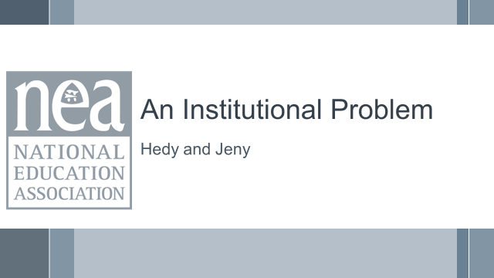  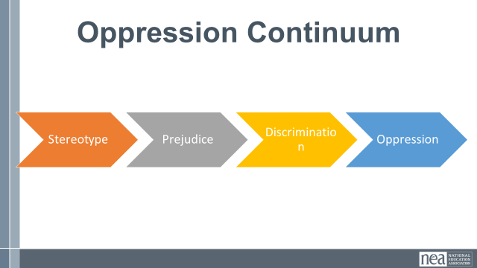  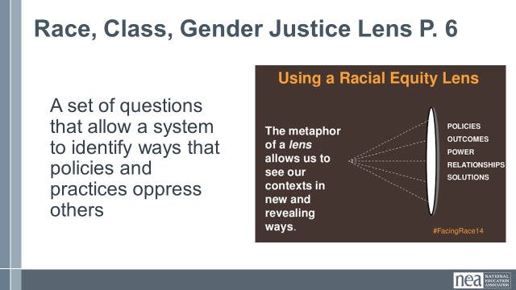  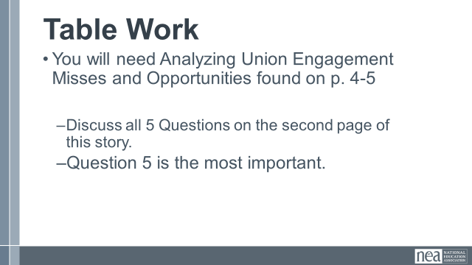  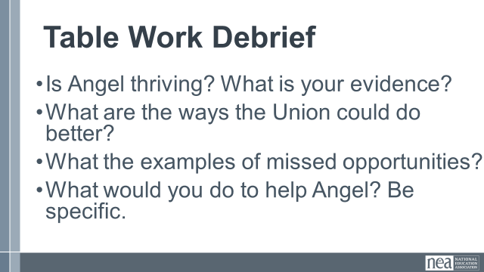  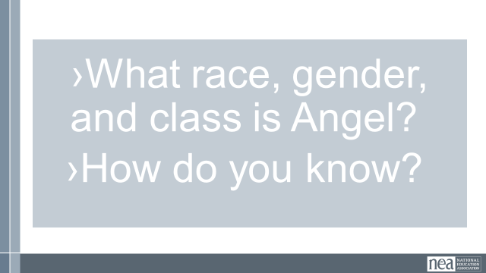  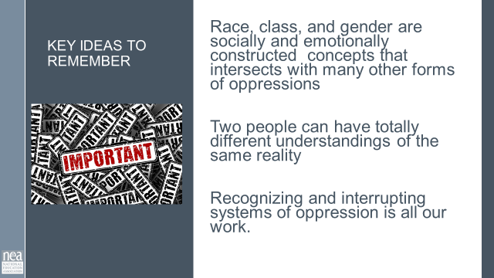 |  | Analyzing Everyday Oppression in Union Work (Angel Scenario) Pg. 4-5 |  |  | 15 Minutes – Analyzing Union Engagement Misses and Opportunities (Angel Scenario) from p.4-5 of Participant Handbook.  5 minutes intro:  Oppression operates on multiple levels, and this drives us toward taking a systems thinking approach to addressing its impact. Biases lead to the development of stereotypes that feed prejudice and discrimination accumulating in systemic oppression.  A way to begin recognizing and planning to interrupt this system of oppression is through a Lens. On page 6 is a suggested lens. It is a set of 6 questions that a system agrees to use consistently and routinely when making decisions, developing budgets, or debriefing implementation.  In the 10 minutes left before lunch – You will work at your table with a story about Analyzing Everyday Oppressions in Union Work.  - You were asked to read and review this before coming so it should not be completely new at your table.  - Working with your table mates, share your answer to the 5 questions on the back.  - The 5th question is the most important, and likely the one you’ll struggle with most. Lean into it.  25 Min- Analyzing Everyday Oppressions in Union Work questions and debrief  15 Minutes Debrief focus on having one table report on each of questions 1, 2, 3, and 5 – save question 4 for the end  Is Angel thriving?  What is your evidence?  What are the ways the Union could do better?  What the examples of missed opportunities?  What would you do to help Angel?  Be specific.  What race gender and class is Angel?  How do you know?  5 Minutes Key Ideas –  - Race, Gender, and Class are socially and emotionally constructed concepts that intersects with many other forms of oppression  - Two people can have totally different understandings of the same reality  - Becoming anti-racist requires a system approach |  |  | Participants will recognize components of oppression and reflect on what they see in their own practice and the systems they support.  What are some of the reasons for the injustices that our ESP members face each day?
11:00-11:30 Financialization (60 mins)
(notes to add to 3rd column:
5 Min – Introduction

SLIDE 23
SAY: What is the purpose of public schools? Stand and talk to a new person in the room. Think about what you would want to share with the whole room.

25 Min TOTAL - History of how the evolution of capitalism and public schools have shifted the purpose of public education
IMPORTANT TO NOTE at some point in this section – This topic is essential to understand because ESPs are the easiest to outsource and cut when financially squeezed.

5 min--Slide 24—Timeline Tango Activity in partners
Quick! Get back-to-back with a partner!
Place your term cards on the wall in the era you believe each terms belongs.
As the content is provided, you and your partner can determine if any signs are incorrectly placed and move them to the right location.
NOTE: Changing the cards is FREE CHOICE so long as you and your partner agree—you can move ANY cards you feel need to be changed.
Example

SLIDE 25-27: Key Points to Listen For

- Capitalism is Constructed
- Over time, Capitalism has been built around 3 ideologies:
- Kenysian (Supply and Demand driven)
- Free Enterprise (TrickleDown-low regulation and open market)
- Neoliberalism (anti-tax, anti-union, anti-regulation, and anti-public sector)
- Financialization converts publicly provided goods into privately "financed goods.”
- Public education reflects and advances the same norms and practices as the prevailing economic ideology.

Slide 28-29 – Share history of education, for individuals, groups and states and talk about how it’s been linked to the economy. [Use info from article "Financialization of Chicago Public Schools- p.93-95.]
- Public education was created to benefit those in power, mostly white males, and to train a working class but still mostly male and white.
  - Industrial revolution 1760-1840
  - Industrialized economy needed reliable, reproducible, and uniform workforce
- Late 1800’s-1900’s Over time public schools began to elevate the workforce, again mostly for those deemed worthy.
  - Plessy v. Ferguson 1896
- Into the 1940’s, it was a time of increased power for workers and labor unions. Education became even more widely available but still not universal (racism in access)
  - 1954 Brown v. Board
  - 1960’s civil rights/women’s rights/title IX 1972

Slide 30-31
- Into the 1970’s, corporations didn’t like the level of profits. This led to a deliberate campaign of anti-tax, anti-government, distrust, pro-capitalism and was really pushed forward by the Reagan admin, especially the anti-tax. This led to the 80’s and 90’s being all pro-capitalism. It was sold... “work hard and make money to be successful”. The narrative didn’t mention the need to step on people on the way
  - Creation of standards and norms, push for assessment, national standards
- This extreme capitalism narrative included anti-tax, anti-union and anti-public education throughout. This shifted what public education’s purpose was.
- Private school vouchers and charters are pushed hard to the detriment of public schools
- NOTE: Each state has different laws on charter schools and charters are not bad, we represent many. The system that they are a part of is zero sum, that is the problem.
- Creates an extremely inefficient system (reference Chicago)

Slide 32-33
- Expectations and realities shift to schools operating in a business model. It’s more about how schools will show a return on investment and create the same type of outputs.
- But businesses operate with openings and closings, compete, and relocate. Schools operating like this leave the community in a bind and disconnected. This model also funnels money out of the community, some are for profit or operate profiting others (charters pay rent with public money).
- Privateers collect rent, sell curriculum and products as well as the private schools that are set up to seek profits.
- Last 20 years – This cycle spins on and we often try to change from within, but we need to stop the cycle.
  - ‘93 Clinton and ESEA – elementary and secondary schools act
  - Bush – No Child Left Behind
  - Obama – Every Student Succeeds Act; Race to the Top
  - Conform, achieve, compete

Slide 34-35 FINANCIALIZATION Definition

- A process whereby financial markets, financial institutions, and financial elites gain greater influence over economic policy and economic outcomes.
- Financialization transforms the functioning of economic systems at both the macro and micro levels.
- ASK: Financialization converts publicly provided public goods into privately “financed goods”. Who Benefits?
- DO: have people share examples...ex. private security = private police, privatized fire departments

Slide 36
ASK: How have recent events impacted the financialization of public schools?
2024 Election -
COVID - ESSR funds usage, impact on supporting the work, etc...
Custodians, Transportation, Security, etc...those furthest from the kids most vulnerable to outsourcing.

5 min--Slide 37-38—ACTIVITY: Wealth Distribution-Divvying up “the American Pie”

1. Return to your "home" table.
2. As a team, collaboratively determine the wealth distribution by
placing the pie pieces onto the chart paper.
3. Be ready to share your reasoning.

3 min--Groups Report Back/Record Wealth Distribution Predictions on chart from each table

NOTE: Emphasize the difference between INCOME (what is currently earned) vs. WEALTH (remaining assets once all debts are paid) (EX: Health is only an asset once it is paid off)

5 min--SLIDE 41: VIDEO of results America's Economic Pie Video (5 min)
Hedy must leave the room when they show this video, or she will yell at the screen from the back of the room.

42-43

Show the disproportionate wealth with circle graph (slide 42) and line graph (slide 43)

Maybe begin with – a very quick what is the difference between wealth and income?

Might need new slide here that outlines where wealth is currently
2023 Wealth distribution (in trillions)

Top .1% has $19.85 T
Top 1% has $43.44 T
Top 10% has $94.89 T
50-90% only has $43.89 T
0-50% only has $3.64 T

A million seconds is11 days, 13 hours, 46 minutes, and 40 seconds.
A billion seconds is 31.7 Years
A trillion seconds is 31, 710 years

2 min—SLIDE 44-Key Points
- Our system is designed to extract wealth and power from the lower levels of our system and move it to the top.
- Financialization benefits the wealthiest.
- When they change the tax codes, where corporation pay less than individual, we need folks in the system to create a tax system that is real
- Comes from fight for a fair economy

Maybe begin with – a very quick what is the difference between wealth and income

Might need new slide here that outlines where wealth is currently
2023 Wealth distribution (in trillions)
Top .1% has $19.85 T
Top 1% has $43.44 T
Top 10% has $94.89 T
50-90% only has $43.89 T
0-50% only has $3.64 T

A million seconds is 11 days, 13 hours, 46 minutes, and 40 seconds.
A billion seconds is 31.7 Years
A trillion seconds is 31, 710 years

11:15–12:00 Michael & Jeny |  |  |  |  | 5 Minutes – Table Brainstorm  Ask tables to come up with all the things – good and bad that they have heard your organization, members, staff, leaders, community members say about ESP – keep a list on paper or your device  Popcorn out some of the things that people say – don't repeat something that has already been said  5 Min – Introduction to Content  Behind the issues we have described above, there may be a number of institutionalized narratives that are supporting these challenges – both for ourselves and for our members - we are going to examine one – classism. There are others – racism, genderism, ageism, and other oppressive systems and these are addressed in ARJ 1 and 2 extensively. For our work together thinking about ESP we are going to explore classism with the clear understanding that in all ways this is coded language in our society for institutionalized racism.  A dominant narrative is an explanation or story that is told in service of the dominant social group’s interests and ideologies. It achieves dominance through repetition, the apparent authority of the speaker, and the silencing of alternative accounts.  Because dominant narratives are so normalized through their repetition and authority, they have the illusion of being objective and apolitical, when in fact they are neither.  Narratives are used to  - 1) trigger imagination and make connection on purpose  - 2) are expressions of or run counter to cultures imagination  - 3) are resources for empowerment or oppression. Tools people use  - Did the narratives on your charts do any of these?  Shifting Narratives- DON’Ts  When we talk about shifting narratives there are some things we don’t do.  Focus on challenging facts or interpretations of information.  Your arguments, as convincing as they may be, will lose to the dominant narrative.  Attack people for their worldview.  Many people operate out of the dominate narrative, even if unconsciously. You cannot move people by attacking them.  Name the dominant narrative as “wrong.”  Accountability with respect  Try to convert or convince people.  We are trying to bring out the best in people, help them find that in themselves  Key Idea  We want to hold people accountable but be respectful.  10 Min So let’s explore how do we change and use narratives 4-5  There is good research that says the more you “argue with” someone, the less they are willing to hear a new idea – or new frame. You are going to learn a simple process and practice it around a small set of scenarios.  Share the slides that outline a four-step process for shifting narratives  (Suggestion – use one of the scenarios as an example when we walk through the 4 ways to shift the narrative.)  - Unmask- Name the dominant narrative. Point out what you are hearing/seeing. What have you seen on the news?  Example- ESPs don’t pay enough for dues to be worth staff time and to be fully staffed.  - Elevate- Name the values and belief for the new narrative. You say what you want to see in the world. “The world as you want it to be”.  Example- ESPs bill of rights, all workers deserve a living wage, etc. If we are a true workers union we have to support all workers, which means ESPs.  - Contrast- Think about the difference between those two thoughts. How does it shift our thinking around our ESP members when we operate in these two different narratives? If your affiliate actually believed in ESP members and supported them. The number of members you have would triple or at the very least outnumber your certified members since ESPs outnumber certified staff in all buildings.  - Draw On Your Own Journey - While it’s important to personalize this, it’s also important to do it in a way that anyone can see themselves in it. Describing your own realizations and shifts will help others  Key points  Sustain your efforts and connect with others  - Shifting a dominant narrative does not happen quickly – it takes sustained effort, over time, with many people working at it.  Demonstrate your worldview, don’t just write / talk about it.  - Our actions say as much or more about our values and beliefs as our words.  15 Min - Narrative Scenario Groups P. 7-14  Working in tables. Everyone is going to look at scenario 1. Quickly familiarize yourselves with scenario 1. One person takes the stance of the “not our framing of the issue” the other two people take the stance of trying to reframe using the process outlined in the handouts. Be ready to share what worked and what did not  5 Min - Debrief  Use one of the scenarios to de brief. Select one that you think went well or one that you think the group struggled with. Walk through the “shifts” with the group.  Show the Key points slide: (quick facilitator note- let them know that there are other scenarios to support their use in trainings when the get back home. )  - Narratives are powerful tools that can be used to maintain power over an oppressed group  Narratives can be intentionally changed and used by an oppressed group to advance a change agenda |  |  | Participants will understand what a dominant narrative is and apply a four-step method for changing narratives.  What are some of the reasons for the injustices that our ESP members face each day?
1:45 – 2:15 Michael |  | Defining Class, Questioning Systems, Reflections on Practices
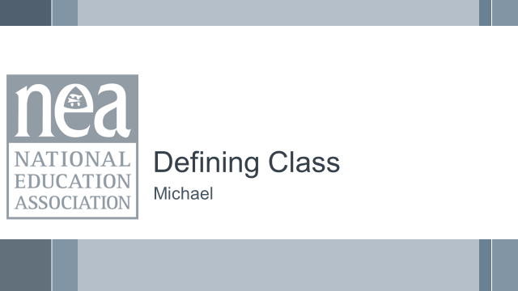  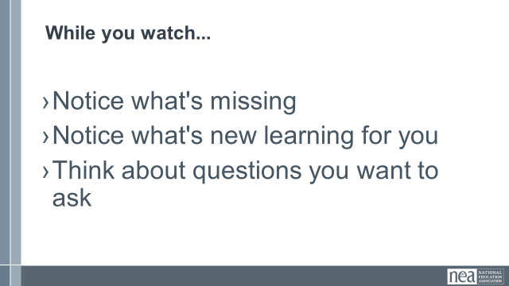    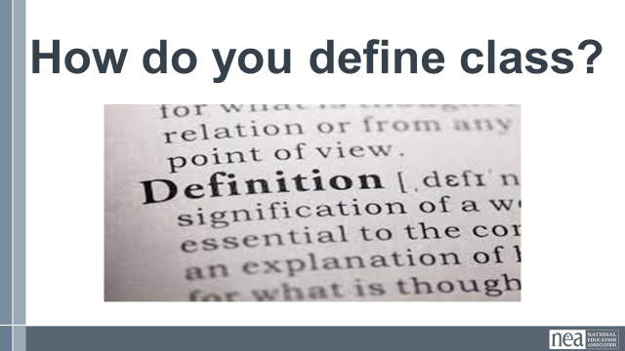  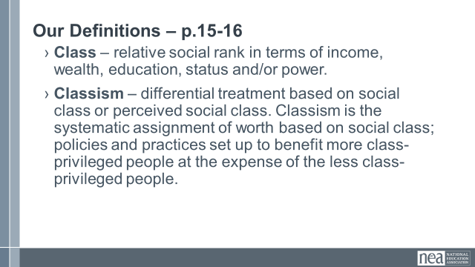 |  | Video about Classism  Defining Classism  Page 40-41  Classism |  |  | 5 Min - Introduction and Definition Pg 40-41  Welcome back everyone. Think of the affinity wall you did this morning and the challenges that your members have – and think about some of the narratives we discussed. We are going to take a look at how our organizations’ and our own relationship to class privilege may be part of the problem. We are going to do that by taking a look at a short video. While you watch notice what’s missing, Notice what’s new learning…for you, think about questions you want to ask.  10 Min – Video and discussion  Watch video and discuss. What did you notice?  (Participants will likely notice that there is a lack of race as part of the analysis, that there are two white people speaking in coded language about classism instead of racism) Key point  Have participants answer the questions:  - What’s missing?  - What’s new learning for you?  - Questions you want to ask  10 Min – Definition  At your tables, come up with a definition of class as you see it. (Take some definitions from around the room) Share our definition slide (p.15-17) –  - Class – relative social rank in terms of income, wealth, education, status and/or power.  - Classism – differential treatment based on social class or perceived social class. Classism is the systematic assignment of worth based on social class; policies and practices set up to benefit more class-privileged people at the expense of the less class-privileged people.  Ask - What do you see here that is missing from yours? What would you like to add?  Race, class, and gender are all connected, it’s intersectionality – cannot be separate, for those who have been on this journey...yet |  |  | Participants will clarify what classism is and make the connections to systemic oppression.
2:15-2:30 BREAK
2:30– 3:05 Jeny & Dawn |  | Practice Defining Class, Questioning Systems, Reflections on Practices (35 Min)
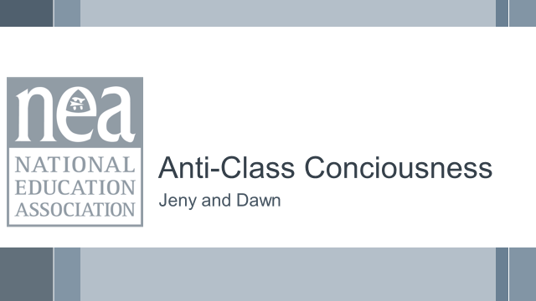  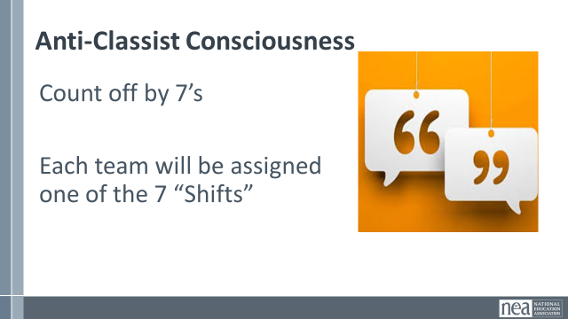  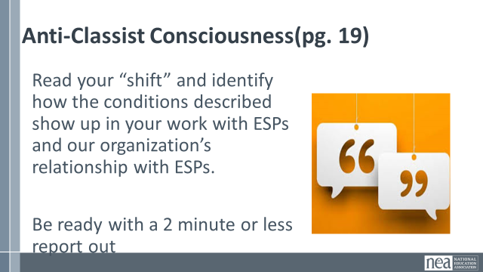  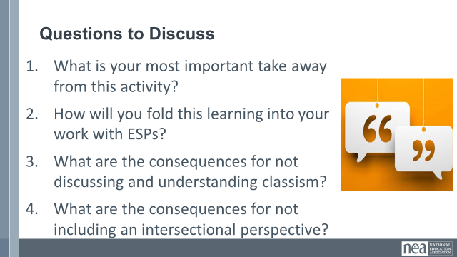  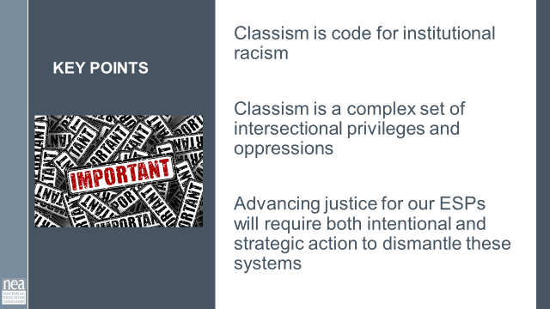 |  | Anti-Classist  Page 19 |  |  | 5 min – INTRDUCTION  Recognizing Classism in Our Organizations and Practices pg. 19  Intro activity (use word: intersectionality) and get into groups. We are going to be creating teams by counting off by 7’s. Each team will work with 1 of the 7 Shifts of Consciousness in the Anti-Classist Activist.  Each Table will read their “shift” and identify how the conditions described show up in our work with ESPs and our organization’s relationship with ESPs. Be ready for each table to report out and have a discussion about the reflections they make.  10 Min Work in Groups with 7 shifts handout  15 Min – Report out (2 minutes per team)  5 Min – Final Debrief  SAY: What is your most important take away from this activity?  - How will you fold this learning into your work with ESPs?  - What are the consequences for not discussing and understanding classism?  - What are the consequences of not including an intersectional perspective?  1 Minute Key points  Classism is code for institutional racism  - Classism is a complex set of intersectional privileges and oppressions  - Advancing justice for our ESP will require both intentional and strategic action to dismantle these systems |  |  | Participants will clarify what classism is and make the connections to systemic oppression.
2:50- 3:20 Beth |  | Issue Identification (30 MIN)
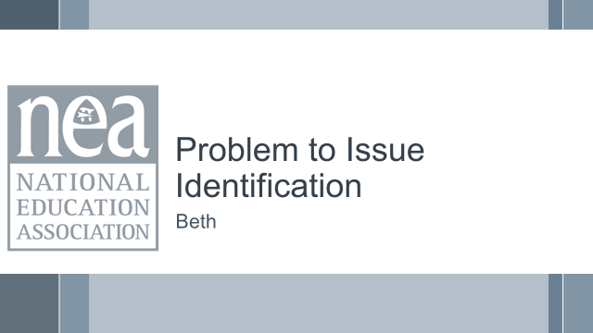  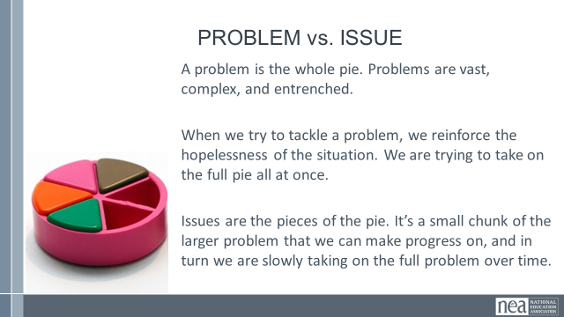  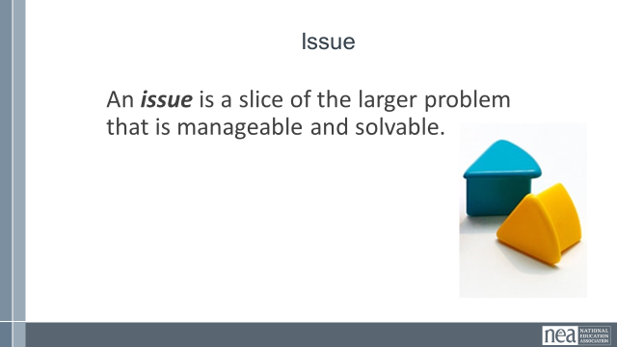  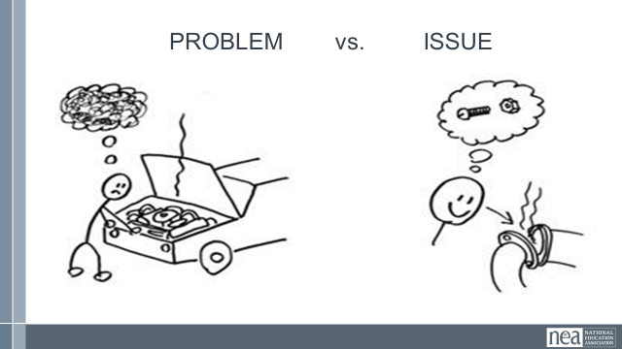  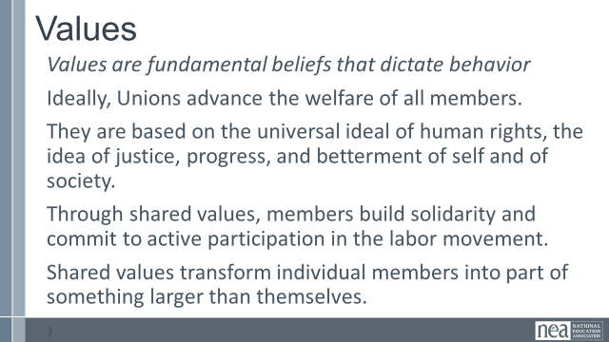  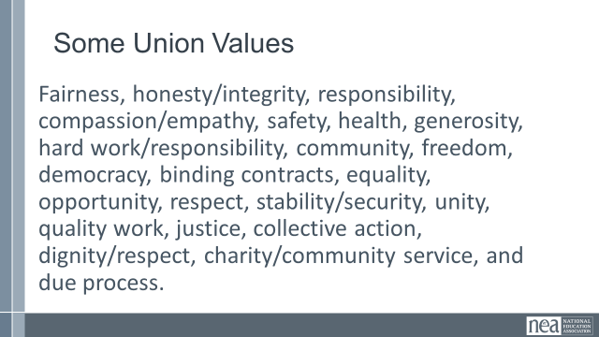  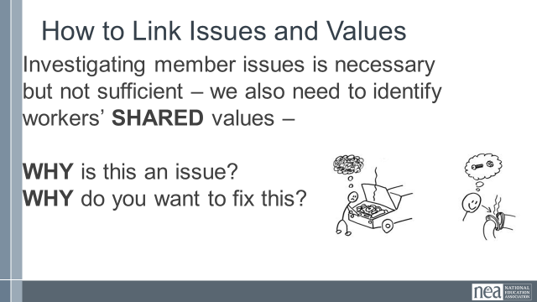  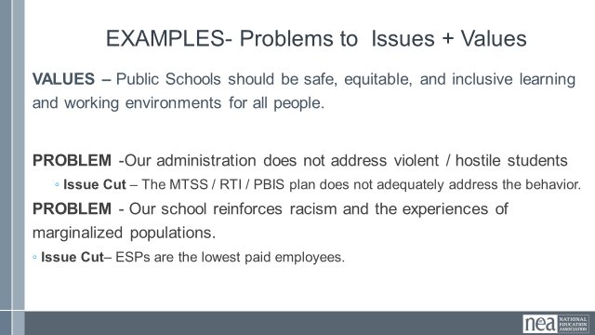  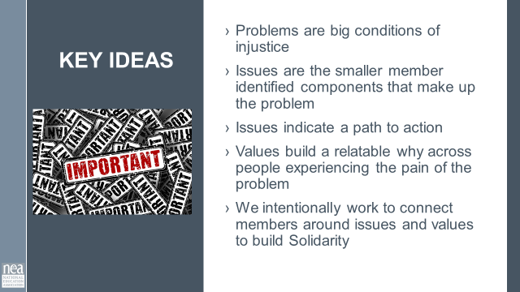  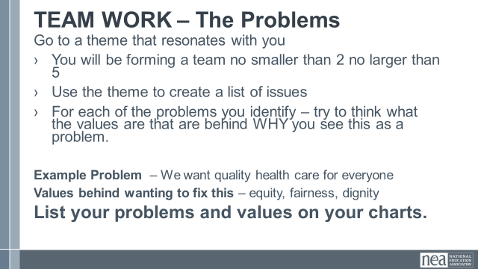  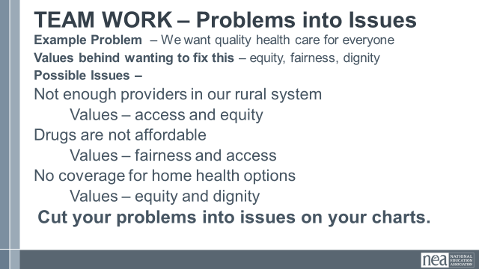  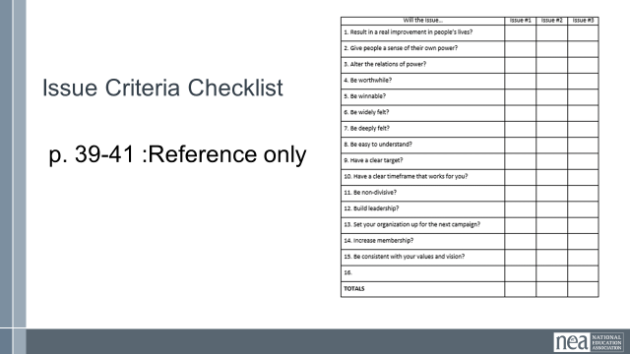  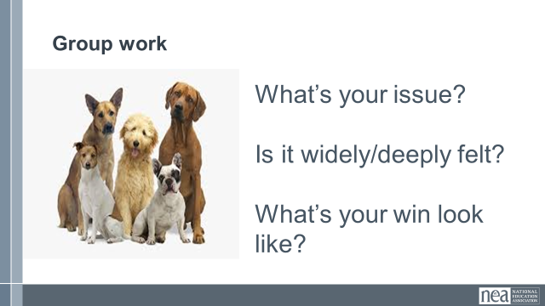  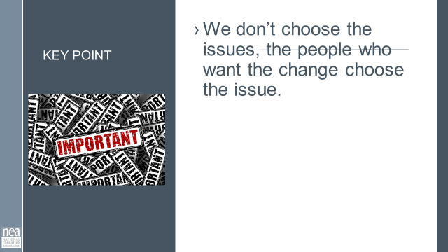 |  | Page 39-41 as a references |  |  | 10 Minutes Content PROBLEM , ISSUES and Values  - Campaigns start with issues that people have value-based solidarity around.  - An issue is a slice of a workplace problem.  - Often a problem can have different issues depending on the perspective of the people we are working with.  - It is KEY to get enough input on what the issues are that make up the problem so that YOU do not drive the solution.  - Investigating the issue is necessary but not sufficient – we also need to identify workers’ SHARED values – WHY is this an issue? WHY do you want to fix this?  For example, A problem My Car is a piece of JUNK --- Issues – broken radiator hose, bad brakes, smelly interior, hole in the muffler.  We Begin to Get to Values when we ask WHY?  VALUES are  - Values are deeply-held beliefs that shape who you are.  - Ideally, Unions advance the welfare of all workers.  - They are based on the universal ideal of human rights, the idea of justice, progress, and betterment of self and of society.  - Through shared values, workers build solidarity and commit to active participation in the labor movement.  - Shared values transform individual members into part of something larger than themselves.  Some union values we might recognize: Fairness, honesty/integrity, responsibility, compassion/empathy, safety, health, generosity, hard work/responsibility, community, freedom, democracy, binding contracts, equality, opportunity, respect, stability/security, unity, quality work, justice, collective action, dignity/respect, charity/community service, and due process.  How to Link Issues and Values – The Organizing Conversation Magic  You might ask, Do you want to fix this problem? Which of these do you think you can fix? Which one matters the most to you? Why does it Matter?  The radiator hose is something that my friend and I can fix and it matters to me because I can afford to fix it.  The radiator hose will be fixed by putting a new fitting on it. Is an issue that allows me to see the solution.  We can get to values by asking how do you feel about your car being a piece of junk? Do you think others feel the same way about cars that are pieces of junk? Why do you want to fix this problem?  We deserve safe and reliable transportation  We deserve access to affordable and quality car parts  Share slide of examples of Problems, the Values, and the issue Cut  Key Ideas  Problems are big conditions that have several smaller solutions  - Issues are the components that make up the problem  - Issues indicate a path to action  - Values build a relatable why across people experiencing the pain of the problem  - We intentionally work to connect people around issues and values to build Solidarity  15 minutes Team Work - Affinity Wall Themes and Team Formation  - Walk to a theme on the affinity wall that resonates with you  - Form a team of 2-5 people  - Take the theme and create a list of issues on a chart.  You and your team are going to make a list of issues that you and your members want to improve – these are big  For each of the problems you identify – try to think what the values are that are behind WHY you see this as a problem.  3 minutes Debrief Whole Room – what did you decide to do? (5 minutes) Take a few examples of problems into issues.  What is the Problem?  What are the issues?  What are some Unifying Values?  2 Minutes Key Ideas – We listen for the values as talk about this problems.  This is how we build solidarity. |  |  | Why are problem and issue something we need to know?  Participants will differentiate between problems and issues,
3:20 – 4:10 Vanessa |  | Spectrum of Allies (50 min)
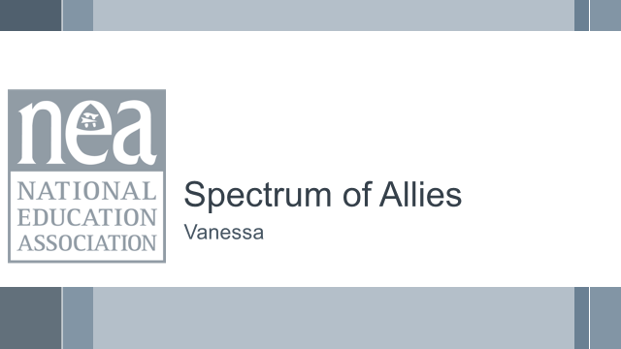  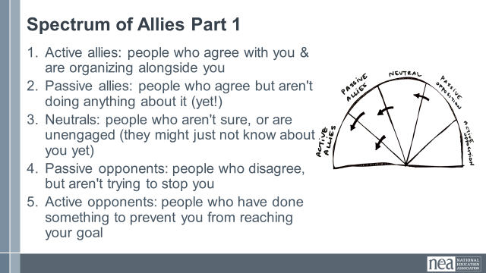  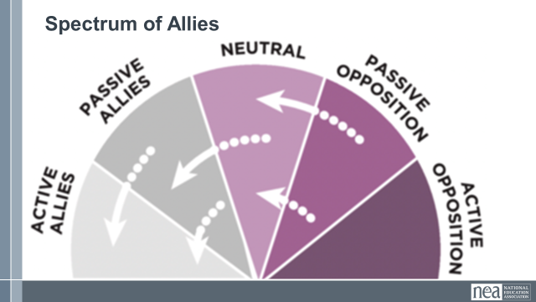  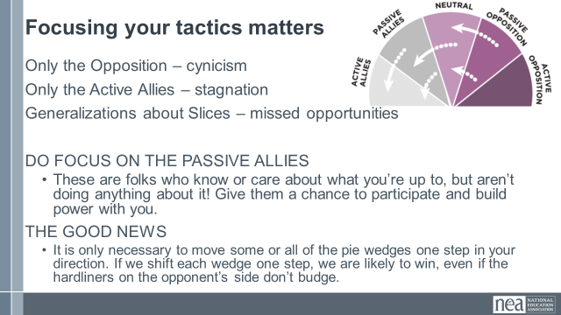  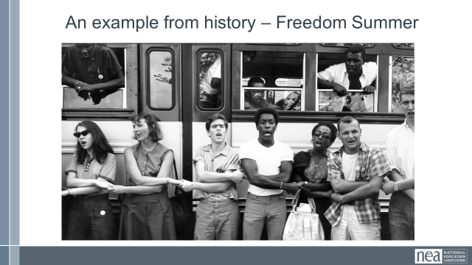  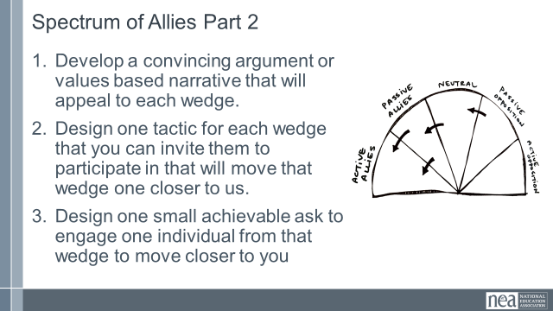  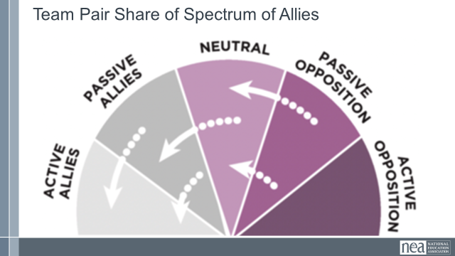  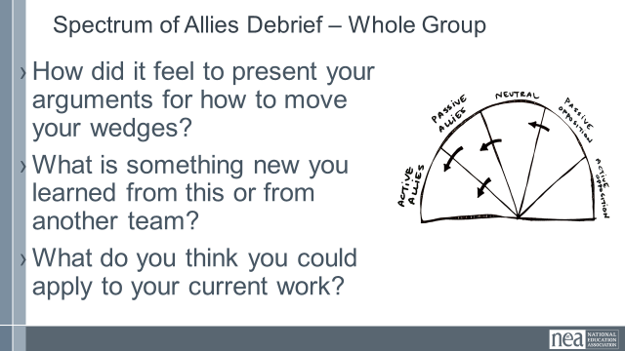  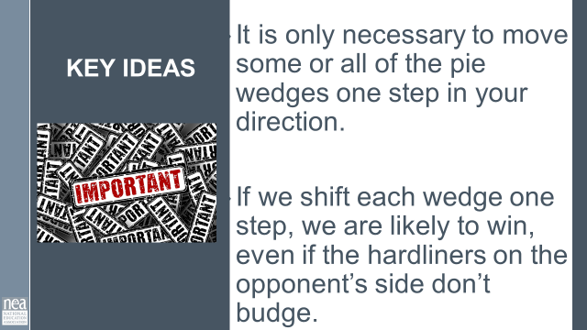 |  |  |  |  | Spectrum of Allies  Earlier today, we talked about how classism and racism can show up in this work. This often comes into the picture when we think about who our allies are and who are those that oppose the change we want to make. I don’t know about you, but I frequently run into divisions amongst the ranks of the ESP groups with whom I work; for example, the clerical staff maybe don’t believe that the custodial staff do the same “level” of work, and therefore, don’t deserve the same benefits. This isn’t just about job categories; all of the isms- classism, racism, sexism- are likely at play here.  So, let’s do an analysis around allies; we want you to intentionally think about the following:  - Your urgent message – why people need a solution to this issue as much as you do- what are your shared values?  - Your structure (leaders and teams)  - Your linked communities (not just YOUR people, but who they are connected with through shared values and commitments)  5 Minutes for teams to create their spectrum (not to fill in- just make the outlines of the 5 pieces of pie.  15 Minutes of work time For Step 1 Activity - We are going to begin by learning a method Called Spectrum of Allies. All of our campaigns CAN include a wide range of groups, but particularly in the campaigns we are thinking about that you will be part of, you MUST include others outside of your constituency.  These include a wide range of groups that can be put on a kind of spectrum, from those closest to the point of view of the advocates to those who actively oppose change. Draw a horizontal line to represent that. Those who advocate change are represented by a point at one end of the line (say, on the left), and the opponents by a point at the other end.  Draw a semicircle with wedges. The wedges closest to either end are the active allies and opponents, next in are passive allies. The group in the middle are neutral.  Use the issue that your group identified.  Begin by asking, who might be inclined to be most supportive, least supportive, or neutral. Some examples of groups: ‘unions?’, ‘poor  people’s groups?’, ‘business community?’. In your teams, identify these (AND WHY) and put them on your spectrum on the spectrum, and write them into the ‘pie’. Be as specific as possible – names, make them up to match the vignettes you are working with. Identify why people are placed where you placed them.  5 Minutes Whole Group Share – Do a little share out – as the facilitator, focus on the sharing of why the teams placed certain people in certain places.  5 Minutes of Content – Where do you focus your tactics?  Focusing only on the opposition leads to becoming disheartened or cynical, which means you ignore potential allies and support. Focusing only on how to convince the important power-holder who is against you leads to ignoring all of the potential support you could build that could overpower her opposition  Focusing only on active allies leads to being an isolated interest-group, which also means you ignore potential allies and support Always doing events with the same group of individuals or organizations isolates you from creative, powerful community-building that can  arise from new alliances and partnerships  Generalizing about whole groups of people risks misunderstanding the nuances of communities If you think about "students" as an entire group, you ignore the huge number of different groups & organizations (potential allies!) that exist in a student community  DO focus on passive allies. These are folks who know or care  about what you’re up to, but aren’t doing anything about it! Give them a chance to participate and build power with you.  Good news, In most social change campaigns, it is not necessary to win the opponent to your point of view, even if the powerholders are the opponent. It is only necessary to move some or all of the pie wedges one step in your direction. If we shift each wedge one step, we are likely to win, even if the hardliners on the opponent’s side don’t budge.  An example from history -  In 1964, the Student Nonviolent Coordinating Committee (SNCC), a major driver of the civil rights movement in the U.S. South, conducted a spectrum of-allies"-style analysis. They had a lot of passive student allies in the North: they were sympathetic, but had no entry point into the movement. They didn’t need to be “educated” or convinced, they needed an invitation to enter. SNCC sent buses north to bring folks down to “Freedom Summer.” Students became active allies -- they came in droves, and many were deeply radicalized in the process, witnessing lynching & violent police simply because black folks were trying to vote. Many wrote letters home to their parents, who suddenly had a personal connection to the struggle. This triggered another shift: their families became passive allies as they learned about the struggle from those letters. The students went back to school in the fall and proceeded to organize their campuses. More shifts. The result: a profound transformation of the political landscape of the U.S., resulting from a deliberate movement strategy.  5 Minutes Whole Group Discussion  1 Minutes – Key Points  It is only necessary to move some or all of the pie wedges one step in your direction.  If we shift each wedge one step, we are likely to win, even if the hardliners on the opponent’s side don’t budge. |  |  | Participants will use a root cause analysis process to identify issues. They will apply an issue analysis to determine what makes a better organizing issue.
4:15-4:30 Ellen |  | Ending it Right (20 Min)
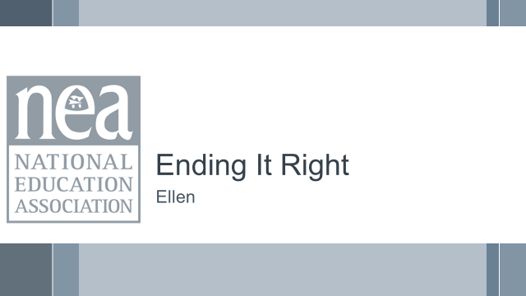  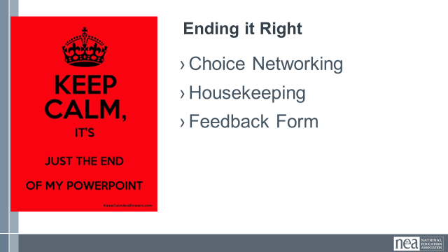 |  |  |  |  | Questions, Connections, Reflections  Housekeeping announcements  Evaluation via email |  |  | Participants will be able to bring a little closure to their learning and provide feedback on the day.
4:30 – 5:00 Ellen |  | Choice Networking Activities (30 Min)
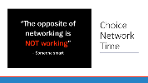 |  |  |  |  | Connect with colleagues from other affiliates. |  |  | Participants will make useful connections with staff from other affiliates.
5:00 | Adjourn

