Somerville, MA, Paraprofessionals Win Huge Living Wage Victory: The Story and Lessons for the Future
By Margaret Whittier-Ferguson June 12, 2020
https://www.socialistalternative.org/2020/06/12/somerville-ma-paraprofessionals-win-huge-living-wage-victory-the-story-and-lessons-for-the-future/

Margaret Whittier-Ferguson works in a prekindergarten classroom as a Paraprofessional in Somerville, Massachusetts. She is a Building Representative with the Somerville Teachers Association and served as the chair of the Paraprofessional Contract Action Team throughout their year-long campaign for fair salaries and job security. Before the contract campaign paras made between $20,000 and $25,000 a year. Margaret is also a member of the Cambridge/Somerville branch of Socialist Alternative.
To see Socialist Alternative’s past reporting on this inspiring campaign, check out these articles written as this struggle unfolded:
Somerville, MA, Paraprofessionals Fight for Livable Salary and Job Security
Somerville, MA Paraprofessionals Escalate Fight for A Fair Contract
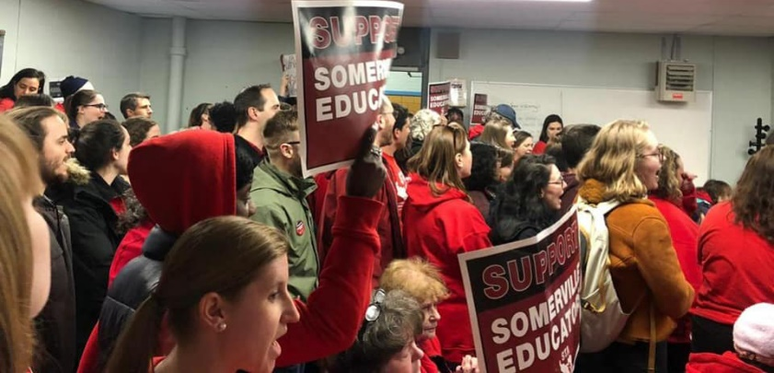
Somerville Paras Continue Fight for Fair Contract
After over a year of organizing and fighting, Somerville Paraprofessionals, organized in the Somerville Teachers Association (STA), have won an important victory. We won a starting salary of $25,000 a year which amounts to an immediate 25% raise. I’m going to say that again: an immediate 25% raise!
What makes this victory all the more critical is its context. Educators face budget cuts across the country triggered – in part – by the impending economic depression. Despite this overall trend, Somerville Paraprofessionals won! By running a rank-and-file and community oriented campaign, we were able to win a starting salary of $25,000, up from an abysmal $20,000, and 3% raises next year and the following year, as well as job security after 4 years of employment (previously Paraprofessionals had no job security).
Paraprofessionals (support staff) in Somerville have been in contract negotiations for around a year now. This victory for Somerville Paraprofessionals can serve as inspiration for support staff and teachers across the country fighting for raises and, crucially, against budget cuts.
This article tells the story of how this victory was won and the most important lessons for teachers’ struggles and the labor movement going forward. Somerville Paras should vote YES on this contract, as this is a massive victory not just for Somerville, but for support staff across the country!
This victory is 100% a testament to the strength of our union and the community campaign that backed us. Before the pandemic hit, we were going all out: we were storming school committee meetings, organizing walk-ins, and receiving large levels of community and parent support. The story of this year-long campaign should serve as a reminder to teachers’ unions that our power comes from our ability to mobilize our unions and the community to fight for what staff and students need!

New Leadership Elected and Paras Reject a Concessionary Contract: The Fight Begins
In October 2019, 77% of Paraprofessionals voted down a contract proposal that did next to nothing to address the financial hardships Paraprofessionals were facing. With a 72% turnout of Paraprofessionals to the vote, it was clear that we were not okay with business-as-usual contract negotiations. This “no” vote came just months after we elected a new “reform leadership” in our union: the Somerville Caucus of Rank and File Educators (SCORE) slate.
The election of SCORE members as President, Vice President, and several building representatives, myself among them, injected new life into the union. SCORE ran on the basis of jump-starting rank-and-file union involvement and social justice unionism, both things that were sorely needed in the STA. SCORE winning brought about a renewed confidence among union members that if we fight, we can win, and this undoubtedly played a major role in the willingness of a majority of Paras to reject the business-as-usual contract.
Following the “no” vote, we decided to try a different type of contract negotiation than what the STA had done in the past. We formed a Contract Action Team (CAT), comprised of rank-and-file Paraprofessionals from across the district, based on the idea that our power as a union comes not from clever arguments at the negotiation table, but by involving as much of the union rank-and-file as possible, building community support, and not being afraid to confront the School Committee and Mayor. Consistent CAT meetings throughout the campaign were crucial in providing ongoing leadership to the rank-and-file of the union. Our demands were as follows:
- A starting salary of $25,000 a year
- Job Security after 4 years of employment
- A 2-year contract so we negotiate at the same time as teachers

A Strategy to Win
At every step in the campaign, there were active debates in the union over what was the most effective strategy to win. How do we most effectively fight for a fair contract? What is the best way to mobilize union members and the community? How do we make democratic decisions? Should we mobilize now, or wait until later?
Democratic discussion and debate involving the rank-and-file are crucial for the success of any contract battle. In the past, the STA focused on closed-door meetings and negotiation with the School Committee. As a socialist, I see the active involvement of fellow union members as the key to our success. We are far stronger when we are united and determined. I consistently pushed for a strategy of rank-and-file mobilization, building a strong base of community support, and not shying away from confrontation with the School Committee and Mayor.
On December 19, 2019, we held an incredibly successful community meeting. We built for this by flyering parents outside of schools and reaching out to those that signed our Pledge of Support. Nearly fifty people attended the meeting, including parents, union members from other local unions, and a City Councilor. We discussed the important role that Paraprofessionals play in our schools — we are the extra set of eyes, ears, and hands that ensure that our students’ basic and more complex needs are met — and strategy for how our movement could win. Out of this meeting, we decided to build for a massive turn-out to the School Committee meeting on January 13, 2020.

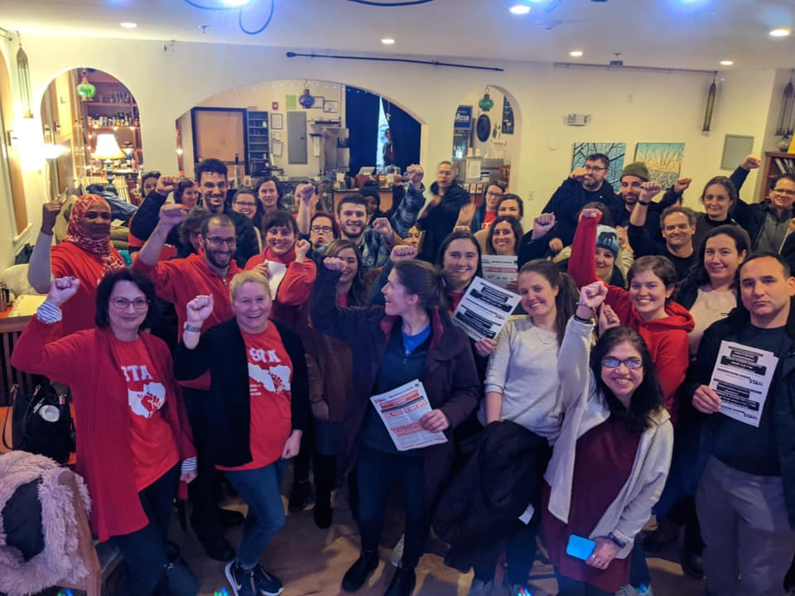
Packing School Committee: A Turning Point in the Campaign
On January 13, 200 Paras, teachers, parents, and community members rallied and packed the School Committee in one of the largest, if not the largest, turnout to a Somerville School Committee meeting ever recorded. After a standout and impromptu rally featuring speakers from the STA, Boston Teachers Union, Massachusetts Teachers’ Association, and Socialist Alternative, we marched into City Hall chambers. Details and videos from this amazing action can be found here.
The mood in schools across the district was electric following our successful turnout to the School Committee meeting. Many educators were realizing for the first time what can be accomplished when a union is organized and takes a movement-building approach to fighting for what we need.
Following the School Committee meeting, the CAT launched a series of walk-ins where educators at schools across the district rallied outside of their schools at the same time. At many of these walk-ins, students, parents, and community members joined rallying educators, putting on full display the depth of our movement! At my school, the school with the most Paraprofessionals in the district, Socialist Alternative members who live in the community played a crucial role in driving turnout to the School Committee and walk-ins.
Throughout February we continued building pressure by hosting community meetings, rallies, and participation in School Committee meetings. Check out a speech I gave at one of these rallies, the last action before the Coronavirus hit.

School Committee Uses Coronavirus for Illegal Move: Paras Stand Strong
The coronavirus pandemic has disrupted the work of educators across the country. We have been tasked with setting up a completely new model of educating – remote learning – with little notice or resources. We have had to adjust our entire approach to teaching to meet the needs of this particular situation. On top of that, for those of us in the middle of contract battles it threw a big wrench in our plans. We have had to teach our students and fight for our rights as educators under lockdown! To add insult to injury, educators across the country are now facing brutal budget cuts as states scramble to deal with growing debt.
This is not a new phenomenon, we have seen how districts use crises as an excuse to cut social services and education. In New Orleans, following Hurricane Katrina, countless public schools were shuttered, replaced by charter and private schools. Now, districts across the country will likely attempt to use Covid-19 to similar ends.
In this context, on April 30th, the School Committee took their last offer – a 5% raise this year, 6% raise next year, and 7% the following year – off the table. They instead offered 0% raises over the next three years. That’s right: 0% raises from a $20,000 starting salary over the next 3 years.
Given this, it is shocking to read the City of Somerville’s official press release about the agreement reached which quotes School Committee Chair Carrie Normand saying, “For many months, School Committee and City officials have publicly stated our support for a Paraprofessional wage scale that starts at $25,000 annually.” This would be laughable if we hadn’t spent a year campaigning for a living wage in the face of the School Committee’s blatant and insulting opposition.
This 0% proposal was a real blow and the CAT struggled to see a path forward, but we were determined to keep up the pressure on the School Committee virtually. We attended virtual School Committee meetings and finance meetings. We attended School Committee office hours en masse. We did not let up the pressure, despite the fact that the budget process was looking grim.
The School Committee’s move to take their last offer off the table and replace it with 0% raises is considered “regressive bargaining” and is totally illegal. While we of course filed an unfair labor practice, we knew we couldn’t rely on Trump’s National Labor Relations Board to rule in our favor. Additionally, getting to a conclusive ruling in this process can take years. It has actually been quite common for supposedly progressive cities and institutions such as universities to consciously carry out illegal bargaining tactics with the full knowledge that Trump’s NLRB appointees will have their back.
At a district-wide all-Paras meeting in mid May, we discussed and debated how to move forward. We voted not to take a 0% raise and to continue fighting for a living wage. District-wide discussions are imperative for unions.

Black Lives Matter: The Straw that Broke the School Committee’s Back
In a complete reversal of their previous position, on Wednesday, June 3, the School Committee offered us a starting salary of $25,000 a year. For many of us, given the 0% raise offered just one month earlier, this new offer felt out of the blue. So what happened, and why did the School Committee finally give into our demands after a full year of fighting us with all their power? We will never fully know what discussions went on behind closed doors that led to this 180 degree turnaround, but we can make a confident, educated guess.
First, the School Committee’s power move in late April didn’t break us. They used the pandemic as cover to offer us 0% raises over three years, knowing we were in a weaker position to organize and hoping to kill our spirits, but this did not work. We did not back down and made it clear we were still going to fight. We discussed organizing a car caravan to put pressure on the School Committee, and we knew that in order to win our demands, we must maintain constant pressure on the School Committee and the Mayor.
Then, Black Lives Matter broke out. The brutal police murder of another black man has sent shock waves around the world, with solidarity protests springing up in every corner of the country and dozens of countries across the world. The majority of Paraprofessionals are women, and many of them are women of color. Demands around defunding the police to fund education, housing, and social services gained steam. A group of community members including members of Democratic Socialists of America and other local activists began to circulate a petition calling for the defunding of Somerville police to fund education, and a living wage for Paraprofessionals in particular. The petition went semi-viral across the city, getting thousands of signatures. Undoubtedly, the Mayor and School Committee saw the writing on the wall that with the new wave of BLM, they would look even worse than before if they refused to pay Paraprofessionals a living wage.
This victory for Somerville Paras would have been unimaginable without the year of intense struggle and a rank-and-file led, movement-building approach by our union. But in the eleventh hour, we believe the straw that finally broke the School Committee’s back was the Black Lives Matter movement. If true, the implications of this are enormous.
The fight against racism and the fight for economic demands are not separate issues to be fought on separate fields of battle. If unions and the labor movement use our power as workers to boldly take up the fight against systemic racism our movement will be unstoppable.
In Seattle, members of the Seattle Education Association have officially voted to support the call, spearheaded in City Hall by Socialist Alternative’s City Councilor Kshama Sawant, to defund the Seattle police by 50% and redirect those funds to necessary social services. Locally, though not as strong but still important, the Boston Teachers Union recently passed a resolution calling for a 10% reduction in the Boston police budget, as well as getting police out of our schools. These are examples of the solidarity we need between the labor movement and anti-racist struggles.

The Role of SCORE and Reform Caucuses in Unions
None of what the STA has accomplished over the last year would have been possible without the election of SCORE at the end of last school year. But at the same time, just electing a new reform leadership was not enough. Immediately after being elected, all sorts of pressures are exerted on any new union leadership. There can be pressure to tone down your message, abandon promises to build rank and file democracy, and give up a more combative approach in favor of backroom negotiations. We see similar pressures exerted on progressive elected officials at the city, state, and federal level as well.
Because of this, active rank-and-file involvement and accountability is crucial. Throughout this campaign there were debates about strategy, leadership, and needing to stay true to the platform and approach that SCORE promised upon election. This is an important lesson for reform caucuses and teachers unions nationally. After the election of a new reform leadership, the caucus should stay active and organized and the members or supporters of the caucus have a crucial role to play in successfully transforming the union into an effective fighting organization.
SCORE’s platform crucially included more general membership meetings, however there’s been a lack of regular meetings over the past year. Going forward, having more regular membership meetings will help build off this victory and prepare us to fight for an equally strong teachers’ contract, which is up next school year. While it may take time to build up, there is no replacement for an actively engaged rank-and-file.

Our Fight is Far From Over
This is an absolutely tremendous victory. Socialist Alternative has stood alongside Paraprofessionals fighting for a living wage throughout this campaign, and this sort of solidarity has been critical to the campaign’s success. A year ago, most people in Somerville had no idea what a Paraprofessionals was. Today, we see massive amounts of community support not just for Paraprofessionals’ living wage campaign, but for school funding more broadly. It is because of the community support that we were able to win this victory. And we should be clear: this is a victory not just for Somerville Paraprofessionals, but for all educators across Massachusetts and the entire country. Paraprofessionals in other districts should reach out to Somerville Paras to discuss how we ran our campaign, so that we can all learn from one another how to fight for a living wage and job security. We need to work together to ensure we have the working and learning conditions we need!
Despite the budget crises we are seeing across the country, it is absolutely imperative that educator unions do not let up the fight for fully funded schools. Wall Street should pay for this crisis, not working families. Brookline Public Schools, one of the wealthier districts in Massachusetts, pink-slipped over 300 teachers in the last few weeks, and only because of a strong public outcry have they retracted some of these layoffs. This is what we should expect to see across the country.
Many of our students are going to be coming back to school dysregulated and many having experienced trauma. We need not less but more well-paid staff and wrap-around services for students including counseling services. This pay raise for Somerville paras cannot come at the expense of staffing cuts, and if the School Committee makes any attempts to cut para or other positions, the STA should fight back against them just as hard as we did for the contract fight. Fully funded schools means well-paid and fully staffed, not just one or the other.
For educators and families across the country, the question of how and when we reopen schools is at the forefront of our minds. Educators must be the ones to determine how and when we go back to school, given the very real health and safety concerns of returning to school.
It is crucial that we learn the lessons of building broad support, being well organized internally, and connecting to larger demands around defunding the police to fully fund our schools. In a period when we are up against massive budget cuts, this victory should be shouted from the rooftops.The union and our community must draw correct conclusions about how and why this campaign was successful: It was only by building a movement that mobilized both the rank-and-file of the union and the community that this victory was won. We should be proud of our success, but should also know that the struggle is not over. We have a responsibility to share these lessons and join in other struggles happening across our city, our state, and our country. We’re going to need to continue to take militant and bold action to win the schools we all deserve.

