Facilitator Agenda: Day # 1 Organizing ESP
General Materials Needed: |  |  |  |  | Room Set-up:
1 Set of Handouts per Person  Name Tags or Name Tents  Room signs, sign-in signs  Painters Tape  One blank half-sheet of paper for each table |  |  | Chart Paper  Post-its  Chart Markers – Mr. Sketch  Pens and Pencils |  | Round Tables - Projector, Screen and Speakers  Carousel stations and reporting stations around the perimeter  Easel with Chart paper
Key Outcomes for the Day:
- Who are ESP?
- What are their issues?
- What is our work like with them?
- What are some institutional challenges we have?
- What are ways that locals have succeeded?
Overview of Content and Facilitator
8:30-9:00 Getting Started  9:00-9:45 What issues do ESP face?  9:45-10:30 What are your experiences leading ESP units?  10:30-10:45 BREAK  10:45-11:30 Language Matters (research)  11:30-12:00- Financialization  12:00-1:00 - LUNCH |  |  |  | Ellen  Beth & Michael  Sonia  Jessica  Ben & Hedy |  | 1:00-1:30 Financialization cont.  1:30-2:15 – An Institutional Problem  2:15-2:30 BREAK  2:30-3:35 Defining Class, Questioning Systems, Reflections on Practices  3:35-4:10 Issue ID  4:10-4:30 Ending it Right  4:30-5:00 – Choice Networking |  | Ben &Hedy  Eric &Sonia  Beth & Monet  Ben  Ellen
Time, Slides, Facilitator |  | Resources |  | Instructions, Activity and Debrief (Facilitators) |  |  | Outcomes and Essential Questions
 | Charts, handouts, articles, materials, slide |  |  | What are you saying, what are they doing, what questions will you use to guide learning and make clear the important points  Include an estimate for how long each section of the learning will take |  |  | As a result of this section, what will participants know or be able to do? What questions will they be able to answer?
Entry activity  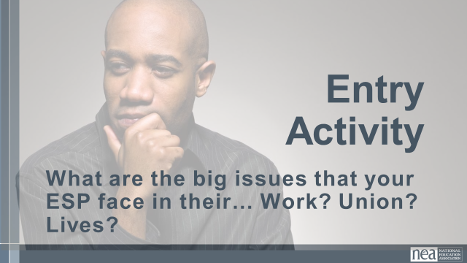 |  |  |  | Make a list – you will use this later
8:30 -9:00 Ellen | Getting Started (30 Min)
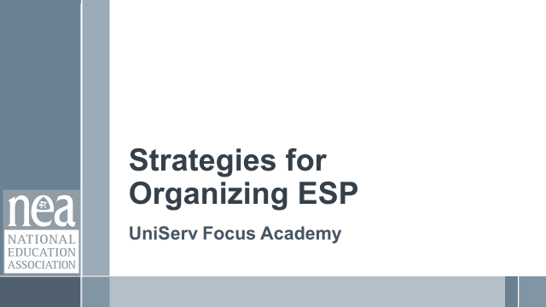  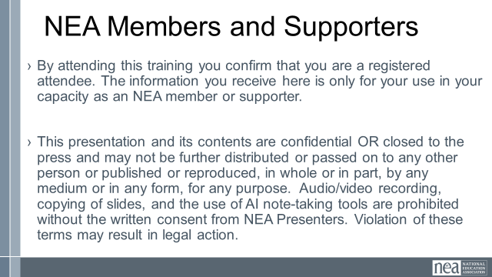  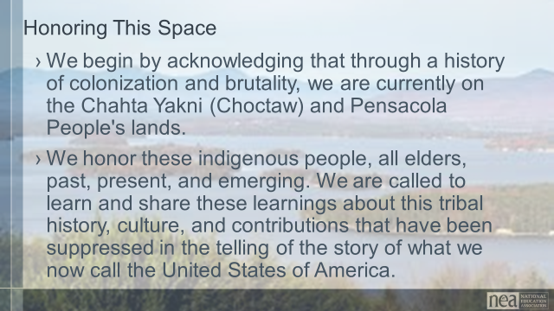    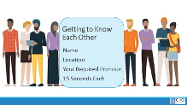  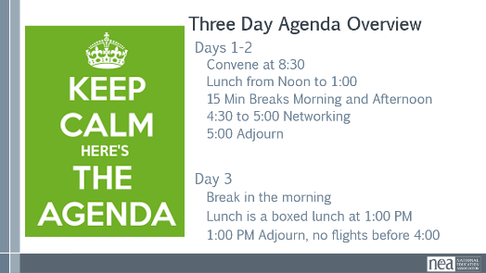  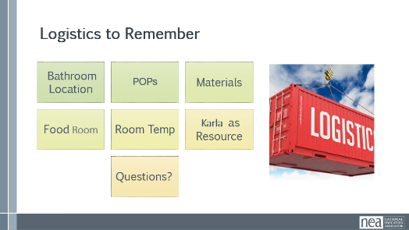  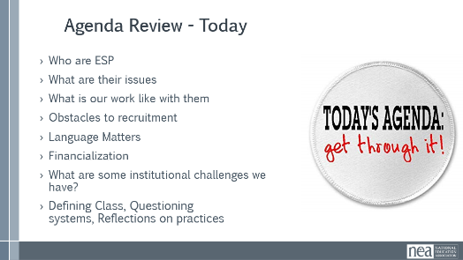  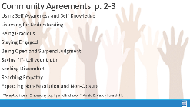  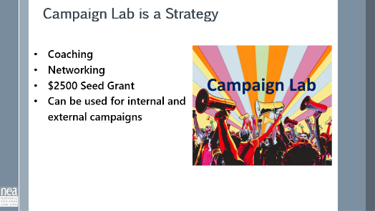 | Make the Following Charts  Community Agreements  Parking Lot  Agenda  Put out  Name Tents  Handout Package  (Re-visit History of ESP Doc) - Katrina |  |  | 4 Min - NEA Welcome  Native Land Recognition  The National Education Association is committed to honoring the spaces that we occupy to advance the work.  - We begin by acknowledging that through a history of colonization and brutality, we currently reside on and are connecting from the traditional lands stewarded by generations of indigenous people.  - We honor these indigenous people, all elders, past, present, and emerging. We are called to learn and share these learnings about this tribal history, culture, and contributions that have been suppressed in the telling of the story of what we now call the United States of America.  Why are we here?  - We are here to build stronger ESP leaders.  - NEA is committed to building effective sites where members can lead and growth their associations.  5 Min - Facilitator Introductions  - Team intros include Name, Work Location, years in the work, and your required pronoun  5 Min - Group Introduction Whip  - Have a quick model from one of the trainers.  Three Day Agenda Review  - See charts on walls for review.  - Note the two breaks, lunch, and adult network 4:30-5pm each day and then 1pm on Thursday.  3 Min - Group Logistics  5 Min – Group Agreements Pg. 2-3  3 Min - Revisit Pre-work Reading |  |  | Participants will know how we are going to work, the basic schedule, and the logistics relevant to the training.  How will we work together to support learning?
9:00 – 9:45 Beth & Michael | What Issues do ESP Face (45 Min)
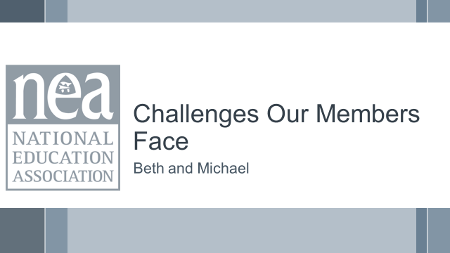  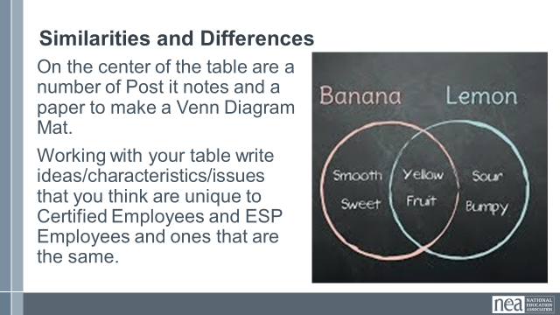  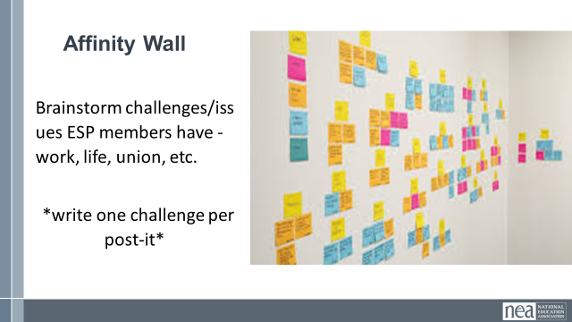 | Chart paper for Venn diagram  Lots of Post it Notes and a large wall  A few Larger sized post-it notes |  |  | 10 Min – Venn Diagram  On the center of the table are a number of Post it notes and a Venn Diagram Mat.  Working with your table, write ideas/characteristics/issues that you think are unique to Certified Employees and ESP Employees and ones that are the same. Have them refer to the list they made during the entry activity.  Ask participants: What common ideas/characteristics/issues do you see between certified employees and ESP employees  25 Min - Understanding Challenges of our Members  This is an activity that you might find useful to do with members who are getting ready to identify priorities for bargaining or a campaign  Ask participants if they know what an Affinity Wall is and if so ask for a volunteer to share out. If not a:  An affinity wall is a collaborative brainstorming and analysis tool used to organize large amounts of unstructured data, ideas, or user feedback into natural, thematic clusters.  Affinity wall activity – each participant is going to brainstorm by themselves (silently) as many challenges/issues as possible that their ESP members have -- work, life, union, etc. – in the true sense of brainstorming, anything that you are aware of is a challenge. Put one challenge per post-it. (this is about a 5-minute activity)  (FACILITATOR NOTE: If the walls are not sticky in your room, prepare an alternate plan: Have much blue tape.]  Step 2 – this part is a little bit like engineered chaos – now the group will apply these post-its to a wall. They put them up – and as they are now on the wall, begin to move them into clusters that are similar – as the clusters begin to form, a few people will begin to NAME the clusters – ex. “Fair Pair” (this can take up to 10 minutes – encourage people at the front to move back and those at the back to move up – keep churning and engaging.  Affinity Wall in 3 Acts  1.Put all post-its on the wall  2. Move post-its – yours and others into similar clouds  3. Name the clouds and outliers  10-minute Debrief  - What are the major clusters? Is there one or two that occurs more than others?  - Are any issues related to each other? (Which/How)  - What does this mean for you in your work as an ESP or your work with ESPs  - What surprises you?  Key Ideas --  Organizers begin with issues. You all ARE organizers  The issues of our members, colleagues or those we represent ARE the issues of their union  Your issues are our best campaign  - Members will rally behind their issues.  - It is not our issue that we focus on. It is the issue the ESP members tell us is important to them. |  |  | Participants will have identified and described issues that ESP members face.  What are the challenges that ESP face in our affiliate system? Their work? Their lives?
9:45 – 10:30 Sonia |  |  |  | What are your experiences in supporting ESP units? (45 Min)
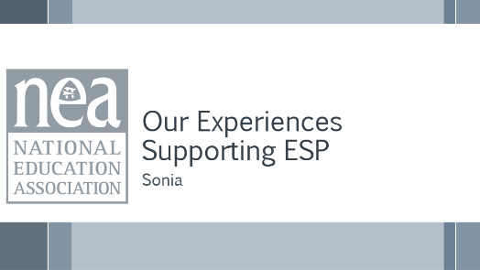    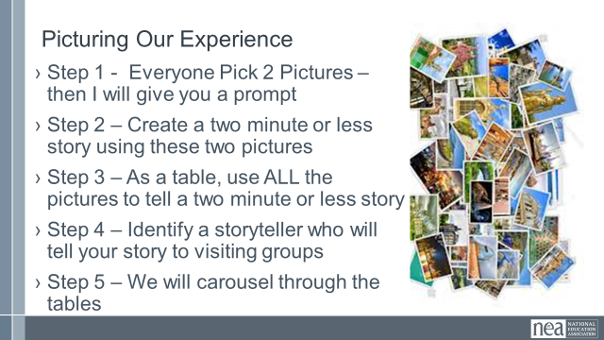  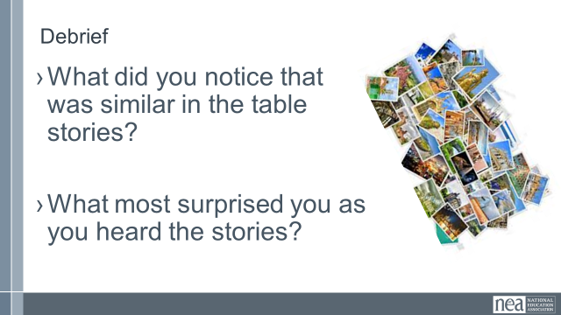 | Picture cards |  |  | 6 Min - Beginning activity  Step 1 - At tables, give each group a random selection of picture cards (face down). Each person picks two (without looking)- Don’t tell them why they are picking. Go around and scoop up the extra before you do the next step.  Once they have picked their two cards, tell them to use these to describe (in under 2 minutes) what their personal experiences are like in working with ESP Units.  [stay on title slide]  10 Min - Table Share  Each person shares their story around the table.  Once these 10 minutes are up, tell them that as a team, they are to use ALL their cards to create one unified story that can be shared. Get ONE team member prepped to tell that story.  10 Min - Whole Table Story  Using all the cards, the table comes up with a story about what their collective experiences are like working with ESPs. (the total story must be less than 2 minutes, and ONE person needs to know it very well)  At the end of these 10 minutes tell them that all but the one team member who knows the story well are going to visit each of the other tables – leave the docent behind at the signal and move to the next table.  14 Min - Visiting the Others Step 3  Leave one person from each table behind as the storyteller who will share the table’s story. Each group rotates through each table. Facilitator signals every 3 minutes getting the group to move in a way that is as easy and effective as possible  5 Min - Quick Debrief  What did you notice that was similar around the room?  What surprised you most as you went around the room?  Why do you think these conditions exist?  REMIND Participants that the BREAK is a great time to review the Pre-Attendance Material, especially the ANAYLYZING EVERYDAY OPPERESSIONS IN UNION WORK in P 4-5 in Participants Handout (p 7 in Pre-Attendance materials POPs)—Be ready when you come back! |  |  | Participants build community and build a common understanding of experiences.  What are your experiences in supporting ESP units?

10:30 -10:45 BREAK
10:45–11:30 Jessica |  | Research: Language Matters (45 Min)
  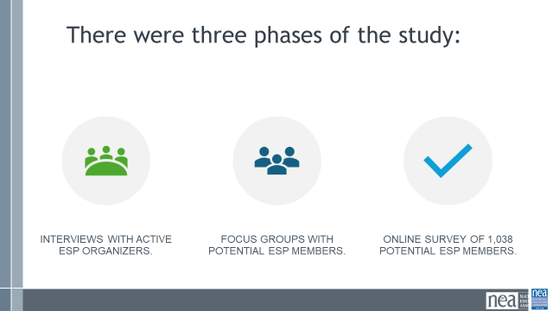  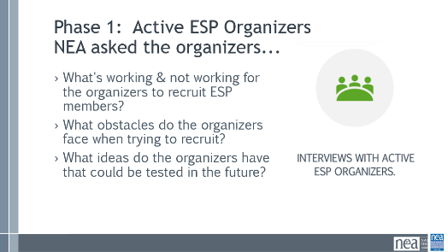  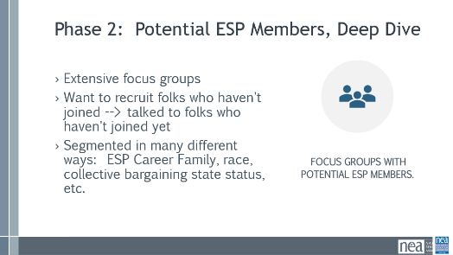  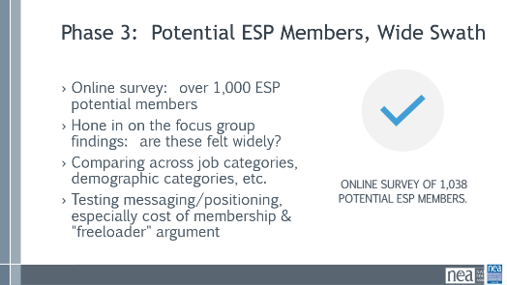  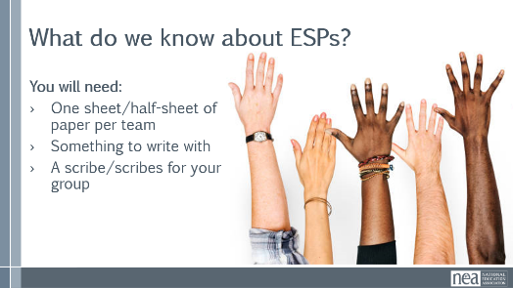  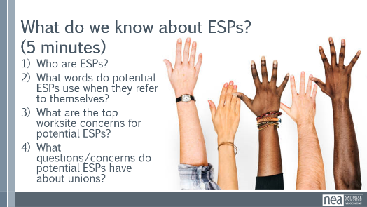  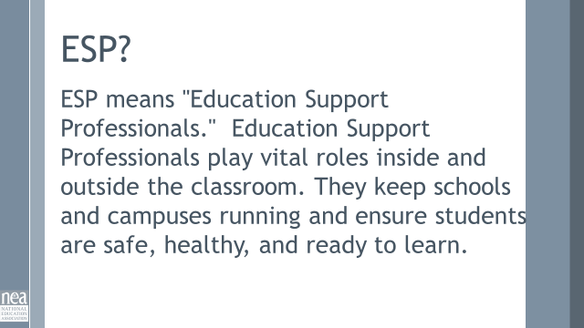  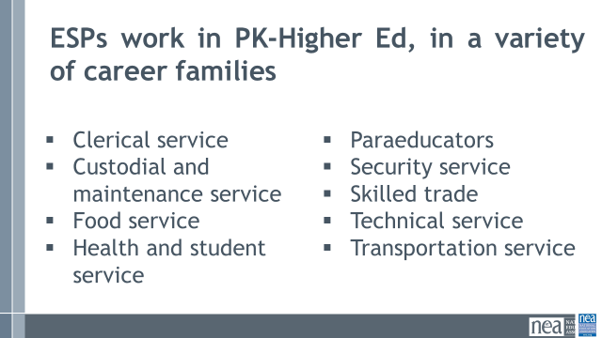  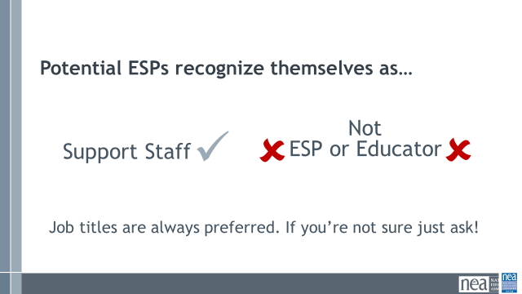  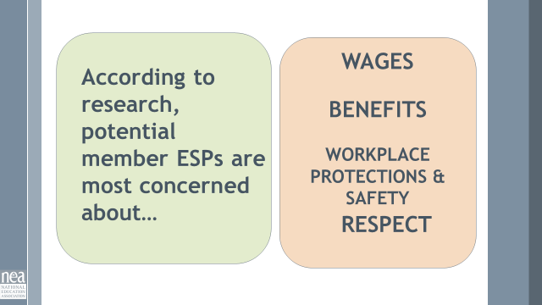  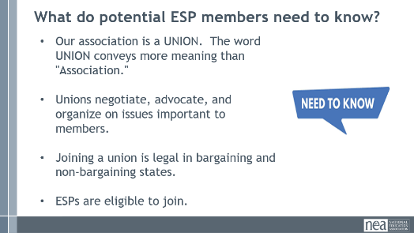  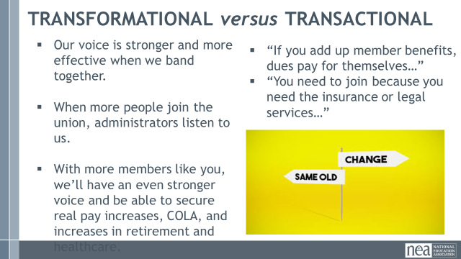  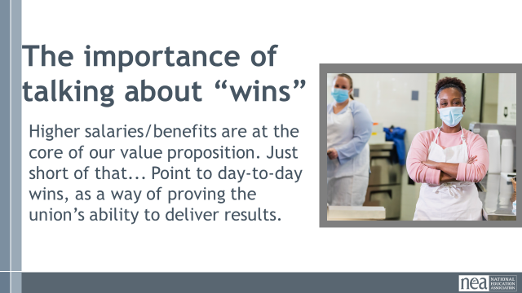  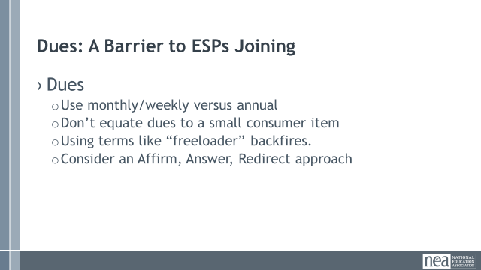  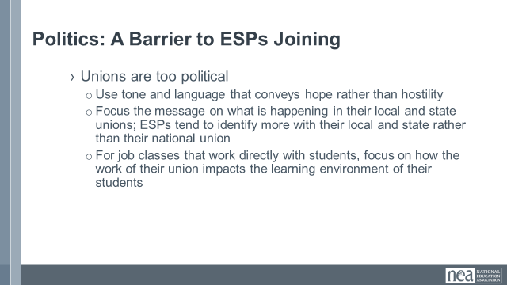  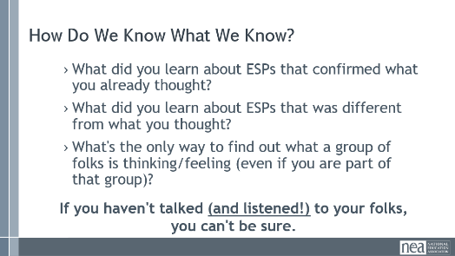  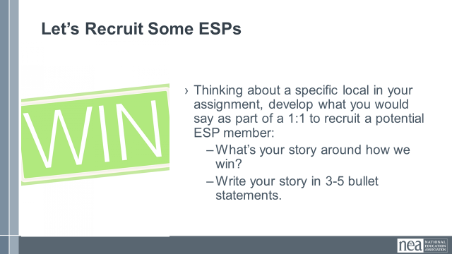  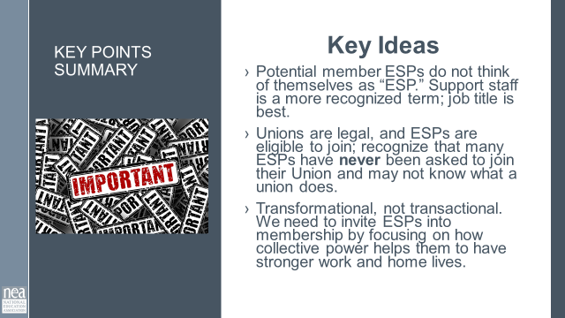 |  | GSG Findings and Recommendation Study Pg. 18  One blank sheet or half-sheet of paper (not chart paper, just regular) on each table. | 10 Minutes: Who are ESPs?  To the Future Folk Who Do this Section: There is a big firehose of info here. I considered what I wanted my Key Points to be for this section and worked backwards from there. It helped the data journey I shared (at least attempt) to be more cohesive and less oh please Lord no, you know? Happy to chat further at UD Facilitator Summer Camp. XOXO, Jessica  ESPs are an untapped resource for NEA, and membership has always lagged. To learn more about what approaches and messages are most helpful in recruiting ESPs into the union, NEA spoke to the following people.  1.They started by conducting interviews with active ESP organizers across the country and with a range of positions within NEA’s state and local affiliates. Each interviewee was selected because they had been identified as particularly experienced in recruiting ESPs. The purpose of the interviews was 1) to determine what’s working and not working for organizers; 2) to understand what obstacles needed to be addressed; and 3) to gather ideas for future testing.  2.Phase two was intensive focus groups among potential member ESPs. This included six 90-minute online focus groups, which were segmented by career families, the collective bargaining status of the respondents’ home state, and race.  3.Conducted an extensive online survey of 1,038 potential member ESPs from across the country to verify and hone the findings and attitudes that emerged in the qualitative research, understand attitudinal differences across job classifications and other demographic groups, and test updated messaging and positioning, including how and whether to address the cost of membership and the “freeloader” argument.  As we take another look at the three phases altogether, what do you notice that they might all have in common?  In all three phases, NEA was engaging directly with, and listening to, the relevant constituency groups. In the first phase, they went to those who were successfully recruiting ESPs and listening to what worked, didn’t work, etc. And then, they went directly to potential ESP members, asked questions of a small group to go deep and suss out their issues, and then asked a much larger group about how those issues might play out on a wider scale. But ultimately, they asked questions directly to the involved groups and listened to the answers.  We are going to share the major findings of this research with you. Some of this research is going to challenge your assumptions. Maybe for you or your colleagues back home. It did for us. So first, we want to know what you know about ESPs.  5 minutes: Brainstorm  Locate some paper and something to write with. (Give them a minute to locate, then call back together.) Working with your tablemates, you will answer the questions that are on the next slide. You will have five minutes to do this. Are there any questions?  (Change slide and set timer; this is an exercise in pre-thinking, not sharing out.)  Now we’re going to share what we found through the research. We want to see if there is anything that challenges your thinking.  15 minutes: Research Findings  Taken from NEA’s website: Education Support Professionals play vital roles inside and outside the classroom. They keep schools and campuses running and ensure students are safe, healthy, and ready to learn.  You may have a basic understanding of what an ESP is and the service they provide to our school communities, but we need to be more specific to support our active and potential ESP members when we advocate and organize for their needs. Referring to an individual’s specific job title honors their work in the school community, and builds a sense of belonging to a school community and by extension a Union. It confirms that they are part of something bigger than just their job, and brings those who are further from a school building into connection with the Union.  While we use the term “educators” to be more inclusive, it has actually had the opposite effect for potential ESP members. While current members may use and identify with the term “ESP,” Support Staff is the most unifying term for potential ESP members. Education Support Professionals (or ESPs) is an important term of respect for current members, but it's virtually unheard of among potentials. Potential members who are ESPs don’t tend to identify as educators, but over time, as they join the union and participate, they often begin to see themselves as educators and embrace the term. The use and belief in the term educator can also be dependent upon the job family/duties/title of the ESP. e.g. A groundskeeper may not view themselves as an educator, therefore they can struggle to see how they fit into a union of educators.  Out of four potential identifiers, support staff rose to the top across job classifications. “Educator” was the least likely to be identified as best descriptor, with ESP second from the bottom (and “Classified Workers” in second).  ESPs want their union to work towards higher salaries, better benefits, and workplace protection. The most important accomplishments a union could win across job categories included winning higher salaries, providing a safe workplace and protecting ESPs from additional duties outside their core responsibilities, and ensuring that the benefits that drew many ESPs to their job in the first place remain strong. The focus on wages is of particular importance to ESPs, more so than with certified educators. ESPs are joining the Union for these things.  Professional Development may be a retention strategy, particularly if by participating it assists with increased pay or the potential for promotion. That said, typically, ESPs do not join for PD. If PD is an important part of your recruitment strategy, take into consideration it’s helpful if it’s free and offered during paid time, and if it leads directly to pay increases.  Finally, respect is a topic that came up in our research in a lot of different ways. ESPs often feel like they are treated as second class citizens in the educational environment; we need to interrupt that narrative within our union.  Awareness of a) the union’s existence and b) the potential benefits for member ESPs are both low.  We must do more to educate potential members that NEA and its affiliates are unions. Additionally, the pitch to education support professionals does require another educational step. We must also be clear that NEA is a union for them, as well as certified members. Many potential member ESPs are aware of the collective power of teachers’ unions but are uncertain of their eligibility for membership or may not feel welcome as full and equal members of NEA.  Basic education about the union has tremendous value with ESPs, especially in non-collective bargaining states. As we saw in the research, a significant minority of ESPs are unaware that there is a local union that they are legally able to join. There are plenty of ESPs out there that would sign up right now if they knew that the union was an option. Moreover, we reach our apex of interest after a simple pitch that clarifies that unions are allowed (and have a legally protected right to bargain in CB states) and that the state affiliate is a union that advocates for higher wages, benefits, and changes that improve workers’ daily lives.  We must show that members can increase their collective power through advocacy, organizing, and/or bargaining. Potential members are generally familiar with the concept of unions, but there is little depth to that knowledge. They generally assume unions exist to solve problems (i.e., provide protection), and many in non-collective bargaining states incorrectly believe unions are illegal, underscoring how much education is necessary. Finally, potential and current members are often concerned that the Union is “too political” and partisan.  It is important to understand the difference between a TRANFORMATIONAL and TRANSACTIONAL approach  A transformational approach asks the potential member to become part of something bigger than them as an individual; it asks them to be a part of the solution.  A transactional approach is a “give to get” that you often see when we’re hawking liability insurance; this conveys that a third party- “the union”- will fix everything for them.  The problem with a transactional approach is that if we’re just selling a consumer product (insurance) and treating members as consumers, they will seek the lowest possible price for that product, and it might not be us!  Wins:  •Sharing "wins" builds credibility and overcomes skepticism; localizing those wins as much as possible helps members see how their union can impact their immediate circumstances  • Higher salaries should always be at the core of our value proposition, but use more tangible day-to-day wins to build credibility on that point. Higher wages are far and away the highest priority and most compelling issue for potential members. But in conversations with potential members, some were still skeptical that it is possible for unions to win better salaries. Regardless, including day-to-day workload issues as part of our focus strengthens messaging by touching on something ESPs value highly while helping to build credibility with those who are more skeptical on wages.  While things like getting air conditioning fixed may not motivate people to join quite the same way higher salaries do, these kinds of wins stick with people and show that the union is far more than a legal backup; these wins can convey that the colleagues who make up the union understand what their colleagues are going through and want to make it easier for everyone to their work so that our schools can run and our students can succeed.  Barriers to Membership: Dues  Organizers say that the ESPs in their locals often work multiple jobs to make ends meet, which makes the cost of dues (or the perceived cost of dues) a major obstacle. Even when the actual cost of dues (and the fact that ESP dues are less than teacher dues) is made clear, organizers say membership can still be just too expensive for many ESPs.  Many believe dues are higher than they really are. A monthly figure is much better for us than an annual figure, but any discussions that focus attention on dues COULD be counterproductive.  Here are some tips for talking about dues:  - Monthly or per paycheck figures, not annual  - Don’t equate dues to cup of coffee/soda, etc.  - Shame doesn’t work  - Consider Affirm, Answer, Redirect......(Participants will learn about this on Day2)  Barriers to Membership: Unions are too political  I know that this is a concern that is not necessarily unique to our ESP members and potential members, as we often hear this amongst our teacher ranks as well. Because we know that nearly everything about this profession is impacted by politics, we can’t avoid the conversation.  - Use tone and language that conveys hope rather than hostility  - Focus the message on what is happening in their local and state unions; ESPs tend to identify more with their local and state rather than their national union  - For job classes that work directly with students, focus on how the work of their union impacts the learning environment of their students  How Do We Know What We Know?  For folks to consider internally/silently:  What did you learn about ESPs that confirmed what you already thought?  What did you learn about ESPs that was different from what you thought?  What is the only way to find out what a group of folks is thinking/feeling, even if you are a part of that group?  10 minutes: Activity (5 minutes) & Sharing (5 minutes)  Let’s Recruit Some ESPs  Using what you know from experience, and what the research says, craft the skeleton of a 1:1 conversation of recruiting am ESP member. Come up with 3-5 bullet points, incorporating a past win, of what you would say when asking an ESP member to join their union.  (allow 5 minutes for individuals to work; share out if time allows)  5 minutes: Key Ideas  If time remains, add the below paragraph. If not, stick to the Key Ideas on the slide.  Many have not even been recruited. Potential members need to see how their lives can be changed. We need to convince potential members that NEA’s affiliates will ‘strengthen their voice’ and ‘improve their daily lives’ especially by improving wages and addressing workload issues. Potential members worry that unions can be hostile, adversarial, or too political. Having the right tone and language to soothe these concerns will be key. Some school staff are fired up by strong, agitating language focused directly on the struggles they face; others are turned off by tones that they read as being “combative.” ESPs primarily identify with local or state affiliates more than the national entity. Messaging that connects to local efforts rather than national efforts are more effective. ESPs work in schools because of the students. Leaving students out of the conversation misses the point: potential members want the union to help them so they can work most effectively with students. (use based on job class)  - Potential Members who are ESPs do not think of themselves as "ESPs." Support Staff is a more recognized term, but job title is best.  - Unions are legal, and ESPs are eligible to join their local Union.  - Wages, benefits, and safety are their most important issues.  - Transformational over Transactional: we need to invite ESPs into membership by focusing on how collective power helps them to have stronger work and home lives. | Participants understand the new findings from the ESP study on potential members.
11:30-1:30 Hedy & Ben |  | Financialization (60 Mins - Split 30 before and 30 after lunch)
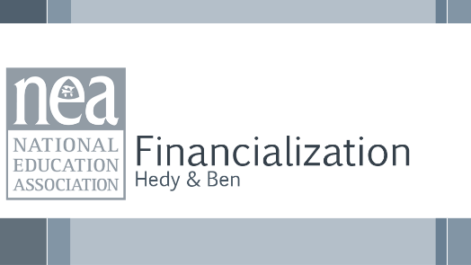  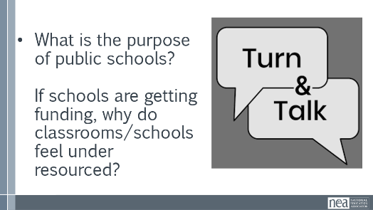  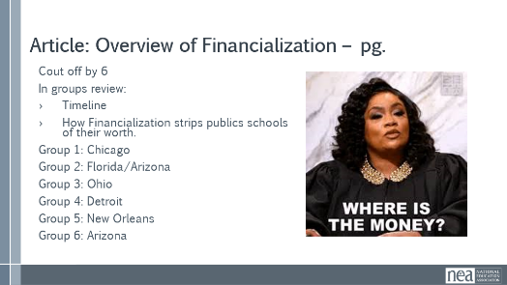  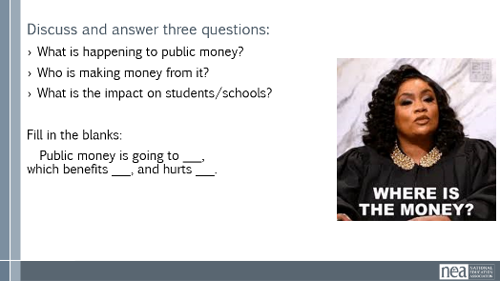  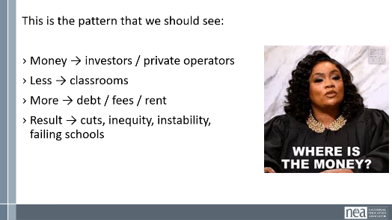  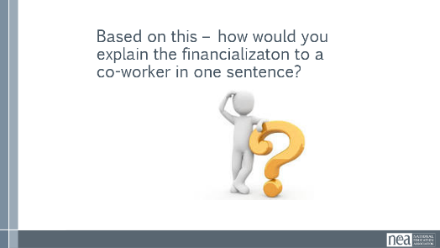  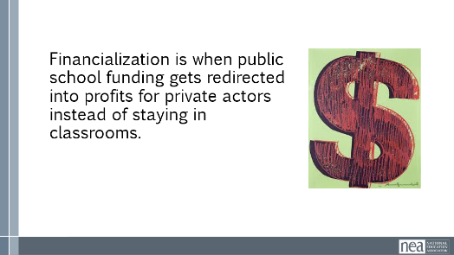  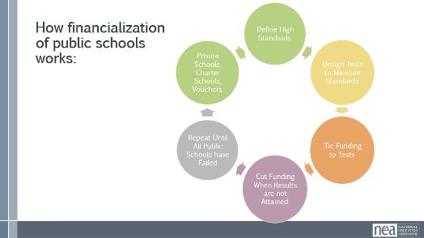  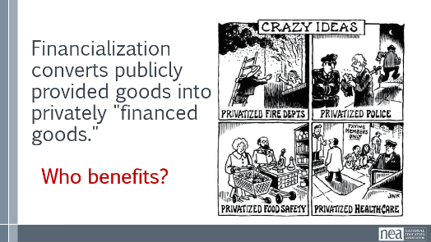  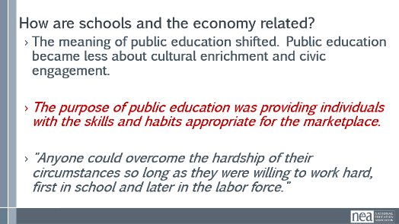  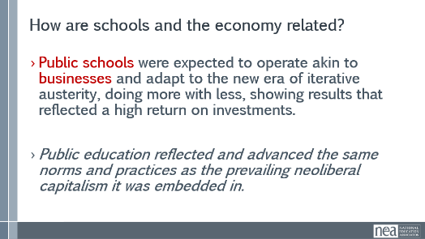  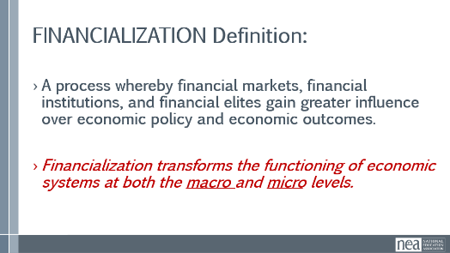  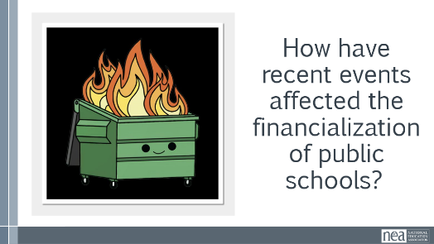 |  |  | IMPORTANT TO NOTE at some point in this section – This topic is essential to understand because ESPs are the easiest to outsource and cut when financially squeezed.  [IDEA- Send participants reading the night before, Tess will talk to Tim Barchak at ESPQ for good relevant articles to supplement this section (Eric-6/9/26)]  What is the purpose of public Schools?  (5 Mins) Ask: “If schools are getting funding… why do classrooms still feel under-resourced?”  Let 2–3 people respond.  Then give a simple framing: “This article argues it’s not just how much money schools get—it’s where the money goes.”  (10 mins) Break into small groups (3–5 people).  NOTE: It is helpful if you divide the group up ahead of time. The pre-attendance email for day 1 should lay out the directions and the prep work needed.  Sample email:  Make sure you have completed the following before tomorrow:  Module 2 in the course – Community Agreements.  Module 3 – you will need to know about shifting conversations around oppression  Module 5 – ESP Bill of Rights  Module 6- The concepts about financialization will be important for our work in the room on day 1  You have been pre- assigned to one of the following groups – 1-6 and these correspond to the articles found in the ATTACHED document. This document is also in the course module called Participant Handouts, the second file down. This should only take 5 minutes.  - Chicago (debt & Wall Street)  - Florida/Arizona (vouchers)  - Ohio/ Wisconsin (charter scandal and diverting state aid)  - Detroit (emergency management)  - New Orleans/ Pennsylvania (100% charters and Cyber Charter)  - West Virgina ( ed savings accounts)  EVERYONE READS THE WHOLE ARTICLE – but your groups are assigned to specific examples that you will need to be familiar with tomorrow.  Give each group ONE short example (you can assign verbally):  - Chicago (debt & Wall Street)  - Florida/Arizona (vouchers)  - Ohio (charter scandal)  - Detroit (emergency management)  - New Orleans (100% charters)  - West Virgina ( ed savings accounts)  Ask them to answer 3 questions:  - What is happening to public money?  - Who is making money from it?  - What is the impact on students/schools?  (10 Mins) After the discussion, each group should complete this sentence, and write it on chart paper:  Public money is going to ___, which benefits ___, and hurts ___.  This is the pattern that we should see:  - Money → investors / private operators  - Less → classrooms  - More → debt / fees / rent  - Result → cuts, inequity, instability, failing schools  (5 Mins) Ask the full group:  So based on all this—how would you explain financialization to a coworker in one sentence?”  Take answers from the group  One suggestion: “Financialization is when public school funding gets redirected into profits for private actors instead of staying in classrooms.”  Slide 53 What does this look like in our schools?  Optional final question:  “What’s one thing educators should push back on when we see this happening?”  Key Ideas:  Financialization converts publicly provided goods into privately "financed goods.”  ASK: How have recent events impacted the financialization of public schools?  2024 Election -  COVID - ESSR funds usage, impact on supporting the work, etc...  Custodians, Transportation, Security, etc... those furthest from the kids most vulnerable to outsourcing.  [ADD- Make a KEY IDEAS slide before lunch (Eric-6/9/26)]  [ADD- Who are the decision makers, how could the circumstances changes, and what role do YOU play in making that happen. Intent here is to highlight that education is one of the only jobs where the employees “choose” their bosses. (Eric-6/9/26)] | Participants will engage in an activity that highlights the history of the evolution of capitalism and public schools  Who benefits from privatization of public schools?  How has COVID affected the finalization on public schools? Political climate?
12:00-1:00 LUNCH
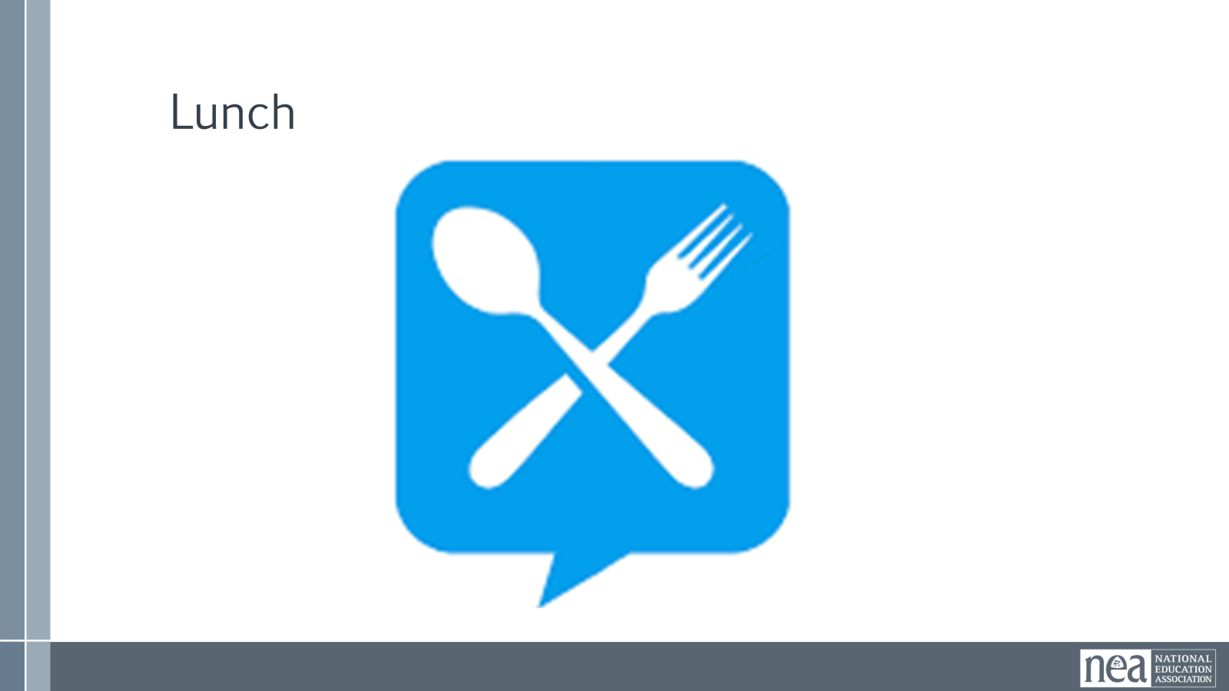
1-1:30 Hedy & Ben |  |  | Financialization (60 Mins - Split 30 before and 30 after lunch)
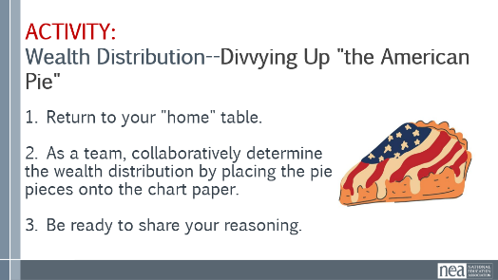  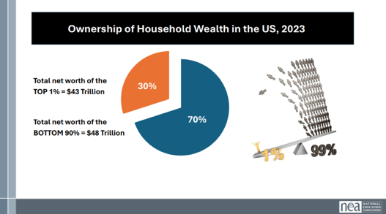  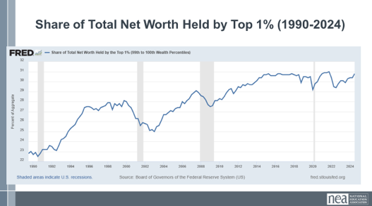  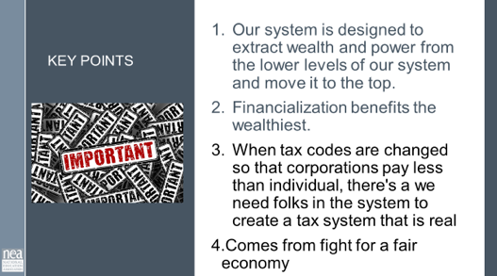 |  |  | 5 min--Slide 37-38—ACTIVITY: Wealth Distribution-Divvying up “the American Pie”  1. Return to your "home" table.  2. As a team, collaboratively determine the wealth distribution by  placing the pie pieces onto the chart paper.  3. Be ready to share your reasoning.  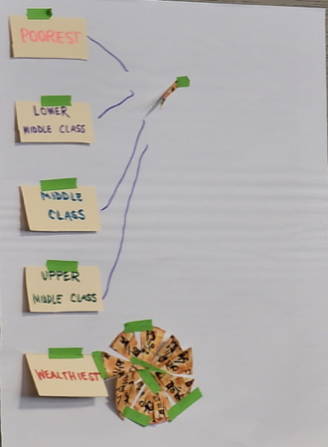  3 min--Groups Report Back/Record Wealth Distribution Predictions on chart from each table  NOTE: Emphasize the difference between INCOME (what is currently earned) vs. WEALTH (remaining assets once all debts are paid) (EX: Health is only an asset once it is paid off)  5 min--SLIDE 41: VIDEO of results America's Economic Pie Video (5 min)  Hedy must leave the room when they show this video, or she will yell at the screen from the back of the room.  42-43  Show the disproportionate wealth with circle graph (slide 42) and line graph (slide 43)  Maybe begin with – a very quick what is the difference between wealth and income?  Might need new slide here that outlines where wealth is currently  2023 Wealth distribution (in trillions)  Top .1% has $19.85 T  Top 1% has $43.44 T  Top 10% has $94.89 T  50-90% only has $43.89 T  0-50% only has $3.64 T  A million seconds is11 days, 13 hours, 46 minutes, and 40 seconds.  A billion seconds is 31.7 Years  A trillion seconds is 31, 710 years  10 Min? Team time to chart  How does this information give you the power you need to make a change?  2 min—SLIDE 44-Key Points  - Our system is designed to extract wealth and power from the lower levels of our system and move it to the top.  - Financialization benefits the wealthiest.  - When they change the tax codes, where corporation pay less than individual, we need folks in the system to create a tax system that is real  - Comes from fight for a fair economy | Participants will engage in an activity that highlights wealth distribution
1:30- 2:15 Eric S/Sonia |  | An Institutional Problem (45 min)
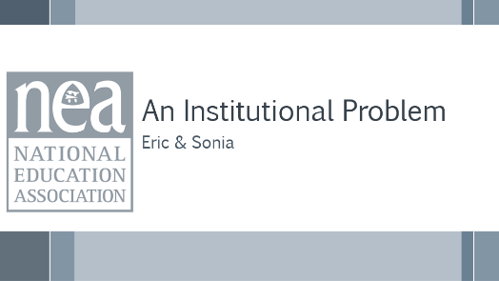  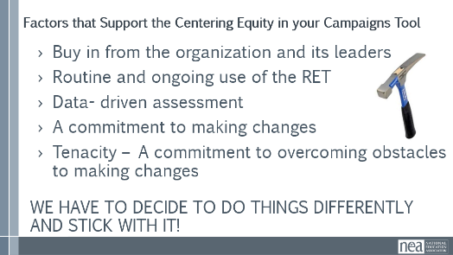  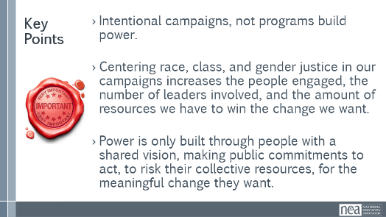  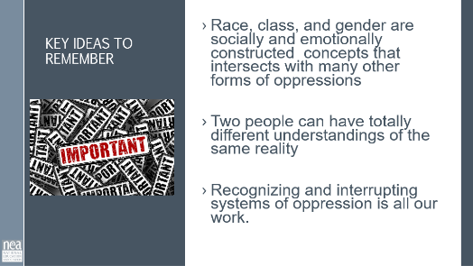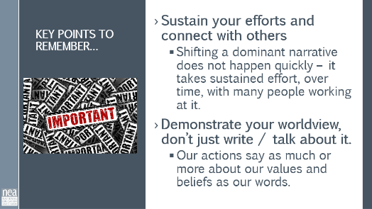 |  | “Analyzing Everyday Oppression in Union Work” (Angel Scenario) Pg. 23-24 | 10 min - Intro:  We are now going to dive into how we can recognize and prevent oppression in our union work.  Oppression operates on multiple levels, and this drives us toward taking a systems thinking approach to addressing its impact. Biases lead to the development of stereotypes that feed prejudice and discrimination accumulating in systemic oppression.  So, what does it mean to “center racial, class and gender justice?”  Race, class, and gender disparities are deeply embedded in society, affecting communities, schools, and classrooms. Systemic oppression is rooted in history, culture, and institutions, making its impact constant and unavoidable.  Achieving race, class, and gender justice requires more than eliminating discrimination—it involves intentionally creating and maintaining systems and supports that ensure equitable opportunities and outcomes for everyone through proactive and preventive efforts.  To continually and systematically keep equity in your work you have to use a Race, Class, and Gender Equity tool, or lens. This is a personal and institutional commitment to:  - Proactively seek to both eliminate systemic barriers and advance equity  - Identify clear goals, objectives and measurable equity outcomes  - Develop mechanisms for successful implementation of equity focused programs  - A set of questions used to anticipate, assess, and prevent potential adverse consequences of proposed actions on different race, class, or gender groups.  TOOL—"Centering Equity in your Campaigns” - Pg. 99  - Take a moment to review these tools  Key Points –  - Intentional campaigns, not programs build power.  - Centering race, class, and gender justice in our campaigns increases the people engaged, the number of leaders involved, and the amount of resources we have to win the change we want.  - Power is only built through people with a shared vision, making public commitments to act, to risk their collective resources, for the meaningful change they want.  15 Min- Analyzing Everyday Oppressions in Union Work questions  You will now work at your table with a story about “Analyzing Everyday Oppressions in Union Work” found on pg. 23-24 of participant handouts.  - You were asked to read and review this before coming so it should not be completely new at your table.  - Working with your table mates, share your answer to the 5 questions on the back.  - The 5th question is the most important, and likely the one you’ll struggle with most. Lean into it.  15 Minutes – Debrief  Focus on having one table report on each of questions 1, 2, 3, and 5 – save question 4 for the end.  - What are the problems that Angel is facing?  - What are causing those problems?  - Where is the leadership in this story?  - What solutions could address these problems?  - What race gender and class is Angel?  - How do you know?  5 Minutes Key Ideas –  - Race, Gender, and Class are socially and emotionally constructed concepts that intersects with many other forms of oppression  - Two people can have totally different understandings of the same reality  - Becoming anti-racist, classist, and genderist requires a system approach  - Sustain your efforts, change happens over time  - Act on your values | Participants will recognize components of oppression and reflect on what they see in their own practice and the systems they support.  What are some of the reasons for the injustices that our ESP members face each day?

2:15-2:30 BREAK
2:30 – 3:00 Beth |  | Defining Class, Questioning Systems, Reflections on Practices
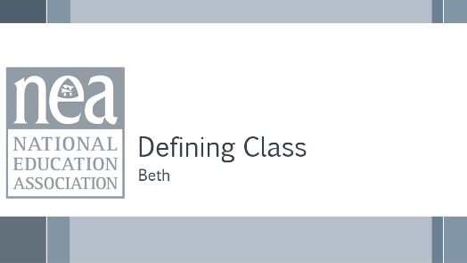  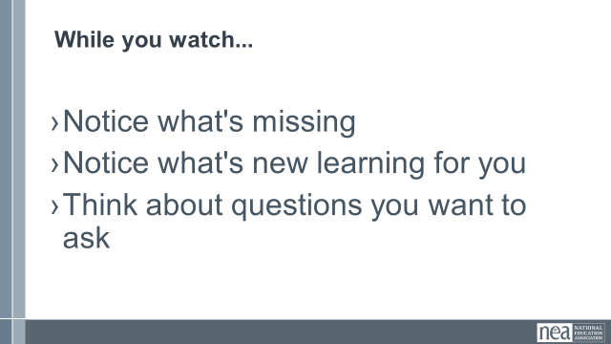    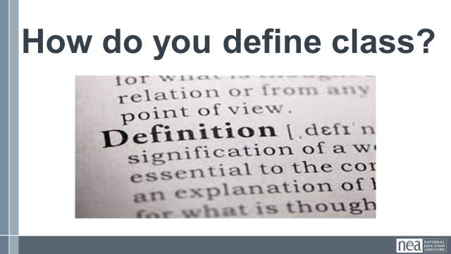  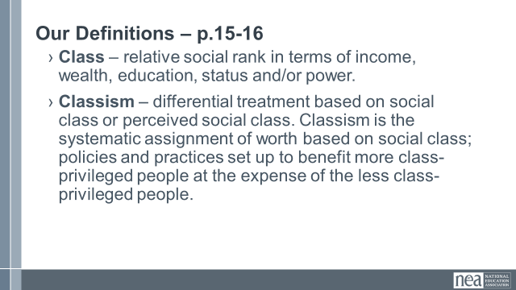 |  | Video about Classism  Defining Classism  Page 40-41  Classism | 5 Min - Introduction and Definition Pg 40-41  Welcome back everyone. Think of the affinity wall you did this morning and the challenges that your members have – and think about some of the narratives we discussed. We are going to take a look at how our organizations’ and our own relationship to class privilege may be part of the problem. We are going to do that by taking a look at a short video. While you watch notice what’s missing, Notice what’s new learning…for you, think about questions you want to ask.  10 Min – Video and discussion  Watch video and discuss. What did you notice?  (Participants will likely notice that there is a lack of race as part of the analysis, that there are two white people speaking in coded language about classism instead of racism) Key point  Have participants answer the questions:  - What’s missing?  - What’s new learning for you?  - Questions you want to ask  10 Min – Definition  At your tables, come up with a definition of class as you see it. (Take some definitions from around the room) Share our definition slide (p.15-17) –  - Class – relative social rank in terms of income, wealth, education, status and/or power.  - Classism – differential treatment based on social class or perceived social class. Classism is the systematic assignment of worth based on social class; policies and practices set up to benefit more class-privileged people at the expense of the less class-privileged people.  Ask - What do you see here that is missing from yours? What would you like to add?  Race, class, and gender are all connected, it’s intersectionality – cannot be separate, for those who have been on this journey...yet | Participants will clarify what classism is and make the connections to systemic oppression.
3:00– 3:35 Monet |  | Practice Defining Class, Questioning Systems, Reflections on Practices (35 Min)
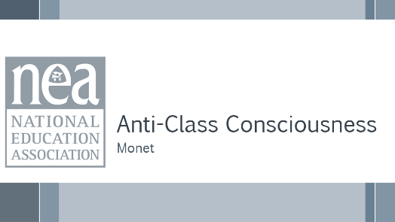  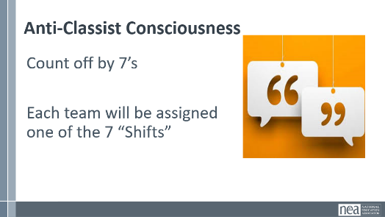  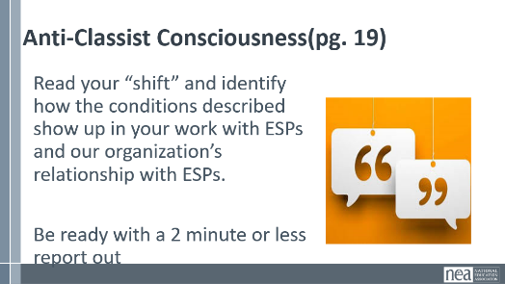  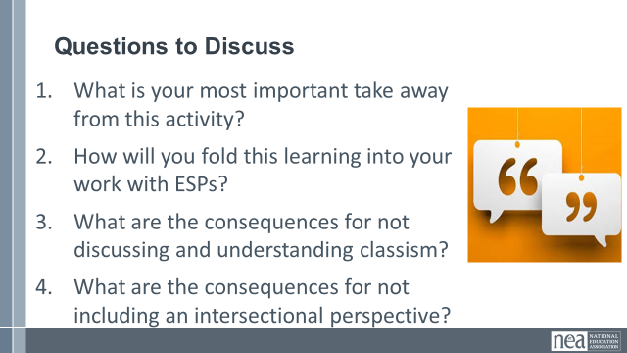  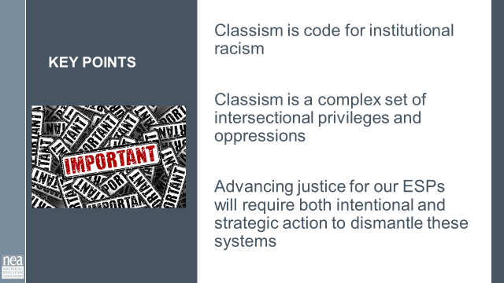 |  | Anti-Classist  Page 19 | 5 min – INTRODUCTION  Recognizing Classism in Our Organizations and Practices pg. 19  Intro activity (use word: intersectionality) and get into groups. We are going to be creating teams by counting off by 7’s. Each team will work with 1 of the 7 Shifts of Consciousness in the Anti-Classist Activist.  Each Table will read their “shift” and identify how the conditions described show up in our work with ESPs and our organization’s relationship with ESPs. Be ready for each table to report out and have a discussion about the reflections they make.  10 Min Work in Groups with 7 shifts handout  15 Min – Report out (2 minutes per team)  5 Min – Final Debrief  SAY:  - What is your most important take away from this activity?  - How will you fold this learning into your work with ESPs?  - What are the consequences for not discussing and understanding classism?  - What are the consequences of not including an intersectional perspective  1 Minute Key points  - Classism is code for institutional racism  - Classism is a complex set of intersectional privileges and oppressions  - Advancing justice for our ESP will require both intentional and strategic action to dismantle these systems | Participants will clarify what classism is and make the connections to systemic oppression.
3:35 – 4:10 Ben |  | Issue Identification (35 min)- need more time for this section
  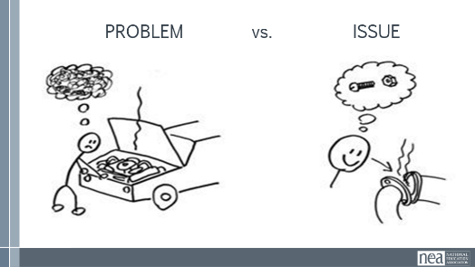  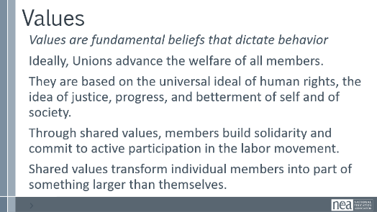  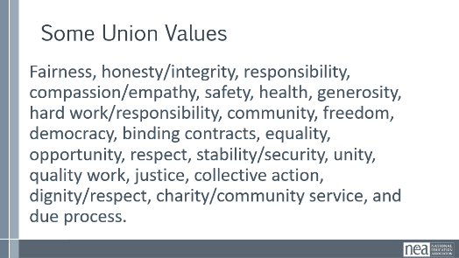  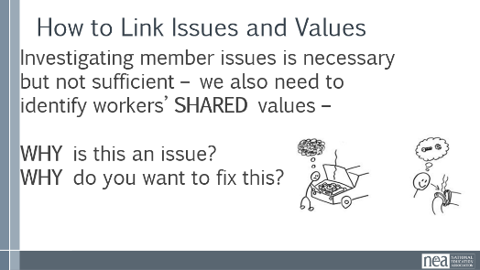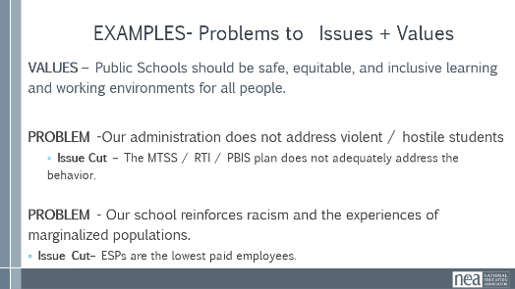  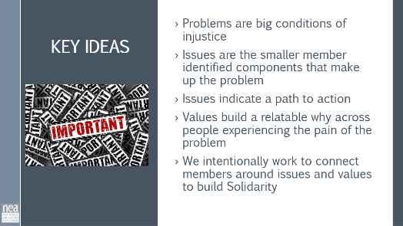  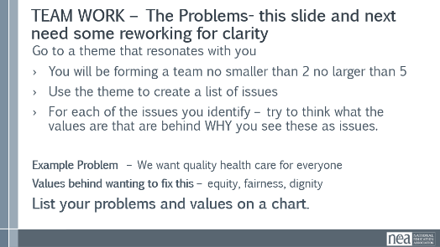  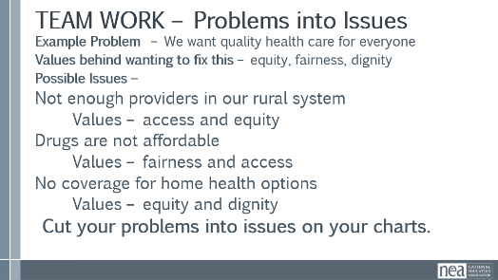  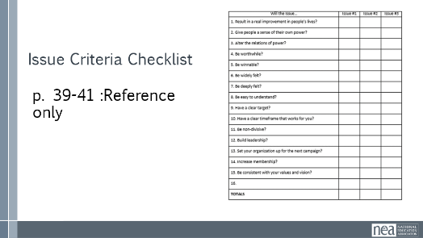  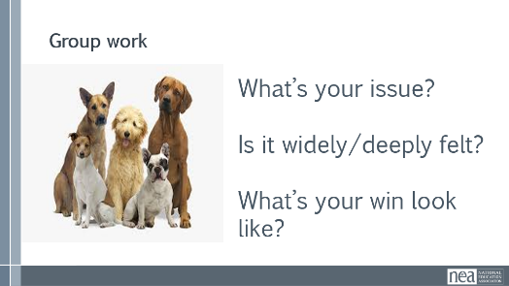  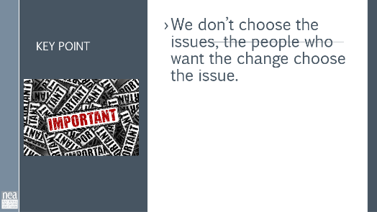 |  | Page 39-41 as a references | 10 Minutes Content PROBLEM , ISSUES and Values  - Campaigns start with issues that people have value-based solidarity around.  - An issue is a slice of a workplace problem.  - Often a problem can have different issues depending on the perspective of the people we are working with.  - It is KEY to get enough input on what the issues are that make up the problem so that YOU do not drive the solution.  - Investigating the issue is necessary but not sufficient – we also need to identify workers’ SHARED values – WHY is this an issue? WHY do you want to fix this?  For example, A problem My Car is a piece of JUNK --- Issues – broken radiator hose, bad brakes, smelly interior, hole in the muffler.  ADD THIS TO SECTION (FIX time)  [Facilitator walks whole group through delineating problem vs issue from the affinity wall.]  [Teams work to identify a problem and the issue that will become their campaign (can be selected from the affinity wall)]  [Room unpacks PROBLEMS and ISSUES that teams develop]  We Begin to Get to Values when we ask WHY?  VALUES are  - Values are deeply-held beliefs that shape who you are.  - Ideally, Unions advance the welfare of all workers.  - They are based on the universal ideal of human rights, the idea of justice, progress, and betterment of self and of society.  - Through shared values, workers build solidarity and commit to active participation in the labor movement.  - Shared values transform individual members into part of something larger than themselves.  Some union values we might recognize: Fairness, honesty/integrity, responsibility, compassion/empathy, safety, health, generosity, hard work/responsibility, community, freedom, democracy, binding contracts, equality, opportunity, respect, stability/security, unity, quality work, justice, collective action, dignity/respect, charity/community service, and due process.  How to Link Issues and Values – The Organizing Conversation Magic  You might ask, Do you want to fix this problem? Which of these do you think you can fix? Which one matters the most to you? Why does it Matter?  The radiator hose is something that my friend and I can fix and it matters to me because I can afford to fix it.  The radiator hose will be fixed by putting a new fitting on it. Is an issue that allows me to see the solution.  We can get to values by asking how do you feel about your car being a piece of junk? Do you think others feel the same way about cars that are pieces of junk? Why do you want to fix this problem?  We deserve safe and reliable transportation  We deserve access to affordable and quality car parts  Share slide of examples of Problems, the Values, and the issue Cut  Key Ideas  Problems are big conditions that have several smaller solutions  - Issues are the components that make up the problem  - Issues indicate a path to action  - Values build a relatable why across people experiencing the pain of the problem  - We intentionally work to connect people around issues and values to build Solidarity  15 minutes Team Work - Affinity Wall Themes and Team Formation  - Walk to a theme on the affinity wall that resonates with you  - Form a team of 2-5 people  - Take the theme and create a list of issues on a chart.  You and your team are going to make a list of issues that you and your members want to improve – these are big  For each of the problems you identify – try to think what the values are that are behind WHY you see this as a problem.  (MOVE THIS UP BEFORE VALUES)  3 minutes Debrief Whole Room – what did you decide to do? (5 minutes) Take a few examples of problems into issues.  What is the Problem?  What are the issues?  What are some Unifying Values?  2 Minutes Key Ideas – We listen for the values as talk about this problems.  This is how we build solidarity. | Participants will use a root cause analysis process to identify issues. They will apply an issue analysis to determine what makes a better organizing issue.
4:10-4:30 Ellen |  | Ending it Right (20 Min)
  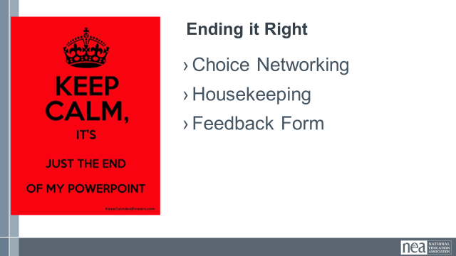  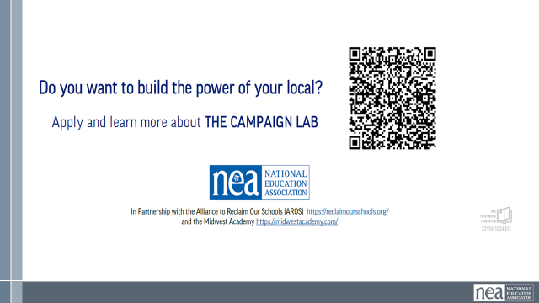 |  |  | Questions, Connections, Reflections  Housekeeping announcements  Evaluation via email | Participants will be able to bring a little closure to their learning and provide feedback on the day.
4:30 – 5:00 Ellen |  | Choice Networking Activities (30 Min)
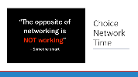 |  |  | Connect with colleagues from other affiliates. | Participants will make useful connections with staff from other affiliates.
5:00 | Adjourn

