Facilitator Agenda: Day # 2 Organizing ESP
General Materials Needed: |  |  |  |  |  | Room Set-up:
1 Set of Handouts per Person  Name Tags or Name Tents  Room signs, sign-in signs  Painters Tape |  | Chart Paper  Post its  Chart Markers – Mr. Sketch  Pens and Pencils |  |  |  | Round Tables  Projector, Screen and Speakers  Carousel stations and reporting stations around the perimeter  20 people  Email links for living wage calculator and budget calculator in advance  Charts needed for today:  1 per table for Living Wage  Spectrum of Allies charts, one per group (doing this to save five minutes of activity time)
Key Outcomes for the Day
Building conversation skills
Understanding financialization’s role in ESP wages
Living wage basics
What is a demand and target
What are tactics and escalation
8:30-9:00 Welcome Back  9:00-10:00 One on Ones and AAR  10:00-10:30 Spectrum of Allies  10:30-10:45 BREAK  10:45-12:00 Living Wage Campaigns (move to day 1)  12:00-1:00 LUNCH |  |  | Ellen  Jessica & Monet  Hedy & Jess  Beth & Michael |  | 1:00-2:00 Organizer Math  2:00-2:30 Centering Race Class and Gender  2:30-2:45 BREAK  2:45-3:15 Demand and Targets  3:15-3:45 Tactics and Escalation  3:45-4:15 Organizing Plan Team Time  4:15-4:30 Ending it Right  4:30-5:00 Choice Networking and Close |  | Hedy  Ben  Eric  Eric  Sonia  Ellen
Time, Slides, Facilitator | Resources |  |  | Instructions, Activity and Debrief (Facilitators) |  |  | Outcomes and Essential Questions
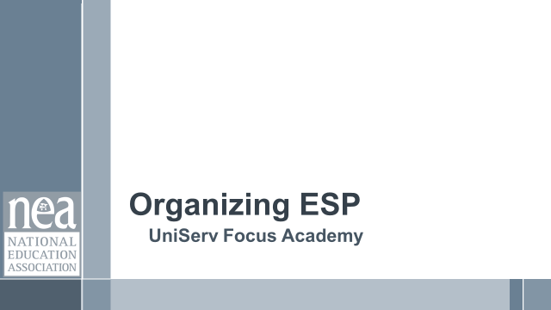 | Charts, handouts, articles, materials, slide |  |  | What are you saying, what are they doing, what questions will you use to guide learning and make clear the important points  Include an estimate for how long each section of the learning will take |  |  | As a result of this section, what will participants know or be able to do? What questions will this answer?
8:30 - 9:00 Ellen |  |  |  | Welcome Back (30 Min)
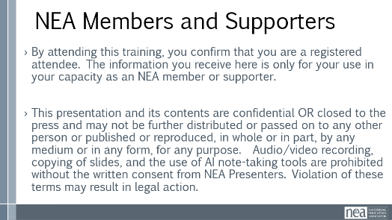 |  |  |  | 15 Min - Welcome  Reentry  Feedback on Feedback  Agenda Review  Norm Review  For Organizer Math later in day— ADD telephone game of with sticky notes for grassroots organizing (dunbars numbers)  15 Min - Revisiting Classism discussion - [if needed]  After stepping away and reflecting, let's expand more on these two questions. What was your reaction to #1? Great info but not going to happen, don’t know how to do it, putting a plan together right now...  - How will you fold this learning into your work with ESPs?  - What are the consequences for not discussing and understanding classism?  Spend most of time on #2 getting to: If our members don’t name this, plan on how to address this and work to erase this within their own worksites and locals they will always be limiting their own power. How would someone who feels put down, degraded, othered and worse feel empowered. Without addressing this first, changing the narrative, collaboration, respect and understanding internally it will always be extremely difficult to move to change any external narrative. |  |  | Participants will re-enter the learning environment.  What have you been thinking about so far?
9:00 – 10:00 Jess & Monet |  |  |  | Organizing Conversations (1:1’s) (15 minutes) & AAR (45 Min)
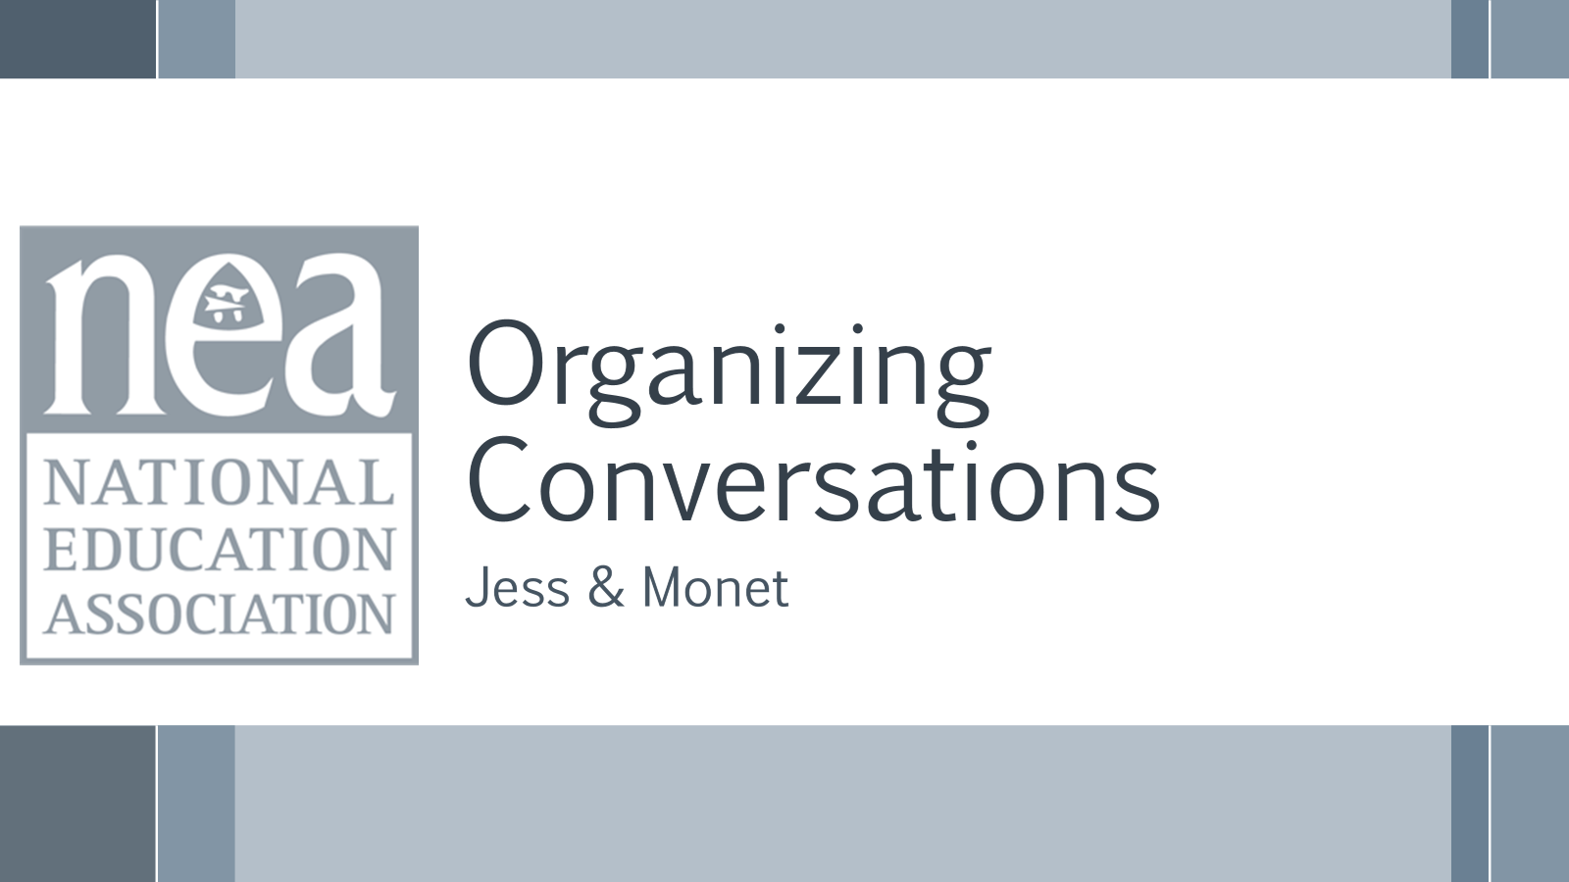  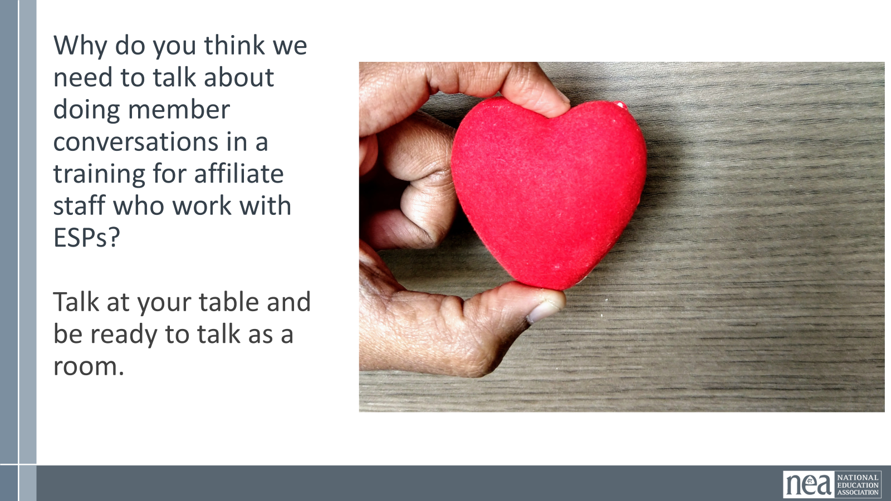  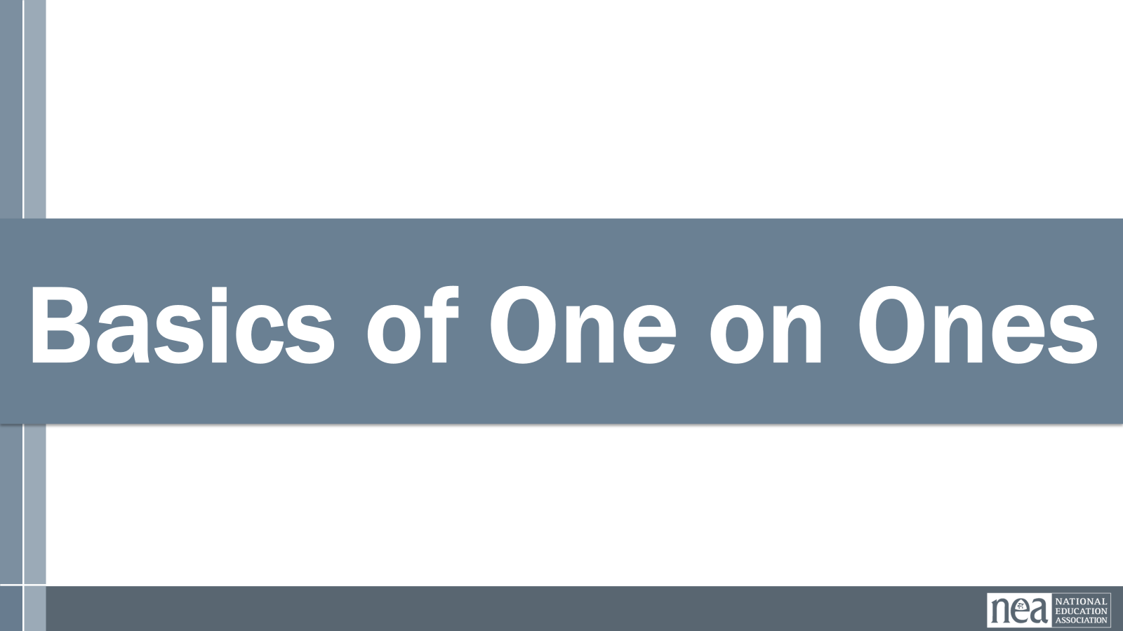  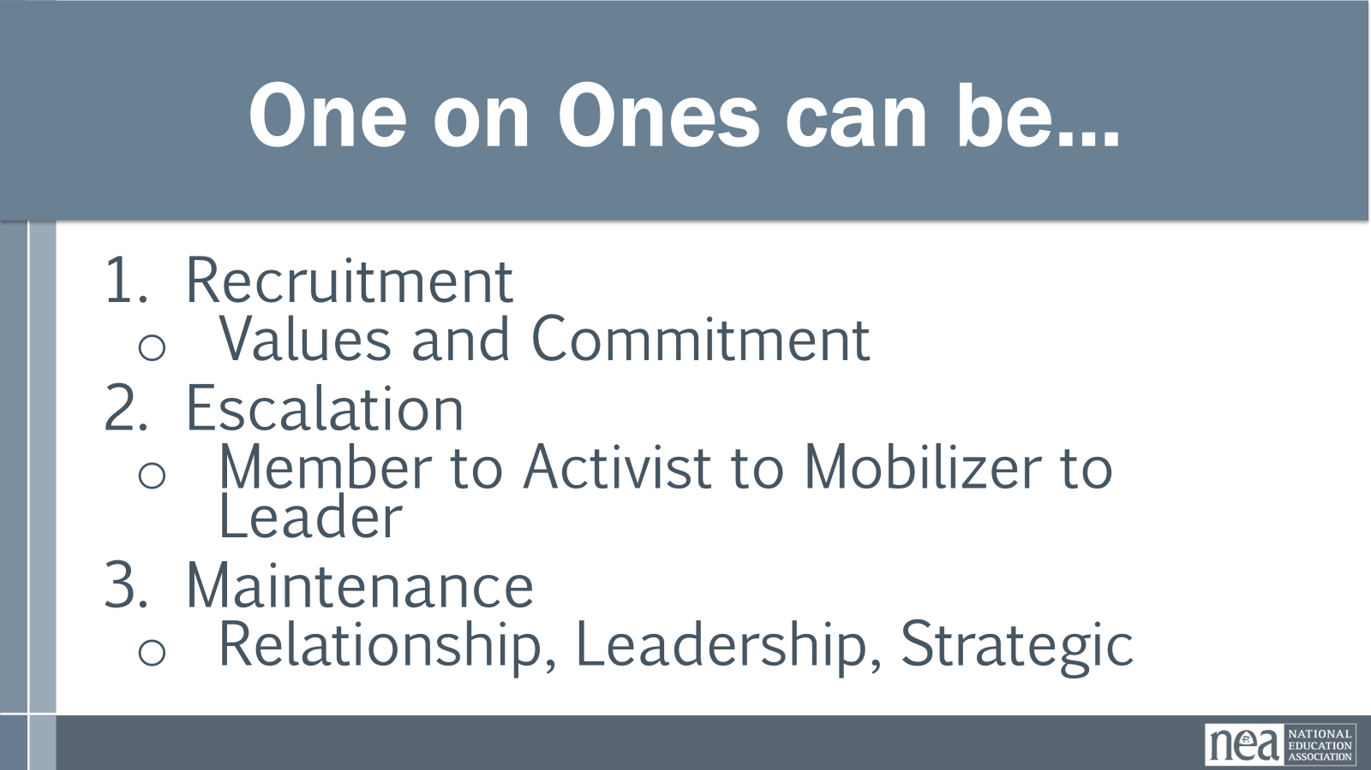  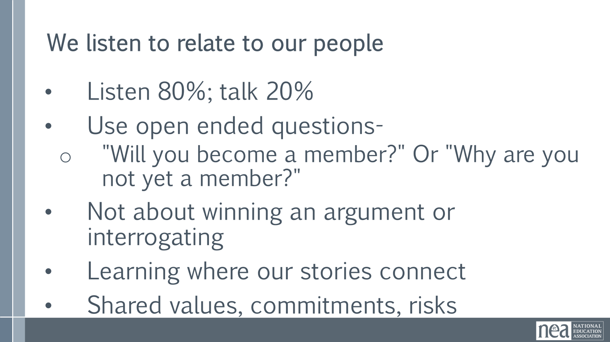  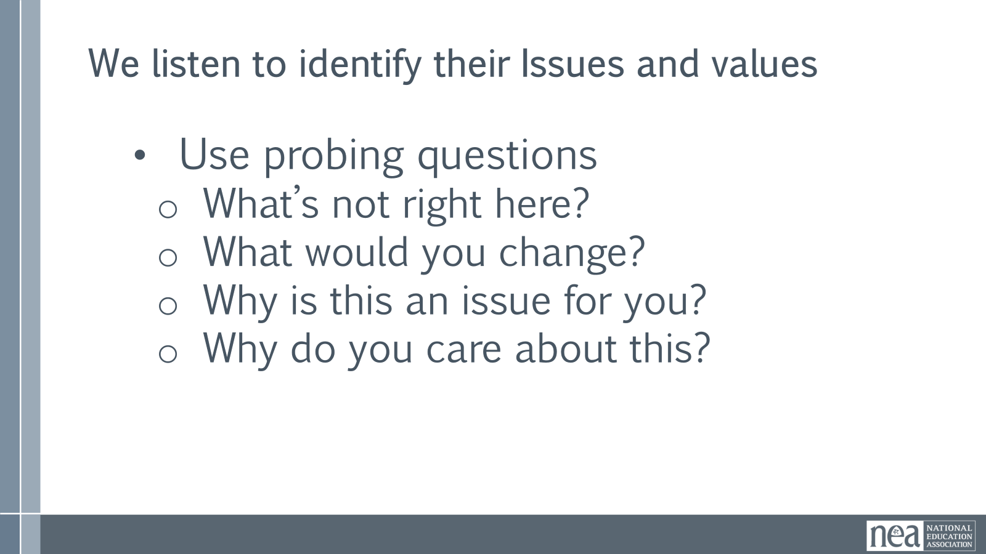  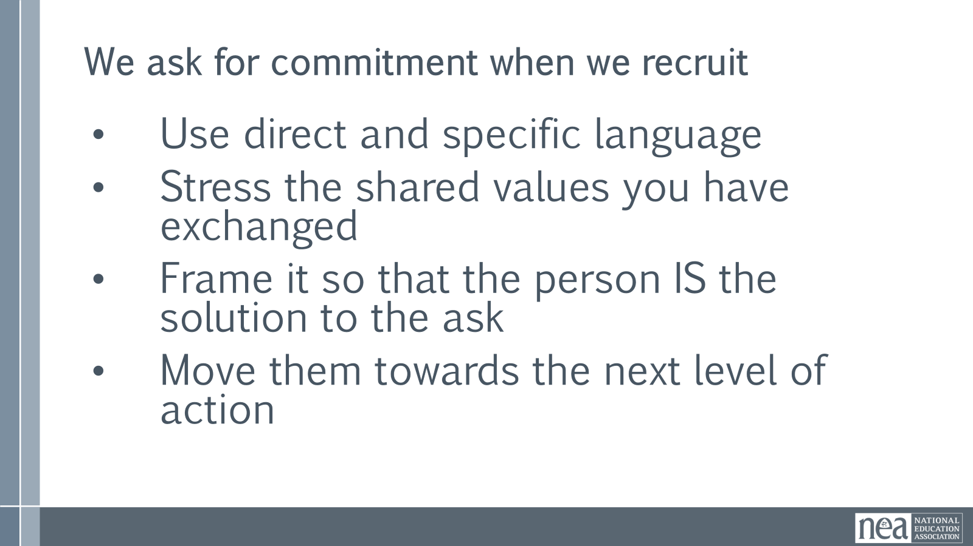  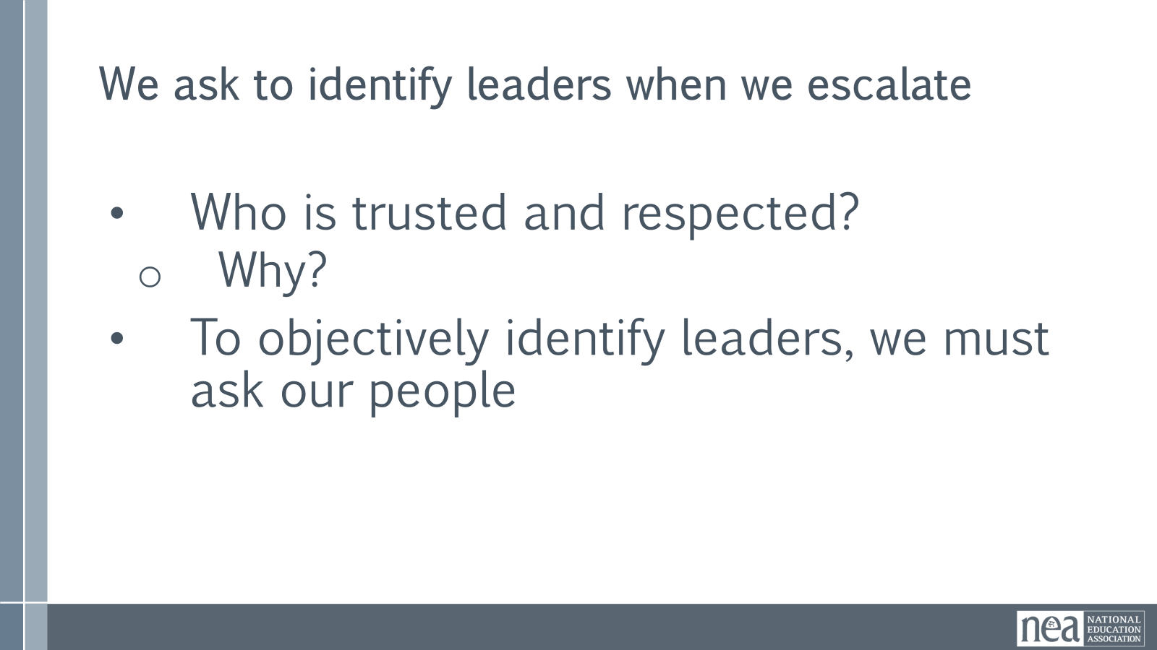  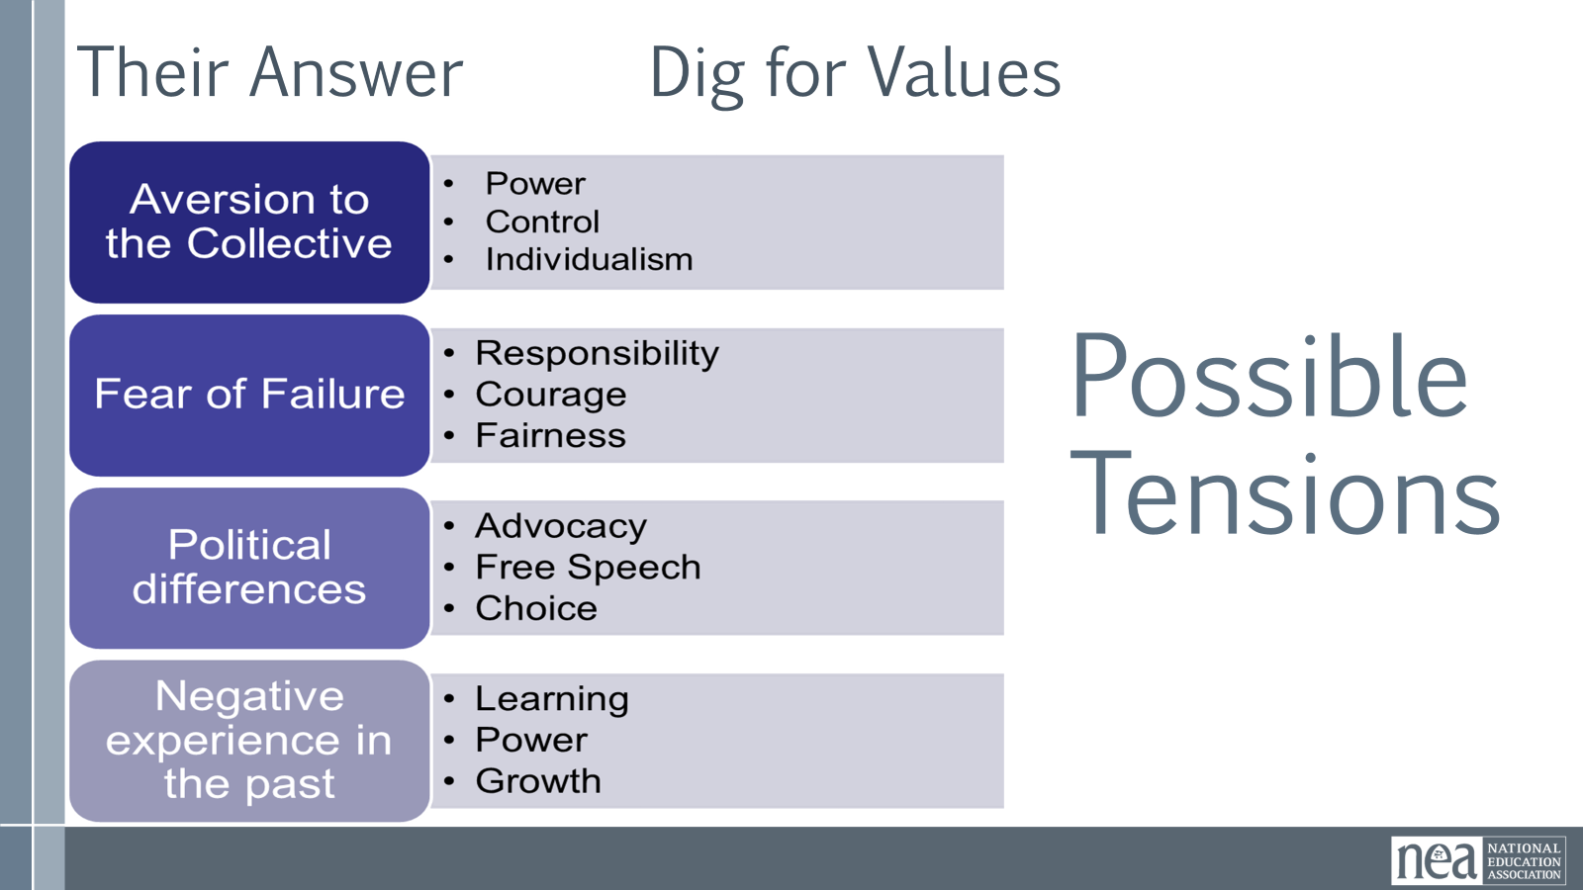  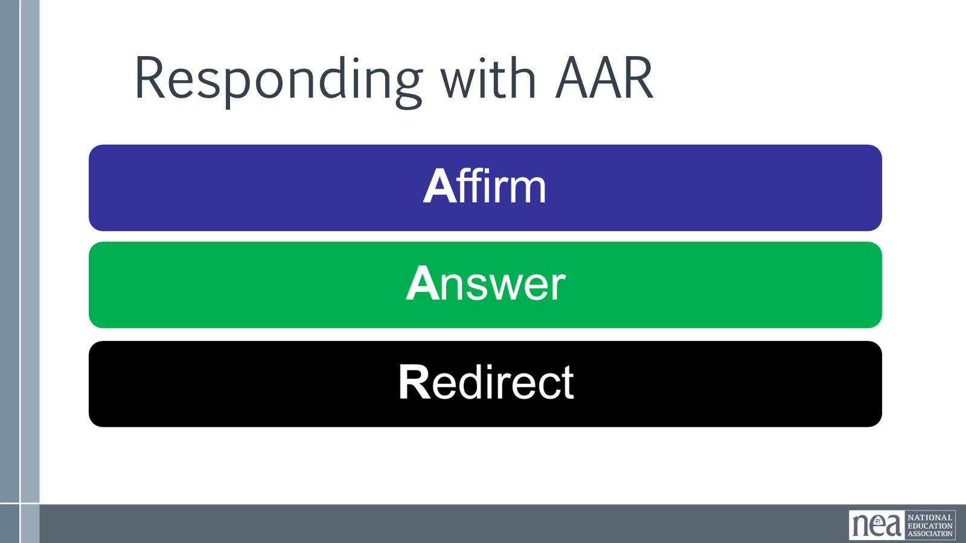  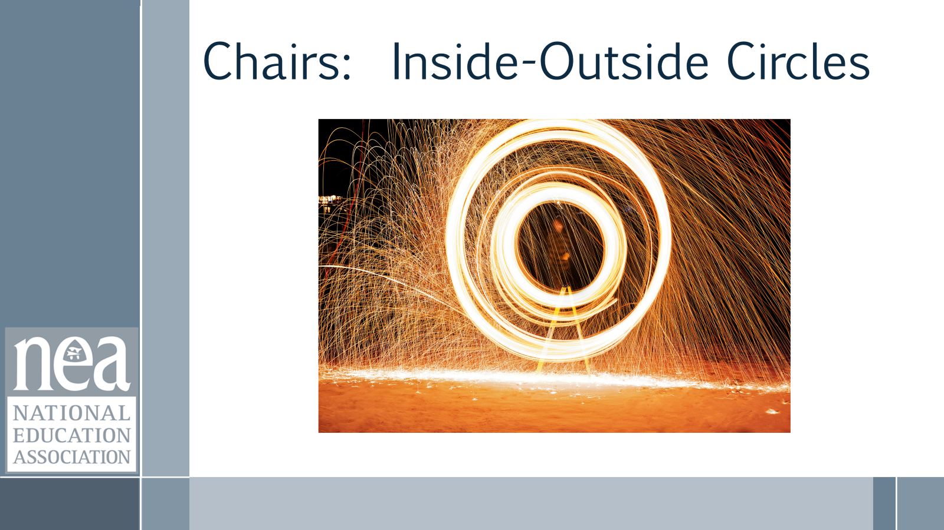  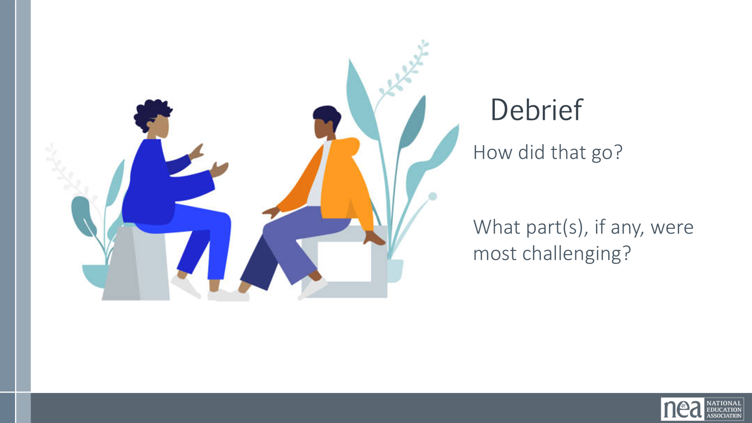  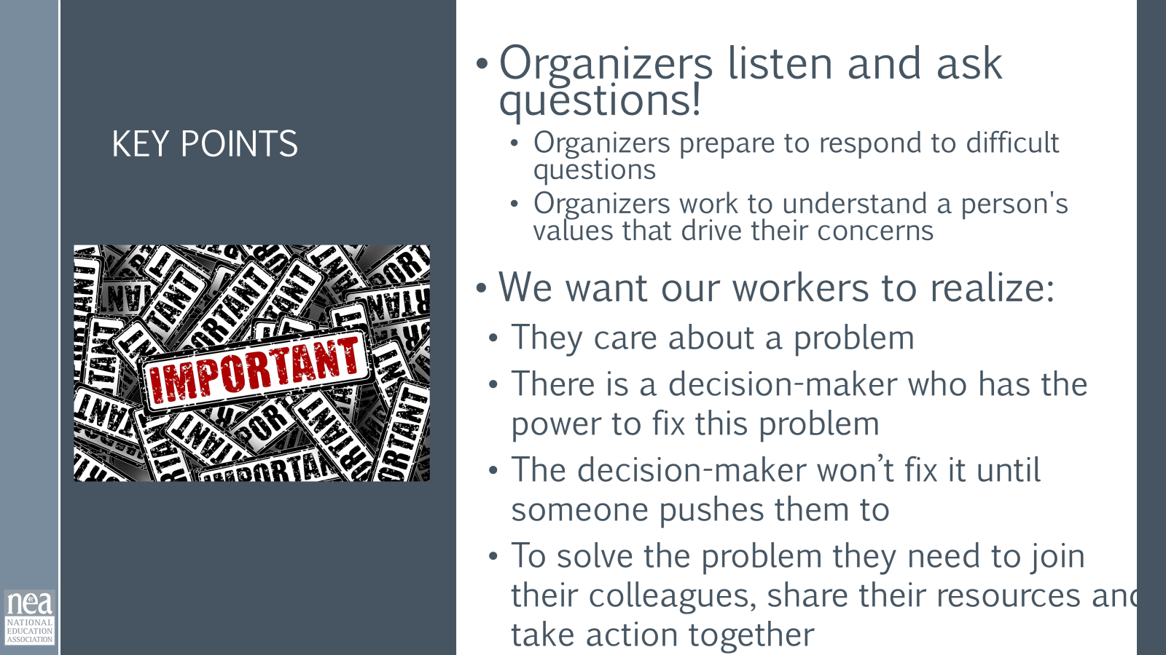 | Resources:  NEA ESP Messaging Framework  Narrative Training Guide |  |  | 15 Min - How do we identify members’ issues and build relationships? --Jess  ERIC- CHANGE to numbering people 1s 2s 3s and get rid of the inner/outer circle  -Keep AAR  -Update Activity Directions (Eric-6/10/26)  Why do you think we need to talk about doing member conversations in a training for affiliate staff who work with workers?  Take some time – about 5 mins – and be ready to talk as a room  What did you come up with?  When one person talks to another person  And it’s primarily to get to know each other, but can be used for  Recruitment, Escalation, Maintenance  - Recruitment  - Values and Commitment  - Escalation  - Member to Activist to Mobilizer to Leader  - Maintenance  - Relationship, Leadership, Strategic  We listen to relate to our people  - Listen 80%; talk 20%  - Use open ended questions  - Not about winning an argument or interrogating  - Learning where our stories connect  As Organizers we are listening to identify their issues and values, not TELL them what the issues are  We use probing questions such as:  •Use probing questions  What’s not right here?  What would you change?  Why is this an issue for you?  Why do you care about this?  •Use direct and specific language – Are you ready to sign this pledge cards, will you bring 5 people with you  •Stress the shared values you have exchanged - Like you, I have been low paid person that has felt disrespected by my managers  •Frame it so that the person IS the solution to the ask – We cant win this if you do not show up, You are critical to the success of this action  •Move them towards the next level of action – You joined us last month at Happy Hour, can you bring 5 people  We do not organize worksites, worksites are already organized by natural leaders  We have to ask who is trusted and respected  Even if they are not a member, we need to be in contact  We cannot identify leaders based on our own observations and bias' -  They wear the swag, they have been here 20 years but no one talks to them  We have to ask our people who they trust.  Ex: The attendance at the most recent ESP Conference  5 Min - Affirm/Answer/Redirect: Intro - Monet  You will often experience conversations where concerns, incorrect information, tensions and disagreements come up. One strategy we are going to explore involves suspending assumptions; instead of immediately disagreeing or responding, what are some more probing questions we could ask to get at the CORE VALUES of their objections? In the slide, we see some broad categories of barriers, such as political differences and an aversion to collective action. But, if we try to dig deeper, maybe we will find that their aversion to the collective is really about their valuing of individualism or that they prefer control. If we can identify those values, we will be better positioned to respond in a productive and engaging way.  Another strategy to answer challenging questions and statements is to use the framework of Affirm, Answer and Redirect; this approach can be very helpful.  AFFIRM: Let them know you’re listening, you understand, and their feelings are valid. Don’t get mad at them—validate and educate them.  ANSWER: Give a truthful, concise answer to the question. If you don’t know the answer, don’t guess. Tell them you’ll find out and get back to them.  REDIRECT: Once you’ve answered the question, bring the conversation back to ask them to join your membership.  Example:  Statement: Unions are too aggressive.  Response:  AFFIRM: I was nervous too. I’m also an educator so my first instinct is to work together and help students—not agitate.  ANSWER: I have actually found our union to be very collaborative and supportive. We are working together with administrators and lawmakers from both major political parties to find a shared path forward, and I know we can be even more successful with a voice like yours at the table.  REDIRECT: Together, our voice can be even stronger to improve our daily lives and give students our best. Will you join ____________________ as a member?  5 minutes - Facilitator directs participants to create two circles of chairs in the room- one chair facing another. [Sometimes known as inside-outside circles]  20 Min - Practice  Count off the participants by 2; direct the 1s to go to the chairs in the outer circle and the 2s to go to the inner circle. The outer circle will act as the organizer for 2 rounds of conversation; then, the inner circle will act as the organizer for the next 2 rounds of conversation. Allow 5 minutes for each round of conversation. Have the outer circle rotate counter-clockwise after each conversation.]  - Imagine you are in the middle of a 1:1 conversation with a worker; the organizer asks “Can you share why you haven’t yet joined our union as a member?”  - The worker will reply with one of these:  - I’d like to join but the fees are too high.  - I just have a hard time believing that joining a union will make a real difference in my life.  - Unions are too political  - Unions don’t focus on issues that matter to custodians like me  - Organizer uses AAR to continue conversation and return to an ask  5 minutes - Facilitator directs participants to move chairs back INTO ISSUE TEAMS.  15 Min – Debrief & Key Points [If previous section ran long, only 10 minutes]  - How did that go? What was challenging?  - Key points: organizers prepare for difficult conversations and work to understand what values may be underlying a person’s concern or hesitation or disagreement. |  |  | Participants identify the types of one-to-one organizing conversations  How can we find out our people’s issues?  How do we have effective organizing conversations to identify member’s issues?
10:00 – 10:30 Hedy & Jessica |  |  |  | Spectrum of Allies (30 minutes)
  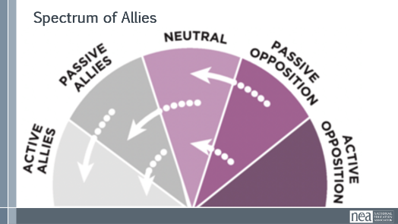  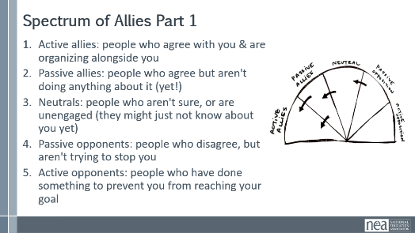  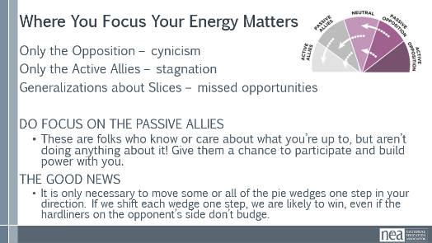  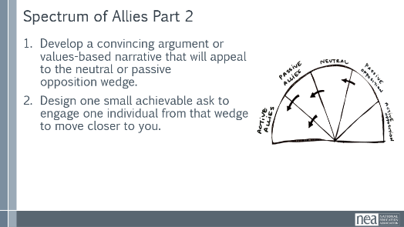  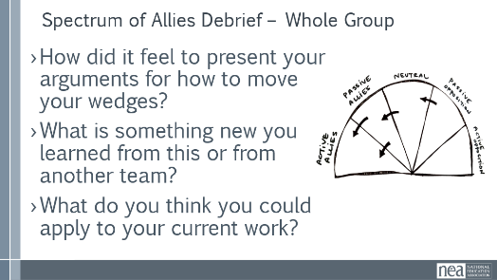  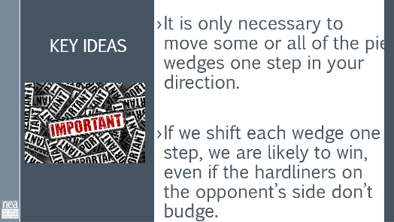 | Spec of Allies Charts (or 1 to use as template) |  |  | Spectrum of Allies  Hedy: 5 minutes Content  Earlier today, we talked about how classism and racism can show up in this work. This often comes into the picture when we think about who our allies are and who are those that oppose the change we want to make. I don’t know about you, but I frequently run into divisions amongst the ranks of the ESP groups with whom I work; for example, the clerical staff maybe don’t believe that the custodial staff do the same “level” of work, and therefore, don’t deserve the same benefits. This isn’t just about job categories; all of the isms- classism, racism, sexism- are likely at play here.  So, let’s do an analysis around allies; we want you to intentionally think about the following:  - Your urgent message – why people need a solution to this issue as much as you do- what are your shared values?  - Your structure (leaders and teams)  - Your linked communities (not just YOUR people, but who they are connected with through shared values and commitments)  10 Minutes of work time For Step 1 Activity – Pg 122 Planning document - We are going to begin by learning a method Called Spectrum of Allies. All of our campaigns CAN include a wide range of groups, but particularly in the campaigns we are thinking about that you will be part of, you MUST include others outside of your constituency.  These include a wide range of groups that can be put on a kind of spectrum, from those closest to the point of view of the advocates to those who actively oppose change.  Spectrum of Allies – Part 1  - Active Allies  - Passive Allies  - Neutrals  - Passive Opponents  - Active Opponents  Draw a horizontal line to represent that. Those who advocate change are represented by a point at one end of the line (say, on the left), and the opponents by a point at the other end.  Draw a semicircle with wedges. The wedges closest to either end are the active allies and opponents, next in are passive allies. The group in the middle are neutral.  Use the issue that your group identified.  Begin by asking, who might be inclined to be most supportive, least supportive, or neutral. Some examples of groups: ‘unions?’, ‘poor people’s groups?’, ‘business community?’. In your teams, identify these (AND WHY) and put them on your spectrum on the spectrum, and write them into the ‘pie’. Be as specific as possible – names, make them up to match the vignettes you are working with. Identify why people are placed where you placed them.  Jess -- 5 Minutes Whole Group Share – Do a little share out – as the facilitator, focus on the sharing of why the teams placed certain people in certain places.  5 Minutes of Content – Where do you focus your tactics?  Focusing only on the opposition leads to becoming disheartened or cynical, which means you ignore potential allies and support. Focusing only on how to convince the important power-holder who is against you leads to ignoring all of the potential support you could build that could overpower her opposition  Focusing only on active allies leads to being an isolated interest-group, which also means you ignore potential allies and support Always doing events with the same group of individuals or organizations isolates you from creative, powerful community-building that can  arise from new alliances and partnerships  Generalizing about whole groups of people risks misunderstanding the nuances of communities If you think about "students" as an entire group, you ignore the huge number of different groups & organizations (potential allies!) that exist in a student community  DO focus on passive allies. These are folks who know or care  about what you’re up to, but aren’t doing anything about it! Give them a chance to participate and build power with you.  Good news, In most social change campaigns, it is not necessary to win the opponent to your point of view, even if the powerholders are the opponent. It is only necessary to move some or all of the pie wedges one step in your direction. If we shift each wedge one step, we are likely to win, even if the hardliners on the opponent’s side don’t budge.  An example from history -  The 9to5 movement, formally know as 9to5: National Association of Working Women, was a grassroots organization founded in 1973 in Boston by Ellen Cassedy and Karen Nussbaum.  It focused on improving working conditions, pay equity, and ending sexual harassment for women clerical and office workers.  The movement's primary allies and key organizational partners included:  Labor Unions and Federations  - Service Employees International Union (SEIU): The most critical ally, which helped the movement transition from an association to a formal union. Together, they launched SEIU Local 925 (Boston) in 1975 and the national District 925 in 1981 to organize office workers.  - AFL-CIO: The largest federation of unions in the U.S. has frequently collaborated with 9to5 to advocate for labor laws, such as the Protecting the Right to Organize (PRO) Act.  - PASSIVE ALLIES - Other Supporting Unions: Organizations like the United Auto Workers (UAW), Communication Workers of America (CWA), and American Federation of Teachers (AFT) also invested resources in organizing women workers alongside 9to5. Emergency Workplace Organizing Committee +5  Who was against — men, business owners  5 minutes worktime – Choose either your Neutral or Passive Opposition wedge:  - Develop a convincing argument, or a narrative based in values that would appeal to this wedge for your issue, AND  - Design one small achievable ask to engage one individual from your chosen wedge to get them closer to you.  4 Minutes Whole Group Discussion/Shareout  1 Minutes – Key Points  It is only necessary to move some or all of the pie wedges one step in your direction.  If we shift each wedge one step, we are likely to win, even if the hardliners on the opponent’s side don’t budge.
10:30 – 10:45 BREAK
10:45–12:00 Michael Beth | Living Wage Campaigns (75 Min)
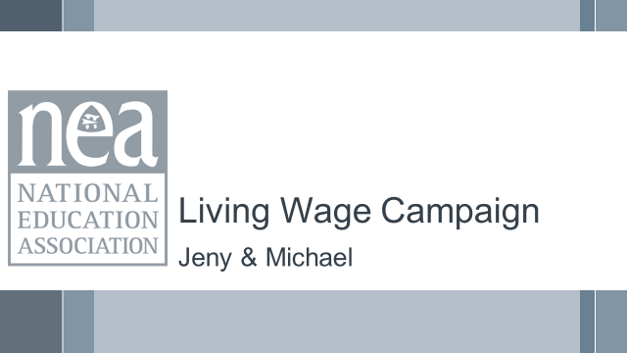  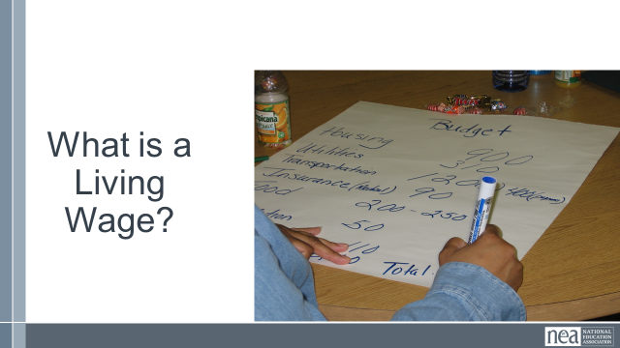  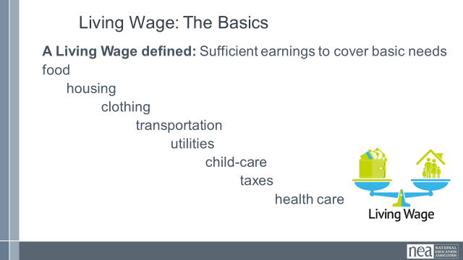  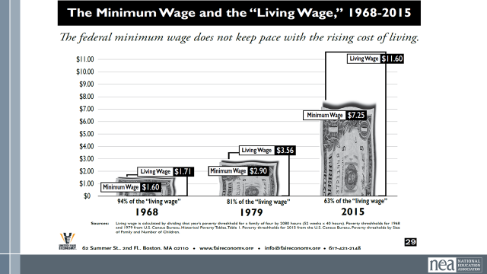  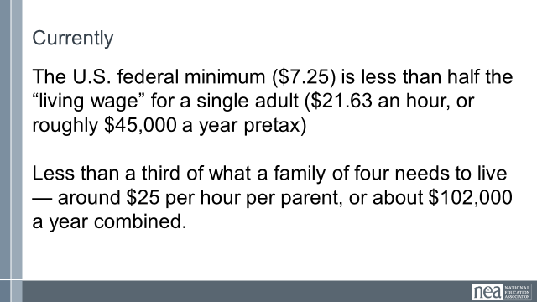  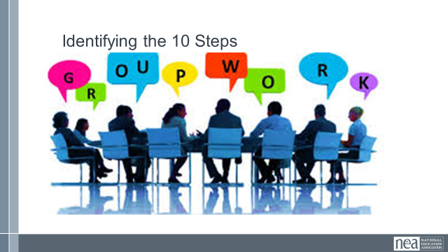    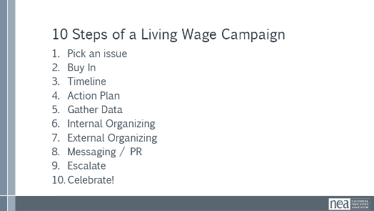  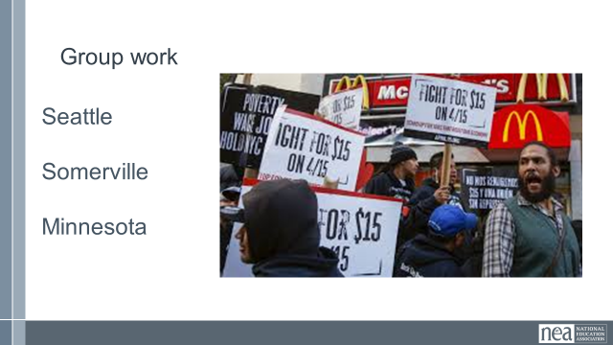 | Research a Living Wage  ESP and Living Wage  Checklist for Living Wage Campaign  Living Wage Communication Tips |  |  | 5 Min – Living Wage, what’s included?  What do you think are all the items that would be covered in a household by a living wage? Work as a table to make a list  5 Min – minimum wage vs living wage  Slide 39  - Note: A Living Wage is still not at a level where someone is accumulating wealth. Think of the list we discussed earlier and what wasn’t on the list. (Take a few answers from the room) “Thriving” is a term to reflect people starting to generate wealth.  Slide 39  In 1938 the minimum wage was set with the purpose of supporting laborers so they can have a wage to live on.  - The ability to live off of the set minimum wage has only deteriorated since.  - The current amount is no longer related at all to the ability to live off of the wage and people have very diverging beliefs on the current purpose of it.  - $7.25 current minimum wage (Federal set in 7/2009); living wage currently would be $40.38 (EPI site) (UPDATE: Living Wage to match the city of the training)  Slide 41  5 Min – Thriving wage  A thriving wage goes beyond simply covering basic needs, aiming to provide enough income for individuals and families to not only survive but also to thrive by allowing for discretionary spending, savings, and participation in community life.  Beyond Basic Needs: While a living wage focuses on covering essential expenses like food, housing, and healthcare, a thriving wage encompasses the ability to afford more than just the bare minimum.  Discretionary Income: A thriving wage allows for some disposable income, enabling individuals to pursue hobbies, invest in personal development, and participate in leisure activities.  Financial Security: It also provides a buffer for unexpected expenses and allows for savings and planning for the future, including retirement and children's education.  Community Participation: A thriving wage enables individuals to contribute to their communities and participate fully in society, rather than being solely focused on survival.  A Thriving wage for one may look different for someone. Each individual has their own unique situation and priorities. Once we cover the basic needs under a living wage a thriving wage allows individuals to focus on their interests.  5 Min - Explain activity  Using either the Seattle, Somerville or Minnesota case studies, your groups will learn and identify the 10 steps of a living wage campaign – you may not find them all in your cases – and some may be implied and not explicitly stated.  Assign groups to Seattle, Somerville or Minnesota cases. Have each group get a piece of chart paper to track the 10 steps. Have them write their case study town on the top of the chart paper.  45 Min - Living wage campaigns  Introduction  We are going to take a look at the steps NEA has identified are core elements of a Living Wage Campaign.  10 Steps  It is all about organizing - -If a local leader doesn’t get this... They’re not ready for a campaign. A LW campaign can be done in a non-bargaining state as well as a bargaining state. Whether you are bargaining or advocating and lobbying – the campaign strategies are the same.  (Summer consideration to put back in 10 Steps slides for next training)  Salary campaign strategy always involves unity, consensus, strategic planning, solid research and arguments, member organizing and engagement, coalition work, constant communications, and the sense that “We’re worth it.”  What is It REALLY About?  - Working only one job and having time for your family, friends, and yourself.  - Social Justice, Worker’s rights, Human rights, Women’s rights,  - Self-worth, respect, and dignity on the job.  - These are settled out in the community, not at the bargaining table.  Send the participants into their groups to identify in your case study the 10 steps, If shown in your case study. Once identified, list on your chart paper. Give the participants about 30 minutes to do this activity, then we will have them share out either through a gallery walk or report out by each group time dependent.  DELETE appropriate parts below to match the change to the online module  10 steps slides:  Step 1 – Pick an issue – how many of the issues identified on our wall can be directly, or indirectly related to the issues of not receiving a living wage?  Step 2 – Buy in This is a campaign for all of the members... Not just the local leaders and the Uniserv!  Everyone should have a chance to contribute and feel ownership. In actuality, a salary campaign builds better, stronger, more knowledgeable and independent locals and in the long run makes for a lighter workload for the UniServ.  Group Work- Read through your groups case study.  Identify in your case study the first 2 steps, Pick an Issue and Buy-In, if shown in your case study. Once identified, list it on your chart paper.  You will have no more than 5 mins before we move on. |  |  | Participants will be introduced to a minimum wage- and living wage calculator that they will apply to their own locals.  Participants will review the 10 steps of a living wage campaign and identify those in case studies.  Participants will develop communications that humanize the issues of workers to build support.  Participants will review the 10 steps of a living wage campaign and identify those in case studies.  Participants will develop communications that humanize the issues of workers to build support.
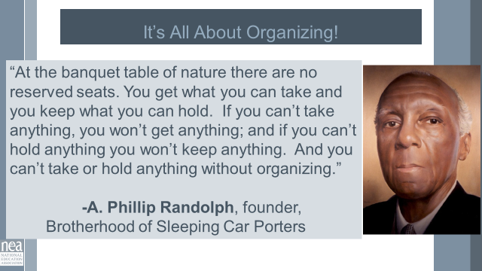  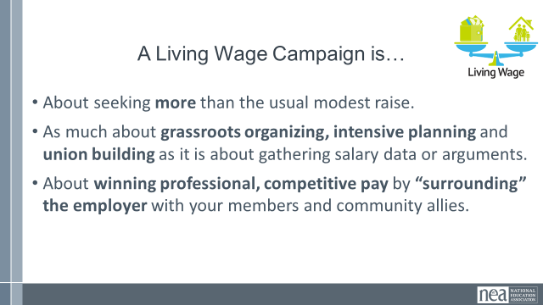  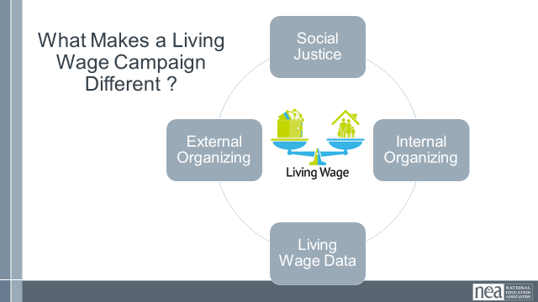  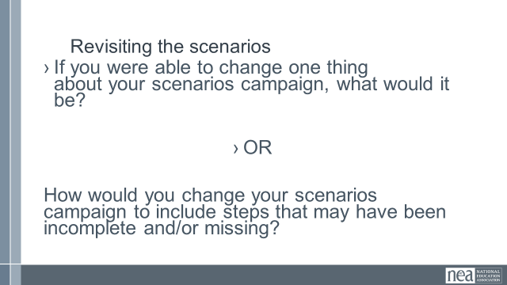  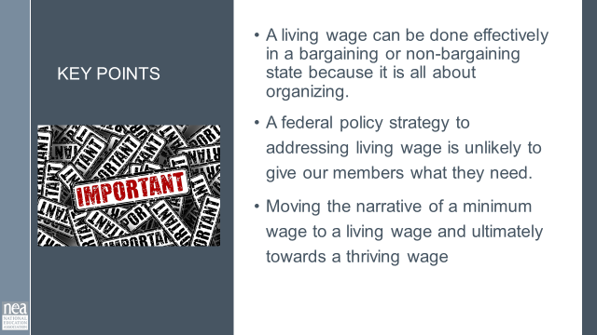 | Ithica Living Wage Case Study  Somerville Paras Case Study |  |  | 13 Min – Living wage wrap up  Bring group together. Why living wage campaigns are important.  - It’s all about organizing.  - About seeking more than the usual modest raise.  - As much about grassroots organizing, intensive planning and union building as it is about gathering salary data or arguments.  - About winning professional, competitive pay by “surrounding” the employer with your members and community allies.  What makes a living wage campaign different from other campaigns?  Social Justice- ESP as a group tend to be groups of people that historically have been left out by decision makers (minorities, woman, non-traditional families). When we fight for a living wage, we are also fighting for social justice for these groups.  Group Discussion- “If you were able to change one thing about your scenarios campaign, what would it be?” OR “how would you change your scenarios campaign to include steps that may have been incomplete and/or missing? “  Key Points  -A living wage can be made effectively in a bargaining or non-bargaining state because it is all about organizing.  -A federal policy strategy addressing living wage is unlikely to give our members what they need.  -Moving the narrative of a minimum wage to a living wage and ultimately towards a thriving wage |  |  | Participants will be able to identify the components of a living wage campaign.  What does a winning campaign look like?
12:00-1:00 LUNCH
1:00- 2:00 Hedy | 60 Minutes Organizer Math
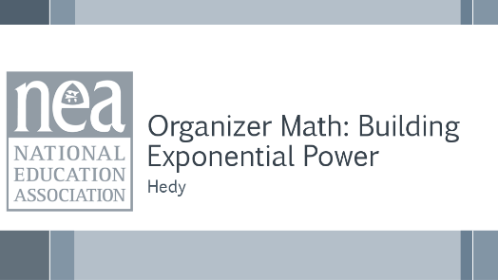   | Dunbar’s Numbers Content  Case Study of Organizer math |  |  | 10 Minutes Intro and Content –  How does one person topple the target?  Show video  What does this have to do with building structures and power in a campaign?  Dunbar's number is the cognitive limit to the number of people with whom an individual can maintain stable personal relationships, generally cited as approximately 150 people.  Challenges of Growth Beyond 150  Once a group surpasses 150 members, the reliance on informal bonds and peer pressure to maintain cohesion begins to fail, leading to:  - Loss of Solidarity: The sense of common purpose weakens as members can no longer know everyone personally, making it harder to build deep trust and kinship required for collective action.  - Weakened Communication: Communication shifts from fluid and informal to more structured and formalized, which reduces face-to-face interaction between general members and leadership.  - Need for Formal Structure: A more formal, hierarchical management structure becomes necessary to maintain organization.  Why do we care about Dunbar’s Numbers? Because it is all about the intersection of continual base building that leads to BOTH membership density and power. At a density of 50% +1, a local will keep the lights on, but if you are not at 80% or greater of engagement then you are not building power  Anything beyond the 150 is why we need BOTH leaders and structures.  Provide a brief summary of the case study (Dunbars Numbers) in the participant handout page 93- 97  10 Minutes Participants will discuss at their table  - What does “Power is not what you have, but what you can mobilize” mean in the context of ESP organizing?  - How did framing the campaign as a Common Good issue expand its reach and influence?  - What were the key turning points that shifted power toward the ESP union?  - Why was achieving 88% internal unity before going public critical for success?  - How did the coalition with parents, teachers, and community groups amplify leverage?  - Which steps from this campaign could your local adapt immediately?  - How can you identify and train 10% of your base as organizers in your district?  - What measurable power metric (similar to the 6,200 pledges) could define success for your next campaign?  - Which organizing phase — Internal Unity, External Coalition, or Final Confrontation — would be most challenging for your local? Why?  - How can you ensure your organizing structure remains strong and accountable during escalation?  NEEDS TO BE UPDATED TO ESP SCENERIO  5 Minutes for Phases 1, 2 and Final Phase -  Phase 1  We are building an internal union. The goal is for 10% of the union to be engaged. 10 core Leaders each worked with 15 Organizers, getting 150 people engaged in a leadership structure. The big test way to get 92% participation in Purple for Dignity Day.  Stress importance of structure tests and supermajority commitment before going public. This phase builds internal strength.  Phase 2  They move to external work and that is the real power multiplier. They recruited 50 external organizers that shared their values through a framing that encompassed bigger shared interests. This framing helps bring more and more people in. The internal numbers, plus the external numbers resulted in a rally of 1,250 attendees where 60% are non-union  Final Phase  The overall outcome – the measurable part of the win – was to get 5042 pledges – a 94% strike vote.  This internal and external pressure caused the board to rescind the cuts. Emphasize measurable commitment as ultimate power metric. Translate numbers into political cost for decision-makers.  Review planning checklist for Organizer  1. Leadership Team: Do we have a diverse, action-oriented team of 5–12 dedicated leaders?  2. Structure Test: Have we identified and trained 10% of our base to be organizers?  3. Measurable Ask: Does our first action (e.g., a pledge, a color day) have a clear participation goal (e.g., 90%)?  4. Narrative: Is our demand framed as a Common Good issue that attracts external allies?  5. Coalition: Have we recruited at least 50 external partners (parents, teachers, clergy, community leaders)?  6. Power Metric: What is our final, public measure of power (pledges, signatures, votes)?  7. Accountability: Do we track participation, follow-up, and progress weekly?  Now, let's apply this to your campaigns. With the checklist for building leaders and structures that exponentially grow your campaign. Pg 98  Provide practical steps for replication. Encourage organizers to apply these immediately in their campaigns  20 Minutes Teams will use the scenario worksheet and the answers that they developed as pre-work to apply to their own campaign.  10 Minutes Report Out  5 Minutes Key points –  Power is not what you have, but what you can mobilize.  Organizing success depends on measurable commitment, not just membership size. |  |  | Participants will understand the actual number of people needed in order to pull off a final outcome.
2:00-2:30 Ben | Centering Race Class and Gender
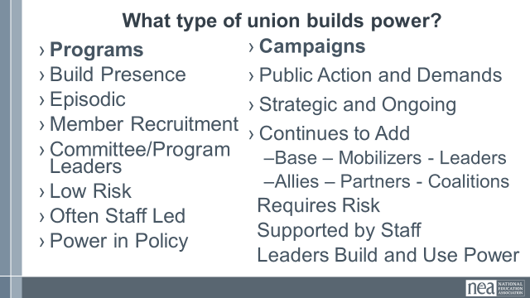  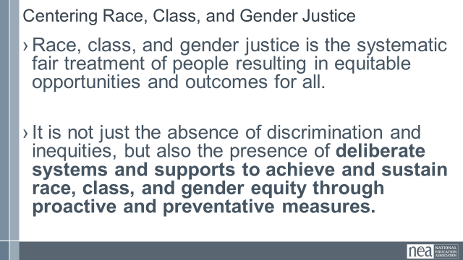  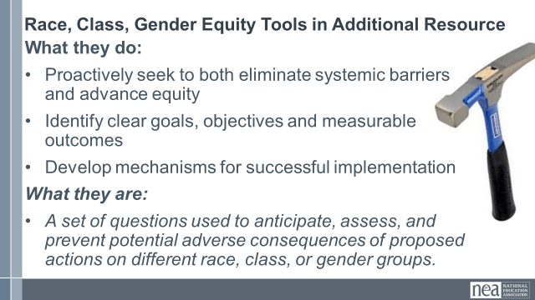  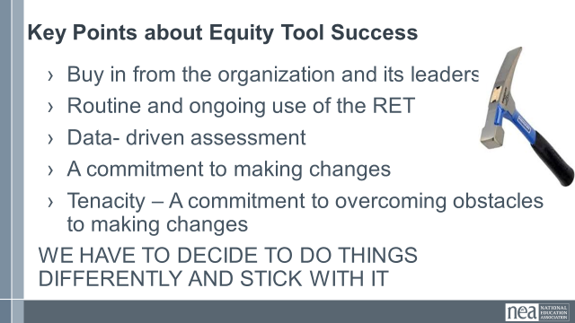  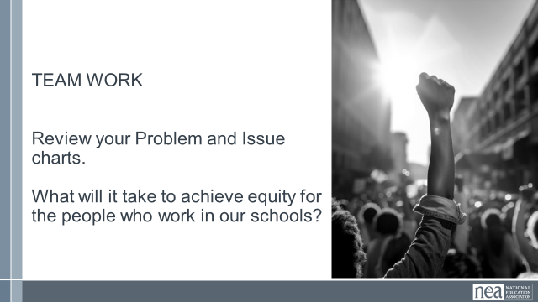  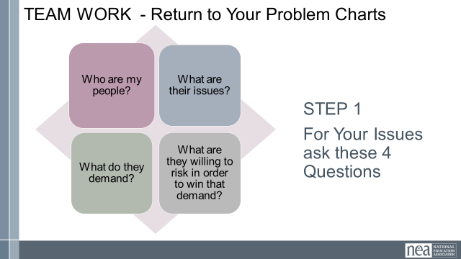  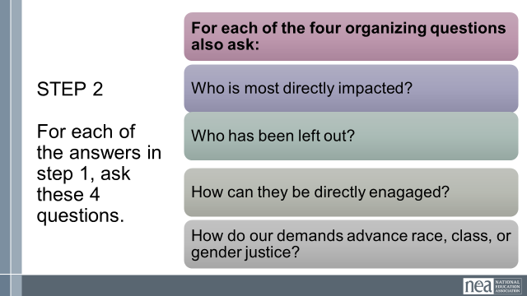  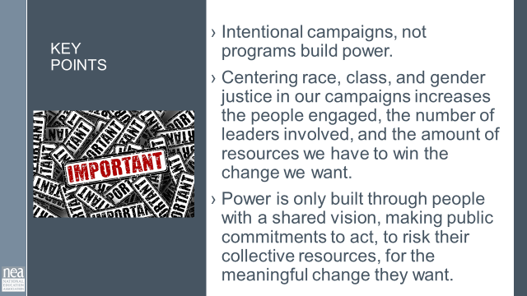 | Charts for problems  Equity Analysis  Equity Assessment  CRSJ BCG Centering Race Guide |  |  | 2 minutes – Union Work that Builds Power  For all of those things, to make meaningful lasting STRUCTURAL change we need power. Power is defined as that ability to create, control, and prevent change. That typically means organized people and organized money or resources – your work is a resource.  What type of union builds power? Programs, such as professional learning, staff led advocacy, social focused events, even policy advocacy do little to build power. Why is that? Well all of these programs are self-selected with little risk to join or leave them. I want to improve my classroom management, so I come to the Union led training on that. I might even lead one – but I have done little to build power with others. Also in a program, I am choosing to solve a “me” Problem and it does not require any other collective commitment.  Campaigns put people at the center of solving the problems they are experiencing. They name the issue, they decide the solution, they decide who they follow, and they determine what the are willing to risk. When we center people in a campaign – staff move to a coaching role. When people are at the center they use their agency and decide how to act, who they will act with, and what they are willing to risk to win. This is when members and leaders feel powerful in their union.  To begin a campaign you have to ask what the people want to solve, ask what they are willing to risk to solve that, and form demands that they think will provided the solution to their problem.  2 mins - What does it mean to center racial, class and gender justice?  Race, class and gender dynamics, disparities, and divisions permeate our society, communities, schools, and classrooms. Systemic oppression is so deeply rooted in our history, culture, and institutions that there is no escaping it. Visible or not, the impacts are ever-present. Race, class, and gender justice is the systematic fair treatment of people of all races, resulting in equitable opportunities and outcomes for all. It is not just the absence of discrimination and inequities, but also the presence of deliberate systems and supports to achieve and sustain race, class, and gender equity through proactive and preventative measures.  [MOVE THIS TO “ISSUE / PROBLEM IDENT” SECTION]  To continually and systematically keep equity in your work you have to use a Race, Class, and Gender Equity too, or lens. This is a person and institutional commitment to  Proactively seek to both eliminate systemic barriers and advance equity  Identify clear goals, objectives and measurable equity outcomes  Develop mechanisms for successful implementation of equity focused programs  A set of questions used to anticipate, assess, and prevent potential adverse consequences of proposed actions on different race, class, or gender groups.  10 Minutes – TEAM WORK – Return to Problem and Issue Charts  Step 1  Looking at your PROBLEM CHARTS – consider the c4 Organizing Questions for at least one of your problems - Who are my people? What are their issues?What do they Demand? What are they willing to risk to achieve that demand? [WE HAVENT DISCUSSED THESE TERMS YET- SO HOW DO WE ADDRESS THIS?]  Step 2- Apply the following Equity Tool:  Who is most directly impacted?  Who has been left out?  How can they be directly engaged?  Hows this demand advance race, class, or gender justice?  2 Minutes Key Points-  Intentional campaigns, not programs build power.  Centering race, class, and gender justice in our campaigns increases the people engaged, the number of leaders involved, and the amount of resources we have to win the change we want.  Power is only built through people with a shared vision, making public commitments to act, to risk their collective resources, for the meaningful change they want. |  |  | Participants will understand how intentionally asking race and equity questions at every point of a campaign helps to center race, class, and gender in campaigns.
 |  |  |  | 2:30 – 2:45 BREAK
2:45-3:15 Eric | Demands and Targets (30 Min)
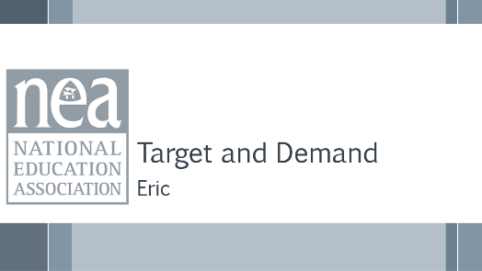  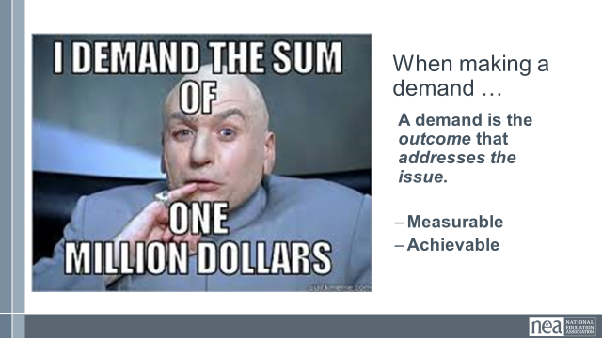  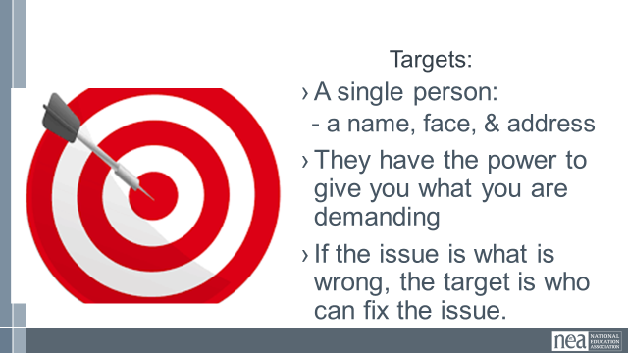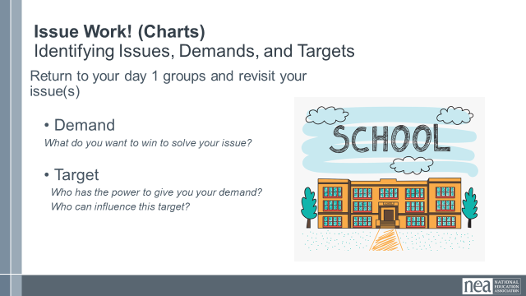  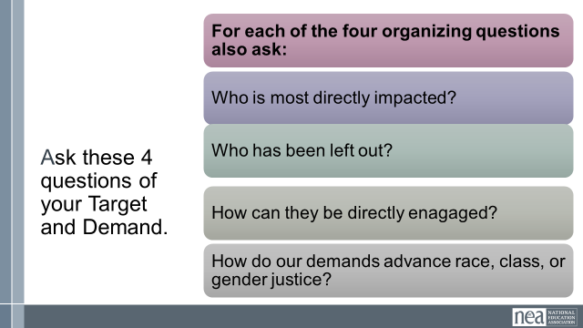  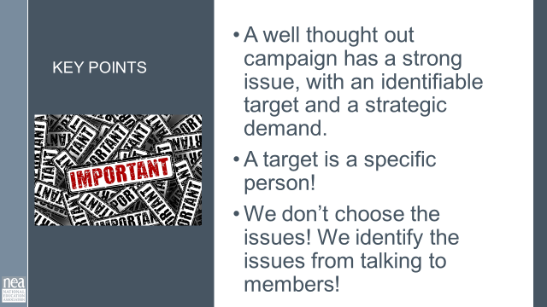 |  |  |  | 3 Min – Introduce Demand and Set Up  - A demand is what the group wants– the win –  - A demand is the outcome that addresses the issue you are making of the target  3 Min - INTRODUCE TARGET  - The last idea that we want to cover is Targets.  - TARGET: A target is a single person with a name and an address. The target is the person with the power to give the workers the change they are asking for. A target has a name, a face and an address.  - If the issue is what is wrong, the target is who we want that will fix the issue.  17 Min – GROUP WORK  In your groups, return to your issue from Day 1 and decide the:  - Issue - Keep in mind what makes a good issue!  - Demand - What do you want to win to solve your issue?  - Target - Who has the power to give you your demand?  - Who can influence this target?  Apply The “Race and Equity” Questions to your demands and targets  (Pg. __ In Campaign Planning Cycle Guide)  2 Min - WRAP UP/KEY POINTS  - A well thought out campaign has a strong issue, with an identifiable target and a strategic demand.  - A target is a specific person!  - We don’t choose the issues! We identify the issues from talking to members! |  |  | Participants will create a demand and a target using the specified criteria.  What is a demand?  How do we identify a target?
3:15-3:45 Eric | Tactics and Escalation (30 Min)
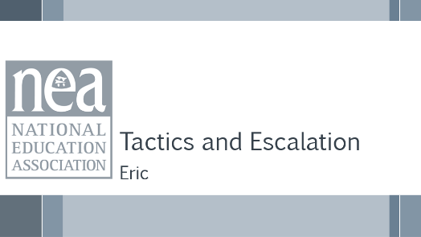  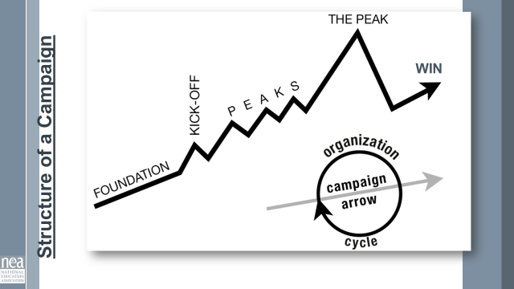  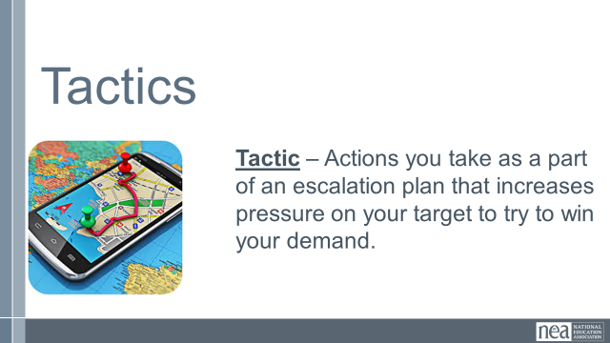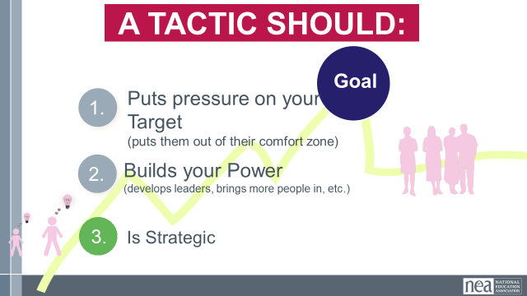  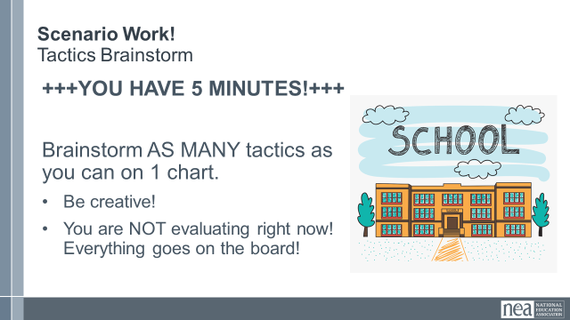  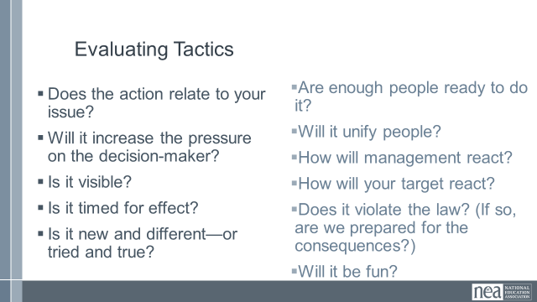  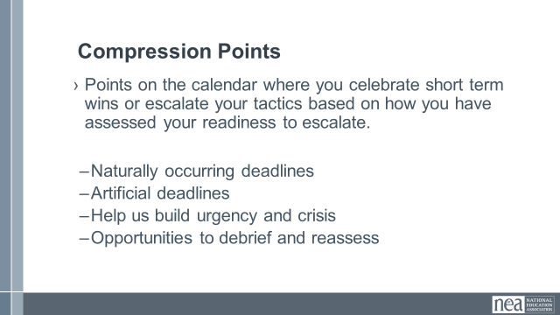  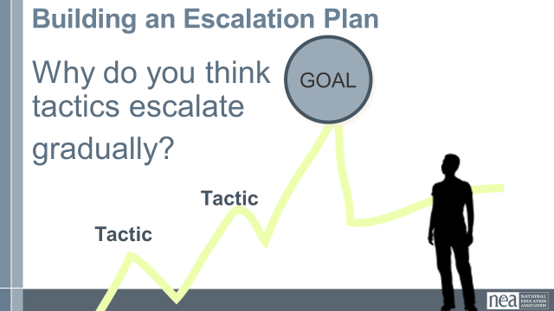  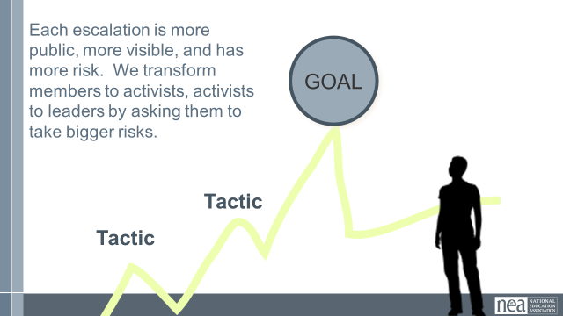  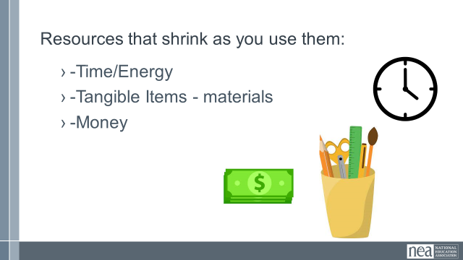  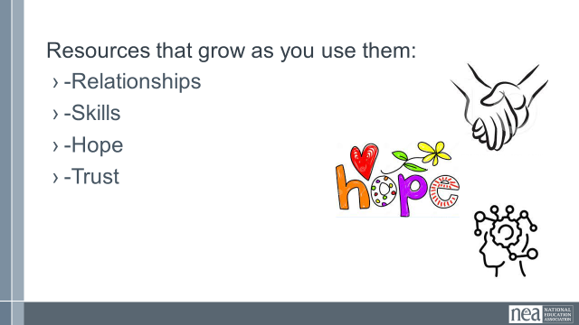  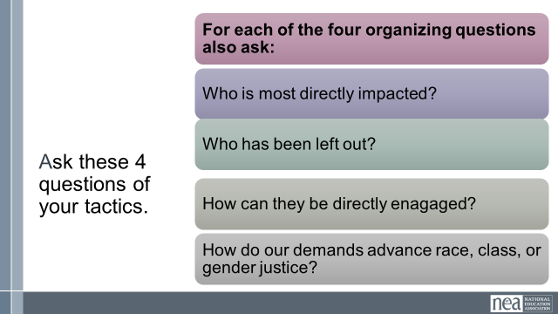  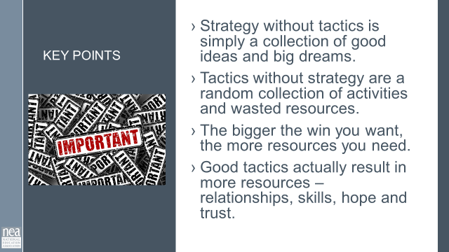 | Campaign Plan |  |  | 4 Min - INTRODUCE Campaign Mountain  - Foundation – gather info, id issues, id leadership team  - Kick-off – public event that indicates what the issue, demand, and targets are  - Escalating peaks of activity that should escalate in  - Risk  - Capacity (people, resources, engagement and Power)  - Increase leadership and ownership  - THE PEAK – The most public, risky, momentum, engagement, and resources  - The Win – We achieve our demand ...or we don’t... and then we  - Debrief, regroup, and continue to climb  3 Min - INTRODUCE Tactics  Next, we are going to talk about Tactics.  Tactics are Actions you to take as a part of an escalation plan that increases pressure on your target to try to win your demand.  A Tactic Should:  - Puts Pressure on the Target—make them uncomfortable!  - Builds Power—develop leaders, build engagement  - Is Strategic—Practice Intentionality  QUESTION: What are some examples of tactics? (Have a few people share out some tactics)  2 Min – Tactic Video "Frog Video”  - Were these effective tactics?  5 Min – Tactics Brainstorm Scenario Work  Now, we are going to model a “tactics brainstorm” that you can use when working with your members.  We are going to have 5 minutes to list as many tactics as you can. Extra points for super creative ideas. WE ARE NOT evaluating tactics at this time. If someone says something (example- We are going to wear the same clothes without washing them until we get what we want) you write it down and move on. All ideas get on the board. Again, this is a brainstorm. NO EVALUATING.  YOU HAVE EXACTLY 5 MINUTES. After 5 minutes, put your pens down.  Open your phone and actively start a timer. “ON YOUR MARKS, GET SET, GO”  Excellent! We now have a whole list of tactics. Next. We are going to assess our tactics. For this, I encourage you to use a list of questions like this:  3 Min - How to evaluate a tactic  - Does the action relate to your issue?  - Will it increase the pressure on the decision-maker?  NOTE! This means that we have to engage in actions that make our target uncomfortable. SOOOOO the same old tactics WON’T WORK! They are used to them!  - Is it visible?  - Is it timed for effect?  - Is it new and different—or tried and true?  Note! If a tactic is the same as always, your target has likely become comfortable with it AND it won’t develop new skills in your members and therefore build your power.  - Are enough people ready to do it?  - Will it unify people?  - How will management react?  - How will your target react?  - Does it violate the law? (If so, are we prepared for the consequences?)  NOTE! This doesn’t mean that it is off limits. Historically, breaking laws has been a big part of social justice movements. ESPECIALLY THE LABOR MOVEMENT! However, we have to consider if an unlawful tactic is the right tactic and whether you have the power to mitigate/absorb the consequences.  - Will it be fun?  Folks want to engage in things that fill them up! Many of the same old  10 Min- Evaluating your tactics  Look at your list of tactics.  - Circle the ones that you think are strategic, when looking at these questions.  - Cross out the ones that are NOT strategic.  - You have 10 minutes.  2 Min – Compression Point Definition  Points on the calendar where you celebrate short term wins or escalate your tactics based on how you have assessed your readiness to escalate.  - Naturally occurring deadlines  - Artificial deadlines  - Help us build urgency and crisis  - Opportunities to debrief and reassess  2 Min – Turn and Talk  We keep saying that tactics should escalate gradually. Turn to your neighbor and discuss why do you think that is?  2 Min – Debrief  Each escalation is more public, more visible, and has more risk. WE transform members to activists, activists to leaders by asking them to take bigger risks  2 Min – Just a word about resources  Resources are what are available to the people who are part of the campaign to use to achieve their demand. I like to think about resources in two categories: those that shrink and those that grow...  Resources that shrink as you use them  - Time/Energy  - Tangible Items – materials  - Money  Resources that Grow as you use them  - Relationships  - Skills  - Hope  - Trust  Apply the “Race and Equity” Tool Process to your identified strategic tactics  (Pg. __ In Campaign Planning Cycle Guide)  2 Min - Key Points  - Strategy without tactics is simply a collection of good ideas and big dreams.  - Tactics without strategy are a random collection of activities and wasted resources.  - The bigger the win you want, the more resources you need.  - Good tactics actually result in more resources – relationships, skills, hope, and trust.  Handout: pg 71 in “organizing for action” (NEA strike manual), pg 96 in pre attendance handout |  |  | Participants will develop an organizing plan with teams that can be shared with whole group.  the whole group.  What are the strategic actions and use of resources we will use to achieve our demand?  How can we apply what we have learned?
3:45-4:15 Sonia | Organizing Plan Team Time (30 Min)
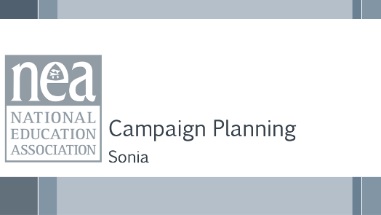  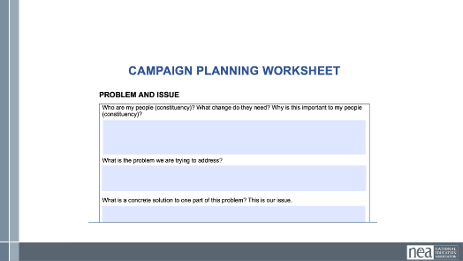  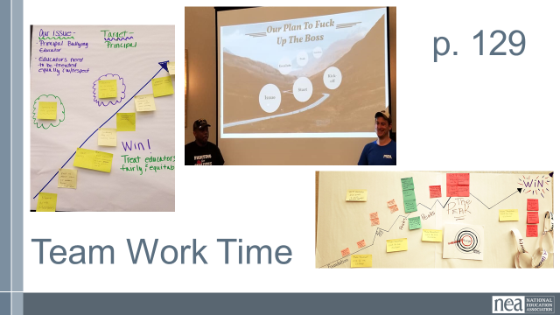 | Organizing Plan Template |  |  | So far, you have worked on your checklist for “Deciding on an Issue”, and you have stated to work on your “Organizing Plan.” Next step, with your team, you will use the Strategic Planning Template and continue to refine your organizing campaign plan.  Your goal is to create a presentation on day three. You can use visuals or no visuals for your presentation.  Review what teamwork is in process/been completed and next steps  - In Process - Checklist for Deciding on an issue Doc  - In Process - Plan for Organizing Doc  - Next step – Strategic Planning Template Doc  - Preview – end result is a presentation on day three w/use of visuals  The idea for the work time of this section is that we go back and forth between using the template and then sharing out what they have done  Here your guidelines:  - When using your campaign planning worksheet, consider using a 18 months timeline.  - Keep in mind the 10 steps you have learned from  - Incorporate the “test/task” design into their tactics  To increase success,  - Your plan should be motivated  - Should consider some of the risk (also more and more…)  - Should have accountability imbedded into it  You will now break into your teams and will have 20-25 minutes to work on your plan. If you leave the room, don’t go too far. Keep an eye on the clock. We will start again at XXX.  CAMPAGIN PLANNING DOCUMENT NEEDS TO BE REFORMATTED |  |  | Participants will build a campaign using the template and content points provided.  How can we apply what we have learned
4:15-4:30 Ellen | Ending it Right (15 Min)
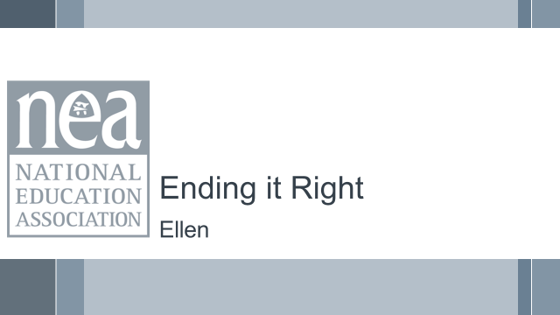  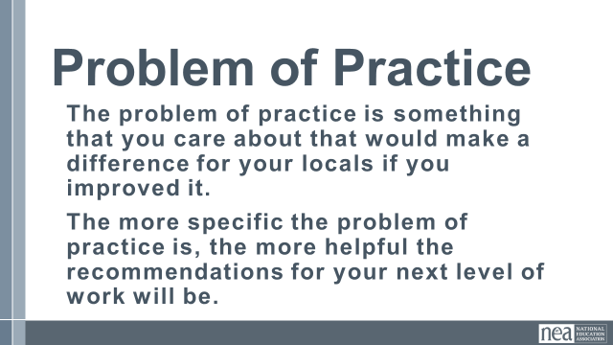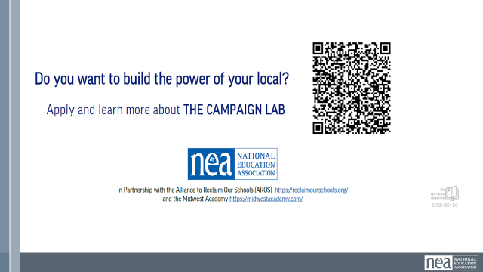  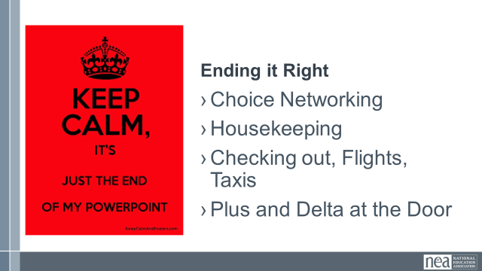 |  |  |  | Questions, Connections, Reflections  Housekeeping announcements  Plus/Delta at the Door  FOR TOMORROW – WHAT IS A PROBLEM THAT YOU ARE EXPERIENCING AROUND DEVELOPING ESP ORGANIZING? |  |  | Participants will be able to bring a little closure to their learning and provide feedback on the day.  How are we doing so far?
4:30 – 5:00 Ellen | Choice Networking Activities and Adjourn
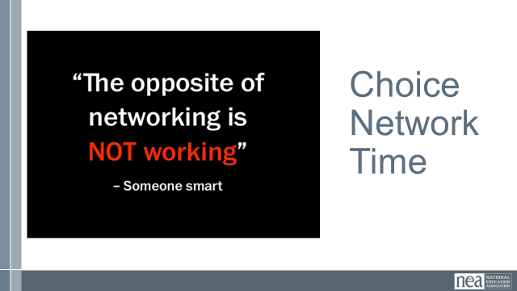 |  |  |  | Participants will make useful connections with staff from other affiliates. |  |  | Participants will make useful connections with staff from other affiliates.

