Facilitator Agenda: Day # 3 Organizing ESP
General Materials Needed: |  |  |  |  |  |  | Room Set-up:
1 Set of Handouts per Person  Name Tags or Name Tents  Room signs, sign-in signs  Painters Tape |  |  | Chart Paper  Post its  Chart Markers – Mr. Sketch  Pens and Pencils |  |  |  | Round Tables  Projector, Screen and Speakers  Carousel stations and reporting stations around the perimeter  50 people  Prep for the day:  Cut apart strips for Engagement activity - the leadership Tasks are the same – they redesign a task to make it go from low leadership and ownership to high ownership and leadership  Charts?
Key Outcomes for the Day
Participants will apply structure tasks and asks that move ESP members to leaders
Participants will be able to apply a consultancy protocol to identify solutions to real workplace problems of practice
Participants will complete a campaign design plan
8:30-8:50 Welcome Back  8:50-9:50 Leaders, from Clubs to Unions  9:50-10:20 Building Engaged Leaders  10:20-10:30 Break |  |  |  |  | Ellen  Monet & Ben  Michael & Eric  --- | 10:30-11:05 Ladder of Engagement  11:05-12:00 Group Work Time  12:00-12:45 Team Presentations  12:45-1:00 Ending Right |  |  | Jess & Hedy  Sonia & Beth  Sonia & Beth  Ellen
Time, Slide, Facilitator |  | Resources |  | Instructions, Activity and Debrief (Facilitators) |  |  |  | Outcomes and Essential Questions
 |  | Charts, handouts, articles, materials, slides, sticky notes |  | What are you saying, what are they doing, what questions will you use to guide learning and make clear the important points  Include an estimate for how long each section of the learning will take |  |  |  | As a result of this section of learning, what will participants know or be able to do? What questions will they be able to answer?
8:30 – 8:50 Ellen |  | Welcome Back (20 Min)
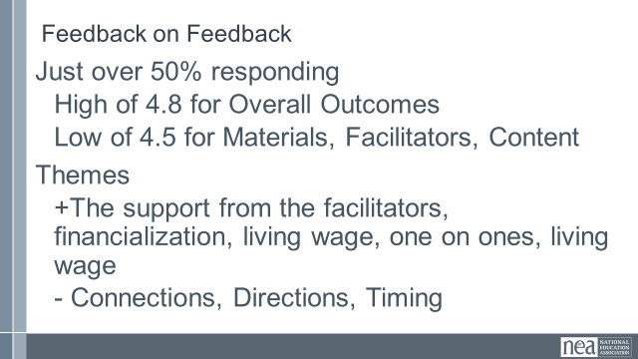  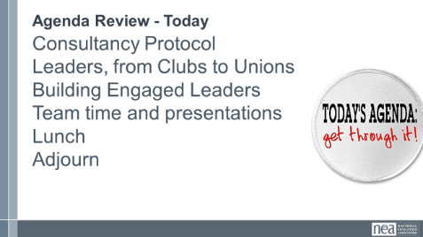  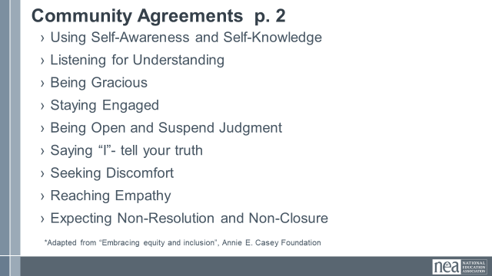 |  |  |  | Norm Review  Reentry  Feedback on Feedback  Today, we are going to turn again to looking at leaders and structures but with more of an eye towards planning a campaign and testing – here is what we mean by testing – if you agreed you would do it, did you? Why or why not?  Showcase the examples of centering, race, class and gender. |  |  |  | Participants will re-enter the learning environment.  What have you been thinking about so far?
8:50-9:50 Monet & Ben |  | Leadership, From Clubs to Unions (60 Min)
  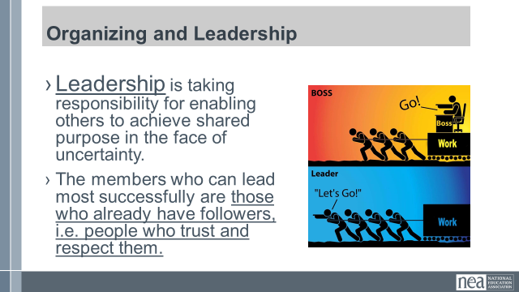  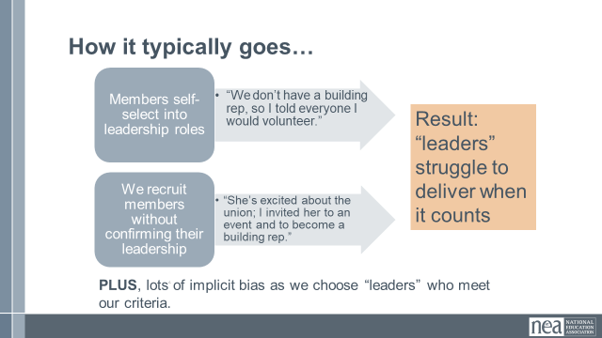  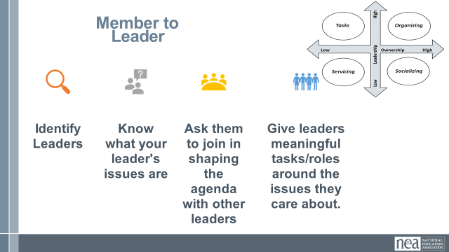  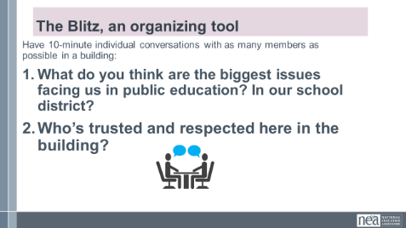  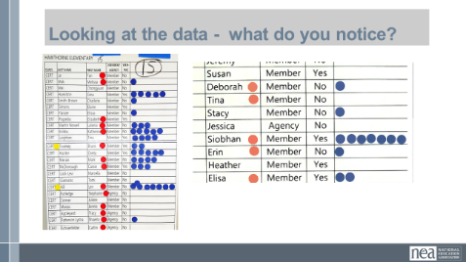  Slide 14:  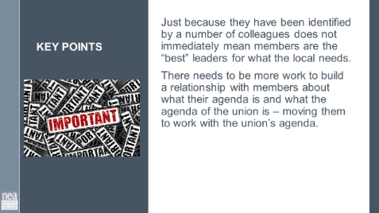    Slide 16  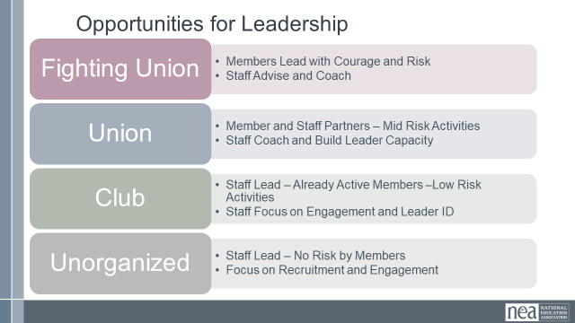  Slide 17  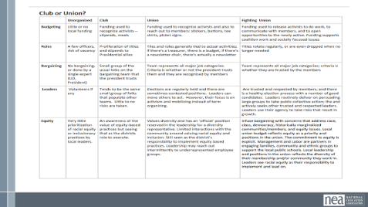  Slide 18  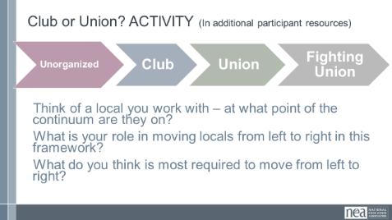  Slide 19:  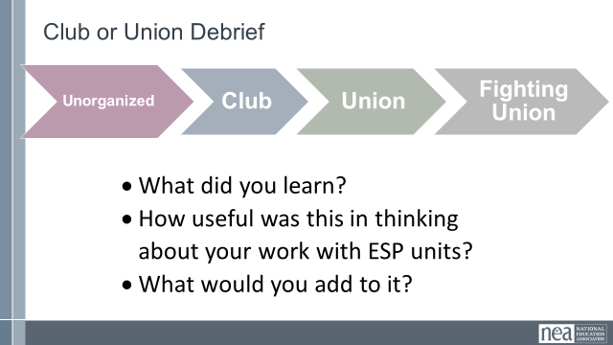  Slide 20:  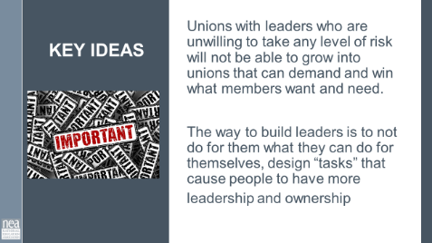 |  | Club to Fighting Union Continuum worksheet |  | DO NOT NEED 60 MINUTES FOR THIS SECTION—Added gallery walk activity and share out to fill time- Review  5 Min - Intro to section Monet  Who are the kind of leaders ESP units will need to achieve the kind of wins their members want?  Let’s look at the definition used across our programs.  Take a minute and read it to yourselves.  There are three intentional and important points in the definition. Leaders take responsibility – they don’t wait for someone to do it for them, and they own the risk of whether or not the action will be successful. Leaders enable others – not empower – they remove the barriers that allow individuals to use their own agency to take action towards a shared purpose. Finally, leaders do both of these in the face of uncertainty. They don’t only choose to do the things that ensure they will be liked, will look successful, will ensure they stay employed. They take risks. Leaders are working towards an organizing stance always.  SLIDE 10:  10 Min - How do we identify leaders, and why it matters?  Leaders, ultimately have followers. We do not make leaders –they already exist in their worksites and our roles are to find them. How do we typically identify leaders when we or our members are working on recruitment?  Either members self-select into a leadership role (it’s my turn, there was no one else, I have always done it) or we recruit members without confirming their leadership with their co-workers (they were really excited about the union, they contact me a lot for information and seem to be in the know, they really remind me of other union folks I like)  What happens when we do this is that leaders struggle to deliver, take risks, and engage others in the union when it counts. They remain reliant on staff for success.  SLIDE 11:  The method that is now widely accepted as best practice is called “Natural Leader ID.” This method is the intentional identification of leaders. You can go high tech or low tech, but the process is the same. You and your organizers go to your people, ask, “Who here is trusted and respected?” Everyone records who they say. The more a person is named as a trusted and respected leader, the more relationship resources they have that could be used for union work. (p.62 article Seatle)  SLIDE 12:  How many of you have done a blitz? Purpose is to have as many conversations with members as possible. Data collection key. It won’t necessarily build relationships, but to gather information in a quick 10 minute conversation. But, if you end with who here is trusted and respected, you are building a data set.  SLIDE 13:  As you look at the data, you are also working to identify who already has relationships with the union, and who does not. If they are an identified leader that is not in relationship with the union – your work is to get to know them and bring them into a relationship. For all who are identified your work is to build relationships with leaders and help them realize how the union can help them achieve their agenda. (red=member, but not actively connected; blue=trusted and respected (Trusted and Respected); yellow=BIPOC)  The slide with blue and red dots should be updated to match the current language. With Member/Potential Member. Agency Fee (Fair Share) was a term used before the Janus Supreme Court decision in some states  In a perfect world – identified leaders are doing the “listening tour” or “blitz” part of this work and staff are connecting with leaders who are identified in this process....If you are in a unit with very little leadership or ownership – there will be more staff work on the front end.  SLIDE 14:  Key Points – just because they have been identified by a number of colleagues does not immediately mean they are the “best” leaders for what the local needs – the needs to be more work to build a relationship with them about what their agenda is and what the agenda of the union is – moving them to work with the union’s agenda.  Slide 16: Ben  Where are you on the Club to Fighting Union Continuum?  5 Min - Introduction to section  Clubs are groups of people who follow, rely, and build programs. Programs have a prescribed way of working with a pretty predictable set of outcomes. They are not bad, and we need to understand how they operate.  Fighting Unions are groups of people with multiple “natural leaders” engaged through structures, moving people to risk use their resources to achieve the change they want. Outcomes are unpredictable.  Slide 17/18:  15 Min - Activity Directions  Everyone – close your eyes and think about one ESP unit you work with – got it in your minds? Great.  You are going to work with your tablemates using a chart that found in the Additional Participant Resources that outlines the conditions we might find along the continuum of Unorganized to Fighting Union.  You will see elements listed in the left-hand column, with descriptors of what each element might look like as it moves across the continuum towards fighting union.  Use this grid to assess where the units you are each thinking about lie, and how you would move them forward. You can also add to this grid by suggesting other elements besides the ones listed in the left-hand column.  Slide 19:  10 Min - Debrief  - What did you learn?  - How useful was this in thinking about your work with ESP units?  - What would you add to it?  Slide 20:  Key Points  - Unions with leaders who are unwilling to take any level of risk will not be able to grow into unions that can demand and win what members want and need.  - The way to build leaders is to not do for them what they can do for themselves, design “tasks” that cause people to have more leadership and ownership  - p.86-89 Jane’s article
9:50 – 10:20 Michael & Eric |  | Building Engaged Leaders (30 Min)
  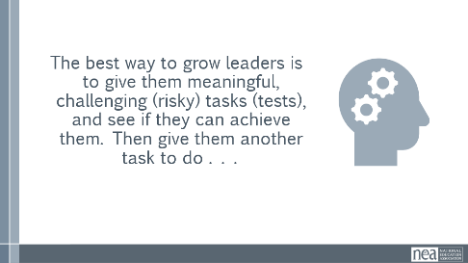  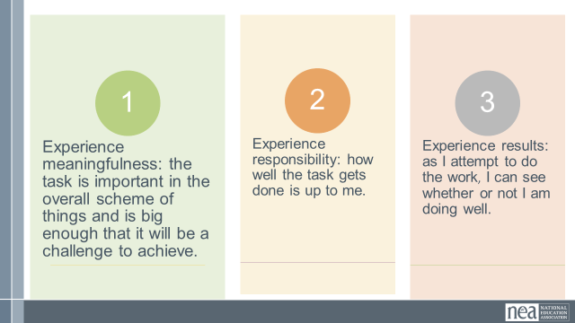  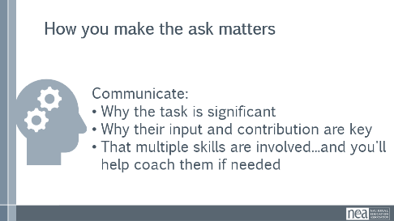  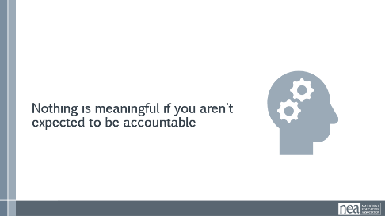  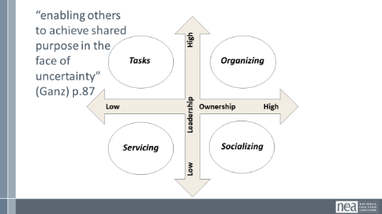  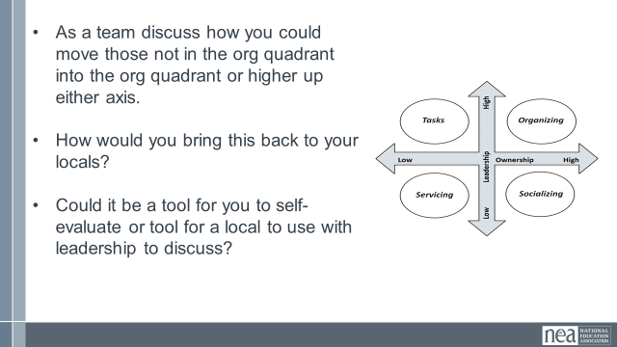  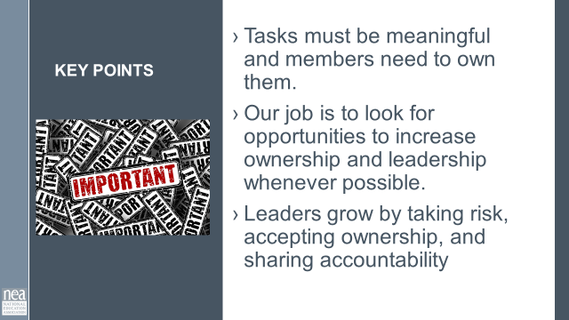 |  | Leadership Development Tasks – Tests |  | 5 Min - Content Intro p.  More often than not when we are working with ESP units (workers), we are relucent to ask them to take on meaningful, challenging (risky) tasks (tests) and see if they can achieve them. Don’t build in the NO for them. Stop doing everything for them. If we don't stop that behavior, they won't do anything for themselves.  The best way to grow leaders is to give them a task to do. If we are nervous and not willing to hear “no” when we ask leaders to do challenging risky things – we never move them along in their development and the affiliate does not move along from a club to fighting union.  When you ask a leader to commit to something. There are 3 conditions that grow leaders. The three conditions to keep in mind when you are developing “tasks” that test and build a leader are Meaningfulness, Responsibility, and Results.  The person’s perspective about the task is what is most important here – For Example - Some will find meaning in asking their colleagues to participate in a bargaining survey while others will find meaning and challenge in learning how to conduct and track member recruitment conversations.  How you make the ask or invitation into the task for the leader matters too – you really need to be able to communicate WHY the task is significant, that their input and contribution will be key to the ask or task accomplishment, that a number of skills may be required, and the leader will be able to apply judgement to accomplish the task.  After we give them one task, we give them another and another, and we let them grow and coach along the way. They will also grow when they know you will be meeting to discuss the outcomes and figure out the next steps.  Conditions of Motivational Task Design  - Task Significance  - Task Identity  - Skill Variety  - Autonomy  - Feedback  Nothing is meaningful if you aren’t expected to be accountable.  [UPDATE ACTIVITY to a Brainstorm things they do in their local, write them down, then place them on grid]  Engagement Grid Activity  5 Min - Introduction of the grid  As we continue to identify and develop engaged leaders, I want us to remember that an important part of our leadership definition is “enabling others to achieve purpose in the face of uncertainty” (Marshall Ganz). If that is our goal, then how we design our tasks and tests for leaders matters. [Model this with chart paper in front of everyone while talking through if time allows]  We are going to be using an engagement grid that has two axis – the vertical one is the leadership, and the horizontal one is the ownership.  Servicing  If you engage a leader in a task in which you have taken all the ownership and risk for the task, and all the leadership – then it is servicing – for example A completely staff led new employee recruitment table.  Socializing  As the leader takes on ownership, then it moves to socializing – think new employee meet and greets with local leaders.  Task  As the activity/event grows in leadership, it becomes a “task” – think of an annual new member meeting that you direct the local to do – but they take on all the roles of implementing it.  Organizing  As the task moves towards high leadership and high ownership – it moves into organizing. Example leaders determine why they are engaging with new employees, how they will do it, and what the outcomes will be. You are consulted and might be asked for resources or coaching.  15 Min - Work time (Activity)  As the facilitator determine if it is time to regroup the participants – if so – do a count off into groups that result in working teams not larger than 4 to 5 – Make sure each group has a set of activity cards and knows where to find the sorting grid. For a paperless activity have participants refer to online module  Directions -  Turn to the page with the Engagement Grid on page 102 of the participant handouts in PEP.  In your table groups, each person will select 2-3 activities listed on the strips in the envelope. Then organize them using the engagement grid on your table.(these are found on the last page of the packet – or as a team – you can cut then into strips and put them in envelopes during team planning)  [For a paperless activity, have the participants pick 2-3 and write them down on a sticky note to be placed on chart paper where they would be. This allows them to move them in step 3.]  Table Work-  - Work as a team and place them into the most appropriate quadrants. Come to some level of agreement as a team about WHY you are placing these where you are.  - Now, as a team discuss how you could move those not in the org quadrant into the org quadrant or higher up either axis. Some may not be worth moving – task – it is what it is.  - Lastly, share/discuss how you would bring it back to your locals. Could it be a tool for you to self-evaluate or tool for a local to use with leadership to discuss.  5 Min - Debrief  - Why were activities placed where they were?  - Were there any of the engagement activities that your table struggled with placement?  - How could you use this activity?  2 Mins - Key Points  - Tasks must be meaningful, and members need to own them.  - Our job is to look for opportunities to increase ownership and leadership whenever possible.  - Leaders grow by taking risk, accepting ownership, and sharing accountability |  |  |  | Participants will learn about the best practices for recruiting members.
10:20-10:30 BREAK
10:30 – 11:05 Jess & Hedy |  | Ladder of Engagement (30 Min)
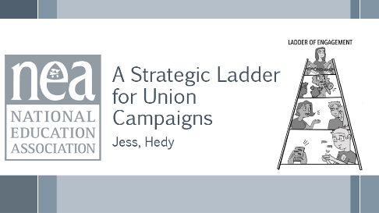  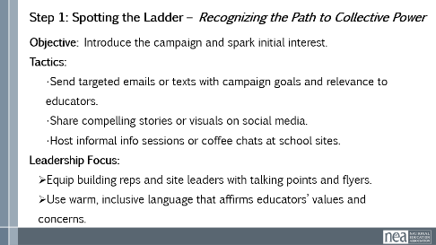  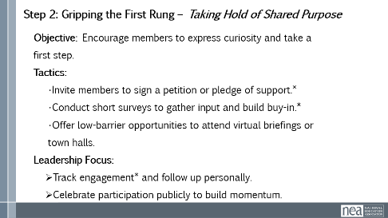  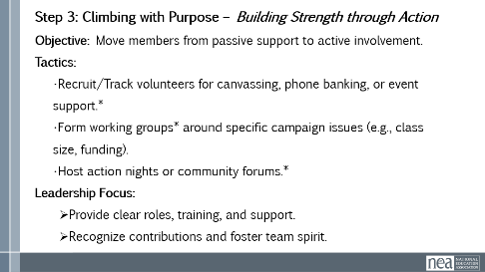  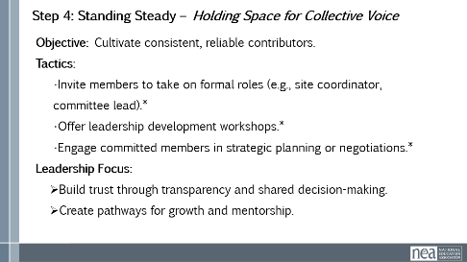  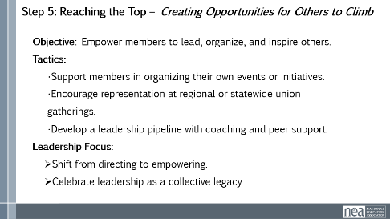  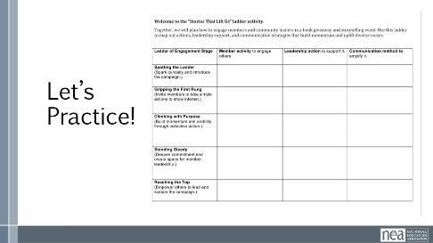    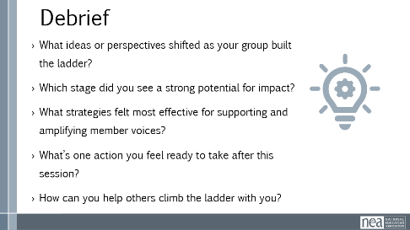  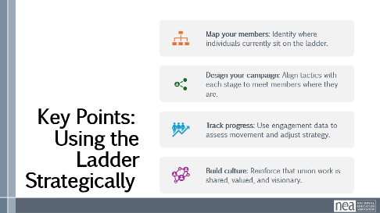 |  | “Stories that Lift Us” Ladder Template |  | Jess -- (5 minutes) Intro: 5 minutes, 2 slides  Slide 32 (Intro)  Before the break, you talked about Engagement on an axis that looked at leadership & ownership. You talked about why one activity or another might be engaging in a particular way.  Now, we’re going to use one more tool to look more closely at how to build engagement using a ladder model.  Slide 32  The Ladder of Engagement is a framework to help union leaders activate and elevate member participation through a series of intentional steps.  We’ll look more closely at the steps in the following slides, but they are:  - Spotting the Ladder: Recognizing the Path;  - Gripping the First Rung: Taking Hold of Shared Purpose;  - Climbing with Purpose: Building Strength through Action;  - Standing Steady: Holding Space for Collective Voice; and  - Reaching the Top: Creating Opportunities for Others to Climb  Each of these stages builds trust, capacity, and ownership—turning passive members into powerful advocates and leaders.  (7 minutes) The Five Rungs: 7 minutes, 5 slides  Slides 34-38  We are going to take a look at the objective, tactics, & leadership focus of each of these steps; then, you’ll have some time to practice as a group, using the Ladder of Engagement to plan a book giveaway and storytelling event. Next to tactics that give us an opportunity to be tracking data, we’ve made an asterisk.  Step 1 is Spotting the Ladder, or Recognizing the Path to Collective Power.  This is where you introduce the campaign in a way that will spark folks’ initial interest. Some tactics you might use to spark interest might be texts that are tailored to folks in a way that would be relevant to them, sharing compelling narratives, or bringing the campaign to them by hosting informal info session at school sites.  To include a focus on leaders, be sure to equip your leaders with talking points, as well as using language that emphasizes educator values & concerns, so that they connect to the campaign.  Step 2 is Gripping the First Rung, or Taking Hold of Shared Purpose.  This step encourages members to be curious and express that curiosity by taking a first, low-barrier step. Here are some tactics that offer folks the opportunity to dip a toe into the campaign and builds their buy-in. You or your leaders can work on tracking engagement data, and work to follow up individually, so members really feel that their active participation is valued. A public celebration is a great way for members to see that others have also taken this first step as well.  Step 3 has folks Climbing with Purpose, or Building Strength through Action.  Our objective here is to move members from passive support to active involvement – they are fully on the ladder and climbing now! As you can see, the tactics are asking people to get out and talk to others, participating in an active, visible way. By providing great support of your leaders, and then recognition of their efforts, you will continue to build their capacity as well.  In Step 4, we are Standing Steady, Holding Space for Collective Voice.  Our goal is to cultivate consistency with our folks generally, while we elevate our reliable contributors. You might invite members who were showing up for those Step 3 activities to take on some more formal roles, like leading a committee or being a site coordinator. It might be a great time to offer those folks a workshop that could offer leadership development as a group, and begin to involve them more meaningfully in strategic planning. This will build trust by engaging those consistently involved members in shared decision-making, and also create those pathways to grow leaders.  By Step 5, we are Reaching the Top and Creating Opportunities for Others to Climb.  It’s now time to empower those members whose engagement we have built, to lead, organize, and inspire others. We might support members in organizing their own events, or boost them up to represent at regional, statewide, or national-level union gatherings. Your folks are now leading, creating their own campaigns and ladders to engage others.  (11 minutes) Jess Releases them to Practice Time: Eleven Minutes, One Slide  Slide 39  Now it’s time to practice using the Ladder of Engagement in a scenario. As it says on your handout, you’ll work with your group to build a campaign Ladder of Engagement around a book giveaway & storytelling event. You’ll have ten minutes to make notes about how you will have a  A member activity to engage others;  A leadership action to support it; and  A communication method to amplify that action  for each of the stages of the Ladder of Engagement. Then, we’ll hear from folks about how that process went.  (Summer change – flip the chart to match the ladder picture)  (10 Mins) Share Out & Debrief: Ten Minutes, Two Slides  Slide 40  The facilitator should choose one or two of the groups to share out ONE STAGE of their Ladder of Engagement.  Slide 41  The facilitator should choose one or two of the debrief questions to run through with the group, based on how the group work/share out went.  Key Points: Two Minutes, One Slide  Slide 42  - Map your members: not everyone is starting from Step 1, so it’s important to identify where folks sit on the ladder, so you can...  - Design your campaign: if you know where folks are on the ladder, you can tailor your tactic to meet members where they are.  - Track progress: by having engagement data handy, you can assess how things are going without relying on “vibes” and adjust your strategies accordingly.  - Build culture: all along the way, it’s essential to reinforce that union work is shared work, that it is valued and valuable, and that it is visionary. |  |  |  | Participants will learn about the best practices for designing a campaign for maximum member engagement.
11:05-12:00 Sonia & Beth |  | GROUP WORK TIME (55 Min)
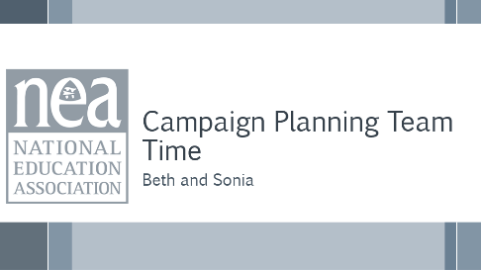  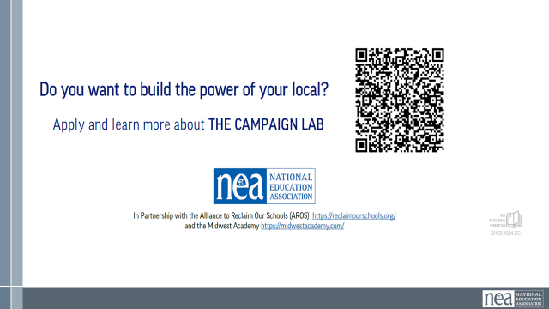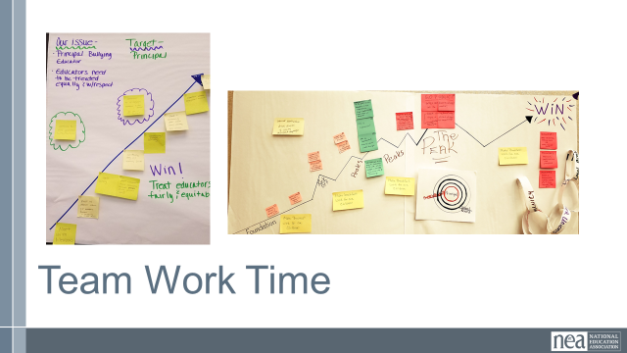 |  | Chart paper, markers |  | 5 Min – Directions  Now you are going to use the learnings from demand targets tactics and escalation to add into your campaign plan you have been working on for the past 2 days.  The end product of this work time is to present your issue and campaign plan to the group. It would be helpful to have a chart paper represent the background information for your campaign as there may be time for groups to provide feedback and ask questions about your plan.  You may not have a fully flushed out plan, but the idea is to have something to be able to share with others that incorporates the learning and insights from this training.  50 Min – Work Time |  |  |  | How can we apply what we have learned?  Participants will develop an organizing plan with teams that can be shared with the whole group.
12:00 -12:45 Sonia & Beth |  | Team Presentations (45 Min)
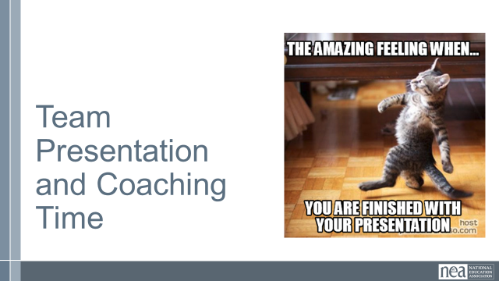 |  | Campaign plans, sticky notes, writing utensil |  | 5 Min – Directions-  Now we will review the plans everyone put together for their ESP campaign. We are going to break you into two groups.  30 min-Presentation  Group One will be presenting first. You will stand next to the campaign you drafted and answer any questions that people have about your campaign. You can provide any context about the situation or run through your plan with anyone who comes to you.  Group Two will need sticky notes and will visit each of the campaigns in Group One. You may ask clarifying or contextual questions about the campaign plan. Your job is to provide feedback, encouragement, or questions that help the presenter with their plan.  You will have 12 minutes to visit each of the campaign plans during this round. When the 12 minutes are over, the groups will switch roles.  Sample Feedback prompts  - How did the plan address finding and developing leaders to help implement the plan?  - Are the tactics directly related to representing the issue and goal of the campaign?  - In what ways does the plan use opportunities to build structure and power?  10-minute Debrief –  Sample Group Debrief Questions:  - Are there specific tactics or ideas that you are going to take back to your locals and share with leaders? What about with co-workers? Why did that stand out for you?  - What are the skills from today you are hoping to train your leaders/members/activists on in the next 6 months?  - What is something you learned from a colleague in the last three days that changed the way you thought about your work? |  |  |  | Participants will develop an organizing plan with teams that can be shared with the whole group.  How can we apply what we have learned?
12:45- 1:00 Ellen |  | Ending Right (15 Min)
 |  |  |  | Farewell
1:00 | Boxed Lunches ADJOURN

