Pre-Attendance Resources
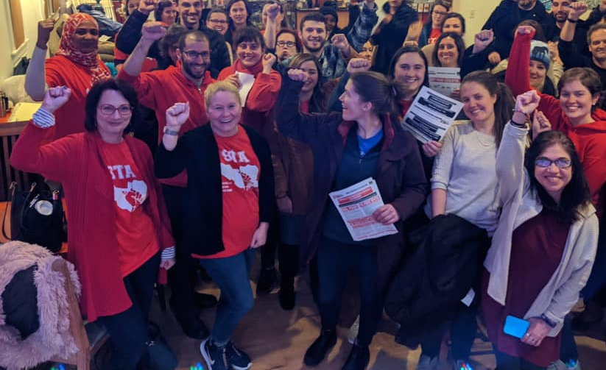   | Organizing Strategies  for work with ESP Members  UniServ Directors who represent ESP locals are responsible for identifying and developing leaders, organizing issue campaigns, and understanding and advocating for the unique needs of ESP members. Strong ESP affiliates have a high ratio of engaged leaders to rank and file members and structures that allow for rapid response, relationship development and collective action. This NEA Center for Organizing training is designed to build skills around ESP leadership identification and development. They will learn how to establish differentiated and innovative structures that can increase member engagement and union presence within and across worksites of the various job families within ESP.  Director  Kyle Serrette  kserrette@nea.org  Academy Coordinator  Ellen Holmes  eholmes@nea.org  Academy Logistics  Karla Medina  kmedina@nea.org

Why pre-attendance reading?

The resources compiled here are short, relevant, and intended to help you shift from the day-to-day cognitive load of work to the thinking you will use as a learner at the academy. We rely on a number of popular education strategies that involve the use of texts and scenarios for group work. Many participants find it difficult to do a “first read” in the classroom so we have provided those items here in case you would like to review them.

Read and Reflect: (Please Do Before Arriving)
Please take the time before arriving to read our community agreements on pages 3-4. We will engage you in a discussion at the very start of our time together around these agreements and your commitment to them.

Resources for Group Work: (Please Do Before Arriving)
The resources on pages 21-62 are for group work. They will require some familiarity with each "case" but not memorization of every one of the details. You should set aside some time to read and review these prior to coming especially if you are not comfortable doing a “first read” amongst others.

Articles for Thinking: (Optional Food for Thought)
The resources included on pages 5-20 are primarily designed to help frame “why” we are offering this academy. NEA's history with ESPs is an interesting one. Understanding class as a form of oppression will support your learning in this academy. The articles on class may cause you to generate questions that you will want to explore while we are together. Consider these options to read prior to attending.

