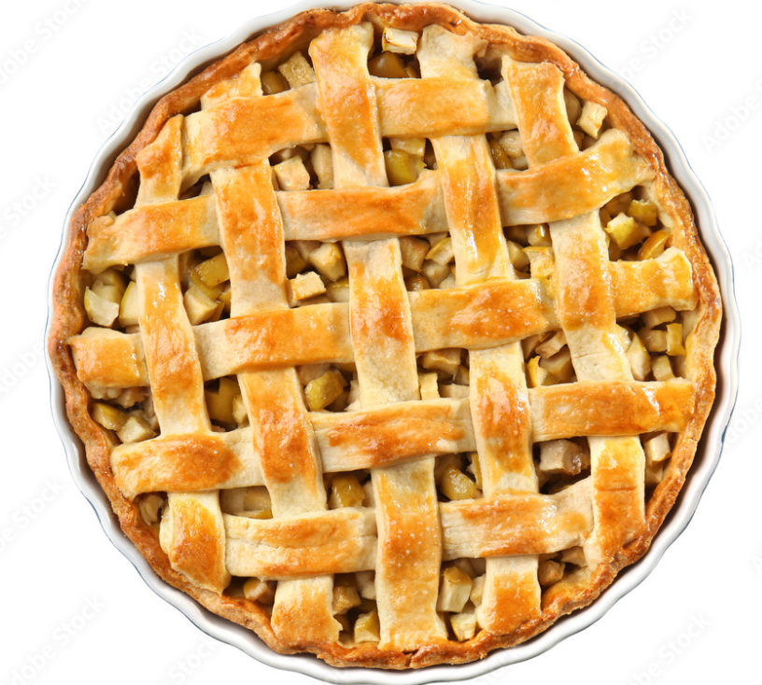

Apple Pie Slices are 1/10 each

