Facilitator Agenda: Day # 1 Organizing ESP
General Materials Needed: |  |  |  |  |  | Room Set-up:
1 Set of Handouts per Person  Name Tags or Name Tents  Room signs, sign-in signs  Painters Tape |  |  |  | Chart Paper  Post its  Chart Markers – Mr. Sketch  Pens and Pencils |  | Round Tables  Projector, Screen and Speakers  Carousel stations and reporting stations around the perimeter  Easel with Chart paper  20 people  Charts needed for today:  - Rideshare (resources to share)  - Blank paper to make -Venn Diagram – 1 per table  - Visual Cards
Key Outcomes for the Day:
- Who are ESP?
- What are their issues?
- What is our work like with them?
- What are some institutional challenges we have?
- What are ways that locals have succeeded?
Overview of Content and Facilitator
8:30-9:00 Getting Started  9:00-9:45 What issues do ESP face?  9:45-10:30 What are your experiences leading ESP units?  10:30-10:45 BREAK  10:45-11:15 Language Matters (research)l  11:15-12:00 An Institutional Problem  12:00-1:00 LUNCH  1:00-1:30 Continue an Institutional Problem |  |  |  |  | Ellen  Juli and Adam  Naomi  Heidi, Katrina  Hedy Ellen  Hedy Ellen |  | 1:30-2:00 Defining Class, Questioning Systems, Reflections on Practices  2:00-2:15 BREAK  2:15-2:50 Continued - Defining Class, Questioning Systems, Reflections on Practices  2:50-3:20 ESP Bill of Rights  3:20-4:10 Issue Identification  4:10-4:30 Ending it right  4:30-5:00 Choice networking |  | Ben Naomi  Ben Naomi  Heidi/Helena  Ellen  Ellen
Time, Slides, Facilitator |  |  | Resources |  | Instructions, Activity and Debrief (Facilitators) |  |  | Outcomes and Essential Questions
 |  | Charts, handouts, articles, materials, slide |  |  | What are you saying, what are they doing, what questions will you use to guide learning and make clear the important points  Include an estimate for how long each section of the learning will take |  |  | As a result of this section, what will participants know or be able to do? What questions will they be able to answer?
Entry activity   |  |  |  |  | Make a list – you will use this later
8:30 -9:00 Ellen |  | Getting Started (30 Min)
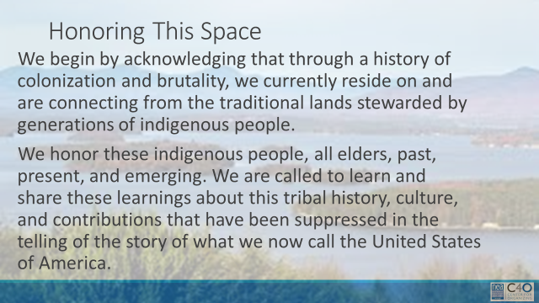    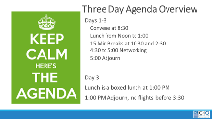  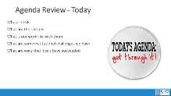  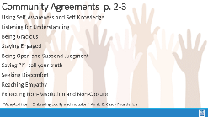 |  | Make the Following Charts  Community Agreements  Parking Lot  Agenda  Put out  Name Tents  Handout Package  (Re-visit History of ESP Doc) - Katrina |  |  | 4 Min - NEA Welcome  Native Land Recognition  The National Education Association is committed to honoring the spaces that we occupy to advance the work.  - We begin by acknowledging that through a history of colonization and brutality, we currently reside on and are connecting from the traditional lands stewarded by generations of indigenous people.  - We honor these indigenous people, all elders, past, present, and emerging. We are called to learn and share these learnings about this tribal history, culture, and contributions that have been suppressed in the telling of the story of what we now call the United States of America.  Why are we here?  - We are here to build stronger ESP leaders.  - NEA is committed to building effective sites where members can lead and growth their associations.  5 Min - Facilitator Introductions  - Team intros include Name, Work Location, years in the work, and your required pronoun  5 Min - Group Introduction Whip  - Have a quick model from one of the trainers.  Three Day Agenda Review  - See charts on walls for review.  - Note the two breaks, lunch, and adult network 4:30-5pm each day and then 1pm on Thursday.  3 Min - Group Logistics  5 Min – Group Agreements Pg. 2-3  3 Min - Revisit Pre-work Reading |  |  | Participants will know how we are going to work, the basic schedule, and the logistics relevant to the training.  How will we work together to support learning?
9:00 – 9:45 Juli and Adam |  | What Challenges do ESP face? (45 Min)
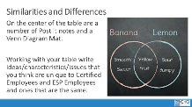    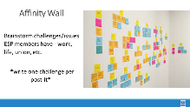  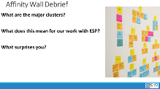  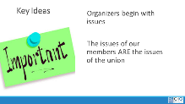 |  | Chart paper for Venn diagram  Lots of Post it Notes and a large wall  A few Larger sized post-it notes |  |  | 10 Min – Venn Diagram  On the center of the table are a number of Post it notes and a Venn Diagram Mat.  Working with your table, write ideas/characteristics/issues that you think are unique to Certified Employees and ESP Employees and ones that are the same. Have them refer to the list they made during the entry activity  25 Min - Understanding Challenges of our Members  This is an activity that you might find useful to do with members who are getting ready to identify priorities for bargaining or a campaign  Affinity wall activity – each participant is going to brainstorm as many challenges/issues as possible that their ESP members have -- work, life, union, etc. – in the true sense of brainstorming, anything that you are aware of is a challenge. Put one challenge per post-it. (this is about a 10-minute activity)  Step 2 – this part is a little bit like engineered chaos – now the group will apply these post-it's to a wall. They put them up – and as they are now on the wall, begin to move them into clusters that are similar – as the clusters begin to form, a few people will begin to NAME the clusters – ex. “Fair Pair” (this can take up to 10 minutes – encourage people at the front to move back and those at the back to move up – keep churning and engaging.  10-minute Debrief  - Do you notice any themes or clusters? Is there one that occurs more than others?  - Are any issues related to each other? (Which/How)  - How do these issues impact our work with ESP members?  - Is there anything that stood out to you as surprising?  Key Ideas -- these members have issues, and it is through our relationship with these members that we build member-led campaigns to address these issues. |  |  | Participants will have identified and described issues that ESP members face.  What are the challenges that ESP face in our affiliate system? Their work? Their lives?
9:45 – 10:30 Naomi |  |  |  |  | What are your experiences supporting ESP units? (45 Min)
    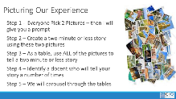   |  | Picture cards |  |  | 6 Min - Beginning activity  Step 1 - At tables, give each group a random selection of picture cards (face down). Each person picks two (without looking)- Don’t tell them why they are picking. Go around and scoop up the extra before you do the next step.  Once they have picked their two, tell them to use these to describe (in under 2 minutes) what their personal experiences are like in working with ESP Units.  [stay on title slide]  10 Min - Table Share  Each person shares their story around the table.  Once these 10 minutes are up, tell them that as a team, they are to use ALL their cards to create one unified story that can be shared. Get ONE team member prepped to tell that story.  10 Min - Whole Table Story  Using all the cards, the table comes up with a story about what their collective experiences are like working with ESPs. (the total story must be less than 2 minutes and ONE person needs to know it very well)  At the end of this 106inutes, tell them that all but the one team member who knows the story well are going to visit each of the other tables – leave the docent behind at the signal and move to the next table.  14 Min - Visiting the Others Step 3  Leave one person from each table behind as the “docent” who will share the table’s story. Each group rotates through each table. Facilitator signals every 3 minutes getting the group to move in a way that is as easy and effective as possible  5 Min - Quick Debrief  What did you notice that was similar around the room?  What surprised you most as you went around the room?  Why do you think these conditions exist? |  |  | Participants build community and build a common understanding of experiences.  What are your experiences in supporting ESP units?
10:30 -10:45
BREAK
10:45–11:15 Heidi & Katrina |  | Vanessa will re – work - Recruitment (60 Min)
 |  |  |  |  | ESPs are an untapped resource for NEA, and membership has always lagged. To learn more about what approaches and messages are most helpful in recruiting ESPs into the union. NEA spoke to the following people.  1.They started by conducting interviews with active ESP organizers across the country and with a range of positions within NEA’s state and local affiliates. Each interviewee was selected because they had been identified as particularly experienced in recruiting ESPs. The purpose of the interviews was 1) to determine what’s working and not working for organizers; 2) to understand what obstacles needed to be addressed; and 3) to gather ideas for future testing.  2.Phase two was extensive focus groups among potential member ESPs. This included six 90-minute online focus groups, which were segmented by career families, the collective bargaining status of the respondents’ home state, and race.  3.Conducted an online survey of 1,038 potential member ESPs from across the country to verify and hone the findings and attitudes that emerged in the qualitative research, understand attitudinal differences across job classifications and other demographic groups, and test updated messaging and positioning, including how and whether to address the cost of membership and the “freeloader” argument.  We are going to share the major findings of this research with you. But first, we want to know what you know about ESPs.  Some of this research is going to challenge your assumptions. Maybe for you or your colleagues back home. It did for us. We want to know what you know about ESPs. |  |  | Participants understand the new findings from the ESP study on potential members.
Say: This training is for you to develop how differentiated and innovative strategies can increase member engagement and union presence within and across worksites of the various job families within ESP. To do that, you need to know about the ESPs in your locals. We are going to give you some time to show us what you know. Locate some paper and something to write with. (Give them a minute to locate, then call back together.) Working with your tablemates, you will answer the questions that are on the next slide. We will check in after five minutes to see if anyone needs more time. Are there any questions?
Change slide and set timer.)

I'm going to show you the answer to these and what we found.
Set a timer for 5 minutes
This is an exercise in pre-thinking, not sharing out.
We want to see what challenged your thinking.

According to the NEA website, Education Support Professionals play vital roles inside and outside the classroom. They keep schools and campuses running and ensure students are safe, healthy, and ready to learn.

You may have a basic understanding of what an ESP is and the service they provide to our school communities, but we need to be more specific to support our active and potential ESP members when we advocate and organize for their needs. Referring to an individual’s specific job title honors their work in the school community, and builds a sense of belonging to a school community and by extension a Union. It confirms that they are part of something bigger than just their job, and brings those who are further from a school building into connection with the Union.

Say: While we use the term educators to be more inclusive, it has actually had the opposite effect for potential ESP members. While current members may use and identify with the term “ESP,” Support Staff is the most unifying term for potential ESP members. Education Support Professionals (or ESPs) is an important term of respect for current members, but it's virtually unheard of among potentials. Potential members who are ESPs don’t tend to identify as educators, but over time, as they join the union and participate, they often begin to see themselves as educators and embrace the terms. The use and belief in the term educator can also be dependent upon the job family/duties/title of the ESP. e.g. A groundskeeper may not view themselves as an educator, therefore they can struggle to see how they fit into a union of educators.

Out of four potential identifiers, support staff rose to the top across job classifications. “Educator” was the least likely to be identified as best descriptor, with ESP second from the bottom (and “Classified Workers” in second).

"Educator" is a term that some potential members just don't identify with, although it can be important for current members to see themselves in that continuum.
Education Support Professionals need to see themselves in NEA’s membership. When ESPs hear the word “educators,” they don’t necessarily think it is referring to them, which leaves them unsure of their eligibility. Likewise, it’s important to have messages (and messengers) tailored to goals and results that impact ESPs.

ESPs want their union to work towards higher salaries, better benefits, and workplace protection. The most important accomplishments a union could win across job categories included winning higher salaries, providing a safe workplace and protecting ESPs from additional duties outside their core responsibilities, and ensuring that the benefits that drew many ESPs to their job in the first place remain strong.
The focus on wages is of particular importance to ESPs, more so than with certified educators. ESPs are joining the Union for these things. PD may be a retention strategy, particularly if by participating it assists with increased pay or the potential for promotion. Typically, ESPs do not join for PD.
If PD is an important part of your recruitment strategy, take into consideration it’s helpful if it’s on free and offered during paid time, and if it leads directly to pay increases.

Finally, respect is a topic that came up in our research in a lot of different ways. ESPs often feel like they are treated as second class citizens in the educational environment we need to interrupt that narrative within our union.

Awareness of the union’s existence and potential benefits for member ESPs are both low.

We must do more to educate potential members that NEA and its affiliates are unions. Additionally, the pitch to education support professionals does require another educational step. We must also be clear that NEA is a union for them, as well as certified members. Many potential member ESPs are aware of the collective power of teachers’ unions but are uncertain of their eligibility for membership or may not feel welcome as full and equal members of NEA.

Some ESPs are aware of a union in their school, and remember being asked to join, but others are entirely unfamiliar and claim that there is no union in their school at all. Among those familiar with NEA, they are almost entirely unaware of what the union could do for them or already does do for them. They value their benefits but are unaware of the efforts made by the union to win those benefits. They don’t know about discounts and programs available to them through union membership. For these ESPs, without a clear understanding of how joining the union could directly benefit them, and direct outreach so they are made aware of the union’s presence and efforts on behalf of ESPs specifically, there will be little incentive for them to join at all. This is especially important given the lack of understanding of the true cost of union dues.

Basic education about the union has tremendous value with ESPs, especially in non-collective bargaining states. As we saw in the teacher research, a significant minority of ESPs are unaware that there is a local union available to join. There are plenty of ESPs out there that would sign up right now if they knew that the union were an option. Moreover, we reach our apex of interest after a simple pitch that clarifies that unions are allowed (and have a legally protected right to bargain in CB states) and that the state affiliate is a union that advocates for higher wages, benefits, and changes that improve workers’ daily lives.

Potential members need to know that Unions are legal. And we must show that members can increase their collective power through advocacy and / or bargaining. ESPs must also be informed that they can join their local union. Many potential members are not aware that they are eligible to join. Potential members are generally familiar with the concept of unions, but there is little depth to that knowledge. They generally assume unions exist to solve problems (i.e., provide protection), and many in non-collective bargaining states incorrectly believe unions are illegal, underscoring how much education is necessary. Finally, potential and current members are often concerned that the Union is “too political” and partisan.

Quiz 2: more question to consider!
Take 3 minutes to answer these questions for yourself and then we will discuss.

TRANFORMATIONAL/TRANSACTIONAL
A transformational approach asks the potential member to become part of something bigger than them as an individual.
A transactional approach is a “give to get” that you often see when we’re hawking liability insurance.
The problem with transactional approach is that if we’re just selling a consumer product (insurance) and treating members as consumers, they will seek the lowest possible price for that product, and it might not be us!

Wins:
•Learning about "wins" builds credibility and overcomes skepticism
•Localizing wins as much as possible
• Higher salaries should always be at the core of our value proposition, but use more tangible day-to-day wins to build credibility on that point. Higher wages are far and away the highest priority and most compelling issue for potential members. But in conversations with potential members, some were still skeptical that’s possible. Pointing to past wins on salaries helps, when possible. Regardless, including day-to-day workload issues as part of our focus strengthens messaging by touching on something teachers value highly while helping to build credibility with those who are more skeptical on wages.

Point to day-to-day wins, as basic as getting improvements to facilities on behalf of educators, as a way of proving the union’s ability to deliver results. While things like getting air conditioning fixed may not motivate people to join quite the same way higher salaries do, these kinds of wins stick with people and show the union is far more than a legal backup – it understands what you’re going through and wants to make it easier for you to connect with your students.

Barriers to Membership: Dues
Organizers say that the ESPs in their locals often work multiple jobs to make ends meet, which makes the cost of dues (or the perceived cost of dues) a major obstacle. Even when the actual cost of dues (and the fact that ESP dues are less than teacher dues) is made clear, organizers say membership can still be just too expensive for many ESPs.

Many believe dues are higher than they really are. A monthly figure is much better for us than an annual figure, but any discussions that focus attention on dues COULD be counterproductive.

Here are some tips for talking about dues:
- Monthly or per paycheck figures, not annual
- Don’t equate dues to cup of coffee/soda, etc.
- Shame doesn’t work
- Consider Affirm, Answer, Redirect

Barriers to Membership: The Union is for Teachers

Further, ESPs often assume that the union is focused solely on teachers and not an option for them. This filters down to union programming as well –ESP members were unaware that they could take advantage programs like student loan forgiveness or professional development opportunities.

Many have not even been recruited. Some report they’ve received no communications or were never formally asked to join. Potential members need to see how their lives can be changed. We need to convince potential members that NEA’s affiliates will ‘strengthen their voice’ and ‘improve their daily lives’ especially by improving wages and addressing workload issues. Potential members worry that unions can be hostile, adversarial, or too political. Having the right tone and language to soothe these concerns will be key with harder audiences. Some educators are fired up by strong, agitating language focused directly on the struggles educators face; others are turned off by tones that they read as being “combative.” Educators/ESPs primarily identify with local or state affiliates of NEA more than the national entity. Messaging that connects to local efforts rather than national efforts are more effective. Educators/ESPs work in schools because of the students. Leaving students out of the conversation misses the point: potential members want the union to help them so they can work most effectively with students. (use based on job class)

10 min Activity
Using the research you have unpacked with your colleagues and with us, we want you to do the following:

Develop what you would say as part of a 1:1 to Demonstrate how the Union will get results. What’s your story around how we win?
Write your story 3-5 bullet statements.

Key Points-5 mins
Potential Members who are ESPs do not think of themselves as "ESPs." Support Staff is a more recognized term, but job title is best.
Unions are legal.
ESPs are eligible to join their local Union.
Wages, benefits, and safety are their most important issues.
Transformational over Transactional
We need to invite ESPs into membership by focusing on how collective power helps them to have stronger work and home lives.

11:15 -12:00 Hedy and Ellen |  | An Institutional Problem (65 Min – Split 45 before and 30 after lunch)
  Oppression Continuum  Race Class and Gender Lens Slide  Table Work Slide |  | Dominant Narrative Handouts with ESP Scenarios  https://neahq-my.sharepoint.com/:w:/g/personal/eholmes_nea_org/EfFCtYJ_oz5FqgPVXgAzTgoBU8zr77ixDvw7q86CZX6_Ow?e=d2B084 |  |  | 15 Minutes – Analyzing Union Engagement Misses and Opportunities (Angel Scenario) from p.4-5 of Participant Handbook.  5 minutes intro:  Oppression operates on multiple levels and this drives us toward taking a systems thinking approach to addressing its impact. Biases lead to the development of stereotypes that feed prejudice and discrimination accumulating in systemic oppression.  A way to begin recognizing and planning to interrupt this system of oppression is through a Lens. On page 6 is a suggested lens. It is a set of 6 questions that a system agrees to use consistently and routinely when making decisions, developing budgets, or debriefing implementations  In the 10 minutes left before lunch – You will work at your table with a story about Angel the Education Support Professional.  - You were asked to read and review this before coming so it should not be completely new at your table.  - Working with your table mates, share your answer to the 5 questions on the back.  - The 5th question is the most important, and likely the one you’ll struggle with most. Lean into it.  25 Min-Angel questions and debrief  15 Minutes Debrief focus on having one table report on each of questions 1, 2, 3, and 5 – save question 4 for the end  - Is Angel thriving? What is your evidence?  - What are the ways the Union could do better?  - What the examples of missed opportunities?  - What would you do to help Angel? Be specific.  What race, gender, and class is Angel?  5 Minutes Key Ideas –  - Race, Gender, and Class are socially and emotionally constructed concepts that intersects with many other forms of oppression  - Two people can have totally different understandings of the same reality  - Becoming anti-racist requires a system approach. |  |  | Participants will recognize components of oppression and reflect on what they see in their own practice and the systems they support.  What are some of the reasons for the injustices that our ESP members face each day?
12:00 to 1:00 LUNCH
1:00 – 1:30 Hedy Ellen |  | Continued - An Institutional Problem (50 Min)
  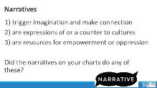  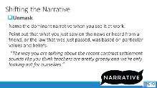  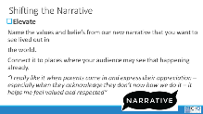  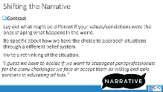  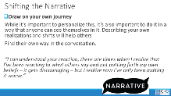  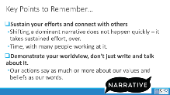  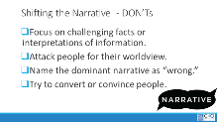  New Table Work Slide  Debrief the Shift Slide  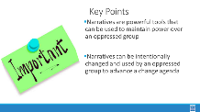 |  | Dominant Narrative Handouts with ESP Scenarios  https://neahq-my.sharepoint.com/:w:/g/personal/eholmes_nea_org/EfFCtYJ_oz5FqgPVXgAzTgoBU8zr77ixDvw7q86CZX6_Ow?e=d2B084 |  |  | NARRATIVES 30 Minutes  5 Min - Introduction  Behind the issues we have described above, there may be a number of institutionalized narratives that are supporting these challenges – both for ourselves and for our members - we are going to examine one – classism. There are others – racism, genderism, ageism, and other oppressive systems and these are addressed in ARJ 1 and 2 extensively. For our work together thinking about ESP we are going to explore classism with the clear understanding that in all ways this is coded language in our society for institutionalized racism.  A dominant narrative is an explanation or story that is told in service of the dominant social group’s interests and ideologies. It achieves dominance through repetition, the apparent authority of the speaker, and the silencing of alternative accounts.  Because dominant narratives are so normalized through their repetition and authority, they have the illusion of being objective and apolitical, when in fact they are neither.  - Narratives are used to  - 1) trigger imagination and make connection  - 2) are expressions of or a counter to cultures  - 3) are resources for empowerment or oppression  - Did the narratives on your charts do any of these?  10 Min So let’s explore how do we change and use narratives 4-5  There is good research that says the more you “argue with” someone, the less they are willing to hear a new idea – or new frame. You are going to learn a simple process and practice it around a small set of scenarios.  Share the slides that outline a four-step process for shifting narratives  (Suggestion – use one of the scenarios as an example when we walk through the 4 ways to shift the narrative.)  - Unmask  - Elevate  - Contrast  - Draw On Your Own Journey  - Key points  - Don’ts  (Make sure that they know these are in their handouts)  10 Min - Narrative Scenario Groups P. 6-11  Working in tables. Everyone is going to look at scenario 1. Quickly familiarize yourselves with scenario 1. One person takes the stance of the “not our framing of the issue” the other two people take the stance of trying to reframe using the process outlined in the handouts. Be ready to share what worked and what did not  5 Min - Debrief  Use one of the scenarios to de brief. Select one that you think went well or one that you think the group struggled with. Walk through the “shifts” with the group.  Show the Key points slide: (quick facilitator note- let them know that there are other scenarios to support their use in trainings when the get back home. )  - Narratives are powerful tools that can be used to maintain power over an oppressed group  - Narratives can be intentionally changed and used by an oppressed group to advance a change agenda |  |  | Participants will understand what a dominant narrative is and apply a four-step method for changing narratives.  What are some of the reasons for the injustices that our ESP members face each day?
1:30 – 2:00 Ben and Naomi |  | Defining Class, Questioning Systems, Reflections on Practices  (65 Min – Split 30 before break and 35 after break)
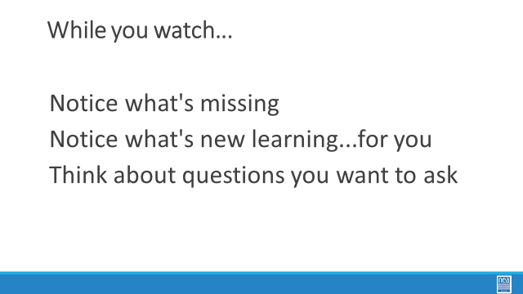      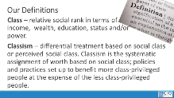 |  | Video about Classism  https://neahq-my.sharepoint.com/:v:/g/personal/eholmes_nea_org/EWbuIiIL7GtPh3uxnfmANrMB0GVtarWejZlpJcPxItPb_g?e=uSE3gE  Defining Classism  Classism |  |  | 10 Min - Introduction and Definition Pg 15-16  Welcome back everyone. Think of the affinity wall you did this morning and the challenges that your members have – and think about some of the narratives we discussed. We are going to take a look at how our organizations’ and our own relationship to class privilege may be part of the problem. We are going to do that by taking a look at a short video. While you watch notice what’s missing, Notice what’s new learning…for you, think about questions you want to ask.  10 Min – Video and discussion  Watch video and discuss. What did you notice?  (Participants will likely notice that there is a lack of race as part of the analysis, that there are two white people speaking in coded language about classism instead of racism) Key point  10 Min – Definition  At your tables, come up with a definition of class as you see it. (Take some definitions from around the room) Share our definition slide (p.15-17) –  - Class – relative social rank in terms of income, wealth, education, status and/or power.  - Classism – differential treatment based on social class or perceived social class. Classism is the systematic assignment of worth based on social class; policies and practices set up to benefit more class-privileged people at the expense of the less class-privileged people.  Ask - what do you see here that is missing from yours? What would you like to add?  Race, class, and gender are all connected, it’s intersectionality – cannot be separate , for those who have been on this journey...yes |  |  | Participants will clarify what classism is and make the connections to systemic oppression.
2:00- 2:15 BREAK

2:15 – 2:50 Ben Naomi |  | Continued - Defining Class, Questioning Systems, Reflections on Practices (35 Min)
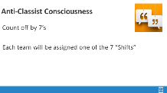  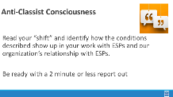  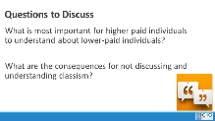  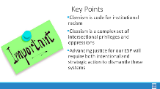 |  | Cross Class Capacity  https://neahq-my.sharepoint.com/:b:/g/personal/eholmes_nea_org/EWZPL46iL9RMq0iGhojmFyEBxCWFFPVrrw79dT9KLFMlmw?e=XOcqpi  Practice the Shifts Handout NEED |  |  | 5 min - Recognizing Classism in Our Organizations and Practices pg. 26-27  Intro and get into groups - We are going to be creating teams by counting off by 7’s. Each team will work with 1 of the 7 Shifts of Consciousness in the Anti-Classist Activist. Each Table will read their “shift” and identify how the conditions described show up in our work with ESPs and our organization’s relationship with ESPs. Be ready for each table to report out and have a discussion about the reflections you make.  10 Min - Work in Groups with 7 shifts handout  15 Min – Report out (2 minutes per team)  5 Min – Final Debrief  What is your most important take away from this session?  How will you fold this learning into your work with ESPs?  What are the consequences for not discussing and understanding classism?  What are the consequences of not including an intersectional perspective?  Share the Key points Slide at the end of the debrief  - Classism is code for institutional racism  - Classism is a complex set of intersectional privileges and oppressions  - Advancing justice for our ESP will require both intentional and strategic action to dismantle these systems |  |  | Participants will clarify what classism is and make the connections to systemic oppression.
2:50- 3:20 |  | ESP Bill of Rights (30 min)
ADD NEW CONTENT HERE; COVER THE FOLLOWING:
- WHAT IT IS (INCLUDE BRIEF HISTORY)- WHAT IT IS NOT (OTHER BILLS OUT THERE)
- WHY AN ESP BILL OF RIGHTS? (FRAMEWORK WITH WHICH TO ORGANIZE, ADVOCATE LEGISLATIVE CHANGES, PLATFORM FOR BARGAINING, ETC)
- THE 10 BUCKETS IN THE BILL OF RIGHTS

3:20 – 4:10 Heidi Helenna |  | Vanessa will incorporate BoR into this section - Issue Identification (50 MIN)
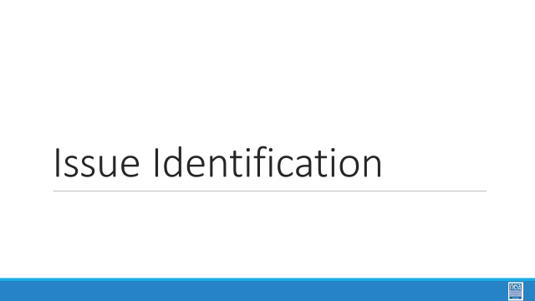  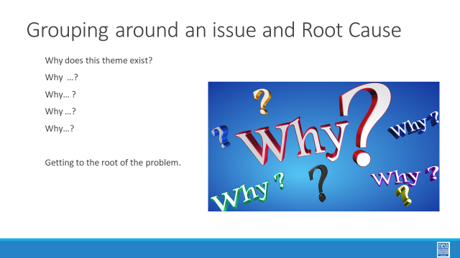    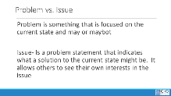      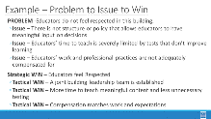    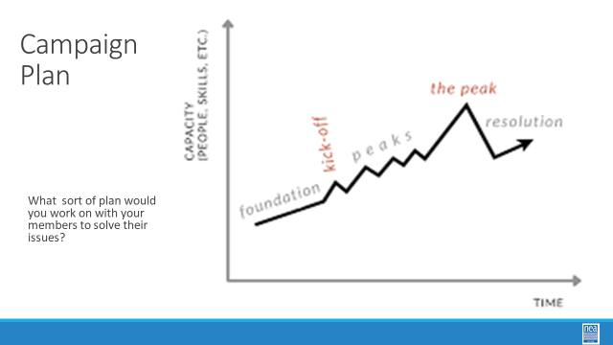  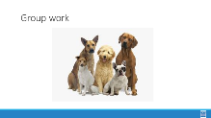  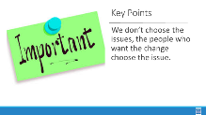 |  | There is a Problem to Issue Assessment handout in the ESP Organizing Toolkit  Teams will use chart paper to record their work of at least one Problem to Issue and then Issue Analysis |  |  | 5 Min - Team Formation Helenna  Return to the Themes of Issues identified at the start of the day during the affinity wall– which one of these would you most like to work on a plan to address in your own work?  Form teams around this and do an analysis of this issue -- what are all the possible root cause? You are going to want to form teams around issues that you would like to work on back home. Teams no larger than 5. You will be working with this team to develop a campaign plan that you will share and could use in some way back home.  5 Min - Problem to Issue and Issue Assessment Intro Helenna  What are possible problems/issues that ESP members want relief from? Share out root cause  5 min of content  PROBLEM vs. ISSUE  Content p.32-33, 46-48  - Campaigns start with issues members care about.  - An issue is a slice of a workplace problem.  - Often, a problem can have different issues depending on the perspective of the people we are working with.  - It is key to get enough input on what the issues are that make up the problem so that YOU don’t drive the solution.  - A staff driven solution may not meet the needs and commitment of the people you are working with.  How to select an issue Content (chart for work is in the ESP Toolkit) p.46  - Since there may be many issues confronting workers on the job, we have to also think about what makes a good issue to organize around.  - CRITERIA:  - It is widely felt.  - It is deeply felt. (by ESPS)  - It is winnable.  - It builds the union and builds leaders.  - It has a connection to students and the public.  - Further defined in the ESP Toolkit p.46-47  - Staff is outside of the schools, we are not impacted by the issues everyday so we cannot come up with the issue.  SET-UP activity  Working with your team, begin to identify which of the brainstormed workplace problems – issues- meet these criteria. When you have winnowed your list to the one that you think meets most of the criteria you are ready to begin planning.  15 Min – GROUP WORK  Groups work on identifying an issue to build a plan around.  15 Min - Report Out and Issue Whip Heidi  What’s your issue?  Is it widely/deeply felt?  What’s your win look like?  5 Min - Key Point Heidi  We don’t choose the issue. The people who want the change choose the issue. |  |  | Participants will use a root cause analysis process to identify issues. They will apply an issue analysis to determine what makes a better organizing issue.
4:10-4:30 Ellen |  | Ending it Right (20 Min)
 |  |  |  |  | Questions, Connections, Reflections  Housekeeping announcements  Evaluation via email |  |  | Participants will be able to bring a little closure to their learning and provide feedback on the day.
4:30 – 5:00 Ellen |  | Choice Networking Activities (30 Min)
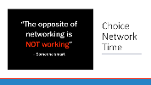 |  |  |  |  | Connect with colleagues from other affiliates. |  |  | Participants will make useful connections with staff from other affiliates.
5:00 | Adjourn

