Facilitator Agenda: Day # 2 Organizing ESP
General Materials Needed: |  |  |  |  |  |  | Room Set-up:
1 Set of Handouts per Person  Name Tags or Name Tents  Room signs, sign-in signs  Painters Tape |  |  | Chart Paper  Post its  Chart Markers – Mr. Sketch  Pens and Pencils |  |  |  | Round Tables  Projector, Screen and Speakers  Carousel stations and reporting stations around the perimeter  20 people  Email links for living wage calculator and budget calculator in advance  Charts needed for today:  1 per table for Living Wage
Key Outcomes for the Day
Building conversation skills
Understanding financialization’s role in ESP wages
Living wage basics
What is a demand and target
What are tactics and escalation
8:30-9:00 Welcome Back  9:00-10:00 One to One Conversations  10:00-10:15 BREAK  10:15-11:00 Financialization  11:00-12:00 Living wage basics and living wage campaigns  12:00-1:00 Lunch  1:00-1:30 Step identification |  |  |  |  | Ellen  Hedy Helenna  Ben  Adam  Heidi and Juli | 1:30-2:00 Coaching of your issue from home  2:00-2:15 BREAK  2:15-2:40 Demand and Target  2:40-3:15 Tactics and Escalation  3:15-4:15 Organizing Plan Team Time  4:15-4:30 Ending it right  4:30-5:00 Choice Networking |  |  | Ben  Naomi  Helenna  Hedy  Ellen  Ellen
Time, Slides, Facilitator |  | Resources |  | Instructions, Activity and Debrief (Facilitators) |  |  |  | Outcomes and Essential Questions
 |  | Charts, handouts, articles, materials, slide |  | What are you saying, what are they doing, what questions will you use to guide learning and make clear the important points  Include an estimate for how long each section of the learning will take |  |  |  | As a result of this section, what will participants know or be able to do? What questions will this answer?
8:30 - 9:00 Ellen |  |  |  | Welcome Back (30 Min)
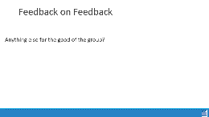  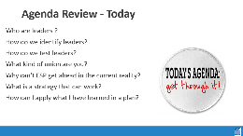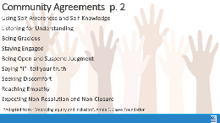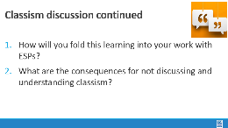 |  | Resource:  https://www.faireconomy.org/ |  | 15 Min - Welcome  Reentry  Feedback on Feedback  Agenda Review  Norm Review  15 Min - Revisiting Classism discussion - if needed  After stepping away and reflecting, let's expand more on these two questions. What was your reaction to #1? Great info but not going to happen, don’t know how to do it, putting a plan together right now...  - How will you fold this learning into your work with ESPs?  - What are the consequences for not discussing and understanding classism?  Spend most of time on #2 getting to: If our members don’t name this, plan on how to address this and work to erase this within their own worksites and locals they will always be limiting their own power. How would someone who feels put down, degraded, othered and worse feel empowered. Without addressing this first, changing the narrative, collaboration, respect and understanding internally it will always be extremely difficult to move to change any external narrative. |  |  |  | Participants will re-enter the learning environment.  What have you been thinking about so far?
9:00 – 10:00 Hedy Helenna |  |  |  | One to One Conversations (60 Min)
  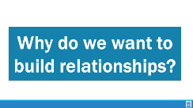  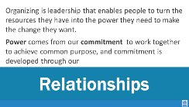  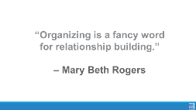  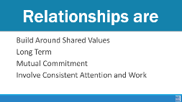    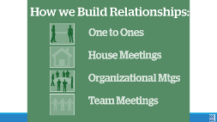    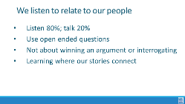  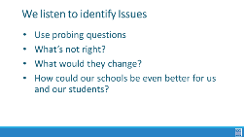  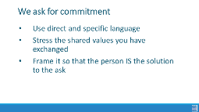  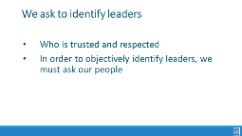  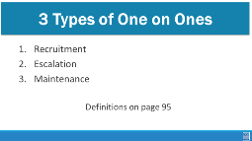  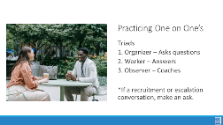    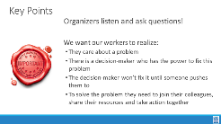 |  |  |  | 15 Min - How do we identify member’s issues and build relationships? Helenna  Why do we want to build relationships?  Because we must. We are having vulnerable conversations with workers and we are asking worker leaders and members to be brave and have vulnerable conversations with their coworkers. To do that we have to know what moves people past fear or apathy to let them do the work of growing their own power. Without talking to them, we don’t know what issues they care about and what will move them to action.  Organizing is a set of leadership practices that enables people to turn the resources they have into the power they need to make the change they want. Power comes from our commitment to work together to achieve common purpose, and commitment is developed through our public relationships.  Show the quote – Organizing is a fancy word for relationship building.  Saying “organizing” to a worker can be confusing. At the core of it organizing is just intentional relationship building.  Relationships are like in other parts of our lives, are based on shared values and shared purpose. Relationships are long-term. But remember, having shared values, a shared purpose and some skills & resources doesn’t mean that you have a relationship. If there is no commitment, there isn’t any glue in your relationship – it won’t last. A relationship with no commitment is not a relationship. If several people come to an association event but I don’t ask them to explicitly to make a commitment to joining me in this work, then they may have a relationship with me, but not with the campaign or the association.  How do we identify what issues people care about and what obstacles are holding them back? We have to talk to them! -We talk to them. We ask. We have intentional organizing conversations (one-on-ones).  Quick Note: Sometimes we default into talking about students and how educators working conditions are students learning conditions. From the research on ESPs that is not always the case for our ESPs and if we simply default to talking about students, we are not only alienating some workers but also repeating the line of "for the students" that bosses use.  I'm sure all of us at some point have said the line "if you had a magic wand, what would you change about your workplace." That is a great tool to get workers issues, but it is also a radical act in and of itself. We are asking workers to paint us a vision of what their workplace should/could be. That doesn't sound super radical, but our workplaces are set up to discourage people from dreaming of more and seeing themselves as change makers. It is our job to get the issue but also to communicate to them that their issues are IMPORTANT, not because it impacts students but because they are workers who deserve better and they know the best solutions for the problems they face.  These are several ways you can build relationships but the one we will focus on is the One-to-One. This is a great tool to identify leaders and recruit them into leadership teams. They are critical for building strong relationships in which both people grow and learn together over time. We use them to build community and commitment within a new leadership team. We use them to build deeper relationships with people we may already know from other work.  p. 49-61 in Participant Handouts  Basics of One to Ones – Hedy [Tie to Day 1 listening to gain understanding, preparation for communication shutdowns and our best practices for listening and building a relationship.]  We listen to relate to our people  - Listen 80%; talk 20%  - Use open ended questions  - Not about winning an argument or interrogating  - Learning where our stories connect  We listen to identify issues  - Use probing questions  - What’s not right?  - What would they change?  - If you had a magic wand, what would you change about your workplace?  - This is your union. What would you like to see you and your colleagues work on?  We ask for commitment  - Use direct and specific language  - Stress the shared values you have exchanged  - Frame it so that the person IS the solution to the ask  We ask to identify leaders  - Who is trusted and respected?  - Why?  - To objectively identify leaders, we must ask our people.  There are three types of one-to-one conversations: p.51  Recruitment: These meetings happen at the start of a relationship to connect you and a new-to-you worker and establish a connection based on shared goals and values. The goals of the recruitment 1:1 are to make a personal connection, use your personal story to identify and gauge potential and interests, probe for a shared experience and connect on values, and lastly, pivot to engagement – that is, move the worker to action and a membership ask based on what you’ve discussed.  Escalation: These meetings are for workers who are ready to take the next step on the “ladder of engagement” in assuming more responsibility and taking on ownership of goals. First, recognize the accomplishments the worker has already made, then propose the idea of taking on higher levels of engagement, whether a leadership role, involvement in a campaign, involvement with other members or actions. If all goes as planned and the worker accepts, take the time to clearly lay out the responsibilities and expectations for this new role.  Maintenance/Relational: These meetings should occur regularly between you and each of your members. This is an opportunity to engage on a personal level, debrief recent actions taken by the members and their team, and offer coaching. Maintenance 1:1s should be scheduled regularly and proactively: do not wait for a problem to occur to schedule one. A good guideline is to schedule a maintenance 1:1 every two weeks.  - There is great value in maintenance conversations. Members who have been engaged regularly are more likely to be engaged, more likely to continue being a member and are more likely to resist and counter negative narratives/information.  5 Min – Overview and practice - Practicing Organizing Conversations Helenna  We want to make sure we give you an overview are working towards the rest of the afternoon. We will be working on our one-to-one skills and our coaching skills in a few different ways with the goal of getting better ourselves, remembering that individuals in any profession, even at the highest levels, must continue to practice and hone their skills. While doing that we will also work on our coaching skills so when we work with our members and leaders our skills are there. While doing all this we’ll also consider how we can/will apply this to training our members to improve their skills. And lastly, immediately most important, we are taking multiple steps to prepare for our worksite organizing tomorrow to support this local/state. We are going out with specific goals and want to help members see their common interests and join their local.  Directions  Count off by number of participants divided by 3 (30 people = count by 10). Group up and sit down.  Then share directions:  35 Min - GROUP ACTIVITY  We will be practicing one-to-one conversations and our coaching.  One person will be the organizer. Another will be the worker and the last will be the observer/coach.  Organizer- You will start a conversation and get to know this person – this is not a scenario. Get to know them as one union staff person to another. Work to identify shared values, their number-one workplace issue and find out as much as you can by only asking questions. It’s important that we use open-ended questions. Closed questions are yes/no questions.  Decide on your own what type of conversation you are having. If a recruitment or escalation conversation, seek some sort of commitment “Will you join us at the school board meeting on Thursday?” or “With members like you, we’ll have a stronger collective voice that improves our daily lives so we can succeed as educators. Will you join the XXX association as a member?”  Workers answer and share for real, no need to make things up. Also, make sure they are doing the work to elicit your responses and values/interests.  Third person will then be the observer/coach (so they can give coaching feedback)  Each round will be 10 minutes total (consider doing 1 of each type to trial each out or you can focus on one type of 1:1)  - Within the 10 minutes, with 3 minutes left, stop the conversation so the observer/coach can share specific feedback for the organizer who led the conversation.  Facilitator will share when it was 7 minutes and when it was 10 and they should change roles.  5 Min - DEBRIEF/ WRAP-UP -Hedy  Whole group  - As a staff person, what will you need to do to make this a member-led practice back home?  KEY POINTS  - Listen and Ask Questions  We want our workers to realize:  - They care about a problem.  - There is a decision-maker who has the power to fix this problem.  - The decision-maker won’t fix it until someone pushes them to.  - If your worker really wants this problem to be fixed, they have to join you and others in taking action. |  |  |  | Participants identify the types of one-to-one organizing conversations  How can we find out our people’s issues?  How do we have effective organizing conversations to identify member’s issues?
10:00 – 10:15
BREAK

10:15-11:00 Ben |  | Financialization (45 Min)
    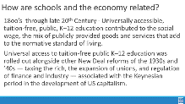  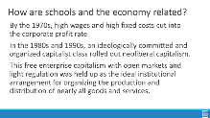  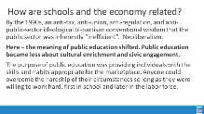  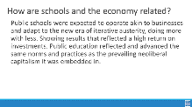  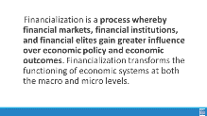  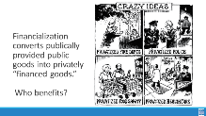  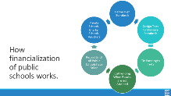  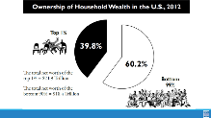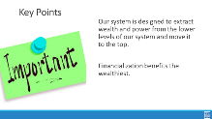 |  | Financialization of Chicago Public Schools  https://neahq-my.sharepoint.com/:b:/g/personal/eholmes_nea_org/EeDQD5wc2CVMrPb8lPjzL7QBajlT7W02c_j9uwZqnf7-xw?e=aQeekZ |  | TO CONSIDER when reworking this section - Consider building an activity that consists of a set of signs around the room with “Eras” that match the content below – another set of 20-30 cards that might have a term such as Kenysian, or Plessy vs. Fergusen, COVID, Ask participants to put the term cards on the wall in the era that they believe is goes in. As the content is provided below – then the signs can get moved if they are incorrectly placed. This can also be used to support the living wage Section that comes next.  10 Min - Introduction  What is the purpose of public schools? Turn and talk to one person at your table. Think about what you would want to share with the whole room.  Inserted stand and talk to a new partner here. Very helpful!  30 Min - History of how the evolution of capitalism and public schools have shifted the purpose of public education  - IMPORTANT TO NOTE at some point in this section – This topic is essential to understand because ESPs are the easiest to outsource and cut when financially squeezed.  Slide 27-28 – Share history of education, for individuals, groups and states and talk about how it’s been linked to the economy. [Use info from article "Financialization of Chicago Public Schools- p.93-95.]  - Public education was created to benefit those in power, mostly white males, and also to train a working class but still mostly male and white.  - Industrial revolution 1760-1840  - Industrialized economy needed reliable, reproducable, and uniform workforce  - Late 1800’s-1900’s Over time public schools began to elevate the workforce, again mostly for those deemed worthy.  - Plessy v. Ferguson 1896  - Into the 1940’s, it was a time of increased power for workers and labor unions. Education became even more widely available but still not universal (racism in access)  - 1954 Brown v. Board  - 1960’s civil rights/women’s rights/title IX 1972  Slides 29-30  - Into the 1970’s, corporations didn’t like the level of profits. This led to a deliberate campaign of anti-tax, anti-government, distrust, pro-capitalism and was really pushed forward by the Reagan admin, especially the anti-tax. This led to the 80’s and 90’s being all pro-capitalism. It was sold... “work hard and make money to be successful”. The narrative didn’t mention the need to step on people on the way  - Creation of standards and norms, push for assessment, national standards  - This extreme capitalism narrative included anti-tax, anti-union and anti-public education throughout. This shifted what public education’s purpose was.  - Private school vouchers and charters are pushed hard to the detriment of public schools  - NOTE: Each state has different laws on charter schools and charters are not bad, we represent many. The system that they are a part of is zero sum, that is the problem.  - Creates an extremely inefficient system (reference Chicago)  Slide 30  - COVID’s effect on financialization of schools  Slide 31-33  - Expectations and realities shift to schools operating in a business model. It’s more about how schools will show a return on investment and create the same type of outputs.  - But business operate with openings and closings, compete with each other and relocate. Schools operating like this leave the community in a bind and disconnected. This model also funnels money out of the community, some are for profit or operate profiting others (charters pay rent with public money).  - Privateers collect rent, sell curriculum and products as well as the private schools that are set up to seek profits.  - Last 20 years – This cycle spins on and we often try to change from within, but we need to stop the cycle.  - ‘93 Clinton and ESEA – elementary and secondary schools act  - Bush – No Child Left Behind  - Obama – Every Student Succeeds Act; Race to the Top  - Conform, achieve, compete  Slide 34  - Who Benefits? have people share examples...ex. private security = private police, privatized fire departments  Slide 35  How has COVID affected the finalization of public schools? ESSR funds usage, impact on supporting the work, etc...  Custodians, Transportation, Security, etc...those furthest from the kids most vulnerable to outsourcing.  Slide 36  Household wealth $45T as of 2022  Might need new slide here that outlines where wealth is currently  2023 Wealth distribution (in trillions)  Top .1% has $19.85 T  Top 1% has $43.44 T  Top 10% has $94.89 T  50-90% only has $43.89 T  0-50% only has $3.64 T  Key Points  - Our system is designed to extract wealth and power from the lower levels of our system and move it to the top.  - Financialization benefits the wealthiest.  - When they changes the tax codes, where corporation pay less than individual, we need folks in the system to create a tax system that is real  - Comes from fight for a fair economy |  |  |  | Participants will learn what financialization is and identify the impact it has had on public sector workers.  Participants will engage in an activity that highlights wealth distribution.
11:00–12:00 Adam |  | Living Wage Basics, and Living Wage Campaigns (60 Min)
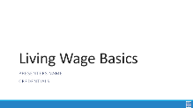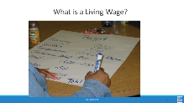  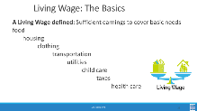  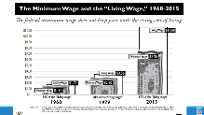  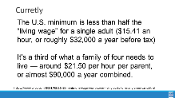  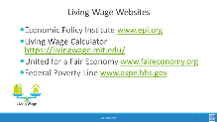  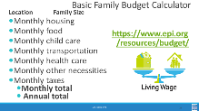  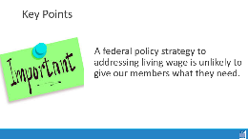    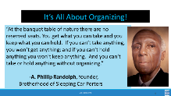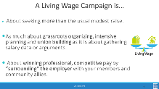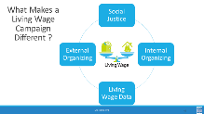    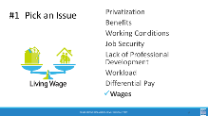  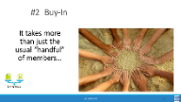  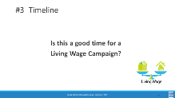  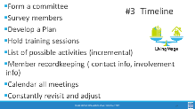  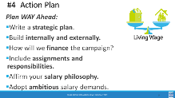  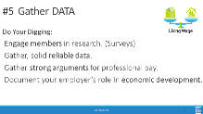  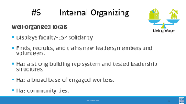  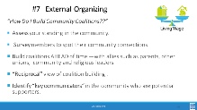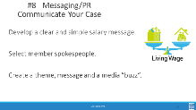  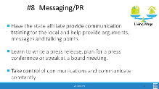  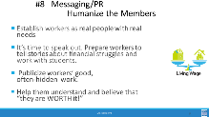  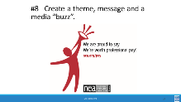  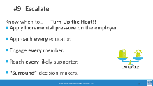  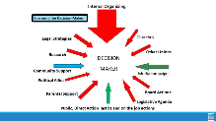  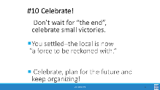 |  | Research a Living Wage  https://neahq-my.sharepoint.com/:w:/g/personal/eholmes_nea_org/EW0rcyW1FQdBmGWN7nOfolQBc98Mipr0uawqAha5gB2fbw?e=PrHHsm  ESP and Living Wage Video https://neahq-my.sharepoint.com/:v:/g/personal/eholmes_nea_org/EY3iOxojxjRBujGsZH7E6qgBEUQ6q3cFTHfJH2xFZNCxTQ?e=20LExo  Checklist for Living Wage Campaign  https://neahq-my.sharepoint.com/:b:/g/personal/eholmes_nea_org/EVrD8aKmRnFEhy633YTrC8MB1p-5ZZ9mAJsU98T8InL0pQ?e=cENpKL  Living Wage Communication Tips  https://neahq-my.sharepoint.com/:w:/g/personal/eholmes_nea_org/Ea_DC80xJ1FKqMPhk7VUeU4BDj59--vJ-sove3ObtLx4OQ?e=OSDpkg |  | 5 Min – Living Wage, What’s included?  What do you think are all the items that would be covered in a household by a living wage? Work as a table to make a list  5 Min –minimum wage vs living wage  Slide 42  - Note: A Living Wage is still not at a level where someone is accumulating wealth. “Thriving” is a term to reflect people starting to generate wealth.  Slide 43  - In 1938 the minimum wage was set with the purpose of supporting laborers so they can have a wage to live on.  - The ability to live off of the set minimum wage has only deteriorated since.  - The current amount is no longer related at all to the ability to live off of the wage and people have very diverging beliefs on the current purpose of it.  - $7.25 current minimum wage (Federal); living wage currently would be $18.81 (EPI site)  10 Min – Living wage calculator activity.  ****[Must email links for living wage calculator and budget calculator in advance]****  Walk them through the calculators  Have them make multiple comparisons  Costs, living wage vs actual, use the locals they work with  Key Points  - A federal policy strategy to address a living wage is unlikely to give our members what they need.  - Also connect... “think of the ESP issues you generated...how many are caused by a lack of a living wage”  25 Min - Living wage campaigns  Introduction  We are going to take a look at the steps NEA has identified are core elements of a Living Wage Campaign.  10 Steps  It is all about organizing - -If a local leader doesn’t get this... They’re not ready for a campaign. A LW campaign can be done in a non-bargaining state as well as a bargaining state. Whether you are bargaining or advocating and lobbying – the campaign strategies are the same.  Salary campaign strategy always involves unity, consensus, strategic planning, solid research and arguments, member organizing and engagement, coalition work, constant communications, and the sense that “We’re worth it.”  What is It REALLY About?  - Working only one job and having time for your family, friends, and yourself.  - Social Justice, Worker’s rights, Human rights, Women’s rights,  - Self-worth, respect, and dignity on the job.  - These are settled out in the community, not at the bargaining table.  10 steps slides:  Step 1 – Pick an issue – how many of the issues identified on our wall can be directly, or indirectly related to the issues of not receiving a living wage?  Step 2 – Buy in This is a campaign for all of the members... Not just the local leaders and the Uniserv!  Everyone should have a chance to contribute and feel ownership. In actuality, a salary campaign builds better, stronger, more knowledgeable and independent locals and in the long run makes for a lighter workload for the UniServ.  Step 3 - YES!!! There is never a better time than now! The lowest paid ESPs are struggling to survive in this economy  Don’t Wait - It takes a good year – 18 months to prepare for a well thought out LW campaign – whether it’s bargaining or lobbying your legislators. When the economy does start to get better, you’re just that much further ahead, prepared to start your campaign, not starting from square one!  Step 4 Action Plan - Salary campaign model: internal organizing, external organizing, use of media, civil rights style tactics, social justice issue, bold salary goals, salary data /cost of living locally  Write a strategic plan: with clear goals, priorities, timelines, assignments and milestones to celebrate.  Step 5 gather data - don’t let comparable pay be the district’s argument – poverty pay is poverty pay –even if it is what the surrounding districts get paid – it’s just not right!  Economic Development- includes faculty and ESP local spending power, institutional purchasing power and direct ties between quality local education, housing values, corporate site selection decisions, creation of rural entrepreneurs  Research – help verify current payroll data but don’t let comparable pay be the districts argument- “The district always says that we make what surrounding districts make.”  Document regional living costs –it’s the district’s problem to find the money  Look at management spending priorities, waste…  Quality… highest salaries attract highest quality applicants  Economic Development- includes ESP local spending power, institutional purchasing power and direct ties between quality local education, housing values, corporate site selection decisions, creation of rural entrepreneurs  Step 6 Internal organizing – leaders, structures, narratives  Step 7 – External organizing  Step 8 – Communicate -- Communication NO MORE SECRETS!! Do not hide the districts dirty little secrets (poverty wages) anymore- and the other secret that the community doesn’t know – TAXES should not now, not ever create or perpetuate poverty!  “Humanize” your members, tell their stories.  Educators are way too modest about the work they do.  We MUST start speaking out! Nobody knows how much they make!  Taxes should not create or perpetuate poverty!  Video tape them!  Help them believe they are worth it BUT if they don’t speak out about it nothing will change  BRANDING - Develop a clear and simple salary message. NEA salary Campaign Create a theme, message and a media “buzz”. Visuals- promotional items, bumper stickers, t-shirts  Step 9 – Escalate: Approach every educator –  1:1 conversations  - Engage every member- a job for everyone, spread the work out-prevent burnout  - Supporters- community allies-parents, students, other union, religious leaders, college faculty, community organizations  - Incremental Pressure – candlelight vigils to full blown rallies, protests  - Surround- pressure on the decision-makers  For bargaining states and non-bargaining states. Decision–maker; Supt., Board of Ed. Members, Legislators, Public  It’s all about your community connections (coalitions) putting pressure on the decision makers (whomever that may be)  Step 10 – Celebrate  Keep improving salary schedules, keep organizing, plan for the next.  “A force to be reckoned with…” - you may not be the districts favorite local president or union but they know you are a force to be reckoned with, you have the community's support...you’re now a player, where before you weren’t even in the game.  This is 45 minutes. Give the other 15 to Financialization to make more interactive |  |  |  | Participants will be introduced to a minimum wage- and living wage calculator that they will apply to their own locals.  Participants will review the 10 steps of a living wage campaign and identify those in case studies.  Participants will develop communications that humanize the issues of workers to build support.  Participants will review the 10 steps of a living wage campaign and identify those in case studies.  Participants will develop communications that humanize the issues of workers to build support.
12:00 to 1:00
LUNCH
1:00 - 1:30 Heidi and Juli |  | Step Identification Activity (30 Min)
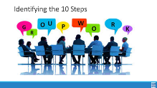  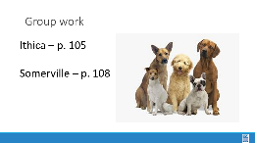  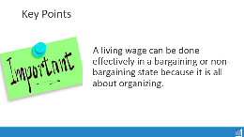 |  | Ithica Living Wage Case Study  https://neahq-my.sharepoint.com/:w:/g/personal/eholmes_nea_org/EbGZkTUC9A9Pm-9pdVQHrY4ByNoqcvJxrlZj_Mf5NzCiAg?e=5pM9Sx  Somerville Paras Case Study https://neahq-my.sharepoint.com/:w:/g/personal/eholmes_nea_org/EeH_wUB-lrpGpyWXU9BSyYEBUVTyXaJ00B9gORZUfk7zYw?e=u4V9ab |  | 5 Min - Explain activity -Heidi  Using either the Ithica p. 105 or the Somervile case p. 108 studies, complete the chart of your assigned article on p.115 of as many of the 10 steps of a living wage campaign as you can identify – you may not find them all in your cases – and some may be implied and not explicitly stated.  Assign half the groups to Ithaca and half to Somerville.  - p.105 Ithaca  - p.108 Somerville  p.115 chart tracks the 10 steps.  10 Min – Teamwork time  10 Min Share out- Juli  Create pairs of Ithaca and Somerville to share what they did in each of the 10 steps.  5 Min - Key Point -Juli  A living wage campaign can be done effectively in bargaining or non-bargaining states because it is ultimately about organizing.  Note: It may be helpful for the facilitators of this section to have some guiding/coaching questions based on each specific article folks are assigned to.  Is there a need to have some sort of guide for “Suggested” or facilitator responses when looking for the 10 steps in each case?  Do we flip the order of this section? Participants did not have enough time to work through the section and do any debrief as a whole group. If we flipped the lesson to work through p. 115 in the article groups and then worked through the “lecture”, it would allow us to go back through the article to find each of the steps. Could we also include some time for participants to be able to answer the following: “If you were able to change one thing about this campaign, what would it be?” OR “how would you change the campaign to include steps that may have been incomplete and/or missing?  Juli created the “Living Wages Articles” in the facilitator tools to link some potential replacements for the Ithica article so both groups have similar length articles to read. (PDFs are made of articles that can be considered, and all are linked on the LINKS page) |  |  |  | Participants will be able to identify the components of a living wage campaign.  What does a winning campaign look like?
1:30-2:00 Ben |  | Coaching of Your Issue from Home (30 Min)
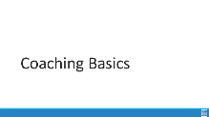    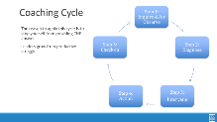  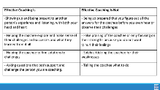  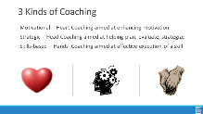      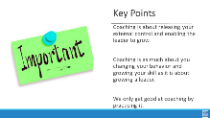 |  | Coaching Content Handouts including Consultancy Protocol  https://neahq-my.sharepoint.com/:b:/g/personal/eholmes_nea_org/EZcbwLqfqRhEpNZ-t-y_4RYB-8PI0HFDzFvZwMgMiqVjZQ?e=Uare8B  Coaching Scenario  https://neahq-my.sharepoint.com/:w:/g/personal/eholmes_nea_org/EWjob3uahd9Ls6eBavLfO9cBKsWk0hKgKl0wVyMrPHaygQ?e=cHCuTI  Coaching Content Handouts including Consultancy Protocol  https://neahq-my.sharepoint.com/:b:/g/personal/eholmes_nea_org/EZcbwLqfqRhEpNZ-t-y_4RYB-8PI0HFDzFvZwMgMiqVjZQ?e=Uare8B |  | 10 Min - What is coaching section p. 120  Coaching is when we release our external control of leaders and enable them to grow. It is a direct intervention designed to help them figure out how to be more effective. Coaching moves individuals and teams away from staff led to self-direction of actions.  There are five steps to observe in a coaching cycle – we observe these to stop our own INCLINATION to move into consultant role and give the answer or the plan.  Effective coaching should result in a transformation of dependence on staff to that of independence. We do that by showing up, being present and listening. We ask good questions that help the team or individual explore what is going on and reflect on what they are learning. We help them identify choices and solutions by asking them what they think they should do and are willing to do. We are almost always in inquiry mode – not directive mode – asking not telling.  There are three kinds of coaching – motivational is when you  diagnose after listening that there is a problem of the heart and will. Strategic coaching is when you diagnose, after listening that help is needed in identifying a plan and sticking to it. Skills based is used when you diagnose, after listening that a strengthening of skills are needed.  Coaching is always asking questions, not directing.  Motivational: Why do you think it’s taking you so long to get started.  Strategic: So tell me more about the difference between  Skills-Based: Why do you think the spreadsheet is sideways  Don’t take away their opportunity to grow  15 Min - 3 Kinds of Coaching activity p.124  Now you and your tables are going to look at 4 scenarios. (stand up and move) In the next 10 minutes, determine which of the three kinds of coaching is best for each scenario. Be ready to shout out answers at the end of 10 minutes.  Take 5 minutes to hear answers.  5 Min - Key Point  - It's not our local  - Our own biases show up when we are directive and patronizing  - Coaching requires asking and listening and enables individual choices  - Coaching is as much about you changing your behavior and growing your skill as it is about growing a leader.  - WE only get good at coaching by practicing it. |  |  |  | How does coaching grow and develop leaders?  How do fighting unions make a material difference in the lives of their members?
2:00 – 2:15
BREAK
2:15-2:40 Naomi |  | Demands and Targets (25 Min)
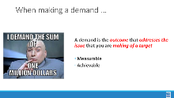  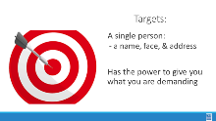  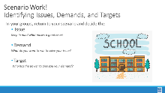  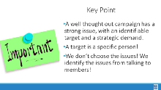 |  |  |  | 3 Min – Introduce Demand and Set Up  - A demand is what the group wants– the win –  - A demand is the outcome that addresses the issue you are making of the target  - If the issue is what is wrong, the target is what we want that will fix the issue.  3 Min - INTRODUCE TARGET  - The last idea that we want to cover is Targets.  - TARGET: A target is a single person with a name and an address. The target is the person with the power to give the workers the change they are asking for. A target has a name, a face and an address.  17 Min – GROUP WORK  In your groups, return to your issue from Day 1 and decide the:  - Issue - Keep in mind what makes a good issue!  - Demand - What do you want to win to solve your issue?  - Target - Who has the power to give you your demand?  - Who can influence this target?  2 Min - WRAP UP/KEY POINTS  - A well thought out campaign has a strong issue, with an identifiable target and a strategic demand.  - A target is a specific person!  - We don’t choose the issues! We identify the issues from talking to members! |  |  |  | Participants will create a demand and a target using the specified criteria.  What is a demand?  How do we identify a target?
2:40-3:15 Helenna |  | Tactics and Escalation (35 Min)
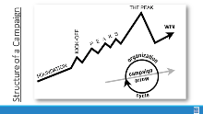  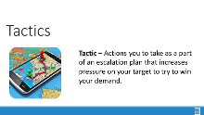  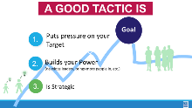  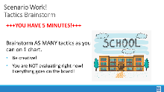  Evaluating tactics slide insert    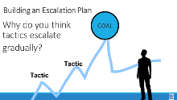  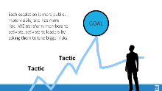  Add in updated versions of these 2 slides  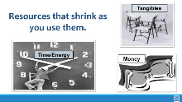    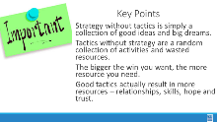 |  | Campaign Plan  https://neahq-my.sharepoint.com/:w:/g/personal/eholmes_nea_org/ERzhoMiTwbZBnVGWtjZp7vMBqcovRLVClohZqMR4in49ww?e=R6d68g |  | 4 Min - INTRODUCE Campaign Mountain  - Foundation – gather info, id issues, id leadership team  - Kick-off –public event that indicates what the issue, demand, and targets are  - Escalating peaks of activity that should escalate in  - Risk  - Capacity (people, resources, engagement and Power)  - Increase leadership and ownership  - Campaign Compression Points  - THE PEAK – The most public, risky, momentum, engagement, and resources  - The Win- We achieve our demand  - Debrief, regroup, and continue to climb  3 Min - INTRODUCE Tactics  Next, we are going to talk about Tactics.  Tactics are Actions you to take as a part of an escalation plan that increases pressure on your target to try to win your demand.  What are some examples of tactics? (Have a few people share out some tactics)  We are going to model a tactics brainstorm that you can use when working with members.  5 Min - Scenario Work  Brainstorm AS MANY tactics as you can on 1 chart.  - Be creative!  - You are NOT evaluating right now! Everything goes on the board!  We are going to have 5 minutes to list as many tactics as you can. Extra points for super creative ideas. WE ARE NOT. NOT. NOT. Evaluating tactics at this time. If someone says something (example- We are going to wear the same clothes without washing them until we get what we want) you write it down and move on. All ideas get on the board. Again, this is a brainstorm. NO EVALUATING.  YOU HAVE EXACTLY 5 MINUTES. After 5 minutes put your pens down.  Open your phone and actively start a timer. “ON YOUR MARKS. GET SET. GO”  Excellent! We now have a whole list of tactics. Next. We are going to assess our tactics. For this, I encourage you to use a list of questions like this-  3 Min - How to evaluate a tactic  - Does the action relate to your issue?  - Will it increase the pressure on the decision-maker?  NOTE! This means that we have to engage in actions that make our target uncomfortable. SOOOOO the same old tactics WON’T WORK! They are used to them!  - Is it visible?  - Is it timed for effect?  - Is it new and different—or tried and true?  Note! SEE above. If a tactic is the same as always, your target has likely become comfortable with it AND it won’t develop new skills in your members and therefore build your power.  - Are enough people ready to do it?  - Will it unify people?  - How will management react?  - How will your target react?  - Does it violate the law? (If so, are we prepared for the consequences?)  NOTE! This doesn’t mean that it is off limits. Historically, breaking laws has been a big part of social justice movements. ESPECIALLY THE LABOR MOVEMENT! However, we have to consider if an unlawful tactic is the right tactic and whether you have the power to mitigate/absorb the consequences.  - Will it be fun?  Folks want to engage in things that fill them up! Many of the same old  10 Min- Evaluating your tactics  Look at your list of tactics.  - Circle the ones that you think are strategic, when looking at these questions.  - Cross out the ones that are NOT strategic.  - You have 10 minutes.  2 Min – Compression Point Definition  Points on the calendar where you celebrate short term wins or escalate your tactics based on how you have assessed your readiness to escalate.  - Naturally occurring deadlines  - Artificial deadlines  - Help us build urgency and crisis  - Opportunities to debrief and reassess  2 Min – Turn and Talk  We keep saying that tactics should escalate gradually. Why do you think that is?  2 Min – Debrief  Each escalation is more public, more visible, and has more risk. WE transform members to activists, activists to leaders by asking them to take bigger risks  2 Min – Just a word about resources  RESOURCES: Resources are what are available to the people who are part of the campaign to use to achieve their demand.  Resources that shrink as you use them  - Time/Energy  - Tangible Items – materials  - Money  Resources that Grow as you use them  - Relationships  - Skills  - Hope  - Trust  2 Min - Key Points  - Strategy without tactics is simply a collection of good ideas and big dreams.  - Tactics without strategy are a random collection of activities and wasted resources.  - The bigger the win you want, the more resources you need.  - Good tactics actually result in more resources – relationships, skills, hope, and trust.  Last note: pg 71 in “organizing for action” would be really beneficial to add into the 2025 Participant Handout |  |  |  | Participants will develop an organizing plan with teams that can be shared with Participants will develop an organizing plan with teams that can be shared with the whole group.  the whole group.  What are the strategic actions and use of resources we will use to achieve our demand?  How can we apply what we have learned?
3:15-4:15 Hedy |  | Organizing Plan Team Time (60 Min)
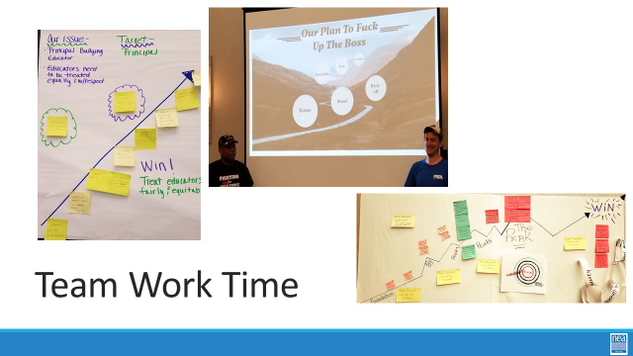 |  | Organizing Plan Template  https://neahq-my.sharepoint.com/:w:/g/personal/eholmes_nea_org/ERzhoMiTwbZBnVGWtjZp7vMBqcovRLVClohZqMR4in49ww?e=KVqAZi |  | Review what team work is in process/been completed and next steps  - In Process - Checklist for Deciding on an issue Doc  - In Process - Plan for Organizing Doc  - Next step – Strategic Planning Template Doc  - Preview – end result is a presentation on day three w/use of visuals  The idea for the work time of this section is that we go back and forth between using the template and then sharing out what they have done  They should be thinking about an 18 Month Timeline  They should keep in mind the 10 steps  They should incorporate the “test/task” design into their tactics  - Must be motivated  - Must be some risk (also more and more…)  - Must have accountability |  |  |  | Participants will build a campaign using the template and content points provided.  How can we apply what we have learned
4:15-4:30 Ellen |  | Ending it Right (15 Min)
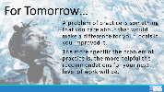 |  |  |  | Questions, Connections, Reflections  Housekeeping announcements  Plus/Delta at the Door  FOR TOMORROW – WHAT IS A PROBLEM THAT YOU ARE EXPERIENCING AROUND DEVELOPING ESP ORGANIZING  Is this activity too tied to the affinity wall? It seems like the issue cut is not specific enough to be actionable. We did not get deep enough into the root cause analysis to identify the target and demand on Day 2 of the training. Could we practice getting to the issue cut with some examples prior to allowing groups to work through identifying the issue they want to work on as a group |  |  |  | Participants will be able to bring a little closure to their learning and provide feedback on the day.  How are we doing so far?
4:30 – 5:00 Ellen |  | Choice Networking Activities
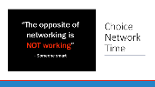 |  |  |  | Participants will make useful connections with staff from other affiliates. |  |  |  | Participants will make useful connections with staff from other affiliates.

