Participant Handouts

2024  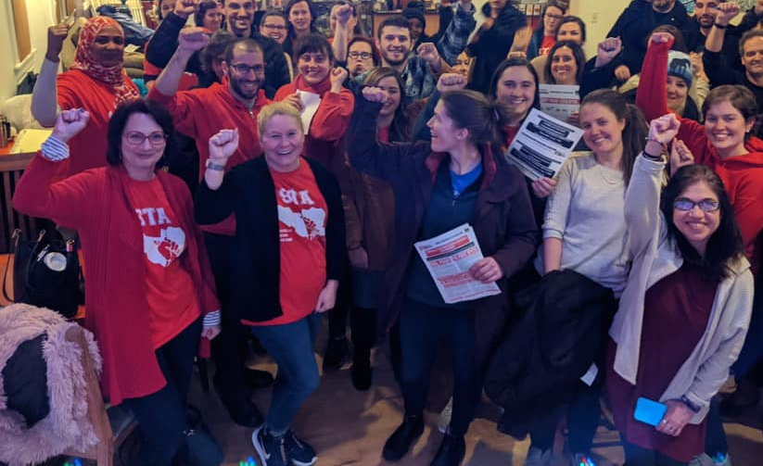   | Organizing Strategies  for work with ESP Members  UniServ Directors who represent ESP locals are responsible for identifying and developing leaders, organizing issue campaigns, and understanding and advocating for the unique needs of ESP members. Strong ESP affiliates have a high ratio of engaged leaders to rank and file members and structures that allow for rapid response, relationship development and collective action. This NEA Center for Organizing training is designed to build skills around ESP leadership identification and development. They will learn how to establish differentiated and innovative structures that can increase member engagement and union presence within and across worksites of the various job families within ESP.  Director  Tom Israel  tisrael@nea.org  Academy Coordinator  Ellen Holmes  eholmes@nea.org  Academy Logistics  Karla Medina  kmedina@nea.org

