Facilitator Agenda: Winning School Board Campaigns Day # 1
General Materials Needed: |  |  | Room Set-up:
1 Set of Handouts per Person  Name Tags or Name Tents  Room signs, sign in signs  Highlighters – 3 colors  Pens and Pencils | Chart Paper – self stick kind  Markers- Mr. Sketch - Non Permanent  Post its  Wifi  Charts for the day:  - Reading/Jigsaw  - Stick Fugure  - Core Values |  | Round Tables for Participants – cords at each table  Long rectangle at back for Facilitators  No Podium – table with projector large enough for laptop  Projector, Screen, Microphones, and Speakers  Carousel stations and reporting stations around the perimeter  50 people Max

Pre-Training Needs
- Info for object icebreaker
- Info on how to find election data they need for vote goal calculation
- Articles to read (different groups read different articles)
- Bring membership, PAC, volunteer data numbers they can get
- Information about their school board
- List of community organizations
- Worksheet with these leading questions

Key Outcomes for Day 1
- Build sense of community
- Understand the importance of school board elections and the current threats we’re facing
- Map their school board, local, & community
- Calculate vote goal and understand components of campaign plan
- Identify strategies for successful candidate & coalition recruitment
- Recognize the need and fundamentals for PAC Fundraising

Content and Facilitator Assignment Overview Day 1
8:30- 9:00 Welcome  9:00 -9:20 Introductions  9:20-10:15 Importance of School Board Elections  10:15-10:30 BREAK  10:30-12:00 Campaign Plan Overview  12:00-1:00 LUNCH |  | Ellen and Meighan  Ellen and Meighan  Vanessa  Hedy | 1:00- 1:45 Coalition Building  1:45-2:15 Recruiting and Recommending Candidates  2:25-2:30 BREAK  2:30- 3:20 Recruiting and Recommending Candidates  3:20-4:20 PAC recruitment  4:20-4:30 Ending It Right  4:30-5:00 Choice Networking | Melissa  Monet  Monet  Meighan  Ellen

Time, Facilitator, and Slides | Resources | Instructions, Activity and Debrief (Facilitators) | Essential Questions and Key Outcomes
What is the clock time for start and end? Who is doing this Section? What are the PPT slides (pic of slides)? | Charts, handouts, materials, videos | What are you saying, what are they doing, what questions will you use to guide learning and make clear the important points  Include an estimate for how long each section of the learning will take  Include Key points. | What question(s) does this section answer?  What will participants know or be able to do?
8:30 – 9:00 Ellen |  | 30 Minutes Welcome
Slides  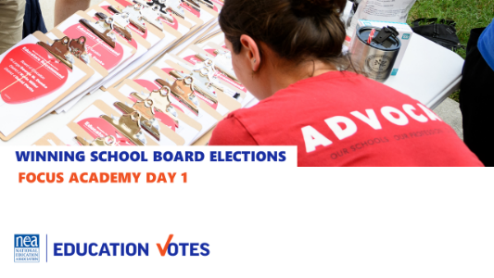  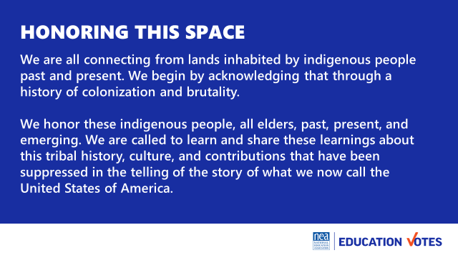  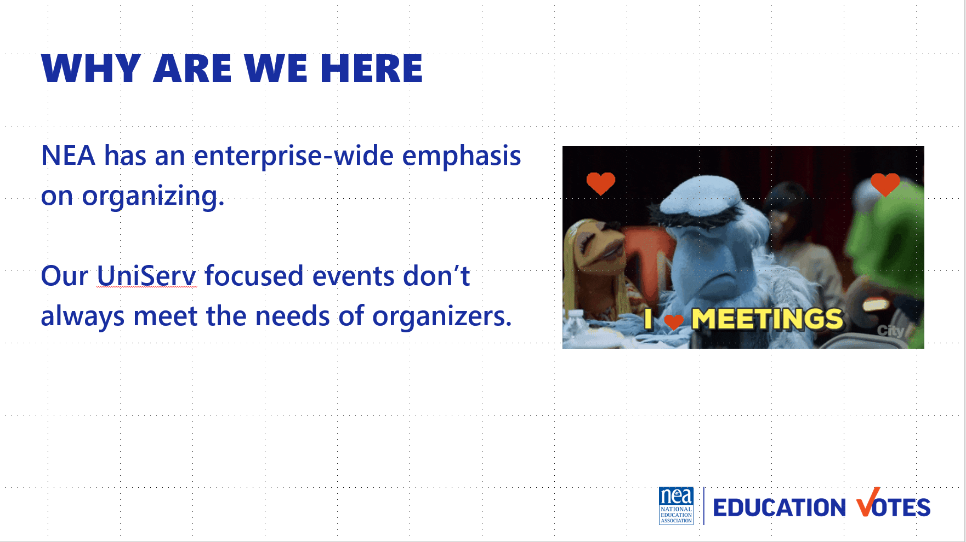  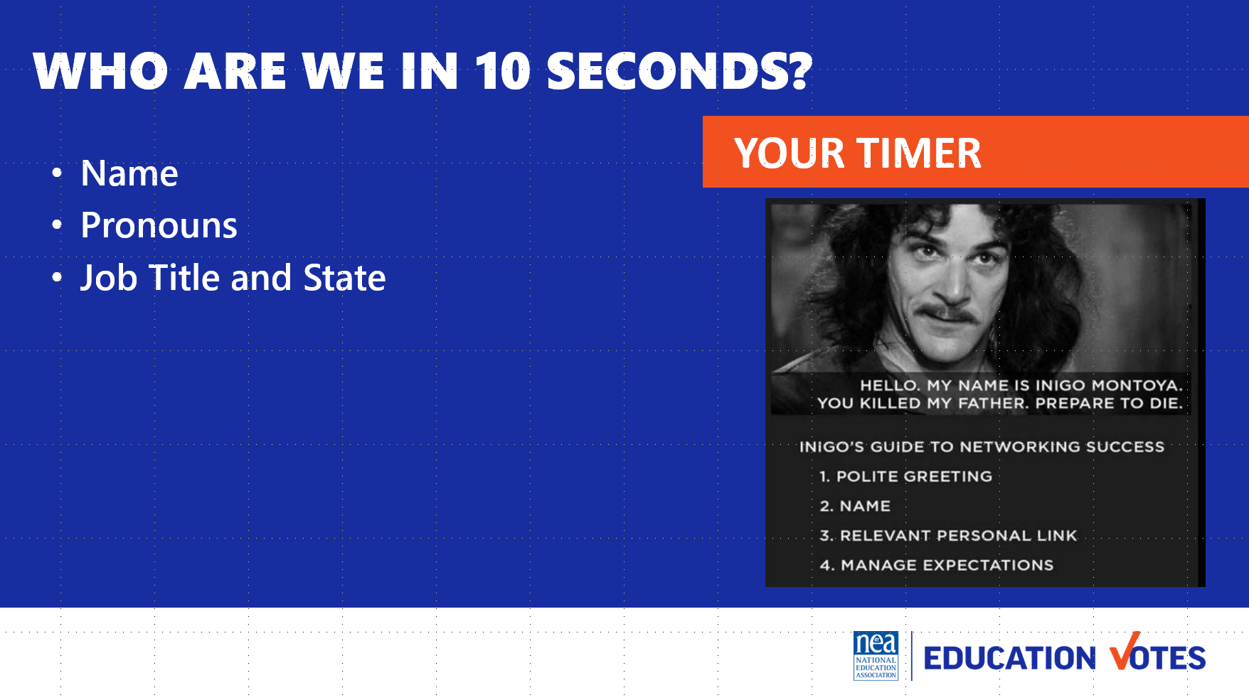  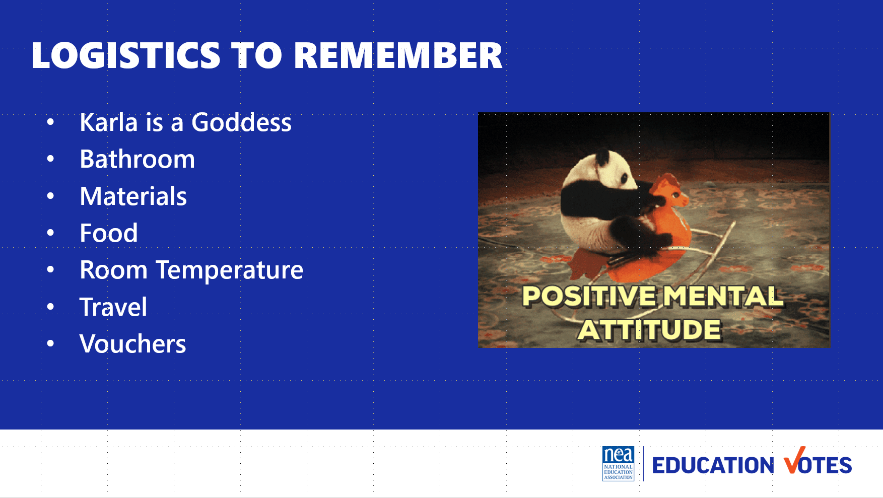  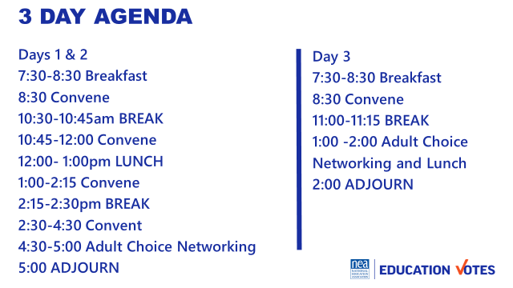  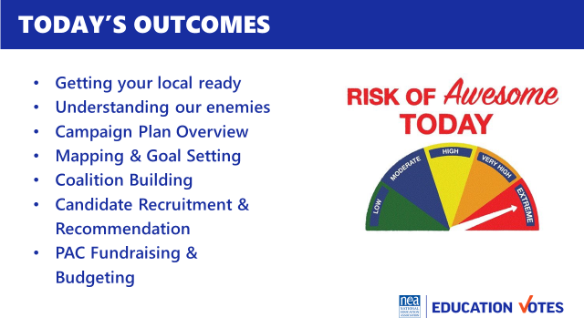  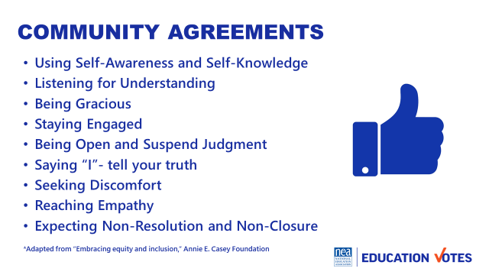 | Community agreements on name tents  Agenda on Table  One Pager on Reimbursements  Community Agreements in Participant Handouts | Welcome  Land Acknowledgement  We begin by acknowledging that through a history of colonization and brutality, we are currently on the traditional lands stewarded by generations of the Wahpekute and Sioux people.  We honor these indigenous people, all elders, past, present, and emerging. We are called to learn and share these learnings about this tribal history, culture, and contributions that have been suppressed in the telling of the story of what we now call the United States of America.  Why are we here?  NEA has and enterprise wide emphasis on organizing and our UniServ focused events did not always meet the needs of organizers. Additionally we are working to create more connections across our centers – silos. Campaigns and Elections operated independently and parallel to our UniServ and Organizer programs. Both doing great work – but duplicating some content and missing many opportunities. One of the biggest misses was in supporting affiliate staff that may not hold the title of Government Relations or Campaign Goddess but who do work most closely with members who work for school boards. Engagement in the most local of politics is the best way to create authentic wins that are secured by and felt by local workers and their communities. They are visible and tangible and can boost union engagement. We are going to learn how to accomplish this.  Introduction of Participants and Facilitators  We are going to do a very fast whip around the room 10 seconds or less per person so we can get every voice heard and every face seen as soon as possible. Let’s start with the facilitator team -Remind Folks to Keep it Short - Name, Required Pronoun, State and Title  Logistics to Remember  - Questions  - Bathroom​  - Materials​  - Food​  - Room Temperature​  - Karla is a Goddess  - Travel​  - Vouchers  Let’s take a look at the basic two and half day agenda. We will not have working lunches or breaks – those are your times to do as you wish including reconnecting with members or the home office. We ask that you put on your out of office notifications and respect them for yourselves as learners. You will notice that at the end of each day is something called adult choice networking. The value of coming together around this learning is really amplified when you have unstructured time with the folks who have come from all over around this topic. All that we ask is that you network any place but in this room. This time is part of the official agenda so that you may report that you have worked a full day while at this experience.  Here are today’s outcomes – please remember this is a pilot so shift will happen.  Group Review (p.2-3)  Begin with a proposed list of community agreements, each table needs to describe what they think each agreement means and propose any additional norms not covered by the proposed agreements:  - Using Self-Awareness and Self-Knowledge  - Listening for Understanding  - Being Gracious  - Staying Engaged  - Being Open and Suspend Judgment  - Saying “I”- tell your truth  - Seeking Discomfort  - Reaching Empathy  - Expecting Non-Resolution and Non-Closure  Refer them to the Community Agreements in their handouts and that they received as part of their Pre-Attendance documents.  Prompt table groups to review the agreements.  - Give them XXX minutes to scan the agreements looking for items that they don’t understand.  - They should also be tracking what they think is missing.  Debrief  Share what you mean by the agreements.  Check to see if tables are on track or need clarity for EACH of the agreements.  Before moving on - ask the group to show thumbs:  - Thumbs up is I totally agree  - Thumbs sideways is I can live with it and I am fine to move on  - Thumbs down – I simply cannot move on AND I have questions or something different to propose.  - A thumbs down comes with the responsibility of working until your thumb can at least be sideways.  (What follows are facilitator notes to help you debrief the ways of thinking that shaped each of the proposed agreements 1-4)  - Learning is a two-way experience - you need to communicate well with the facilitators and your group mates to ensure your own learning and that of the group. You are invited to share in the development and maintenance of a productive adult learning space.  - Speak up and make room for others to do the same. Sometimes that means stepping back. Expect to be called on even if your hand is not up – it is a way for facilitators to ensure a balance of voices in the room – we expect that you might pass as well.  - Be free to discuss ideas that you heard, but not identify the person or people involved. | How is this work structured?  Participants will understand how the days will be structured.
9:00- 9:20 Meighan |  | 20 Minutes Introductions
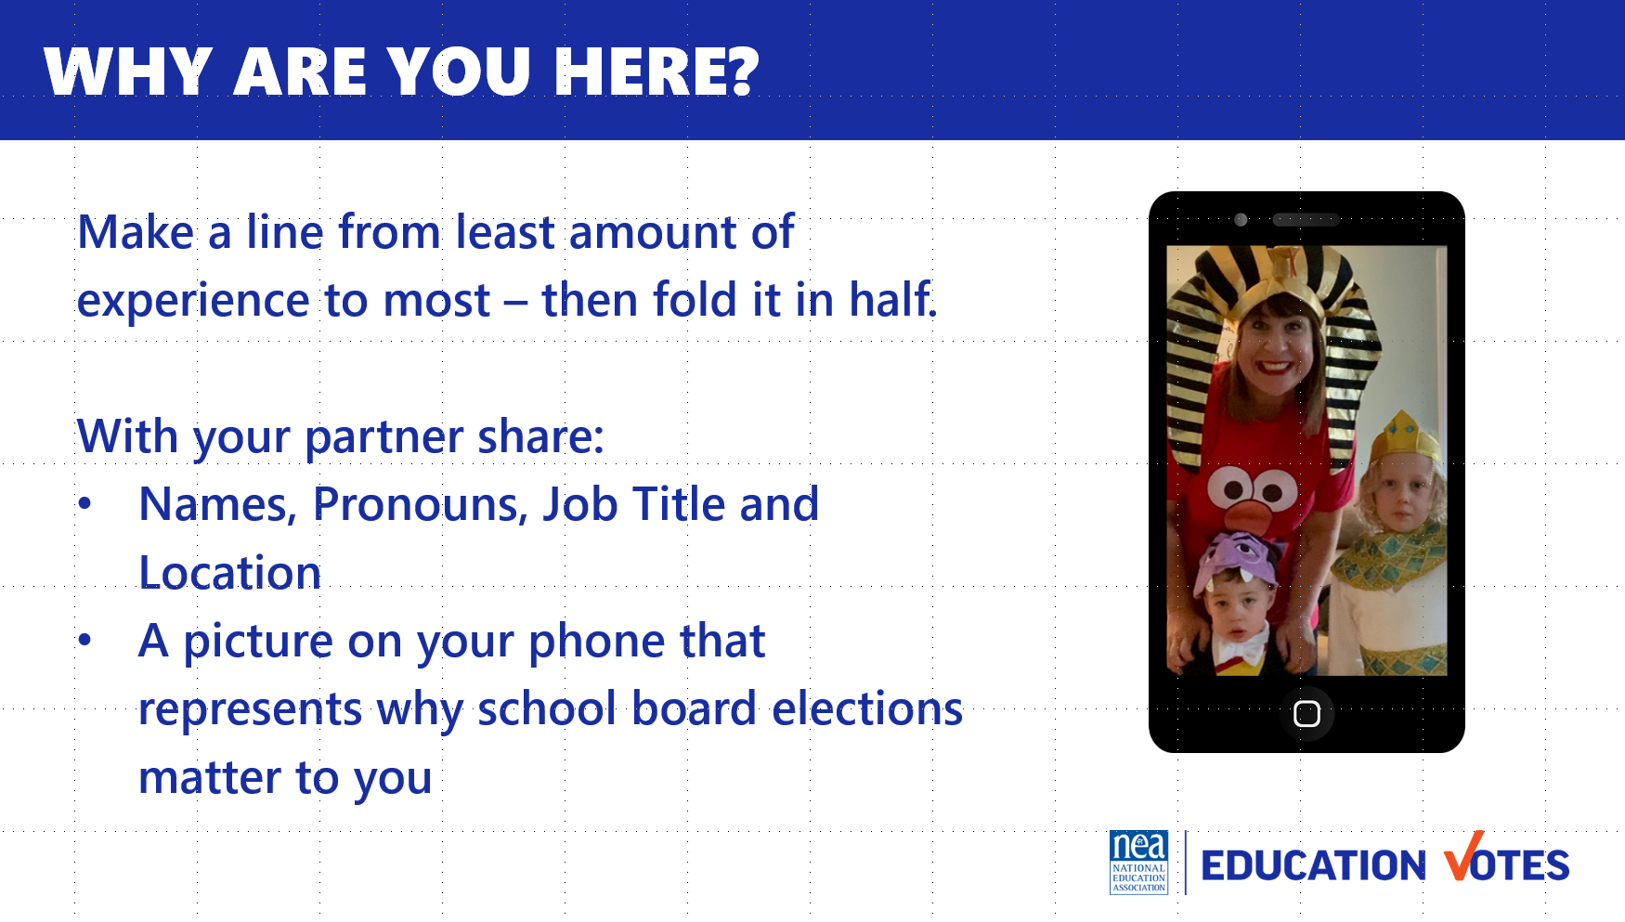   | Participants will need a picture on their phone about why school board elections matter to them. | 5 Minutes set up – We are going to do a fold the line activity – so everyone will be up and moving. The first part of this activity is for you to have a number in your mind – How many years have you done this work? However you count those years – have a number. Now – those with the smallest number will begin over here with 0, a few months, 1 year, 5 year etc… in a line all the way to those with the biggest number – 100 years of union work – in a line. (Facilitators will help get folks on an arc single file from least to greatest) Now for the second part – You need to locate that picture on your phone that you were told to have ready that represents WHY school board elections are important to you. Ready?  Now, we are going to fold this line from the ends towards the middle – so the two on the end are a pair, then the next are a pair, then the next, - (facilitators can help with the pairing) once you have found your partner –  6 Minutes in Share Pairs  Each have 3 minutes – self time and Share  Names, Pronouns, Job Title and Location  A picture on your phone that represents why school board elections matter to you  10 Minutes – Debrief | Who is in the room?  Participants will begin to build a learning community
9:20 – 10:10 Vanessa |  | 50 Minutes The Importance of School Board Elections
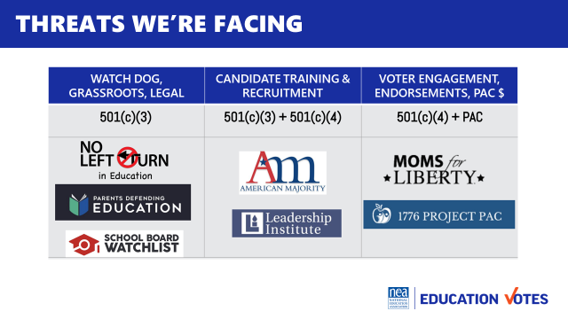  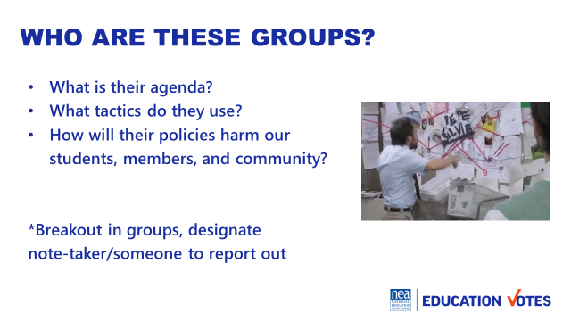  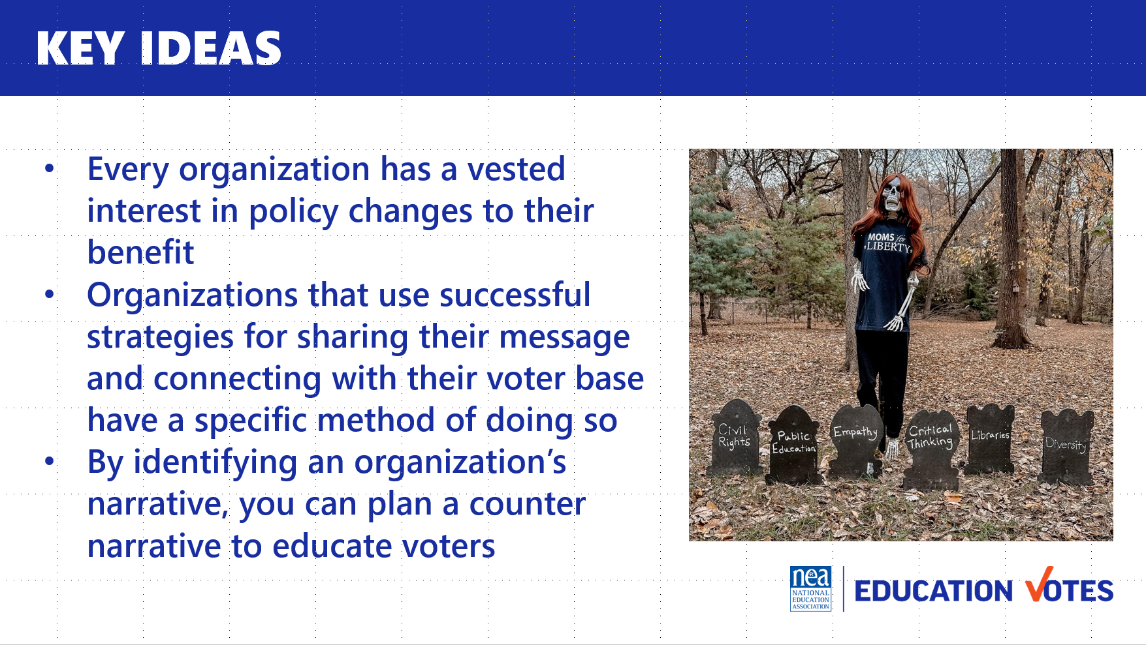 | Article(s)  Handout with questions | What are the threats? (5 min intro)  There are various organizations around the country that have a vested interest in getting involved in local politics. You can find examples of this by studying the various businesses and organizations that begin to get involved in school board races or create alternate organizations that do so on their behalf. Here are a few of the organizations throughout the country that are currently investing in school board races in targeted areas around the country. There are three different types of organizations that can be defined by their tax identification. This can be interesting to track as there are different ways that organizations can be involved in school board races based on their limitations and resources.  To better understand the impact of the involvement of organizations like the ones we’ve listed on the slide, we are going to look at several examples of what involvement from these groups have looked like in the last few years. Some examples are more recent than others, and the impact varies depending on the area and the objective of the organization.  Our goal from this activity is to be able to identify the organization’s threat to public schools, and what the purpose of their involvement is.  2-minute Set up  In the pre-participation email, you were assigned an article. Get into the group now.  15-minute Group Work –  In your group, read through the article you were assigned. As you complete the article, work as a group to identify the answers to the questions posed on the slides. (Also included below).  Questions to Answer  - What is their agenda?  - What tactics do they use?  - How will their policies harm students, NEA members, and communities?  - What was the reason the organization had an interest in schools?  - How did they communicate their priorities? (What was their narrative)  - What was the result of their involvement in schools outlined?  20-minute Jigsaw  Now that you have done a study on the organization you were assigned to through your article, you will be comparing the impact of your case study with each of the others in the room. (Have each person count off by 5 and then group them in their new groups, so that each new groups has representation from each of the articles. Once they have put themselves in their new groups, give the next set of instructions.)  Now that you have had the chance to think through some different scenarios and case studies of organizations that have had impacts on school board races, it’s time to think about them as a collective. A counternarrative is a tactic that is used to discredit the claims of another organization. It is used by taking the organizations’ stated goals and objectives and stating the impact they have with their potential influence.  For example: If Vanessa is running a campaign that fights for the choice of parents in their child’s education (ie. Book banning and/or censorship) the narrative would be “Parent should have choice and influence over the content their child is exposed to”  The counternarrative for Vanessa’s campaign would address the gap in what Vanessa’s message is (that parents currently have NO choice in educational content). The counternarrative could include the following: “All educational content is based on state and national standards for education, which are all decided as a collective. Any curriculum adopted goes through a process that allows for both parental and professional input prior to adoption. Educators are professionals and are trained on providing education to students. Parents are not”  In your groups, answer the questions on the slide (and included below), paying special attention to the last question about a counter-narrative. Chart your answers to the questions.  Discussion Questions  - What do each of the organizations have in common?  - What are common tactics or strategies that organizations utilize in their campaigns?  - How did they frame their messaging to their audience(s)?  - What tools made their campaigns successful?  - What counternarratives could be used to address some of the p riorities outlined by the organizations?  (Have each group share out their answers to one of the questions)  Possible Counter Narrative:  Student Rights and Parents Responsibilities. One frame that has been useful and important is related to jurisprudence in other countries like Canada, where legally parents don’t have “rights”, they have responsibilities. Children have rights in Canada. To counter, we can do things like organize for Students’ Bill of Rights, which includes a right to honest history, a right to read, I right to self-identify, a right to exist as their own humans outside of their parents’/guardians' expectations and wishes.  Key Ideas (3 minutes)  - Every organization has a vested interest in policy changes to their benefit  - Organizations that use successful strategies for sharing their message and connecting with their voter base have a specific method of doing so  - By identifying an organization’s narrative, you can plan a counternarrative to educate voters | Why do we need to be working on school board elections? Participants will understand the threats our school boards are facing and why elections matter.
10:15 – 10:30 BREAK
10:30 – 12:00 Hedy |  | 90 Minutes - Campaign Plan Components
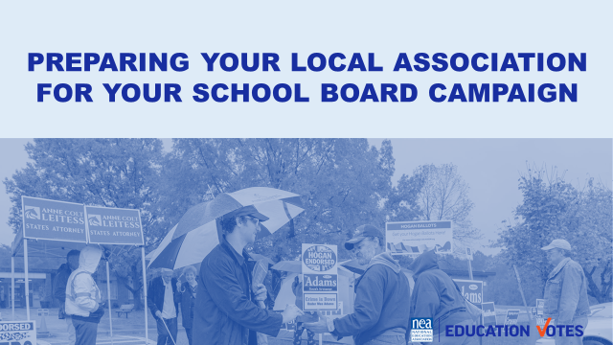  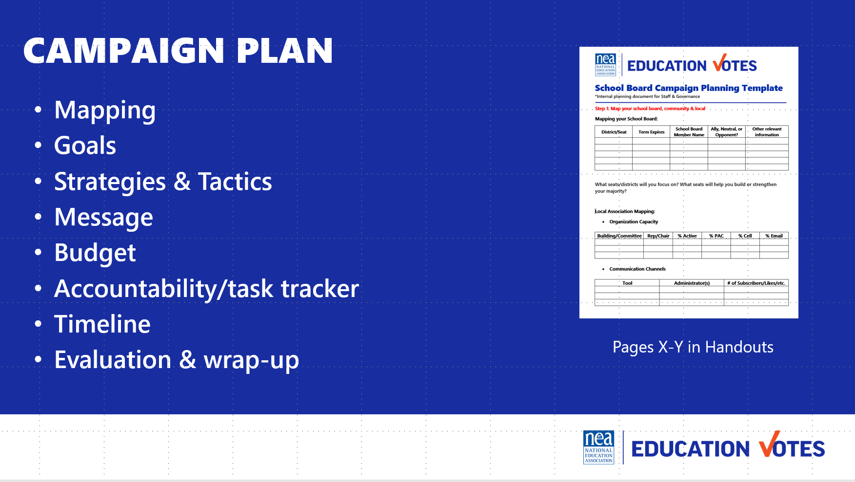  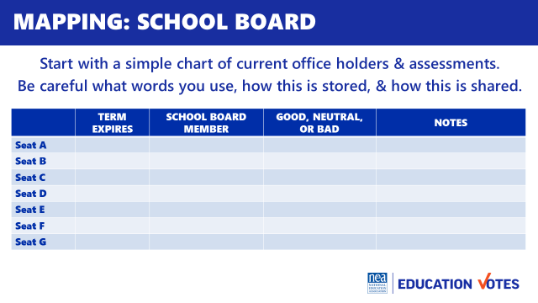  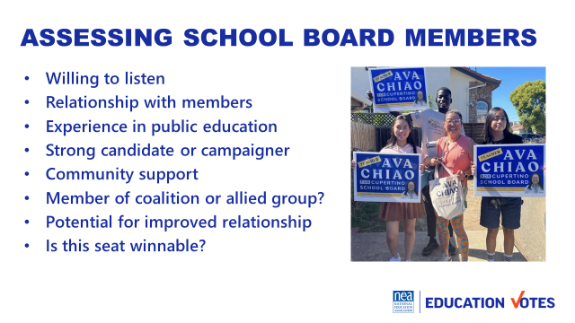  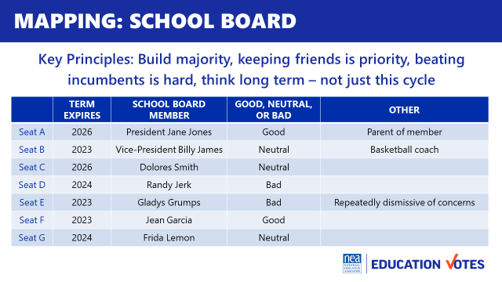  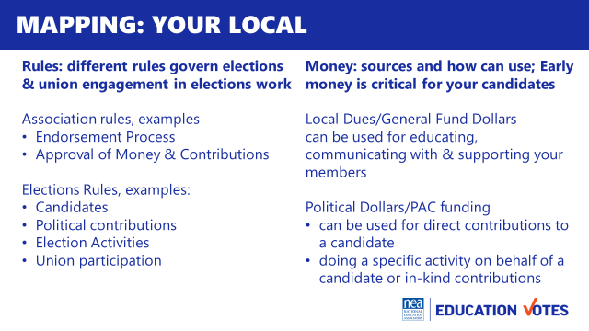  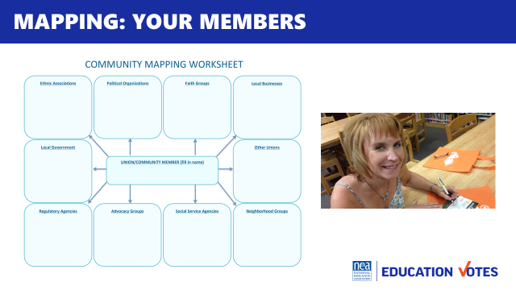  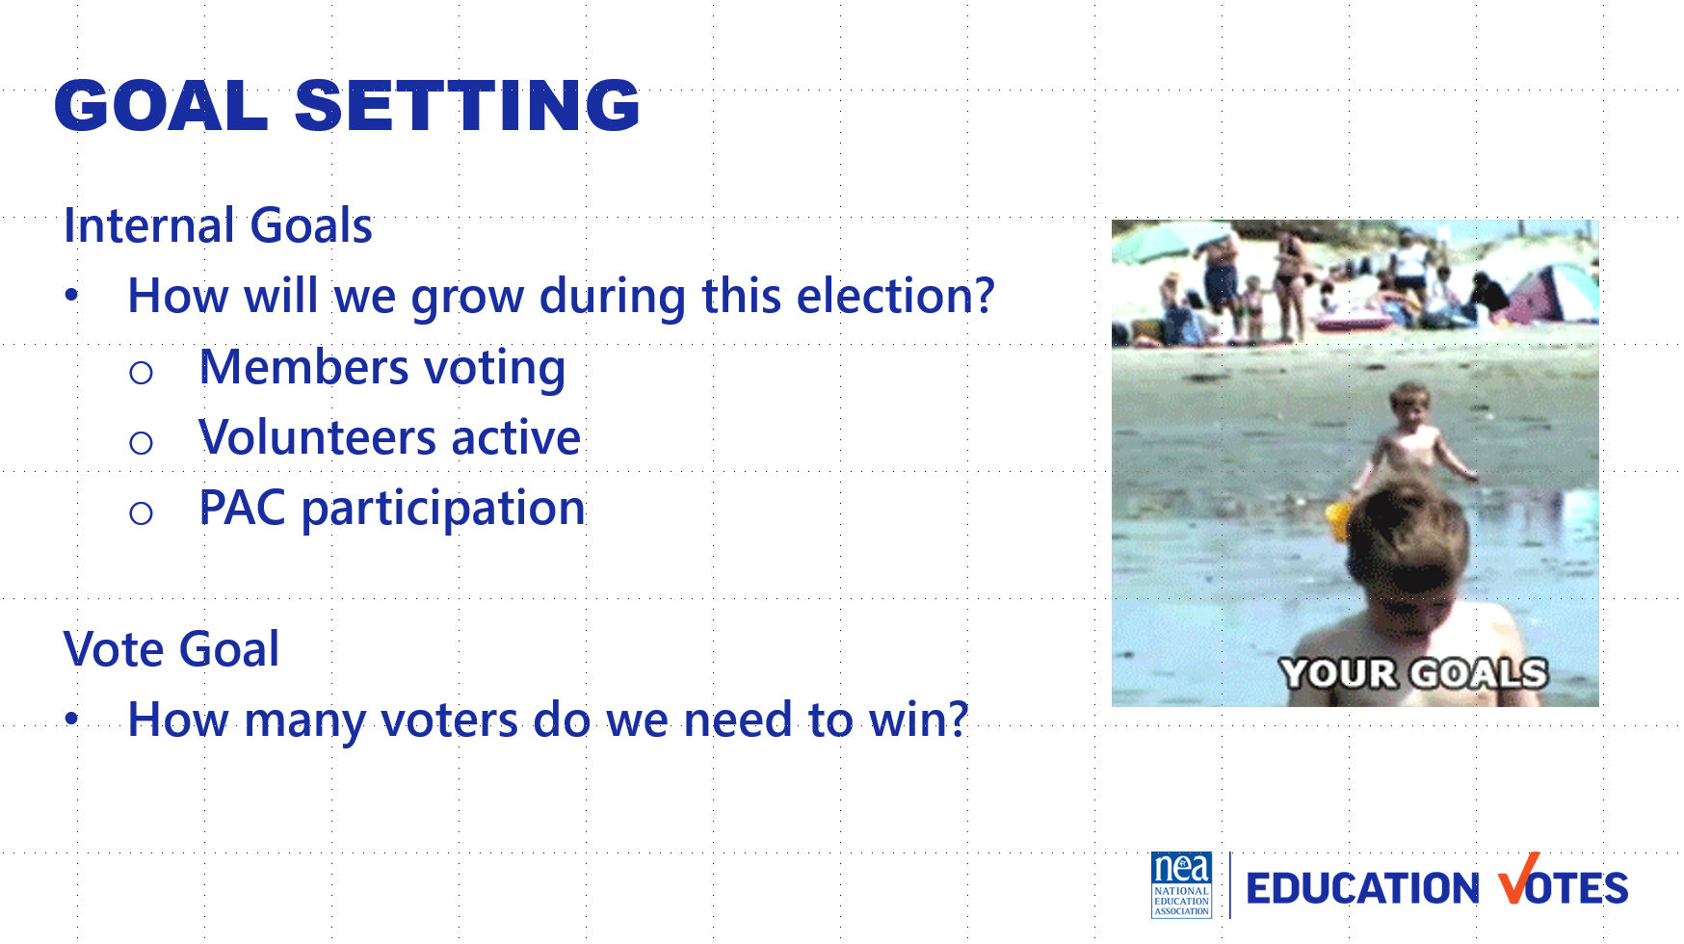  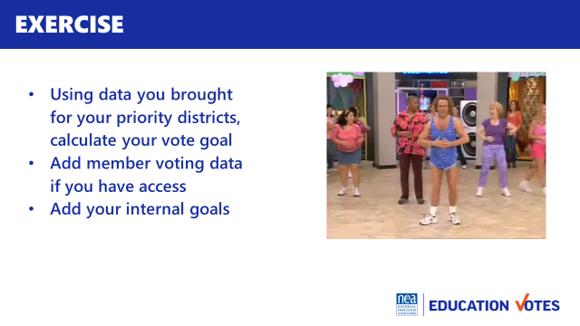  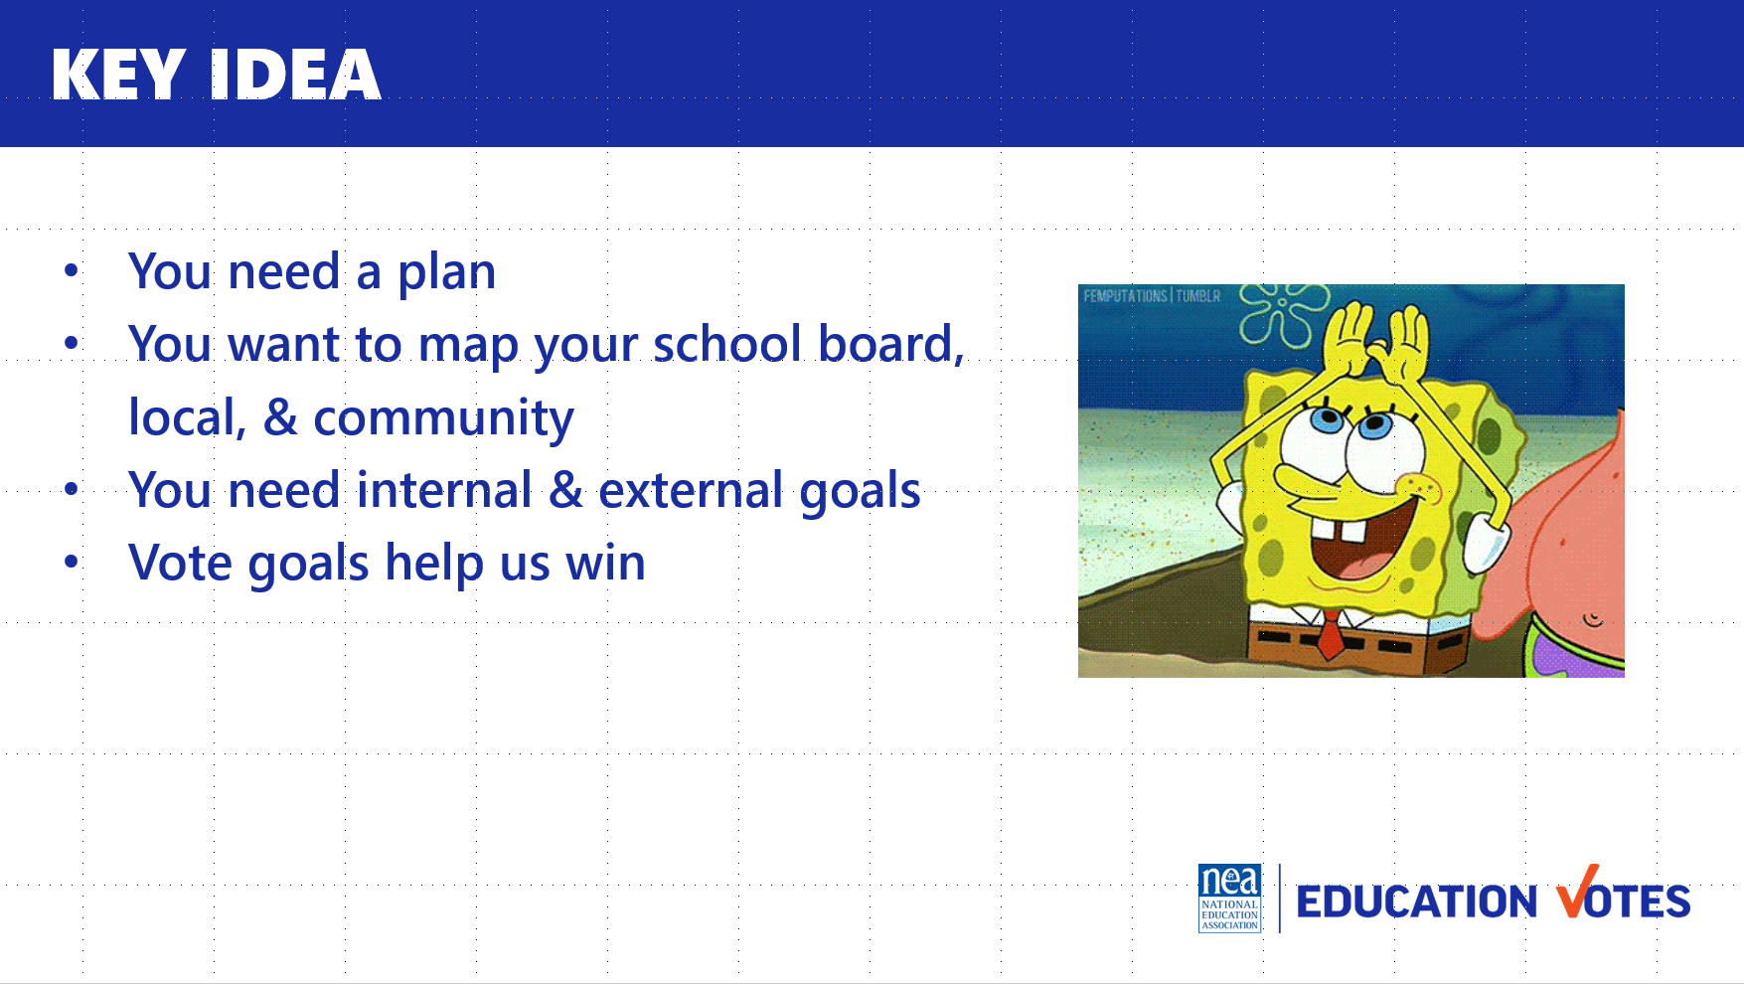 | Campaign Plan Template  Map your Community template  Community Organizing Worksheet | - Overview of Campaign Plan (8ish minutes) – So now that we’ve spent some time talking about what we’re up against, the next hour and half will be devoted to getting ourselves prepared to run winning campaigns. To have that winning campaign, we need a plan. There are lot of different formats for campaign plans. The important thing is to find a format that works for your local. Here are the components we will be focusing on.  - Mapping – this is getting the lay of the land. Some campaign plans might refer to this section as research.  - Goals – these are external goals like winning an election, and our internal goals about increasing PAC participation, recruiting x number of volunteers etc.  - Our strategy is our overall plan and our tactics are those individual actions to get us there, for example we know having our members vote in big numbers is part of our strategy and doing building meetings is the tactic to help us achieve that strategy.  - Message – We have a message that we will be repeating to external audiences like voters, and what we will be saying to our members to motivate them to vote.  - Budget/Fundraising - Elections are expensive and we have outside money trying to influence our elections so it’s critical that we have our own independent political action committee’s to support our campaigns and a budget for our spending priorities.  - Accountability/Task tracker –We know stuff doesn’t get done unless there is a name and deadline attached to it.  - Timeline – Our last step is putting it on a calendar that will work for you  - Mapping (pg.7)- Consider adding political party affiliation to the mapping chart.  - As we get started you will need to think about a local you work with that may be struggling with their current board, has open seats due to termed out members, wants to maintain the current board etc. Have that local in mind as you work through the components of the plan.  - (3 mins) Mapping your School Board- the first thing we want to map to prepare for the election is the school board  - Considerations on Assessment of School Board – here are some helpful considerations as you start making your assessments on which races you are going to target. (Slide - Assessing School Board Members)  - Here is an example of a potential school board map.  - Chart – we want to start with a chart so we can start figuring out how many allies we have and how many races/seats we need to target. We can’t always win everything, so it’s important that we know how to tier these races out based on winning a majority and playing in races we have the most likelihood to win.  - Give them 10 minutes to work on the chart.  - Discussion: What did you learn?  - Where do you find this information?  - Why is this important to analyze?  - What’s missing on the chart? Why?  - Occupation  - Party Affiliation  - Voting History  - Spouse  - Social media search  - Petition to run signatures  - Key Lessons when deciding electoral priorities  - Once you have your chart filled out, as you are making decisions on who is going to receive your financial and volunteer support  - Make sure you are protecting friends and keep in mind:  - Incumbents are hard to beat. That doesn’t mean don’t try to take them out, but you may not be able to win all those races against established candidates.  - Mapping your Local (5 minutes) - once we’ve taken stock of what we need to win, then we need to look internally  - Organizing Capacity - our two biggest resources are our organized people and money. We need to know what we have and make sure we have contact info to build more volunteers and PAC.  - Communications Tools – we need to know what tools we have access to and be clear who those administrators are.  - Leadership engagement – as we start looking at ourselves, we need to make sure we are thinking through how we can get our leaders invested. Maybe that means doing one-on-one policy discussions with candidates. We also need to be thinking through what team we currently have, what strengths we have and what we need to build on.  - Constitutions & Bylaws around electoral work – many locals have how you recommend candidates and maybe how money is decided. If it’s not, it’s an important conversation to have with Governance and Executive Boards ASAP.  - Rules – knowing the rules for the local, coordinating with candidates, and how you can spend money is crucial. Your GR Director is a good person to start with if you have no idea or want to talk through how you might be able to get creative with campaign spending.  - Mapping Community (5 minutes) - The last thing you want to map is your community. You need to know who may be potential allies and who will be your opposition  - First step is to brainstorm all the organizations that impact education/work on elections  - Prioritize your outreach to potential coalition partners with more power  - Don’t forget to research member involvement, we have a great worksheet you can start using with building reps or and GR committee so you can research what groups our members are already a part of.  Goals Overview (10 minutes)  - We have two types of goals. External & Internal.  - Our internal goals are about how we plan to build the union, like new PAC donors, volunteers etc.  - Our external goals are about how many voters we want to contact, what races we want to win etc.  - The most important external goal we need is our vote goal. This is how many voters we need to turn out.  - To calculate your vote goal you need to gather information for the past three elections that look like the one you are working on. If it’s in a presidential year, look at the information for that district for the past three presidential elections. Depending on your state, this may be super easy to find on the State Board of Elections website or your clerk’s website.  - You will average the turnout for these past three elections. This is your projected turnout %.  - You also need to look up how many registered voters there are in this district. Take the percentage from step 1 and multiply that percentage with registered voters. This is your projected voter turnout.  - If this is a two-person race, you take that number and multiply .52. If you have more than 2 candidates, you’ll divide it by number of serious viable candidates and add 1. It’s also smart to add cushion on top of that.  If it comes up . . .  - What is the impact of Ranked Choice Voting?  - You still work to get 50% of the vote, or whatever the margin has been set at  - What is ranked-choice voting?  - Ranked-choice voting is an electoral system that allows people to vote for multiple candidates, in order of preference. Instead of just choosing who you want to win, you fill out the ballot saying who is your first choice, second choice, or third choice (or more as needed) for each position.  - The candidate with the majority (more than 50%) of first-choice votes wins outright. If no candidate gets a majority of first-choice votes, then it triggers a new counting process. The candidate who did the worst is eliminated, and that candidate’s voters’ ballots are redistributed to their second-choice pick. In other words, if you ranked a losing candidate as your first choice, and the candidate is eliminated, then your vote still counts: it just moves to your second-choice candidate. That process continues until there is a candidate who has the majority of votes.  15 Minutes Exercise  Now it’s your turn, use this data to calculate the vote goal or if you have access to the data for your upcoming school board election you are focusing on, you are welcome to work on that. Make sure to round up. Answer is 21,919.  Discussion:  What was the number? (21,919)  What did you notice about voting trends in the example?  - Voter turnout increased each year – do we need to adjust our goal as a result?  Why is it important to calculate your vote goal?  - Assists with coalition work – how many votes does each group need to bring in to secure a win?  Key Ideas 5  - You need a plan  - You want to map your school board, local, & community  - You need goals internally & externally a vote goal is key  - Vote goals help you win | `
12:00– 1:00 LUNCH
1:00 – 1:45 Melissa |  | 45 Minutes Coalition Building
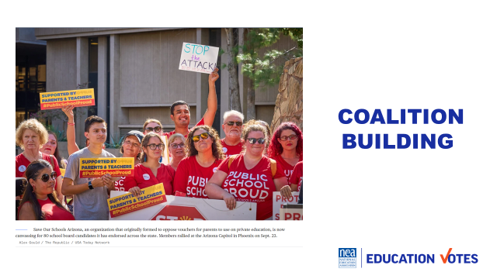  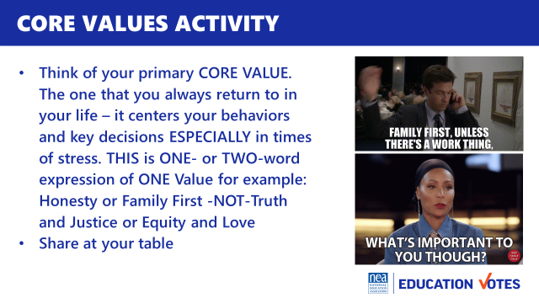  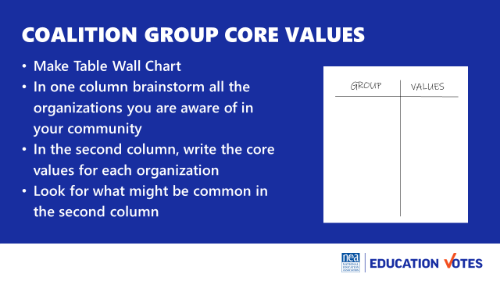  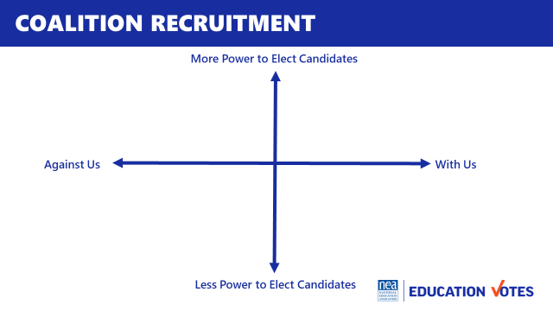  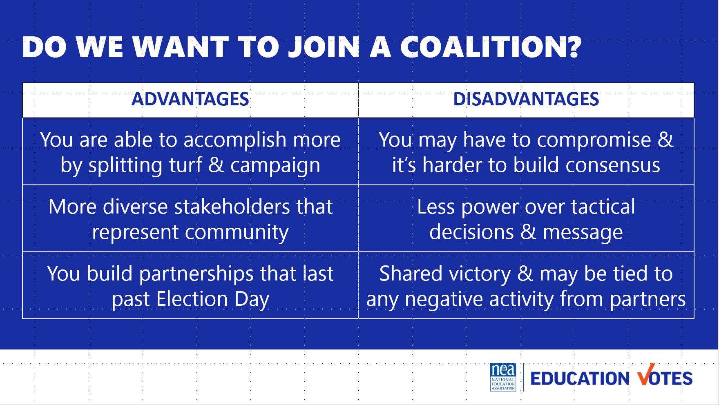  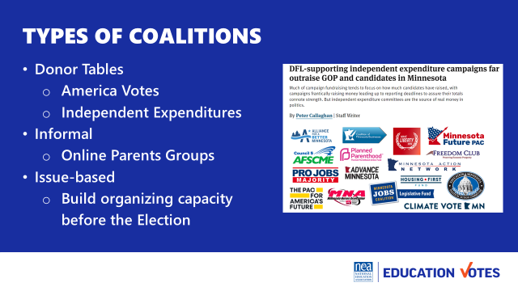  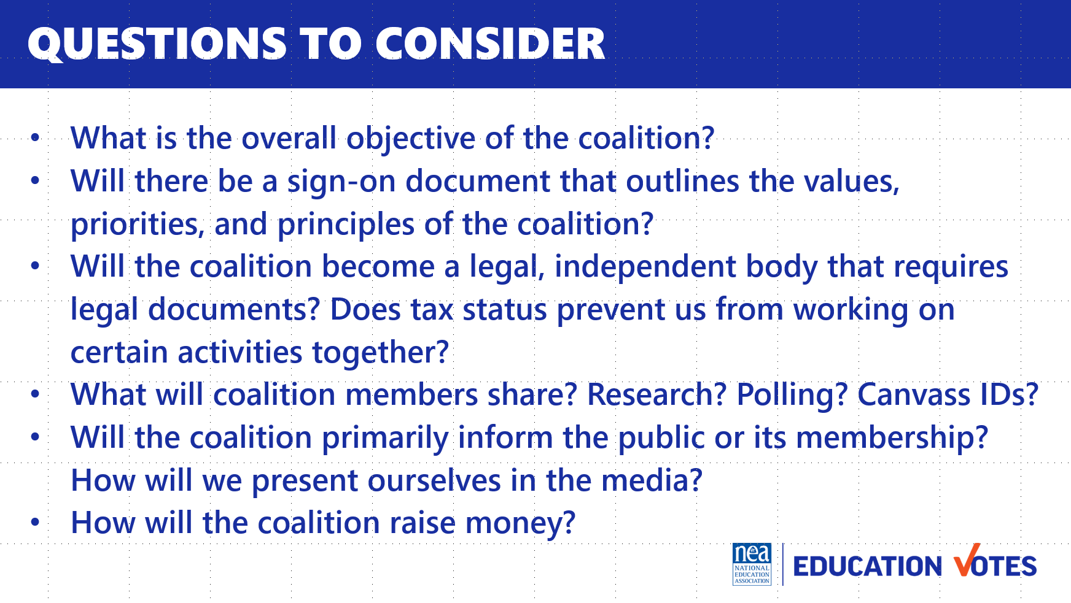  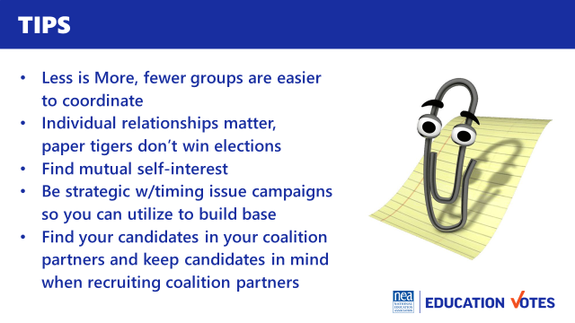  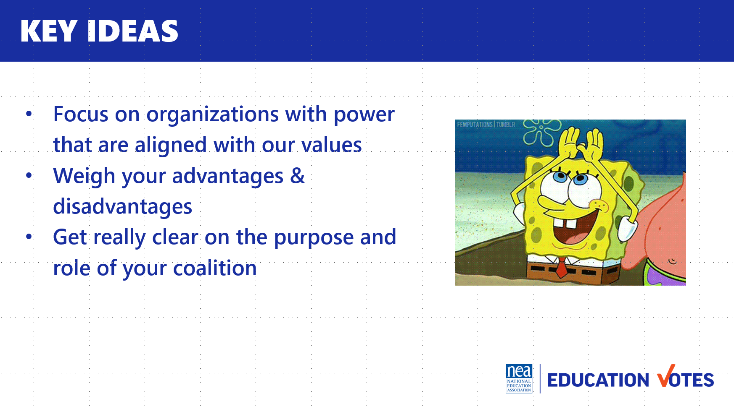 | Coalitions handout | Why join coalitions? 25  - 10 min One of the most important things we need to consider when aligning ourselves with others is to make sure our values are aligned. We’re going to spend some time now, talking about our own core values at our tables  - I hope everyone got to understand each other better from that activity, was there a common value folks shared at the table?  - 10 min Now we want you to take the next 10 minutes to brainstorm different organizations and what their core values might be.  - 5 min Report out  - What were most common shared values?  - What group do you hope to recruit and why?  - Besides shared values what are other reasons to join with others?  Who should we join in coalition with? 5  - We saw this XY axis in our mapping section of our campaign template  - As we are thinking through how we are spending our time in recruiting others to join us, what quadrant should we be focusing the most on?  - Sometimes it doesn’t make sense to have coalitions depending on the players. Check out these advantages and disadvantages. Are there any up here that you hadn’t really thought about it?  Types of Coalitions with campaign example 5  - Now you’ve decided if your advantages outweigh the disadvantages, it’s very important that you get clear on what type of coalition you are going to create, here are the 3 primary coalitions you can form for an election  - Donor Tables  - Informal  - Issue coalitions to build capacity before elections  - These are also some important questions you want to make sure you know the answer to when you are clarifying your purpose and how you will interact with these different groups.  Tips 5  - Less is More, fewer groups are easier to coordinate  - Individual relationships matter, paper tigers don’t win elections  - Find mutual self-interest  - Be strategic w/timing issue campaigns so you can utilize to build base  - Find your candidates in your coalition partners and keep candidates in mind when recruiting coalition partners  Key Ideas 5  - Focus on organizations with power that are aligned on our values  - Weigh your advantages & disadvantages  - Get really clear on purpose and role of your coalition | How can coalitions be helpful to our election?  What kind of coalitions exist?  What should I keep in mind as I work with coalition partners?  Participants will understand the importance of formalizing relationships into coalitions, the types of coalitions to build for elections, and helpful tips as they navigate these relationships.
1:45 – 2:15 Monet |  | Recruiting and Recommending Candidates 30 Minutes
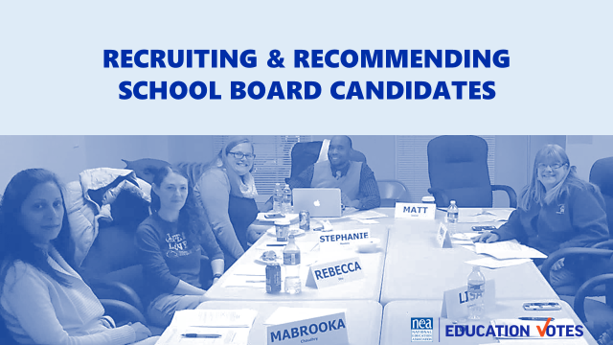  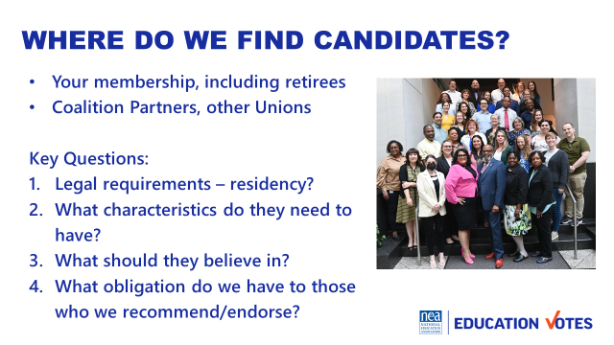  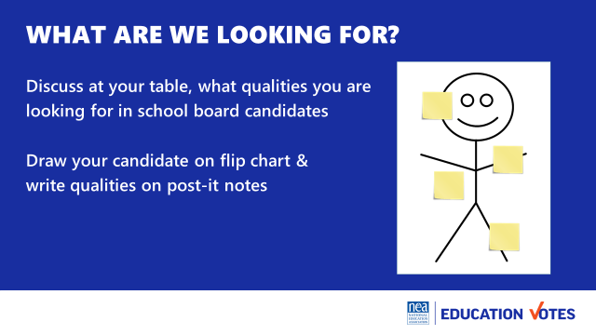  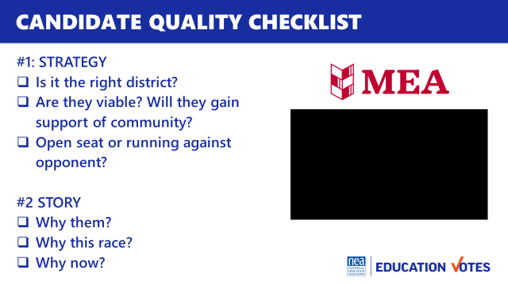  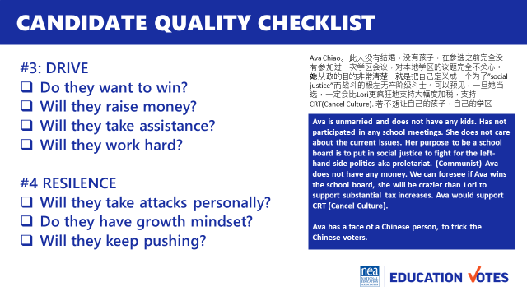  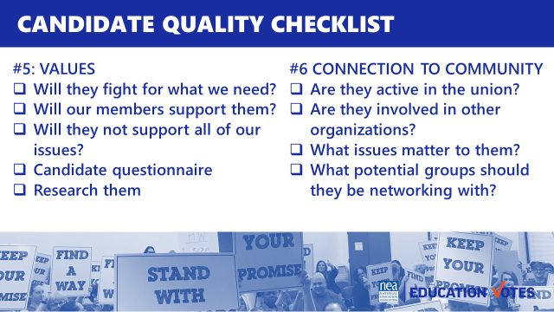  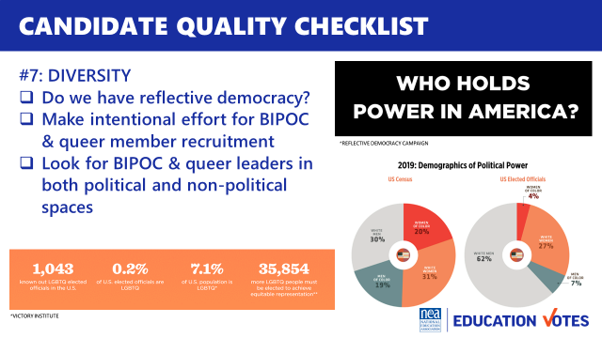  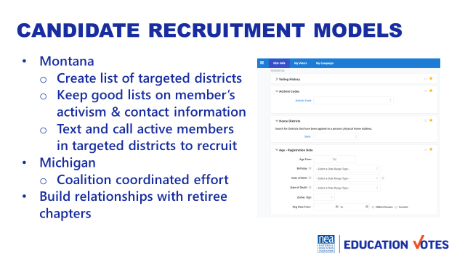  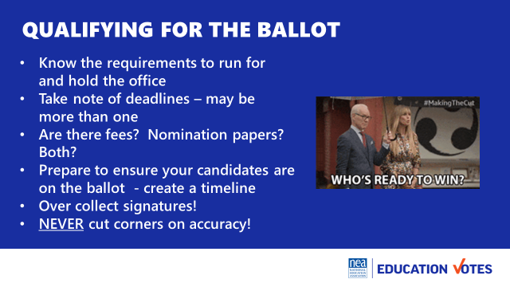  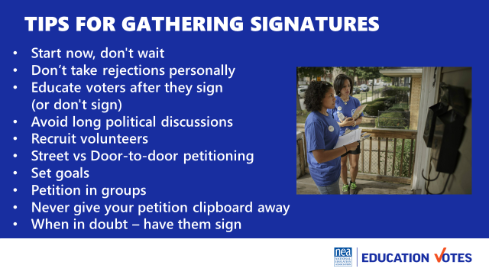  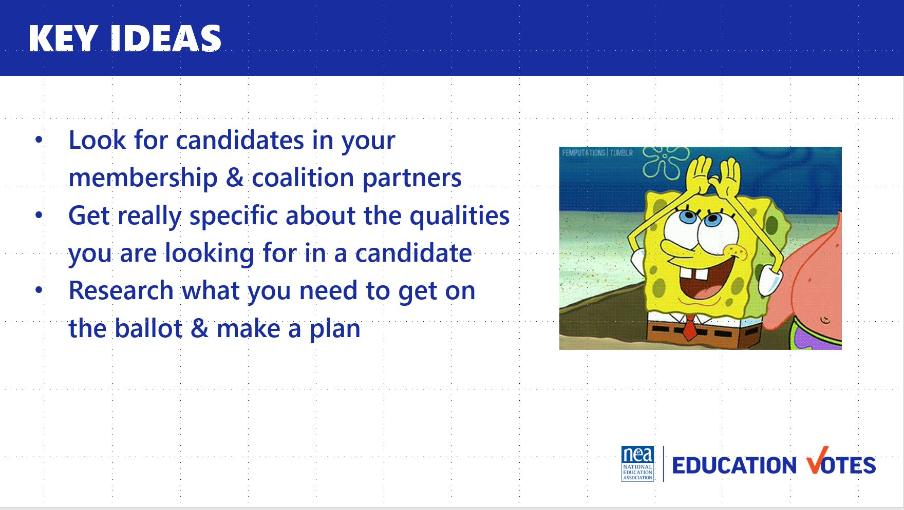 | Candidate Checklist | Recruiting and Recommending Candidates 5 min  - Let’s face it, not all of our locals are going to be able to run really robust school board campaigns. One of the most basic things we can do in our school board work is making sure we run a transparent recommendation process and encourage quality candidates to run.  - So where do we find those candidates? Where do your best candidates come from?  - Here are some key questions to think about as you start brainstorming potential candidates.  - What are we looking for? 10 min  - For the next 10 minutes, brainstorm the qualities you are looking for and draw them on post its  - Candidate Quality Checklist 10 – these are some great looking stick figure candidates hanging around the room. We’re going to add some more of these qualities with a candidate quality checklist.  - Strategy (right seat/right party) - our first consideration is strategy. You don’t want to run the super liberal democrat in the incredibly conservative district. You also don’t want your members to run against incumbent who has been friendly in the past.  - Personal Story – you want to make sure your candidate has a story, here’s a quick video from a member who ran for state house in Michigan. She’s not the greatest speaker in the world but she knows why her and why now.  - Drive & Resilence – These may the most important qualities given our current political climate right now. You want someone who is going to work their head off and listen to you. And you want someone who is going to have thick skin when they get attacked. This language to the right was from a flyer they posted about one of our members who ran for office in California. They were trying to race bait in the Chinese community. Ava didn’t take the bait though and just kept pushing and was able to win her election because her students needed her to have thick skin.  - Values – this may seem obvious but if you’ve ever had a candidate turn their back on you when they got into office, you want to really think about their values and character.  - Connection to Community – you want someone who is connected, your campaign will be easier if they have relationships established.  - Diversity – we know this is important, something like 90% of school board members are white men and are communities aren’t 90% white men. Recruit folks who reflect the district and will represent marginalized communities.  - 5 min Models 3 – A couple of states have tried to institutionalize how they do candidate recruitment.  - In Montana, the use data to recruit from their membership and do direct outreach to individuals  - In Michigan, they use a coalition model where different organizations will divvy up districts and recruit out of their membership. This is smart b/c then you don’t have an NEA member running against a UAW member in the primary.  - Getting on Ballot 5 – we aren’t going to spend a lot of time on this, but we wanted to include some information about getting on the ballot. How many states here require signatures? How many do you just have to pay a filing fee? How many of you have no idea?  - The first step is finding out what you need to do to qualify and start working on a timeline with the candidate if signatures are required.  - Here are some signature gathering pointers  Key Ideas 5  - Look for candidates in your membership & coalition partners  - Get really specific about qualities you are looking for  - Research what you need to get on the ballot & make a plan | How do we recruit candidates?  Participants will practice having a persuasive conversation to recruit.
2:15 – 2:30 BREAK
2:30 - 3:20 Monet |  | 50 Minutes Recruiting and Recommending Candidates Continued
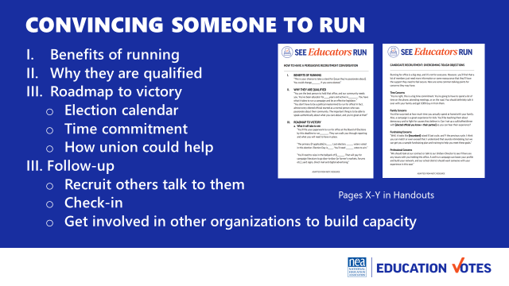  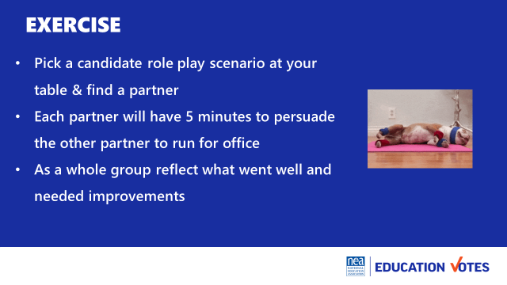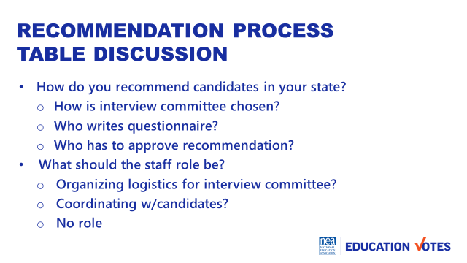  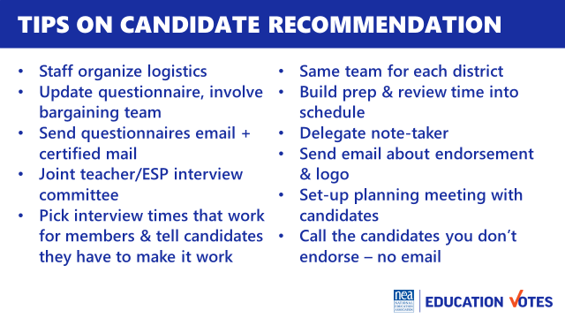  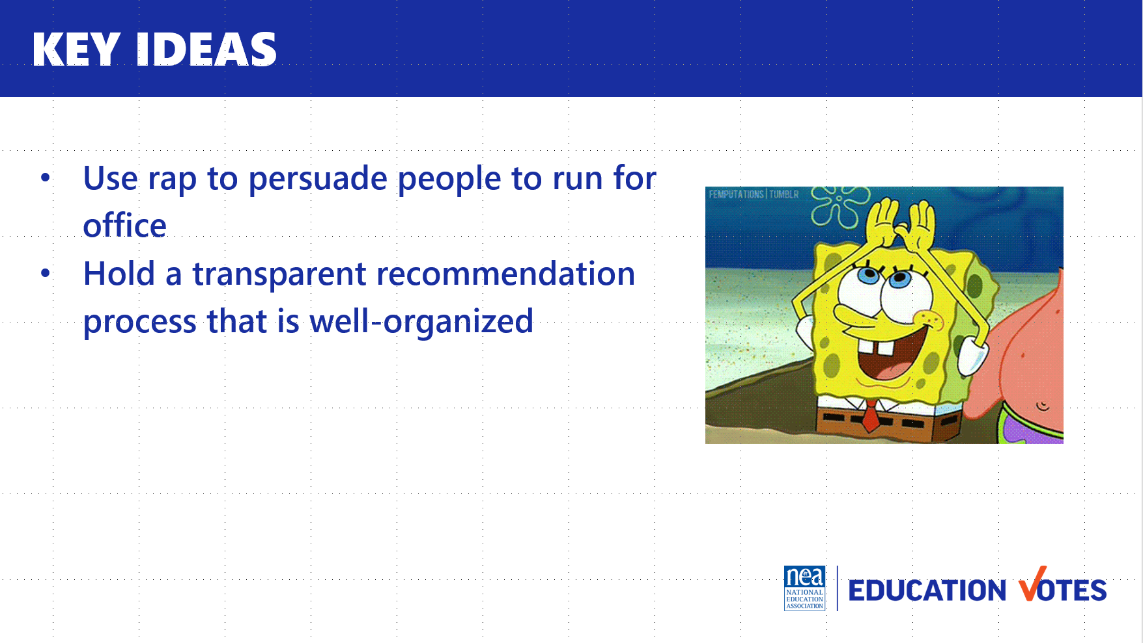 | Sample Persuasive Conversation  Overcoming Common Objections  Roleplay scenarios in a cup at table | How to convince someone to run for office 10 – Now that you’ve identified someone to run, you may have to convince them to run.  - Why do you think folks say no to running for office? 3  - Just like we have outline of an organizing conversation, we need to go into with a roadmap on how to persuade someone to run for office. Here’s a great outline to use as you approach people you have to convince they are qualified  - Everyone nailed the most common excuses folks have on not running. In your packet/online folder there is an overcoming common objections sheet with responses to use 2 minutes  15 Minutes Exercise  At everybody’s table, there is a scenario. Pick one and partner up. You’ll each have 5 min to convince that person to run.  Debrief – How was that? Did anyone’s partner say anything brilliant?  Candidate Recommendation Process 20 minutes – Once we have the  candidates identified and convinced them to run, it’s important we have a transparent recommendation process.  - For the next 15 minutes talk at your tables about how you do recommendations in your state & how you navigate the staff role  - Did anybody hear something really great at their table that we should share with the whole group?  - Here are some great tips as you start putting your interviews and team together.  Key Ideas 5 min  - Use rap for persuasive conversation  - Hold transparent recommendation process that is well organized | What should we be looking for when we recruit candidates?  Participants will recognize qualities for successful candidates and learn from other states on their models.
3:20 – 4:20 Meighan |  | PAC Fundraising 60 Minutes
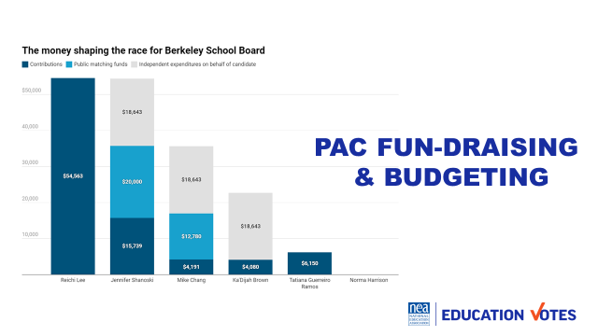  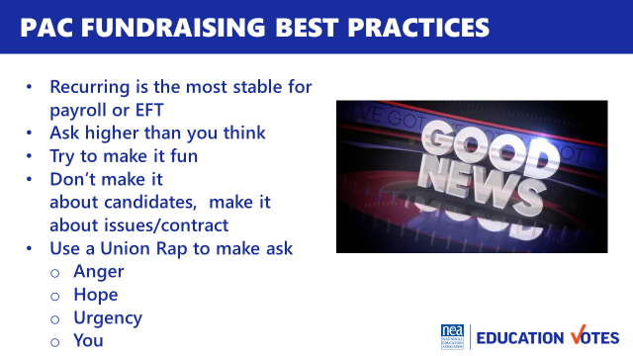  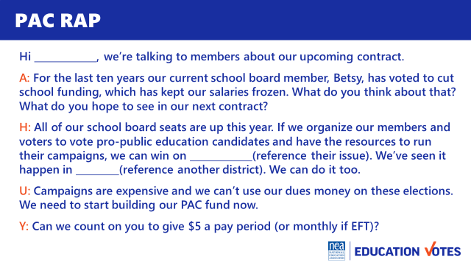  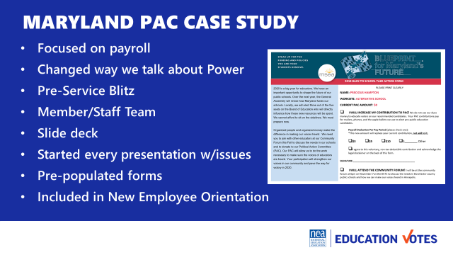  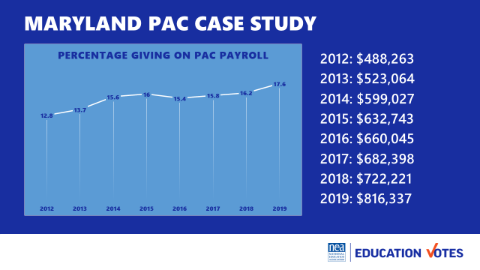  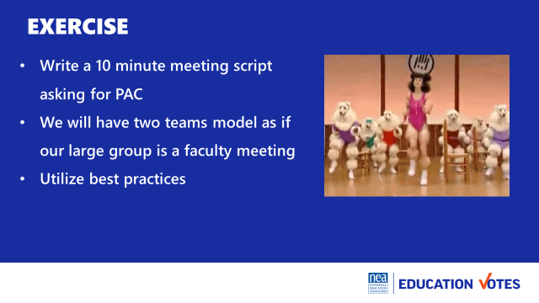  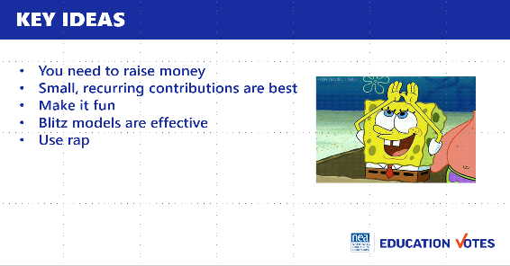 | Sample 10 min meeting agenda and deck from Maryland  PAC Sample Rap Handout  Labor Notes AHUY Handout  Overcoming Tough Objections | PAC Fundraising  What is PAC? 5 Why is it important? 5  - Ask them what is a PAC?  - A PAC for our workshop purposes is a separate fund from our dues, that members make voluntary contributions to. We use that money to give candidate’s direct contributions or pay for voter contact.  - This graphic shows the spending for a school board election in Berkeley, CA  - CA has a clean elections clause where candidates can get matching funds if they meet certain fundraising thresholds.  - Lee was the non-union candidate, Shanoski/Chang/Brown were the union endorsed  - These independent expenditure campaigns were from CTA/Local  - Lee lost by 1k votes, the 3 union endorsed candidates won  - Even in places like the People’s Republic of Berkley, CA where you have matching public funds, it’s critical that our locals are raising money to make sure our candidates are able to compete against these folks that are being bankrolled by the bad guys whether it’s Mom for Liberty or Democrats for Education Reform  - How do you raise it? 15  - Ask how many people raise PAC at their state RA/convention? How many collect it on payroll deduction Does anyone collect monthy EFT/bankdraft?  - Whether it’s payroll or EFT, recurring is the most stable source compared to events based fundraising. Key Point: It’s much easier to get 100 members to give $5 a month at 20 pays than 100 members to give you $100 and more time intensive when it’s one-time donation.  - Ask what folks think most members would give per month? The NEA average is $1.41 for the federal PAC. Delaware asks their members $20 and their average per member is $12.34. And again, these are all federal PAC stats. We know members are much more invested in their local school board election than Congress. Key point: Ask higher than you need. Don’t make decisions for your members.  - Politics can be a real bummer where folks tune out before you even start engaging them. In Maryland, they started spoofing Jimmy Fallon skits to kick-off their PAC meetings. These are silly, fake good news headlines filmed with some of their rank & file leaders. [Show Video]. It’s super corny, but the transition was here’s a headline that’s not fake – School Board Elections are coming and we need to get ready. Key Point: Making it fun, caught people’s attention and using other members gave us some validators before we even started our conversations  - Speaking of Conversations. You want to make it that. 9 times out of 10, folks don’t care who is running. It’s not about electing X candidate. We need to have a strong PAC so we can win these races so we can win X and refer back to what they care about.  - We find out what they care about by using a rap. There are all sorts of variations of what people call this. Basically, you don’t want your PAC ask is to be a mobilizing ask. It needs to be an organizing conversation where you get their issues out and connect it to why they need to donate to PAC.  - One great model Labor Notes uses for their rap is called AHUY.  - Anger is where you get someone fired up and find out what they care about.  - Hope is where you talk about how we can fix those issues by coming together.  - Urgency is talking about why we need to do this now.  - You is the ask. In this case, it would be signing up for PAC.  - Here is an example of how to put a PAC ask into an AHUY one-on-one ask script.  Case Study Maryland 10 minutes  - Here’s an example from Maryland, they were focused on increasing their payroll deduction starting 2012 through the pandemic.  - A lot of the previous PAC conversations had been too focused on candidates, their narrative shifted that we needed to build power to win and the way we built power is organizing our people and organizing our money.  - Previously their PAC had been only talked about as one time donations at convention and maybe a new member might have checked it by mistake. We shifted that to focus on doing a blitz model and hitting as many schools that first week educators were back.  - We built out a 10 minute slide deck presentation and put member and staff teams on a schedule to hit as many schools as they could. We modeled our script after AHUY where we always got issues out. Most presentations were “Contract Updates.” We asked folks what they wanted to see changed or see in their new contract if we were about to bargain.  - Towards 2018 and 2019, they focused more energy on developing resources that explained PAC for New Employee Orientations.  - Here’s how they did, there was a slight dip down 2015-2017 b/c of mship growth, that’s when they started focusing on NEOs.  - These weren’t huge jumps, but because it was payroll look how much the money grew.  - They became the primary PAC funding campaigns up and down the ballot and have swept small school board races to large County Executive races electing folks no one thought had a chance of winning.  30 Minutes Exercise  Write a 10 min meeting PAC script, ask for 1-2 teams to model  [put the rap model back up]  Debrief  What did they do well?  Key Ideas 5 min  - You need money, small recurring contributions build PAC  - Make it fun  - Blitz model is effective  - Use rap or AHUY | What is PAC?  How do I raise it?  What do I spend it on?  Participants will understand the importance of PAC fundraising, the mechanics of a PAC drive, and how to build an effective electoral budget.
4:20 – 4:30 Ellen |  | 10 Minutes Ending it Right
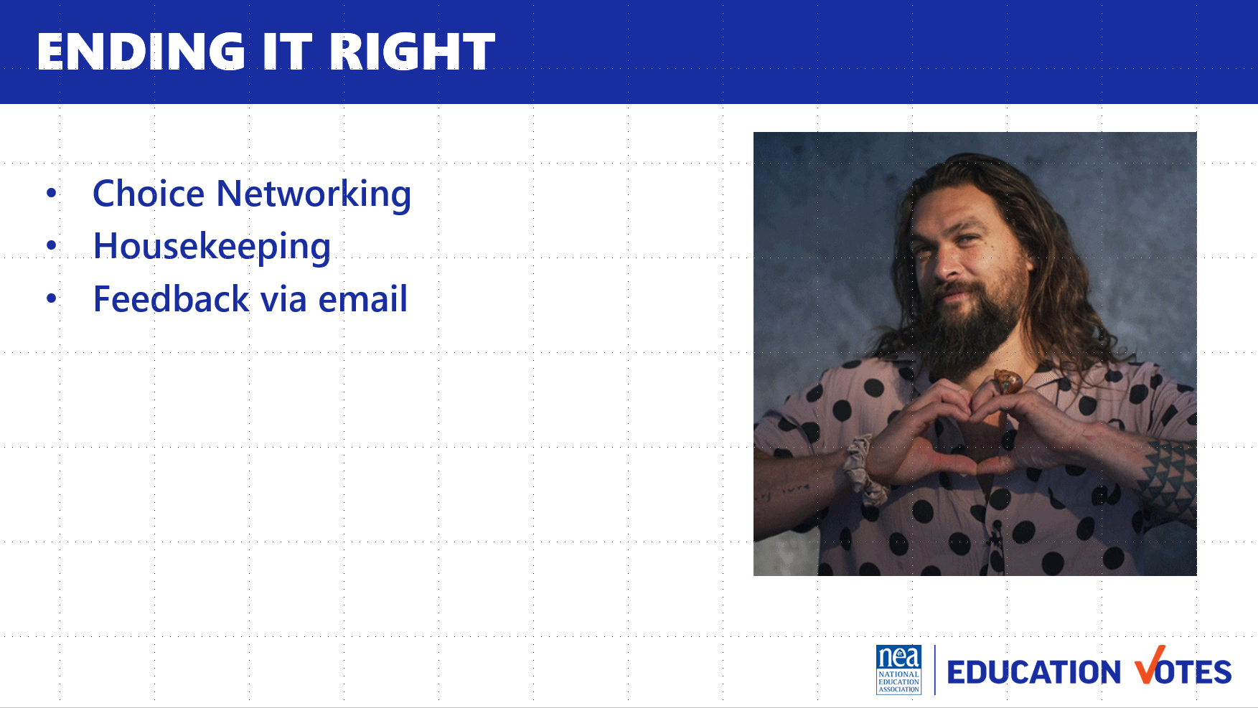  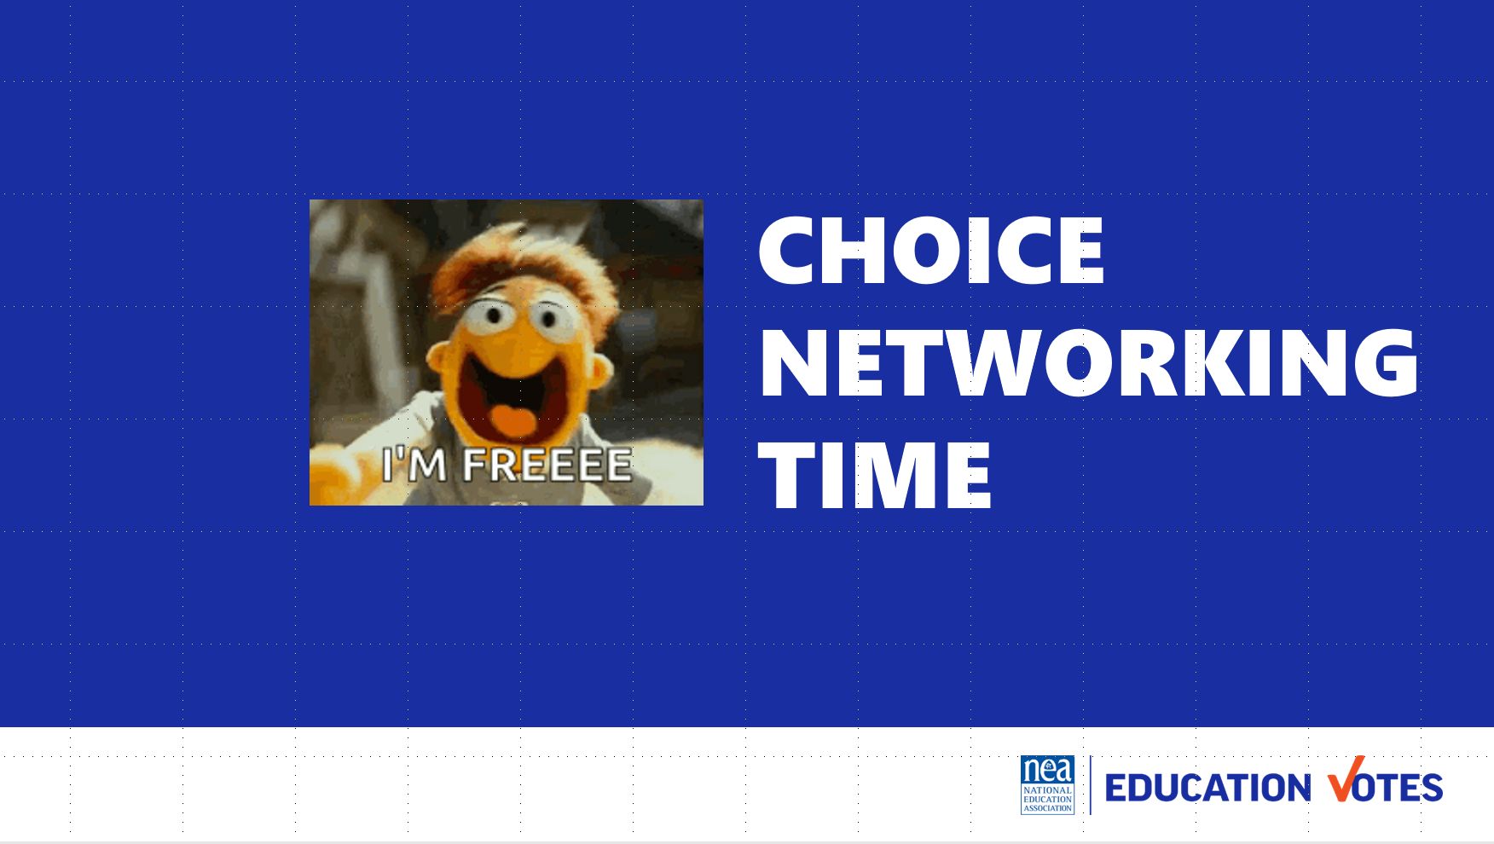 |  | - Questions, Connections, Reflections  - Housekeeping announcements  - Evaluation | What questions do I have? What do I need to know?  Participants will get opportunity for feedback and leave session with what they need to know for tomorrow.
4:30 – 5:00 |  | Choice Networking
5:00 ADJOURN

