Facilitator Agenda: Winning School Board Campaigns Day # 2
General Materials Needed: |  |  |  | Room Set-up:
1 Set of Handouts per Person  Name Tags or Name Tents  Room signs, sign in signs  Highlighters – 3 colors  Pens and Pencils | Chart Paper – self stick kind  Markers- Mr. Sketch - Non Permanent  Post its  Wifi |  |  | Round Tables for Participants – cords at each table  Long rectangle at back for Facilitators  No Podium – table with projector large enough for laptop  Projector, Screen, Microphones, and Speakers  Carousel stations and reporting stations around the perimeter  50 people Max
Key Outcomes for Day 2
- Understanding of the phases of an electoral campaign
- Learn to develop effective member engagement plans that increase volunteer recruitment and voter turnout
- Review most effective voter contact methods

Content and Facilitator Assignment Overview Day 2
8:30- 9:00 Reentry  9:00 - 10:30 Voter Contact  10:30-10:45 BREAK  10:45-11:15 Creative Voter Contact Tactics  11:15 – 11:30 Budget  11:30-12:00 Work on Campaign Plan  12:00-1:00 LUNCH |  | Ellen  Jackie  Jackie  Meighan  Meighan | 1:00- 1:30 Winning w/Members  1:30-2:15 Volunteer Recruitment  2:15-2:30 BREAK  2:30- 3:30 Building the Team  3:30- 4:00 Team Communications Exercise  4:00 – 4:15 Organizing Successful Events  4:15-4:30 Ending It Right  4:30-5:00 Choice Networking  5:00 ADJOURN |  | Hedy  Monet  Vanessa  Vanessa  Melissa  Ellen or Meighan

Time, Facilitator and Slides | Resources | Instructions, Activity and Debrief | Essential Questions and Key Outcomes
 | Charts, handouts, articles, materials, videos | What are you saying, what are they doing, what questions will you use to guide learning and make clear the important points  Include an estimate for how long each section of the learning will take  Include Key points. | What question(s) does this section answer?  What will participants know or be able to do?
8:30 – 9:00 Ellen |  | 30 Minutes Welcome back
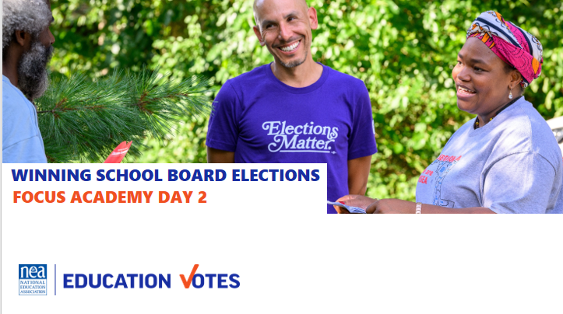  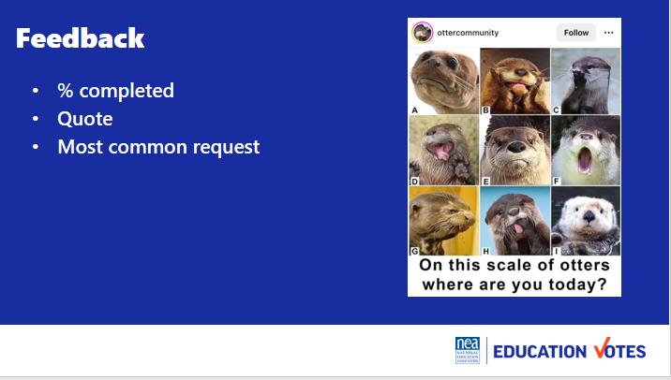  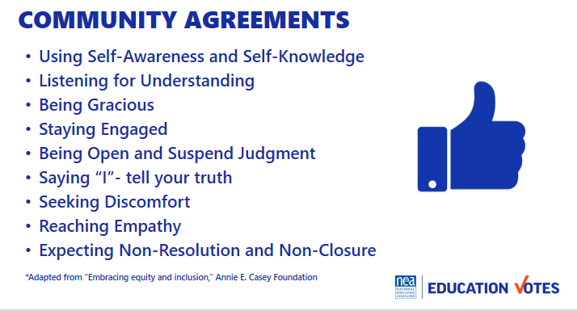  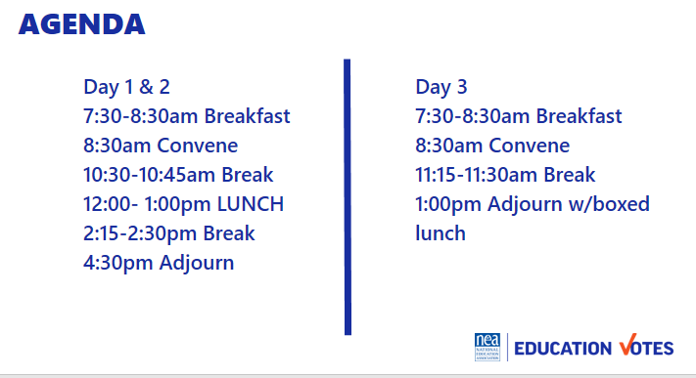  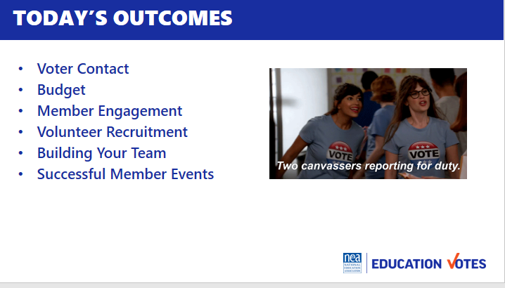 |  | Reentry  Feedback on Feedback  Norm Review  Agenda Review  Today’s Outcomes | How are we feeling and what are we covering today?  Participants will re-enter the learning environment.
9:00-10:30am Jackie |  | Voter Contact
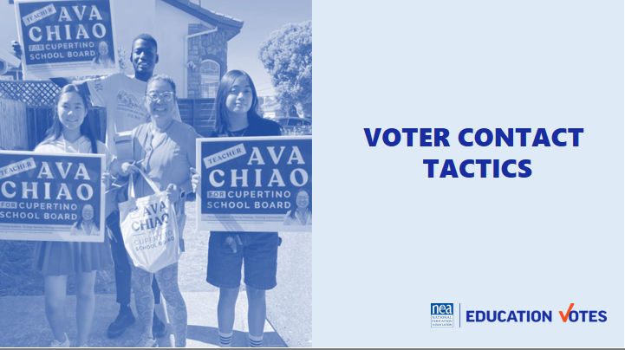  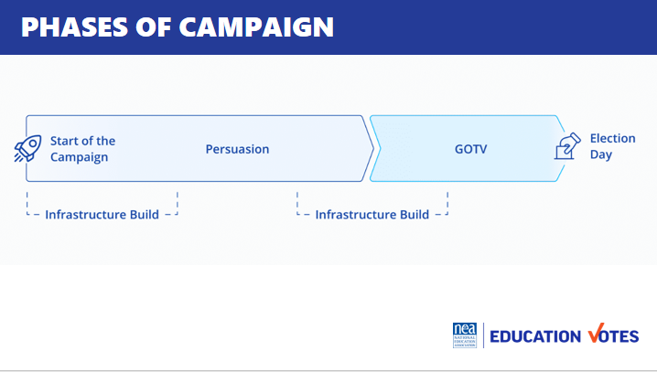  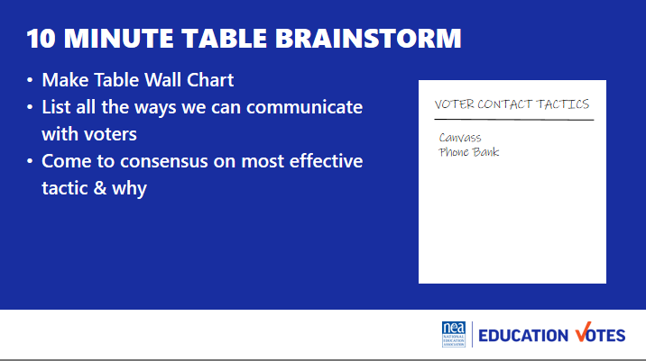  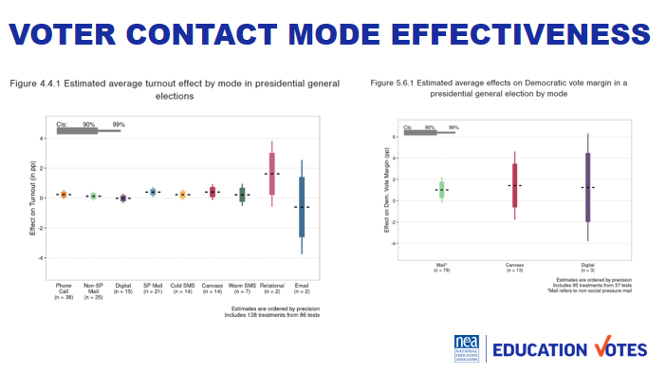  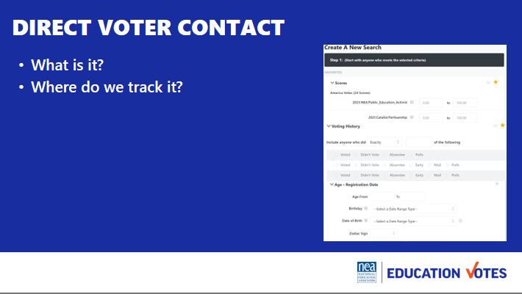  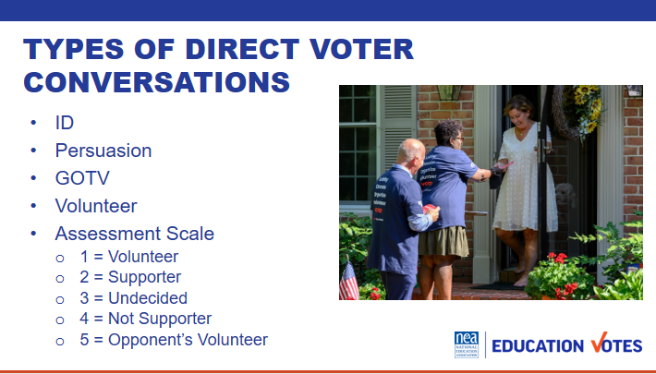  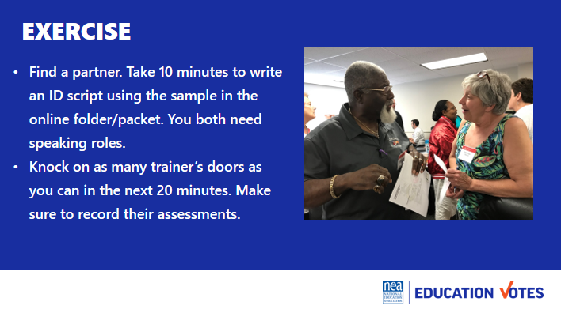  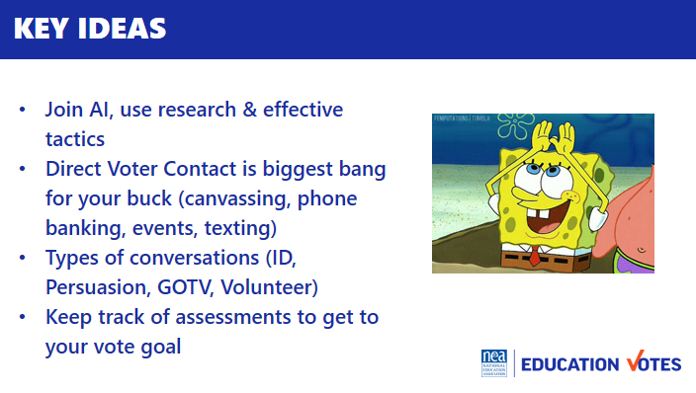 | ID Script  Persuasion  Script  GOTV Scripts  Trainer Scenarios & Assessment | 10 min Introduction  - So yesterday we spent a lot time talking about preparing for the election. Today we are going to spend the bulk of the day talking about what we’re going to be doing during the election - communicating with voters.  - Let’s start with some important lingo  - Campaigns are really broken up into 2 phases. The first is your ID/Persuasion Phase and the second is GOTV or get out the vote. In your ID/Persuasion phase, this is where you are identifying your supporters and persuading your undecideds. This is really where you have to make your case to voters on why they should support your candidates  - In GOTV, this is where you switch over to the types of voters you are talking to. In GOTV, you should have identified enough supporters to reach your vote goal and you are pushing them to mail their ballot, early vote, or head to the polls on election day.  - In both cases, you see infrastructure build. What do folks think that means? (volunteer recruitment/PAC etc). We’ll be spending the afternoon talking about how we build our volunteer armies.  15 min How do we communicate with voters  - For 10 min at your table brainstorm list on flipchart all the tactics we could use during our election to communicate with the general public and what you think is the most effective & why.  - On this slide are the most common voter contact methods that were studied by a group of progressive strategists and researchers called the Analyst Institute that help us win elections. These rolling pin graphs show you what increases turnout and persuasion by percentage point. The longer the rolling pin plot is, the less certainty we have that tactic increased turnout or persuasion. Now a lot of these tactics on here cost a lot of money, we are probably not having a huge direct mail program for our school board election and we know relational organizing is incredibly effective, but just telling our folks to go talk to their friends and family isn’t going to get us to that win number we calculated yesterday. This is where we need to hone in on direct voter contact.  10 min What is Direct Voter Contact?  - Ask them what they think it is  - Definition: It’s two-sided and targeted communications with voters where you keep track. Not yard signs, but primarily canvassing, phone banking, events, and texting.  - Keeping track is key. This is why you need a voter file. Every NEA affiliate has access to VAN, it’s the Voter Activation Network which is our online voter file database. It has a tab for members and voters. This is where you can pull lists for your canvasses, phone banks, etc. Your state has its own administrator that can get you access. If you can’t access VAN for whatever reason, there are a couple of work-arounds. 1. If you are working with a well-resourced candidate and you are able to coordinate then you could use their VAN. 2. The Board of Elections sells voter reg file for a small fee. It’s not ideal, but we have seen folks get creative. Get yourself access to a list for Direct Voter Contact. If you need someone to troubleshoot with, Meighan is no longer on probation at NEA and loves to help with list access issues.  10 min Types of Direct Voter Contact Conversations  - There are four types of conversations you’ll have with voters You have sample scripts of all of these in your folder/packet.  - Here’s the purpose of each script:  - Your ID script is where you want to ask voters if they know who they are voting for.  - Some campaigns group ID and Persuasion scripts together. You make take a longer persuasion script back to your undecideds closer to GOTV. Sometimes it’s a better use of time to go find more voters than trying to find your undecided voter again.  - Your Get Out the Vote (GOTV) script is where you go back to our supporters and get them out. There are some key pieces in this script based on more of that Analyst Institute research like asking them when and how they plan to vote that will increase turnout. You also might end up doing blind GOTV if just turning out base voters is going to help your candidate. Most campaigns have to do this when they don’t have enough IDs. You may have a couple of different GOTV scripts if it’s a ballot chase or early vote or Election Day.  - Your Volunteer script should definitely be part of your ID script. One of the biggest mistakes we make is start doing volunteer recruitment without making an ID first. How likely are you to volunteer for someone you don’t plan to vote for? We will talk about using a union rap for our member volunteer conversations this afternoon.  - We also make assessments on these conversations b/c you ultimately want to be tracking these to get back to that vote goal we talked about. This is the most used scale:  - 1 supporter, wants to volunteer, wants a yard sign  - 2 voting yes  - 3 undecided  - 4 voting for your opponent  - 5 volunteering for your opponent  Exercise Time Estimate: 35 minutes (10 min script write, 20 min knock time, Debrief 10 min)  Now it’s your turn. Everyone is going to partner up. Pull up the ID/Persuasion script and take 5 minutes to make it someone’s campaign. Both of you should have speaking role in the script.  Once you feel ready. Knock on as many trainer doors as you can. Make sure you record their assessment.  Debrief 10 min:  - How did that feel?  - Ask about trainer assessments, did they get them right?  - Tips from each person at the door  Tips to mention in debrief  - If it’s a 4 or 5, get out of there don’t waste your time  - Get contact info, especially phone & emails  - Go in pairs  - Don’t bother w/No Soliciting people  - Don’t touch mailboxes  - Leave lit  Other Ideas to be sure to bring up in the debrief:  -Exit strategies  -Know the local election rules  - Mail in ballot rules  - Date of election  - How do you handle No soliciting signs  - Be nibble with your script  - Make sure you ask supports to be volunteers  - Be sure to sure update phone #’ and email of supporters  5 min Key Ideas  - Use research like AI to choose effective tactics  - Direct voter contact is our primary mode b/c it’s cheapest bang for our buck  - Types of conversations are ID, Persuasion, GOTV, & Volunteer  - We keep track and assess voters to get us to our win number | What are phases of an election?  Why does this matter?  Participants will understand phases and how this impacts who they are talking to and what they are saying.
10:30 – 10:45 BREAK

10:45 – 11:15 Jackie |  | 45 Minutes Creative Voter Contact Tactics
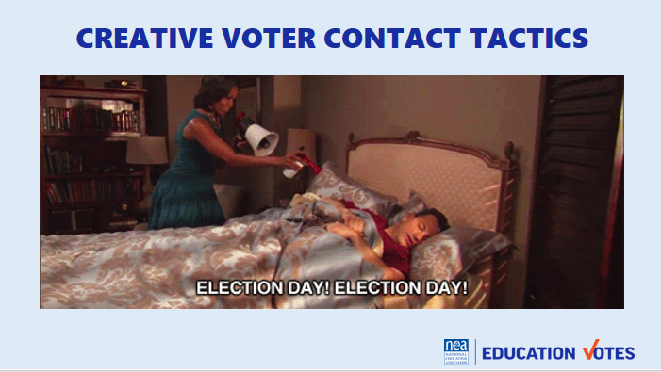  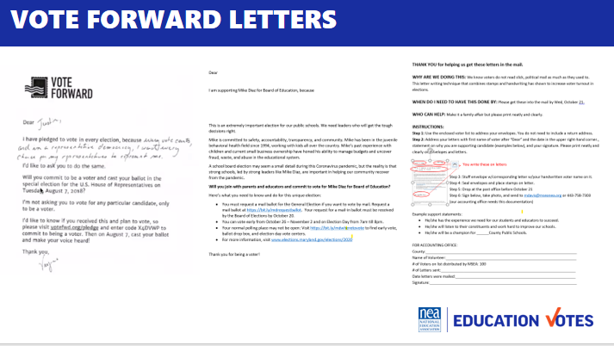  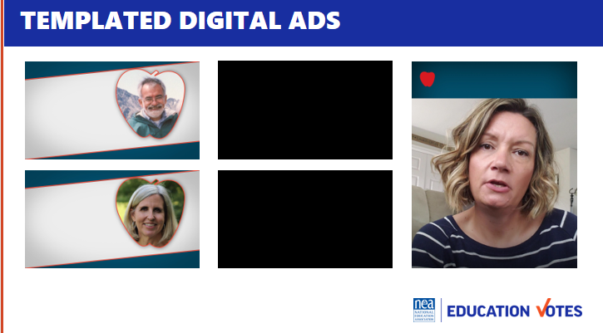  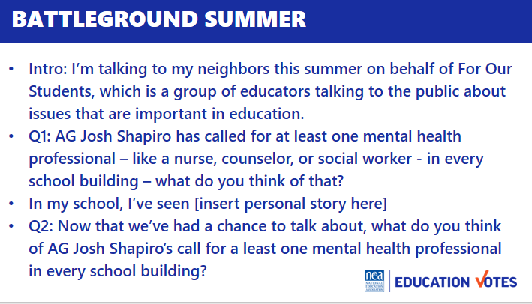    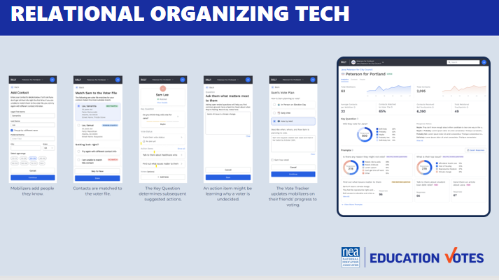  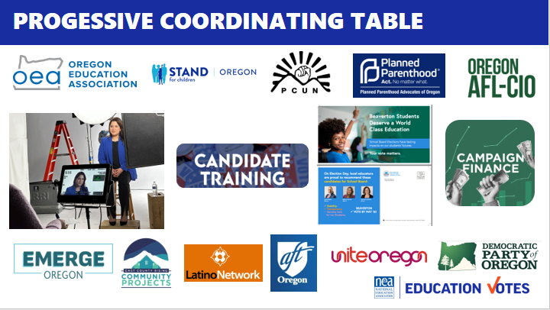  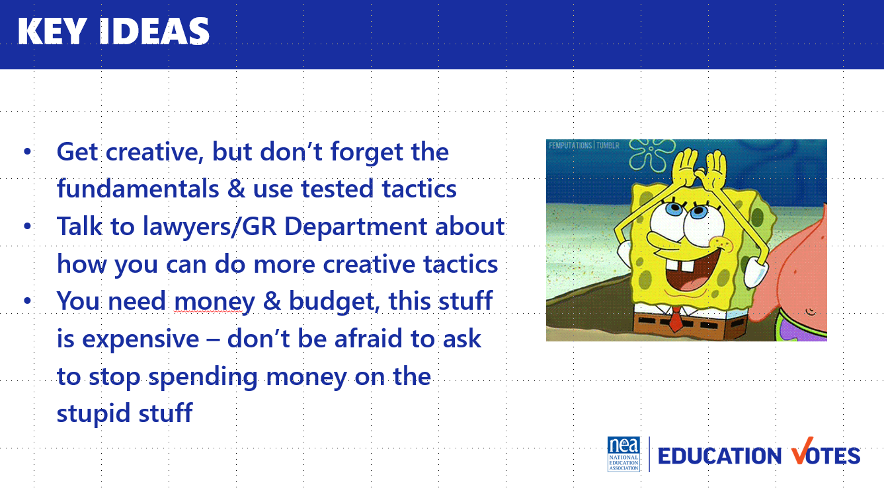 | Sample Costs for Election | Voter Contact Tactics Overview 5  - Unfortunately, we can’t sneak in voters’ bedrooms at night with an airhorn, but we’re going to delve into some different tactics that locals have been using and some tactics that have been testing well in different elections around the country to get you inspired for writing your plan  - Show examples of creative tactics 20  - Vote Forward letters – This is the new spin on direct mail. It started in 2019-2020 as the big pandemic activity but continues to test well because voters are more likely to open an envelope and read it than a slick piece of direct mail. Here’s how it works - volunteers use a form letter and add a handwritten reason why voting. Some campaigns write the name on the front, I’ve also seen others do labels. In Maryland, we tried this in 2020 with school board elections. We made it expressed advocacy and talked about the candidate. We had packets of 50 for members and in a 300 person local, 30 members volunteered to write letters. Over 80% of the voters we mailed these letters to voted in 2020 and their candidate won by huge margins. In other states, this tactic with a generic turnout message (which you don’t have to use PAC for) can increase voter turnout up to 3 percentage points which can mean the difference of winning or losing your election.  - Templated digital ads – Most vendors will not take on small school board races, that’s why we started creating templated ads. You save on the cost of making the ad so you can spend more money on the actual buy. For the buy, you take the voter file and have the vendor match it so the only folks seeing these ads are the actual voters who live in these districts. The vendor handles all of the approvals and submission and we had to find the people to star in these ads. We specifically used people folks knew as the quasi celebrity in these small towns. It stopped a lot of the trolling that can happen on digital ads like this. One thing to keep in mind is to try to make sure you have good photos of your candidates and a list of member leaders that you know are good communicators. There’s a lot of low cost ways to make it look more grassroots by having folks film on their phone or even record on zoom. This would be a great thing to talk to your GR Department about if there’s lots of school board races going on around the state. [show ads]  - Battleground Summer – How many folks do union summer in their state? What is that? We’ve been doing the electoral version of that for a couple years in battleground states. Instead of knocking on members’ doors, paid member organizers knock on voters’ doors. They aren’t talking about the election or voting though because we don’t have that kind of PAC money, they are educating folks on the candidate’s record and identifying what issues folks care about. It’s such a good activity to do before an Election and really starts to build your canvassing muscle and base of support. Think of what an amazing list you build that you could go back to when you are in the middle of your budget fight or strike. You could do the same thing for your school board races.  - Spank you mail/digital - Just like going door-to-door educating voters on the positive stuff, you can also do it on the negative side. This is a piece of issue mail and corresponding digital ad done on a Maryland County Executive. We timed it with back to school and used the voter file to target likely parents and for the cherry on top, we targeted on zip codes with the most overcrowded classrooms and bus issues. The County officials set the budget for the school board so this race was just as important as the school board election. This guy was a jerk who you could a get a rise out of him so easy. He should have won his election by the amount of money he spent, but money can’t buy you manners. Communications like these just activated him more to polarize voters against him.  - Relational apps – Relational organizing is what we’ve been doing forever, but what is exciting for elections is there are all these new tech toys now to start tracking it better and make it part of your plan to reach your vote goal. There’s 8 million new apps or websites that you can use for your volunteers to either match on their phone or in this case add the person as someone they are reaching out to. It matches with the voter file so you can check registration, it gives a field to make an ID or track an issue, and tag how they plan to vote. The best part is these dashboards so you can track your volunteers’ activity.  - Progressive Coordinating Tables – Oregon did a really great job bringing together progressive groups and labor union together last year to start sharing resources on school board races. They were able to do media shoots together so candidates had great photos/union had high res images they needed, they trained candidates on electoral campaigns including a consultant that was on retainer to help them and they had folks help them on their filings so the candidates could focus on doors, this was all on top of the traditional sharing volunteers and IDs that most coordination. This kind of work is really dependent on your campaign finance rules and what your contribution limits are.  - FUN  - One study Analyst Institute did was around if making an event fun increased the % of volunteers. They found in the Oregon trick or vote canvass where volunteers dressed up for Halloween to go talk to voters, it increased the number of volunteers at their canvass by 6.8pp.  - Candidate Survivor – Another fun idea from the left coast comes from Washington state where they took a hum drum voter forum and turned it into a game show. Candidate Survivor was hosted by a local drag queen as fun wacky, youth forum that not only asked candidates important policy questions, they had to present a talent and compete in a lip sync battle.  5 min KEY IDEAS  - We need to get creative but don’t forget the fundamentals  - Make sure you used tested tactics  - Talk to lawyer & GR department  - This stuff cost money. We have a sample cost sheet in your folder/packet. It’s really important you start planning with your Governance on budgets ASAP if you haven’t already. Don’t be afraid to tell them to stop paying for the stupid dinner or the stupid appreciation gift no one wants. Even in less resourced states, we spend money on stupid stuff. Try to redirect that shit, which is what we’ll be talking about next. | How do we talk to members to get them to vote and volunteer?  Participants will understand they have to have organizing conversations to mobilize members, they will understand the types of contact, and importance of layered communications.
11:15 – 11:30am Meighan |  | Budget
  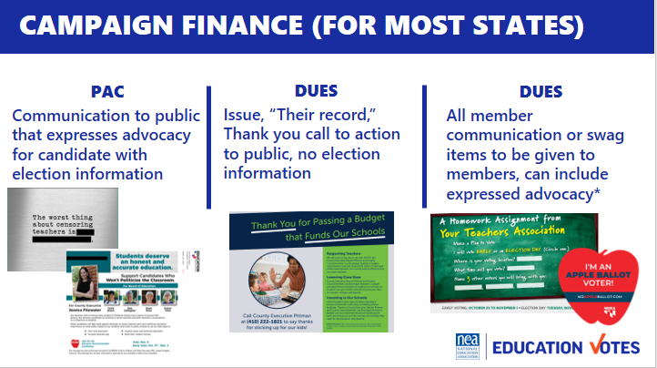  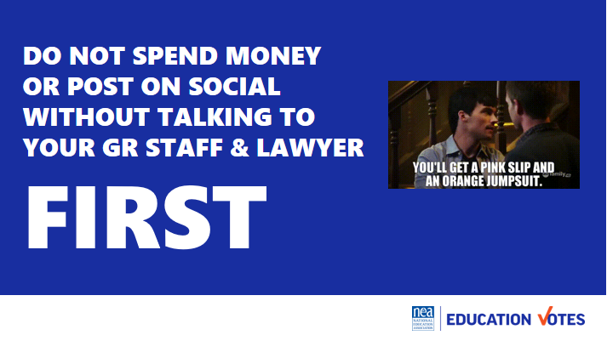  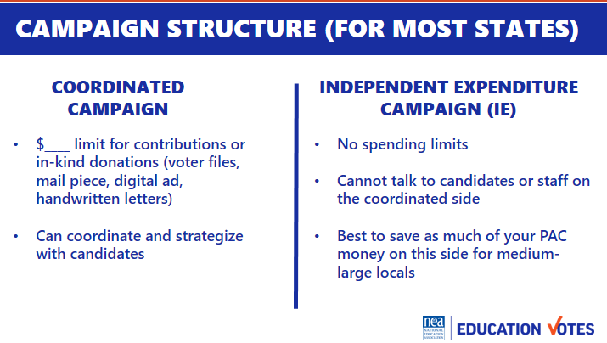  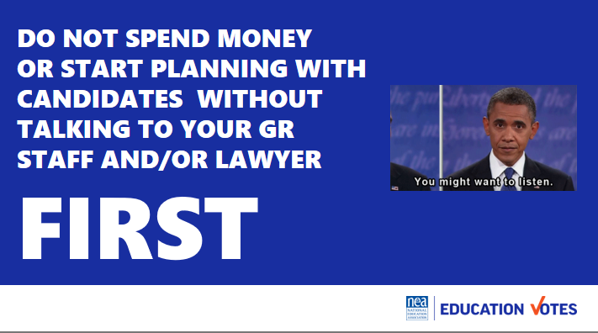  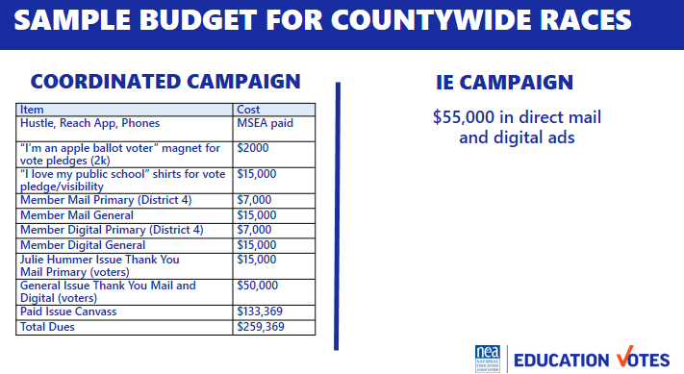  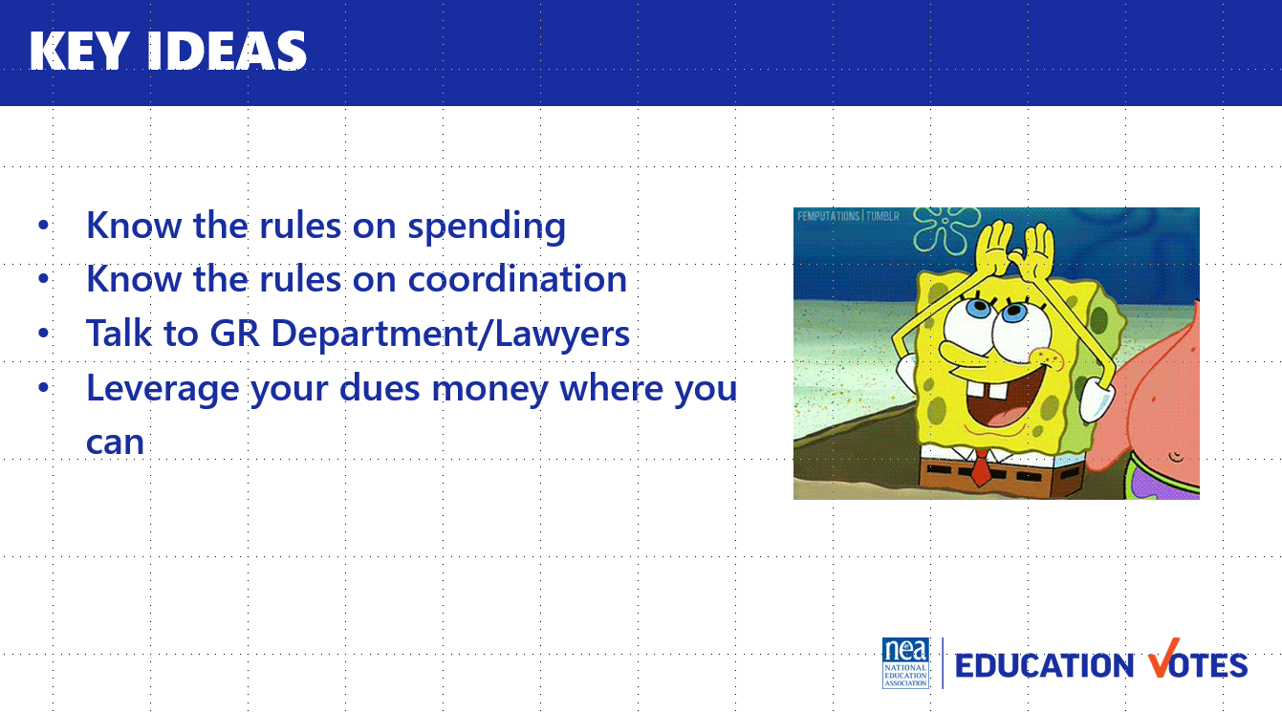 |  | How do you budget? 10  - So we have to start this by saying all states are different  - Here’s a great slide on what kind of money you can use for different election communications, again this is for most states, it’s important to ask lawyers what’s possible/allowed in your state  - This is an important PSA because we can’t say this enough and we don’t want you or your local to get in trouble.  - Another important thing to ask GR staff about is what you need to know about the campaign structure. There are two sides in campaigns. Coordinated and independent expenditures. The two key things to pay attention to are 1. Who you can talk to and 2. How much money you can spend. You can see from here, IEs are where it’s at. Most candidates spend money on stupid stuff like nail files or chapstick with their name on it. Avoid contributions to candidates/make in-kind or better yet, save all your money for an IE if you are able to build this structure.  - Another PSA plug to coordinate with your GR Department  - Here’s a sample budget from a local who moved all their PAC money to the IE and then after consulting their lawyer and learning they could use dues for a paid canvass, they went to their executive board and tapped into their emergency fund. It was an emergency for their contract to elect pro-public education candidates.  Key Ideas  - Know the rules  - Know the structure  - Talk to your GR Department/Lawyers  - Leverage your dues money where you can
11:30 – 12:00pm Meighan |  | Campaign Plan Tactics & Timeline
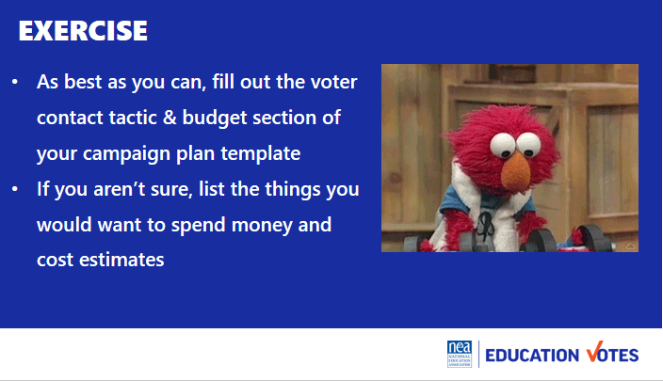 | Campaign Plan Template | So we’ve given you all the fundamentals of campaigns and some of the creative tactics we’re seeing. Now it’s time for you to take that and start working on your plan. We want you to decide on which tactics you will be using and start putting them on your tactic chart & budget. This is Step 4 & 5 in the Campaign Plan Template.  You have until lunchtime. We will have trainers at table to thought partner.
12:00 to 1:00 LUNCH

1:00 – 1:30pm Hedy |  | 30 Minutes Winning with Members
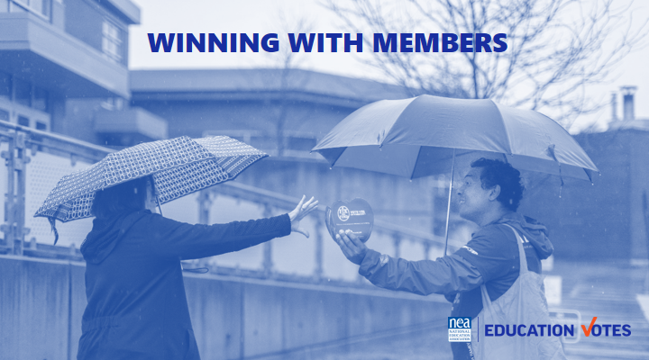  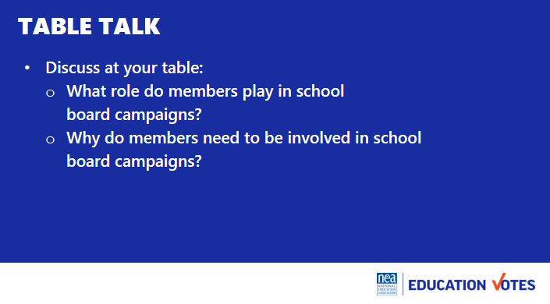  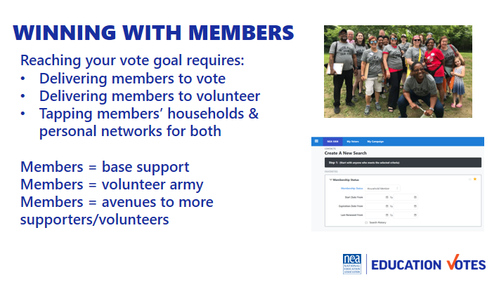  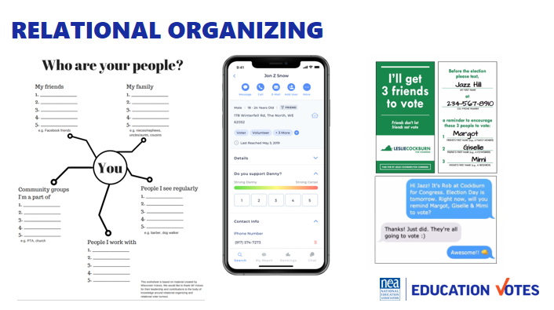  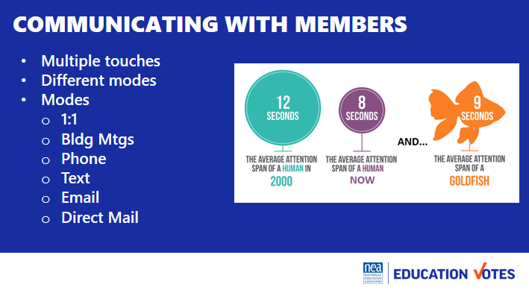  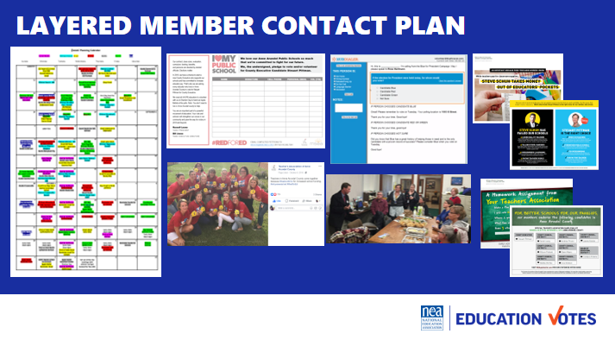  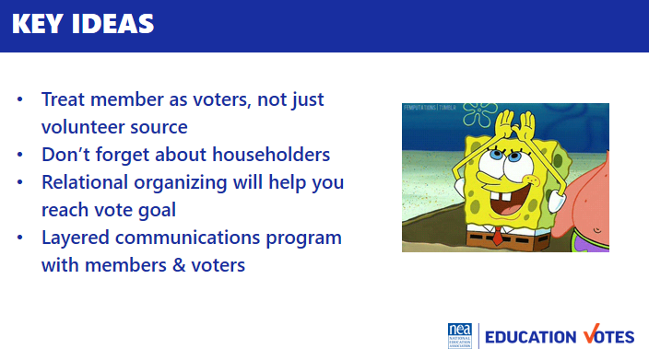 | Communicating with members chart | It’s really easy in campaign work to do stuff just to get it done versus having a member-driven campaign. For the next 8ish minutes, at your table talk about:  - What do you as staff, need to do to do to get your members to engage in school board elections?  - Why do members need to be involved in school board campaigns?  Purpose of the table talk is to get participants to understand:  - Members need to do work around school board elections because they directly impact their workspace. They are closest to the impacts of school board elections and are in a unique and trusted position to explain to community members why this is important and why others should care.  - Educators are in a unique position where they can have a say in electing their boss. We have to remember that is an avenue of power.  Debrief 2 min  - Why should our members be leading this work?  - We need to always keep this at the forefront. This is their union and if they want to build a strong organization, they need to be leading this work.  - It’s important to know who your people are – leader, mobilizers, activists – this knowledge can help you determine how they can be most impactful.  Engaging members 3 min  - Another thing we need to remember is that our members are more than just volunteers. They should be the first folks we think of when we start thinking through our vote goal counts.  - They also make the most incredible volunteers. Most voters do not vote in school board races so to have an educator at their door or polling place tell them who are recommended candidates are is powerful.  - Our members are incredibly connected and another thing to realize is we can talk to the members in their household with dues money as well and we have those folks listed in the VAN.  Relational Organizing 2min  - We mentioned relational organizing in the creative voter contact, but we wanted to surface that again because it is the most effective voter contact. Folks listen to people they know & trust more than a TV commercial or a stranger at their door. Building a relational organizing program into your work with members is incredibly effective.  - You can use one of these old school worksheets, pay for a fancy apps, or use hustle to create a vote tripling program. The big key is you are building accountability back in or time during your phone bank or canvass where folks are also taking time to text their network.  Communicating w/members 5 min  - How many times do you think a voter needs to be reminded? (used to be 7, now it’s closer to 13)  - Our members prob don’t need 13, but once you start looking at your part turnout, you’ll have a better idea. A good rule of thumb is at least 3, they need to know who the candidates are, they need to know why this is important, and they need a reminder before GOTV  - You don’t want to just communicate the same way, especially if it’s just email. Mixing up a mail piece, phone call, text, or building visit are great different modes of contact for member program  - It’s important to layer the communication throughout your campaign.  - Here’s an example from a local where you can see their calendar and each of these different colors represents different mode of contact.  - They started with ID petition where members got a “I love my public school” t-shirt if they took the voter pledge.  - On Tuesdays every week, schools would take pictures and have visibility days in their shirts and we posted them on Facebook.  - The GR committee had weekly phone banks to call through the 5k members that lived in the county and what was great about these events is the candidate would come out and thank them while they had the best takeout we could find.  - We also sent every member 3 pieces of mail – one bio piece in September, one persuasion candidate comparison piece in early October, and one GOTV piece right before early voting started.  If time allows – ask the people in the room to share examples of this type of layered contact  Be sure to point out pgs 39/40  Key Ideas 5min  - We need to treat members as voters, not just volunteers  - Don’t forget about householders  - Relational organizing will help us get to that vote goal number  - We need to create layered ID, persuasion, GOTV program for our members just like we would with the public | How do we talk to members to get them to vote and volunteer?  Participants will understand they have to have organizing conversations to mobilize members, they will understand the types of contact, and importance of layered communications.
1:30 – 2:15pm Monet |  | 45 Minutes Volunteer Recruitment
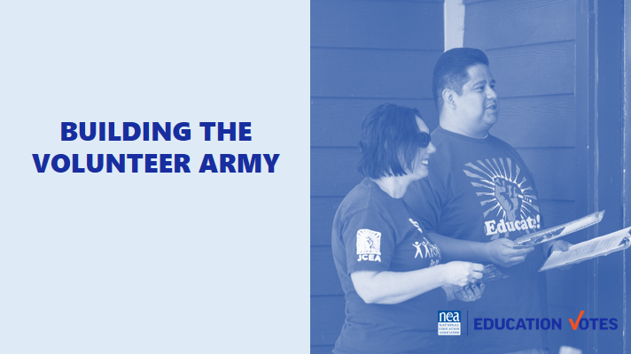  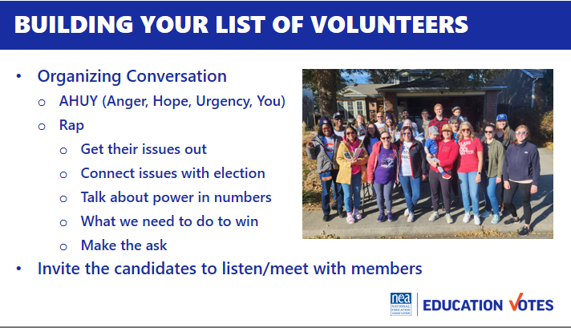  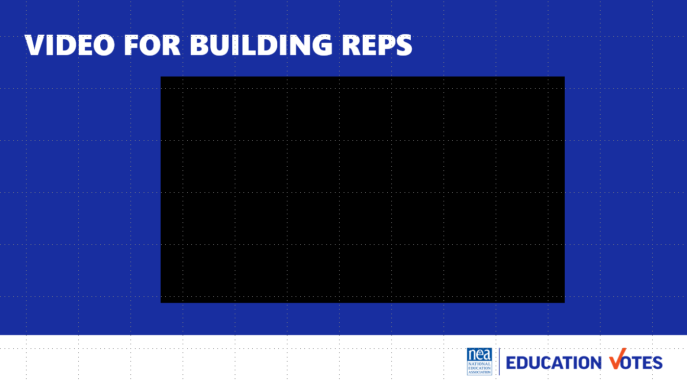  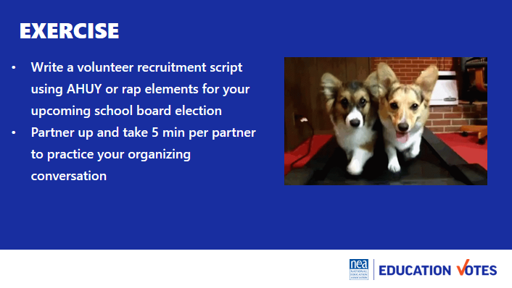  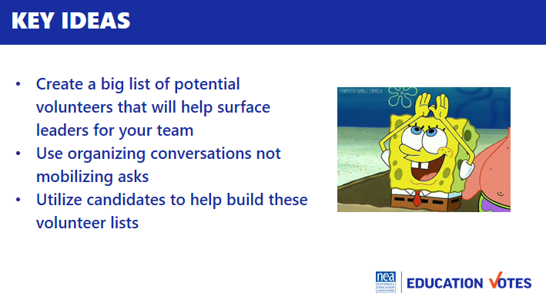 | AHUY Handout | 5 min How do we actually talk to leaders about this work? Like we said earlier, our role is not necessarily to do all the asking and relationship development, but to know how to support leaders and mobilizers in how to build these networks. Before we find the leaders and mobilizers, we need to build our list of volunteers through organizing conversations.  Let’s review how organizing conversations can work.  10 min Content talk -  - Our first step is to build the potential volunteer list, this will help you surface the leaders and identify folks for your team  - It’s important that these are organizing conversations first, not mobilizing asks  - There’s two popular models to have these organizing conversation  - Labor Notes developed this acronym AHUY to help your remember how to have this conversation  - Anger – this is where we try to tap into emotion to get them fired up about making a change  - Hope – this is where we offer solutions on how we could make the change  - Urgency – this is where we talk about how this needs to happen now  - You – This is the ask of them  - This is more of a traditional Union Organizing Rap from the AFL-CIO Organizing Institute, but you can see it follows a similar thread as AHUY  - Get their issues out​  - Connect issues with election ​  - Talk about power in numbers​  - What we need to do to win​  - Make the ask​  - One important element as you start building your volunteer list is to make sure you are involving the candidates listening and meeting with members. Have them at your RAs, visit phone banks etc.  - Here’s an example of how that local used their Vote/Volunteer Pledge Petition using building reps to create their potential volunteer list and training video they sent out to their reps (5 minutes)  25 min Exercise – Now it’s your turn, for the next 10 minutes write a volunteer recruitment script using AHUY or rap elements for your upcoming school board election. Then find a partner to practice with and we’ll come back together to debrief.  - 10 minutes to write your rap  - 5 min per partner to make ask (10 min)  - Debrief 5 minutes  - How was that?  - Any partner do something great worth shouting out?  5 min Key Ideas  - Create a big list of potential volunteers that will help surface leaders  - Organizing conversations not mobilizing asks  - Utilize candidates to help build these lists | What do I say to recruit a volunteer?  Participants will write a volunteer recruitment script.
2:15 – 2:30 BREAK
2:30 - 3:30pm Vanessa |  | 60 Minutes Building the Team
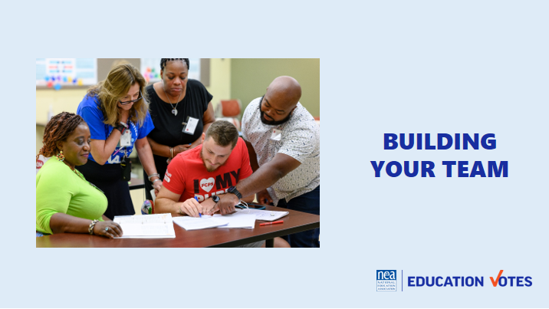  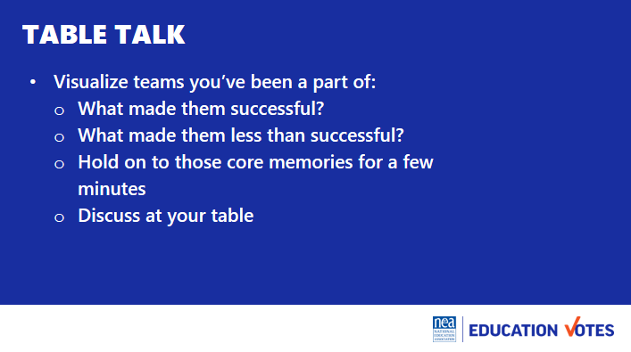  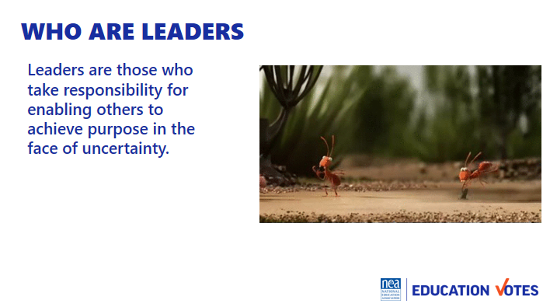  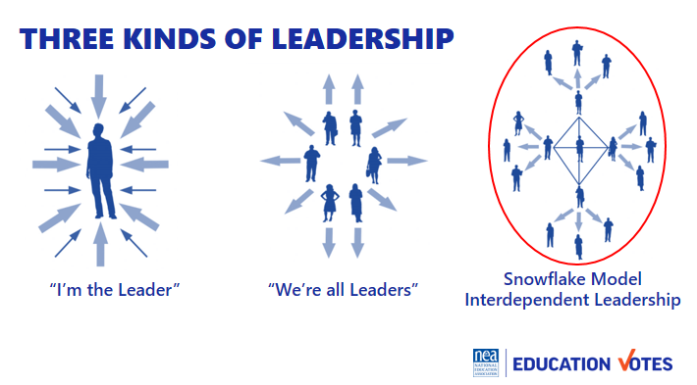  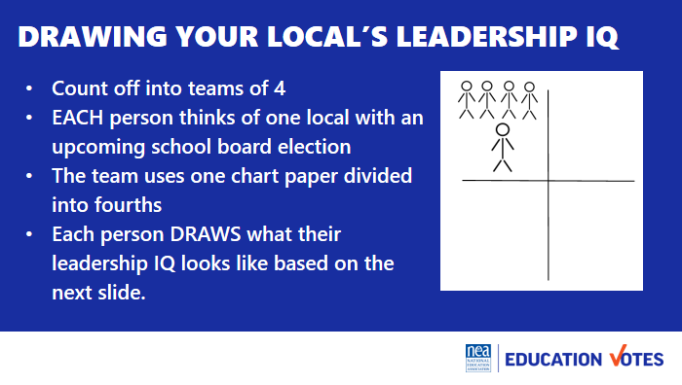  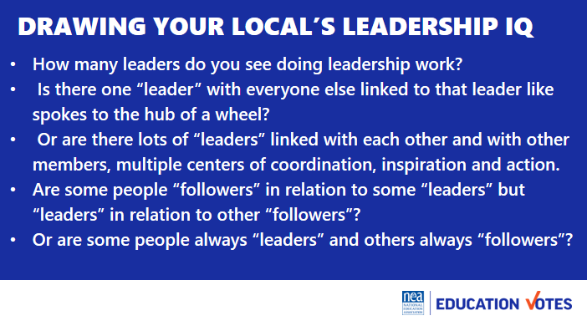  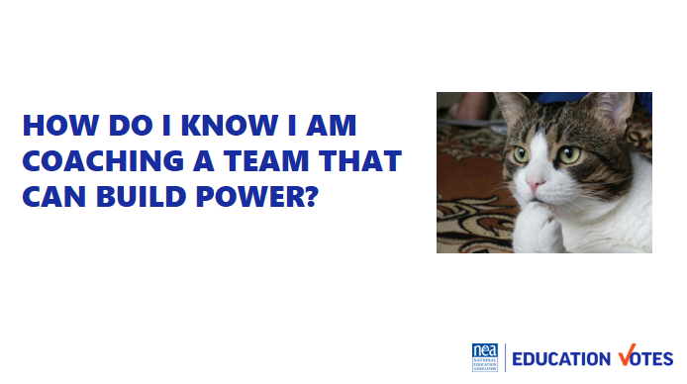  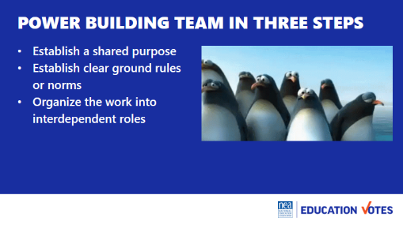  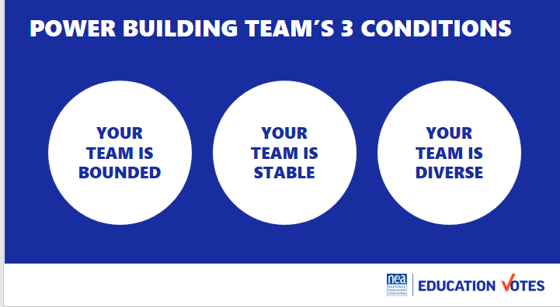  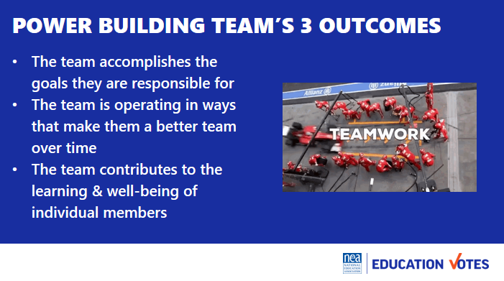  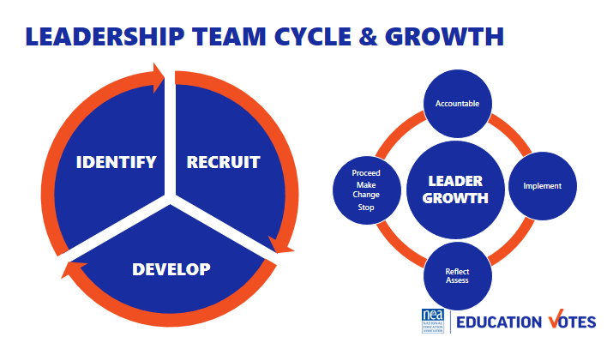  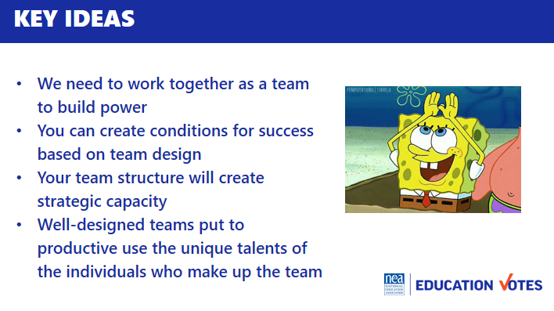 |  | Visualize teams you have been a part of, table talk 5  - What made them successful?  - What made them less than successful?  - Hold on to those core memories for a few minutes  30 Min Who are leaders? 15 Minutes Intro and Group Work 15 Minutes  - Leaders are those who enable others to achieve purpose in the face of uncertainty.  - WE are always coaching away from single leaders/authorities towards interconnected leadership/ teams.  - We are going to spend time at your tables drawing your local’s Leadership IQ for elections. Let’s count into groups of Four people to a team Each team gets on piece of chart paper divided into 4 quadrants. Each person draws what their local’s leadership IQ looks like using the following questions on the screen.  - How many leaders do you see doing leadership work?  - Is there one “leader” with everyone else linked to that leader like spokes to the hub of a wheel?  - Or are there lots of “leaders” linked with each other and with other members, multiple centers of coordination, inspiration and action.  - Are some people “followers” in relation to some “leaders” but “leaders” in relation to other “followers”?  - Or are some people always “leaders” and others always “followers”?  These teams don’t just magically happen. No difference than letters don’t just fall together for people to know how to read. The mechanics are there, but someone needs to teach the rules, and guide you to how to do it.  How do I know I am coaching a team that can build power?  10 Min What makes an effective team  - Establish a shared purpose. What are you fighting for and can you clearly articulate your common purpose as a team. It is clear, challenging, and matters. You have defined your goal, whom you work with, and the kinds of things you will do?  - Establish clear ground rules or norms. Your team sets explicit expectations of how you will work together: how you will make decisions, manage your time, and honor your commitments. What are things you will always do and what are the things you will never do. And how will you correct yourselves if you do them. Perhaps you most important norm is how you will make decisions. Steps that can guide effective decision making are: defining the problem, establishing criteria, brainstorming possibilities, synthesizing ideas, formulating options, evaluation options against the criteria, deciding. Some prefer deciding by vote; others, by consensus; others by delegating the decision to an individual.  - Organize the work into interdependent roles. Everyone should have responsibility for their own share of the leadership work needed to achieve the goal. Role requirements need to be clearly described. Team members need to assess their strengths and limitations, to the greatest extent possible, matching individual capabilities with role requirements. Because roles are designed to be interdependent, everyone has a stake in everyone else’s success. Team members speak up when they need help and get it. No one works in a silo that’s secretive to others. The team with diverse identities, experiences and resources brings more to the table than a team that is very homogeneous  5 Min Three Conditions  - Your team is bounded. It is clear who is on the team and who is not on the team. It is clear how new people can join the team and what is expected of those who must leave the team.  - Your team is stable. People commit to clear terms of service: regular meetings, length of time, etc. Your team is not a revolving door, never knowing who will show up.  - Your team is diverse. Your team has the appropriate diversity of skills, talents, viewpoints, and constituencies that will be needed to do a good job.  2 Min Three outcomes  - The team accomplishes the goals for which it is responsible.  - The team is operating in ways that make it better as a performing unit over time  - The team contributes the learning and well-being of individual members  5 Min Leadership Team and Leadership Growth Cycle  - As an organizer your job is to recognize and then help the team recognize that in order to build power, there is a continual identify, recruit, and develop cycle of new folks into the team.  - A team that does not continual recognize that one of their jobs is to continue to make space for new leaders, perspectives, diversity, and talents is a team that is not intent on base building and power development.  - Further a team grows in capacity to strategically achieve outcomes using everyone’s unique talents by attending to a continual cycle of implementation, reflection/assessment, proceed-change-stop, and accountability for the outcomes. We do a disservice to teams, the constituencies they are from, and the local as a whole when we don’t identify non-growing, non-power building teams. An even great disservice is done when we jump in to do it ourselves.  3 Minutes of Key Ideas –  - We can’t become powerful enough to do what we need to do if we can’t even work together as a leadership team.  - You can create the conditions that will increase the odds your team will work drawing on the craft of team design  - Structuring a leadership team creates strategic capacity: the ability to strategize creatively together in ways that produce more vibrant, engaging strategy than any individual could create alone.  - Well-designed teams put to productive use the unique talents of the individuals who make up the team. | How do we build effective GR committee/ election teams?  Participants will understand how to coach and develop the leadership needed for an effective GR team to lead a campaign.
3:30 – 4:00 Vanessa |  | 30 Minutes Team Communications Exercise
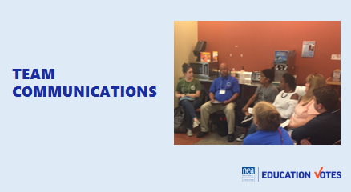  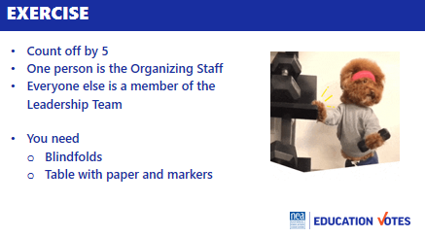  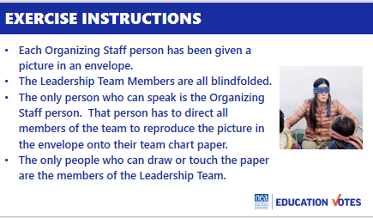  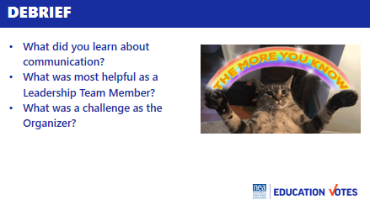  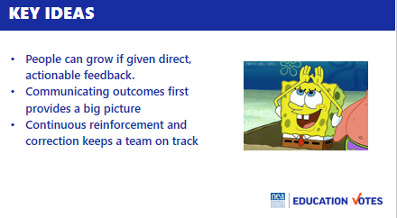 | Blindfolds & Envelopes with drawing | Team Communications Exercise  Intro and divide into teams 10  - We are going to be working in teams of 5 to 6. Go ahead and get settled in with your team.  - Now that you are settled, pick one person to be the Organizing Staff Person. The rest of you will be members of a leadership team.  - We are going to co-create a product in teams. On your tables are blindfolds paper and markers.  - If you are a Leadership team member you need to put your blindfold on so that you can’t see – no peeking out the side, and if you can see through it—close your eyes.  - Organizing Staff person- you have an envelope in your hand that contains a drawing. When we begin you are the only person allowed to talk to your team. They can not ask you questions, they can not talk to each other or to you or out loud at all. When we begin you will be able to open your envelope and your task is to direct every member of your team to draw as closely as possible the picture in your envelope. You cannot touch them in any way, only use your voice to direct. The only people allowed to touch markers or paper or to draw on the paper are the leadership team. You will have 10 minutes to make your masterpieces.  Group activity 10  Sharing of Pictures and Reflection on Learning as teams 5  - Take off your blindfolds. Take 5 minutes to discuss as a team the following questions:  - What did you learn about communication?  - What was most helpful as a Leadership Team Member?  - What was a challenge as the Organizer?  Group report-out 5  Key Ideas 5  - People can grow if given direct, actionable feedback  - Communicating outcomes first provides a big picture  - Continuous reinforcement and correction keeps a team on track
4:00 – 4:15pm Melissa |  | 15 Minutes Organizing successful member engagement events
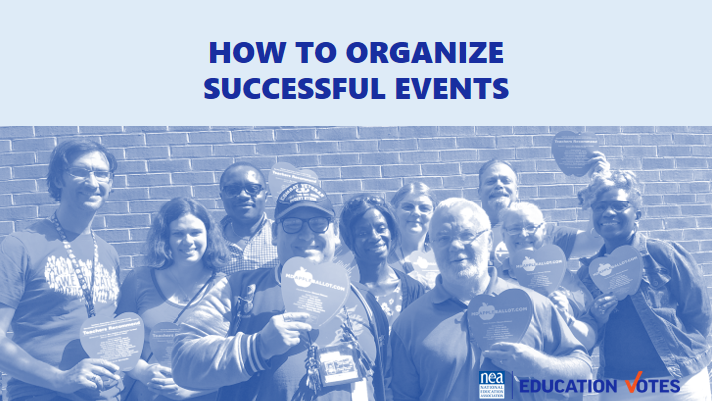  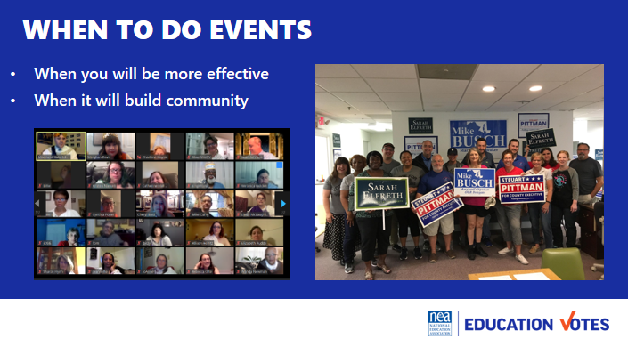  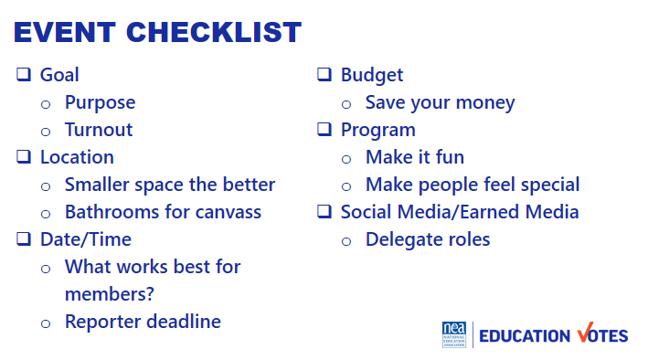  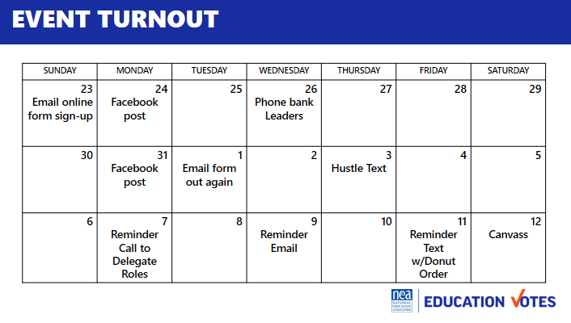  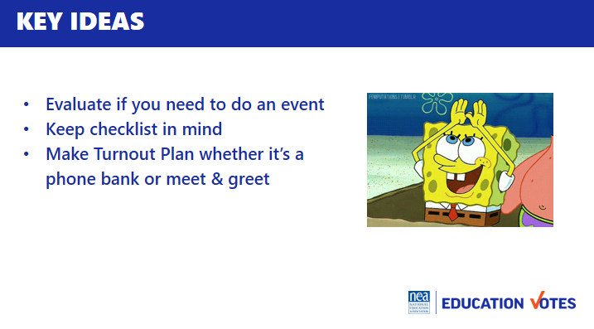 |  | - 5 Min Why do events  - Opening pic is event of early vote field trip that I wish I hadn’t organized (it was end of school year, no one wanted to come, we lost money on happy hour & those folks could have been doorknocking instead of drinking beer)  - Think of the worst event you went to, why was it bad?  - We should only do events when:  - It’s more effective (you make more calls/knock more doors when it’s group effort)  - They build community & you need it  - 3 Min Here’s a checklist of considerations as you start thinking through events  - What is the Goal? This could be goal of event and turnout goal.  - Where should Location/Room be. Think through what optics will look like, small rooms are good sometimes b/c it will feel bigger.  - Date/Time – think about what is most convenient time for members  - Budget – always think through is it worth it? Could this money be spent on something more effective.  - Program – what’s your run of show  - 5 Min Turnout math/plan  - You need to do turnout for everything, including your canvasses & phone banks  - Here’s a sample turnout calendar  - Usually 2/3 is our worst scenario flake rate, a good rule of thumb is that you need 3 times the number of yeses you want for people to show up.  - There are some jedi mind tricks to help reduce your flake rake.  - Ask what donut flavor they want or t-shirt size  - Give them a role so they know you are counting on them being there  2 Min Key Ideas  - Evaluate if you need to do event  - Keep checklist in mind  - Make Turnout Plan whether it’s a phone bank or meet & greet | How do I turn members out? What are best practices for events with members and candidates?  Participants will understand turnout math and how to have successful events with members and candidates.
4:15 – 4:30 Ellen |  | Ending it Right
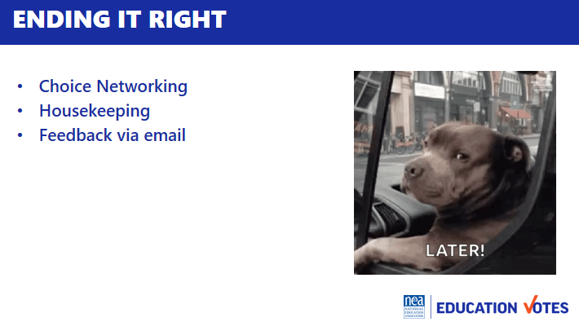  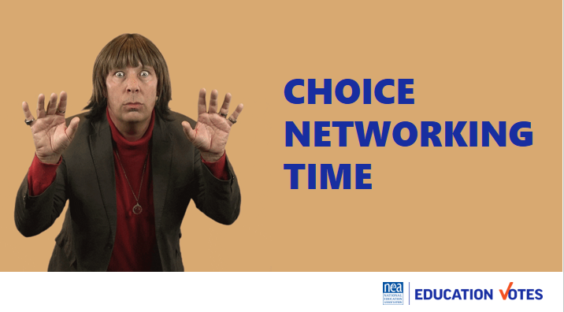 |  | Questions, Connections, Reflections  Housekeeping announcements  Plus/Delta at the Door | What questions do I have? What do I need to know?  Participants will get opportunity for feedback and leave session with what they need to know for tomorrow.
4:30-5:00 |  | Choice Networking
5:00 ADJOURN

