Facilitator Agenda: Winning School Board Campaigns Day # 3
General Materials Needed: |  |  |  | Room Set-up:
1 Set of Handouts per Person  Name Tags or Name Tents  Room signs, sign in signs  Highlighters – 3 colors  Pens and Pencils | Chart Paper – self stick kind  Markers- Mr. Sketch - Non Permanent  Post its  Wifi |  |  | Round Tables for Participants – cords at each table  Long rectangle at back for Facilitators  No Podium – table with projector large enough for laptop  Projector, Screen, Microphones, and Speakers  Carousel stations and reporting stations around the perimeter  50 people Max
Key Outcomes for the Day
- Review the new finds on message and dealing with opposition groups
- Understanding that work doesn’t end on Election Day, how to push your policy agenda forward
- Get Feedback on Campaign Plans
- Get inspired to do the work

Content and Facilitator Assignment Overview Day 3
8:30- 9:00 Reentry  9:00 - 10:30 Message  10:30-10:45 Break  10:45 – 11:30 Post Election Day |  | Ellen  Melissa, Meighan & Monet  Hedy & Vanessa | 11:30 – 12:45 Present Campaign Plans & Get Feedback  12:45 1:00 Ending it Right  1:00 ADJOURN w/Boxed Lunch |  | Jackie  Ellen & Meighan  Ellen or Meighan

Time, Facilitator and Slides | Resources | Instructions, Activity and Debrief | Essential Questions and Key Outcomes
 | Charts, handouts, articles, materials, videos | What are you saying, what are they doing, what questions will you use to guide learning and make clear the important points  Include an estimate for how long each section of the learning will take  Include Key points. | What question(s) does this section answer?  What will participants know or be able to do?
8:30 – 9:00 Ellen |  | 30 Minutes Welcome back
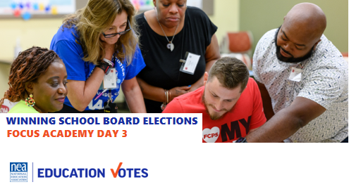  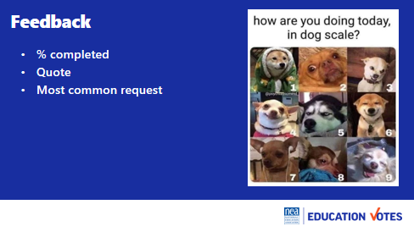  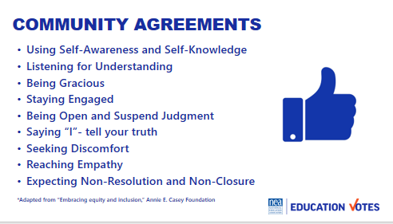  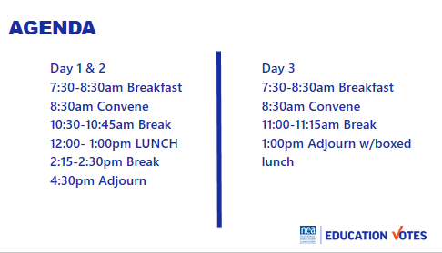  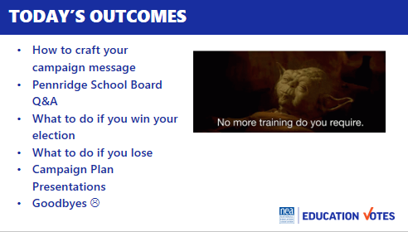 |  | Reentry  Feedback on Feedback  Agenda Review  Norm Review | How are we feeling and what are we covering today?  Participants will re-enter the learning environment.
9:00-10:30am Melissa & Meighan |  | Message 35 min
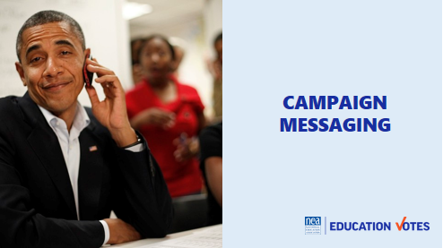  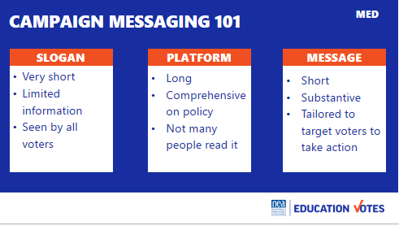  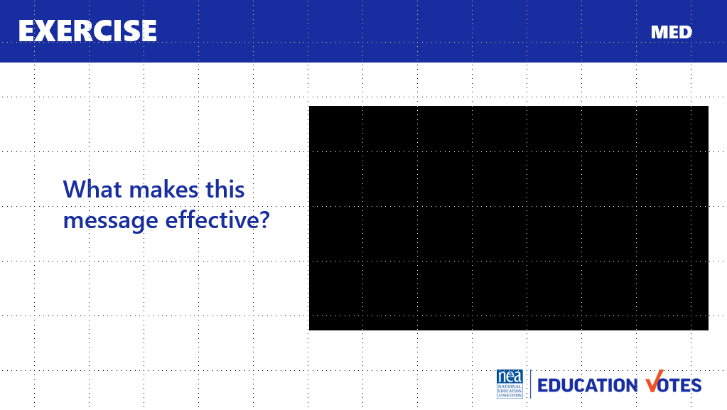  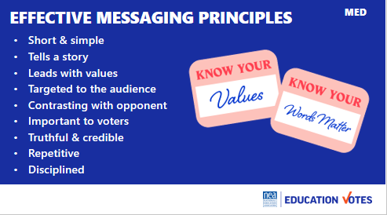  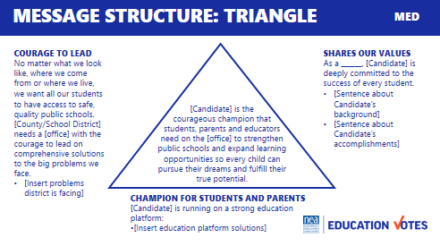  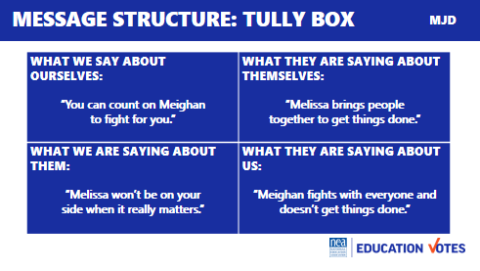  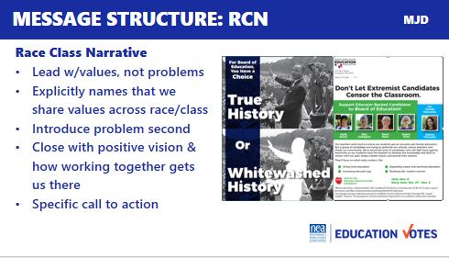  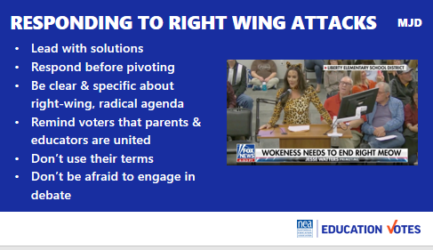  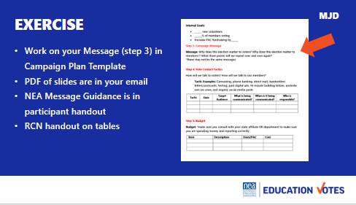  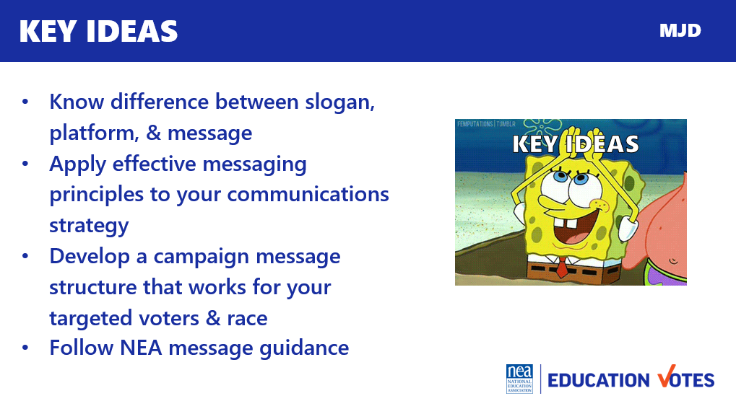  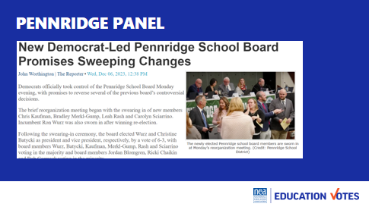 |  | Introduction 2 min  - This is session focused on message to public in your campaign. What you are saying in public-facing messages & communications.  - Let’s start with what a message is. A lot of candidates make the mistake of using a slogan and calling it their message. School Board candidates especially love to create an abbreviation for what their platform is and call it a message. A message is not a slogan or policy platform. A message is a statement that motivates targeted voters to take action. It contrasts between you & your opponent that you repeat over and over again.  Effective Messaging 7min  - Show video 3 min  - Why was this video effective? (told story, led with values) popcorn answers 2 min  - 2 min Here are principles to remember as you start crafting your message. Tell stories and lead with values where you can. Unfortunately, we all don’t have Slotkin-type candidates with compelling stories. You want to keep it short and make sure it’s targeted to the voters you are trying to reach. Use issues the community cares about and issues you know they are talking about. Make sure you have data to back-up any facts you cite. You want to constantly be using your message in your communications on doors, in your mail, and digital ads. Repeat, repeat, repeat & stay disciplined.  Message Structure 9 min  - 1 min There isn’t a one-size-fits-all all formula for messaging. We are going to show you two widely used formats and one new emerging structure that you might have seen in your affiliate in your RSJ work.  - 2 min Message triangle – this is prob most used format in our union. It’s the three points you are going to repeat over and over. I like this one b/c it helps you boil down their background & qualifications, what the issues are, & what their fighting for. The message in the middle ties the three points together.  - 2 min Tully Box – this may be the simplest structure when it comes to developing your message, but it’s important to note especially if you have candidates attacking one another. This format is really great to help you build a contrast and develop your comparisons for voters.  - 2 min RCN was developed in 2017 as a message structure to neutralize the use of dog whistle racism to win on issues. It follows this structure where you start by talking about your values & being explicit that we share these values across race & class. Then you introduce the problem, & close with the solution of working together for a call to action. Here’s a great mail piece from MSEA that used RCN elements in a school board and county Exec race in 2022.  - 1 min With all of these structures, use what’s best for your community. Sometimes it makes more sense to focus on issues like you saw in the triangle. Sometimes you really want to paint the picture of the choice of candidates you have using the message box. And you may be in the middle of moms for liberty hell and need a race-class narrative that reminds voters of values, names the problem/people calling division, and reminds them of the positive future our kids need.  - 1 min There’s a great message guidance from NEA that was focused specifically on school board races with sample talking points in your participant handout. It has sample talking points for you to use. We also have this handout on RCN.  Responding to Right Wing Attacks 2 min  - There’s also a section at the end of that NEA message guidance handout with tips on responding to attacks  - You may end up with patriot Barbie dressing up like a cat at your school board like this photo. I know it’s tempting to take their bait, here are some good tips on how to respond to those attacks smarter not harder.  - Always lead with your positive, solutions. We saw this in the 2023 races, voters don’t want the culture war. They want to hear about what your candidate is going to do for students, public schools, and communities.  - That said, you can’t ignore the debate. You need to respond, but pivot back to your message. There are great talking points to use in that NEA Message Guidance doc.  - Don’t let the right-wing claim parents as their ally. Remind them educators & parents are united – leaning in on your work to partner with parents and educators.  - Don’t use their terms like CRT or “grooming” - even when responding or being asked questions about it. Make sure to use your words to speak about your values. .  - I’m sure some of your governance leaders will want to stay out of it b/c we know educators hate conflict – but it is a mistake to ignore the debate. We have to engage, but we have to engage strategically and with a smile on your face. Make sure you engage in a way that highlights how educators are the cool, calm, and collected people in any debate to ensure any viral videos that come from any discussion or debate shows the otherside as the gadflies they largely are.  10 Min Exercise Participants asked for a template for this. And a suggestion of an issue vs problem earlier on to know what a good issue is to focus on.  - For the next 10 minutes, start working on your message in your campaign plan template. It mentions 3 points, but It’s up to you if you create triangle, a message box, or a narrative.  - You have the pdf of the slides in your email if you want to refer to the 3 different structures we highlighted today  - Also make sure to check-out the 3 pages of NEA message guidance in your participant handout  Key Ideas 2 min  - Know the difference between slogan, platform, & message  - Apply effective messaging principles to your communications strategy  - Develop a campaign message structure that works for your targeted voters & race  - Follow NEA message guidance  40 Min - Have 2-3 PSEA Staff/Leaders Present  - How were you attacked?  - What was their message? What was yours?  - How did you win?  - What would you have done differently | Participants will understand what makes a winning message and how to craft a message for the public
10:30 – 11:15 Hedy & Vanessa |  | Post Election Day
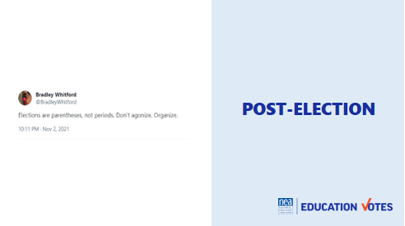  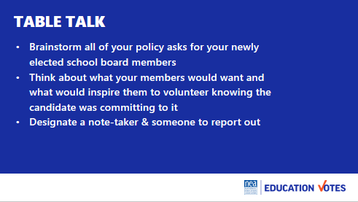  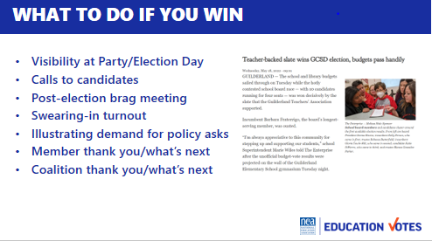  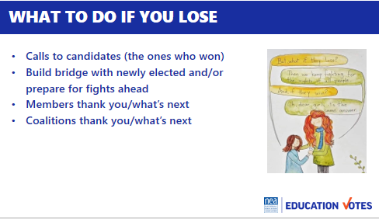  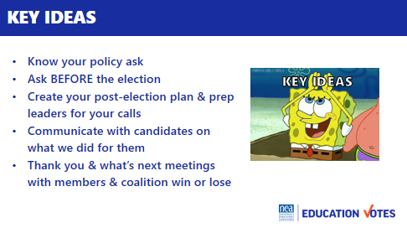 |  | 45 Minutes What to do after Election  - I love this tweet from Bradley Whitford. I think it’s true whether we win or lose. We can’t hang up our boots on Election Day and think we’re done. We want to spend the next 45 minutes going through those scenarios and helpful ways to push your agenda forward.  - So let’s talk about that agenda. Too often we spend all of our time working to elect someone, but we haven’t spend time on what we’re asking of them or prepping them on those asks. For the next 10 minutes, at your table, discuss what your policy asks to your newly elected School Board members would be. Make sure someone takes notes and you designate someone to report out for your table.  - Let’s hear those policies you want to win. Report out table talk 10  - When do folks think we should be talking to the candidates about these asks? 5 (BEFORE THE ELECTION, during interviews, planning meeting, giving them talking points, asking them to incorporate into platform/mentioning at rep meetings etc.)  - What to do if you win 8 – Isn't that a great headline out of NY? So let’s talk about what you should do if everything goes right.  - Visibility at Party/Election Day visits – How many folks make sure their volunteers go to the parties in union shirts? A lot of the next few weeks is making sure you are constantly reminding your candidates they could not have won without your local’s help so you are setting yourself up for those policy asks. If you have a polling operation, it’s also a good idea to coordinate w/your candidates so they visit your volunteers and thank them. Ask your comms department to send a photographer along too.  - Calls to candidates – Some school board candidates may not be connected to a party or you may not know if they won their election right away w/mail ballots. Once a race is called you want to make sure you connect with the candidate right away and set-up a follow-up meeting.  - Post-election brag meeting – In your follow-up meeting you want to make sure they know everything you did. If you had one of those independent expenditure campaigns they didn’t know about, this is the time to share that information. You should also try to coordinate their appearance at a building rep meeting or event to thank your members. Again, this is all setting up for reminding them of those policy asks.  - Swearing-in turnout – Swearing-ins are also great opportunities to do turnout in your t-shirts. We coordinated one where everyone wore green so folks were reminded of the funding commitments they had made before the Election.  - Providing cover/illustrating demand for policy asks – Once you start talking about policy or budget, a good question to ask your new elected allies is what organizing can we be doing to demonstrate demand for this. It could be op-eds in the newspaper or community forums, blast emails etc.  - Members – What are some things folks have done to thank their members after an election?  - Coalitions – You also want to make sure you are thanking your coalition partners and strengthening that partnership for the organizing ahead.  - What to do if you don’t win 8  - Calls to candidates – this means calling candidates that did win that you didn’t endorse. You want to prep your leaders for that call and have them do a roleplay with you. They will want to send an email instead, but it’s in your members’ best interest to attempt to not go scorched earth immediately and try to start a relationship.  - What are some ideas on how to start building bridges with candidates you didn’t endorse that win?  - Members – You want to make sure you still honor your volunteers. It’s also a good idea to do some kind of all-member email that reminds folks that elections aren’t’ periods and we keep fighting no matter what.  - Coalitions – Again, you want to keep strengthening your partnerships for the organizing ahead win or lose. It’s also a good idea to try to do a debrief meeting to see what you learned from the election for next time.  Key Ideas 2 min  - Know your policy ask  - Ask BEFORE the election  - Create your post-election plan & prep your leaders for calls  - Communicate with candidates on what we did for them  - Thank you & what’s next meetings with members & coalition win or lose | Participants will hear from their peers on what their policy asks will be. They will learn tangible skills on how to transition from election to campaign mode.
11:15-11:30 BREAK

11:30 – 12:45 Jackie |  | Present Campaign Plan & Get Feedback
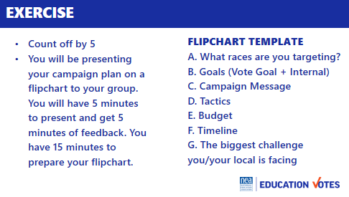 |  | Make Groups of 3  Show flipchart template for them to summarize key points so they can share with group  - What races are you targeting?  - Goals  - Vote Goal  - Internal Goals  - Campaign Message  - Tactics you’ll be using  - Budget  - Timeline  - What will be your biggest challenge?  15 Min work time on flip chart  1hr share (create groups where folks have 5 min share, 5 min feedback per person)
12:45 – 1:00 Meighan |  | Ending it Right
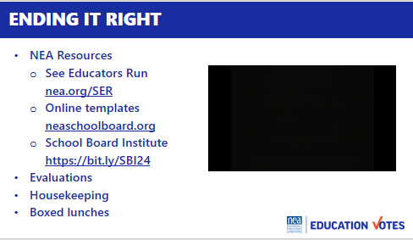 |  | 15 Minutes Ending it Right  - NEA Tools/who to talk to handout  - Thank Yous  - Evaluations  - Boxed Lunch | Participants will leave with new skills and know where to give feedback and access resources.
1:00 ADJOURN

