Facilitator Agenda: Winning School Board Campaigns Day # 2
General Materials Needed: |  |  |  | Room Set-up:
1 Set of Handouts per Person  Name Tags or Name Tents  Room signs, sign in signs  Highlighters – 3 colors  Pens and Pencils | Chart Paper – self stick kind  Markers- Mr. Sketch - Non Permanent  Post its  Wifi |  |  | Round Tables for Participants – cords at each table  Long rectangle at back for Facilitators  No Podium – table with projector large enough for laptop  Projector, Screen, Microphones, and Speakers  Carousel stations and reporting stations around the perimeter  50 people Max
Key Outcomes for Day 2
- Understanding of the phases of an electoral campaign
- Learn to develop effective member engagement plans that increase volunteer recruitment and voter turnout
- Review most effective voter contact methods
- Develop a message and understand the best responses to right-wing attacks
Review case studies for large, urban school board campaign and a small, rural campaign

Content and Facilitator Assignment Overview Day 2
8:30- 9:00 Reentry  9:00 -9:15 Campaign Phases  9:15-9:30 Winning with Members  9:30-10:00 Volunteer Engagement  10:00-10:30 Building Your Team  10:30-10:45 BREAK  10:45-12:00 Campaign Plan Overview  10:45-11:00 Missing Content  11:00 -11:30 Team Communication  11:30-12:00 Member Engagement Events  12:00-1:00 LUNCH |  | Ellen and Meighan | 1:00- 1:40 Voter Contact 101  1:40-2:15 Voter Contact Tactics  2:15-2:30 BREAK  2:30- 2:50 Campaign Messaging  2:50- 3:20 Messaging Tool  3:20-3:45 Case Study  3:45 -4:20 Campaign Work – Tactics  4:20-4:30 Ending It Right  4:30-5:00 Choice Networking  5:00 ADJOURN |  | Ellen or Meighan

Time, Facilitator and Slides | Resources | Instructions, Activity and Debrief | Essential Questions and Key Outcomes
 | Charts, handouts, articles, materials, videos | What are you saying, what are they doing, what questions will you use to guide learning and make clear the important points  Include an estimate for how long each section of the learning will take  Include Key points. | What question(s) does this section answer?  What will participants know or be able to do?
8:30 – 9:00 Ellen |  | 30 Minutes Welcome back
Slides  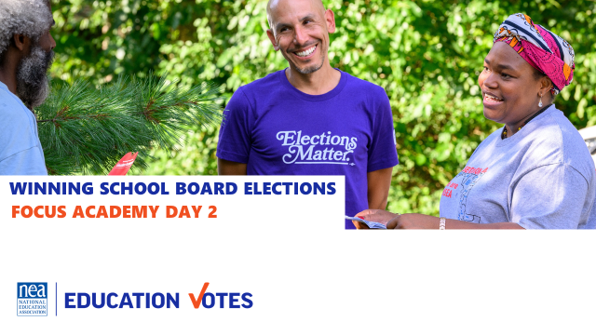  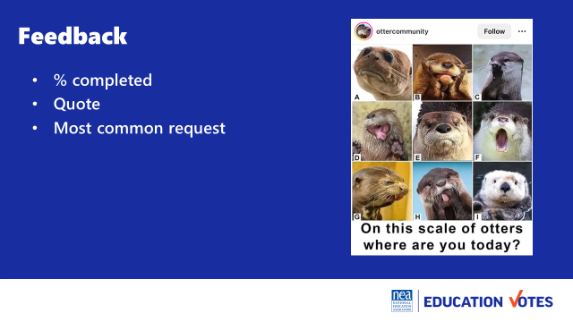  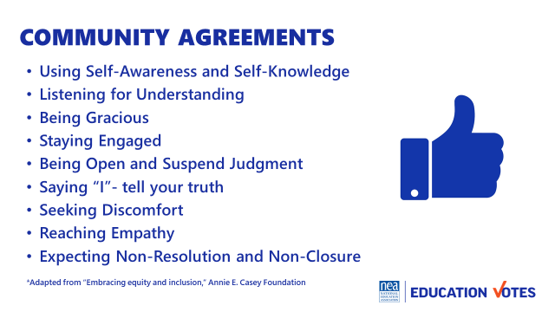  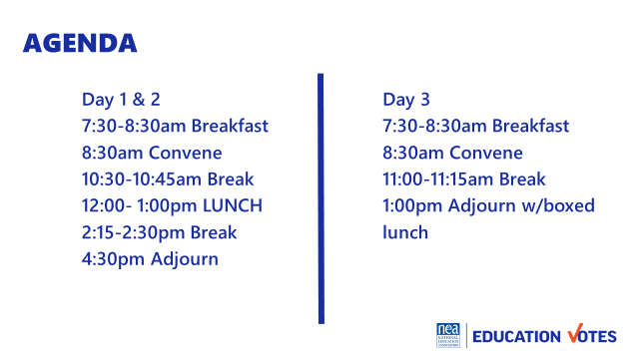  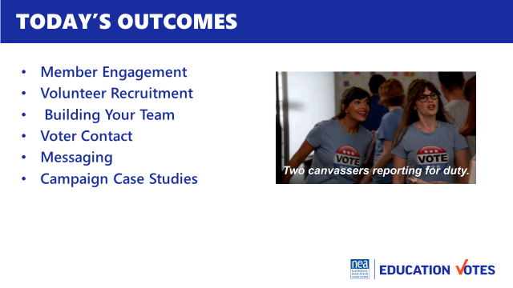 |  | Reentry  Feedback on Feedback  Agenda Review  Norm Review | How are we feeling and what are we covering today?  Participants will re-enter the learning environment.
9:00-9:30 Monet |  | 15 Minutes Phases of a Campaign
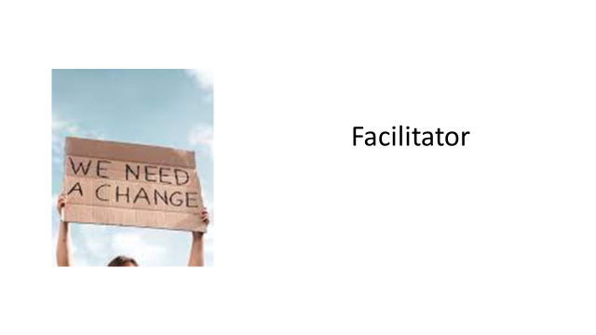  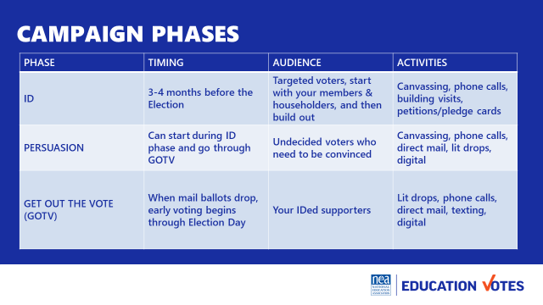  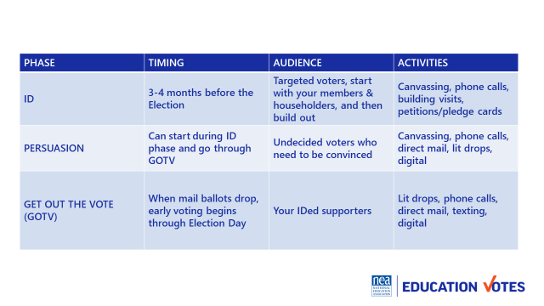  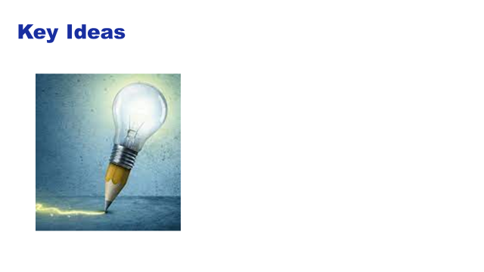 | Make chart of phases and include audience you are targeting and script elements | Could we make this a game – each table has a set of cards with the phases and they have to put them in order –then you debrief and go through the answers.  It would take about 10 minutes to play the game and do a little debrief  It would then take about 5 to 10 minutes to give content and key ideas  So this is like 20 minutes at least.  - ID – who are your supporters, getting to your vote goal  - Persuasion – talking to undecideds  - GOTV – get out the vote  - Important b/c depending on phase, we change who/how we are talking to folk  NEED KEY IDEAS  Meighan’s take w/game 9-9:30am | What are phases of an election?  Why does this matter?  Participants will understand phases and how this impacts who they are talking to and what they are saying.
9:30–9:45 Helenna |  | 20 Minutes Winning with Members
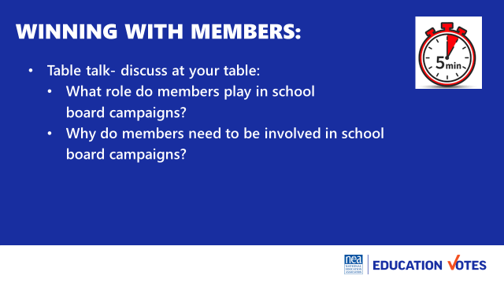  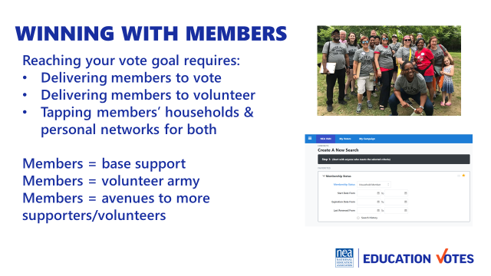  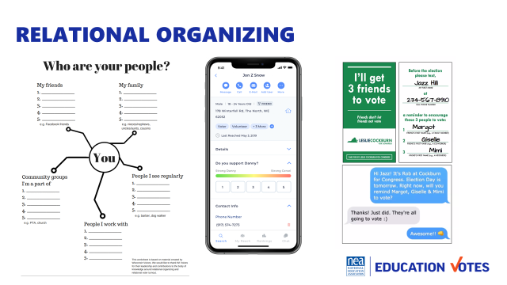  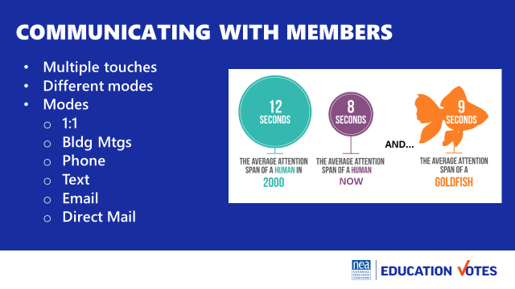  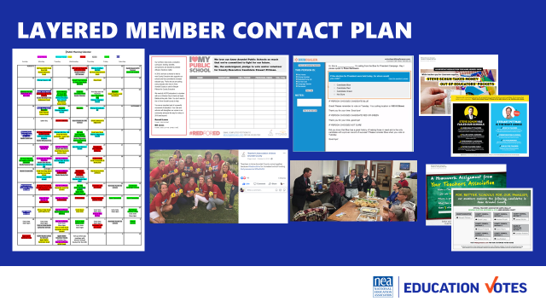 | Member comms effectiveness chart/NEA tools chart  Tough Objections Handout | Table Talk: 5 minutes:  Who needs to be “doing” the school board campaign?  WHY do members need to be involved in school board campaigns?  Purpose of the table talk is to get participants to understand:  Members need to do work around school board elections because they directly impact their work space. They are closest to the impacts of school board elections and are in a unique and trusted position to explain to community members why this is important and why others should care. Teachers are in a unique position where they can have a say in electing their boss. We have to remember that is an avenue of power  Engaging members 3 min  - As voters  - As volunteers  - Tapping into their Householders and personal networks  Relational Organizing 2min  - Most effective  - Old school worksheet, fancy apps, & vote tripling  Communicating w/members 5 min  - Multiple touches, ask how many times people need to be contacted to vote (used to be 7, now it’s closer to 13)  - Modes of contact  - Layering  NEED KEY POINTS 5min | How do we talk to members to get them to vote and volunteer?  Participants will understand they have to have organizing conversations to mobilize members, they will understand the types of contact, and importance of layered communications.
9:45 –10:15 Helenna |  | 30 Minutes Volunteer Recruitment
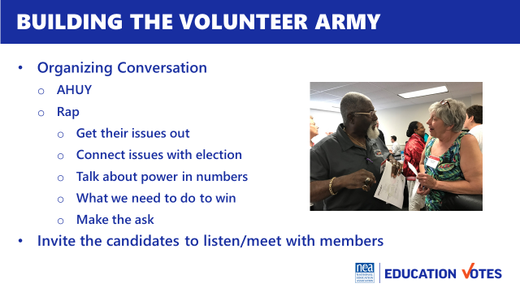  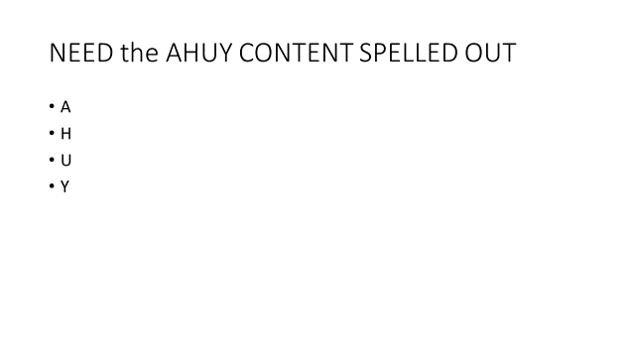  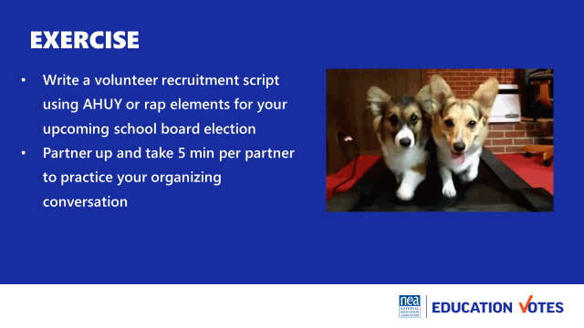 | Maybe use the Labor Notes organizing conversation handouts that follow AHUY | How do we actually talk to leaders about this work? Our role is not necessarily to do all the asking and relationship development, but to know how to support leaders and mobilizers in how to build these networks.  Let’s review how organizing conversations can work.  Content talk -  - First step is to build the volunteer army list  - Organizing conversations first, not mobilizing ask  - Use the Rap  Organizing Conversation  - AHUY  - Rap  - Get their issues out​  - Connect issues with election ​  - Talk about power in numbers​  - What we need to do to win​  - Make the ask​  - Invite the candidates to listen/meet with members  Exercise  Write a volunteer recruitment script using AHUY or rap elements for your upcoming school board election  - Partner up and take 5 min per partner to practice your organizing conversation  - 10 minutes to write your rap  - 5 min per partner to make ask (10 min)  - Debrief 5 minutes  NEED KEY IDEAS | What do I say to recruit a volunteer?  Participants will write a volunteer recruitment script.
10:15 – 10:45 Jackie |  | 30 Minutes Building your Team
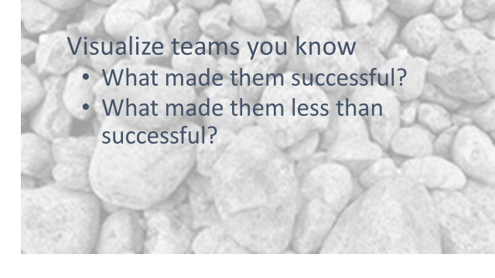  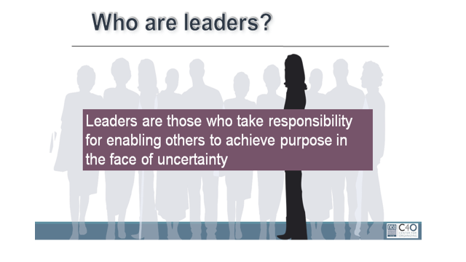  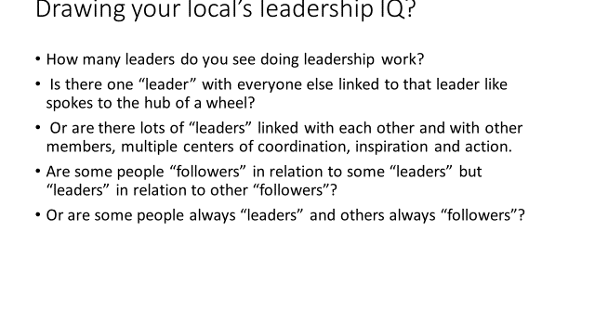  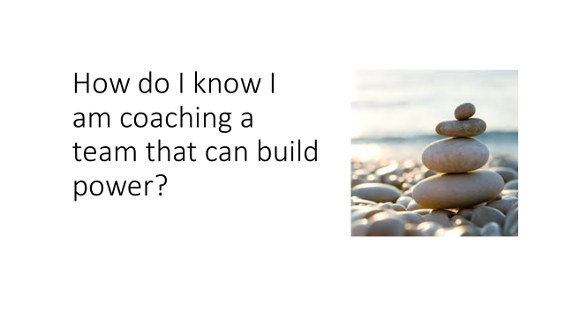  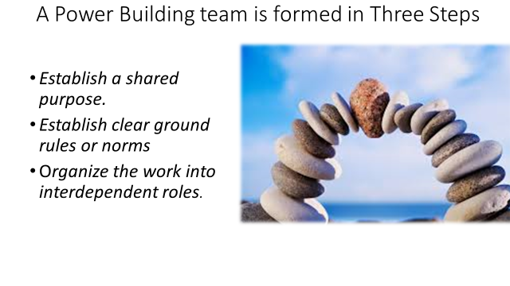  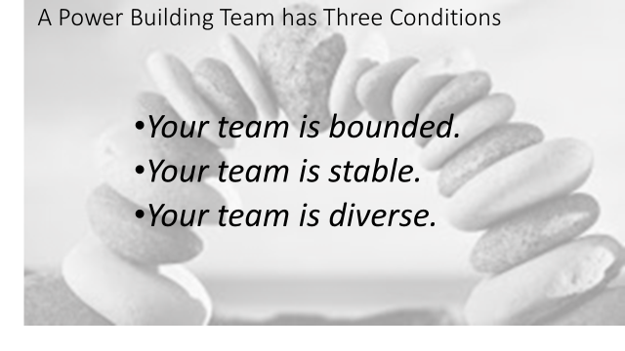  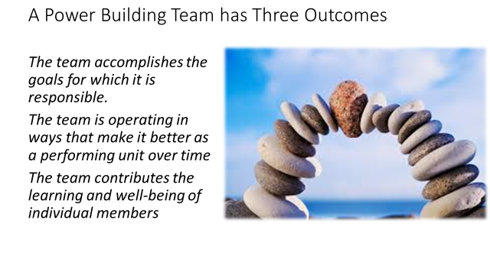  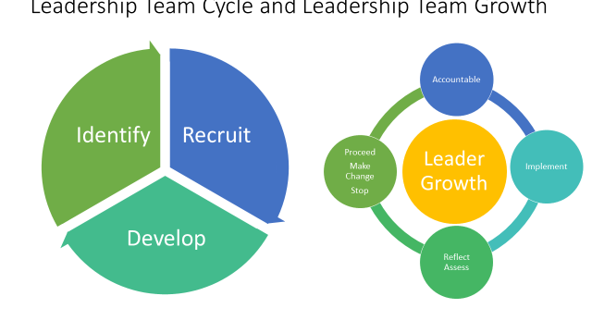  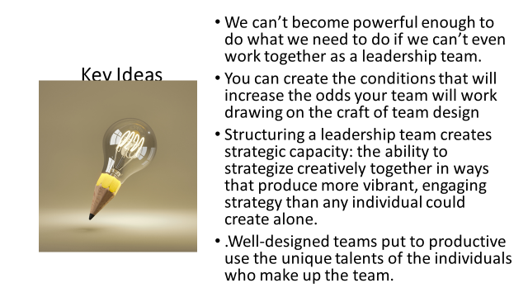 |  | Visualize teams you have been a part of, table talk 5  - What made them successful?  - What made them less than successful?  - Hold on to those core memories for a few minutes  Who are leaders? 15 Minutes Intro and Group Work 12 Minutes  - Leaders are those who enable others to achieve purpose in the face of uncertainty. WE are always coaching away from single leaders/authorities towards interconnected leadership/ teams.  - We are going to spend time at your tables drawing your local’s Leadership IQ for elections. Let’s count into groups of Four people to a team Each team gets on piece of chart paper divided into 4 quadrants. Each person draws what their local’s leadership IQ looks like using the following questions on the screen.  - How many leaders do you see doing leadership work?  - Is there one “leader” with everyone else linked to that leader like spokes to the hub of a wheel?  - Or are there lots of “leaders” linked with each other and with other members, multiple centers of coordination, inspiration and action.  - Are some people “followers” in relation to some “leaders” but “leaders” in relation to other “followers”?  - Or are some people always “leaders” and others always “followers”?  These teams don’t just magically happen. No difference than letters don’t just fall together for people to know how to read. The mechanics are there, but someone needs to teach the rules, and guide you to how to do it.  How do I know I am coaching a team that can build power?  What makes an effective team 6  - Establish a shared purpose. What are you fighting for and can you clearly articulate your common purpose as a team. It is clear, challenging, and matters. You have defined your goal, whom you work with, and the kinds of things you will do?  - Establish clear ground rules or norms. Your team sets explicit expectations of how you will work together: how you will make decisions, manage your time, and honor your commitments. What are things you will always do and what are the things you will never do. And how will you correct yourselves if you do them. Perhaps you most important norm is how you will make decisions. Steps that can guide effective decision making are: defining the problem, establishing criteria, brainstorming possibilities, synthesizing ideas, formulating options, evaluation options against the criteria, deciding. Some prefer deciding by vote; others, by consensus; others by delegating the decision to an individual.  - Organize the work into interdependent roles. Everyone should have responsibility for their own share of the leadership work needed to achieve the goal. Role requirements need to be clearly described. Team members need to assess their strengths and limitations, to the greatest extent possible, matching individual capabilities with role requirements. Because roles are designed to be interdependent, everyone has a stake in everyone else’s success. Team members speak up when they need help and get it. No one works in a silo that’s secretive to others. The team with diverse identities, experiences and resources brings more to the table than a team that is very homogeneous  Three Conditions  - Your team is bounded. It is clear who is on the team and who is not on the team. It is clear how new people can join the team and what is expected of those who must leave the team.  - Your team is stable. People commit to clear terms of service: regular meetings, length of time, etc. Your team is not a revolving door, never knowing who will show up.  - Your team is diverse. Your team has the appropriate diversity of skills, talents, viewpoints, and constituencies that will be needed to do a good job.  Three outcomes  - The team accomplishes the goals for which it is responsible.  - The team is operating in ways that make it better as a performing unit over time  - The team contributes the learning and well-being of individual members  Leadership Team and Leadership Growth Cycle  - As an organizer your job is to recognize and then help the team recognize that in order to build power, there is a continual identify, recruit, and develop cycle of new folks into the team.  - A team that does not continual recognize that one of their jobs is to continue to make space for new leaders, perspectives, diversity, and talents is a team that is not intent on base building and power development.  - Further a team grows in capacity to strategically achieve outcomes using everyone’s unique talents by attending to a continual cycle of implementation, reflection/assessment, proceed-change-stop, and accountability for the outcomes. We do a disservice to teams, the constituencies they are from, and the local as a whole when we don’t identify non-growing, non-power building teams. An even great disservice is done when we jump in to do it ourselves.  2 Minutes of Key Ideas –  - We can’t become powerful enough to do what we need to do if we can’t even work together as a leadership team.  - You can create the conditions that will increase the odds your team will work drawing on the craft of team design  - Structuring a leadership team creates strategic capacity: the ability to strategize creatively together in ways that produce more vibrant, engaging strategy than any individual could create alone.  - Well-designed teams put to productive use the unique talents of the individuals who make up the team. | How do we build effective GR committee/ election teams?  Participants will understand how to coach and develop the leadership needed for an effective GR team to lead a campaign.
10:45 – 11:00 BREAK
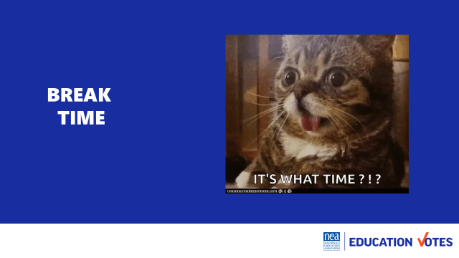
11:00 – 11:30 |  | 30 Minutes Team Communications Exercise
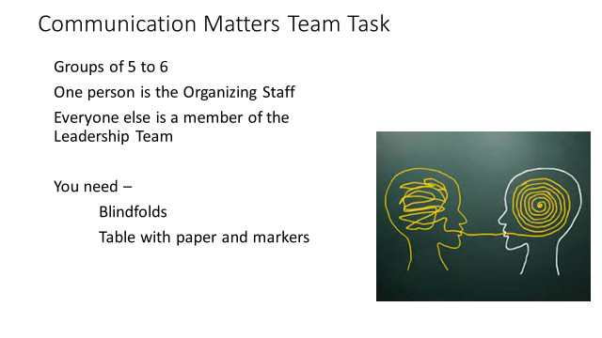  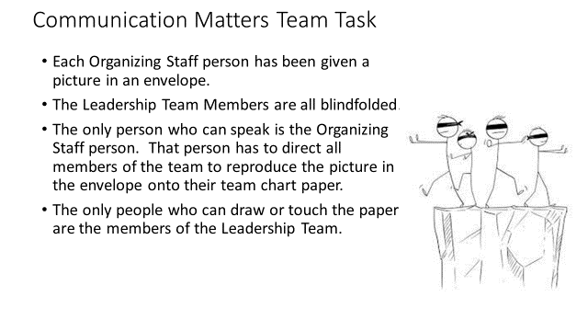  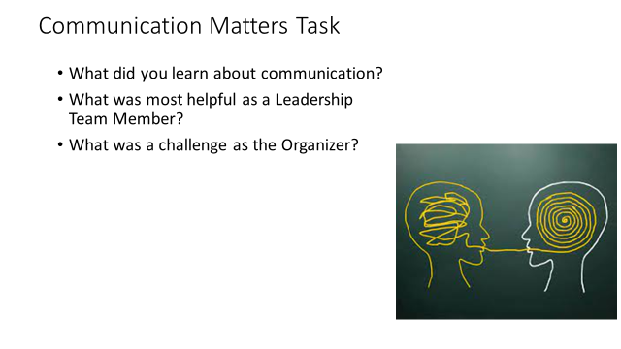  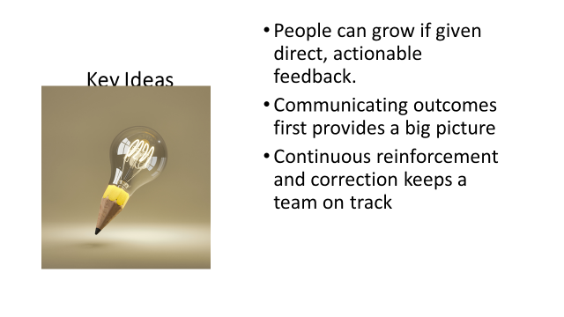 |  | Team Communications Exercise  Intro and divide into teams 3  - We are going to be working in teams of 5 to 6. Go ahead and get settled in with your team.  - Now that you are settled, pick one person to be the Organizing Staff Person. The rest of you will be members of a leadership team.  - We are going to co-create a product in teams. On your tables are blindfolds paper and markers.  - If you are a Leadership team member you need to put your blindfold on so that you can’t see – no peeking out the side, and if you can see through it—close your eyes.  - Organizing Staff person- you have an envelope in your hand that contains a drawing. When we begin you are the only person allowed to talk to your team. They can not ask you questions, they can not talk to each other or to you or out loud at all. When we begin you will be able to open your envelope and your task is to direct every member of your team to draw as closely as possible the picture in your envelope. You cannot touch them in any way, only use your voice to direct. The only people allowed to touch markers or paper or to draw on the paper are the leadership team. You will have 10 minutes to make your masterpieces.  Group activity 10  Sharing of Pictures and Reflection on Learning as teams 5  - Take off your blindfolds. Take 5 minutes to discuss as a team the following questions:  - What did you learn about communication?  - What was most helpful as a Leadership Team Member?  - What was a challenge as the Organizer?  Group report-out 5  Key Ideas 2  - People can grow if given direct, actionable feedback  - Communicating outcomes first provides a big picture  - Continuous reinforcement and correction keeps a team on track
11:30 – 12:00 |  | 30 Minutes Organizing successful member engagement events
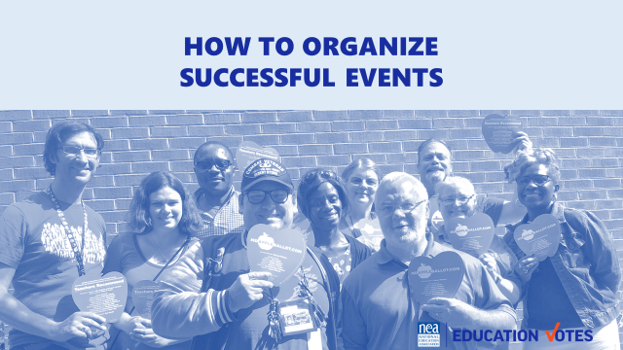  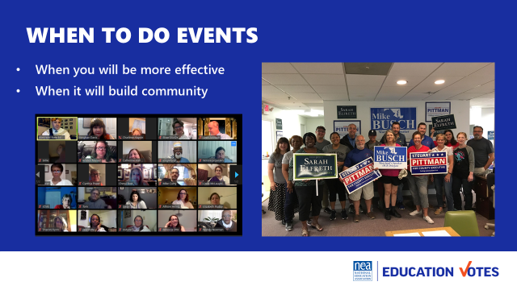  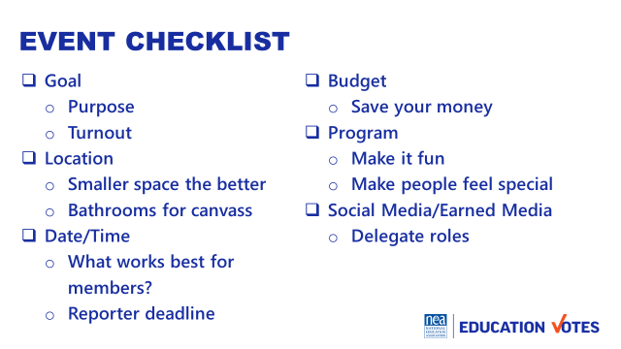  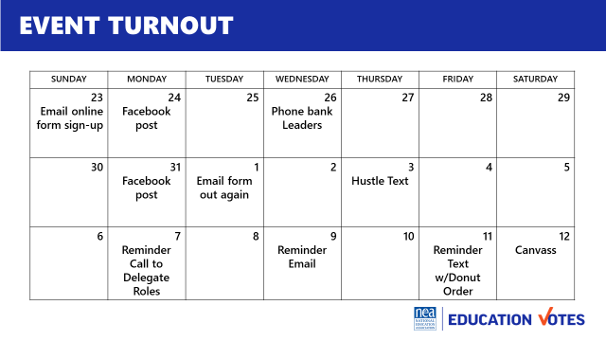 |  | - Why do events  - Opening pic is event of early vote field trip that I wish I hadn’t organized (end of school year, no one wanted to come, we lost money on happy hour & those folks could have been door knocking)  - Think of the worst event you went to, why was it bad  - We should do them  - More effective (you make more calls/knock more doors when it’s group effort)  - Build community & you need it  - Checklist considerations  - Goal  - Location/Room  - Date/Time  - Budget  - Program  - Turnout math/plan  - Need to do turnout for everything, including your canvasses & phone banks  - Calculating flake rate  - Donut or t-shirt size trick  - Delegate roles so your flake rate goes down  Need Key Ideas  ARE THEY GOING TO BUILD A TURNOUT PLAN HERE ? | How do I turn members out? What are best practices for events with members and candidates?  Participants will understand turnout math and how to have successful events with members and candidates.
12:00 to 1:00 LUNCH
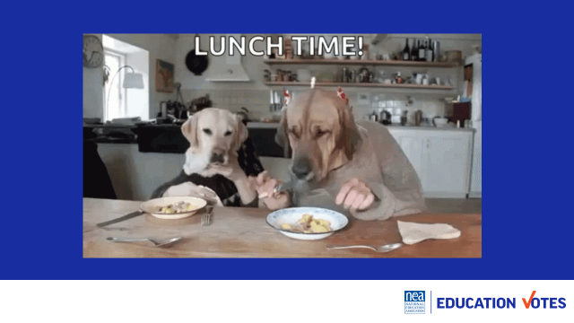
 |  | Maybe the section on Strategy and Tactics goes here as what follows are examples of those – and what I mean is just a little definition – The strategy is the overarching message and method – and tactics are the escalation of actions .
1:00 – 1:40 |  | 40 Minutes Voter Contact 101
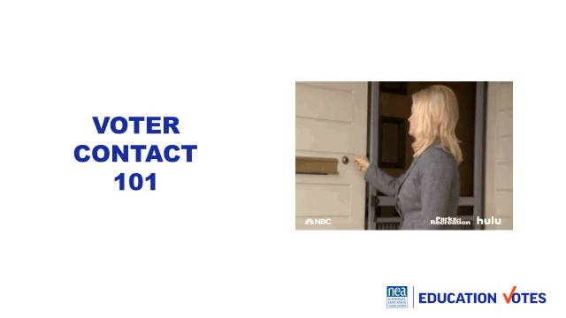  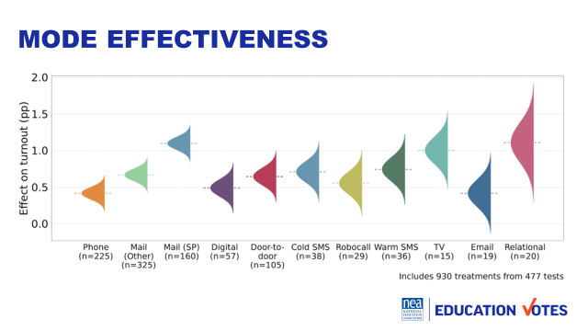  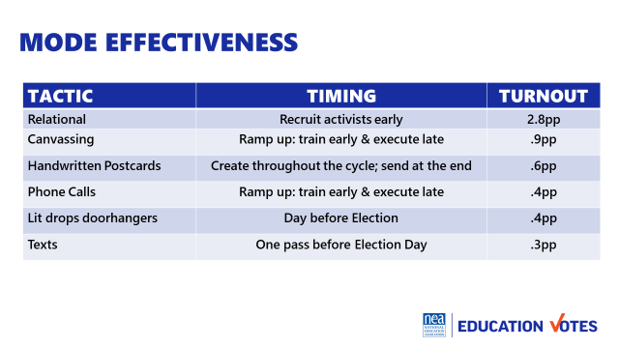 |  | 20 Minutes Voter Contact  - Poll on what folks they think is most effective  - What it is/isn’t 5  - Effectiveness by mode 5 (added some charts from AI)  - Types of Scripts/Assessment Scales 10  - Model ID/Persuasion Script  20 Minutes Exercise  Trainers are voters and they have to go around the room to door knock and guess assessments  SO we will need descriptions written for each of the voters so that the trainers - or the participants can role play  Ex. Ellen is a middle class single mother that prides herself on her own resourcefulness. She is not interested in politics that give freebies to those that have not earned it. She does value neighborhood schools and wants them to be accountable to the tax payers for strong education that prepares kids for college and careers. She typically only votes in presidential election cycle years - big elections and typically votes her party line. She has voted for Republican candidates in the past three elections.  Need Key Ideas | What is effective voter contact? What is an assessment? How do I door knock a voter?  Participants will understand direct voter contact, what methods are effective, and how to canvass a voter.
1:40 – 2:15 |  | 35 Minutes Voter Contact Tactics
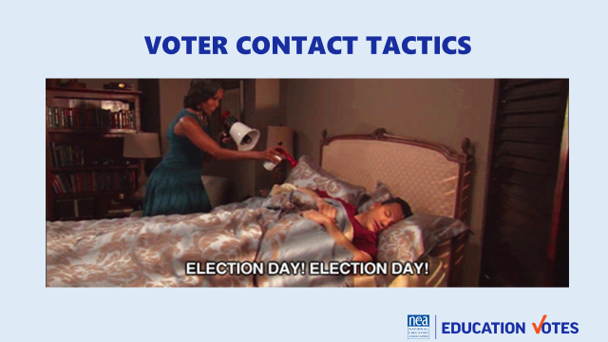  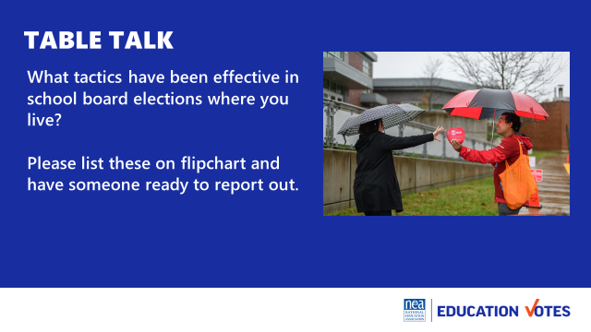  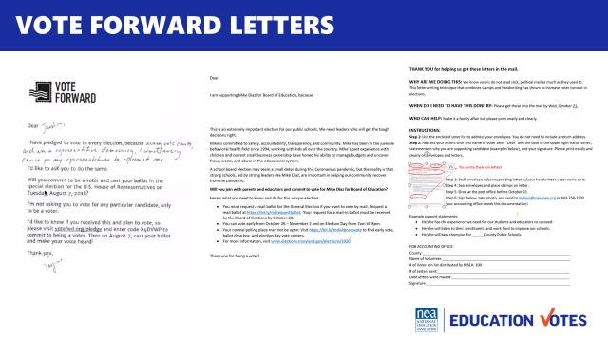  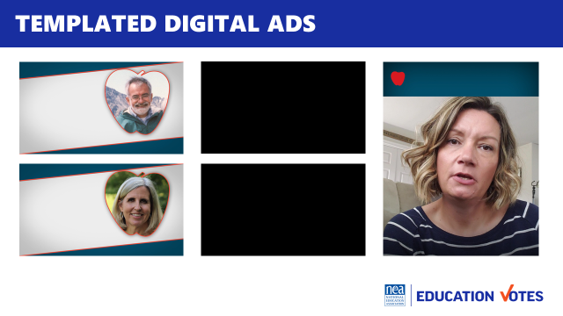  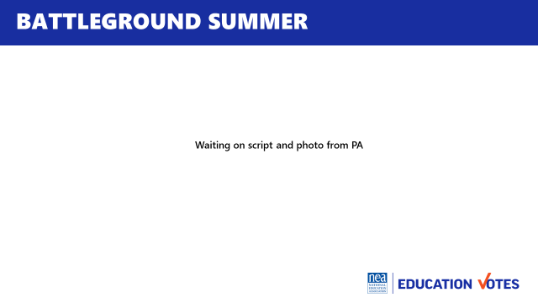    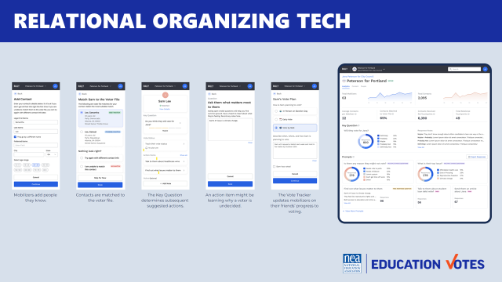 |  | Voter Contact Tactics  - Unfortunately, we can’t sneak in voters’ bedrooms at night with an airhorn, but we’re going to delve into some different tactics that locals have been using and some tactics that have been testing well in different elections around the country.  - We’re going to take 10 minutes to hear from you about what you’ve been seeing and what’s effective back home in your school board races. Please add these to flipchart and pick someone to report out  - [Report out 5 minutes]  - Connecting with voters face to face will always be the best contact and if it’s someone they have a relationship with, we know it’s the absolute best. We’re going to run through some different creative tactics different locals and other organizations have been using to get you inspired  - Show examples of creative tactics 20  - Vote Forward letters – This is the new spin on direct mail. It started in 2019-2020 as the big pandemic activity but continues to test well because voters are more likely to open an envelope and read it than a slick piece of direct mail. Here’s how it works - volunteers use a form letter and add a handwritten reason why voting. Some campaigns write the name on the front, I’ve also seen others do labels. In Maryland, we tried this in 2020 with school board elections. We made it expressed advocacy and talked about the candidate. We had packets of 50 for members and in a 300 person local, 30 members volunteered to write letters. Over 80% of the voters we mailed these letters to voted in 2020 and their candidate won by huge margins. In other states, this tactic with a generic turnout message (which you don’t have to use PAC for) can increase voter turnout up to 3 percentage points which can mean the difference of winning or losing your election.  - Templated digital ads – Most vendors will not take on small school board races, that’s why we started creating templated ads. You save on the cost of making the ad so you can spend more money on the actual buy. For the buy, you take the voter file and have the vendor match it so the only folks seeing these ads are the actual voters who live in these districts. The vendor handles all of the approvals and submission and we had to find the people to star in these ads. We specifically used people folks knew as the quasi celebrity in these small towns. It stopped a lot of the trolling that can happen on digital ads like this. One thing to keep in mind is to try to make sure you have good photos of your candidates and a list of member leaders that you know are good communicators. There’s a lot of low cost ways to make it look more grassroots by having folks film on their phone or even record on zoom. This would be a great thing to talk to your GR Department about if there’s lots of school board races going on around the state. [show ads]  - Battleground Summer – How many folks do union summer in their state? What is that? We’ve been doing the electoral version of that for a couple years in battleground states. Instead of knocking on members’ doors, paid member organizers knock on voters’ doors. They aren’t talking about the election or voting though because we don’t have that kind of PAC money, they are educating folks on the candidate’s record and identifying what issues folks care about. It’s such a good activity to do before an Election and really starts to build your canvassing muscle and base of support. Think of what an amazing list you build that you could go back to when you are in the middle of your budget fight or strike. You could do the same thing for your school board races.  - Spank you mail/digital - Just like going door-to-door educating voters on the positive stuff, you can also do it on the negative side. This is a piece of issue mail and corresponding digital ad done on a Maryland County Executive. We timed it with back to school and used the voter file to target likely parents and for the cherry on top, we targeted on zip codes with the most overcrowded classrooms and bus issues. The County officials set the budget for the school board so this race was just as important as the school board election. This guy was a jerk who you could a get a rise out of him so easy. He should have won his election by the amount of money he spent, but money can’t buy you manners. Communications like these just activated him more to polarize voters against him.  - Relational apps – Relational organizing is what we’ve been doing forever, but what is exciting for elections is there are all these new tech toys now to start tracking it better and make it part of your plan to reach your vote goal. There’s 8 million new apps or websites that you can use for your volunteers to either match on their phone or in this case add the person as someone they are reaching out to. It matches with the voter file so you can check registration, it gives a field to make an ID or track an issue, and tag how they plan to vote. The best part is these dashboards so you can track your volunteers’ activity.  - We don’t have a lot of time, but did these examples jog anyone’s memory of something cool they’ve seen that we should check out?  KEY IDEAS | What creative voter contacts are state affiliates utilizing with public and members?  Participants will discuss what they are doing in their states and see examples from other affiliates.
2:15 – 2:30 BREAK
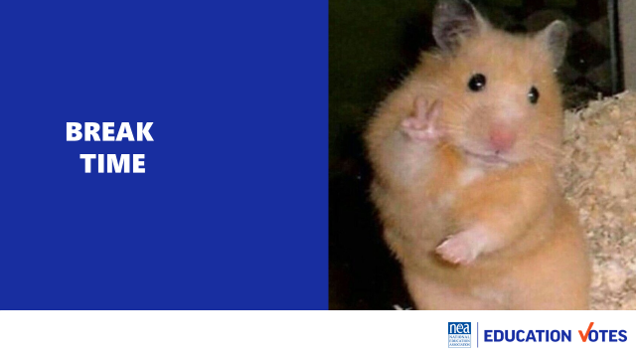
2:30 – 2:50 |  | 20 Minutes Messaging Your Campaign
 | Message Guidance on right wing attacks | Messaging  - What makes a good message  - Difference between Internal/External messages  - Message Triangle/Box  - Tips including NEA Polling on attacks (responding and messaging to use) | What makes a good message?  Participants will understand what makes a good message, the importance of message discipline, and see the latest research on responding to right wing attacks.
2:50 –3:20 |  | 30 Minutes The Message Triangle Tool
 | Message Triangle | Message Triangle Exercise  - Develop individual campaign message for voters and members (split the room)  - Feedback from your group  - Vote on one to share with group  - Update their campaign plans with their messages | What is my local’s campaign message to voters? To members  Participants will write an internal/external message triangle for a local school board election.
3:20 – 3:45 |  | 25 Minutes Case Study Practice
 |  | Case Studies  - Urban/Well Resourced Campaign  - Rural/Low Budget Campaign | What are some best practices for well resourced and low budget campaigns?  Participants will see examples from affiliates of a well-funded school board election and low budget campaign.
3:45 – 4:15 |  | 30 Minutes Campaign Plan – Strategy and Tactics
 |  | Campaign Plan  - Strategy & Tactics section | What should my voter/member contact plan be?
4:15 – 4:30 |  | 15 Minutes Ending it Right
 |  | - Questions, Connections, Reflections  - Housekeeping announcements  - Plus/Delta at the Door | What questions do I have? What do I need to know?  Participants will get opportunity for feedback and leave session with what they need to know for tomorrow.
4:30-5:00 Choice Networking
5:00 ADJOURN

