Facilitator Agenda: Winning School Board Campaigns Day # 1
General Materials Needed: |  |  | Room Set-up:
1 Set of Handouts per Person  Name Tags or Name Tents  Room signs, sign in signs  Highlighters – 3 colors  Pens and Pencils | Chart Paper – self stick kind  Markers- Mr. Sketch - Non Permanent  Post its  Wifi |  | Round Tables for Participants – cords at each table  Long rectangle at back for Facilitators  No Podium – table with projector large enough for laptop  Projector, Screen, Microphones, and Speakers  Carousel stations and reporting stations around the perimeter  50 people Max

Pre-Training Needs
- Survey on capacity, staffing, PAC, VAN, unconference ideas
- Info for object icebreaker
- Info on how to find election data they need for vote goal calculation
- Articles to read (different groups read different articles)
- Bring membership, PAC, volunteer data numbers they can get
- Information about their school board
- List of community organizations
- Worksheet with these leading questions

Key Outcomes for Day 1
- Build sense of community
- Understand the importance of school board elections and the current threats we’re facing
- Map their school board, local, & community
- Calculate vote goal and understand components of campaign plan
- Identify strategies for successful candidate & coalition recruitment
Recognize the need and fundamentals for PAC Fundraising

Content and Facilitator Assignment Overview Day 1
8:30- 9:00 Welcome  9:00 -9:20 Introductions  9:30-10:30 Importance of School Board Elections  10:30-10:45 BREAK  10:45-12:00 Campaign Plan Overview  12:00-1:00 LUNCH |  | Ellen and Meighan  Ellen and Meighan  Juli  Hedy | 1:00- 1:45 Coalition Building  1:45-2:15 Recruiting and Recommending Candidates  2:25-2:30 BREAK  2:30- 3:10 Recruiting and Recommending Candidates  3:120-4:20 PAC recruitment  4:20-4:30 Ending It Right  4:30-5:00 Choice Networking | Melissa  Sara  Sara  Meighan  Ellen

Time, Facilitator, and Slides |  | Resources | Instructions, Activity and Debrief (Facilitators) | Essential Questions and Key Outcomes
What is the clock time for start and end? Who is doing this Section? What are the PPT slides (pic of slides)? |  | Charts, handouts, materials, videos | What are you saying, what are they doing, what questions will you use to guide learning and make clear the important points  Include an estimate for how long each section of the learning will take  Include Key points. | What question(s) does this section answer?  What will participants know or be able to do?
8:30 – 9:00 Ellen |  |  | 30 Minutes Welcome
Slides  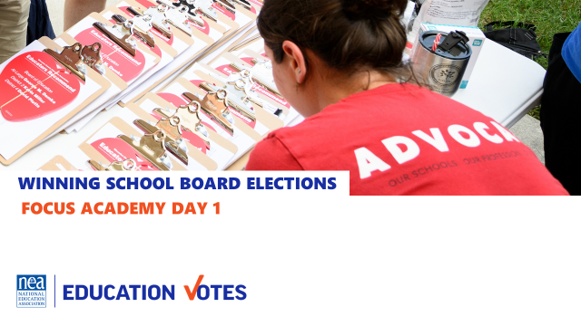  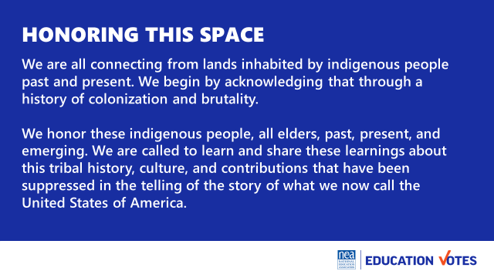  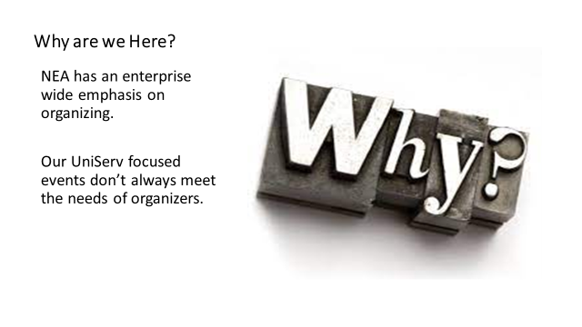  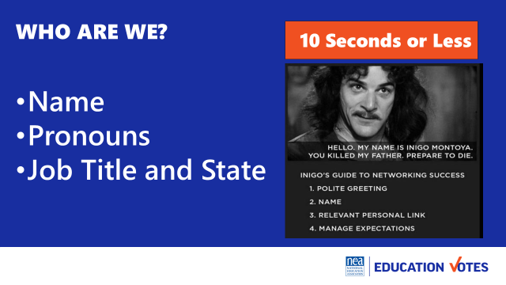  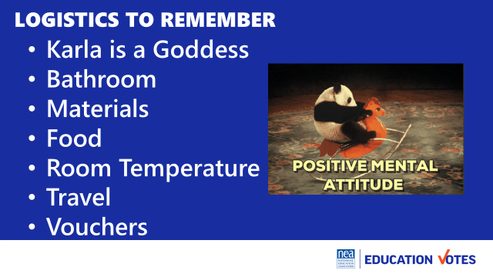  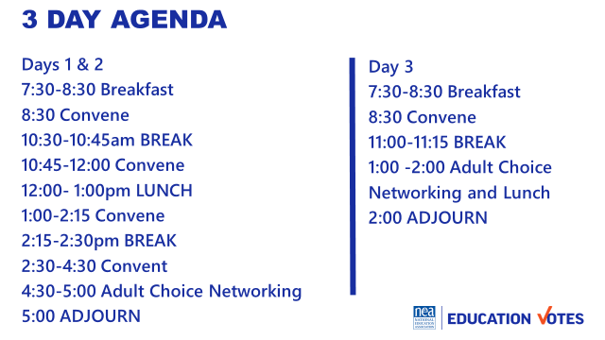  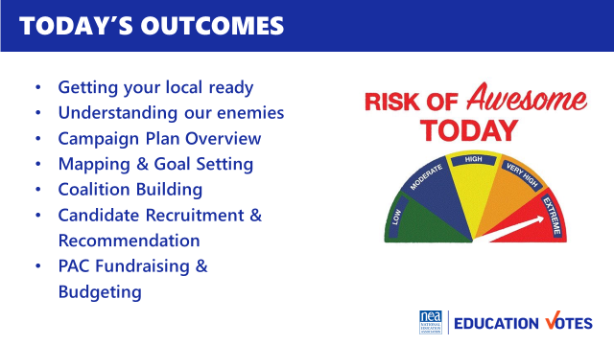  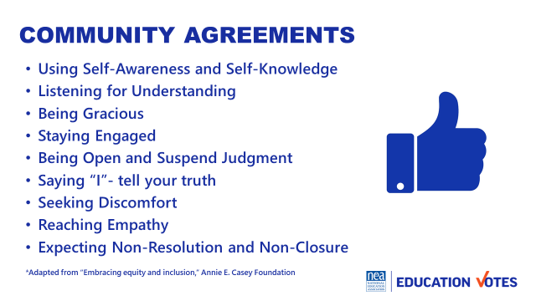 |  | Community agreements on name tents  Agenda on Slides  One Pager on Reimbursements  Community Agreements in Participant Handouts | Welcomes  Land Acknowledgement  We begin by acknowledging that through a history of colonization and brutality, we are currently on the traditional lands stewarded by generations of the Wahpekute and Sioux people.  We honor these indigenous people, all elders, past, present, and emerging. We are called to learn and share these learnings about this tribal history, culture, and contributions that have been suppressed in the telling of the story of what we now call the United States of America.  Why are we here?  NEA has and enterprise wide emphasis on organizing and our UniServ focused events did not always meet the needs of organizers. Additionally we are working to create more connections across our centers – silos. Campaigns and Elections operated independently and parallel to our UniServ and Organizer programs. Both doing great work – but duplicating some content and missing many opportunities. One of the biggest misses was in supporting affiliate staff that may not hold the title of Government Relations or Campaign Goddess but who do work most closely with members who work for school boards. Engagement in the most local of politics is the best way to create authentic wins that are secured by and felt by local workers and their communities. They are visible and tangible and can boost union engagement. We are going to learn how to accomplish this.  Introduction of Participants and Facilitators –  We are going to do a very fast whip around the room 10 seconds or less per person so we can get every voice heard and every face seen as soon as possible. Let’s start with the facilitator team -Remind Folks to Keep it Short - Name, Required Pronoun, State and Title  Logistics to Remember  - Questions  - Bathroom​  - Materials​  - Food​  - Room Temperature​  - Karla is a Goddess  - Travel​  - Vouchers  Let’s take a look at the basic two and half day agenda. We will not have working lunches or breaks – those are your times to do as you wish including reconnecting with members or the home office. We ask that you put on your out of office notifications and respect them for yourselves as learners. You will notice that at the end of each day is something called adult choice networking. The value of coming together around this learning is really amplified when you have unstructured time with the folks who have come from all over around this topic. All that we ask is that you network any place but in this room. This time is part of the official agenda so that you may report that you have worked a full day while at this experience.  Here are today’s outcomes – please remember this is a pilot so shift will happen.  Group Review (p.2-3)  Begin with a proposed list of community agreements, each table needs to describe what they think each agreement means and propose any additional norms not covered by the proposed agreements:  - Using Self-Awareness and Self-Knowledge  - Listening for Understanding  - Being Gracious  - Staying Engaged  - Being Open and Suspend Judgment  - Saying “I”- tell your truth  - Seeking Discomfort  - Reaching Empathy  - Expecting Non-Resolution and Non-Closure  Refer them to the Community Agreements in their handouts and that they received as part of their Pre-Attendance documents.  Prompt table groups to review the agreements.  - Give them XXX minutes to scan the agreements looking for items that they don’t understand.  - They should also be tracking what they think is missing.  Debrief  Share what you mean by the agreements.  Check to see if tables are on track or need clarity for EACH of the agreements.  Before moving on - ask the group to show thumbs:  - Thumbs up is I totally agree  - Thumbs sideways is I can live with it and I am fine to move on  - Thumbs down – I simply cannot move on AND I have questions or something different to propose.  - A thumbs down comes with the responsibility of working until your thumb can at least be sideways.  (What follows are facilitator notes to help you debrief the ways of thinking that shaped each of the proposed agreements 1-4)  - Learning is a two-way experience - you need to communicate well with the facilitators and your group mates to ensure your own learning and that of the group. You are invited to share in the development and maintenance of a productive adult learning space.  - Speak up and make room for others to do the same. Sometimes that means stepping back. Expect to be called on even if your hand is not up – it is a way for facilitators to ensure a balance of voices in the room – we expect that you might pass as well.  - Be free to discuss ideas that you heard, but not identify the person or people involved. | How is this work structured?  Participants will understand how the days will be structured.
9:00- 9:20 Meighan |  |  | 20 Minutes Introductions
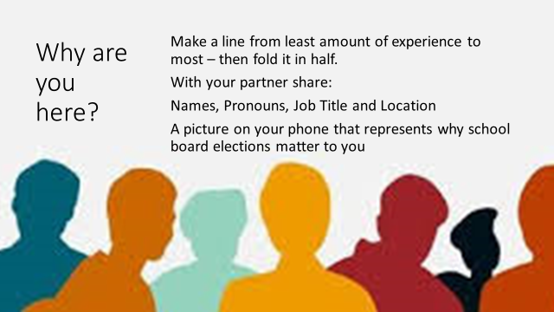   |  | Participants will need a picture on their phone about why school board elections matter to them. | 5 Minutes set up – We are going to do a fold the line activity – so everyone will be up and moving. The first part of this activity is for you to have a number in your mind – How many years have you done this work? However you count those years – have a number. Now – those with the smallest number will begin over here with 0, a few months, 1 year, 5 year etc… in a line all the way to those with the biggest number – 100 years of union work – in a line. (Facilitators will help get folks on an arc single file from least to greatest) Now for the second part – You need to locate that picture on your phone that you were told to have ready that represents WHY school board elections are important to you. Ready?  Now, we are going to fold this line from the ends towards the middle – so the two on the end are a pair, then the next are a pair, then the next, - (facilitators can help with the pairing) once you have found your partner –  6 Minutes in Share Pairs  Each have 3 minutes – self time and Share  Names, Pronouns, Job Title and Location  A picture on your phone that represents why school board elections matter to you  10 Minutes – Debrief | Who is in the room?  Participants will begin to build a learning community
9:20 – 10:15 Juli |  |  | 55 Minutes The Importance of School Board Elections
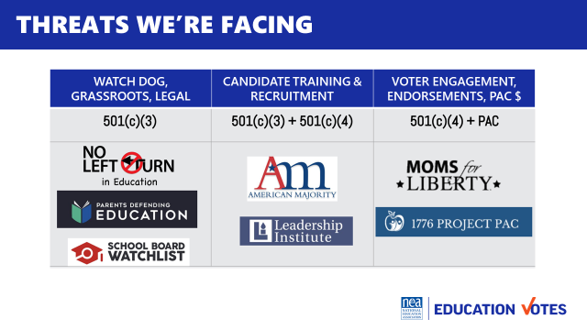  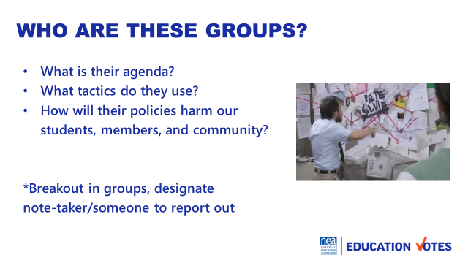   |  | Article(s)  Handout with questions | Group Discussion  20 Minutes of reading news articles (article alike discussion)  20 Minutes of group discussion (mixed group discussion)  15 Minutes of report out on their organizations  (See folder for potential articles)  Questions to Answer:  - What is their agenda?  - What tactics do they use?  - How will their policies harm our students, members, and community?  - What was the reason the organization had an interest in schools?  - How did they communicate their priorities? (What was their narrative)  - What was the result of their involvement in schools outlined?  Group Discussion  - What do each of the organizations have in common? | Why do we need to be working on school board elections? Participants will understand the threats our school boards are facing and why elections matter.
10:15 – 10:30 BREAK
10:30 – 12:00 Hedy |  |  | 60 Minutes - Campaign Plan Components
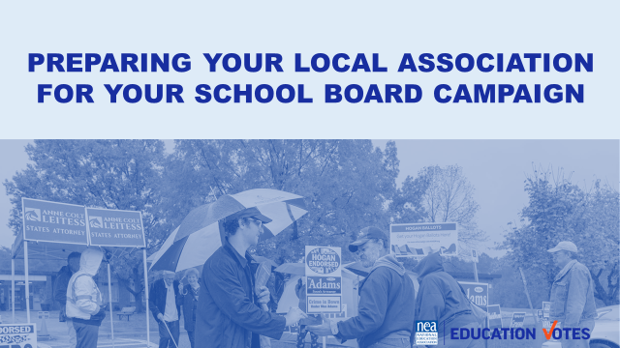  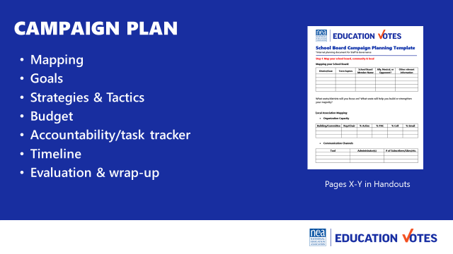  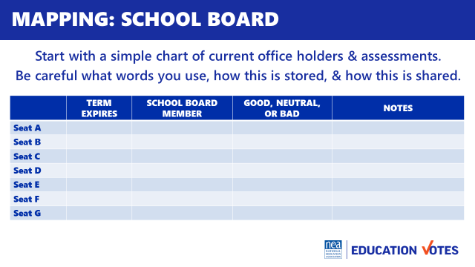  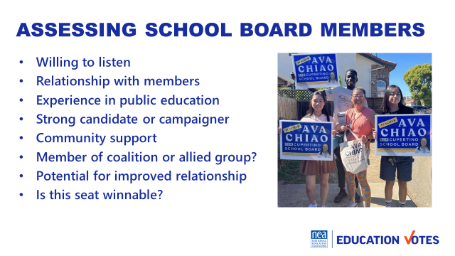  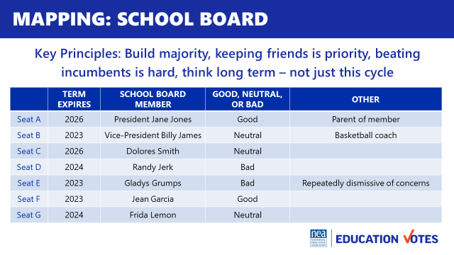  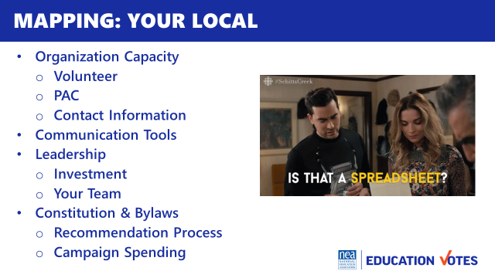  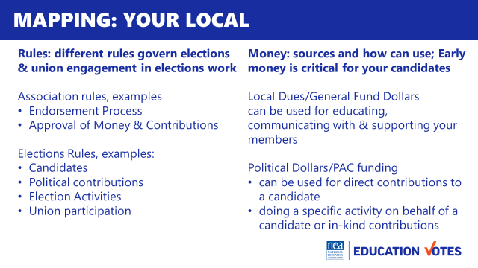  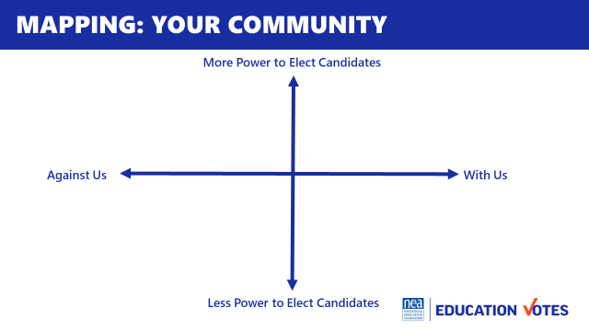  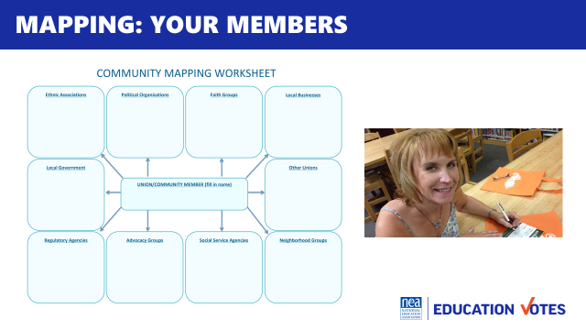  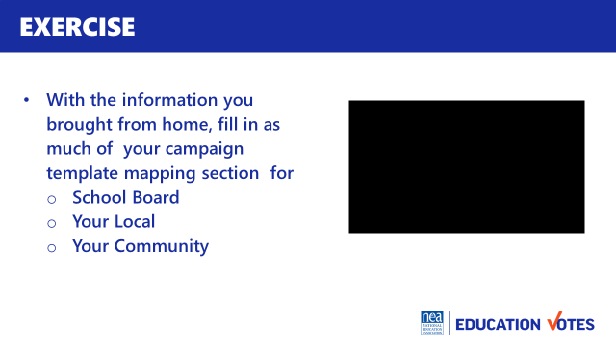  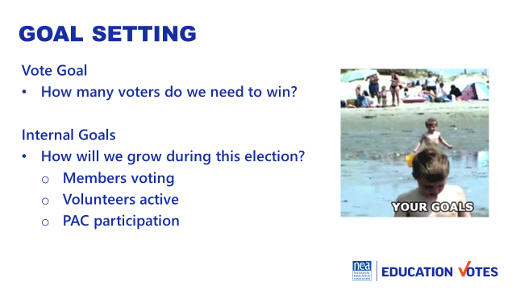  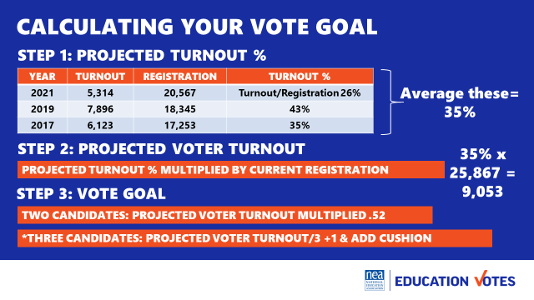  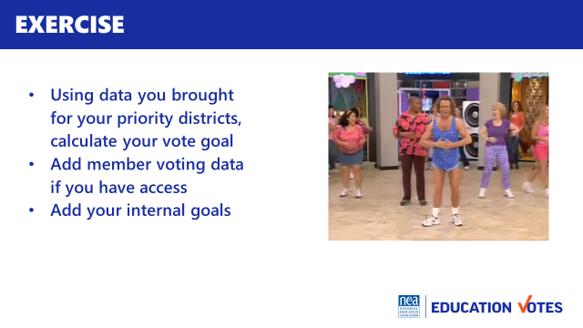   |  | Campaign Plan Template that’s filled out and blank one  Map your Community template  Wall Chart to house vote goals  NEED LOTS OF PRIOR SUPPORT SO THAT THEY BRING STUFF WITH THEM | - Overview (5 minutes)  - Mapping  - Goals  - Strategies & Tactics  - Budget/Fundraising  - Accountability/Task tracker  - Timeline  - Mapping  - Mapping your School Board (10 minutes)  - Chart  - Considerations on Assessment of School Board Members  - Key Lessons when deciding electoral priorities  - Protect friends  - Incumbents are hard to beat  - Mapping Local (5 minutes)  - Organizing Capacity  - Communications Tools  - Leadership engagement  - Constitutions & Bylaws around electoral work  - Legal requirements from affiliate  - Mapping Community (5 minutes)  - Organizations that care about education/work on elections  - Plot them on XY axis  - Prioritize potential coalition partners  - Don’t forget to research member involvement  15 Minutes Exercise  Fill in mapping on campaign plan  - Goals (10 minutes)  - Where to find data?  - What is a Vote Goal?  - What are good internal goals?  - How to calculate vote goal  15 Minutes Exercise  Fill in goals step on campaign plan | What goes into a campaign plan?  How do I map my election, local, & community?  What goals should I be setting?  How do I calculate a vote goal?  Participants will learn components of a campaign plan, how to map their school board and calculate vote goal.
11:30 -12:00 |  |  | 30 Minutes
12:00– 1:00 LUNCH
1:00 – 1:45 Melissa |  |  | 30 Minutes Coalition Building
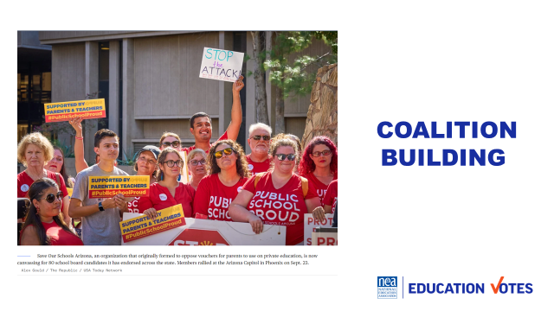  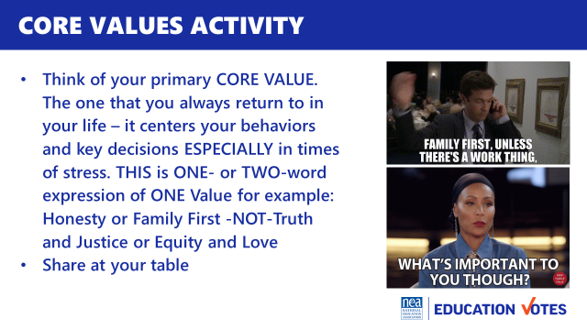  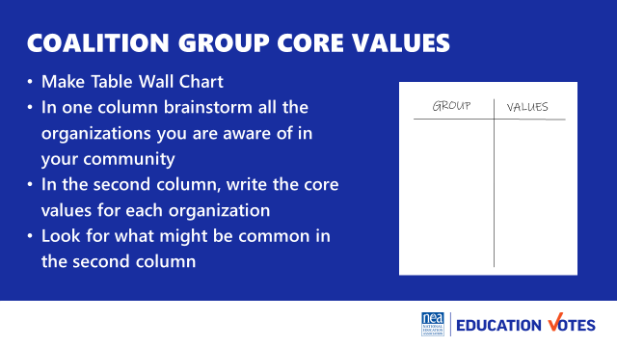  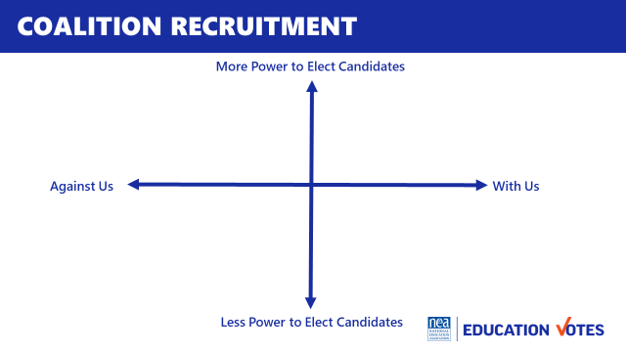  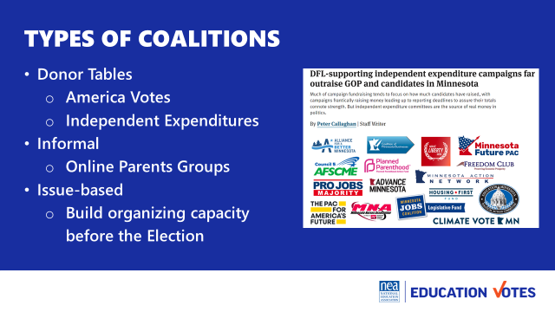  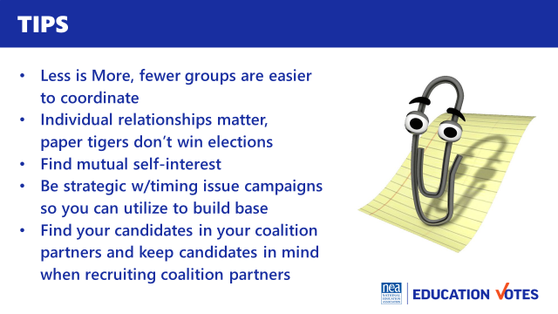 |  | Use the Core Values Handout from Foundations  Reading on Coalitions that Ellen has from Tom | Why join coalitions? 25  - Core Values at their tables  - Core Value Wall Chart Activity  - Report out  - What were most common shared values?  - What group do you hope to recruit and why?  - Besides shared values what are other reasons to join with others?  Who should we join in coalition with? 5  - Reference XY axis mapping template  Types of Coalitions with campaign example 5  - Donor Tables  - Informal  - Issue coalitions to build capacity before elections  Tips 10  - Less is More, fewer groups are easier to coordinate  - Individual relationships matter, paper tigers don’t win elections  - Find mutual self-interest  - Be strategic w/timing issue campaigns so you can utilize to build base  - Find your candidates in your coalition partners and keep candidates in mind when recruiting coalition partners | How can coalitions be helpful to our election?  What kind of coalitions exist?  What should I keep in mind as I work with coalition partners?  Participants will understand the importance of formalizing relationships into coalitions, the types of coalitions to build for elections, and helpful tips as they navigate these relationships.
1:45 – 2:15 Sara |  |  | Recruiting and Recommending Candidates 30 MInutes
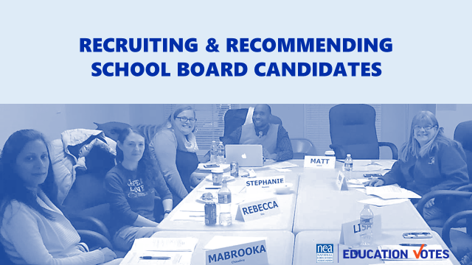  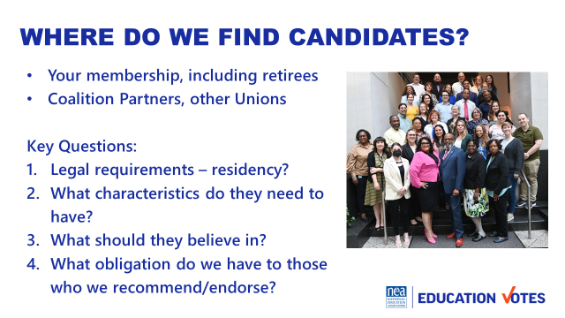  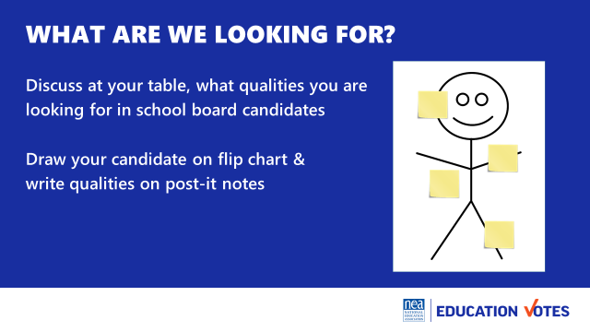  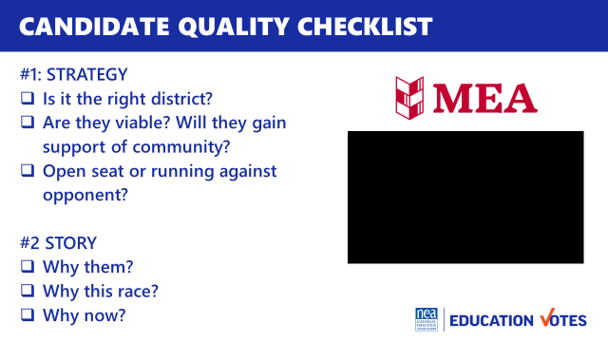  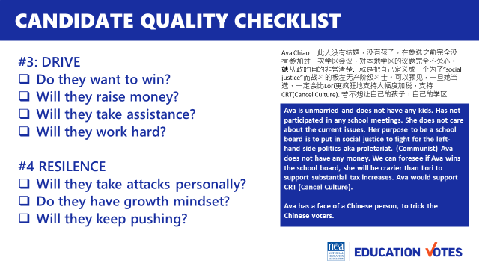  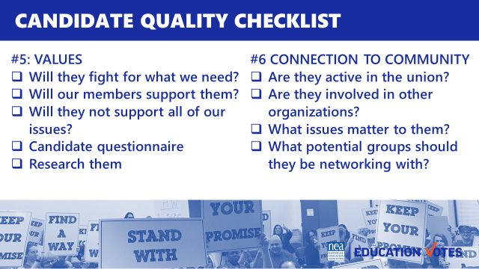  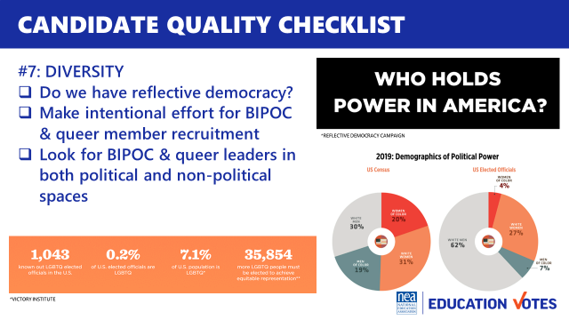  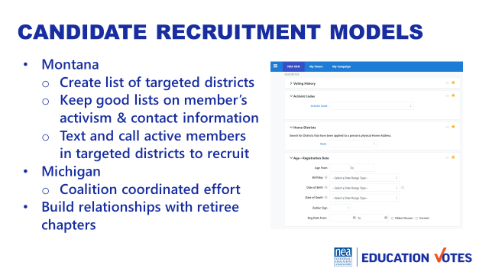  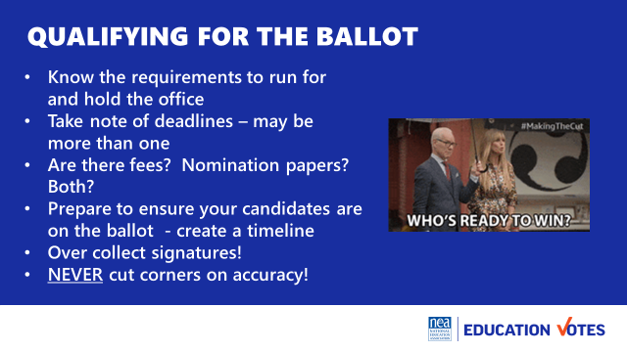  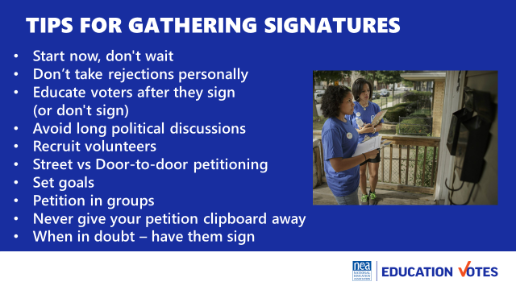 |  | Candidate Checklist | Recruiting and Recommending Candidates  - Where do we find them? 2 minutes  - What are we looking for?  - Table talk on qualities you look for 10  - Candidate Quality Checklist 10  - Strategy (right seat/right party)  - Personal Story  - Resilience  - Drive  - Values  - Connection to Community  - Diversity  - Models 3  - Michigan (coalition model)  - Montana (data model)  - Getting on Ballot 5  - Qualifying  - Sig Gatheriing Pointers | How do we recruit candidates?  Participants will practice having a persuasive conversation to recruit.
2:15 – 2:30 BREAK
2:30 - 3:10 Sara |  |  | 40 Minutes Recruiting and Recommending Candidates Continued
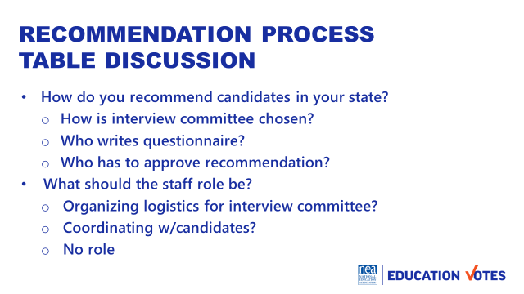  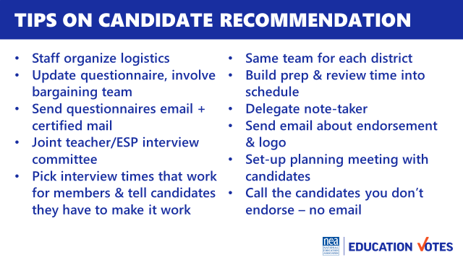  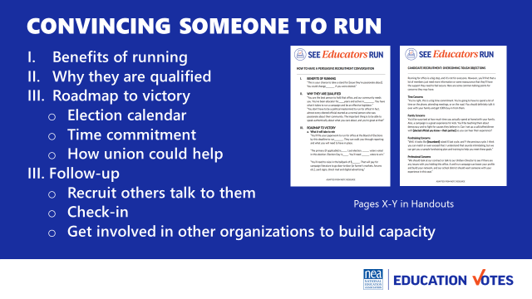  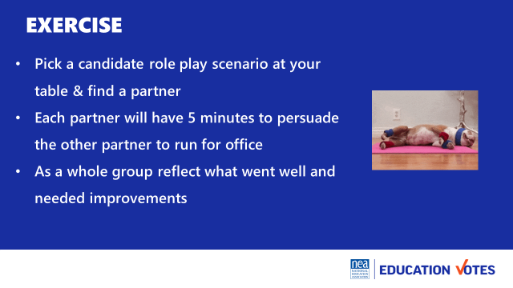 |  | Candidate Checklist  Sample Persuasive Conversation  Overcoming Common Objections  Roleplay scenarios in a cup at table | Candidate Recommendation Process 15 minutes  - Table talk on how people do it in their states & Navigating staff role  - Tips  How to convince someone to run for office 10  - Brainstorm why people say no to running for office 3  - How to have persuasive conversation to recruit candidate 5 minutes  - Overcoming common objections about running for office 2 minutes  15 Minutes Exercise  Partner up with scenario to convince someone to run, two rounds 5 minutes, debrief 5 minutes | What should we be looking for when we recruit candidates?  Participants will recognize qualities for successful candidates and learn from other states on their models.
3:10 – 4:20 Meighan |  |  | PAC Fundraising 70 Minutes
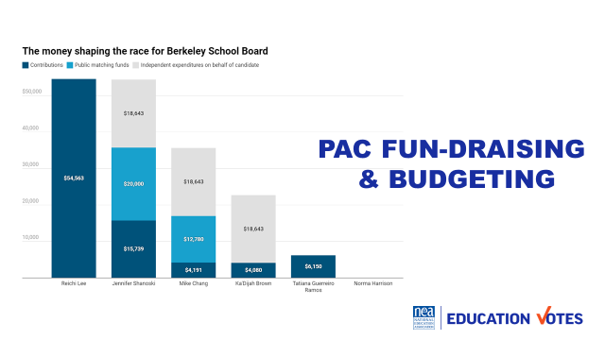  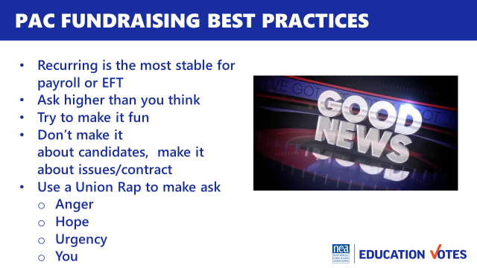  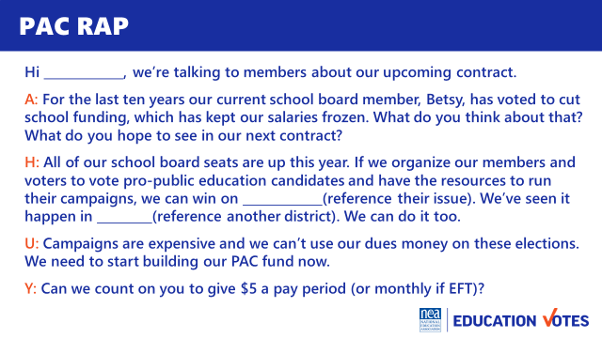  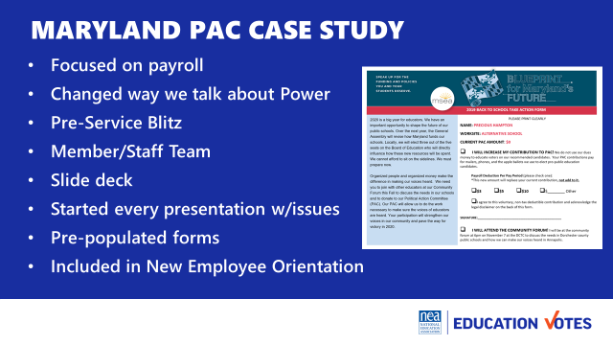  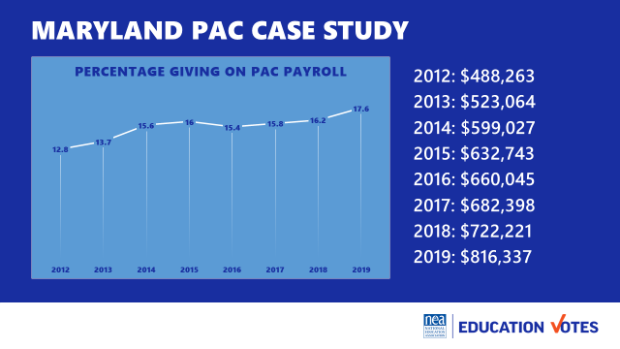  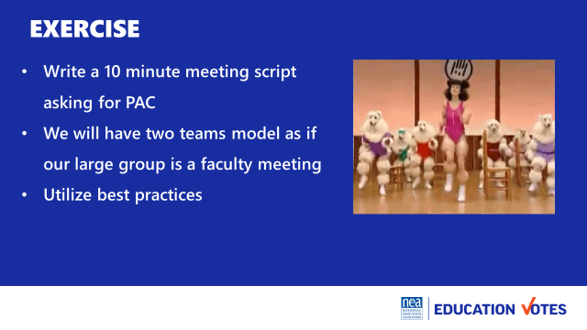  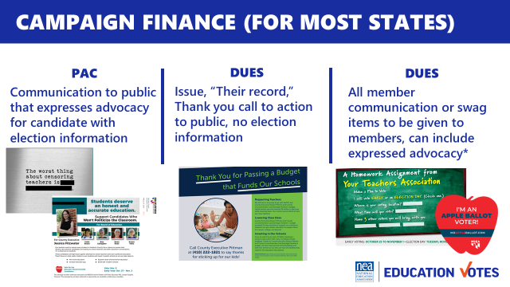    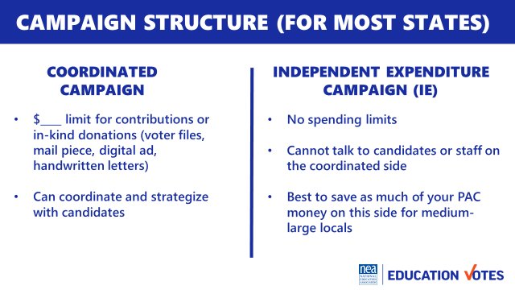  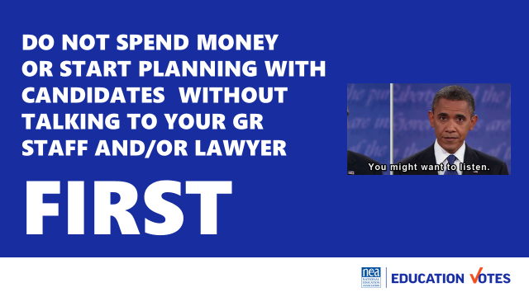  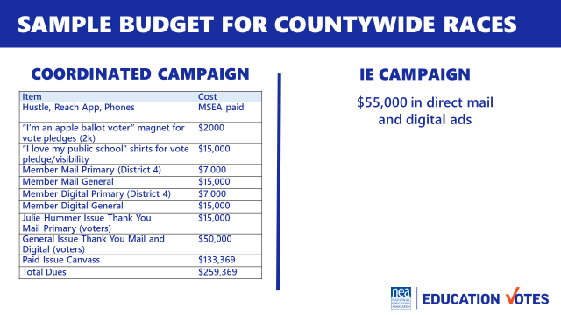  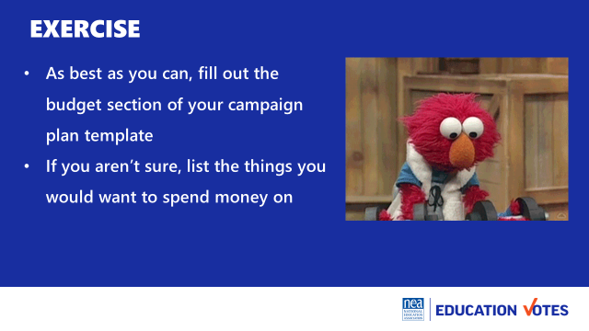 |  | Sample 10 min meeting agenda and deck from Maryland  Tough Objections Handout  Labor Notes AHUY Handout | PAC Fundraising  What is PAC? 5 Why is it important? 5  - Ask them what is a PAC?  - A PAC for our workshop purposes is a separate fund from our dues, that members make voluntary contributions to. We use that money to give candidate’s direct contributions or pay for voter contact.  - This graphic shows the spending for a school board election in Berkeley, CA  - CA has a clean elections clause where candidates can get matching funds if they meet certain fundraising thresholds.  - Lee was the non-union candidate, Shanoski/Chang/Brown were the union endorsed  - These independent expenditure campaigns were from CTA/Local  - Lee lost by 1k votes, the 3 union endorsed candidates won  - Even in places like the People’s Republic of Berkley, CA where you have matching public funds, it’s critical that our locals are raising money to make sure our candidates are able to compete against these folks that are being bankrolled by the bad guys whether it’s Mom for Liberty or Democrats for Education Reform  - How do you raise it? 15  - Ask how many people raise PAC at their state RA/convention? How many collect it on payroll deduction Does anyone collect monthy EFT/bankdraft?  - Whether it’s payroll or EFT, recurring is the most stable source compared to events based fundraising. Key Point: It’s much easier to get 100 members to give $5 a month at 20 pays than 100 members to give you $100 and more time intensive when it’s one-time donation.  - Ask what folks think most members would give per month? The NEA average is $1.41 for the federal PAC. Delaware asks their members $20 and their average per member is $12.34. And again, these are all federal PAC stats. We know members are much more invested in their local school board election than Congress. Key point: Ask higher than you need. Don’t make decisions for your members.  - Politics can be a real bummer where folks tune out before you even start engaging them. In Maryland, they started spoofing Jimmy Fallon skits to kick-off their PAC meetings. These are silly, fake good news headlines filmed with some of their rank & file leaders. [Show Video]. It’s super corny, but the transition was here’s a headline that’s not fake – School Board Elections are coming and we need to get ready. Key Point: Making it fun, caught people’s attention and using other members gave us some validators before we even started our conversations  - Speaking of Conversations. You want to make it that. 9 times out of 10, folks don’t care who is running. It’s not about electing X candidate. We need to have a strong PAC so we can win these races so we can win X and refer back to what they care about.  - We find out what they care about by using a rap. There are all sorts of variations of what people call this. Basically, you don’t want your PAC ask is to be a mobilizing ask. It needs to be an organizing conversation where you get their issues out and connect it to why they need to donate to PAC.  - One great model Labor Notes uses for their rap is called AHUY.  - Anger is where you get someone fired up and find out what they care about.  - Hope is where you talk about how we can fix those issues by coming together.  - Urgency is talking about why we need to do this now.  - You is the ask. In this case, it would be signing up for PAC.  - Here is an example of how to put a PAC ask into an AHUY one-on-one ask script.  Case Study Maryland 10 minutes  - Here’s an example from Maryland, they were focused on increasing their payroll deduction starting 2012 through the pandemic.  - A lot of the previous PAC conversations had been too focused on candidates, their narrative shifted that we needed to build power to win and the way we built power is organizing our people and organizing our money.  - Previously their PAC had been only talked about as one time donations at convention and maybe a new member might have checked it by mistake. We shifted that to focus on doing a blitz model and hitting as many schools that first week educators were back.  - We built out a 10 minute slide deck presentation and put member and staff teams on a schedule to hit as many schools as they could. We modeled our script after AHUY where we always got issues out. Most presentations were “Contract Updates.” We asked folks what they wanted to see changed or see in their new contract if we were about to bargain.  - Towards 2018 and 2019, they focused more energy on developing resources that explained PAC for New Employee Orientations.  - Here’s how they did, there was a slight dip down 2015-2017 b/c of mship growth, that’s when they started focusing on NEOs.  - These weren’t huge jumps, but because it was payroll look how much the money grew.  - They became the primary PAC funding campaigns up and down the ballot and have swept small school board races to large County Executive races electing folks no one thought had a chance of winning.  30 Minutes Exercise  [put the rap model back up]  Write a 10 min meeting PAC script, ask for two teams to model  How do you budget? 10  - All states are different  - Dues vs PAC, ask lawyers what’s possible  - Coordinated vs IE, avoid contributions to candidates/make in-kind  - Sample budget with mix of dues/PAC, ask Governance what’s possible for due  15 Minutes Exercise  Work on budget section of campaign plan | What is PAC?  How do I raise it?  What do I spend it on?  Participants will understand the importance of PAC fundraising, the mechanics of a PAC drive, and how to build an effective electoral budget.
4:20 – 4:30 Ellen |  |  | 10 Minutes Ending it Right
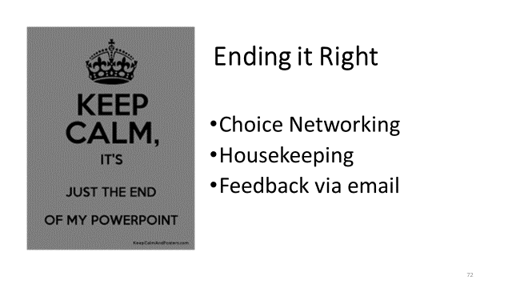  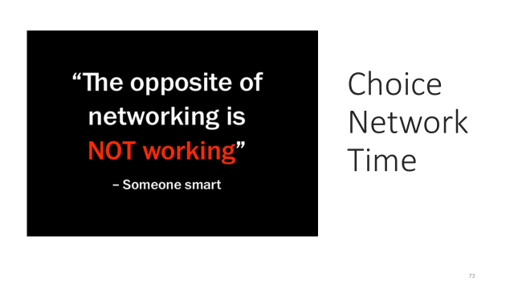 |  |  | - Questions, Connections, Reflections  - Housekeeping announcements  - Evaluations | What questions do I have? What do I need to know?  Participants will get opportunity for feedback and leave session with what they need to know for tomorrow.
4:30-5:00 | Choice Networking
5:00 ADJOURN

