WINNING SCHOOL BOARD ELECTIONS 2024
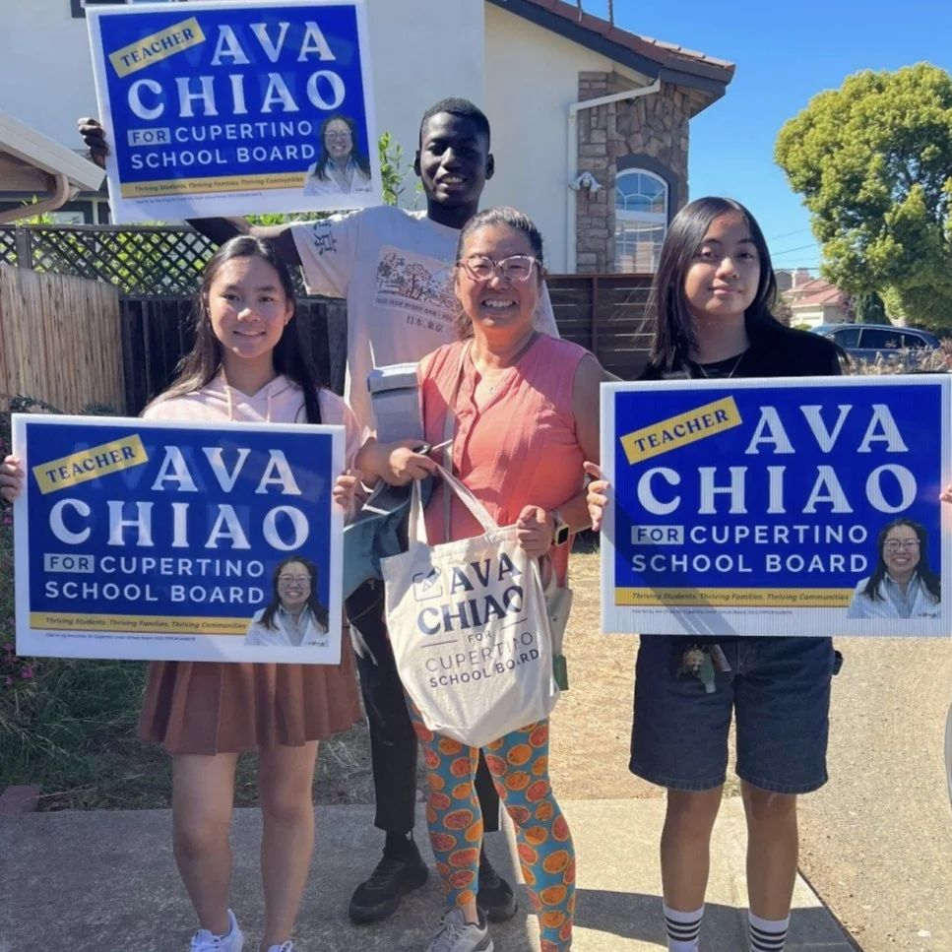  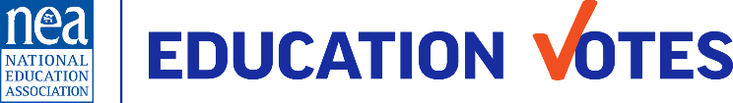  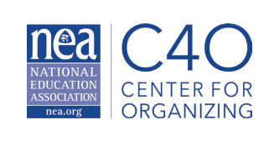 | PRE ATTENDANCE HANDOUTS  Organizers must distinguish between worksite and local political campaigns, with school board elections having a significant impact on public school employees. To win, they need to develop strong leaders and build relationships with external groups, while also mobilizing voters and finding candidates, using member engagement plans, and exploring best practices.  The NEA Center for Organizing and Affiliate Support in partnership with the NEA Campaigns and Elections department created a training designed to build participants’ understanding of political campaigns that increases the power and organizing capacity of their locals and community. Participants will deepen their understanding of campaign planning, candidate recruitment, coalition building, PAC fundraising, member engagement, voter contact, and messaging.  Lead Contacts:  Academy Coordinator  Ellen Holmes  eholmes@nea.org  Academy Logistics  Karla Medina  kmedina@nea.org  Campaigns & Elections Specialist  Meighan Davis  NEA Campaigns & Elections  mdavis@nea.org

