DE CONTRACT/PAC MEETING SCRIPT/SLIDES/FORM

SAMPLE ACTION FORM:
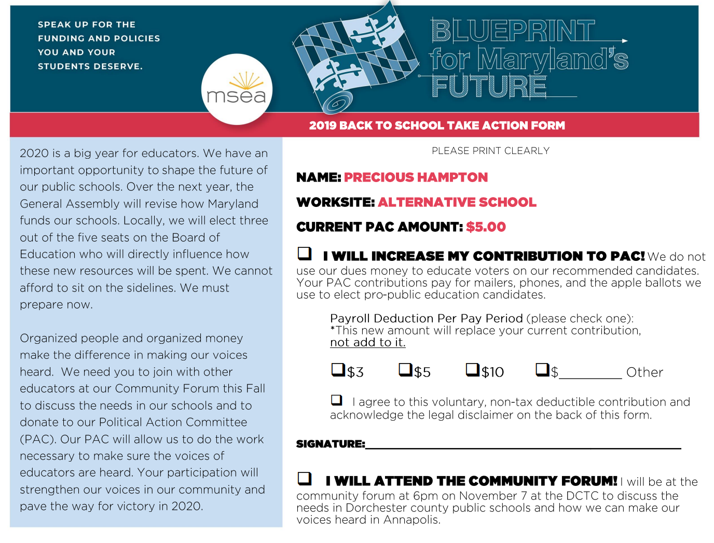
Excel Mail
Merge with the
PAC file

[ASK BUILDING REP TO HELP YOU PASS ACTION FORMS OUT, IF YOU HAVEN’T BEFORE MEETING STARTS TRY TO LINE SOMEONE UP FOR MEMBER TESTIMONY AT THE END]

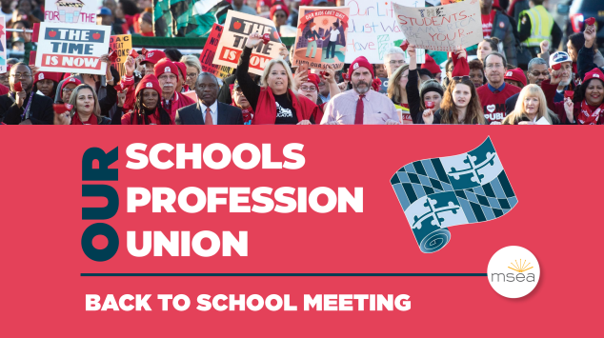
[SLIDE 1] Hi, I’m ______________________ from MSEA. First off, I wanted to welcome you back to school. We’re here to help your President Katie Holbrook deliver lunch to you and give you important updates about your job.

I promise to only take 10 minutes since I know how busy getting ready for students can be. The Association is busy getting ready for what will be a very important year for the future of educators and that’s what we want to talk to you about today.

Make sure you get your custom form with your name on it or a blank form that are being passed out right now.

Since the world is so full of bad news, we wanted to kick-off with a fun video of DE colleagues reading some headlines we wish were true, headlines we believe about you, and headlines that make us laugh about our jobs.

[SLIDE 2] [Play video]

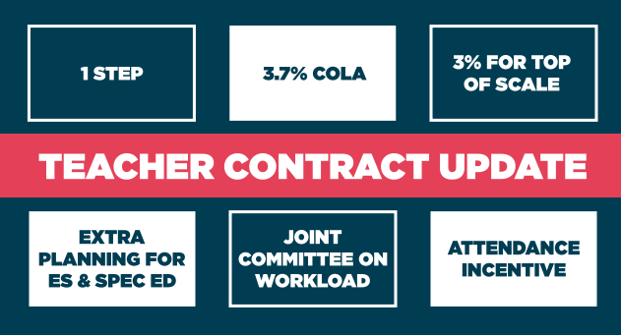
[SLIDE 3] Here’s some real good news! We have some contract updates. Contract questions can get really specific to individuals and we want keep this a short meeting so please save your questions till the end. Here are some of the highlights from the agreement for certificated employees:
- 1 step for eligible employees w/$500 added to step 2, $600 to step 3
- 3.7% COLA added to scale
- For certificated employees not eligible for a step, you will receive 3% and $1k for longevity pay w/26 or more years of service
- Extra Planning for ES teachers and extra 45 minutes a week for paperwork for Special Ed teachers
- Joint committee to make recommendations for reducing workload
- Attendance incentive of $1,000 for perfect attendance, $500 for folks who use three sick days.

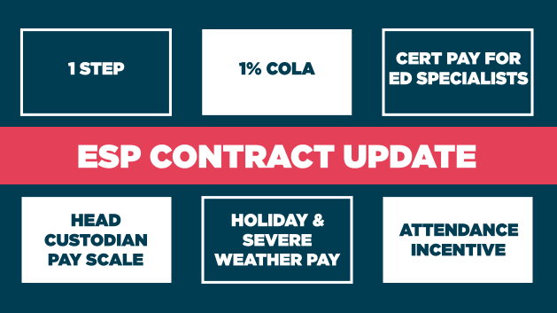
[SLIDE 4] For ESP members:
- 1 Step
- 1% COLA
- Education Specialist additional pay for certifications
  - $400 for Level 1 CPR & First Aid
  - $600 for Level 2 Student Trauma & Med Tech
  - $900 for Level 3 Student Trauma, Med Tech &TACT 2
- Employees on the Maintenance I scale will move to the Tradesman I pay scale
- Holiday and Severe Weather pay will be paid at rate of 1 ½
- Same attendance incentive pay as teachers

There’s a handout going around that summarizes more of the contract wins.
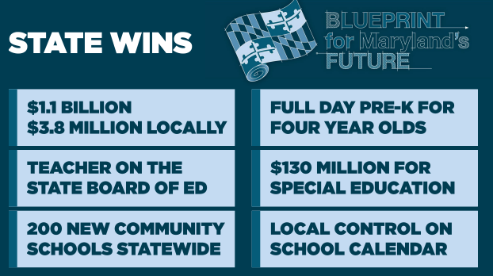
[SLIDE 5] Our victories this year were really tied not only to our work on the local level but going to the state advocating for more funding with the Blueprint for Maryland’s Future. While the Blueprint funding that helped fund our salary improvements was the major headline from Annapolis this year, we also put an active, certificated teacher on the State Board of Education, added 200 new community schools statewide, and won full day PreK for four-year old’s, $130 million for special ed, and local control over the school calendar.

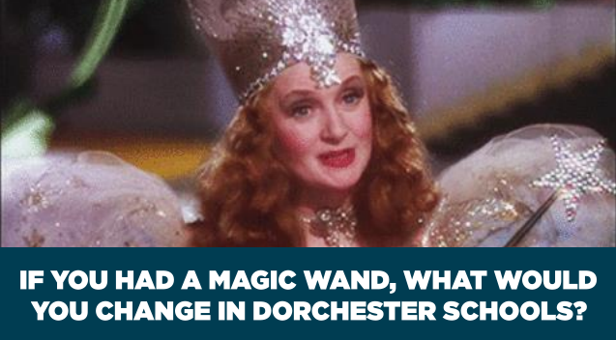
[SLIDE 6] Getting raises and economic victories are always good news, but the truth is our kids and our schools deserve more. The Blueprint was a good start, but we still have a lot to do, especially for our ESPs. Since we've already talked about the raises we’re getting, we’d love to hear about other issues you would like to see changed in education [get issues out]?

[SHORT DISCUSSION, find out what people care about – move on if it meanders or 1-2 members dominate discussion, hot buttons issues might include –top down decision making, workload, discipline]
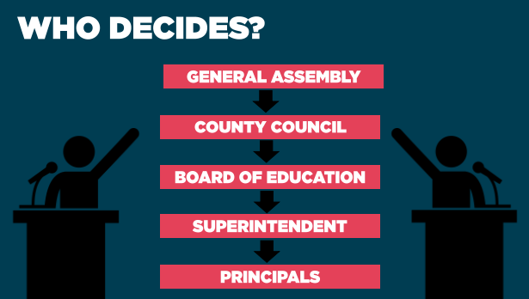
[SLIDE 7] These are all important issues, but look at who makes the final decision about what should be happening in the schools?

Look at the organization chart and who is at the top. If we want to see changes relative to [reference issues], we have to make sure we have a seat at the table with elected officials.

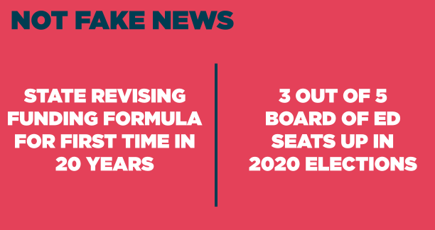
[SLIDE 8] Here are the biggest non-fake headlines we’ll be facing in 2020: The state will be re-writing the formula for how we fund schools for the first time in 20 years and we’ll be electing 3 of the 5 seats on the school board. These campaigns will be critical to our future because it’s who we bargain with and how much funding we receive from the state to bargain with.
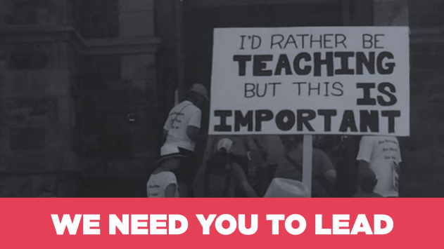
[SLIDE 9] Does anybody want to take a guess at how many voters skip Board of Ed on the ballot? Close to 50%. Anybody want to take a guess on how much money we receive from the state? Close to 70%. We have two choices, we can be the leaders in public education our students and community need us to be – or – we can sit on the sidelines and let others decide for us.
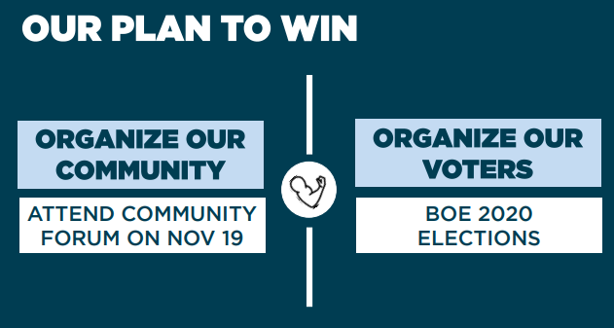
[SLIDE 10] Are you ready to win on the issues you mentioned before? Here’s how we do it.
The first thing we need to do is to organize our community to make sure we have elected officials who know what policies will make a difference for our schools and are ready to fight for them.

Almost every county in the state will be hosting Community Forums this Fall, where we’ll ask educators, coalition partners, parents, and community members to come together to keep the pressure on the General Assembly to take action next year. Your attendance at these events are vital, but it’s also important that you reach out to your neighbors and networks to engage non-educators in these important conversations, too. DE will be doing ours on Nov 7 at 6pm at DCTC.

Getting the General Assembly to do the right thing is only half the battle though. We also need local elected officials to ensure that new funding makes it to our classrooms. That will take organizing our voters to vote for pro-public education Board of Education candidates next year.

Our tool to run our own campaigns to elect these candidates is our Political Action Committee, or PAC, the Fund for Children and Public Education.

The reason our PAC is so important is because we cannot spend our dues money on advocating for or against any candidate. Our PAC is about pooling our resources so we can have more of an impact at the ballot box.

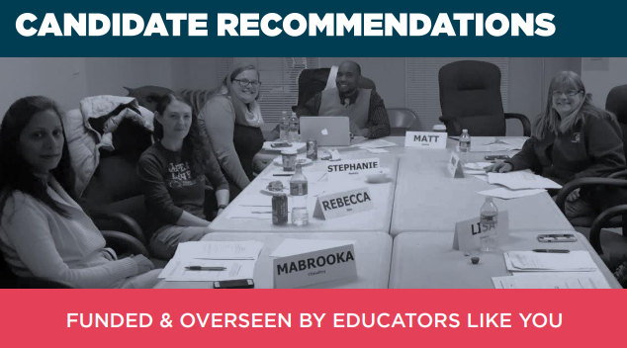
[SLIDE 11] The public listens to educators on elections and education issues because they know we do our homework. Your PAC contributions give us the resources to make sure the right people get elected.

This is your PAC: these are decisions made by DE members just like you. Our first step, no matter what the office or party, is to get the candidate’s stance on important issues facing our profession. It’s not about democrat or republican, it’s about what’s right and wrong for educators and students.

Once the candidates return their questionnaire, they meet with a committee of members to discuss these issues. If you are interested in serving on this interview committee, please let me know before you leave.

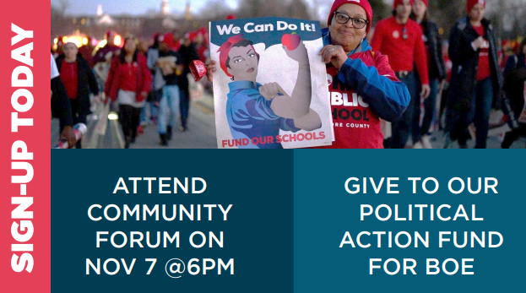
[SLIDE 12] You’ve seen the stakes. You’ve seen why this is important. Now we need you to sign-up to attend the forum and/or give to our PAC.
(MEMBER TESTIMONY) - I’m putting my money where my mouth is and joining at the $___/per pay period amount (or attending forum) because______________.

Please pass back your forms, whether you are upgrading, signing up for the first time, or choosing to keep your current PAC status amount the same. This helps us track that we’ve asked all of our members.

For folks who signed up for the forum, we’ll give you a couple of reminders before Nov 7.

If you have any questions, I’ll be here for another 5-10 minutes if you want to see me up front. If you are not a member and would like to join, I also have membership forms with me. Thank you for all you do and welcome back.

