Facilitator Agenda: Winning School Board Campaigns Day # 1
General Materials Needed: |  |  | Room Set-up:
1 Set of Handouts per Person  Name Tags or Name Tents  Room signs, sign in signs  Highlighters – 3 colors  Pens and Pencils  Post-its | Chart Paper – self-stick kind  Markers- Mr. Sketch - Non-Permanent  Post its  Wi-Fi  Charts for the day:  - Core Values Coalition |  | Round Tables for Participants – cords at each table  Long rectangle at back for Facilitators  No Podium – table with projector large enough for laptop  Projector, Screen, Microphones, and Speakers  Carousel stations and reporting stations around the perimeter  50 people Max

Pre-Training Needs
- Articles to read about Panel Case Study

Key Outcomes for Day 1 (Be sure to check for participant movement throughout the day.)
- Build sense of community
- Understand the importance of school board elections and lessons learned from OR locals
- Map their school board, local, & community
- Calculate vote goal and understand components of campaign plan
- Develop effective campaign message
- Identify strategies for successful candidate & coalition recruitment

Content and Facilitator Assignment Overview Day 1
8:30- 9:00 Welcome  9:00 -9:25 Introductions  9:25-10:20 Panel  10:20-10:35 BREAK  10:35-12:00 Campaign Plan Overview  12:00-1:00 LUNCH |  | Ellen  Meighan  Elvyss/Yvie  Jackie & Adia | 1:00- 2:00 Message  2:00-2:45 Coalition Building  2:45 – 3:00 BREAK  3:00 – 4:20 Recruiting and Recommending Candidates  4:20-4:30 Ending It Right  4:30-5:00 Choice Networking | Beth  Jackie  Meighan & Monet  Ellen

Time, Facilitator, and Slides | Resources | Instructions, Activity and Debrief (Facilitators) | Essential Questions and Key Outcomes
What is the clock time for start and end? Who is doing this Section? What are the PPT slides (pic of slides)? | Charts, handouts, materials, videos | What are you saying, what are they doing, what questions will you use to guide learning and make clear the important points  Include an estimate for how long each section of the learning will take  Include Key points. | What question(s) does this section answer?  What will participants know or be able to do?
8:30 – 9:00 Ellen |  | 30 Minutes Welcome
Slides  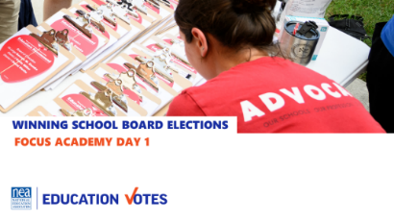    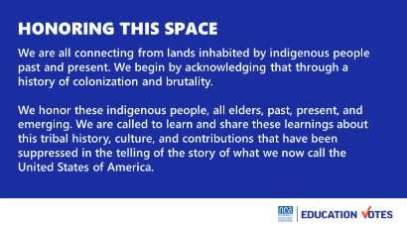  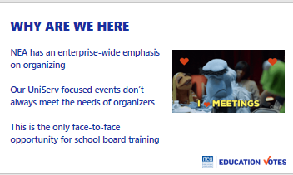  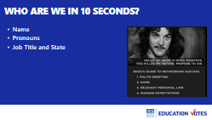  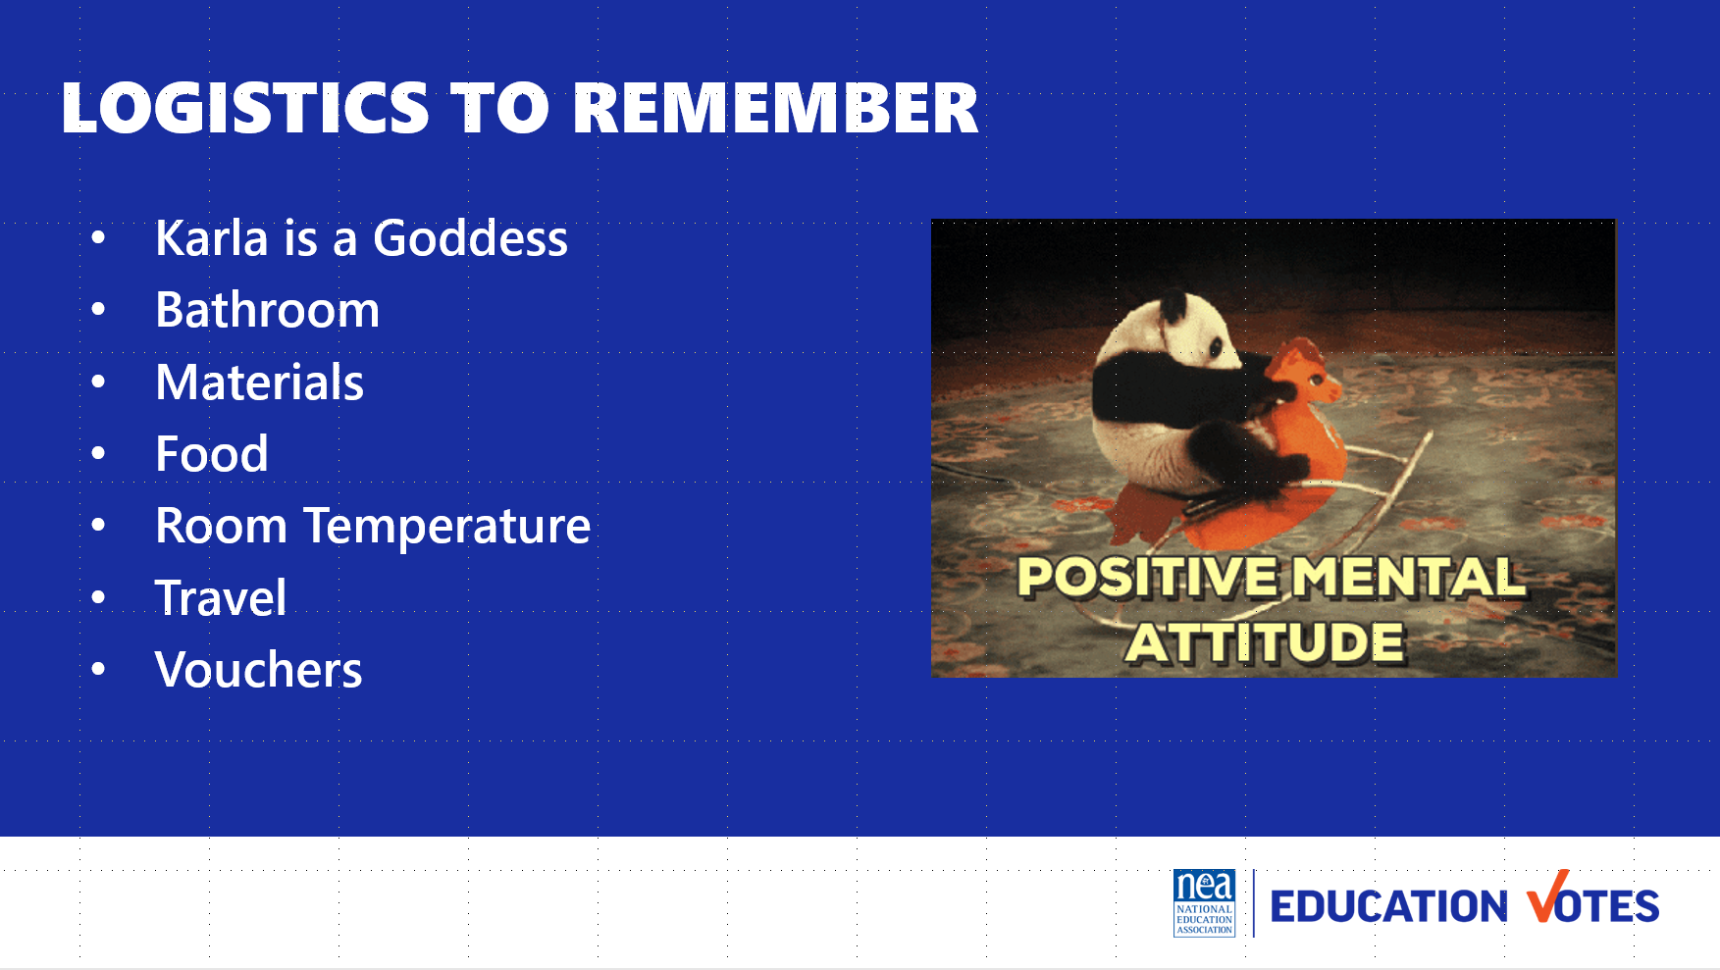  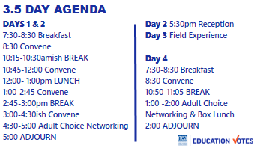  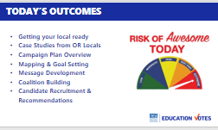  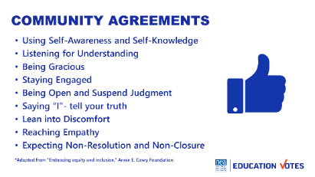 | Community agreements on name tents  Agenda on Table  One Pager on Reimbursements  Community Agreements in Participant Handouts | Welcome  JARGON GIRAFFE REMINDER  Land Acknowledgement  We begin by acknowledging that through a history of colonization and brutality, we are currently on the traditional lands stewarded by generations of the of the Multnomah, Kathlamet, Clackamas, Cowlitz bands of Chinook, Tualatin, Kalapuya, Molalla and many other Tribes who made their homes along the Columbia River.  We honor these indigenous people, all elders, past, present, and emerging. We are called to learn and share these learnings about this tribal history, culture, and contributions that have been suppressed in the telling of the story of what we now call the United States of America.  Why are we here?  NEA has and enterprise wide emphasis on organizing and our UniServ focused events did not always meet the needs of organizers. Additionally we are working to create more connections across our centers – silos. Campaigns and Elections operated independently and parallel to our UniServ and Organizer programs. Both doing great work – but duplicating some content and missing many opportunities. One of the biggest misses was in supporting affiliate staff that may not hold the title of Government Relations or Campaign Goddess but who do work most closely with members who work for school boards. Engagement in the most local of politics is the best way to create authentic wins that are secured by and felt by local workers and their communities. They are visible and tangible and can boost union engagement. We are going to learn how to accomplish this.  Introduction of Participants and Facilitators  We are going to do a very fast whip around the room 10 seconds or less per person so we can get every voice heard and every face seen as soon as possible. Let’s start with the facilitator team -Remind Folks to Keep it Short - Name, Required Pronoun, State and Title  Logistics to Remember  - Questions  - Bathroom​  - Materials​  - Food​  - Room Temperature​  - Karla is a Goddess  - Travel​  - Vouchers  Agenda  Let’s take a look at the basic three and half day agenda. We will not have working lunches or breaks – those are your times to do as you wish including reconnecting with members or the home office, except for on day 3, our field experience where you will have a boxed lunch to enjoy while at your worksites . We ask that you put on your out of office notifications and respect them for yourselves as learners. You will notice that at the end of each day is something called adult choice networking. The value of coming together around this learning is really amplified when you have unstructured time with the folks who have come from all over around this topic. All that we ask is that you network any place but in this room. This time is part of the official agenda so that you may report that you have worked a full day while at this experience.  Today’s Outcomes  Here are today’s outcomes – please remember this is our second time doing this training so shift will happen.  Community Agreements Review  Begin with a proposed list of community agreements, each table needs to describe what they think each agreement means and propose any additional norms not covered by the proposed agreements:  - Using Self-Awareness and Self-Knowledge  - Listening for Understanding  - Being Gracious  - Staying Engaged  - Being Open and Suspend Judgment  - Saying “I”- tell your truth  - Leaning into Discomfort  - Reaching Empathy  - Expecting Non-Resolution and Non-Closure  Refer them to the Community Agreements in their handouts and that they received as part of their Pre-Attendance documents.  Prompt table groups to review the agreements.  - Give them XXX minutes to scan the agreements looking for items that they don’t understand.  - They should also be tracking what they think is missing.  Debrief  Share what you mean by the agreements.  Check to see if tables are on track or need clarity for EACH of the agreements.  Before moving on - ask the group to show thumbs:  - Thumbs up is I totally agree  - Thumbs sideways is I can live with it and I am fine to move on  - Thumbs down – I simply cannot move on AND I have questions or something different to propose.  - A thumbs down comes with the responsibility of working until your thumb can at least be sideways.  (What follows are facilitator notes to help you debrief the ways of thinking that shaped each of the proposed agreements 1-4)  - Learning is a two-way experience - you need to communicate well with the facilitators and your group mates to ensure your own learning and that of the group. You are invited to share in the development and maintenance of a productive adult learning space.  - Speak up and make room for others to do the same. Sometimes that means stepping back. Expect to be called on even if your hand is not up – it is a way for facilitators to ensure a balance of voices in the room – we expect that you might pass as well.  - Be free to discuss ideas that you heard, but not identify the person or people involved. | How is this work structured?  Participants will understand how the days will be structured.
9:00- 9:25 Meighan |  | 20 Minutes Introductions
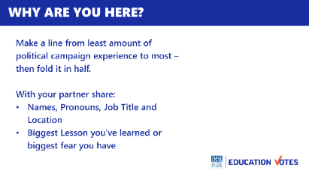   |  | 5 Minutes set up – We are going to spend next 20 minutes to get to know each other a little more. Everyone have a phone? Everyone have some photos on it. Here’s what I want you to do. I want you to find a photo that represents why school board elections matter. Here’s my example [explain your photos].  6 Minutes in Share Pairs  Each have 3 minutes – self time and Share  Names, Pronouns, Job Title and Location  Photo & story  6 Minutes – Go another round  9 Minutes – Debrief | Who is in the room?  Participants will begin to build a learning community
9:25 – 10:20 Yvie |  | 55 Minutes Panel
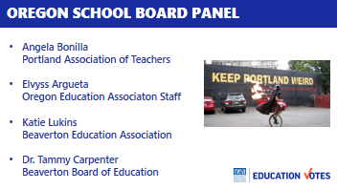 | Before panel: World as it is/ World as it should be activity – grab from pre-uniserv  This could also help with the flow of the campaign plan section – they could pick ad issue from this activity  Page 5 of Participant Handouts  Keep the panel at the beginning of the day  How can we improve the flow from the panel to the Campaign Planning? | 45 Min - Have 2-3 Staff/Leaders Present (15 min each)  - School Board Dynamics/Lay of the Land  - What was your program  - What was the result  - What would you have done differently/Lessons Learned  10 min – Questions from Audience | Why do we need to be working on school board elections? Participants will understand the threats our school boards are facing and why elections matter.
10:20 – 10:35 BREAK
10:35 – 12:00 Adia & Jackie |  | 90 Minutes - Campaign Plan and Goal Setting
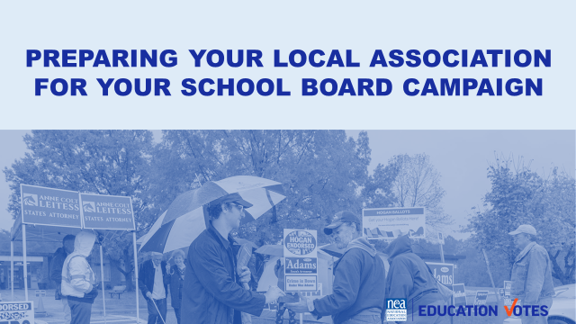  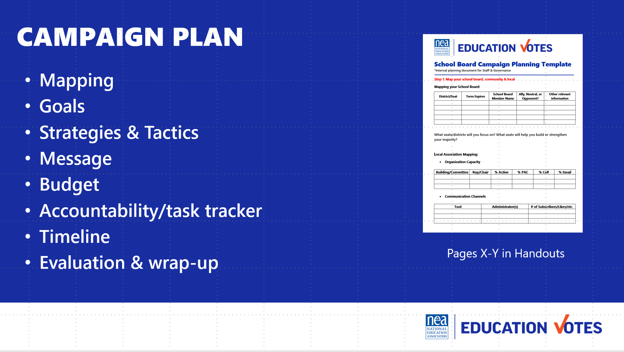  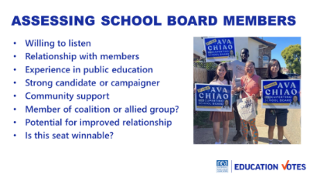  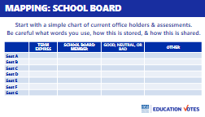  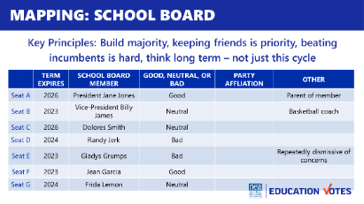  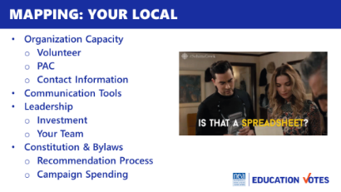  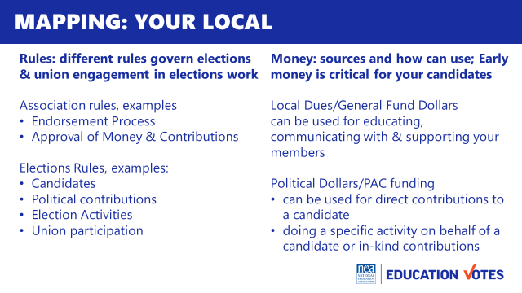  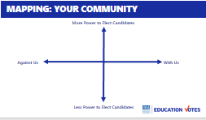  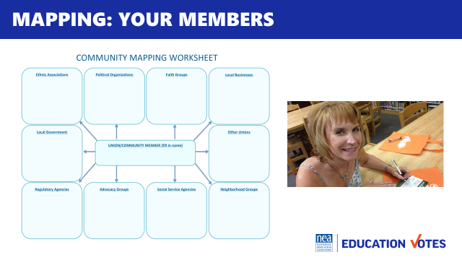  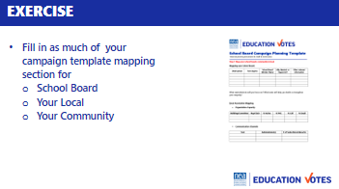  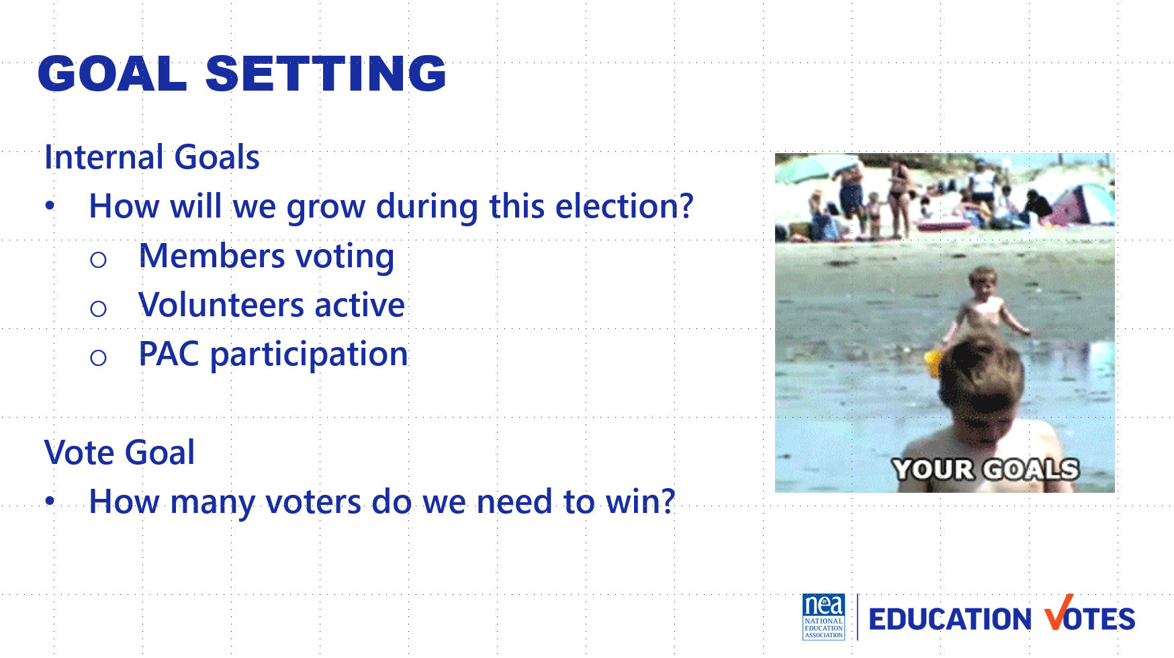  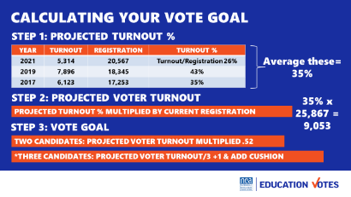  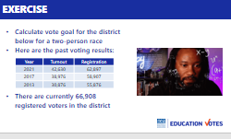  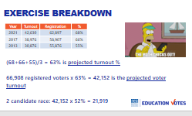  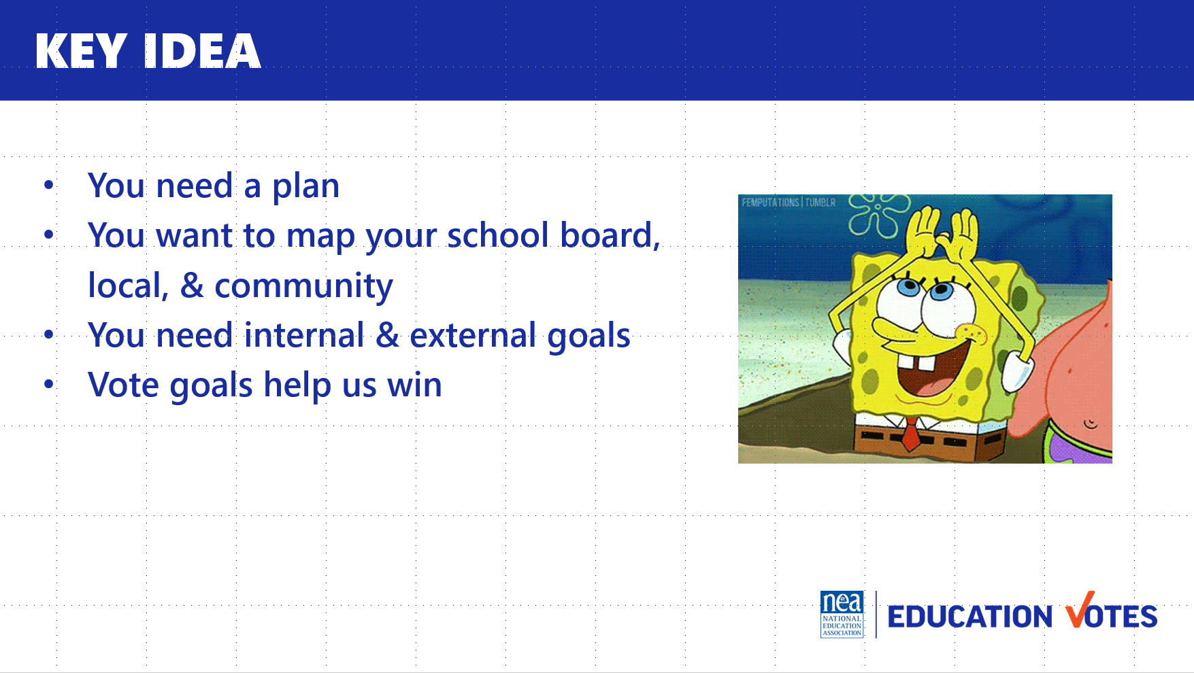 | Campaign Plan Template  THIS SECTION RAN 15 MINUTES SHORT  Consider having an issue for them to work through a campaign plan.  -One issue for entire group  -Provide several options (scenarios/videos) and let them self-select and group themselves  There seemed to be a disconnect when we got to messaging  Map your Community template  Community Organizing Worksheet  Would be a good idea to incorporate concrete examples of functioning coalitions and how work was successfully divided- maybe one example in a big, well funded race, and one in a tiny, super local race. This was the table, the union did x, the PTA did y, the labor council did z, the local business owners did a?  Charting | - Overview of Campaign Plan (8ish minutes) – So now that we’ve spent some time talking about what it takes to win, the next hour and half will be devoted to getting ourselves prepared to run our own winning campaigns. To have that winning campaign, we need a plan. There are lot of different formats for campaign plans. The important thing is to find a format that works for your local. Here are the components we will be focusing on.  - Mapping – this is getting the lay of the land. Some campaign plans might refer to this section as research.  - Goals – these are external goals like winning an election, and our internal goals about increasing PAC participation, recruiting x number of volunteers etc.  - Our strategy is our overall plan, and our tactics are those individual actions to get us there, for example we know having our members vote in big numbers is part of our strategy and doing building meetings is the tactic to help us achieve that strategy.  - Message – We have a message that we will be repeating to external audiences like voters, and what we will be saying to our members to motivate them to vote.  - Budget/Fundraising - Elections are expensive and we have outside money trying to influence our elections so it’s critical that we have our own independent political action committee’s to support our campaigns and a budget for our spending priorities.  - Accountability/Task tracker –We know stuff doesn’t get done unless there is a name and deadline attached to it.  - Timeline – Our last step is putting it on a calendar that will work for you  - Mapping  As we get started you will need to think about a local you work with that may be struggling with their current board, has open seats due to termed out members, wants to maintain the current board etc. Have that local in mind as you work through the components of the plan.  - (3 mins) Mapping your School Board- the first thing we want to map to prepare for the election is the school board  - Considerations on Assessment of School Board – here are some helpful considerations as you start making your assessments on which races you are going to target. (Slide - Assessing School Board Members)  - Here is an example of a potential school board map.  - Chart – we want to start with a chart so we can start figuring out how many allies we have and how many races/seats we need to target. We can’t always win everything, so it’s important that we know how to tier these races out based on winning a majority and playing in races we have the most likelihood to win.  - Give them 10 minutes to work on the chart.  - Discussion: What did you learn?  - Where do you find this information?  - Why is this important to analyze?  - What’s missing on the chart? Why?  - Occupation  - Party Affiliation  - Voting History  - Spouse  - Social media search  - Petition to run signatures  - Key Lessons when deciding electoral priorities  - Once you have your chart filled out, as you are making decisions on who is going to receive your financial and volunteer support  - Make sure you are protecting friends and keep in mind:  - Incumbents are hard to beat. That doesn’t mean don’t try to take them out, but you may not be able to win all those races against established candidates.  - Mapping your Local (5 minutes) - once we’ve taken stock of what we need to win, then we need to look internally  - Organizing Capacity - our two biggest resources are our organized people and money. We need to know what we have and make sure we have contact info to build more volunteers and PAC.  - Communications Tools – we need to know what tools we have access to and be clear who those administrators are.  - Leadership engagement – as we start looking at ourselves, we need to make sure we are thinking through how we can get our leaders invested. Maybe that means doing one-on-one policy discussions with candidates. We also need to be thinking through what team we currently have, what strengths we have and what we need to build on.  - Constitutions & Bylaws around electoral work – many locals have how you recommend candidates and maybe how money is decided. If it’s not, it’s an important conversation to have with Governance and Executive Boards ASAP.  - Rules & Money Slide – knowing the rules for the local, coordinating with candidates, and how you can spend money is crucial. Your GR Director is a good person to start with if you have no idea or want to talk through how you might be able to get creative with campaign spending.  - Mapping Members (2 minutes) - As your mapping your local, don’t forget to research member involvement, we have a great worksheet you can start using with building reps or and GR committee so you can research what groups our members are already a part of.  - Mapping Community (3 minutes) - The last thing you want to map is your community. You need to know who may be potential allies and who will be your opposition  - First step is to brainstorm all the organizations that impact education/work on elections  - Who has a great coalition partner they want to tell us about?  - What about this top left quadrant? Who has serious opposition they are facing that would like to share?  - It’s important to prioritize your outreach to potential coalition partners with more power & capacity.  - Exercise – spend 5 minutes filling out XY axis on your community  Goals Overview (10 minutes)  - We have two types of goals. External & Internal.  - Our internal goals are about how we plan to build the union, like new PAC donors, volunteers etc.  - Our external goals are about how many voters we want to contact, what races we want to win etc.  - The most important external goal we need is our vote goal. This is how many voters we need to turn out.  - To calculate your vote goal you need to gather information for the past three elections that look like the one you are working on. If it’s in a presidential year, look at the information for that district for the past three presidential elections. Depending on your state, this may be super easy to find on the State Board of Elections website or your clerk’s website.  - You will average the turnout for these past three elections. This is your projected turnout %.  - You also need to look up how many registered voters there are in this district. Take the percentage from step 1 and multiply that percentage with registered voters. This is your projected voter turnout.  - If this is a two-person race, you take that number and multiply .52. If you have more than 2 candidates, you’ll divide it by number of serious viable candidates and add 1. It’s also smart to add cushion on top of that.  If it comes up . . .  - What is the impact of Ranked Choice Voting?  - You still work to get 50% of the vote, or whatever the margin has been set at  - What is ranked-choice voting?  - Ranked-choice voting is an electoral system that allows people to vote for multiple candidates, in order of preference. Instead of just choosing who you want to win, you fill out the ballot saying who is your first choice, second choice, or third choice (or more as needed) for each position.  - The candidate with the majority (more than 50%) of first-choice votes wins outright. If no candidate gets a majority of first-choice votes, then it triggers a new counting process. The candidate who did the worst is eliminated, and that candidate’s voters’ ballots are redistributed to their second-choice pick. In other words, if you ranked a losing candidate as your first choice, and the candidate is eliminated, then your vote still counts: it just moves to your second-choice candidate. That process continues until there is a candidate who has the majority of votes.  5 Minutes Exercise  Now it’s your turn, use this data to calculate the vote goal or if you have access to the data for your upcoming school board election you are focusing on, you are welcome to work on that. Make sure to round up. Answer is 21,919.  Discussion:  What was the number? (21,919)  Here’s how the math breaks down?  What did you notice about voting trends in the example?  - Voter turnout increased each year – do we need to adjust our goal as a result?  Why is it important to calculate your vote goal?  - Helps you assess your candidate, do they have a vote goal? Is it the same as your number?  - If you do have a paid program, it can help you gauge how much mail or digital you need.  - Assists with coalition work – how many votes does each group need to bring in to secure a win?  Key Ideas 5  - You need a plan  - You want to map your school board, local, & community  - You need goals internally & externally a vote goal is key  - Vote goals help you win | `
12:00– 1:00 LUNCH
1:00 – 2:00 Beth & Hedy |  | 60 Minutes Developing Your Message
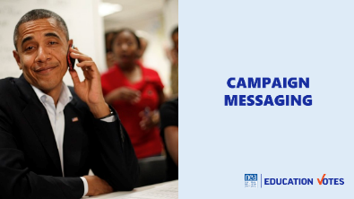  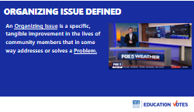  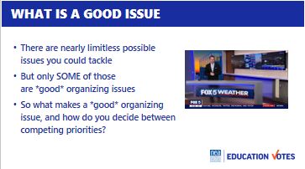  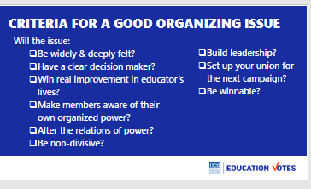  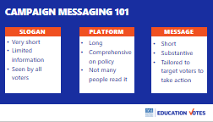  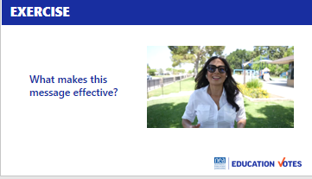  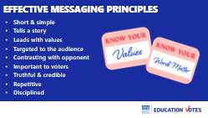  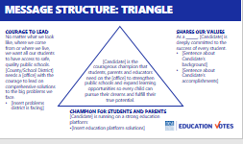  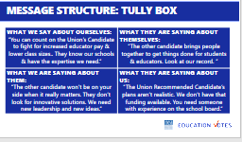  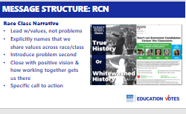  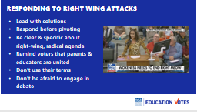  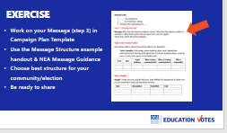  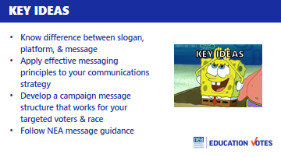 | Hedy  Pages 15- 19  Videos need to be full screen  Beth  Page 19  Maybe more time to pull apart and explain each type of messaging  Hedy  NEA Message Guidance  Page 15  Message Template Worksheet w/3 examples | Introduction 2 min  - One of the most important parts of preparing for your school board election is developing your message. Tomorrow we will spend more time on our message to members and what those conversations look like. This type of message development is focused on the message you will be delivering to the public in your campaign. Specifically what issue are you going to tie to your candidates to help you get voters to the polls and what you are putting in your communications.  Issue Organizing 7 min  - Let’s start with what is your issue that will help you with your campaign. MAYBE ADD AN ACTIVITY  - Why do folks think it may be better to start with an issue vs a candidate? (self-interest)  - An organizing issue is a specific, tangible improvement in the lives of community members that in some way addresses or solves a Problem.  - What makes that a great issue to use in their school board election?  - Here’s criteria for good organizing issue.  - Here’s a great example of an issue that mobilized the community in Virginia. Show video.  Message 101 - 2 min  - So what is a message? A lot of candidates make the mistake of using a slogan and calling it their message. School Board candidates especially love to create an abbreviation for what their platform is and call it a message. A message is not a slogan or policy platform. A message is a statement that motivates targeted voters to take action. It contrasts between you & your opponent that you repeat over and over again.  Effective Messaging 11min  - So we have a video of one of our members who did our See Educators Run program and ran for city council.  - Show video 1:46 min  - 5 min Put groups into 6 small groups, answer: what did you like about it? (told story, led with values) Anything you would change?  - 2 min Report out  - 2 min Here are principles to remember as you start crafting your message. Tell stories and lead with values where you can. That wasn’t some big production on Michelle videos, that was prob shot on a phone and edited in iMovie. You want to keep your messages short and make sure it’s targeted to the voters you are trying to reach. Anybody remember how long Michelle’s video was? (1:46). Use issues the community cares about and issues you know they are talking about. Make sure you have data to back-up any facts you cite. You want to constantly be using your message in your communications on doors, in your mail, and digital ads. Repeat, repeat, repeat & stay disciplined.  Message Structure 9 min  - 1 min There isn’t a one-size-fits-all all formula for messaging. We are going to show you two widely used formats and one new emerging structure that you might have seen in your affiliate in your RSJ work.  - 2 min Message triangle – THIS NEEDS TO BE A HANDOUT this is prob most used format in our union. It’s the three points you are going to repeat over and over. I like this one b/c it helps you boil down their background & qualifications, what the issues are, & what they're fighting for. The message in the middle ties the three points together.  - 2 min Tully Box – THIS NEEDS TO BE A HANDOUT this may be the simplest structure when it comes to developing your message, but it’s important to note especially if you have candidates attacking one another. It’s essentially comparing the two candidate’s message and how they talk about their opponent. This format is really great to help you build a contrast and develop your comparisons for voters. You might want to do this with your candidates so they refine their talking points, but this is probably not the best structure to create a message for your local.  - 2 min RCN was developed in 2017 as a message structure to neutralize the use of dog whistle racism to win on issues. It follows this structure where you start by talking about your values & being explicit that we share these values across race & class. Then you introduce the problem, & close with the solution of working together for a call to action. Here’s a great mail piece from MSEA that used RCN elements in a school board and county Exec race in 2022.  - 1 min With all of these structures, use what’s best for your community. Sometimes it makes more sense to focus on issues like you saw in the triangle. Sometimes you really want to paint the picture of the choice of candidates you have using the message box. And you may be in the middle of moms for liberty hell and need a race-class narrative that reminds voters of values, names the problem/people calling division, and reminds them of the positive future our kids need.  - 1 min There’s a great message guidance from NEA that was focused specifically on school board races with sample talking points in your participant handout. It has sample talking points for you to use. There is also a handout on RCN from We Make the Future.  Responding to Right Wing Attacks 2 min  - At the very end of the NEA message guidance handout, there are tips on responding to attacks  - You may end up with patriot Barbie dressing up like a cat at your school board like this photo. I know it’s tempting to take their bait, here are some good tips on how to respond to those attacks smarter not harder.  - Always lead with your positive solutions. We saw this in the 2023 races, voters don’t want the culture war. They want to hear about what your candidate is going to do for students, public schools, and communities.  - That said, you can’t ignore the debate. You need to respond, but pivot back to your message. There are great talking points to use in that NEA Message Guidance doc.  - Don’t let the right-wing claim parents as their ally. Remind them educators & parents are united – leaning in on your work to partner with parents and educators.  - Don’t use their terms like CRT or “grooming” - even when responding or being asked questions about it. Make sure to use your words to speak about your values.  - As much as we all hate conflict & our guts might say we shouldn’t give these folks any attention – it is a mistake to ignore the debate. We have to engage, but we have to engage strategically and with a smile on your face. Make sure you engage in a way that highlights how educators are the cool, calm, and collected people in any debate to ensure any viral videos that come from any discussion or debate shows the other side as the gadflies they largely are.  15 Min Exercise  - For the next 15 minutes, start working on your message on a flipchart. It mentions 3 points, but It’s up to you if you create triangle, a message box, or a narrative. There is a handout with examples of all three.  - Also make sure to check-out the 3 pages of NEA message guidance in your participant handout  10 Min Report out – Ask if there are volunteers to share flipchart messages  Key Ideas 2 min  - Know the difference between slogan, platform, & message  - Apply effective messaging principles to your communications strategy  - Develop a campaign message structure that works for your targeted voters & race  - Follow NEA message guidance | Participants will understand what makes a winning message and how to craft a message for the public
2:00 – 2:45 – Jackie & Melissa |  | 45 Minutes Coalition Building
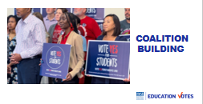  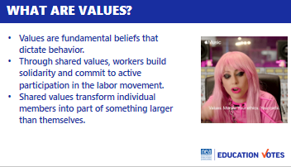  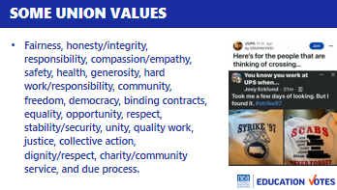  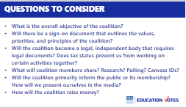  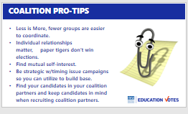  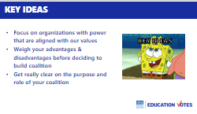 | Coalitions handout  Page 21 | Why join coalitions? 5  - 2 min One of the most important things we need to consider when aligning ourselves with others in coalitions is to make sure our values are aligned.  - Let’s start by defining what we mean by values. It’s essentially what we believe that dictates our behavior. What do folks think the primary value that unites us in the labor movement (worker’s welfare)?  - Values are so important b/c they inspire our solidarity & make us believe we’re part of a movement.  - Here are examples of some common value in our union work that we should have in mind as we start thinking through partners to do this work.  Table Talk Activity Exercise Part One - 10  - 10 min Now we’re going to spend some time talking about our own core values at our tables.  - You want think of expression one of these values, not a laundry list  - I hope everyone got to understand each other better from that activity, was there a common value folks shared at the table?  Why we want to join a coalition 1  - Sometimes it doesn’t make sense to have coalitions depending on the players (but not very often!). Check out these advantages and disadvantages. Are there any up here that you hadn’t really thought about it?  Types of Coalitions with campaign example 2  - Now you’ve decided if your advantages outweigh the disadvantages, it’s very important that you also get clear on what type of coalition you are going to create, here are the 3 primary coalitions you can form for an election.  - Donor Tables  - Informal alliances  - Issue coalitions to build capacity before elections  Exercise Part Two - 15  - Break up into different groups  - 10 min Now we want you to take the next 10 minutes to brainstorm different organizations and what their core values might be.  - 5 min Report out  - What were the most common shared values?  - What group do you hope to recruit and why?  - Besides shared values what are other reasons to join with others?  Who should we join in coalition with? 1  - We saw this XY axis in our mapping section of our campaign template.  - As we are thinking through how we are spending our time in recruiting others to join us, what quadrant should we be focusing the most on?  Questions to consider 1  - Here’s some questions to consider to help your clarify on how you will interact w/these groups. Elections are much more regulated and are much higher stakes in funding than when we work on issue campaigns so it’s really important you get clear on purpose, tax status, and deliverables.  Pro Tips 5  - Here a few pro-tips as you start doing your coalition work  - Less is More, fewer groups are easier to coordinate.  - Individual relationships matter, paper tigers don’t win elections. Sometimes a long list of supporters might be meaningful in a budget fight or legislative campaign, but for elections we need to be able to call in favors and get organizations to deliver.  - Find mutual self-interest. Values are a good place to start, but remembering what’s in it for them besides just your candidate winning i.e. how can they grow their capacity from this will bring more folks along. We have a lot of labor unions who don’t get involved or share Board of Ed endorsements, but their members have kids in public schools. If schools are good. More jobs come to area. More jobs, more members.  - Be strategic w/timing issue campaigns so you can utilize to build base. Use budget fights and issue campaigns to build your lists. Make sure you are tracking those supporters in a database.  - Find your candidates in your coalition partners and keep candidates in mind when recruiting coalition partners.  Key Ideas 5  - Just to review, here were our key ideas from today  - Focus on organizations with power that are aligned on our values.  - Weigh your advantages & disadvantages.  - Get really clear on the purpose and role of your coalition. | How can coalitions be helpful to our election?  What kind of coalitions exist?  What should I keep in mind as I work with coalition partners?  Participants will understand the importance of formalizing relationships into coalitions, the types of coalitions to build for elections, and helpful tips as they navigate these relationships.
2:45 – 3:00pm BREAK
3:00 – 4:25 Monet & Meighan |  | Recruiting and Recommending Candidates 85 Minutes
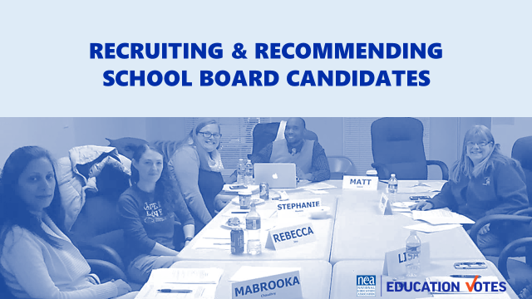  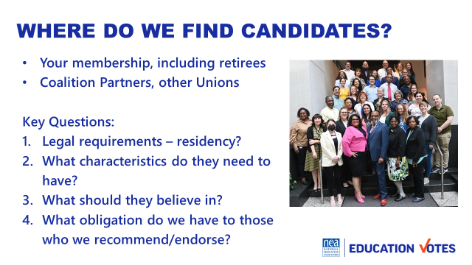  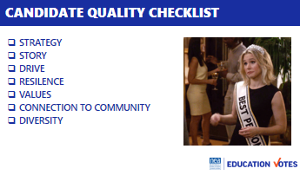  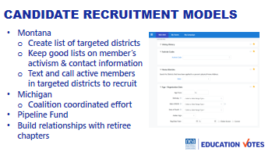  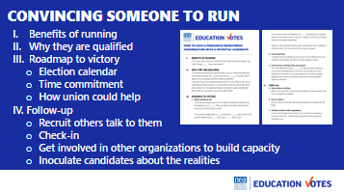  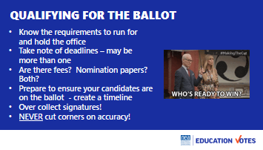  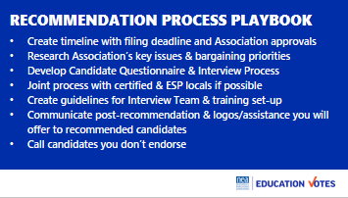  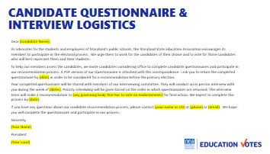  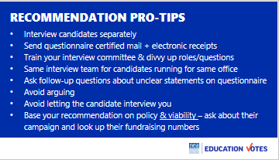  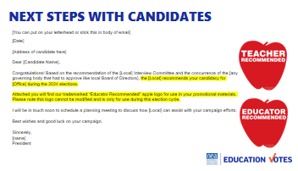  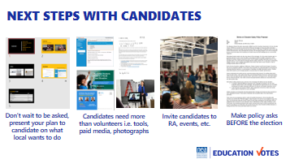  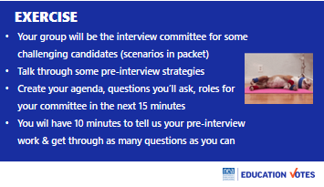  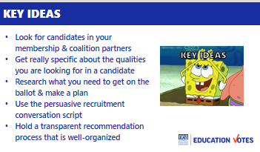 | Candidate Quality Checklist  Sample Persuasive Conversation  Overcoming Common Objections  Exercise Roleplay Scenario | Introduction 5 min  - Let’s face it, not all of our locals are going to be able to run really robust school board campaigns. One of the most basic things we can do in our school board work though is making sure we run a transparent recommendation process and encourage quality candidates to run.  - So where do we find those candidates? Where do your best candidates come from?  Candidate Recruitment 7 min  - Here are some key questions to think about as you start brainstorming potential candidates.  - Let’s spend some time talking about the characteristics. What do folks think is the most important quality? Shout it out.  - Here’s a simple candidate quality checklist to consider for candidate recruitment that is included in your handouts.  - Strategy (right seat/right party) - our first consideration is strategy. You don’t want to run the super liberal democrat in the incredibly conservative district. You also don’t want your members to run against incumbent who has been friendly in the past.  - Personal Story – you want to make sure your candidate has a compelling story if you can. It will make the campaigning work easier.  - Drive & Resilience – These may the most important qualities given our current political climate right now. You want someone who is going to work their head off and listen to you. And you want someone who will be able to get back up when they get attacked.  - Values – this may seem obvious but if you’ve ever had a candidate turn their back on you when they got into office, you want to really think about their values and character. And look for those examples where they have demonstrated integrity in hard situations.  - Connection to Community – you want someone who is connected, your campaign will be easier if they have relationships established already.  - Diversity – this is so important, 90% of school board members are white men and our communities aren’t 90% white men. Recruit folks who reflect the district and will represent marginalized communities.  - Models – A couple of states have tried to institutionalize how they do candidate recruitment. Here are those examples  - In Montana, they’ve used data to recruit from their membership from VAN and do direct phone outreach to individuals based on scores and activist codes  - In Michigan, they use a coalition model where different organizations will divvy up districts and recruit out of their membership. This is smart b/c then you don’t have an NEA member running against a UAW member in the primary. We work with a national group called Pipeline Fund that is setting up similar coalition models across the country.  Convincing someone to run 5 min  - Okay, we’ve used all those tools to find the person that should run for our school board. How many folks know the perfect person to run school board, but you know they will tell you go kick rocks if you suggest it? Moms for Liberty has definitely made serving on school boards not so appealing so we wanted to share some resources on how to convince someone to run.  - Why do you think folks say no to running for office? Shout them out.  - Just like we have outlines for an organizing conversation, we need to go in with a roadmap on how to persuade someone to run for office. Here’s a great outline to use as you approach people you have to convince that they are qualified. Which unfortunately, Emily’s List data shows us that is usually women candidates.  - In your packet/online folder there is also an overcoming common objections sheet with responses to use to some of the most common reasons people to tell you they won’t run.  Getting on the Ballot 2 min  - We aren’t going to spend a lot of time on this, but we wanted to include some information about getting on the ballot.  - How many states here require signatures? How many do you just have to pay a filing fee? How many of you have no idea?  - Your first step is finding out what you need to do to qualify and start working on a timeline with the candidate if signatures are required.  - Another alarming stat, 73% of school board races were uncontested in 2024- meaning if you just got your person to file/qualify, you won!  Candidate Recommendation Process 7 min  - Once you’ve recruited candidates, you want to start your recommendation process. Here are few things you need to prepare for that.  - Make sure you know your timeline. Not just filing deadlines, but if you need to have your whole rep assembly vote on it – will you have a quorum at that meeting. What happens if you don’t. Think through your plan Bs and also be prepared to do turnout if you need to get those approvals with certain thresholds of support.  - Check-in with your leaders so you know what are the big issues your members are dealing with and what bargaining priorities are coming up. You want to make sure you have questions that address those issues on your questionnaire. We have a sample questionnaire in your packet.  - Clarify your interview process. What dates will you be interviewing. What questions will the team ask in the in-person interview.  - Also be prepared with how you will communicate with candidates after the interviews. Be ready to share logos and have planning meetings.  - Here’s a great example of template to distribute your questionnaire and schedule your interviews. It highlights deadline for questionnaire, tells them when the interviews will be, lays out that there’s incentive to turn questionnaire in early b/c they get first picks on time and then explains how recommendation are decided. If you are not a full-time release president or if you are a very busy full-time release president, it’s a good idea to identify a staff point of contact that they can call during workday.  - Here’s some more tips for your recommendation process.  - You will want to do these interviews separately, not as a big forum. Candidates will be more candid with a one-on-one.  - To make sure you have transparent process and cover your butt that a candidate can’t say they didn’t get your questionnaire, send it certified US mail and request electronic read receipt on email. Some locals we’ve seen just send candidates a notice of how their process works and then it’s on the candidate to request questionnaire.  - Another thing to make your process fair is to have the same people interview all the candidates for the same office.  - You don’t want to start arguing with candidates during these interviews.  - You also don’t want to let them control this meeting where they start asking you more questions than you are asking. Having a list of questions prepared and note-taker will make these interviews go smoothly.  - You want to base your interviews on policy and electability. Have someone look up fundraising numbers and make sure a couple of your questions are about their campaign.  - Once you have your recommendations, make sure you plan how you will communicate with candidates. We have some sample talking points for the candidates who do win your endorsement and for those who don’t get it in your packet. Here’s a great template that includes high res logos for them to use and talks about setting up a planning meeting.  - Here’s a slide deck from one of those planning meetings where the President and UniServ Director outline what support they wanted to offer including a budget for voter contact that the local wanted to pay for. Giving candidates a check is not our favorite. You can’t guarantee it’s spent of voter contact, this way we know our PAC money is being spent effectively.  - Candidates need more than volunteers. These are all in-kind contributions so make sure you coordinate with your GR staff on how to do that, but think about what other resources you could offer to make your endorsement mean something.  - Make sure you are inviting candidates to rep meetings and events.  - This last image is maybe one of the most important next steps. You want to have a policy ask and you want to talk about this before Election Day. This is a picture of a memo that a local prepared on salary increase proposal where they showed the data on how many folks were behind on their step increases and where the money could come from to pay for the raises. They also gave candidate tested message on increasing salary to show voters were supportive. It wasn’t a quid pro quo on you need to do this to get our endorsement. It was a constant part of the conversation, the questionnaire, and conversations with members. They made it more tangible with a clear plan and talking points for the candidate to use. He made good on his promise bc it was a central part of his campaign from the very beginning.  Exercise 56 min (2min explanation, 15 min prep, 10 min present x 3 = 30, Debrief 3 min after each group)  - Here comes the fun part. We’re going to split up into 3 groups with 3 different, but very common scenarios we face during candidate recommendation processes. We know those interviews and decisions look very different across the country, but whether you are staff or a governance leader – you should be prepping folks to be prepared for these situations or training up your replacement if this is a process you normally oversee as a member leader.  - Each group will have their own problem candidate you can read in your exercise scenario. We want you to prep with your group for 15 minutes. If there are things you think that should happen before the interview to help solve your problem, talk about those & make sure you mention them when it is your time to present.  - You will want to make sure you have an interview Chair and just like a real process, we wouldn’t just want the chair to be the only one speaking. You will be the ones developing your agenda & deciding which questions to ask.  - Each group will have 10 minutes for their interview in front of the whole group, and we’ll do a quick debrief after.  - Everybody got it? 1s will be here..Let’s count off 1-3.  Key Ideas 3 min  - Look for candidates in your membership & coalition partners  - Get really specific about qualities you are looking for  - Research what you need to get on the ballot & make a plan  - Use rap for persuasive conversation  - Hold transparent recommendation process that is well organized | How do we recruit candidates?  What should we be looking for when we recruit candidates?  Participants will recognize qualities for successful candidates and learn from other states on their models.  Participants will participate in a mock recommendation process with challenging scenarios
4:25 – 4:30 Ellen |  | 10 Minutes Ending it Right
   |  | - Questions, Connections, Reflections  - Housekeeping announcements  - Evaluation  Notes for next time:  Less time for interviews and more time to prep  Debrief immediately after each interview then large group debrief (bring your best question to the large group) | What questions do I have? What do I need to know?  Participants will get opportunity for feedback and leave session with what they need to know for tomorrow.
4:30 – 5:00 |  | Choice Networking
5:00 ADJOURN

