Facilitator Agenda: Winning School Board Campaigns Day # 2
General Materials Needed: |  |  |  | Room Set-up:
1 Set of Handouts per Person  Name Tags or Name Tents  Room signs, sign in signs  Highlighters – 3 colors  Pens and Pencils | Chart Paper – self-stick kind  Markers- Mr. Sketch - Non-Permanent  Post its  Wi-Fi |  |  | Round Tables for Participants – cords at each table  Long rectangle at back for Facilitators  No Podium – table with projector large enough for laptop  Projector, Screen, Microphones, and Speakers  Carousel stations and reporting stations around the perimeter  50 people Max
Key Outcomes for Day 2
- Ground our election work focused on relational & issues that matter to our communities
- Understand key principles for budgeting/fundraising & develop list of best practices
- Understanding of the phases of an electoral campaign
- Learn to develop effective member engagement plans that increase volunteer recruitment and voter turnout
- Review most effective voter contact methods

Content and Facilitator Assignment Overview Day 2
8:30- 8:40 Reentry  8:40 – 9:30 PAC Fundraising & Budget  9:30-12:00 Voter Contact  10:30-10:45 BREAK  12:00-1:00 LUNCH |  |  | 1:00-2:15 Building the Team  2:15-2:30 BREAK  2:30-3:00 Team Communications Exercise  3:00 – 4:15 Volunteer Recruitment  4:15-4:30 Ending It Right  4:30-5:00 Choice Networking

Time, Facilitator and Slides | Resources | Instructions, Activity and Debrief | Essential Questions and Key Outcomes
 | Charts, handouts, articles, materials, videos | What are you saying, what are they doing, what questions will you use to guide learning and make clear the important points  Include an estimate for how long each section of the learning will take  Include Key points. | What question(s) does this section answer?  What will participants know or be able to do?
8:30 – 8:40 Ellen |  | 10 Minutes Welcome back
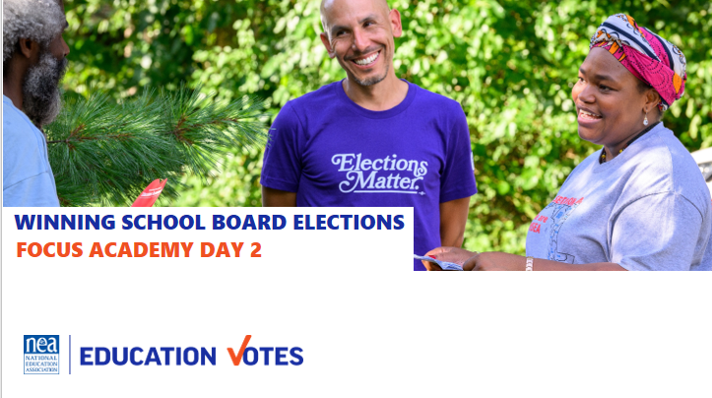  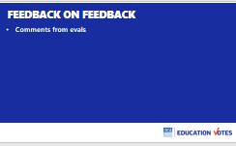  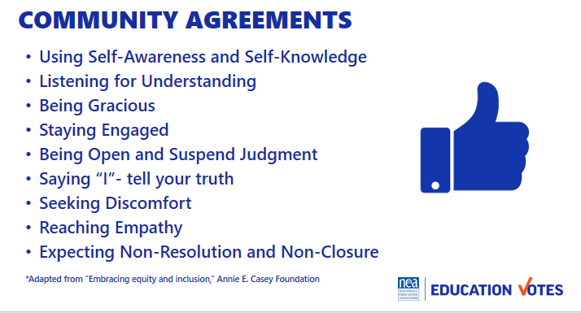  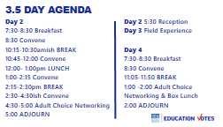   |  | Reentry  Feedback on Feedback  Agreements Review  Agenda Review  Today’s Outcomes | How are we feeling and what are we covering today?  Participants will re-enter the learning environment.
8:40-9:30 Meighan |  | PAC Fundraising & Budget
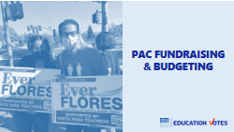  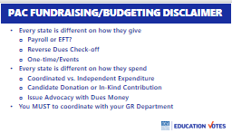  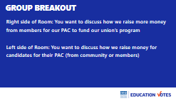  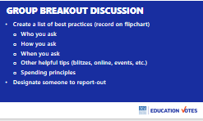  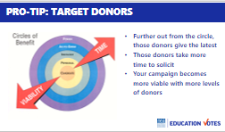  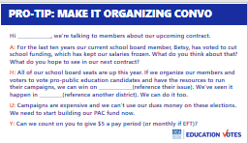  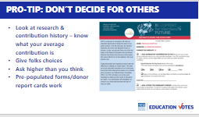  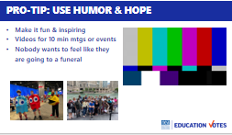  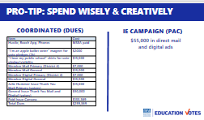  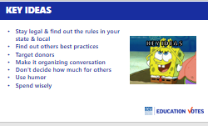 |  | Introduction 1 min  - But before we can talk about voter contact and member organizing, we need to talk about how we pay for it  - There’s probably different schools of thought if you should start with the program you want to run and figure out where you can raise the money, or start with how much money you run and use that to determine what your program looks like  - Regardless, having a paid program can be a real game changer either for your union’s program or your candidate’s campaign  Disclaimer 5 min  - Your states are all very different. How many of you raise money on payroll? How many of you don’t have payroll anymore, but members give monthly on credit card or bank draft?  - How many of you have reverse dues check-off where members have to opt out of PAC so you never worry about money (IL, MN)  - How many of you don’t raise PAC money at all and thinking about going to the bathroom.  - On the flip side, the spending in all of your states is very different. In WA, the contribution limit can be as low as $500. It’s $6,000 in Maryland. Anybody know theirs?  - Some states, just give to candidates or may in-kind their contribution by paying for a mail piece or digital ad. Some states have such large PACs, they also have an independent expenditure campaign that doesn’t have limits, but candidates can’t know about. There’s also states that have figured out you can use dues money as issue advocacy to share awesome things or not so awesome things politicians do without mentioning an election.  - So we can’t really have a fundraising/budgeting workshop that says this is how to do it. Plus that wouldn’t be much fun either.  - In this room, we have a school board member. We have staff that have run for office or are married to elected officials. We have folks that have raised thousands of dollars, and leaders who have cut off candidates and said no more yard signs. We’re changing the way we spend our money. So you are going to lead this workshop.  Group Breakout 30 min  - We are going to split into two sides of the room. If you are interested in talking about how we raise more money for the union’s program come to the right side of the room. If you don’t have access to a local PAC, or don’t need one and want to talk about how we raise money for candidates either from our members or community, come to left side of the room.  - Split into groups of __________.  - This is your assignment. We want a best practice list, here’ s a few questions to get you started. Write on flipchart. You are going to present it. Once you’ve talked about all the things we should be doing. If anyone is having a challenge. Maybe you can’t get your building reps to give, or you have a candidate that is refusing to raise money and signed an affidavit they won’t spend more than 1k. This is your opportunity to ask for help from your friends.  - You have 20 minutes to make your lists  - Report –out 10 minutes  Pro-tips 10 min  - Those were great best practice lists. Here’s a few extra pro-tips to throw in there that work whether you are raising money for our PAC or raising money for a candidate’s campaign  - Target donors. This is fundraising donor circle that we candidate trainings that holds true for member fundraising. Always start with folks with immediate relationship. If you can’t get your building reps to give, there’s good chance those folks aren’t going to be asking other folks. Same goes with candidate’s immediate friends and family. The farther you go out in the circle, the longer it takes to raise from those folks, but the more diversity you have in your donor base like this, the more viable your campaign will be.  - Has anyone seen this AHUY acronym? What does it stand for? You can see that in this PAC ask. We are going to talk organizing conversations more in the afternoon, but it’s important not forget this when it comes to making money asks. When you go up to someone and ask for money without a meaningful conversation on the why, you may get some pity donations, but most folks will not give you money.  - I used to have one local leader that always wanted to ask folks for a dollar. Other locals raised so much more money from fewer people. Small donations can add up, but give people a choice. You have no idea about someone’s financial situation. If you want to know where to start, look up your average per member. What I learned was to make my middle amount higher than my average. Folks seem to choose that middle amount, but you can see on the form – there was blank space to write their own and amount slightly higher and slightly lower. Another trick we learned was using pre-populated forms. So many folks think they give b/c they gave that one time at the RA. It’s also why you see donor records or report cards in email from candidates.  - This is my favorite pro-tip and what helped change the culture around fundraising in Maryland. You need to make it fun and inspiring. I was in charge of videos and this was one I made for_________.  - You can also do this with silly costumes, if it’s for a candidate, I’m sure there is a weird thing like we have conventions where they can do something silly.  - And make it fun for the folks helping you fundraise, this was my PAC Captains at my last NEA RA. We got them all boat captain hats and celebrated them by buying a ticket for the Chicago architectural boat tour. This committee was always the biggest b/c folks felt like the work they did really mattered and was celebrated.  - Last but not least, spend this money wisely & creatively. This was a sample budget for a county with 500k where we needed 119k votes to win. It was a make it or break it for the local. They had been frozen for years. They didn’t have the PAC money they needed, but they had 3 million in an emergency reserve in dues. You know what happened when Meighan found out there was 3 million dollars? We got on the phone with lawyers & GR Director, & consultant and figured out other ways we could be using that money for issue advocacy, a really robust member program where they were served ads and mail, and we had a paid canvass where folks didn’t talk about candidates but talked about importance of voting in key precincts we needed to turn out. They flipped to a majority and restored all of their steps within the first four years of the new administration.  Key Ideas 4 min  - Stay legal & find out the rules in your state & local for spending and fundraising  - Find out others best practices  - Target donors  - Make it organizing conversation  - Don’t decide how much for others  - Use humor  - Spend wisely | What are the best practices for raising money for our PAC? If that’s not a possibility or needed, what are best practices for increasing candidates’ capacity to fundraise?
10:20-10:35 BREAK BUILT INTO NEXT SESSION
9:30-11:30 pm Beth & Monet |  | Voter Contact WITH BREAK BUILT IN
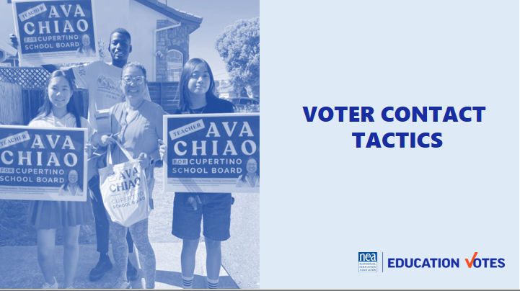  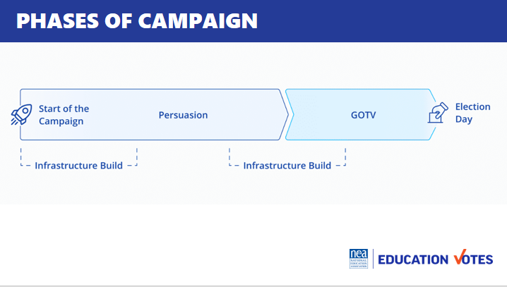  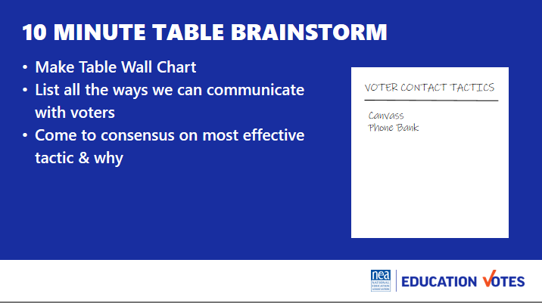  THREE MOST EFFECTIVE SLIDE  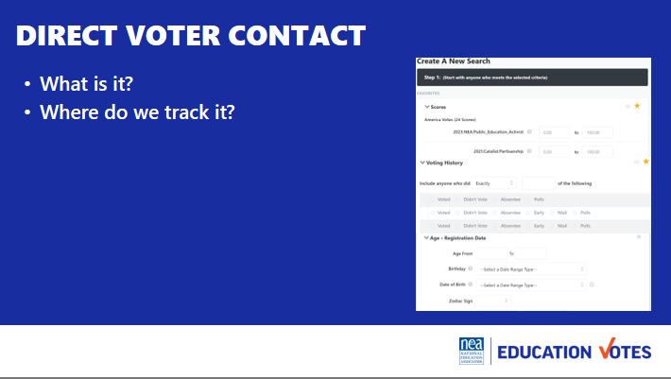  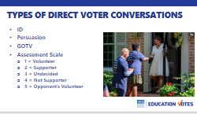  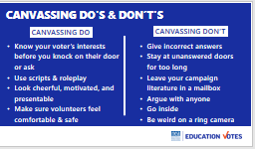  BREAK GOES HERE  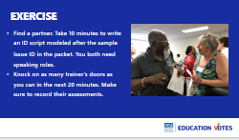 | Issue ID Script  VOLUNTEERS FOR DOOR KNOCKING - Your assignment is to know your voter type, AND draw your door on Chart Paper  1 supporter, wants to volunteer, wants a yard sign – Jackie, Melissa  2 voting yes –Adia, Hedy  3 undecided - Ellen, Meighan  4 voting for your opponent – Beth, Yvie  5 volunteering for your opponent - Monet | Introduction 5 min  - So yesterday we spent a lot time talking about preparing for the election. Today we are going to spend the rest of the day talking about what we’re going to be doing during the election - communicating with voters.  - Let’s start with some important lingo  - Campaigns are really broken up into 2 phases. The first is your ID/Persuasion Phase and the second is GOTV or get out the vote. In your ID/Persuasion phase, this is where you are identifying your supporters and persuading your undecideds. This is really where you have to make your case to voters on why they should support your candidates  - In GOTV, this is where you switch over to the types of voters you are talking to. In GOTV, you should have identified enough supporters to reach your vote goal and you are pushing them to mail their ballot, early vote, or head to the polls on election day.  - In both cases, you see infrastructure build. What do folks think that means? (volunteer recruitment/PAC etc). We’ll be spending the afternoon talking about how we build our volunteer armies.  How do we communicate with voters 25 min  - For 10ish min at your table brainstorm list on flipchart all the tactics we could use during our election to communicate with the general public and what you think is the most effective & why.  - Report out around the room  - Highlight most effective tactics  - Relational  - Canvassing  - Social Pressure  What is Direct Voter Contact? 5 min  - Ask them what they think it is  - Definition: It’s two-sided and targeted communications with voters where you keep track. Not yard signs, but primarily canvassing, phone banking, events, and texting.  - Keeping track is key. This is why you need a voter file. Every NEA affiliate has access to VAN, it’s the Voter Activation Network which is our online voter file database. It has a tab for members and voters. This is where you can pull lists for your canvasses, phone banks, etc. Your state has its own administrator that can get you access. If you can’t access VAN for whatever reason, there are a couple of work-arounds. 1. If you are working with a well-resourced candidate and you are able to coordinate then you could use their VAN. 2. The Board of Elections sells voter reg file for a small fee. It’s not ideal, but we have seen folks get creative. Get yourself access to a list for Direct Voter Contact. If you need someone to troubleshoot with, Meighan is no longer on probation at NEA and loves to help with list access issues.  Types of Direct Voter Contact Conversations 10 min  - There are three types of conversations you’ll have with voters You have sample issue ID script in your folder/packet.  - Here’s the purpose of each script:  - Your ID script is where you want to ask voters if they know who they are voting for.  - Some campaigns group ID and Persuasion scripts together. You make take a longer persuasion script back to your undecideds closer to GOTV. Sometimes it’s a better use of time to go find more voters than trying to find your undecided voter again.  - Your Get Out the Vote (GOTV) script is where you go back to our supporters and get them out. There are some key pieces in this script based on more of that Analyst Institute research like asking them when and how they plan to vote that will increase turnout. You also might end up doing blind GOTV if just turning out base voters is going to help your candidate. Most campaigns have to do this when they don’t have enough IDs. You may have a couple of different GOTV scripts if it’s a ballot chase or early vote or Election Day.  - You want to make sure you are asking folks to volunteer, after you make an ID. One of the biggest mistakes we make is start doing volunteer recruitment without making an ID first. How likely are you to volunteer for someone you don’t plan to vote for? We will talk about using a union rap for our member volunteer conversations this afternoon.  - We also make assessments on these conversations b/c you ultimately want to be tracking these to get back to that vote goal we talked about. This is the most used scale:  - 1 supporter, wants to volunteer, wants a yard sign – Jackie, Melissa  - 2 voting yes –Adia, Hedy  - 3 undecided - Ellen, Meighan  - 4 voting for your opponent – Beth, Yvie  - 5 volunteering for your opponent - Monet  Canvassing Do’s & Don’ts 5 min  - Here are some key do’s & don’ts when you go canvassing  Exercise Time Estimate: 45 minutes (10 min script write, 20 min knock time, Debrief 15 min)  Now it’s your turn. Everyone is going to partner up. Pull up the ID/Persuasion script and take 5 minutes to make it someone’s campaign. Both of you should have speaking role in the script.  Once you feel ready. Knock on as many trainer doors as you can. Make sure you record their assessment.  Debrief:  - How did that feel?  - Ask about trainer assessments, did they get them right?  - Tips from each person at the door  Tips to mention in debrief  - If it’s a 4 or 5, get out of there don’t waste your time  - Get contact info, especially phone & emails  - Go in pairs  - Don’t bother w/No Soliciting people  - Don’t touch mailboxes  - Leave lit  Other Ideas to be sure to bring up in the debrief:  - Exit strategies  - Know the local election rules  - Mail in ballot rules  - Date of election  - How do you handle No soliciting signs  - Be nimble with your script  - Make sure you ask supports to be volunteers  - Be sure to sure update phone #’ and email of supporters  5 min Key Ideas  - Use research like AI to choose effective tactics  - Direct voter contact is our primary mode b/c it’s cheapest bang for our buck  - Types of conversations are ID, Persuasion, GOTV, & Volunteer  - We keep track and assess voters to get us to our win number | What are phases of an election?  Why does this matter?  Participants will understand phases and how this impacts who they are talking to and what they are saying.  Remind participants not to use acronyms or “ed speak” when creating their wrap or canvassing voters. Educators have so much jargon that everyday voters do not know or that varies from district to district.
11:30 – 12:00 pm Adia |  | 30 Minutes Winning with Members
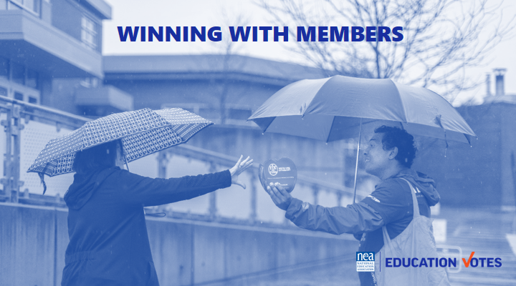  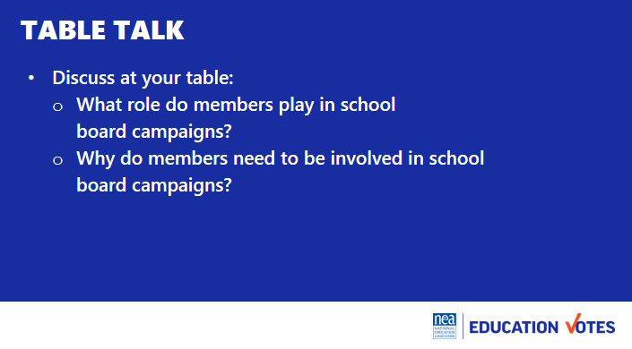  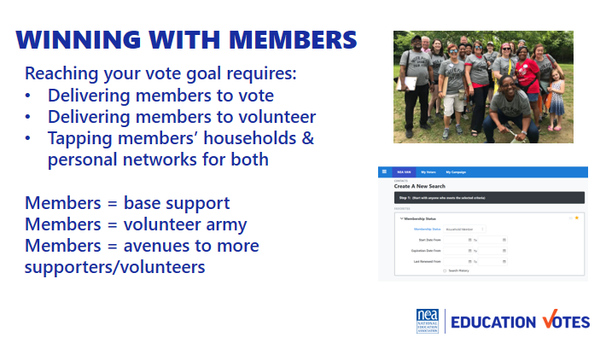  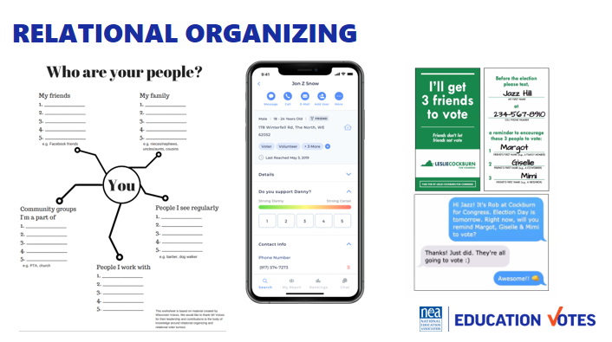  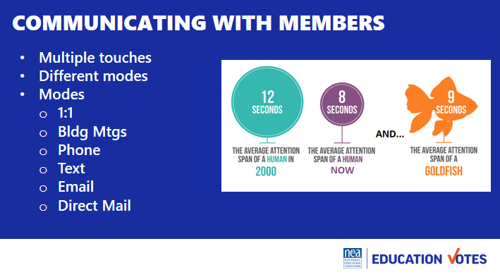  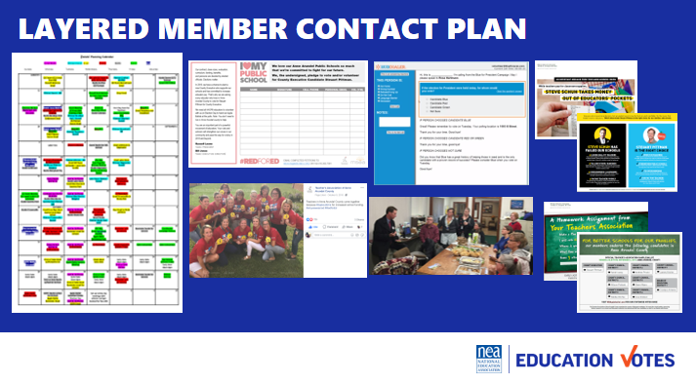  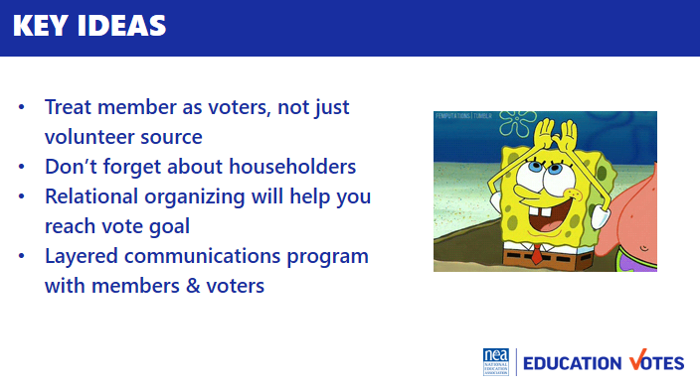 | Communicating with members chart | Introduction 10 min  It’s really easy in campaign work to do stuff just to get it done versus having a member-driven campaign. For the next 8ish minutes, at your table talk about:  - What do staff need to do to get your members to engage in school board elections? What does governance need to do?  - Why do members need to be involved in school board campaigns?  Purpose of the table talk is to get participants to understand:  - Members need to do the work around school board elections because they directly impact their workspace. They are closest to the impacts of school board elections and are in a unique and trusted position to explain to community members why this is important and why others should care.  - Educators are in a unique position where they can have a say in electing their boss. We must remember that it is an avenue of power.  Debrief 5 min  - Why should our members be leading this work?  - We need to always keep this at the forefront. This is their union and if they want to build a strong organization, they need to be leading this work.  - It’s important to know who your people are – leaders, mobilizers, activists – this knowledge can help you determine how they can be most impactful.  Engaging members 3 min  - Another thing we need to remember is that our members are more than just volunteers. They should be the first folks we think of when we start thinking through our vote goal counts.  - They also make the most incredible volunteers. Most voters do not vote in school board races so to have an educator at their door, or a polling place to tell them who the recommended candidates are is powerful.  - Our members are connected, and another thing to realize is we can talk to the household members with dues money too, and we have those folks listed in the VAN.  Relational Organizing 2min  - Relational organizing is the most effective method of voter contact. Folks listen to people they know & trust more than a TV commercial or a stranger at their door. Building a relational organizing program into your work with members is incredibly effective.  - You can use one of these old school worksheets, pay for a fancy app, or use hustle to create a vote tripling program. The big key is you are building accountability back in time during your phone bank or canvass where folks are also taking time to text their network.  Communicating w/members 5 min  - How many times do you think a voter needs to be reminded? (used to be 7, now it’s closer to 13)  - Our members prob don’t need 13, but once you start looking at your part turnout, you’ll have a better idea. A good rule of thumb is at least 3, they need to know who the candidates are, they need to know why this is important, and they need a reminder before GOTV.  - You don’t want to just communicate the same way, especially if it’s just email. Mixing up a mail piece, phone call, text, or building visit are great different modes of contact for member program.  - It’s important to layer the communication throughout your campaign.  - Here’s an example from a local where you can see their calendar and each of these different colors represents a different mode of contact.  - They started with an ID petition where members got an “I love my public school” t-shirt if they took the voter pledge.  - On Tuesdays every week, schools would take pictures and have visibility days in their shirts, and we posted them on Facebook.  - The GR committee had weekly phone banks to call through the 5k members that lived in the county and what was great about these events is the candidate would come out and thank them while they had the best takeout we could find.  - We also sent every member 3 pieces of mail – one bio piece in September, one persuasion candidate comparison piece in early October, and one GOTV piece right before early voting started.  If time allows – Ask the people in the room to share examples of this type of layered contact.  Key Ideas 5min  - We need to treat members as voters, not just volunteers.  - Don’t forget about householders.  - Relational organizing will help us get to that vote goal number.  - We need to create layered ID, persuasion, GOTV program for our members just like we would with the public. | How do we talk to members to get them to vote and volunteer?  Participants will understand they have to have organizing conversations to mobilize members, they will understand the types of contact, and importance of layered communications.
12:00 to 1:00 LUNCH

1:00– 1:45 pm Monet |  | 45 Minutes Volunteer Recruitment
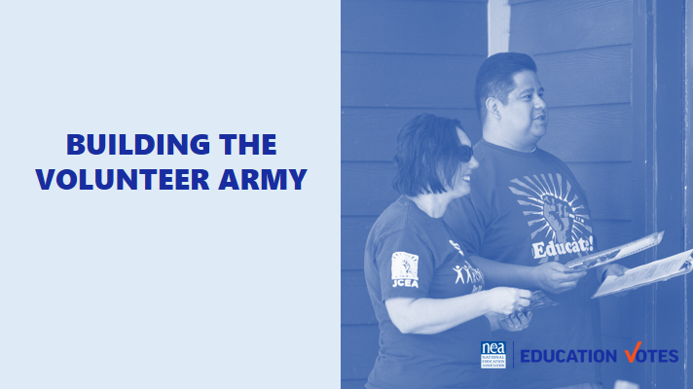  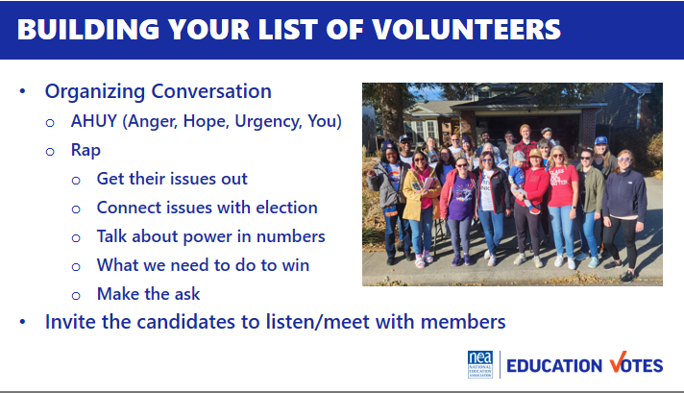  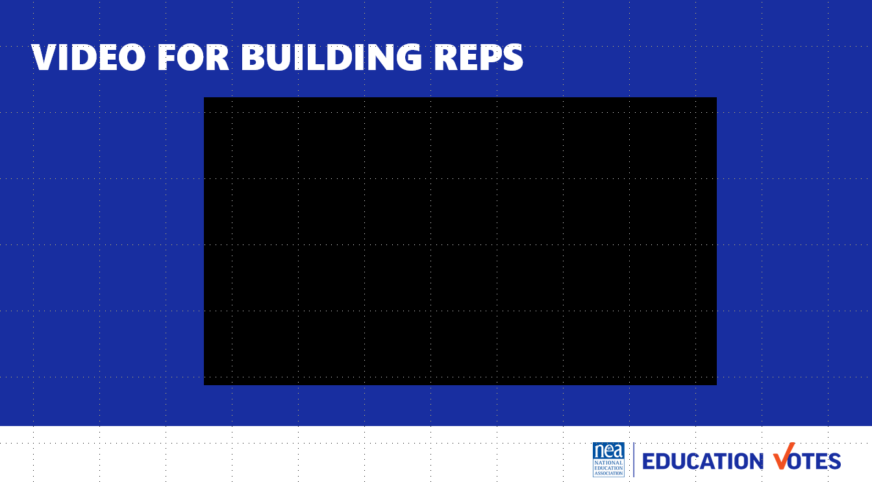  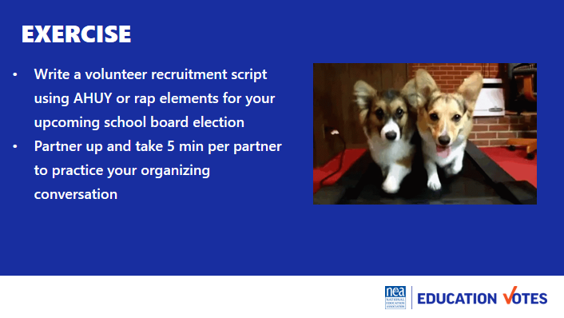  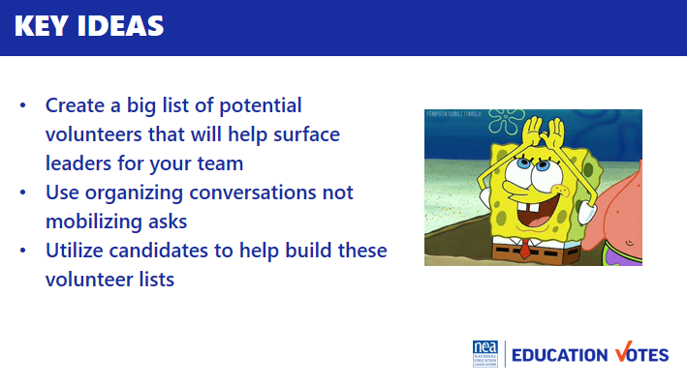 | AHUY Handout | Introduction 2 min  How do we actually talk to leaders about this work? Like we said earlier, our role is not necessarily to do all the asking and relationship development, but to know how to support leaders and mobilizers in how to build these networks. Before we find the leaders and mobilizers, we need to build our list of volunteers through organizing conversations.  Let’s review how organizing conversations can work.  Organizing Conversations 13 min  - Our first step is to build the potential volunteer list, this will help you surface the leaders and identify folks for your team  - It’s important that these are organizing conversations first, not mobilizing asks  - There’s two popular models to have these organizing conversation  - Labor Notes developed this acronym AHUY to help your remember how to have this conversation  - Anger – this is where we try to tap into emotion to get them fired up about making a change  - Hope – this is where we offer solutions on how we could make the change  - Urgency – this is where we talk about how this needs to happen now  - You – This is the ask of them  - This is more of a traditional Union Organizing Rap from the AFL-CIO Organizing Institute, but you can see it follows a similar thread as AHUY  - Get their issues out​  - Connect issues with election ​  - Talk about power in numbers​  - What we need to do to win​  - Make the ask​  - One important element as you start building your volunteer list is to make sure you are involving the candidates listening and meeting with members. Have them at your RAs, visit phone banks etc.  - Here’s an example of how that local used their Vote/Volunteer Pledge Petition using building reps to create their potential volunteer list and training video they sent out to their reps (5 minutes)  Exercise 25 min  - Now it’s your turn, for the next 10 minutes write a volunteer recruitment script using AHUY or rap elements for your upcoming school board election. Then find a partner to practice with and we’ll come back together to debrief.  - 5 min per partner to make ask (10 min)  - Debrief 5 minutes  - How was that?  - Any partner do something great worth shouting out?  5 min Key Ideas  - Create a big list of potential volunteers that will help surface leaders  - Organizing conversations not mobilizing asks  - Utilize candidates to help build these lists | What do I say to recruit a volunteer?  Participants will write a volunteer recruitment script.  SUGGESTION: have them pull out their door knocking script- “Would you use this to recruit member volunteers? Why or why not? What would need to change about thsi? What would you keep the same?”
2:20- 2:35 BREAK is BUILT INTO NEXT SESSION
1:45-3:00 pm Jackie and Adia |  | 60 Minutes Building the Team WITH BREAK BUILT IN
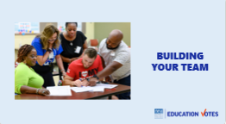  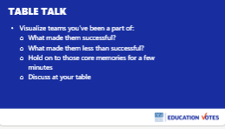  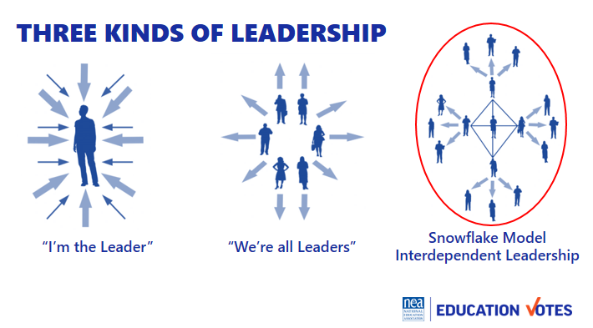  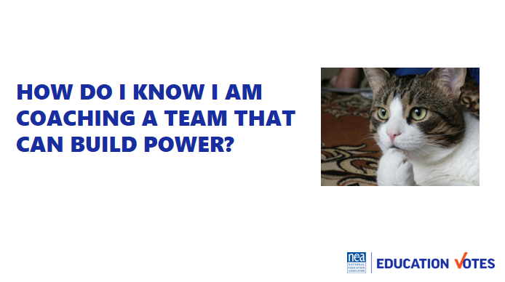  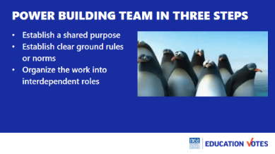  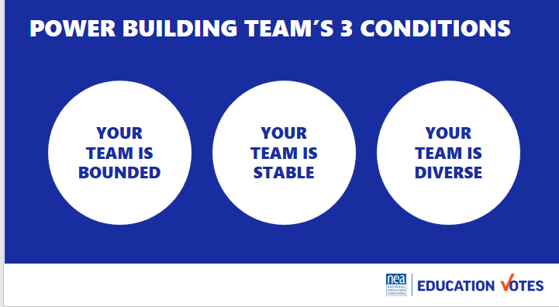  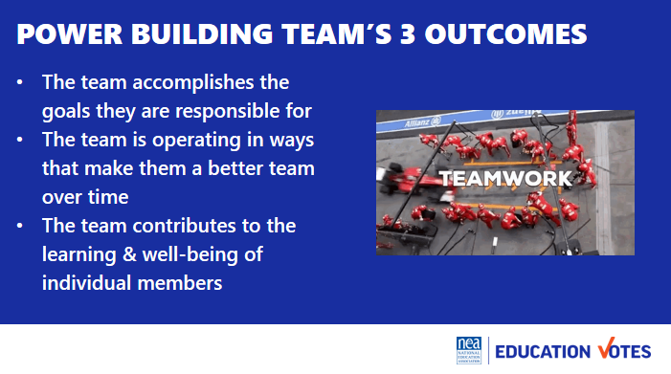  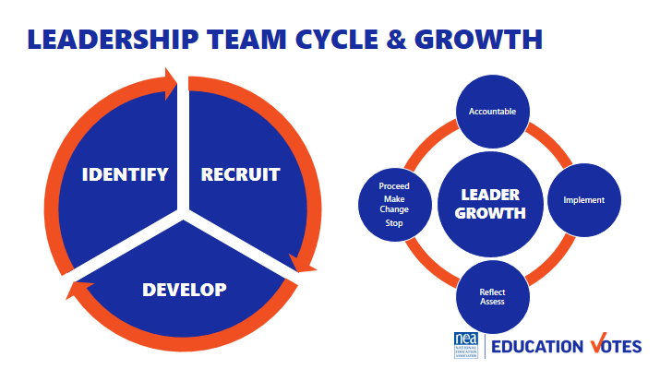  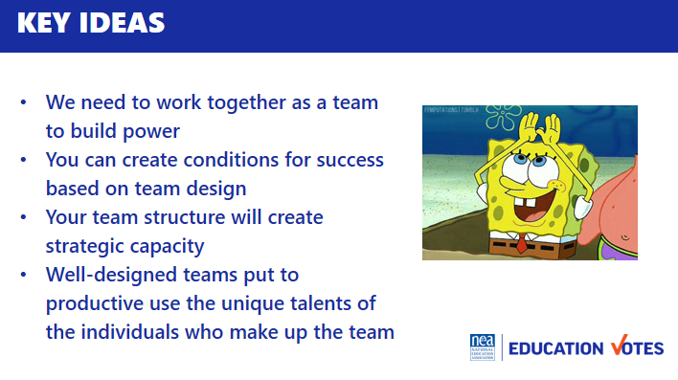 | Stick to the script: no war stories. Good vibes only.  DON’T say “you guys” instead  Party people  Tablemates  Y’all  Folks  Count off by 11  43 attendees  One groups of 3 | This section is super content heavy and needs to be broken up with another activity or something where we are not just talking at them for as long.  Table Talk 5 min  - Visualize teams you have been a part of  - What made them successful?  - What made them less than successful?  - Hold on to those core memories for a few minutes  Who are leaders? 15 min Intro & Group Work 15 min (30 total)  - Leaders are those who enable others to achieve purpose in the face of uncertainty.  - WE are always coaching away from single leaders/authorities towards interconnected leadership/ teams.  - We are going to spend time at your tables drawing your local’s Leadership Structure for elections. Let’s count into groups of Four people to a team Each team gets on piece of chart paper divided into 4 quadrants. Each person draws what their local’s leadership structure looks like using the following questions on the screen.  - How many leaders do you see doing leadership work?  - Is there one “leader” with everyone else linked to that leader like spokes to the hub of a wheel?  - Or are there lots of “leaders” linked with each other and with other members, multiple centers of coordination, inspiration and action.  - Are some people “followers” in relation to some “leaders” but “leaders” in relation to other “followers”?  - Or are some people always “leaders” and others always “followers”?  These teams don’t just magically happen. No difference than letters don’t just fall together for people to know how to read. The mechanics are there, but someone needs to teach the rules, and guide you to how to do it.  How do I know I am coaching a team that can build power?  What makes an effective team 10 min  - Establish a shared purpose. What are you fighting for and can you clearly articulate your common purpose as a team. It is clear, challenging, and matters. You have defined your goal, whom you work with, and the kinds of things you will do?  - Establish clear ground rules or norms. Your team sets explicit expectations of how you will work together: how you will make decisions, manage your time, and honor your commitments. What are things you will always do and what are the things you will never do. And how will you correct yourselves if you do them. Perhaps you most important norm is how you will make decisions. Steps that can guide effective decision making are: defining the problem, establishing criteria, brainstorming possibilities, synthesizing ideas, formulating options, evaluation options against the criteria, deciding. Some prefer deciding by vote; others, by consensus; others by delegating the decision to an individual.  - Organize the work into interdependent roles. Everyone should have responsibility for their own share of the leadership work needed to achieve the goal. Role requirements need to be clearly described. Team members need to assess their strengths and limitations, to the greatest extent possible, matching individual capabilities with role requirements. Because roles are designed to be interdependent, everyone has a stake in everyone else’s success. Team members speak up when they need help and get it. No one works in a silo that’s secretive to others. The team with diverse identities, experiences and resources brings more to the table than a team that is very homogeneous  Three Conditions 3 min  - Your team is bounded. It is clear who is on the team and who is not on the team. It is clear how new people can join the team and what is expected of those who must leave the team.  - Your team is stable. People commit to clear terms of service: regular meetings, length of time, etc. Your team is not a revolving door, never knowing who will show up.  - Your team is diverse. Your team has the appropriate diversity of skills, talents, viewpoints, and constituencies that will be needed to do a good job.  Three outcomes 2 min  - The team accomplishes the goals for which it is responsible.  - The team is operating in ways that make it better as a performing unit over time  - The team contributes the learning and well-being of individual members  Leadership Team and Leadership Growth Cycle 5 min  - As an organizer your job is to recognize and then help the team recognize that in order to build power, there is a continual identify, recruit, and develop cycle of new folks into the team.  - A team that does not continual recognize that one of their jobs is to continue to make space for new leaders, perspectives, diversity, and talents is a team that is not intent on base building and power development.  - Further a team grows in capacity to strategically achieve outcomes using everyone’s unique talents by attending to a continual cycle of implementation, reflection/assessment, proceed-change-stop, and accountability for the outcomes. We do a disservice to teams, the constituencies they are from, and the local as a whole when we don’t identify non-growing, non-power building teams. An even great disservice is done when we jump in to do it ourselves.  Key Ideas 5 min  - We can’t become powerful enough to do what we need to do if we can’t even work together as a leadership team.  - You can create the conditions that will increase the odds your team will work drawing on the craft of team design  - Structuring a leadership team creates strategic capacity: the ability to strategize creatively together in ways that produce more vibrant, engaging strategy than any individual could create alone.  - Well-designed teams put to productive use the unique talents of the individuals who make up the team.  Jackie- I think we should create mini scenarios here to put this in context. For instances, we’re talking about smart leadership structures- let's say you’re creating a canvassing recruitment committee. What roles might you need on that committee? What might you do to ensure accountability? How will you develop leadership in a space like that? Include some organizer math of # of buildings, # of reps, how many doors they want to hit, etc? | How do we build effective GR committee/ election teams?  What resources and support do you have in your state? Who can you ask for help and support?  Grants? GR?  Participants will understand how to coach and develop the leadership needed for an effective GR team to lead a campaign.
3:00 – 3:30 Jackie & Adia |  | 30 Minutes Team Communications Exercise
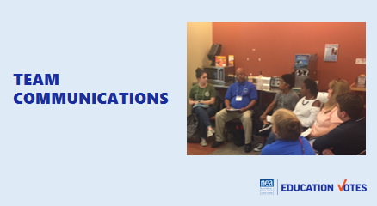  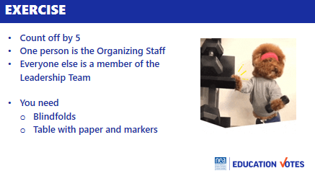  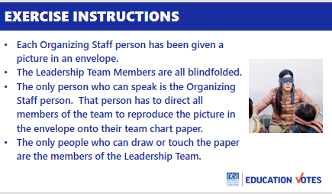  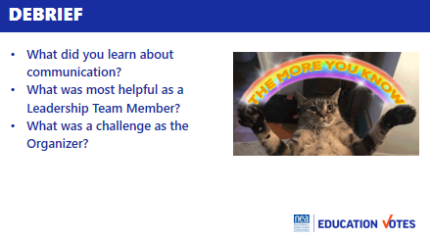  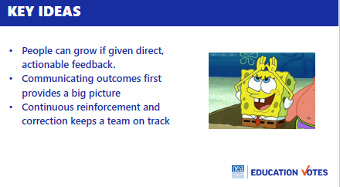 | Blindfolds & Envelopes with drawing  Divided into groups by school site visit teams.  Hedy announced the teams by table. | Team Communications Exercise  Intro and divide into teams 10  - We are going to be working in teams of 5 to 6. Go ahead and get settled in with your team. We had folks break up into their worksite visit teams instead, and this was super successful. They got mixed up, we made them put all their stuff away in order to do so and many laptops didn’t come back out, and it broke the ice with their worksite teams. Highly recommend.  - Now that you are settled, pick one person to be the Organizing Staff Person. The rest of you will be members of a leadership team.  - We are going to co-create a product in teams. On your tables are blindfolds paper and markers.  - If you are a Leadership team member you need to put your blindfold on so that you can’t see – no peeking out the side, and if you can see through it—close your eyes.  - Organizing Staff person- you have an envelope in your hand that contains a drawing. When we begin you are the only person allowed to talk to your team. They can not ask you questions, they can not talk to each other or to you or out loud at all. When we begin you will be able to open your envelope and your task is to direct every member of your team to draw as closely as possible the picture in your envelope. You cannot touch them in any way, only use your voice to direct. The only people allowed to touch markers or paper or to draw on the paper are the leadership team. You will have 10 minutes to make your masterpieces.  Group activity 10  Sharing of Pictures and Reflection on Learning as teams 5  - Take off your blindfolds. Take 5 minutes to discuss as a team the following questions:  - What did you learn about communication?  - What was most helpful as a Leadership Team Member?  - What was a challenge as the Organizer?  Group report-out 5  Key Ideas 5  - People can grow if given direct, actionable feedback  - Communicating outcomes first provides a big picture  - Continuous reinforcement and correction keeps a team on track
 |  | 45 Mins TOTAL – Leader/Volunteer Development Scenarios
Needs slides | Charts, handouts? | Intro 5 min  We’ve talked a lot about volunteer recruitment and building a strong team in the abstract, now let’s talk about what it could really look like. As we just saw, it can be incredibly difficult to get others to do a thing that they literally can’t see.  You know your win number, you know how many doors you need to knock, you know what messages will work on the doors- now you need to help your member leaders see it.  Scenario- 5 min introduction  You’re working to build an Election Committee in a local. This local has been lightly involved in elections in the past, recommending candidates through a low-key interview process run by the Exec Committee and donating a couple thousand dollars to their candidates of choice. They would communicate their preferences to members and encourage them to engage in the candidates’ campaigns, but did not organize walks or do any real turnout for walks.  This cycle, however, Moms for Liberty has shown up to ruin the party. They’re running for your BOE majority and have a slate in place. They’ve made the local news more than once for outrageous claims about pornographic books in school libraries and how “wokeness is hurting white students.” In your conservative community, you’re worried its getting traction. All the seats they are hoping to win are against incumbents that the local has previously endorsed and they’ve all been fairly good for educators during their tenure. Members are reaching out daily asking what The Union is going to do to keep these nutbars off our board.  Stats on the local:  - 16 elementary schools, 5 middle schools, 4 high schools.  - Wall to wall bargaining unit with all certified and non certified covered by the contract.  - Bargaining unit of 800, union density is about 75%, at least one solid certified and non certified AR in each building.  - Consistently across cycles, you see about 60% of members who live in the district voting.  - Your win number is 6000.  - Today is August 1st and election day is November 10th.  Discussion 20 min  - What roles might you need on your Election Committee?  - What accountability measures do you need on your committee?  - What are some ways you might create structures that develop the leadership skills of your committee members?  Debrief 15 min  - Roles answers to uplift or pull out if people don’t get there:  - chair,  - comms/social media captain  - walk logistics captain  - liaison to BOE members  - walk recruitment captain  - regional leads  - Accountability answers to uplift or pull out if people don’t get there:  - Timelines/calendars  - Scheduled meetings  - Roles  - concrete goals for number of walks/walkers and member turnout  - ensuring every agenda includes “next steps” with specific assignments and numbers  - Leadership answers to uplift or pull out if people don’t get there:  - 1:1s and debriefing 1:1s  - Launching a walk train the trainer (create toolkit or customize toolkit)  - Comms training for SM chair  Key Ideas | Participants make the connection between the abstract concept we talk about in “building a team” and real life structures that help teams thrive.  Participants are able to clearly articulate concrete roles that member leaders can take on to ensure the work gets done.  Participants are able to come up independently with the idea that goals and timelines (collaboratively built with member leaders) are inherently accountability measures.  Participants are able to clearly articulate concrete actions they can take to put tools and training into members’ hands so they can win their own races.
4:15 – 4:30 Ellen |  | Ending it Right
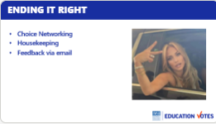   |  | Questions, Connections, Reflections  Housekeeping announcements  Plus/Delta at the Door | What questions do I have? What do I need to know?  Participants will get opportunity for feedback and leave session with what they need to know for tomorrow.
4:30-5:00 |  | Choice Networking
5:00 ADJOURN

