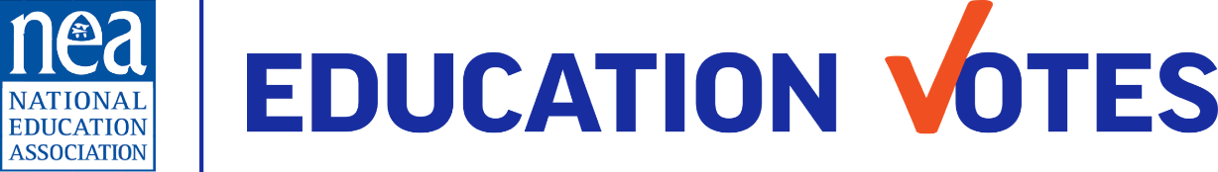
CAMPAIGN MESSAGE STRUCTURE
Below are three of the most widely use tools to structure your campaign message
Message Triangle:
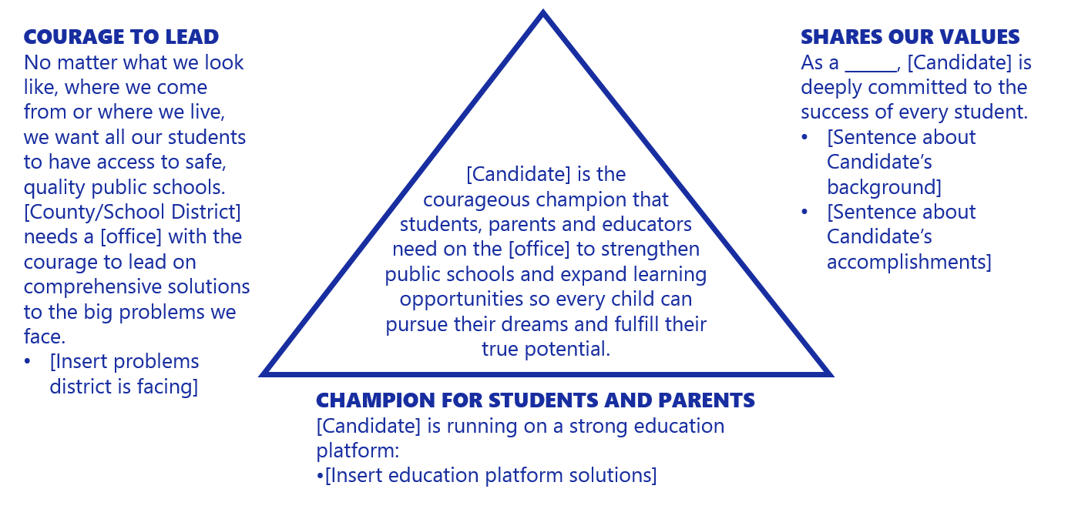
Tully Box:
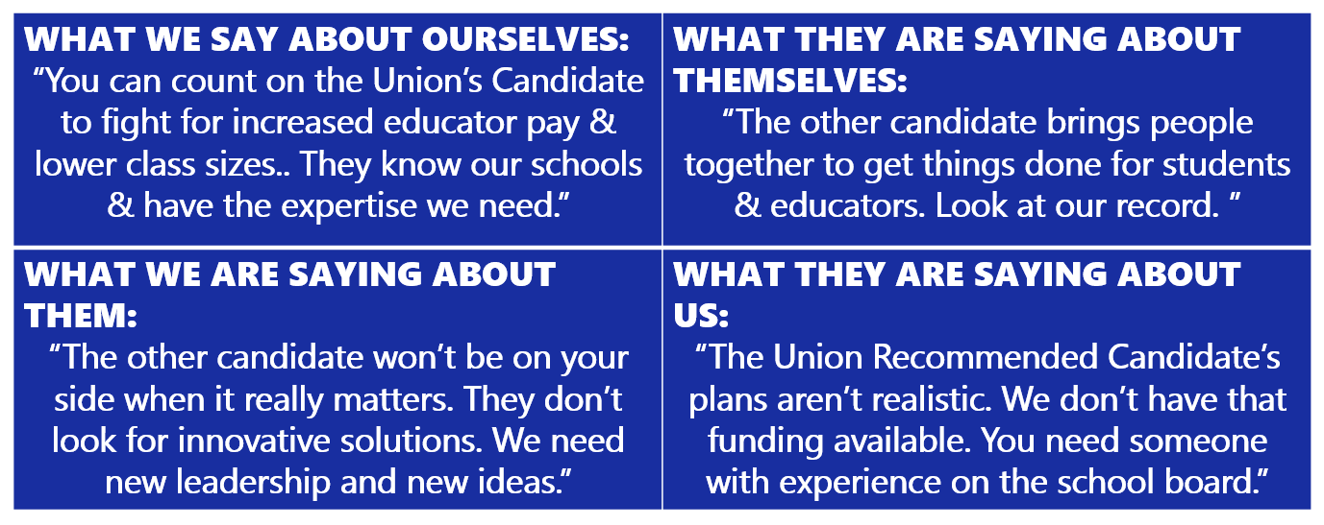

Race Class Narrative:
- Open with shared values that name (and/or show) race.
- Name villains, their motivation, and how they use strategic racism and scapegoating to divide and distract us while they harm us all.
- Uplift victories and/or everyday collective actions that solve problem(s).
- Describe a vision for what will change that includes everyone coming together to achieve it.
- Insert a specific call to action.
Example:
“From Up North to Milwaukee’s northside, we marched, protested and turned out in
record numbers to vote and pick the leaders that we trusted to fund our public
neighborhood schools. We see through politicians who spread lies, refuse to govern in our interests, and pass laws to silence our voices based on where we live and what we look like. That’s why we are coming together to elect leaders who’ll deliver the fully funded public schools that all our families need and deserve. Join us on Election Day to elect X to help deliver for our communities.”

