Facilitator Agenda: Winning School Board Campaigns Day # 2
General Materials Needed: |  |  |  | Room Set-up:
1 Set of Handouts per Person  Name Tags or Name Tents  Room signs, sign in signs  Highlighters – 3 colors  Pens and Pencils | Chart Paper – self-stick kind  Markers- Mr. Sketch - Non-Permanent  Post its  Wi-Fi |  |  | Round Tables for Participants – cords at each table  Long rectangle at back for Facilitators  No Podium – table with projector large enough for laptop  Projector, Screen, Microphones, and Speakers  Carousel stations and reporting stations around the perimeter  50 people Max
Key Outcomes for Day 2
- Ground our election work focused on relational & issues that matter to our communities
- Understand key principles for budgeting/fundraising & develop list of best practices
- Understanding of the phases of an electoral campaign
- Learn to develop effective member engagement plans that increase volunteer recruitment and voter turnout
- Review most effective voter contact methods

Content and Facilitator Assignment Overview Day 2
9:00- 9:10 Reentry  9:10 – 10:00 PAC Fundraising & Budget  10:00-12:00 Voter Contact  10:40-10:55 BREAK  12:00-1:00 LUNCH  1:00- 1:30 Winning w/Members |  | Hedy  Meighan  Sara & Beth  Meighan | 1:30- 2:15 Volunteer Recruitment  2:15-3:15 Building the Team (Break at 2:20)  2:50-3:05 BREAK  3:15-3:45 Team Communications Exercise  3:45 – 4:25 Organizing Successful Events  4:25-4:30 Ending It Right  4:30 ADJOURN |  | Beth  Vanessa & Jackie  Vanessa & Jackie  Sara

Time, Facilitator and Slides | Resources | Instructions, Activity and Debrief | Essential Questions and Key Outcomes
 | Charts, handouts, articles, materials, videos | What are you saying, what are they doing, what questions will you use to guide learning and make clear the important points  Include an estimate for how long each section of the learning will take  Include Key points. | What question(s) does this section answer?  What will participants know or be able to do?
9:00-9:10 Hedy |  | 10 Minutes Welcome back
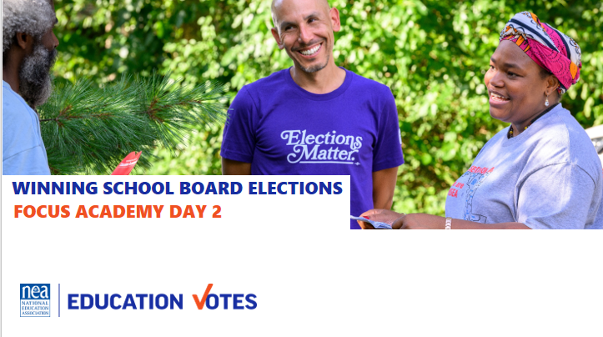  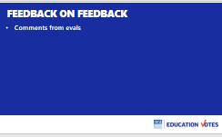  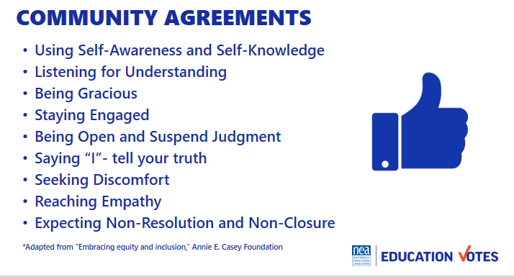  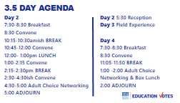  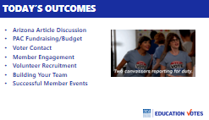 |  | Reentry  Feedback on Feedback  Agreements Review  Agenda Review  Today’s Outcomes | How are we feeling and what are we covering today?  Participants will re-enter the learning environment.
9:10-10:00 Meighan |  | PAC Fundraising & Budget
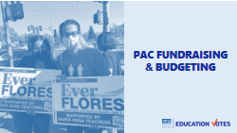  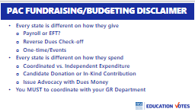  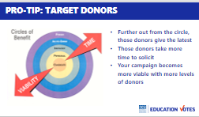  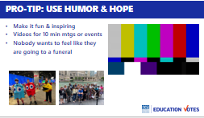  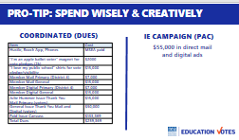  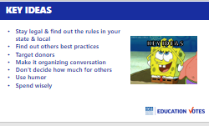 |  | Introduction 1 min  - But before we can talk about voter contact and member organizing, we need to talk about how we pay for it  - There’s probably different schools of thought if you should start with the program you want to run and figure out where you can raise the money, or start with how much money you run and use that to determine what your program looks like  - Regardless, having a paid program can be a real game changer either for your union’s program or your candidate’s campaign  PAC 101 in Alaska 5 min  - Let’s start with the lay of the land here in Alaska. Matt is on standby if I screw this up. Every single state seems to be different, so this workshop is always a challenge for me.  - In terms of giving, you are one of the few states left where everyone gives to your state PAC, those amounts are $25 for certificated and $12.50 for ESPs  - Sara mentioned this yesterday, you can receive 25% back by holding recommendation process and submitting a plan  - You also have the ability to help your candidates raise more  - Which is important b/c your limit to give as a PAC is $1,000  - One thing to note on spending, you can use your dues money to do issue advocacy about candidate’s records. You can mention voting or elections, but let’s say there is a Board of Education member who voted to privatize the custodians and the buildings are really dirty, you could put a mail piece to voter describing what happened.  - That’s not permission slip to go crazy, make sure you check with Matt first so you avoid any fines and follow the rules on campaign finance.  Candidate Fundraising Intro 5 min  - 1 min With your 1k limit and the fact that most people give to the PAC already, helping your candidates become better fundraisers is most important. We’re going to focus on that. This next content is actually from some of our candidate training materials so we’ll put that hat on.  - 3 min Most people hate ask people for money. Take the next 30 seconds and write 1-2 words down. What were they? Why?  - Here’s the thing, fundraising isn’t about you. Can someone read this quote from Senator from NY?  - We have to keep reminding ourselves that fundraising is about the issues we want to see changed and we’re giving folks an opportunity to take part in that by asking them to give.  Pro-tip: Target Donors 7 min  - Target donors. This is the circle of benefit that I believe comes from Emily’s List.  - Each of these circles represents a different type of donor and the farther you go out, the more you will have to prove to them that you are viable, and the later they will give.  - It makes sense, your family & friends should be the easiest ask, while organizations like ours will want to wait and make sure the candidate is serious before we cut our PAC check.  - So I have profiles of each of these types of donors.  - Personal. The big takeaway here, start here first and these should be folks who give b/c they love you. You don’t have to spend a ton of time on the why. If you do, that candidate should not be running.  - Ideological. Fairbanks – who would be a good example of this type of donor on the privatization issue?  - Axe to Grind. These are the petty labelle’s in your community. Which reinforces why you want to really research your community to try to surface who might really hate your opponents.  - Power Circle. Who has a good example of this type of donor? Where I lived in NC, it was not only organizations like outs but the business community and usually one CEO who wanted to keep schools ranked well so folks would move to the area.  - Here a few tips on where to look to try to find these donors. One good rule of thumb, always ask for more than you think.  Exercise 5 min  Now I want you to look in your phone and think as if you were the candidate and look for 10 ppl who you think would give and how much you would ask. I’ll give you a couple minutes. Who was able to get to a 1,000? This is a great exercise to do with your candidates and your leaders.  Pro-tip: Fundraising System 5 min  - You want to work with your candidates on a system. A lot of folks just start thinking of doing events.  - Step 1 you want to do a rolodex with everyone they ever met and all the organizations.  - Then you want to add the amount.  - There’s also the ask to raise. Candidates love me for this. I’m not independently wealthy so I’m not able to cut the big $6k limit check in Maryland, but I’m an organizer so I know lots of people. Think about folks who you could ask to become the fundraisers.  - Second step, you need to figure out how to ask. Based on these response rate % - where should your candidates be spending their time?  - Here’s a great slide to see how the math works on call time. Remember these are folks they know. But you can see now – it's such a better bang for your buck to do this then host a big event. Candidates hate it. One thing that really works tho is if they have someone there with them encouraging and debriefing after the conversation.  Pro-tip: Making the ask 5 min  - Just like organizing – consider their why and what motivates them  - Here’s a good outline on steps  - Model with someone  Exercise 10 min  Practice making ask  These last two tips are more for when you think about fundraising & budgeting with your local association hat on.  Pro-tip Make it Fun 5 min  - This is my favorite pro-tip and what helped change the culture around fundraising in Maryland. You need to make it fun and inspiring. I was in charge of videos and this was one I made for a march, but just wanted to show how you can take serious issue like a funding but catch folks attention.  Pro-tip Spend Wisely 3 min  - Last but not least, spend this money wisely & creatively. This was a sample budget for a county with 500k where we needed 119k votes to win. It was a make it or break it for the local. They had been frozen for years. They didn’t have the PAC money they needed, but they had 3 million in an emergency reserve in dues. You know what happened when Meighan found out there was 3 million dollars? We got on the phone with lawyers & GR Director, & consultant and figured out other ways we could be using that money for issue advocacy, a really robust member program where they were served ads and mail, and we had a paid canvass where folks didn’t talk about candidates but talked about importance of voting in key precincts we needed to turn out. They flipped to a majority and restored all of their steps within the first four years of the new administration.  Key Ideas 2 min | What are the rules for AK?  What are the best practices for raising money for candidates that you can share? What are good things to remember for our locals?
10:40-10:55 BREAK BUILT INTO NEXT SESSION
10:00-11:30pm Beth & Sara |  | Voter Contact WITH BREAK BUILT IN
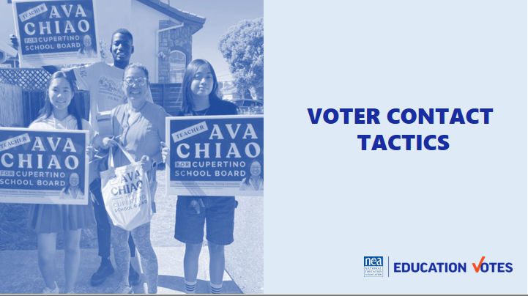  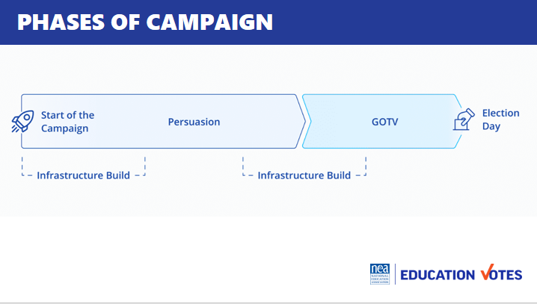  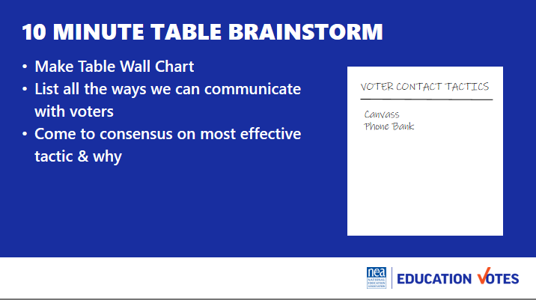  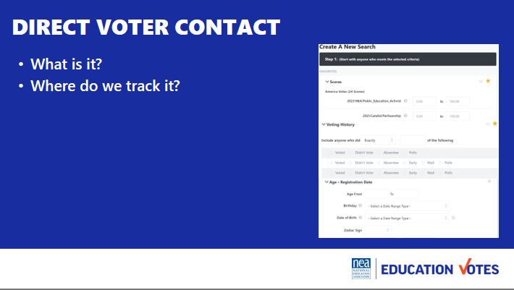  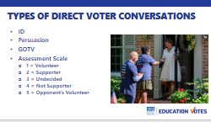  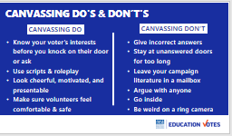  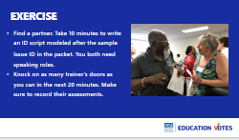 | Issue ID Script  VOLUNTEERS FOR DOOR KNOCKING - Your assignment is to know your voter type, AND draw your door on Chart Paper  1 supporter, wants to volunteer, wants a yard sign – Jackie  2 voting yes –Hedy, Beth  3 undecided – Meighan, Matt  4 voting for your opponent – Sara  5 volunteering for your opponent - Vanessa | Introduction 5 min  - So yesterday we spent a lot time talking about preparing for the election. Today we are going to spend the rest of the day talking about what we’re going to be doing during the election - communicating with voters.  - Let’s start with some important lingo  - Campaigns are really broken up into 2 phases. The first is your ID/Persuasion Phase and the second is GOTV or get out the vote. In your ID/Persuasion phase, this is where you are identifying your supporters and persuading your undecideds. This is really where you have to make your case to voters on why they should support your candidates  - In GOTV, this is where you switch over to the types of voters you are talking to. In GOTV, you should have identified enough supporters to reach your vote goal and you are pushing them to mail their ballot, early vote, or head to the polls on election day.  - In both cases, you see infrastructure build. What do folks think that means? (volunteer recruitment/PAC etc). We’ll be spending the afternoon talking about how we build our volunteer armies.  How do we communicate with voters 20 min total  - For 10ish min at your table brainstorm list on flipchart all the tactics we could use during our election to communicate with the general public and what you think is the most effective & why.  - Report out around the room (5 min)  - (5 min) We work with a group of progressive strategists and scientists that study elections and test what’s most effective. We’re not going to confuse you with their crazy bar graphs, here are the latest findings we’re seeing:  - Really boring black and white comparison letters like these do really well when you need some persuasion. It helps if they look non-partisan and just providing info only.  - Relational – What do folks think when we say relational organizing? It’s this crazy idea that people listen to folks they know and trust. The way this has been translating into election work can look like a fancy app where folks can tell you which of their friends they talked to or it can be as simple as having a pledge card where people commit to tripling their vote by talking to 3 friends.  - Canvassing – who loves to knock on doors? We won’t lie, a lot of times you are just leaving literature at a door, but if you get someone – that will be the most memorable voter contact they probably receive. The good thing for us, it’s relatively cheap to host a canvass. The cost is usually only the literature you are leaving and some water or donuts for your volunteers.  - Social Pressure – This tactic gets a lot of raised eyebrows, but in every election it gets more data that backs up that it is incredibly effective. Social pressure basically means using accountability to persuade someone to vote. It’s prob most used in mailers that show a report card of elections you voted in or missed. It is recommended that if you are doing that type of work to create a separate committee b/c some folks get peeved about it. There’s also a lighter version where you just remind folks that voter records are public and you can even demonstrate in videos like this. [show animated video]  What is Direct Voter Contact? 5 min  - Ask them what they think it is  - Definition: It’s two-sided and targeted communications with voters where you keep track. Not yard signs, but primarily canvassing, phone banking, events, and texting.  - Keeping track is key. This is why you need a voter file. Every NEA affiliate has access to VAN, it’s the Voter Activation Network which is our online voter file database. It has a tab for members and voters. This is where you can pull lists for your canvasses, phone banks, etc. Your state has its own administrator that can get you access. If you can’t access VAN for whatever reason, there are a couple of work-arounds. 1. If you are working with a well-resourced candidate and you are able to coordinate then you could use their VAN. 2. The Board of Elections sells voter reg file for a small fee. It’s not ideal, but we have seen folks get creative. Get yourself access to a list for Direct Voter Contact. If you need someone to troubleshoot with, Meighan is no longer on probation at NEA and loves to help with list access issues.  Types of Direct Voter Contact Conversations 5 min  - There are three types of conversations you’ll have with voters You have sample issue ID script in your folder/packet.  - Here’s the purpose of each script:  - Your ID script is where you want to ask voters if they know who they are voting for.  - Some campaigns group ID and Persuasion scripts together. You make take a longer persuasion script back to your undecideds closer to GOTV. Sometimes it’s a better use of time to go find more voters than trying to find your undecided voter again.  - Your Get Out the Vote (GOTV) script is where you go back to our supporters and get them out. There are some key pieces in this script based on more of that Analyst Institute research like asking them when and how they plan to vote that will increase turnout. You also might end up doing blind GOTV if just turning out base voters is going to help your candidate. Most campaigns have to do this when they don’t have enough IDs. You may have a couple of different GOTV scripts if it’s a ballot chase or early vote or Election Day.  - You want to make sure you are asking folks to volunteer, after you make an ID. One of the biggest mistakes we make is start doing volunteer recruitment without making an ID first. How likely are you to volunteer for someone you don’t plan to vote for? We will talk about using a union rap for our member volunteer conversations this afternoon.  - We also make assessments on these conversations b/c you ultimately want to be tracking these to get back to that vote goal we talked about. This is the most used scale:  Canvassing Do’s & Don’ts 5 min  - Here are some key do’s & don’ts when you go canvassing  Exercise Time Estimate: 45 minutes (10 min script write, 20 min knock time, Debrief 15 min)  Now it’s your turn. Everyone is going to partner up. Pull up the ID/Persuasion script and take 5 minutes to make it someone’s campaign. Both of you should have speaking role in the script.  Once you feel ready. Knock on as many trainer doors as you can. Make sure you record their assessment.  Debrief:  - How did that feel?  - Ask about trainer assessments, did they get them right?  - Tips from each person at the door  Tips to mention in debrief  - If it’s a 4 or 5, get out of there don’t waste your time  - Get contact info, especially phone & emails  - Go in pairs  - Don’t bother w/No Soliciting people  - Don’t touch mailboxes  - Leave lit  Other Ideas to be sure to bring up in the debrief:  - Exit strategies  - Know the local election rules  - Mail in ballot rules  - Date of election  - How do you handle No soliciting signs  - Be nimble with your script  - Make sure you ask supports to be volunteers  - Be sure to sure update phone #’ and email of supporters  5 min Key Ideas  - Use research like AI to choose effective tactics  - Direct voter contact is our primary mode b/c it’s cheapest bang for our buck  - Types of conversations are ID, Persuasion, GOTV, & Volunteer  - We keep track and assess voters to get us to our win number | What are phases of an election?  Why does this matter?  Participants will understand phases and how this impacts who they are talking to and what they are saying.
11:30 – 12:00pm Meighan |  | 30 Minutes Winning with Members
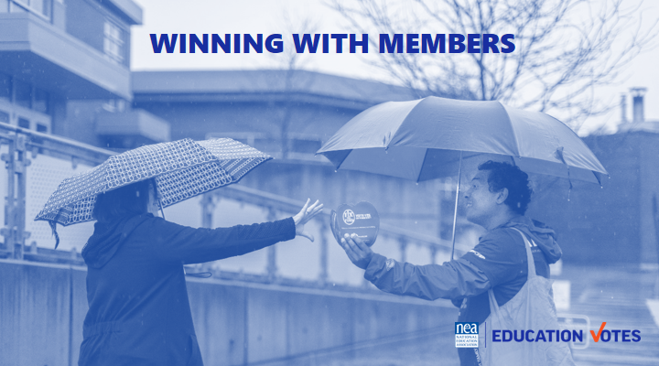  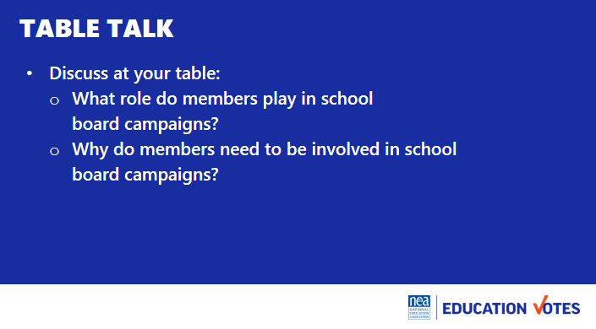  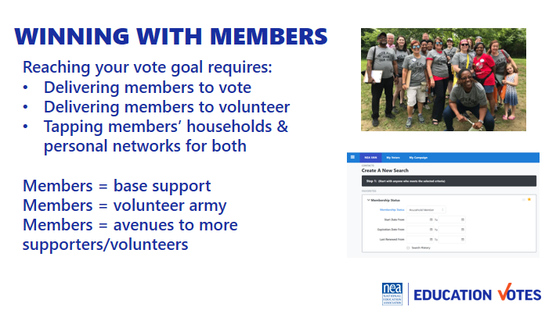  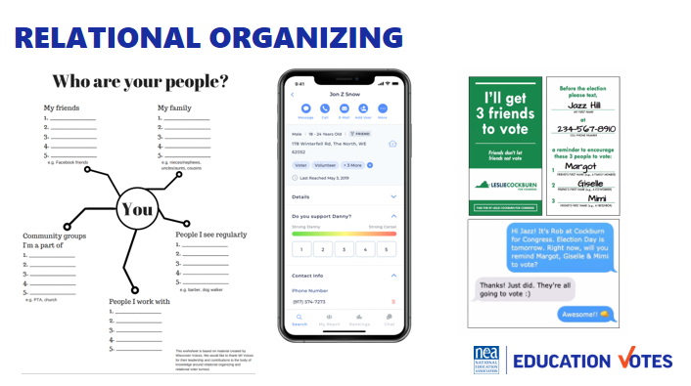  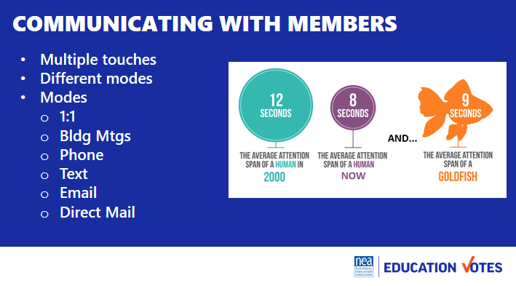  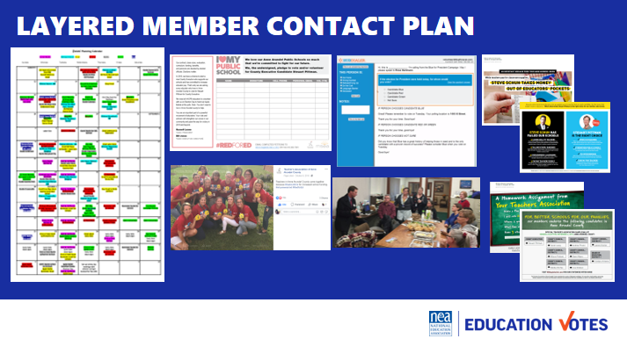  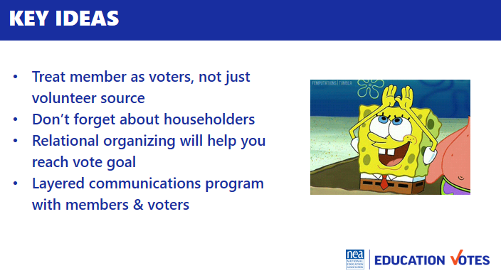 | Communicating with members chart | Introduction 10 min  So we spent the last hour talking about communicating with voters. At your tables, answer:  - Should we be going through all the phases with our members like we do with voters (ID/Persuasion/GOTV)  - How does that look different than our campaign with the public?  - What types of tactics work best in your local getting members to vote?  Report out answers 5 min  Winning with members 3 min  - Like you all said, it’s important we get our members out to vote and note just see them as volunteers. They should be the first folks we think of when we start thinking through our vote goal counts.  - They also make the most incredible volunteers and we’ll be spending some more time this afternoon talking about that. Most voters do not vote in school board races so to have an educator at their door, or a polling place to tell them who the recommended candidates are is powerful.  - Our members are connected, and another thing to realize is we can talk to the household members with dues money too, and we have those folks listed in the VAN.  Relational Organizing 2 min  - Speaking of householders, we mentioned relational organizing as an effective tactic. Who remembers what we mean?  - It’s incredibly effective with our members and not just their householders.  - Here are a few ways locals have been utilizing this merging their member and voter contact.  Communicating w/members 5 min  - How many times do you think a voter needs to be reminded? (used to be 7, now it’s closer to 13)  - Our members prob don’t need 13, but once you start looking at your part turnout, you’ll have a better idea. A good rule of thumb is at least 3, they need to know who the candidates are, they need to know why this is important, and they need a reminder before GOTV.  - You don’t want to just communicate the same way, especially if it’s just email. Mixing up a mail piece, phone call, text, or building visit are great different modes of contact for member program.  - It’s important to layer the communication throughout your campaign.  - Here’s an example from a local where you can see their calendar and each of these different colors represents a different mode of contact.  - They started with an ID petition where members got an “I love my public school” t-shirt if they took the voter pledge.  - On Tuesdays every week, schools would take pictures and have visibility days in their shirts, and we posted them on Facebook.  - The GR committee had weekly phone banks to call through the 5k members that lived in the county and what was great about these events is the candidate would come out and thank them while they had the best takeout we could find.  - We also sent every member 3 pieces of mail – one bio piece in September, one persuasion candidate comparison piece in early October, and one GOTV piece right before early voting started.  Key Ideas 5min  - We need to treat members as voters, not just volunteers.  - Don’t forget about householders.  - We need to create layered ID, persuasion, GOTV program for our members just like we would with the public. | How do we talk to members to get them to vote and volunteer?  Participants will understand they have to have organizing conversations to mobilize members, they will understand the types of contact, and importance of layered communications.
12:00 – 1:00pm LUNCH

1:00– 1:45 pm Beth |  | 45 Minutes Volunteer Recruitment
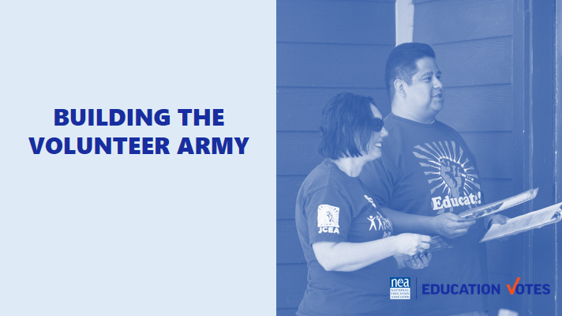  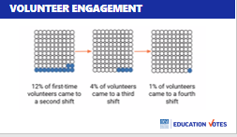  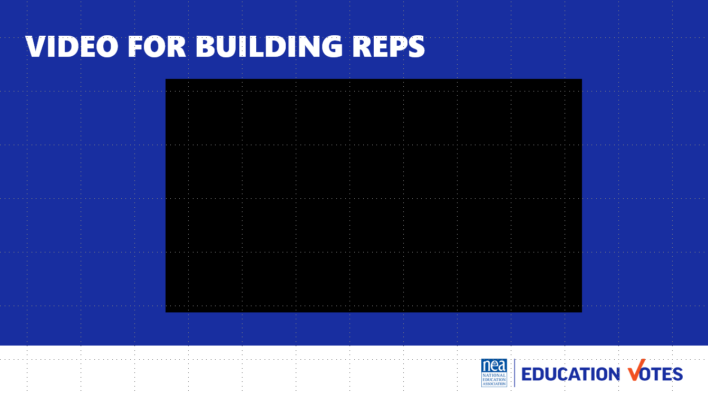  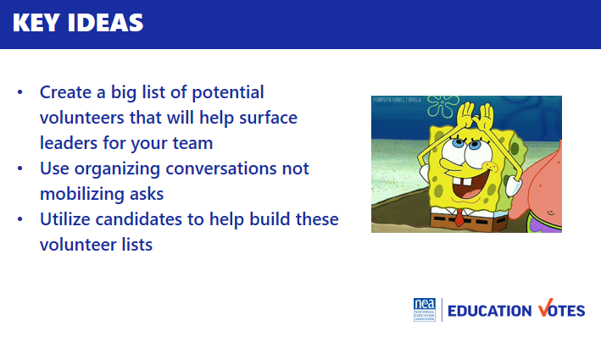 | AHUY Handout | Introduction 5 min  Our elections hinge on having great volunteer operations. Who can tell us what the ladder of engagement is? Why is it bad to start with high level activities (folks get scared don’t come back)?  We’re taking our ladder and making it a triangle of engagement. We’ll spend some time talking about how to build some structures for our engaged and highly engaged this afternoon, but we know to get these folks – we have to start down here with our broad base and interested. Our biggest problem is we usually don’t have enough of those members to move up that ramp so our highly engaged are doing everything, amIright?  A big problem we’re facing is folks are one and done and don’t come back. We know especially in our world of the labor movement, burn out is real. Check out this data from AFL-CIO on volunteers who return after they canvass for the first time.  Standing Brainstorm 15 min  We’re going to count off by 4 and brainstorm ideas on how to increase our volunteer engagement. Brainstorm 10 min on ideas you have to engage volunteers more deeply so we can keep them coming back and moving up that ramp, and designate someone to report out  Report-out 5 min  [get folks up & standing next to flipcharts]  Research Findings 5 min  Here’s what our smart researchers found as most effective ways to engage volunteers more deeply.  - Start ask with someone they know (like a building rep)  - Confirmation calls and texts before events  - Start w/small asks and move to higher risk ask action  - Have an immediate ask after they volunteer  - Reduce barriers (childcare, time of day etc)  - Train folks beforehand  - Develop relationships through organizing conversations  Organizing Conversations 15 min  - Let’s dig deeper on organizing conversations. What’s the difference between organizing and mobilizing? (organizing convos longer/develop relationship & mobilizing is quick and just the ask)  - There’s two popular models to have organizing conversations  - Labor Notes developed this acronym AHUY to help your remember how to have this conversation. We talked about this briefly in PAC.  - Anger – this is where we try to tap into emotion to get them fired up about making a change  - Hope – this is where we offer solutions on how we could make the change  - Urgency – this is where we talk about how this needs to happen now  - You – This is the ask of them  - This is more of a traditional Union Organizing Rap from the AFL-CIO Organizing Institute, but you can see it follows a similar thread as AHUY  - Get their issues out​  - Connect issues with election ​  - Talk about power in numbers​  - What we need to do to win​  - Make the ask​  - Here’s an example of how that local used their Vote/Volunteer Pledge Petition using building reps to create their potential volunteer list and training video on organizing conversations they sent out to their reps (5 minutes)  - Get reactions  - What did you like about that video? What would you change?  - That local used a petition to start creating that initital list of volunteers, what will your local use?  - How do you plan to train your reps?  2 min Key Ideas  - Use ramp of engagement, start with small and move to higher risk actions  - Have someone they know ask  - Confirmation calls & text  - Immediate next step  - Reduce barriers  - Organizing conversations not mobilizing asks  - Train your reps | What do I say to recruit a volunteer?  Participants will write a volunteer recruitment script.
2:20- 2:35 BREAK is BUILT INTO NEXT SESSION
1:45-2:45 Vanessa & Jackie |  | 60 Minutes Building the Team WITH BREAK BUILT IN
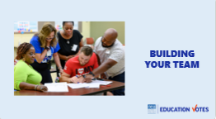    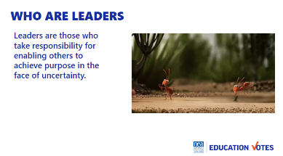  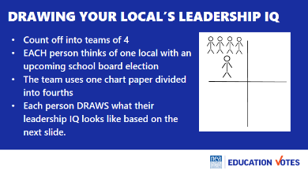  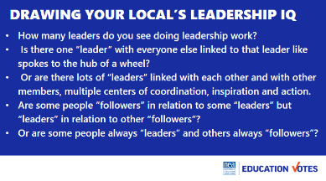  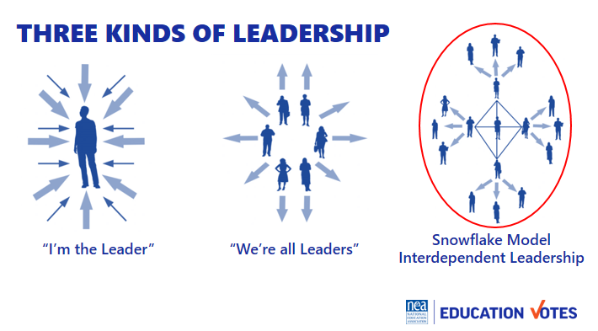  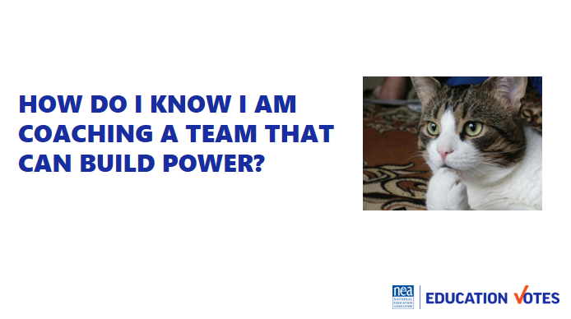  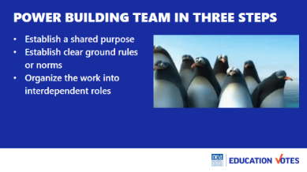  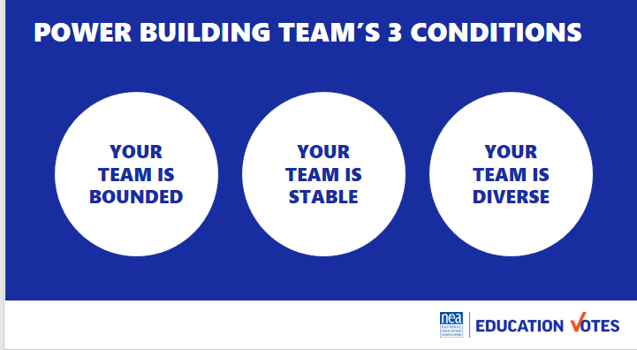  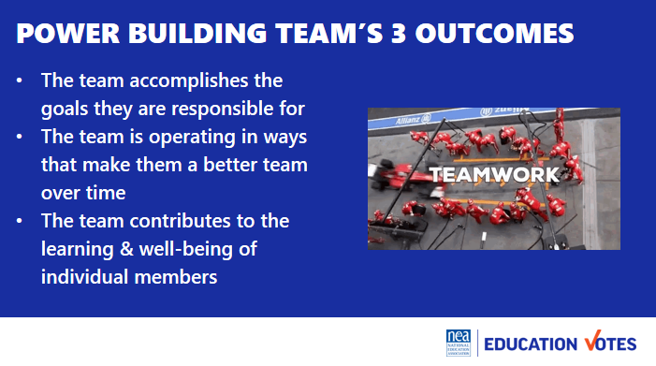  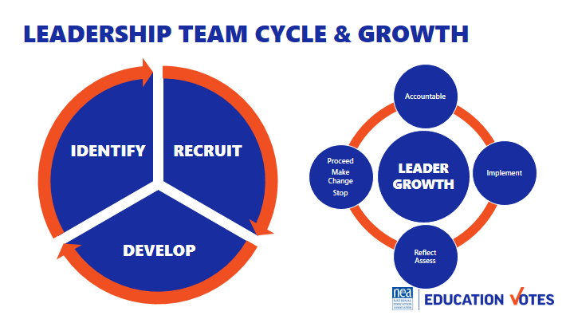  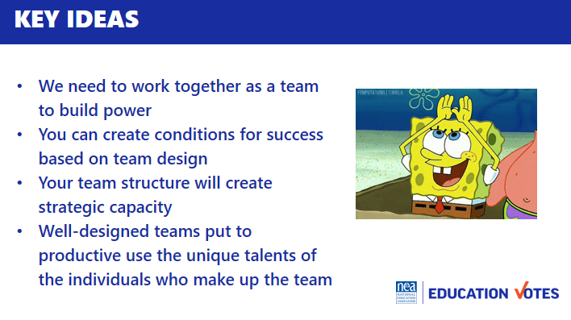 |  | Table Talk 5 min  - Visualize teams you have been a part of  - What made them successful?  - What made them less than successful?  - Hold on to those core memories for a few minutes  Who are leaders? 15 min Intro & Group Work 15 min (30 total)  - Leaders are those who enable others to achieve purpose in the face of uncertainty.  - WE are always coaching away from single leaders/authorities towards interconnected leadership/ teams.  - We are going to spend time at your tables drawing your local’s Leadership Structure for elections. Let’s count into groups of Four people to a team Each team gets on piece of chart paper divided into 4 quadrants. Each person draws what their local’s leadership structure looks like using the following questions on the screen.  - How many leaders do you see doing leadership work?  - Is there one “leader” with everyone else linked to that leader like spokes to the hub of a wheel?  - Or are there lots of “leaders” linked with each other and with other members, multiple centers of coordination, inspiration and action.  - Are some people “followers” in relation to some “leaders” but “leaders” in relation to other “followers”?  - Or are some people always “leaders” and others always “followers”?  These teams don’t just magically happen. No difference than letters don’t just fall together for people to know how to read. The mechanics are there, but someone needs to teach the rules, and guide you to how to do it.  BREAK  How do I know I am coaching a team that can build power?  What makes an effective team 10 min  - Establish a shared purpose. What are you fighting for and can you clearly articulate your common purpose as a team. It is clear, challenging, and matters. You have defined your goal, whom you work with, and the kinds of things you will do?  - Establish clear ground rules or norms. Your team sets explicit expectations of how you will work together: how you will make decisions, manage your time, and honor your commitments. What are things you will always do and what are the things you will never do. And how will you correct yourselves if you do them. Perhaps you most important norm is how you will make decisions. Steps that can guide effective decision making are: defining the problem, establishing criteria, brainstorming possibilities, synthesizing ideas, formulating options, evaluation options against the criteria, deciding. Some prefer deciding by vote; others, by consensus; others by delegating the decision to an individual.  - Organize the work into interdependent roles. Everyone should have responsibility for their own share of the leadership work needed to achieve the goal. Role requirements need to be clearly described. Team members need to assess their strengths and limitations, to the greatest extent possible, matching individual capabilities with role requirements. Because roles are designed to be interdependent, everyone has a stake in everyone else’s success. Team members speak up when they need help and get it. No one works in a silo that’s secretive to others. The team with diverse identities, experiences and resources brings more to the table than a team that is very homogeneous  Three Conditions 3 min  - Your team is bounded. It is clear who is on the team and who is not on the team. It is clear how new people can join the team and what is expected of those who must leave the team.  - Your team is stable. People commit to clear terms of service: regular meetings, length of time, etc. Your team is not a revolving door, never knowing who will show up.  - Your team is diverse. Your team has the appropriate diversity of skills, talents, viewpoints, and constituencies that will be needed to do a good job.  Three outcomes 2 min  - The team accomplishes the goals for which it is responsible.  - The team is operating in ways that make it better as a performing unit over time  - The team contributes the learning and well-being of individual members  Leadership Team and Leadership Growth Cycle 5 min  - As an organizer your job is to recognize and then help the team recognize that in order to build power, there is a continual identify, recruit, and develop cycle of new folks into the team.  - A team that does not continual recognize that one of their jobs is to continue to make space for new leaders, perspectives, diversity, and talents is a team that is not intent on base building and power development.  - Further a team grows in capacity to strategically achieve outcomes using everyone’s unique talents by attending to a continual cycle of implementation, reflection/assessment, proceed-change-stop, and accountability for the outcomes. We do a disservice to teams, the constituencies they are from, and the local as a whole when we don’t identify non-growing, non-power building teams. An even great disservice is done when we jump in to do it ourselves.  Key Ideas 5 min  - We can’t become powerful enough to do what we need to do if we can’t even work together as a leadership team.  - You can create the conditions that will increase the odds your team will work drawing on the craft of team design  - Structuring a leadership team creates strategic capacity: the ability to strategize creatively together in ways that produce more vibrant, engaging strategy than any individual could create alone.  - Well-designed teams put to productive use the unique talents of the individuals who make up the team. | How do we build effective GR committee/ election teams?  What resources and support do you have in your state? Who can you ask for help and support?  Grants? GR?  Participants will understand how to coach and develop the leadership needed for an effective GR team to lead a campaign.
2:45 – 3:15 Jackie & Vanessa |  | 30 Minutes Team Communications Exercise
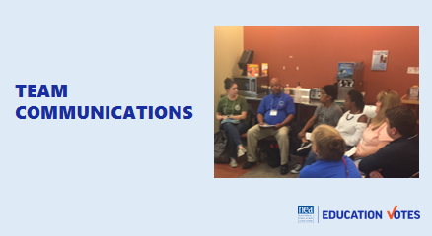  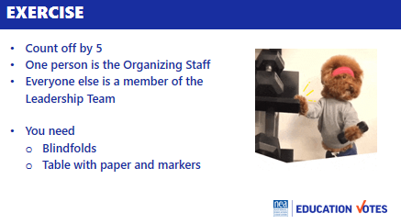  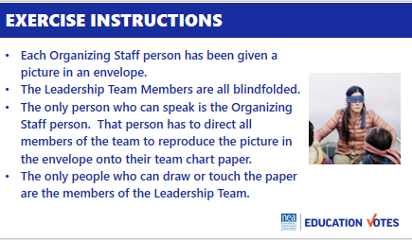  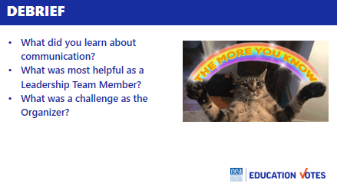  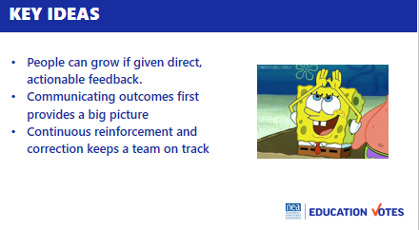 | Blindfolds & Envelopes with drawing  Divided into groups by school site visit teams.  Hedy announced the teams by table. | Team Communications Exercise  Intro and divide into two teams  - We are going to be working in teams of 5-7. Go ahead and get settled in with people you haven’t worked with yet.  - Now that you are settled, pick one person to be the Organizing Staff Person. The rest of you will be members of a leadership team.  - We are going to co-create a product in teams. On your tables are blindfolds paper and markers.  - If you are a Leadership team member you need to put your blindfold on so that you can’t see – no peeking out the side, and if you can see through it—close your eyes.  - Organizing Staff person- you have an envelope in your hand that contains a drawing. When we begin you are the only person allowed to talk to your team. They can not ask you questions, they can not talk to each other or to you or out loud at all. When we begin you will be able to open your envelope and your task is to direct every member of your team to draw as closely as possible the picture in your envelope. You cannot touch them in any way, only use your voice to direct. The only people allowed to touch markers or paper or to draw on the paper are the leadership team. You will have 10 minutes to make your masterpieces.  Group activity 10  Sharing of Pictures and Reflection on Learning as teams 5  - Take off your blindfolds. Take 5 minutes to discuss as a team the following questions:  - What did you learn about communication?  - What was most helpful as a Leadership Team Member?  - What was a challenge as the Organizer?  Group report-out 5  Key Ideas 5  - People can grow if given direct, actionable feedback  - Communicating outcomes first provides a big picture  - Continuous reinforcement and correction keeps a team on track
3:15 – 4:00 Sara |  | Organizing Successful Events
 |  | - Why do events 5 min  - Opening pic is event of early vote field trip this local shouldn’t have organized (it was end of school year, no one wanted to come, we lost money on happy hour & those folks could have been door knocking instead of drinking beer).  - Think of the worst event you went to, why was it bad?  - We should only do events when:  - It’s more effective (you make more calls/knock more doors when it’s group effort)  - They build community & you need to do that  - Checklist 5 min  - What is the Goal? This could be the goal of the event and turnout goal.  - Where should the location/room be? Think through what optics will look like, small rooms are good sometimes b/c it will feel bigger.  - Date/Time – think about what the most convenient time for members is.  - Budget – Always think through - Is it worth it? Could this money be spent on something more effective?  - Program – What’s your run of show?  - Is there something missing on this checklist you would add?  - Turnout math/plan 5 min  - You need to do turnout for everything, including your canvasses & phone banks  - Here’s a sample turnout calendar  - Usually, 2/3 is our worst scenario flake rate, a good rule of thumb is that you need 3 times the number of yeses you want for people to show up. But your flake rate is dependent on your local so make sure are keeping track of yeses and who shows so you can average.  - There are some jedi mind tricks to help reduce your flake rake.  - Ask what donut flavor they want or t-shirt size.  - Give them a role so they know you are counting on them being there.  - Do folks have other ideas to reduce flake rate?  Exercise 20 min  Let’s get into our local groups and create our own turnout calendars for this scenario. You need to make a flipchart calendar as well. Have someone ready to report-out.  Report-out 8 min (2 min each)  Key Ideas 2 min  - Evaluate if you need to do an event.  - Keep the checklist in mind.  - Make a Turnout Plan whether it’s a phone bank or meet & greet. | How do I turn members out? What are best practices for events with members and candidates?  Participants will understand turnout math and how to have successful events with members and candidates
4:00 – 4:05 Hedy |  | Ending it Right
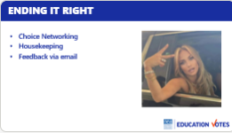   |  | Questions, Connections, Reflections  Housekeeping announcements  Plus/Delta at the Door | What questions do I have? What do I need to know?  Participants will get opportunity for feedback and leave session with what they need to know for tomorrow.
4:05 ADJOURN

