Facilitator Agenda: Winning School Board Campaigns Day # 3
General Materials Needed: |  |  |  | Room Set-up:
1 Set of Handouts per Person  Name Tags or Name Tents  Room signs, sign in signs  Highlighters – 3 colors  Pens and Pencils | Chart Paper – self stick kind  Markers- Mr. Sketch - Non Permanent  Post its  Wifi |  |  | Round Tables for Participants – cords at each table  Long rectangle at back for Facilitators  No Podium – table with projector large enough for laptop  Projector, Screen, Microphones, and Speakers  Carousel stations and reporting stations around the perimeter  50 people Max
Key Outcomes for the Day
- Learn the most effective modes to get your message out
- Understanding that work doesn’t end on Election Day, how to push your policy agenda forward
- Get Feedback on Campaign Plans
- Get inspired to do the work

Content and Facilitator Assignment Overview Day 3
9:00-9:05ish Reentry  9:05ish – 10:10 Getting your Message Out  10:10-10:25 Break  10:25– 10:55 Post Election Day |  | Hedy  Beth & Meighan  Vanessa & Sara | 10:55– 11:50 Present Campaign Plans & Get Feedback  11:50 - 12:00 Ending it Right  12:00 ADJOURN |  | Jackie  Hedy & Meighan

Time, Facilitator and Slides | Resources | Instructions, Activity and Debrief | Essential Questions and Key Outcomes
 | Charts, handouts, articles, materials, videos | What are you saying, what are they doing, what questions will you use to guide learning and make clear the important points  Include an estimate for how long each section of the learning will take  Include Key points. | What question(s) does this section answer?  What will participants know or be able to do?
9:00 – 9:05 Hedy |  | 5 Minutes Welcome back
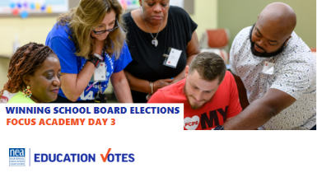  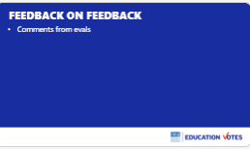  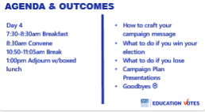 |  | Reentry  Feedback on Feedback  Agenda Review | How are we feeling and what are we covering today?  Participants will re-enter the learning environment.
9:05-10:10am Beth & Meighan |  | Getting Your Message Out
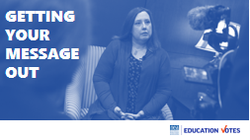    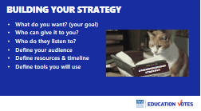  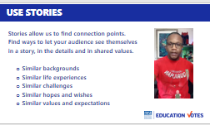  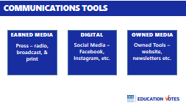  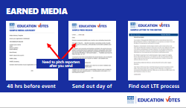  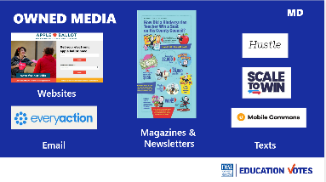  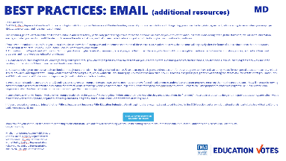  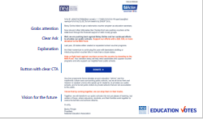  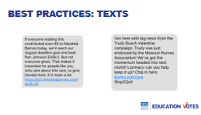  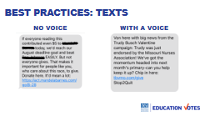  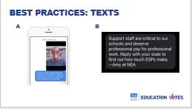  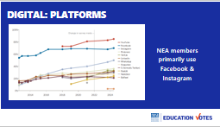  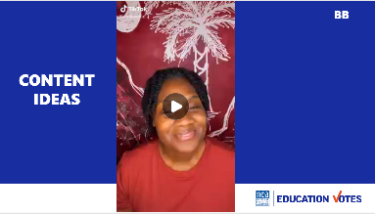  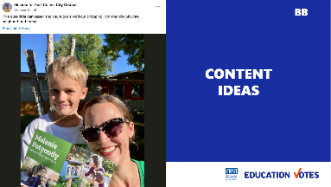  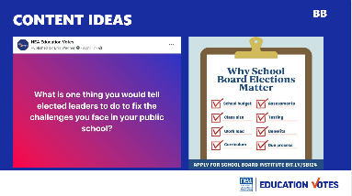  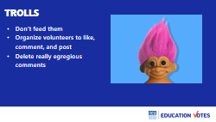      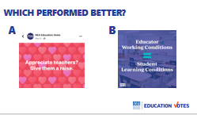  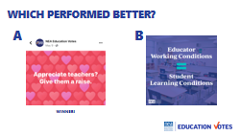  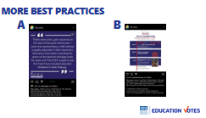  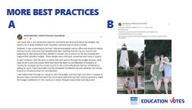  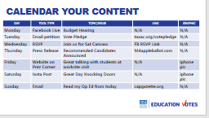  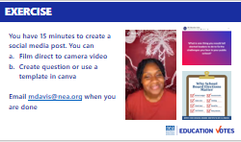  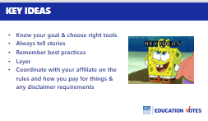 |  | Beth: Introduction 2 min (9)5-9:07)  - We’re almost at the finish line and saved some of our best skills workshops for last.  - So on Day 1 we talked about message. Does anybody remember what the definition of a message was? [A message is not a slogan or policy platform. A message is a statement that motivates targeted voters to take action. It contrasts between you & your opponent that you repeat over and over again.]  - We’re going to spend the next hour focused on best practices on how we get that message out.  Meighan: How do we get our message out 3 min (9:07-9:10)  - What are all the ways you get your message out to voters and members? Turn to someone next to you. Then have 2-3 people share.  Beth: Building Your Strategy 5 min (9:10 – 9:15)  - Disclaimer – please check with your GR department about authority lines. that you are spending the right kind of money, and in case anything needs to be in your local/affiliates campaign finance reports. You may not get a pink slip or an orange jumpsuit, but you could get a fine and put the organization at risk.  - Before you choose what your communications plan for your school board race will look like, let’s take a step back and talk about strategy.  - Here are some key questions to answer that will help drive what tools you will use and how.  - You want to make sure you can answer these questions  - What do you want?  - Who can make that happen?  - Who do those people listen to?  - Define your audience, timeline, resources, types of media you will use to accomplish your goals  - One pro-tip for whatever tool you are using is to tell stories. They are much more effective content. It’s why your comms staff in your affiliate is always asking for personal stories.  - This isn’t a school board video, it’s about joining the union, but listen to how this member conveys the “join the union message”  - [Show video]  Meighan: Choosing Communications Tools 7 min (9:15 –9:22)  - So we’re going to focus on three categories of communications tools today – earned, digital, and owned. There are three chart areas around the room. We want you to take a marker and add some examples of these types of tools for each chart. Don’t worry if you aren’t entirely sure. You’ve got 5 minutes.  - Ok, times up. Let’s see what we have [2 min report out]  - Define each  - Earned media is probably what a lot more of our veteran organizers are used to. This is the outreach to the press.  - Digital is something I hope all of our locals are doing. The amount of people who get their news these days from this category instead of press is alarming. So it’s critical we are utilizing these social media platforms.  - Owned media are the tools that we own and have more control over like our website or email lists.  Beth: Earned Media 2 min (9:22 – 9:24)  - Earned media is great because it’s free.  - It’s pretty straightforward formula on how to get attention from press. You tell them what you are doing with advisory 48 hours before if it’s event or send a release making announcement of recommendations. You need to make sure you pitch reporters.  - Lastly, LTEs (Letters to the Editor) are an easy way to get earned media. If you have someone who is a great writer, have them write a bunch of different ones and then give them to members to customize. Make sure you research what the submission process is. We gave you a sample one.  Meighan: Owned Media 2 min (9:24 – 9:26)  - Our owned media, are the tools we have control to disseminate information. Websites to list recommendations, newsletters/emails & peer-to-peer or SMS blast text messages.  - One quick tool shoutout. Scale to win is exciting because it has text but is also the best phone dialer I’ve seen and they incorporate the tool, where if someone tells you they will volunteer. You can click button on your phone script and send them a text with location etc.  Beth: Email Best Practices 3 min (9:26 – 9:29)  - What do folks think is wrong with this email? (too long, button, is way at the bottom)  - Here’s example of a better email, it’s probably still a touch too long, but as you are building your emails you want to make sure you get attention early, most folks give you 11 seconds and that’s it. You want to have a clear ask that you repeat several times and add button. You need to keep your language simple at a third grade reading level.  Meighan: Text Best Practices 3 min (9:29– 9:32)  - Who loves to hustle? Who hates getting really bad text messages? What text message do you think performed better? Why?  - Including Sender (Von) – the one that said who it was from. You can even do this if you are doing an SMS text. How many folks get text from Amy?  - How about this message. Which one do you think did better? Why?  - Video – Amy did better, video messages have lower engagement and performance than simple text messages.  Beth: Digital Media Introduction 2 min (9:32 – 9:34)  - Okay, we’re moving into everyone’s favorite: social media!  - Platform Popularity – this is the latest research from Pew on platform popularity. When you overlay our membership and think through the type of content we post, Facebook & Instagram are still where it’s at. Youtube is incredibly popular and if you have money for paid ads, you should talk about that with your consultant.  Meighan: Content Ideas 3 min (9:34 – 9:37)  - We know what platforms we are going to use, let’s talk about what we should be posting.  - Here a few examples of content that does well:  - Direct to Video posts. Let’s checkout this video from Erin a history teacher in Florida to show you what that direct to camera can look like. i  - Photos of what you are doing also perform great. This is Melanie from Fort Collins — a See Educators Run alum who just won her race for city council in Colorado in 2023. Her best performing content was regular canvassing photos and photos that featured her son.  - Has anybody ever used the Facebook engagement questions? This one had 326 responses, great engagement among people in the comments, as well.  - Infographic or what we might refer to as shareables are really popular to share information about voting or stress importance of why we need to vote, this is one we made into canva template that you can all customize.  Beth: Dealing with Haters 2 min (9:37 – 9:39)  - Trolls - if you haven’t had to deal with trolls on your own pages, you will most likely to start getting those comments, especially if you are running paid ad with a consultant. No matter if it’s a paid ad or organic post. Here are the guidelines on dealing with trolls.  - Make sure you have some community rules posted on Association FB pages  - Don’t engage. Don’t argue. Don’t feed them.  - Organize your people to post positive comments so they look like minority.  - There’s also a feature on Community pages where you can hide comments that contain certain words like communist, thug etc.  Meighan: Best Practices Animated Social Media Posts 6min (9:39 – 9:45)  - Animated shareable – what's wrong with this? why  - QR codes don't belong on digital graphics  - Off brand/hard to read colors  Too much animation/text  - Wrong logo  - Non-transparent backgrounds  - Shareable highly designed or simple – Which one performed better? Why?  - These templates in canva are super fun to make and its good to mix it up, but sometimes super simple will win the day, especially if it’s popular sentiment like this one.  - Which one is easier to read?  - This our See Educators Run alum from Maryland, which one of his posts do you think performed better? Why?  - Jacob gets a lot of engagement on FB but the long budget post won with 224 reactions, 111 comments, 120 shares, his anniversary post: 122 reactions, 7 comments. Why do you think the budget post won? (it was info folks wanted to know)  Beth: Layering tools & Content Calendar 2 min (9:45 – 9:47)  - You want to make sure you are layering which tools you are using. What are the 3 categories again (earned, owned, digital)? Use all three.  - Sample Content Calendar – here's an example of a sample content calendar where they were very specific about social media, press conf they were having, website updates, & emails they would be sending. Just like the rest of your campaign plan, plan these communications in your timeline  Meighan: Create social media post exercise 15 min (9:47 – 10:02)  - You have 15 minutes to create a social media post for your school board campaign. You can use canva to create a shareable/infographic, a question, or you can film a direct to camera video.  - If you don’t have recommended candidates yet or haven’t started your process, make it about importance of upcoming election and getting involved interview process etc.  - Once you are done, you will drop in this google drive  - Email them to Meighan and show group some good ones 10min (ask for volunteers)  Show a few examples 6 min (10:02 – 10:08)  - Why was this good?  Beth: Key Ideas 2 min (10:08 – 10:10)  - Know your goal & choose right tools  - Always tell stories  - Remember best practices  - Layer tools  - Coordinate with your affiliate & don’t break the law | How do we get our message out to voters and members?  What are some best practices?  Participants will make a social media post?
10:10-10:25 Break
10:25 – 10:55 Sara & Vanessa |  | Post Election Day
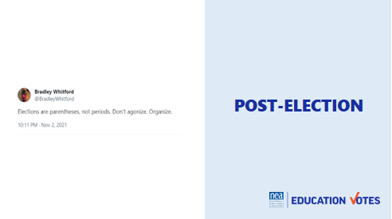  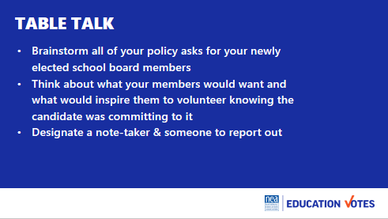  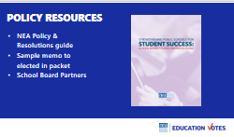  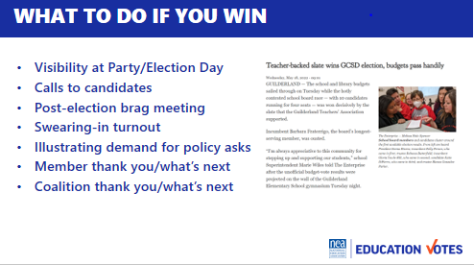  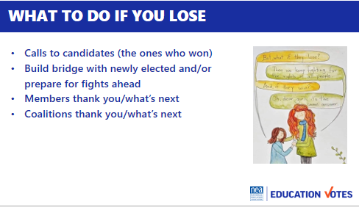  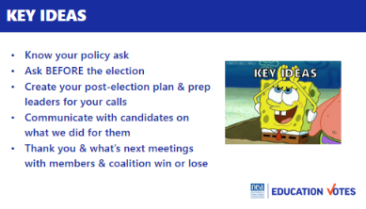 |  | Introduction  - I love this tweet from Bradley Whitford. I think it’s true whether we win or lose. We can’t hang up our boots on Election Day and think we’re done. We want to spend the next 30 minutes going through those scenarios and helpful ways to push your agenda forward no matter what the outcome.  Table Talk 10  - So, let’s talk about that amazing winning agenda. Too often we spend all of our time working to elect someone, but we haven’t spent enough time on what we’re asking of them or prepping them on those post-election policy asks. For the next 10 minutes, at your table, discuss what your policy “asks” are of your newly elected School Board Trustees would be. Designate someone to take notes, and someone else to report out for your table.  - [Challenge pick someone who has not held the microphone this morning.]  - If you are having a hard time thinking about policies, check out the additional resources or go to schoolboardpartners.org [MEIGHAN]  - Let’s hear those policies you want to win. Report out table talk  - When do folks think we should be talking to the candidates about these asks? 5 (BEFORE THE ELECTION, during interviews, planning meeting, giving them talking points, asking them to incorporate into platform/mentioning at rep meetings etc.)  Policy Resources  - Here are a few resources we have that can help you start developing some of your policy proposals  If you win 5 min  - Isn't that a great headline out of NY? This is the dream, we elect the people to do the thing and then they get into office and do the thing we asked.  - So let’s talk about what you should do if everything goes your way.  - Visibility at Party/Election Day visits – Some of this might start before the race is called. How many folks make sure their volunteers go to the parties in union shirts? A lot of the next few weeks is making sure you are constantly reminding your candidates they could not have won without your local’s help so you are setting yourself up for those policy asks. If you have a polling operation, it’s also a good idea to coordinate w/your candidates so they visit your volunteers and thank them. Ask your comms department to send a photographer along too.  - Calls to candidates – Some school board candidates may not be connected to a party or you may not know if they won their election right away w/mail ballots. Once a race is called you want to make sure you connect with the candidate right away and set-up a follow-up meeting.  - Post-election brag meeting – In your follow-up meeting you want to make sure they know everything you did. If you had one of those independent expenditure campaigns they didn’t know about, this is the time to share that information. You should also try to coordinate their appearance at a building rep meeting or event to thank your members. Again, this is all setting up for reminding them of those policy asks.  - Swearing-in turnout – Swearing-ins are also great opportunities to do turnout in your t-shirts. We coordinated one where everyone wore green so folks were reminded of the funding commitments they had made before the Election.  - Providing cover/illustrating demand for policy asks – Once you start talking about policy or budget, a good question to ask your new elected allies is what organizing can we be doing to demonstrate demand for this. It could be op-eds in the newspaper or community forums, blast emails etc.  - Members – What are some things folks have done to thank their members after an election?  - Coalitions – You also want to make sure you are thanking your coalition partners and strengthening that partnership for the organizing ahead.  - What to do if you don’t win 3  - Calls to candidates – this means calling candidates that did win that you didn’t endorse. You want to prep your leaders for that call and have them do a roleplay with you. They will want to send an email instead, but it’s in your members’ best interest to attempt to not go scorched earth immediately and try to start a relationship.  - What are some ideas on how to start building bridges with candidates you didn’t endorse that win?  - Members – You want to make sure you still honor your volunteers. It’s also a good idea to do some kind of all-member email that reminds folks that elections aren’t’ periods and we keep fighting no matter what.  - Coalitions – Again, you want to keep strengthening your partnerships for the organizing ahead win or lose. It’s also a good idea to try to do a debrief meeting to see what you learned from the election for next time.  Key Ideas 2 min  - Know your policy ask  - Ask BEFORE the election  - Create your post-election plan & prep your leaders for calls  - Communicate with candidates on what we did for them  - Thank you & what’s next meetings with members & coalition win or lose | Participants will hear from their peers on what their policy asks will be.  They will learn tangible skills on how to transition from election to campaign mode.
10:55 – 11:50 Jackie |  | Present Campaign Plan & Get Feedback
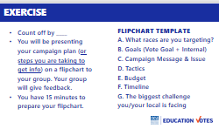 |  | Make Groups of ______(depending on turnout). This is prob a good time to split up from folks you may have come with so you can get some feedback from other locals.  Show chart template for them to summarize key points so they can share with group  - What races are you targeting?  - Goals  - Vote Goal  - Internal Goals  - Campaign Message  - Tactics you’ll be using  - Budget  - Timeline  - What will be your biggest challenge?  *And if you can’t answer some of these questions yet, then identify what you need and your next steps on your plan to get it. For vote goal, that might mean going to the clerk’s office, for budget it might mean meeting with your executive board.  Work time on chart paper individually – 15 min  Share in their groups and get feedback – 30 min  Groups of 3 charts- 5 minutes share, 5 minutes feedback  Debrief 15 min  - What do folks need to work on, what’s their plan to get it?  - What is your biggest takeaway from training? | Participants will start to organize their skills into plan and identify what information they need to collect.
11:50 – 12:00 Meighan & Ellen |  | Ending it Right
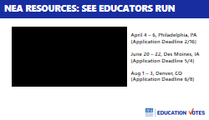  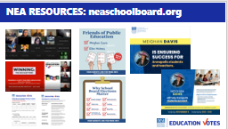  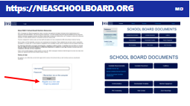  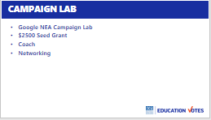  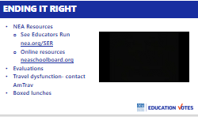 |  | 15 Minutes Ending it Right  - NEA Tools  - Member candidate training program – See Educators Run. Members come in Friday night for reception and we train all day Saturday and half of Sunday on stump speeches, fundraising, budget, message, endorsements, field, digital, and they practice firsthand how to deal with attacks in a mock town hall forum. These are the trainings coming up.  - In addition to the learning platform you accessed for training, we also have a microsearch site like the collective bargaining site where it has all of these school board resources, templates, and videos of past training.. This is how you get a login.  - Here are those websites again.  - Evaluations  - Reimbursement  - Thank yous | Participants will leave with new skills and know where to give feedback and access resources.
12:00 ADJOURN

