Facilitator Agenda: From Club to Fighting Union Day #1
General Materials Needed: |  |  |  |  | Room Set-up:
1 Set of Handouts per Person  Name Tags or Name Tents  Sign-in Sheet  Pens and Pencils |  |  | Chart Paper  Post its  Highlighters – 3 colors  Chart Markers – non-permanent |  | Round Tables  Projector, Screen and Speakers  Carousel stations and reporting stations around the perimeter  50 people
Key Outcomes for the Day
Describing the kind of organizing that can actually build the power we need to get what our people want that can’t be won on their own.
Lots of things we do are programs and clubs – they may build numbers within the constituency for a time (but will not sustain majority power) but they are not building power, power is built through collectively confronting uncertainty/the boss
Being able to identify and define organizing -- includes winning stuff from the boss or the power holder
What does it look like when you are part of a culture of a fighting union – expectations of engagement and common practices of staff.
Clubs are formed around identities and not issues - organizing is about collectively demanding a solution to a widely felt problem
Limitations of Low Risk Solidarity Groups (does not add to base) (need a scenario? Or real stories? Chart carousel with monikers at top- and ask what they have won) )
- Why would I want to change a club- it is successful Day 1
- Recognizing that clubs have limits – reframing what is success Day 1
- How to add to the base of club to achieve power – success is winning bigger and bolder things Day 2
- How to build out a campaign that moves a club to a fighting union Day 2 and Day3

Methods and Concepts to achieve these Outcomes
One on Ones (reasons to have them – targeting the kind that is needed for the point of the campaign you are in, next level)
Raise Expectations – Levels of Engagement - what we can win - (low risk social events – afraid to “be for something” -- afraid that we will reject the real vision of the union) and we miss the most powerful reason that someone might join and put their whole heart into it
Challenges of Leadership in a time of transformation – why might your employer not want a club to transform
Structure tests – do you have the right leaders to make the transformation – people get a lot of benefit from being leaders of clubs and there can become gate keeping to keep others out - (exercise that tries out recruitment based on fun and recruitment based on power -- you get the commitment that you recruit – recruit for fun you get frivolous – recruit for vision and hard work and you get folks who KNOW this is tough)

Data Use
Totally lost the audio about the “different scales of organizing” that Michelle began talking about
Time | Essential Questions | Resources |  | Instructions, Activity and Debrief (Facilitators) |  | Outcomes
 | What question(s) should this learning section answer? | Charts, handouts, articles, materials, slide |  | What are you saying, what are they doing, what questions will you use to guide learning and make clear the important points  Include an estimate for how long each section of the learning will take |  | As a result of this section of learning, what will participants know or be able to do?
8:30-9:00  Ellen  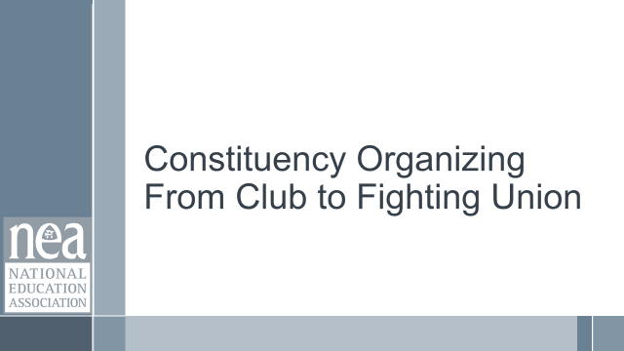  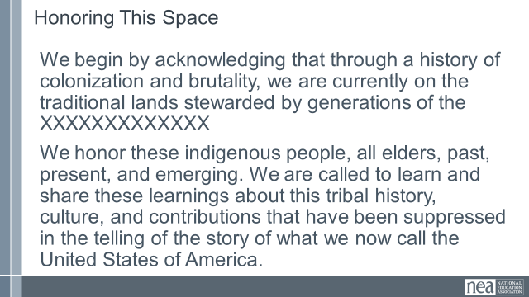  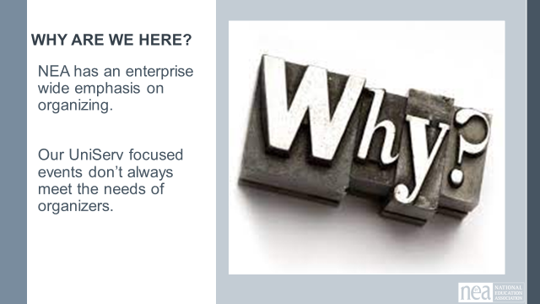  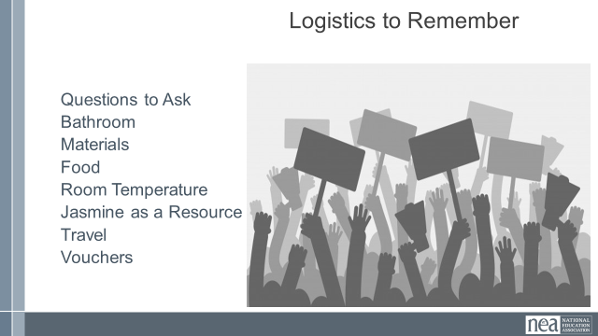  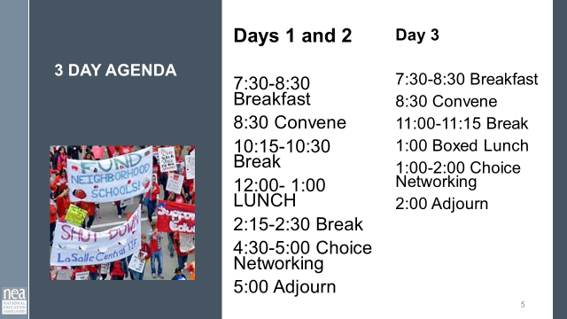  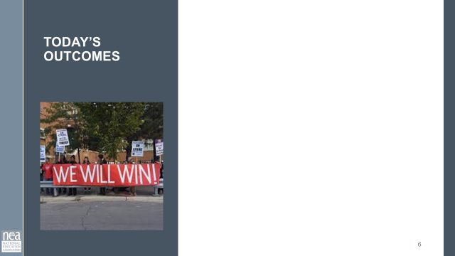  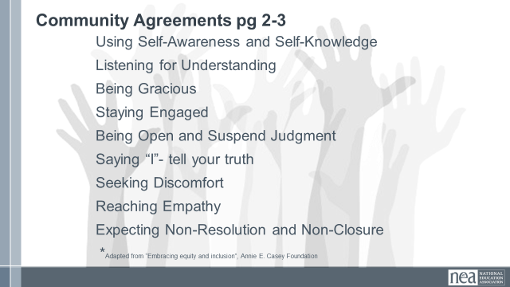  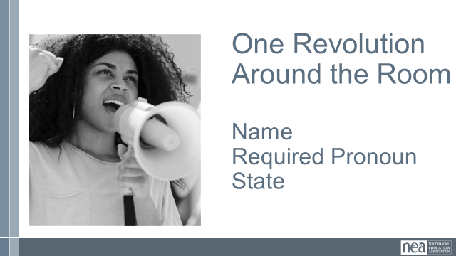  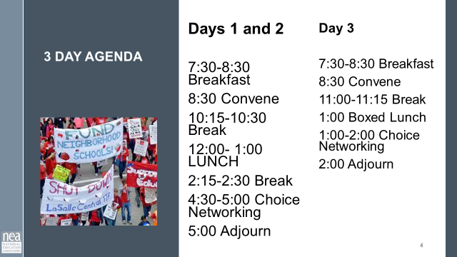  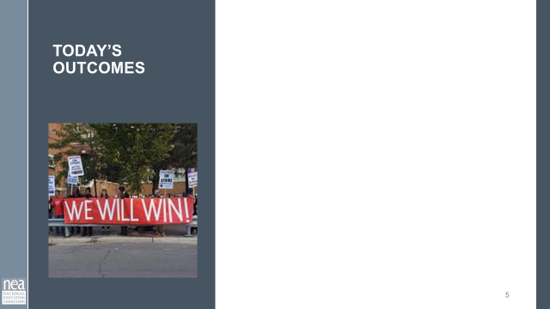 | How will we work together during our time? |  |  | 30 Minutes Getting Started :  Welcome  Land Acknowledgement – include the native peoples names on slides  Community Agreements – Take 5-10 minutes to review pages 2-3 of handouts, these were sent in advance. At your tables first then as a whole group, answer any questions, discuss anything that you want to include, seek understanding of what is needed to learn. As a whole room we are going to do a visible community adoption of these agreements. We seek consensus. In this case consensus will mean the following: each person only has to be comfortable enough to move forward, showing a sideways thumb, we don’t have to strive for perfect agreement, a completely upright thumb. IF however you cannot move forward you indicate that with a down thumb. The responsibility for the down thumb is to explain what it would take to move at least to side-ways. These agreements will be revisited as needed by anyone in this community and each morning. Show me up, side, or down thumb and please keep them in this position until I can visually check.  Quick Intro Whip Around the Room - Name, Pronouns, Location  Agenda for our Time  Outcomes for Today |  | Participants will understand the structure of their time and how we will work together.
9:00 – 9:25  Katie B    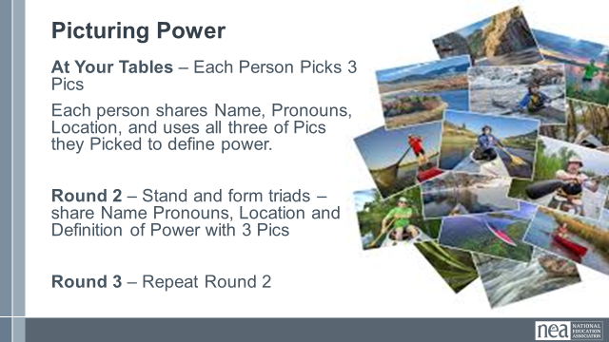  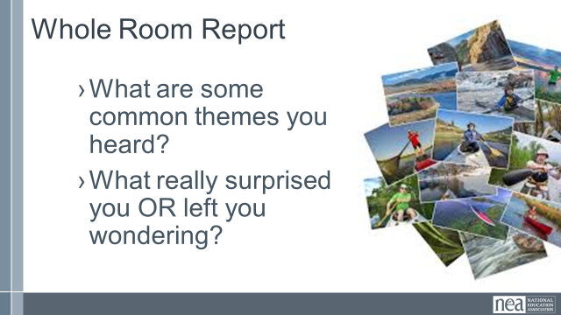 | Community Building | Need the Picture cards File |  | 25 Minutes Total – Picturing Power  2 minutes -Facilitator asks participants to choose 3 pictures from the piles on the tables.  Extra pics are picked up.  8 Minutes - Each person provides name, pronouns, location and uses the three pictures to describe what power means to them AND shares with the others at the tables.  5 minutes -Ask folks to move into new groups of not more than 3 – and share name, pronouns, location and their story of power  5 minutes - Ask folks to move into new groups of not more than 3 – and share name, pronouns, location and their story of power  5 Minutes Debrief  What are some common themes you heard as you travelled around the room |  | Participants will begin to develop a sense of community and begin to think about what power means.
9:30-10:15  Melissa  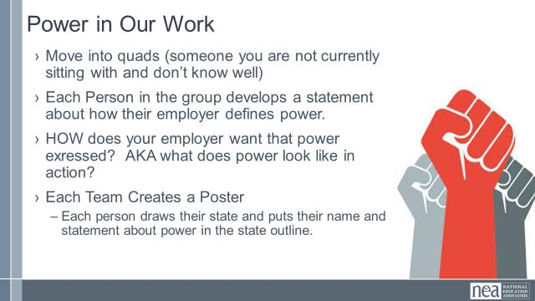  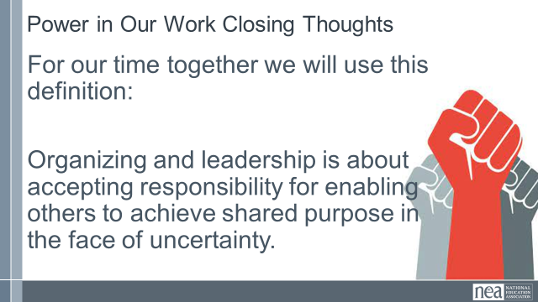\  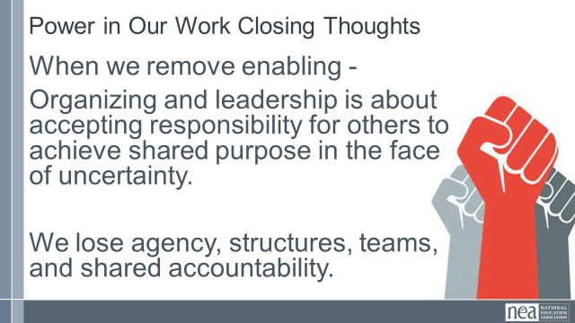  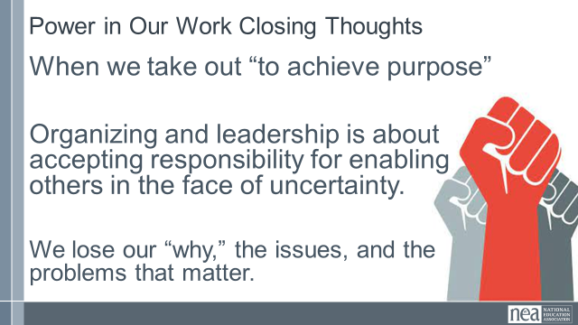  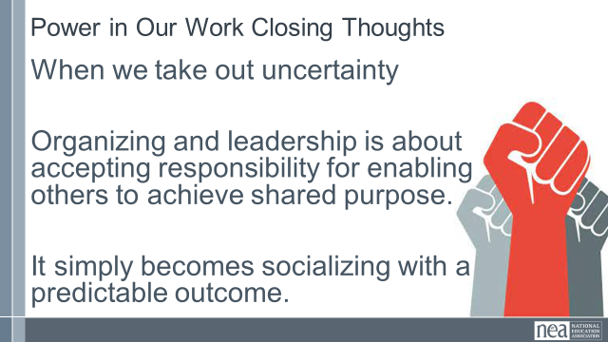  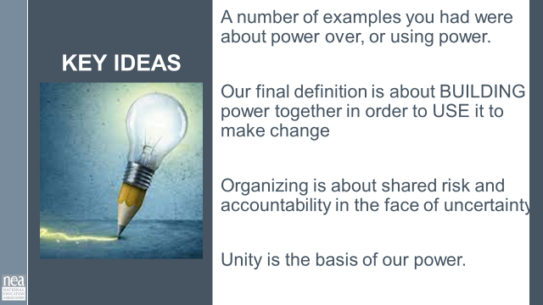 | What is your current thinking about power? | Ganz definition and reading about power pages 8-12 |  | 45 Minutes Total- Power In Our Work  3 Minutes Intro - This training is about focusing on building the power necessary to achieve the things we cannot alone. If we could have won them already, we would have. But there are issues our members cannot change alone. You were given an article from Marshall Ganz that outlines in a more deep way concepts of power that we might think about in our work. This is included on pages 8-12 in your handouts  Get into quads (find someone you do not actively work with).  20 Minute Group Discussion  - Each Person in the group develops a statement about how your employer defines power.  - Discuss within your group HOW your employer expresses their power? AKA what does power look like in action?  - Each person draws their state and puts their name and statement about power on your poster.  10 Minutes – Whole Room Share  Introduce your team to the room. Share what is common between your definitions of power  AS YOU LISTEN TO THE TEAMS Pay attention to  - Common threads  - Ideas that cause you to wonder  - Surprises  10 Mins - Closure  Share this Definition with the group:  Organizing and leadership is about accepting responsibility for enabling others to achieve shared purpose in the face of uncertainty.  Now break it down for them -  Take out the word enabling, we lose structure and building a team.  Take out the word achieve purpose, we lose the issues/problems that matter.  Take out the word uncertainty, then it is just socializing. If we were certain, it is likely already a pre-determined outcome.  2 MInutes Key Point  As we listened around the room, a good number of the examples and commonalities were about power over, or using power. Think about this final closing definition – it is about BUILDING POWER together in order to USE IT to achieve a common purpose. ** love this concept and pointing this out. KB  Organizing is about shared risk and accountability in the face of uncertainty. (Marshall Ganz definition)  Unity is the basis of our power. |  | Describing power and having a common definition.
10:15-10:30   | BREAK
10:30-11:15  Zac  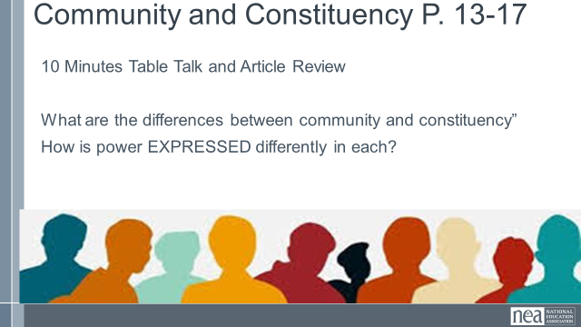  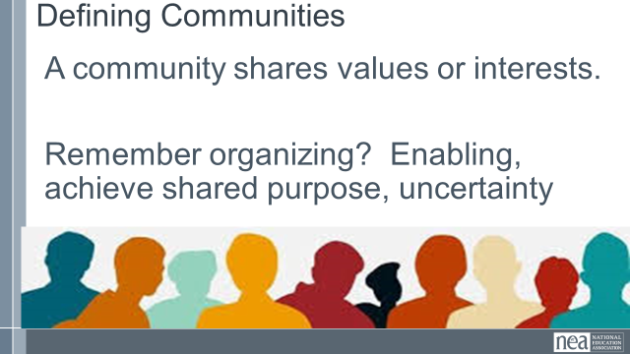  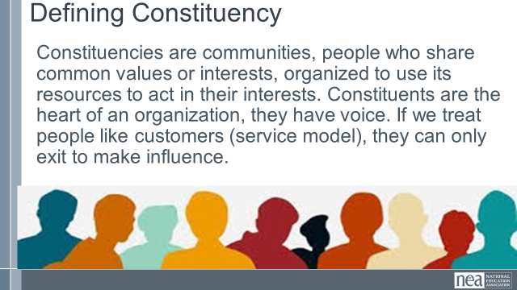  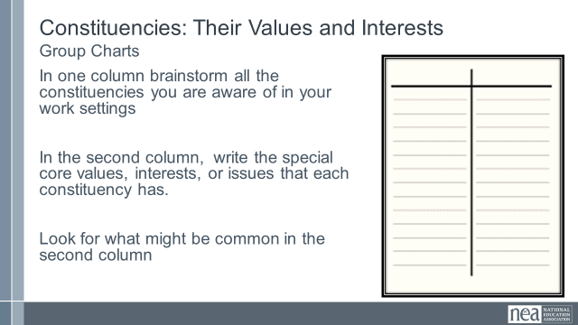  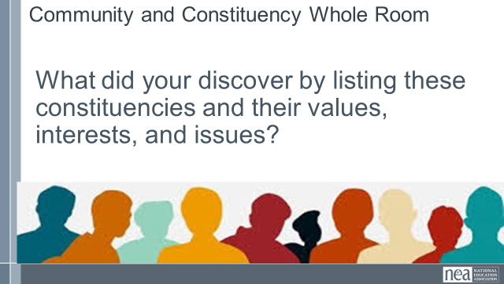  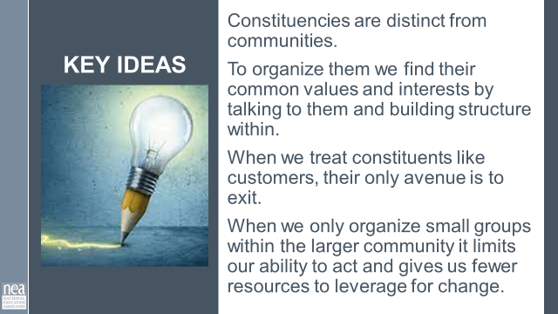 | What is the difference between a community and a constituency? | Community and Constituency Definition from Marshall Ganz pages 13-17 |  | 45 Minutes - Communities and Constituencies  2 Minutes - Introduction -As organizers, we work to turn communities into constituencies let’s work to define both of those. An article included in your pre attendance readings defines these in the ways that we will use in this training. They are also in your handouts on pages 13-17.  6 Minutes - Using the article from Marshall Ganz – identify the major differences between communities and constituencies. How is power expressed differently in a community or in a constituency?  2 Minutes Share our definitions  Communities share common values and interests but they are not organized.  Constituencies are communities, people who share common values or interests, organized to use its resources to act in their interests. Not clients or customers. Constituents are the heart of an organization, they have voice. If we treat people like customers, they can only exit to make influence.  Share the pause to think slide – no discussion yet – Does power look differently in each of these?  20 Minutes - Group Wall Chart Activity intro: Now that we have some definitions, let’s apply those to our work. Step 1 – about 10 minutes -Thinking about your affiliates, brainstorm a list of the constituencies within them that you are aware of.  Step 2- about 10 minutes – what are the core values or interests in these constituencies? Are there any common values or interests across these?  10 Minutes – Whole Group Report  What did you discover by listing out these separate constituencies and their core values?  5 Minutes Key Points  Constituencies are distinct from communities.  Organizing identifies their common values and interests builds structure to act. Building power.  When we treat constituents like customers, their only avenue is to exit. They relied on us to have power.  Only organizing small groups within the larger community limits power and gives us fewer resources to leverage for change. |  | Understanding what a constituency is versus a community.
11:15 – 12:00  Jeny  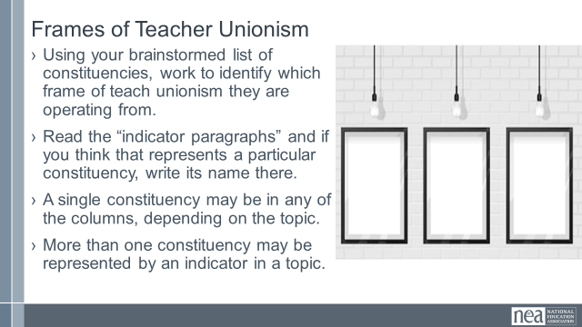  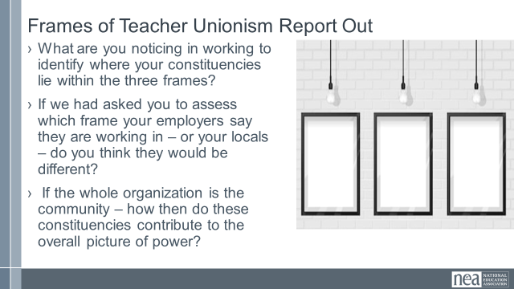  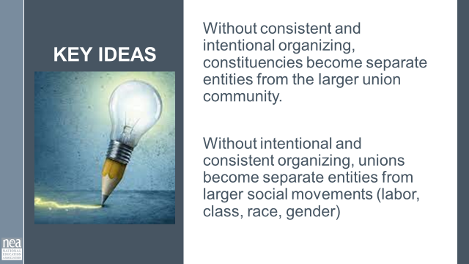  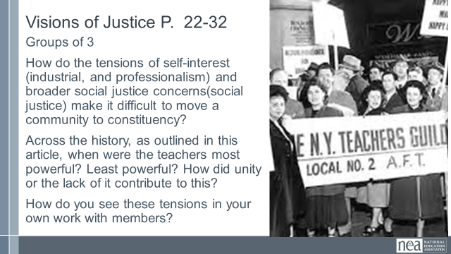 | How has educator organizing changed across time? | TUSJ 3 Frames  18-22  Visions of Justice Article page 23-31  Two Tensions Worksheet page 32 |  | 45 Minutes – Framing Constituency Organizing Over Time  1 Minutes Intro - Let’s take a look at a framework for thinking about the various interests, values, and approaches that constituencies use. This Frame was first developed by the Mooney Institute for Teacher Union Leadership as a way to help leaders assess what they were doing and where they wanted to go.  20 minutes – Using the 3 Frames of Unionism found on pages 18-22, and your brainstormed list of constituencies – assess which frames these constituencies are operating in. They may be varied. Write in the name of the constituency by the indicator that you think represents them.  10 Minutes Whole Room Discussion –  What are you noticing in working to identify where your constituencies lie within the three frames?  If we had asked you to assess which frame your employers say they are working in – or your locals – do you think they would be different?  If the whole organization is the community – how then do these constituencies contribute to the overall picture of power?  2 Minutes Key Ideas  Without consistent and intentional organizing, constituencies become separate entities from the larger union community.  Without intentional and consistent organizing, unions become separate entities from larger social movements (labor, class, race, gender)  35 Total -THIS NEXT SECTION WILL BEGIN BEFORE LUNCH AND THEN CONTINUE You will have about 15 minutes to start it and then 20 Minutes after lunch.  25 minutes Visions of Justice- The shift of Unity and Power Shift Over Time You were asked to read the article Visions of Justice prior to arriving. It is the story of the rise of teacher unionism in New York. Move into new groups, TRIADs. In your group discuss the following:  - How do the tensions of self-interest (industrial, and professionalism) and broader social justice concerns (social justice) make it difficult to move a community to constituency?  - Across the history, as outlined in this article, when were the teachers most powerful? Least powerful? How did unity or the lack of it contribute to this?  - How do you see these tensions in your own work with members?  10 Minutes Report out  Key Point: Long lasting Unity within teacher unions requires BOTH a focus on self-interests and public interest. |  | Be able to identify three frames of unionism they relate to constituencies.  Reflect on the complicated reality of organizing public sector employees.
12:00 –1:00  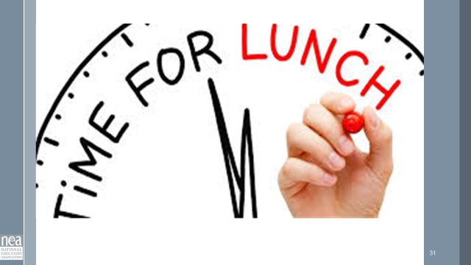 | LUNCH
1:00- 1:20 |  |  |  | Continued from Above  35 Total -THIS NEXT SECTION WILL BEGIN BEFORE LUNCH AND THEN CONTINUE You will have about 15 minutes to start it and then 20 Minutes after lunch. Remain in triads for after lunch  25 minutes Visions of Justice- The shift of Unity and Power Shift Over Time You were asked to read the article Visions of Justice prior to arriving. It is the story of the rise of teacher unionism in New York. In your group discuss the following:  - How do the tensions of self-interest (industrial, and professionalism) and broader social justice concerns (social justice) make it difficult to move a community to constituency?  - Across the history, as outlined in this article, when were the teachers most powerful? Least powerful? How did unity or the lack of it contribute to this?  - How do you see these tensions in your own work with members?  10 Minutes Report out on the questions posed on page  2 Minutes Key Point:  Without consistent and intentional organizing, constituencies become separate entities from the larger union community.  Without intentional and consistent organizing, unions become separate entities from larger social movements (labor, class, race, gender)  Long lasting Unity within teacher unions requires BOTH a focus on self-interests and public interest.
1:20 -2:15  Ellen  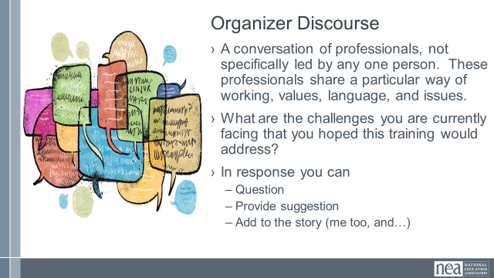 | COULD BE MOVED OR SHORTENED  IF NECESSARY |  |  | Organizer Discourse  Discussion of what organizing constituencies looks like where each participant is. Whole room – maybe in a circle. Relaxed discussion.  Discourse is A conversation of professionals, not specifically led by any one person. These professionals share a particular way of working, values, language, and issues.  - What are the challenges you are currently facing that you hoped this training would address?  - In response you can  - Question  - Provide suggestion  - Add to the story (me too, and…) |  | Participants will form professional community around work challenges, share their resources and knowledge.
2:15-2:30 | BREAK
2:30 –3:45  Katie  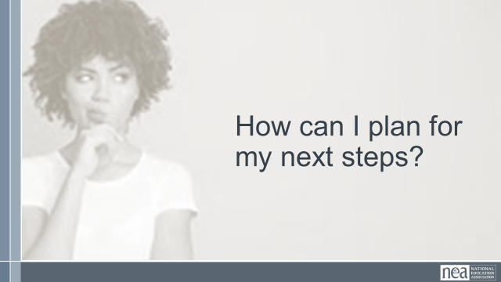  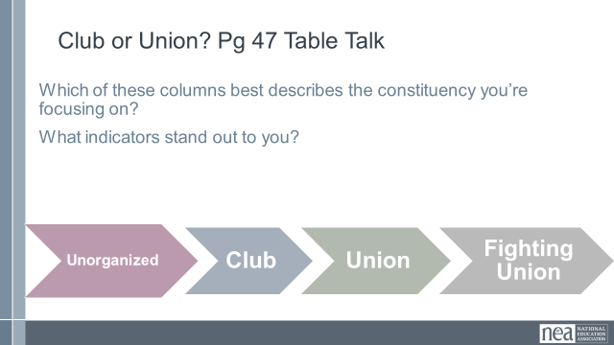  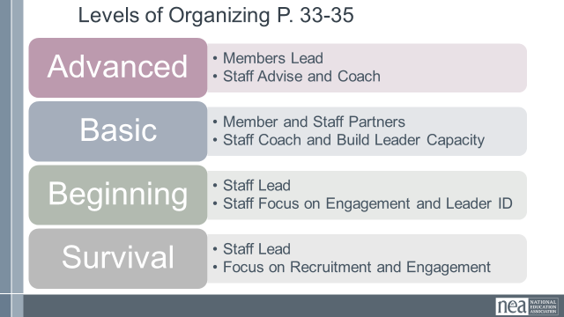  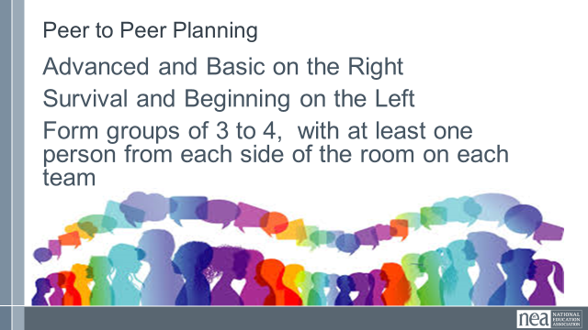  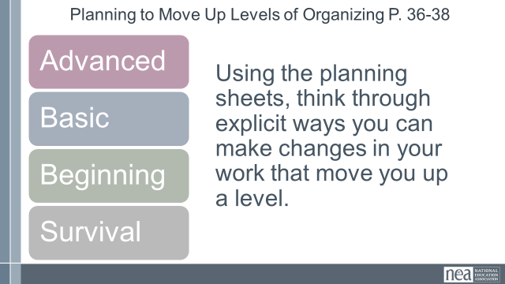  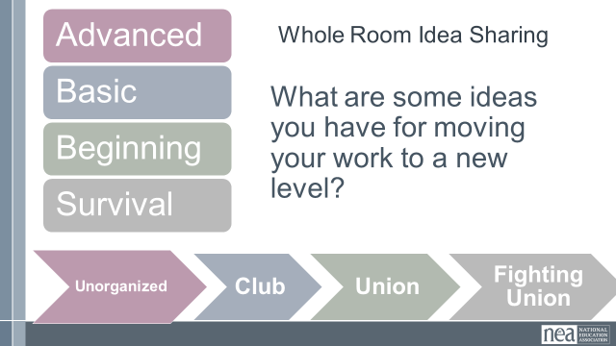  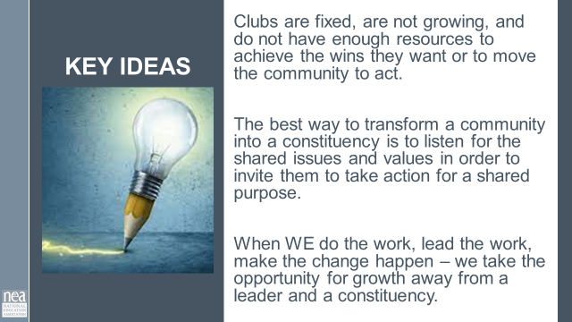 | How do I determine what my next steps are? | Club to Fighting Union P 47  Levels of Organizing and Planning to Move  P. 33-38  MIGHT WANT THEM TO ASSESS THE FOUR CASE STUDIES WITH THE CLUB TO FIGHTING UNION Framework  Worried about the timing here – doesn't seem like enough to really digest all the definitions in the levels of organizing framework and they won’t have seen it before. I also imagine most will want more than 15 minutes for planning (Zac) |  | 75 Minutes Assessing Our Work.  1 Minutes Into - If organizing is about turning our community into a constituency that can pool its resources, we need to have a good handle on how they are currently operating so that we can adjust our work with them to grow their capacity. We are going to look at two frameworks – Club or Fighting Union P. 47 and Levels of Organizing p. 33-38. Make sure you are working with your same table that created your charts of constituencies, you will need these. Each person needs to have in their mind one of the constituencies they added to the chart that they work with. You are going to use this constituency to focus your work in this section.  15 Minutes Group Work -. Use your targeted constituency and assess which level it is operating at on the Club to fighting union scale. As your table finishes, discuss what you have assessed and why.  1 Minutes – Intro – now you are going to switch your focus a little bit and used the framework found on pages 33-35.  15 Minutes Group Work –Review the Levels of Organizing found on page 33-38. Think on your current work with your targeted constituency. What level of organizing are you working at with them? As your table finishes, discuss what you have assessed and why.  8 Minutes- Now we are going to rearrange and do some coaching and planning. If you are a person that has identified Survival or Beginning come to the left side of the room. If you are a person that has identified Basic or Advanced Bargaining come to the right side of the room. NOW, from groups of no more than 4 that includes at least one person who is advanced or basic, and at least one person that is survival or beginner. Get into your groups and then I will give you your directions.  Now that you are in your small groups, you are going to use pages 36-38 to do some planning. As peers, work to write explicit plans in worksheet that would move your work with your constituency from the level that it is at to a higher level.  15 minutes Planning Work.  10 Minutes Whole Room Talk – What are some ways that you are thinking about changing your work?  5 Minute - Key Point:  Clubs are fixed, are not growing, and do not have enough resources to achieve the wins they want or to move the community to act.  The best way to transform a community into a constituency is to listen for the shared issues and values in order to invite them to take action for a shared purpose.  When WE do the work, lead the work, make the change happen – we take the opportunity for growth away from a leader and a constituency. |  | Participants will be able to assess and plan their work through two frameworks. They will understand that Organizing across affiliates looks differently, but advanced organizing has similar characteristics, regardless of where you are.
3:45-4:20  Melissa  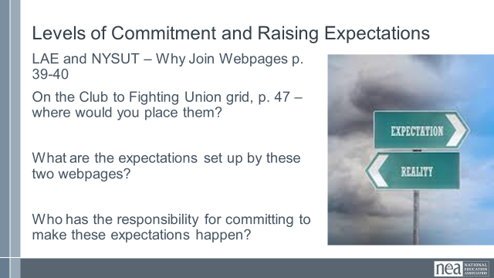  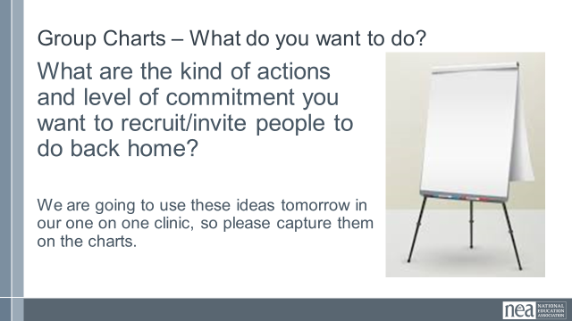  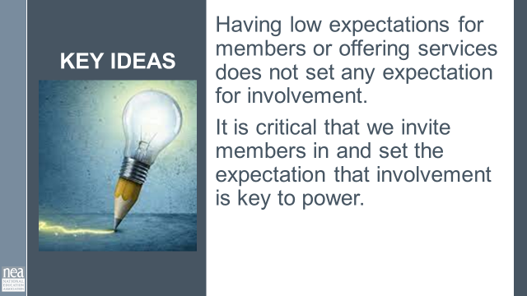 | How do we break the cycle of low expectations? How do we invite people into a different shared purpose?  SWAP WITH ZAC’S SECTION FROM DAY 2 | Examples of Why join p 39-40  Red State Revolt (Building Expectations)  p. 41-46  Club to Fighting Union Spectrum p.47  Could bump to Day 3 beginning/reminder section if more space needed (Zac) |  | 35 Minutes Setting and Raising Expectations  2 Mins Introduction Leaders join organizations and people. You are going to use your own or someone else’s device at your tables to contrast two web pages. You can find the URL on p. 39-40  10 Minutes Group Work - Looking at two different websites (Louisiana and NYSUT), what do you expect to get? Using the club to fighting Union spectrum again – where on this spectrum would you put each?  5 Minutes Report Out –  What are the kinds of expectations being set up by these webpages  Where does the primary level of commitment lie in these expectations (staff or member)?  How does the level of commitment for the member change as you move across this framework? For staff?  10 Minutes – Your group is going to reflect on the work you want to do back home and create a chart of your ideas.  What are the kind of actions and level of participation you want to recruit/invite people to do back home?  We are going to use these ideas tomorrow in our one on one clinic, so please capture them on the charts.  2 Minutes- Is there anything that needs to be shared?  1 Minute Key Point: Having low expectations for members or offering services does not set any expectation for involvement. It is critical that we invite members in and set the expectation that involvement is key to power.
4:20-4:30  Ellen  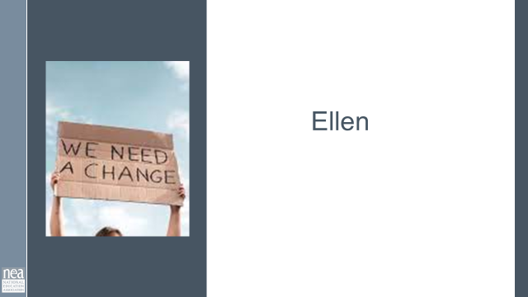  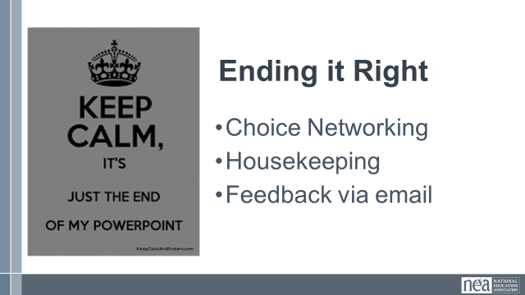  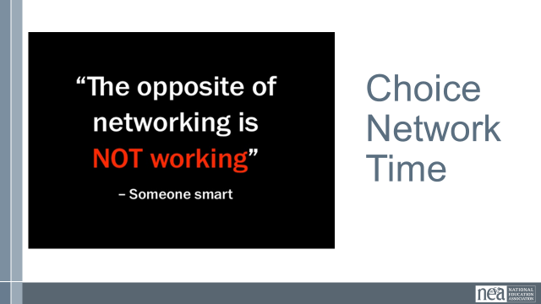 |  |  |  | Closing
4:30 -5:-00 | Adult Choice Networking
5:00 | ADJOURN

