Facilitator Agenda: From Club to Fighting Union Day #2
General Materials Needed: |  |  |  |  | Room Set-up:
1 Set of Handouts per Person  Name Tags or Name Tents  Sign-in Sheet  Pens and Pencils |  |  | Chart Paper  Post its  Highlighters – 3 colors  Chart Markers – non-permanent |  | Round Tables  Projector, Screen and Speakers  Carousel stations and reporting stations around the perimeter  50 people
Recognize that they take a risk
Opportunities to build structures that scaffold the movement into risk
Identifying Leaders because they have followers not their personal attributes
Beyond Leader identification – how to you listen to their “objections and differences” and move them to the shared values (enhanced one on one)
Expansion beyond the safe 1/3 - communication outside of the safety of your community(how do we move away from the niche – transforming culture, small changes through organizing.) Is there a benefit in designing an exercise that has several “clubs” with similar “visions” and having teams work to get them to work together?
How do you invite into the base by inviting them to tackle an issue they cannot win alone and help them FACE uncertainty by joining with others.

Methods and Concepts
Recognizing Competing Clubs moving multiple clubs together – strategies that encourage the joining together (ex. Invite the best of the others,
Data Mapping – natural leaders, map connections to larger constituency (michelle, draw our your leadership team. Draw out the leadership of your club, how are they connected to others, how were they invited and what qualities did we use to extend an invitation?) What kinds of data do we need – there are leaders and followers – who is trusted and respected
Identifying leadership – do we want to do a leadership ID activity?
Identifying issues – need the right leaders to move the issues
Assessing a worksite if they are ready to take action --

Time | Essential Questions | Resources |  | Instructions, Activity and Debrief (Facilitators) |  | Outcomes
 | What question(s) should this learning section answer? | Charts, handouts, articles, materials, slide |  | What are you saying, what are they doing, what questions will you use to guide learning and make clear the important points  Include an estimate for how long each section of the learning will take |  | As a result of this section of learning, what will participants know or be able to do?
8:30-8:45  Ellen  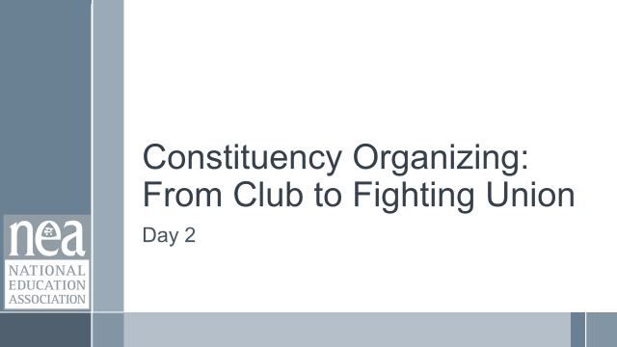  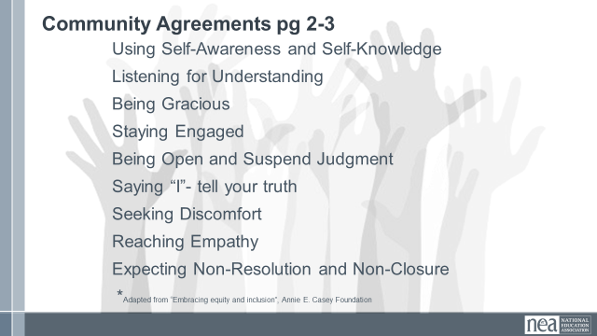    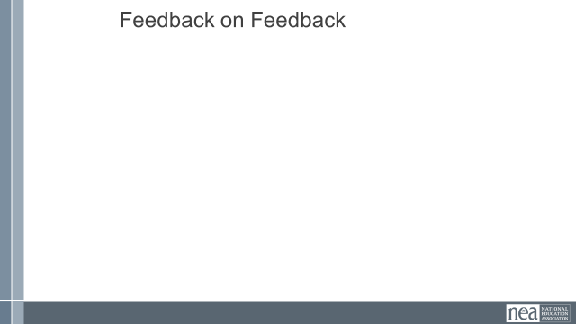 | How will we work together on Day 2? |  |  | Re-entry  Review of Community Agreements  Housekeeping Details  Feedback on Feedback |  | Participants continue to build as a learning community.
8:45 -9:00  Jeny     | What does organizing look like to me? |  |  | 15 Minutes Total - Synectics Activity  There are a number of pictures on the wall.  Select the one that best represents how you feel about your work right now.  Go there, meet the folks that show up. Share why your choose to be there.  Pick one person to share a single sentence report out about why you all arrived at this picture.  (Facilitator note: Adjust the number of pictures according the number of people and the amount of time you have |  | Participants will build a shared sense for what their work is like in various places.
9:00 – 9:30  Zac  I think that this should move to Day 1 in the place where we look at LAE and NYSUT  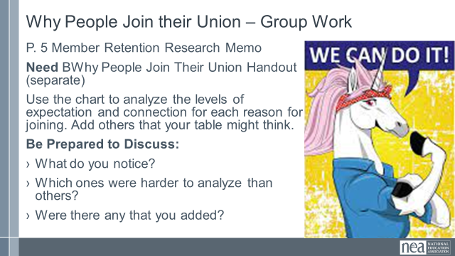  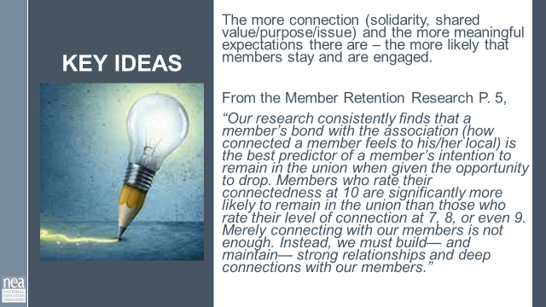 | How does our invitation to membership change the work?  SWAP WITH MELISSA’S SECTION FROM END OF DAY 1 | Membership Retention Data P. 5-7 as a resource.  Need to print handout for each table (Why People Join ) it is not in the handout booklet. |  | 30 Minutes - Why Belong to a Union  2 Minutes Introduction - How and why educators join our union shapes their expectations and commitment going forward. A person may join for protection, or to further a shared purpose, or any number of reasons. But a person who joins for protection may have a quite different idea about what it means to be in a union than someone who joins to achieve a shared purpose.  The decisions we make about how to ask someone to join, and even who asks them to join, can shape their reasons and expectations for joining.  Below is a list of typical reasons that someone might join our union. Add some of the ones you have heard that aren’t on the list.  Then place the letter next to each reason in a cell on each row of the rubric (so, where does A go on the first row, and where does it go on the second row?) For some statements, we may not have enough information to be able to place them on both rows.  - I joined because it’s the right thing to do  - I joined because we need to stand up for our profession  - Our working conditions are our students’ learning conditions, and we need to improve them both!  - I joined because others were all doing it at orientation  - I joined because the people were nice and it sounded good  - I joined because it sounds like it won’t cost much when they called me on the phone.  - I joined because parents are so litigious, and I don’t want to lose the job I worked so hard to get  - I joined because everyone needs insurance.  - I joined because Mary, the building rep, came and told me that everyone here belongs  - I joined because my mentor teacher, Jaime, said as a new teacher I might need protection.  - I joined because my mentor teacher, Ronald, told me that we are in a big fight with the new district administration and that they want to make special ed ratios worse, which I think would be terrible!  - I joined because my friend Teresa is a member.  - I joined because I had an issue with the principal and someone from the union office helped me.  5 Minutes Report Out  Were any of these hard to place on the list?  What other reasons did you add?  2 Minutes Key Points  The more connection (solidarity, shared value/purpose/issue) and the more meaningful expectations there are – the more likely that members stay and are engaged. |  | Participants will analyze the reasons people join to build an understanding about the function of connection and meaningful expectations.
   | Little | Some | Much | A lot
  What do I think might be expected of me as a member?
  What level of connection and solidarity with my coworkers does joining imply?
9:30 -10:15  Ellen  9:00- 9:45  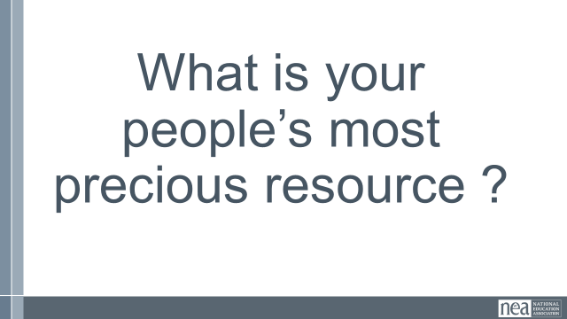    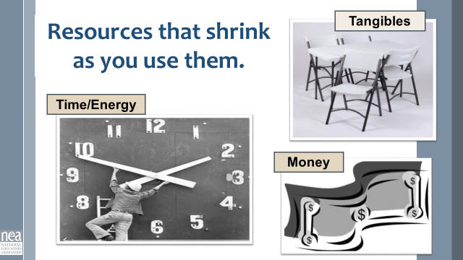  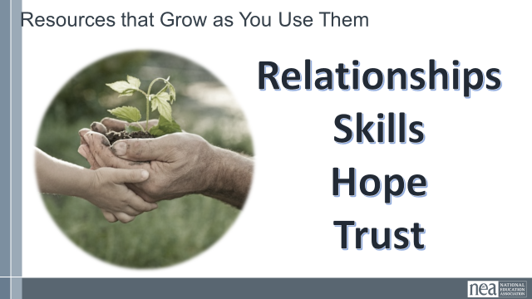  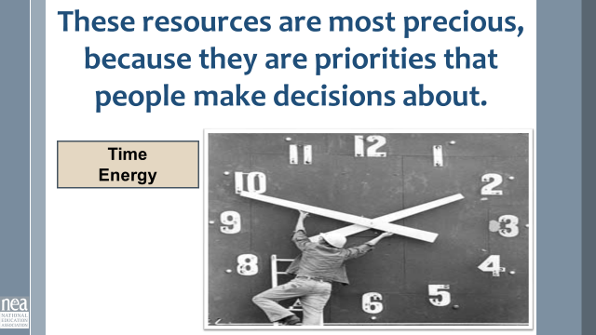  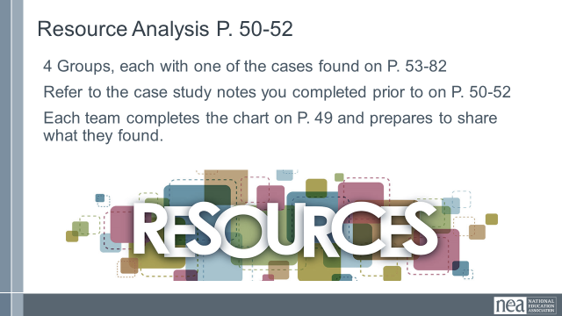  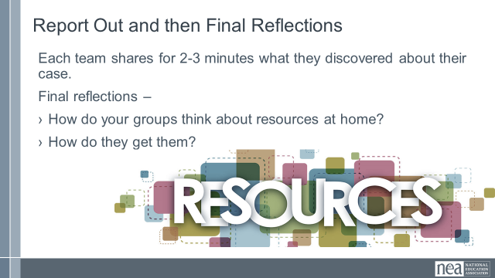  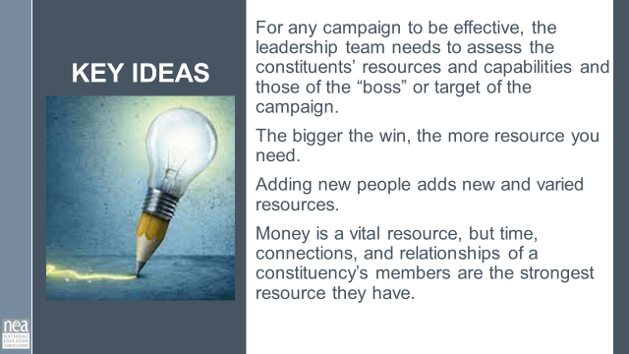 | What are the resources of my community?  How can my leadership team ID them? | Resource Assessment  P. 49  Case Analysis Worksheet  P. 50 -52.  Cases P. 53-82  PAR  New Teachers  Organizing a Caucus  It’s Not Magic  MIGHT WANT TO INCLUDE RED STATE REVOLT AS ONE OF THE CASES |  | 45 Minutes Resources for Change  5 Minutes Introduction: Turn your heads in at your table and take one minute to decide what your members’ most valuable resource is that they have to give. Ok shout out that answer – most folks are going to say time. Resources are what organized people in a constituency have and are willing to risk to achieve the shared purpose that they want.  Some resources shrink as you use them like tangible goods, money, time and energy.  Some resources grow as you use them – hope, trust, relationships, skills  Some resources are especially precious because they are the result of a person’s decisions and priorities. Time and energy are like that. I might have time to binge watch my latest Netflix until 2:00 AM, but I can’t find the time or energy to help the bargaining team call my colleagues about coming to an information meeting.  20 Minutes: Group Activity We are going to move into four groups. Each group will be assigned to be the “expert” on one case found in p 53-82.  PAR  New Teachers  Organizing a Caucus  It’s Not Magic  Using the chart on page 49-and the analysis sheet of the four cases found on pages 50-52 that you completed prior to coming, let’s figure out what each of our cases had in terms of resources.  What resources are currently available to the group? What is the group lacking? What resources does the boss have? What is the boss lacking? In this assessment, be certain to consider all types of resources – those that deplete as you use them and those that grow.  15 Minutes – Sharing what you found – each group will report out what their case had for resources.  Final reflections – what do your groups consider as resources at home? How doe they get them?  5 Minutes Key Point:  For any campaign to be effective, the leadership team needs to assess the constituents’ resources and capabilities and those of the “boss” or target of the campaign. The bigger the win you want, the more resource you need.  Adding new people adds new and varied resources.  Money is a vital resource, but time, connections, and relationships of a constituency’s members are the strongest resource they have.
10:15-10:30   | BREAK
10:30-11:45  Katie  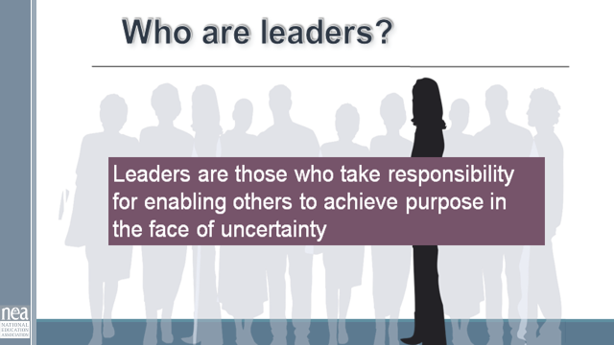  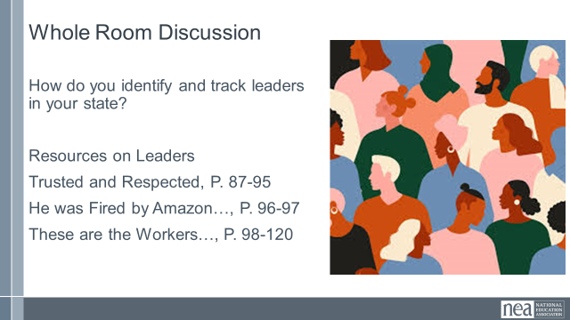    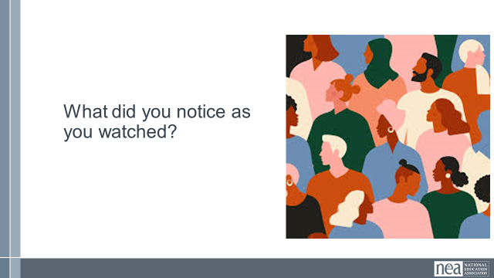  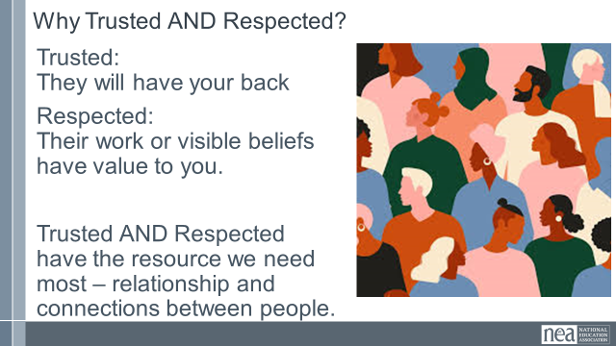  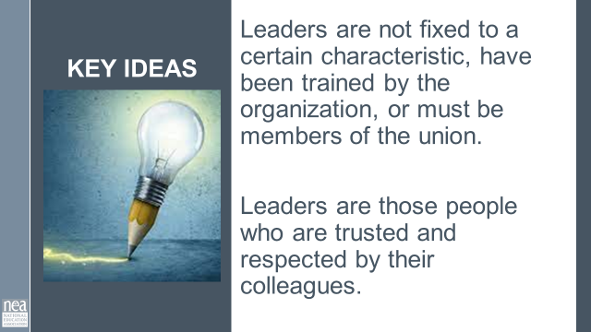  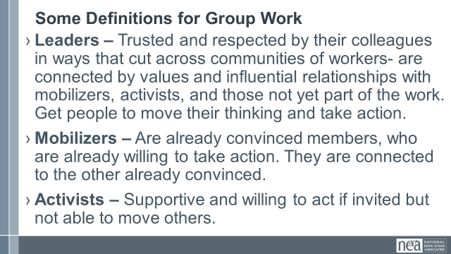  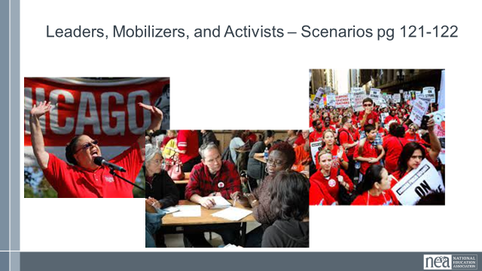  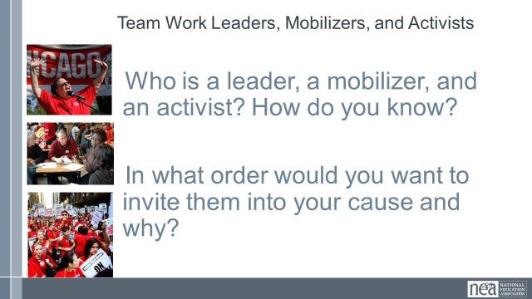  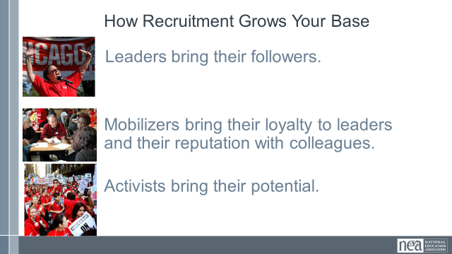  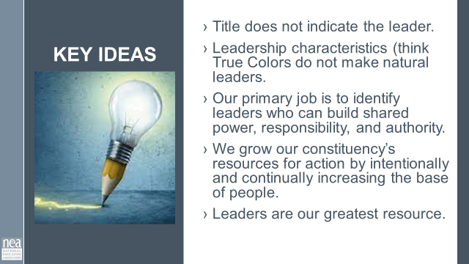    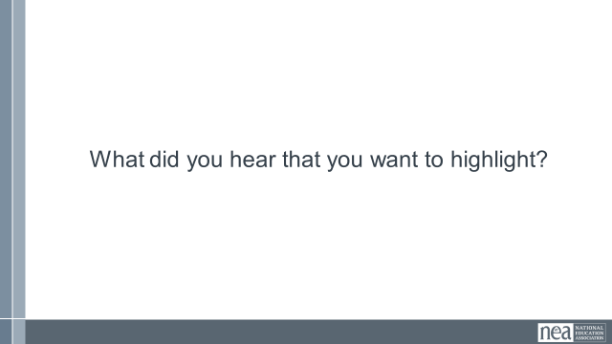  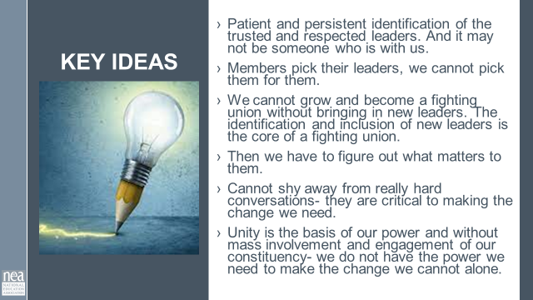 | Finding Leaders,  Why do we need to ID leaders?  How do we identify leaders? | Leadership Development Cycle P. 84-86  Trusted and Respected  P. 87-95  Chris Smalls  p. 96-97  These are the Workers  p 98-120  Activist Mobilizer Leader  P 121.122 |  | 75 Minutes Leaders  5 Minutes Introduction: If you have been with us before you know that we use the following definition of leaders: Show the slide and read Leader are those who enable others in the face of uncertainty. Very similar to the organizing definition we broke down on Day 1.  Quick share out: How do you ID leaders in your state? (Take about 3 or 4 – encourage them not to repeat) WE have included some additional resources on Leaders for your thinking and skill development.  5 Minutes Leadership Development Cycle – Pg 84-86  Every affiliate runs some sort of leadership conference. It is focused on building the skills of governing the organization. BUT the type of leadership development that turns a club into a fighting union is disciplined, intentional iterative. WE have to be disciplined about how we identify leaders – using methods grounded in good practice and data collection. We have to intentionally recruit leaders into our constituency by listening to what matters most to them and linking their core issues and values to our work. And then we repeatedly develop their ability to lead others by asking them to be responsible for meaningful work. We don’t ask them to do OUR responsibilities – we ask them to take responsibility for achieving an outcome, give any resources that might help, trust them to implement, reflect and assess with them, coach and give formative feedbackv0- then repeat and repeat and repeat this spiral. We sometimes refer to these as ‘tests’ – if they can’t do it, then they are not yet ready to move to the next level. They did not fail, they just did not grow.  20 minutes: 11 minutes on video We are going to take a look at a bit of a longish video. It is from Spokane Washington (a very conservative part of the state) about the power of 1:1’s and finding trusted and respected leaders. You should know that in this video: the people invited to the dinners were specifically asked because they were leaders.  Solid Gaines Through Solidarity 1920x1080 - YouTube  4 Minutes- What did you notice? (take a few responses)  4 Minutes: Why trusted and respected?  Trusted: they are those people who will have your back when you need it. (The teacher you can count on to speak up when something needs to be said or done).  Respected: You see their work and know it is quality and/or something that is similar in its value to you.  Without respect, they maybe your friend, but not someone you would trust to have your back.  Without trust, you know they do good work, but when the boss asks what's going on, you are not sure they won’t throw you under the bus.  It is that intersection that we find people with a resource of gold- the resource of relationship and connection between people.  1 Minute key ideas –  Leaders are not fixed to a certain characteristic, have been trained by the organization, or must be members of the union. They are those people who are trusted and respected by their colleagues.  35 Minutes Leader ID  5 Minutes Introduction – We are going to spend some time looking at some scenario descriptions of people that are part of your constituency. You are going to work in teams (3 Teams). Each Team is going to decide who in these stories are Leaders, Mobilizers, or Activists. We are going to use the following definitions  - Leaders – Trusted and respected by their colleagues in ways that cut across communities of workers- are connected by values and influential relationships with mobilizers, activists, and those not yet part of the work. Get people to move their thinking and take action.  - Mobilizers – Are already convinced members, who are already willing to take action. They are connected to the other already convinced.  - Activists – Supportive and willing to act if invited but not able to move others.  4 Minutes Let’s get into our groups (3 groups) and make sure you have page 121-122 with you.  15 Minutes – Now that you are in your groups you are going to take the next 15 minutes to decide who is who – AND you need to decide the order in which you would invite them to be part of the work of your constituency. YOU MUST reach consensus.  15 Minutes – Let’s hear want your teams decided – there is only one right answer. Facilitator note get them to be in discussion with each other. One technique is to ask for a person to share how they ID’d one person. Then ask the room who had the same ID. GO BACK To the first person and ask with the group decided this. Then go to the person who had a different ID and ask why. And so on. The key ideas you are pulling out is who is BOTH trusted and respected, and who ACTUALLY MOVED PEOPLE to do something. What is the evidence of these. It is not about who is liked – or even has the potential – it is who is DOING it.  Ted – Activist  Tina- Activist  Destiny – Leader  Paul- Mobilizer  Jorge- Activist  Use same method as who should be invited. This is a little looser – but really Desitiny should be approached last. SHE is the big recruitment. If you blow it, then you don’t get another chance. Look for answers that talk about those in relationship with Destiny and who can give you insight into what her core values are and what she might have in common with your constituency’s issues and interests.  2 Minutes -How Recruitment grows your base.  Leaders bring their followers.  Mobilizers bring their loyalty to leaders and their reputation with colleagues.  Activists bring their potential.  2 Minutes Key Points Title does not indicate the leader.  Leadership characteristics (think True Colors do not make natural leaders.  Our primary job is to identify leaders who can build shared power, responsibility, and authority.  We grow our constituency’s resources for action by intentionally and continually increasing the base of people.  Leaders are our greatest resource  15 Minutes – Final Words from Jane and Your Thoughts  11 Minutes for Video – we are going to sum up this section on leaders by viewing a video by Jane Mcalevey: Jane McAlevey on Deep Organizing - YouTube  What did you see?  - Stop and note about 1-1. Did Jane accept the “No”, did Jane give up on a leader- no.  - She acknowledges, and then focused on the importance of the task and work ahead and who the persons involvement would make all the difference- and clearly had an ask for them that would make a difference.  4 Minutes Key Ideas – Ask folks for that they heard. Then at the end of the time share the slide and point out any key ideas that they missed.  Key Ideas  Patient and persistent identification of the trusted and respected leaders. And it may not be someone who is with us.  Members pick their leaders, we cannot pick them for them.  We cannot grow and become a fighting union without bringing in new leaders. The identification and inclusion of new leaders is the core of a fighting union.  Then we have to figure out what matters to them.  Cannot shy away from really hard conversations- they are critical to making the change we need.  Unity is the basis of our power and without mass involvement and engagement of our constituency- we do not have the power we need to make the change we cannot alone. |  | Participants
11:45 to 12:00 then 1:00-1:35)  Zac  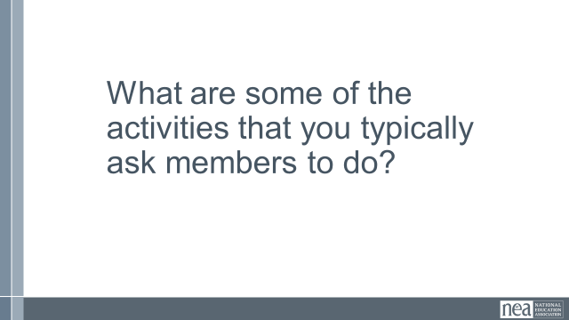  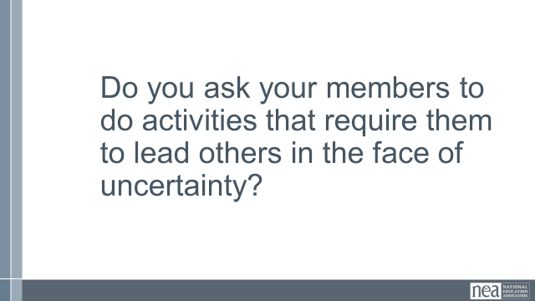  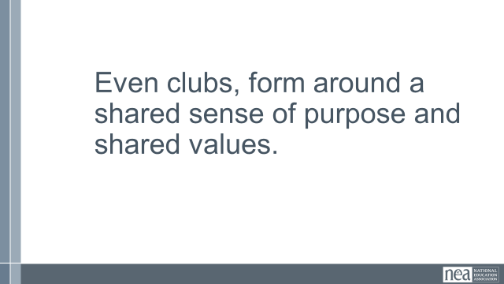  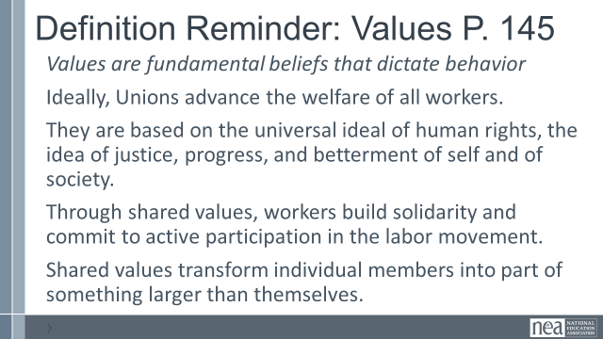  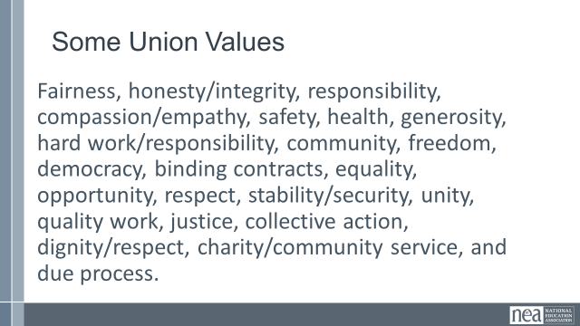  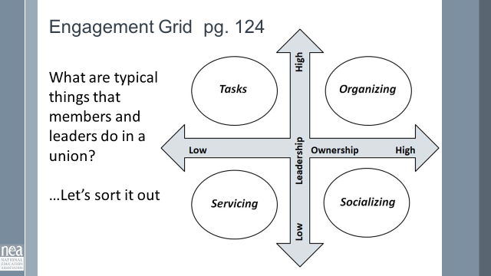  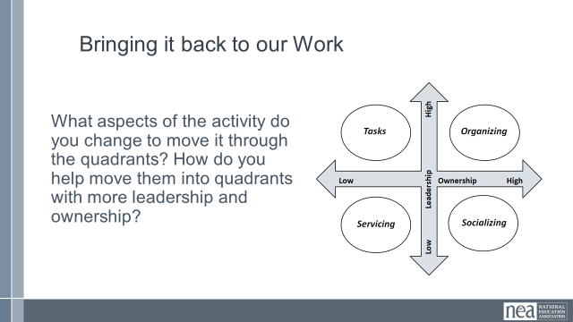  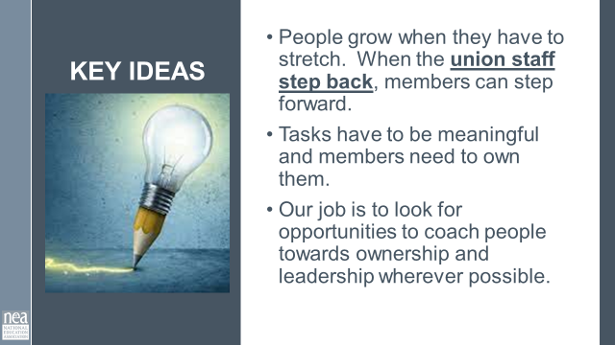  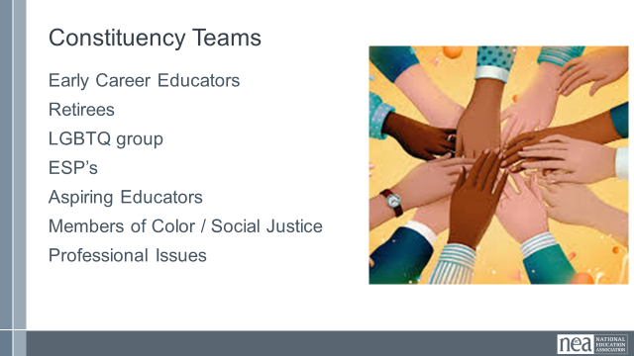  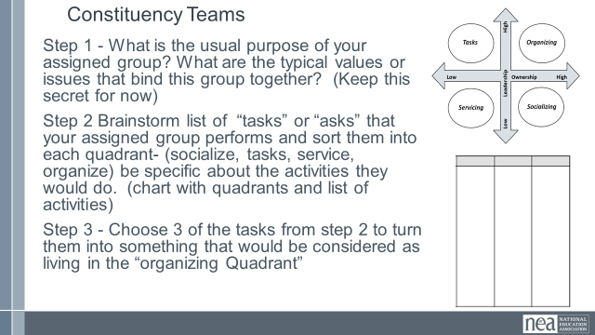  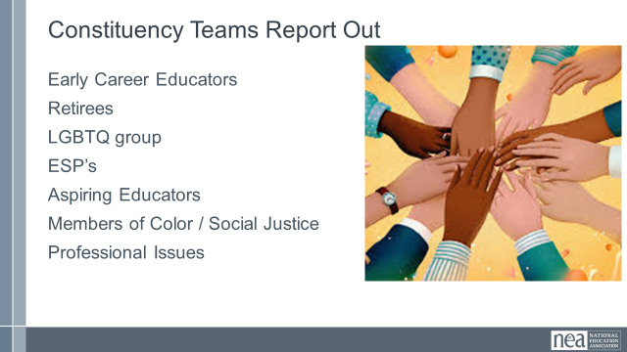  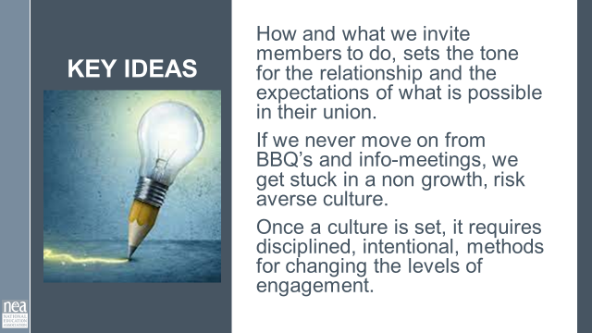 | MAKE SURE TIMING MAKES SENSE | Ladder of Engagement  - 123-124  Advocacy Mobilizing Organizing Grid  p. 129  Core Values  p. 145 |  | 50 Minutes Engaging Leaders and Members  3 minutes Table talk – Turn in at your tables for 5 minutes and share what some of the activities are that your current work assignment asks members to do.  2 Minutes Whole Room – Let’s hear a few – don’t repeat something that you heard  1 Minute Just thinking on your own about the responses you heard, Do we ask or expect our members to lead others in the face of uncertainty?  1 Minutes- Even clubs form around a shared purpose and have shared values.  Let’s review the definition of values quickly, and then review some examples union values  3 Minutes activity introduction. What we ask people to do is directly linked to their decision to stay engaged and how much effort they contribute to the resolution of the problem in front of them. Turn to your Engagement Grid Handout on Page 129 . Our colleague at NEA, John Donaghy, broke down what brings us to organizing – it is a function of how much ownership and leadership a person has in the activity. We defined leadership already (enabling others in the face of uncertainty). Ownership is the accountability and responsibility for the outcome of something.  Let's break it down  - Servicing- low ownership, low leadership. You are receiving something while doing very little to achieve it.  - Tasks: Low ownership, but high leadership. You are asking to do something and have responsibility, but are not responsible/accountable for the outcome.  - Socializing: High ownership, and low leadership. You have high accountability, but it takes very little engagement to get this outcome.  - Organizing: High ownership and low leadership. You have high accountability for the outcomes and it takes brining in others to achieve this work.  Here is an example: We have a constituency group that is focused on professional issues ‘organizing’. Staff write the training and provide the training, and invite members to it.  5 Minutes table Activity : Work with your table mates to answer the following:  - Where does this example land on the grid?  - How would you change the actions in the example to move it to other quadrants?  5 Minutes Report Out - They should have identified the scenario as being a service. In order to make it socializing, the members might take ownership of the invitations but not much else. To move it to task, the staff person would pick a cadre, train the cadres, provided support for the cadre to implement the training. For it to move into organizing – the members would identify what the problem is they need to solve, they would then determine if traning is how they want to solve it. They design, implement, and do the turnout. Staff advises and supports.  Key Points:  - People grow when they have to stretch. When the union staff step back, members can step forward.  - Tasks have to be meaningful and members need to own them.  - Our job is to look for opportunities to coach people towards taking risks and raising expectations for what they can do with their union.  5 minutes Activity Introduction Now we will do some real life practice.  Each table gets well known constituency; Retirees, LGBTQ group, ESP’s, Aspiring Educators, Members of Color Group, Student Group,, and Professional Issues Group. You are going to complete three products for each of your group.  First, What is the usual purpose of your assigned group. What are the typical values or issues that bind this group together. Discuss this, take good notes on 8.5 x 11 paper and put it away for safe keeping. This should take about 10 minutes. You are not to share this with any other group yet.  Second, you are going to brainstorm a typical list of “tasks” or “asks” that your assigned group performs. Put these on a chart. What are activities that this group could do that would fall into each quadrant- (socialize, tasks, service, organize) be specific about the activities they would do. (chart with quadrants and list of activities)  PICK 3 of these from step 2 to turn them into something that would be considered as living in the “organizing Quadrant” it has high ownership and high leadership. (chart with three sections that describes organizing activities.  20 MInutes of work time  10 Minutes to share out  What was most challenging about this?  What is a big new learning that you think the room needs to hear?  1 Minute Key Point:  How and what we invite members to do, sets the tone for the relationship and the expectations of what is possible in their union.  If we never move on from BBQ’s and info-meetings, we get stuck in a non growth, risk averse culture.  Once a culture is set, it requires disciplined, intentional, methods for changing the levels of engagement.  SOME OF THIS MIGHT EXTEND PAST LUNCH  There will be another time when the materials generated by the teams will be used. |  | Participants will learn to use the engagement grid to analyze and design tasks.  They will review and identify purpose and core values and their roles in recruiting.
12:00 -1:00   | Lunch
1:00-1:35  Zac |  |  |  | Continue from Before Lunch
1:35 – 3:20(with 15 minute break in there)  Katie  W/ Zac and Melissa  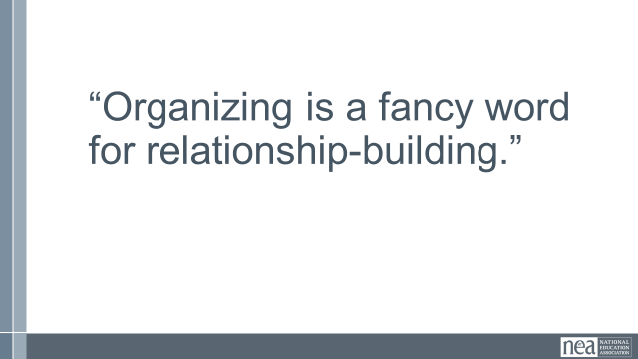  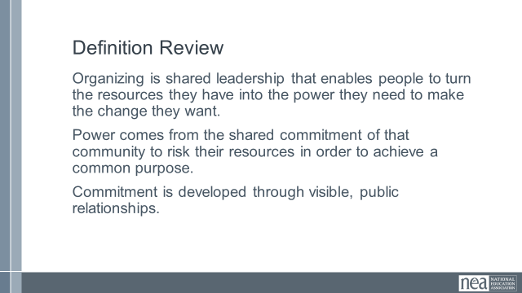  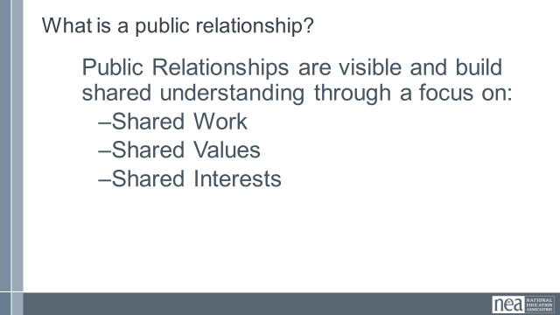  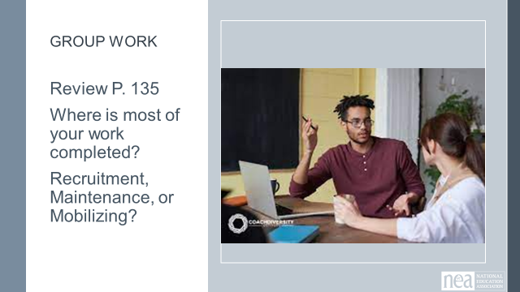  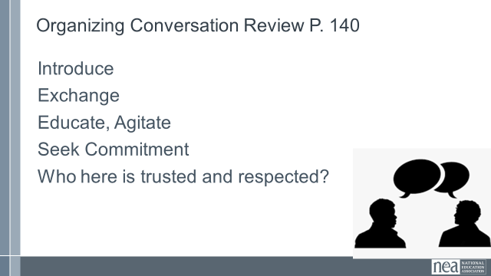  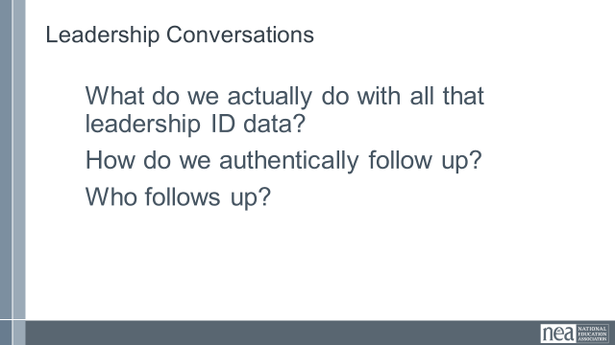    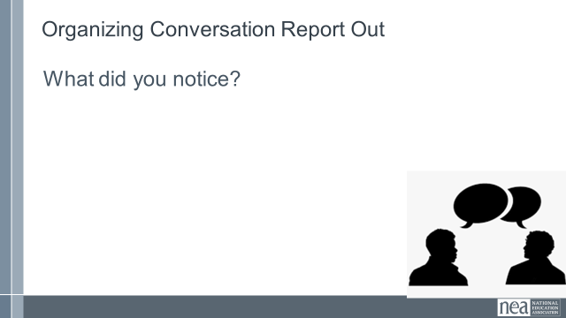  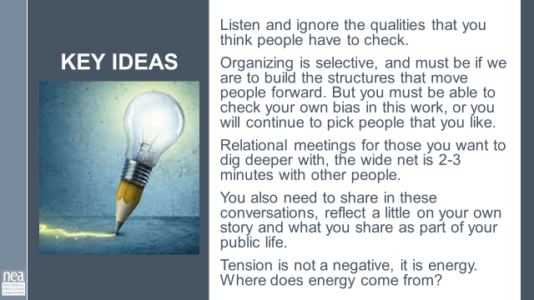  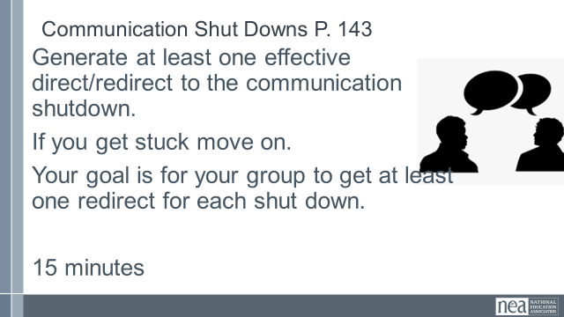  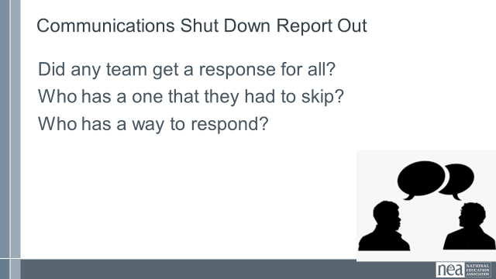  DO WE INCLUDE ARR RESPONDING TO OBJECTSION SLIDES?  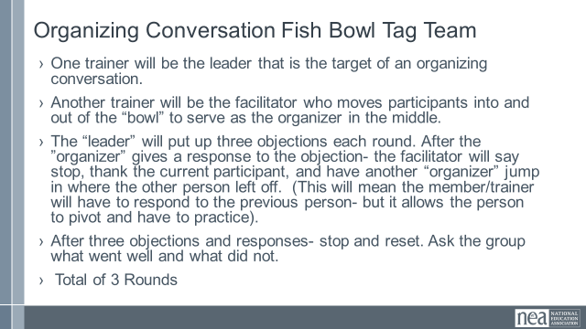  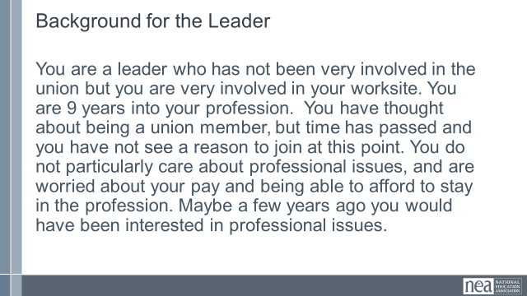  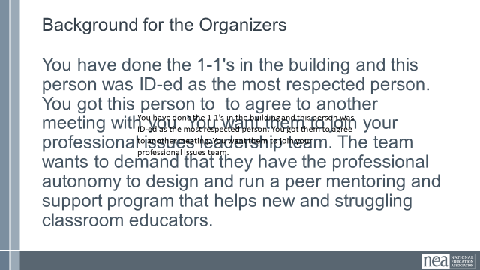  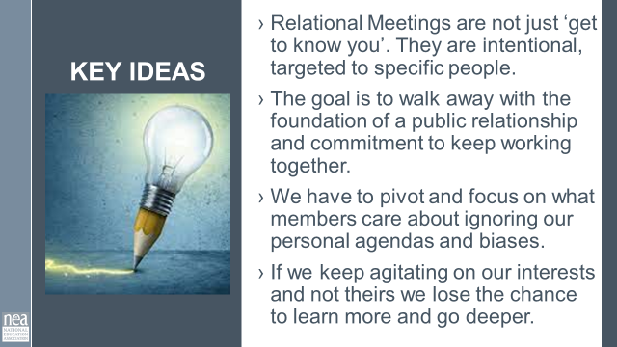 |  | One on Ones Pg 135 - 139  Developing Your Script p. 140  IAF P. 141  Listening Resources  P 142  Communication Shut Downs  p. 143  Asking Questions Grid p. 144 |  | 90 Minutes One on One for Leader Recruitment  2 Minutes Introduction: We do 1-1s to build relationships. Mary Beth Rogers once said, “Organizing is a fancy work for relationship-building. We define organizing as leadership that enables people to turn the resources they have into the power they need to make the change they want. Power comes from commitment to work together to achieve a common purpose and commitment is developed through relationships. These are our public relationships- not our private relationships. They focus on the shared work and through sharing common values and interests- we create understanding that is the bedrock of public relationships. Something about Public Relationships  5 Minutes – Quick reviewLooking at page 135, where is the majority of your work? Recruitment, Maintenance, or mobilizing.  5 Minutes Introduction : We have gotten into the habit of considering the quick blitzes and membership recruitment conversations as relationship building 1-1's. But they are not. They are data collection, education, and recruitment. WHO Is doing them is as important as HOW they are being done. We as staff have to build the capacity of members to do these types of 1 to 1s so that we can work on the deeper relationship building conversations with leaders. Return to the assessment piece of Leaders – needs to be a skill that is broadly taught to increase capacity.  Every good conversation of every membership recruitment or issue blitz is ended with “who is trusted and respected” and that data is fairly regularly collected. A solid example of this can be found on page 140 . The real question to address is how WE are following up with the identified leaders?  The follow up with identified leaders is key. For identified leaders, as we invite them into our organization, we take the time to do relational meetings. Something about this is not a blitzy type conversation or necessarily is scripted. We are typically also asking them if they are willing to risk relationship capital or credibility  12 Minutes VIDEO - We are going to watch a video about relational 1-1's with Ernesto Cortez. He is an organizer with IAF in the south. You will notice that they are loosely following the guidance on page 141. Something about the IAF  In between his lecture, you will see people practicing 1-1's. – Keep track of what you notice about these one on ones.  Ernesto Cortes on Relational Meetings - YouTube  10 Minutes Report Out – What did you notice? Facilitator will listen for the keyLearning Points from Video, then facilitator shares the key learning points and highlights any that were not said out loud.  - Listen and ignore the qualities that you think people have to check.  - Organizing is selective, and must be if we are to build the structures the move people forward. But you must be able to check your own bias in this work, or you will continue to pick people that you like.  - Relational meetings for those you want to dig deeper with, the wide net is 2-3 minutes with other people.  - You also need to share in these conversations, reflect a little on your own story and what you share as part of your public life.  - Tension is not a negative, it is energy. Where does energy come from?  A good self check for you can be found on page 142 – Bad habits of listening  4 Minutes Intro and Group Move - We are going to move into smaller new groups. Once I get you assigned, I will give you the directions.  We are going to work with page 143. As a team generate at least one effective direct/redirect to the communication shutdown. If you get stuck move on, our goal is for the group to get at least one redirect for each shut down in the next  15 minutes. Group Work - Teams work on their redirects  10 minutes Debreif – Were there any teams that got them all?  Who has one that they could not come up with a good redirect? Who has something for that?  DO WE INCLUDE ARR RESPONDING TO OBJECTSION SLIDES?  5 minutes Prepping for Fishbowl -Let’s move into a circle with two chairs in the middle.  We will practice the relationship recruitment 1-1 with leaders.  3 Minutes -Tag Team Relational Fishbowl Intro  - One trainer will be the leader that is the target of an organizing conversation (See background below) are going to talk to.  - Another trainer will be the facilitator who moves participants into and out of the role of organizer in the middle.  - The “leader” will put up three objections each round. After the ”organizer” gives a response to the objection- the facilitator will say stop, thank the current participant, and have another “organizer” jump in where the other person left off. (This will mean the member/trainer will have to respond to the previous person- but it allows the person to pivot and have to practice).  - After three objections and responses- stop and reset. Ask the group what went well and what did not.  - Total of 3 Rounds.  Background:  - Leader in the Middle: You are a leader who has not been very involved in the union but you are very involved in your worksite. You are 9 years into your profession. You have thought about being a union member, but time has passed and you have not see a reason to join at this point. You do not particularly care about professional issues, and are worried about your pay and being able to afford to stay in the profession. Maybe a few years ago you would have been interested in professional issues.  - Organizers: You have done the 1-1's in the building and this person was ID-ed as the most respected person. You got them to agree to another meeting. You want them to join your professional issues team.  20 Minutes of Activity 3 rounds of 3 people.  2 Minutes Key Learning  - Relational Meetings are not just ‘get to know you’. They are intentional, not with everybody, and the goal is to walk away with the foundation of a public relationship and commitment to keep working together.  - We have to pivot and focus on what members care about. If we keep agitating on our interests and not theres- we lose the chance to learn more and go deeper.
2:30-2:45   | BREAK
3:20-4:05  Jeny |  | Review pages 136 Hard asks and Types of NO |  | 45 Minutes – Making Connections and Building Your Base  4 Minute Introduction – we are going to return to our Constituency groups. You are going to work on getting as many other constituencies to see the value of joining together with you. Think about what build solidarity – shared values and interests. Your task is to try out your organizing skills to get other groups to join you. Now, remember, the more resources and people we have, the bigger actions we can take – aka the more power we can wield. It really is NOT in any constituency’s best interest to remain an island BUT it is also not healthy to dilute solidarity and purpose by joining everything – this causes a lessening of credibility and focus.  Step 1 – in your constituency groups first, review your three activities – then strategically think about which of the other groups may have shared values or issues that this activity could support. You also need to review what you said were your values and your issues. Take 10 minutes to consider who you will target AND what you might be willing to say yes to.  Step 2- Move out and have one on ones that seek commitment for your ask. The goal is a yes from as many other groups as possible. Work your 1-1 skills, have conversations and see how much you can build your base.  10 Minutes in Constituency Groups  20 Minutes to seek commitments  10 Minutes Debrief:  Who really asked you great questions?  Who genuinely made you move your thinking? How?  Who really challenged your skills in asking? Why?  What is something that you will take away from this?  1 Minute Key Point:  It is critical that our constituencies continue to grow their base by connecting with other groups in the union.  Base building allows our constituency groups the ability to leverage more resources to achieve the things they cannot alone. |  | Participants will work through a scenario to apply the skills of relational 1-1’s, in order to recruit more people to their base.
4:05-4:20  Ellen |  |  |  | Organizers’ Discourse
4:20-4:30  Ellen |  |  |  | Closing  Prepping for Getting Home
4:30 – 5:00 | Adult Choice Networking
5:00 | ADJOURN

