Facilitator Agenda: From Club to Fighting Union Day #3
General Materials Needed: |  |  |  |  | Room Set-up:
1 Set of Handouts per Person  Name Tags or Name Tents  Sign-in Sheet  Pens and Pencils |  |  | Chart Paper  Post its  Highlighters – 3 colors  Chart Markers – non-permanent |  | Round Tables  Projector, Screen and Speakers  Carousel stations and reporting stations around the perimeter  50 people
Key Outcomes for the Day
What is an organizing plan that moves a club to a fighting union
Clubs are focused on a problem but it is not a fight with the boss and/or on the issues their larger constituency would engage on.
Cooperation with the boss will not win the fight for the workers.
FSE – F---ing social events 😊 or WBF – winning boss fights
Leaders and managers can be moved by wins --- then we can “undermine” that charge. Has to be a recognition of a failure in order to move forward

Bring something from home for this day -- ?
Working within one constituency OR stitching together several constituencies?

Time | Essential Questions | Resources |  | Instructions, Activity and Debrief (Facilitators) |  | Outcomes
 | What question(s) should this learning section answer? | Charts, handouts, articles, materials, slide |  | What are you saying, what are they doing, what questions will you use to guide learning and make clear the important points  Include an estimate for how long each section of the learning will take |  | As a result of this section of learning, what will participants know or be able to do?
8:30-8:40  Ellen  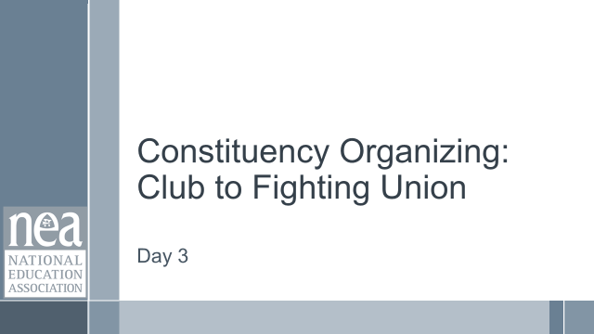  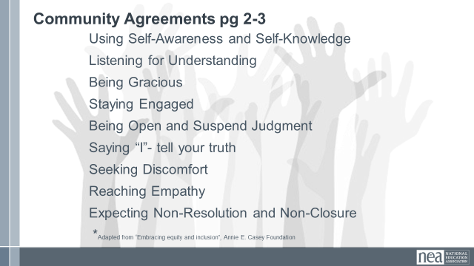  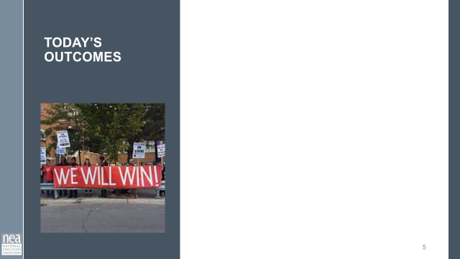  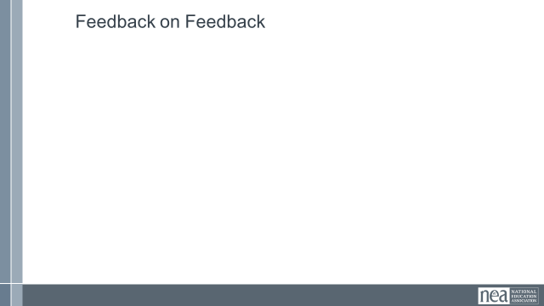 |  |  |  | Re-entry  Review the Norms  Today’s Outcomes  Housekeeping Details  Feedback on Feedback
8:40 – 9:30  Jeny    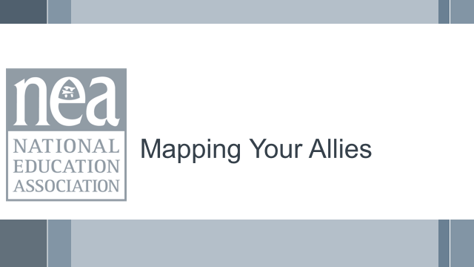  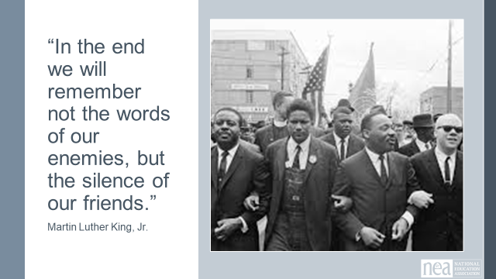  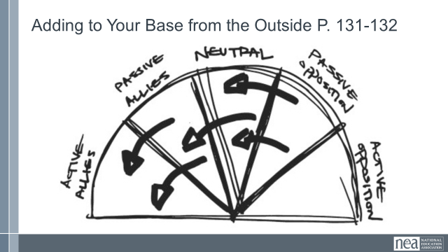  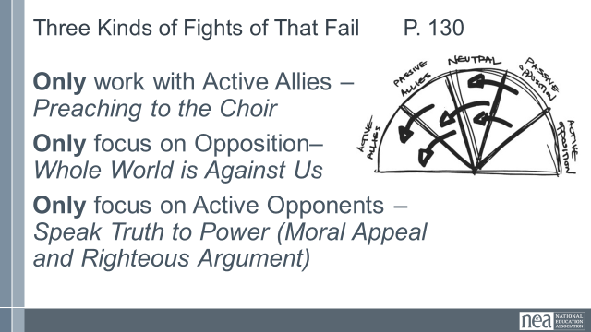  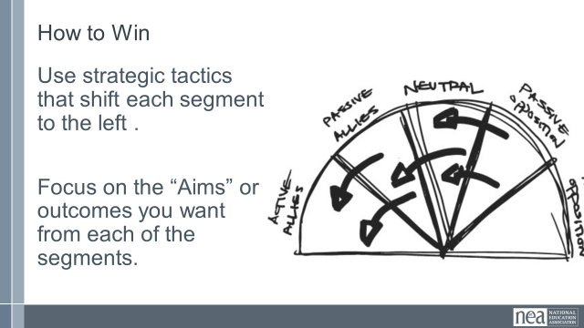  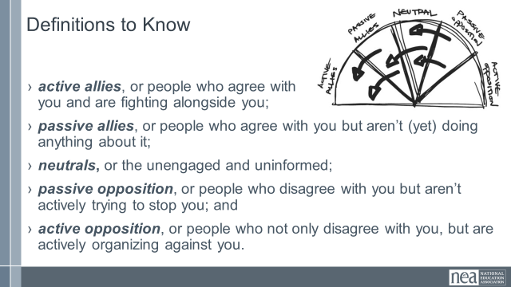  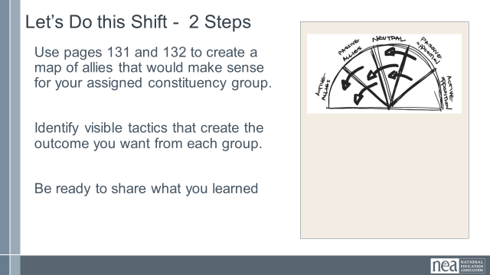  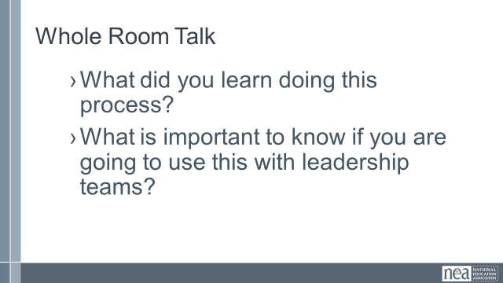  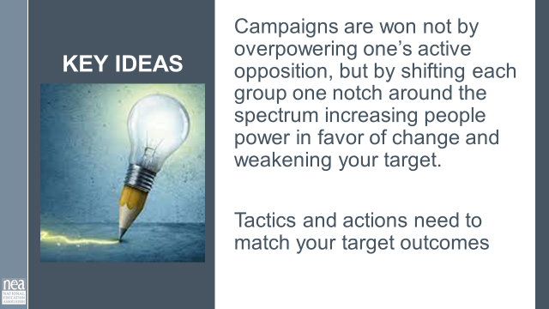 | Who can we strategically add to our base?  What are the tactics and outcomes we need to build our base of people power? | Strategic campaign pages 154-155  Spectrum of Allies pg. 130-132 |  | 50 Minutes Map the Allies  10 Minutes Introduction: Show the slide with Quote. The bigger your demand, the more broadly you need to build your base. Big demands are not simply won by overpowering the target, but also by shifting support away from the target.  We are going to use a spectrum-of-allies analysis tool, found on page 130 and first attributed to George Lakey to identify the other constituency groups that are affected by your issue. You will place those groups along a spectrum, from active opposition to active allies. Because every constituency has limited resources, this allows teams to focus efforts on shifting those groups closer to their position.  One key in using this tool is to be specific in Identifying allies (e.g. not just other union members, but members at specific worksites; not just workers, but workers who do similar work) can help you identify the most effective ways of moving different groups closer to your position, in order to win your campaign. Clubs may do a good job of identifying other allies aligned with their values, but fighting unions seek to form action oriented alliances that working towards shared demands.  Using this tool that allows a leadership team to evaluate the spectrum of allies that exist around their issue. Constituencies sometimes only concern themselves with their active allies, which runs the risk of “preaching to the choir” — building marginal connections to shared interests that are invisible to everyone else, while ignoring the people they actually need to convince. Others behave as if everyone who disagrees with their position is an active opponent, playing out the “story of the righteous few,” acting as if the whole world is against them. Yet others take a “speak truth to power” approach, figuring that through moral appeal or force of logical argument, they can somehow win over their most entrenched active opponents. All three of these extreme approaches virtually guarantee failure.  Campaigns are won not by overpowering one’s active opposition, but by shifting each group one notch around the spectrum (passive allies into active allies, neutrals into passive allies, and passive opponents into neutrals), thereby increasing people power in favor of change and weakening your opposition. Look at p. 130, and notice the “Aims” or the target level of support you want each ally to provide – do the tactics you are using align with these ?  On the right side of this chart, we don’t list  30 Minutes Creating the Map - Pg 131-132 – Use the definitions found on page 131 and the outline on p. 132 to make a wall chart of your assigned constiuency’s ally landscape.  - active allies, or people who agree with you and are fighting alongside you;  - passive allies, or people who agree with you but aren’t (yet) doing anything about it;  - neutrals, or the unengaged and uninformed;  - passive opposition, or people who disagree with you but aren’t actively trying to stop you; and  - active opposition, or people who not only disagree with you, but are actively organizing against you.  In the appropriate wedges, place different constituencies, organizations, or individuals. Spend a significant amount of time brainstorming the groups and individuals that belong in each of the sections. Be specific: list them with as many identifying characteristics as possible. And make sure to cover every wedge; neglecting sections will limit your strategic planning and your potential effectiveness  10 Minutes - Whole Room Talk  What did you learn doing this process?  What is important to know if you are going to use this with leadership teams?  1 Minute Key Ideas –  Campaigns are won not by overpowering one’s active opposition, but by shifting each group one notch around the spectrum increasing people power in favor of change and weakening your target.  Tactics and actions need to match your target outcomes |  | Participants will learn about and apply a power analysis tool
9:30- 10:15  Melissa  NEED SLIDES | Issues that win | Levels of Organizing  P  . 33-35  Case Studies from p. 48-82 |  | 45 Minutes – What are Issues that Bring a Fight to the Boss  Issues are central to organizing. Without knowing the issues our people face we end up either focusing on issues that are too big, aka problems, or without a focus to our efforts and energy. Problems have underlying issues, and as staff, we help members dig into the larger issues and work out what is underlying the problems they face.  Reminder: Issues are fixable, widely felt, and deeply felt. Using handout on page ___.  Looking back over yesterday's work:  - What are the typical ‘club union’ issues? Using the levels as a guide.  - What is a fighting union issue?  Looking at the previous reading from NC, Seattle, and New England- what were the issues people most cared about?  Looking back home: What are the issues people most identify that they want addressed?  Chart it up. Use the Issues to Problem.  Key Point: Issues are what move people and give organizations purpose. If we are to move from club unions to fighting unions, picking strong issues to build teams of members around is critical to engagement and changing the narrative of your union.
30 Minutes  Katie  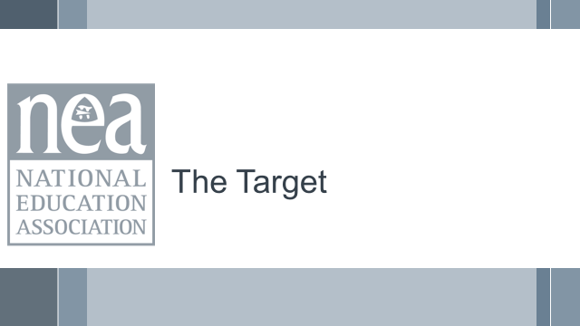  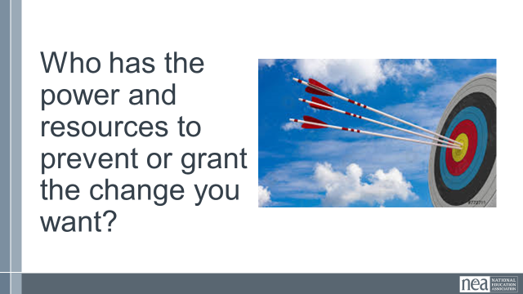  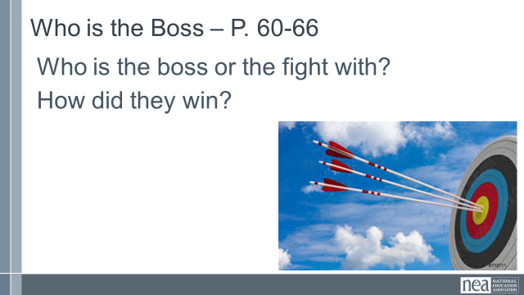  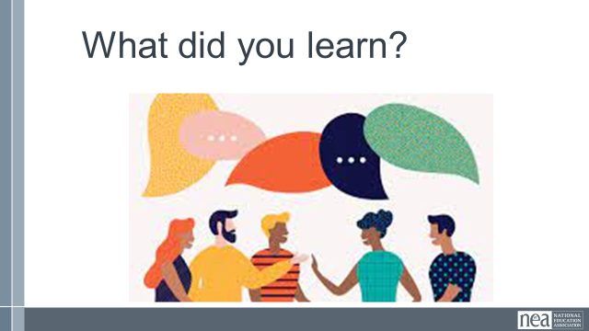  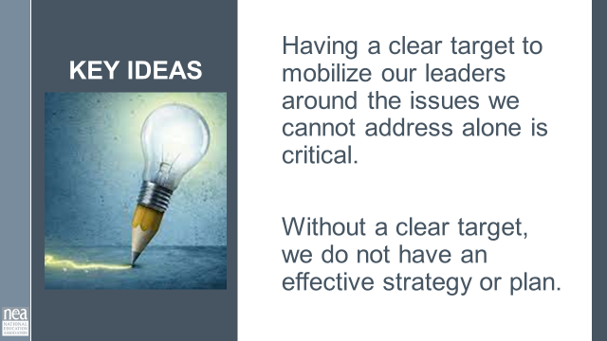 | Who are we fighting? What do we want them to do? | Use the Case Studies and the Club to Union P. 47  Organizing A caucus Step by Step p. 60-66 |  | 30 Minutes – Who is the Target  3 Minutes Introduction: Club unions typically have low expectations and if they do have an issue to work on- there is no target for change.  Ask participants: When you ask your members back home who has the resources to make the change they want?  Answer is typically, I do not know or “the board”. With no sense of who that is.  In order to organize, we need to assess who has the resources to make the change we seek. As staff our role is to help define that for members.  Being able to Identify the boss is critical to any union campaign. The “boss” is the person who has the ability to deliver the resources to address the issue that your people face. In a fighting union, we identify the boss or target that has the resources to deliver on what our people need. Without a clear target, we are acting without strategy, and actions without strategy are wasted resources.  20 Minutes Who is the boss? Activity  Looking at a club model of union work, who is the boss or the fight with?  Organizing a Caucus Step By Step p. 60-66, analyze who was the boss was and how the local “won” their campaign.  5 Minutes Report Out – What did you find?  2 Minutes Key Point: Having a clear target to mobilize our leaders around the issues we cannot address alone is critical. Without a clear target, we do not have an effective strategy or plan. |  | Having a clearly recognized and defined target helps focus actions and tactics.
10:15- 10:45  Zac  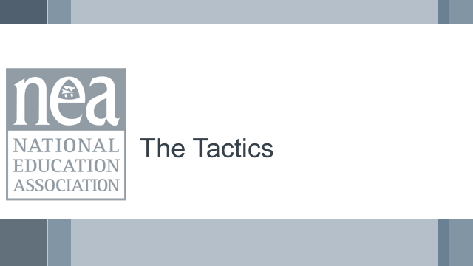  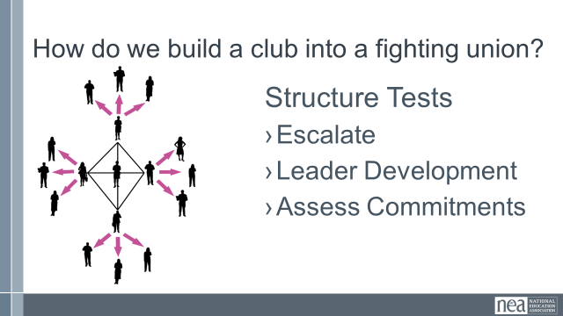  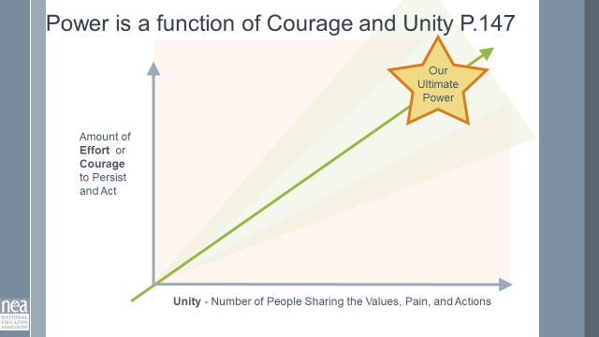  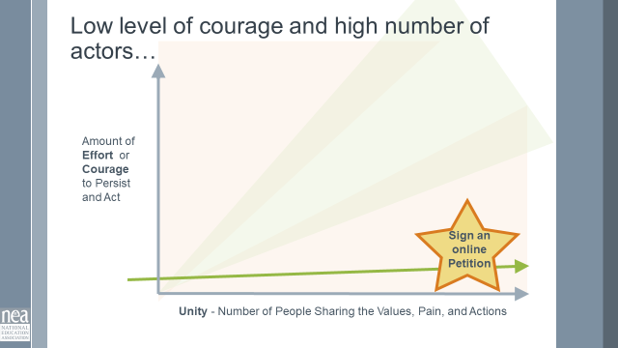  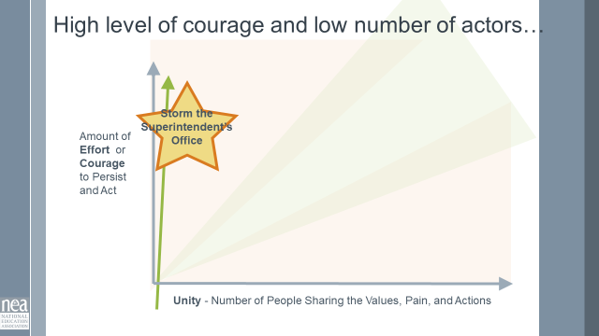  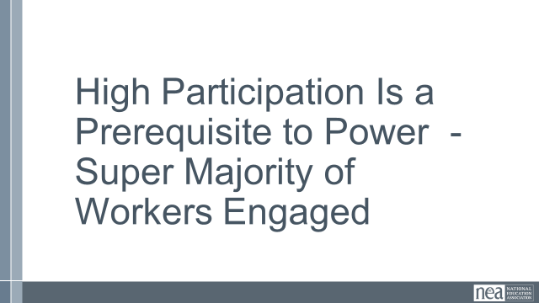  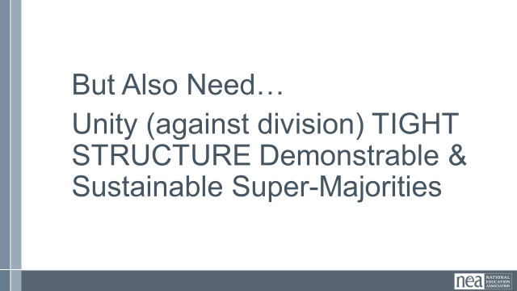  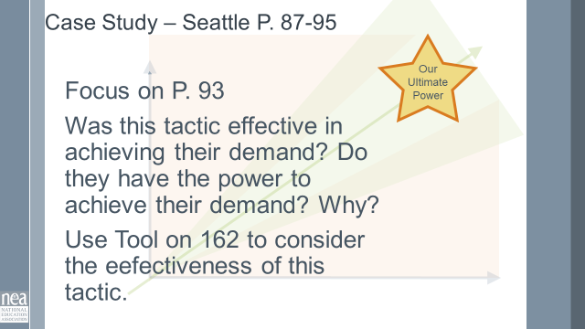  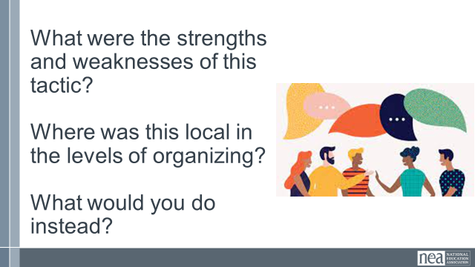  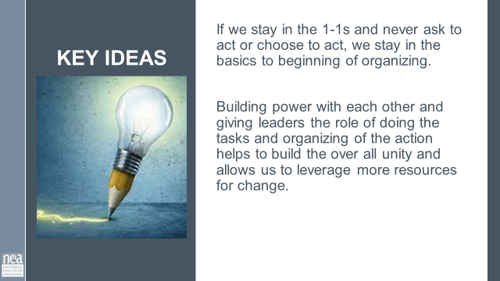 | Structure Tests | Power as a function of unity P. 147  PAR SEATTLE  87-95 specific focus on p. 93  Campaign Assessment Tool P. 162 |  | 30 Minutes – Tactics that Build a Club Into a Fighting Union  3 Minutes Intro - Structure Tests! These are actions we ask people to lead – they function to make our campaigns visible, AND allows us to see if the people who have committed can act together and leverage their resources for change.  What is a structure test? It is essentially a tactic, set within a larger campaign and strategy to engage leaders. We test to see if we truly have commitment to act together. Now, we know not to start with the hardest tactic, but something that engages and shows our effectiveness and brings people on board. (Use the tool on page 147) to highlight the idea of unity and courage/effort.  NEED SOME SCRIPT ABOUT POWER AND UNITY  Looking at the handout PAR SEATTLE 87-95. Read this story- reflect on the specific story on page 93. Assess the effectiveness of this tactic (of voting down school budgets). Using the tool on page 162. (Can be done by table.)  5 Minutes Share out.  What were the strengths and weaknesses of this tactic?  Where was this local in the levels of organizing?  What would you do instead?  2 Minutes Key Point  - If we stay in the 1-1s and never ask to act or choose to act, we stay in the basics to beginning of organizing.  - Building power with each other and giving leaders the role of doing the tasks and organizing of the action helps to build the over all unity and allows us to leverage more resources for change. |  | Participants will add to their understanding of tactics – not only are they about building pressure on a target, they also grow capacity of a club to take on a boss fight.
10:45-11:00  Jeny  ADD TIME TO NEXT SECTION? | Can participants reflect on this mornings work and put the concepts together? |  |  | 15 Minutes –  This does not seem to fit unless we rework it?  Think back to the work we did this morning and get back into your assigned constituency groups. (Get back into those groups).  Lets put a few things together.  - What structure test could you employ with your partnership groups to address the pain your group feels and act on the values you have?  - Who has the power to address your constituency needs?  - What resources do you have?  Add charts to your paper.  Key Learning Point  - Coalition Work within our union or with other groups is delicate and requires us to hold onto our interests while seeking commonalities.  The more we partner, the more resources we have to leverage for change.
11:00-11:15   | BREAK
11:15-12:15  MELISSA AND ZAC WILL COMBINE WITH NEXT SECTION | What are the structures of winning campaigns? How can we rebuild club structures to be more effective? | Planning Levels of Organizing  P. 36-38 |  | Reflecting on things that moved from Clubs to Fighting Union  Three stories: Amazon Union, Seattle PAR, North Carolina.  Use the analysis on page 50 as your guide.  - Identify: At what level of organizing are these groups are at?  - What were their tactics they used to engage people?  - Who were the identified leaders?  - What is their constituency?  - What were the resources (using information from yesterday).  - Which frame of unionism are they in?  - Who was the boss/target?  - How Club or Fighting Union are they?  Then...  - If you were going to bring this to life, how would you take it to the next level?
11:30-12:15  MELISSA AND ZAC REWORKING |  |  |  | Back Home Work:  This is not to think about a campaign- but a reflection of the current and to the possible. Where is your work currently? How can you take it to the next level? (Dream big!).  Start with where you are currently on the levels of Organizing, where do you want to be.  Draw your roadmap for getting there. Start with your goal.  - What activities and actions do you want your local or group to be focused on?  - Where are you now in the levels of organizing?  - Who is your constituency?  - What steps can you take to get there given the levels?  Be as specific as possible  Thinking to your back home work: Draw this out.  - What is your current constituency group  - What are they asked to do?  - In a perfect world what would you ask them to do?  - Who are the leaders and how or how will you find them?  - What are your communities/local/groups resources?  - Who are your leaders? How will you create a cycle of interruption and leader identification?  - What the issues and who has the resources to give your constituency what they want?
12:15-12:45  MELISSA AND ZAC REWORKING |  | We may not even want to say “feedback,” and instead say they can ask a question or point to an area for improvement. Also think we could steal some work time since they have many examples to pull from and have time for everyone to have 2-3 minutes to share? (Zac) |  | Presentation Time  - Share out in front of the group.  Participants will write post it notes giving specific feedback. Not general or “good job”, but questions about potential missing links or feedback about positives.
12:45-1:00  Ellen  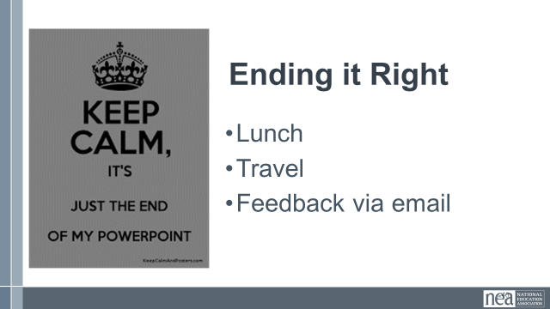 |  |  |  | Closing  - Some kind of recognition and time to do evaluations?
1:00 -2:00 | LUNCH and ADJOURN

