Facilitator Agenda Foundations for Winning Campaign: Day #1
General Materials Needed: |  |  |  | Room Set-up:
1 Set of Handouts per Person  Name Tags or Name Tents  Sign-in Sheet  Room signs, sign in signs  I Full Carton of Chart Paper |  | Chart Paper  Markers  Post its  Highlighters – 3 colors  Chart Markers – non-permanent  Pens and Pencils |  | Round Tables  I lavalier, 3 handheld microphones  Projector, Screen and Speakers  Carousel stations and reporting stations around the perimeter  40 people
Key Outcomes Day 1:
- Clear definition of issue organizing
- Staff roles in winning campaigns
- Understand How Leadership Teams Contribute to Winning Campaigns
Time | Essential Questions | Resources | Instructions, Activity and Debrief (Facilitators) |  | Outcomes
 | What question(s) should this learning section answer? | Charts, handouts, articles, materials, slide | What are you saying, what are they doing, what questions will you use to guide learning and make clear the important points  Include an estimate for how long each section of the learning will take |  | As a result of this section of learning, what will participants know or be able to do?
8:30 – 9:00  Ellen Holmes  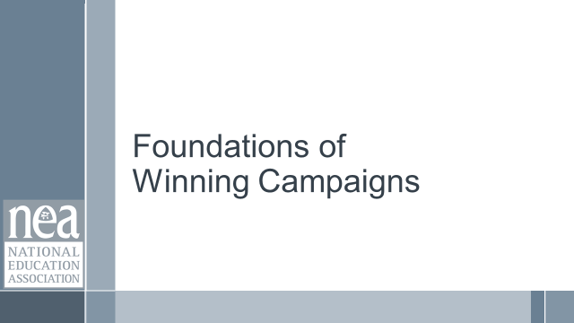  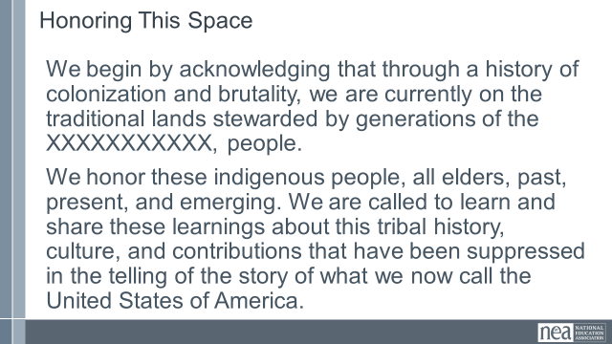  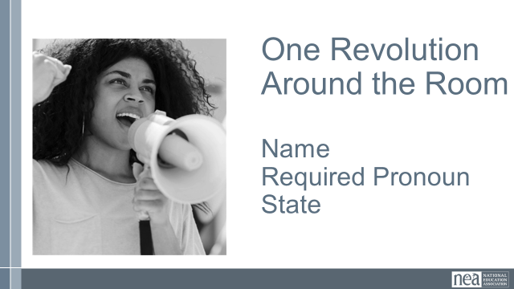  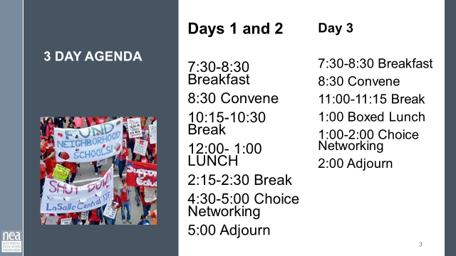  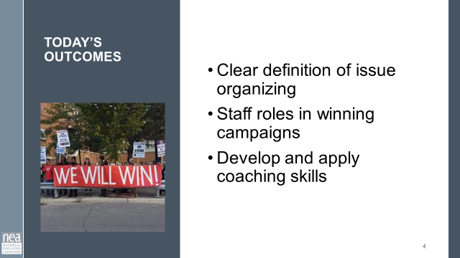  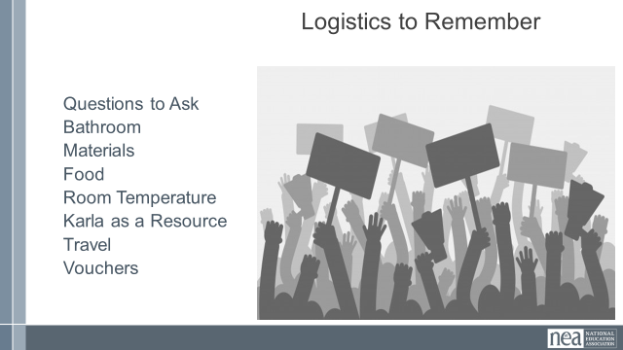  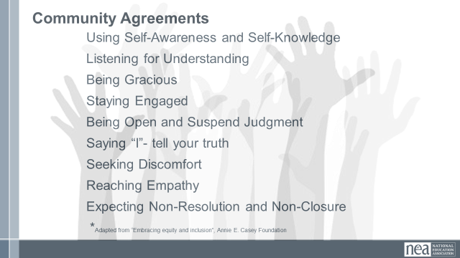  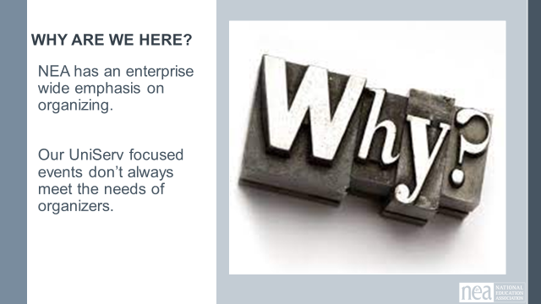 | How is this work structured? | Community Agreements | Getting Started  Welcomes  Land Acknowledgement  We begin by acknowledging that through a history of colonization and brutality, we are currently on the traditional lands stewarded by generations of the Wahpekute and Sioux people.  We honor these indigenous people, all elders, past, present, and emerging. We are called to learn and share these learnings about this tribal history, culture, and contributions that have been suppressed in the telling of the story of what we now call the United States of America.  Introduction of Participants and Facilitators –  Remind Folks to Keep it Short  Name, Required Pronoun, State From  Agenda Review  Logistics  Questions to Ask, Bathroom, Materials, Name Tents, Food  Room Temperature, Karla as a Resource  Travel, Vouchers  Community Agreements found on Page 2  Using Self-Awareness and Self-Knowledge  Listening for Understanding  Being Gracious  Staying Engaged  Being Open and Suspend Judgment  Saying “I”- tell your truth  Seeking Discomfort  Reaching Empathy  Expecting Non-Resolution and Non-Closure  Why we are here  NEA has an enterprise wide emphasis on organizing.  Our UniServ focused events don’t always meet the needs of organizers. |  | Participants will understand how the days will be structured.
9:00 – 9:20  Zac Johnson  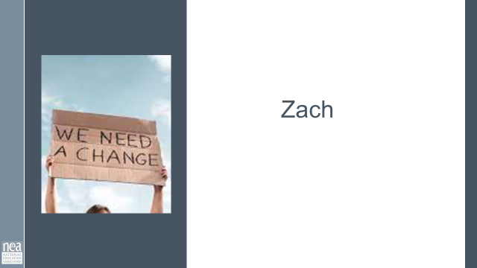  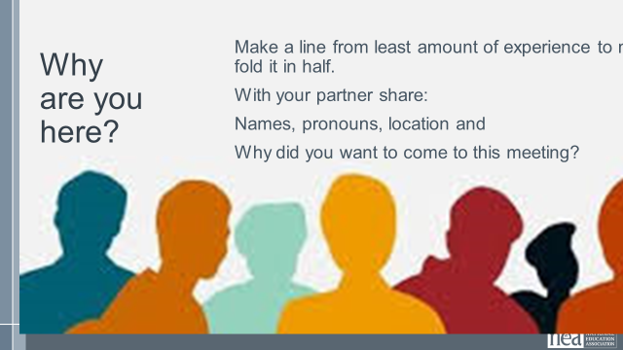 | Who is in the room? |  | 20 Minutes Building Our Community  Fold the line – ask people to line up with the starting point being the least amount of experience to the most amount of experience.  Note from Zac – need to ask folks to share amount of experience down the line.  Next - fold that line in half. The least and the most are partners, then the next least and next most are partners – and so on.  There may be a group of 3 in the middle  Once paired off – ask them to introduce with name, pronouns, where they are from, and what made them want to come to this.  Be ready for some report outs. |  | Participants will begin to meet others and build enough familiarity to begin taking learning risks.
9:20-10:10  Keightley  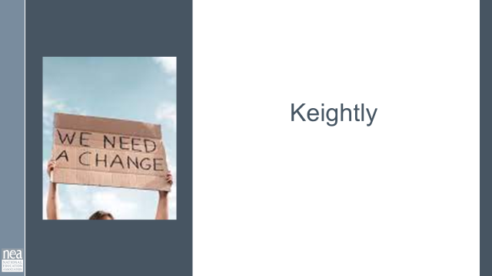  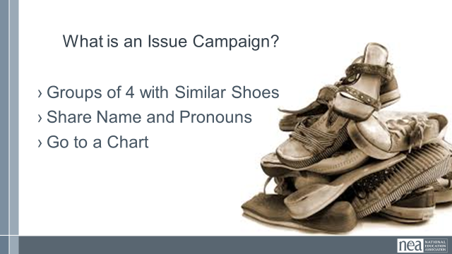  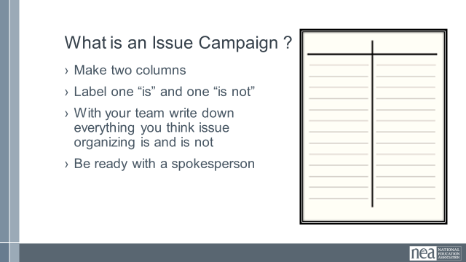  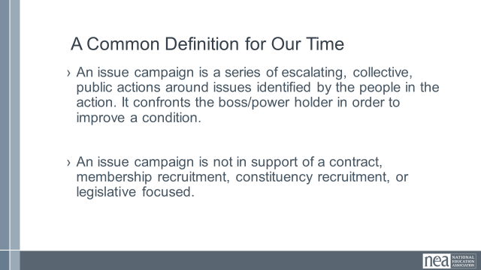  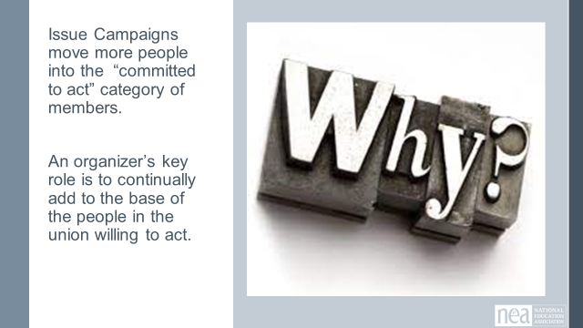  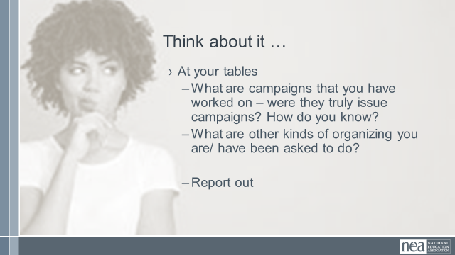  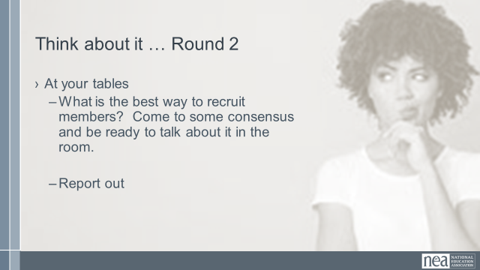  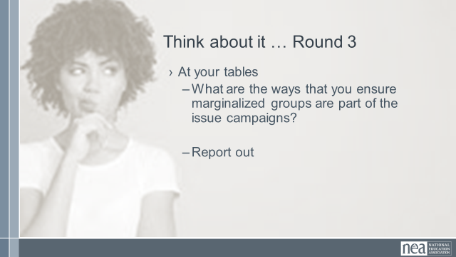  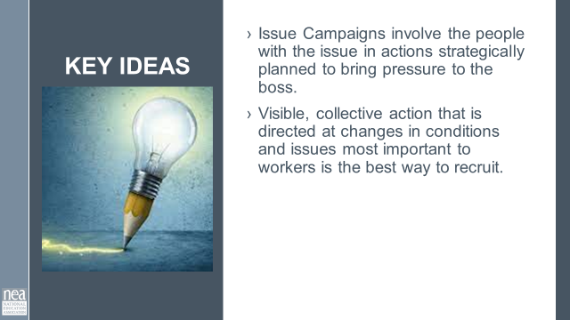 | How do we define issue organizing? |  | 50 Minutes – How do you define issue organizing ?  We are going to get into small groups - let’s do it by making groups of 4 and in your group you have to have as similar types of shoes as possible. Once you have made a group of go stand by one of the charts and then I will give you your directions.  – small groups create charts with two columns , What it is, What is isn’t– then do a gallery walk or debrief out whole group.  Now share the definition we are going to use for the next 2.5 days.  Clarify this definition as a group- common language?  How is organizing at your house?  What are some possible answers to this? How to make it relevant?  An issue campaign is a series of escalating collective public actions around issues identified by the people in the action (from club to fighting union) - It is not in support of a contract, membership recruitment, legislative focused. It is not building a club. An issue campaign confronts the power of the boss/power holder in order to improve a condition.  Why issue campaigns – because it is a Campaign that moves more people into the committed to act on this issue. (Idea that an organizer’s job is to build the union, the way to do that is through issue organizing) Base building --  Have participants think of campaigns they’ve participated in/led in the past and evaluate whether or not they’re issue based campaigns.  Rubric?  Comparison to other kinds of organizing?  What is the best way to recruit members? Being visible, being active, making a change that matters to the workers. That is a campaign.  Emphasize the importance of remembering marginalized groups- GOLD when it comes to issue organizing  Key Ideas  - Issue Campaigns involve the people with the issue in actions strategically planned to bring pressure to the boss.  - Visible, collective action that is directed at changes in conditions and issues most important to workers is the best way to recruit.  Including marginalized workers in your activist ranks builds intersectional solidarity across your base of power – your people. |  | Participants will understand what issue organizing is and how it is different from other types of organizing.
10:10-10:30  Jeny  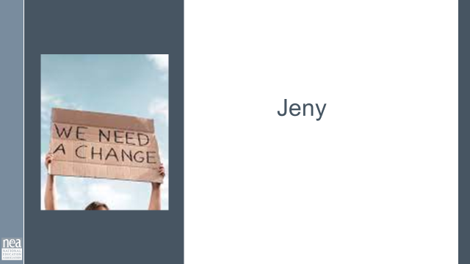  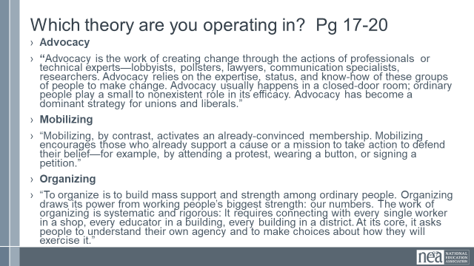  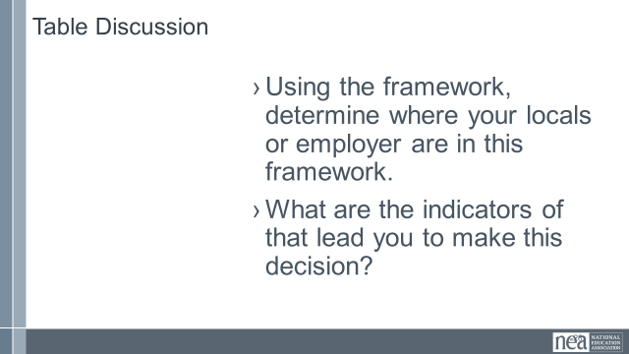  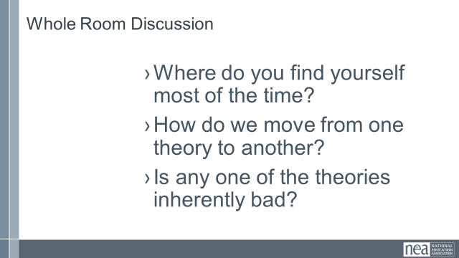  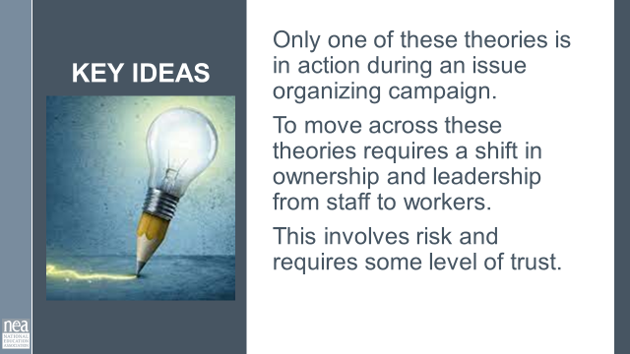 | Where does the power to win come from? | Resources  Theories of Power Article from TUSJ  (Handout)  Pg 17-20 | 20 Minutes – Theories of Power (Might make more sense moved before who are leaders and with 30 mins)  Where does the power to win come from?  Advocacy Mobilizing Organizing (perhaps add Socializing)  Discuss at your tables  Using the framework, determine where your campaign lives in this framework. What are the indicators that lead you to make this decision?  Discuss as a Whole Room  How do we move from one theory to another?  Is any one of the theories inherently bad?  Key Ideas  Only one of these theories is in action during an issue organizing campaign. To move across these theories requires a shift in ownership and leadership from staff to workers.  This involves risk and requires some level of trust. |  | Participants will analyze their current reality against a table and determine which of the lanes they are in.
10:30- 10:45   | BREAK
10:45- 11:15  Ellen  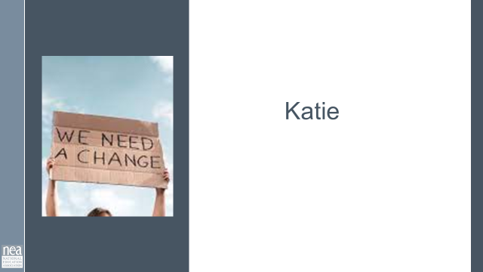  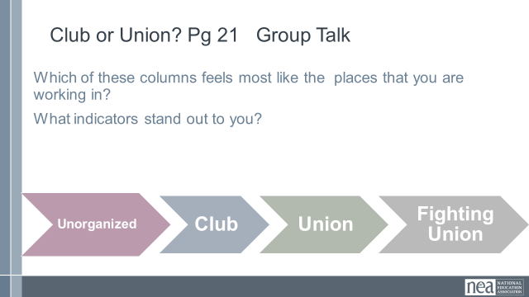  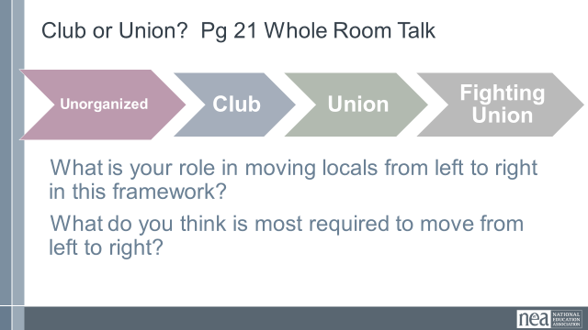  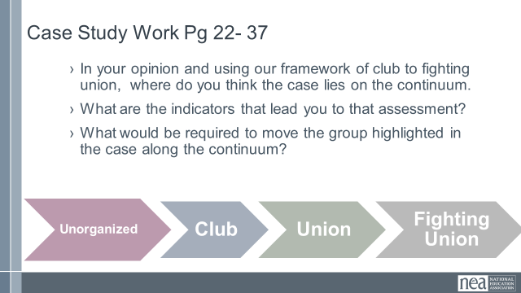  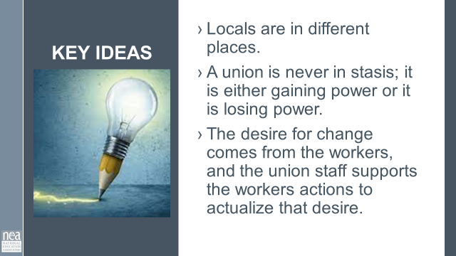 | What does base-building require? | Resources  Club to Fighting Union  (Handout- Ellen has it).  7 articles | 30 Minutes - Level of Engagement (Needs MORE TIME 10-15 mins)  Club to Fighting Union  Group Talk  Using the framework, determine where your locals or employer are in this framework. What are the indicators of that lead you to make this decision.  Whole Room Talk  What is your role in moving locals from left to right in this framework?  What do you think is most required to move from left to right?  Case Study time – there are 1 to 2 real life cases. Move participants into new groups. In your opinion and using our framework of club to fighting union,  Where do you think the cases are on the continuum?  What are the indicators that lead you to that assessment?  What would be required to move the group highlighted in the case along the continuum?  Key ideas  - Locals are in different places.  - A union is never in stasis; it is either gaining power or it is losing power.  - The desire for change comes from the workers, and the union staff supports the workers actions to actualize that desire. |  | Participants will understand a framework for describing member engagement that allows them to move away from
11:15-11:40 Katie  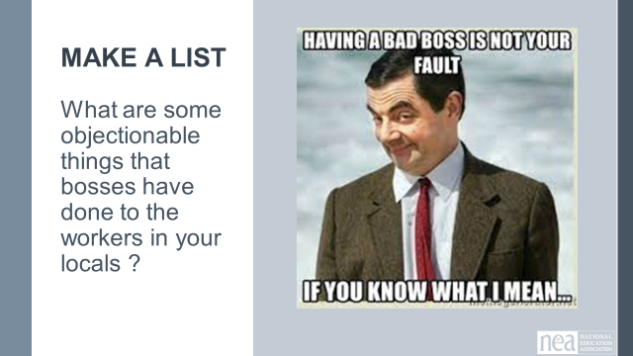  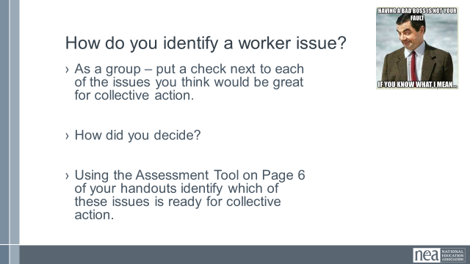  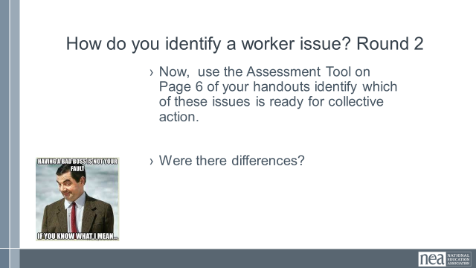  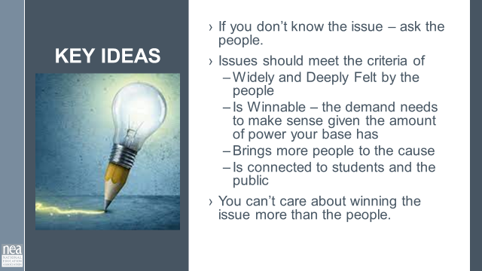 | What is an issue? | Resources –  Issue Assessment Tool  (Handout)  In campaign Guide  Pg 6-8 | 25 Minutes – How do you identify an issue?  Count by 4s and chart  What are some objectionable things that bosses have done to your workers in your local school or a district (focus on your at home plan)? (if you don’t know – how do you find out???)  Generate a list –  Which of these issues is ripe for collective action?  First they decide what they think - then they use the assessment tool  Page 6 (7 and 8 would be better later)  Key Ideas  - If you don’t know the issue – ask the people.  - Issues should meet the criteria of  - Widely and Deeply Felt by the people  - Is Winnable – the demand needs to make sense given the amount of power your base has  - Brings more people to the cause  - Is connected to students and the public  You can’t care about winning the issue more than the people. |  | Participants will be able to assess a number of issues.
11:40-12:00  Zac  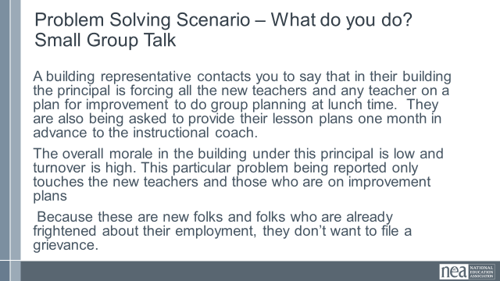  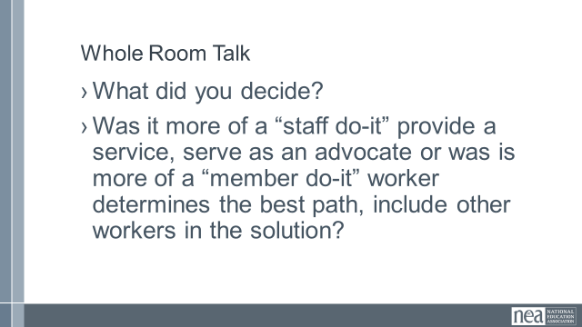  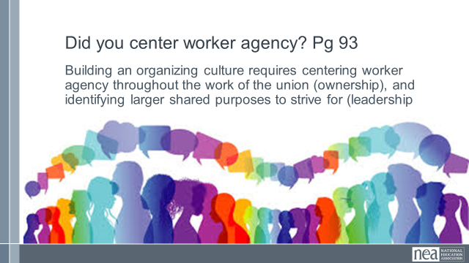 |  |  | 20 Minutes –  Problem Solving Scenario Small Group Talk – Discuss at your tables and determine what you would do?  A building representative contacts you to say that in their building the principal is forcing all the new teachers and any teacher on a plan for improvement to do group planning at lunch time. They are also being asked to provide their lesson plans one month in advance to the instructional coach.  The overall morale in the building under this principal is low and turnover is high. This particular problem being reported only touches the new teachers and those who are on improvement plans  Because these are new folks and folks who are already frightened about their employment, they don’t want to file a grievance  Debrief Whole Room Talk– what did you decide to do?  Was it more of a “staff do-it” provide a service, serve as an advocate or was is more of a “member do-it” worker determines the best path, include other workers in the solution?  As you go to lunch – think about – Did you center worker agency?
12:00 to 1:00  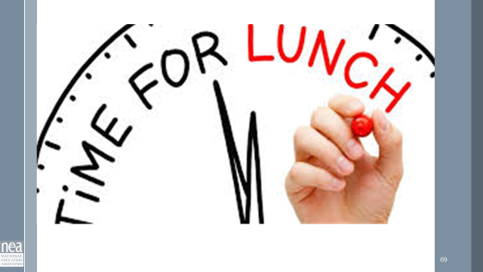 | LUNCH
1:00 – 1:30  Zac  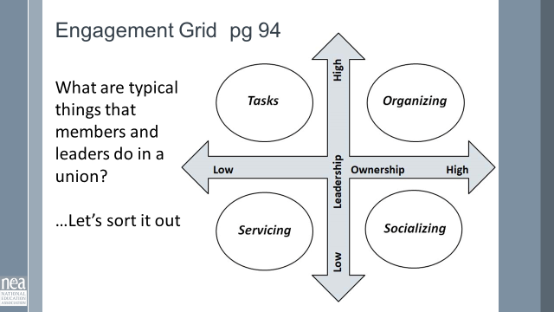  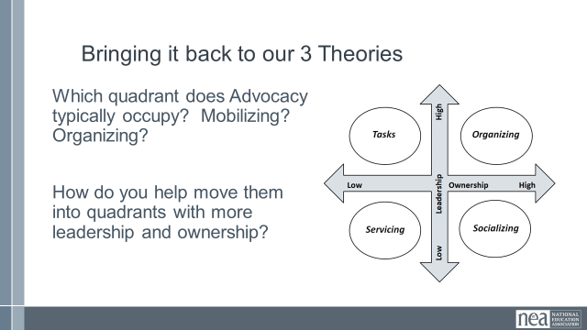  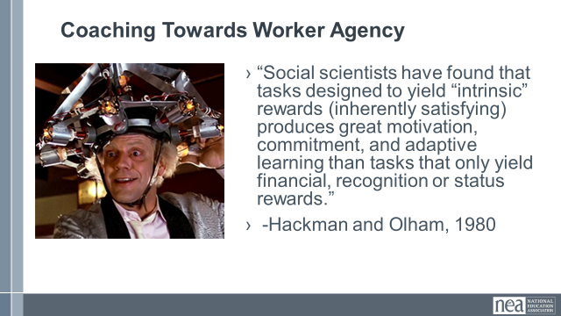  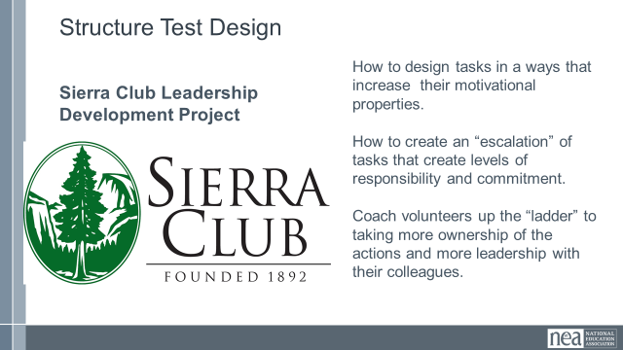  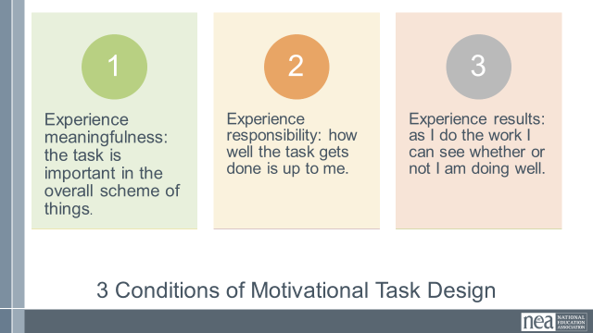  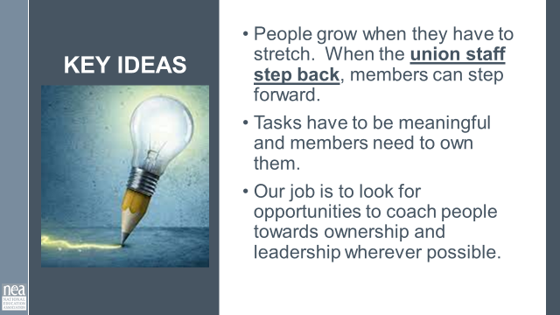 | Why do I need to let others do for themselves? | Resources -  Questions that break the cycle  Resources – Axis of Ownership and Leadership | 30 Minutes – How do we break the Cycle of Service?  PICK UP FROM BEFORE LUNCH  Did you center worker agency – pg 93  Building an organizing culture requires centering worker agency throughout the work of the union (ownership), and identifying larger shared purposes to strive for (leadership)  Look at the types of questions that you can use that shifts the ownership from staff back to the worker. Have you ever used any of these?  Engagement Grid –pg 94  Introduce the grid – you can use this grid to think about ways to coach people towards centering worker agency. There are two axes – Leadership and Ownership. When leadership is low and ownership is low that is Servicing – we are doing it. When leadership is low and ownership is high that is socializing. When Leadership is high and ownership is low – that is members just doing what they are asked. They do, you design. WE want high leadership and high ownership and that moves us into organizing.  USING PAGE 54 ( tactics from Strike Guide) have small groups discuss how to take any tactic (they will pick 4) and move it around the grid.  Example:  Tactic – Pack a School Board Meeting  Servicing – Staff and a couple of release time leaders go to meeting  Socializing – Members attend meeting without any visible union presence or coordinated message  Tasking – Staff make signs, staff supply t-shirts, distribute them, coordinate speakers and write the script, the usual folks do what they are asked to do  Organizing – Members determine what the messages are and ask their co-workers to share their own story related to the issue. Members meet to make t shirts and protest art for the meeting. Members have a sign-up and then do a check-in before the meeting, then run a sign-in at the meeting.  Where do our three theories from this morning land on this grid?  Advocacy, Mobilizing, Organizing  *Use examples from the morning session on the definitions to shift between quadrants*  How do you know?  NOTE FROM ZAC – section below to Key Ideas seemed unnecessary  Task Design to Support Worker Agency  “Social scientists have found that tasks designed to yield “intrinsic” rewards (inherently satisfying) produces great motivation, commitment, and adaptive learning than tasks that only yield financial, recognition or status rewards.” -Hackman and Olham, 1980  Task Design – The Non profit – Sierra Club wanted to shift the leadership and ownership of volunteers in the organization they worked with social scientists Hackman and Olham to study how to design tasks in a ways that increase their motivational properties for volunteers. They then worked to create an “escalation” of tasks that build levels of responsibility and commitment. Finally, they trained their staff in the ways to coach volunteers up the “ladder” to taking more ownership of the actions and more leadership with their colleagues  They identified 3 conditions of Motivational Task Design – that is tasks (asks) that get people to take on more ownership and leadership.  These three conditions are meaningfulness, responsibility, and results.  Tasks that people find meaningful and aligned with their values, that allow them to feel important in conducting the task, and that have a clear window of what success looks like encourage more leadership and ownership  Key Ideas –  People grow when they have to stretch. When the union staff step back, members can step forward.  - Tasks have to be meaningful and members need to own them.  - Our job is to look for opportunities to coach people towards ownership and leadership wherever possible. |  | Participants will be able to name what makes an action organizing or service.
1:30-2:15  Jeny, Renita  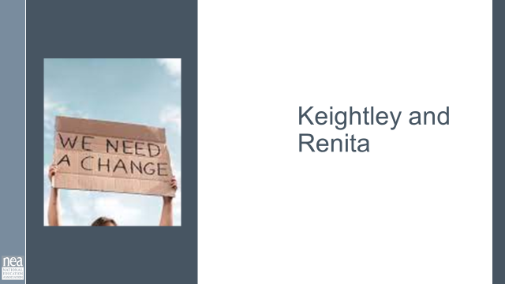  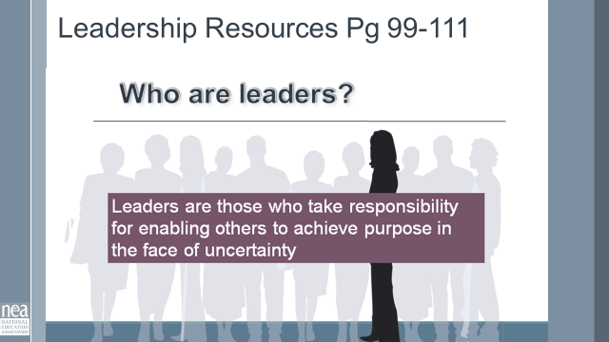  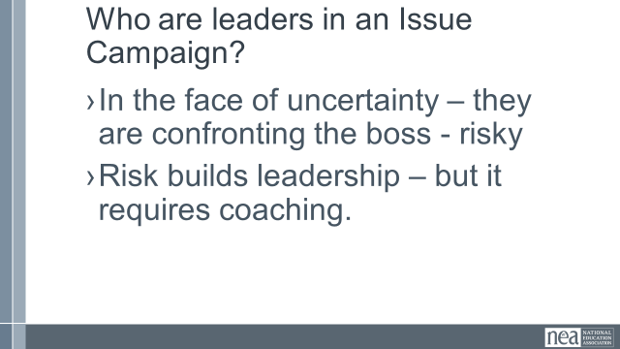  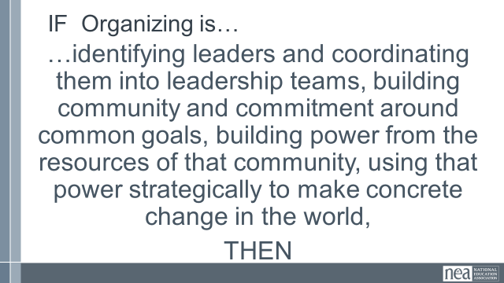  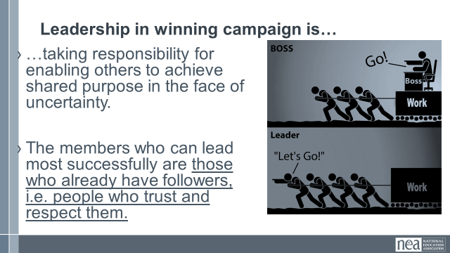  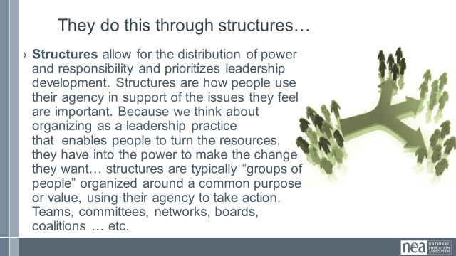  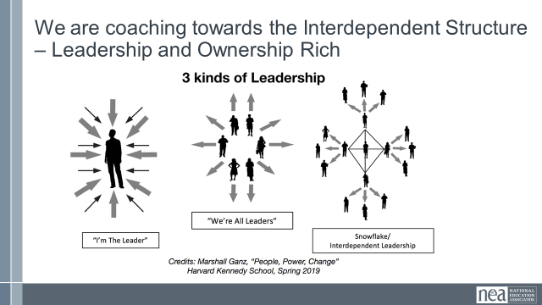  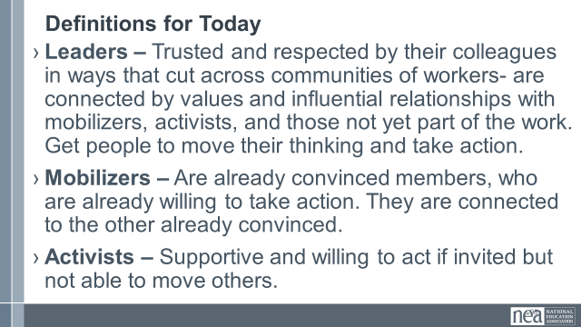  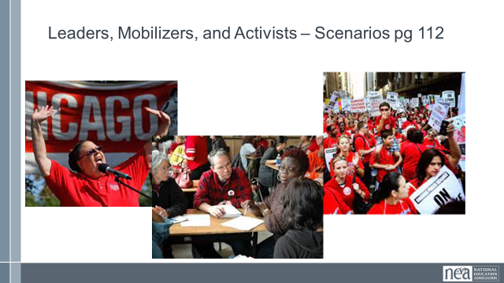  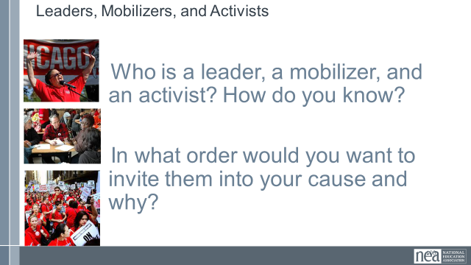  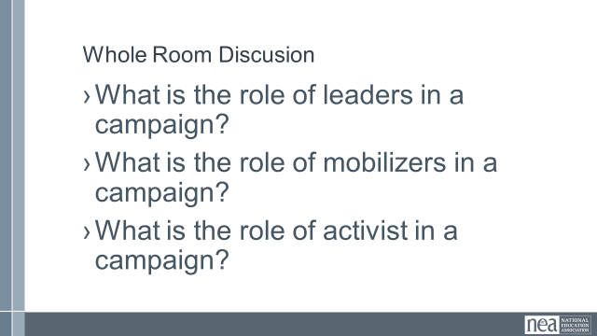  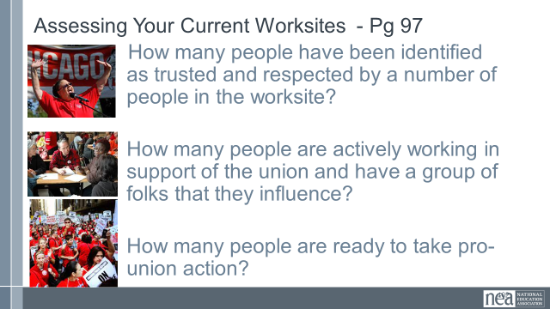  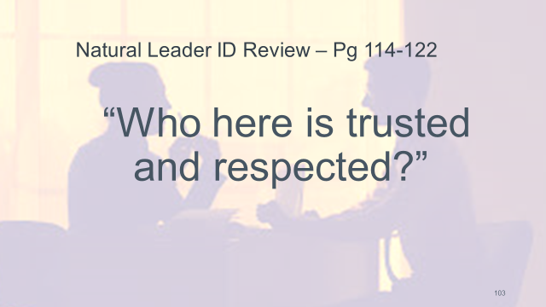  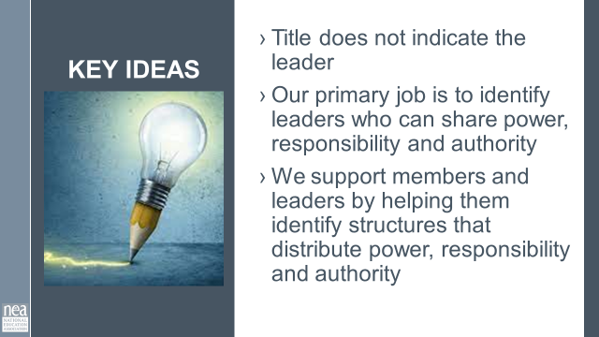 | Who do we need in a winning campaign? | Resources –  Ellen Handouts  Jane’s Leaders, Mobilizers, Activists ID  Article on SEA trusted and Respected  Handout that defines different leadership types. | 45 Minutes – Who are leaders?  Who are Leaders – Pg 99-111  Leaders are those who take responsibility for enabling others to achieve purpose in the face of uncertainty.  Enabling is getting out of the way. Empowering is a myth that says you have the power and you have to give it to them. Enabling is the idea that you are removing things in their way even if that is you.  What words stand out to you and why?  Remember that enabling simply means removing barriers to action.  In the face of uncertainty - have to be confronting the boss. Risk builds leadership- but requires coaching  It is the condition of risk that transforms a members relationship with what their unions is. When staff steps back and enables members to use their agency and they allow them to take a risk. When that succeeds it gives them ownership of their union. Transforming it from the union to THEIR union.  If Organizing is  …identifying leaders and coordinating them into leadership teams, building community and commitment around common goals, building power from the resources of that community, using that power strategically to make concrete change in the world,  THEN  Leadership in winning campaign is…  - …taking responsibility for enabling others to achieve shared purpose in the face of uncertainty.  - The members who can lead most successfully are those who already have followers, i.e. people who trust and respect them.  They do this through structures…  Structures allow for the distribution of power and responsibility and prioritizes leadership development. Structures are how people use their agency in support of the issues they feel are important. Because we think about organizing as a leadership practice that enables people to turn the resources, they have into the power to make the change they want… structures are typically “groups of people” organized around a common purpose or value, using their agency to take action. Teams, committees, networks, boards, coalitions … etc.  Note from Zac – this could use more context – WHY aren’t the first two structures desireable? (I think Ganz talks about the first being a dictatorship and references Hannah Arendt’s critique of leaderless bureaucracy for the “everyone’s a leader” approach)  We are coaching towards the Interdependent Structure – Leadership and Ownership Rich  We want the snowflake  Definitions for Today  - Leaders – Trusted and respected by their colleagues in ways that cut across communities of workers- are connected by values and influential relationships with mobilizers, activists, and those not yet part of the work. Get people to move their thinking and take action.  - Mobilizers – Are already convinced members, who are already willing to take action. They are connected to the other already convinced.  - Activists – Supportive and willing to act if invited but not able to move others.  Count off by 3’s an put them in triads  Leaders, Mobilizers, and Activists – Scenarios pg 112  Who is a leader, a mobilizer, and an activist? How do you know?  In what order would you want to invite them into your cause and why?  Whole Group Discussion  What is the role of leaders in a campaign?  What is the role of mobilizers in a campaign?  What is the role of activist in a campaign?  Possibly Droppable Content  Assessing Your Current Worksites - Pg 97  How many people have been identified as trusted and respected by a number of people in the worksite?  How many people are actively working in support of the union and have a group of folks that they influence?  How many people are ready to take pro-union action?  Natural Leader ID REVIEW – Pg 114-122  Who here is trusted and respected?  Have an intentional plan to look for and mitigate racial bias.  Key Ideas –  - Title does not indicate the leader  - Our primary job is to identify leaders who can share power, responsibility and authority  We support members and leaders by helping them identify structures that distribute power, responsibility and authority |  | Participants will be able to analyze a scenario and conclude what are the differences between leaders, mobilizers, organizers.
2:15-2:30 | BREAK
2:30-3:00  Renita and Ellen  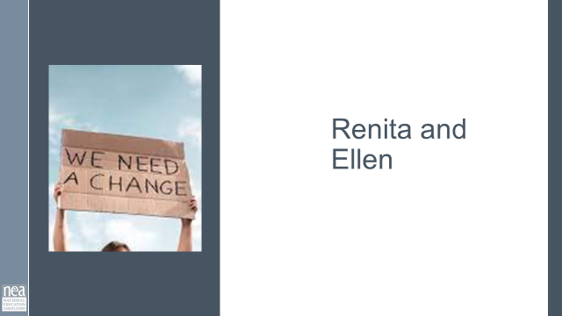  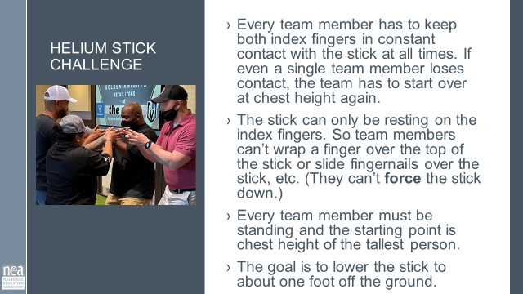  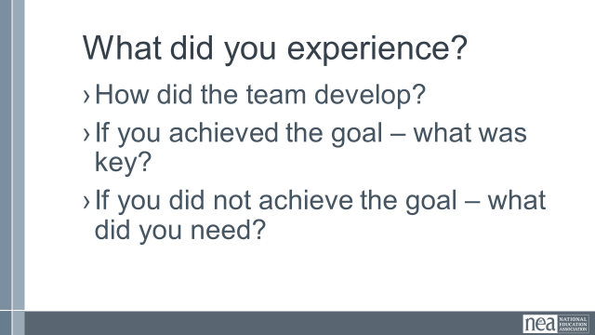  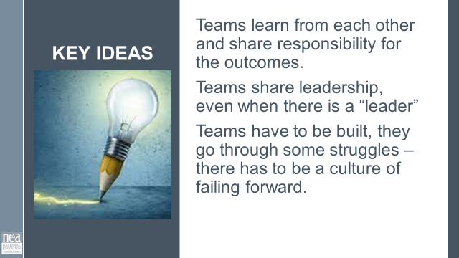 | How do teams come together? | 48” x ¼” dowels | - 30 Minutes - Helium Stick Team Challenge  - Form teams that are at least 6 to 8  - Challenge  - Every team member has to keep both index fingers in constant contact with the stick at all times. If even a single team member loses contact, the team has to start over at chest height again.  - The stick can only be resting on the index fingers. So team members can’t wrap a finger over the top of the stick or slide fingernails over the stick, etc. (They can’t force the stick down.)  - Every team member must be standing and the starting point is chest height of the tallest person. (You have to give this rule or everyone will drop to their knees and try to cheat right away.)  - The goal is to lower the stick to about one foot off the ground.  What happened?  How did the team develop?  If you achieved the goal – what was key?  If you did not achieve the goal – what did you need?  Key Ideas  Teams learn from each other and share responsibility for the outcomes.  Teams share leadership, even when there is a “leader”  Teams have to be built, they go through some struggles – there has to be a culture of failing forward. |  | Participants will understand how teams work in real time.
3:00 -4:10  Zac and Katie  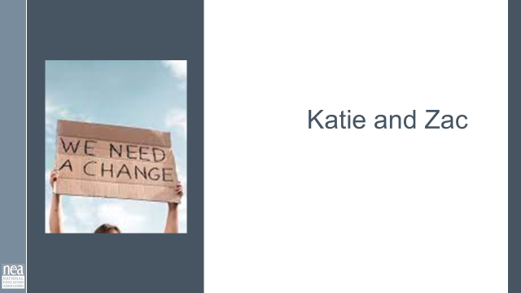  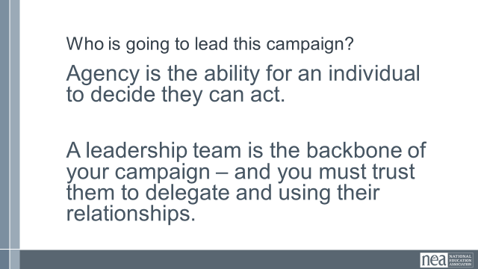  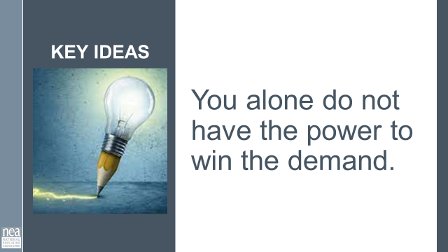  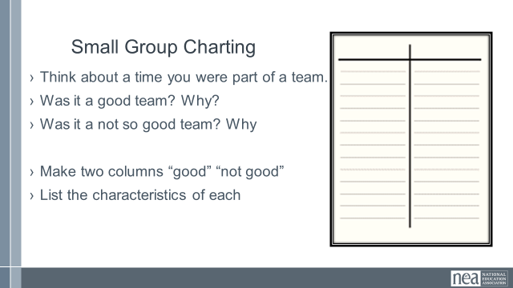  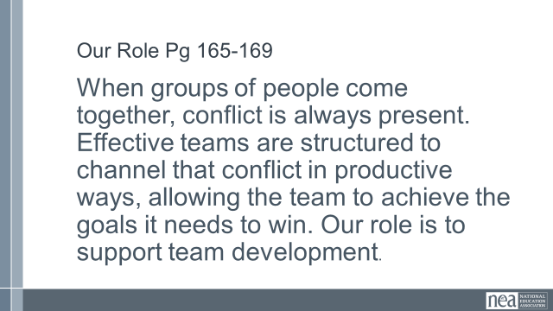  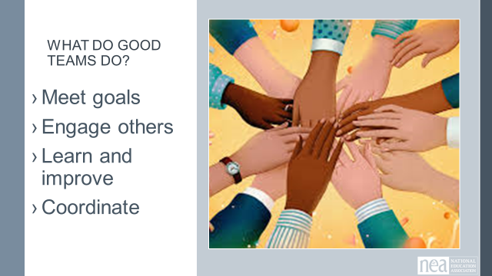  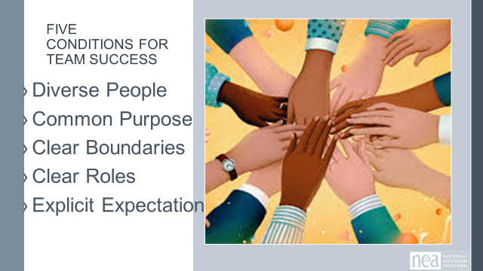  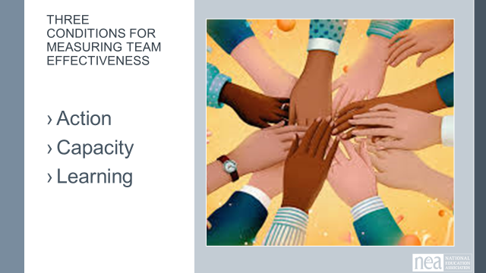  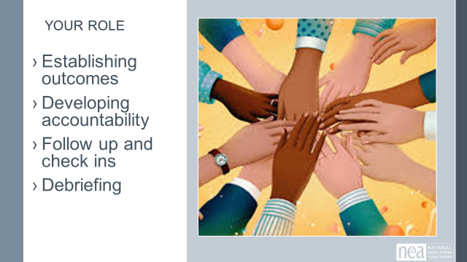  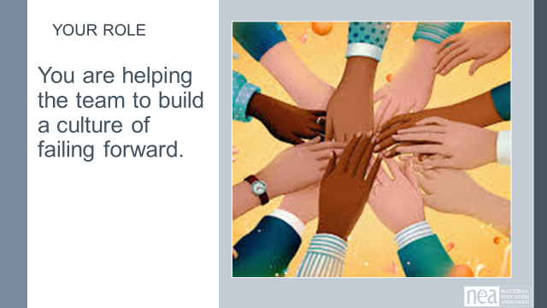  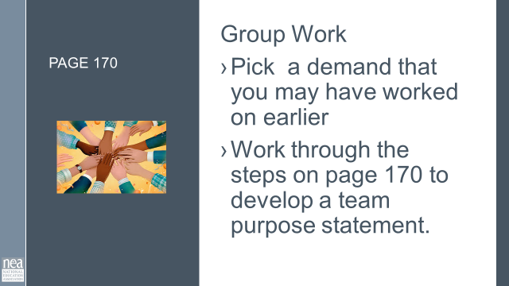  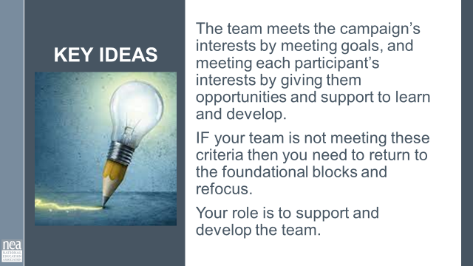  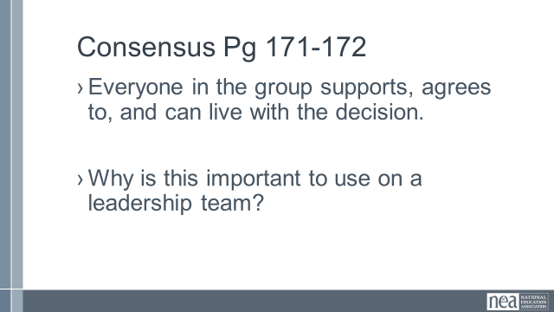  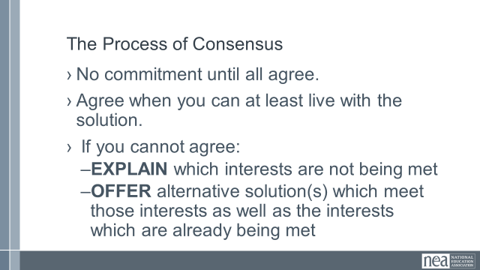  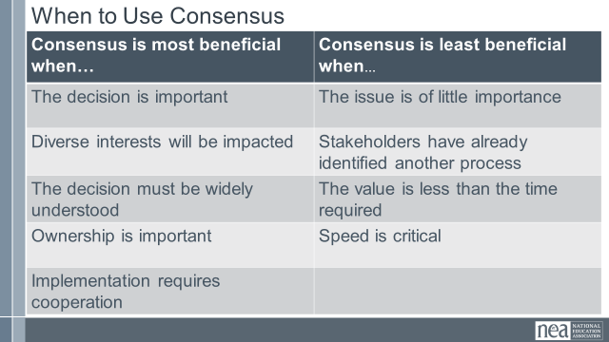  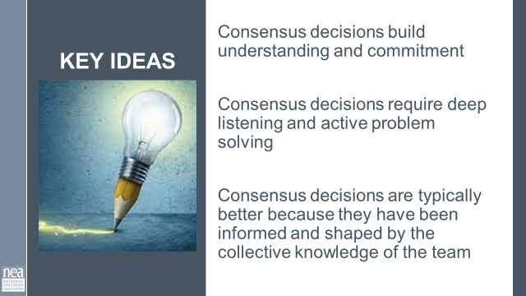 | How do I develop a leadership team? | Resources:  Coaching  Facilitating  (Ellen handouts, from adult learning)  IDEA: Extend this portion, delete content below and extend campaign clinic.  OR Move section below before this one. (structure before putting it all together).  Marshall Ganz on Team Video | 60 Minutes -Who is going to lead this work? (leaders and leadership teams)  Who is going to lead this campaign  Agency is the ability for an individual to decide they can act.  A leadership team is the backbone of your campaign – and you must trust them to delegate and using their relationships.  Key Idea – You alone do not have the power to win  Small Group Charting- Count by 3’s to make new groups. Make a T chart.  Think about a time you were part of a team.  Was it a good team? Why?  Was it a not so good team? Why  Make two columns “good” and “not good”  List the characteristics of each  Note from Zac – need to find a way to make this section more engaging. (all slides with hands in)  Our Role Pg 165-169  Agency is the ability for an individual to decide they can act.  A leadership team is the backbone of your campaign – and you must trust them to delegate and using their relationships.  What Good Teams Do  Agency is the ability for an individual to decide they can act.  A leadership team is the backbone of your campaign – and you must trust them to delegate and using their relationships.  Five Conditions for Team Success  - Diverse People  - Common Purpose  - Clear Boundaries  - Clear Roles  - Explicit Expectations  Three Conditions for Measuring Team Effectiveness  - Action  - Capacity  - Learning  Your Role  - Establishing outcomes  - Developing accountability  - Follow up and check ins  - Debriefing  You are helping the team to build a culture of failing forward.  Table Group Work Page 170  Pick one at-home issue from your table.  What's a possible win for the identified at-home campaign?  Work through the steps on page 170 to develop a team purpose statement.  Key Ideas  The team meets the campaign’s interests by meeting goals, and meeting each participant’s interests by giving them opportunities and support to learn and develop.  IF your team is not meeting these criteria then you need to return to the foundational blocks and refocus.  Your role is to support and develop the team.  Consensus Pg 171-172  - Everyone in the group supports, agrees to, and can live with the decision.  - Why is this important to use on a leadership team?  The Process of Consensus  - No commitment until all agree.  - Agree when you can at least live with the solution.  - If you cannot agree:  - EXPLAIN which interests are not being met  - OFFER alternative solution(s) which meet those interests as well as the interests which are already being met  When to Use Consensus – Review table  Key Ides –  Consensus decisions build understanding and commitment  Consensus decisions require deep listening and active problem solving  Consensus decisions are typically better because they have been informed and shaped by the collective knowledge of the team |  | Participants will be able to identify the skills needed to build strong teams.
4:10 -4:20 | Campaign Circle  How is your campaign going? |  | 10 mins-Everyone get up and stand in a large circle  We are going to do a check in our at home campaigns  - Step into the circle if you have the following:  - A core leadership team  - You have some decision making process within your group  - Your campaign leadership team is diverse  - Your campaign leadership team has common purpose  - You campaign has a clear issue  - Your campaign leadership team has explicit expectations  - Your campaign has trusted and respected leaders on it, that have been identified by their peers  - It is easy for you to step back and allow members to take a risk.  - You feel confident that your campaign will win
4:20- 4:30  Ellen  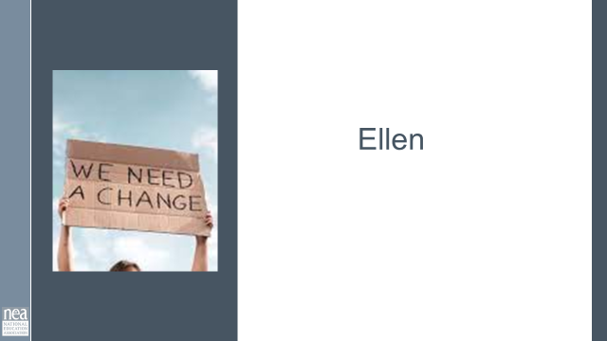  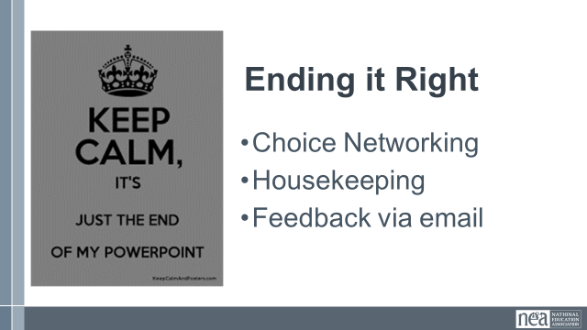 |  |  | 10 Minutes – Closing
4:30-5:00  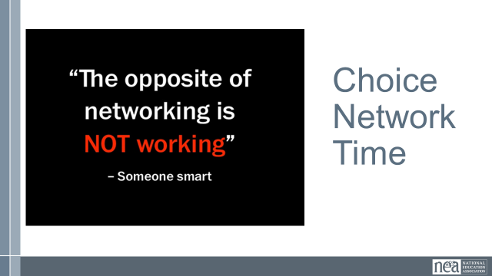 |  |  | Choice Networking Time
5:00 | ADJOURN

