Facilitator Agenda Foundations for Winning Campaign: Day #2
General Materials Needed: |  |  |  |  | Room Set-up:
1 Set of Handouts per Person  Name Tags or Name Tents  Sign-in Sheet  Room signs, sign in signs  I Full Carton of Chart Paper |  |  | Chart Paper  Markers  Post its  Highlighters – 3 colors  Chart Markers – non-permanent  Pens and Pencils |  | Round Tables  I lavalier, 3 handheld microphones  Projector, Screen and Speakers  Carousel stations and reporting stations around the perimeter  40 people
Key Outcomes Day 2:
- Participants will understand how to develop leaders and support the growth of leadership teams.
- Participants will analyze campaigns and identify what is likely to bring success and cause challenge to build better campaign plans
- Participants will explore and apply the skills for developing strong issue campaign leadership teams
Time | Essential Questions | Resources |  | Instructions, Activity and Debrief (Facilitators) |  | Outcomes
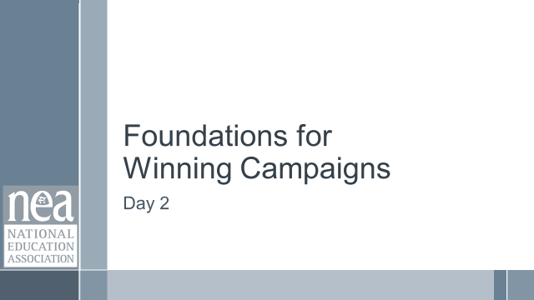 | What question(s) should this learning section answer? | Charts, handouts, articles, materials, slide |  | What are you saying, what are they doing, what questions will you use to guide learning and make clear the important points  Include an estimate for how long each section of the learning will take |  | As a result of this section of learning, what will participants know or be able to do?
8:30 – 8:45  Ellen  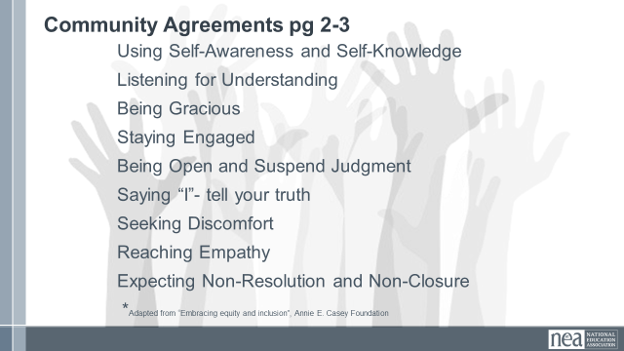  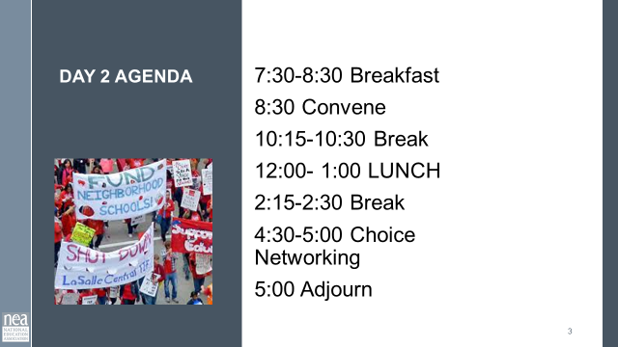  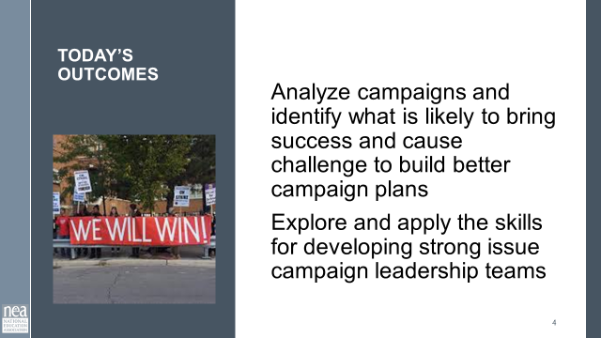  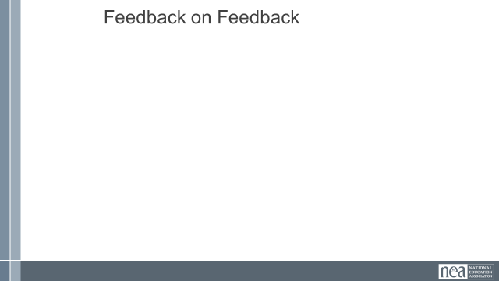 | What will day 2 look like and what are we still thinking about from day 1? |  |  | 15 Minutes – Getting Started  Review of Agreements  Feedback on Feedback  Table Big Wow from Day 1  2 Minutes quick talk at tables – report out one from each table Biggest Wow  A wow is something that really caused you to pause, rethink, question, or soundly affirm how you approach the work.
8:45-9:50  Katie and  Zac  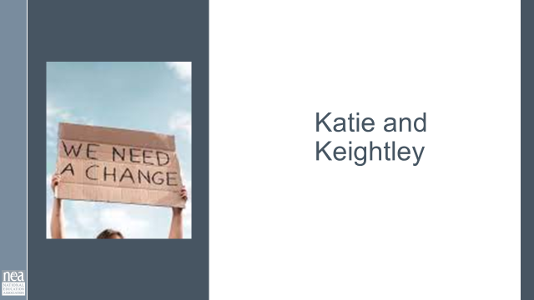  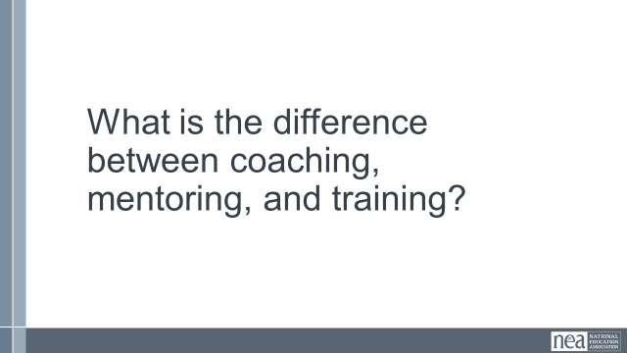  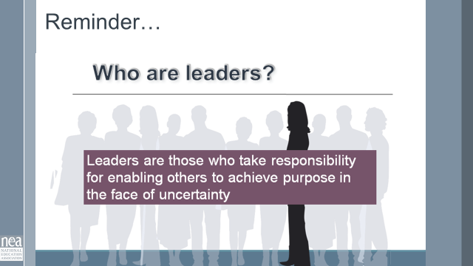  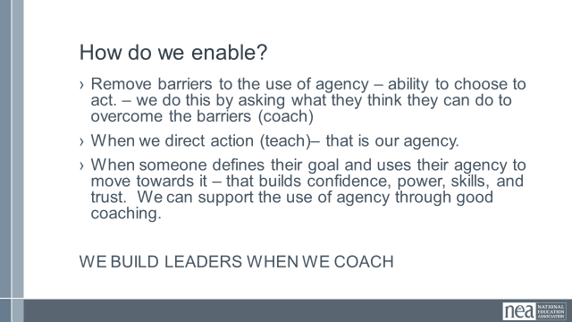  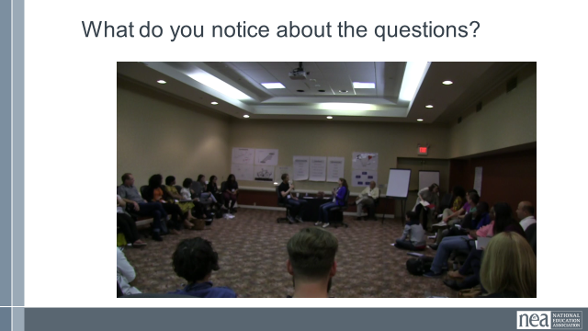  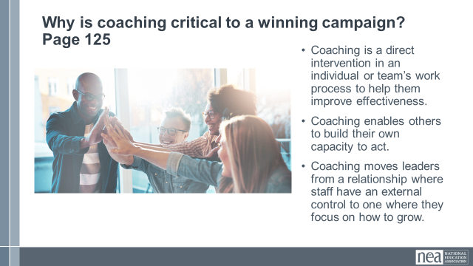  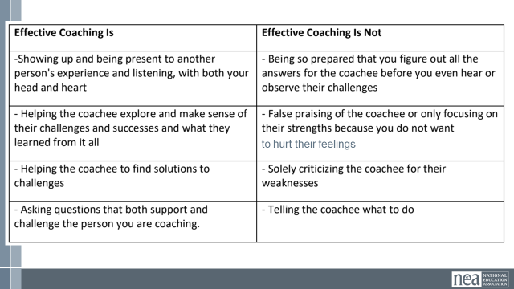  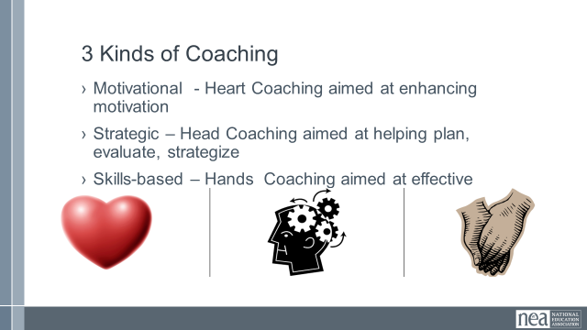  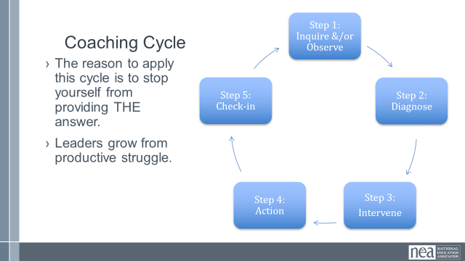  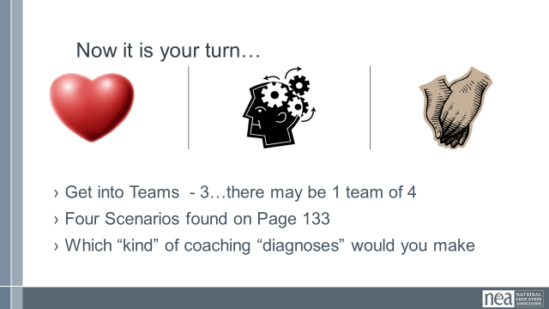  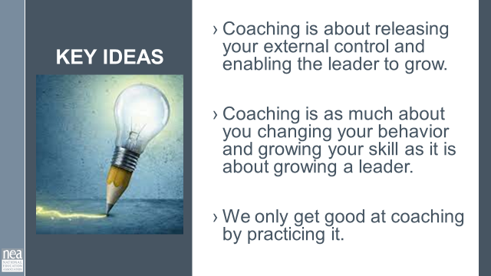  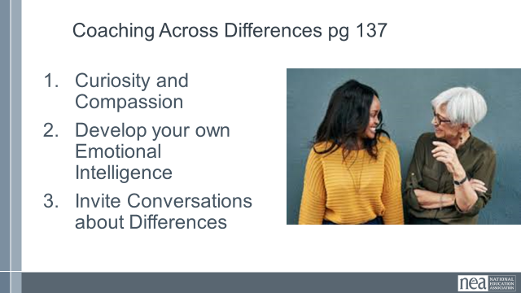  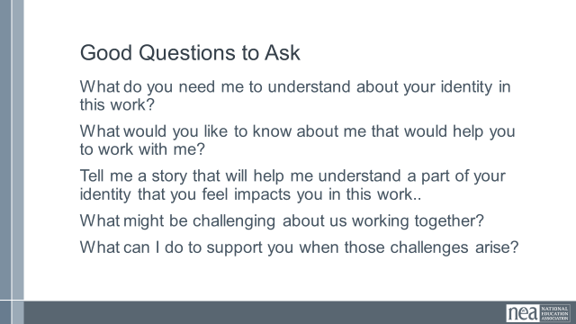  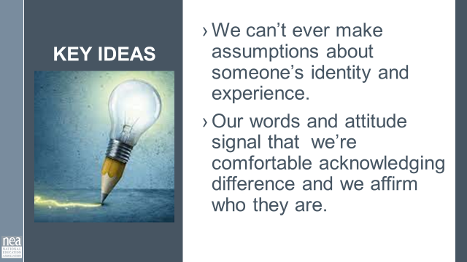 | Who is doing the work? | Resources –  Coaching 101  Video- Ganz coaching class.  Ask Drew for Cross Race Coaching Article or Podcast  Ganz Coaching Cycle |  | 65 Minutes – How do we develop leaders?  Turn at your table be ready to rapid fire out.  What is the difference between coaching, mentoring, and training?  Small group discussion then a little report out.  Reminder Leaders are those who take responsibility for enabling others to achieve purpose in the face of uncertainty.  How do we enable?  Remove barriers to the use of agency – ability to choose to act. – we do this by asking what they think they can do to overcome the barriers (coach)  - When we direct action (teach)– that is our agency.  - When someone defines their goal and uses their agency to move towards it – that builds confidence, power, skills, and trust. We can support the use of agency through good coaching.  WE BUILD LEADERS WHEN WE COACH  10 mins SHOW VIDEO (Needs to have closed captions added) – What do you notice about the questions that are asked? Look at resistance school video on YouTube!!  Why is coaching critical to a winning campaign?  10 mins – Content for coaching (All comes from the content handout, pp) - Provide the definition of coaching we are going to use in this training. Share why we think this model of coaching is useful, and what is the difference between good coaching and bad coaching.  Good coaching and ineffective coaching  Chart to read is on page 128 as well as in slides  3 Types of Coaching - knowing which you need  - Motivational - Heart Coaching aimed at enhancing motivation  - Strategic – Head Coaching aimed at helping plan, evaluate, strategize  - Skills-based – Hands Coaching aimed at effective  Coaching Cycle  - The reason to apply this cycle is to stop yourself from providing THE answer.  - Leaders grow from productive struggle  PG 133 Teams will work through the four scenarios and identify which of the three types of coaching might be required.  Get into small groups.  Debrief by going over the responses from the teams. Facilitate dialogue and questions between teams as opposed to you “leading and lecturing. “  Key points to draw out – when we coach we are releasing the external control we have and allowing for the individuals to grow. It is really step 4 and 5 that several struggle – for a variety of reasons. We only get good at coaching by doing it. We use a coaching framework to break the habit of “diagnose and direct” which takes away the person’s ability to rise as a leader.  Coaching Across Differences Pg 137  - Curiosity and Compassion  - Develop your own Emotional Intelligence  - Invite Conversations about Differences  Good Questions to Ask  What do you need me to understand about your identity in this work?  What would you like to know about me that would help you to work with me?  Tell me a story that will help me understand a part of your identity that you feel impacts you in this work..  What might be challenging about us working together?  What can I do to support you when those challenges arise?  Key Points  - We can’t ever make assumptions about someone’s identity and experience.  Our words and attitude signal that we’re comfortable acknowledging difference and we affirm who they are.  Inherent, in a coaching relationship is trust. There has to be trust to give and receive feedback. |  | Participants will apply a coaching model to a number of scenarios.
9:50 – 10:30  Keightley  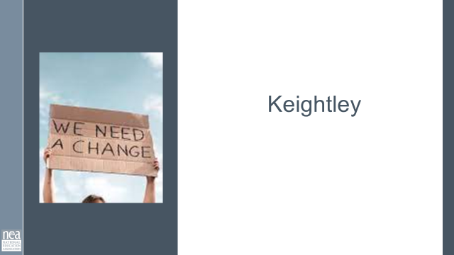  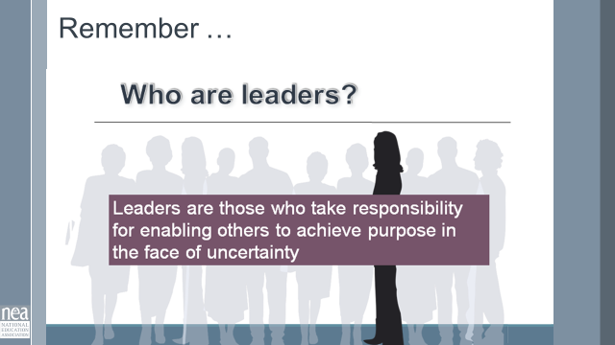  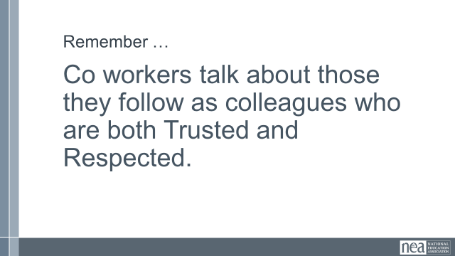  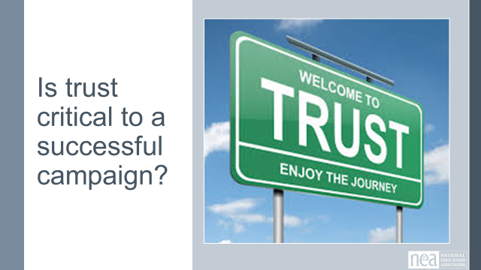    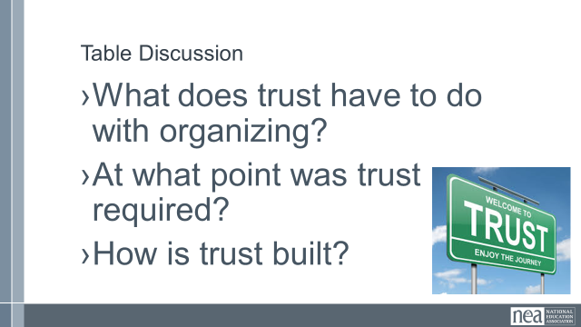  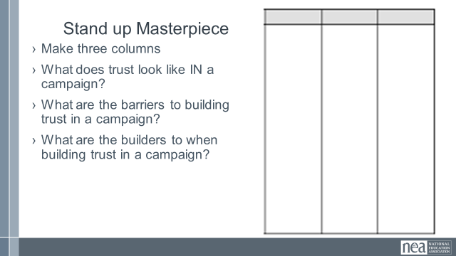  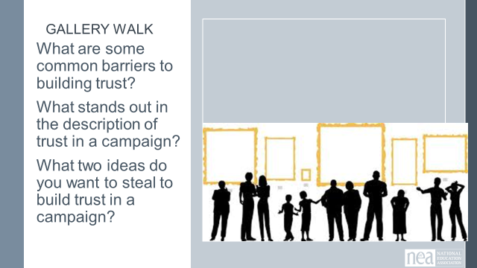  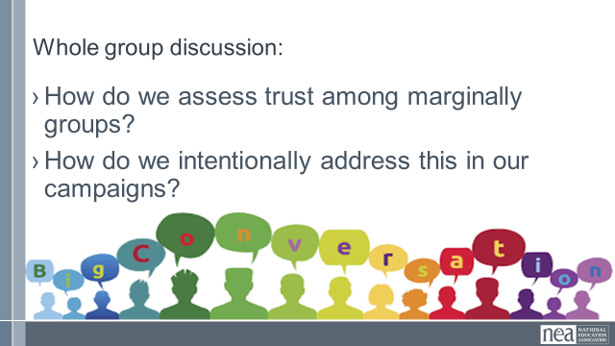  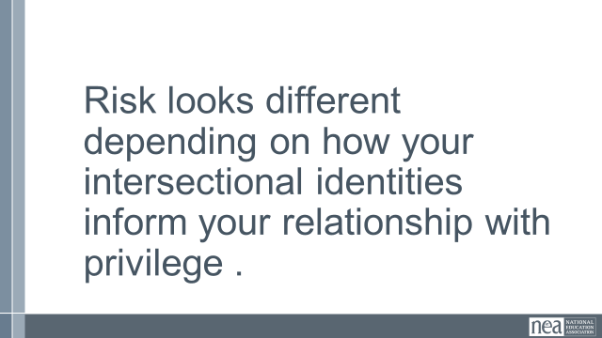  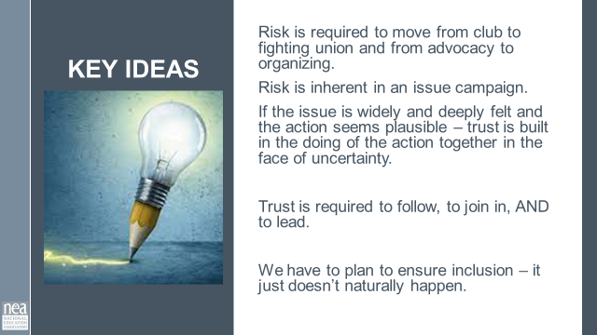 | What is trust in organizing and when do we need it on our work? | Resources – Charts and maybe an article on building trust in a team  When Agreement is Not Consent | Rae x Nkem (medium.com) |  | 40 Minutes (Needs more time to allow true conversations at the end. Suggest 60 Mins) - What’s trust got to do with it?  Reminder the Ganz leader definition: Leadership is enabling others to achieve shared purpose in the face of uncertainty.  Reminder of how we identify leaders: Who here is trusted and respected?  What’s trust got to do with organizing? As you watch the next video, we often use this to think about leadership – BUT watch it this time (or for the first time) thinking about three questions:  - What does trust have to do with organizing?  - At what point was trust required?  - How is trust built?  4 mins- Show Dancing Guy Video and then discuss the three questions at your table  Report out - take a few mins for each of the three questions.  What does trust have to do with organizing?  At what point was trust required?  How was trust built?  Look for and pull out responses that connect with the following ideas – It was risky to just jump in and dance (look foolish, might get hurt, might be the only one) As some point just sitting became intolerable to a person– and that person decided (agency) that joining in was plausible. So, the first few followers were likely in relationship so they had some level of trust when they decided to join. BUT it took their public commitment, public display of continuing engagement, and some level of public success for others to join them. What made the risk of dancing tolerable?  Stand up Masterpiece (Be mindful of time given to avoid losing valuable talk time at the end) (count off or in some way create groups of 4 to 5) Go to a chart paper.  Make three columns. In each column answer one of these questions-  What does trust look like IN a campaign?  What are the barriers to building trust in a campaign?  How can trust be built in a campaign?  (During activity, all facilitators help and go throughout the room).  Gallery Walk looking for the following debrief questions:  Debrief –  What were some common barriers to building trust?  What stood out in the description of trust in a campaign?  What Idea do you want to steal to build trust in a campaign?  Whole Group Discussion:  How might the concept of trust differ among marginalized groups??  How do we assess trust among marginalized groups?  How do we strategically address deficits?  Risk looks different depending on how your intersectional identities inform your relationship with privilege.  Key Points  - Risk is required to move from club to fighting union and from advocacy to organizing.  - Risk is inherent in an issue campaign.  - If the issue is widely and deeply felt and the action seems plausible – trust is built in the doing of the action together in the face of uncertainty.  - Trust is required to follow, to join in, AND to lead.  - We have to plan to ensure inclusion – it just doesn’t naturally happen.  I have been talking to you about trust. After the break Zac is going to talk to you about the application of that with difficult conversations. |  | Participants will identify what builds trust and to what extent it is needed in a campaign.
10:30-10:45  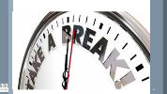 | BREAK

10:45-11:45  Zac  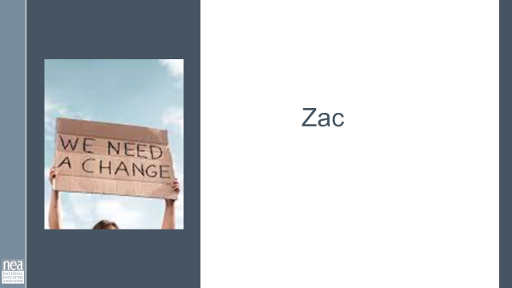  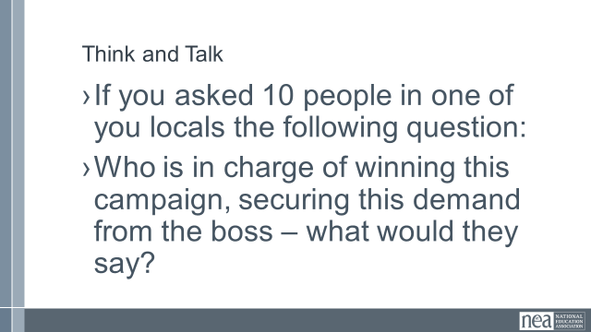  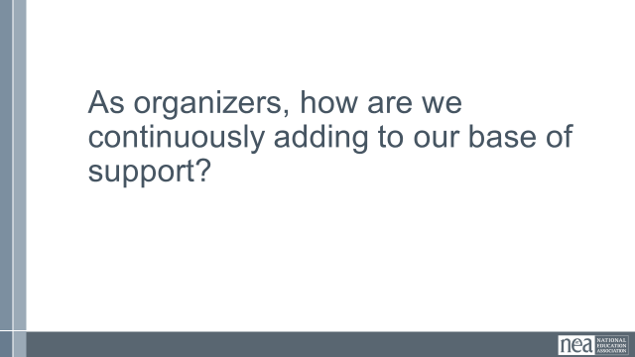  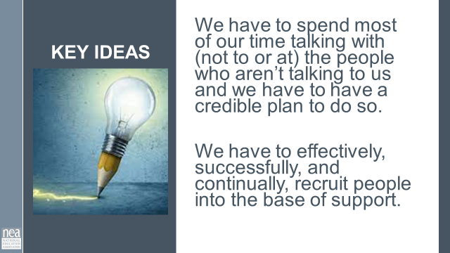  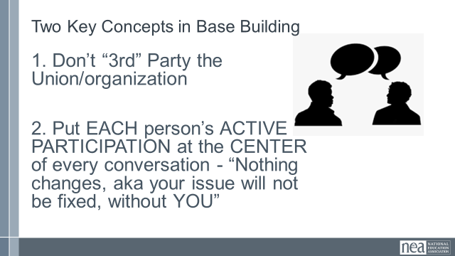  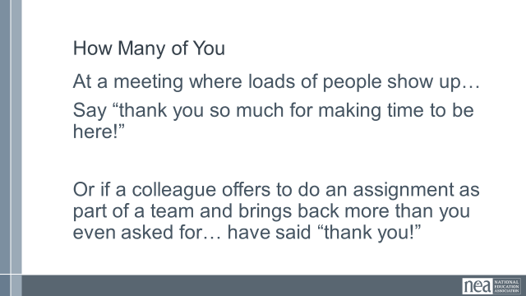  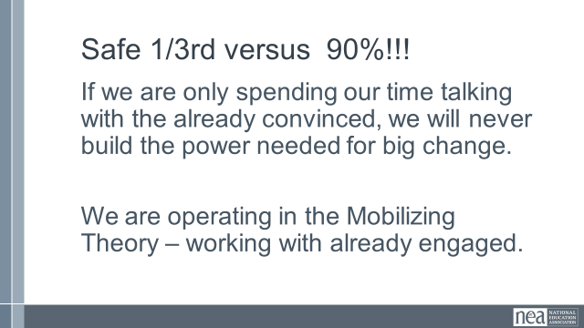  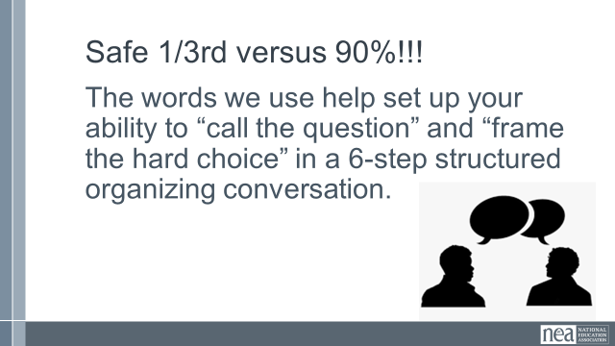  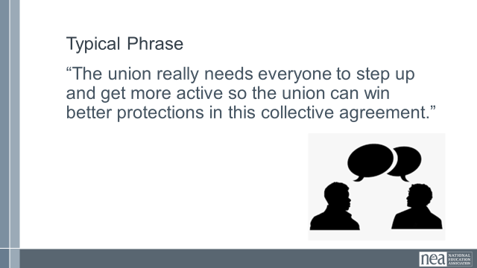  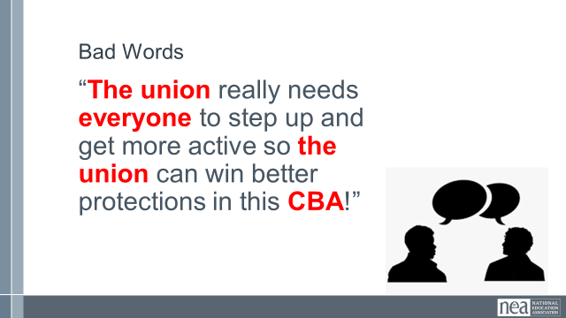  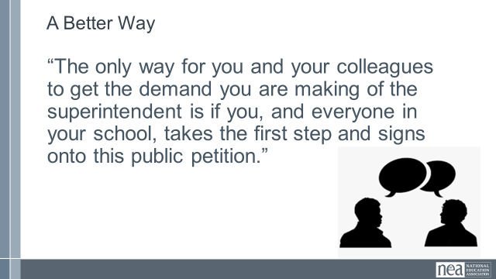  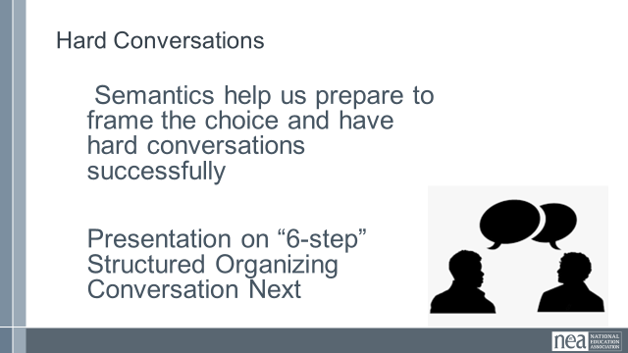  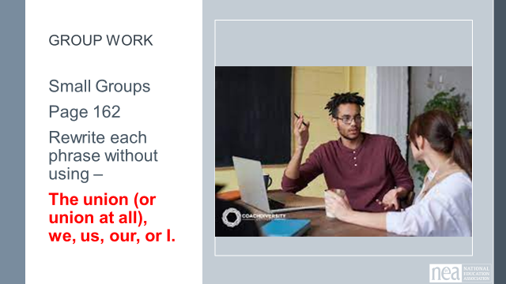  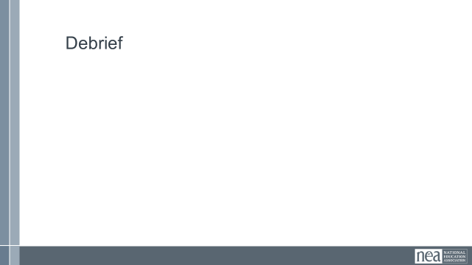  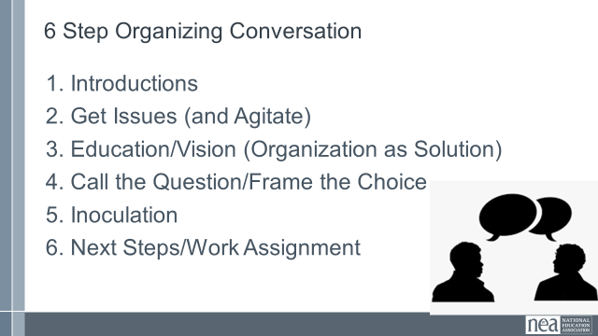  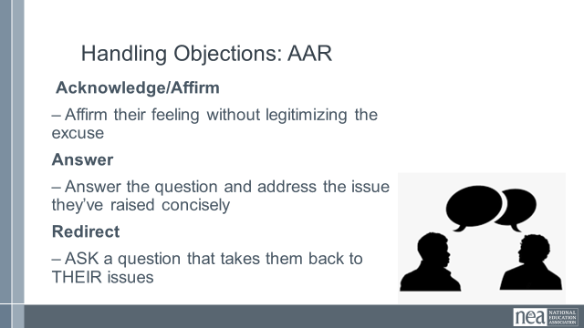  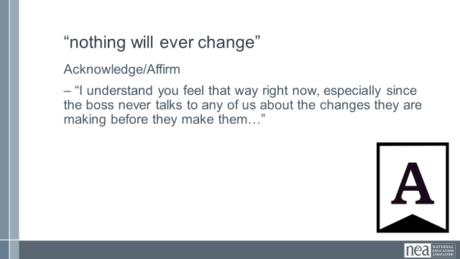  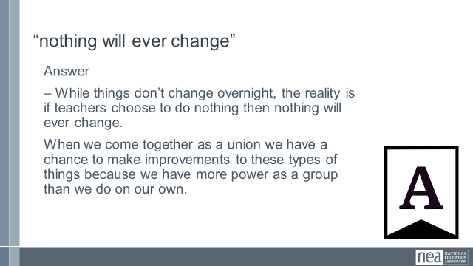  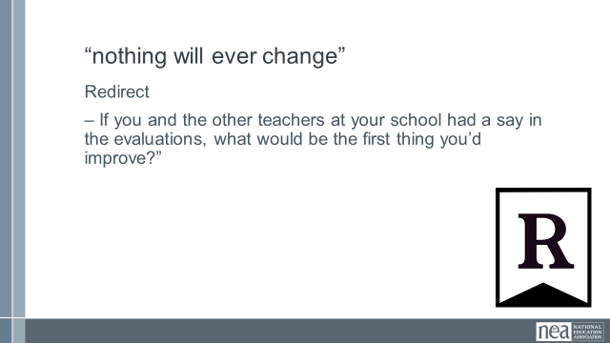  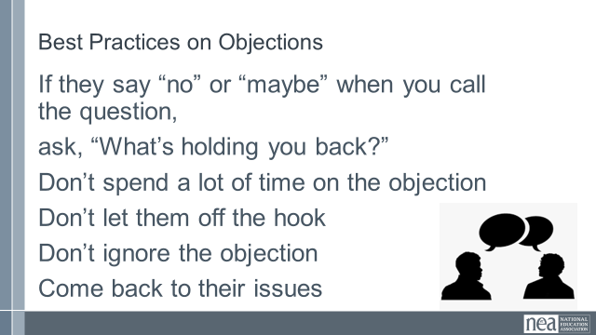  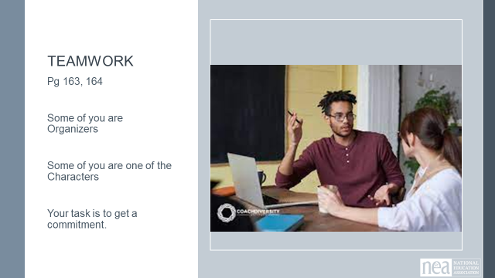  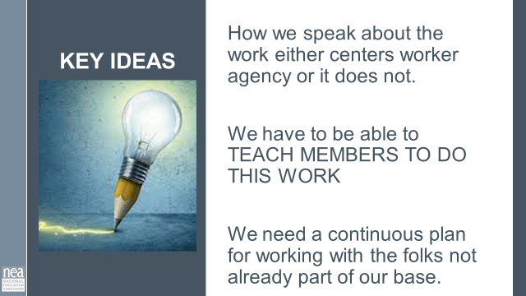 | How do I talk to people about the campaign and the work required to win? | Resources –  Jane’s Semantics Activity (Ellen handouts) |  | 60 Minutes – How do people choose to do these actions? (This should be split into two sections of 1 hour each or it needs to be edited)  Think and Talk  If you asked 10 people in one of you locals the following question:  Who is in charge of winning this campaign, securing this demand from the boss – what would they say?  As organizers, how are we continuously adding to our base of support?  Key Idea - We have to spend most of our time talking with (not to or at) the people who aren’t talking to us and we have to have a credible plan to do so.  We have to effectively, successfully, and continually, recruit people into the base of support.  Two Key Concepts in Base Building  1. Don’t “3rd” Party the Union/organization  2. Put EACH person’s ACTIVE PARTICIPATION at the CENTER of every conversation - “Nothing changes, aka your issue will not be fixed, without YOU  How many of you  At a meeting where loads of people show up…  Say “thank you so much for making time to be here!”  Or if a colleague offers to do an assignment as part of a team and brings back more than you even asked for… have said “thank you!”  Why is this not such a good thing?  Safe 1/3 vs. 90%  If we are only spending our time talking with the already convinced, we will never build the power needed for big change.  We are operating in the Mobilizing Theory – working with already engaged.  Safe 1/3 vs. 90%  The words we use help set up your ability to “call the question” and “frame the hard choice” in a 6-step structured organizing conversation.  Typical Phrase  “The union really needs everyone to step up and get more active so the union can win better protections in this collective agreement.”  Bad Words  “The union really needs everyone to step up and get more active so the union can win better protections in this CBA!”  A better way  “The only way for you and your colleagues to get the demand you are making of the superintendent is if you, and everyone in your school, takes the first step and signs onto this public petition.”  Hard Conversations  Semantics help us prepare to frame the choice and have hard conversations successfully  Group Work  Small Groups  Page 162  Rewrite each phrase without using –  The union (or union at all), we, us, our, or I.  Debrief  1. Introductions  2. Get Issues (and Agitate)  3. Education/Vision (Organization as Solution)  4. Call the Question/Frame the Choice  5. Inoculation  6. Next Steps/Work Assignment  Handling Objections  Acknowledge/Affirm  – Affirm their feeling without legitimizing the excuse  Answer  – Answer the question and address the issue they’ve raised concisely  Redirect  – ASK a question that takes them back to THEIR issues  Show Examples for “Nothing here will ever change”  Acknowledge/Affirm  – “I understand you feel that way right now, especially since the boss never talks to any of us about the changes they are making before they make them…”  Answer  – While things don’t change overnight, the reality is if teachers choose to do nothing then nothing will ever change.  When we come together as a union we have a chance to make improvements to these types of things because we have more power as a group than we do on our own.  Redirect  – If you and the other teachers at your school had a say in the evaluations, what would be the first thing you’d improve?”  Best Practices on Objections  If they say “no” or “maybe” when you call the question,  ask, “What’s holding you back?”  Don’t spend a lot of time on the objection  Don’t let them off the hook  Don’t ignore the objection  Come back to their issues  Teamwork  Pg 163, 164  Some of you are Organizers  Some of you are one of the Characters  Your task is to get a commitment.  Debrief  Key Ideas  How we speak about the work either centers worker agency or it does not.  We have to be able to TEACH MEMBERS TO DO THIS WORK  We need a continuous plan for working with the folks not already part of our base.  We just talked through a structured conversation to get an outcome we want. We are now going to look at another structured conversation with a different audience to talk about your problems of practice. |  | Participants will develop and use language that does not third party the union from the workers they are organizing.
11:45-12:00  CONTINUES After lunch  Renita  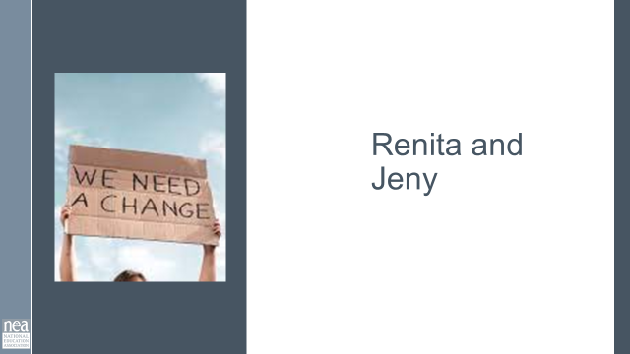  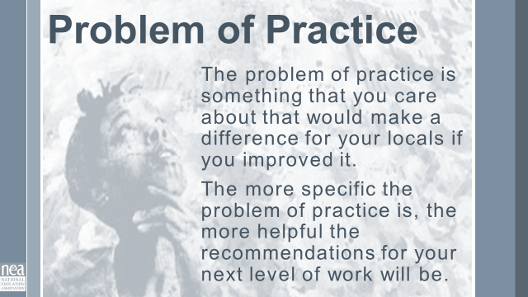 | How do we talk about our work? | Resources -  Problem of Practice Protocol  Questions to ask when coaching |  | 15 Minutes Total (Timing on this is very dependent on the number in groups. 10 mins to get in groups and 15 mins per round) - Consultancy Protocol Coaching on Your Problem of Practice - Pg 134-136  Discuss the Protocol - Presenter needs to explain the protocol in depth from pg 134. and set up the participants. (20 minutes) |  | Participants will employ a problem of practice protocol to structure a problem solving discussion around a current or future campaign.
12:00 - 1:00  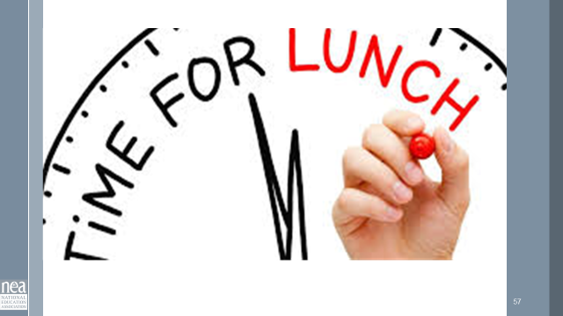 | LUNCH
1:00-1:50  Renita will finish  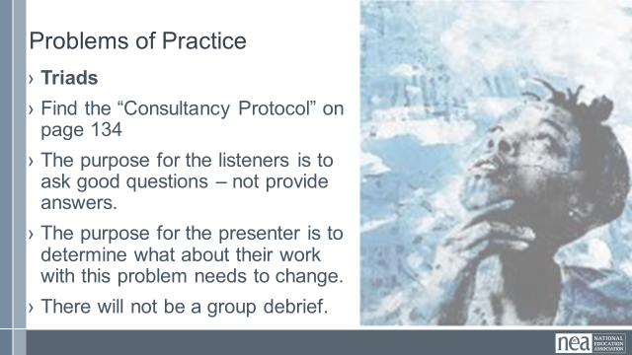  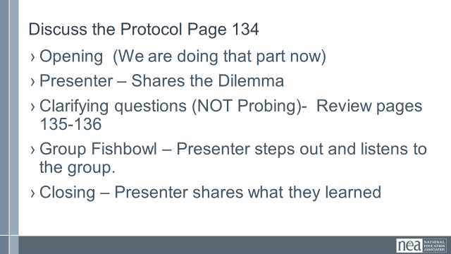  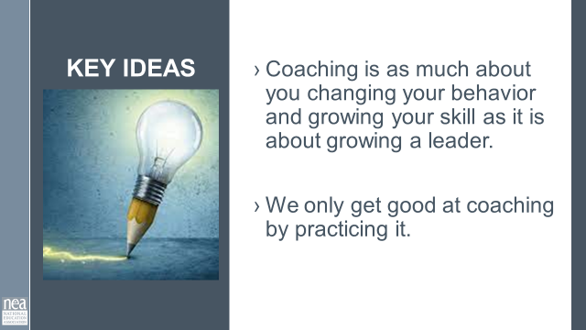 |  | Resources -  Problem of Practice Protocol  Questions to ask when coaching |  | Problem of Practice  - Work in Triads  - Find the “Consultancy Protocol” on page 134  - The purpose for the listeners is to ask good questions – not provide answers.  - The purpose for the presenter is to determine what about their work with this problem needs to change.  Depending on times, share their reflections on the process. Ask for one or two feedbacks. There may not be a group debrief  Key Points –  - Coaching is as much about you changing your behavior and growing your skill as it is about growing a leader.  We only get good at coaching by practicing it.  We have spent a great deal of time learning how to listen. It's an important skill for an organizer. Now let’s look at how we can use those skills in a building campaign. |  | Participants will employ a problem of practice protocol to structure a problem solving discussion around a current or future campaign.
1:50-2:15  Keightley  And Jeny  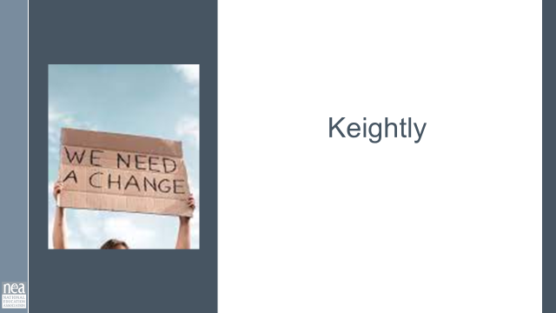  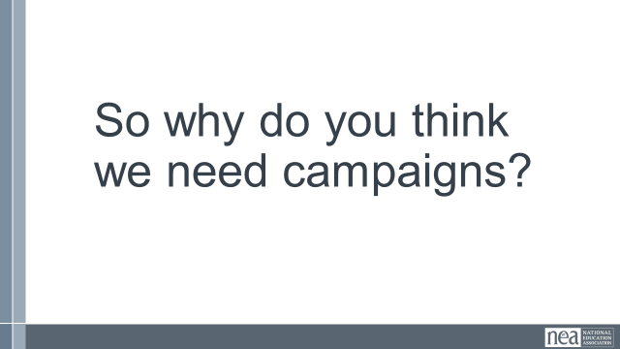  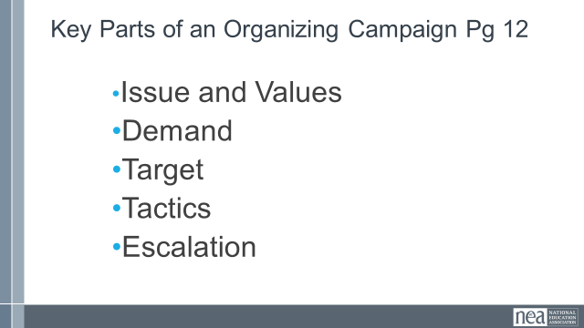  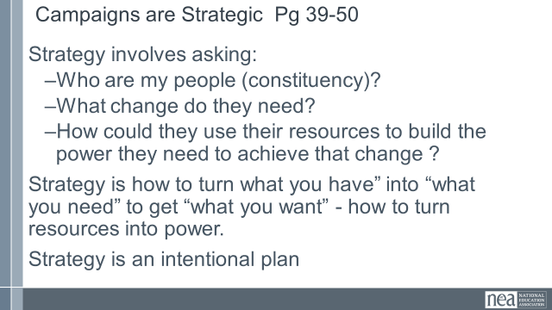  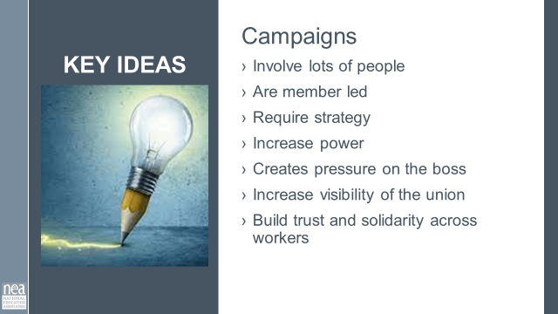  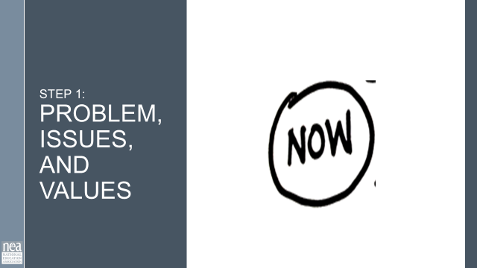  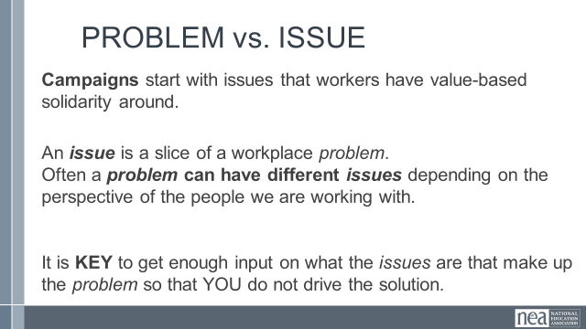  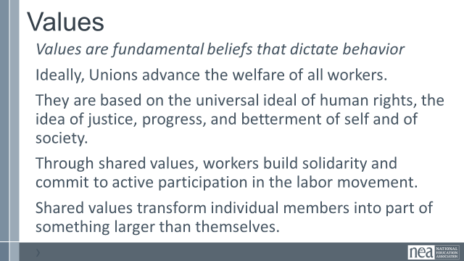  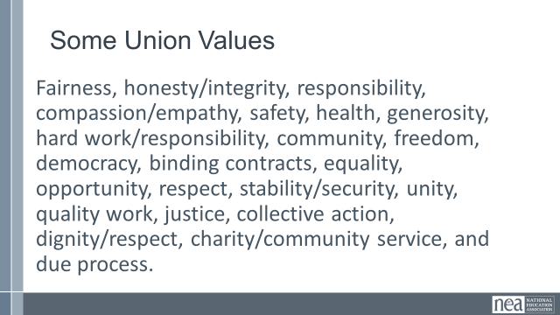  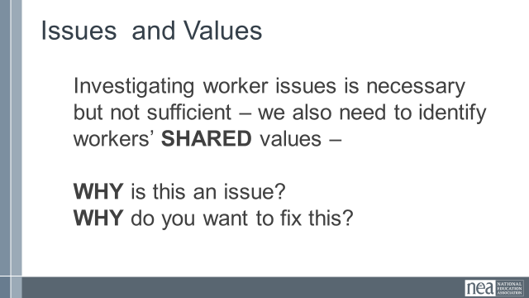  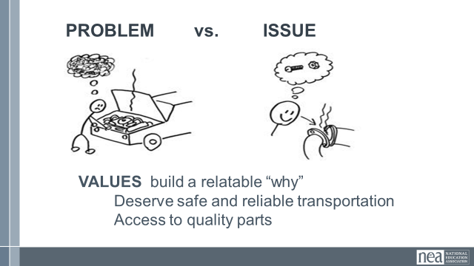  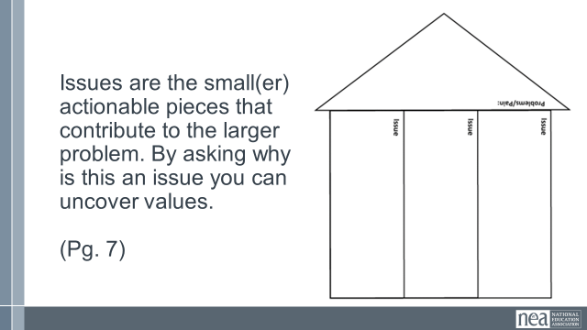  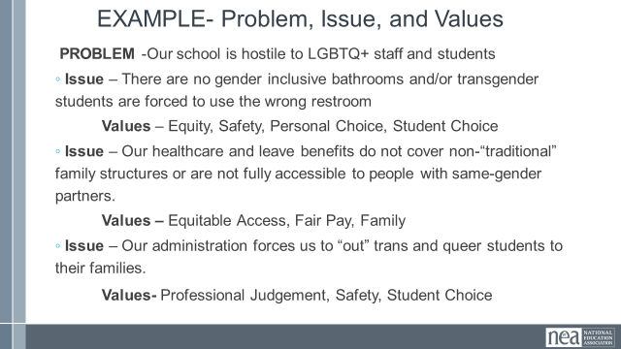  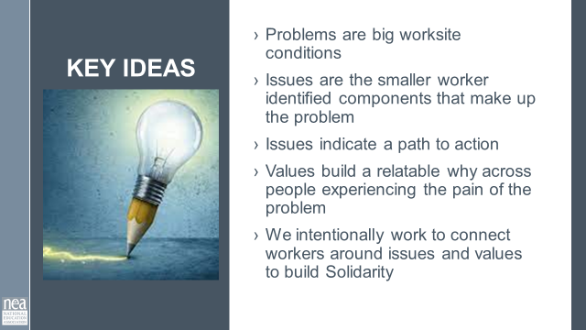  POSSIBLE GROUP WORK  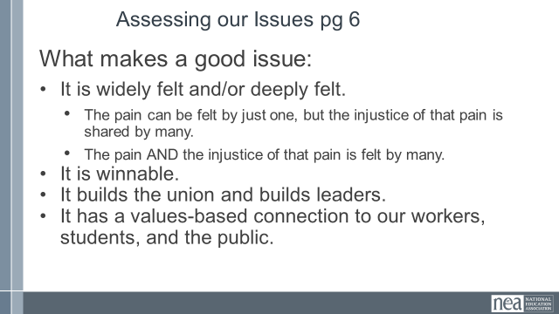  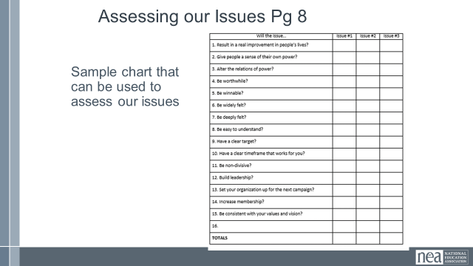  POSSIBLE GROUP WORK  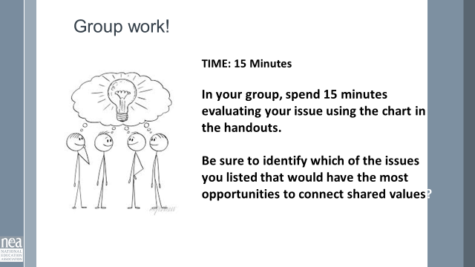  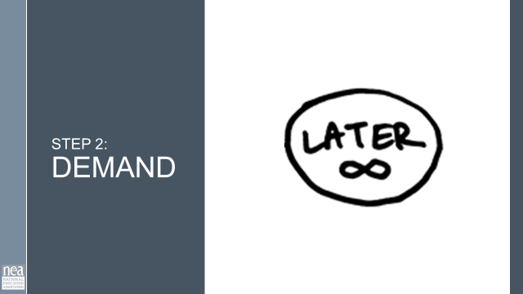  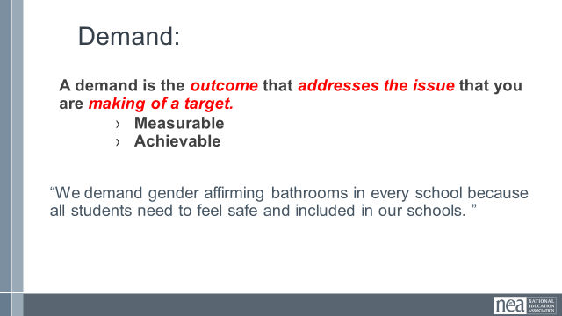    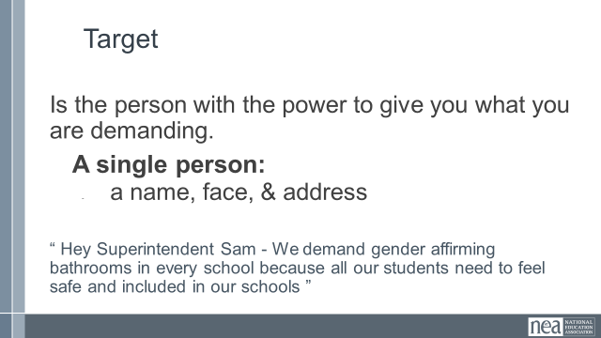  POSSIBLE GROUP WORK  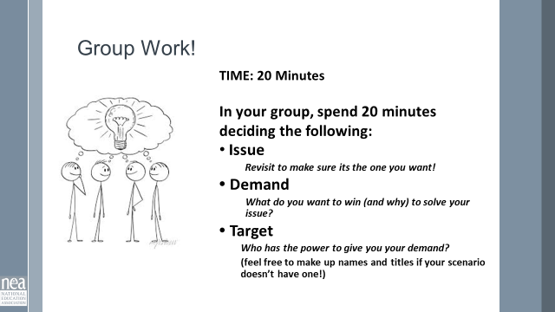  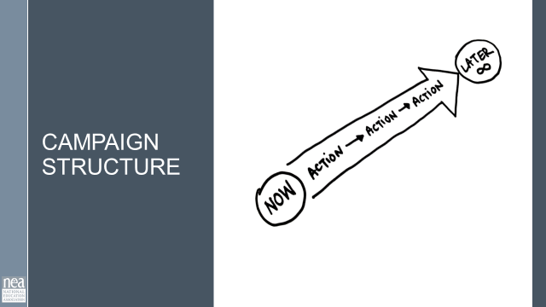  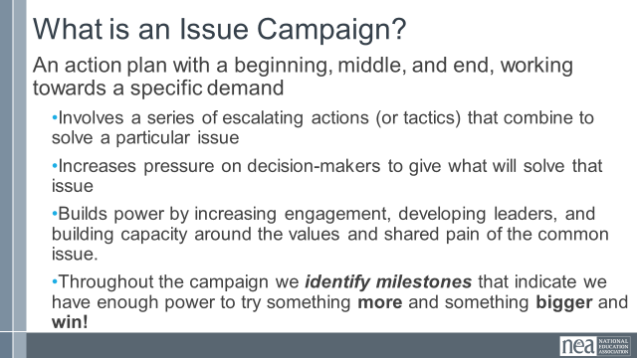  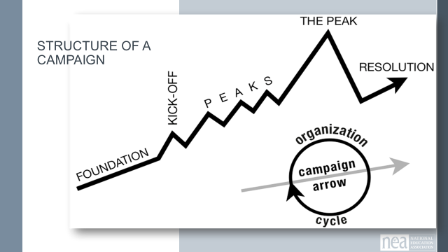  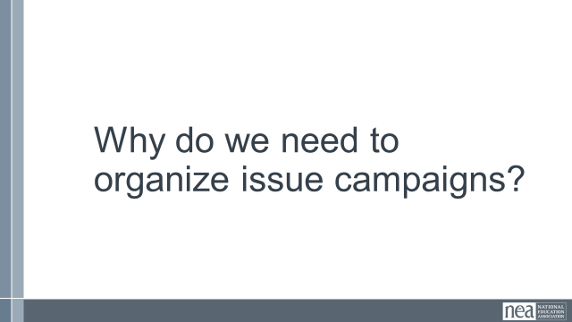  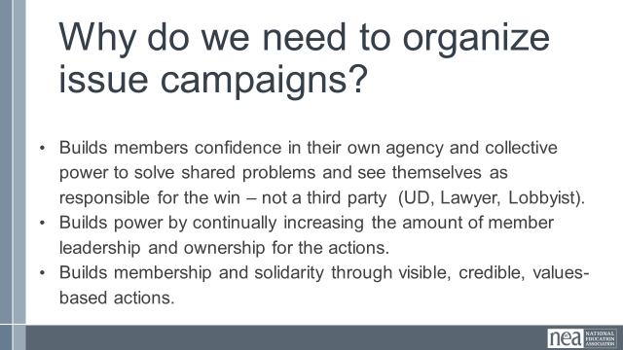  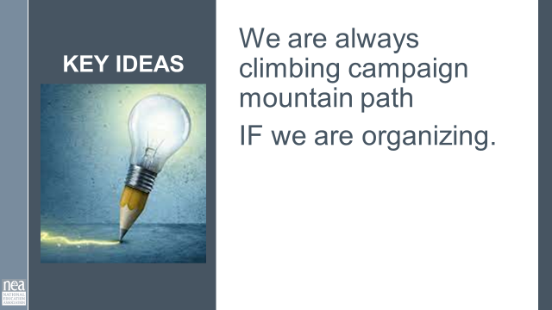  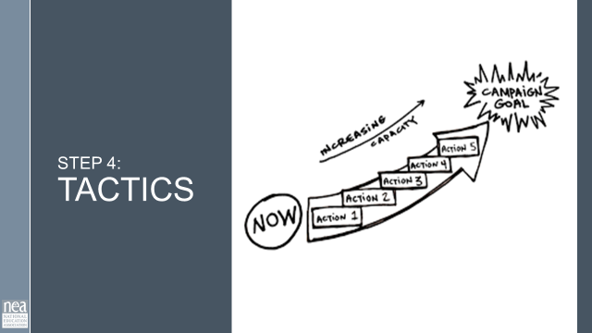  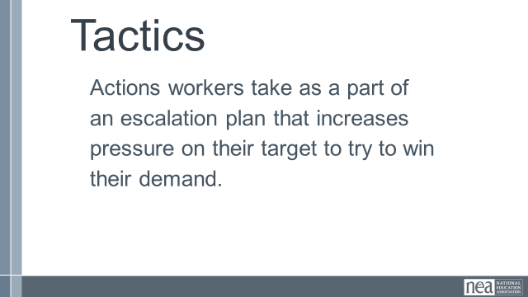  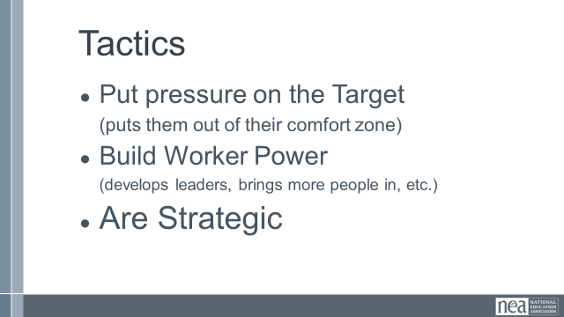  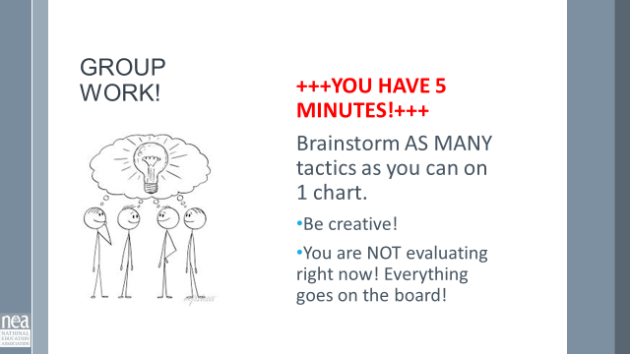  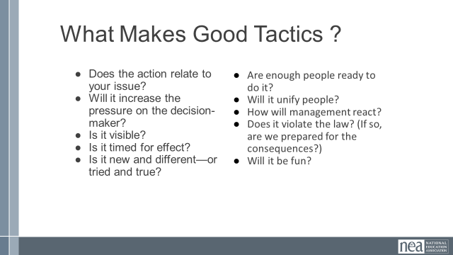  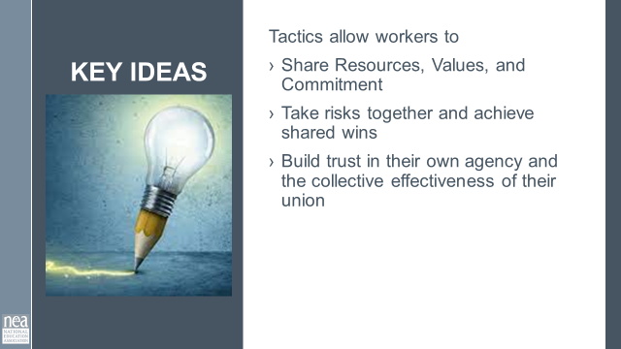  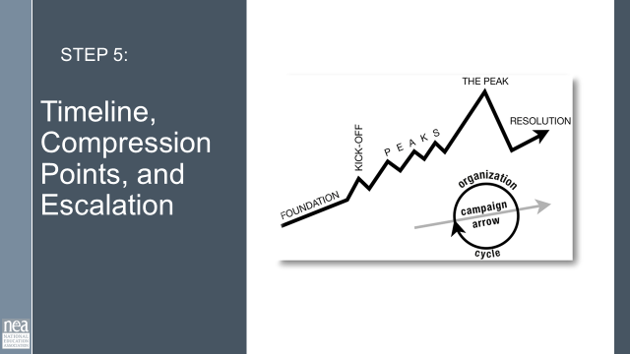  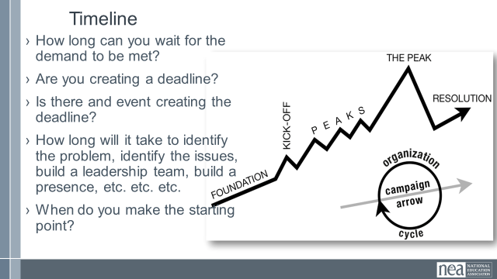  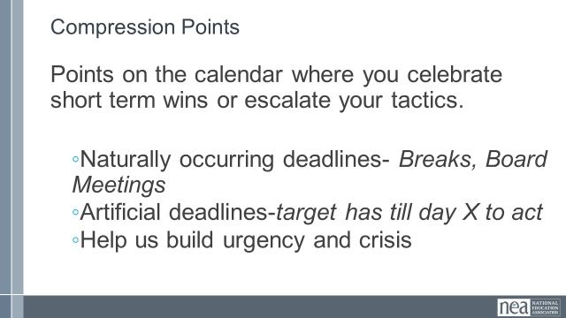  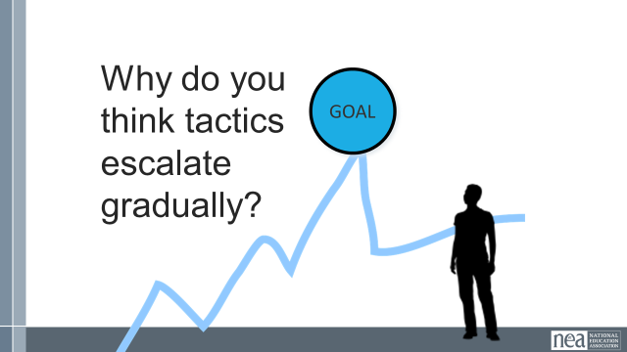  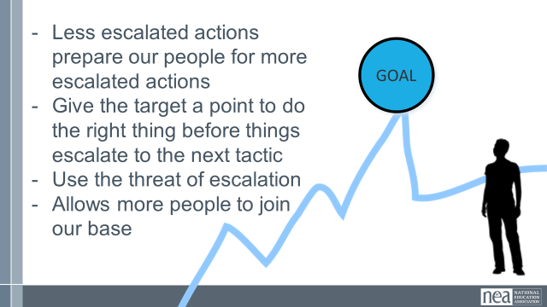  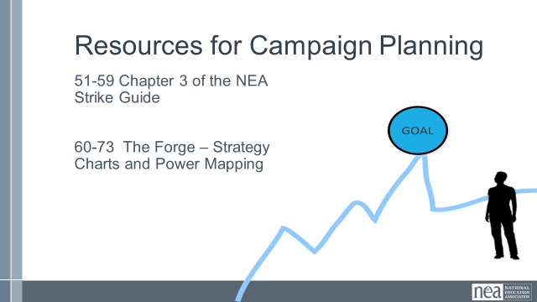  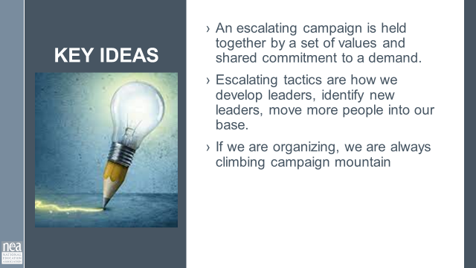  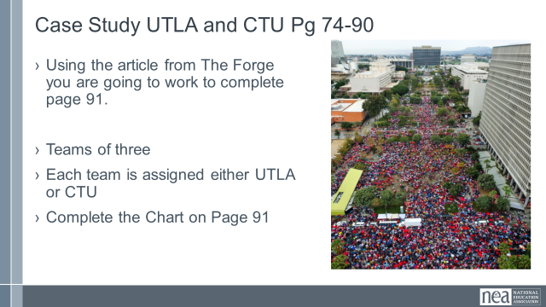 | What makes a campaign successful?  What is the staff role in a campaign? | Resources –  Campaign Mountain  Ganz Article on Strategy  Labor Notes – Staff in a democratic union  Strike guide – who does what chart  UTLA and CTU Case  Case Study Sheet |  | 55 (As is this needs more then 55 mins. Closer to 90 mins unless cut down) TOTAL SPLIT OVER BREAK Mins-Review of Campaigns  So why do you think we need campaigns?  - A campaign is an action plan with a beginning, middle, and end, working towards a specific demand that we want to win.  - A campaign has a target, someone who can give us what we want. It usually involves a series of escalating actions (or tactics), which means that we progressively turn up the heat.  - A good campaign creates increasing pressure on the boss over time by escalating the intensity and visibility of the tactics and increasing the numbers of people involved.  - Campaigns are a way to identify in advance the ingredients we need to win and put them together in a way that maximizes our chances of success.  - One isolated action may not be enough to solve the problem.  - Campaigns help us to shift the balance of power in our workplaces and build members’ confidence.  - Many issues that members care about can’t be solved with grievance or with legal wins.  - Besides, grievances are invisible to most members, because they don’t usually involve collective action.  - We need our actions to be participatory and public.  What is an issue campaign?  An action plan with a beginning, middle, and end, working towards a specific demand  •Involves a series of escalating actions (or tactics) that combine to solve a particular issue  •Increases pressure on decision-makers to give what will solve that issue  •Builds power by increasing engagement, developing leaders, and building capacity around the values and shared pain of the common issue.  •Throughout the campaign we identify milestones that indicate we have enough power to try something more and something bigger and win!  There are five main parts to a campaign. We are going to go through each-  - Issue  - Demand  - Target  - Tactic  - Escalation  We are going to go through each of the key components of an organizing campaign.  Campaigns are Strategic Pg 39-50 – Expanded Content on the parts of a wining campaign and a focus on strategy  Strategy involves asking:  - Who are my people (constituency)?  - What change do they need?  - How could they use their resources to build the power they need to achieve that change ?  Strategy is how to turn what you have” into “what you need” to get “what you want” - how to turn resources into power.  Strategy is an intentional plan  KEY POINTS Campaigns involve lots of people are member led and increase power and visibility of the union  Case Study UTLA and CTU pg 74-90  - Using the article from The Forge you are going to work to complete page 91.  - Teams of three  - Each team is assigned either UTLA or CTU  - Complete the Chart on Page 91  Step 1 Values, Problems, and Issues  PROBLEM and ISSUES Pg 7  - Campaigns start with issues that workers have value-based solidarity around.  - An issue is a slice of a workplace problem.  - Often a problem can have different issues depending on the perspective of the people we are working with.  - It is KEY to get enough input on what the issues are that make up the problem so that YOU do not drive the solution.  - Investigating the issue is necessary but not sufficient – we also need to identify workers’ SHARED values – WHY is this an issue? WHY do you want to fix this?  VALUES  - Values are fundamental beliefs that dictate behavior  - Ideally, Unions advance the welfare of all workers.  - They are based on the universal ideal of human rights, the idea of justice, progress, and betterment of self and of society.  - Through shared values, workers build solidarity and commit to active participation in the labor movement.  - Shared values transform individual members into part of something larger than themselves.  Some union values we might recognize: Fairness, honesty/integrity, responsibility, compassion/empathy, safety, health, generosity, hard work/responsibility, community, freedom, democracy, binding contracts, equality, opportunity, respect, stability/security, unity, quality work, justice, collective action, dignity/respect, charity/community service, and due process.  ISSUES AND VALUES  - Investigating worker issues is necessary but not sufficient – we also need to identify workers’ SHARED values –  - WHY is this an issue?  - WHY do you want to fix this?  Show slide of car and specific part – The car is a piece of junk is a problem that seems hopeless, no indication of being able to solve.  The natural next question is “What makes this a piece of junk? ”  The car needs a radiator hose, new brakes, and a new drivers seat are all issues.  You might ask, Do you want to fix this problem? Which of these do you think you can fix? Which one matters the most to you?  The radiator hose is something that my friend and I can fix and it matters to me because I can afford to fix it.  The radiator hose will be fixed by putting a new fitting on it. Is an issue that allows me to see the solution.  We can get to values by asking how do you feel about your car being a piece of junk? Do you think others feel the same way about cars that are pieces of junk? Why do you want to fix this problem?  We deserve safe and reliable transportation  We deserve access to affordable and quality car parts  KEY POINTS  - Problems are big worksite conditions  - Issues are the smaller worker identified components that make up the problem  - Issues indicate a path to action  - Values build a relatable why across people experiencing the pain of the problem  - We intentionally work to connect workers around issues and values to build Solidarity  POSSIBLE GROUP WORK? On ISSUE Brainstorming from the case study.  What makes a good issue: Pg 6 and 8  - It is widely felt and/or deeply felt.  - The pain can be felt by just one, but the injustice of that pain is shared by many.  - The pain AND the injustice of that pain is felt by many.  - It is winnable.  - It builds the union and builds leaders.  - It has a values-based connection to our workers, students, and the public.  POSSIBLE GROUP WORK? On Issue Assessment from the case study  Step 2 Demand  A demand is the outcome that addresses the issue that you are making of a target.  - Measurable  - Achievable  “We demand gender affirming bathrooms in every school because all students need to feel safe and included in our schools. ”  Step 3 Target  Is the person with the power to give you what you are demanding.  A single person:  - a name, face, & address  “ Hey Superintendent Sam - We demand gender affirming bathrooms in every school because all our students need to feel safe and included in our schools ”  POSSIBLE GROUP WORK On Demand Identification from the case study  Campaign Structure  Show campaign mountain  Why do we need to organize issue campaigns?  - Builds members confidence in their own agency and collective power to solve shared problems and see themselves as responsible for the win – not a third party (UD, Lawyer, Lobbyist).  - Builds power by continually increasing the amount of member leadership and ownership for the actions.  - Builds membership and solidarity through visible, credible, values-based actions.  Key Points - We are always along the campaign mountain path IF we are organizing  Step 4 Tactics  Actions workers take as a part of an escalation plan that increases pressure on their target to try to win their demand.  - Put pressure on the Target  (puts them out of their comfort zone)  - Build Worker Power  (develops leaders, brings more people in, etc.)  - Are Strategic  POSSIBLE GROUP WORK? From the Case Studies  What makes good Tactics? Pg 13 (I think some real good share around Tactics could be done. Sometime organizers get stuck in same old tactics rut (not always bad but if people feel negative about the tactic it will be). Also, we were asked how to bring the fun/joy into organizing. I think initially addressing that in tactics would be a good long-term idea. For example: Even a letter writing campaign can be done in a way that is fun joyful- separate on their own vs. Together in a room with empowering music and building community, working to contract teachers can stay home and show up at start time or can come to school and tailgate across the street until start time, etc. Might even be fun to give them some “boring” tried and true tactics and have them add fun/joy for an activity that won’t take up too much time but will allow them to breath and interact with each other.)  - Does the action relate to your issue?  - Will it increase the pressure on the decision-maker?  - Is it visible?  - Is it timed for effect?  - Is it new and different—or tried and true?  - Are enough people ready to do it?​  - Will it unify people?​  - How will management react?​  - Does it violate the law? (If so, are we prepared for the consequences?)​  - Will it be fun?  Key points – Tactics allow workers to  Share Resources, Values, and Commitment  Take risks together and achieve shared wins  Build trust in their own agency and the collective effectiveness of their union  Step 5 Timeline Compression Points and Escalation  Timeline  - How long can you wait for the demand to be met?  - Are you creating a deadline?  - Is there and event creating the deadline?  - How long will it take to identify the problem, identify the issues, build a leadership team, build a presence, etc. etc. etc.  - When do you make the starting point?  Compression Points  - How long can you wait for the demand to be met?  - Are you creating a deadline?  - Is there and event creating the deadline?  - How long will it take to identify the problem, identify the issues, build a leadership team, build a presence, etc. etc. etc.  - When do you make the starting point?  Escalation pg 14  Why do you think tactics escalate gradually?  - Less escalated actions prepare our people for more escalated actions  - Give the target a point to do the right thing before things escalate to the next tactic  - Use the threat of escalation  - Allows more people to join our base  Resources for Campaign Planning  51-59 Chapter 3 of the NEA Strike Guide  60-73 The Forge – Strategy Charts and Power Mapping  Key Points – An escalating campaign is held together by a set of values and shared commitment to a demand.  Escalating tactics are how we develop leaders, identify new leaders, move more people into our base.  If we are organizing, we are always climbing campaign mountain |  | Participants will be able to identify the various stages of a campaign.  Participants will develop an understanding of strategy.
2:15-2:30  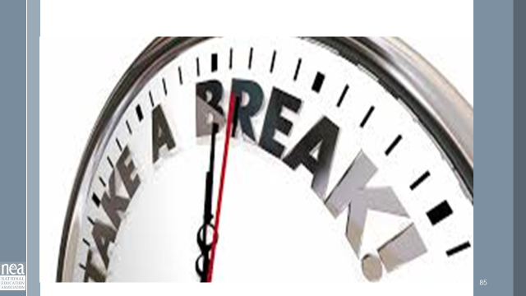 | BREAK
2:30 – 3:00  Keightley Finishes |  |  |  | Campaigns can’t run without unity and courage. Katie will tell us all about how to get both of these to power a campaign.
3:00 -3:30  Katie  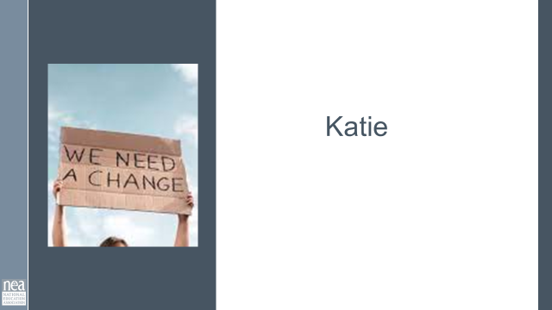  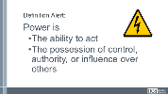  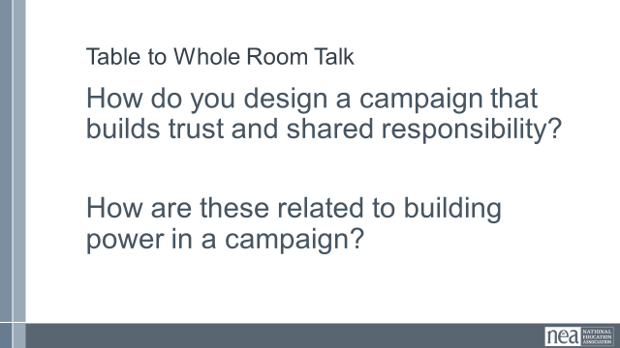  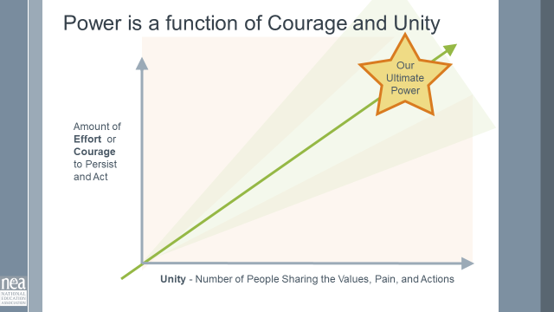  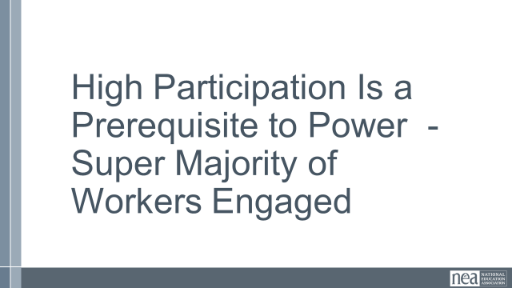  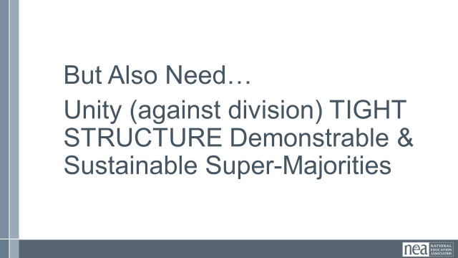  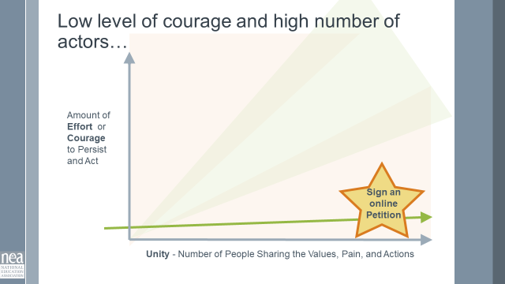  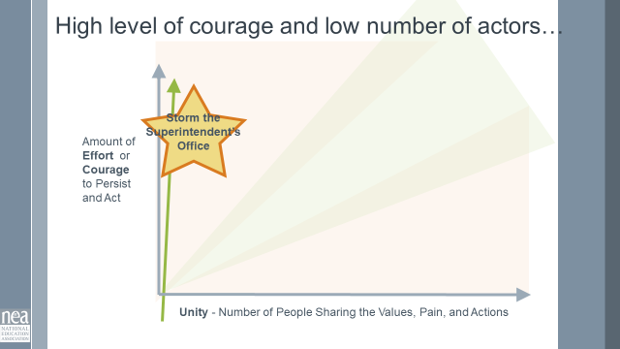  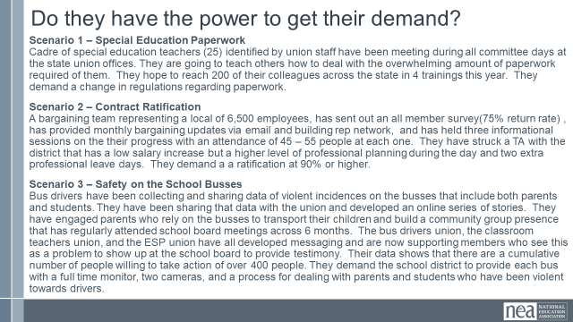  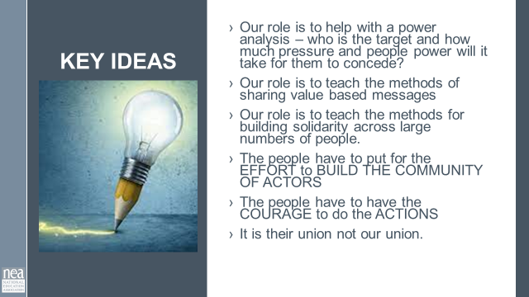 | What is the connection between good campaigns and development of solidarity? | Resources Needed  Unity vs. Courage Graphic |  | 35 Minutes – How can we design a campaign that builds trust and shared responsibility?  Power is  The ability to act  The possession of control, authority, or influence over others  Table to Whole Room Talk-  Write the answer on a piece of paper, crunch it up, throw it across the room, grab someone elses paper to share it out with the room. Call on people to share. (Not everyone gets to read them)  How do you design a campaign that builds trust and shared responsibility?  How are these related to building power in a campaign?  Power is a Function of Courage and Unity  The amount of Courage or Effort that is needed to commit to act  And the relationship to the Number of people feeling the pain, sharing the values, and participating in the change (unity and shared responsibility) is what gets us to our ultimate power to win the demand.  The more the courage and the more people who are acting – the more power we have.  Show the example online petition – high participation, low effort and courage – low power to cause the target to concede the demand  Show the example of storming the superintendent's office – a lot of courage and effort but low participation – low power to cause the target to concede the demand.  Group work Three Scenarios – (Graph is on page 16)  Where are they placed on this graph?  Do they have the power to achieve their win?  What would you do to increase their chances?  Issue – Special Education Paperwork  Cadre of special education teachers (25) identified by union staff have been meeting during all committee days at the state union offices. They are going to teach others how to deal with the overwhelming amount of paperwork required of them. They hope to reach 200 of their colleagues across the state in 4 trainings this year. They want the state to change the regulations regarding paperwork.  Issue – Contract Ratification  A bargaining team representing a local of 6,500 employees, has sent out an all member survey(75% return rate) , has provided monthly bargaining updates via email and building rep network, and has held three informational sessions on the their progress with an attendance of 45 – 55 people at each one. They have struck a TA with the district that has a low salary increase but a higher level of professional planning during the day and two extra professional leave days. They want the members to Ratify at a 90% or higher rate.  Issue – Safety on the School Busses  Bus drivers have been collecting and sharing data of violent incidences on the busses that include both parents and students. They have been sharing that data with the union and developed an online series of stories. They have engaged parents who rely on the busses to transport their children and build a community group presence that has regularly attended school board meetings across 6 months. The bus drivers union, the classroom teachers union, and the ESP union have all developed messaging and are now supporting members who see this as a problem to show up at the school board to provide testimony. Their data shows that there are a cumulative number of people willing to take action of over 400 people. They are now asking the school district to provide each bus with a full time monitor, two cameras, and a process for dealing with parents and students who have been violent towards drivers.  Key Ideas  Our role is to help with a power analysis – who is the target and how much pressure and people power will it take for them to concede?  Our role is to teach the methods of sharing value based messages  Our role is to teach the methods for building solidarity across large numbers of people.  The people have to put for the EFFORT to BUILD THE COMMUNITY OF ACTORS  The people have to have the COURAGE to do the ACTIONS  It is their union not our union.  We design feedback, debrief, and activities for the group to share responsibility for the core outcomes and tasks necessary to win.  We went through the things that power a campaign. Now Zac is going to talk about the concepts and skills for winning a campaign. |  | Participants will build understanding of how the development of trust in a campaign improves the overall commitment to the workers’ union.
3:30 – 3:45  Zac  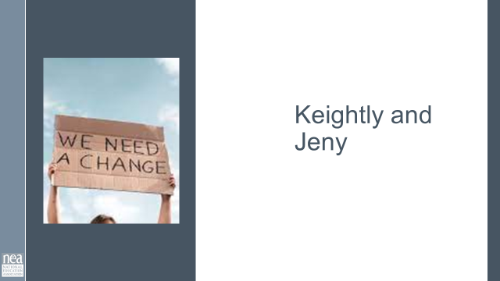  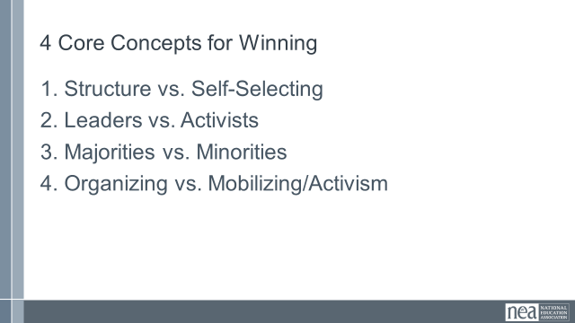  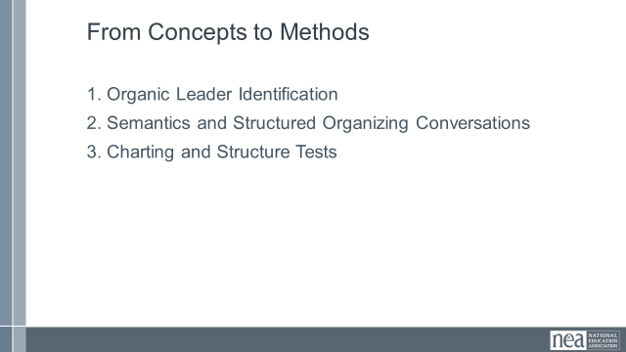  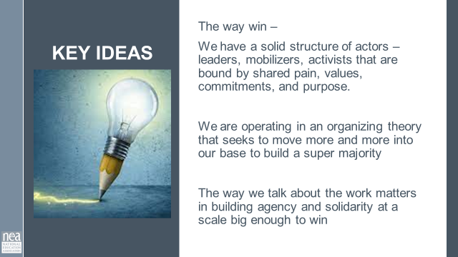 | How do I build a structure with the power to achieve the change the workers want? |  |  | 15 Minutes –So what are the concepts and skills of a winning campaign?  What is our role in making these successful?  Review the 4 Core Concepts and what it takes to win  Have a discussion of what you role is in supporting a winning campaign?  Review the Key ideas  Now that we are clear on what we need to do, Renita is going to lead us into apply that knowledge to the campaigns you brought. |  | Participants will understand how to build a structure for power.
3:45-4:20  Renita  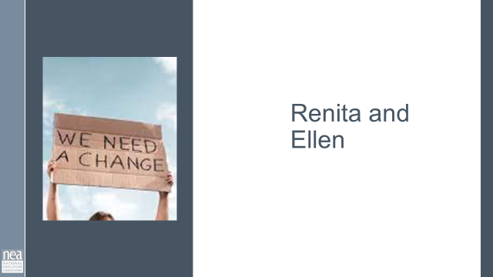  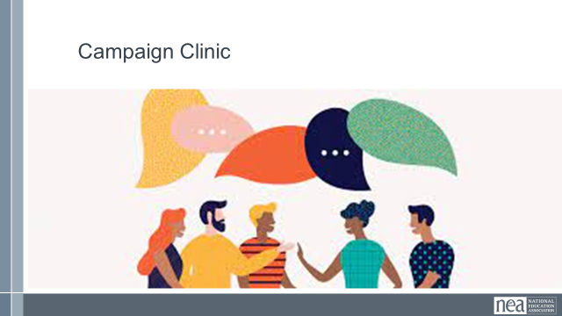 | What can I do to design a solid campaign? | Resources needed –  Tools for assessing and designing campaigns |  | 35 Minutes - Campaign Clinic  You are discussing your campaign now in order to prepare an overview of your campaign tomorrow – we are asking you to consider the following.  - Does the campaign have all 5 parts?  - Issues and Values, Demands, Target, and Escalation  - Is there a clearly understood value driven narrative?  - To what extent is the campaign led by a leadership team?  - What intentional ways have you recruited and involved people who are marginalized?  - What percent of the workers are engaged?  - What is working?  - What is not working?  - What do you want to be able to figure out?  - Where are you stuck in your campaign?
4:20-4:30  Ellen Holmes |  |  |  | 10 Minutes - Closing  Flights, check out, final lunch, vouchers
4:30- 5:00  Ellen Holmes |  |  |  | Choice Networking
5:00 | ADJOURN

