Facilitator Agenda Day 3 – Organizing Through Advocacy
General Materials Needed: |  |  |  |  | Room Set-up:
1 Set of Handouts per Person  Name Tents with the Norms  Sign-in Sheet  Agendas on the table (1 per)  Room signs, sign in signs  One ream of white photocopy paper  Chart Paper (4 to 5 full w Sticky Strip) |  |  | Materials Box for each table with:  Markers (Mr. Sketch variety)  Post its – 3x3” and 4X5” sizes  Index Cards  Highlighters – 4 colors  Pens and Pencils  Participant “toys” |  | Round Tables  Projector, Screen and Speakers  Carousel stations and reporting stations around the perimeter  50 people
Key Outcomes for the Event:

Time | Essential Questions | Resources |  | Instructions, Activity and Debrief (Facilitators) |  | Outcomes
 | What question(s) should this learning section answer? | Charts, handouts, articles, materials, slide |  | What are you saying, what are they doing, what questions will you use to guide learning and make clear the important points  Include an estimate for how long each section of the learning will take |  | As a result of this section of learning, what will participants know or be able to do?
7:00-8:30 | Breakfast, Facilitator Prep
Entry Activity | Make sure you know your escape plan – check out, flight and taxis
8:30 – 9:00  Ellen  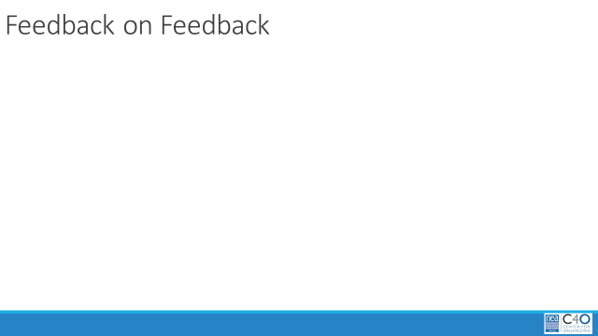  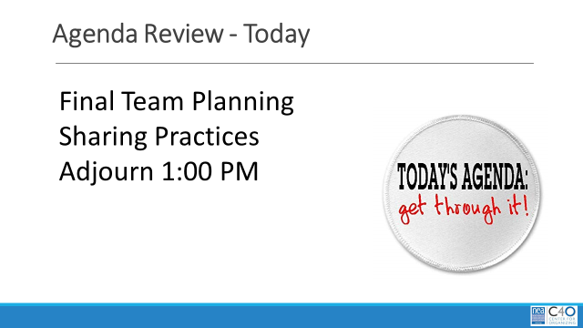 | What is the status of our learning? |  |  | 30 Mins Total - Welcome back  5 Mins Feedback on Feedback, Agenda Review, Norms Review  15 Mins Community building exercise – Getting Graphic  - Each table has only one sheet of chart paper  - Only pictures - no words, letters or numbers  - They will use the pictures to tell the story of what they have learned so far.  - Must be a joint effort, all table members should contribute  10 Mins – Share out
9:00 – 9:30  Seleste  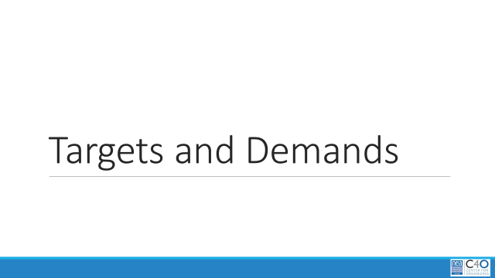  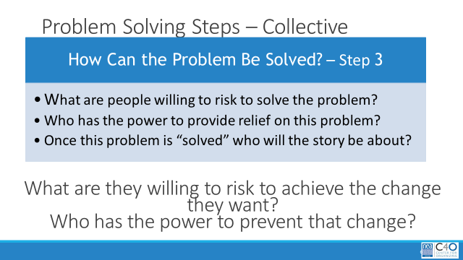  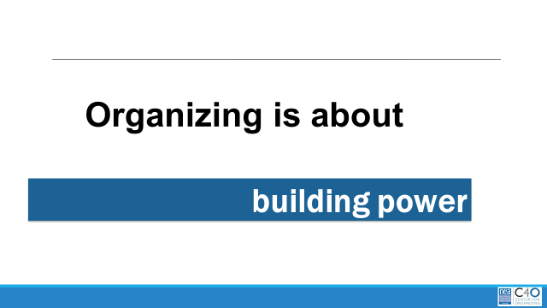  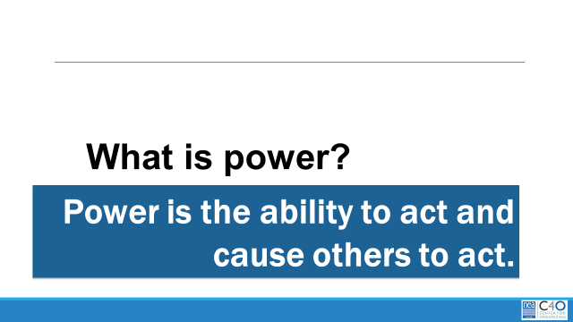 |  |  |  | 30 Mins – Targets and Demands  3 Mins Total- INTRODUCE DEMAND and Set Up p.113  - A demand is what the group wants– the win –  - A demand is the outcome that addresses the issue you are making of the target  - If the issue is what is wrong, the target is what we want that will fix the issue.  3 Min- INTRODUCE TARGET p 103-109  - The last idea that we want to cover is Targets.  - TARGET: A target is a single person with a name and an address. The target is the person with the power to give the workers the change they are asking for. A target has a name, a face and an address.  20 Mins – GROUP WORK  In your groups, return to your scenario and decide the:  Issue Keep in mind what makes a good issue!  Demand What do you want to win to solve your issue?  Target Who has the power to give you your demand?  1 min- Organizing is about building power  - Use our resources to generate power  1 min- What is Power  - Power is getting folks to act  2 Min- WRAP UP/KEY POINTS  - A well thought out campaign has a strong issue, with an identifiable target and a strategic demand.  - A target is a specific person!  - We don’t choose the issues! We identify the issues from talking to members!
9:30-10:00  Charles and Steven |  |  |  | 30 min-  5 mins to introduce- (Charles)  Open the link to the CBMA website to research items. Provide a brief walk through of each category.  15 min worktime: (Steven) (Registrations from prior day...Using the CBMA database website, Participants to research resources that might be relevant to their group’s scenario)  10 min debrief (Steven)  Which resources may help support your scenario? How will those resources support your scenario?
10:00-10:50  Vanessa  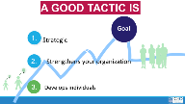 |  |  |  | 50 Minutes total – How to Apply Pressure  10 minutes for slides Demand and Tactics through Campaign Mountain  Demand and Tactics  Demand- the BIG Win  Tactics- Are Actions you to take as a part of an escalation plan that increases pressure on your target to try to win your demand.  Demand and Tactical Win  Walk through how each tactic leads to a tactical win. Tactical wins lead to achieving the demand.  A good tactic:  - Strategic- right time and place  - Strengthens – creates solidarity  - Develops individuals...moves them from mobilizing to organizing  Why should tactics escalate?  Each escalation is more public, more visible, and has more risk. WE transform members to activists, activists to leaders by asking them to take bigger risks  3 Mins- Campaign Mountain  Let’s put it all together...  - Foundation – gather info, id issues, id leadership team  - Kick-off –public event that indicates what the issue, demand, and targets are  - Escalating peaks of activity that should escalate in  - Risk  - Capacity (people, resources, engagement)  - Increase leadership and ownership  - Campaign Compression Points  - THE PEAK – The most public, risky, momentum, engagement, and resources  - The Win- We achieve our demand  - Debrief, regroup, and continue to climb  3 Minutes on Key Points  - Strategy without tactics is simply a collection of good ideas and big dreams.  - Tactics without strategy are a random collection of activities and wasted resources.  - The bigger the win you want, the more resource you need.  - Good tactics actually result in more resources – relationships, skills, hope and trust.  45 Minutes of Group work time - Return to your Scenarios – what are the various tactics that you can use to apply pressure at the various stages of the process.  Are there different demands at different levels?  How many people are engaged?  How will you know if the tactic was successful?
10:50 – 11:50  Bekah  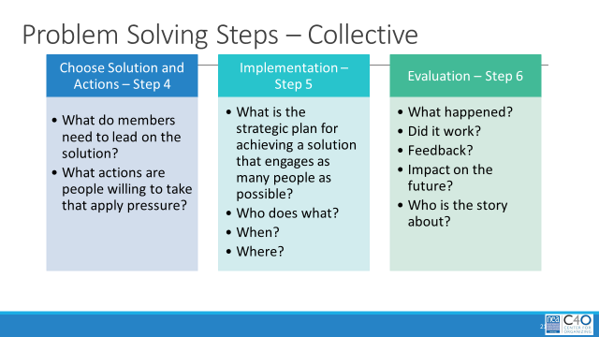 |  |  |  | 60 Mins -Team Planning Worktime  Walk them through expectations for their presentation with inclusion of their issue, their demand (and how they’ll know they achieved it), their targets, tactics as they escalate and how many people involved at each step in the plan. They should also include how their org plan ties to the steps in the grievance plan.  Participants should take their 15-minute break during this time, when it works for them. |  | Participants will apply their learning in the development of a campaign.
11:50 –12:45  Toney & All  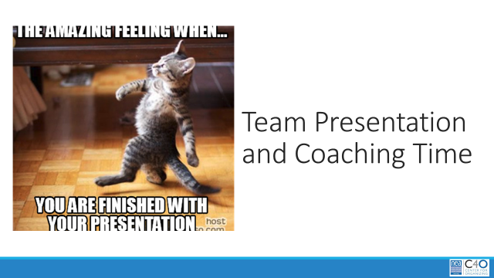  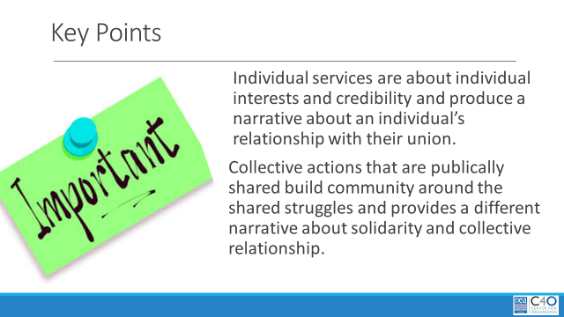 |  |  |  | 50 Mins -Presentations, Coaching and final Seminar  1. Each group presents their campaign and explains how it is paired with the grievance.  2. Other groups provide coaching, using the coaching resource |  | Participants will apply the consultancy protocol in the group presentation context.
12:45 -1:00  Ellen |  |  |  | Ending it Well  Warm and Cool Feedback for the Team  Leave a Word in the Room
1:00 | Adjourn with Boxed Lunches

