Facilitator Agenda: Day # 1 Organizing ESP
General Materials Needed: |  |  |  |  | Room Set-up:
1 Set of Handouts per Person  Name Tags or Name Tents  Room signs, sign-in signs  Painters Tape |  |  | Chart Paper  Post its  Chart Markers – Mr. Sketch  Pens and Pencils |  | Round Tables  Projector, Screen and Speakers  Carousel stations and reporting stations around the perimeter  50 people
Charts needed for today:
- Parking lot
- Blank paper to make -Venn Diagram
- Institutional problem – two blank charts per group

Key Outcomes for the Day

LINK TO WHOLE FOLDER OF RESOURCES https://neahq:-my.sharepoint.com/:f:/g/personal/eholmes_nea_org/EqBeGgLRG_NJsSYdz9aU7FcBRV0ht7TkTMONHLVptq5hdQ?e=5sAoL7

Time | Essential Questions | Resources |  | Instructions, Activity and Debrief (Facilitators) |  | Outcomes
 | What question(s) should this learning section answer? | Charts, handouts, articles, materials, slide |  | What are you saying, what are they doing, what questions will you use to guide learning and make clear the important points  Include an estimate for how long each section of the learning will take |  | As a result of this section of learning, what will participants know or be able to do?
Entry activity

8:30 -9:00    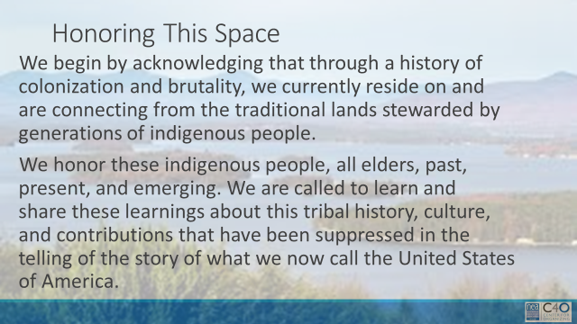      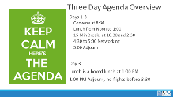  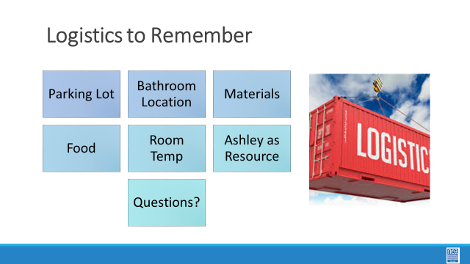  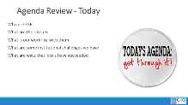  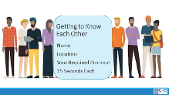  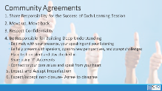  BEN | How will we work together to support learning? | Make the Following Charts  Community Agreements  Parking Lot  Agenda  Put out  Name Tents  Handout Package |  | 30 Mins TOTAL Getting Started (Ellen)  4 Mins NEA Welcome  Native Land Recognition  The National Education Association is committed to honoring the spaces that we occupy to advance the work.  - We begin by acknowledging that through a history of colonization and brutality, we currently reside on and are connecting from the traditional lands stewarded by generations of indigenous people.  - We honor these indigenous people, all elders, past, present, and emerging. We are called to learn and share these learnings about this tribal history, culture, and contributions that have been suppressed in the telling of the story of what we now call the United States of America.  Why are we here?  - We are here to build stronger ESP leaders.  - NEA is committed to building effective sites where members can lead and growth their associations.  5 Mins Facilitator Introductions  - Team intros include: Name, Work Location, years in the work, and your required pronoun  5 Mins Group Introduction Whip  - Have a quick model from one of the trainers.  Three Day Agenda Review  - See charts on walls for review.  - Note the two breaks, lunch, and adult network 4:30-5pm each day and then 1pm on Thursday.  3 Mins Group Logistics  5 Mins – Group Agreements Pg. 2-3  3 minutes- Revisit Pre-work Reading, History of ESPs, select and share sections of the timeline. Facilitators may choose to break up and share parts of the timeline. Don’t share the Issues of Importance as this will be addressed in the section. (add a slide for History of ESPs) |  | Participants will know how we are going to work, the basic schedule, and the logistics relevant to the training.
9:00 – 9:10 |  | Chart paper for venn diagram |  | 5 Minutes - 8:50 -Ben  On the center of the table are a number of Post it notes and a Venn Diagram Mat.  Working with your table, write ideas/characteristics/issues that you think are unique to Certified Employees and ESP Employees and ones that are the same.
9:00 - 9:30  Ginny and Daria  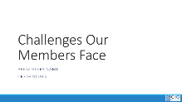  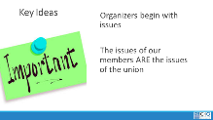 | What are the challenges that ESP face in our affiliate system? Their work? Their lives? | Lots of Post it Notes and a large wall  A few Larger sized post-it notes |  | 30 Mins -Understanding Challenges of our Members (Ginny/Daria)  This is an activity that you might find useful to do with members who are getting reading to identify priorities for bargaining or a campaign  Affinity wall activity – each participant is going to brainstorm as many challenges/issues as possible that their ESP members have -- work, life, union, etc. – in the true sense of brainstorming, anything that you are aware is a challenge. Put one challenge per post-it. (this is about a 10 minute activity)  Step 2 – this part is a little bit like engineered chaos – now the group will apply these post-it's to a wall. They put them up – and as they are now on the wall, begin to move them into clusters that are similar – as the clusters begin to form, a few people will begin to NAME the clusters – ex. “Fair Pair” (this can take up to 10 minutes – encourage people at the front to move back and those at the back to move up – keep churning and engaging.  Debrief (10 minutes) –  What are the major clusters?  What does this mean for our work with ESP?  What surprises you?  Key Ideas -- these members have issues, and it is through our relationship with these members that we build member led campaigns to address these issues. |  | Participants will have identified and described issues that ESP members face.
9:30 – 10:00  Naomi  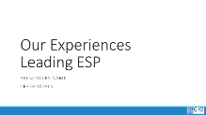    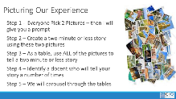  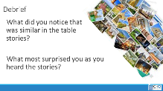 | What are your experiences in leading ESP units? | Picture cards |  | 30 Minutes – What are your experiences leading ESP units (Naomi)  6 Minutes Beginning activity – Step 1 - At tables, give each group a random selection of picture cards. Each person picks two- Don’t tell them why they are picking. Go around and scoop up the extra before you do the next step.  Once they have picked their two, tell them to use these to describe (in under 2 minutes) what their personal experiences are like in working with ESP Units.  [stay on title slide]  6 Minutes Table Share- Each person shares their story around the table.  Once these 10 minutes are up, tell them that as a team, they are to use ALL their cards to create one unified story that can be shared. Get ONE team member prepped to tell that story.  6 Minutes Whole Table Story- Using all the cards, the table comes up with a story about what their collective experiences are like working with ESPs. (the total story must be less than 2 minutes and ONE person needs to know it very well )  At the end of this 10 minutes, tell them that all but the one team member who knows the story well are going to visit each of the other tables – leave the docent behind at the signal and move to the next table.  6 Minutes Visiting the Others Step 3 – leave One person from each table behind as the “docent” who will share the table’s story. (10 Mins) Each group rotates through each table. Facilitator signals every three minutes getting the group to move in a way that is as easy and effective as possible  6 Minutes Quick Debrief  What did you notice that was similar around the room?  What surprised you most as you went around the room?  Why do you think these conditions exist? |  | Participants build community and build a common understanding of experiences.
10:00 -10:15 | BREAK
10:15 – 11:45  Seleste and Katrina Byrne |  | NOTE: What will be put in this spot next year?  Also – How do we use this data in the future in this and other trainings?  Work the data in the organizing conversations? |  | 90 Minutes – ESP Poll Data Presentation and Discussion (Katrina/Seleste)  5 Minutes Introduction and Expectations for Listening and Questions  Use a piece of paper to write all your questions for the section that Katrina is presenting. At the end of each section, turn in as a table and rank the most important to least important questions you want asked. As we take questions, listen carefully so that you don’t re ask a question that was already presented.  Don’t share your personal experiences, ask clarifying questions about the data  10 Minutes First Question Round  5 Minutes Each Second and Third Question Rounds  5 Minutes Final Discussion of 5  How does this impact your trainings?  What will you bring back? |  | Participants understand the new findings from the ESP study
11:45 -12:00  Ellen and Hedy  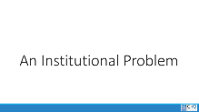  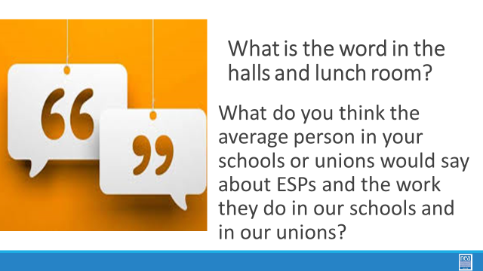 | What are some of the reasons for the injustices that our ESP members face each day? | NOTE: This can be combined with the next activity for a total of 50 minutes for both  Chart Paper  Dominant Narrative Handouts with ESP Scenarios  https://neahq-my.sharepoint.com/:w:/g/personal/eholmes_nea_org/EfFCtYJ_oz5FqgPVXgAzTgoBU8zr77ixDvw7q86CZX6_Ow?e=d2B084 |  | 15 Minutes (65 Minutes Total Split over Lunch)– An Institutional Problem (Ellen/Hedy)  2 Minutes Introduction:  Behind the issues we have described above, there may be a number of institutionalized narratives that are supporting these challenges – both for ourselves and for our members - we are going to examine one – classism. There are others – racism, genderism, ageism, and other oppressive systems and these are addressed in ARJ 1 and 2 extensively. For our work together thinking about ESP we are going to explore classism with the clear understanding that in all ways this is coded language in our society for institutionalized racism.  13 Minutes Charting What We have Heard:  Participants will work to create a chart. The chart is divided into a top and a bottom. At the top, of the chart record all the things that the average NON ESP worker in a school or a union would have to say about the ESP and their work in schools. At the bottom – what do you think ESP say about themselves and their work? |  | Participants will recognize components of classism and begin to reflect on what they see in their own practice and the systems that they support.
12:00 to 1:00  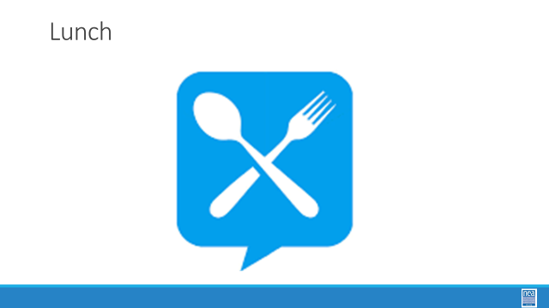 | LUNCH
1:00 – 1:50  Hedy and Ellen | What are some of the reasons for the injustices that our ESP members face each day? | Dominant Narrative Handouts with ESP Scenarios  https://neahq-my.sharepoint.com/:w:/g/personal/eholmes_nea_org/EfFCtYJ_oz5FqgPVXgAzTgoBU8zr77ixDvw7q86CZX6_Ow?e=d2B084  Suggestion – use one of the scenarios as an example when we walk through the 4 ways to shift the narrative. |  | 50 Minutes An Institutional Problem Continued from before lunch (Ellen/Hedy)  5 Minutes to finish charting  5 Minutes What are some themes?  Share out the posters - Either do a gallery walk looking for similarities and outliers, OR do a share out from each chart. Ask them to return to their seats and ask folks to do a little report out –  Do you notice any patterns?  What is something that caused you pain to read it?  Was there something that caused you to have hope?  5 Minutes – Why does this matter?  - A dominant narrative is an explanation or story that is told in service of the dominant social group’s interests and ideologies. It achieves dominance through repetition, the apparent authority of the speaker, and the silencing of alternative accounts.  - Because dominant narratives are so normalized through their repetition and authority, they have the illusion of being objective and apolitical, when in fact they are neither.  - Narratives are used to  - 1) trigger imagination and make connection  - 2) are expressions of or a counter to cultures  - 3) are resources for empowerment or oppression  - Did the narratives on your charts do any of these?  10 Minutes So let’s explore how do we change and use narratives 4-5 There is good research that says the more you “argue with” someone, the less they are willing to hear a new idea – or new frame. You are going to learn a simple process and practice it around a small set of scenarios.  Share the slides that outline a four-step process for shifting narratives  Unmask  Elevate  Contrast  Draw On Your Own Journey  Key points  Don’ts  (Make sure that they know these are in their handouts)  10 Mins Narrative Scenario Groups P. 6-11 - assign triads to the scenarios. First 2 minutes, get familiar with the assigned scenario. Second 5 minutes - One person takes the stance of the “not our framing of the issue” the other two people take the stance of trying to reframe using the process outlined in the handouts. Final 53minutes – what worked and what did not  5 Mins Debrief – What did you notice? What was tough? What worked well?  10 Minutes Return to our Narrative Charts - What is the narrative you want to be promoted about your union?  Teams now return to their Dominant Narrative charts AND COVER those with a blank chart paper – they will come up a with a list of bulleted statements that they want the PUBLIC to know about their union.  Debrief – Share out the new narrative – what is common, what are outliers?  Tip: Shift from Negative to Positive  Show the Key points slide:  - Narratives are powerful tools that can be used to maintain power over an oppressed group  - Narratives can be intentionally changed and used by an oppressed group to advance a change agenda |  | Participants will understand what a dominant narrative is and apply a four step method for changing narratives.
1:50 – 2:15  Ben and Naomi  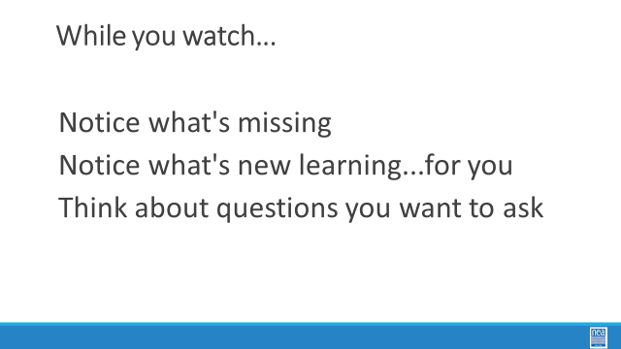    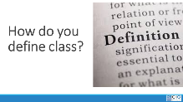  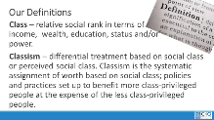 |  | Video about Classism  https://neahq-my.sharepoint.com/:v:/g/personal/eholmes_nea_org/EWbuIiIL7GtPh3uxnfmANrMB0GVtarWejZlpJcPxItPb_g?e=uSE3gE  Defining Classism  Classism |  | 25 Minutes this section (75 Minutes Total) - Defining Class, Questioning Systems, Reflections on Practices (Ben/Naomi)  5 Minutes – Introduction and Definition Pg 12-13: Welcome back everyone. Think of the affinity wall you did this morning and the challenges that your members have – and think about some of the narratives we discussed. We are going to take a look at how our organizations’ and our own relationship to class privilege may be part of the problem. We are going to do that by taking a look at a short video.  10 Minutes -While you watch – Notice what’s missing, Notice what’s new learning…for you, think about questions you want to ask. (4 minutes for video and 10 minutes to discuss questions (Participants will likely notice that there is a lack of race as part of the analysis, that there are two white people speaking in coded language about classism instead of racism) Key point  10 Minutes -At your tables, come up with a definition of class as you see it. (Take some definitions from around the room) Share our definition slide –  - Class – relative social rank in terms of income, wealth, education, status and/or power.  - Classism – differential treatment based on social class or perceived social class. Classism is the systematic assignment of worth based on social class; policies and practices set up to benefit more class-privileged people at the expense of the less class-privileged people.  Ask - what do you see here that is missing from yours? What would you like to add? |  | Participants will clarify what classism is and make the connections to systemic oppression.
2:15- 2:30 | BREAK
2:30 – 3:10  Ben and Naomi |  | Cross Class Capacity  https://neahq-my.sharepoint.com/:b:/g/personal/eholmes_nea_org/EWZPL46iL9RMq0iGhojmFyEBxCWFFPVrrw79dT9KLFMlmw?e=XOcqpi |  | 40 Minutes - Defining Class, Questioning Systems, Reflections on Practices Continued (Ben/Naomi)  40 Minutes – Recognizing Classism in Our Organizations and Practices pg. 23-24  2 minutes to intro and get into groups - We are going to be creating teams by counting off by 7’s. Each team will work with 1 of the 7 Shifts of Consciousness in the Anti-Classist Activist. Each Table will read their “shift” and identify how the conditions described show up in our work with ESPs and our organization’s relationship with ESPs. Be ready for each table to report out and have a discussion about the reflections you make.  Shifts handout - https://neahq-my.sharepoint.com/:b:/g/personal/eholmes_nea_org/EfDoolTZFJJBpYmjhCv_IXwBZd_VWdcO8zs647sOSJ9hdA?e=O6heXy  10 Minutes to work in Groups with 7 shifts handout  15 Minutes to report out (2 minutes per team)  10 Minutes for final debrief-  What is your most important take away from this session?  How will you fold this learning into your work with ESPs?  What are the consequences for not discussing and understanding classism?  What are the consequences of not including an intersectional perspective?  Share the Key points Slide at the end of the Debrief  - Classism is code for institutional racism  - Classism is a complex set of intersectional privileges and oppressions  - Advancing justice for our ESP will require both intentional and strategic action to dismantle these systems |  | Participants will clarify what classism is and make the connections to systemic oppression.
3:10 – 4:10  Daria and Ginny  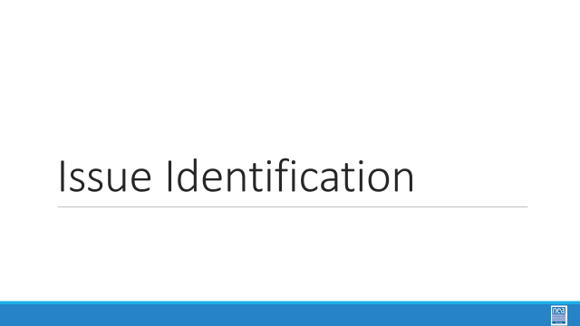  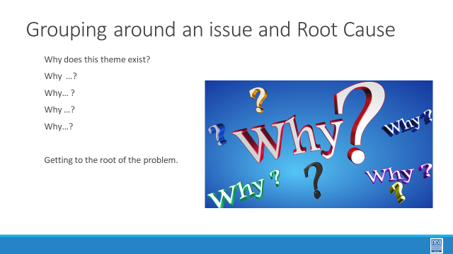    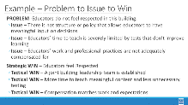  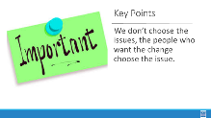  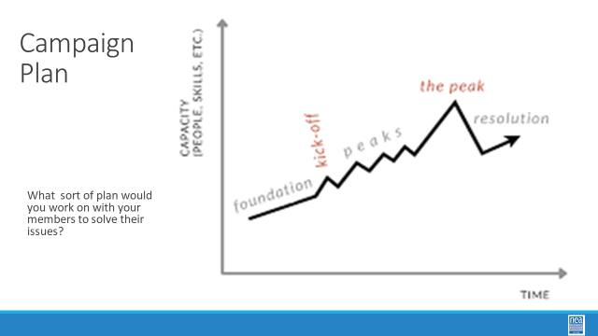 |  | Root Cause Analysis Process??  There is a Problem to Issue to Issue Assessment handout in the ESP Organizing Toolkit  Teams will use chart paper to record their work of at least one Problem to Issue and then Issue Analysis  Suggestion:  First Explain the Why. Model.  Then the Problem/Issue/Issue Analysis first.  THEN create teams |  | 60 minutes TOTAL (Daria and Ginny)  5 Minutes Team Formation and Root Cause of the Theme  Return to the Themes of Issues identified at the start of the day during the affinity wall– which one of these would you most like to work on a plan to address in your own work? Form teams around this and do an analysis of this issue -- what are all the possible root causes – and what might it look like to win on this? You are going to want to form teams around issues that you would like to work on back home. Teams no larger than 5. You will be working with this team to develop a campaign plan that you will share and could use in some way back home.  15 Minutes -5 Why root analysis –  5 Minutes to teach the concept of 5 Why  9 Minutes to practice at tables applying the 5 Why Analysis  Why does this them exist – getting to the root of it… what is the problem?  1 Minute Report Out - what is something you learned?  30 Minutes - Problem to Issue and Issue Assessment  What are possible problems/issues that ESP members want relief from  What would it take to win those  2 Min- PROBLEM vs. ISSUE Content P.29-30  - Campaigns start with issues members care about.  - An issue is a slice of a workplace problem.  - Often, a problem can have different issues depending on the perspective of the people we are working with.  - It is key to get enough input on what the issues are that make up the problem so that YOU don’t drive the solution.  - A staff driven solution may not meet the needs and commitment of the people you are working with.  2 Min- How to select an issue Content (chart for work is in the ESP Toolkit) P.43  - Since there may be many issues confronting workers on the job, we have to also think about what makes a good issue to organize around.  - CRITERIA:  - It is widely felt.  - It is deeply felt.  - It is winnable.  - It builds the union and builds leaders.  - It has a connection to students and the public.  1 Min- SET-UP activity  Working with your team, begin to identify which of the brainstormed workplace problems – issues- meet these criteria. When you have winnowed your list to the one that you think meets most of the criteria you are ready to begin planning.  25 Mins – GROUP WORK  Groups work on identifying an issue to build a plan around.  10 Minutes Report Out and Issue Whip  1 Minute Key Point We don’t choose the issue the people who want the change choose the issue. |  | Participants will use a root cause analysis process to identify issues. They will apply an issue analysis to determine what makes a better organizing issue.
4:10-4:30  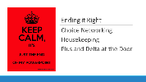  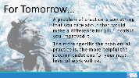 | How are we doing so far? |  |  | 20 Minutes - Ending it Right - (Ellen)  Questions, Connections, Reflections  Housekeeping announcements  Plus/Delta at the Door  FOR TOMORROW – WHAT IS A PROBLEM THAT YOU ARE EXPERIENCING AROUND DEVELOPING ESP ORGANIZING |  | Participants will be able to bring a little closure to their learning and provide feedback on the day.
4:30 – 5:00  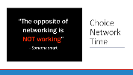 | What is the expertise among my colleagues? | 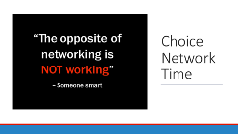 |  | Choice Networking Activities |  | Participants will make useful connections with staff from other affiliates.
5:00 | Adjourn

