Facilitator Agenda: Day # 2 Organizing ESP
General Materials Needed: |  |  |  |  | Room Set-up:
1 Set of Handouts per Person  Name Tags or Name Tents  Room signs, sign-in signs  Painters Tape |  |  | Chart Paper  Post its  Chart Markers – Mr. Sketch  Pens and Pencils |  | Round Tables  Projector, Screen and Speakers  Carousel stations and reporting stations around the perimeter  50 people
Key Outcomes for the Day
Time | Essential Questions | Resources |  | Instructions, Activity and Debrief (Facilitators) |  | Outcomes
 | What question(s) should this learning section answer? | Charts, handouts, articles, materials, slide |  | What are you saying, what are they doing, what questions will you use to guide learning and make clear the important points  Include an estimate for how long each section of the learning will take |  | As a result of this section of learning, what will participants know or be able to do?
Entry Activity  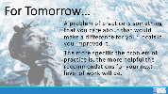 | Day needs more movement |  |  | After Lunch – WHAT IS A PROBLEM THAT YOU ARE EXPERIENCING AROUND DEVELOPING ESP ORGANIZING
8:30 - 9:00  Ellen  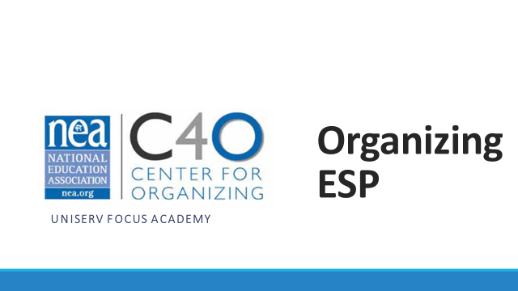      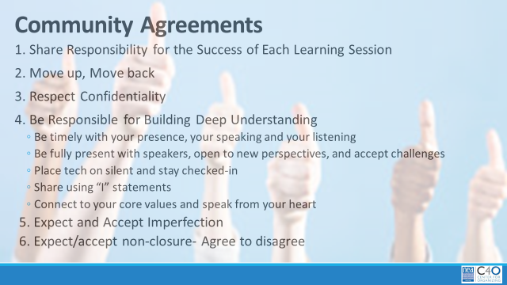 | What have you been thinking about so far? | Resource:  https://www.faireconomy.org/ |  | 30 Minutes - Welcome back (Ellen)  Reentry  Feedback on Feedback  Agenda Review  Norm Review  15 min Section (9:15-30) – Revisiting Classism discussion  After stepping away and reflecting, let's expand more on these two questions. What was your reaction to #1? Great info but not going to happen, don’t know how to do it, putting a plan together right now...  - How will you fold this learning into your work with ESPs?  - What are the consequences for not discussing and understanding classism?  Spend most of time on #2 getting to: If our members don’t name this, plan on how to address this and work to erase this within their own worksites and locals they will always be limiting their own power. How would someone who feels put down, degraded, othered and worse feel empowered. Without addressing this first, changing the narrative, collaboration, respect and understanding internally it will always be extremely difficult to move to change any external narrative. |  | Participants will re-enter the learning environment.
9:00 – 9:45  Seleste    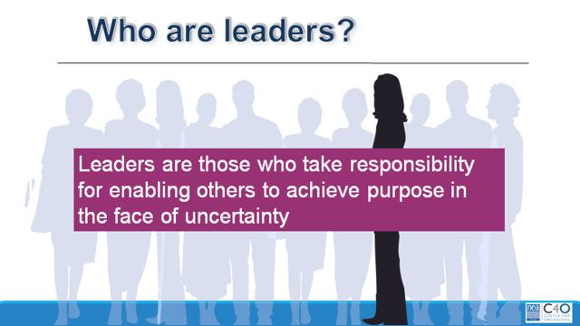  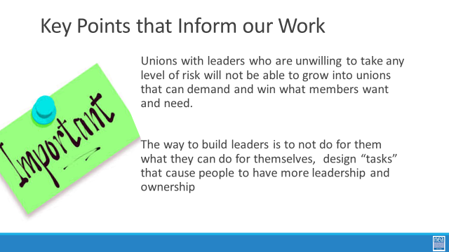  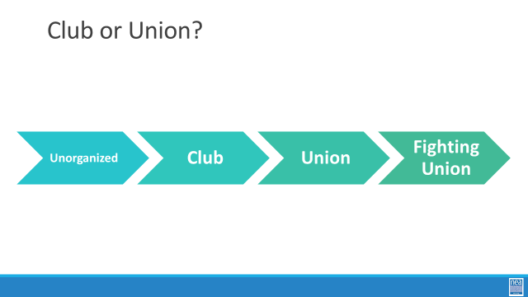  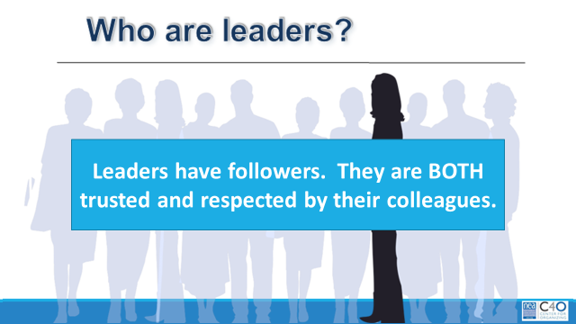  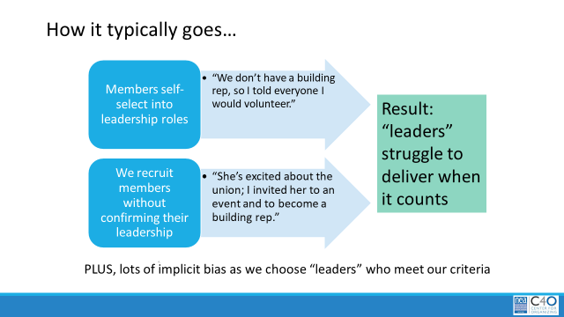 | What kind of leaders do ESP members need to achieve significant and material changes in their work lives? | Club or Union Worksheet  https://neahq-my.sharepoint.com/:w:/g/personal/eholmes_nea_org/ETzST6GSurlEn97KAGnAD-kBFZITqVCivxtF4dmDYVhx0w?e=wmjM1V  ESP Case Studies as examples of Fighting Unions –What makes them that?  https://neahq-my.sharepoint.com/:b:/g/personal/eholmes_nea_org/EWN05s-fvoZEih0RH3xRjZkBrypOWAlff3K58Fx_m2Vgkw?e=F1PqAI  Natural Leader ID in Seattle Article  https://neahq-my.sharepoint.com/:b:/g/personal/eholmes_nea_org/ERMrHcJlEH5OiyoP9J81SPkBAcQAYZ0awEh1t62yNZz9tg?e=PH7RCI |  | 45 Minutes Section – Leadership, From Clubs to Unions (Seleste)  5 Min (9-9:05) - Intro to section  Who are the kind of leaders ESP units will need to achieve the kind of wins their members want? Let’s look at the definition used across our programs. Take a minute and read it to yourselves. There are three intentional and important points in the definition. Leaders take responsibility – they don’t wait for someone to do it for them and they own the risk of whether or not the action will be successful. Leaders enable others – not empower – they remove the barriers that allow individuals to use their own agency to take action towards a shared purpose. Finally, leaders do both of these in the face of uncertainty. They don’t only choose to do the things that ensure they will be liked, will look successful, will ensure they stay employed. They take risks. Leaders are working towards an organizing stance always.  Key Point – Unions with leaders who are unwilling to take any level of risk will not be able to grow into unions that can demand and win what members want and need.  Key point - The way to build leaders is to not do for them what they can do for themselves, design “tasks” that cause people to have more leadership and ownership  30 Min (9:05-9:35) - Where are you on the Club to Fighting Union Continuum?  - 5 Min (9:05-10) - Introduction to section: Clubs are groups of people who follow, rely, and build programs. Programs have a prescribed way of working with a pretty predictable set of outcomes. They are not bad, and we need to understand how they operate. Fighting Unions are groups of people with multiple “natural leaders” engaged through structures, moving people to risk use their resources to achieve the change they want. Outcomes are unpredictable.  - 15 Min (9:10-25) - Activity Directions: Everyone – close your eyes and think about one ESP unit you work with – got it in your minds? Great. You are going to work with your table mates using a chart that outlines the conditions we might find along the continuum of Unorganized to Fighting Union. You will see elements listed in the left-hand column, with descriptors of what each element might look like as it moves across the continuum towards fighting union. Use this grid to assess where the units you are each thinking about lie, and how you would move them forward. You can also add to this grid by suggesting other elements besides the ones listed in the left-hand column.  - 10 Min (9:25-35) - Debrief  - What did you learn?  - How useful was this in thinking about your work with ESP units?  - What would you add to it?  10 Min (9:35-9:45) -How do we identify leaders, and why it matters: (Halimah)  Leaders, ultimately have followers. We do not make leaders –they already exist in their worksites and our roles are to find them. How do we typically identify leaders when we or our members are working on recruitment.  Either members self-select into a leadership role (it’s my turn, there was no one else, I have always done it) or we recruit members without confirming their leadership with their co-workers (they were really excited about the union, they contact me a lot for information and seem to be in the know, they really remind me of other union folks I like)  What happens when we do this is that leaders struggle to deliver, take risks, and engage others in the union when it counts. They remain reliant on staff for success.  The method that is now widely accepted as best practice is called “Natural Leader ID.” This method is the intentional identification of leaders. You can go high tech or low tech, but the process is the same. You and your organizers go to your people, ask, “Who here is trusted and respected?” Everyone records who they say. The more a person is named as a trusted and respected leader, the more relationship resource they have that could be used for union work.  As you look at the data, you are also working to identify who already has relationships with the union, and who does not. If they are an identified leader that is not in relationship with the union – your work is to get to know them and bring them into a relationship. For all who are identified your work is to build relationship with leaders, and help them realize how the union can help them achieve their agenda.  In a perfect world – identified leaders are doing the “listening tour” or “blitz” part of this work and staff are connecting with leaders who are identified in this process.  If you are in a unit with very little leadership or ownership – there will be more staff work on the front end.  Key Points – just because they have been identified by a number of colleagues does not immediately mean they are the “best” leaders for what the local needs – the needs to be more work to build a relationship with them about what their agenda is and what the agenda of the union is – moving them to work with the union’s agenda. |  | Participants will understand a common definition of leadership from Marshall Ganz.  Participants will use a tool that helps them begin to assess a particular ESP local on a continuum from unorganized to fighting union.
9:45-10:15  Ginny Daria | How do fighting unions make a material difference in the lives of their members?  Inserted stand and talk to a new partner here. Very helpful! | Financialization of Chicago Public Schools  https://neahq-my.sharepoint.com/:b:/g/personal/eholmes_nea_org/EeDQD5wc2CVMrPb8lPjzL7QBajlT7W02c_j9uwZqnf7-xw?e=aQeekZ |  | 30 Minutes Total – Financialization, Living Wage Basics and Living Wage Campaigns (Ginny/Daria) SECTION NEEDS CUT DOWN  - 5 Min (10:30-35) Introduction to Section- What is the purpose of public schools? Turn and talk to one person at your table. Think about what you would want to say out loud to the whole room. (Adam)  - 10 Min (10:35-45) History of how the evolution of capitalism and public schools have shifted the purpose of public education (Adam)  - IMPORTANT TO NOTE at some point in this section – This topic is essential to understand because ESPs are the easiest to outsource and cut when financially squeezed.  Slide 22-23 – Share history of education, for individuals, groups and states and talk about how it’s been linked to the economy. [Use info from article "Financialization of Chicago Public Schools-pg. 91-98.]  - Public education was created to benefit those in power, mostly white males, and also to train a working class but still mostly male and white.  - Late 1800’s-1900’s Over time public schools began to elevate the workforce, again mostly for those deemed worthy.  - Into the 1940’s, it was a time of increased power for workers and labor unions. Education became even more widely available but still not universal (racism in access)  Slides 24-25  - Into the 1970’s, corporations didn’t like the level of profits. This led to a deliberate campaign of anti-tax, anti-government, distrust, pro-capitalism and was really pushed forward by the Reagan admin, especially the anti-tax. This led to the 80’s and 90’s being all pro-capitalism. It was sold... “work hard and make money to be successful”. The narrative didn’t mention the need to step on people on the way  - This extreme capitalism narrative included anti-tax, anti-union and anti-public education throughout. This shifted what public education’s purpose was.  - Private school vouchers and charters are pushed hard to the detriment of public schools  - NOTE: Each state has different laws on charter schools and charters are not bad, we represent many. The system that they are a part of is zero sum, that is the problem.  - Creates an extremely inefficient system (reference Chicago)  Slide 26  - COVID’s effect on financialization of schools  Slide 27-28  - Expectations and realities shift to schools operating in a business model. It’s more about how schools will show a return on investment and create the same type of outputs.  - But business operate with openings and closings, compete with each other and relocate. Schools operating like this leave the community in a bind and disconnected. This model also funnels money out of the community, some are for profit or operate profiting others (charters pay rent with public money).  - Privateers collect rent, sell curriculum and products as well as the private schools that are set up to seek profits.  Slide 29  - Who Benefits? have people share examples...ex. private security = private police, privatized fire departments  Slide 30  - Last 20 years – This cycle spins on and we often try to change from within but we need to stop the cycle. |  | Participants will learn what financialization is and identify the impact it has had on public sector workers.  Participants will engage in an activity that highlights wealth distribution.
10:15-10:30   | BREAK
10:30-11:00  Ginny and Daria  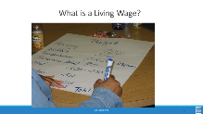  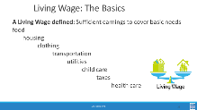  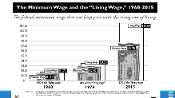  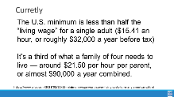  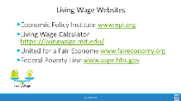  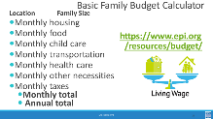    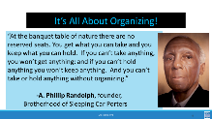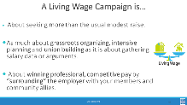  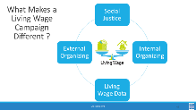  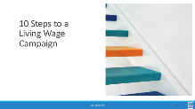  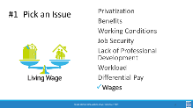    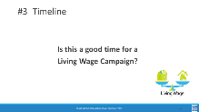  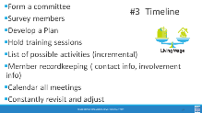  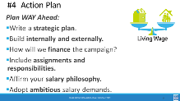  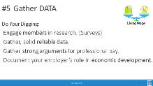  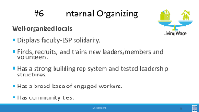  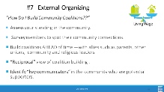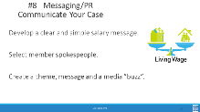  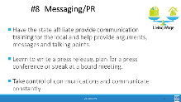  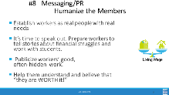    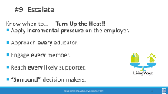  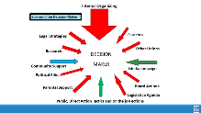 |  | Research a Living Wage  https://neahq-my.sharepoint.com/:w:/g/personal/eholmes_nea_org/EW0rcyW1FQdBmGWN7nOfolQBc98Mipr0uawqAha5gB2fbw?e=PrHHsm  ESP and Living Wage Video https://neahq-my.sharepoint.com/:v:/g/personal/eholmes_nea_org/EY3iOxojxjRBujGsZH7E6qgBEUQ6q3cFTHfJH2xFZNCxTQ?e=20LExo  Checklist for Living Wage Campaign  https://neahq-my.sharepoint.com/:b:/g/personal/eholmes_nea_org/EVrD8aKmRnFEhy633YTrC8MB1p-5ZZ9mAJsU98T8InL0pQ?e=cENpKL  Living Wage Communication Tips  https://neahq-my.sharepoint.com/:w:/g/personal/eholmes_nea_org/Ea_DC80xJ1FKqMPhk7VUeU4BDj59--vJ-sove3ObtLx4OQ?e=OSDpkg |  | 30 Minutes Total Living Wage Basics, and Living Wage Campaigns (Ginny/Daria) SECTION NEEDS CUT DOWN  20 Min (1:00-:20) for Living Wage Basics Section  - 5 Min (1:00-:05) – What do you think are all the items that would be covered in a household by a living wage? Work as a table to make a list  - 5 Min (1:05-:10) – show content about minimum wage vs living wage  Slide 36  - Note: A Living Wage is still not at a level where someone is accumulating wealth. “Thriving” is a term to reflect people starting to generate wealth.  Slide 37  - In 1938 the minimum wage was set with the purpose of supporting laborers so they can have a wage to live on.  - The ability to live off of the set minimum wage has only deteriorated since.  - The current amount is no longer related at all to the ability to live off of the wage and people have very diverging beliefs on the current purpose of it.  - 10 Min (1:10-:25) – Living wage calculator activity.  [Must email links for living wage calculator and budget calculator in advance]  Walk them through the calculators  Have them make multiple comparisons  Costs, living wage vs actual, use the locals they work with  Key Points  - A federal policy strategy to address a living wage is unlikely to give our members what they need.  - Also connect... “think of the ESP issues you generated...how many are caused by a lack of a living wage”  25 Min (10:20-:45) Living wage campaigns Section  - 10 Min (10:25-:35) - Introduction  We are going to take a look at the steps NEA has identified are core elements of a Living Wage Campaign, and to kick it off we are going to watch a video from the ESPQ department.  - 15 Min (10:35-:50) – 10 Steps  It is all about organizing - -If a local leader doesn’t get this... They’re not ready for a campaign. A LW campaign can be done in a non-bargaining state as well as a bargaining state. Whether you are bargaining or advocating and lobbying – the campaign strategies are the same  Salary campaign strategy always involves unity, consensus, strategic planning, solid research and arguments, member organizing and engagement, coalition work, constant communications, and the sense that “We’re worth it.”  What is It REALLY About?  - Working only one job and having time for your family, friends, and yourself.  - Social Justice, Worker’s rights, Human rights, Women’s rights,  - Self-worth, respect, and dignity on the job.  - These are settled out in the community, not at the bargaining table.  10 steps slides  Step 1 – Pick an issue – how many of the issues identified on our wall can be directly, or indirectly related to the issues of not receiving a living wage?  Step 2 – Buy in This is a campaign for all of the members... Not just the local leaders and the Uniserv!  Everyone should have a chance to contribute and feel ownership. In actuality, a salary campaign builds better, stronger, more knowledgeable and independent locals and in the long run makes for a lighter workload for the UniServ.  Step 3 - YES!!! There is never a better time than now! The lowest paid ESPs are struggling to survive in this economy  Don’t Wait - It takes a good year – 18 months to prepare for a well thought out LW campaign – whether it’s bargaining or lobbying your legislators. When the economy does start to get better, you’re just that much further ahead, prepared to start your campaign, not starting from square one!  Step 4 Action Plan - Salary campaign model: internal organizing, external organizing, use of media, civil rights style tactics, social justice issue, bold salary goals, salary data /cost of living locally  Write a strategic plan: with clear goals, priorities, timelines, assignments and milestones to celebrate.  Step 5 gather data - don’t let comparable pay be the district’s argument – poverty pay is poverty pay –even if it is what the surrounding districts get paid – it’s just not right!  Economic Development- includes faculty and ESP local spending power, institutional purchasing power and direct ties between quality local education, housing values, corporate site selection decisions, creation of rural entrepreneurs  Research – help verify current payroll data but don’t let comparable pay be the districts argument- “The district always says that we make what surrounding districts make.”  Document regional living costs –it’s the district’s problem to find the money  Look at management spending priorities, waste…  Quality… highest salaries attract highest quality applicants  Economic Development- includes ESP local spending power, institutional purchasing power and direct ties between quality local education, housing values, corporate site selection decisions, creation of rural entrepreneurs  Step 6 Internal organizing – leaders, structures, narratives  Step 7 – External organizing  Step 8 – Communicate -- Communication NO MORE SECRETS!! Do not hide the districts dirty little secrets (poverty wages) anymore- and the other secret that the community doesn’t know – TAXES should not now, not ever create or perpetuate poverty!  “Humanize” your members, tell their stories.  Educators are way too modest about the work they do.  We MUST start speaking out! Nobody knows how much they make!  Taxes should not create or perpetuate poverty!  Video tape them!  Help them believe they are worth it BUT if they don’t speak out about it nothing will change  BRANDING - Develop a clear and simple salary message. NEA salary Campaign Create a theme, message and a media “buzz”. Visuals- promotional items, bumper stickers, t-shirts  Step 9 – Escalate Approach every educator –  1:1 conversations  - Engage every member- a job for everyone, spread the work out-prevent burnout  - Supporters- community allies-parents, students, other union, religious leaders, college faculty, community organizations  - Incremental Pressure – candlelight vigils to full blown rallies, protests  - Surround- pressure on the decision-makers  For bargaining states and non-bargaining states. Decision–maker; Supt., Board of Ed. Members, Legislators, Public  It’s all about your community connections (coalitions) putting pressure on the decision makers (whomever that may be)  Step 10 – Celebrate  Keep improving salary schedules, keep organizing, plan for the next.  “A force to be reckoned with…” - you may not be the districts favorite local president or association but they know you are a force to be reckoned with, you have the community's support...you’re now a player, where before you weren’t even in the game. |  | Participants will be introduced to a minimum wage- and living wage calculator that they will apply to their own locals.  Participants will review the 10 steps of a living wage campaign and identify those in case studies.  Participants will develop communications that humanize the issues of workers to build support.  Participants will review the 10 steps of a living wage campaign and identify those in case studies.  Participants will develop communications that humanize the issues of workers to build support.
11:00-11:15  Naomi |  | Ithica Living Wage Case Study  https://neahq-my.sharepoint.com/:w:/g/personal/eholmes_nea_org/EbGZkTUC9A9Pm-9pdVQHrY4ByNoqcvJxrlZj_Mf5NzCiAg?e=5pM9Sx  Somerville Paras Case Study https://neahq-my.sharepoint.com/:w:/g/personal/eholmes_nea_org/EeH_wUB-lrpGpyWXU9BSyYEBUVTyXaJ00B9gORZUfk7zYw?e=u4V9ab  This section could use more time. The room could be split down the middle and one side reads one article, the other side reads the other article. Each table then jigsaws and creates a chart of where they find a number of the steps in the ten step process. e.g. - table one looks for and charts steps one, two, and three, and the other tables follow. |  | 15 Minutes - Step Identification Activity (Naomi) P. 115  - 3 Min Explaining the activity  Using either the Ithica p. 105 or the Somervile case p. 108 studies, create a chart of as many of the 10 steps of a living wage campaign as you can identify – you may not find them all in your cases – and some may be implied and not explicitly stated.  - 7 Min Team time – half the group does Ithaca and half does Somerville  - 5 Min Share out – create pairs of Ithaca and Somerville to share what they did in each of the 10 steps.  Pg. 105 Ithaca  Pg. 108 Somerville  Key Point  A living wage campaign can be done effectively in bargaining or non-bargaining states because it is ultimately about organizing.
11:15 – 12:00 |  |  |  | 45 Minutes – NEA ESPQ Data (Lisa/Amber)
12:00 to 1:00 | LUNCH  Remind participants: You are going to need your problem of practice ready for this session.
1:00 - 1:30 |  |  |  | 30 Minutes – NEA ESPQ Data Discussion and Wrap-Up (Lisa/Amber)
1:30-2:30  Ben and Hedy    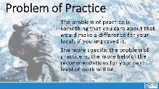  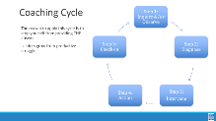  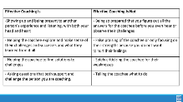  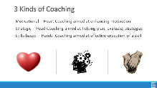    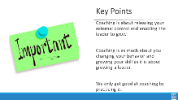 | How does coaching grow and develop leaders?  How do fighting unions make a material difference in the lives of their members? | Coaching Content Handouts including Consultancy Protocol  https://neahq-my.sharepoint.com/:b:/g/personal/eholmes_nea_org/EZcbwLqfqRhEpNZ-t-y_4RYB-8PI0HFDzFvZwMgMiqVjZQ?e=Uare8B  Coaching Scenario  https://neahq-my.sharepoint.com/:w:/g/personal/eholmes_nea_org/EWjob3uahd9Ls6eBavLfO9cBKsWk0hKgKl0wVyMrPHaygQ?e=cHCuTI  Coaching Content Handouts including Consultancy Protocol  https://neahq-my.sharepoint.com/:b:/g/personal/eholmes_nea_org/EZcbwLqfqRhEpNZ-t-y_4RYB-8PI0HFDzFvZwMgMiqVjZQ?e=Uare8B  This section could use more structure and check-ins. I propose the following: Do the content and have everyone do the scenarios and the sharing. Then – prep the coaching protocol with some instruction and some modeling of the protocol. Send everyone out to practice. Bring back together and do a fishbowl. Group in the middle that follows the protocol explicitly, everyone else around them watching in a circle. Then send everyone out to practice again Make sure lots of trainers are observing and coaching the process. |  | 60 Minutes - Consultancy Protocol Coaching of Your Issue from Home (Ben/Hedy)  Remind participants: You are going to need your problem of practice ready for this session.  10 Min (1:30-40) What is coaching section P .116  Coaching is when we release our external control of leaders and enable them to grow. It is a direct intervention that is designed to help them figure out how to be more effective. Coaching moves individuals and teams away from staff led to self-direction of actions.  There are five steps to observe in a coaching cycle – we observe these to stop our own INCLINATION to move into consultant role and give the answer or the plan.  Effective coaching should result in a transformation of dependence on staff to that of independence. We do that by showing up, being present and listening. We ask good questions that help the team or individual explore what is going on and reflect on what they are learning. We help them identify choices and solutions by asking them what they think they should do and are willing to do. We are almost always in inquiry mode – not directive mode – asking not telling.  There are three kinds of coaching – motivational is when you  diagnose after listening that there is a problem of the heart and will. Strategic coaching is when you diagnose, after listening that help is needed in identifying a plan and sticking to it. Skills based is used when you diagnose, after listening that a strengthening of skills are needed.  15 Min (1:40-55) 3 Kinds of Coaching activity P. 124  Now you and your tables are going to look at 4 scenarios. In the next 10 minutes, determine which of the three kinds of coaching is best for each scenario. Be ready to shout out answers at the end of 10 minutes. Take 5 minutes to hear answers.  35 Min (1:55-2:30) Consultancy protocol section Ben  Now we are going to look at a different type of coaching protocol. Just like the above section, this process is focused on the person identifying the solutions and the listeners acting as coaches – AND provides a way to give some consultation without becoming the director again. Some staff use this routinely in their staff meetings to discuss problems that they are having. You were asked to think of just such a problem. The problem of practice is something that you care about that would make a difference for your locals if you improved it.  First, let’s find the consultancy protocol in our handouts. And let’s take 3 minutes of silence to read it.  We are going to get into triads – so let’s do that and then we will review the directions. (About 3 minutes)  Each Person of the triad will have about 5 Minutes to Discuss their problem, the context and the specific challenge you are faced with. The more specific the problem of practice is, the more helpful the recommendations for your next level of work will be.  Using the Coaching Learning that we have been exposed to, the other two will ask questions and possibly suggest interventions that could be applied to solve the problem (10 minutes)  Repeat one time before break – it’s pretty essential to stay on time  One round and debrief after break - share their reflections on the process. Ask for one or two feedbacks.  Key Point  It's not our local  Our own biases show up when we are directive and patronizing  Coaching requires asking and listening and enables individual choices  Coaching is as much about you changing your behavior and growing your skill as it is about growing a leader.  WE only get good at coaching by practicing it. |  | Participants will understand the basics of coaching and apply their learning in a scenario.  Participants will work on a problem of practice that they are experiencing using a consultancy protocol.
2:30 – 2:45 | BREAK
2:45-3:15  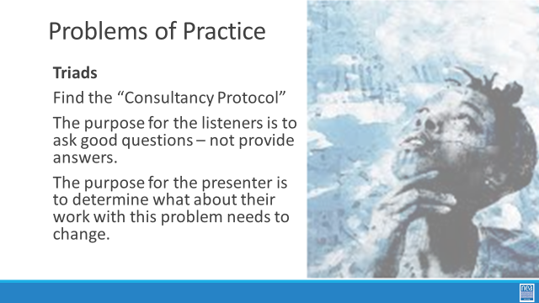 | What are ways to grow leadership? |  |  | 30 Minutes total - Final round and Debrief of Consultancy Protocol  20 Min (2:45-3:05) final round of consultancy  10Min (2:20 - 2:30) Debrief  - What was surprising to you about how you coach?  - Was it difficult to stay in coaching mode?  - Given your learning so far, why is coaching an especially important stance to take when working with ESP locals and leaders?
3:15 -4:15  Seleste  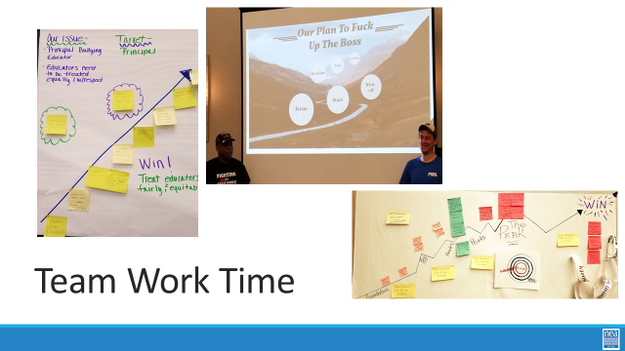 | Needs targets demands, tactics before this.  How can we apply what we have learned? | Organizing Plan Template  https://neahq-my.sharepoint.com/:w:/g/personal/eholmes_nea_org/ERzhoMiTwbZBnVGWtjZp7vMBqcovRLVClohZqMR4in49ww?e=KVqAZi |  | 60 Minutes - Organizing Plan Team Time (Seleste)  Review what team work is in process/been completed and next steps  - In Process - Checklist for Deciding on an issue Doc  - In Process - Plan for Organizing Doc  - Next step – Strategic Planning Template Doc  - Preview – end result is a presentation on day three w/use of visuals  The idea for the work time of this section is that we go back and forth between using the template and then sharing out what they have done  They should be thinking about an 18 Month Timeline  They should keep in mind the 10 steps  They should incorporate the “test/task” design into their tactics  - Must be motivated  - Must be some risk (also more and more…)  - Must have accountability
4:15-4:30 | How are we doing so far? |  |  | 15 Minutes - Ending it Right (Ellen)  Questions, Connections, Reflections  Housekeeping announcements  Plus/Delta at the Door |  | Participants will be able to bring a little closure to their learning and provide feedback on the day.
4:30 – 5:00 | What is the expertise among my colleagues? |  |  | Choice Networking Activities  Participants will make useful connections with staff from other affiliates. |  | Participants will make useful connections with staff from other affiliates.

